Model 1: Architecture and Test Evaluation
RGB-D Cornell Grasp Prediction | Mihika_grasp_Prediction
Prepared 24 September 2026. This report documents Model 1 only.

1. Model and training summary
Model 1 is a lightweight, fully convolutional encoder-decoder inspired by GG-CNN. It takes a 4-channel RGB-D image and predicts dense grasp-quality, grasp-angle, and gripper-width maps. The model has 847,235 trainable parameters, uses a base width of 32 channels, and processes 300 x 300 pixel inputs.
The available checkpoint was selected at epoch 45 of 100 by minimum validation loss (0.228780). Final epoch training loss was 0.074987; final validation loss was 0.268587.

2. Exact architecture
Each ConvBlock contains two 3 x 3 Conv2d layers, each with stride 1 and padding 1, followed by BatchNorm2d and in-place ReLU. Downsampling convolutions use kernel 4 x 4, stride 2, padding 1, followed by ReLU. Transposed convolutions use kernel 4 x 4, stride 2, padding 1. Their outputs are concatenated with encoder skip features before the decoder ConvBlock.
Stage / operation | Channels | Kernel / stride / padding | Activation / details | Trainable params
Encoder block 1 | 4 to 32 to 32 | 3 x 3 / 1 / 1 (both convs) | BN + ReLU after each conv | 10560
Downsample 1 | 32 to 64 | 4 x 4 / 2 / 1 | ReLU | 32832
Encoder block 2 | 64 to 64 to 64 | 3 x 3 / 1 / 1 (both convs) | BN + ReLU after each conv | 74112
Downsample 2 | 64 to 128 | 4 x 4 / 2 / 1 | ReLU | 131200
Bottleneck | 128 to 128 to 128 | 3 x 3 / 1 / 1 (both convs) | BN + ReLU after each conv | 295680
Up 1 (transpose conv) | 128 to 64 | 4 x 4 / 2 / 1 | Concat encoder-2 features (64 channels); 128 channels into decoder | 131136
Decoder block 1 | 128 to 64 to 64 | 3 x 3 / 1 / 1 (both convs) | BN + ReLU after each conv | 110976
Up 2 (transpose conv) | 64 to 32 | 4 x 4 / 2 / 1 | Concat encoder-1 features (32 channels); 64 channels into decoder | 32800
Decoder block 2 | 64 to 32 to 32 | 3 x 3 / 1 / 1 (both convs) | BN + ReLU after each conv | 27840
Quality head | 32 to 1 | 1 x 1 / 1 / 0 | Linear logits; sigmoid for inference | 33
Angle head | 32 to 1 | 1 x 1 / 1 / 0 | Linear direct-radian regression | 33
Width head | 32 to 1 | 1 x 1 / 1 / 0 | Linear output; sigmoid bounds normalized width | 33
Total trainable parameters: 847,235. Spatial sizes: 300 x 300 to 150 x 150 to 75 x 75 in the encoder, returning to 150 x 150 and 300 x 300 in the decoder. Each output head produces a 300 x 300 map.

3. Gradient clipping and learning-rate scheduling
Neither gradient clipping nor a learning-rate scheduler is used. The training loop calls loss.backward() and optimizer.step() directly. The optimizer is Adam with learning rate 0.001 and weight decay 0.00001; the learning rate remains fixed throughout training.

4. 70/15/15 data split and held-out test result
The saved checkpoint configuration uses seed 42, val_split = 0.15, and test_split = 0.15. Cornell sample records are shuffled deterministically and partitioned into 70% training, 15% validation, and 15% test. Validation is used for checkpoint selection; test is held out for final evaluation.
Evaluation of checkpoints/best.pt on test: 99/133 correct (74.44%) at polygon IoU >= 0.25 and antipodal angle error <= 30 degrees. The discovered dataset has 885 samples: train 619, validation 133, test 133.
Evaluation selects one proposal per image: the pixel with maximum sigmoid quality. The predicted rectangle thickness is half its predicted opening width for IoU calculation.

5. Model 1 test examples
These examples use the held-out test split. Green outlines are Cornell positive grasp annotations; red is Model 1. Success requires both thresholds to be met against at least one annotation.

Success examples
pcd0288r.png - success; IoU 0.501, angle error 5.0 degrees.
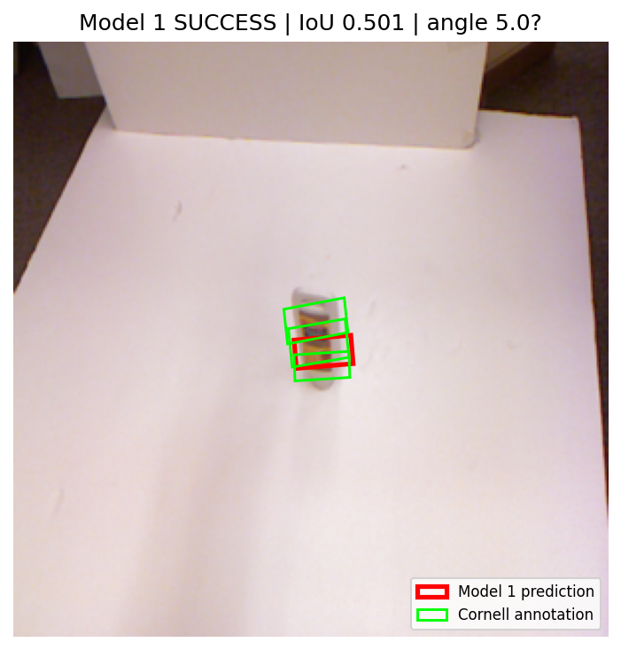
pcd0503r.png - success; IoU 0.361, angle error 1.2 degrees.
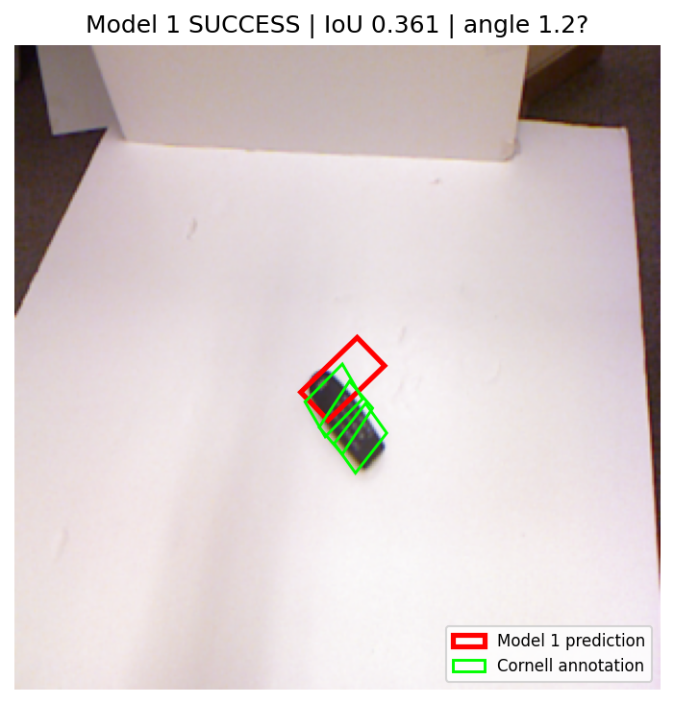

Failure examples
pcd0187r.png - failure; best IoU 0.000, angle error 71.3 degrees.
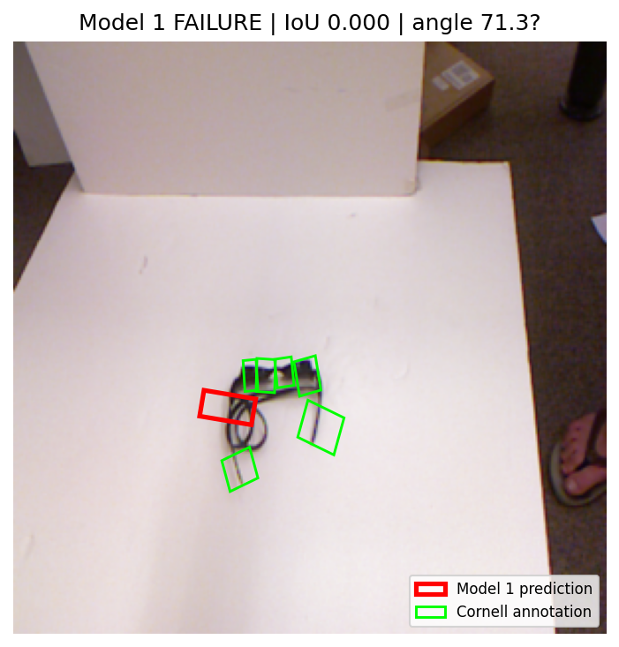
pcd0799r.png - failure; best IoU 0.408, angle error 44.0 degrees.
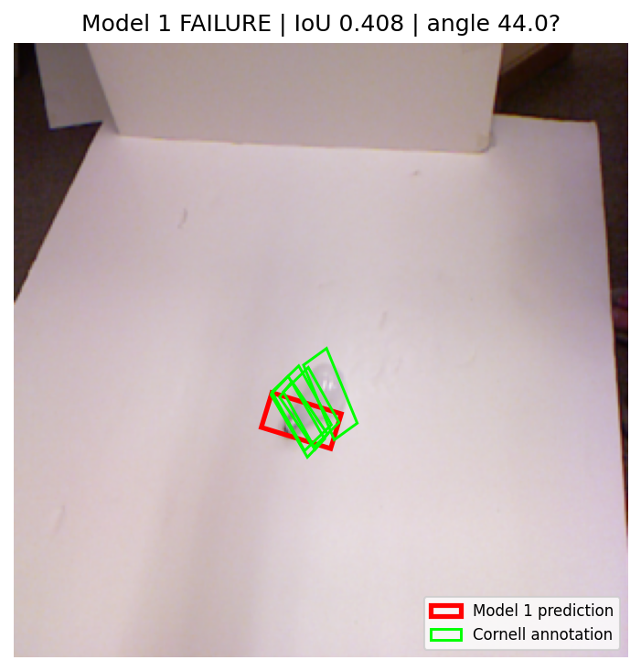

6. Model 2 comparison
Omitted by scope: this report covers Model 1 only. No Model 2 results are included.

Reproducibility references
Architecture: models/ggcnn.py. Training loop: train.py. Split settings: configs/baseline.yaml and data/cornell.py. Test protocol: evaluate.py and utils/geometry.py. Evaluated checkpoint: checkpoints/best.pt; training log: outputs/train_log.csv.

