Rust Category Detection Platform - Model Training Report
This document summarizes the achieved training metrics and visual artifacts for the two oriented object detection models used in the rust category detection platform. The models detect mild, moderate, and severe corrosion with oriented bounding boxes.

Dataset Summary
Split | Images | Label files | Mild | Moderate | Severe | Objects
train | 1658 | 1658 | 7969 | 5707 | 6808 | 20484
valid | 207 | 207 | 927 | 694 | 840 | 2461
test | 208 | 208 | 1029 | 729 | 773 | 2531
Total images: 2073; total label files: 2073; total annotated rust instances: 25476. Class names: mild-corrosion, moderate-corrosion, severe-corrosion.

YOLOv8n OBB
Item | Value
Base model | yolov8n-obb.pt
Run folder | runs\obb\runs\obb\rust_corrosion_yolov8_obb
Best weights | runs\obb\runs\obb\rust_corrosion_yolov8_obb\weights\best.pt
Epochs completed | 100
Image size | 640
Batch size | 8
Device | cpu
Optimizer | auto
Learning-rate schedule | Standard LR
Patience | 25
The table below reports the strongest achieved validation points from the training CSV, plus the final epoch. mAP50-95 is the strictest summary metric because it averages performance across multiple IoU thresholds.
Metric point | Epoch | Precision | Recall | mAP50 | mAP50-95 | Box loss | Class loss | DFL loss | Angle loss
Best mAP50-95 | 99 | 0.7136 | 0.5923 | 0.6731 | 0.4709 | 1.0737 | 1.1452 | 1.4126 | 0.0380
Best mAP50 | 99 | 0.7136 | 0.5923 | 0.6731 | 0.4709 | 1.0737 | 1.1452 | 1.4126 | 0.0380
Best precision | 91 | 0.7251 | 0.5811 | 0.6555 | 0.4537 | 1.0890 | 1.1871 | 1.4258 | 0.0394
Best recall | 90 | 0.6663 | 0.6059 | 0.6639 | 0.4622 | 1.0819 | 1.1726 | 1.4157 | 0.0393
Final epoch | 100 | 0.7022 | 0.5913 | 0.6693 | 0.4681 | 1.0756 | 1.1559 | 1.4139 | 0.0379

Training and Validation Images
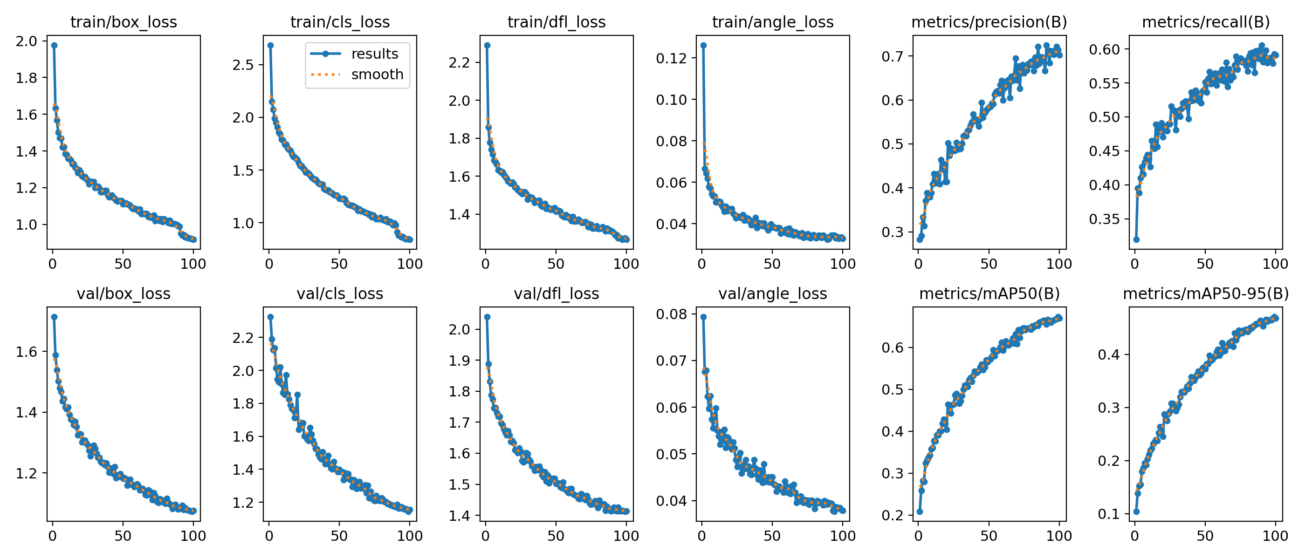
results.png: For YOLOv8n OBB, this image summarizes the training history across epochs, including box, classification, DFL, and angle losses together with precision, recall, mAP50, and mAP50-95 validation metrics.
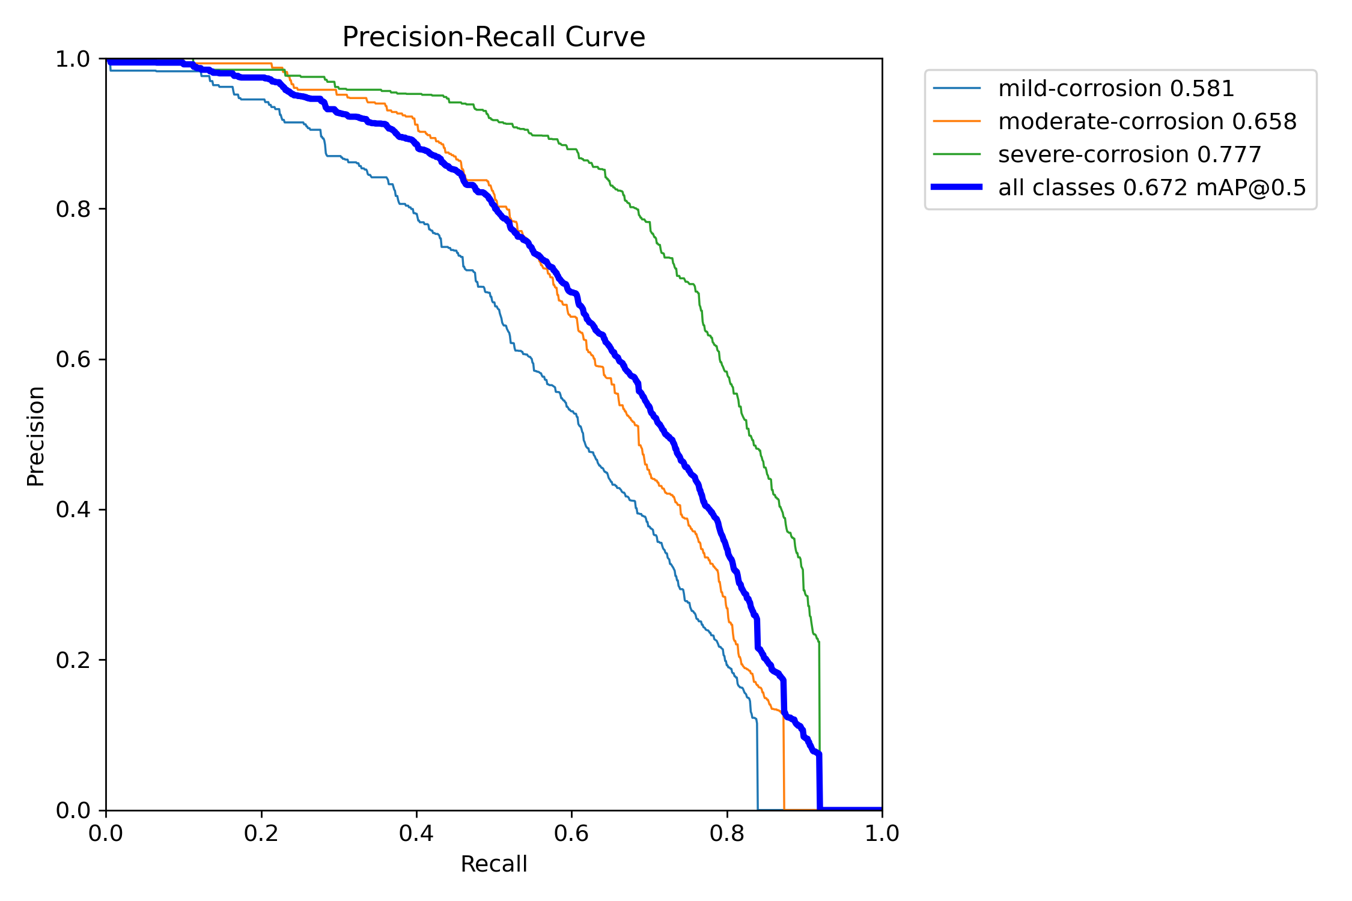
BoxPR_curve.png: For YOLOv8n OBB, this image shows the precision-recall curve for oriented rust detections. The area and curve shape indicate how well the model balances correct detections against missed detections across confidence thresholds.
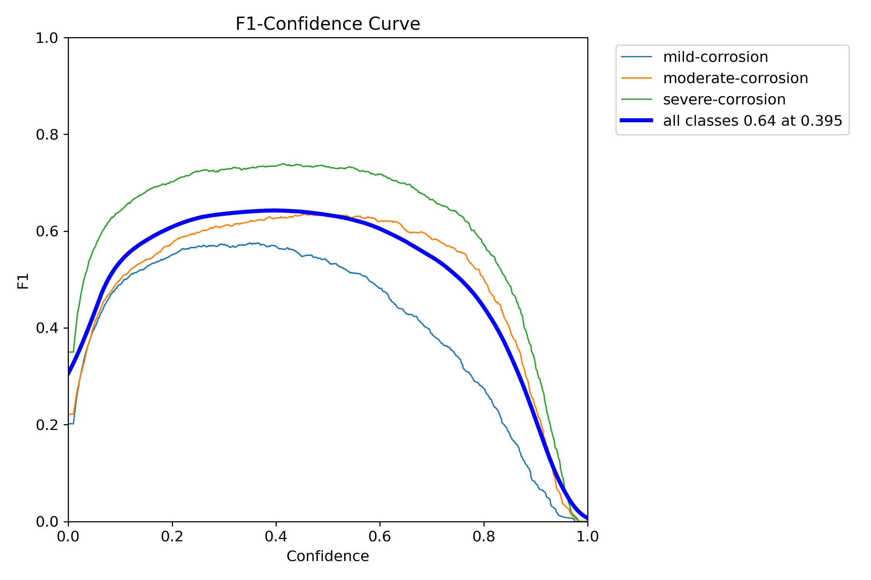
BoxF1_curve.png: For YOLOv8n OBB, this image shows F1 score across confidence thresholds. It highlights the threshold region where precision and recall are best balanced.
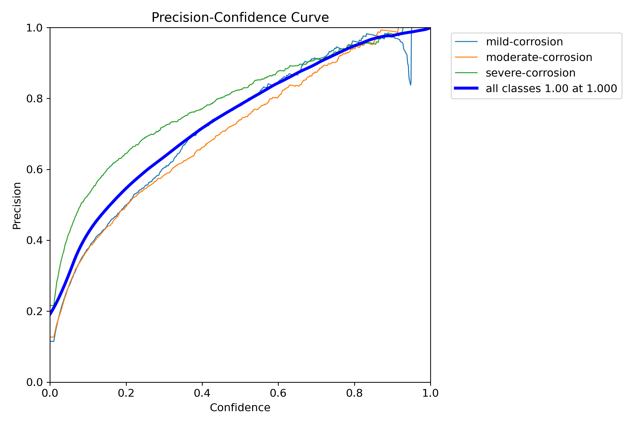
BoxP_curve.png: For YOLOv8n OBB, this image shows precision across confidence thresholds. Higher precision means fewer false rust detections are produced.
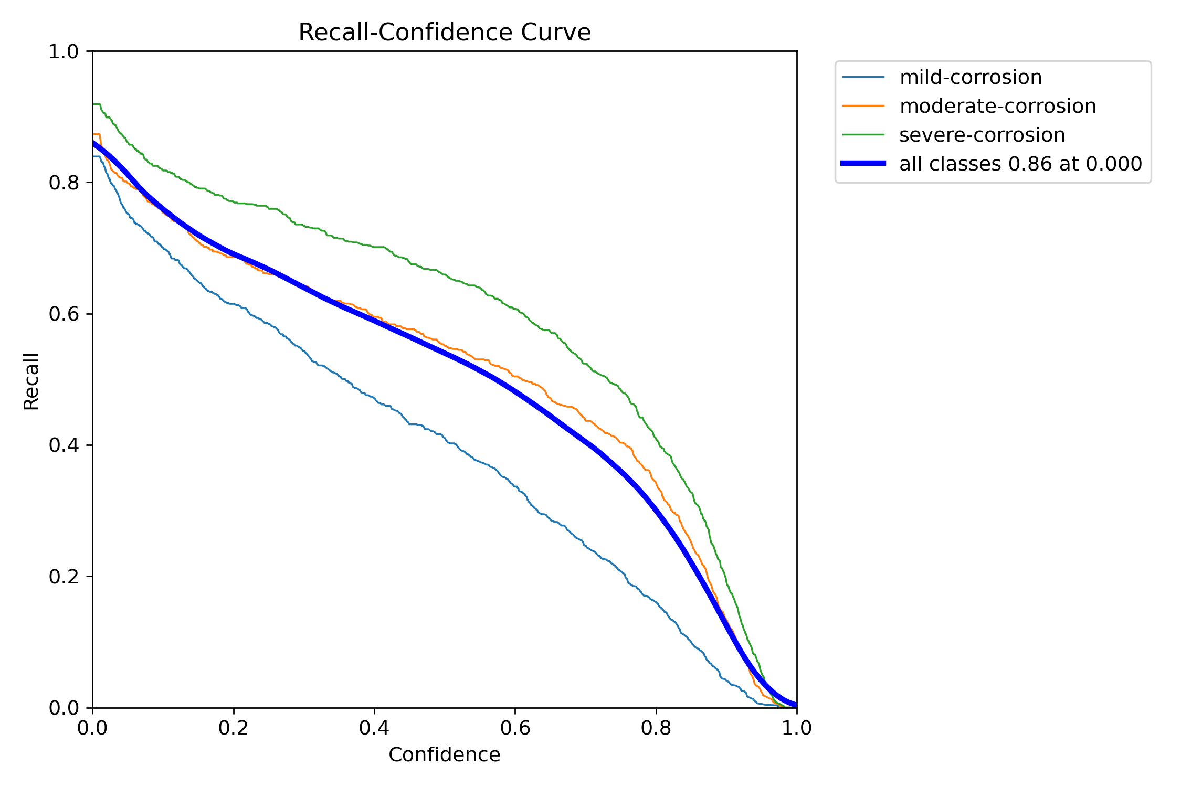
BoxR_curve.png: For YOLOv8n OBB, this image shows recall across confidence thresholds. Higher recall means more annotated rust regions are found by the model.
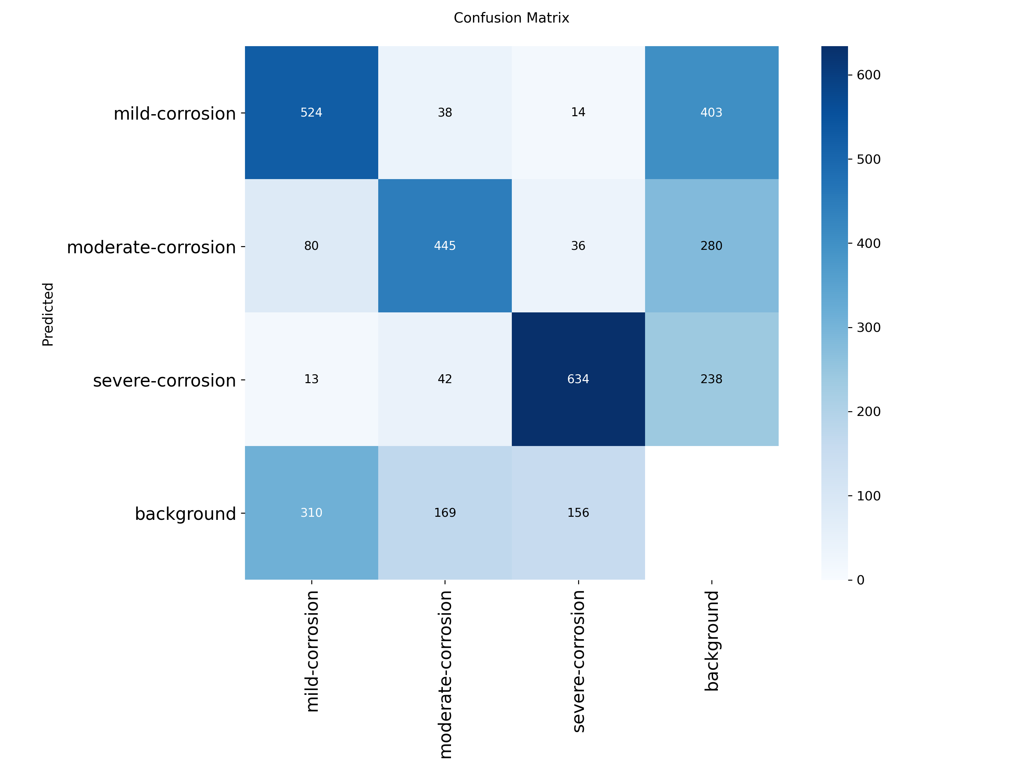
confusion_matrix.png: For YOLOv8n OBB, this image is the raw confusion matrix, showing how detections are assigned to mild, moderate, and severe corrosion classes and where class confusion occurs.
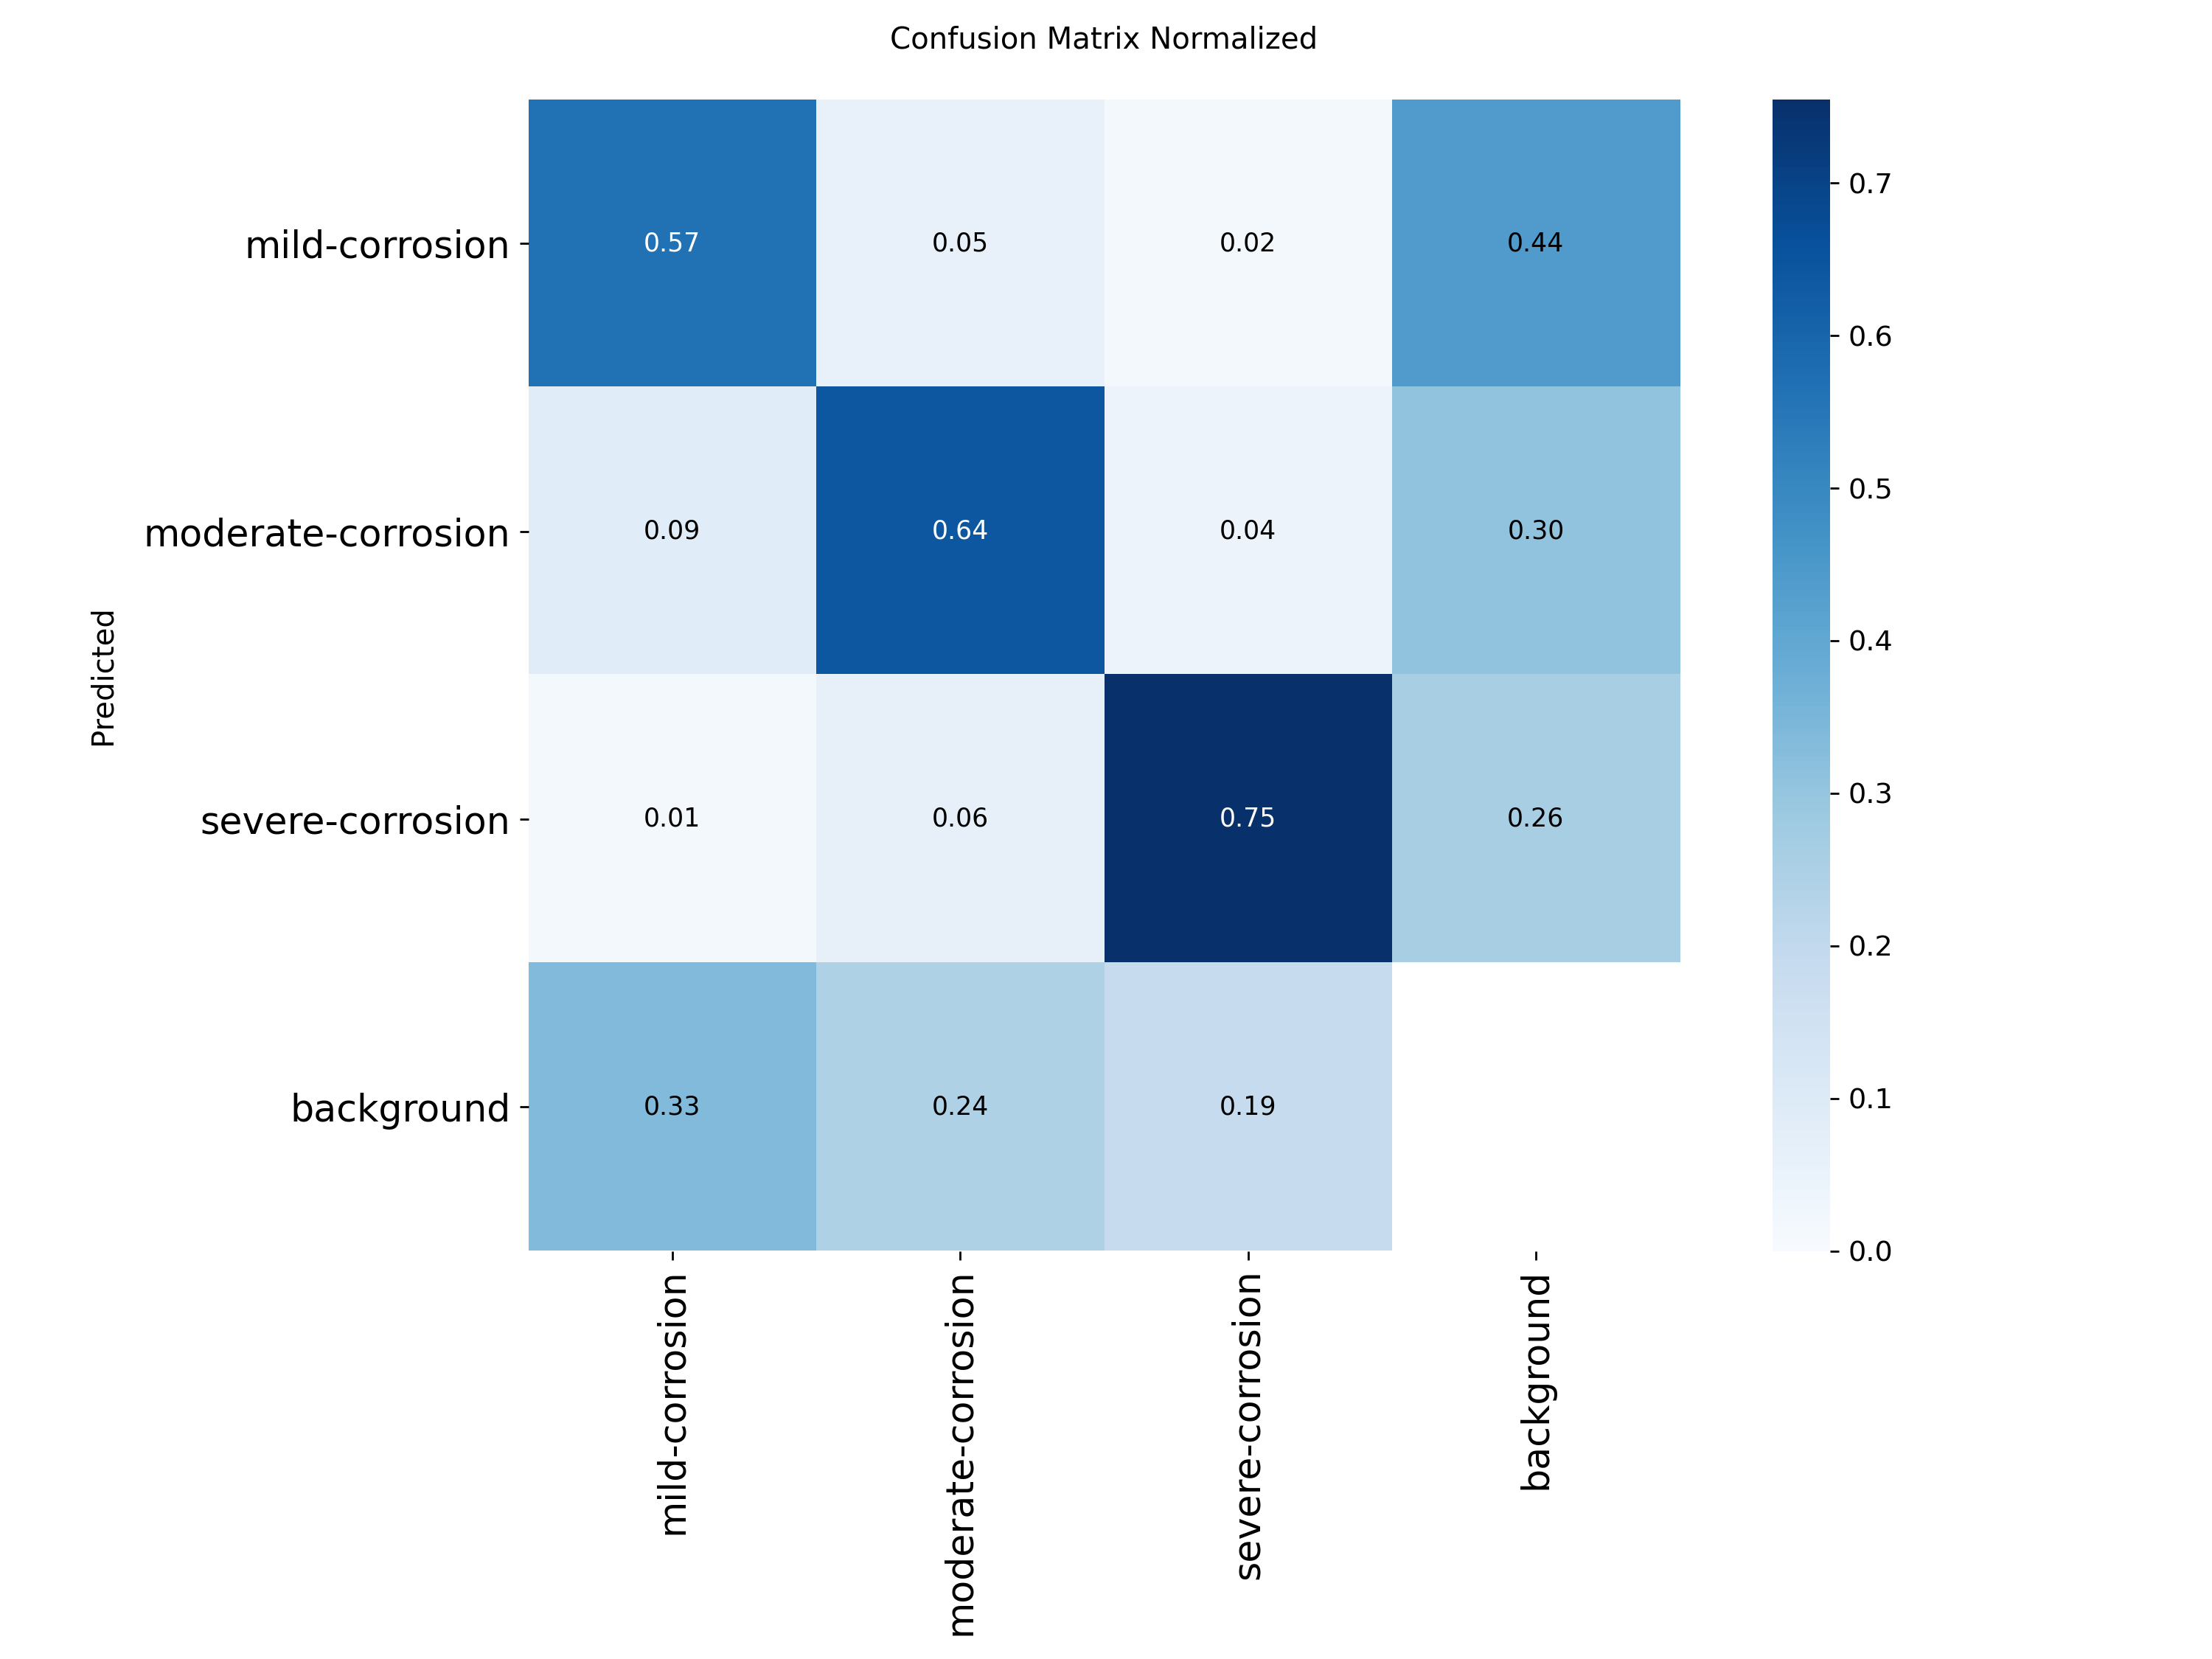
confusion_matrix_normalized.png: For YOLOv8n OBB, this image is the normalized confusion matrix, making class-wise accuracy and misclassification patterns easier to compare.
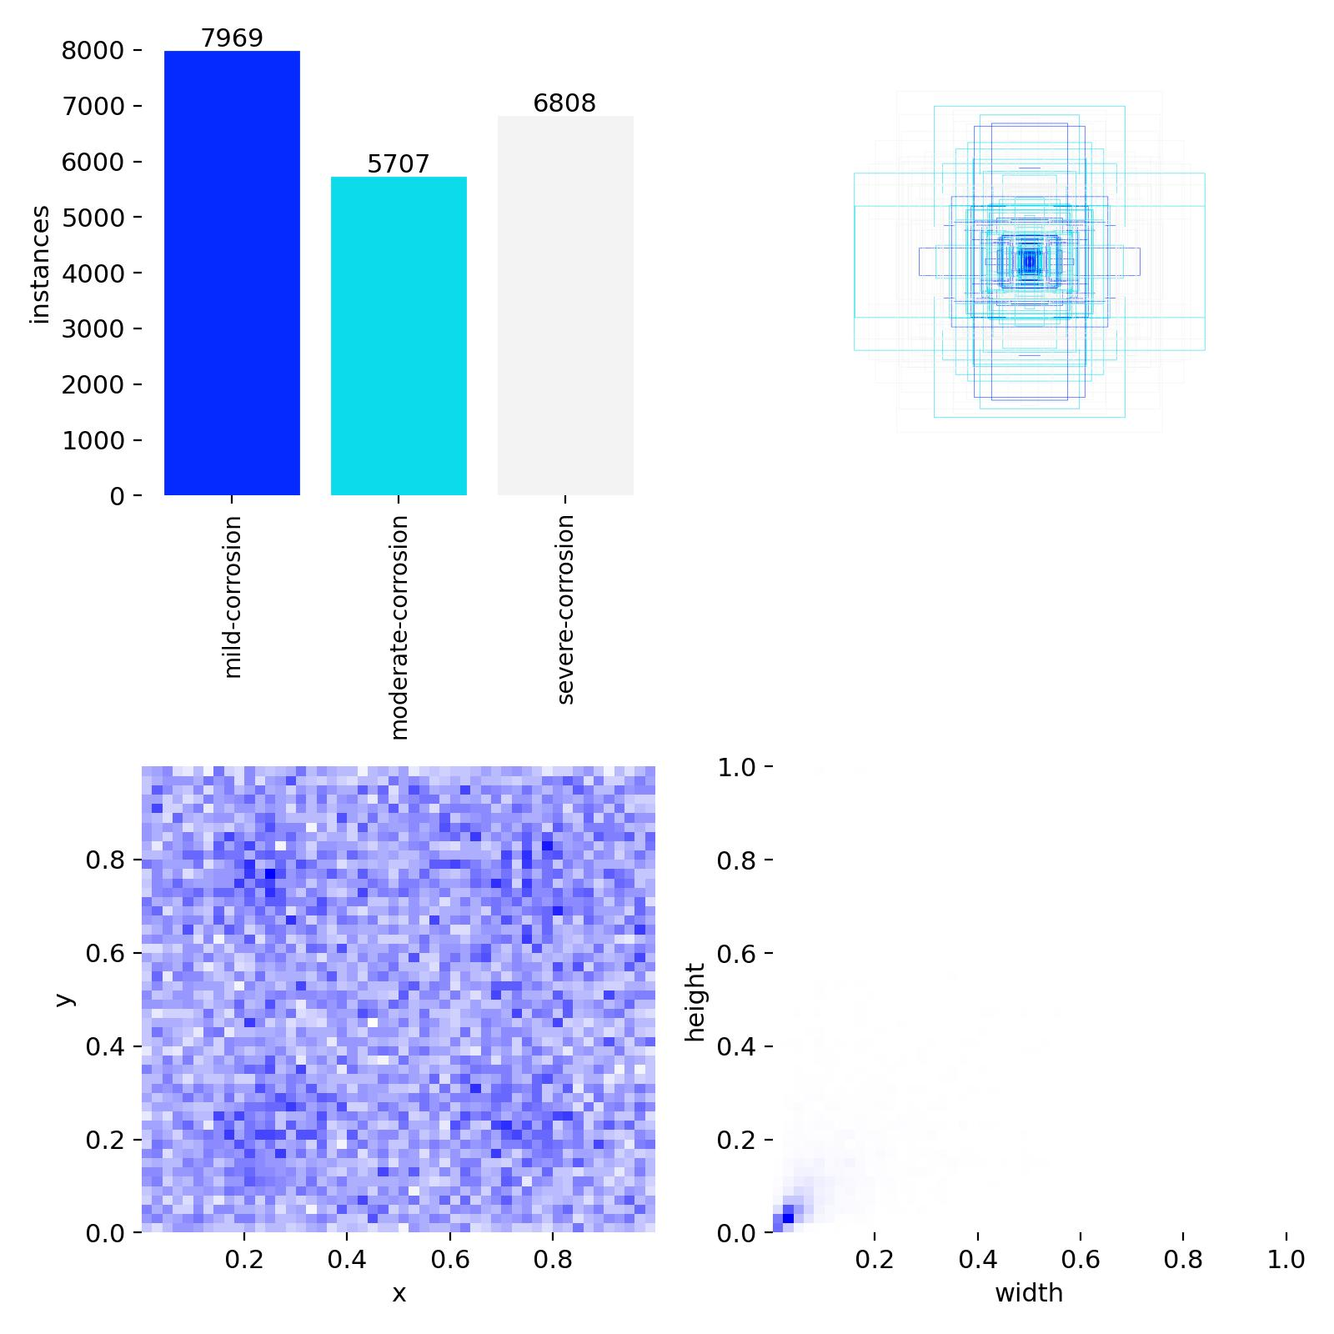
labels.jpg: For YOLOv8n OBB, this image visualizes the dataset label distribution and oriented box placement patterns used during training.
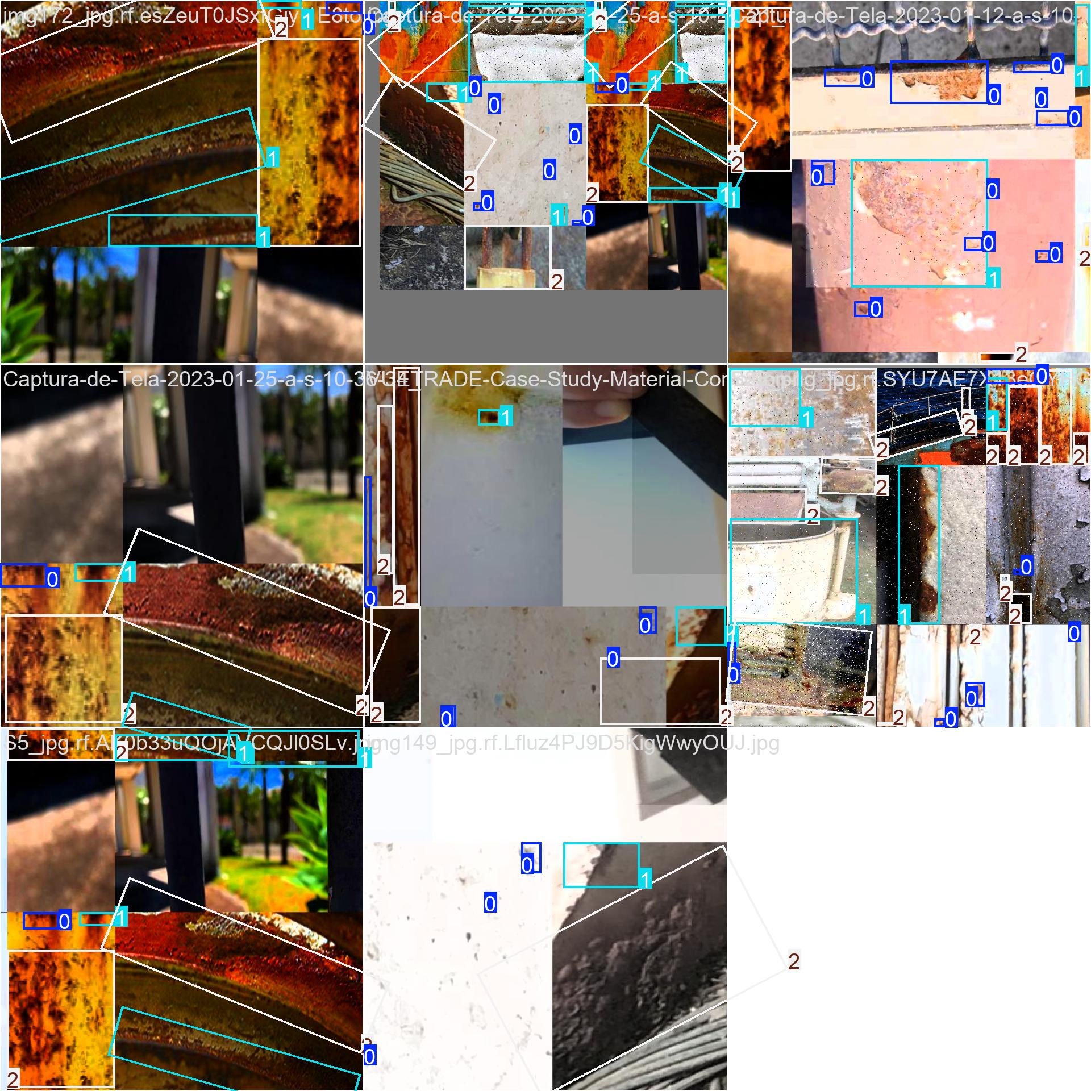
train_batch0.jpg: For YOLOv8n OBB, this image shows a training batch with augmented input images and oriented ground-truth rust boxes used to teach the model.
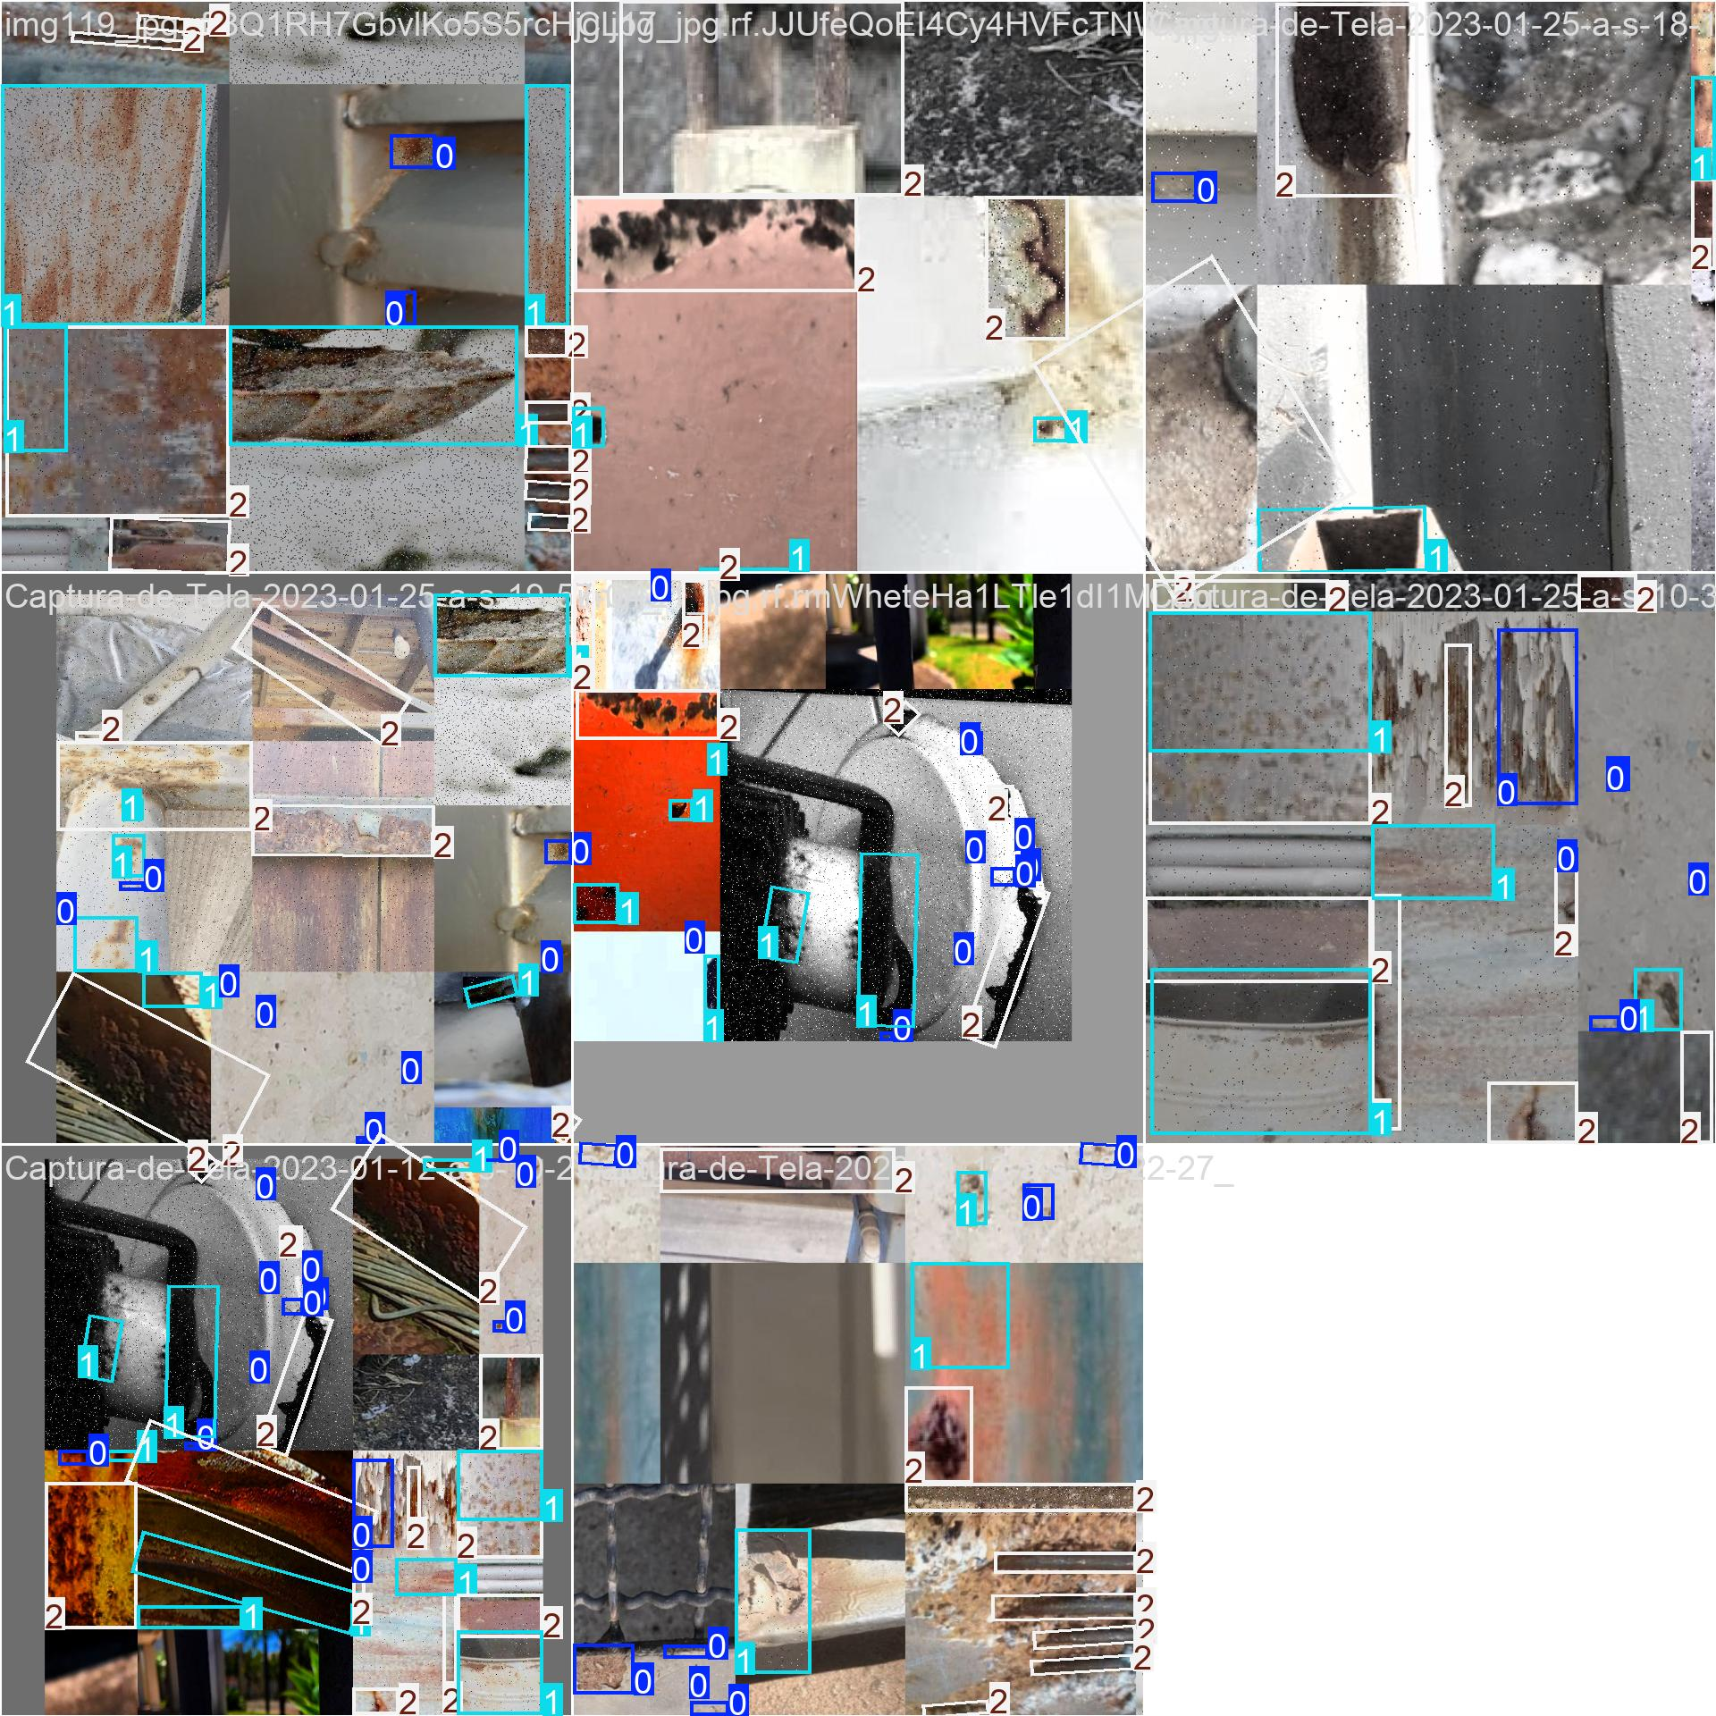
train_batch1.jpg: For YOLOv8n OBB, this image shows a training batch with augmented input images and oriented ground-truth rust boxes used to teach the model.
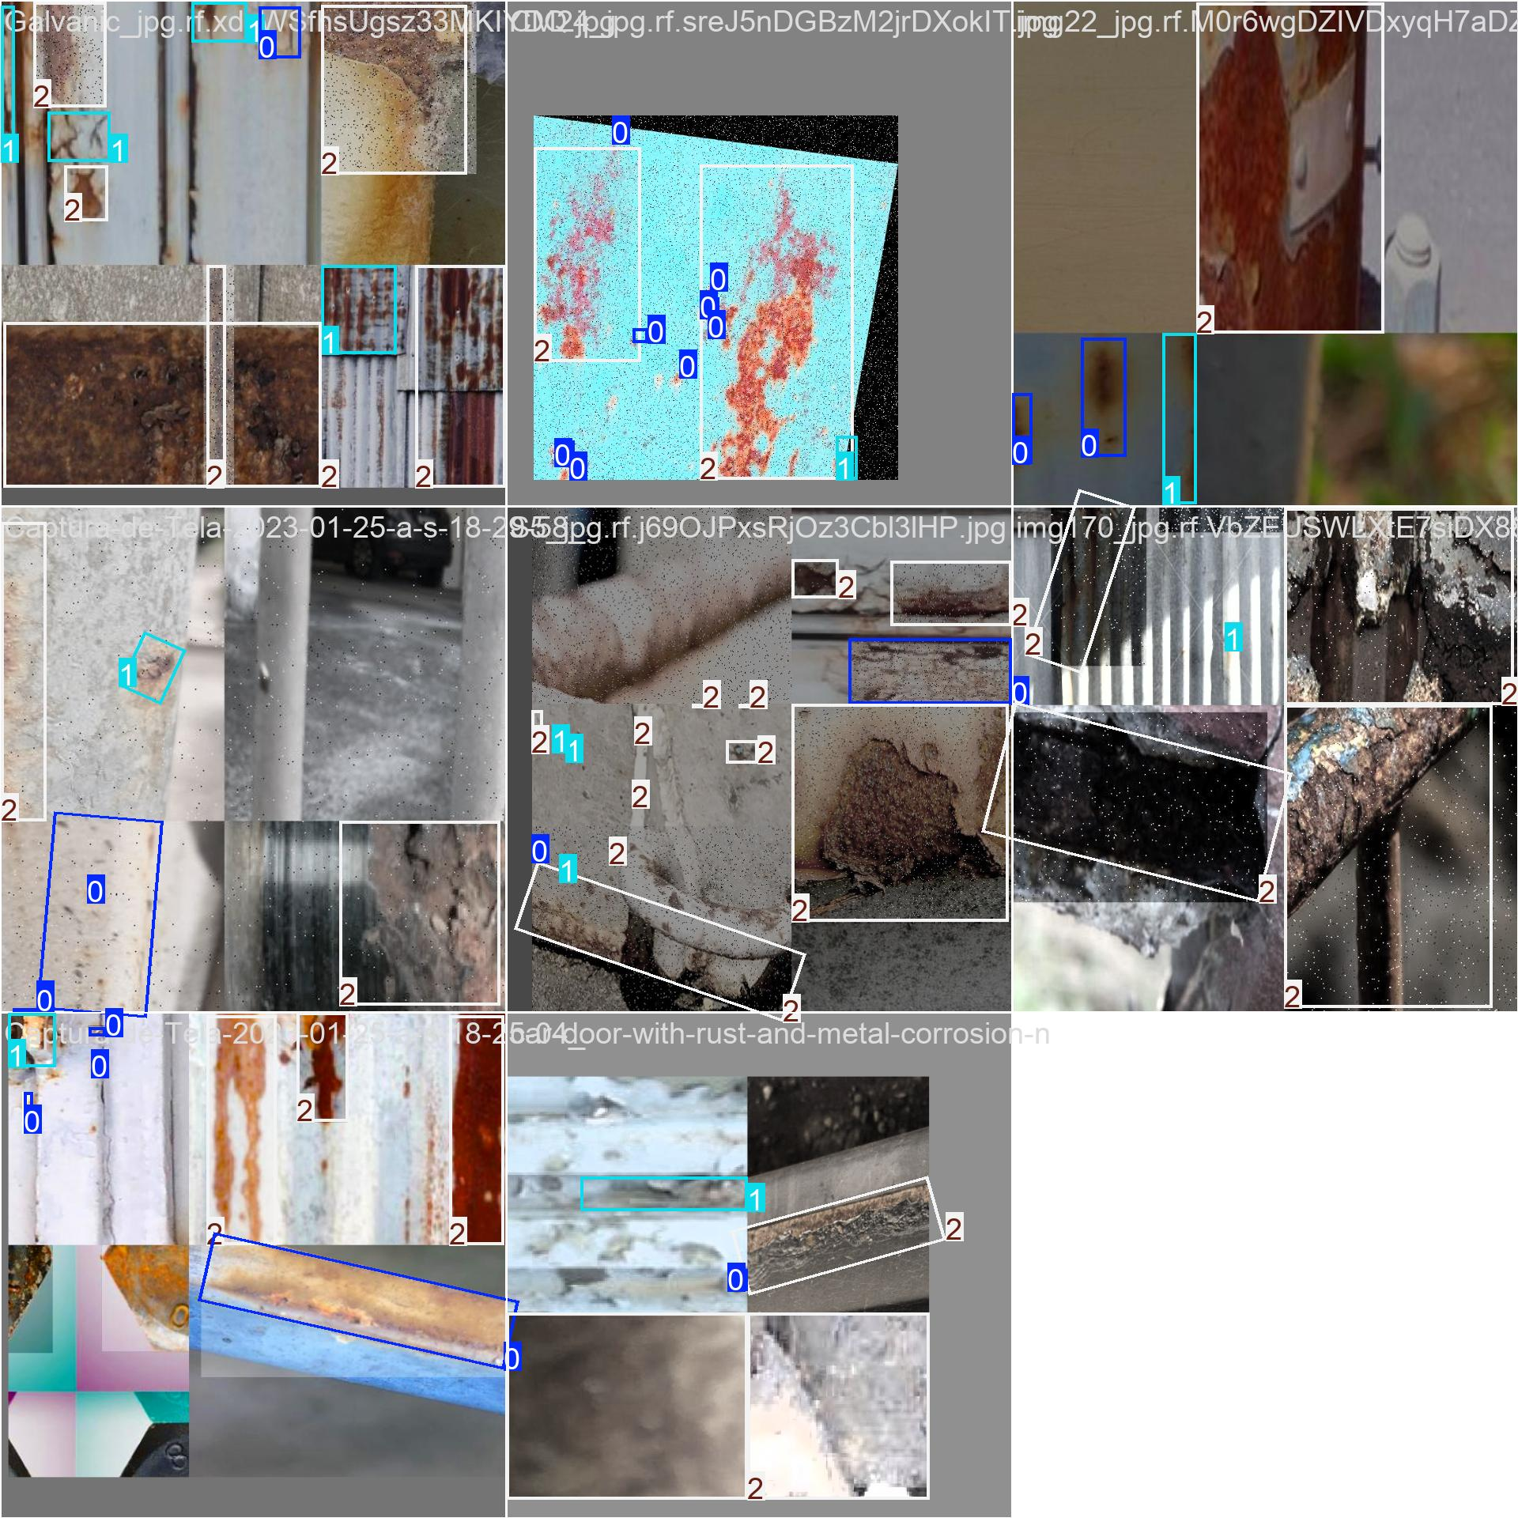
train_batch18720.jpg: For YOLOv8n OBB, this image shows a training batch with augmented input images and oriented ground-truth rust boxes used to teach the model.
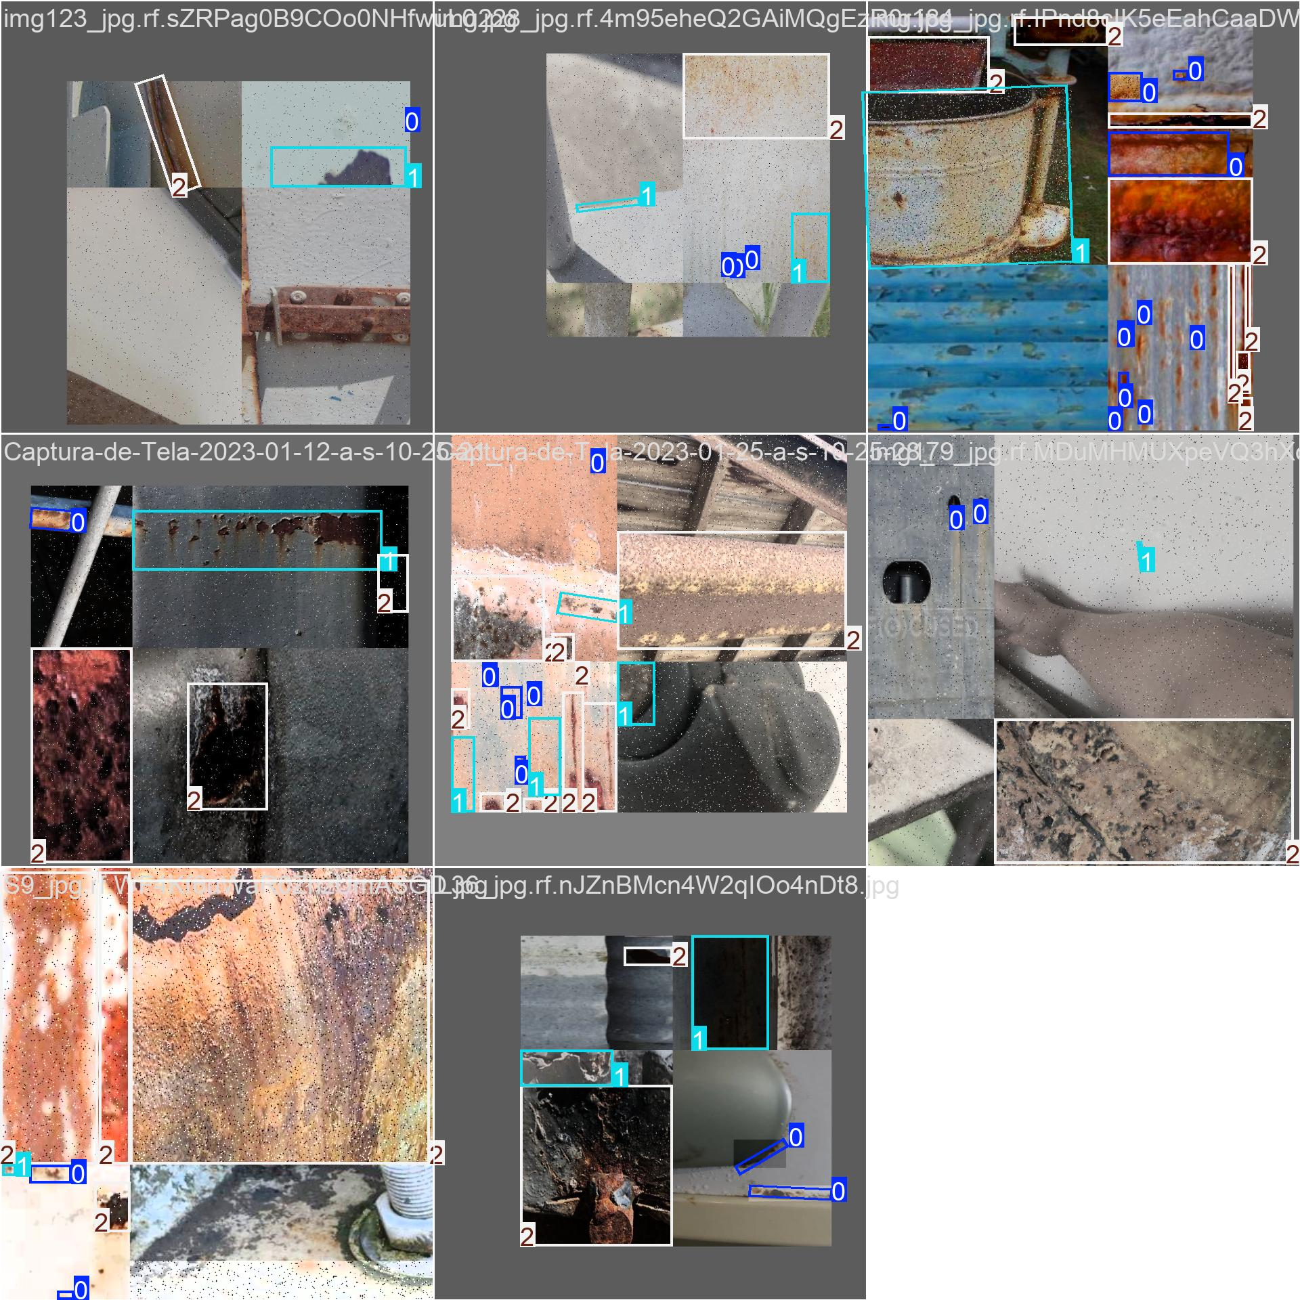
train_batch18721.jpg: For YOLOv8n OBB, this image shows a training batch with augmented input images and oriented ground-truth rust boxes used to teach the model.
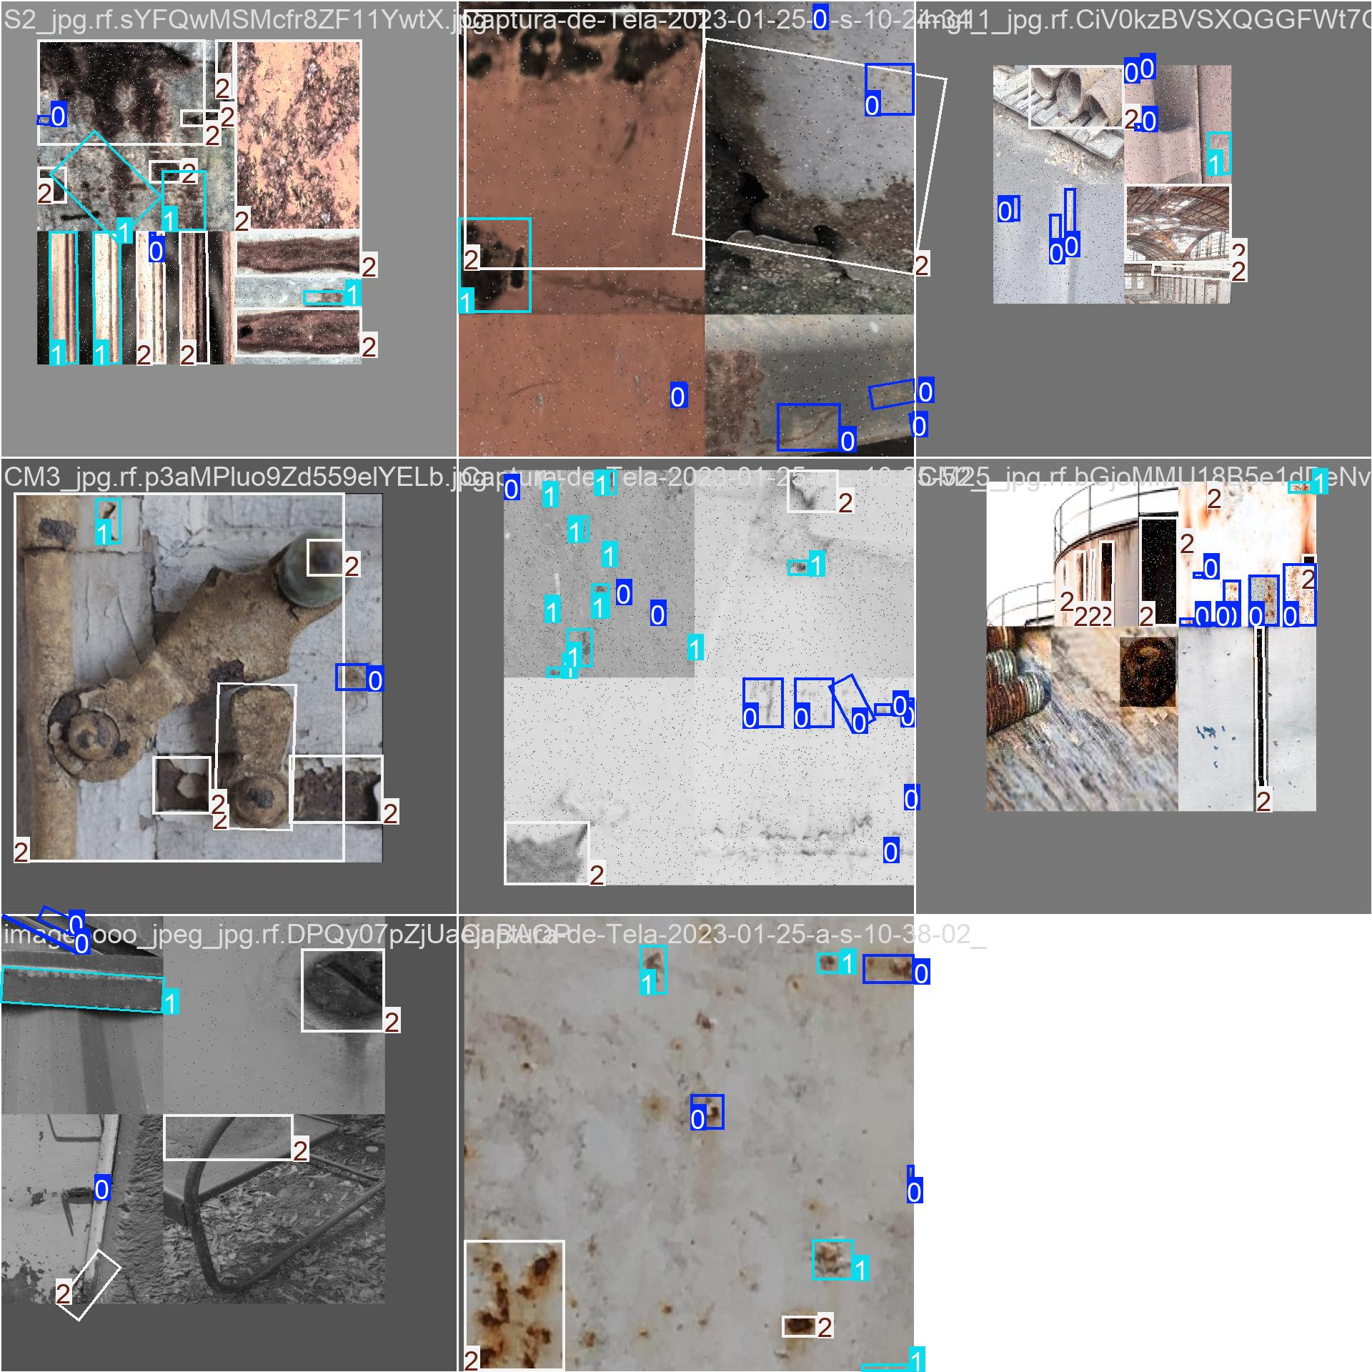
train_batch18722.jpg: For YOLOv8n OBB, this image shows a training batch with augmented input images and oriented ground-truth rust boxes used to teach the model.
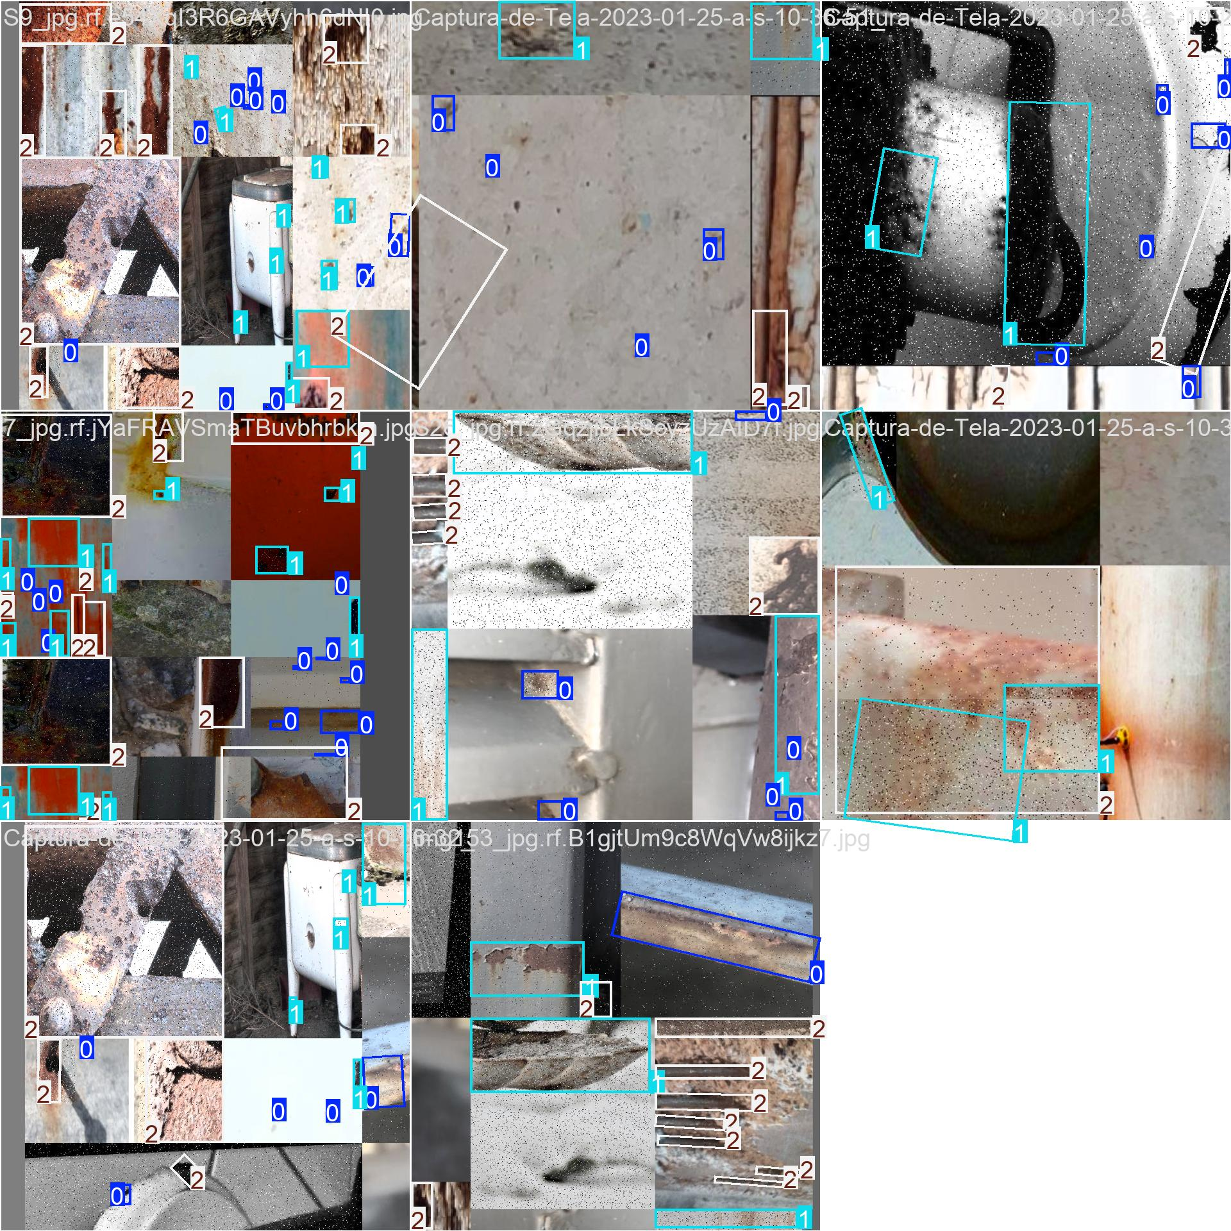
train_batch2.jpg: For YOLOv8n OBB, this image shows a training batch with augmented input images and oriented ground-truth rust boxes used to teach the model.
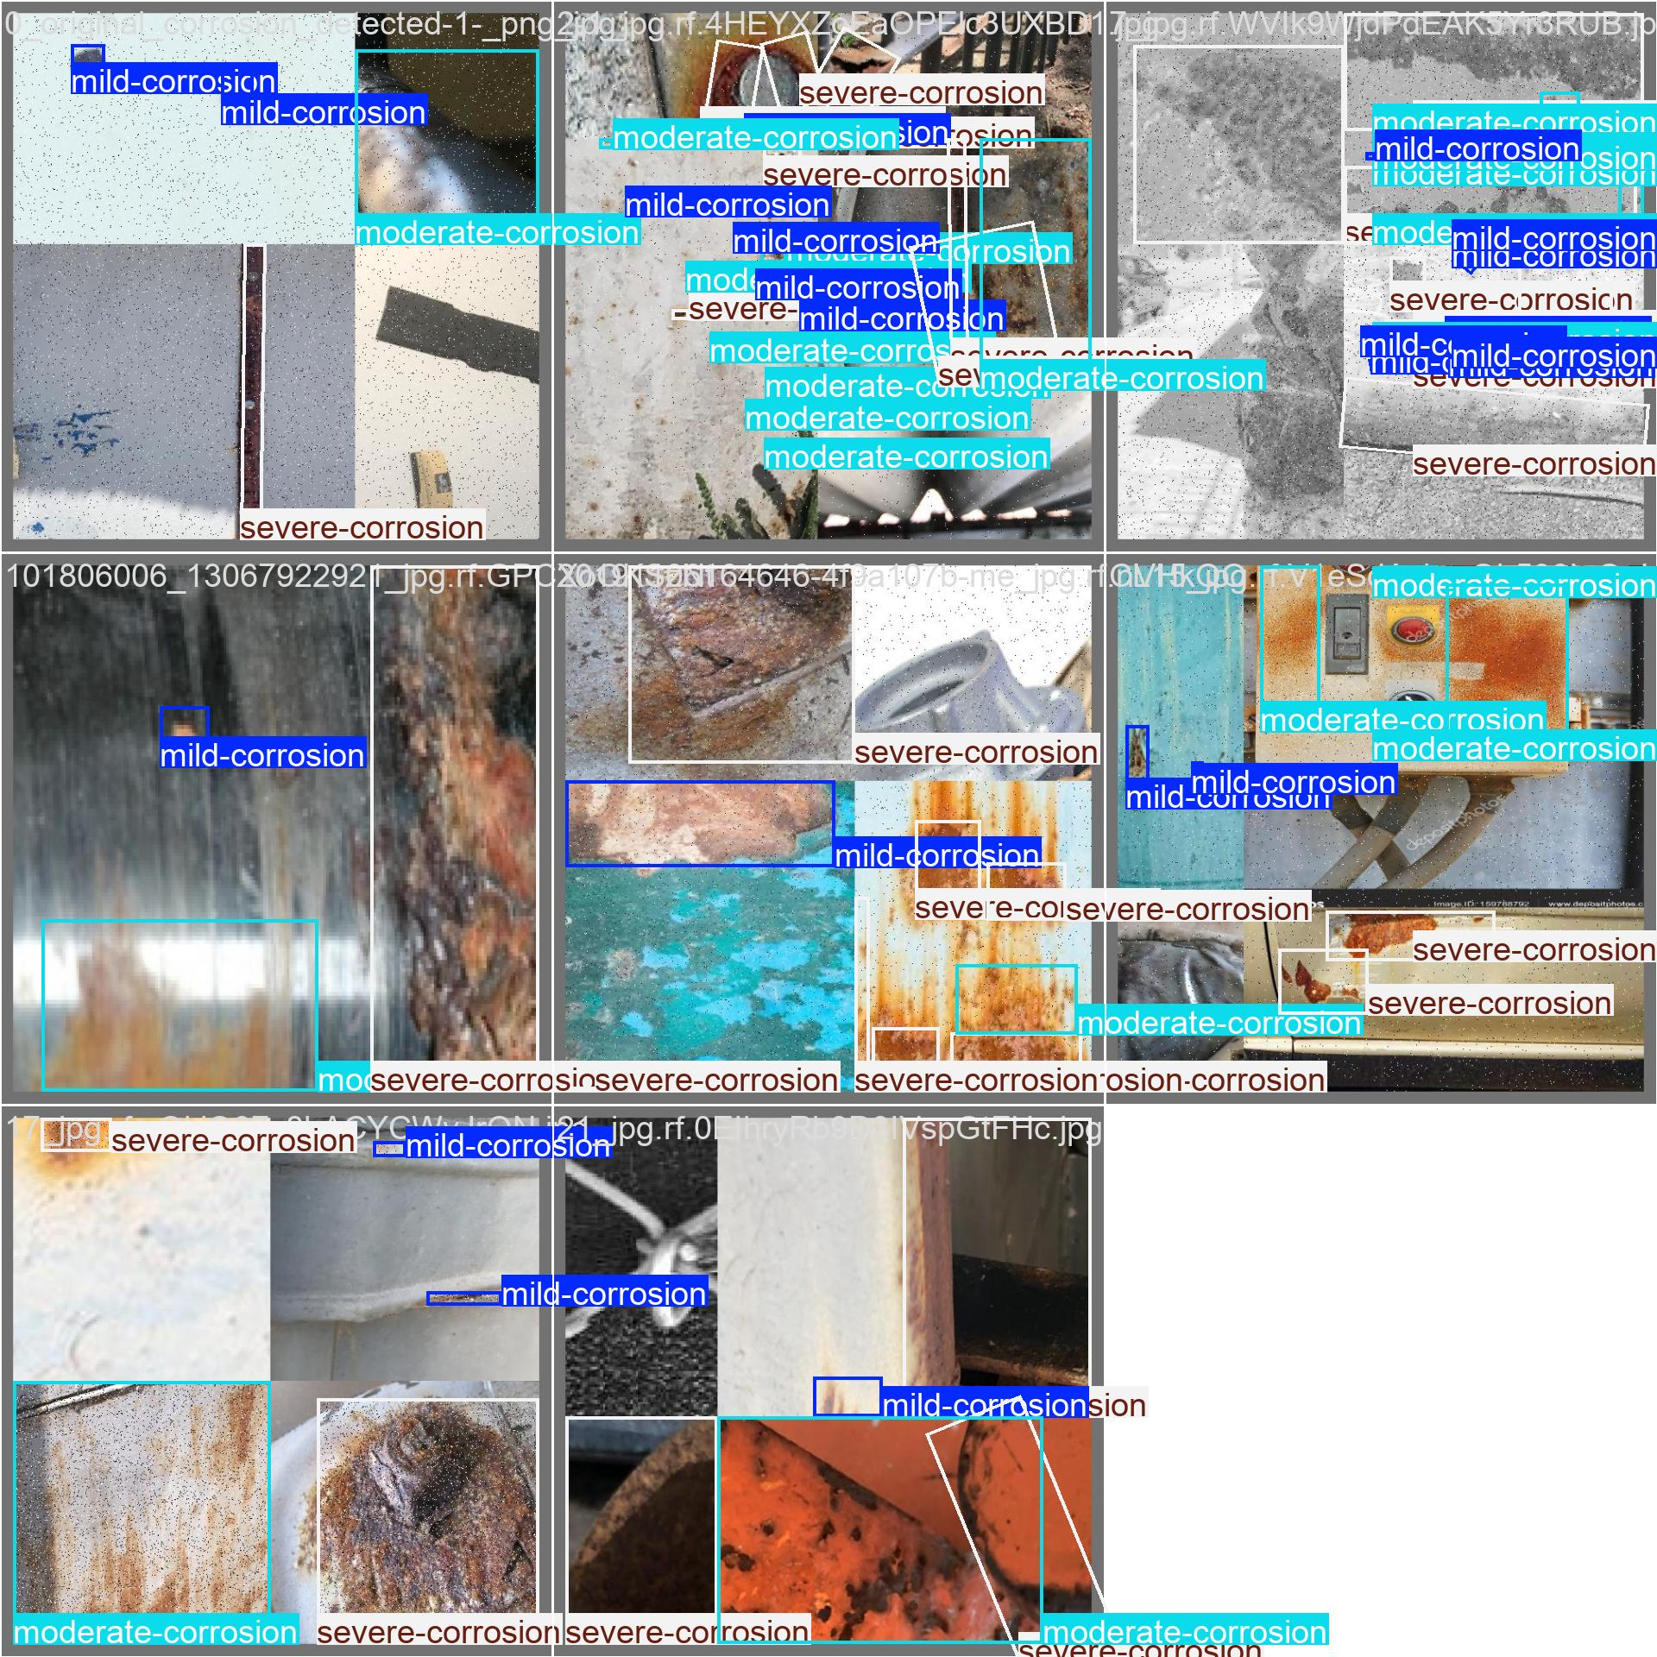
val_batch0_labels.jpg: For YOLOv8n OBB, this image shows validation images with ground-truth oriented rust labels. These annotations are the reference used to evaluate predictions.
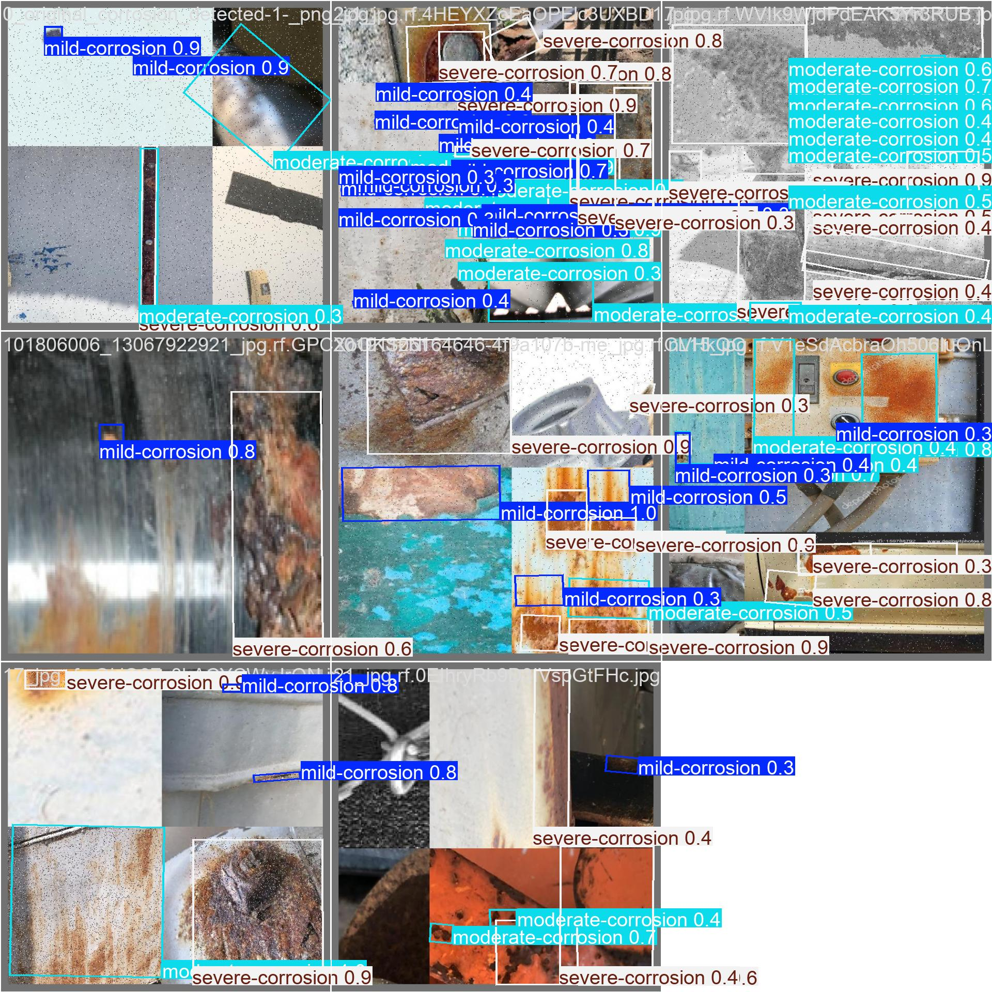
val_batch0_pred.jpg: For YOLOv8n OBB, this image shows validation predictions generated by the trained model, including oriented boxes and predicted corrosion categories.
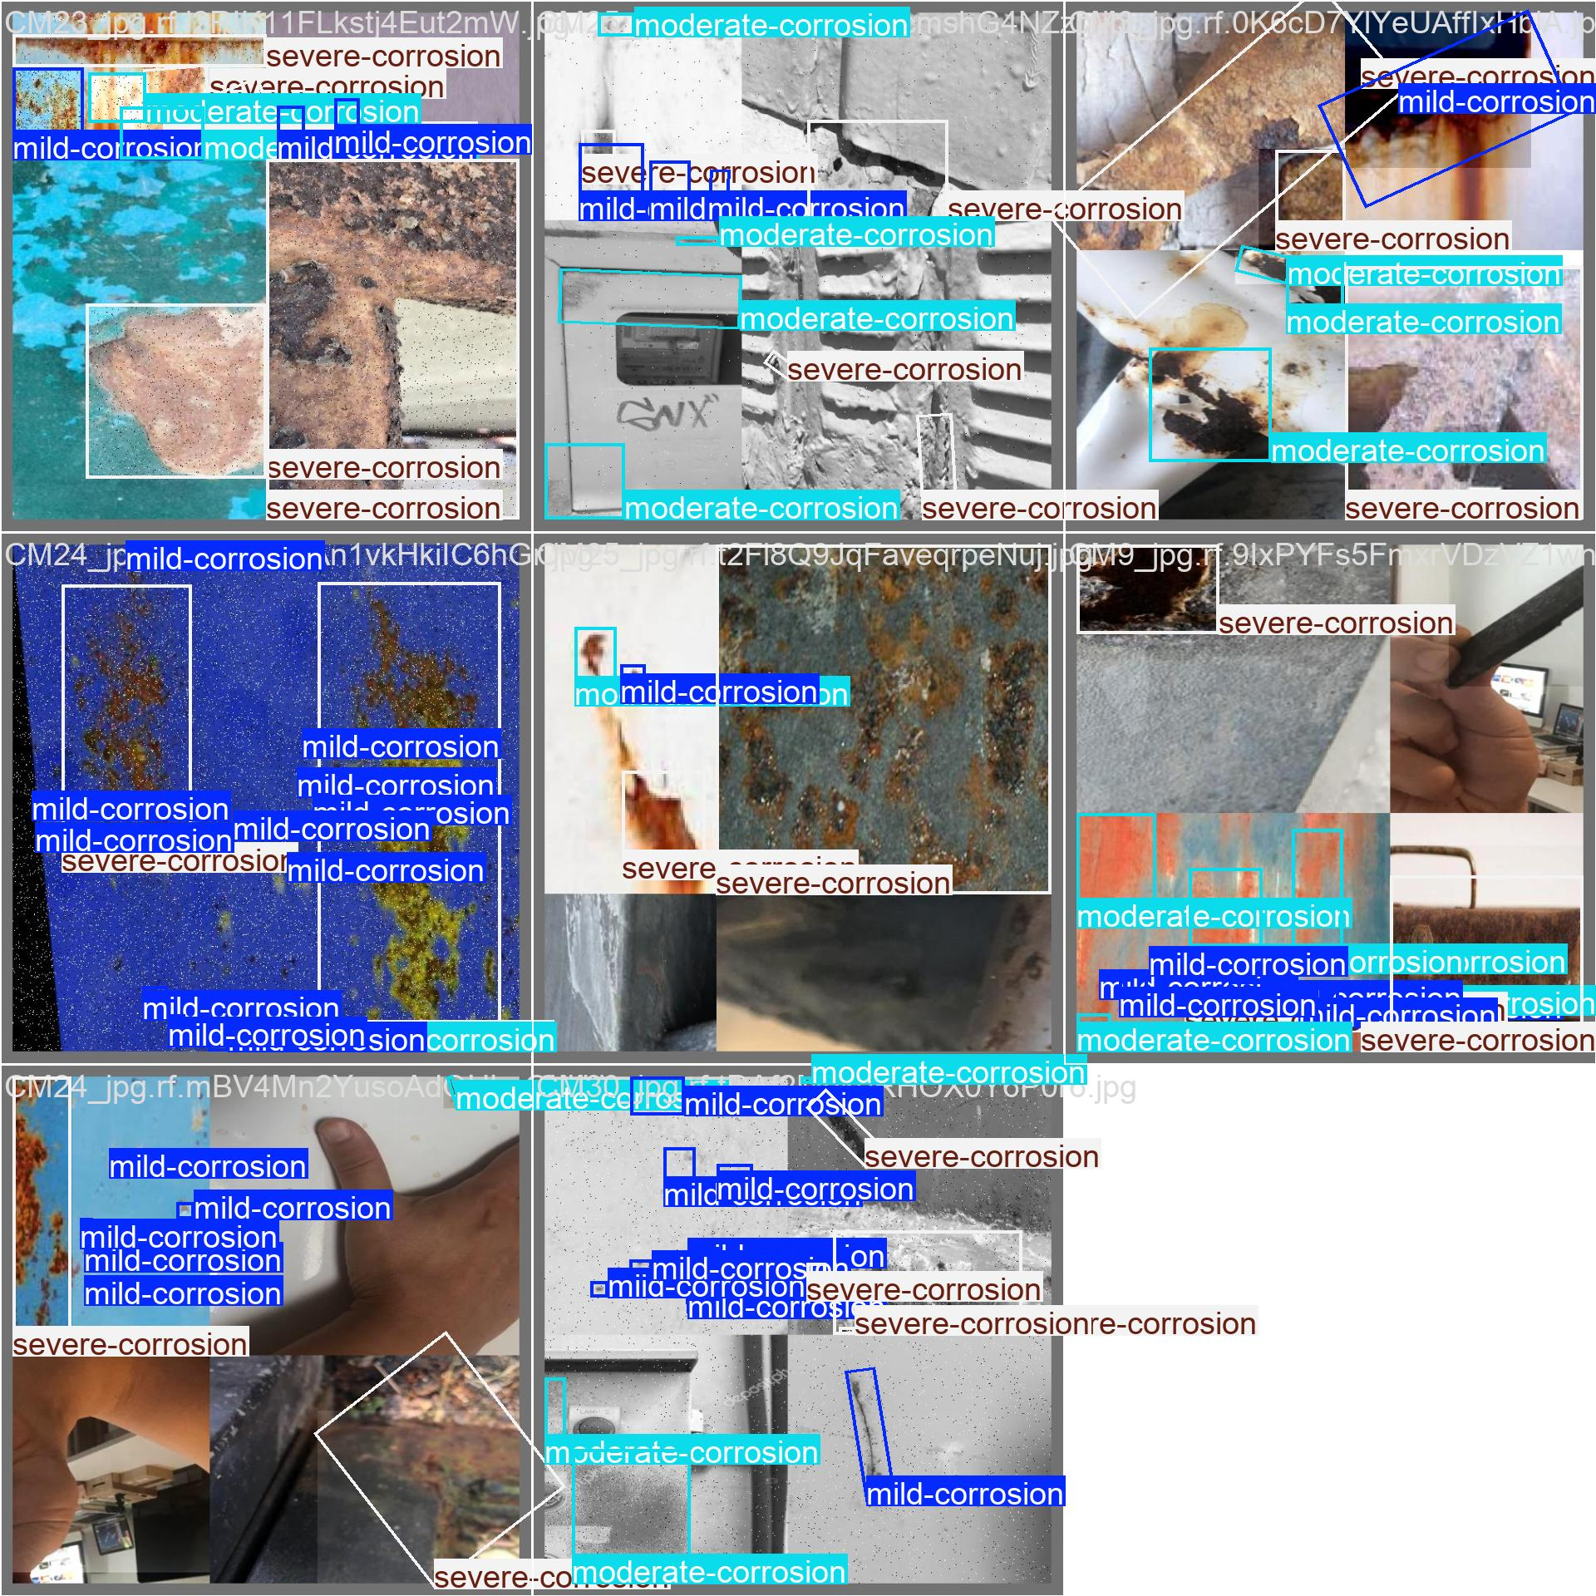
val_batch1_labels.jpg: For YOLOv8n OBB, this image shows validation images with ground-truth oriented rust labels. These annotations are the reference used to evaluate predictions.
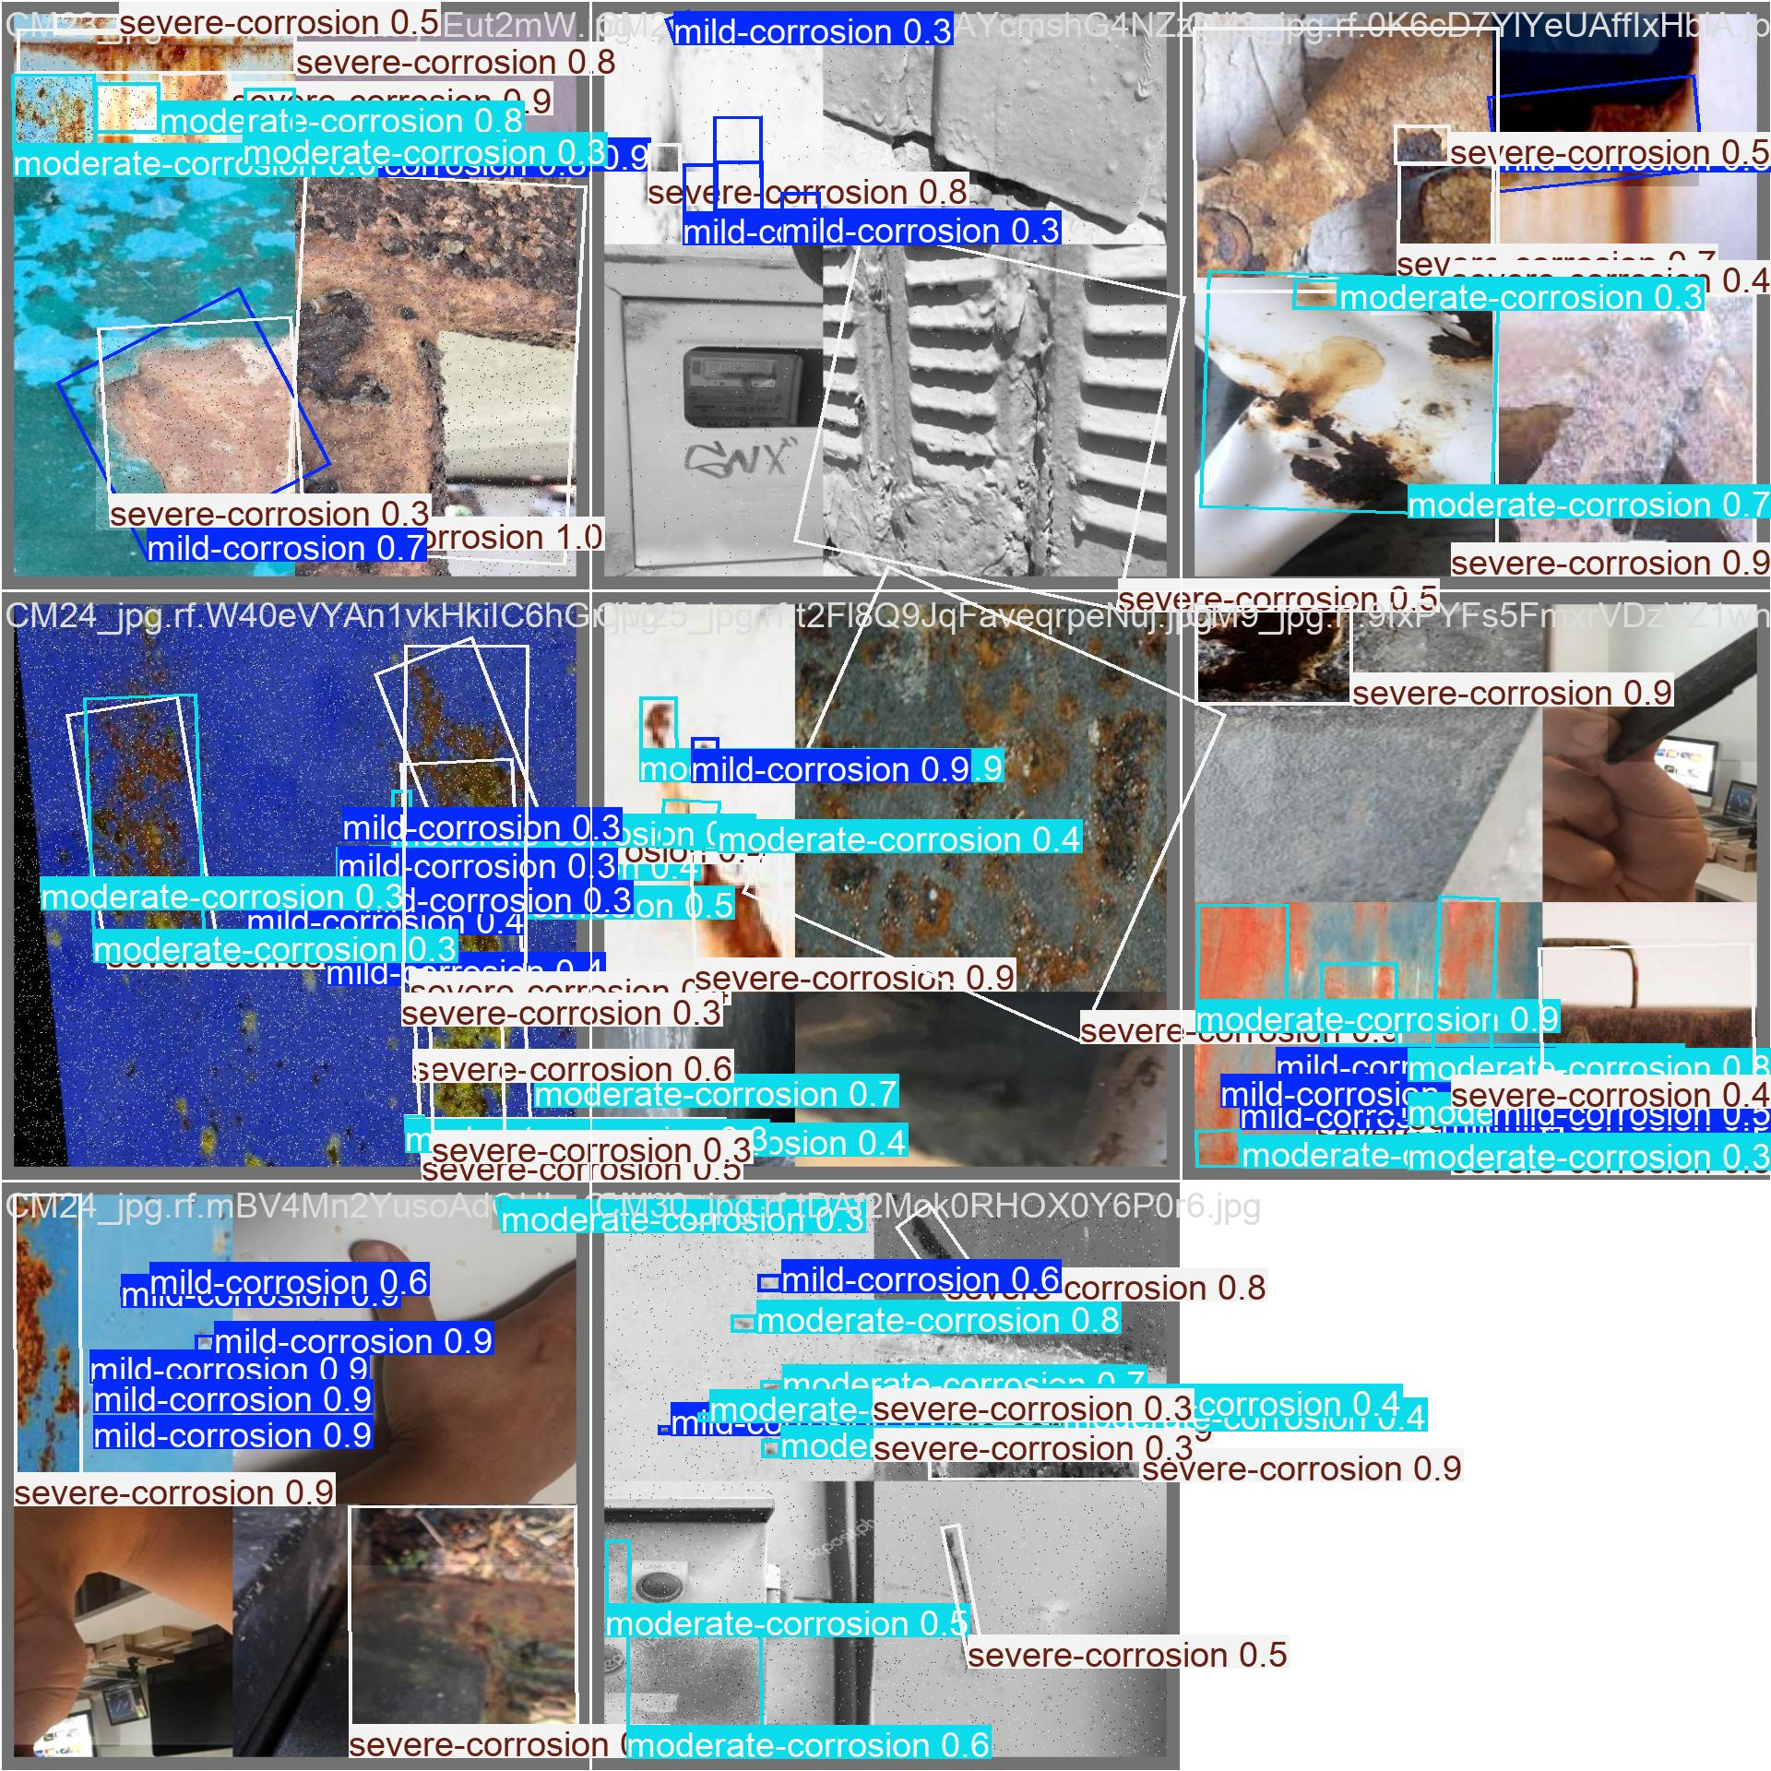
val_batch1_pred.jpg: For YOLOv8n OBB, this image shows validation predictions generated by the trained model, including oriented boxes and predicted corrosion categories.
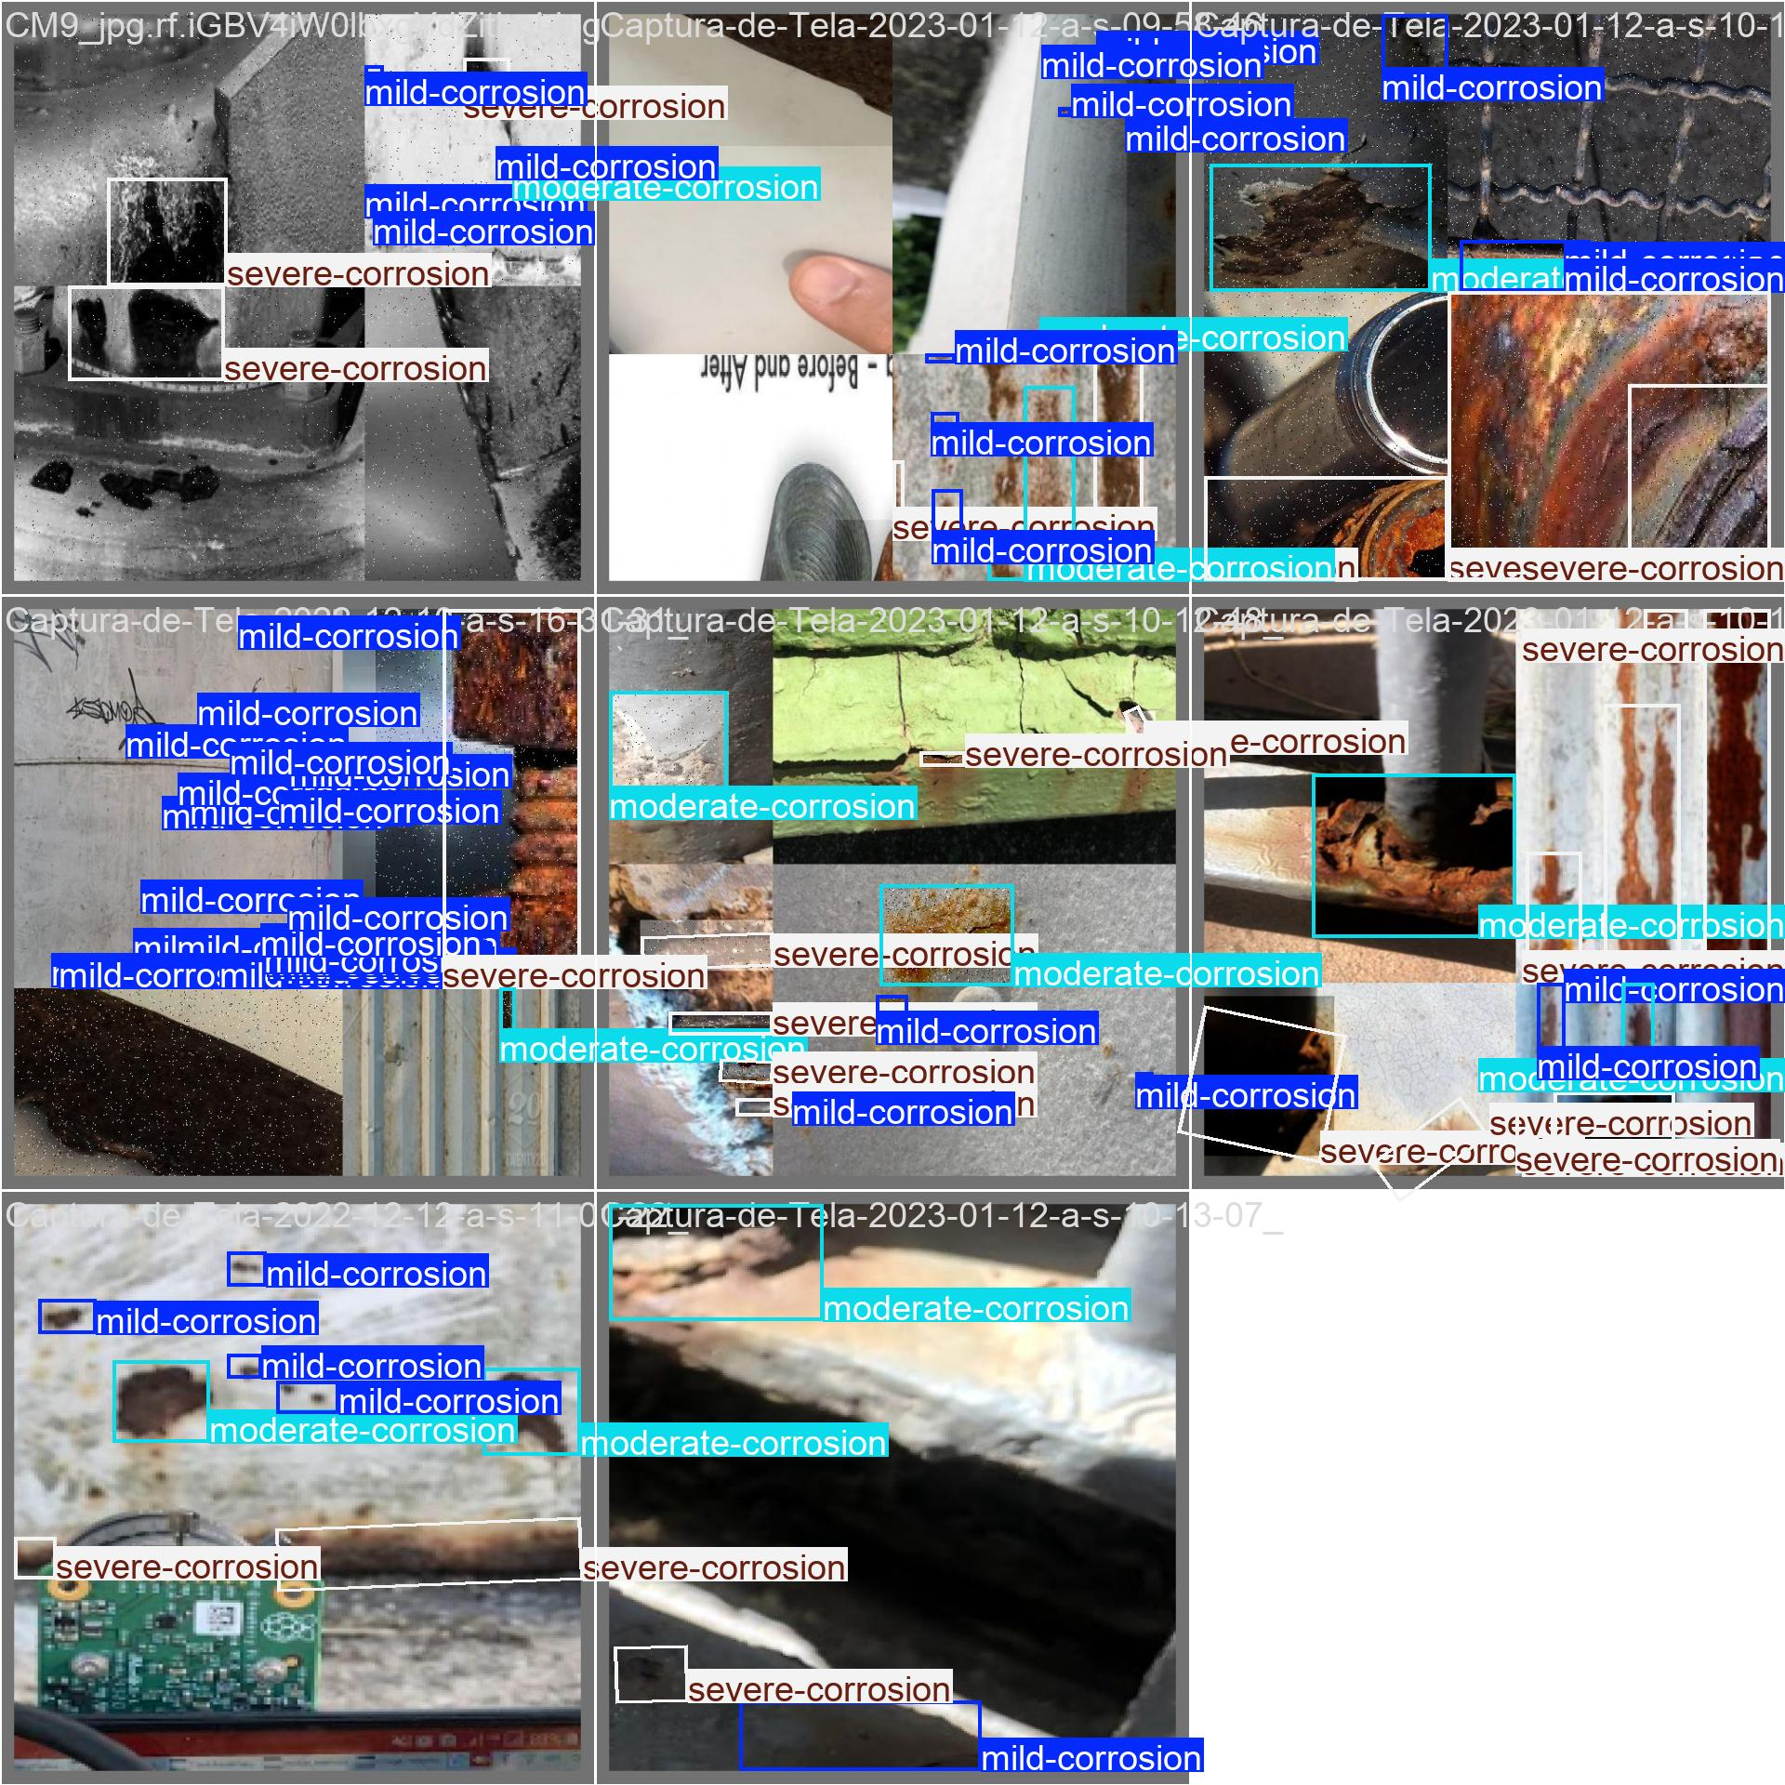
val_batch2_labels.jpg: For YOLOv8n OBB, this image shows validation images with ground-truth oriented rust labels. These annotations are the reference used to evaluate predictions.
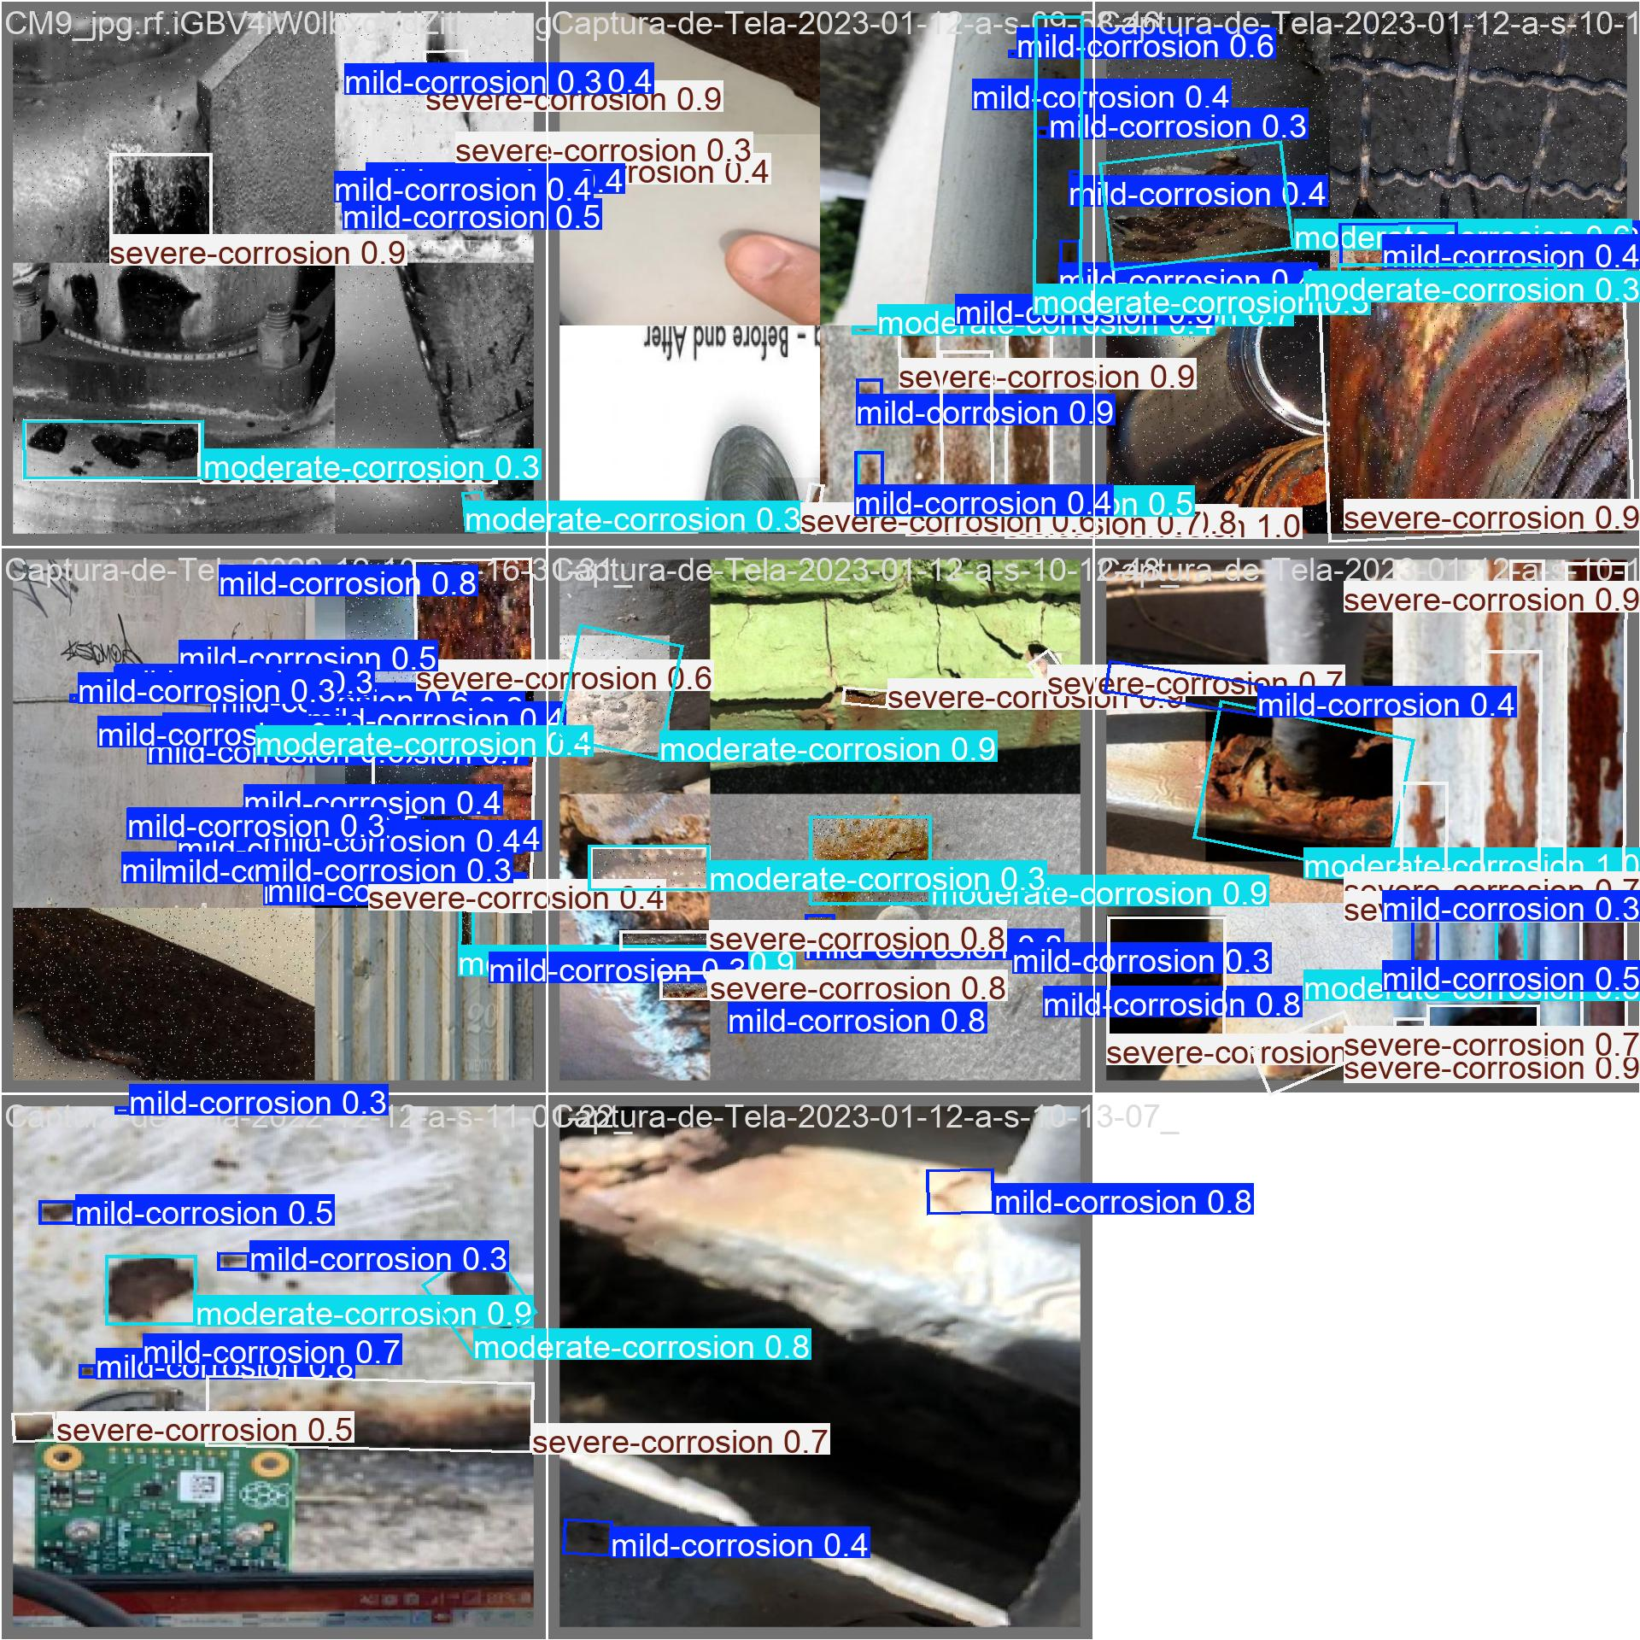
val_batch2_pred.jpg: For YOLOv8n OBB, this image shows validation predictions generated by the trained model, including oriented boxes and predicted corrosion categories.

YOLO11s OBB
Item | Value
Base model | yolo11s-obb.pt
Run folder | runs\obb_yolo11\rust_corrosion_yolo11s_obb
Best weights | runs\obb_yolo11\rust_corrosion_yolo11s_obb\weights\best.pt
Epochs completed | 100
Image size | 768
Batch size | 8
Device | cpu
Optimizer | auto
Learning-rate schedule | Cosine LR
Patience | 35
The table below reports the strongest achieved validation points from the training CSV, plus the final epoch. mAP50-95 is the strictest summary metric because it averages performance across multiple IoU thresholds.
Metric point | Epoch | Precision | Recall | mAP50 | mAP50-95 | Box loss | Class loss | DFL loss | Angle loss
Best mAP50-95 | 90 | 0.7955 | 0.6949 | 0.7706 | 0.5787 | 0.9057 | 0.8908 | 1.3604 | 0.0307
Best mAP50 | 84 | 0.8182 | 0.6796 | 0.7714 | 0.5778 | 0.9062 | 0.8846 | 1.3636 | 0.0305
Best precision | 85 | 0.8252 | 0.6827 | 0.7706 | 0.5774 | 0.9036 | 0.8896 | 1.3602 | 0.0307
Best recall | 86 | 0.7833 | 0.7064 | 0.7677 | 0.5749 | 0.9067 | 0.8977 | 1.3606 | 0.0307
Final epoch | 100 | 0.7988 | 0.6936 | 0.7665 | 0.5745 | 0.9044 | 0.8963 | 1.3591 | 0.0308

Training and Validation Images
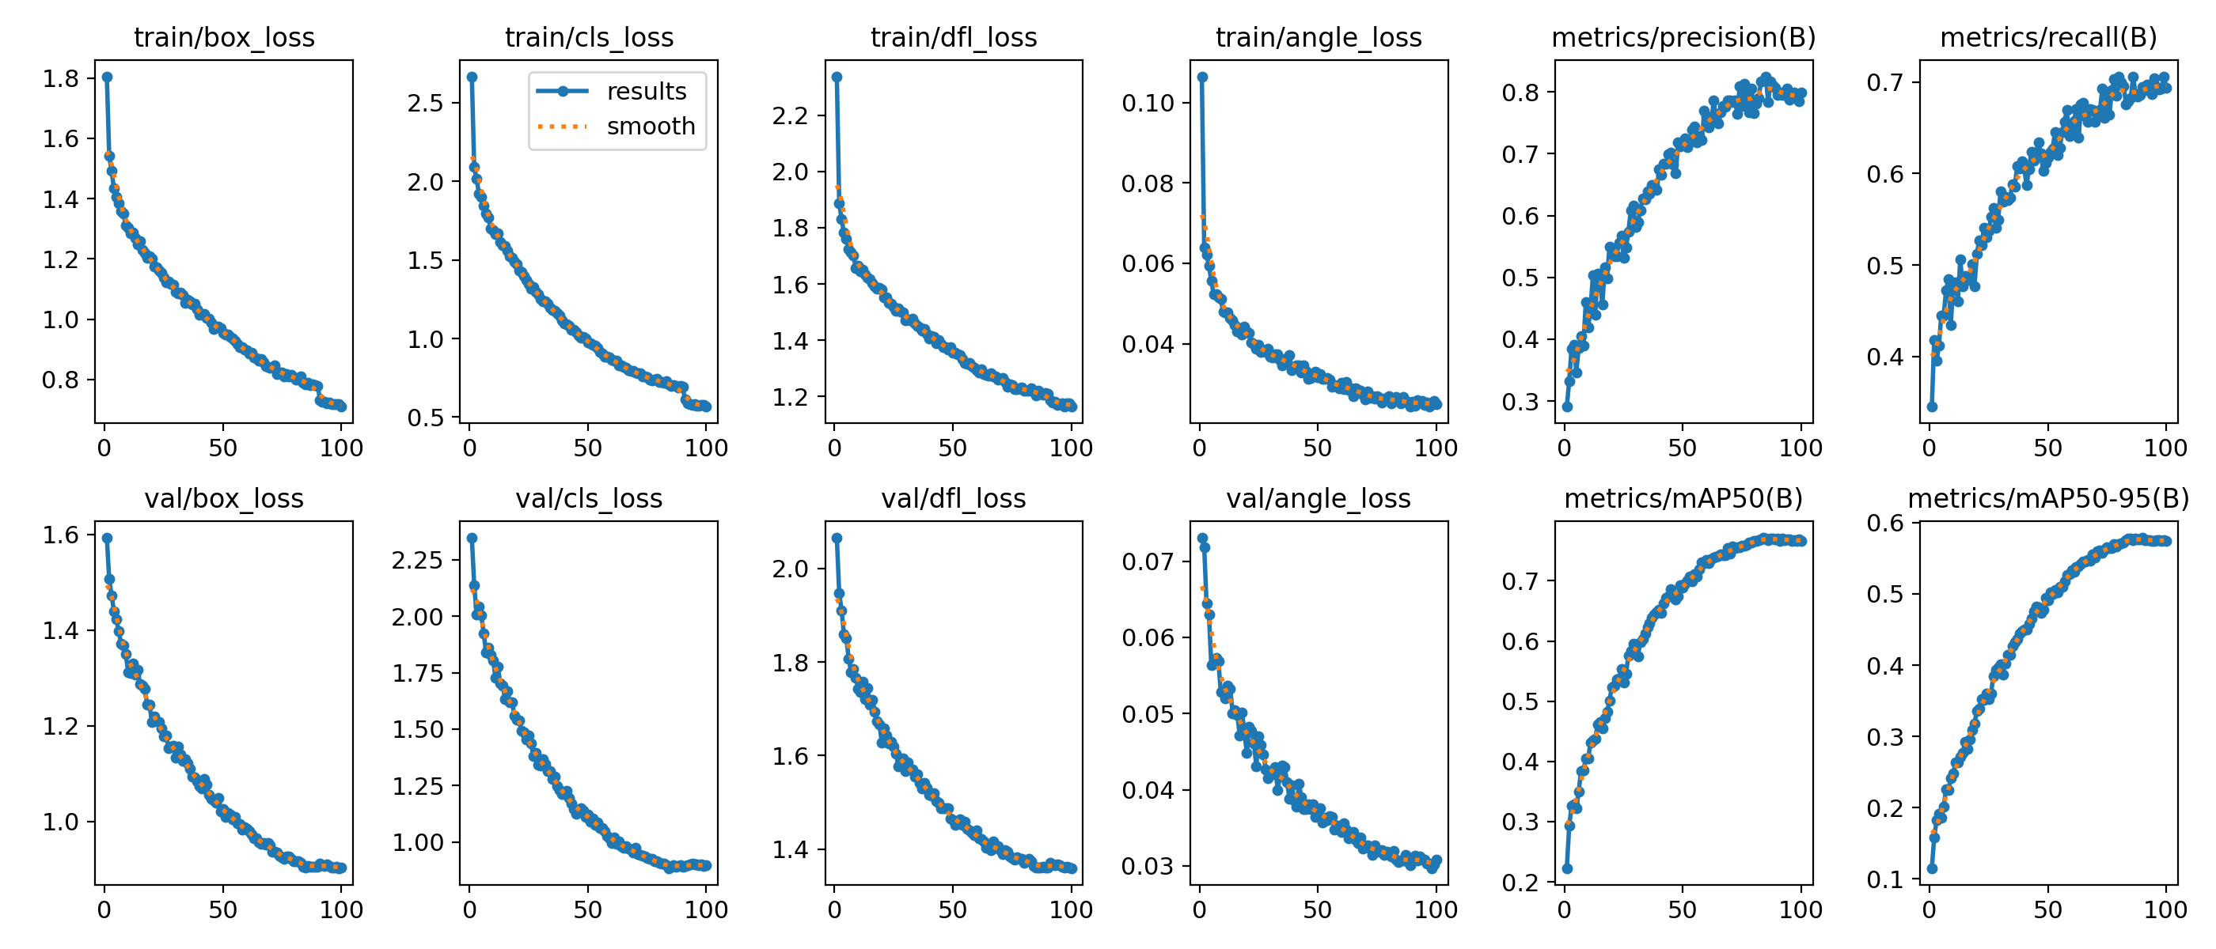
results.png: For YOLO11s OBB, this image summarizes the training history across epochs, including box, classification, DFL, and angle losses together with precision, recall, mAP50, and mAP50-95 validation metrics.
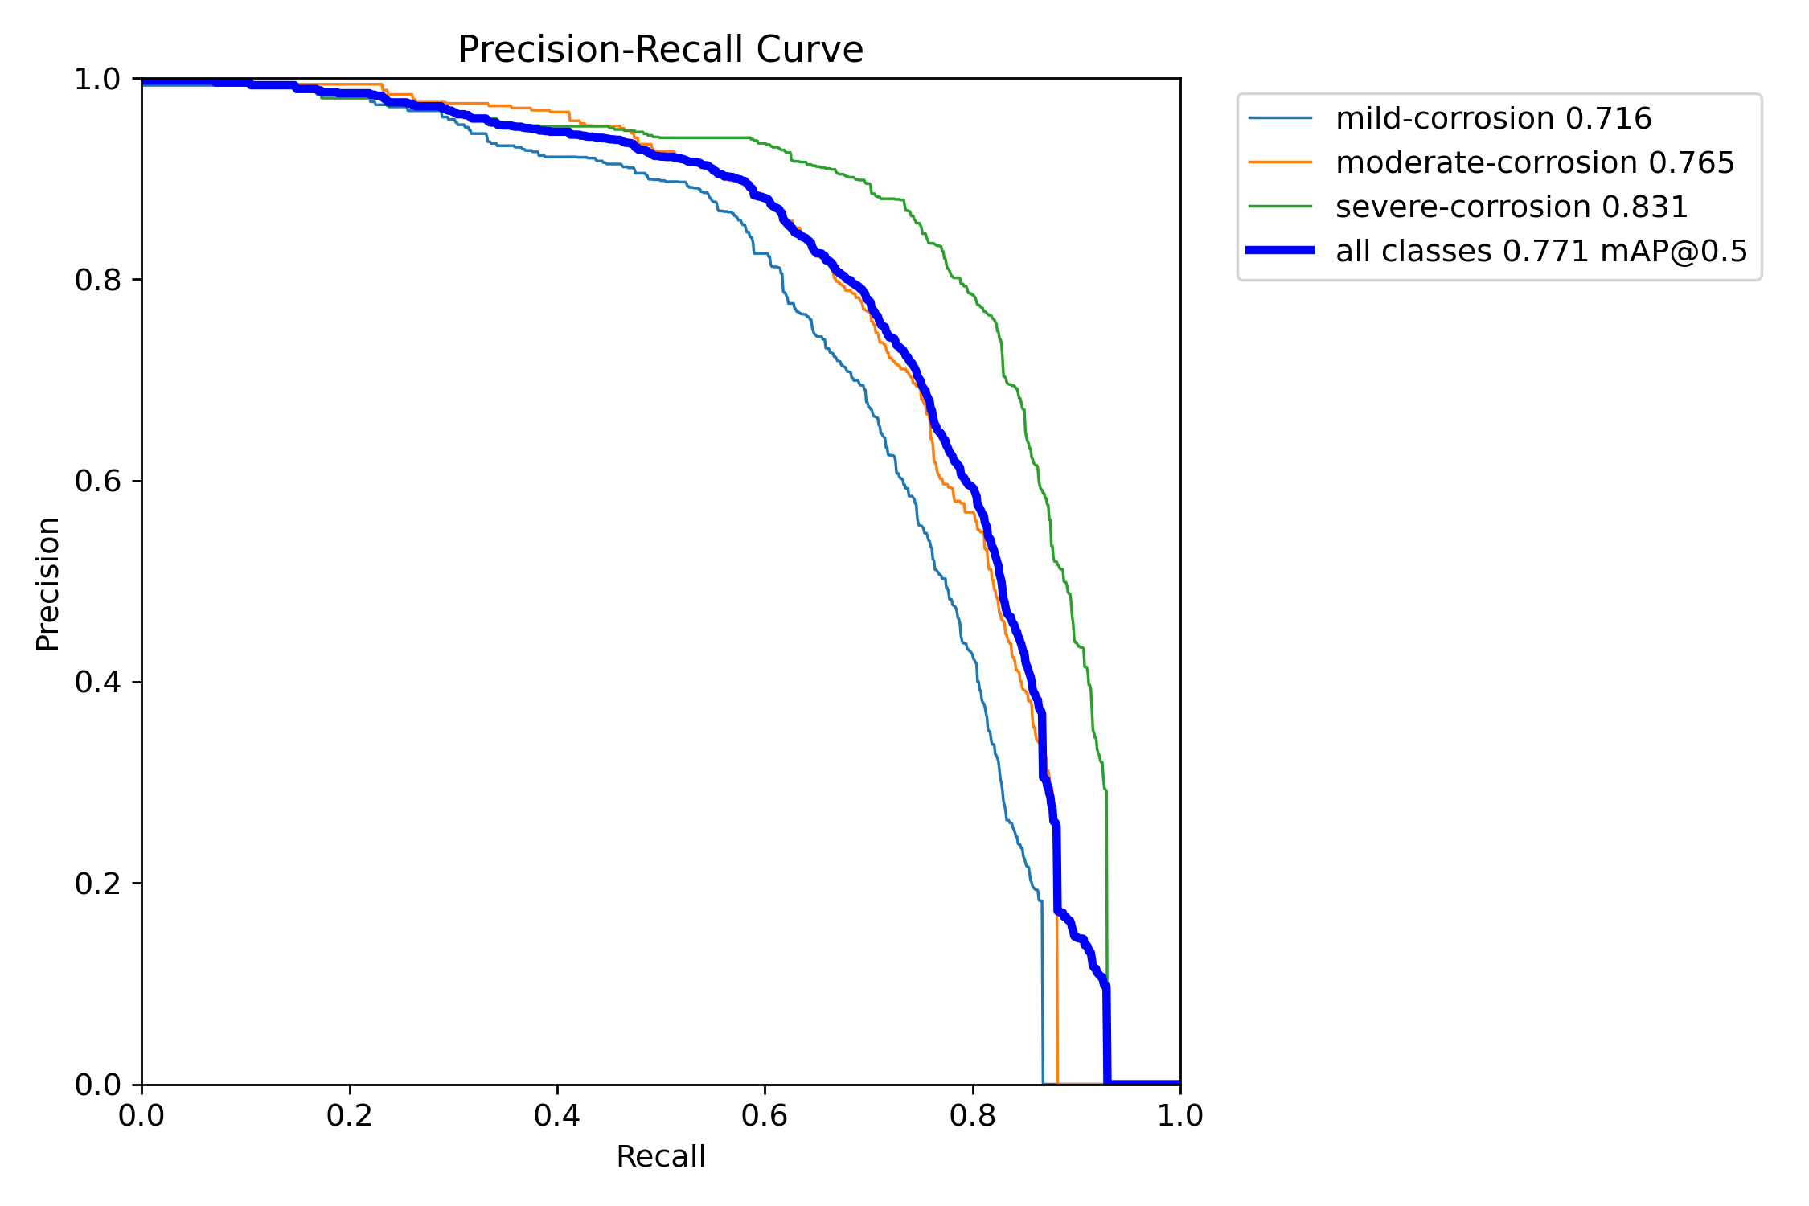
BoxPR_curve.png: For YOLO11s OBB, this image shows the precision-recall curve for oriented rust detections. The area and curve shape indicate how well the model balances correct detections against missed detections across confidence thresholds.
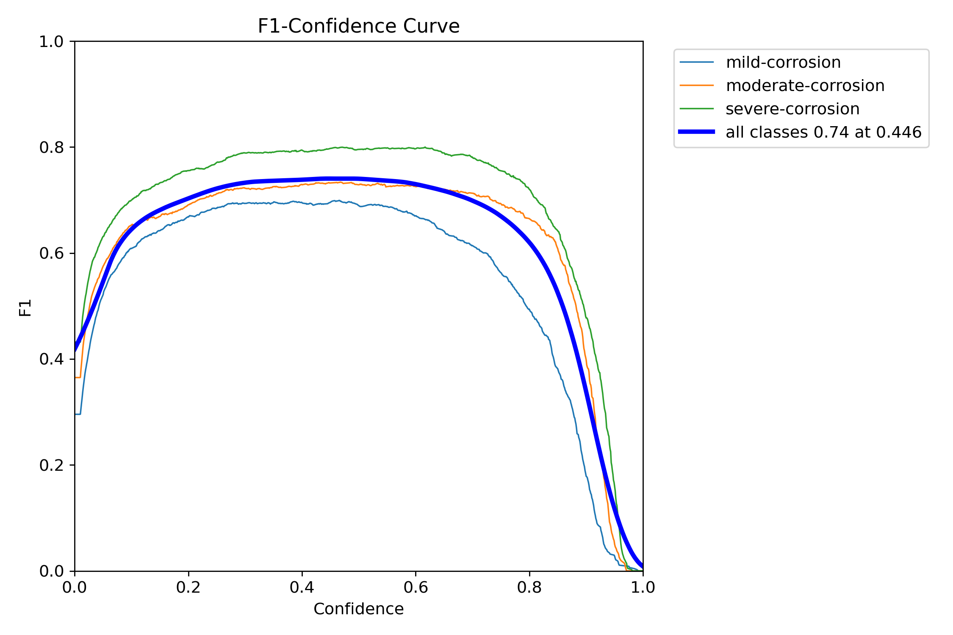
BoxF1_curve.png: For YOLO11s OBB, this image shows F1 score across confidence thresholds. It highlights the threshold region where precision and recall are best balanced.
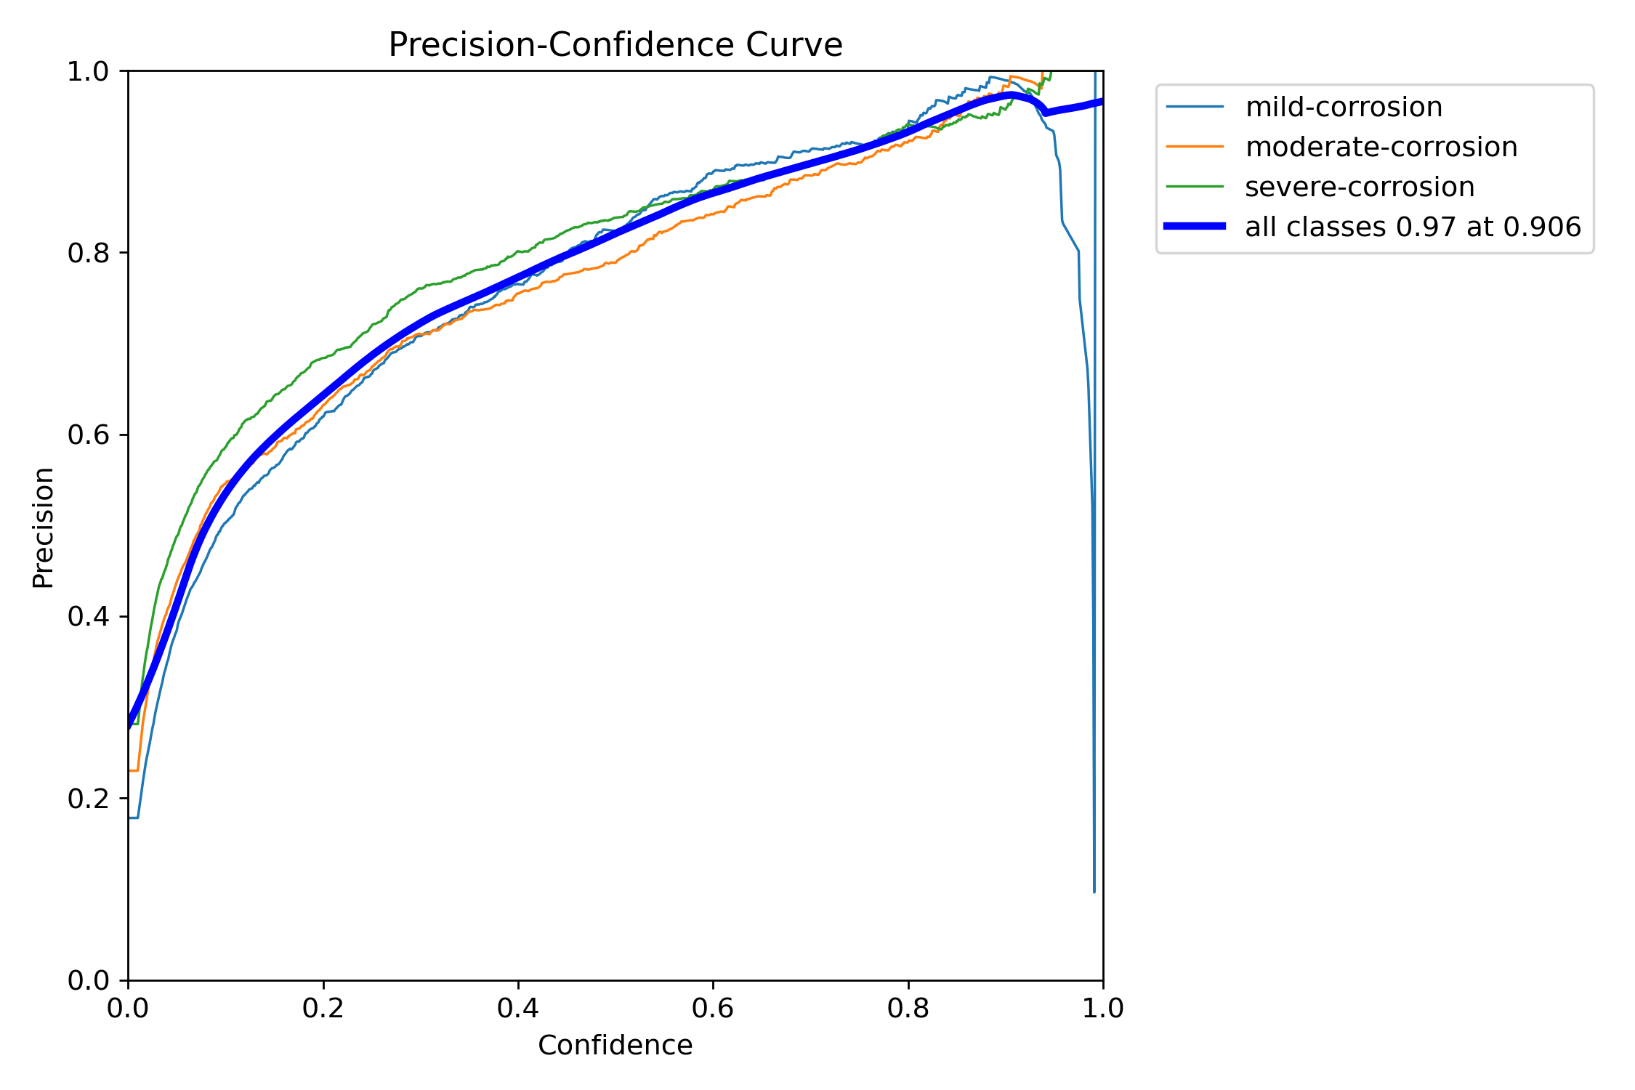
BoxP_curve.png: For YOLO11s OBB, this image shows precision across confidence thresholds. Higher precision means fewer false rust detections are produced.
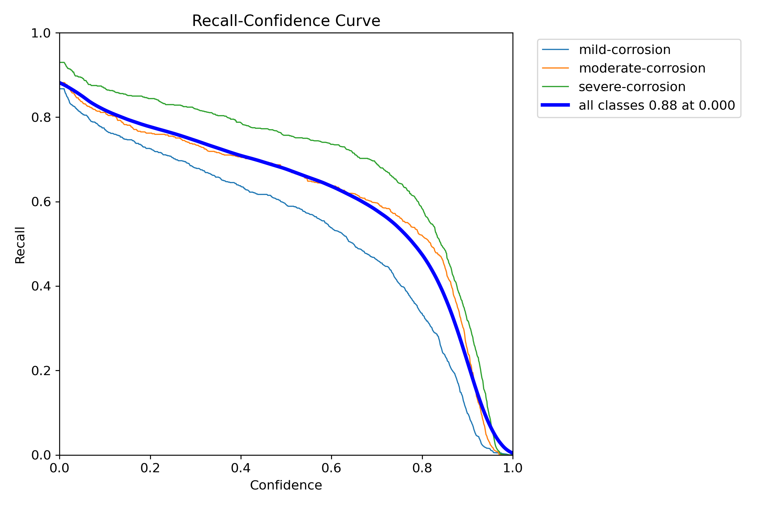
BoxR_curve.png: For YOLO11s OBB, this image shows recall across confidence thresholds. Higher recall means more annotated rust regions are found by the model.
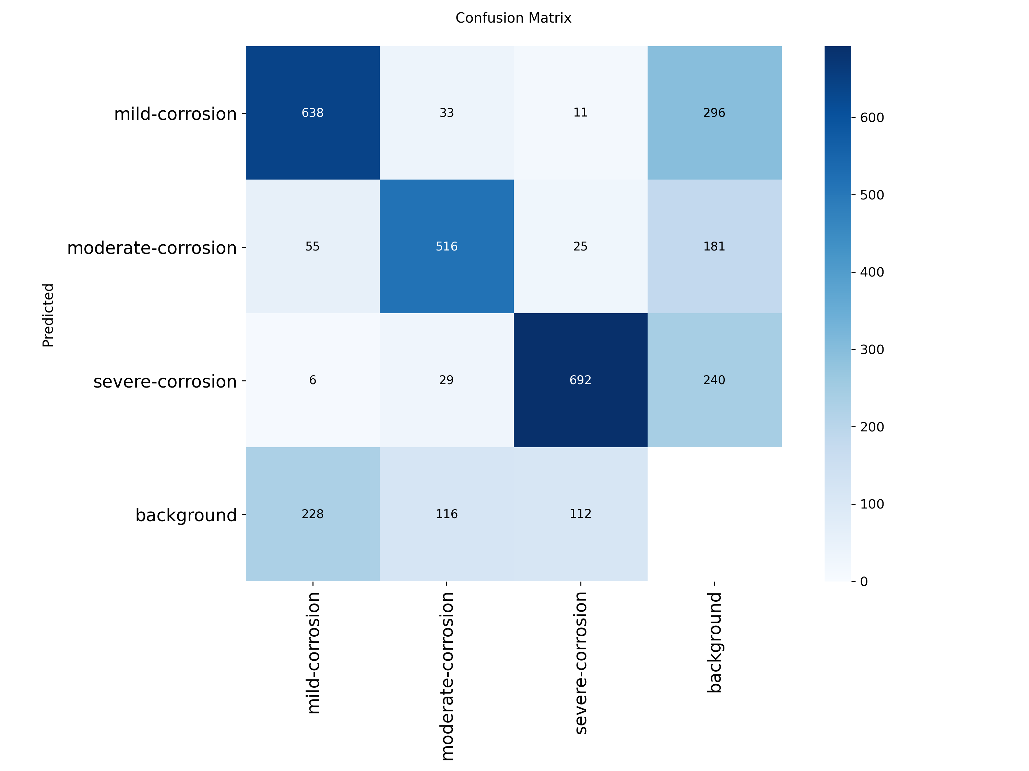
confusion_matrix.png: For YOLO11s OBB, this image is the raw confusion matrix, showing how detections are assigned to mild, moderate, and severe corrosion classes and where class confusion occurs.
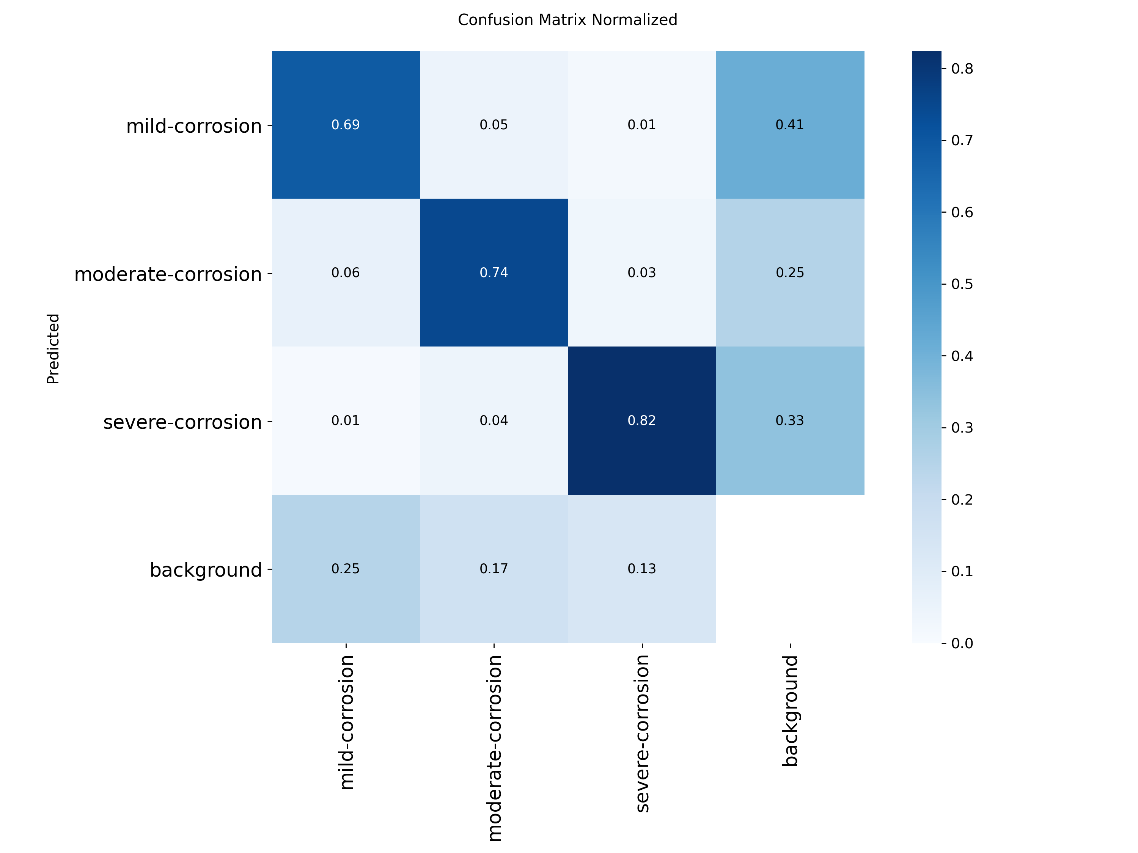
confusion_matrix_normalized.png: For YOLO11s OBB, this image is the normalized confusion matrix, making class-wise accuracy and misclassification patterns easier to compare.

labels.jpg: For YOLO11s OBB, this image visualizes the dataset label distribution and oriented box placement patterns used during training.
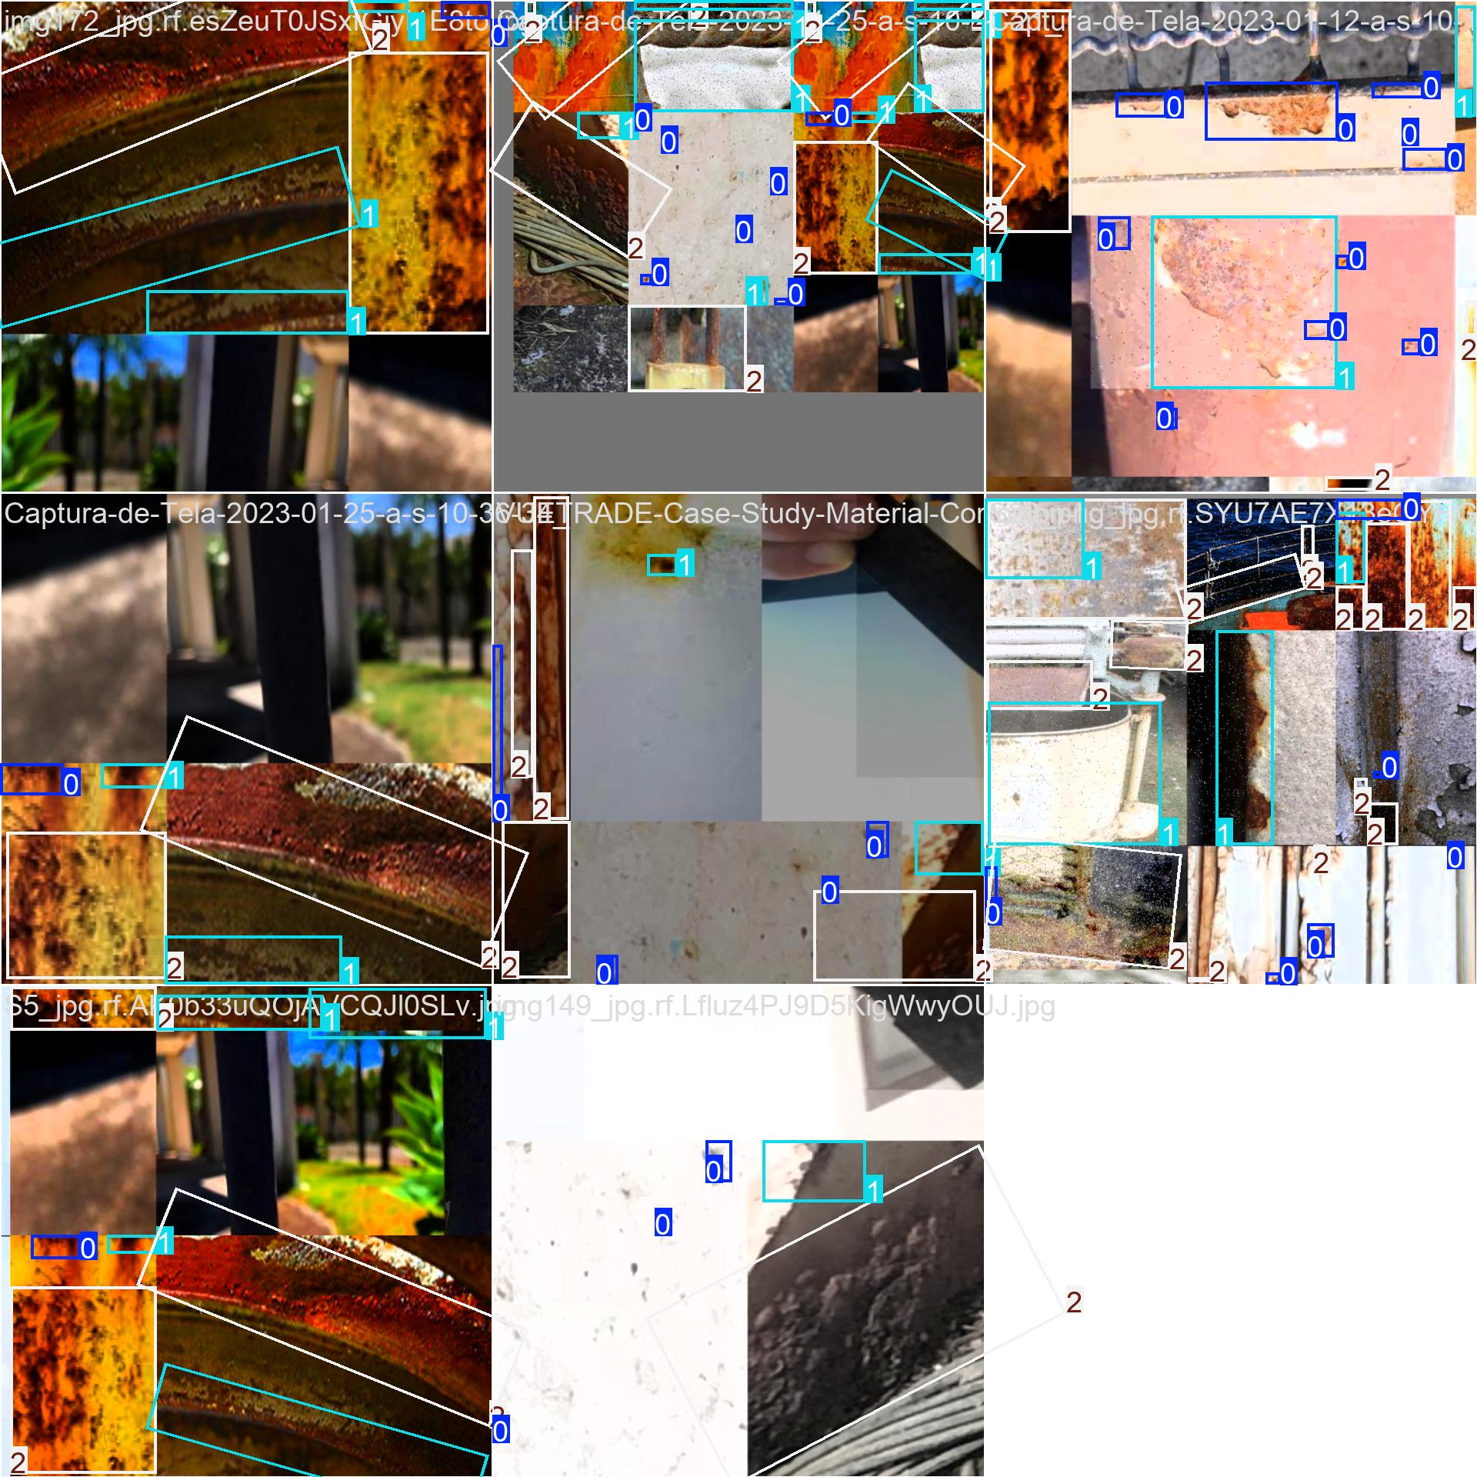
train_batch0.jpg: For YOLO11s OBB, this image shows a training batch with augmented input images and oriented ground-truth rust boxes used to teach the model.
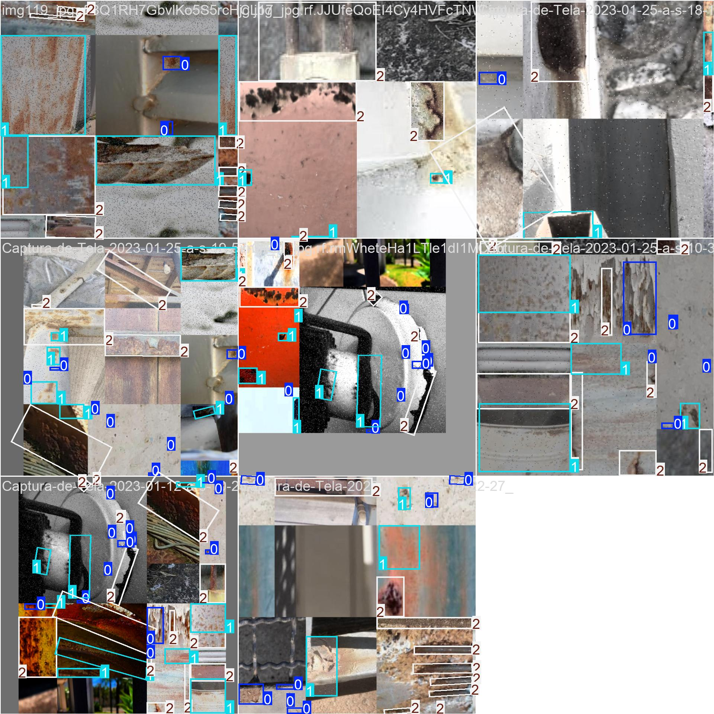
train_batch1.jpg: For YOLO11s OBB, this image shows a training batch with augmented input images and oriented ground-truth rust boxes used to teach the model.
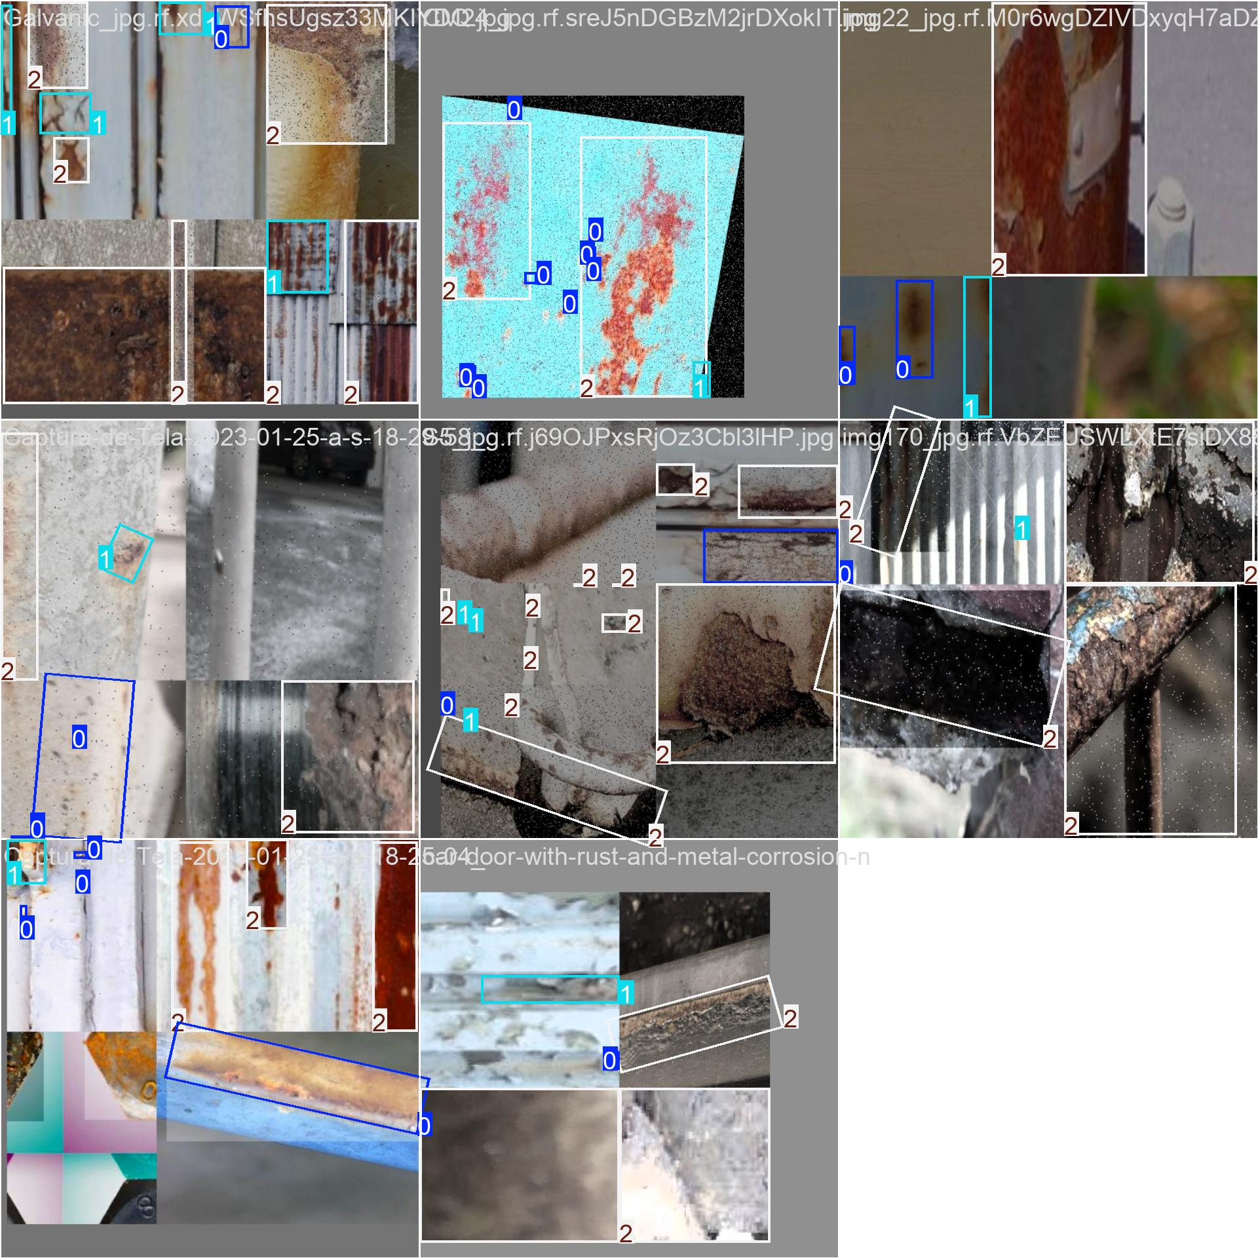
train_batch18720.jpg: For YOLO11s OBB, this image shows a training batch with augmented input images and oriented ground-truth rust boxes used to teach the model.
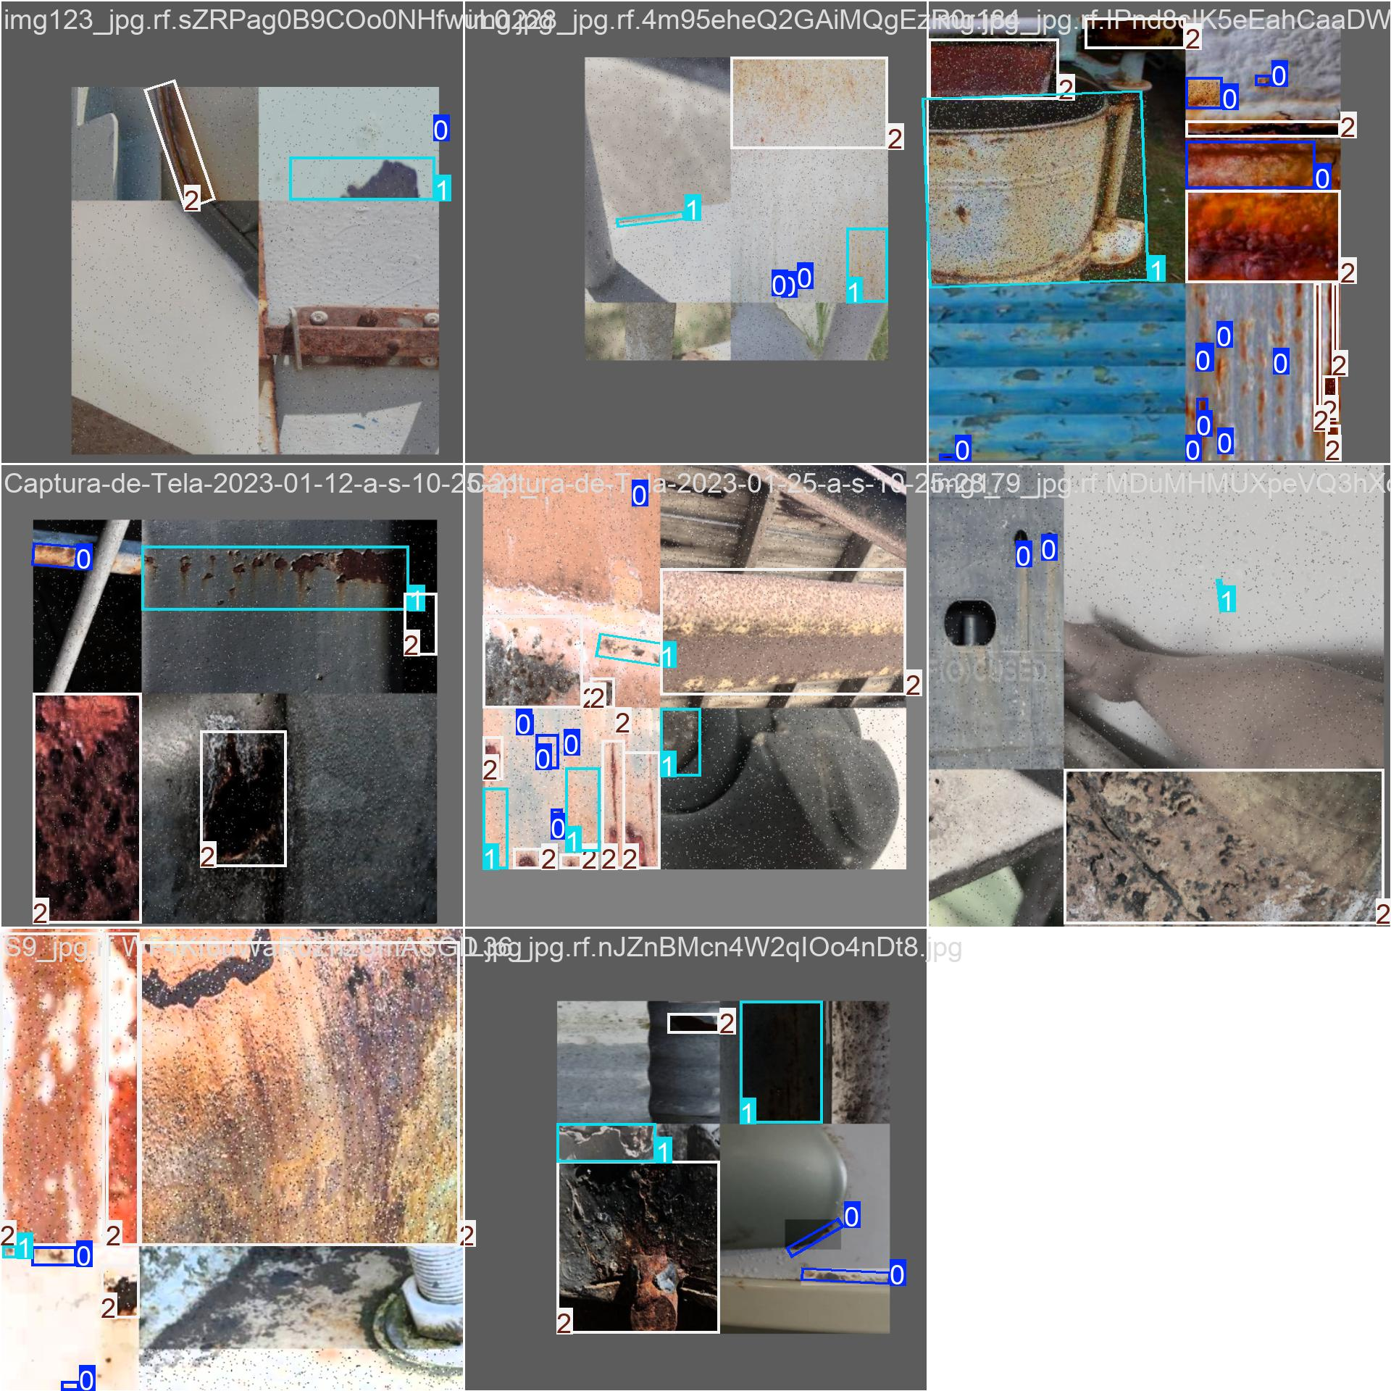
train_batch18721.jpg: For YOLO11s OBB, this image shows a training batch with augmented input images and oriented ground-truth rust boxes used to teach the model.
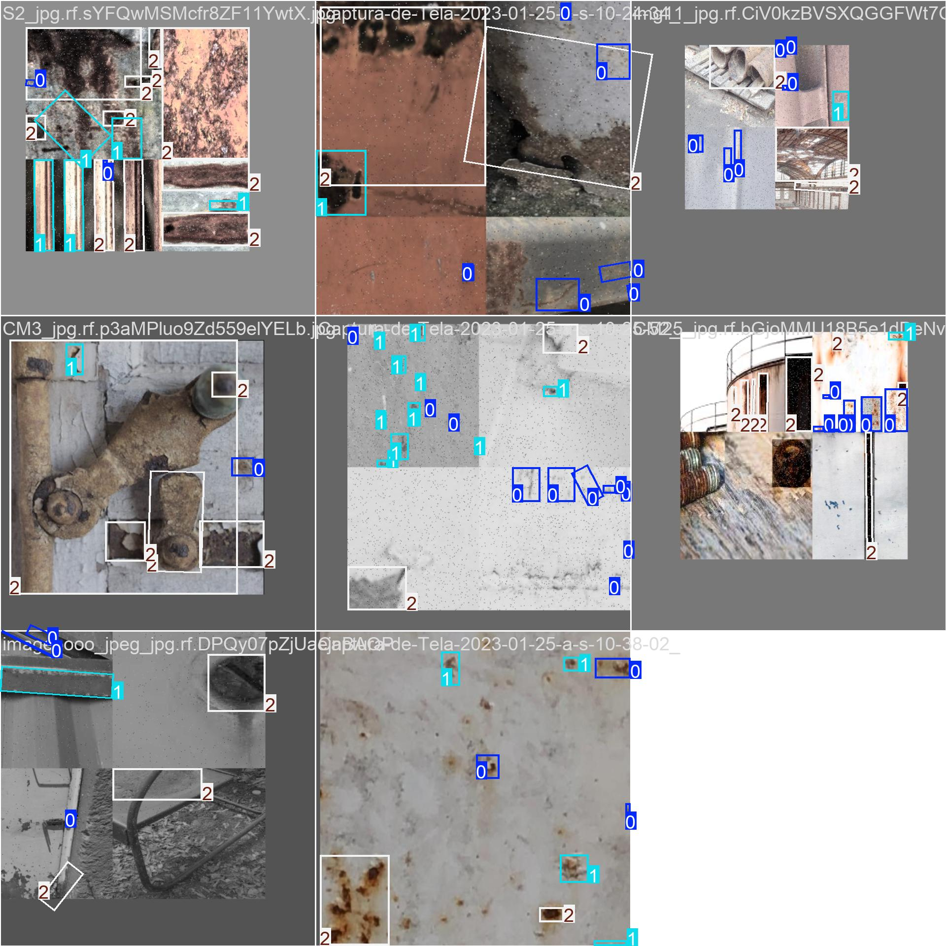
train_batch18722.jpg: For YOLO11s OBB, this image shows a training batch with augmented input images and oriented ground-truth rust boxes used to teach the model.
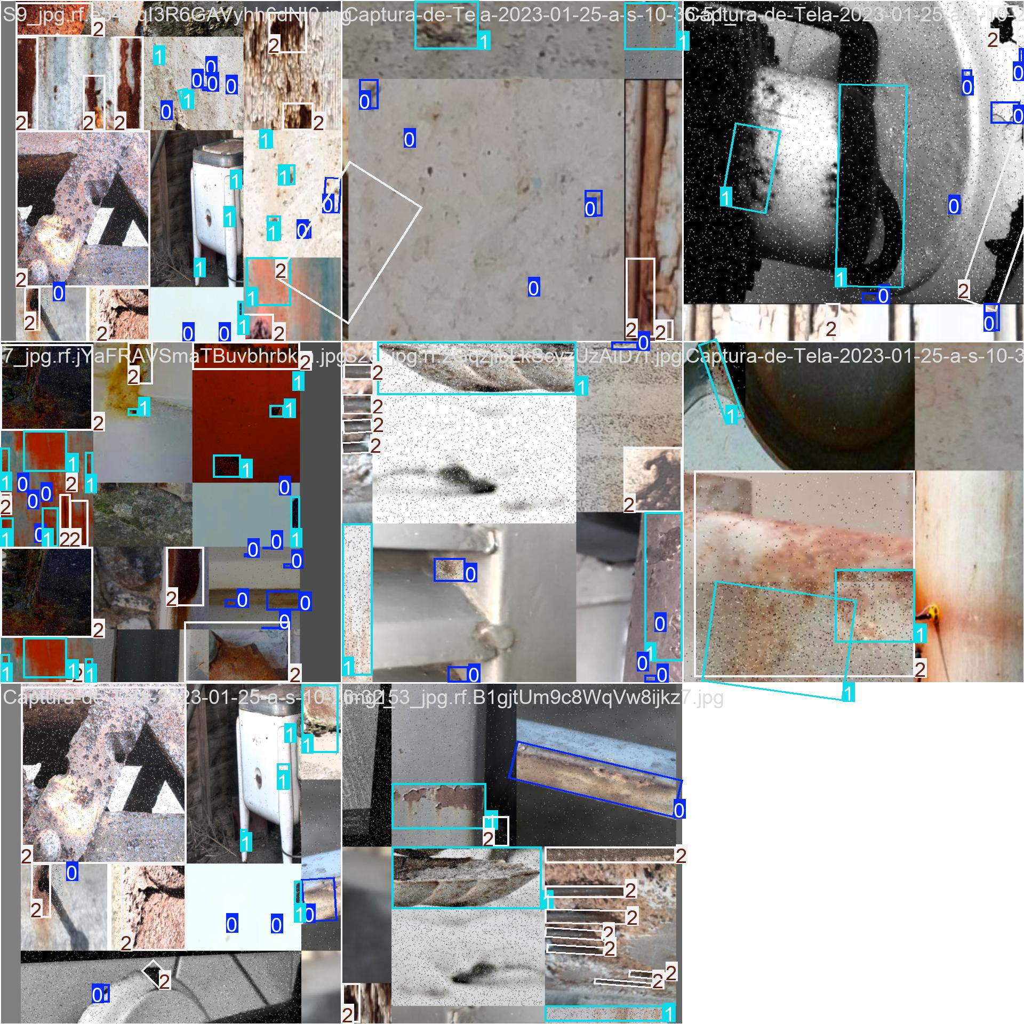
train_batch2.jpg: For YOLO11s OBB, this image shows a training batch with augmented input images and oriented ground-truth rust boxes used to teach the model.
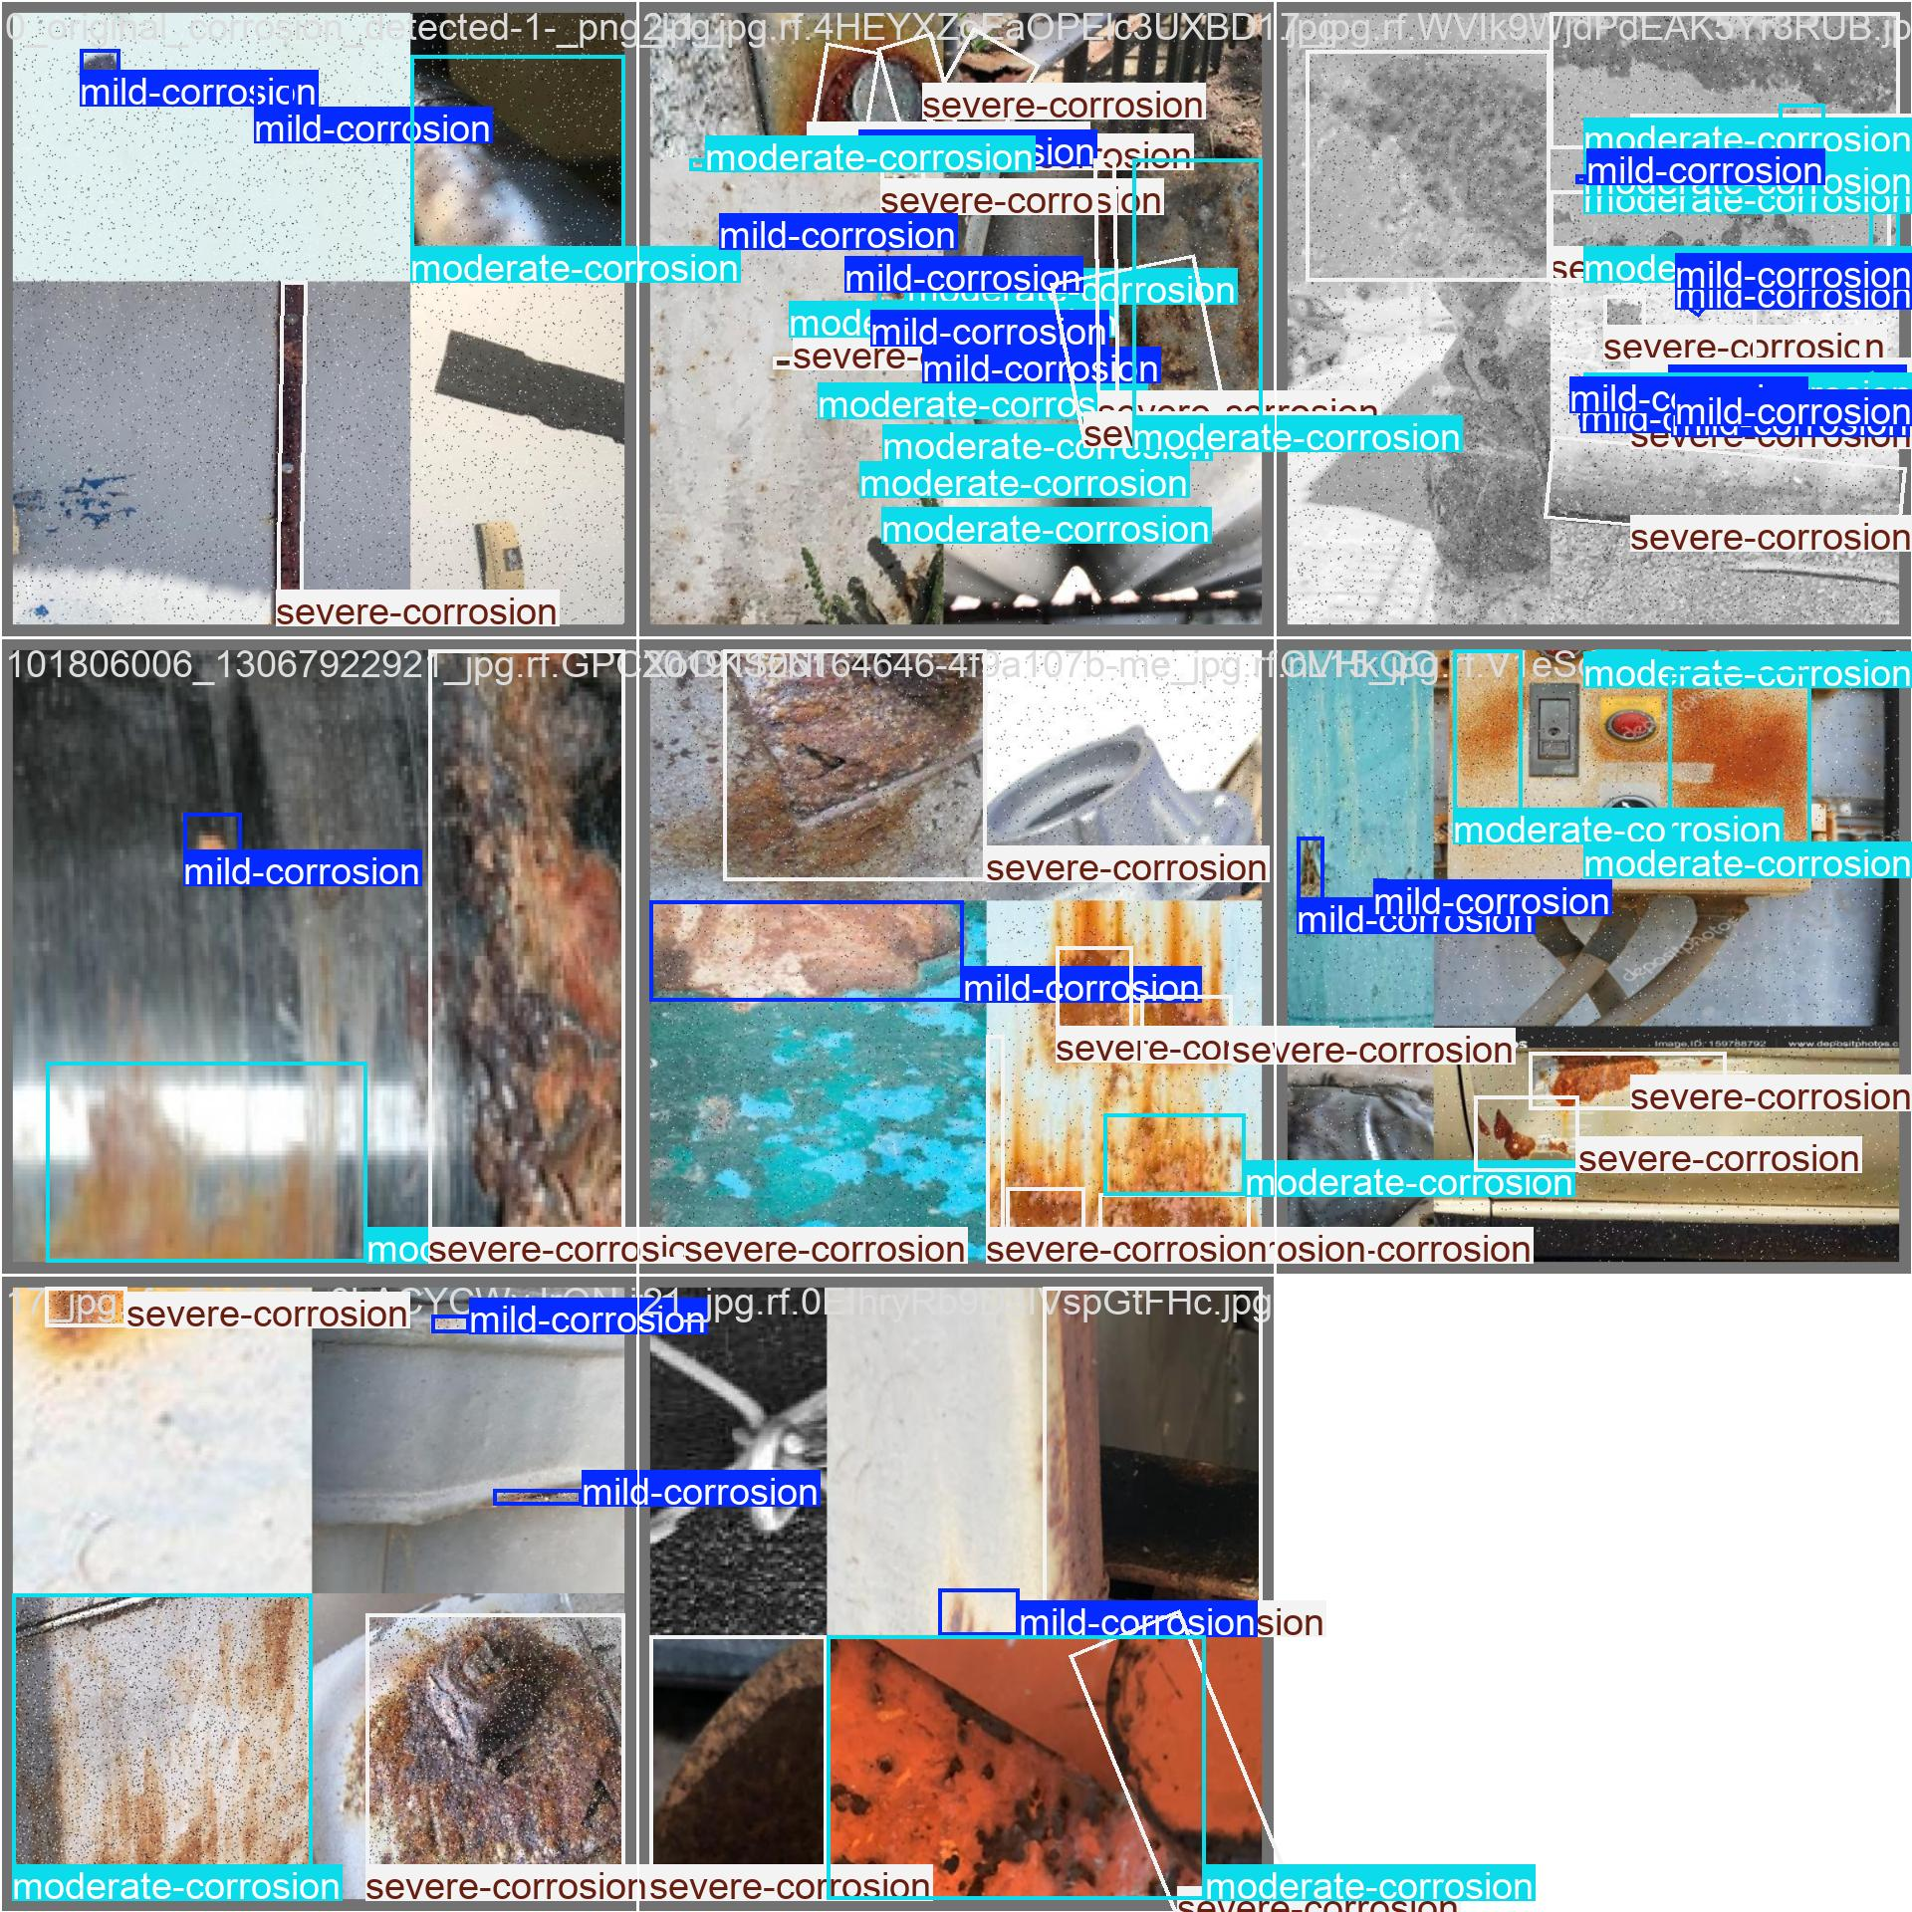
val_batch0_labels.jpg: For YOLO11s OBB, this image shows validation images with ground-truth oriented rust labels. These annotations are the reference used to evaluate predictions.
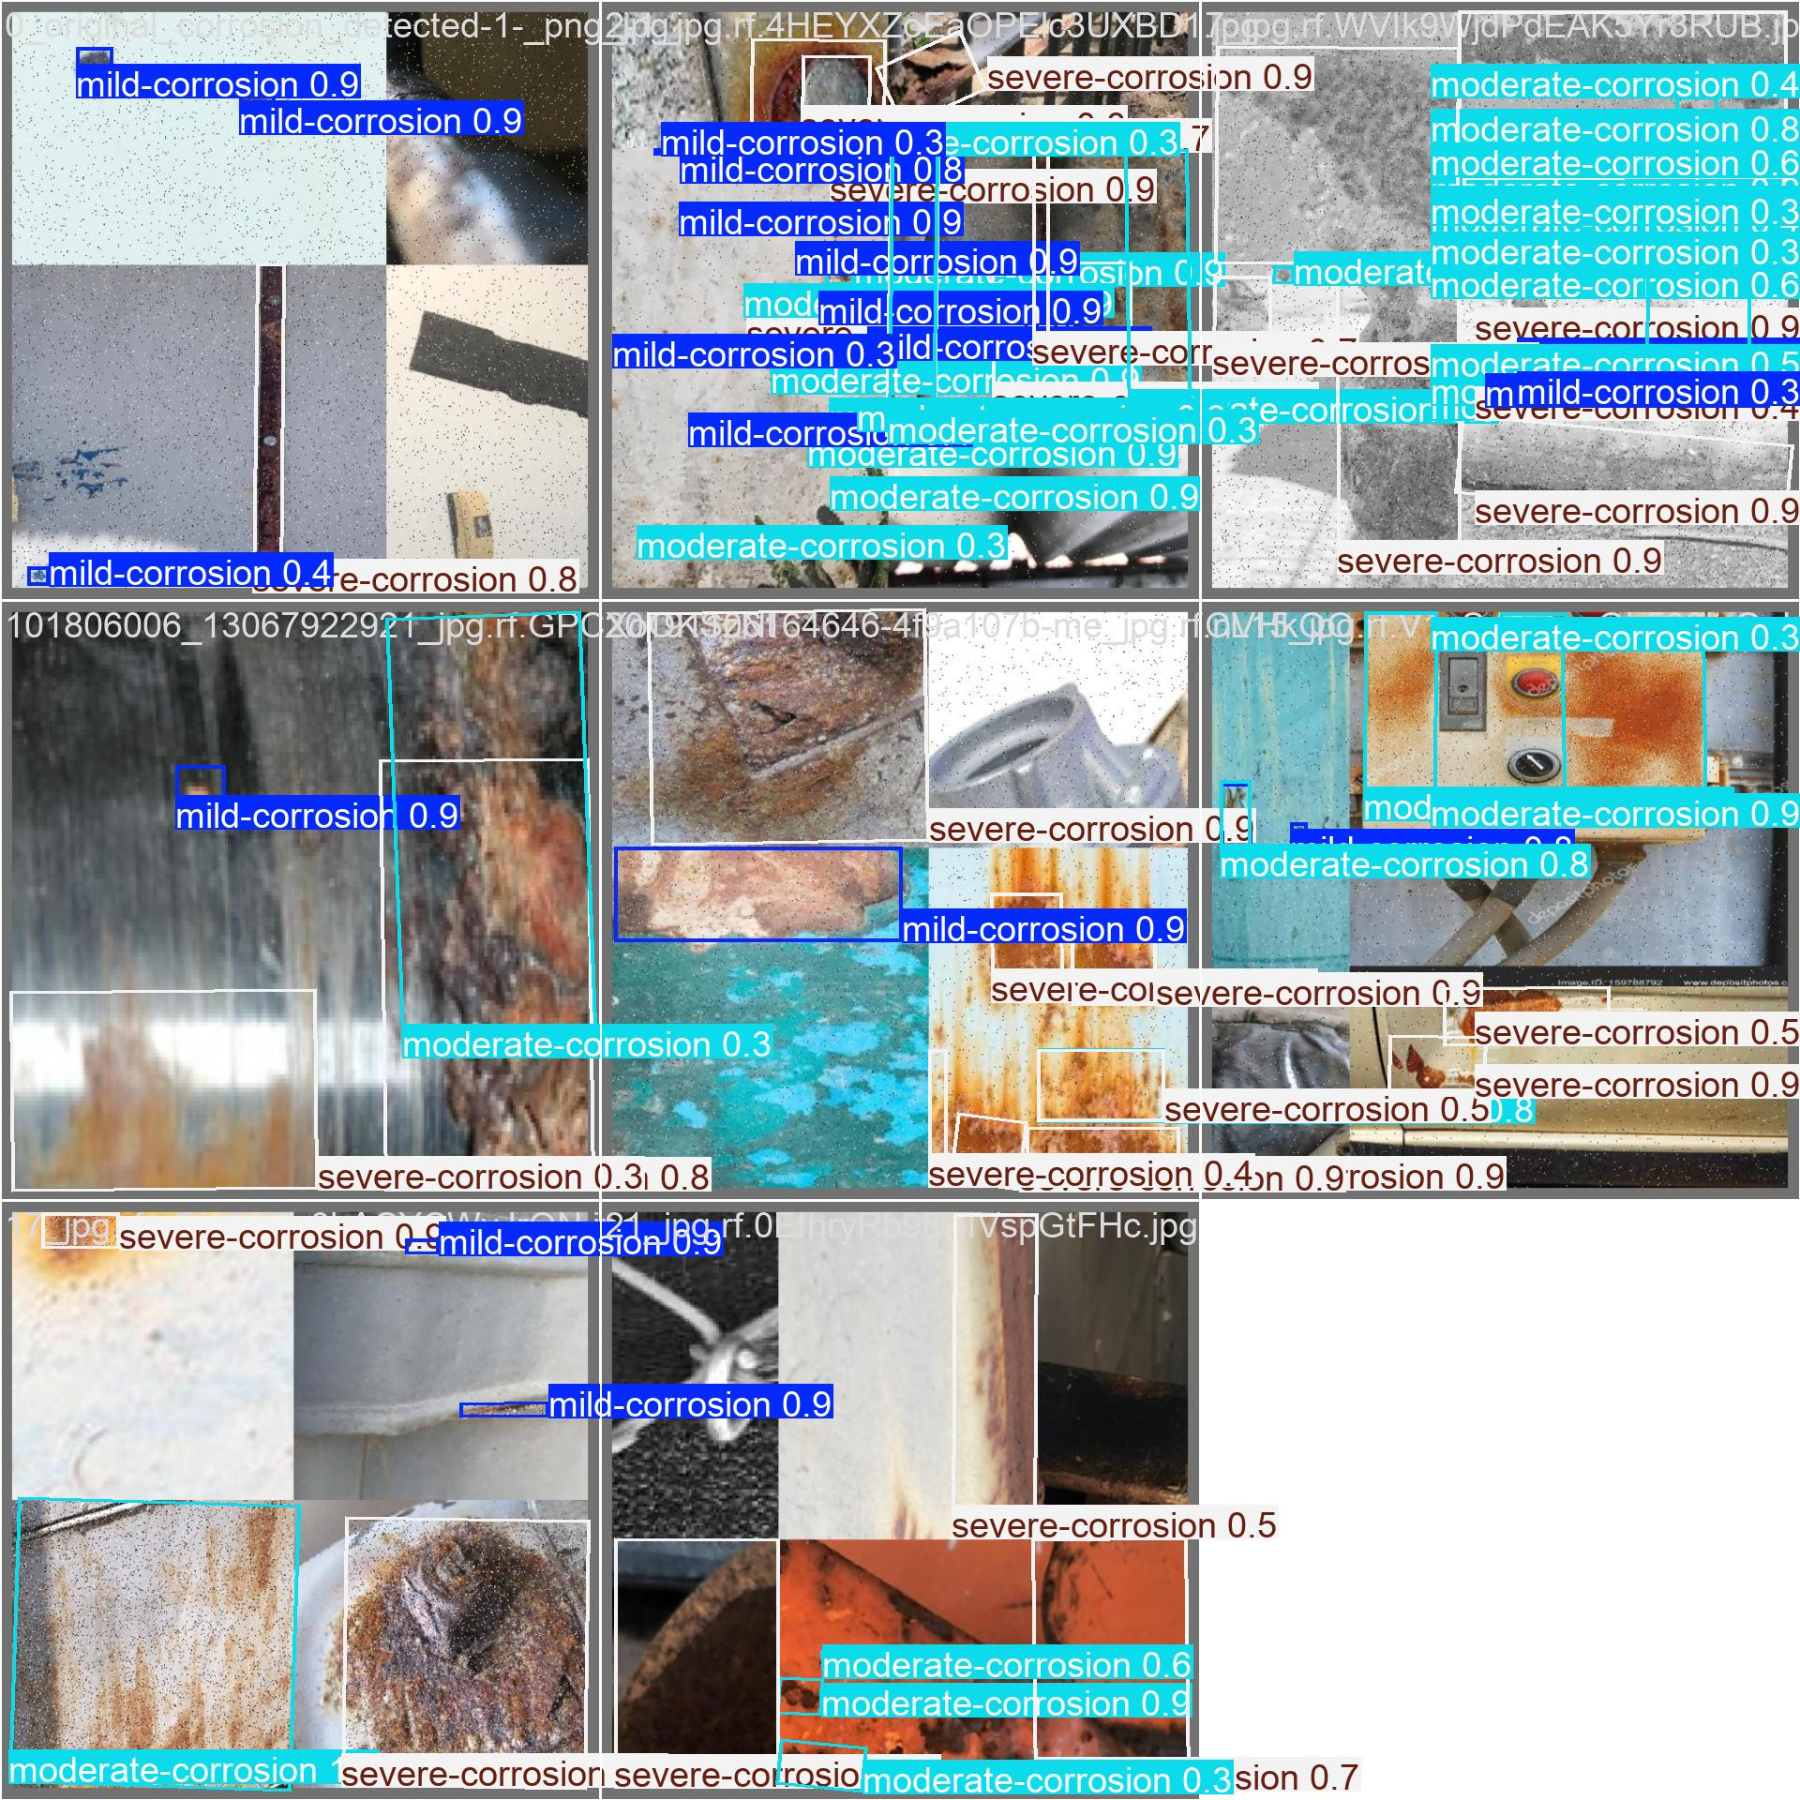
val_batch0_pred.jpg: For YOLO11s OBB, this image shows validation predictions generated by the trained model, including oriented boxes and predicted corrosion categories.
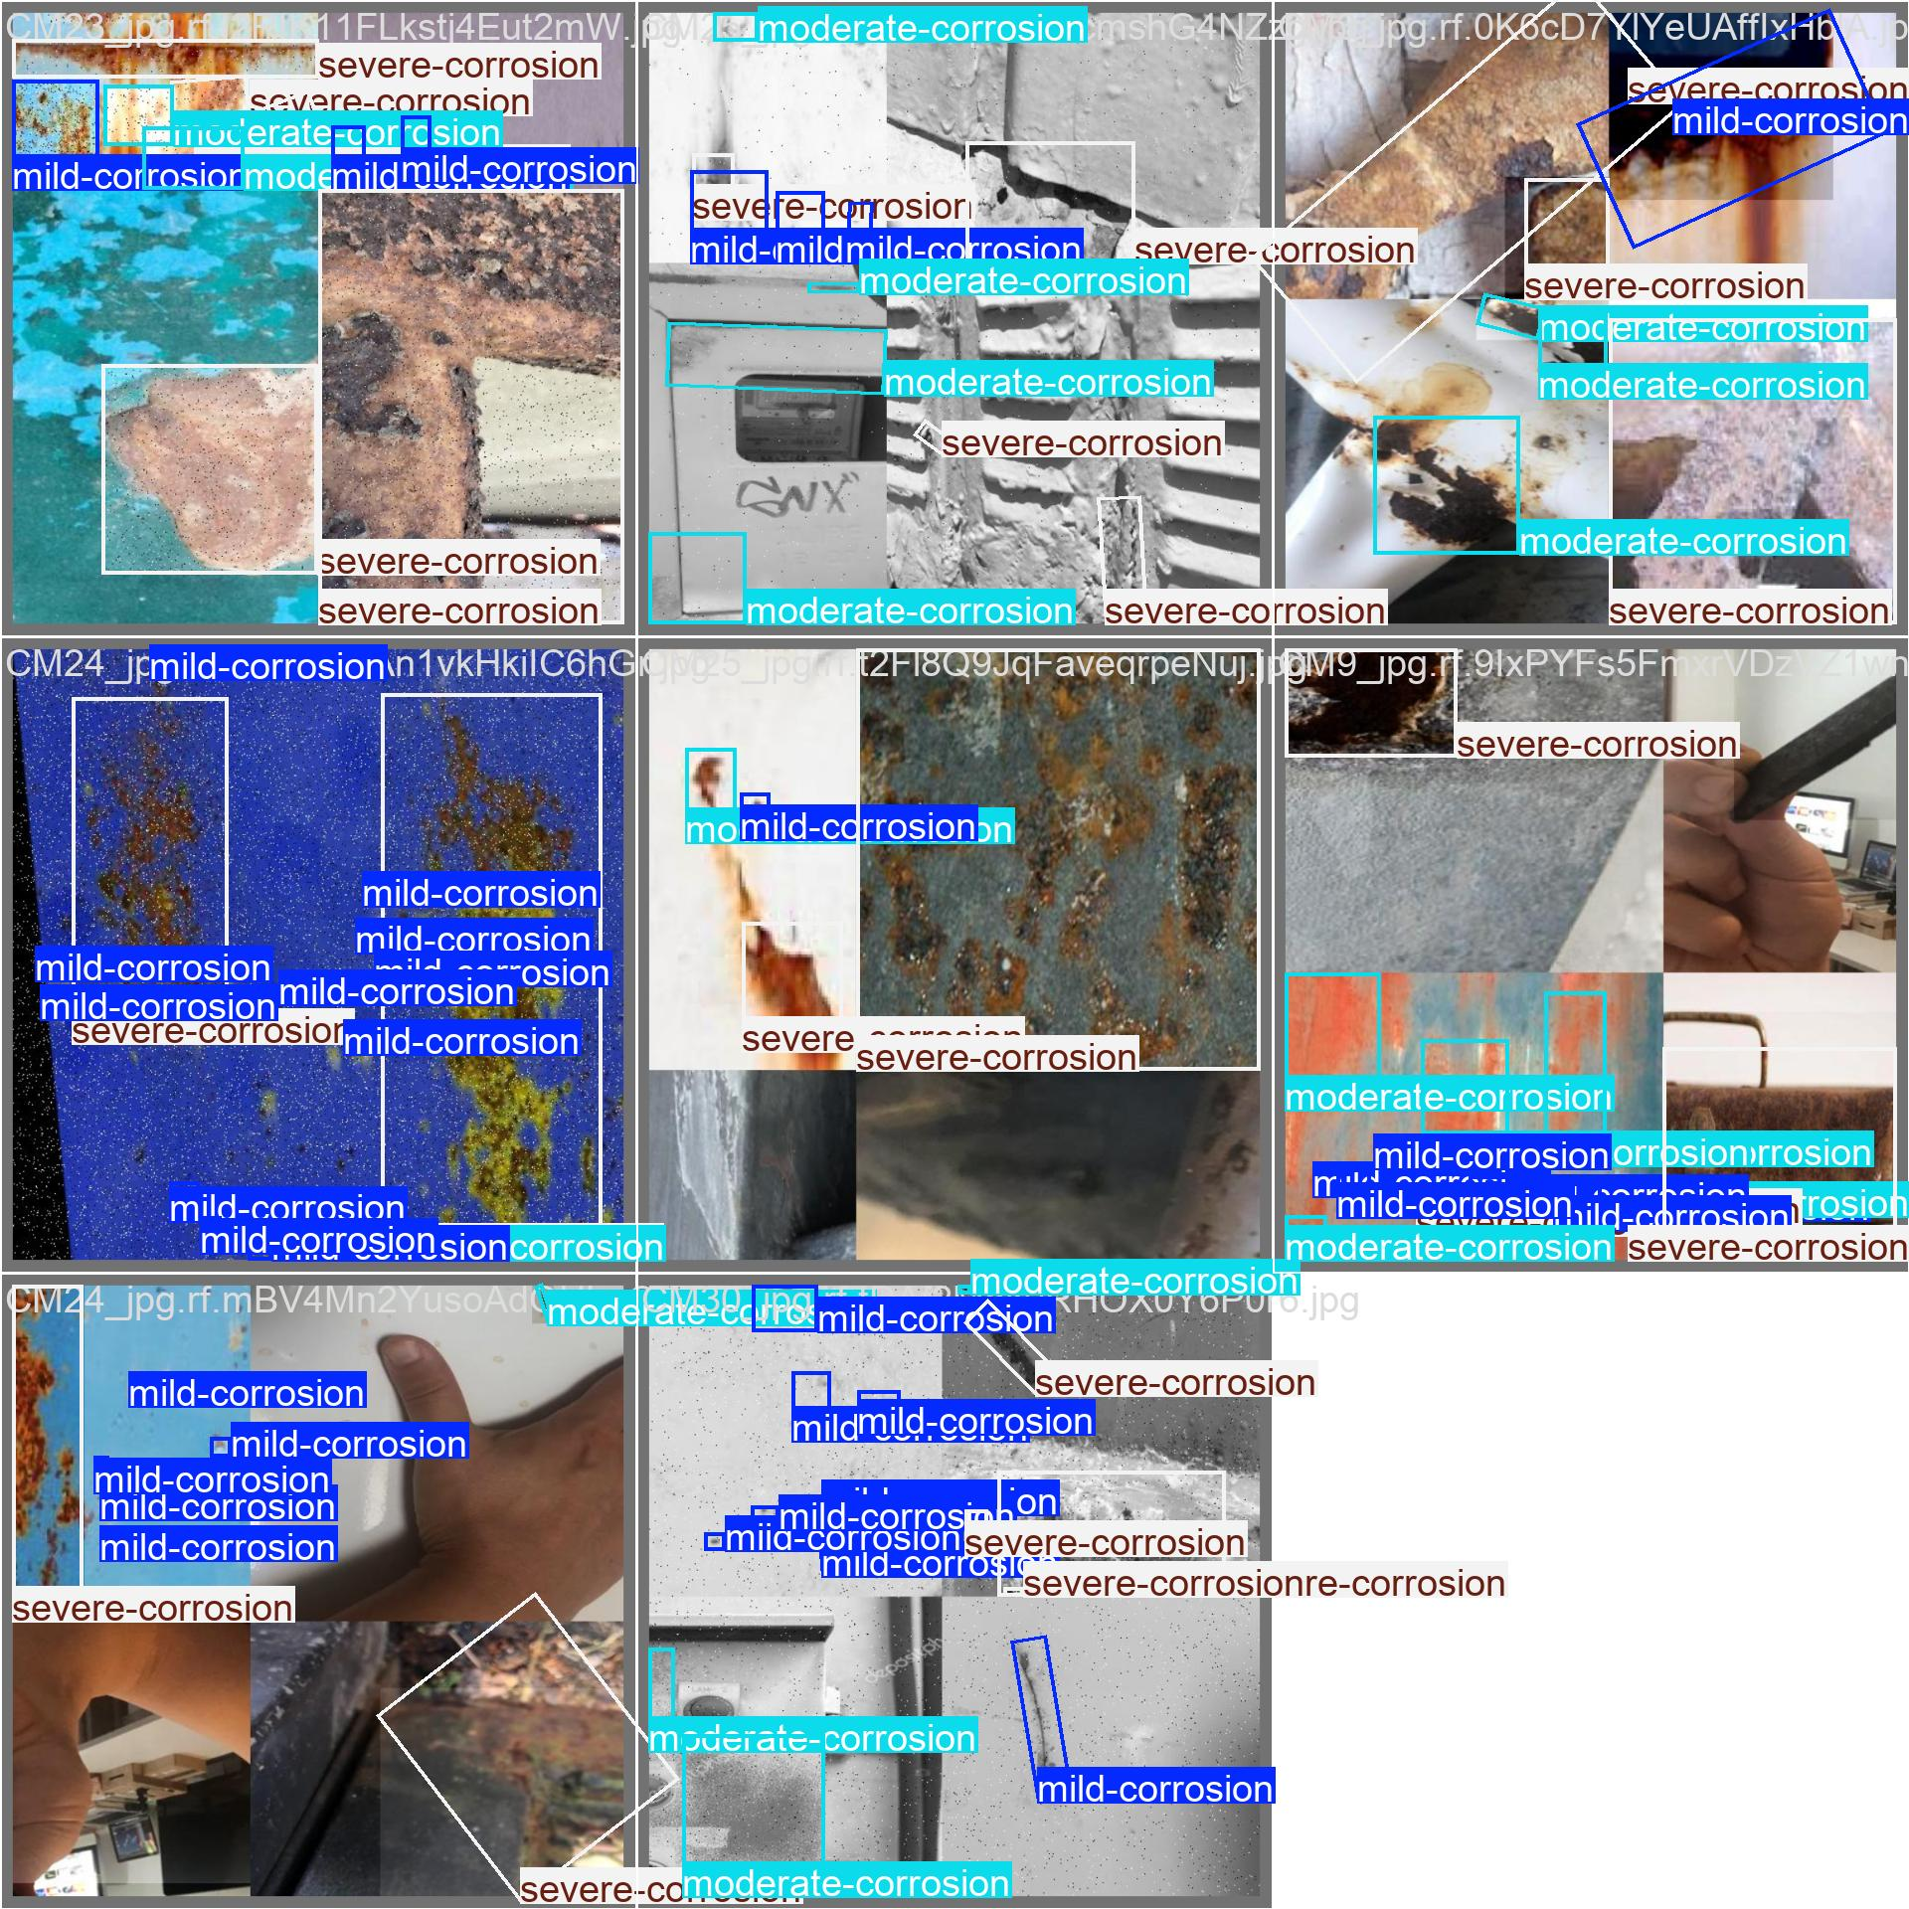
val_batch1_labels.jpg: For YOLO11s OBB, this image shows validation images with ground-truth oriented rust labels. These annotations are the reference used to evaluate predictions.
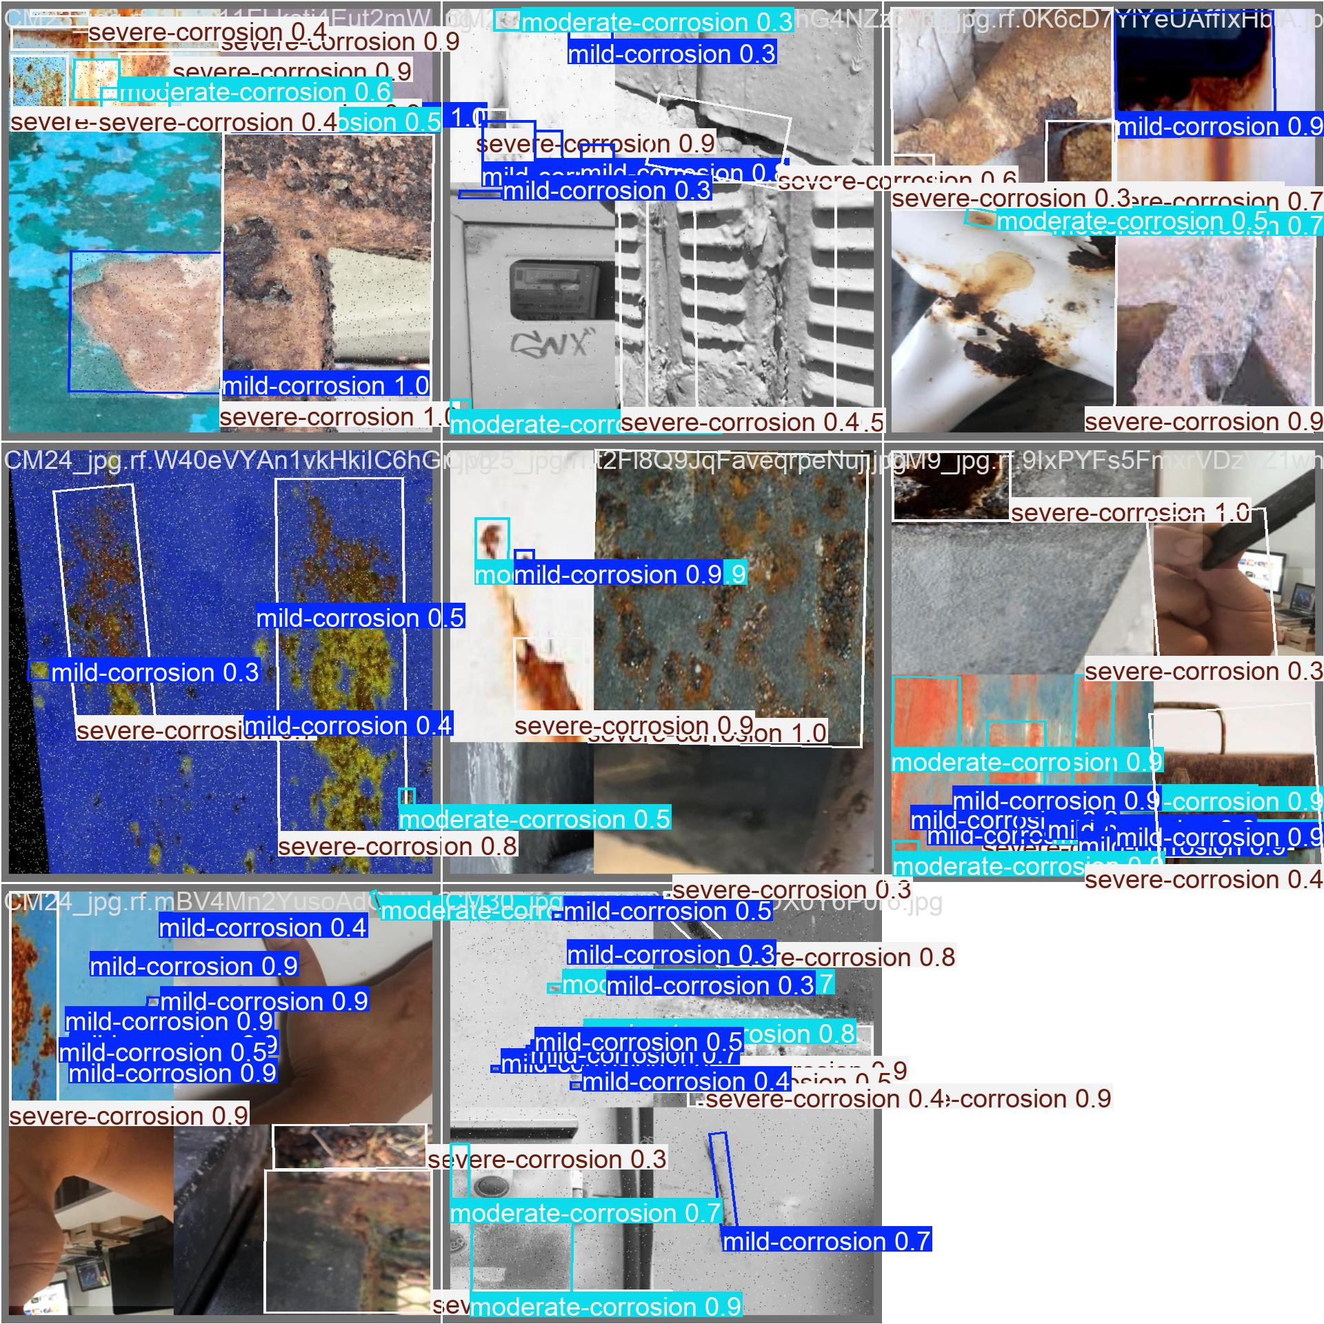
val_batch1_pred.jpg: For YOLO11s OBB, this image shows validation predictions generated by the trained model, including oriented boxes and predicted corrosion categories.
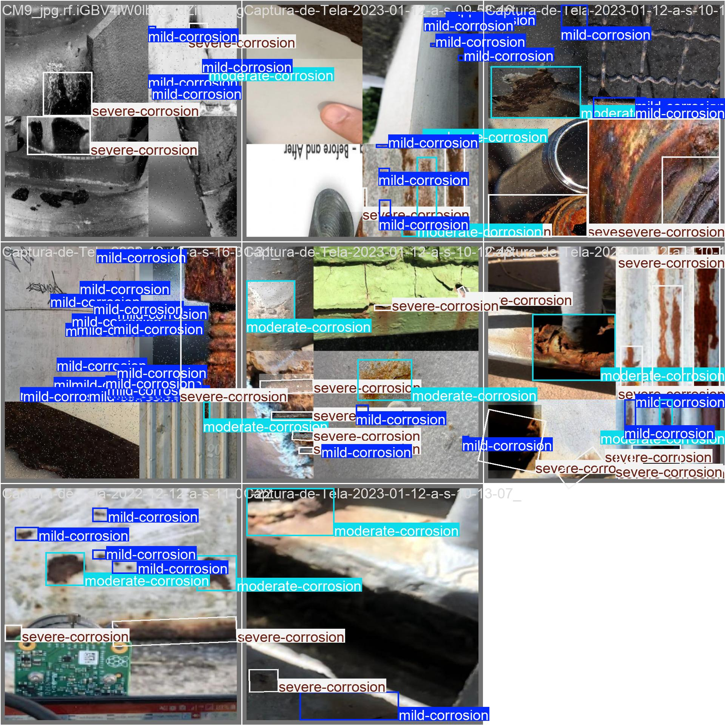
val_batch2_labels.jpg: For YOLO11s OBB, this image shows validation images with ground-truth oriented rust labels. These annotations are the reference used to evaluate predictions.
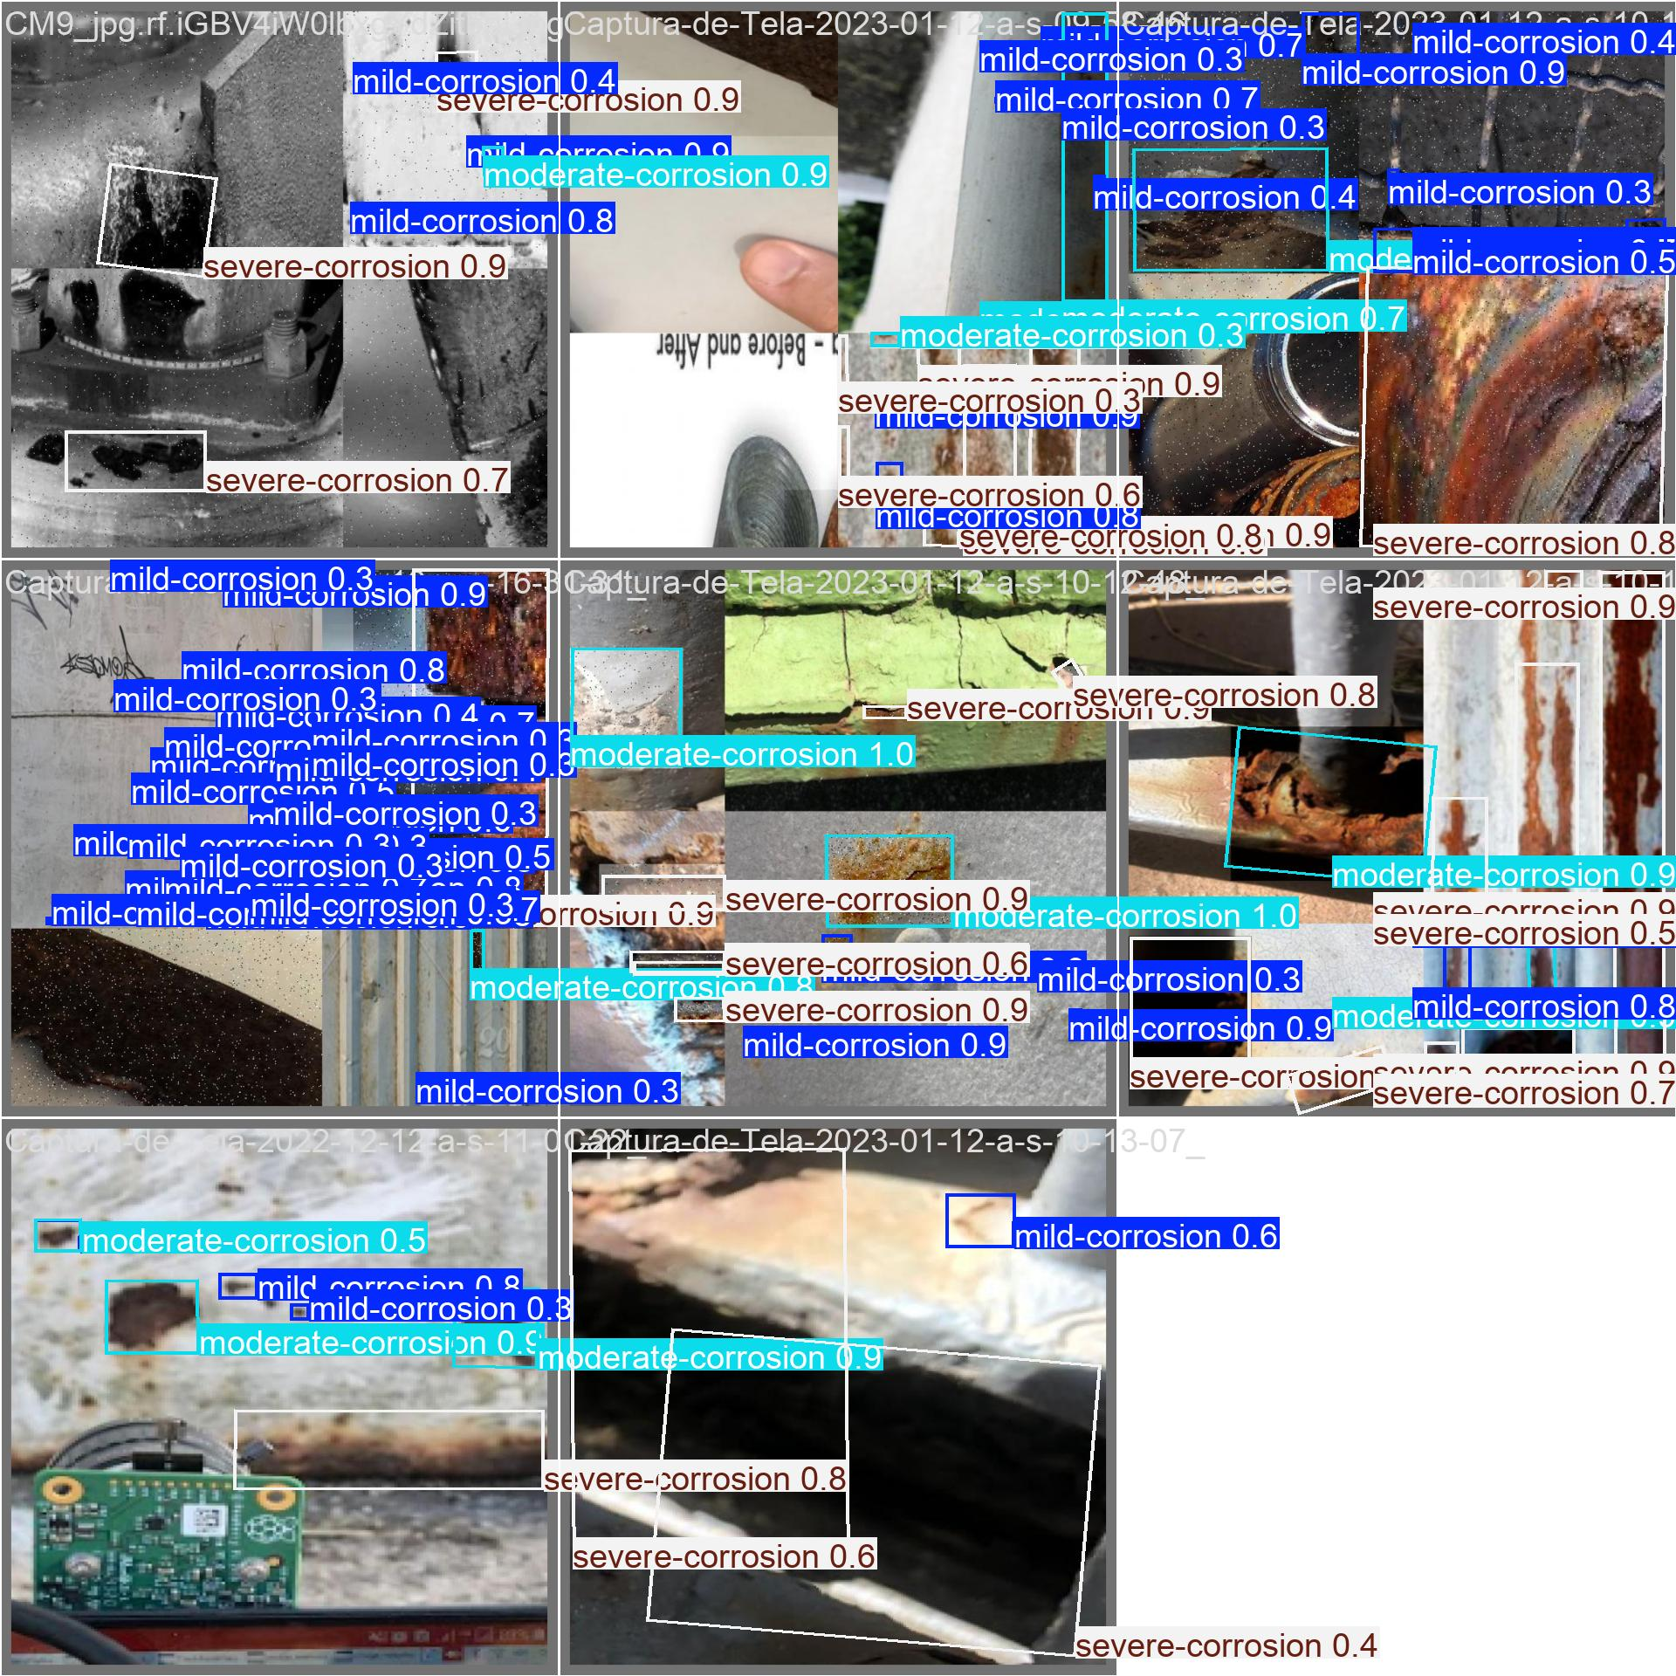
val_batch2_pred.jpg: For YOLO11s OBB, this image shows validation predictions generated by the trained model, including oriented boxes and predicted corrosion categories.

Platform Sample and Result Images
These images are included from the platform's static sample/result folders to show how the trained rust detection output appears in the application.
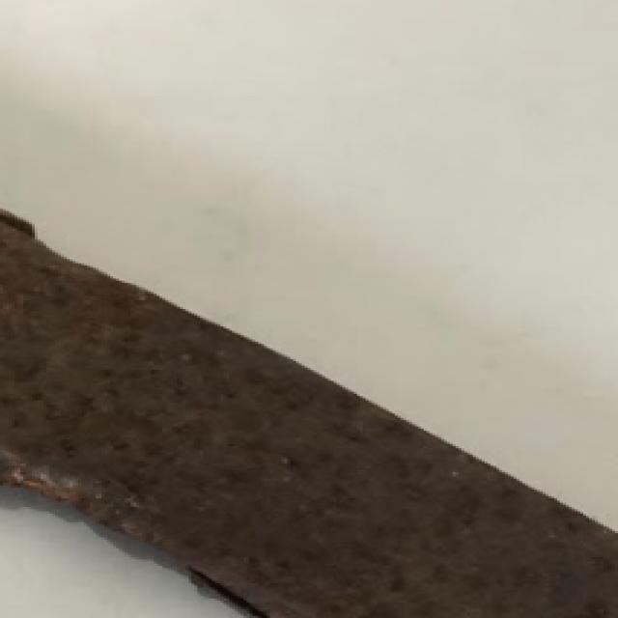
0e8d9a88083b42b4bdaaf490e2b1bb2a.jpg: This platform result image shows the web application output after running rust category detection on an uploaded inspection image.
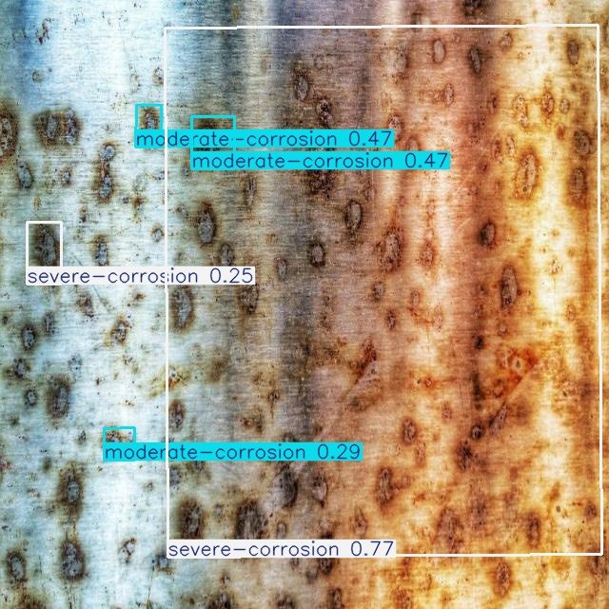
5be7fc5001ed4a6c8509d1e313276aeb.jpg: This platform result image shows the web application output after running rust category detection on an uploaded inspection image.

affa2edbaed54a95869a8066b687584f.jpg: This platform result image shows the web application output after running rust category detection on an uploaded inspection image.
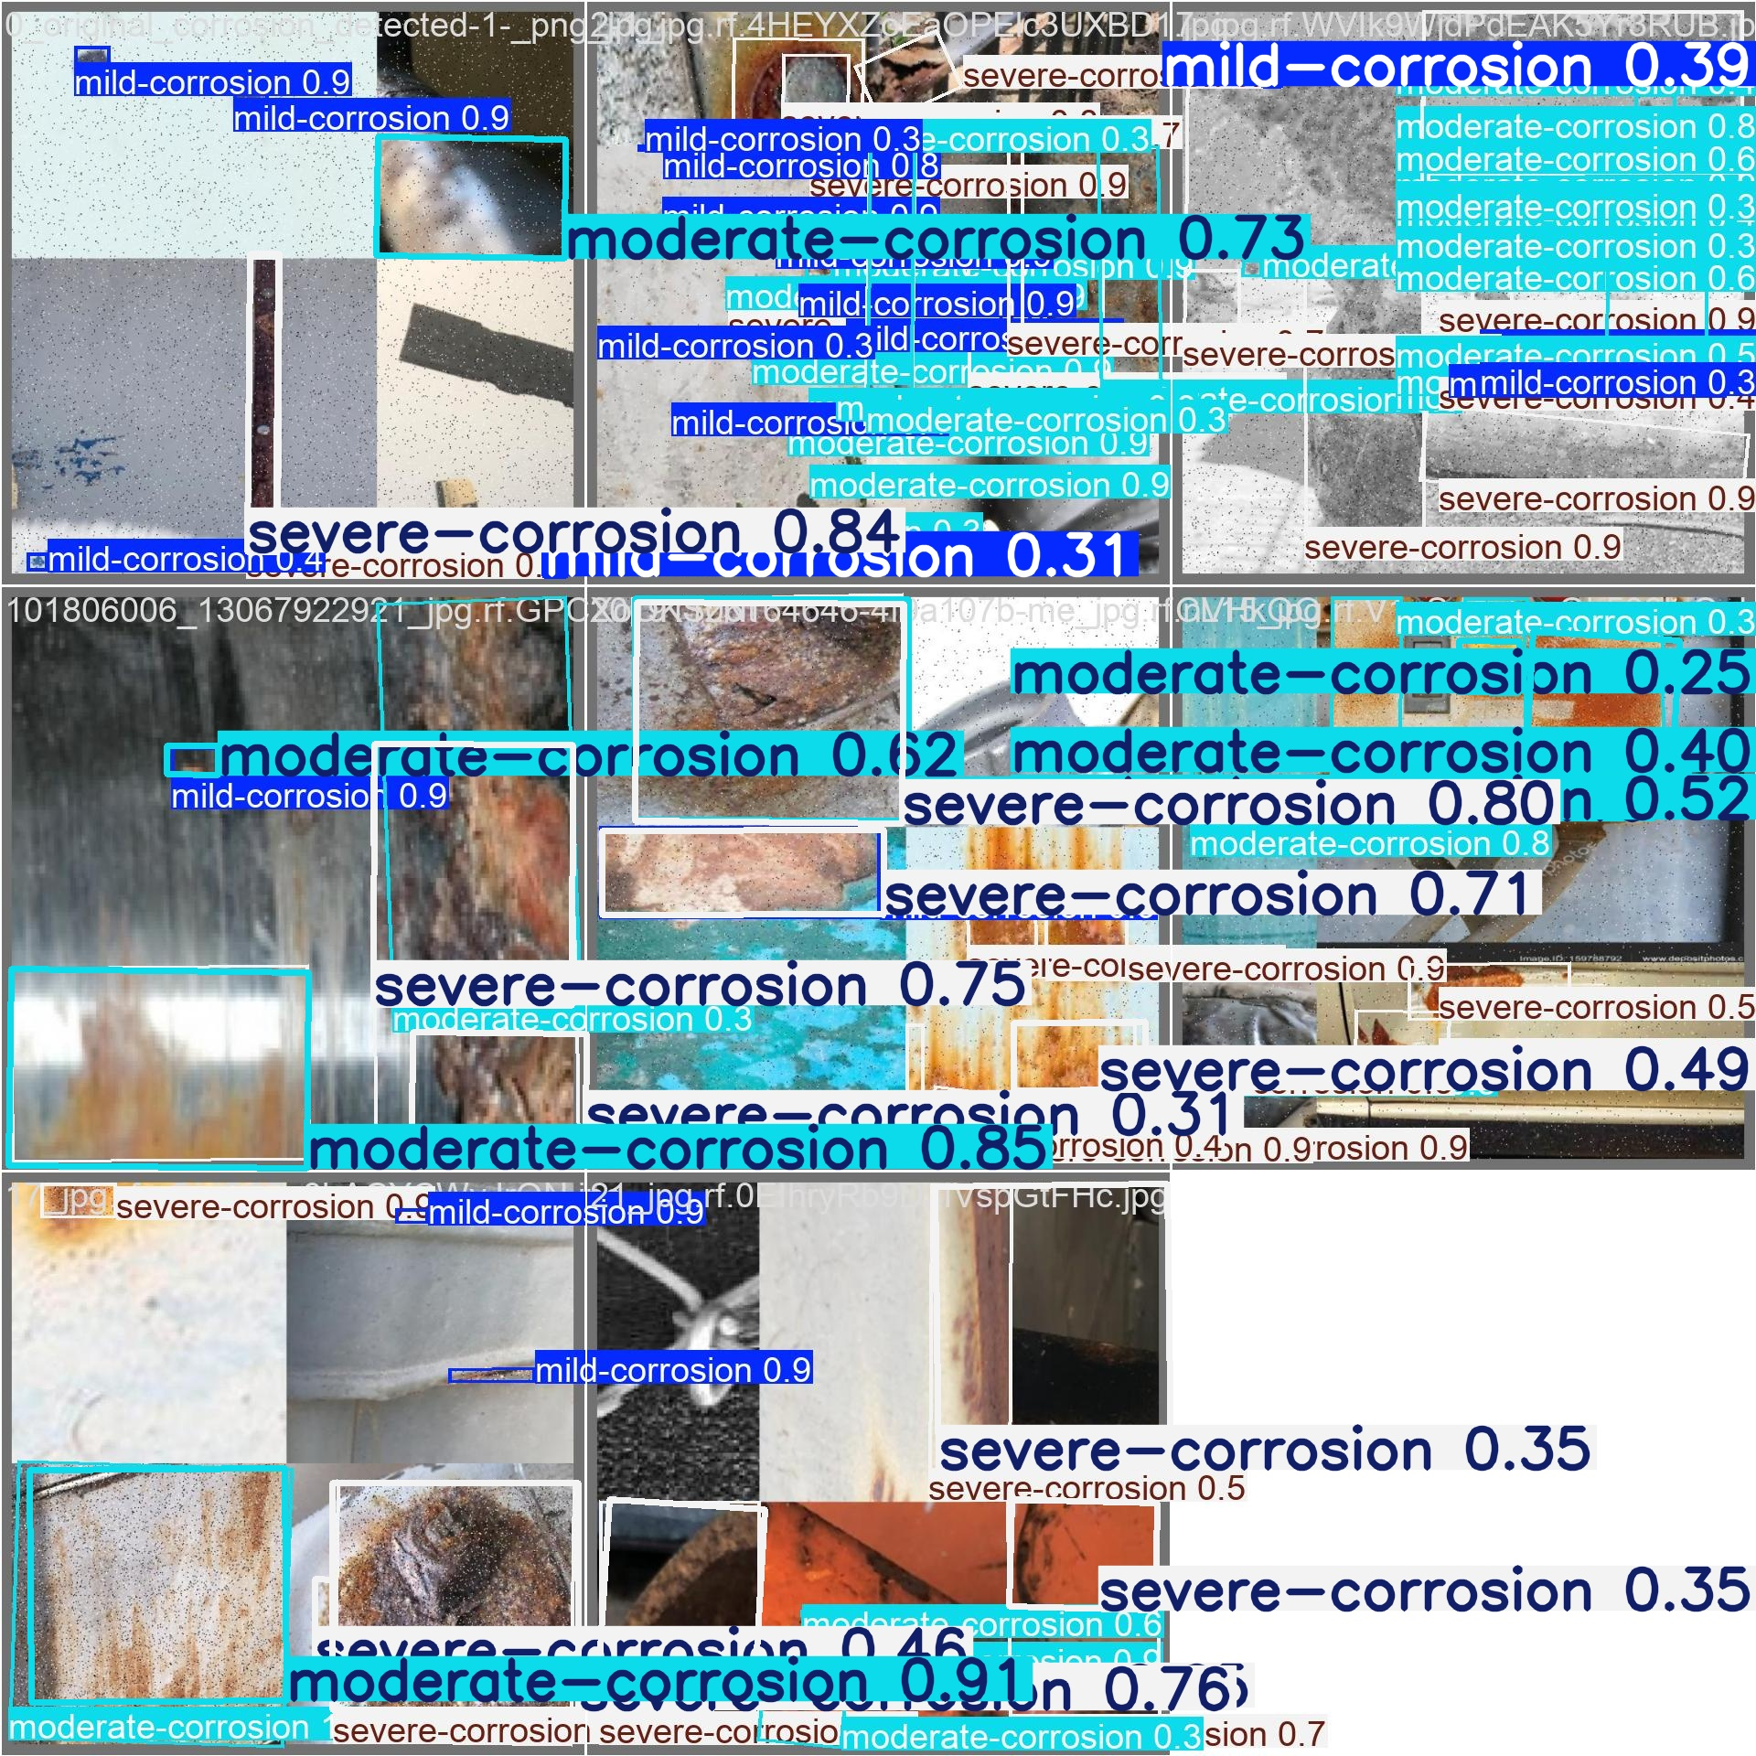
b76715288c564fe7bba32ba02e2671f2.jpg: This platform result image shows the web application output after running rust category detection on an uploaded inspection image.

inspection-example.jpg: This platform sample image is used in the web interface to demonstrate rust inspection outputs and model performance visuals.

training-results.png: This platform sample image is used in the web interface to demonstrate rust inspection outputs and model performance visuals.

