**Introduction:-**

In today’s digital age, efficient management of student information is essential for educational institutions. **Student Database Management** refers to the systematic process of storing, managing, and retrieving student data using digital systems. This includes personal details, academic records, attendance, grades, and other administrative information. Traditional paper-based systems are increasingly being replaced by robust database solutions that offer accuracy, accessibility, and data security. A well-structured student database management system not only simplifies administrative tasks but also enhances communication between students, teachers, and administrators. This topic explores the significance, structure, and advantages of implementing effective student database management systems in modern educational environments.

**Background:-**

Educational institutions handle vast amounts of data related to students, including personal information, academic performance, attendance records, and disciplinary history. Traditionally, this data was managed through manual record-keeping systems, which were time-consuming, prone to human error, and difficult to maintain over time. As the number of students and the complexity of educational administration grew, the need for an efficient, secure, and scalable solution became evident.

With advancements in technology, **Student Database Management Systems (SDMS)** have emerged as powerful tools to streamline the management of student information. These systems leverage database technologies to store, process, and retrieve data quickly and accurately. They support a range of functionalities such as automated record updates, report generation, secure access control, and integration with other educational tools.

The development of a student database management system aims to address common challenges faced by schools, colleges, and universities, including data redundancy, slow processing, and limited accessibility. This project is initiated to design and implement a solution that not only manages student data effectively but also enhances administrative efficiency and decision-making within educational institutions.

**Entity-Relationship Diagram**

The ER diagram for the given database schema can be represented as follows:

**Entities and Attributes**

* **Students**
  + Roll_No (Primary Key)
  + Name
  + Branch
  + Phone_No
  + DOB
  + Email
  + Address
  + CGPA
* **Branches**
  + Branch_name (Primary Key)
  + Head_of_Department
  + No_of_Students
  + No_of_Faculty
* **Hostels**
  + Hostel_Name (Primary Key)
  + No_of_Students
  + No_of_Rooms
* **Clubs**
  + Club_Name (Primary Key)
  + Club_Head
  + No_of_Members

**Relationships**

* A student belongs to one branch (One-To-One).
  + **Students** → **Branches** (Many-To-One)

Students

Branches

Clubs

Hostels

**Primary Key:**

**Table name Primary Key**

Branches Branch_name

Clubs Club_name

Hostels Hostel_name

Students Roll_no

**MySQL code:**

-- Creating the database

CREATE DATABASE IF NOT EXISTS StudentDB;

USE StudentDB;

-- Creating the Branches table

CREATE TABLE Branches (

Branch_name VARCHAR(10) PRIMARY KEY,

Head_of_Department VARCHAR(50),

No_of_Students INT,

No_of_Faculty INT

);

-- Inserting into Branches

INSERT INTO Branches VALUES

('CSE', 'Prof. Anil Mehta', 50, 20),

('IT', 'Prof. Rajiv Sinha', 50, 20),

('ECE', 'Prof. Kiran Desai', 50, 20),

('EE', 'Prof. Sandeep Rathi', 50, 20),

('ME', 'Prof. Manoj Verma', 50, 20);

-- Creating the Students table

CREATE TABLE Students (

Roll_No VARCHAR(10) PRIMARY KEY,

Name VARCHAR(50),

Branch VARCHAR(10),

Phone_No VARCHAR(15),

DOB DATE,

Email VARCHAR(100),

Address TEXT,

CGPA DECIMAL(3,2),

FOREIGN KEY (Branch) REFERENCES Branches(Branch_name)

);

-- Sample Insert for Students (10 for each branch)

INSERT INTO Students (Roll_No, Name, Branch, Phone_No, DOB, Email, Address, CGPA) VALUES

('23CSE01', 'Aaradhya Sharma', 'CSE', '9845612345', '2005-04-15', 'aaru@23@gmail.com', 'Delhi', 8.4),

('23CSE02', 'Ananya Mehta', 'CSE', '9845612346', '2004-08-12', 'anya@xmail.com', 'Jaipur', 8.1),

('23CSE03', 'Diya Gupta', 'CSE', '9845612347', '2004-05-23', 'diya_123@gmail.com', 'Mumbai', 7.9),

('23CSE04', 'Kavya Nair', 'CSE', '9845612348', '2005-01-19', 'kavya!321@gmail.com', 'Kochi', 8.6),

('23CSE05', 'Saanvi Rao', 'CSE', '9845612349', '2005-06-30', 'saanvi.r@rediffmail.com', 'Hyderabad', 8.0),

('23CSE06', 'Isha Sen', 'CSE', '9845612350', '2004-07-10', 'isha_sen123@mail.com', 'Kolkata', 7.8),

('23CSE07', 'Myra Kapoor', 'CSE', '9845612351', '2005-09-05', 'myra_kapoor99@gmail.com', 'Chandigarh', 9.1),

('23CSE08', 'Meera Joshi', 'CSE', '9845612352', '2004-12-25', 'meerajoshi87@gmail.com', 'Pune', 8.2),

('23CSE09', 'Tanya Bhat', 'CSE', '9845612353', '2005-03-11', 'tanya.bhat23@ymail.com', 'Bangalore', 8.7),

('23CSE10', 'Riya Deshmukh', 'CSE', '9845612354', '2005-11-29', 'riya_deshmukh@gmail.com', 'Nagpur', 7.5),

-- Repeat similarly for IT, ECE, EE, ME branches with unique roll nos and names

-- Sample for IT branch

('23IT01', 'Nitya Sharma', 'IT', '9845612360', '2005-08-22', 'nitya.sharma@xmail.com', 'Indore', 8.3),

('23IT02', 'Simran Jain', 'IT', '9845612361', '2004-10-12', 'sim_jain321@gmail.com', 'Udaipur', 8.1),

('23IT03', 'Tisha Verma', 'IT', '9845612362', '2005-06-17', 'tisha.v@outlook.com', 'Bhopal', 7.8),

('23IT04', 'Neha Singh', 'IT', '9845612363', '2004-11-23', 'nehasingh_123@gmail.com', 'Kanpur', 8.5),

('23IT05', 'Avni Kapoor', 'IT', '9845612364', '2005-02-14', 'avni@live.com', 'Lucknow', 8.2),

('23IT06', 'Jiya Agarwal', 'IT', '9845612365', '2005-09-03', 'jiyaag_99@gmail.com', 'Patna', 8.0),

('23IT07', 'Reeva Iyer', 'IT', '9845612366', '2004-07-01', 'reevaiyer23@ymail.com', 'Trivandrum', 8.4),

('23IT08', 'Shruti Dixit', 'IT', '9845612367', '2005-04-19', 'shruti_dixit@rediffmail.com', 'Agra', 7.9),

('23IT09', 'Pihu Chatterjee', 'IT', '9845612368', '2005-12-01', 'pihu_cht@gmail.com', 'Siliguri', 7.7),

('23IT10', 'Sanya Khan', 'IT', '9845612369', '2004-03-27', 'sanyak@ymail.com', 'Noida', 8.6);

-- Add similar inserts for ECE, EE, ME branches (10 students each)

-- Students for ECE Branch

INSERT INTO Students (Roll_No, Name, Branch, Phone_No, DOB, Email, Address, CGPA) VALUES

('23ECE01', 'Ira Sharma', 'ECE', '9845612401', '2005-04-10', 'ira_s@xmail.com', 'Delhi', 8.0),

('23ECE02', 'Trisha Nair', 'ECE', '9845612402', '2004-11-15', 'trisha_n@ymail.com', 'Chennai', 8.2),

('23ECE03', 'Ridhi Patel', 'ECE', '9845612403', '2005-05-22', 'ridhip@live.com', 'Ahmedabad', 7.9),

('23ECE04', 'Ishita Mehra', 'ECE', '9845612404', '2004-06-30', 'ishita_mehra@gmail.com', 'Pune', 8.4),

('23ECE05', 'Tanisha Roy', 'ECE', '9845612405', '2005-01-25', 'tanisharoy23@xmail.com', 'Kolkata', 8.1),

('23ECE06', 'Ritika Paul', 'ECE', '9845612406', '2004-10-20', 'ritikapaul99@gmail.com', 'Shillong', 7.8),

('23ECE07', 'Zoya Khan', 'ECE', '9845612407', '2005-08-18', 'zoya_khan@ymail.com', 'Lucknow', 8.3),

('23ECE08', 'Vanya Iyer', 'ECE', '9845612408', '2005-03-07', 'vanya.iyer@gmail.com', 'Bangalore', 8.7),

('23ECE09', 'Lavanya Bhat', 'ECE', '9845612409', '2004-12-13', 'lavanya.bhat@outlook.com', 'Srinagar', 8.0),

('23ECE10', 'Nandini Desai', 'ECE', '9845612410', '2004-09-11', 'nandini_d@rediffmail.com', 'Vadodara', 7.6);

-- Students for ME Branch

INSERT INTO Students (Roll_No, Name, Branch, Phone_No, DOB, Email, Address, CGPA) VALUES

('23ME01', 'Bhavya Rao', 'ME', '9845612451', '2005-06-16', 'bhavyar@ymail.com', 'Nagpur', 7.9),

('23ME02', 'Sneha Menon', 'ME', '9845612452', '2004-04-14', 'snehamenon99@mail.com', 'Cochin', 8.2),

('23ME03', 'Anjali Dubey', 'ME', '9845612453', '2005-09-09', 'anjalidubey@live.com', 'Varanasi', 8.0),

('23ME04', 'Aditi Shah', 'ME', '9845612454', '2005-12-05', 'aditi.shah@xmail.com', 'Surat', 8.4),

('23ME05', 'Charvi Jain', 'ME', '9845612455', '2004-11-29', 'charvijain@gmail.com', 'Bhopal', 7.7),

('23ME06', 'Divya Saxena', 'ME', '9845612456', '2005-02-18', 'divyasaxena@outlook.com', 'Indore', 8.5),

('23ME07', 'Preeti Rani', 'ME', '9845612457', '2004-08-30', 'preeti_rani@mail.com', 'Ranchi', 8.1),

('23ME08', 'Yamini Joshi', 'ME', '9845612458', '2005-01-20', 'yamini.j@xmail.com', 'Ajmer', 7.8),

('23ME09', 'Prachi Thakur', 'ME', '9845612459', '2004-07-07', 'prachi_t@rediffmail.com', 'Shimla', 8.3),

('23ME10', 'Ayesha Siddiqui', 'ME', '9845612460', '2005-10-23', 'ayesha.sid@gmail.com', 'Aligarh', 7.6);

-- Students for EE Branch

INSERT INTO Students (Roll_No, Name, Branch, Phone_No, DOB, Email, Address, CGPA) VALUES

('23EE01', 'Mira Kale', 'EE', '9845612501', '2005-03-16', 'mirak@xmail.com', 'Mumbai', 8.2),

('23EE02', 'Pallavi Reddy', 'EE', '9845612502', '2004-05-20', 'pallavired@ymail.com', 'Hyderabad', 7.9),

('23EE03', 'Sakshi Arora', 'EE', '9845612503', '2005-09-27', 'sakshiarora_89@gmail.com', 'Chandigarh', 8.3),

('23EE04', 'Kritika Mishra', 'EE', '9845612504', '2005-11-08', 'kritikam@live.com', 'Noida', 8.0),

('23EE05', 'Niharika Joshi', 'EE', '9845612505', '2004-08-15', 'niharikajoshi@gmail.com', 'Dehradun', 7.7),

('23EE06', 'Anushka Rawat', 'EE', '9845612506', '2004-06-25', 'anushkarawat@outlook.com', 'Mussoorie', 8.4),

('23EE07', 'Vaishnavi Nair', 'EE', '9845612507', '2005-02-11', 'vaishnavi.n@xmail.com', 'Thiruvananthapuram', 8.1),

('23EE08', 'Harshita Singh', 'EE', '9845612508', '2005-04-01', 'harshita_singh@mail.com', 'Ghaziabad', 8.0),

('23EE09', 'Suhana Das', 'EE', '9845612509', '2004-12-19', 'suhana.das@rediffmail.com', 'Howrah', 7.8),

('23EE10', 'Anvi Bhatt', 'EE', '9845612510', '2005-07-21', 'anvibhatt@gmail.com', 'Pithoragarh', 8.3);

-- Creating the Hostels table

CREATE TABLE Hostels (

Hostel_Name VARCHAR(20) PRIMARY KEY,

No_of_Students INT,

No_of_Rooms INT

);

-- Inserting into Hostels

INSERT INTO Hostels VALUES

('BJR', 30, 15),

('Mahi', 30, 15),

('Mansi', 30, 15);

-- Creating the Clubs table

CREATE TABLE Clubs (

Club_Name VARCHAR(50) PRIMARY KEY,

Club_Head VARCHAR(50),

No_of_Members INT

);

-- Inserting into Clubs

INSERT INTO Clubs VALUES

('Coding Club', 'Anaya Jain', 35),

('Eco Club', 'Priya Rathi', 35),

('Anti Ragging Club', 'Sneha Iyer', 35),

('Photography Club', 'Tanvi Shekhar', 35),

('Cultural Club', 'Ritika Bose', 35);

**Output:**

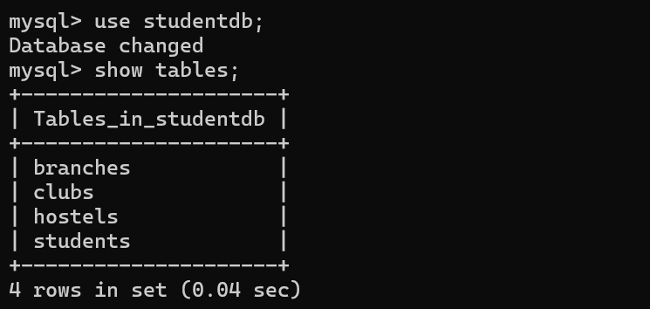

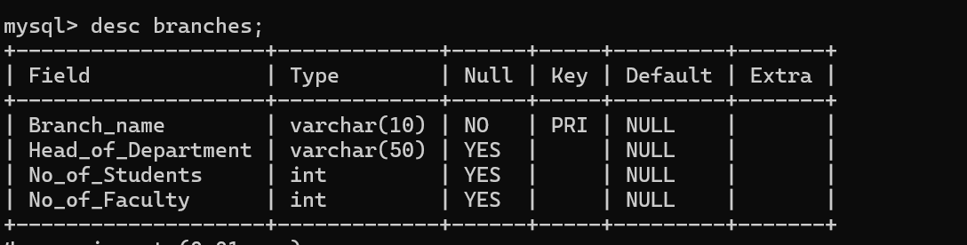

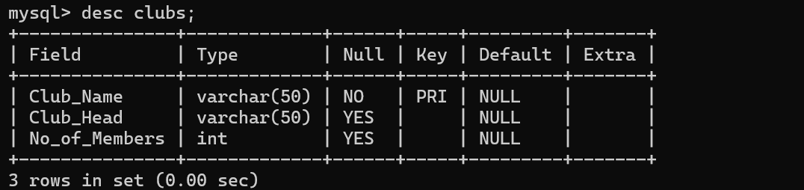

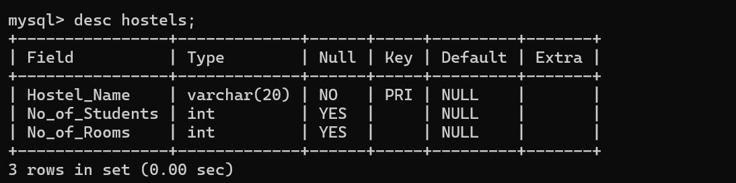

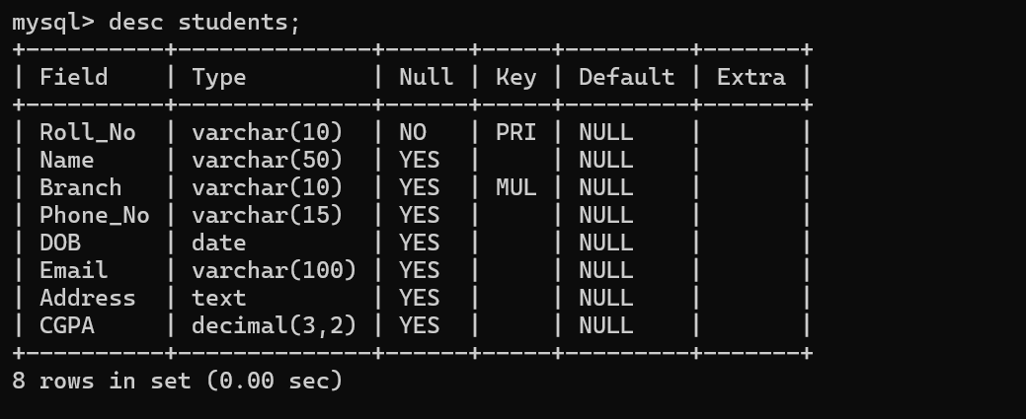

**Conclusion:-**

In conclusion, a **Student Database Management System (SDMS)** plays a crucial role in modernizing and streamlining the administrative processes of educational institutions. By replacing outdated manual systems with automated digital solutions, institutions can ensure greater accuracy, data security, and efficiency in handling student records. Such systems not only reduce the workload for staff but also improve communication, transparency, and decision-making. As education continues to evolve in the digital age, investing in reliable and scalable database management systems will be key to supporting academic excellence and institutional growth.