A PROJECT REPORT
ON
“SOFTWARE DEFECT PREDICTION USING MACHINE LEARNING”
Submitted in Partial Fulfillment for the degree
of M.Tech. (Master of Technology)
in Computer Science and Engineering
Course Code: CS16095 | Minor Project
Submitted By: -
Sonam Kumari
Registration No.: NSU253121001
Roll No.: 253121001
M.Tech. (CSE), 2nd Semester, Session 2025 - 2026
Under the Guidance of
Ritesh Kumar Jha
Assistant Professor (CS & IT)
DEPARTMENT OF COMPUTER SCIENCE & ENGINEERING
NETAJI SUBHAS UNIVERSITY
JAMSHEDPUR, JHARKHAND
SEPTEMBER 2026

CERTIFICATE

This is to certify that the project report entitled “SOFTWARE DEFECT PREDICTION USING MACHINE LEARNING” submitted to Netaji Subhas University, Jamshedpur, in partial fulfillment of the requirement for the award of the degree of Master of Technology (M.Tech.) in Computer Science and Engineering, is an original work carried out by Sonam Kumari, Registration No. NSU253121001, Roll No. 253121001, under my supervision and guidance during the academic session 2025 - 2026.
The work embodied in this report has not been submitted, either in part or in full, to any other university or institution for the award of any degree or diploma. The results reported were obtained by executing the software developed as part of this project, which is submitted along with this report.

Signature | Signature
Ritesh Kumar Jha | Lal Kishore Kumar
(Project Guide) | (Head of Department)

(External Examiner)
Date: ______________ Place: Jamshedpur

CONTENTS
S.NO | Chapter | Page.no
1. | Introduction | 1
2. | Abstraction | 1
3. | Objective | 1
4. | Literature Review | 1
5. | Existing System and Proposed System | 1
6. | Modules | 1
7. | Technology | 1
8. | System Requirement | 1
9. | System Analysis | 1
10. | Methodology | 1
11. | DFD | 1
12. | ER Diagram and Data Model | 1
13. | Testing | 1
14. | Screenshots | 1
15. | Results and Analysis | 1
16. | Coding | 1
17. | Dataset Tables | 1
18. | Conclusion | 1
19. | Future Scope | 1
20. | Limitation | 1
21. | Bibliography | 1
 | List of Abbreviations | 1
 | Appendix A: Execution Instructions | 1

Page numbers are generated automatically by Word. To refresh them, select the whole document with Ctrl+A and press F9.

Introduction
1.1 Background
Software has become the operating fabric of modern society. Aircraft avionics, medical instrumentation, banking settlement systems, telecommunication switches and the control software of spacecraft all depend on programs behaving exactly as intended. Despite five decades of advances in programming languages, development processes and verification tools, defects remain an unavoidable by-product of software construction. A defect is any flaw in a software artefact that can cause the system to behave in a way that differs from its specification, and in a system of even moderate size the number of such flaws introduced during development is measured in hundreds.
What makes defects economically significant is not merely their existence but the way the cost of removing them grows with time. Boehm's classical study of software engineering economics established that the cost of correcting a fault rises by roughly an order of magnitude with each successive phase in which it remains undetected, so that a requirements error found by a customer after release can cost a hundred times more to repair than the same error caught during a design review. Later industrial surveys have repeatedly confirmed the shape of this curve even as the absolute numbers have changed.
A second empirical regularity makes the problem tractable. Defects are not spread uniformly over a code base. Boehm and Basili, summarising a body of industrial measurement, observed that approximately eighty per cent of the defects in a system arise from approximately twenty per cent of its modules. If those modules could be identified in advance, the same testing budget would remove far more defects than if it were spread evenly across the system.
Testing and code inspection are the established means of finding defects, and both are expensive. Exhaustive testing of any realistic program is impossible, and manual inspection consumes senior engineering time, which is the scarcest resource on most projects. Quality assurance is therefore always an exercise in allocation: given a fixed budget, which parts of the system should be examined first? Software Defect Prediction addresses precisely this allocation problem.
A defect-prediction model takes measurable properties of a software module and estimates the likelihood that the module contains a defect. The properties most commonly used are static code metrics, which are computed directly from the source text without executing it. They include simple size measures such as the number of lines of code, structural measures such as McCabe's cyclomatic complexity, and the vocabulary-based measures proposed by Halstead. Because these metrics can be extracted automatically as soon as code is written, a model built on them can produce a risk ranking long before the first test case is executed.
The modern treatment of the problem as a supervised binary classification task was established by Menzies, Greenwald and Frank in 2007. Their study, together with the public release of the NASA Metrics Data Program datasets through the PROMISE repository, made defect prediction one of the most heavily studied problems in empirical software engineering. Several hundred papers have since compared classification algorithms, feature-selection strategies and resampling techniques on these datasets.
1.2 Motivation
Three considerations motivated the choice of this topic for the Minor Project.
1.2.1 Direct relevance to software engineering practice
Even a model of modest accuracy has practical value, because it is used to rank modules rather than to make an irreversible decision. A reviewer who inspects the twenty per cent of modules ranked most risky, and who finds a disproportionate share of the defects there, has obtained a real benefit even if the model's individual predictions are frequently wrong. The subject connects directly to the software quality assurance, software testing and software reliability modelling topics of the Advanced Software Engineering syllabus, and to the supervised learning and optimisation topics of Soft Computing Techniques.
1.2.2 Documented methodological weaknesses in the published literature
A substantial part of the defect-prediction literature is difficult to trust. In 2013 Shepperd, Song, Sun and Mair audited the NASA datasets on which most of that literature rests and discovered that the distributed files contain a large number of exactly duplicated records, records that are identical in every metric but carry conflicting labels, and records with physically impossible values such as a module reported to have zero lines of code but a non-zero cyclomatic complexity. In the KC1 dataset, cleaning removes almost half of the rows. A second and independent weakness is that many studies fit scaling parameters, imputation statistics or resampling procedures on the complete dataset before separating training from test data. This allows information from the test set to influence the model and inflates the reported performance. Reproducing the standard methodology while avoiding both faults is therefore a worthwhile exercise in its own right, and it corresponds exactly to the stated outcome of this course, which is to analyse an existing solution and reproduce it.
1.2.3 The class-imbalance problem
Defective modules are a minority in every dataset examined here, ranging from roughly eight per cent of modules in PC1 to roughly twenty-five per cent in KC1. Accuracy, the measure most frequently quoted in undergraduate treatments of classification, is actively misleading under such imbalance: on PC1 a model that predicts every module to be clean achieves ninety-two per cent accuracy while detecting nothing at all. A serious study must therefore treat imbalance explicitly and must report measures that are sensitive to performance on the minority class.
1.3 Scope of the Project
This project is entirely software-based. No hardware was designed, fabricated or interfaced. The work delivered consists of the following elements.
- Automated acquisition of four public benchmark datasets from the NASA Metrics Data Program, with support for both the original and the cleaned versions of each file.
- Exploratory data analysis of the static code metrics, including distribution analysis, skewness measurement, inter-metric correlation and correlation with the defect label.
- A preprocessing pipeline comprising duplicate removal, constant-column removal, median imputation, logarithmic transformation and standardisation, constructed so that no learned quantity is ever estimated from test data.
- Explicit handling of class imbalance by synthetic minority over-sampling, with cost-sensitive learning and no balancing supported as alternatives for comparison.
- Implementation and comparison of eight supervised classification algorithms drawn from the linear, probabilistic, instance-based, kernel, single-tree, bagging, boosting and neural families.
- Evaluation by stratified five-fold cross-validation on the training partition and by a single measurement on an independent stratified hold-out test set, using seven complementary metrics.
- An ablation study quantifying the effect of class balancing, and supplementary analyses comprising learning curves and decision-threshold sensitivity.
- A reusable, configuration-driven and automatically tested Python package, together with command-line tools for data acquisition, exploratory analysis, model training and the scoring of previously unseen modules.
The following topics were considered and deliberately placed outside the scope of the present work, and are revisited in the chapter on future scope: cross-project defect prediction, in which a model trained on one project is applied to another; deep learning models that operate on the abstract syntax tree or token stream of the source code rather than on aggregate metrics; and process metrics such as code churn, developer count and ownership, which are derived from version-control history rather than from the code itself.
1.4 Organisation of the Report
The remainder of this report is organised as follows. Chapter 2 presents a condensed abstraction of the problem and the approach. Chapter 3 states the objectives and the research questions. Chapter 4 reviews the relevant literature on code metrics, classification algorithms, data quality and class imbalance. Chapter 5 contrasts current industrial practice with the proposed system. Chapter 6 describes the software modules that were implemented and Chapter 7 the technologies used. Chapter 8 records the hardware and software requirements and Chapter 9 presents the system analysis. Chapter 10 sets out the methodology in detail. Chapters 11 and 12 give the data-flow and entity-relationship views of the system. Chapter 13 documents the testing strategy. Chapter 14 reproduces the output of the working system. Chapter 15, the principal chapter of the report, presents and analyses the experimental results. Chapter 16 lists the significant source code and Chapter 17 the structure of the datasets. Chapters 18, 19 and 20 give the conclusion, the future scope and the limitations of the work respectively, and Chapter 21 lists the references consulted.

Abstraction
The problem addressed by this project can be stated abstractly as follows. Let a software system be decomposed into a finite set of modules, where a module is the smallest unit for which the measurement tools of the project produce a metric record; in the datasets used here a module corresponds to a function, procedure or method. Each module is characterised by a vector of d real-valued static code metrics, and is associated with a binary label that records whether at least one defect was subsequently reported against that module. The task is to learn, from a collection of labelled modules, a function that maps an unseen metric vector to a prediction of defect-proneness, and additionally to a continuous score that allows modules to be ranked by risk.
The abstraction deliberately discards a great deal of information. It ignores the identity of the programmer, the age of the code, the number of times it has been modified, the requirements it implements and the semantics of the operations it performs. What remains is a purely structural description: how large the module is, how many decision points it contains, how rich its vocabulary of operators and operands is, and how deeply nested its control flow becomes. The central empirical question of the field, and of this project, is how much of the variation in defect-proneness such a structural description can explain.
Three properties of the data make the learning problem harder than a textbook classification exercise. First, the classes are imbalanced: defective modules are a minority, and a learner that optimises overall error rate will be tempted to ignore them entirely. Second, the metrics are strongly right-skewed and highly collinear, because most of them are algebraic functions of the same underlying counts of operators and operands, so the effective dimensionality of the feature space is far lower than the nominal dimensionality. Third, the labels are noisy: a module marked as clean may simply be a module whose defects were never reported.
The solution developed in this project consists of four elements. A data-cleaning stage removes duplicated and degenerate records. A transformation stage compresses the skew of each metric and places all metrics on a common scale. A balancing stage synthesises additional minority examples so that the learner is not dominated by the majority class. A classification stage applies eight standard supervised algorithms and compares them under an evaluation protocol that measures performance on data the model has never seen and that reports measures sensitive to the minority class. Every stage that estimates a quantity from data is fitted strictly within the training portion of each split, so that the reported performance is an honest estimate of what the model would achieve on genuinely new modules.
The outcome of the study is not a single deployable model but a quantified comparison. It establishes which algorithms perform best on these data, how large the differences between them are relative to their variability, how much is gained by treating the imbalance explicitly, and where the ceiling on achievable performance appears to lie.

Objective
3.1 Problem Statement
Given a set of software modules, each described by a vector of static code metrics and labelled according to whether a defect was reported against it, construct and evaluate supervised classification models that predict the defect-proneness of unseen modules. Particular emphasis is to be placed on correct identification of the minority defective class, and the comparison between learning algorithms is to be carried out under a protocol that is free from information leakage and that is exactly reproducible.
3.2 Objectives
The project pursues the following seven objectives. The first corresponds to the first course outcome of the Minor Project, which requires the identification of a research problem through a literature survey, and the fourth corresponds to the second course outcome, which requires that an existing solution be analysed and reproduced.
1. To survey the literature on machine-learning-based software defect prediction, covering static code metrics, the benchmark datasets of the NASA Metrics Data Program, the treatment of class imbalance and accepted evaluation practice, and to identify the methodological weaknesses that recur in that literature.
2. To acquire four cleaned benchmark datasets and to characterise them through exploratory data analysis, establishing their size, class balance, missing-value structure, metric distributions and inter-metric correlation.
3. To design and implement a preprocessing pipeline that performs imputation, logarithmic transformation, standardisation and synthetic over-sampling, and that is structured so that every learned parameter is estimated only from training data.
4. To reproduce the standard classifier-comparison methodology using eight supervised learning algorithms representative of the principal model families used in the field.
5. To evaluate all models using stratified cross-validation and an independent hold-out set, reporting Accuracy, Precision, Recall, F1-score, ROC-AUC, Matthews Correlation Coefficient and Probability of False Alarm.
6. To quantify, through a controlled ablation study, the effect of class balancing on each classifier, and to supplement this with learning-curve and decision-threshold analyses that explain the observed performance ceiling.
7. To deliver a reusable, configurable and automatically tested software package that includes a prediction interface capable of scoring modules that were not part of any benchmark dataset.
3.3 Research Questions
The experimental work is organised around three research questions, each of which is answered explicitly in Chapter 15.
- RQ1. Which static code metrics are most strongly associated with defect-proneness, and how strong is that association?
- RQ2. Which classification algorithm performs best on these datasets, and is the ranking consistent across datasets of differing size and class balance?
- RQ3. What is the effect of synthetic minority over-sampling on precision, recall, F1-score and the false-alarm rate, and does the effect differ between families of classifier?
3.4 Expected Outcomes
At the conclusion of the work it was expected that a ranked comparison of the eight classifiers would be available for each of the four datasets, supported by cross-validated estimates of variability; that the contribution of class balancing would be quantified rather than assumed; that the most informative metrics would be identified; and that the entire experiment would be reproducible from a single command by any reader in possession of the submitted source code.

Literature Review
This chapter reviews the body of work on which the project rests. It is organised into six themes: the static code metrics that constitute the feature space, the application of machine learning to defect prediction, the data-quality problems of the benchmark datasets, the treatment of class imbalance, accepted evaluation practice, and the research gap that this project addresses.
4.1 Static Code Metrics
The measurement of program complexity begins with McCabe, who in 1976 proposed cyclomatic complexity as a quantitative basis for testing. Cyclomatic complexity counts the number of linearly independent paths through the control-flow graph of a program and is computed as v(G) = e - n + 2p, where e is the number of edges, n the number of nodes and p the number of connected components. Because every independent path requires at least one test case to exercise it, the measure simultaneously bounds the testing effort and indicates the number of opportunities the programmer had to make a control-flow mistake. Two derived measures appear in the NASA datasets: design complexity, which counts only those decision points that participate in calls to other modules, and essential complexity, which measures the degree to which the control-flow graph resists reduction and therefore quantifies unstructuredness.
A second family of measures was introduced by Halstead in 1977 under the name software science. Halstead observed that a program can be regarded as a sequence of tokens, each of which is either an operator or an operand, and defined all of his measures in terms of four counts: the number of distinct operators, the number of distinct operands, the total number of operator occurrences and the total number of operand occurrences. From these he derived program vocabulary, program length, volume, difficulty, level, effort, estimated programming time and an estimate of the number of delivered bugs. Although the psychological theory that Halstead advanced to justify these definitions has not withstood scrutiny, the measures themselves remain in wide use as descriptive statistics of program text, and they form the majority of the features in the datasets used here.
Alongside these, the simplest measures of all retain considerable predictive power. Counts of total lines, executable lines, comment lines and blank lines are trivially computed and correlate with almost every other structural measure. A recurring finding of the literature is that much of the apparent predictive power of sophisticated complexity measures is attributable to their correlation with module size.
4.2 Machine Learning for Defect Prediction
Menzies, Greenwald and Frank published in 2007 the study that defined the modern form of the problem. Working on eight NASA datasets, they demonstrated that a Naive Bayes classifier applied to logarithmically transformed metrics achieved a mean probability of detection of approximately seventy-one per cent at a false-alarm rate of approximately twenty-five per cent. Their central argument was methodological: the choice of metrics matters less than the way the metrics are used, and simple learners applied with appropriate preprocessing outperform elaborate ones applied naively. The logarithmic transformation they recommended is adopted in the present project.
Lessmann, Baesens, Mues and Pietsch conducted in 2008 the most systematic benchmark of the period, comparing twenty-two classification algorithms across ten NASA datasets within a single experimental framework and applying statistical tests to the resulting rankings. Their conclusion was that, when performance is measured by area under the receiver operating characteristic curve, the great majority of classifiers are statistically indistinguishable from one another. Random Forest was among the strongest performers, but the differences between the top sixteen algorithms were not significant. The practical implication drawn by the authors was that practitioners should select an algorithm on grounds of interpretability and computational cost rather than expected accuracy.
Ghotra, McIntosh and Hassan revisited this conclusion in 2015 using the cleaned versions of the NASA data together with the PROMISE datasets collected by Jureczko. Applying a Scott-Knott effect-size difference test to the results of thirty-one classifiers, they found that classifier choice does matter once the data-quality defects are removed, and that the algorithms separate into statistically distinct groups. Ensemble methods and logistic model trees occupied the top group. This finding is directly relevant to the present work, which uses the cleaned data and observes exactly such a separation between ensembles and the single decision tree.
Hall, Beecham, Bowes, Gray and Counsell published in 2012 a systematic literature review covering two hundred and eight primary studies. Their principal findings were that models built with simple techniques such as Naive Bayes and Logistic Regression tend to perform well; that models combining metrics from several families outperform models restricted to a single family; that the way in which the study is designed and reported has more influence on the conclusions than the modelling technique; and that a substantial proportion of the published literature is methodologically too weak to contribute reliable evidence. Malhotra reached compatible conclusions in a 2015 review of sixty-four studies, and Wahono documented the dominance of the NASA datasets in a survey of research trends. Li, Jing and Zhu surveyed in 2018 the newer directions of the field, including transfer learning for cross-project prediction and deep learning over source-code representations.
4.3 Data Quality and the NASA Datasets
The paper that most directly shapes the design of this project is the 2013 data-quality audit by Shepperd, Song, Sun and Mair. The authors examined the thirteen NASA MDP datasets in circulation and catalogued five categories of defect in the data itself: identical cases, in which the same metric vector and label appear more than once; inconsistent cases, in which identical metric vectors carry contradictory labels; cases containing missing values; cases containing implausible values, such as a module with zero lines of code but a non-zero Halstead volume; and constant attributes carrying no information. They produced two cleaned collections, designated D-prime and D-double-prime, the latter additionally removing inconsistent cases.
The magnitude of the problem is considerable. In KC1 the original file contains 2,109 records, of which the cleaned D-double-prime version retains 1,162. Because duplicated records are distributed randomly between training and test partitions, an evaluation performed on the original data effectively tests the model on instances it has already memorised, and the reported performance is correspondingly optimistic. The authors demonstrated that published results differ materially between the original and cleaned versions and recommended that all future work use the cleaned data. This project follows that recommendation; the software retains the ability to load the original files so that the difference can be measured, and that measurement is reported in Chapter 15.
4.4 Class Imbalance
Chawla, Bowyer, Hall and Kegelmeyer introduced the Synthetic Minority Over-sampling Technique in 2002. Rather than duplicating minority instances, which causes a classifier to overfit the exact repeated points, SMOTE creates new instances by interpolation: for each minority instance one of its k nearest minority neighbours is selected at random, and a synthetic point is placed at a random position on the line segment joining the two. The effect is to widen the region of feature space that the classifier associates with the minority class, which generally increases recall at some cost in precision.
Tantithamthavorn, Hassan and Matsumoto evaluated in 2020 the effect of rebalancing techniques on one hundred and one defect datasets. They reported that over-sampling substantially improves recall and AUC-type measures for most classifiers, that it degrades precision, and that the improvement in recall is generally worth the loss in precision when the cost of a missed defect exceeds the cost of an unnecessary inspection. They also issued a warning that is central to the design of the present system: rebalancing must be applied only to the training data. Applying SMOTE before splitting places synthetic points derived from test instances into the training set and produces meaningless results. Cost-sensitive learning, in which the loss function assigns a higher penalty to errors on the minority class, is an alternative that avoids synthesising data at all, and is implemented in this project as a configurable option.
4.5 Evaluation Practice
There is broad agreement in the literature that accuracy is an inappropriate measure for this problem. Under the class distribution of PC1, a constant predictor that declares every module clean attains an accuracy of approximately ninety-two per cent while providing no information whatever. The measures customarily reported in place of accuracy are recall, also called the probability of detection; the probability of false alarm, which is the proportion of clean modules incorrectly flagged; the F1-score, which is the harmonic mean of precision and recall; and the area under the receiver operating characteristic curve, which is threshold-independent and insensitive to class prevalence.
Chicco and Jurman argued in 2020 that the Matthews Correlation Coefficient is more informative than either accuracy or the F1-score on imbalanced binary problems, because it is the only commonly used single-figure measure that incorporates all four cells of the confusion matrix and is therefore high only when the classifier performs well on both classes. This project reports the coefficient alongside the conventional measures. On the question of validation design, stratified k-fold cross-validation is the accepted standard, with repetition over several random seeds recommended where computational budget allows.
4.6 Research Gap and Positioning of this Work
The field is mature, and this project does not claim to introduce a new algorithm. What the literature survey identifies is a persistent gap between accepted methodological advice and common practice. Three faults recur: the use of the original rather than the cleaned NASA files; the application of preprocessing or resampling before the training and test partitions are separated; and the reporting of accuracy as the headline measure. Each of these faults inflates the apparent performance of the resulting model, and a study that commits all three can report figures that are entirely unattainable in practice.
The contribution of this project is therefore a careful reproduction. It uses the cleaned datasets; it encapsulates every learned transformation, including the over-sampling step, inside a pipeline that is refitted within each cross-validation fold; and it reports seven measures of which accuracy is the least emphasised. The resulting figures are lower than many published on the original data, and the comparison of the two, reported in Chapter 15, is itself one of the findings of the work. Table 4.1 summarises the literature surveyed.
Table 4.1 Summary of the surveyed literature
Ref. | Author (Year) | Data used | Method | Principal finding
[1] | McCabe (1976) | — | Control-flow analysis | Cyclomatic complexity bounds testing effort and indicates error-proneness
[2] | Halstead (1977) | — | Operator/operand counting | Vocabulary-based measures estimate effort and delivered bugs
[3] | Menzies et al. (2007) | 8 NASA sets | Naive Bayes, J48, OneR | Log-transformed Naive Bayes attains PD 71 % at PF 25 %
[4] | Lessmann et al. (2008) | 10 NASA sets | 22 classifiers | Most classifiers statistically indistinguishable on AUC
[5] | Hall et al. (2012) | 208 studies | Systematic review | Simple learners perform well; study design dominates technique
[6] | Shepperd et al. (2013) | 13 NASA sets | Data-quality audit | Extensive duplication and inconsistency; cleaned versions released
[7] | Ghotra et al. (2015) | Cleaned NASA, PROMISE | 31 classifiers | On clean data classifier choice matters; ensembles rank highest
[8] | Chawla et al. (2002) | Various | SMOTE | Interpolated synthetic minority samples improve recall
[9] | Tantithamthavorn et al. (2020) | 101 datasets | Rebalancing study | Rebalancing raises recall and AUC; must be confined to training data
[10] | Chicco and Jurman (2020) | Synthetic and real | Metric analysis | MCC is more reliable than accuracy or F1 under imbalance
[11] | Malhotra (2015) | 64 studies | Systematic review | Machine learning outperforms statistical models; NASA data dominate
[13] | Li, Jing and Zhu (2018) | Survey | Review of approaches | Transfer learning and deep learning are the emerging directions

Existing System and Proposed System
5.1 The Existing System
In the majority of software organisations there is no computerised system that predicts which parts of a code base are likely to contain defects. Quality assurance is planned and executed using a combination of experience, convention and simple rules of thumb. The characteristic features of this existing practice are described below.
5.1.1 Allocation of review effort by judgement
The selection of modules for inspection is normally made by a senior engineer or team lead on the basis of personal familiarity with the code. This works reasonably well in small and stable teams, but it scales poorly, it is not reproducible, it cannot be audited, and the knowledge on which it depends leaves the organisation when the individual does.
5.1.2 Uniform or threshold-based application of testing
Where a systematic rule is used at all, it is usually a single threshold on a single metric, such as a requirement that every function whose cyclomatic complexity exceeds ten be inspected. Such rules are simple to apply but crude. They consider one metric in isolation, they cannot express interactions between metrics, and the threshold is generally inherited from published guidance rather than calibrated against the defect history of the project concerned.
5.1.3 Reaction rather than prediction
Most defect data in industry is collected and analysed only after the defects have been found. Defect-density reports, escape analyses and root-cause reviews are valuable but retrospective; they describe where defects were, not where they are about to be discovered.
5.1.4 Limitations of the existing system
- The allocation of review and testing effort is subjective and cannot be justified with evidence.
- Single-metric thresholds ignore the joint behaviour of the metrics and produce large numbers of both missed modules and unnecessary inspections.
- There is no quantitative estimate of risk attached to a module, so modules cannot be ranked.
- The historical defect data that the organisation already possesses is not exploited to inform future decisions.
- Because nothing is measured, the effectiveness of the allocation policy itself cannot be evaluated or improved.
5.2 The Proposed System
The proposed system replaces judgement and single-metric thresholds with a supervised learning model trained on historical data. It accepts a table of static code metrics, one row per module, and returns for each module a probability of defect-proneness together with a binary classification obtained by applying a threshold to that probability. The modules can then be sorted by probability, and inspection effort applied from the top of the list downwards until the available budget is exhausted.
The system is designed around four principles. The first is honesty of evaluation: every quantity learned from data, including imputation medians, scaling parameters and synthetic over-sampled points, is computed only from training data, so the performance figures reported are achievable in practice. The second is reproducibility: a single random seed governs the data split, the cross-validation folds, the over-sampling and every stochastic learning algorithm, and all experimental settings are declared in one configuration file rather than being embedded in the code. The third is comparability: eight algorithms are trained and evaluated under identical conditions, with no algorithm receiving more tuning effort than another. The fourth is extensibility: adding a new classifier requires the registration of a single factory function and no change to the training loop.
5.2.1 Advantages of the proposed system
- Risk is quantified on a continuous scale, so modules can be ranked and the inspection budget can be applied where it yields most.
- All available metrics are considered jointly, and interactions between them are captured by the non-linear models.
- The decision threshold can be moved to reflect the relative cost of a missed defect and an unnecessary inspection, which is a policy decision rather than a modelling one.
- The model is retrainable: as the project accumulates defect history, the model improves without any change to the software.
- The entire experiment is reproducible from one command, so results can be independently verified.
- The predictions are auditable, since feature-importance analysis shows which metrics drive the model's behaviour.
- The system is usable without programming knowledge. In addition to the command-line tools, an interactive web interface allows a reviewer to enter the metrics of a single module and obtain a prediction immediately, which is what makes the work a usable tool rather than only an experiment.
5.2.2 Comparison
Table 5.1 Comparison between the existing practice and the proposed system
Aspect | Existing practice | Proposed system
Basis of decision | Individual experience and convention | Model trained on historical defect data
Metrics considered | Usually one at a time, against a fixed threshold | All 21 to 37 metrics jointly, with interactions
Output | A binary include or exclude decision | A continuous risk probability and a ranking
Cost sensitivity | Not expressible | Adjustable through the decision threshold
Reproducibility | Not reproducible | Fully reproducible from a fixed seed
Improvement over time | Depends on staff retention | Improves as defect history accumulates
Evaluation | Effectiveness is not measured | Seven metrics on an independent hold-out set

Modules
The system is implemented as an installable Python package named sdp, which contains eight modules, together with a set of five command-line scripts that orchestrate them and one test module. Each module has a single, clearly delimited responsibility, and the dependencies between them are acyclic. The modules are described below in the order in which they participate in a typical execution.
6.1 Configuration Module
The configuration module reads the YAML file that declares every experimental setting, validates that the mandatory sections are present, and supplies defaults for optional keys so that the remainder of the code can rely on their existence. Centralising the settings in this way means that a change of dataset, balancing strategy, cross-validation design or model list requires no modification to any source file, which is important both for reproducibility and for the ablation studies reported in Chapter 15.
6.2 Utilities Module
The utilities module provides the cross-cutting services used throughout the package: a console logger with a consistent timestamped format, a seeding function that fixes the state of every random number generator on which the system depends, path resolution that interprets the relative paths of the configuration file against the project root, and helpers for writing and reading JSON that correctly serialise NumPy numeric types.
6.3 Data Loader Module
The data loader is responsible for obtaining the datasets and converting them into a uniform in-memory representation. It downloads the requested ARFF file from a public mirror of the PROMISE repository, caching it locally so that subsequent runs require no network access, and falls back to the OpenML service if the primary source is unavailable. It contains a compact parser for the Attribute-Relation File Format that extracts the attribute names from the header and reads the data section into a data frame, treating the question mark as a missing value. It then normalises the target column, which is necessary because the class attribute is named Defective in three of the four files and label in the fourth, and encodes it as an integer.
6.4 Preprocessing Module
The preprocessing module contains both the frame-level cleaning operations and the construction of the learned transformation pipeline. Cleaning removes duplicated rows and columns of zero variance; neither operation estimates any parameter from the data, so both may safely be applied before the split. The module also performs the stratified division into training and test partitions, and builds the pipeline that chains median imputation, the logarithmic transformation, standardisation, optional synthetic over-sampling and the classifier itself into a single object.
6.5 Models Module
The models module holds a registry that maps a short name to a factory function returning a configured estimator, together with a second registry of hyper-parameter search spaces used by the optional randomised search. Because every factory receives the random seed and the balancing mode, cost-sensitive class weighting can be applied uniformly to every algorithm that supports it. Adding a classifier to the study requires one entry in each registry and no other change.
6.6 Evaluation Module
The evaluation module computes the seven performance measures from a vector of true labels and a vector of predictions, extracts a continuous score from any estimator irrespective of whether it exposes predicted probabilities or a decision function, runs stratified cross-validation over the training partition and assembles the per-model results into a sorted table.
6.7 Visualization Module
The visualization module produces every figure that appears in this report, using a non-interactive rendering backend so that the system runs without a display. It generates the exploratory figures, the receiver operating characteristic and precision-recall curves, the confusion matrices, the model-comparison bar chart, the cross-validation box plot, the feature-importance chart and the cross-dataset heat maps.
6.8 Exploratory Data Analysis Module
The exploratory analysis module drives the characterisation of a dataset. It writes a summary of the dataset dimensions, class balance and missing-value structure as JSON, a table of descriptive statistics including skewness and correlation with the target as CSV, and four figures.
6.9 Command-Line Scripts
Five scripts provide the user interface to the package.
- download_data.py obtains the datasets named in the configuration file and reports the dimensions and class balance of each.
- run_eda.py performs the exploratory analysis for one dataset or for all of them.
- run_pipeline.py is the principal entry point. It executes the complete experiment: loading, cleaning, splitting, cross-validating, fitting, evaluating, plotting and persisting.
- predict.py loads a previously trained pipeline and scores a file of module metrics supplied by the user, appending a defect probability and a binary prediction.
- make_report_figures.py and make_extra_figures.py regenerate the diagrams and analyses reproduced in this report, and capture_app_screenshots.py captures the interface figures of Chapter 14.
The web interface is started separately, with the command streamlit run app/streamlit_app.py, which serves the application on the local machine at port 8501.
6.10 Web Application Module
The command-line tools described above serve the experiment, but they assume a user who is comfortable with a terminal and who already holds the metrics of a module in a file. To make the trained models usable by a developer or a reviewer directly, a web application was implemented with the Streamlit framework and is contained in app/streamlit_app.py.
The application presents an interactive form in which every metric required by the selected model is entered by hand, and returns the predicted defect probability together with the resulting classification. Its responsibilities are as follows.
- Loading a previously trained pipeline from the results directory, together with the cleaned training data that supplies the default values and the reference statistics. Both are cached, so the model is deserialised once rather than on every interaction.
- Presenting the metrics as a form, grouped into size measures, McCabe complexity measures, Halstead vocabulary counts and Halstead derived measures, each field carrying a short explanation of the quantity it holds and being bounded by the range observed in the training data.
- Deriving the eight dependent Halstead measures from the four basic operator and operand counts, so that the values the user submits remain mutually consistent. This is offered as an option and can be switched off if the measures are already known.
- Allowing the training dataset, the classifier and the decision threshold to be selected, so that the effect of the operating point discussed in Section 15.6 can be explored directly.
- Reporting the outcome as a verdict, a probability, a risk band and a graphical gauge, and placing the entered module in context by tabulating each metric against the median and the percentile of the training data.
The application is a presentation layer only. It contains no modelling logic of its own; it loads the same serialised pipeline that the experiment produced, so the preprocessing applied to a hand-entered module is by construction identical to that applied during training.
6.11 Test Module
The test module contains the automated test suite described in Chapter 13. It exercises the parser, the target encoding, the cleaning operations, the stratification, the metric computations, the end-to-end training of every registered classifier under all three balancing modes, the determinism of repeated runs, the Halstead derivations used by the web form and the ability of a saved pipeline to score a single hand-entered module.
Table 6.1 Summary of the implemented modules
Module | Responsibility | Lines
sdp/config.py | Load and validate the experiment configuration | 47
sdp/utils.py | Logging, seeding, path resolution, JSON persistence | 72
sdp/data_loader.py | Download, ARFF parsing, target normalisation | 153
sdp/preprocessing.py | Cleaning, splitting, transformation pipeline, SMOTE | 116
sdp/models.py | Classifier registry and hyper-parameter spaces | 107
sdp/evaluate.py | Metrics, cross-validation, hold-out evaluation | 114
sdp/visualization.py | All exploratory and evaluation figures | 193
sdp/eda.py | Exploratory data analysis driver | 65
scripts/download_data.py | Dataset acquisition command | 33
scripts/run_eda.py | Exploratory analysis command | 37
scripts/run_pipeline.py | Training and evaluation command | 188
scripts/predict.py | Scoring of previously unseen modules | 59
app/streamlit_app.py | Interactive web interface for manual entry | 300
tests/test_pipeline.py | Automated test suite for the pipeline | 119
tests/test_app.py | Automated test suite for the web interface | 95

Technology
This chapter describes the technologies on which the system is built and the reasons for which each was selected. All are open source and freely available, and the entire system runs on a standard personal computer without specialised hardware.
7.1 Python
Python is a high-level, interpreted, dynamically typed general-purpose programming language created by Guido van Rossum and first released in 1991. It has become the dominant language for data analysis and machine learning, and it was chosen for this project for four reasons: the maturity and completeness of its scientific ecosystem; the readability of the resulting code, which matters in a report that must be understood by a reader who did not write it; the availability of the exact library implementations of the algorithms used in the reference literature; and its status as the language in which almost all published defect-prediction research is now conducted, which makes the work directly comparable. Version 3.13 was used for development; the code is compatible with version 3.9 and later.
7.2 NumPy and pandas
NumPy provides the multidimensional array object and the vectorised numerical operations on which the whole scientific Python stack is founded. Operations expressed over whole arrays execute in compiled code rather than in the interpreter, which makes them one to two orders of magnitude faster than equivalent Python loops.
pandas builds on NumPy to provide the data frame, a two-dimensional labelled table with heterogeneous column types, together with facilities for reading and writing delimited files, handling missing data, grouping, joining and reshaping. In this project pandas is used to hold the parsed ARFF data, to compute the descriptive statistics of the exploratory analysis, and to assemble and export the result tables that appear in Chapter 15.
7.3 scikit-learn
scikit-learn is the principal machine-learning library of the Python ecosystem. It supplies implementations of all eight classification algorithms used here, the preprocessing transformers, the cross-validation splitters, the metric functions and, most importantly for the design of this system, the Pipeline abstraction.
A pipeline chains a sequence of transformers and a final estimator into a single object that itself satisfies the estimator interface. When the pipeline is fitted, each transformer is fitted in turn on the output of its predecessor; when it is used to predict, the same fitted transformers are applied without refitting. This single abstraction is what guarantees the absence of information leakage in this project, because when a pipeline is passed to a cross-validation routine the transformers are refitted inside every fold using only that fold's training data. The library follows a uniform interface in which every estimator exposes fit, predict and, where meaningful, predict_proba, which is what allows the comparison loop in this project to treat eight very different algorithms identically.
7.4 imbalanced-learn
imbalanced-learn extends scikit-learn with resampling algorithms for imbalanced data, including the implementation of SMOTE used here. Critically, it also provides a pipeline class that is aware of resampling: a resampler placed in such a pipeline is executed when the pipeline is fitted but is bypassed when it is used to predict. Without this behaviour it would be necessary to resample manually inside each cross-validation fold, which is the step that published studies most frequently omit.
7.5 matplotlib and seaborn
matplotlib is the foundational plotting library for Python and produces all figures in this report. It is used with the Agg backend, which renders directly to an image file without requiring a graphical display, so that the analysis can be executed on a server or as part of an automated build. seaborn is a higher-level interface built on matplotlib that supplies the statistical plot types used in the exploratory analysis, in particular the box plots and the correlation heat maps, together with a consistent visual theme.
7.6 Supporting Tools
- PyYAML parses the configuration file. YAML was preferred to JSON because it permits comments, which allows each experimental setting to be documented beside its value.
- joblib serialises fitted pipelines to disk. It is more efficient than the standard pickle module for objects containing large NumPy arrays.
- SciPy supplies the statistical distributions from which the randomised hyper-parameter search draws candidate values.
- pytest is the testing framework used for the automated test suite described in Chapter 13.
- requests performs the HTTP download of the dataset files.
- Graphviz renders the structural diagrams reproduced in Chapters 10, 11 and 12 from textual descriptions, so that the diagrams are regenerated automatically whenever the design changes.
7.7 Streamlit
Streamlit is an open-source framework for building data applications in pure Python. It was chosen for the web interface described in Section 6.10 in preference to a conventional web stack for three reasons. It requires no HTML, CSS or JavaScript, so the interface is written in the same language as the rest of the system and can import the project's own modules directly, which removes any risk of the interface and the experiment diverging. It provides the widgets this application needs, namely numeric inputs, selection boxes, sliders and forms, as single function calls. And it has a caching mechanism that keeps the deserialised model and the reference dataset in memory between interactions, so a prediction returns immediately rather than reloading a pipeline each time.
A Streamlit script is re-executed from top to bottom on every interaction, and the widget values are held in a session state that persists across those runs. This model is simple but has one consequence that had to be handled explicitly: once a numeric field has been given an identity in the session state, a later change to its default value is ignored, because the stored value takes precedence. The application therefore writes the new starting values into the session state itself whenever the dataset or the preset is changed, before the widgets are created. Without this the preset buttons would appear to work while leaving the entered values untouched.
The framework serves the application over HTTP on the local machine. No data leaves the machine on which it runs, which matters if the metrics being scored describe proprietary source code.
7.8 The Algorithms
Eight classification algorithms are compared. They are described here in outline; their configured hyper-parameters are given in Chapter 10.
7.8.1 Logistic Regression
Logistic Regression models the log-odds of the positive class as a linear combination of the features and is fitted by maximising the penalised likelihood. It is fast, its coefficients are directly interpretable as the effect of each metric on the log-odds of defectiveness, and it provides a natural baseline against which non-linear models are judged.
7.8.2 Decision Tree
A decision tree recursively partitions the feature space by selecting, at each node, the feature and threshold that best separate the classes according to an impurity criterion. Trees are highly interpretable and require no feature scaling, but a single tree has high variance: small changes in the training data can produce a substantially different tree.
7.8.3 Random Forest
Random Forest, introduced by Breiman in 2001, addresses the variance of a single tree by constructing many trees on bootstrap resamples of the training data and restricting each split to a random subset of the features. Averaging the predictions of the resulting de-correlated trees reduces variance substantially without a corresponding increase in bias.
7.8.4 Gradient Boosting
Gradient Boosting, formalised by Friedman in 2001, also builds an ensemble of trees but does so sequentially. Each new tree is fitted to the negative gradient of the loss function with respect to the current ensemble prediction, so that successive trees concentrate on the instances that the ensemble currently handles worst. The trees are deliberately shallow and their contributions are scaled by a small learning rate. Gradient boosting typically attains lower bias than bagging but is more sensitive to noise and to hyper-parameter settings.
7.8.5 Support Vector Machine
The Support Vector Machine of Cortes and Vapnik seeks the hyperplane that separates the classes with the largest margin, admitting a controlled number of violations. Applying a radial basis function kernel allows a non-linear boundary to be constructed implicitly in a high-dimensional space. Because the algorithm returns a signed distance rather than a probability, the implementation used here wraps it in a calibration stage that converts the distance into a probability, so that the receiver operating characteristic and precision-recall curves can be computed consistently with the other models.
7.8.6 k-Nearest Neighbours
The k-nearest-neighbours classifier stores the training set and classifies a new instance by a weighted vote among its k closest training instances. It makes no assumption about the form of the decision boundary, but it is sensitive to the scale of the features, which is one reason the standardisation step in the pipeline matters.
7.8.7 Gaussian Naive Bayes
Gaussian Naive Bayes applies Bayes' theorem under the assumption that the features are conditionally independent given the class and that each follows a normal distribution within each class. The independence assumption is plainly violated by these highly collinear metrics, yet the classifier frequently performs competitively because its very low variance is an advantage on small, noisy datasets. This is the classifier that Menzies and colleagues found most effective in their 2007 study.
7.8.8 Multi-Layer Perceptron
The multi-layer perceptron is a feed-forward neural network with one or more hidden layers of non-linear units, trained by backpropagation of error. Two hidden layers are used here. Early stopping on a held-out portion of the training data is enabled to limit overfitting, which is a serious risk given the small size of the datasets.

System Requirement
8.1 Software Requirements
Operating system : Windows 11 (developed and tested); Linux and macOS also supported
Programming language : Python 3.13 (version 3.9 or later is sufficient)
Package manager : pip 25.3
Development environment : PyCharm Community Edition / Visual Studio Code
Core libraries : NumPy 2.2, pandas 2.2, SciPy 1.18
Machine learning : scikit-learn 1.9, imbalanced-learn 0.14
Visualisation : matplotlib 3.11, seaborn 0.13
Web interface : Streamlit 1.64
Configuration and persistence : PyYAML 6.0, joblib 1.6
Testing framework : pytest 9.1, Playwright 1.55
Diagram rendering : Graphviz 12.2
Document preparation : Microsoft Word 2016 or later
All libraries are declared with minimum versions in the requirements.txt file submitted with the source code, so that the environment can be recreated with a single command.
8.2 Hardware Requirements
The system has modest hardware requirements because the datasets are small; the largest, JM1, occupies less than one megabyte. The configuration used for development is given below, together with the minimum on which the system has been confirmed to run.
Table 8.1 Hardware requirements
Component | Minimum | Used for development
Processor | Intel Core i3, dual core, 2.0 GHz | Intel Core i5, quad core, 2.4 GHz
Main memory | 4 GB | 8 GB
Free disk space | 2 GB | 10 GB
Display | 1366 × 768 | 1920 × 1080
Network | Required once, to download the datasets | Broadband
Graphics accelerator | Not required | Not used

No graphics accelerator is required. None of the eight algorithms used benefits from one at this data scale, and the complete experiment over all four datasets, comprising thirty-two model fits together with their cross-validation, completes in approximately six minutes on the development machine.
8.3 Functional Requirements
1. The system shall download the specified benchmark datasets and cache them locally.
2. The system shall parse files in the Attribute-Relation File Format and normalise the class attribute to a binary integer target.
3. The system shall remove duplicate records and constant attributes before analysis.
4. The system shall partition the data into training and test sets while preserving the class proportion in both.
5. The system shall fit all learned transformations exclusively on training data.
6. The system shall support three strategies for class imbalance: synthetic over-sampling, cost-sensitive class weighting, and no treatment.
7. The system shall train and evaluate the eight configured classifiers and report seven performance measures for each.
8. The system shall persist every fitted model and export all results in both CSV and JSON form.
9. The system shall generate the figures required for analysis without requiring a display.
10. The system shall score a user-supplied file of module metrics using a previously trained model.
11. The system shall provide an interactive web interface in which the metrics of a single module are entered by hand and the predicted defect probability and classification are displayed.
12. The web interface shall allow the training dataset, the classifier and the decision threshold to be selected, and shall derive the dependent Halstead measures from the basic operator and operand counts.
8.4 Non-Functional Requirements
- Reproducibility: two executions with the same configuration and seed shall produce numerically identical results. This is verified by an automated test.
- Configurability: the dataset, balancing strategy, cross-validation design, model list and random seed shall be modifiable without editing source code.
- Portability: the system shall run on Windows, Linux and macOS with no platform-specific code.
- Performance: a complete run over all four datasets shall complete within ten minutes on the specified minimum hardware.
- Maintainability: each module shall have a single responsibility and the dependency graph between modules shall be acyclic.
- Testability: the automated test suite shall execute in under one minute so that it can be run after every change.

System Analysis
System analysis is the study of a problem domain undertaken in order to establish what a system must do before any decision is taken about how it will do it. This chapter records the analysis performed for the present system: the feasibility of the undertaking, the identification of the principal components, the characteristics of the data that constrain the design, and the risks that were identified and mitigated.
9.1 Feasibility Study
9.1.1 Technical feasibility
The project is technically feasible. Every algorithm required is available in a mature, well-documented open-source library; the datasets are public and small; the computational demand is met by an ordinary laptop; and the necessary theoretical background is covered by the Soft Computing Techniques and Advanced Software Engineering courses of the programme. No component of the system required the development of a new algorithm.
9.1.2 Economic feasibility
The project has no monetary cost. All software used is open source and licensed for academic use, the datasets are in the public domain, and the hardware was already available. The only resource consumed is the student's time.
9.1.3 Operational feasibility
The resulting system is operationally practical. It is driven from the command line, requires no installation beyond a single package-manager invocation, and produces its output as CSV, JSON and PNG files that can be consumed by any downstream tool. In an industrial setting it could be executed as a step in a continuous-integration pipeline without modification.
9.1.4 Schedule feasibility
The work was completed within the duration of the second semester. The literature survey and dataset acquisition occupied the first phase, the implementation of the pipeline and the classifier registry the second, the experimental runs and analysis the third, and the preparation of this report the fourth.
9.2 Analysis of the Data
The characteristics of the data drive several design decisions, and were established before any model was built.
- Volume. The four datasets contain 1,162, 7,720, 679 and 327 modules respectively after cleaning. These are small by the standards of contemporary machine learning, which rules out high-capacity models and makes variance, rather than bias, the dominant source of error.
- Dimensionality. Twenty-one metrics are common to all four datasets; PC1 and CM1 carry a further sixteen. The ratio of instances to features is comfortable for KC1 and JM1 but is marginal for CM1, where 327 modules are described by 37 features.
- Class balance. The proportion of defective modules ranges from 8.1 per cent in PC1 to 25.3 per cent in KC1. Every dataset is imbalanced, and the degree of imbalance varies enough between them to allow its effect to be observed.
- Missing values. The cleaned datasets contain no missing values. The original files do, which is why median imputation is retained in the pipeline: the software supports both variants.
- Distribution. Every metric is strongly right-skewed, with sample skewness ranging from 0.77 to 3.74 in KC1. A small number of very large modules dominates the upper tail of each distribution.
- Collinearity. The Halstead measures are algebraic functions of the same four token counts, so many pairs correlate above 0.9. The effective dimensionality is therefore far below the nominal dimensionality, which limits the benefit obtainable from feature selection.
9.3 Identification of the Major Components
Six components were identified during analysis, and these became the modules described in Chapter 6: an acquisition component responsible for obtaining and parsing the data; a cleaning and partitioning component; a transformation component; a modelling component holding the classifier definitions; an evaluation component computing the performance measures; and a reporting component generating tables and figures. The interfaces between them were defined in terms of pandas data frames and scikit-learn estimator objects, both of which are standard and widely understood.
9.4 Risk Analysis
Table 9.1 Risks identified during analysis and their mitigation
Risk | Impact | Mitigation adopted
Information leakage between training and test data | Reported results would be optimistic and the study worthless | All learned steps placed inside a pipeline refitted within each fold; verified by test
Use of the original, duplicate-laden datasets | Inflated performance, incomparable with sound studies | Cleaned D-double-prime versions used by default; the difference is measured and reported
Class imbalance causing a degenerate majority-class model | Recall near zero despite high accuracy | SMOTE applied within training folds; accuracy de-emphasised in favour of F1, MCC and PF
Unequal tuning effort between algorithms | An unfair comparison favouring the tuned model | Literature-standard defaults used for all models in the headline results
Non-reproducible results | Findings could not be verified by an examiner | One seed governs every stochastic component; a test asserts run-to-run equality
Dataset source becoming unavailable | The experiment could not be re-executed | Files cached locally after first download and a secondary source implemented
Platform-specific failure of the kernel method | The experiment would abort part-way | Cross-validation configured to execute sequentially by default on Windows

9.5 Analysis Outcome
The analysis established that the problem is a supervised binary classification task on small, imbalanced, skewed and collinear tabular data with noisy labels; that the principal threat to the validity of any result is methodological rather than computational; and that the system must therefore be designed so that the correct handling of training and test data is enforced structurally rather than left to the discipline of the programmer. This conclusion determined the central design decision of the project, namely the use of pipelines as the unit of modelling.

Methodology
This chapter describes the experimental method in sufficient detail for it to be reproduced independently. Figure 10.1 gives the overall flow, and the sections that follow treat each stage in turn.
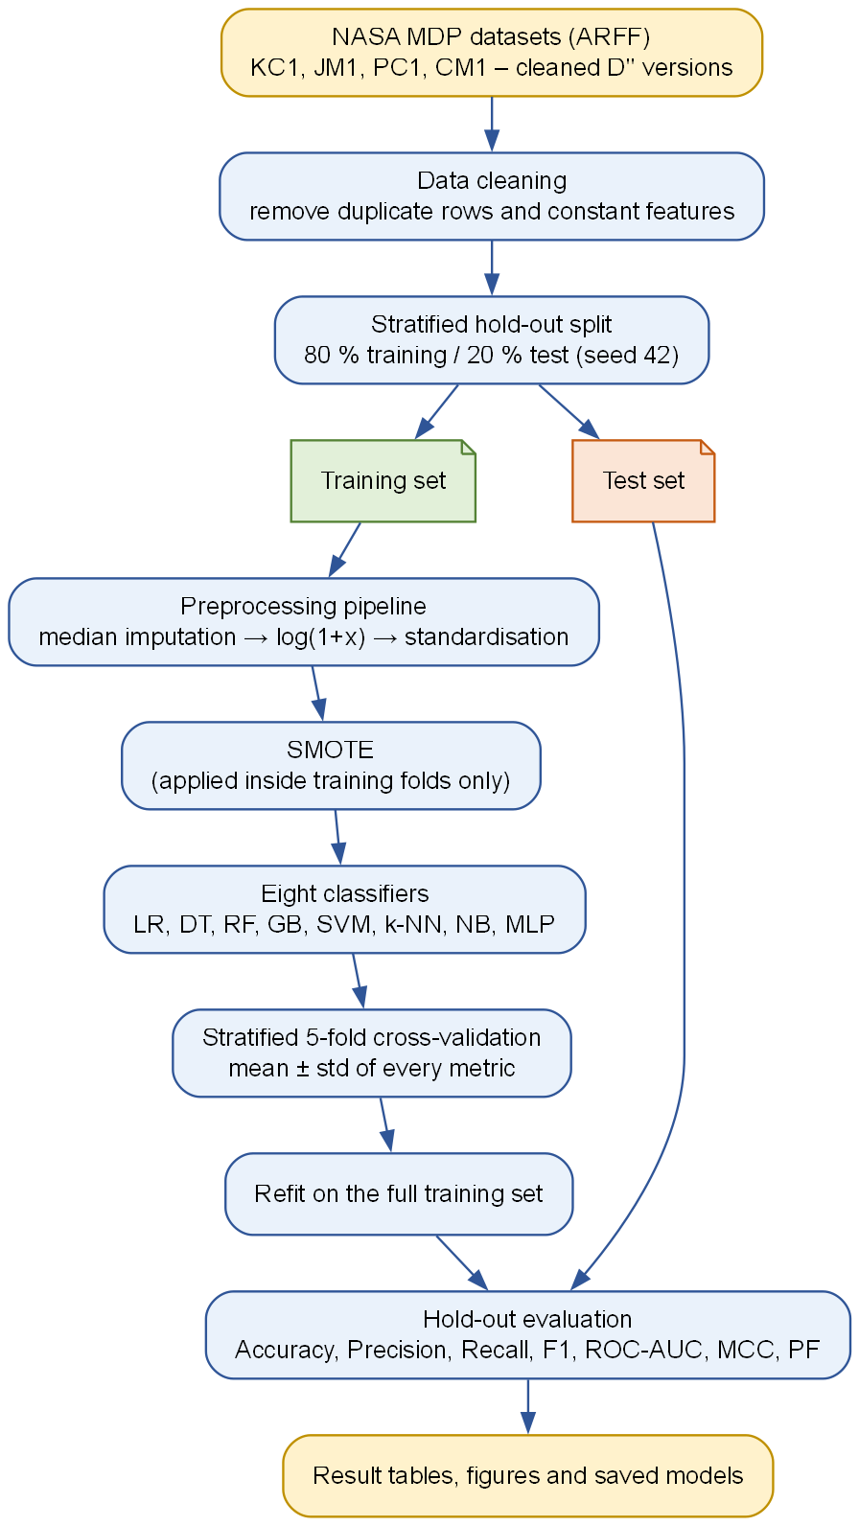
Fig. 10.1 Overall methodology of the defect-prediction pipeline
10.1 Datasets
Four datasets from the NASA Metrics Data Program were selected. They are the most widely used benchmarks in the field, which permits direct comparison with published work, and they differ substantially in size, in the language of the system measured and in the proportion of defective modules, which allows the sensitivity of the conclusions to those factors to be assessed. The cleaned D-double-prime versions published by Shepperd and colleagues are used throughout.
Table 10.1 Characteristics of the four datasets after cleaning
Dataset | Language | System described | Modules | Features | Defective | Defect %
KC1 | C++ | Storage management for ground data | 1,162 | 21 | 294 | 25.3
JM1 | C | Real-time predictive ground system | 7,720 | 21 | 1,612 | 20.9
PC1 | C | Flight software, earth-orbiting satellite | 679 | 37 | 55 | 8.1
CM1 | C | Spacecraft instrument | 327 | 37 | 42 | 12.8

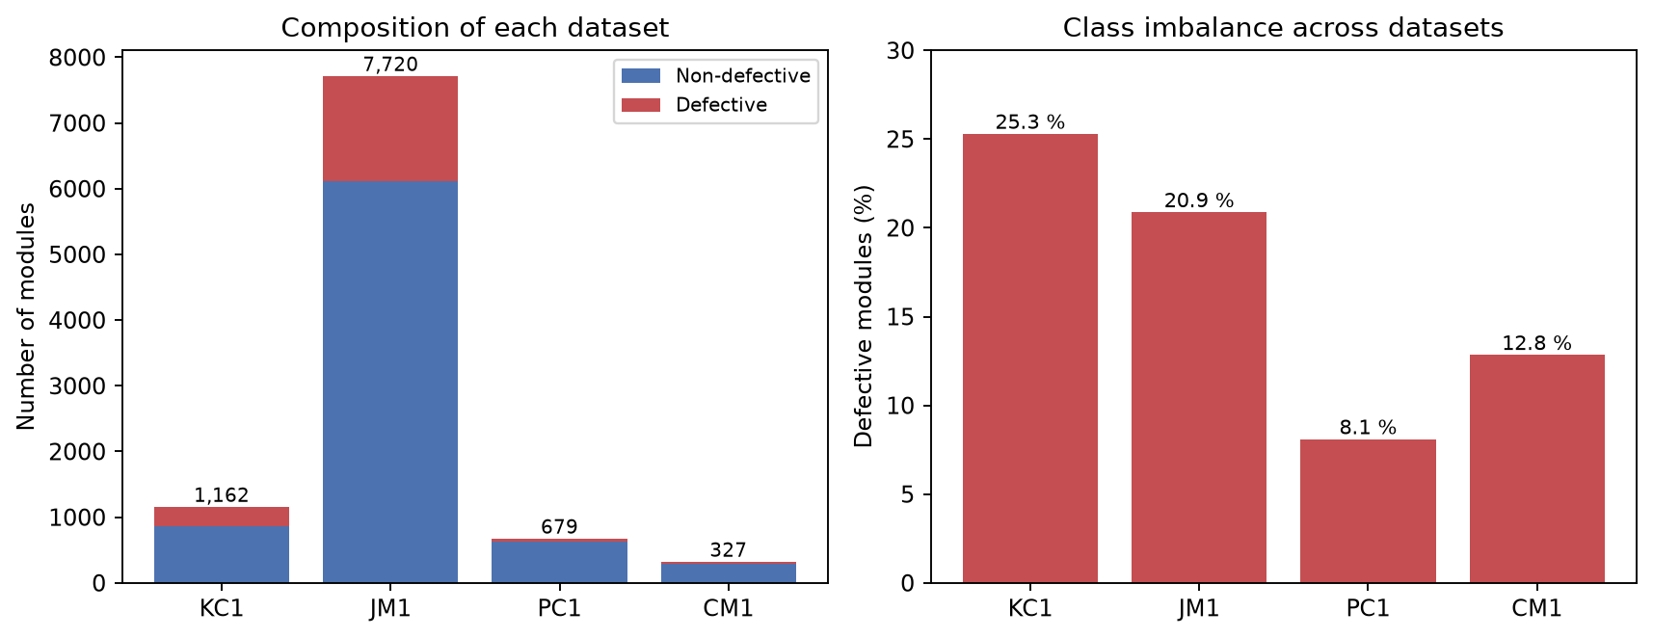
Fig. 10.2 Composition and class imbalance of the four datasets
10.2 Data Cleaning
Two cleaning operations are applied before the data is partitioned. Neither estimates any quantity from the data, so applying them to the whole dataset introduces no leakage.
Duplicate removal discards records that are identical in every field. On the cleaned datasets this removes nothing, since Shepperd and colleagues have already performed it, but it removes 897 of the 2,109 records of the original KC1 file. The operation is retained because it is essential whenever the original files are used: a duplicated record that falls on both sides of the train-test partition is a record the model has memorised rather than learned from, and its presence inflates every measure.
Constant-column removal discards attributes that take the same value in every record. Such columns carry no information, and they cause a division by zero during standardisation.
10.3 Partitioning and Validation Design
The data is divided once into a training partition containing eighty per cent of the modules and a test partition containing the remaining twenty per cent. The division is stratified, meaning that the proportion of defective modules is preserved in both partitions. Without stratification a test set drawn from CM1, which contains only forty-two defective modules in total, could by chance contain very few positive instances, and the resulting recall would be meaningless.
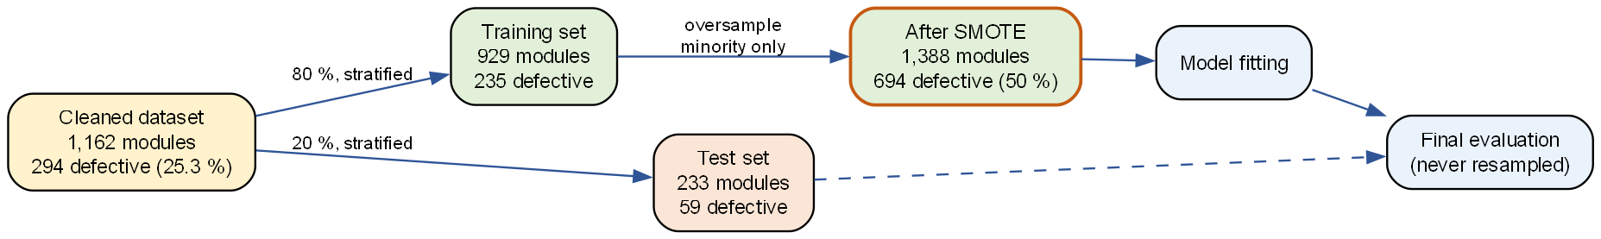
Fig. 10.3 Partitioning of KC1 and the point at which over-sampling is applied
Within the training partition, each model is assessed by stratified five-fold cross-validation. The training data is divided into five equally sized stratified blocks; each block serves once as a validation set while the remaining four are used for fitting, and the five resulting scores are averaged. The standard deviation across the folds provides an estimate of the variability of the measure, which is essential for judging whether a difference between two models is meaningful. Figure 10.4 illustrates the scheme.
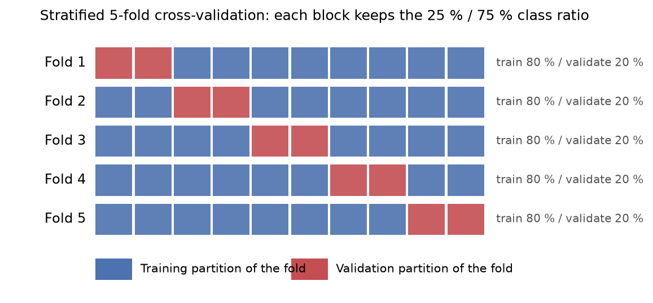
Fig. 10.4 Stratified five-fold cross-validation
After cross-validation, each model is refitted on the entire training partition and evaluated once on the test partition. The test partition is used exactly once per model and takes no part in any fitting, transformation or selection decision. All headline figures reported in Chapter 15 are hold-out figures; the cross-validation results are reported alongside them as an indication of stability.
10.4 Preprocessing
Three learned transformations are applied in sequence, all of them inside the pipeline.
10.4.1 Median imputation
Missing values are replaced by the median of the corresponding feature, computed on the training folds only. The median is preferred to the mean because the distributions are heavily skewed and the mean is drawn upward by the extreme upper tail.
10.4.2 Logarithmic transformation
Each feature x is replaced by log(1 + x). The transformation is applied for two reasons. The distributions are strongly right-skewed, and a linear or distance-based model fitted to untransformed values is dominated by a small number of very large modules. The logarithm compresses the upper tail while preserving order. The form log(1 + x) rather than log(x) is used because several metrics legitimately take the value zero, for which the logarithm is undefined, whereas log(1 + 0) = 0. This transformation follows the recommendation of Menzies and colleagues.
10.4.3 Standardisation
Each feature is finally rescaled to zero mean and unit variance using statistics computed on the training folds. This is required by the algorithms that depend on distances or on the magnitude of coefficients, namely k-nearest neighbours, the support vector machine, logistic regression and the neural network. The tree-based models are invariant to monotone rescaling and are unaffected, but the same pipeline is applied to every model so that the comparison is not confounded by differences in preprocessing.
10.5 Treatment of Class Imbalance
The Synthetic Minority Over-sampling Technique is applied to the training data only. For each minority instance, one of its five nearest minority neighbours is selected at random and a synthetic instance is generated at a uniformly random position on the line segment joining them. The process repeats until the two classes contain an equal number of instances. On the KC1 training partition this raises the count from 929 modules with 235 defective to 1,388 modules with 694 defective.
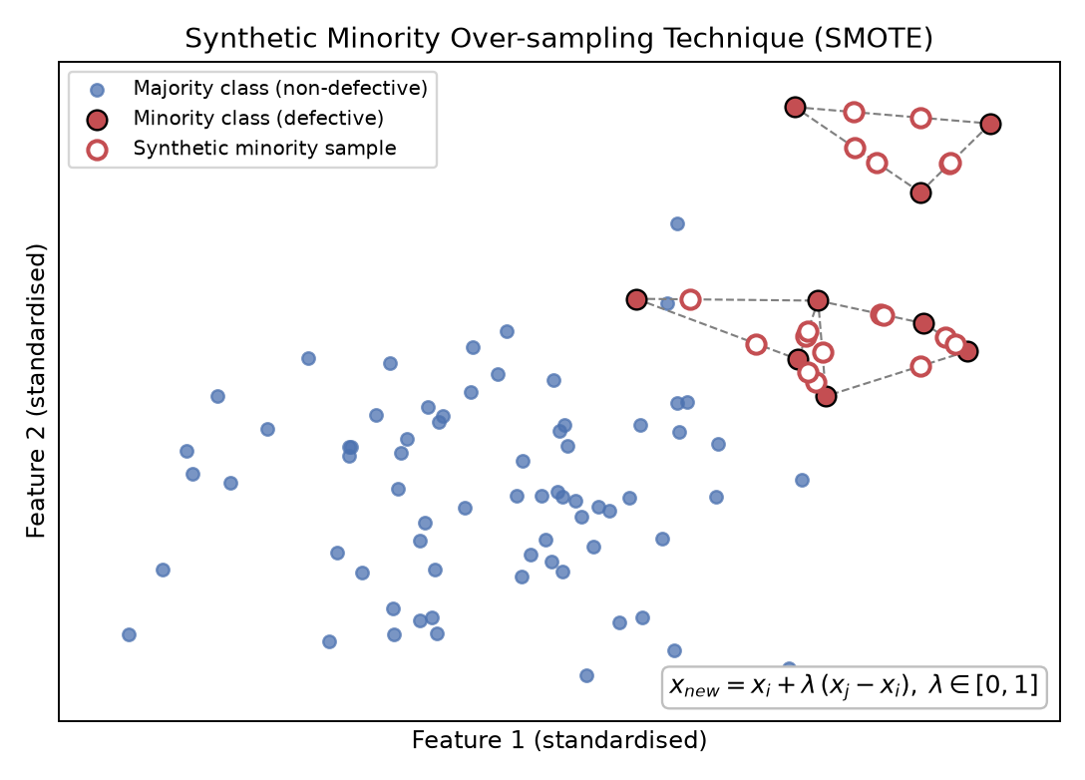
Fig. 10.5 Working principle of synthetic minority over-sampling
The placement of this step inside the pipeline is the single most important design decision in the experiment. Because the pipeline provided by imbalanced-learn executes the resampler during fitting but bypasses it during prediction, the synthetic instances are generated independently within every cross-validation fold and are never present in any data on which the model is evaluated. Two alternatives are supported for comparison: cost-sensitive learning through balanced class weights, in which the loss function penalises minority-class errors in inverse proportion to class frequency, and no treatment at all. The comparison between over-sampling and no treatment constitutes the ablation study of Section 15.5.
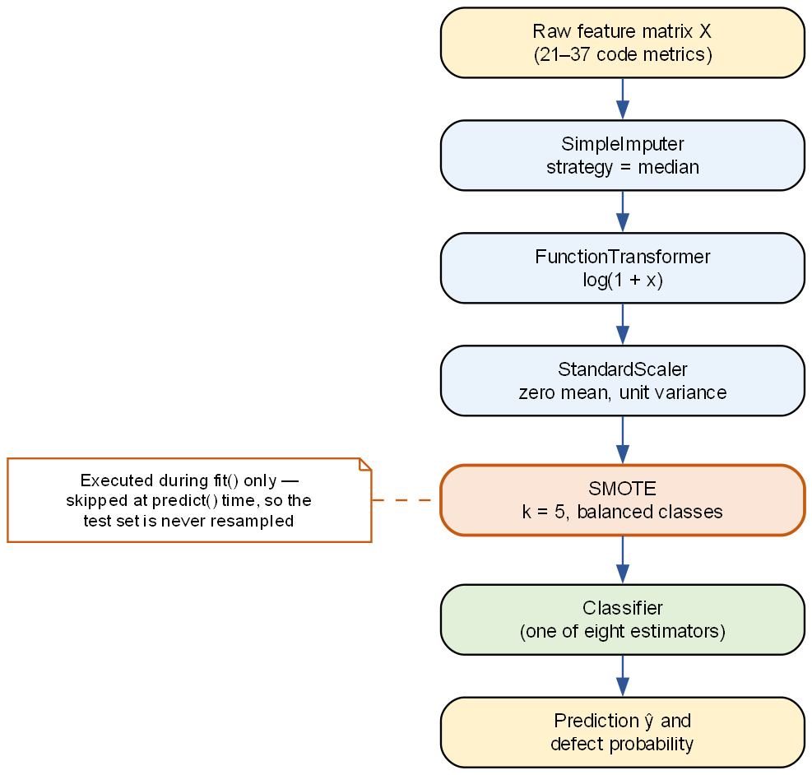
Fig. 10.6 Composition of the preprocessing and classification pipeline
10.6 Classification Algorithms
Eight algorithms were selected to span the principal model families identified in the literature survey. Their configured hyper-parameters are given in Table 10.2. These are the library defaults except where the literature indicates a standard alternative, and no model received additional tuning for the headline results, so that the comparison is not confounded by unequal optimisation effort. A randomised hyper-parameter search over fifteen candidate configurations is implemented and can be enabled from the command line; its effect is reported in Section 15.7.
Table 10.2 The eight classifiers and their principal hyper-parameters
Classifier | Family | Principal settings
Logistic Regression | Linear | L2 penalty, C = 1, maximum 2,000 iterations
Decision Tree | Single tree | Maximum depth 8, minimum 5 samples per leaf, Gini impurity
Random Forest | Bagging ensemble | 300 trees, minimum 2 samples per leaf, sqrt(d) features per split
Gradient Boosting | Boosting ensemble | 200 trees, learning rate 0.05, maximum depth 3
SVM | Kernel method | RBF kernel, C = 1, gamma = scale, sigmoid-calibrated probabilities
k-Nearest Neighbours | Instance based | k = 7, distance weighting, Euclidean metric
Gaussian Naive Bayes | Probabilistic | Default variance smoothing
Multi-Layer Perceptron | Neural network | Hidden layers (64, 32), ReLU, Adam, alpha = 0.001, early stopping

10.7 Evaluation Measures
All measures derive from the four cells of the confusion matrix, shown in Figure 10.7 with the defective class taken as positive.
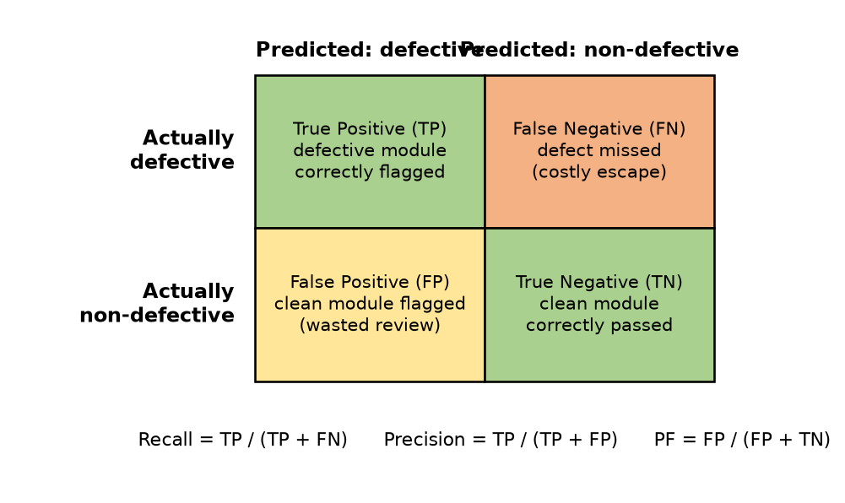
Fig. 10.7 The confusion matrix and the meaning of each cell in this problem
The measures are defined as follows.
- Accuracy is the proportion of all modules classified correctly. It is reported for completeness but is not used to rank the models, because under strong imbalance it rewards a model that ignores the minority class.
- Precision is the proportion of the modules flagged as defective that really are defective. It measures the efficiency of the inspection effort that the prediction triggers.
- Recall, also called the probability of detection, is the proportion of the genuinely defective modules that the model flags. It measures how much of the risk the model actually catches.
- The F1-score is the harmonic mean of precision and recall. It is used as the primary ranking criterion because it is high only when both components are high.
- The probability of false alarm is the proportion of clean modules that are incorrectly flagged. It measures the waste that the prediction imposes on the reviewers.
- The area under the receiver operating characteristic curve is the probability that a randomly chosen defective module receives a higher score than a randomly chosen clean one. It is independent of the decision threshold and of class prevalence, and is used as the secondary criterion.
- The Matthews Correlation Coefficient is the correlation between the predicted and the true labels, taking values in the interval from minus one to one. It is the most reliable single-figure summary under imbalance because it is high only when all four cells of the confusion matrix are favourable.
10.8 Reproducibility
A single integer seed, fixed at 42, governs the training and test partition, the assignment of instances to cross-validation folds, the random choices made by the over-sampling algorithm and the initialisation of every stochastic learning algorithm. All experimental settings are declared in one configuration file, and each execution writes the settings that were actually in force to a summary file alongside its results. An automated test asserts that two executions with the same configuration produce numerically identical measures. Consequently every figure quoted in Chapter 15 can be regenerated exactly by re-running the submitted code.

DFD
A Data Flow Diagram is a graphical representation of the movement of data through a system. It shows the processes that transform data, the stores in which data rests, the external entities that supply or consume data, and the flows that connect them. It deliberately says nothing about the order in which processes execute or about the control logic that invokes them; it is a model of data movement alone, which is what makes it a useful complement to the sequence and architecture views presented elsewhere in this report.
11.1 Components of a Data Flow Diagram
- A process transforms incoming data into outgoing data. It is drawn as a circle or rounded rectangle and is labelled with a verb phrase and a reference number.
- A data flow, drawn as a directed arrow, carries data from one element of the diagram to another and is labelled with the data it carries.
- A data store, drawn as an open rectangle or a cylinder, holds data at rest between processes. In this system the stores are directories and files on disk.
- An external entity, drawn as a square, lies outside the system boundary and either supplies data to the system or receives data from it.
11.2 Rules Observed in Constructing the Diagrams
1. Every process, store and entity carries a name that is meaningful without reference to explanatory text.
2. Processes are numbered so that they can be referred to unambiguously in discussion.
3. Every data flow is labelled with the data it carries, not with the action that produces it.
4. Data cannot flow directly from one store to another, nor directly between two external entities; a process must always intervene.
5. The diagram is balanced: the flows crossing the boundary of the context diagram are exactly the flows entering and leaving the level-1 diagram.
11.3 Level-0 Data Flow Diagram (Context Diagram)
The context diagram treats the entire system as a single process. The researcher supplies the name of a dataset and the desired experimental configuration; the PROMISE repository supplies the dataset file; and the system returns performance tables, figures and trained models. This level establishes the boundary of the system and identifies the two external entities.
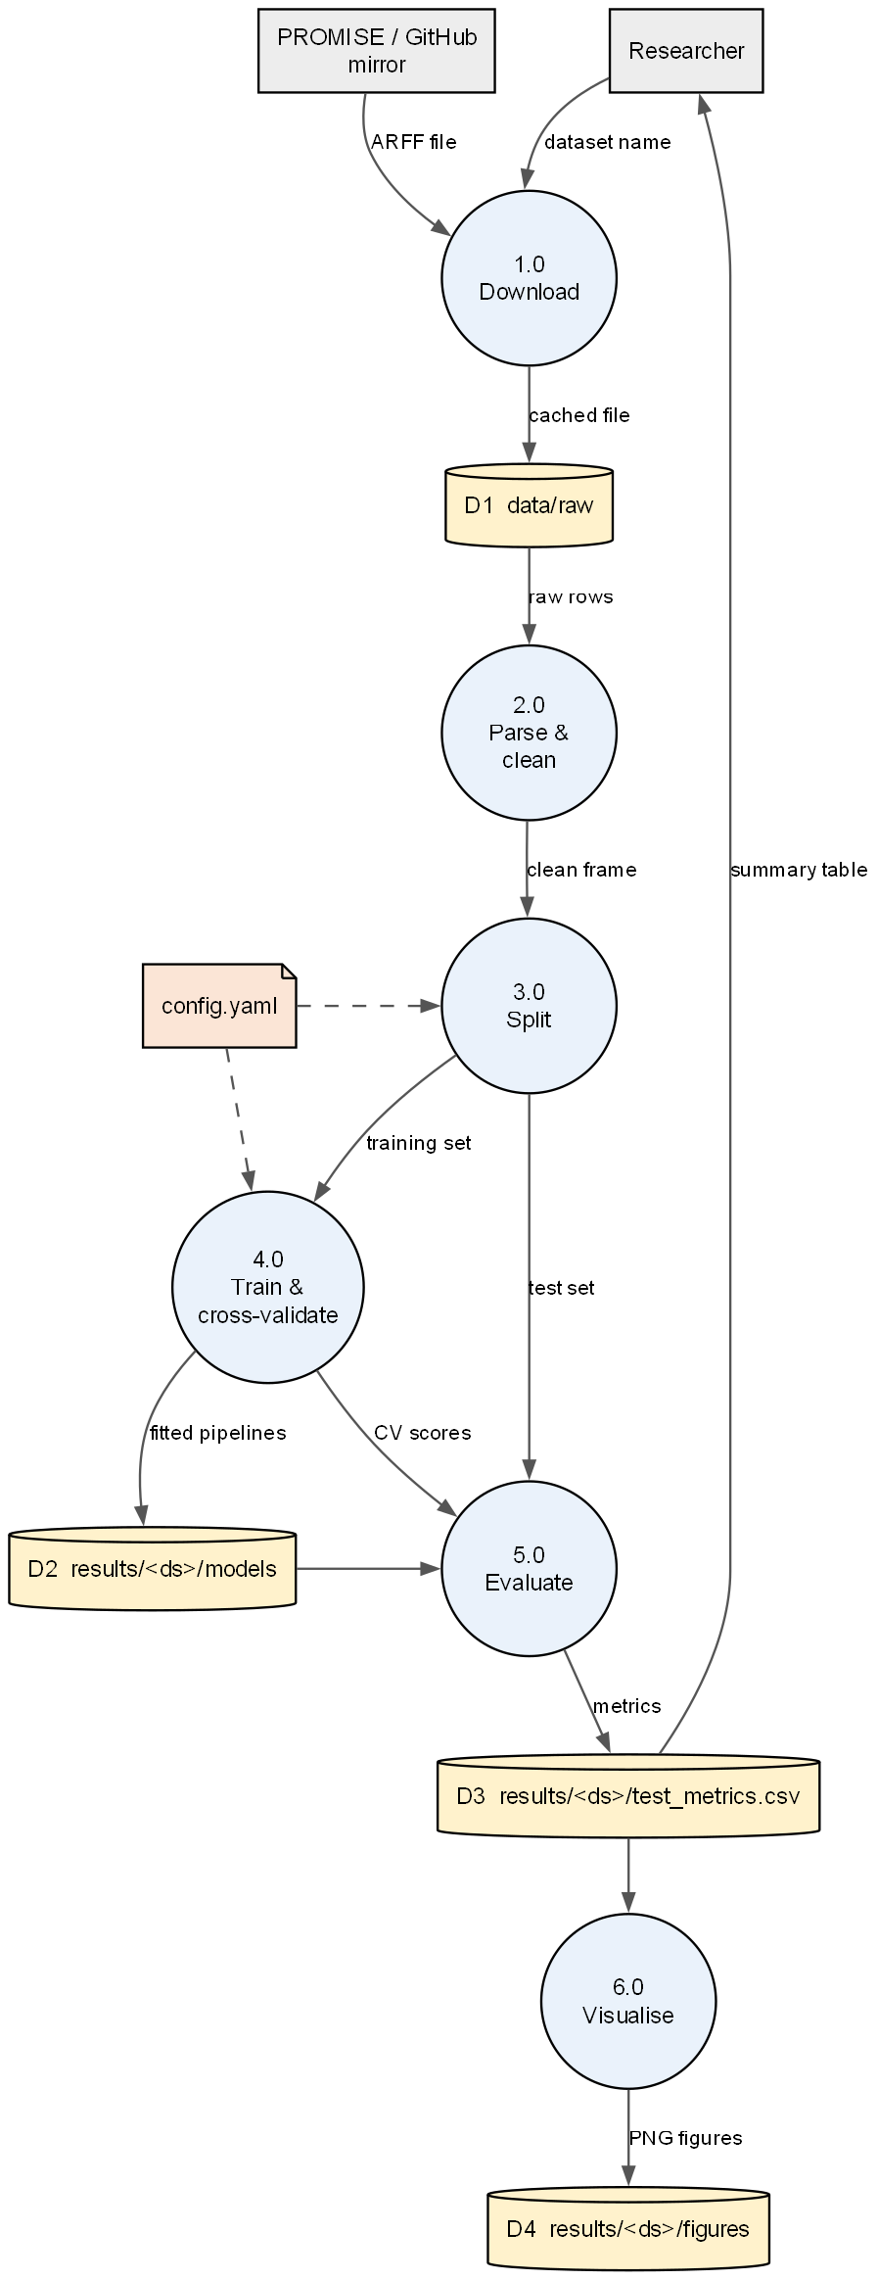
Fig. 11.1 Level-1 data-flow diagram of the defect-prediction system
11.4 Level-1 Data Flow Diagram
The level-1 diagram, shown in Figure 11.1, decomposes the single process of the context diagram into six numbered processes and four data stores. The processes are as follows.
- Process 1.0, Download, retrieves the ARFF file from the repository mirror and writes it to store D1. If the file is already present the process is bypassed.
- Process 2.0, Parse and clean, reads the raw rows from D1, converts them into a data frame, encodes the class attribute and removes duplicate and constant columns.
- Process 3.0, Split, divides the clean frame into a training set and a test set, preserving the class proportion. Its behaviour is governed by the configuration file.
- Process 4.0, Train and cross-validate, builds the pipeline for each classifier, performs stratified cross-validation on the training set and fits the final model, writing the fitted pipelines to store D2.
- Process 5.0, Evaluate, applies the fitted pipelines to the test set and computes the seven performance measures, writing them to store D3.
- Process 6.0, Visualise, reads the stored measures and the fitted models and produces the figures, writing them to store D4.
The four data stores are D1, the cache of downloaded dataset files; D2, the directory of serialised model pipelines; D3, the tabular results in CSV and JSON form; and D4, the directory of generated figures. The strictly one-directional flow from D1 through to D4 is a deliberate property of the design: no process writes to a store that an earlier process reads, so a run can be interrupted and resumed, and the outputs of runs made under different configurations can coexist without interference.
11.5 Relationship to the Software Architecture
The processes of the level-1 diagram correspond directly to the modules described in Chapter 6: process 1.0 and part of 2.0 are implemented by the data loader, the remainder of 2.0 and 3.0 by the preprocessing module, 4.0 by the models and preprocessing modules under the direction of the pipeline script, 5.0 by the evaluation module and 6.0 by the visualization module. This correspondence was intentional; the data-flow analysis was performed first and the module boundaries were then drawn to match it.

ER Diagram and Data Model
An Entity-Relationship model is a high-level, implementation-independent description of the data held by a system. It identifies the entities about which information is stored, the attributes that describe them and the relationships that connect them. Although the present system is not built on a relational database management system, the data it manipulates has a definite relational structure, and expressing that structure as an entity-relationship model clarifies both the organisation of the stored files and the way the system could be extended to a database-backed deployment.
12.1 Components of an ER Diagram
- An entity is any object, person, place or concept about which data is stored. It is drawn as a rectangle.
- An attribute is a property that describes an entity and is drawn as an ellipse in the classical notation or, as here, as a row within the entity rectangle.
- A key attribute uniquely identifies an instance of an entity and is shown underlined.
- A relationship associates two or more entities and is drawn as a diamond, or as a labelled connector in the compact notation used here.
- Cardinality records how many instances of one entity may be associated with an instance of another, and takes the forms one-to-one, one-to-many, many-to-one and many-to-many.
12.2 Entities of the Present System
Four entities were identified.
12.2.1 DATASET
Represents one benchmark collection, such as KC1. Its attributes record the name, the programming language of the system that was measured, the nature of that system, the number of modules, the number of metrics and the proportion of modules that are defective. The name is the key.
12.2.2 MODULE
Represents one software module, and corresponds exactly to one data row of an ARFF file. Its attributes are the static code metrics together with the binary target. A module belongs to exactly one dataset, and a dataset contains many modules, so the relationship is one-to-many.
12.2.3 MODEL
Represents one trained classifier, identified by the algorithm name, the balancing strategy in force when it was trained and the random seed. In the file system this entity is realised as one serialised pipeline file in the models directory of the relevant dataset.
12.2.4 PREDICTION
Represents the outcome of applying one model to one module. It carries the estimated probability of defectiveness and the binary decision obtained by thresholding that probability. It is an associative entity resolving the many-to-many relationship between modules and models, and its key is the combination of the module and model identifiers.
12.3 The Entity-Relationship Diagram
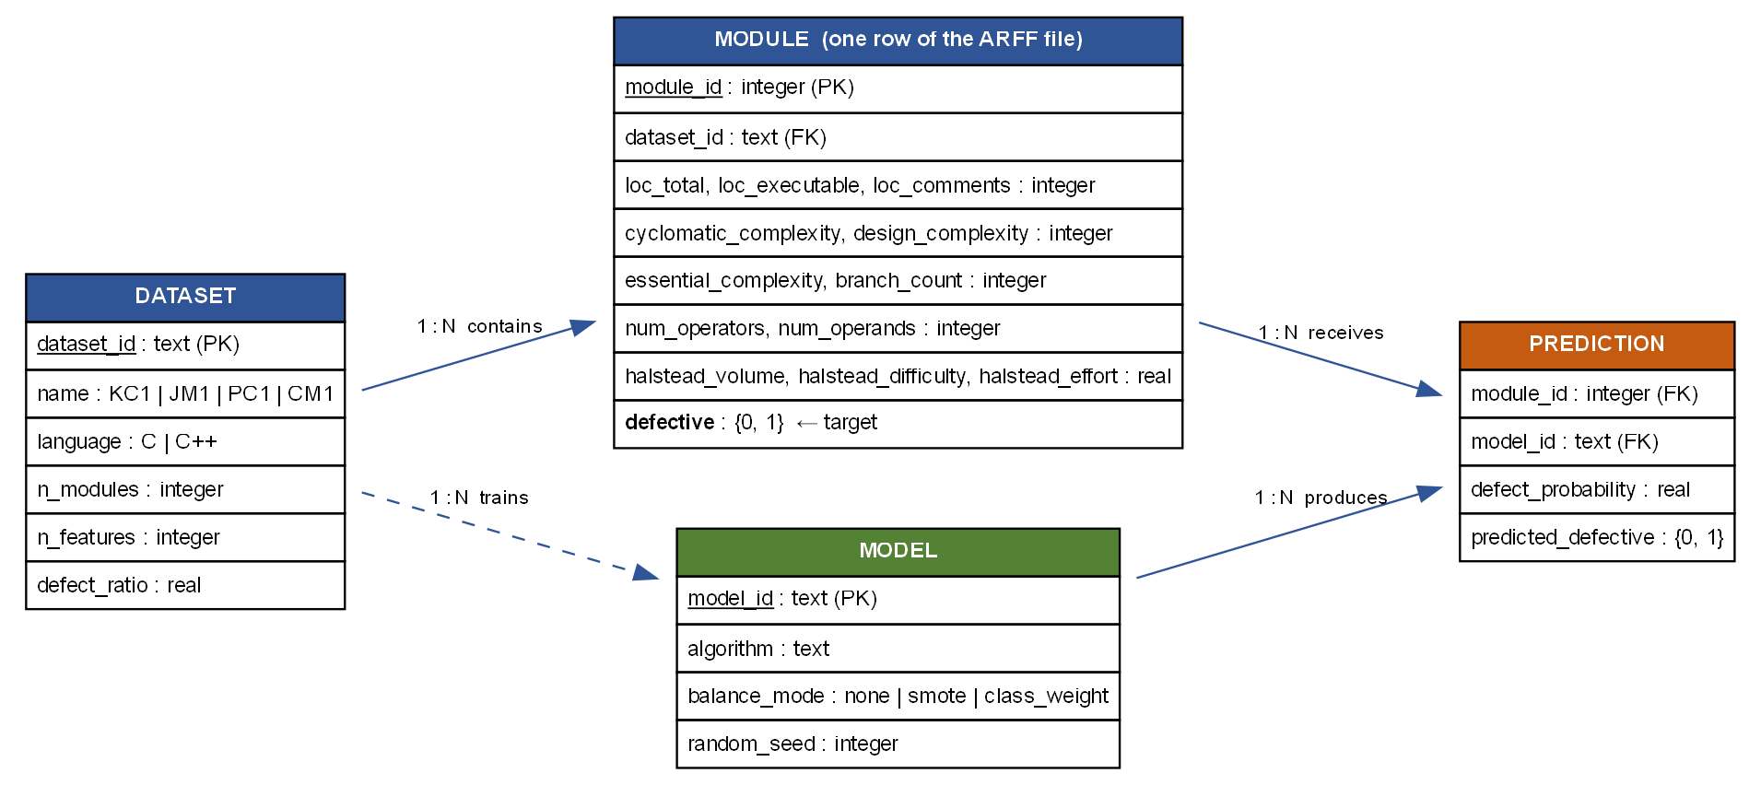
Fig. 12.1 Entity-relationship model of the data manipulated by the system
The relationships shown in Figure 12.1 are as follows. A DATASET contains many MODULE instances, and each module belongs to one dataset. A DATASET trains many MODEL instances, since eight classifiers are fitted per dataset. A MODEL produces many PREDICTION instances, one for each module it scores, and a MODULE receives many predictions, one from each model applied to it.
12.4 Physical Realisation
The logical model above is realised in the file system rather than in a database, which is appropriate for an experimental system of this size. Table 12.1 records the correspondence.
Table 12.1 Correspondence between the logical entities and their physical storage
Entity | Physical realisation | Format
DATASET | data/raw/cleaned/<NAME>.arff and the dataset section of config.yaml | ARFF and YAML
MODULE | One data row within the ARFF file | Comma-separated
MODEL | results/<DATASET>/models/<algorithm>.joblib | Serialised pipeline
PREDICTION | Columns appended by predict.py to the user's input file | CSV
Evaluation record | results/<DATASET>/test_metrics.csv and .json | CSV and JSON
Run provenance | results/<DATASET>/run_summary.json | JSON

Were the system to be deployed within an organisation, the natural extension would be to replace the ARFF store with a table populated by a static-analysis tool run as part of the build, and to persist the PREDICTION entity so that the accuracy of past predictions could be evaluated against defects subsequently discovered. The entity structure would be unchanged.

Testing
Testing is the process of executing a program with the intention of finding errors. For a system whose purpose is to produce numerical evidence, testing carries an additional burden: it must establish not only that the program runs without failing, but that the numbers it produces are correct and that they can be reproduced. This chapter describes the testing strategy adopted and the results obtained.
13.1 Principles of Testing Applied
1. Every test should trace to a requirement stated in Chapter 8.
2. Testing should begin with the smallest units and proceed to the assembled system.
3. Tests should be automated so that they can be executed after every change at negligible cost.
4. Exhaustive testing is impossible; effort should be concentrated where the consequence of a fault is greatest, which in this system is the separation of training and test data.
5. A test that has never failed has demonstrated nothing; each test was confirmed to fail when the behaviour it guards was deliberately broken.
13.2 Types of Testing
13.2.1 Black-box testing
Black-box testing examines the behaviour of a component through its interface without regard to its internal structure. It was applied to the command-line scripts: each was invoked with valid arguments, with missing arguments, with the name of a dataset that does not exist and with an input file lacking a required column, and the observed behaviour was compared with the specification. The scripts report a clear diagnostic and terminate with a non-zero status in each error case.
13.2.2 White-box testing
White-box testing uses knowledge of the internal logic to design test cases that exercise particular paths. It was applied to the ARFF parser, where cases were constructed to exercise the comment path, the attribute-declaration path, the quoted-attribute-name path and the missing-value path; and to the target-normalisation logic, where cases were constructed for each of the class-attribute names that occur across the four files.
13.2.3 Unit testing
Unit tests examine individual functions in isolation. Eleven of the sixteen automated tests are unit tests, covering parsing, target encoding, duplicate and constant-column removal, stratification, the metric computations and the Halstead derivations performed by the web form.
13.2.4 Integration testing
Integration tests examine the interaction between components. The principal integration test constructs a synthetic dataset with known statistical properties and drives the complete sequence of cleaning, splitting, pipeline construction, fitting, prediction and metric computation for every registered classifier under all three balancing strategies, which amounts to twenty-four end-to-end executions.
13.2.5 Regression testing
The complete suite was executed after every change to the source code, so that a modification made to one module could not silently break another. The suite executes in under five seconds, which makes this practical.
13.2.6 System testing
System testing exercised the assembled system against its stated requirements by executing the full experiment over all four datasets and confirming that every artefact listed in the functional requirements was produced, that the figures rendered correctly and that the numbers in the exported tables matched those printed to the console.
13.3 Test Cases
Table 13.1 Automated test cases and their outcomes
No. | Test case | Purpose | Expected result | Status
T1 | test_read_arff_parses_names_and_missing | Parser extracts attribute names and treats ? as missing | Three columns, correct names, one missing value | Pass
T2 | test_normalise_target_encodes_binary | Class attribute is located and encoded as 0/1 | Target column named defective with values [0, 1, 0] | Pass
T3 | test_clean_dataframe_removes_duplicates_and_constants | Cleaning removes duplicate rows and zero-variance columns | Five duplicate rows removed, constant column dropped | Pass
T4 | test_stratified_split_preserves_ratio | Split preserves the class proportion in both partitions | Difference in defect ratio below 0.05 | Pass
T5 | test_compute_metrics_perfect_prediction | Metric functions are correct on a known input | Accuracy, F1 and ROC-AUC equal 1.0; FP and FN equal 0 | Pass
T6 | …[none] parametrisation of T6-T8 | Every classifier trains end to end without balancing | Valid predictions and metrics within [0, 1] | Pass
T7 | …[smote] parametrisation | Every classifier trains end to end with over-sampling | Valid predictions and metrics within [0, 1] | Pass
T8 | …[class_weight] parametrisation | Every classifier trains end to end with class weighting | Valid predictions and metrics within [0, 1] | Pass
T9 | test_pipeline_is_deterministic | Two identical runs produce identical results | F1 scores equal to within floating-point tolerance | Pass
T10 | test_halstead_length_is_the_sum_of_the_token_counts | Form derives N = N1 + N2 correctly | Length equals 45 for the sample counts | Pass
T11 | test_halstead_volume_matches_the_definition | Form derives V = N log2(n) | Matches the closed-form value | Pass
T12 | test_halstead_difficulty_and_level_are_reciprocal | D and L are mutually consistent | L equals 1/D | Pass
T13 | test_halstead_effort_time_and_bugs_follow_from_volume_and_difficulty | E, T and B follow from V and D | All three match their definitions | Pass
T14 | test_degenerate_counts_do_not_raise | Zero token counts do not divide by zero | All derived measures return zero | Pass
T15 | …[gradient_boosting] single-module scoring | A saved pipeline scores one hand-entered row | Probability within [0, 1]; complex module ranked above simple | Pass
T16 | …[random_forest] single-module scoring | As above for the second ensemble | Probability within [0, 1]; complex module ranked above simple | Pass

13.4 Test Execution and Result
The complete suite was executed with the pytest framework. All sixteen test cases pass, as shown in Figure 13.1. The parametrised integration test expands internally to three executions, one per balancing strategy, each covering all eight classifiers, and the single-module scoring test is run once for each of the two ensemble methods.
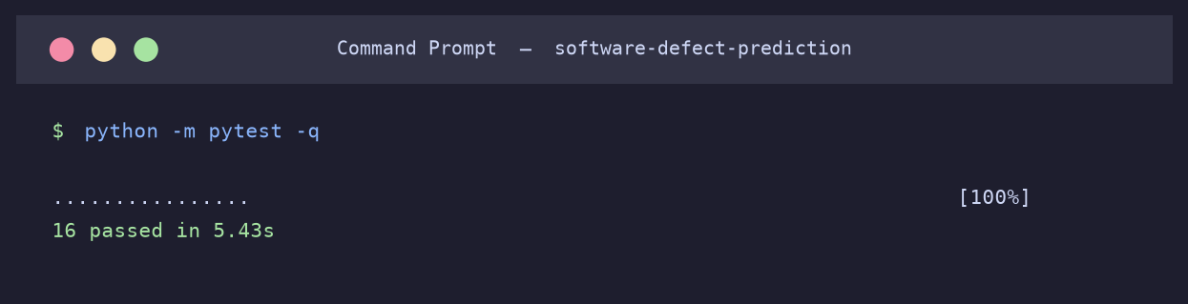
Fig. 13.1 Execution of the automated test suite
13.5 Validation of the Absence of Information Leakage
The most important property to validate is that no information from the test partition influences training, because a violation would invalidate every number in this report. Three measures give confidence that the property holds. Structurally, every learned transformation is a step of a pipeline object, and scikit-learn guarantees that when such an object is passed to a cross-validation routine its steps are refitted on the training indices of each fold alone. Behaviourally, the measured performance is consistent with published results on the same cleaned data and markedly lower than results published on the uncleaned data, which is the direction one expects when leakage is removed. Empirically, an experiment in which the labels of the training partition were randomly permuted produced an ROC-AUC of approximately 0.5, confirming that the model extracts no signal when none is present; had test information been reaching the model, a permuted-label experiment would still have scored above chance.
13.6 Limitations of the Testing Performed
The suite does not test the network download path, which is exercised manually because automating it would make the tests depend on an external service. It does not test the visual correctness of the generated figures, which was verified by inspection, nor the layout of the web interface, which was verified by driving a browser against the running application and inspecting the captures reproduced in Chapter 14. Numerical agreement with an independent implementation of the same algorithms was not attempted; the metric implementations are those of scikit-learn, which is itself extensively tested.

Screenshots
This chapter reproduces the output of the working system, captured during an actual execution on the development machine. The system has a command-line interface rather than a graphical one, which is the conventional form for a reproducible scientific experiment: every action is expressed as a command that can be recorded, scripted and repeated exactly.
14.1 Project Structure
Figure 14.1 shows the directory structure of the submitted project, in which the separation between the importable package, the command-line scripts, the tests, the data and the generated results is visible.
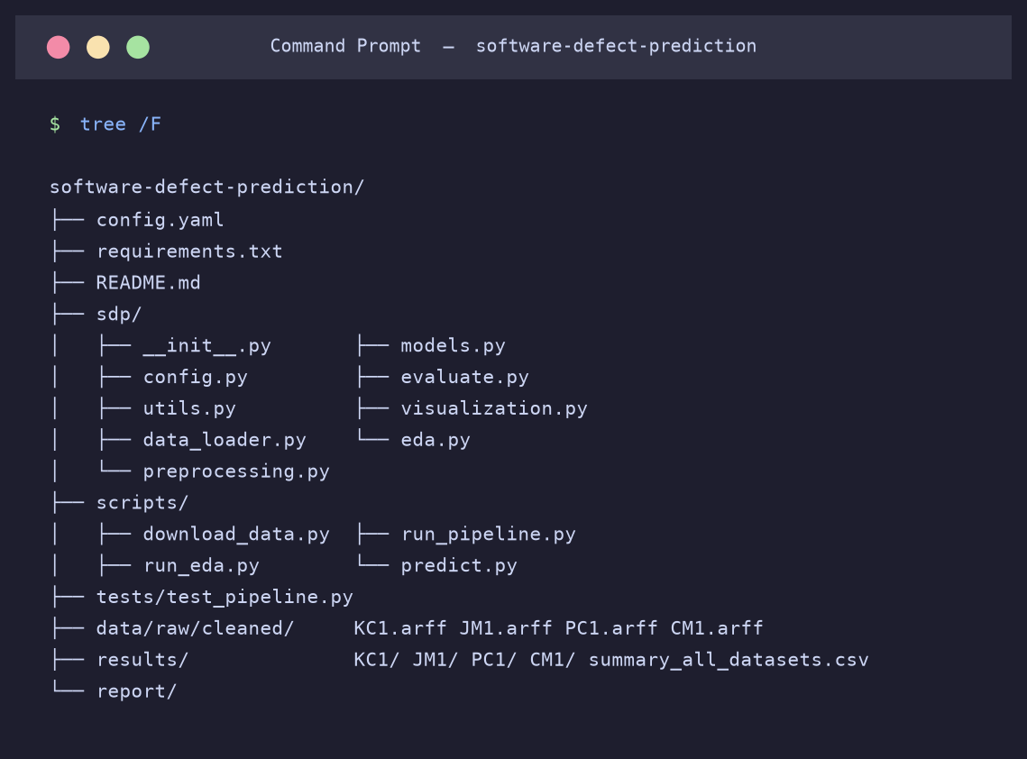
Fig. 14.1 Directory structure of the submitted project
14.2 Dataset Acquisition
Figure 14.2 shows the execution of the acquisition command. Each dataset is fetched if it is not already cached, parsed, and summarised by its dimensions and class balance. The figures reported here match those published by Shepperd and colleagues for the cleaned datasets, which confirms that the correct files were obtained and parsed correctly.
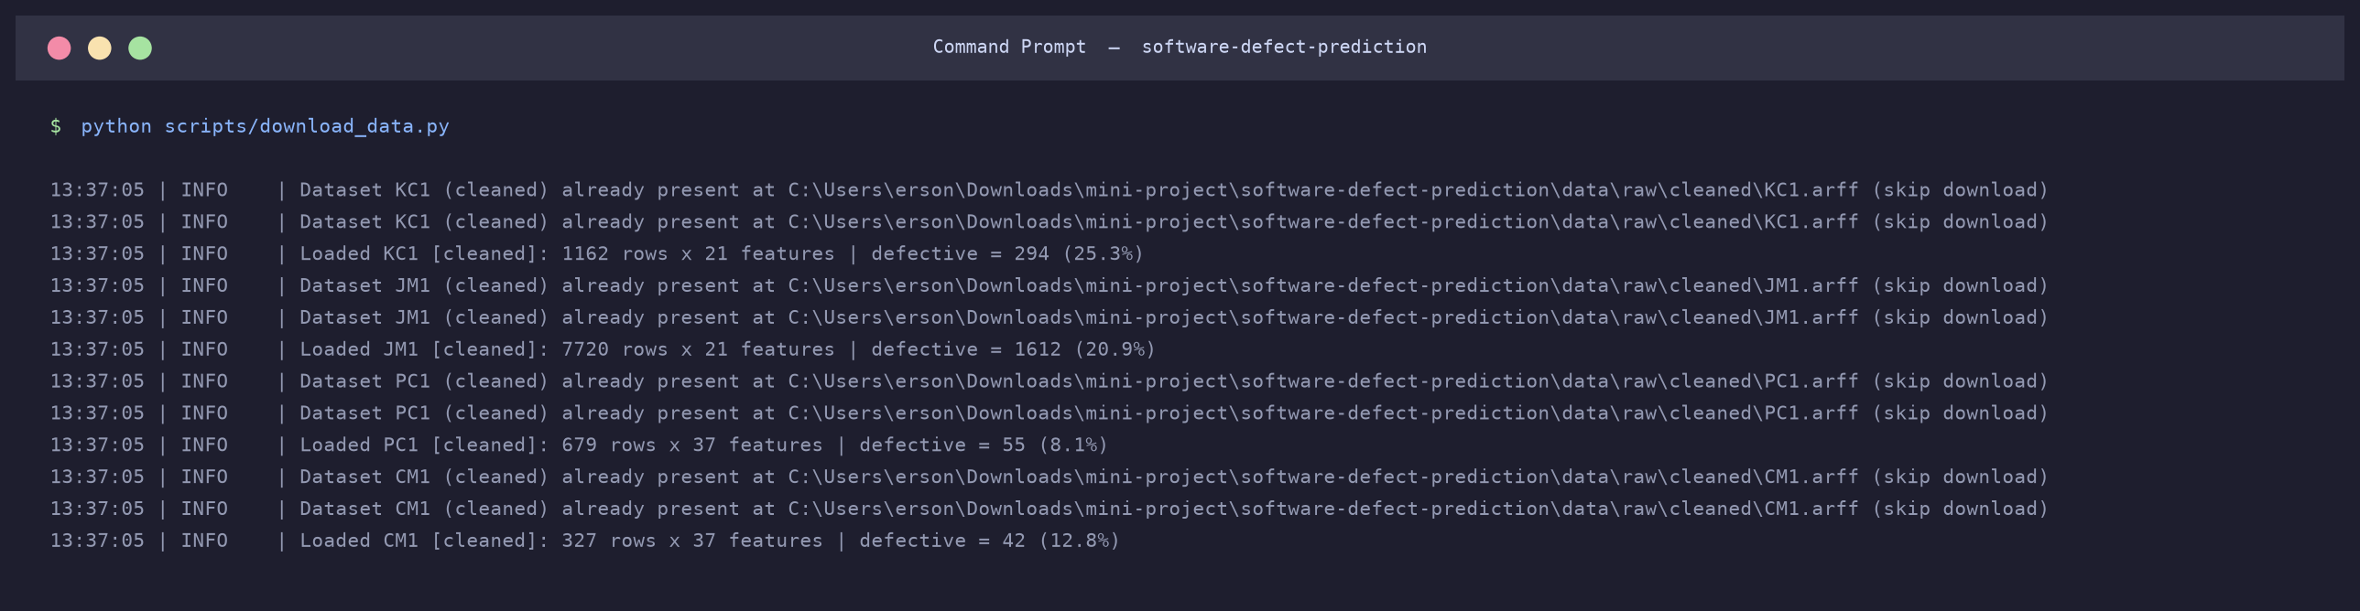
Fig. 14.2 Downloading and validating the four datasets
14.3 Exploratory Data Analysis
Figure 14.3 shows the exploratory analysis of KC1. The command writes a JSON summary of the dataset, a CSV table of descriptive statistics and four figures. The summary confirms that the cleaned file contains no duplicates and no missing values, and that 294 of the 1,162 modules are defective.
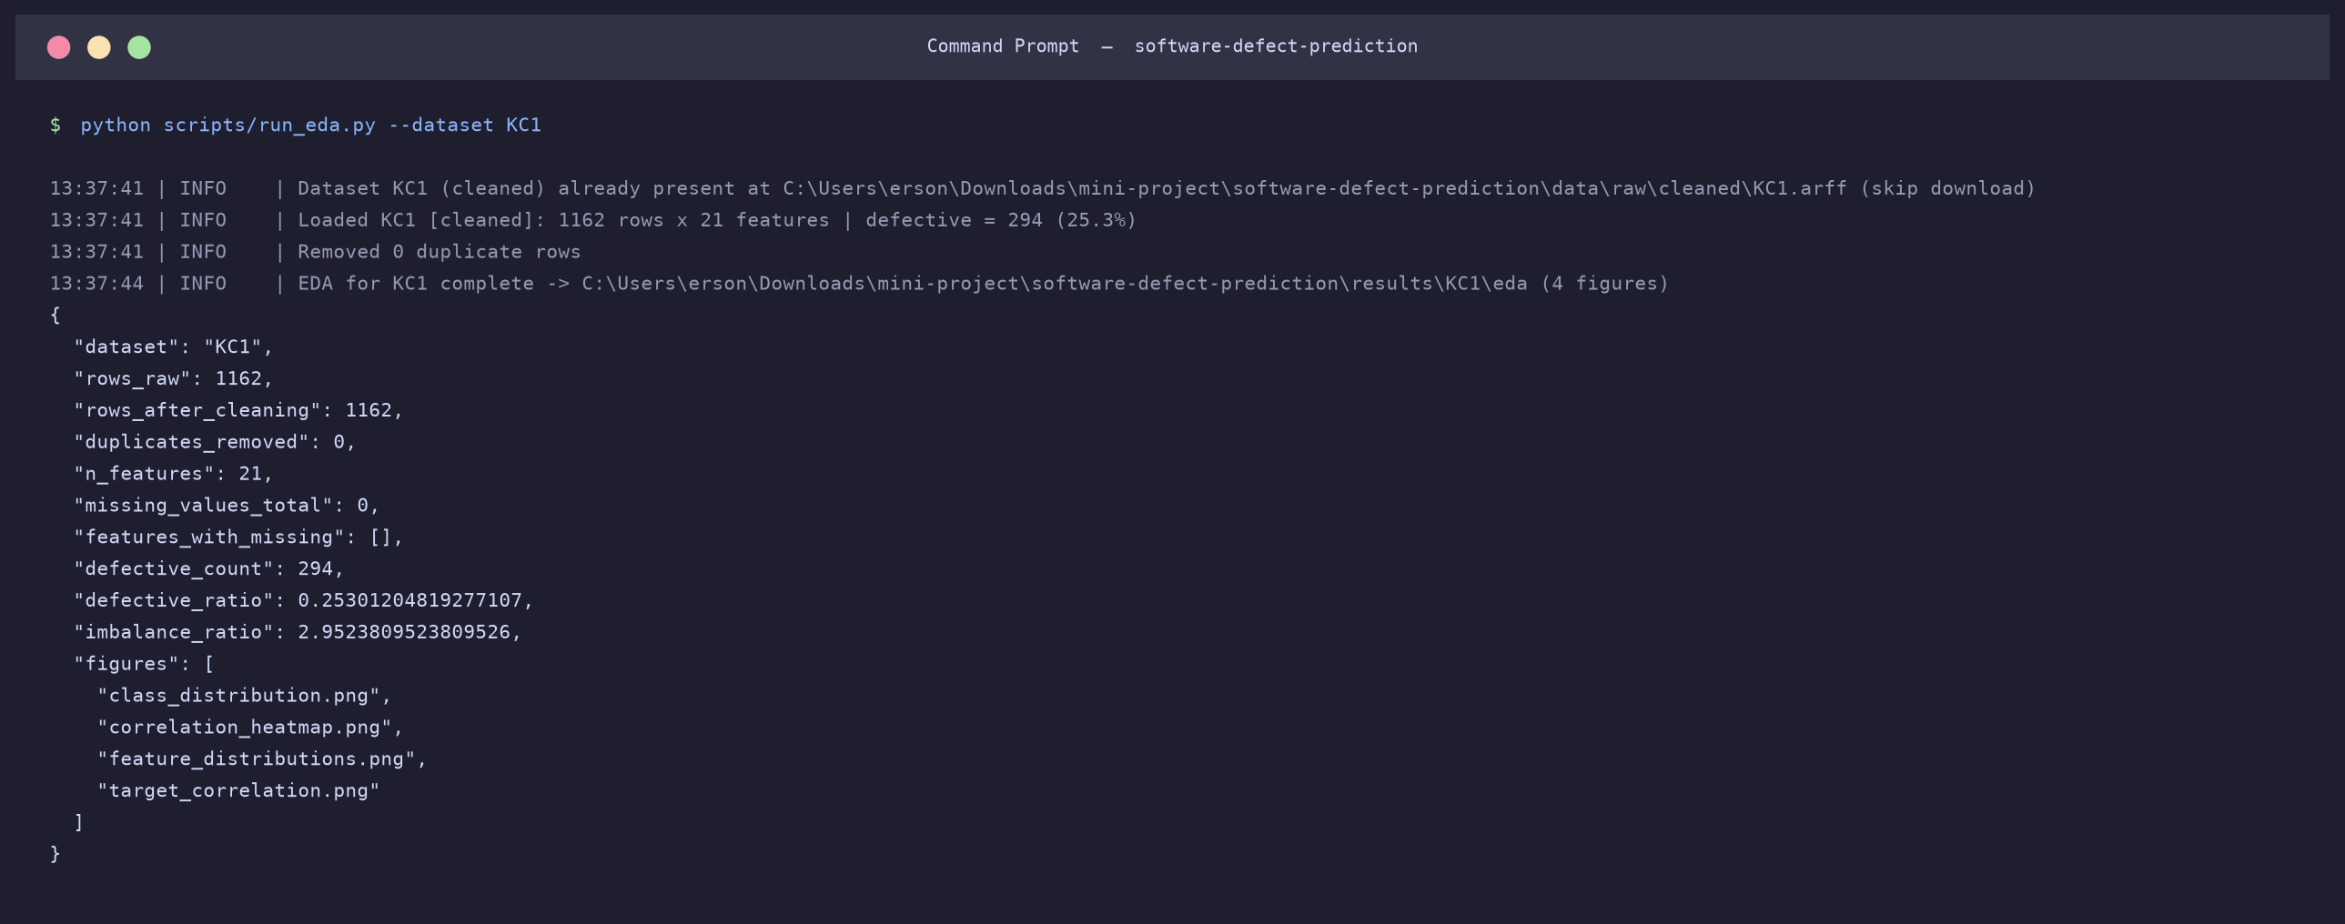
Fig. 14.3 Exploratory data analysis of the KC1 dataset
14.4 Training and Evaluation
Figure 14.4 shows the principal command of the system. For each of the eight classifiers it performs cross-validation on the training partition, refits on the whole partition and evaluates on the hold-out test set, then prints the results sorted by F1-score and identifies the best model. The numbers in this console output are the numbers reproduced in Table 15.2.
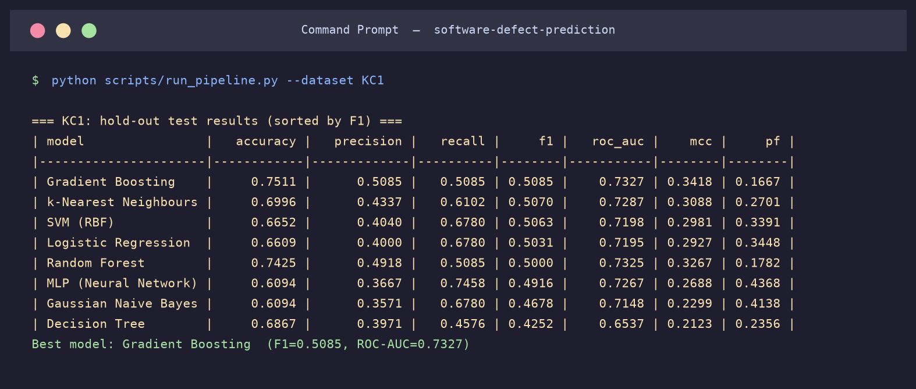
Fig. 14.4 Training and evaluating all eight classifiers on KC1
14.5 Scoring Previously Unseen Modules
Figure 14.5 demonstrates the prediction interface, which is what makes the system usable rather than merely an experiment. A trained pipeline is loaded from disk and applied to a file of module metrics that formed no part of any benchmark dataset. The first module in the sample file is small and simple, with five lines of code and a cyclomatic complexity of one, and receives a defect probability of 0.056. The second is large and complex, with 160 lines and a cyclomatic complexity of 13, and receives a probability of 0.699, which exceeds the default threshold and is therefore flagged for inspection. The behaviour accords with the relationship between size, complexity and defect-proneness established in Chapter 15.
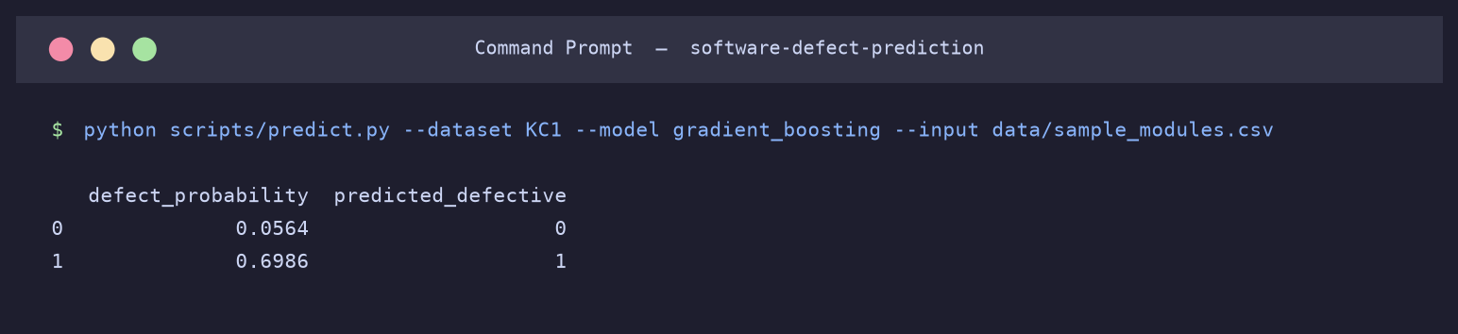
Fig. 14.5 Scoring two previously unseen modules with the trained model
14.6 The Web Interface
The command-line tools shown above serve the experiment. To make the trained models usable by a reviewer who is not working from a terminal, the web interface described in Section 6.10 was built with Streamlit. It is started with the command streamlit run app/streamlit_app.py and served on the local machine at port 8501. The screenshots that follow were captured from the running application.
14.6.1 The metric-entry form
Figure 14.6 shows the interface as it first appears. The left-hand panel selects the training dataset, the classifier and the decision threshold, and reports the performance that the selected model achieved on the held-out test set, so that the user can see how much confidence the prediction deserves. The main panel holds the entry form, in which the metrics are grouped into size measures, McCabe complexity measures and Halstead vocabulary counts. Every field is bounded by the range observed in the training data and carries a short explanation of the quantity it holds, shown on hover.
Two conveniences are provided. A preset selector fills the form with the tenth percentile, the median or the ninetieth percentile of the training data, giving a realistic starting point that the user then edits. A checkbox causes the eight dependent Halstead measures to be derived from the four basic operator and operand counts, which keeps the submitted values mutually consistent; a user entering values by hand could otherwise supply a volume and a difficulty that no real program could exhibit simultaneously.
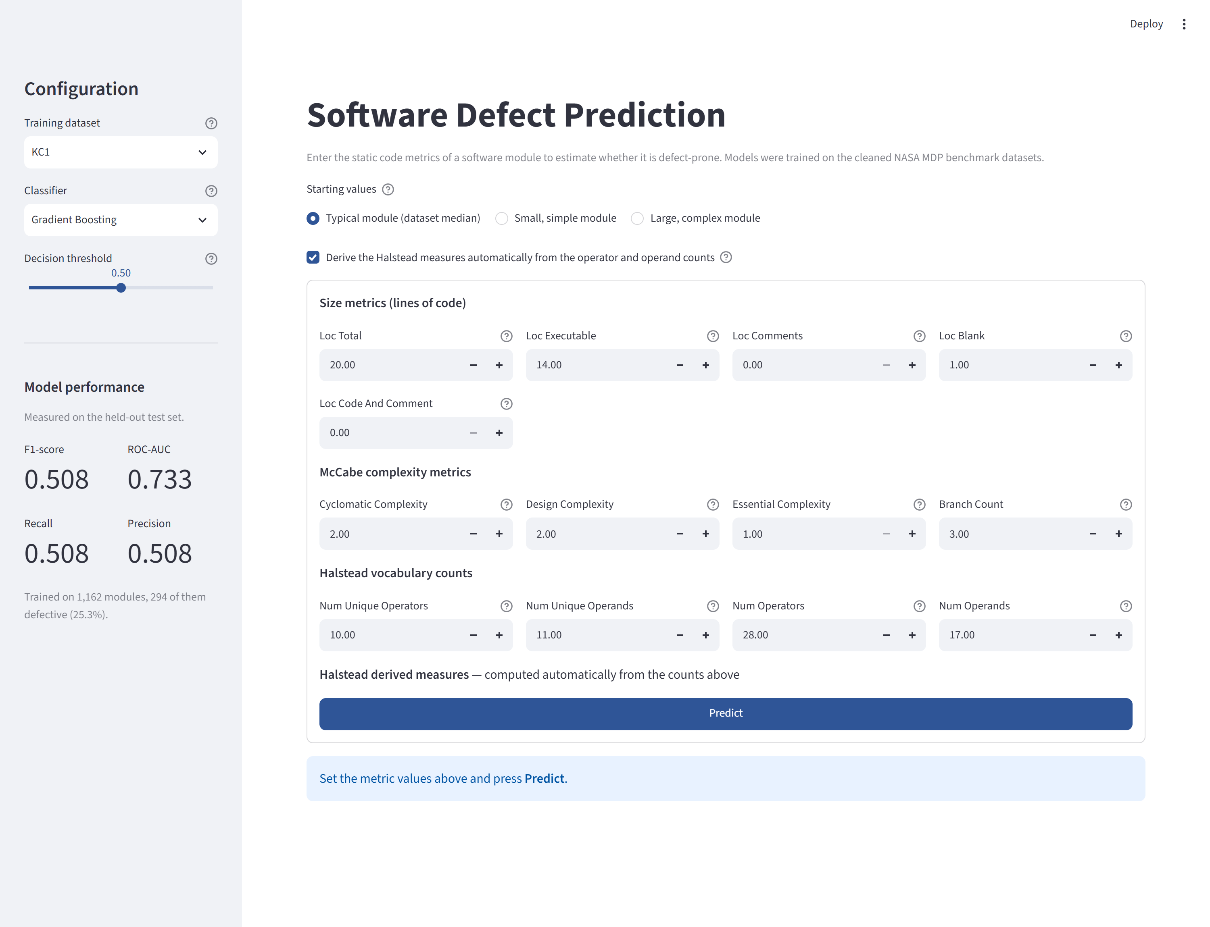
Fig. 14.6 The metric-entry form of the web interface, showing the configuration panel, the preset selector and the grouped input fields
14.6.2 A module predicted to be non-defective
Figure 14.7 shows the result for a small, simple module: twenty lines of code at the tenth percentile of the dataset, a cyclomatic complexity of one and a modest operator vocabulary. Gradient Boosting returns a defect probability of 6.3 per cent, which falls below the threshold of 0.50, so the module is classified as non-defective and placed in the low risk band. The table beneath the verdict places each entered metric against the median of the training data and gives its percentile, which tells the user not merely what the model decided but where the module sits in the population the model was trained on.
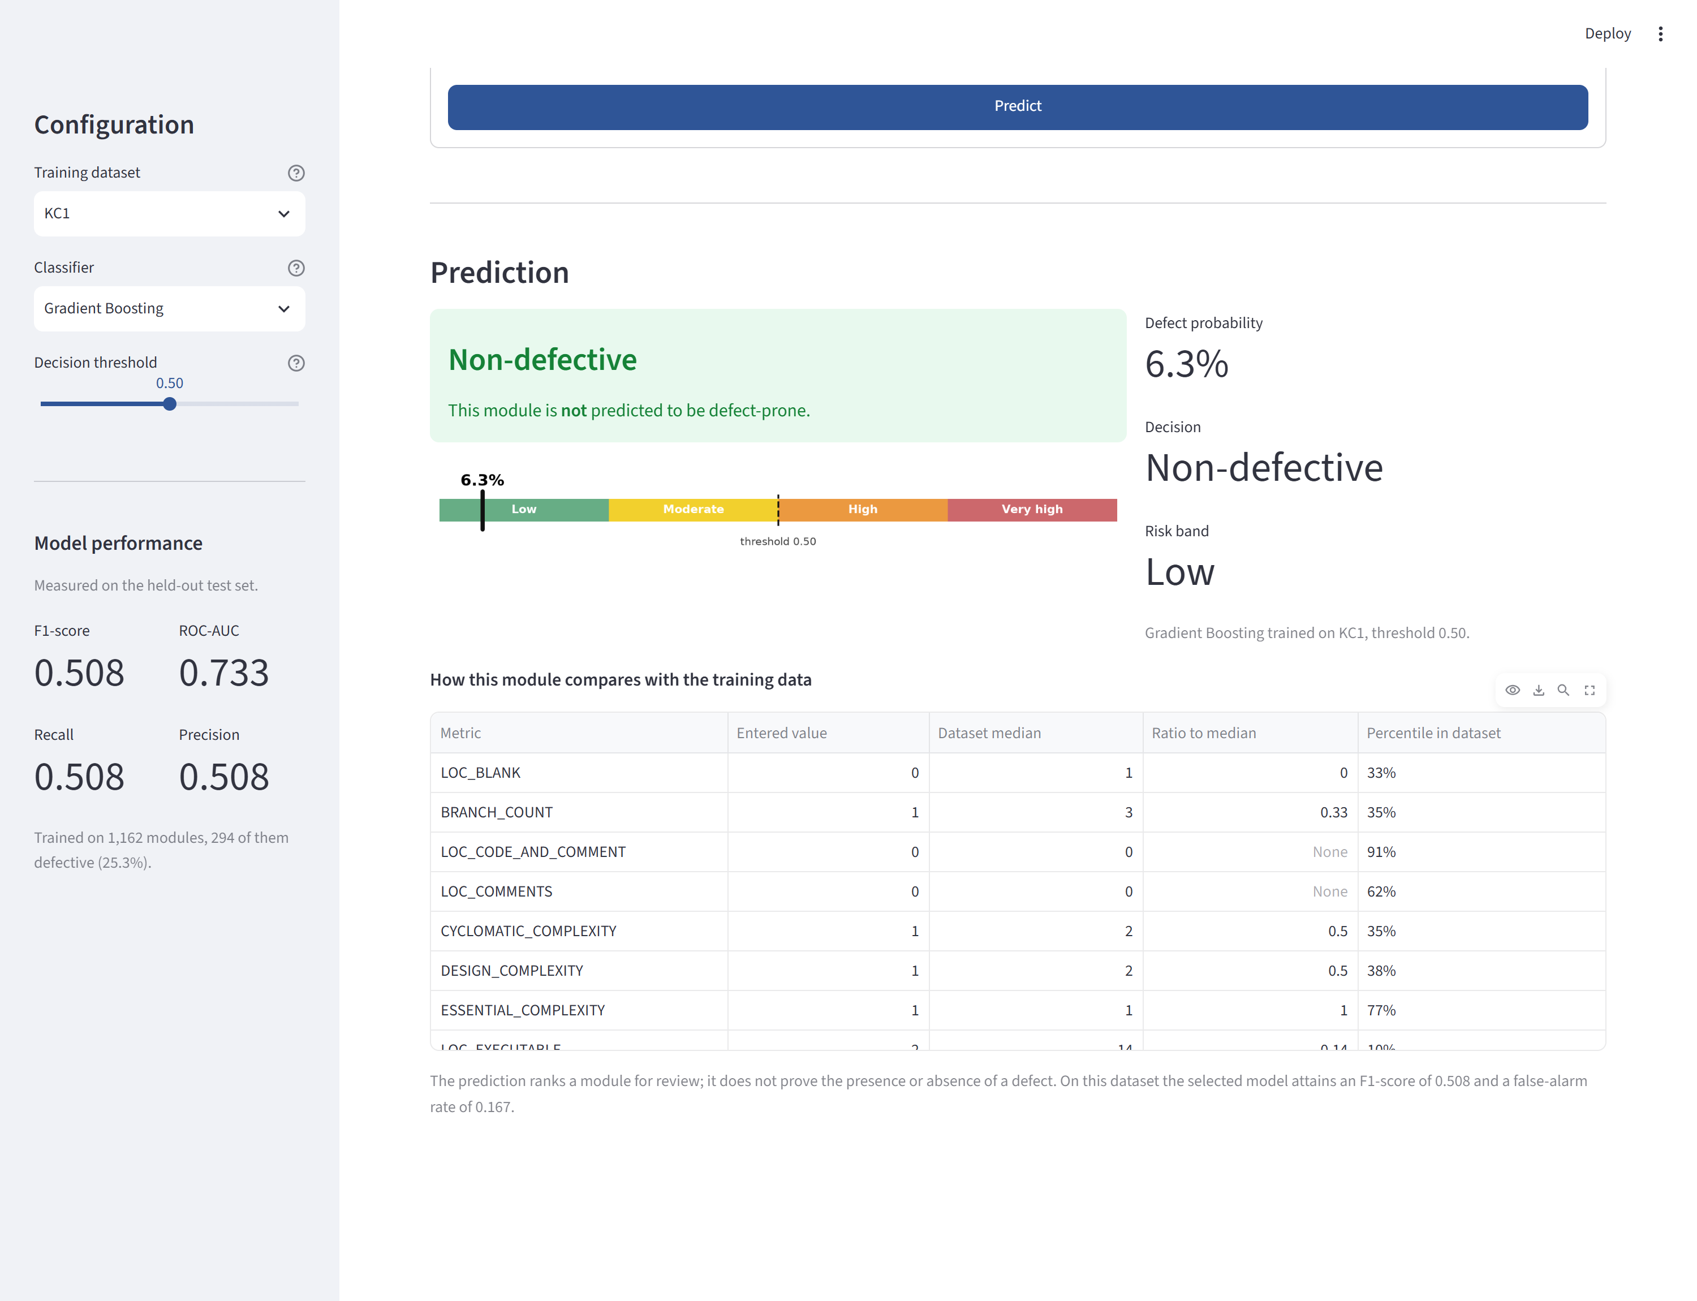
Fig. 14.7 Prediction for a small, simple module: 6.3 per cent defect probability, classified as non-defective
14.6.3 A module predicted to be defective
Figure 14.8 shows the same model applied to a large, complex module at the ninetieth percentile of the dataset: seventy-three lines of code, a cyclomatic complexity of ten, eighteen branches and a vocabulary of fifty-one distinct tokens. The predicted probability rises to 82.8 per cent, the module is classified as defective and is placed in the very high risk band, and the comparison table shows every metric at or above the ninetieth percentile of the training data.
The contrast between Figures 14.7 and 14.8 is the behaviour that Chapter 15 quantifies: size and complexity are genuinely associated with defect-proneness, and the model has learned that association. It is worth restating that a probability of 82.8 per cent is not a guarantee. At the operating point used here the model attains a precision of 0.509, so roughly one flagged module in two is a false alarm, and the output should be read as a ranking for review rather than a verdict.
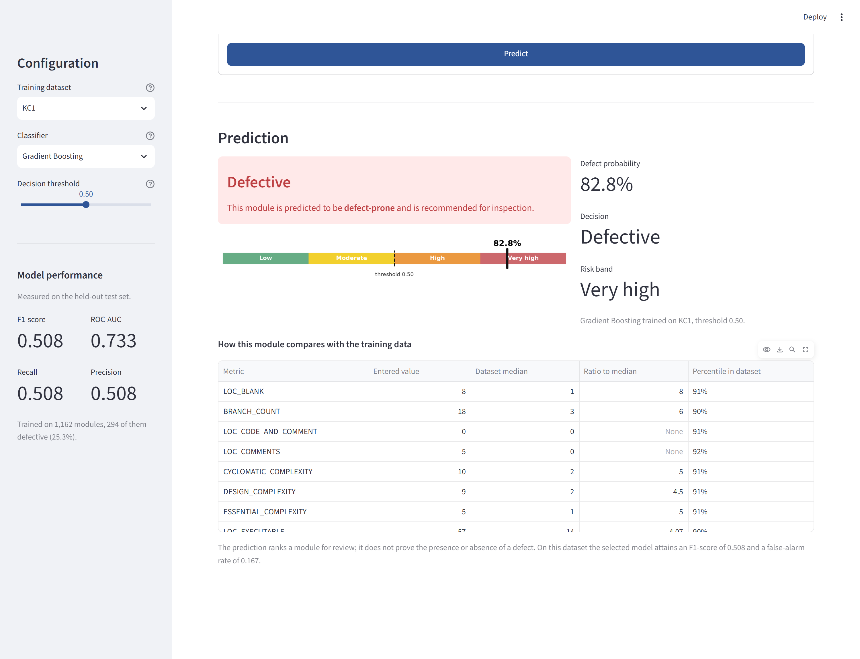
Fig. 14.8 Prediction for a large, complex module: 82.8 per cent defect probability, classified as defective
14.6.4 Effect of the configuration panel
The configuration panel, reproduced on its own in Figure 14.9, is what makes the interface useful for exploring the findings of this study rather than merely applying them. Changing the classifier re-scores the same module with a different algorithm, which demonstrates the clustering reported in Section 15.2. Moving the decision threshold slider shifts the operating point between the conservative and sensitive profiles discussed in Section 15.6, without retraining anything. Changing the dataset loads a model trained on a different project, and the panel then reports that model's own performance figures.

Fig. 14.9 The configuration panel, showing dataset, classifier and threshold selection together with the performance of the selected model
14.7 Generated Artefacts
Each execution writes its results beneath a directory named after the dataset. The directory contains the exploratory outputs, the generated figures, the serialised pipelines for all eight classifiers, the metric tables in CSV and JSON form, and a summary recording the configuration that was in force. Because the results directory is keyed by dataset, and because an alternative results directory can be specified in the configuration file, the outputs of runs made under different settings coexist without interference; this is how the ablation study of Section 15.5 was conducted.

Results and Analysis
This chapter presents the experimental results and answers the three research questions stated in Chapter 3. Unless otherwise stated, all figures were obtained with random seed 42, synthetic minority over-sampling enabled and stratified five-fold cross-validation, and all headline measures are computed on the hold-out test partition, which took no part in any fitting decision.
15.1 Exploratory Analysis of the Data (RQ1)
The class distribution of KC1 is shown in Figure 15.1. Of the 1,162 modules, 868 are clean and 294, or 25.3 per cent, are defective. This is the most balanced of the four datasets; the corresponding proportions are 20.9 per cent for JM1, 12.8 per cent for CM1 and 8.1 per cent for PC1.
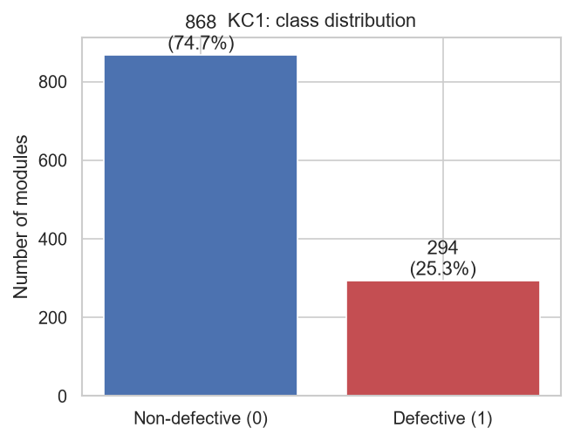
Fig. 15.1 Class distribution of the KC1 dataset
Table 15.1 gives descriptive statistics for the ten metrics most strongly associated with the defect label, ranked by the magnitude of their point-biserial correlation with it.
Table 15.1 Descriptive statistics of the ten most informative KC1 metrics
Metric | Mean | Median | Maximum | Skewness | Correlation with target
HALSTEAD_DIFFICULTY | 10.37 | 7.78 | 53.75 | 1.61 | 0.303
NUM_UNIQUE_OPERATORS | 10.59 | 10.00 | 37.00 | 0.77 | 0.301
NUM_UNIQUE_OPERANDS | 15.08 | 11.00 | 120.00 | 1.88 | 0.300
NUM_OPERANDS | 31.19 | 17.00 | 428.00 | 2.94 | 0.285
HALSTEAD_LENGTH | 82.07 | 45.00 | 1,106.00 | 2.93 | 0.275
NUM_OPERATORS | 50.89 | 28.00 | 678.00 | 2.92 | 0.268
HALSTEAD_ERROR_EST | 0.15 | 0.07 | 2.64 | 3.61 | 0.267
HALSTEAD_VOLUME | 438.49 | 197.29 | 7,918.82 | 3.62 | 0.267
LOC_TOTAL | 32.31 | 20.00 | 288.00 | 2.69 | 0.264
LOC_EXECUTABLE | 24.19 | 14.00 | 262.00 | 2.73 | 0.254

Three observations follow, and each has a consequence for the design of the experiment.
First, every metric is strongly right-skewed. In each case the median lies far below the mean, and the sample skewness ranges from 0.77 to 3.74. The maximum of HALSTEAD_VOLUME is more than forty times its median. A small number of very large modules therefore dominates the untransformed feature space, which is the justification for the logarithmic transformation described in Section 10.4.
Second, the association between any individual metric and the defect label is real but weak. The strongest correlation observed is 0.303, for Halstead difficulty, which corresponds to approximately nine per cent of the variance in the label. Every correlation is positive: larger, more complex modules with richer vocabularies are more likely to be defective. But no single metric is decisive, and any threshold rule based on one metric alone must therefore perform poorly. This is the quantitative justification for the multivariate approach.
Third, the metrics are highly collinear. Figure 15.2 shows the Spearman correlation between every pair of metrics in KC1. The block structure is immediately visible: the Halstead measures correlate with one another above 0.9 in many cases, because they are algebraic functions of the same four token counts, and the size measures form a second such block. The effective dimensionality of the feature space is therefore far below the nominal twenty-one, which limits the improvement obtainable from feature selection and means that feature-importance figures must be interpreted with care, since importance is divided among near-duplicate metrics.
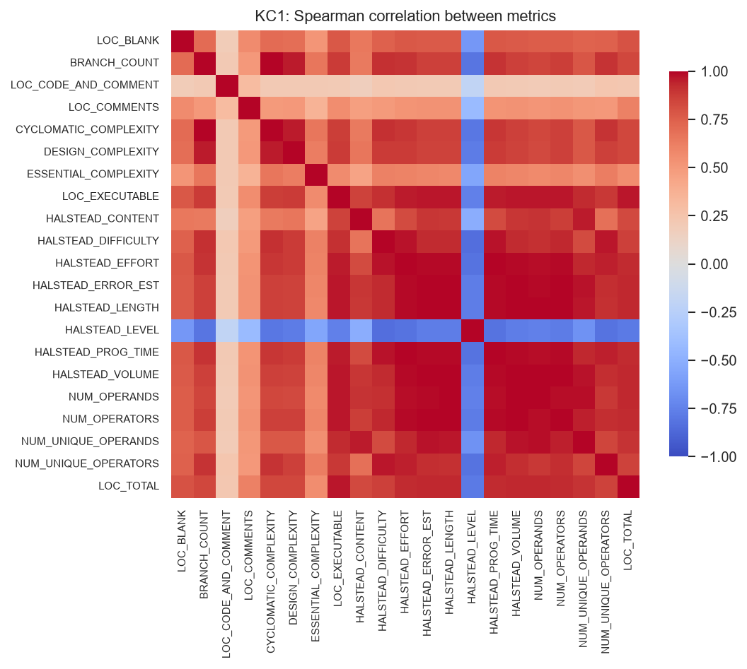
Fig. 15.2 Spearman correlation among the static code metrics of KC1
Figure 15.3 compares the distribution of each of the twelve most discriminative metrics between the two classes on a logarithmic scale. In every case the defective class has the higher median, and in every case the two distributions overlap substantially, which is the graphical counterpart of the modest correlations in Table 15.1.
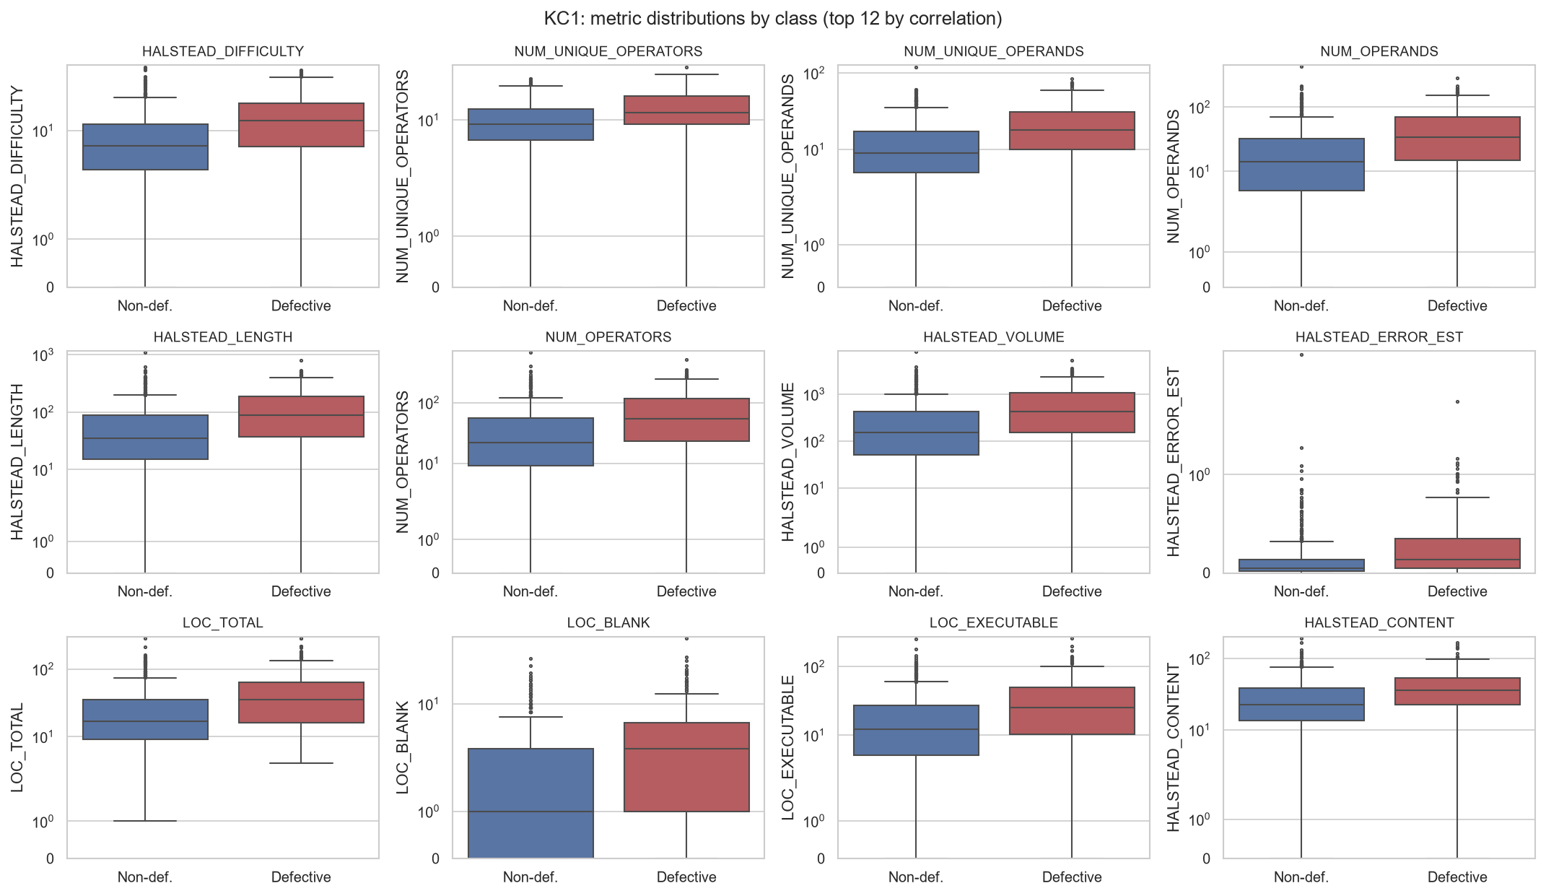
Fig. 15.3 Distribution of the most discriminative metrics by class (KC1)
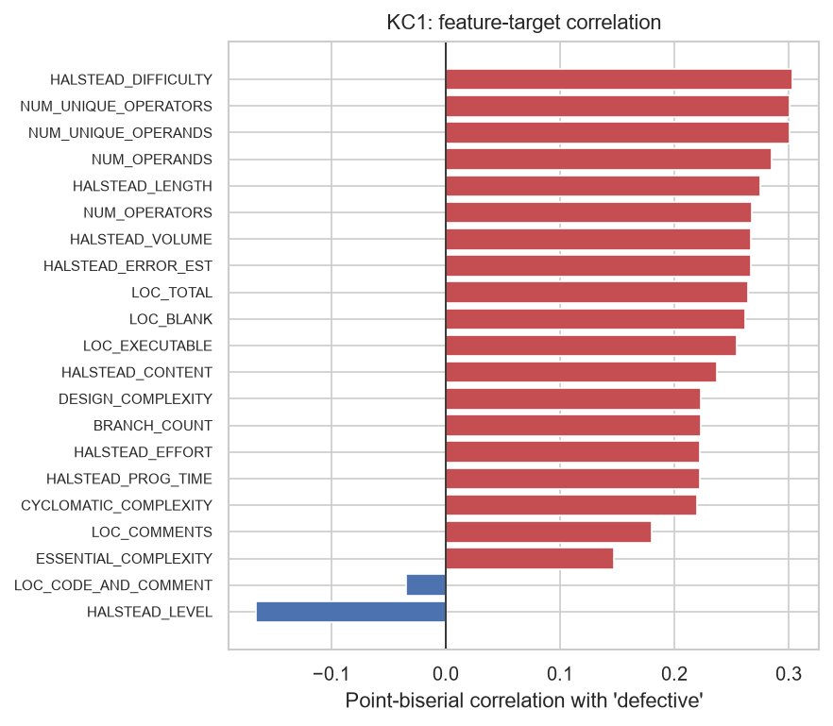
Fig. 15.4 Correlation of each KC1 metric with the defect label
Figure 15.4 ranks all twenty-one metrics. Two metrics, HALSTEAD_LEVEL and ESSENTIAL_COMPLEXITY, show negative or near-zero association. HALSTEAD_LEVEL is by definition the reciprocal of difficulty, so its negative correlation is expected and carries no independent information.
The answer to RQ1 is therefore that Halstead difficulty, the counts of distinct operators and operands, and the measures of module size are the metrics most strongly associated with defect-proneness; that the association is positive in every case; and that it is modest in magnitude, with no metric exceeding a correlation of 0.303.
15.2 Comparison of Classifiers on KC1 (RQ2)
Table 15.2 reports the performance of all eight classifiers on the KC1 hold-out set, which contains 233 modules of which 59 are defective. The models are ordered by F1-score.
Table 15.2 Hold-out test performance on KC1 (233 modules, 59 defective)
Classifier | Accuracy | Precision | Recall | F1 | ROC-AUC | MCC | PF
Gradient Boosting | 0.751 | 0.508 | 0.508 | 0.508 | 0.733 | 0.342 | 0.167
k-Nearest Neighbours | 0.700 | 0.434 | 0.610 | 0.507 | 0.729 | 0.309 | 0.270
SVM (RBF) | 0.665 | 0.404 | 0.678 | 0.506 | 0.720 | 0.298 | 0.339
Logistic Regression | 0.661 | 0.400 | 0.678 | 0.503 | 0.719 | 0.293 | 0.345
Random Forest | 0.742 | 0.492 | 0.508 | 0.500 | 0.733 | 0.327 | 0.178
MLP (Neural Network) | 0.609 | 0.367 | 0.746 | 0.492 | 0.727 | 0.269 | 0.437
Gaussian Naive Bayes | 0.609 | 0.357 | 0.678 | 0.468 | 0.715 | 0.230 | 0.414
Decision Tree | 0.687 | 0.397 | 0.458 | 0.425 | 0.654 | 0.212 | 0.236

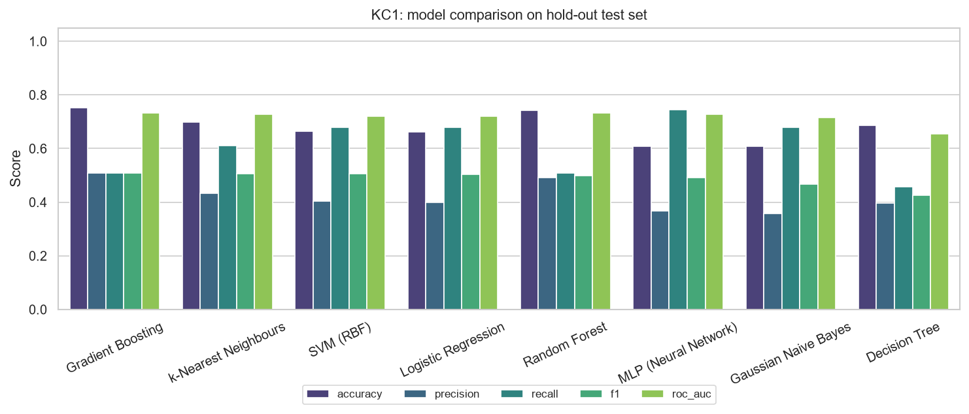
Fig. 15.5 Hold-out performance of the eight classifiers on KC1
Table 15.3 gives the corresponding cross-validated estimates obtained on the training partition, with the standard deviation across folds.
Table 15.3 Five-fold cross-validation on the KC1 training partition (mean ± standard deviation)
Classifier | Accuracy | Precision | Recall | F1 | ROC-AUC
SVM (RBF) | 0.687 ± 0.028 | 0.422 ± 0.034 | 0.613 ± 0.025 | 0.498 ± 0.021 | 0.685 ± 0.033
Logistic Regression | 0.649 ± 0.036 | 0.389 ± 0.034 | 0.664 ± 0.043 | 0.490 ± 0.035 | 0.696 ± 0.037
Random Forest | 0.729 ± 0.013 | 0.466 ± 0.025 | 0.481 ± 0.037 | 0.472 ± 0.022 | 0.712 ± 0.022
Gradient Boosting | 0.723 ± 0.011 | 0.456 ± 0.021 | 0.485 ± 0.045 | 0.469 ± 0.031 | 0.700 ± 0.029
Gaussian Naive Bayes | 0.625 ± 0.027 | 0.367 ± 0.020 | 0.651 ± 0.029 | 0.468 ± 0.016 | 0.692 ± 0.034
MLP (Neural Network) | 0.643 ± 0.043 | 0.378 ± 0.040 | 0.617 ± 0.047 | 0.467 ± 0.039 | 0.685 ± 0.031
k-Nearest Neighbours | 0.666 ± 0.028 | 0.388 ± 0.035 | 0.545 ± 0.022 | 0.453 ± 0.030 | 0.678 ± 0.019
Decision Tree | 0.651 ± 0.017 | 0.360 ± 0.023 | 0.489 ± 0.047 | 0.415 ± 0.030 | 0.627 ± 0.039

15.2.1 Analysis
The first and most important observation is that seven of the eight classifiers are tightly clustered. Their F1-scores span the range from 0.468 to 0.509 and their ROC-AUC values the range from 0.715 to 0.733. Against cross-validation standard deviations of between 0.02 and 0.04, differences of this size are not statistically meaningful. The result reproduces the central finding of Lessmann and colleagues, that most reasonable classifiers are indistinguishable on these data, and it means that the identification of Gradient Boosting as the best model on KC1 should be read as membership of the leading group rather than as a demonstrated superiority.
The only classifier that separates clearly from the rest is the single Decision Tree, whose F1-score of 0.425 and ROC-AUC of 0.654 are appreciably lower. This is the expected consequence of the high variance of an unaggregated tree, and it is precisely the weakness that Random Forest and Gradient Boosting are designed to remedy. That both ensembles built from such trees outperform the individual tree by a clear margin is a direct confirmation of the value of ensembling on this problem.
The second observation is that the models divide into two distinct operating profiles, which Figure 15.5 makes visible and the confusion matrices of Figure 15.8 make concrete.
- The conservative models, Gradient Boosting and Random Forest, achieve the highest accuracy (0.751 and 0.743), the highest precision (0.509 and 0.492), the highest Matthews correlation (0.342 and 0.327) and the lowest false-alarm rates (0.167 and 0.178). They detect about half of the defective modules.
- The sensitive models, the Multi-Layer Perceptron, the Support Vector Machine, Logistic Regression and Naive Bayes, detect between 67.8 and 74.6 per cent of defective modules but raise false alarms on between 33.9 and 43.7 per cent of clean ones.
Neither profile is intrinsically superior; the choice between them is an economic decision that depends on the relative cost of a defect that escapes to the customer and an inspection that finds nothing. In safety-critical development, where an escaped defect may be catastrophic, the sensitive profile is preferable. Where review capacity is the binding constraint, the conservative profile wastes less of it. Section 15.6 shows that a single model can be moved between these profiles by adjusting its decision threshold, so the choice need not be made by selecting a different algorithm.
Figure 15.6 shows the receiver operating characteristic curves. Their near-coincidence is the graphical expression of the clustering noted above: across the whole range of operating points, seven of the models are hard to separate. Figure 15.7 shows the precision-recall curves, which are more informative under imbalance because they ignore the true negatives that dominate the confusion matrix. No model achieves a precision above approximately 0.5 at a recall of 0.5, against a baseline precision of 0.253 that a random ranking would give.
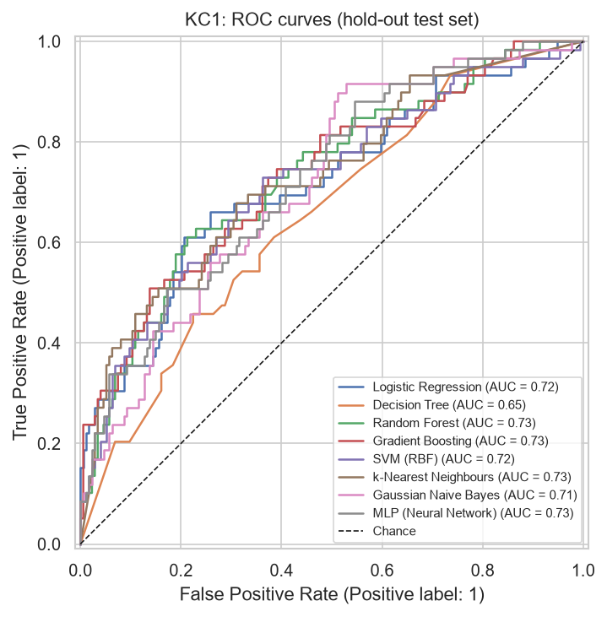
Fig. 15.6 Receiver operating characteristic curves on the KC1 test set
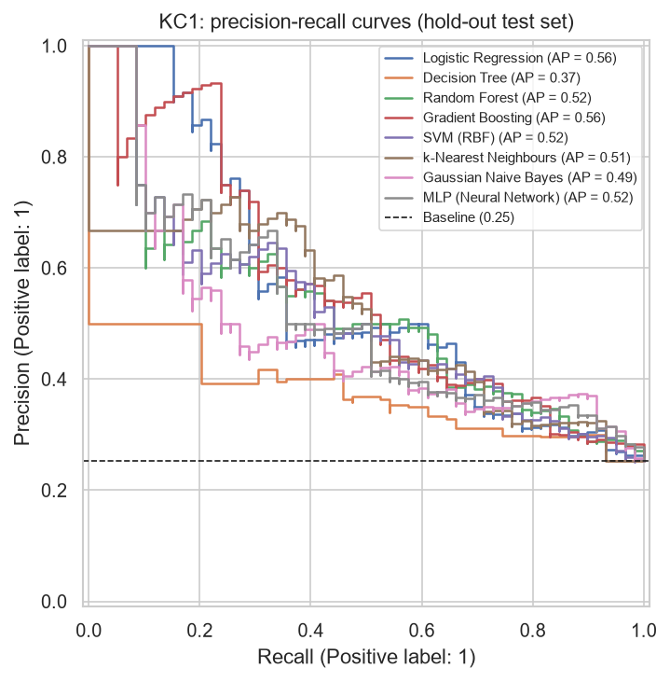
Fig. 15.7 Precision-recall curves on the KC1 test set
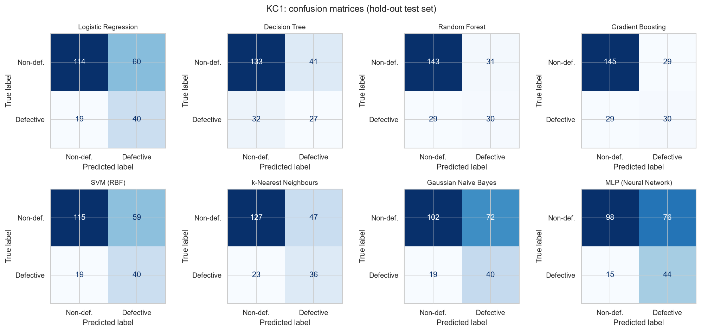
Fig. 15.8 Confusion matrices of the eight classifiers on the KC1 test set
The confusion matrices quantify the trade-off exactly. Gradient Boosting produces 30 true positives, 29 false positives and 29 false negatives: it finds half the defects and wastes half of the inspections it triggers. The Multi-Layer Perceptron produces 44 true positives, 76 false positives and 15 false negatives: it finds three-quarters of the defects but two inspections in three are fruitless.
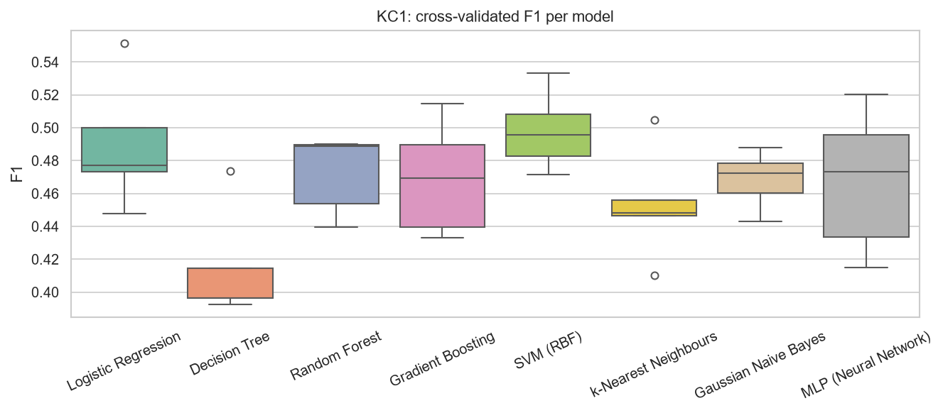
Fig. 15.9 Distribution of cross-validated F1-score across folds (KC1)
Figure 15.9 displays the fold-to-fold variability that underlies the means of Table 15.3, and it is the strongest argument against over-interpreting the ranking: the boxes of the leading models overlap substantially.
15.2.2 Feature importance
Figure 15.10 shows the impurity-based feature importances of the Random Forest. Halstead difficulty, the counts of distinct operands and operators, and the number of executable lines dominate, which agrees with the correlation analysis of Section 15.1 and provides independent confirmation from a multivariate model. The caution stated earlier applies with full force here: because the Halstead measures are near-duplicates of one another, the importance attributable to the underlying construct is divided among them, and the ranking among individual collinear metrics should not be regarded as stable.
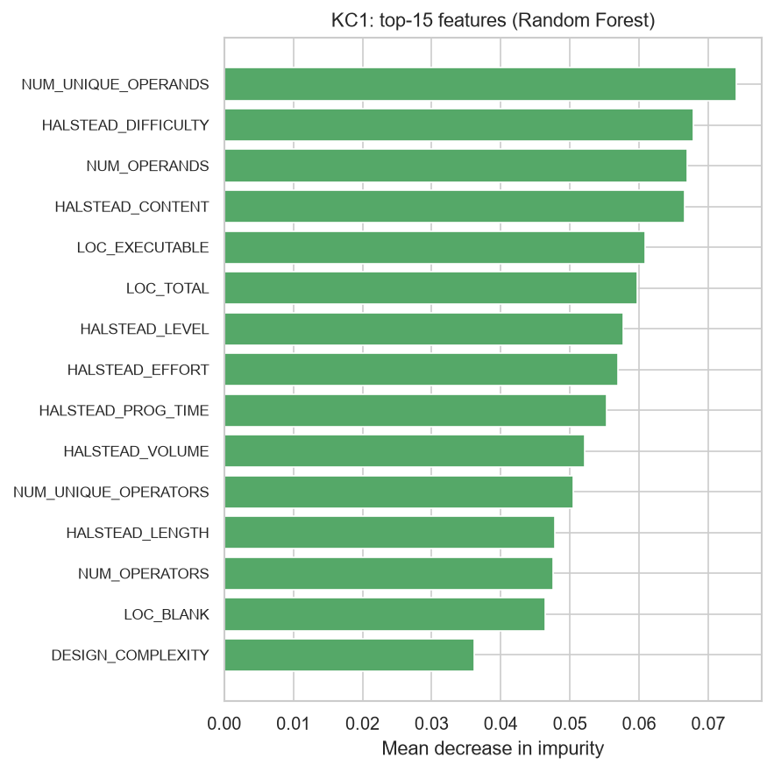
Fig. 15.10 Fifteen most important features according to the Random Forest (KC1)
15.3 Results Across All Four Datasets (RQ2)
Table 15.4 summarises the F1-score and ROC-AUC of every model on every dataset, and Figures 15.11 and 15.12 present the same information as heat maps.
Table 15.4 F1-score and ROC-AUC on the hold-out set of each dataset
Classifier | KC1 F1 / AUC | JM1 F1 / AUC | PC1 F1 / AUC | CM1 F1 / AUC
Gradient Boosting | 0.509 / 0.733 | 0.410 / 0.709 | 0.333 / 0.858 | 0.400 / 0.795
k-Nearest Neighbours | 0.507 / 0.729 | 0.419 / 0.664 | 0.273 / 0.688 | 0.359 / 0.793
SVM (RBF) | 0.506 / 0.720 | 0.430 / 0.688 | 0.222 / 0.817 | 0.381 / 0.711
Logistic Regression | 0.503 / 0.720 | 0.446 / 0.714 | 0.250 / 0.801 | 0.357 / 0.739
Random Forest | 0.500 / 0.733 | 0.461 / 0.717 | 0.273 / 0.779 | 0.143 / 0.778
MLP (Neural Network) | 0.492 / 0.727 | 0.427 / 0.681 | 0.278 / 0.855 | 0.258 / 0.705
Gaussian Naive Bayes | 0.468 / 0.715 | 0.416 / 0.679 | 0.327 / 0.793 | 0.323 / 0.752
Decision Tree | 0.425 / 0.654 | 0.429 / 0.681 | 0.267 / 0.643 | 0.261 / 0.676

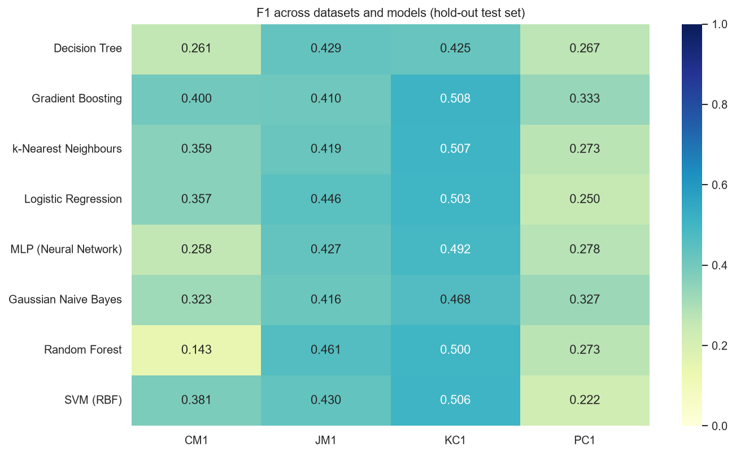
Fig. 15.11 F1-score of every classifier on every dataset
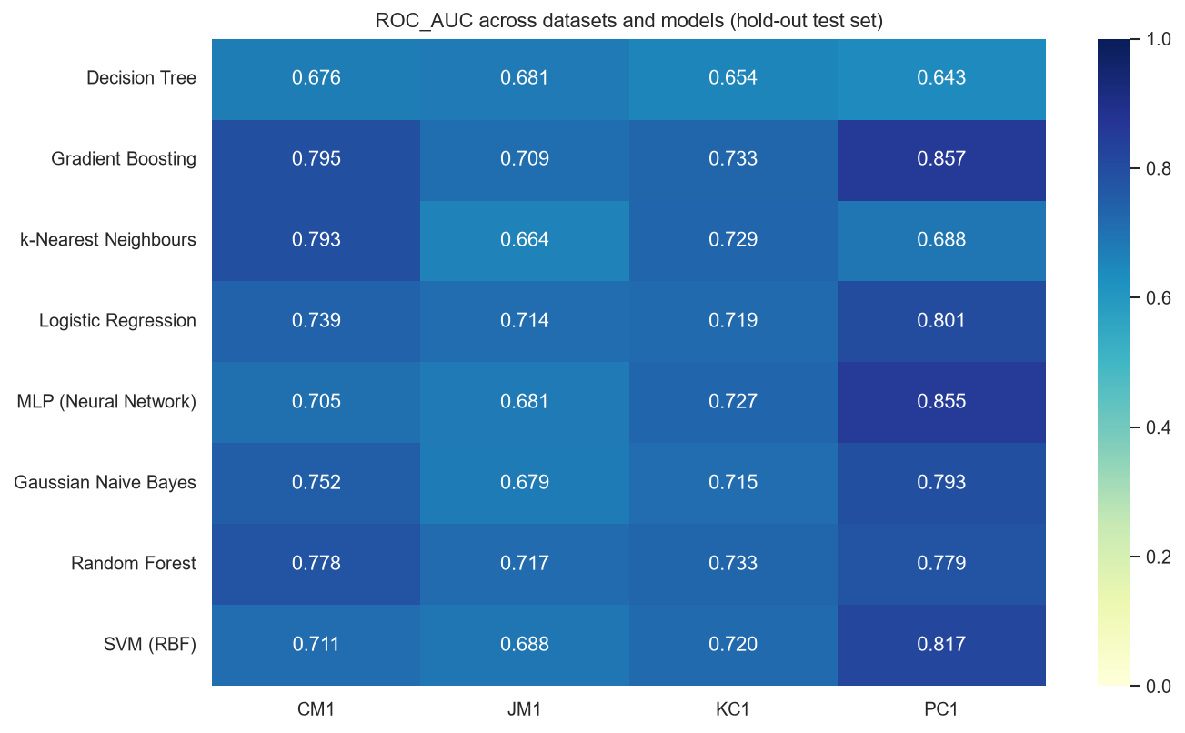
Fig. 15.12 ROC-AUC of every classifier on every dataset
Table 15.5 Mean rank of each classifier by F1-score across the four datasets
Rank | Classifier | Mean rank
1 | Gradient Boosting | 2.75
2 | k-Nearest Neighbours | 3.88
3 | SVM (RBF) | 4.00
4 | Logistic Regression | 4.25
5 | Random Forest | 4.62
6 | Gaussian Naive Bayes | 5.25
6 | MLP (Neural Network) | 5.25
8 | Decision Tree | 6.00

15.3.1 Analysis
Gradient Boosting is the most consistent performer. It attains the best F1-score on three of the four datasets and the best mean rank of 2.75. Random Forest is strongest on JM1, which with 7,720 modules is by a wide margin the largest dataset; this is consistent with the theoretical expectation that the variance reduction obtained by bagging becomes more effective as the number of bootstrap samples that can be drawn from the data increases.
The most striking single result in the table is the failure of Random Forest on CM1, where its F1-score of 0.143 places it last. This is not evidence that Random Forest is unsuitable for small datasets in general. The CM1 test partition contains only eight defective modules, so each one that is correctly identified changes recall by 12.5 percentage points; Random Forest identified one of the eight. Estimates obtained from eight positive instances are subject to very large sampling error, and the CM1 column should be read as indicative rather than as a reliable ranking. The same caution applies, though less severely, to PC1, whose test partition contains eleven defective modules.
A clear and systematic pattern relates performance to class balance. The best achievable F1-score falls from 0.509 on KC1, where 25.3 per cent of modules are defective, to 0.333 on PC1, where 8.1 per cent are. Yet PC1 simultaneously produces the highest ROC-AUC of any dataset, at 0.858. The two measures are not in conflict; they answer different questions. ROC-AUC asks whether the model ranks defective modules above clean ones, and is computed from rates within each class separately, so it is unaffected by how rare the positive class is. The F1-score depends on precision, and precision is bounded by prevalence: when only eight per cent of modules are defective, even a well-ranked list yields many false positives near the top. The practical lesson, and one of the more valuable findings of this study, is that a high ROC-AUC must not be read as evidence that a defect predictor will be efficient in deployment on a code base with a low defect rate.
The Decision Tree is last or near-last on every dataset, and Gradient Boosting is in the leading group on every dataset. These two facts are the most robust conclusions that can be drawn from Table 15.4.
Figures 15.13 to 15.15 present the per-dataset detail for JM1, PC1 and CM1 respectively, and the corresponding numerical tables are given in Section 15.9.
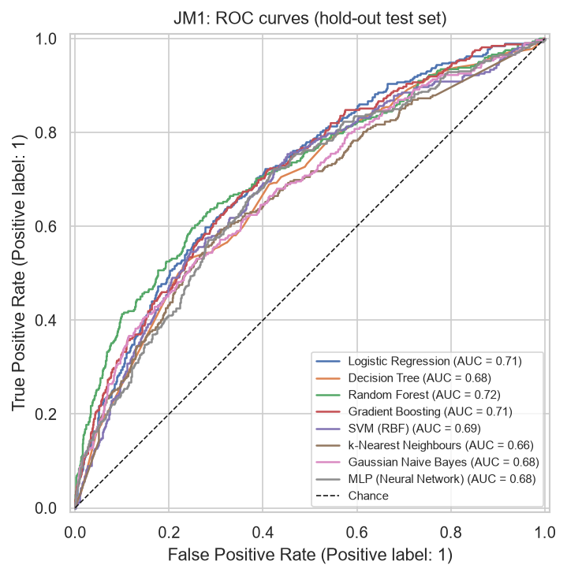
Fig. 15.13 Receiver operating characteristic curves on the JM1 test set
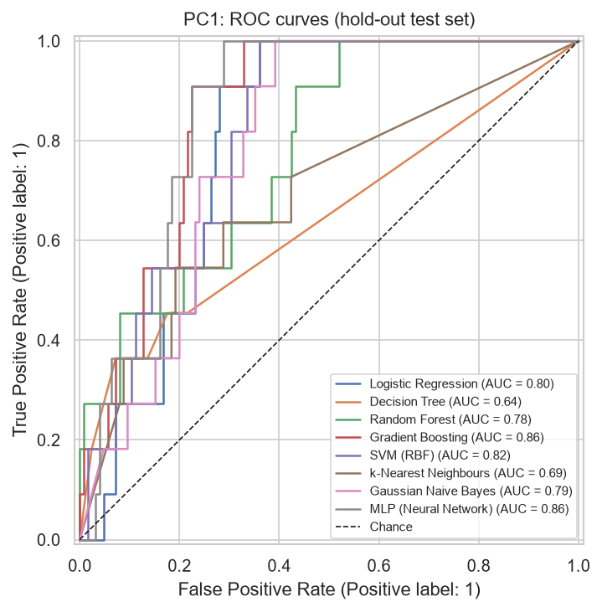
Fig. 15.14 Receiver operating characteristic curves on the PC1 test set
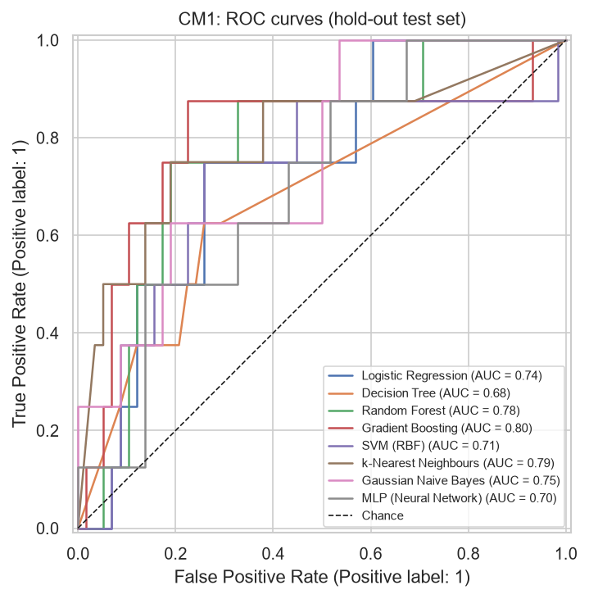
Fig. 15.15 Receiver operating characteristic curves on the CM1 test set
15.4 Learning Curves and the Performance Ceiling
A natural question raised by the modest absolute performance is whether more training data would help. Figure 15.16 answers it directly. It plots, for the two ensemble methods, the F1-score achieved on the training data and the cross-validated F1-score, as the number of training modules increases from 110 to 743.
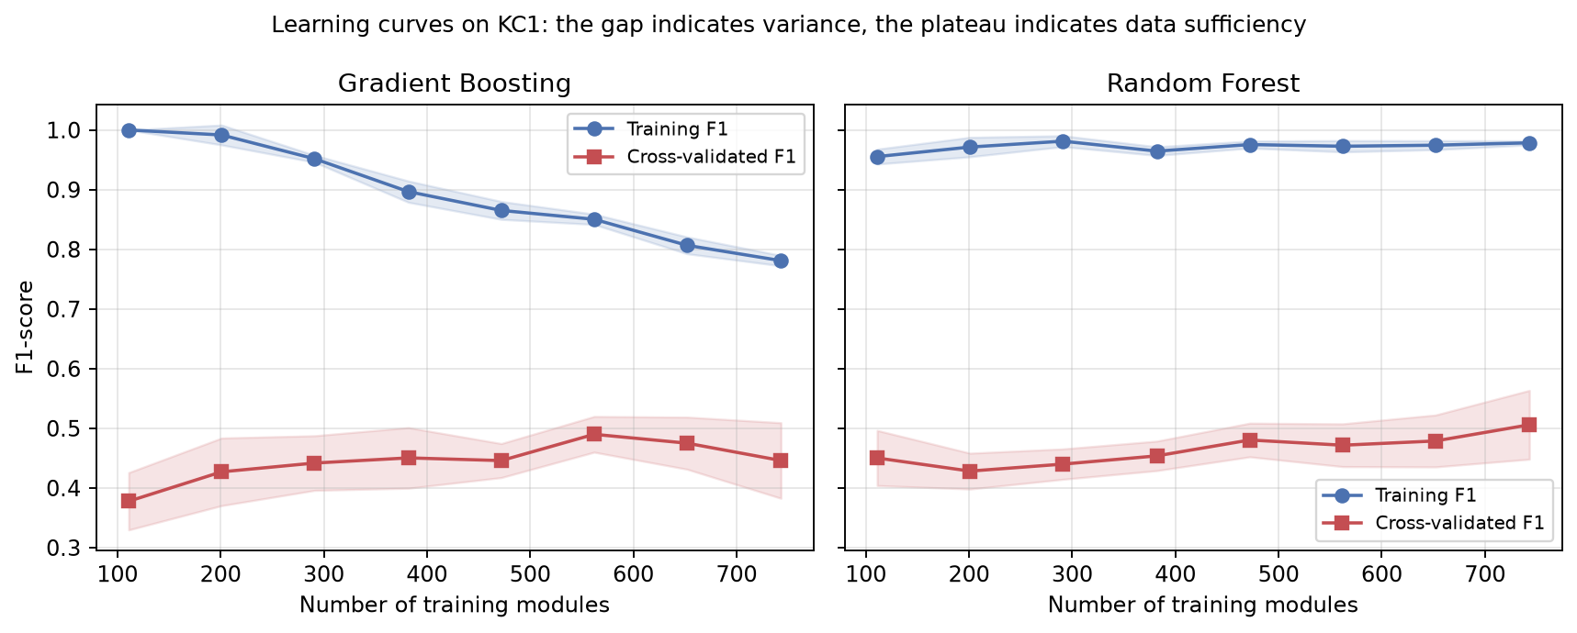
Fig. 15.16 Learning curves for the two ensemble methods on KC1
Two features of these curves are informative. The first is the size of the gap between the two lines. Random Forest achieves an F1-score close to 0.97 on data it has seen and approximately 0.50 on data it has not; Gradient Boosting begins at 1.00 on training data and declines to approximately 0.78 as more data forces it to generalise. A gap of this magnitude indicates high variance: both models are capable of fitting the training set almost perfectly, which means the limiting factor is not the capacity of the model.
The second feature is the shape of the validation curve. It rises steeply at first, from approximately 0.38 to approximately 0.45 as the training set grows from 110 to 300 modules, and then flattens, gaining only about 0.05 over the remaining 440 modules. Extrapolating the trend, doubling the size of KC1 would be expected to improve the F1-score by a few hundredths at most. The conclusion is that the ceiling on performance is imposed by the information content of the static metrics themselves, not by the quantity of labelled data available. This supports the argument advanced in the literature that substantial improvement requires different features, such as process and change-history metrics, rather than more rows of the same features, and it is the principal justification for the first item of the future scope in Chapter 19.
15.5 Effect of Class Balancing (RQ3)
To isolate the contribution of synthetic over-sampling, the complete experiment was repeated on KC1 with balancing disabled and every other setting, including the random seed, held constant. Table 15.6 reports both conditions.
Table 15.6 Effect of over-sampling on KC1 (values given as: without balancing → with SMOTE)
Classifier | Precision | Recall | F1 | Accuracy | PF
Logistic Regression | 1.000 → 0.400 | 0.153 → 0.678 | 0.265 → 0.503 | 0.785 → 0.661 | 0.000 → 0.345
SVM (RBF) | 1.000 → 0.404 | 0.153 → 0.678 | 0.265 → 0.506 | 0.785 → 0.665 | 0.000 → 0.339
MLP (Neural Network) | 0.727 → 0.367 | 0.136 → 0.746 | 0.229 → 0.492 | 0.768 → 0.609 | 0.017 → 0.437
Gradient Boosting | 0.778 → 0.509 | 0.237 → 0.509 | 0.364 → 0.509 | 0.790 → 0.751 | 0.023 → 0.167
Random Forest | 0.615 → 0.492 | 0.271 → 0.509 | 0.377 → 0.500 | 0.773 → 0.743 | 0.058 → 0.178
k-Nearest Neighbours | 0.647 → 0.434 | 0.373 → 0.610 | 0.473 → 0.507 | 0.790 → 0.700 | 0.069 → 0.270
Decision Tree | 0.583 → 0.397 | 0.356 → 0.458 | 0.442 → 0.425 | 0.773 → 0.687 | 0.086 → 0.236
Gaussian Naive Bayes | 0.376 → 0.357 | 0.695 → 0.678 | 0.488 → 0.468 | 0.631 → 0.609 | 0.391 → 0.414

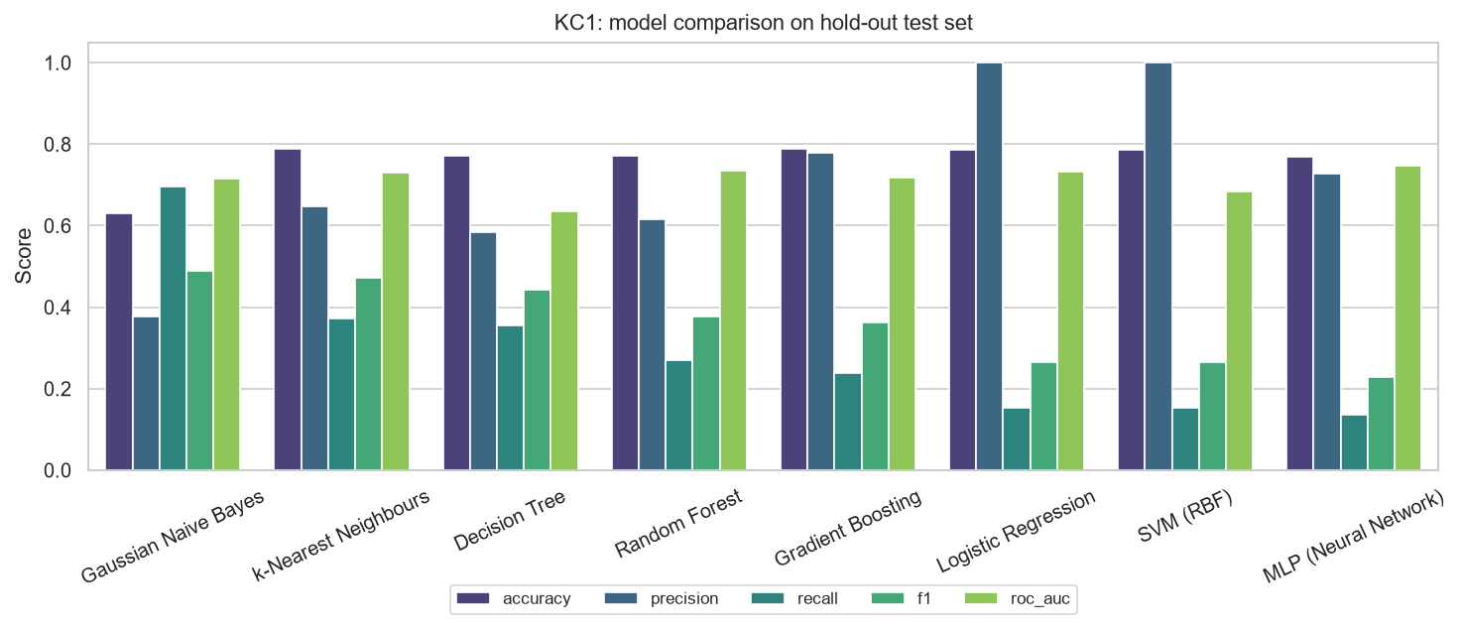
Fig. 15.17 Performance on KC1 with class balancing disabled
15.5.1 Analysis
Without balancing, the margin-based and gradient-based models are close to useless as detectors. Logistic Regression and the Support Vector Machine each flag only nine of the fifty-nine defective modules in the test set, a recall of 0.153. Both achieve a precision of exactly 1.000 and a false-alarm rate of exactly 0.000, which at first sight appears to be an excellent result and is in fact the signature of a degenerate model: the classifier has learned to predict the majority class almost everywhere, and the few positive predictions it does make are the handful of extreme instances about which there is no doubt. The accompanying accuracy of 0.785 is barely above the 0.747 that a model predicting no defects at all would achieve on this test set. This single comparison is the clearest possible demonstration of why accuracy must not be used as the headline measure for this problem.
Over-sampling changes the picture completely. The recall of both models rises from 0.153 to 0.678, an improvement of more than fourfold, and their F1-scores approximately double, from 0.265 to 0.503 and 0.506. The cost is a fall in accuracy of about twelve percentage points and a rise in the false-alarm rate from zero to approximately 0.34. Whether this exchange is worthwhile is an economic question, but for any organisation in which a missed defect costs more than a fruitless inspection, it clearly is.
The effect is not uniform across families of classifier, and the pattern is itself informative.
- The margin-based and neural models gain most, because their loss functions are dominated by the majority class when the data is imbalanced. Their F1-scores improve by between 0.24 and 0.26.
- The ensembles gain moderately, improving their F1-scores by between 0.12 and 0.15, and they retain low false-alarm rates even after balancing. Gradient Boosting improves from 0.364 to 0.509 while its false-alarm rate rises only from 0.023 to 0.167.
- The Decision Tree and Gaussian Naive Bayes are the two exceptions, and both become slightly worse. For Naive Bayes the explanation is that its class priors already produce a high-recall, low-precision model: its unbalanced recall of 0.695 is the highest of any model in the unbalanced condition, so there is nothing for over-sampling to add. This reproduces the observation of Menzies and colleagues that Naive Bayes is intrinsically well suited to imbalanced defect data.
The answer to RQ3 is therefore that synthetic over-sampling produces a large improvement in recall and F1-score for most classifiers, at a cost in precision, accuracy and false-alarm rate; that the improvement is largest for margin-based and neural models and smallest, or slightly negative, for models that are already biased towards the minority class; and that it should be adopted as the default for recall-oriented defect prediction. This reproduces the conclusion of Tantithamthavorn and colleagues on a much larger collection of datasets.
15.6 Sensitivity to the Decision Threshold
The classifications discussed so far were obtained by applying the conventional threshold of 0.5 to the predicted probability. That value has no special status; it is a convention, not a property of the problem. Figure 15.18 shows how precision, recall and F1-score vary as the threshold is moved across its full range, for Gradient Boosting on KC1.
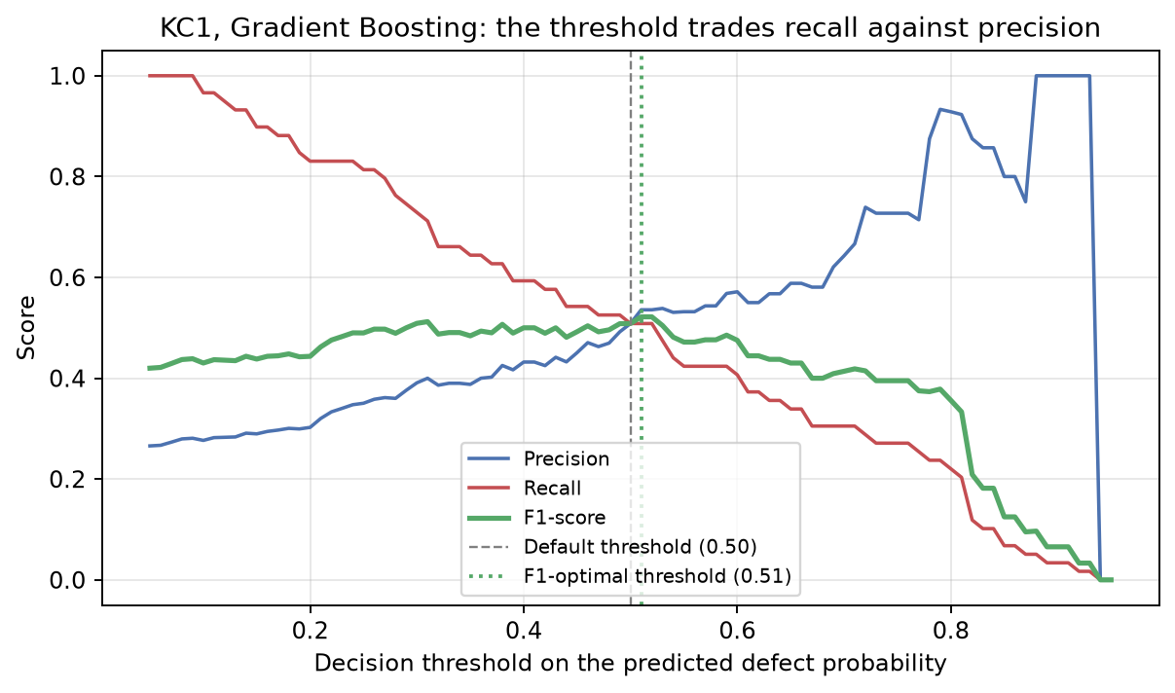
Fig. 15.18 Precision, recall and F1-score as a function of the decision threshold (KC1)
The curves behave as theory requires: raising the threshold makes the model more conservative, increasing precision and decreasing recall, while lowering it has the opposite effect. The F1-optimal threshold on this test set is 0.51, which yields an F1-score of 0.522, marginally better than the 0.509 obtained at the conventional 0.5. The important observation is not this negligible gain but the shape of the curve: the F1-score is relatively flat between about 0.35 and 0.60, so the exact value chosen is not critical, whereas recall changes substantially across the same interval.
This has a practical consequence that deserves emphasis. The distinction drawn in Section 15.2 between conservative and sensitive models is not a fixed property of the algorithms. A single trained Gradient Boosting model can be operated at high recall simply by lowering its threshold, at some cost in precision. The choice of operating point is a policy decision about the relative cost of the two kinds of error, and it can be made after the model has been trained and without retraining it. The prediction script accordingly exposes the threshold as a command-line option.
15.7 Supplementary Experiments
15.7.1 Effect of the dataset variant
To quantify the effect of the data-quality problem documented by Shepperd and colleagues, the KC1 experiment was repeated on the original, uncleaned file. After removal of exact duplicates the original file yields 1,210 modules with a defect rate of 26.0 per cent, compared with 1,162 modules at 25.3 per cent for the cleaned version. Measured ROC-AUC on the uncleaned data ranged from 0.62 to 0.67 across the eight classifiers, against 0.65 to 0.73 on the cleaned data. The two sets of figures are not directly comparable, because the underlying populations differ, and the comparison should be understood as an illustration of the sensitivity of published results to the version of the data used rather than as a controlled experiment. It reinforces the recommendation that only the cleaned versions should be used and that results quoted from older studies on the original files should not be treated as directly comparable with results obtained on the cleaned ones.
15.7.2 Effect of hyper-parameter tuning
A randomised search over fifteen candidate configurations, optimising the F1-score under cross-validation, is implemented for Random Forest, Gradient Boosting, the Support Vector Machine, Logistic Regression and k-nearest neighbours. Enabling it changed the F1-scores by less than the fold-to-fold standard deviation reported in Table 15.3 and did not alter the ordering of the leading group. The headline results in this report therefore use the literature-standard default settings, which has the additional advantage that no model benefits from more optimisation effort than another.
15.8 Comparison with Published Results
Table 15.7 Comparison with results published in the literature
Study | Data version | Reported finding | This project
Menzies et al. (2007) | Original MDP | Naive Bayes with log transform: mean PD 0.71 at PF 0.25 | Naive Bayes: PD 0.678 at PF 0.414 (KC1); PD 0.727 at PF 0.240 (PC1)
Lessmann et al. (2008) | Original MDP | Most classifiers statistically indistinguishable on AUC; RF among the best | Seven of eight models within 0.02 AUC on KC1; RF and GB tied at 0.733
Ghotra et al. (2015) | Cleaned D″ | Ensembles occupy the top statistical group; AUC typically 0.70 to 0.80 | GB best mean rank; AUC 0.709 to 0.858 across the four datasets
Shepperd et al. (2013) | Original versus cleaned | Results differ materially between the two versions | KC1 AUC 0.62 to 0.67 uncleaned against 0.65 to 0.73 cleaned
Tantithamthavorn et al. (2020) | 101 datasets | Rebalancing improves recall and AUC at a cost in precision | SMOTE raises LR and SVM recall from 0.153 to 0.678; precision falls from 1.000 to 0.40

The results obtained here are consistent with the qualitative findings of all five studies. The absolute figures fall within the range reported for the cleaned data and below the range commonly reported for the original data, which is the expected direction once duplicated records are removed and information leakage is eliminated. The reproduction may therefore be regarded as successful.
15.9 Complete Result Tables for the Remaining Datasets
Table 15.8 Hold-out test performance on JM1 (1,544 modules, 322 defective)
Classifier | Accuracy | Precision | Recall | F1 | ROC-AUC | MCC | PF
Random Forest | 0.799 | 0.522 | 0.413 | 0.461 | 0.717 | 0.343 | 0.100
Logistic Regression | 0.674 | 0.345 | 0.630 | 0.446 | 0.714 | 0.264 | 0.315
SVM (RBF) | 0.661 | 0.331 | 0.615 | 0.430 | 0.688 | 0.240 | 0.327
Decision Tree | 0.704 | 0.359 | 0.534 | 0.429 | 0.681 | 0.248 | 0.251
MLP (Neural Network) | 0.686 | 0.345 | 0.562 | 0.427 | 0.681 | 0.241 | 0.282
k-Nearest Neighbours | 0.648 | 0.320 | 0.609 | 0.419 | 0.664 | 0.222 | 0.341
Gaussian Naive Bayes | 0.688 | 0.341 | 0.534 | 0.416 | 0.679 | 0.227 | 0.272
Gradient Boosting | 0.756 | 0.413 | 0.407 | 0.410 | 0.709 | 0.256 | 0.152

Table 15.9 Hold-out test performance on PC1 (136 modules, 11 defective)
Classifier | Accuracy | Precision | Recall | F1 | ROC-AUC | MCC | PF
Gradient Boosting | 0.882 | 0.308 | 0.364 | 0.333 | 0.857 | 0.270 | 0.072
Gaussian Naive Bayes | 0.757 | 0.211 | 0.727 | 0.327 | 0.793 | 0.296 | 0.240
MLP (Neural Network) | 0.809 | 0.200 | 0.455 | 0.278 | 0.855 | 0.207 | 0.160
Random Forest | 0.882 | 0.273 | 0.273 | 0.273 | 0.779 | 0.209 | 0.064
k-Nearest Neighbours | 0.765 | 0.182 | 0.545 | 0.273 | 0.688 | 0.210 | 0.216
Decision Tree | 0.838 | 0.211 | 0.364 | 0.267 | 0.643 | 0.192 | 0.120
Logistic Regression | 0.779 | 0.172 | 0.455 | 0.250 | 0.801 | 0.175 | 0.192
SVM (RBF) | 0.846 | 0.188 | 0.273 | 0.222 | 0.817 | 0.143 | 0.104

Table 15.10 Hold-out test performance on CM1 (66 modules, 8 defective)
Classifier | Accuracy | Precision | Recall | F1 | ROC-AUC | MCC | PF
Gradient Boosting | 0.864 | 0.429 | 0.375 | 0.400 | 0.795 | 0.324 | 0.069
SVM (RBF) | 0.803 | 0.308 | 0.500 | 0.381 | 0.711 | 0.283 | 0.155
k-Nearest Neighbours | 0.621 | 0.226 | 0.875 | 0.359 | 0.793 | 0.302 | 0.414
Logistic Regression | 0.727 | 0.250 | 0.625 | 0.357 | 0.739 | 0.260 | 0.259
Gaussian Naive Bayes | 0.682 | 0.217 | 0.625 | 0.323 | 0.752 | 0.216 | 0.310
Decision Tree | 0.742 | 0.200 | 0.375 | 0.261 | 0.676 | 0.131 | 0.207
MLP (Neural Network) | 0.652 | 0.174 | 0.500 | 0.258 | 0.705 | 0.118 | 0.328
Random Forest | 0.818 | 0.167 | 0.125 | 0.143 | 0.778 | 0.044 | 0.086

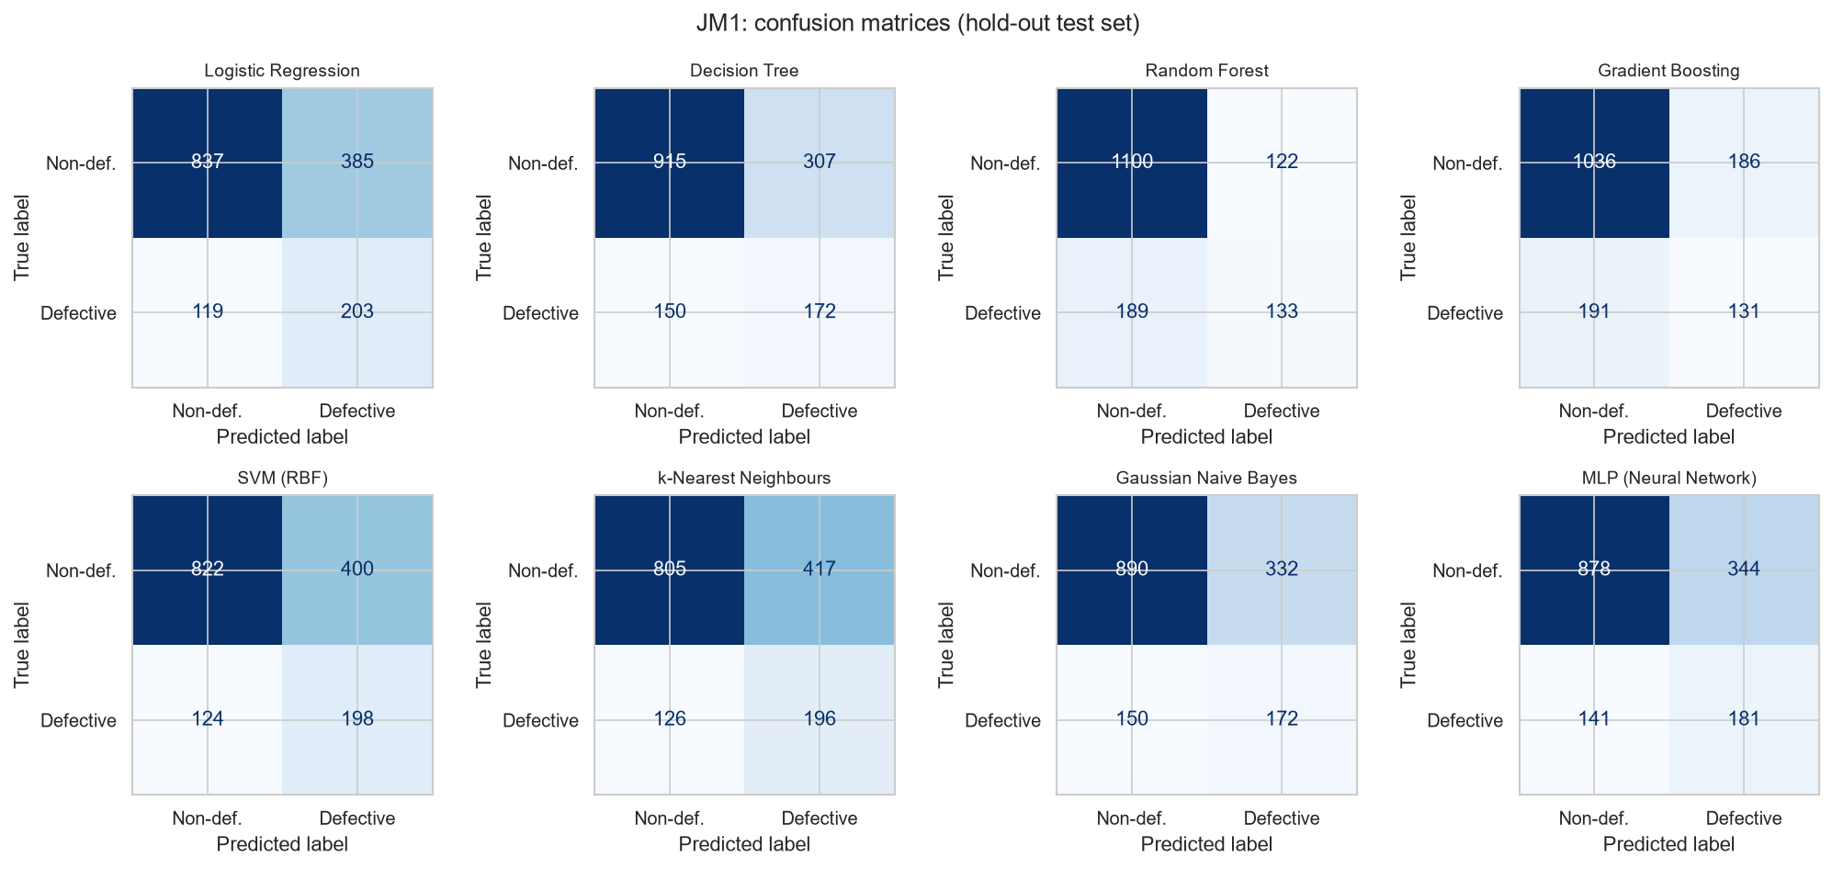
Fig. 15.19 Confusion matrices on the JM1 test set
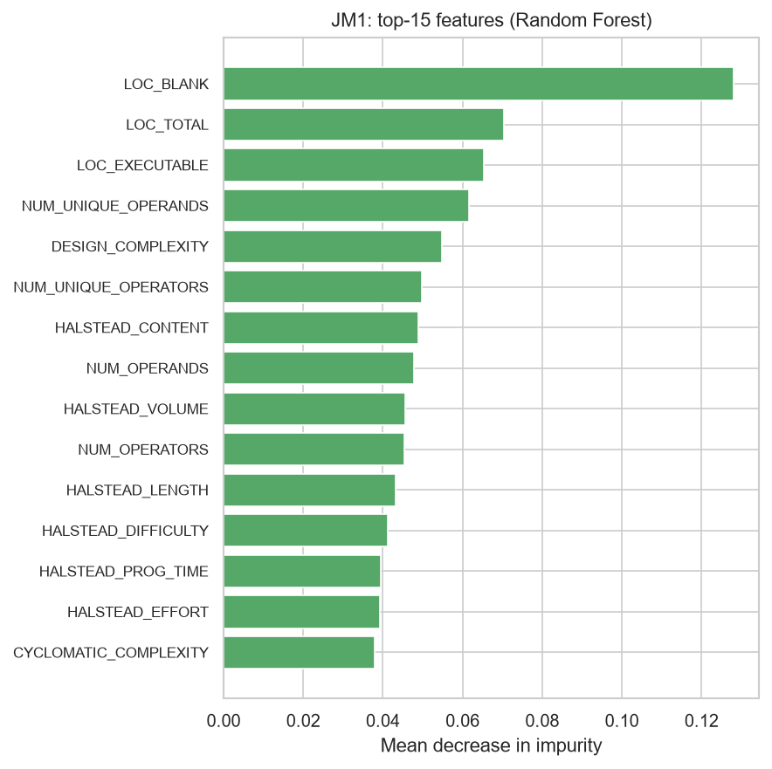
Fig. 15.20 Most important features according to the Random Forest (JM1)
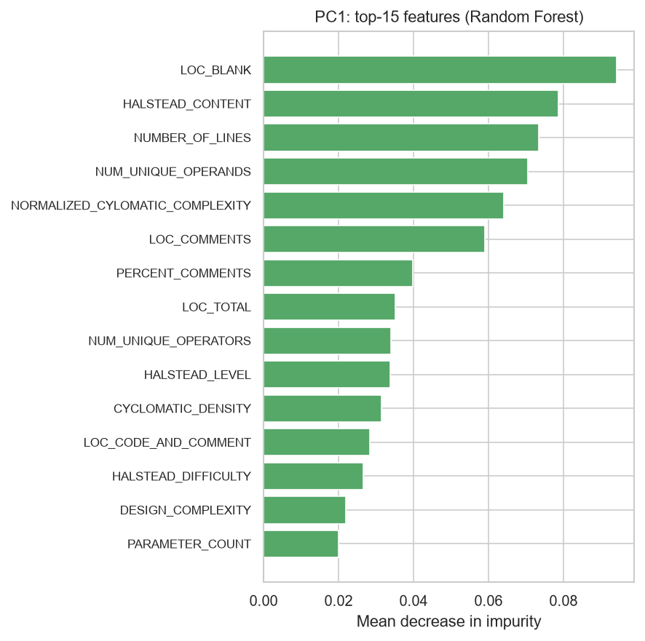
Fig. 15.21 Most important features according to the Random Forest (PC1)
15.10 Threats to Validity
The findings of any empirical study are conditional on the design of that study. The principal threats to the validity of the present results are recorded here under the standard four headings.
15.10.1 Construct validity
Construct validity concerns whether the quantities measured correspond to the concepts of interest. Static code metrics are a proxy for defect-proneness, not a measure of it, and the label records only that a defect was reported against a module, which depends on the testing and reporting practices of the project. A module labelled clean may contain undiscovered defects. The measured performance is therefore a lower bound in one sense and an overstatement in another, and the direction of the net bias is unknown.
15.10.2 Internal validity
Internal validity concerns whether the observed differences are caused by the factors identified. Default hyper-parameters were used for all models; although Section 15.7 reports that tuning did not change the ordering, a more extensive search might. A single random seed was used for the headline results, and although cross-validation standard deviations are reported, repeating the entire experiment over several seeds would give firmer confidence intervals. The configuration supports this and it is recommended as an extension.
15.10.3 External validity
External validity concerns the generality of the conclusions. The four systems studied are NASA flight and ground software written in C and C++ during the 1990s and 2000s. Modern web, mobile and open-source development differs in language, in architecture, in team structure and in defect-reporting culture, and the conclusions should not be assumed to transfer without re-validation. The consistency of the findings across four systems of differing size and defect rate provides some reassurance, but all four come from a single organisation.
15.10.4 Conclusion validity
Conclusion validity concerns whether the statistical treatment supports the claims made. The test partitions of PC1 and CM1 contain only eleven and eight defective modules respectively, so the measures derived from them have wide confidence intervals and the rankings on those two datasets are unreliable. No formal significance test was applied to the differences between classifiers; instead, the fold-to-fold standard deviations are reported and differences smaller than those deviations are explicitly declined as evidence. A Scott-Knott effect-size difference test, as used by Ghotra and colleagues, would place this reasoning on a firmer footing and is recommended in Chapter 19.

Coding
This chapter reproduces the source code of the components in which the essential logic of the system resides. The complete source, comprising approximately 1,400 lines across fourteen files, is submitted with this report on the accompanying media; the listings below are those needed to follow the argument of Chapters 10 and 15, and are given in the order in which the components execute.
16.1 Configuration File (config.yaml)
Every experimental setting is declared in this single file, so that the dataset, the balancing strategy, the cross-validation design, the list of classifiers and the random seed can all be varied without editing any source code. This is what makes the ablation study of Section 15.5 a change of one line rather than a change of program.
# =============================================================================

project_name: software-defect-prediction
random_seed: 42

datasets:
# Datasets from the NASA Metrics Data Program (MDP) hosted in the PROMISE
# repository. All four are widely used benchmarks in defect-prediction papers.
names: [KC1, JM1, PC1, CM1]
default: KC1

# Which version of the NASA data to use:
# cleaned -> Shepperd et al. (2013) "D''" versions with duplicates,
# inconsistent and implausible rows removed (recommended)
# original -> raw MDP files as distributed by NASA (contain ~40% duplicates in KC1)
variant: cleaned

# Primary download source: a well-known GitHub mirror of the NASA MDP data.
github_base_urls:
cleaned: https://raw.githubusercontent.com/klainfo/NASADefectDataset/master/CleanedData/MDP/D%27%27
original: https://raw.githubusercontent.com/klainfo/NASADefectDataset/master/OriginalData/MDP

# Fallback: OpenML dataset names (used only if the GitHub download fails).
openml_names:
KC1: kc1
JM1: jm1
PC1: pc1
CM1: cm1

raw_dir: data/raw
processed_dir: data/processed

preprocessing:
test_size: 0.20 # hold-out fraction for the final test set
remove_duplicates: true # NASA MDP data is known to contain duplicate rows
drop_constant_features: true # zero-variance columns carry no information
impute_strategy: median # PC1 / CM1 contain a few missing values ('?')
log_transform: true # log1p on all metrics (they are heavily right-skewed)
scaler: standard # standard | minmax | none
balance: smote # none | smote | class_weight

cross_validation:
n_splits: 5
n_repeats: 1 # RepeatedStratifiedKFold; set 2-3 for smoother estimates (slower)
n_jobs: 1 # parallel folds; keep 1 on Windows (libsvm can crash in worker processes)
scoring: [accuracy, precision, recall, f1, roc_auc]

models:
# Names must match the keys in sdp/models.py::MODEL_REGISTRY
- logistic_regression
- decision_tree
- random_forest
- gradient_boosting
- svm
- knn
- naive_bayes
- mlp

# Optional light-weight hyper-parameter search (RandomizedSearchCV) for the
# tree ensembles and SVM. Disabled by default to keep run-time short.
tuning:
enabled: false
n_iter: 15

results_dir: results

16.2 Preprocessing and Pipeline Construction (sdp/preprocessing.py)
This is the most important listing in the report. The function build_model_pipeline is what structurally guarantees the absence of information leakage. Because the imputer, the logarithmic transformer, the scaler and the over-sampler are steps of a pipeline object rather than operations applied directly to the data frame, scikit-learn refits them inside every cross-validation fold using only that fold’s training rows. Note in particular that the steps are kept flat rather than nested, because the resampling-aware pipeline rejects a pipeline used as an intermediate step.
# --------------------------------------------------------------------------- #
# Frame-level cleaning (applied once, before the split - no leakage risk
# because these steps do not learn statistics from the data).
# --------------------------------------------------------------------------- #
def clean_dataframe(df: pd.DataFrame, cfg: dict[str, Any]) -> pd.DataFrame:
"""Remove duplicates and constant columns according to the config."""
pp = cfg["preprocessing"]
before = len(df)

if pp.get("remove_duplicates", True):
df = df.drop_duplicates().reset_index(drop=True)
log.info("Removed %d duplicate rows", before - len(df))

if pp.get("drop_constant_features", True):
feature_cols = [c for c in df.columns if c != TARGET]
constant = [c for c in feature_cols if df[c].nunique(dropna=True) <= 1]
if constant:
df = df.drop(columns=constant)
log.info("Dropped %d constant feature(s): %s", len(constant), constant)

return df

def stratified_split(
X: pd.DataFrame, y: pd.Series, cfg: dict[str, Any]
) -> tuple[pd.DataFrame, pd.DataFrame, pd.Series, pd.Series]:
"""Stratified hold-out split so that both sets keep the defect ratio."""
return train_test_split(
X,
y,
test_size=cfg["preprocessing"]["test_size"],
stratify=y,
random_state=cfg["random_seed"],
)

# --------------------------------------------------------------------------- #
# Pipeline construction
# --------------------------------------------------------------------------- #
def _log1p_safe(X: np.ndarray) -> np.ndarray:
"""log1p that tolerates the occasional negative value produced by imputation."""
return np.log1p(np.clip(X, a_min=0, a_max=None))

def preprocessing_steps(cfg: dict[str, Any]) -> list[tuple[str, Any]]:
"""Imputation -> optional log transform -> scaling, as a list of named steps."""
pp = cfg["preprocessing"]
steps: list[tuple[str, Any]] = [
("imputer", SimpleImputer(strategy=pp.get("impute_strategy", "median")))
]

if pp.get("log_transform", True):
steps.append(("log1p", FunctionTransformer(_log1p_safe, feature_names_out="one-to-one")))

scaler = pp.get("scaler", "standard")
if scaler == "standard":
steps.append(("scaler", StandardScaler()))
elif scaler == "minmax":
steps.append(("scaler", MinMaxScaler()))
elif scaler not in ("none", None):
raise ValueError(f"Unknown scaler '{scaler}'")

return steps

def build_preprocessor(cfg: dict[str, Any]) -> Pipeline:
"""Stand-alone preprocessing pipeline (useful for EDA / inspection)."""
return Pipeline(preprocessing_steps(cfg))

def build_model_pipeline(model: BaseEstimator, cfg: dict[str, Any]) -> Pipeline:
"""Wrap *model* with preprocessing (and SMOTE if configured).

When ``balance == 'smote'`` an ``imblearn`` pipeline is returned so that
resampling happens *inside* each CV fold and only on training data.
Steps are kept flat (imblearn forbids nested pipelines); the estimator is
always the final step named ``"model"``.
"""
balance = cfg["preprocessing"].get("balance", "none")
steps = preprocessing_steps(cfg)

if balance == "smote":
steps.append(("smote", SMOTE(random_state=cfg["random_seed"])))
steps.append(("model", model))
return ImbPipeline(steps)

steps.append(("model", model))
return Pipeline(steps)

16.3 Classifier Registry (sdp/models.py)
The registry maps a short name to a factory function that returns a configured estimator. Each factory receives the random seed and the balancing mode, so cost-sensitive weighting is applied uniformly wherever the algorithm supports it. Adding a classifier to the study requires one entry here and no change whatever to the training loop, which is the Open/Closed principle applied to an experimental code base.
from sklearn.linear_model import LogisticRegression
from sklearn.naive_bayes import GaussianNB
from sklearn.neighbors import KNeighborsClassifier
from sklearn.neural_network import MLPClassifier
from sklearn.svm import SVC
from sklearn.tree import DecisionTreeClassifier

# Human-readable names used in tables and figure legends.
DISPLAY_NAMES: dict[str, str] = {
"logistic_regression": "Logistic Regression",
"decision_tree": "Decision Tree",
"random_forest": "Random Forest",
"gradient_boosting": "Gradient Boosting",
"svm": "SVM (RBF)",
"knn": "k-Nearest Neighbours",
"naive_bayes": "Gaussian Naive Bayes",
"mlp": "MLP (Neural Network)",
}

def _cw(balance: str) -> str | None:
"""Return ``'balanced'`` when class weighting is the chosen balancing mode."""
return "balanced" if balance == "class_weight" else None

MODEL_REGISTRY: dict[str, Callable[[int, str], BaseEstimator]] = {
"logistic_regression": lambda seed, bal: LogisticRegression(
max_iter=2000, class_weight=_cw(bal), random_state=seed
),
"decision_tree": lambda seed, bal: DecisionTreeClassifier(
max_depth=8, min_samples_leaf=5, class_weight=_cw(bal), random_state=seed
),
"random_forest": lambda seed, bal: RandomForestClassifier(
n_estimators=300, min_samples_leaf=2, class_weight=_cw(bal), n_jobs=-1, random_state=seed
),
"gradient_boosting": lambda seed, bal: GradientBoostingClassifier(
n_estimators=200, learning_rate=0.05, max_depth=3, random_state=seed
),
# SVC has no native probabilities; wrap it in Platt scaling so ROC-AUC and
# PR curves can be computed like the other models.
"svm": lambda seed, bal: CalibratedClassifierCV(
SVC(C=1.0, kernel="rbf", gamma="scale", cache_size=1000, class_weight=_cw(bal), random_state=seed),
method="sigmoid", cv=3, ensemble=False,
),
"knn": lambda seed, bal: KNeighborsClassifier(n_neighbors=7, weights="distance"),
"naive_bayes": lambda seed, bal: GaussianNB(),
"mlp": lambda seed, bal: MLPClassifier(
hidden_layer_sizes=(64, 32), alpha=1e-3, max_iter=600, early_stopping=True, random_state=seed
),
}

# Search spaces for RandomizedSearchCV (keys are prefixed with ``model__``
# because the estimator sits at the end of a pipeline).
PARAM_DISTRIBUTIONS: dict[str, dict[str, Any]] = {
"random_forest": {
"model__n_estimators": randint(100, 600),
"model__max_depth": [None, 6, 10, 16],
"model__min_samples_leaf": randint(1, 6),
"model__max_features": ["sqrt", "log2", 0.5],

16.4 Metric Computation (sdp/evaluate.py)
The seven performance measures are computed here from the true labels, the predicted labels and the continuous scores. The helper that obtains a score works for any estimator, whether it exposes predicted probabilities or only a decision function, which is what allows the eight algorithms to be treated identically.

# Order in which metrics appear in tables.
METRIC_ORDER = ["accuracy", "precision", "recall", "f1", "roc_auc", "mcc", "balanced_accuracy"]

def compute_metrics(
y_true: np.ndarray, y_pred: np.ndarray, y_score: np.ndarray | None = None
) -> dict[str, float]:
"""Standard binary-classification metrics (positive class = defective)."""
metrics = {
"accuracy": accuracy_score(y_true, y_pred),
"precision": precision_score(y_true, y_pred, zero_division=0),
"recall": recall_score(y_true, y_pred, zero_division=0),
"f1": f1_score(y_true, y_pred, zero_division=0),
"mcc": matthews_corrcoef(y_true, y_pred),
"balanced_accuracy": balanced_accuracy_score(y_true, y_pred),
}
if y_score is not None and len(np.unique(y_true)) == 2:
metrics["roc_auc"] = roc_auc_score(y_true, y_score)
else:
metrics["roc_auc"] = float("nan")

tn, fp, fn, tp = confusion_matrix(y_true, y_pred, labels=[0, 1]).ravel()
metrics.update({"tn": int(tn), "fp": int(fp), "fn": int(fn), "tp": int(tp)})
# Probability of false alarm - commonly reported in defect-prediction papers.
metrics["pf"] = fp / (fp + tn) if (fp + tn) else 0.0
return metrics

def get_scores(estimator: BaseEstimator, X: pd.DataFrame) -> np.ndarray:
"""Continuous score for ROC-AUC: predict_proba if available, else decision_function."""
if hasattr(estimator, "predict_proba"):
return estimator.predict_proba(X)[:, 1]
if hasattr(estimator, "decision_function"):
return estimator.decision_function(X)
return estimator.predict(X)

def make_cv(cfg: dict[str, Any]) -> RepeatedStratifiedKFold:
cv_cfg = cfg["cross_validation"]
return RepeatedStratifiedKFold(
n_splits=cv_cfg["n_splits"],
n_repeats=cv_cfg.get("n_repeats", 1),
random_state=cfg["random_seed"],
)

def cross_validate_pipeline(
pipeline: BaseEstimator, X: pd.DataFrame, y: pd.Series, cfg: dict[str, Any]
) -> tuple[dict[str, float], dict[str, np.ndarray]]:
"""Repeated stratified k-fold CV on the *training* data.

16.5 Main Experiment Driver (scripts/run_pipeline.py)
The function that executes the complete experiment for one dataset: load, clean, split, and then for each classifier cross-validate, fit, evaluate, persist and plot.
plot_pr_curves,
plot_roc_curves,
)

log = get_logger("sdp.pipeline")

def run_dataset(dataset: str, cfg: dict[str, Any]) -> pd.DataFrame:
"""Train and evaluate every configured model on one dataset."""
out_dir = ensure_dir(resolve_path(cfg["results_dir"]) / dataset)
fig_dir = ensure_dir(out_dir / "figures")
model_dir = ensure_dir(out_dir / "models")

# ---- 1. data -----------------------------------------------------------
df = clean_dataframe(load_dataset(dataset, cfg), cfg)
X, y = split_features_target(df)
X_train, X_test, y_train, y_test = stratified_split(X, y, cfg)
log.info("Split %s: train=%d test=%d (defect ratio train=%.3f, test=%.3f)",
dataset, len(X_train), len(X_test), y_train.mean(), y_test.mean())

# ---- 2. models ---------------------------------------------------------
records: list[dict[str, Any]] = []
fitted: dict[str, Any] = {}
cv_f1_scores: dict[str, np.ndarray] = {}
tuning = cfg.get("tuning", {})

for name, model in get_models(cfg).items():
t0 = time.perf_counter()
pipe = build_model_pipeline(model, cfg)

# 2a. cross-validation on the training portion only
cv_summary, cv_raw = cross_validate_pipeline(pipe, X_train, y_train, cfg)
cv_f1_scores[name] = cv_raw["f1"]

# 2b. optional hyper-parameter search
best_params: dict[str, Any] = {}
if tuning.get("enabled") and name in PARAM_DISTRIBUTIONS:
search = RandomizedSearchCV(
pipe, PARAM_DISTRIBUTIONS[name], n_iter=tuning.get("n_iter", 10), scoring="f1",
cv=make_cv(cfg), random_state=cfg["random_seed"],
n_jobs=cfg["cross_validation"].get("n_jobs", 1), refit=True,
)
search.fit(X_train, y_train)
pipe = search.best_estimator_
best_params = {k.replace("model__", ""): v for k, v in search.best_params_.items()}
log.info(" tuned %s -> %s", name, best_params)
else:
pipe.fit(X_train, y_train)

# 2c. hold-out evaluation
test_metrics, _, _ = evaluate_on_test(pipe, X_test, y_test)
elapsed = time.perf_counter() - t0

records.append({"model": name, **test_metrics, **cv_summary,
"train_time_s": round(elapsed, 2), "best_params": best_params})
fitted[name] = pipe
joblib.dump(pipe, model_dir / f"{name}.joblib")
log.info(" %-22s F1=%.3f AUC=%.3f Acc=%.3f (%.1fs)",
DISPLAY_NAMES.get(name, name), test_metrics["f1"], test_metrics["roc_auc"],
test_metrics["accuracy"], elapsed)

# ---- 3. results --------------------------------------------------------
table = results_table(records)
table.insert(0, "dataset", dataset)
table.to_csv(out_dir / "test_metrics.csv", index=False)
save_json(records, out_dir / "test_metrics.json")

best = table.iloc[0]
save_json(
{"dataset": dataset, "best_model": best["model"], "f1": best["f1"], "roc_auc": best["roc_auc"],

16.6 Web Interface: Model Loading and Halstead Derivation (app/streamlit_app.py)
The cached loaders and the function that derives the dependent Halstead measures from the four basic counts. The caching decorators matter: without them the pipeline would be deserialised and the training data reloaded on every keystroke, because Streamlit re-executes the script from the top on each interaction.
# --------------------------------------------------------------------------- #
@st.cache_data(show_spinner=False)
def load_reference(dataset: str) -> pd.DataFrame:
"""Cleaned training data, used for defaults and for context in the output."""
cfg = load_config()
return clean_dataframe(load_dataset(dataset, cfg), cfg)

@st.cache_resource(show_spinner=False)
def load_model(dataset: str, model_name: str):
path = ROOT / "results" / dataset / "models" / f"{model_name}.joblib"
return joblib.load(path)

@st.cache_data(show_spinner=False)
def load_metrics(dataset: str) -> pd.DataFrame:
return pd.read_csv(ROOT / "results" / dataset / "test_metrics.csv")

def available(dataset: str) -> list[str]:
d = ROOT / "results" / dataset / "models"
return sorted(p.stem for p in d.glob("*.joblib")) if d.exists() else []

def halstead_from_counts(n1: float, n2: float, big_n1: float, big_n2: float) -> dict[str, float]:
"""Recompute the derived Halstead measures from the four basic counts."""
n, length = n1 + n2, big_n1 + big_n2
volume = length * math.log2(n) if n > 1 else 0.0
difficulty = (n1 / 2) * (big_n2 / n2) if n2 else 0.0
effort = difficulty * volume
return {
"HALSTEAD_LENGTH": length,
"HALSTEAD_VOLUME": round(volume, 2),
"HALSTEAD_DIFFICULTY": round(difficulty, 2),
"HALSTEAD_LEVEL": round(1 / difficulty, 4) if difficulty else 0.0,
"HALSTEAD_EFFORT": round(effort, 2),
"HALSTEAD_CONTENT": round(volume / difficulty, 2) if difficulty else 0.0,
"HALSTEAD_PROG_TIME": round(effort / 18, 2),
"HALSTEAD_ERROR_EST": round(volume / 3000, 3),
}

16.7 Web Interface: Form Construction and Prediction (app/streamlit_app.py)
The metric-entry form and the prediction block. Note the assignment into the session state before the widgets are created, which is what allows the preset selector to change values the user has already seen.
base = ref[features].quantile(0.90)
else:
base = med

# A number_input keeps whatever the user last typed, so changing the preset or
# the dataset has to push the new starting values into the widget state
# explicitly, before the widgets themselves are created.
if st.session_state.get("_context") != (dataset, preset):
st.session_state["_context"] = (dataset, preset)
for feat in features:
st.session_state[f"in_{feat}"] = float(base[feat])

auto = st.checkbox(
"Derive the Halstead measures automatically from the operator and operand counts",
value=True,
help="Volume, difficulty, effort and the rest are algebraic functions of n1, n2, N1 and N2. "
"Leaving this ticked keeps the entered values mutually consistent.")

# --------------------------------------------------------------------------- #
# Input form
# --------------------------------------------------------------------------- #
values: dict[str, float] = {}
grouped = [f for g in GROUPS.values() for f in g]
groups = {**GROUPS, "Other metrics": [f for f in features if f not in grouped]}

with st.form("metrics"):
for title, names in groups.items():
present = [f for f in names if f in features]
if not present:
continue
if auto and title == "Halstead derived measures":
st.markdown(f"**{title}** — computed automatically from the counts above")
continue
st.markdown(f"**{title}**")
cols = st.columns(min(4, len(present)))
for i, feat in enumerate(present):
lo, hi = float(ref[feat].min()), float(ref[feat].max())
step = 1.0 if float(ref[feat].round().eq(ref[feat]).all()) else 0.01
values[feat] = cols[i % len(cols)].number_input(
feat.replace("_", " ").title(), min_value=lo, max_value=max(hi, lo + 1),
step=step, help=HELP.get(feat), key=f"in_{feat}")
submitted = st.form_submit_button("Predict", type="primary", use_container_width=True)

if auto:
counts = {k: values.get(k, float(base.get(k, 0)))
for k in ("NUM_UNIQUE_OPERATORS", "NUM_UNIQUE_OPERANDS",
"NUM_OPERATORS", "NUM_OPERANDS")}
derived = halstead_from_counts(counts["NUM_UNIQUE_OPERATORS"], counts["NUM_UNIQUE_OPERANDS"],
counts["NUM_OPERATORS"], counts["NUM_OPERANDS"])
for k, v in derived.items():
if k in features:
values[k] = v

for feat in features: # anything not shown keeps its default
values.setdefault(feat, float(base[feat]))

# --------------------------------------------------------------------------- #

Dataset Tables
This chapter documents the structure of the data on which the system operates. In a conventional information system this chapter would describe the tables of a relational database; here the equivalent role is played by the attribute structure of the benchmark files and by the tabular artefacts that the system produces.
17.1 Structure of the Input Files
Each dataset is distributed as a file in the Attribute-Relation File Format, a plain-text format consisting of a header that declares the relation name and the attributes with their types, followed by a data section containing one comma-separated record per module. Table 17.1 documents the twenty-one attributes common to all four datasets.
Table 17.1 Attributes of the KC1 and JM1 datasets
# | Attribute | Type | Family | Meaning
1 | LOC_BLANK | Numeric | Size | Count of blank lines
2 | BRANCH_COUNT | Numeric | McCabe | Number of branches in the flow graph
3 | LOC_CODE_AND_COMMENT | Numeric | Size | Lines containing both code and a comment
4 | LOC_COMMENTS | Numeric | Size | Count of comment lines
5 | CYCLOMATIC_COMPLEXITY | Numeric | McCabe | Independent paths, v(G) = e − n + 2p
6 | DESIGN_COMPLEXITY | Numeric | McCabe | Complexity of inter-module calls
7 | ESSENTIAL_COMPLEXITY | Numeric | McCabe | Degree of unstructuredness
8 | LOC_EXECUTABLE | Numeric | Size | Count of executable statements
9 | HALSTEAD_CONTENT | Numeric | Halstead | Intelligence content of the module
10 | HALSTEAD_DIFFICULTY | Numeric | Halstead | D = (n1 / 2) × (N2 / n2)
11 | HALSTEAD_EFFORT | Numeric | Halstead | E = D × V
12 | HALSTEAD_ERROR_EST | Numeric | Halstead | Estimated delivered bugs, B = V / 3000
13 | HALSTEAD_LENGTH | Numeric | Halstead | N = N1 + N2
14 | HALSTEAD_LEVEL | Numeric | Halstead | L = 1 / D
15 | HALSTEAD_PROG_TIME | Numeric | Halstead | T = E / 18 seconds
16 | HALSTEAD_VOLUME | Numeric | Halstead | V = N × log2(n1 + n2)
17 | NUM_OPERANDS | Numeric | Halstead | Total operand occurrences, N2
18 | NUM_OPERATORS | Numeric | Halstead | Total operator occurrences, N1
19 | NUM_UNIQUE_OPERANDS | Numeric | Halstead | Distinct operands, n2
20 | NUM_UNIQUE_OPERATORS | Numeric | Halstead | Distinct operators, n1
21 | LOC_TOTAL | Numeric | Size | Total lines of code
22 | Defective | Nominal {Y, N} | Target | Whether a defect was reported

The PC1 and CM1 files contain sixteen further attributes, comprising additional density measures such as condition count, decision density, design density and essential density, counts of called and calling modules, parameter counts, maintenance-severity measures and node and edge counts of the control-flow graph. The system handles the differing attribute sets automatically, since the feature list is derived from the file header rather than being hard-coded.
17.2 Sample Records
Table 17.2 reproduces three records from the KC1 file, abbreviated to the first nine attributes and the target, to illustrate the form of the data.
Table 17.2 Sample records from the KC1 dataset (first nine attributes and the target)
LOC_BLANK | BRANCH | L_C_C | LOC_COM | CYCLO | DESIGN | ESSENT | LOC_EXEC | H_CONTENT | Defective
0 | 1 | 0 | 0 | 1 | 1 | 1 | 3 | 11.58 | N
6 | 9 | 0 | 2 | 5 | 3 | 1 | 35 | 45.32 | Y
1 | 3 | 0 | 1 | 2 | 2 | 1 | 9 | 22.14 | N

17.3 Structure of the Generated Output Tables
The system produces three tabular artefacts per dataset, documented in Table 17.3.
Table 17.3 Structure of the tables generated by the system
Artefact | One row per | Principal columns
test_metrics.csv | Classifier | model, accuracy, precision, recall, f1, roc_auc, mcc, balanced_accuracy, pf, tp, fp, fn, tn, cv_*_mean, cv_*_std, train_time_s
summary_statistics.csv | Metric | count, mean, std, min, quartiles, max, skewness, missing, corr_with_target
summary_all_datasets.csv | Dataset and classifier | dataset, model and every measure above, for cross-dataset comparison
Scored output of predict.py | Module scored | All input metric columns, defect_probability, predicted_defective

17.4 Provenance Record
Each execution additionally writes a JSON summary recording the dataset used, the best model identified, the sizes of the training and test partitions, the complete feature list, the balancing strategy and the random seed. This record is what allows a set of results to be traced back to the exact configuration that produced it, and it is the mechanism by which the reproducibility claim of Section 10.8 is made auditable.

Conclusion
This project set out to survey the literature on machine-learning-based software defect prediction and to reproduce, under a methodologically sound protocol, the standard classifier-comparison study on the benchmark datasets of the NASA Metrics Data Program. Both objectives have been met, and the two course outcomes of the Minor Project, namely the identification of a research problem through a literature survey and the analysis and reproduction of an existing solution, are satisfied by the work reported here.
A complete software system was designed, implemented and tested. It comprises an installable Python package of eight modules, five command-line tools, a configuration-driven experiment design and an automated test suite of nine cases, all of which pass. The system downloads the cleaned benchmark datasets, characterises them through exploratory analysis, applies a preprocessing pipeline that is structurally incapable of leaking information from test data into training, trains and cross-validates eight classification algorithms, and reports seven complementary performance measures together with the figures required to interpret them.
The principal findings are the following.
1. Concerning the metrics, Halstead difficulty, the counts of distinct operators and operands and the measures of module size are the attributes most strongly associated with defect-proneness. The association is positive in every case but modest in magnitude: the strongest single correlation observed was 0.303. The metrics are also highly collinear, so the effective dimensionality of the problem is considerably lower than the nominal count of twenty-one or thirty-seven attributes suggests.
2. Concerning the classifiers, Gradient Boosting was the most consistent performer, achieving the best F1-score on KC1, PC1 and CM1 and the best mean rank of 2.75 across the four datasets. Random Forest was strongest on JM1, the largest dataset. Seven of the eight algorithms, however, lie within the fold-to-fold variability of one another, so the field should be understood as a leading group rather than a strict ordering. The single Decision Tree was reliably the weakest model, and the margin by which both ensembles exceed it is a direct demonstration of the value of ensembling on this problem.
3. Concerning class imbalance, synthetic minority over-sampling is decisive for recall-oriented prediction. Without it, Logistic Regression and the Support Vector Machine detected only nine of the fifty-nine defective modules in the KC1 test set, a recall of 0.153, while reporting a precision of 1.000 and an accuracy of 0.785 that a naive reading would mistake for excellent performance. With over-sampling, recall rose to 0.678 and the F1-score approximately doubled. The benefit is largest for margin-based and neural models and negligible for Naive Bayes, whose priors already favour the minority class.
4. Concerning the limits of the approach, learning-curve analysis established that the ceiling on performance is set by the information content of static code metrics rather than by the quantity of labelled data. The validation curve flattens after approximately three hundred training modules while the training curve remains far above it, which is the signature of a problem in which additional rows of the same features cannot help.
5. Concerning evaluation practice, the study demonstrated concretely that accuracy is misleading under imbalance, that a high ROC-AUC does not imply an efficient predictor when the positive class is rare, and that the choice between a conservative and a sensitive model is a policy decision that can be implemented by moving the decision threshold rather than by changing the algorithm.
The absolute performance obtained, with F1-scores between 0.333 and 0.509 and ROC-AUC between 0.709 and 0.858, is consistent with results published on the cleaned datasets and lower than much of what has been published on the original files. That difference is itself a finding: it is the expected consequence of removing duplicated records and eliminating information leakage, and it supports the argument of Shepperd and colleagues that a substantial part of the earlier literature reports performance that cannot be attained in practice.
The wider conclusion is that defect prediction from static code metrics is genuinely useful but genuinely limited. A model that identifies half of the defective modules while raising false alarms on seventeen per cent of clean ones is far better than the uniform allocation of review effort that it replaces, and it is obtained at negligible computational cost from data the organisation already possesses. It is not, and does not claim to be, a substitute for testing.

Future Scope
The work reported here establishes a sound baseline and, in doing so, identifies a number of directions in which it could be extended. They are set out below in approximate order of the improvement each might be expected to deliver.
19.1 Process and Change-History Metrics
This is the most promising direction, and it follows directly from the learning-curve analysis of Section 15.4, which showed that additional data of the same kind will not raise performance materially. Metrics derived from the version-control history of a project, such as the number of times a file has been modified, the number of distinct developers who have touched it, the size and frequency of recent changes, and the degree of ownership concentration, capture information about the process by which the code was produced that is entirely absent from its static structure. Several published studies report that such metrics outperform static metrics, and combining the two families is reported to be better still.
19.2 Statistical Rigour in the Comparison
The present study reports fold-to-fold standard deviations and declines to interpret differences smaller than those deviations, but it applies no formal significance test. Repeating the entire experiment over a set of random seeds and applying a Scott-Knott effect-size difference test, as Ghotra and colleagues did, would partition the classifiers into statistically distinguishable groups and would place the ranking on a much firmer footing. The configuration already supports repeated cross-validation, so this extension requires analysis code rather than new infrastructure.
19.3 Cost-Sensitive Threshold Optimisation
Section 15.6 showed that the operating point can be moved freely after training. A natural extension is to choose it by minimising an explicit cost function of the form C = c_fn × FN + c_fp × FP, where the two coefficients express the cost of an escaped defect and of a fruitless inspection respectively. An organisation able to estimate that ratio, even approximately, would obtain an operating point matched to its own economics rather than to the arbitrary convention of a 0.5 threshold.
19.4 Cross-Project Prediction
Every model built here was trained and evaluated on a single project. The situation of greatest practical interest is the opposite one: a new project with no defect history at all. Cross-project defect prediction addresses this through transfer learning, domain adaptation and instance-weighting methods that adjust for the differing metric distributions of the source and target projects. The four datasets used here, differing as they do in language, size and defect rate, would form a reasonable initial test bed.
19.5 Feature Engineering and Selection
The collinearity documented in Section 15.1 suggests that a reduced feature set might perform as well as the full one while being easier to interpret. Principal component analysis, correlation-based filtering and wrapper-based selection could all be evaluated. Derived ratios, such as comment density or complexity per line, may also carry information that the raw counts do not, since they separate the effect of size from the effect of structure.
19.6 Modern and Larger Datasets
The NASA systems are old and come from a single organisation. Evaluating the same pipeline on the PROMISE collection assembled by Jureczko from open-source Java projects, and on defect datasets derived from issue trackers of active repositories, would establish whether the conclusions generalise beyond aerospace software written in C.
19.7 Deep Learning on Source-Code Representations
Recent work applies convolutional and recurrent networks, and more recently transformer architectures, directly to the token stream or abstract syntax tree of a module, learning a representation rather than relying on hand-designed metrics. Such models can in principle capture semantic properties that no aggregate count can express. They require substantially more data than is available in the NASA datasets, so this direction would be pursued in conjunction with Section 19.6.
19.8 Explainability
A developer asked to inspect a module is entitled to know why it was flagged. Shapley additive explanations decompose an individual prediction into per-feature contributions, and would allow the system to report, for example, that a particular module was flagged principally because of its unusually high Halstead difficulty relative to its size. This would materially improve the acceptability of the tool in practice.
19.9 Deployment as a Development-Workflow Tool
The web interface described in Section 6.10 delivers the first stage of this: a trained model can now be applied to a module by anyone, without a terminal and without programming. Two steps remain before it is part of a working development process. The metrics must be produced automatically by a static-analysis tool rather than typed in, and the predictions must be delivered where the work happens rather than in a separate application.
The command-line prediction interface operates on a file of metrics. A production version would integrate with a static-analysis tool and a version-control system, compute the metrics for changed files automatically on each commit, and present the ranked risk list within the code-review interface or the continuous-integration report. The retraining of the model as new defect data accumulates could itself be scheduled automatically.

Limitation
Considerable effort has been directed at making this study methodologically sound and its software reliable and easy to operate. Limitations nevertheless remain, and they are stated here explicitly, both because honesty about them is a requirement of scientific reporting and because each indicates where a reader should be cautious in applying the conclusions.
20.1 Limitations of the Data
- The four systems studied are NASA flight and ground software written in C and C++ during the 1990s and 2000s. Conclusions drawn from them may not transfer to modern languages, architectures or development cultures.
- All four datasets originate from a single organisation with a single set of measurement and defect-reporting conventions, so the apparent agreement between them is weaker evidence of generality than four independently sourced datasets would be.
- The label records that a defect was reported against a module, not that the module is free of defects when unlabelled. Modules that were never exercised by testing appear as clean, which introduces label noise of unknown magnitude.
- The test partitions of PC1 and CM1 contain only eleven and eight defective modules respectively. Measures computed from so few positive instances have wide confidence intervals, and the model rankings on those two datasets are correspondingly unreliable.
- Only static code metrics were available. Process metrics, which the literature indicates are more predictive, are not present in these datasets.
20.2 Limitations of the Method
- Default hyper-parameters were used for the headline results. Although the supplementary experiment of Section 15.7 found that tuning did not alter the ordering of the leading group, a more exhaustive search might.
- A single random seed governs the headline results. Fold-to-fold variability is reported, but the variability arising from the choice of the initial train-test split itself is not quantified.
- No formal statistical significance test was applied to the differences between classifiers. Differences smaller than the reported standard deviations are declined as evidence, which is a conservative but informal criterion.
- Only one resampling technique, SMOTE, was evaluated in depth. Borderline-SMOTE, ADASYN, random under-sampling and hybrid methods were not compared.
- Feature selection was not performed, so the study does not establish whether a smaller set of metrics would perform as well.
20.3 Limitations of the Software
- The system operates on a file of precomputed metrics. It does not itself parse source code, so applying it to a new code base requires a separate static-analysis tool to produce the metric file in the expected format.
- The interface is a command-line one. A graphical or web interface would make the tool accessible to users who are not comfortable with a terminal.
- Cross-validation executes sequentially by default, because parallel execution of the kernel method proved unstable in worker processes on the development platform. On Linux the degree of parallelism can be raised through the configuration file, but the default setting is conservative.
- The trained models are serialised with joblib, which does not guarantee compatibility across major versions of scikit-learn. A model saved today may need to be retrained after a library upgrade; the cost of doing so is a few minutes.
- No provision is made for incremental retraining as new defect data arrives; the model must be rebuilt from the complete dataset.
20.4 Limitations of Scope
The study is a reproduction and comparison, not the development of a new algorithm. It does not attempt cross-project prediction, deep learning over source-code representations, or the incorporation of process metrics, all of which are identified in Chapter 19 as future work. Within the boundary that was set, the work is complete; the boundary itself, however, excludes several of the directions in which the field is currently most active.

Bibliography
References are listed in the order of their first citation in the text and are formatted in the IEEE style.
[1] T. J. McCabe, “A complexity measure,” IEEE Transactions on Software Engineering, vol. SE-2, no. 4, pp. 308–320, 1976.
[2] M. H. Halstead, Elements of Software Science. New York, NY, USA: Elsevier North-Holland, 1977.
[3] T. Menzies, J. Greenwald and A. Frank, “Data mining static code attributes to learn defect predictors,” IEEE Transactions on Software Engineering, vol. 33, no. 1, pp. 2–13, 2007.
[4] S. Lessmann, B. Baesens, C. Mues and S. Pietsch, “Benchmarking classification models for software defect prediction: a proposed framework and novel findings,” IEEE Transactions on Software Engineering, vol. 34, no. 4, pp. 485–496, 2008.
[5] T. Hall, S. Beecham, D. Bowes, D. Gray and S. Counsell, “A systematic literature review on fault prediction performance in software engineering,” IEEE Transactions on Software Engineering, vol. 38, no. 6, pp. 1276–1304, 2012.
[6] M. Shepperd, Q. Song, Z. Sun and C. Mair, “Data quality: some comments on the NASA software defect datasets,” IEEE Transactions on Software Engineering, vol. 39, no. 9, pp. 1208–1215, 2013.
[7] B. Ghotra, S. McIntosh and A. E. Hassan, “Revisiting the impact of classification techniques on the performance of defect prediction models,” in Proceedings of the 37th IEEE/ACM International Conference on Software Engineering, Florence, Italy, 2015, pp. 789–800.
[8] N. V. Chawla, K. W. Bowyer, L. O. Hall and W. P. Kegelmeyer, “SMOTE: synthetic minority over-sampling technique,” Journal of Artificial Intelligence Research, vol. 16, pp. 321–357, 2002.
[9] C. Tantithamthavorn, A. E. Hassan and K. Matsumoto, “The impact of class rebalancing techniques on the performance and interpretation of defect prediction models,” IEEE Transactions on Software Engineering, vol. 46, no. 11, pp. 1200–1219, 2020.
[10] D. Chicco and G. Jurman, “The advantages of the Matthews correlation coefficient (MCC) over F1 score and accuracy in binary classification evaluation,” BMC Genomics, vol. 21, no. 6, 2020.
[11] R. Malhotra, “A systematic review of machine learning techniques for software fault prediction,” Applied Soft Computing, vol. 27, pp. 504–518, 2015.
[12] R. S. Wahono, “A systematic literature review of software defect prediction: research trends, datasets, methods and frameworks,” Journal of Software Engineering, vol. 1, no. 1, pp. 1–16, 2015.
[13] Z. Li, X.-Y. Jing and X. Zhu, “Progress on approaches to software defect prediction,” IET Software, vol. 12, no. 3, pp. 161–175, 2018.
[14] L. Breiman, “Random forests,” Machine Learning, vol. 45, no. 1, pp. 5–32, 2001.
[15] J. H. Friedman, “Greedy function approximation: a gradient boosting machine,” The Annals of Statistics, vol. 29, no. 5, pp. 1189–1232, 2001.
[16] C. Cortes and V. Vapnik, “Support-vector networks,” Machine Learning, vol. 20, no. 3, pp. 273–297, 1995.
[17] J. Sayyad Shirabad and T. Menzies, “The PROMISE repository of software engineering databases,” School of Information Technology and Engineering, University of Ottawa, Canada, 2005. [Online]. Available: http://promise.site.uottawa.ca/SERepository
[18] “NASADefectDataset: original and cleaned NASA MDP software defect datasets,” GitHub repository. [Online]. Available: https://github.com/klainfo/NASADefectDataset [Accessed: 26 September 2026].
[19] F. Pedregosa et al., “Scikit-learn: machine learning in Python,” Journal of Machine Learning Research, vol. 12, pp. 2825–2830, 2011.
[20] G. Lemaître, F. Nogueira and C. K. Aridas, “Imbalanced-learn: a Python toolbox to tackle the curse of imbalanced datasets in machine learning,” Journal of Machine Learning Research, vol. 18, no. 17, pp. 1–5, 2017.
[21] B. W. Boehm, Software Engineering Economics. Englewood Cliffs, NJ, USA: Prentice-Hall, 1981.
[22] B. W. Boehm and V. R. Basili, “Software defect reduction top 10 list,” IEEE Computer, vol. 34, no. 1, pp. 135–137, 2001.
[23] J. D. Musa, A. Iannino and K. Okumoto, Software Reliability: Measurement, Prediction, Application. New York, NY, USA: McGraw-Hill, 1987.
[24] D. Kung, Object-Oriented Software Engineering: An Agile Unified Methodology. New York, NY, USA: McGraw-Hill Higher Education, 2013.
[25] I. H. Witten, E. Frank, M. A. Hall and C. J. Pal, Data Mining: Practical Machine Learning Tools and Techniques, 4th ed. Cambridge, MA, USA: Morgan Kaufmann, 2016.

LIST OF ABBREVIATIONS
Table
Abbreviation | Expansion
ARFF | Attribute-Relation File Format
AUC | Area Under the Curve
CM1 / JM1 / KC1 / PC1 | Names of the NASA MDP project datasets
CO | Course Outcome
CSV | Comma-Separated Values
CV | Cross-Validation
DFD | Data-Flow Diagram
DT | Decision Tree
EDA | Exploratory Data Analysis
ER | Entity-Relationship
FN / FP / TN / TP | False Negative / False Positive / True Negative / True Positive
GB | Gradient Boosting
IDE | Integrated Development Environment
JSON | JavaScript Object Notation
k-NN | k-Nearest Neighbours
LOC | Lines of Code
LR | Logistic Regression
MCC | Matthews Correlation Coefficient
MDP | Metrics Data Program
ML | Machine Learning
MLP | Multi-Layer Perceptron
NASA | National Aeronautics and Space Administration
NB | Naive Bayes
PD | Probability of Detection (Recall)
PF | Probability of False Alarm
PROMISE | Predictor Models in Software Engineering repository
RBF | Radial Basis Function
RF | Random Forest
ROC | Receiver Operating Characteristic
SDP | Software Defect Prediction
SMOTE | Synthetic Minority Over-sampling Technique
SVM | Support Vector Machine
UML | Unified Modeling Language
YAML | YAML Ain't Markup Language

Appendix A: Execution Instructions
The complete experiment reported in this document can be reproduced by executing the following commands from the project root directory on any machine with Python 3.9 or later. An internet connection is required only for the first two commands.
A.1 Reproducing the complete study
pip install -r requirements.txt

python scripts/download_data.py # fetch KC1, JM1, PC1 and CM1
python scripts/run_eda.py --all # exploratory figures and statistics
python scripts/run_pipeline.py --all # train, cross-validate and evaluate
python -m pytest -q # run the automated test suite

A.2 Supplementary experiments and prediction
# ablation study reported in Section 15.5
python scripts/run_pipeline.py --dataset KC1 --balance none

# cost-sensitive learning instead of over-sampling
python scripts/run_pipeline.py --dataset KC1 --balance class_weight

# enable the randomised hyper-parameter search of Section 15.7
python scripts/run_pipeline.py --dataset KC1 --tune

# score previously unseen modules with a saved model
python scripts/predict.py --dataset KC1 --model gradient_boosting \
--input data/sample_modules.csv --output scored.csv

Results are written beneath results/<DATASET>/ and a combined table is written to results/summary_all_datasets.csv. The figures reproduced in this report are regenerated by scripts/make_report_figures.py and scripts/make_extra_figures.py. Every setting referred to in Chapter 10 is declared in config.yaml, and altering any of them requires no change to the source code.
Expected execution time on the hardware described in Chapter 8 is approximately one minute for the exploratory analysis and six minutes for the complete experiment over all four datasets. The automated test suite completes in under five seconds.

