Objectives
After performing this lab, students shall be able to learn:
1: stream insertion and extraction operators overloading (<< , >>)
2: Subscript operator overloading [ ]
3: association and composition.

TASK 1:
Implement a class called BiggerInt. The BiggerInt class will have two data members:
· int* big_int_; // Pointer to the int array that holds the big integer
· int int_length_; // Variable to store the length of the big integer
While an integer is of 4 bytes in size with a range of -2,147,483,648 to 2,147,483,647. A big integer can store long integer numbers with no size limitation.

You have to implement the following:
Constructors (Default, Overloaded, Copy), Assignment Operator, Destructors, Display Function, Getters and setters.
Moreover, you have to overload the following operators:
- []
This operator returns an element in the array only if the index is not out of bounds.
- Pre and Post increment
Increase value of all elements of array by 1.
- Pre and Post decrement
Decrease value of all elements in the array by 1.

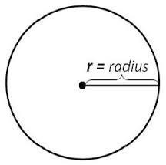
TASK 2: (Composition and Association)
Create classes as mentioned below.
class Point
{
private:
int* x;
int* y;
public:
//Constructors, Getters and Destructor
};

class Circle
{
private:
float* radius;
Point* coordinate;
public:
//Constructors, Getters, Destructor
bool CheckOnCircle(Point& p1) //Returns true if point lies in circle,
// false otherwise
};

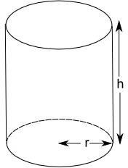
class Cylinder
{
private:
int height;
Circle* top; //Circle on top of Cylinder circle* bottom;
//Circle on bottom of Cylinder
public:
//Constructors, Destructors
bool CheckOnCylinder(Point& p1) //Returns true if point lies
//in cylinder, false otherwise
};

main() should contains following lines, You can add more code, but these lines should be included:
point p1(2,4);
circle c1(5.3,2,3); //Take radius, x, y c1.CheckOnCircle(p1) ;
cylinder cl1(7,5.3,2,9,5.3,2,3); //takes height, parameters for top and bottom circles
cl1.CheckOnCylinder(p1);

Note
- Follow all the code indentation, naming conventions and code commenting guidelines.

