**ProblemSet5Report_Kuka_JiaweiGe**

**The Line Trajectory**

I designed the kuka robot chain as the screenshot shown below. The largest frame is the base and the pink one is the end effector. The RGB axis represent the x, y, z axis respectively.

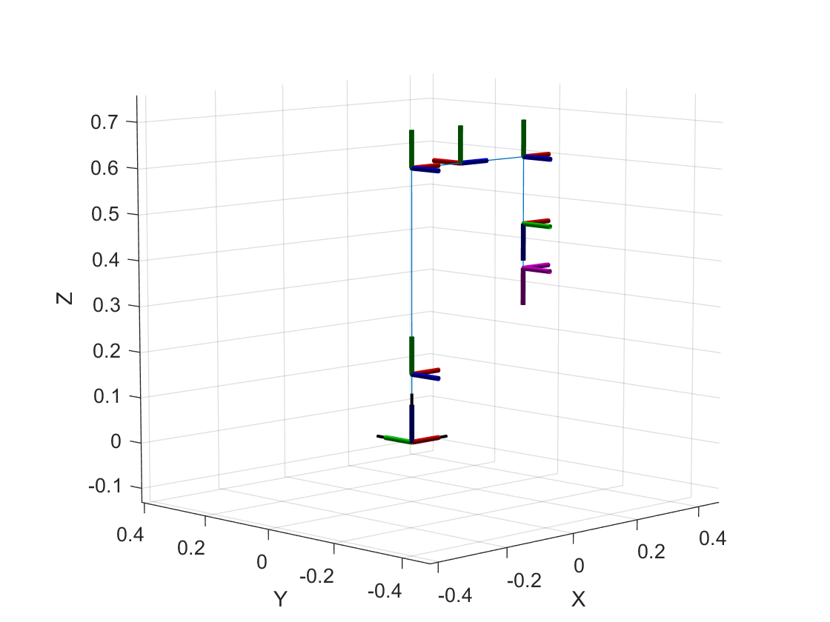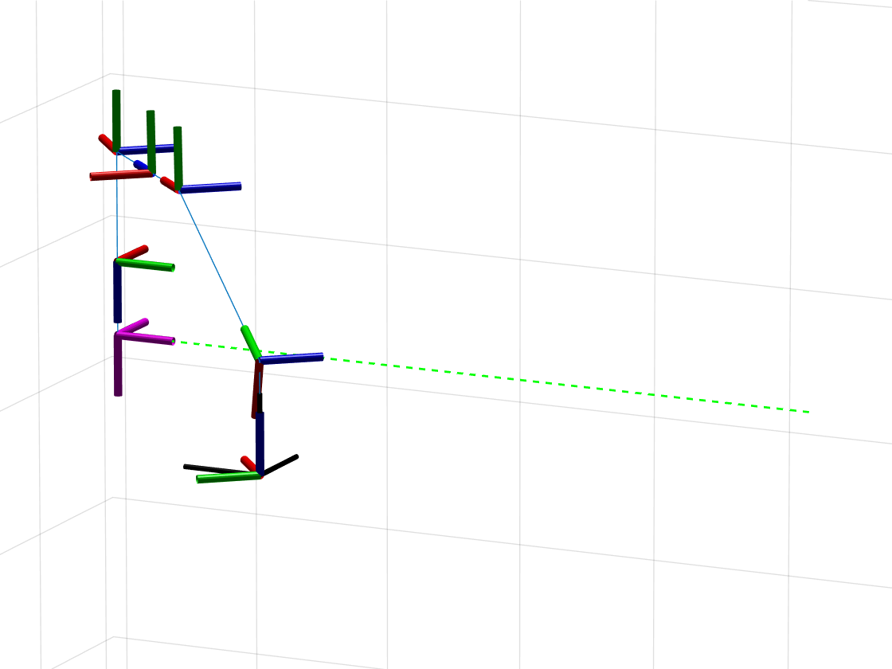

The original configSols definition is wrong. Thanks to the announcement by Rihsabh, I locate the bug without spending lots of time. The original (n x 6 matrix) should be changed to ((n + 1) x 6 struct array). The given code line of "configSols = zeros(size,6)" should be revised to be just “configSols = [];” and then append every structure configSol to it.

The result shows the end effector traversing the line trajectory perfectly as the above screenshot. The rotations of each joint are along the z axis (blue axis), which satisfy the expectation.

Results:

error = 6.29306191096482e-09;

totalTime = 3.590726867858397;

configSols is so complicated to show. Please run the code to see that.