**LabReport8_JiaweiGe**

The dimensions of each red slice equal **215.6 mm x 247.92 mm**. The length **215.6 mm** is yield by **154 slices x 1.4 mm**. The width **247.92 mm** is yield by **240 pixels x 1.033 mm**. The distance between fiducials’ plane and targets’ plane equals **54.899 mm**, which is yield by adding up the depth information in the upper-right box in the screenshots **(33.629 mm + 21.270 mm)**.

The fiducials’ centers are **[619.2565, 596.6149]**, **[629.9568, 1.1356e+03]**, **[1.4237e+03, 1.1028e+03]** in the Matlab results. Because the bw size is **1799 x 1569**. Using the proportion of **240/1799**, we can get the y value of fiducials’ centers, which are **79.59, 151.50, 147.12 = 80th, 152th, 147th pixel**, respectively. Using the proportion of **154/1569**, we can get the slice number of fiducials’ centers, which are **60.78, 61.83, 139.74 = 61, 62, 140**, respectively. The true length and width have a **215.6/1569** and **247.92/1799** proportion, respectively. The true positions of the fiducials’ centers in red slices, therefore, are **(85.09, 82.22), (86.56, 156.50), (195.63, 151.98) mm**.

The targets’ centers are **[934.5005,567.5116], [1.1933e+03,717.6362], [1.4366e+03,565.3621]** in the Matlab results. Because the bw size is **1791 x 1567**. Using the proportion of **240/1791**, we can get the y values of targets’ centers are **78.05, 96.17, 75.76 = 78th, 96th, 76th pixel**, respectively. Using the proportion of **154/1567**, we can get the slice number of fiducials’ centers, which are **91.84, 117.23, 141.18 = 92, 117, 141**, respectively. The true length and width have a **215.6/1567** and **247.92/1791** proportion, respectively. The true positions of the targets’ centers in red slices, therefore, are **(128.58, 78.56), (164.18, 99.34), (197.66, 78.26) mm**.

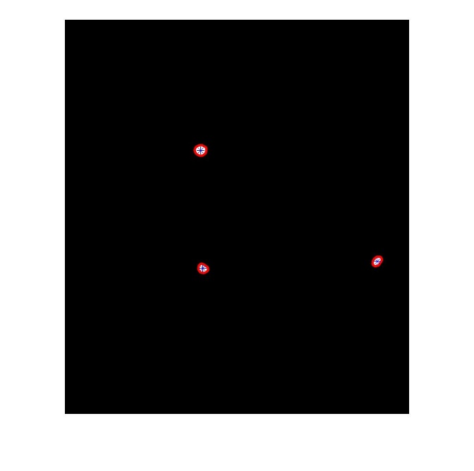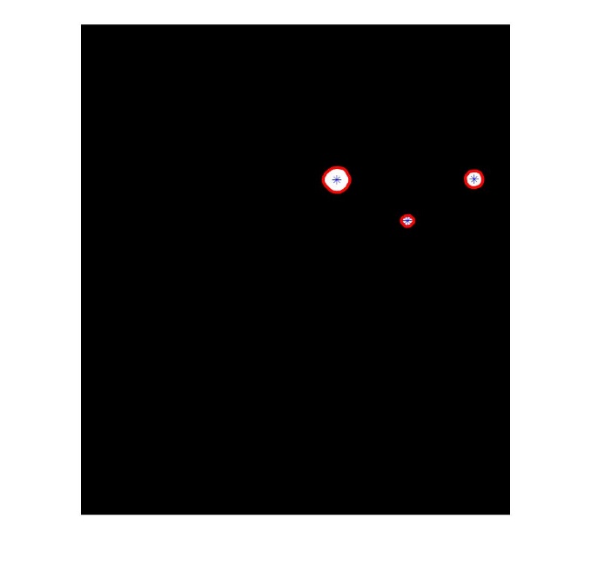

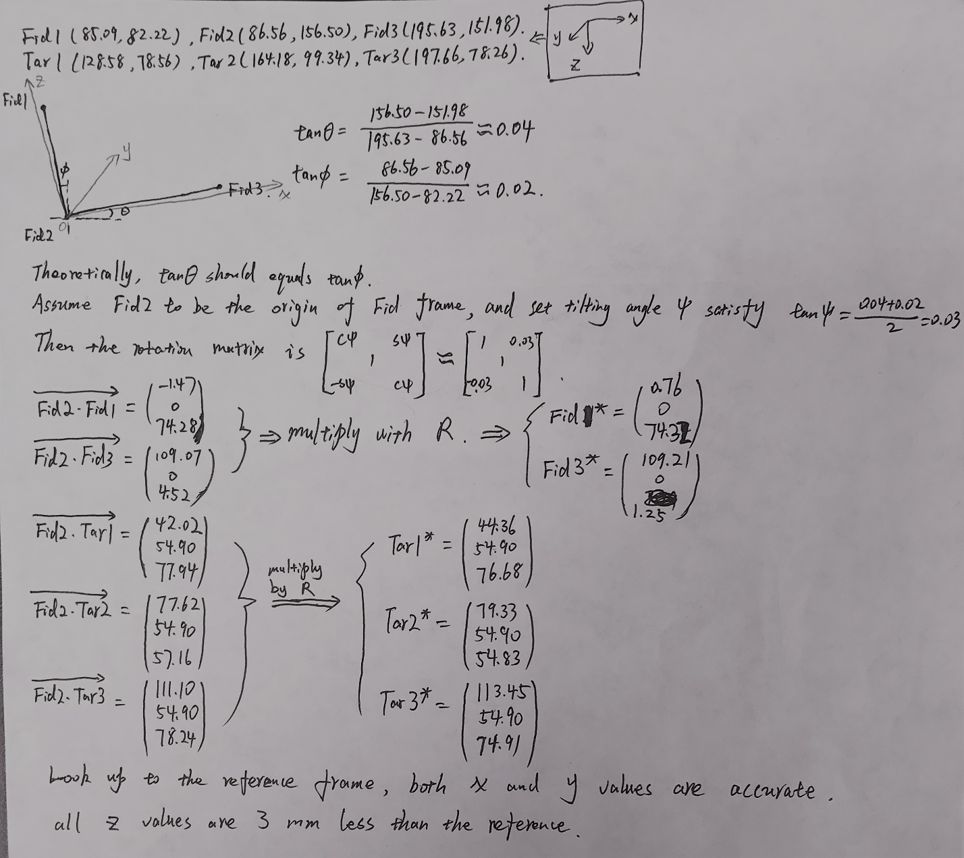

The center position of Fid1 equals **[3.9548e+02,3.8029e+02]**, the depth is **-20.271mm**, and the bw size is **1154 x 997**. The center position of Fid2 equals **[4.0654e+02,7.2571e+02]**, the depth is **-23.371mm**, and the bw size is **1153 x 1001**. The center position of Fid3 equals **[9.1061e+02,7.0301e+02]**, the depth is **-18.204mm**, and the bw size is **1151 x 997**. Using the same methods as mentioned above **(215.6 / bw(2) * Fid1(1) = x_fid; depth = y_fid; -247.92 / bw(1) * Fid1(2) = z_fid)**, we can easily yield that the fiducials’ centers locate at **(85.52, -20.27, 81.70), (87.56, -23.37, 156.04), (196.92, -18.20, 151.43) mm**.

