**6. Z distance changes’ error report**

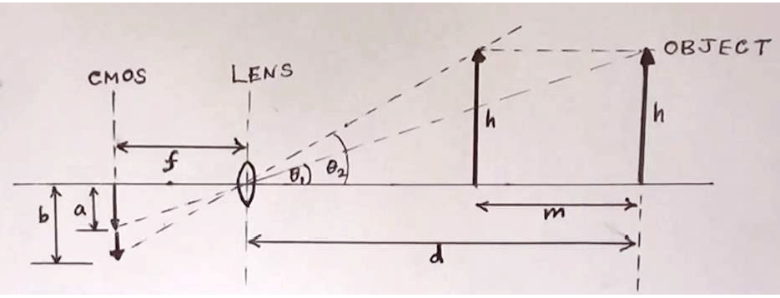

According to the graph above. We can easily yield the formula that:

d = m/(1-a/b);

d-m = m/(b/a-1).

Note that a & b are in pixel unit and m & d are in millimeter unit. We fixed the fiducial frame in camera X-Y plane and move it approaching the camera 5 times with 15 millimeters spacing per time. The ruler-measured distances for them relative to the camera are 358, 343, 328, 313, 298 mm, respectively.

Firstly, we need to know the a & b parameters. We choose the x value differences between 2 fiducial which are closer to the ground in that they are the largest relative distance of fiducials we can get.

The pixel positions of 3 fiducials in 5 different z positions are listed below:

fid1 = [ 449.523684210526,440.484210526316;

447.623145400593,739.287833827893;

891.915829145729,737.802763819096];

fid2 = [ 435.595984943538,444.895859473024;

437.614361702128,760.045212765957;

902.865671641791,755.537313432836];

fid3 = [ 431.067331670823,427.581047381546;

428.656292286874,752.806495263870;

913.092324805339,751.219132369299];

fid4 = [ 417.983940042827,422.226980728051;

417.154491017964,764.713772455090;

926.591992373689,760.070543374643];

fid5 = [ 408.244131455399,412.337089201878;

404.810140237325,769.409924487594;

938.053886925795,765.880742049470];

Then we start to apply the method mentioned above,

a = fid1(3,1)-fid1(2,1);

b = fid5(3,1)-fid5(2,1);

m = 4*15.0;

z = m/(1-a/b);

z1 = 359.6879 z1_reference = 358 error = 1.7mm

a = fid2(3,1)-fid2(2,1);

b = fid4(3,1)-fid4(2,1);

m = 2*15.0;

z = m/(1-a/b);

z2 = 345.8801 z2_reference = 343 error = 2.9mm

a = fid3(3,1)-fid3(2,1);

b = fid5(3,1)-fid5(2,1);

m = 2*15.0;

z = m/(1-a/b);

z3 = 327.7620 z3_reference = 328 error = 0.2mm

a = fid2(3,1)-fid2(2,1);

b = fid4(3,1)-fid4(2,1);

m = 2*15.0;

z = m/(b/a-1);

z4 = 315.8801 z4_reference = 313 error = 2.9mm

a = fid3(3,1)-fid3(2,1);

b = fid5(3,1)-fid5(2,1);

m = 2*15.0;

z = m/(b/a-1);

z5 = 297.7620 z5_reference =298 error = 0.2mm

Finally, we can get the average error to be 1.58mm.