***4.*** In the third section, we utilized image processing methods to segment centroid of the fiducial marker. First, we transform the image from RGB into HSV color space. Second, we set thresholds to hue, saturation, and value image to filter out yellow color in the image. Third, by combining hue and saturation images and applying “regionprops” command, we can derived several areas in a structure. Finally, if an area has eccentricity lager than 0.1 but smaller than 0.5 and with its area larger than 15, we marked it as a fiducial marker and return its position.

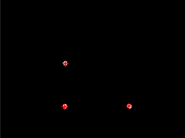

***5.*** After calibration procedures, we derived 372.83 mm on Z direction. We then used this value, pixel position of the centroid points, and the intrinsic matrix to calculate the world coordinates of three centroid points. We also experiment with five different X-Y positions of the markers. The average distance between two markers along vertical direction is 77.9154 mm and average distance between two markers along horizontal direction is 114.972 mm. By comparing with the CAD model, the average distance error between two markers along vertical direction is 3.9154 mm and average distance error between two markers along horizontal direction is 5.972 mm.

|  |  |  |
| --- | --- | --- |
| Centroid 1 | 123.2788548 | 119.0937783 |
| Centroid 2 | 122.8113048 | 196.3143255 |
| Centroid 3 | 237.2640951 | 196.3818537 |
| Distance error between two markers along horizontal direction | | 77.22055 |
| Distance error between two markers along vertical direction | | 114.4528 |

|  |  |  |
| --- | --- | --- |
| Centroid 1 | 121.918647 | 101.5835224 |
| Centroid 2 | 121.62627 | 179.3454568 |
| Centroid 3 | 236.7957179 | 179.6665927 |
| Distance error between two markers along horizontal direction | | 77.76193 |
| Distance error between two markers along vertical direction | | 115.1694 |

|  |  |  |
| --- | --- | --- |
| Centroid 1 | 120.9977939 | 122.2917136 |
| Centroid 2 | 121.506763 | 200.1501676 |
| Centroid 3 | 236.5081094 | 198.9094271 |
| Distance error between two markers along horizontal direction | | 77.85845 |
| Distance error between two markers along vertical direction | | 115.0013 |

|  |  |  |
| --- | --- | --- |
| Centroid 1 | 93.91879382 | 121.7037098 |
| Centroid 2 | 94.09138462 | 200.0108083 |
| Centroid 3 | 209.0122247 | 198.297948 |
| Distance error between two markers along horizontal direction | | 78.3071 |
| Distance error between two markers along vertical direction | | 114.9208 |

|  |  |  |
| --- | --- | --- |
| Centroid 1 | 76.96709385 | 121.6615725 |
| Centroid 2 | 76.69343726 | 200.0909454 |
| Centroid 3 | 192.0114392 | 198.3210172 |
| Distance error between two markers along horizontal direction | | 78.42937 |
| Distance error between two markers along vertical direction | | 115.318 |

**6. Z distance changes’ error report**

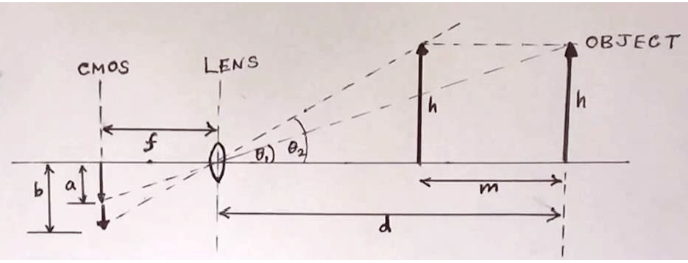

According to the graph above. We can easily yield the formula that:

d = m/(1-a/b);

d-m = m/(b/a-1).

Note that a & b are in pixel unit and m & d are in millimeter unit. We fixed the fiducial frame in camera X-Y plane and move it approaching the camera 5 times with 15 millimeters spacing per time. The ruler-measured distances for them relative to the camera are 358, 343, 328, 313, 298 mm, respectively.

Firstly, we need to know the a & b parameters. We choose the x value differences between 2 fiducial which are closer to the ground in that they are the largest relative distance of fiducials we can get.

The pixel positions of 3 fiducials in 5 different z positions are listed below:

fid1 = [449.523684210526,440.484210526316;

447.623145400593,739.287833827893;

891.915829145729,737.802763819096];

fid2 = [435.595984943538,444.895859473024;

437.614361702128,760.045212765957;

902.865671641791,755.537313432836];

fid3 = [431.067331670823,427.581047381546;

428.656292286874,752.806495263870;

913.092324805339,751.219132369299];

fid4 = [417.983940042827,422.226980728051;

417.154491017964,764.713772455090;

926.591992373689,760.070543374643];

fid5 = [408.244131455399,412.337089201878;

404.810140237325,769.409924487594;

938.053886925795,765.880742049470];

Then we start to apply the method mentioned above,

a = fid1(3,1)-fid1(2,1);

b = fid5(3,1)-fid5(2,1);

m = 4*15.0;

z = m/(1-a/b);

z1 = 359.6879 z1_reference = 358 error = 1.7mm

a = fid2(3,1)-fid2(2,1);

b = fid4(3,1)-fid4(2,1);

m = 2*15.0;

z = m/(1-a/b);

z2 = 345.8801 z2_reference = 343 error = 2.9mm

a = fid3(3,1)-fid3(2,1);

b = fid5(3,1)-fid5(2,1);

m = 2*15.0;

z = m/(1-a/b);

z3 = 327.7620 z3_reference = 328 error = 0.2mm

a = fid2(3,1)-fid2(2,1);

b = fid4(3,1)-fid4(2,1);

m = 2*15.0;

z = m/(b/a-1);

z4 = 315.8801 z4_reference = 313 error = 2.9mm

a = fid3(3,1)-fid3(2,1);

b = fid5(3,1)-fid5(2,1);

m = 2*15.0;

z = m/(b/a-1);

z5 = 297.7620 z5_reference =298 error = 0.2mm

Finally, we can get the average error to be 1.58mm.