**Dedication and perseverance during COVID pandemic**

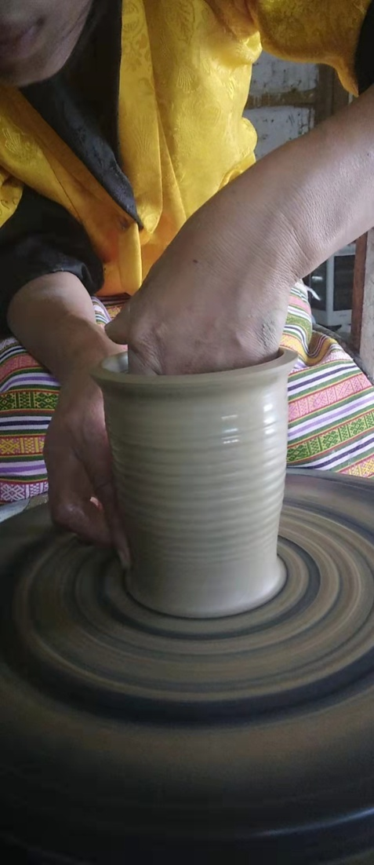Ugyen, now 27 year old, lives in Langthel gewog, Trongsa with her parents and two younger brothers. She was not able to go to school due to poor family background and had to shoulder the responsibility of being the eldest from the family. Not even in her dreams could she believe that she would be exposed to such an opportunity. Up until 2015 she was lost and unsatisfied with her life as she was not able to provide any financial help to her family when needed but she was helping her parents by herding. In 2015, Tarayana foundation came as an opportunity at her doorsteps and she took the chance to learn mud pottery. There were a total of 12 members who took the training and among them, Ugyen was passionate about it as she still continued till date and made the best use of her acquired skills.

In spite of being uneducated she is now an entrepreneur and an employer today. Ugyen runs a mud pottery business and employs two people from the community whenever there is a huge order and pays them a daily wage Nu.500. The pottery business helped her life become lively and she was able to help her family financially and make a profit of Nu 50,000-60,000 annually. Tarayana foundation not only helped her market the products via Tarayana rural crafts (it acts as a unique bridge between the market and artisans to facilitate their access to the global markets) but also built a work shed and her own shelter in 2018.

Her story was also featured in Kuensel on 30th December, 2019 titled “A **farmer turned entrepreneur keeps pottery tradition alive**”, making her skills be known to other people and show her gratitude towards Tarayana foundation and Her Majesty GyalyumDorjiWangmoWangchuck. Everything was going well and she was able to attract customers from different districts. She also got a chance to go to Bangladesh for 10 days to familiarize using machine, get exposure, thus this helped her to collaborate her pottery work with VAST Bhutan and APIC (Agency for Promotion of Indigenous Crafts). She also travelled to Gangzur, a village in Lhunste to refine her pottery work and also share her skills with others.

“The COVID has been the greatest challenge ever since my pottery business”, she said. Yet, Ugyen who has been down-the-line with her work despite knowing that she won’t be able to access the market still continued to make it and kept it ready for all the orders she received online via Wechat and some other social networking sites. During lockdown she was able to incorporate the skills learned at Gangzur and she got to be creative and play with different designs. She also took the feedback she received from her customers and enhanced the products such that previously, her products were the same as the old ones without handles afterwards; she started to design with handles from both sides as per customers demand. Other products include flower pots, vase and flasks.

Her continued dedication and perseverance towards her work is due to the contribution carried out by Tarayana foundation to the rural vulnerable communities. “It has been a helpful and life changing skill for me and I am forever grateful to Her Majesty”, she said. She once used to be shy, naïve and oblivious whereas now she is able to use the phone, travel alone and take orders using social media.

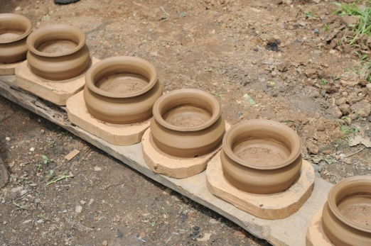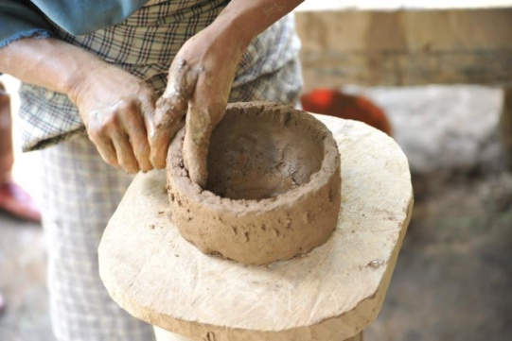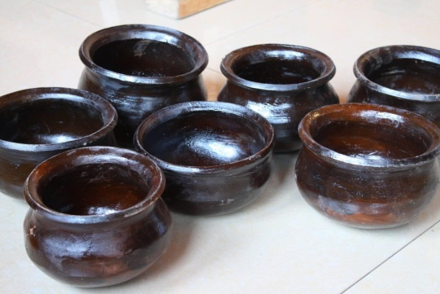

Figure 2: The process of mud pottery in Trongsa

By: Ugyen Phuntsho Selden

Tarayana Foundation