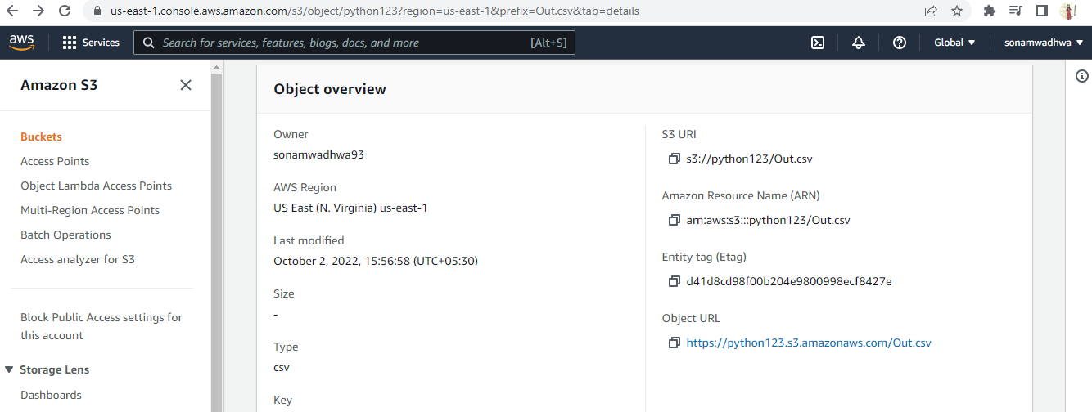

Object URL - <https://python123.s3.amazonaws.com/Out.csv>

S3 URL - s3://python123/Out.csv