**Question 1**

Convert 1D Array Into 2D Array

You are given a **0-indexed** 1-dimensional (1D) integer array original, and two integers, m and n. You are tasked with creating a 2-dimensional (2D) array with m rows and n columns using **all** the elements from original.

The elements from indices 0 to n - 1 (**inclusive**) of original should form the first row of the constructed 2D array, the elements from indices n to 2 * n - 1 (**inclusive**) should form the second row of the constructed 2D array, and so on.

Return *an* m x n *2D array constructed according to the above procedure, or an empty 2D array if it is impossible*.

**Example 1:**

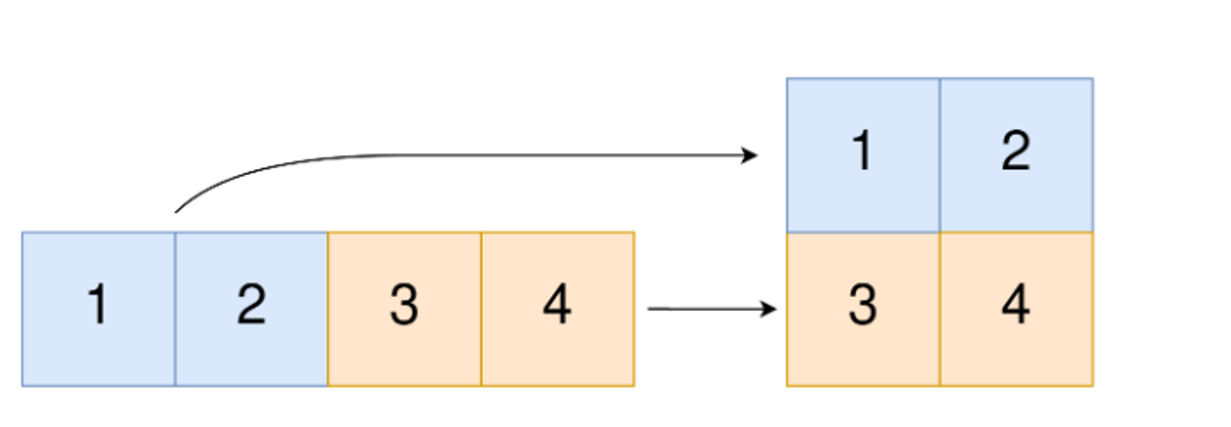

**Input:** original = [1,2,3,4], m = 2, n = 2

**Output:** [[1,2],[3,4]]

**Explanation:** The constructed 2D array should contain 2 rows and 2 columns.

The first group of n=2 elements in original, [1,2], becomes the first row in the constructed 2D array.

The second group of n=2 elements in original, [3,4], becomes the second row in the constructed 2D array.

**Program: class Solution:**

**def construct2DArray(self, original: List[int], m: int, n: int) -> List[List[int]]:**

**if len(original)!= m * n:**

**return[]**

**ans = [[0]* n for _ in range(m)]**

**for i, num in enumerate(original):**

**ans[i//n][i % n] = num**

**return ans**

**INPUT: Original= [1,2,3,4], m = 2, n = 2**

**OUTPUT : [[1,2],[3,4]]**

**Question 2**

**You have n coins and you want to build a staircase with these coins. The staircase consists of k rows where the ith row has exactly i coins. The last row of the staircase may be incomplete.**

**Given the integer n, return *the number of complete rows of the staircase you will build*.**

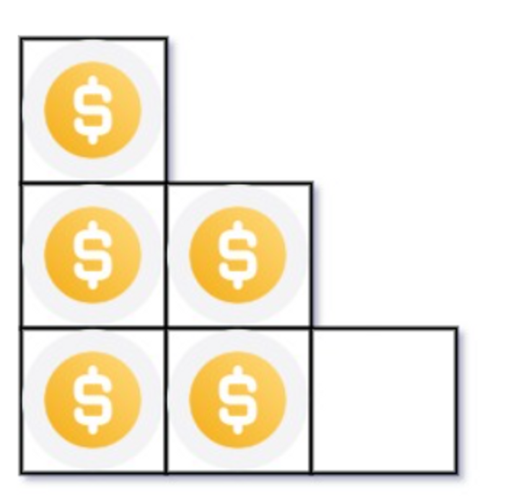

**Input: n = 5**

**Output: 2**

**Explanation: Because the 3rd row is incomplete, we return 2.**

**Program: class Solution:**

**def arrangeCoins(self, n: int) -> int:**

**rows = 0**

**i = 1**

**while n >= i:**

**n-= i**

**rows+= 1**

**i+=1**

**return rows**

**Input: n = 5 , Output: 2**

**Question 3. Given an integer array nums sorted in non-decreasing order, return *an array of the squares of each number sorted in non-decreasing order*.**

**Example 1:**

**Input: nums = [-4,-1,0,3,10]**

**Output: [0,1,9,16,100]**

**Explanation: After squaring, the array becomes [16,1,0,9,100].**

**After sorting, it becomes [0,1,9,16,100].**

**Program:**

**class Solution:**

**def sortedSquares(self, nums: List[int]) -> List[int]:**

**res = []**

**left = 0**

**right = len(nums) - 1**

**while left <= right:**

**if abs(nums[left]) > abs(nums[right]):**

**res.append(nums[left] ** 2)**

**left += 1**

**else:**

**res.append(nums[right] ** 2)**

**right -= 1**

**return res[::-1]**

**INPUT: nums = [-4,-1,0,3,10]**

**OUTPUT: [0,1,9,16,100]**

**Question 4**

**Given two 0-indexed integer arrays nums1 and nums2, return *a list* answer *of size* 2 *where:***

* **answer[0] *is a list of all distinct integers in* nums1 *which are not present in* nums2*.\***
* **answer[1] *is a list of all distinct integers in* nums2 *which are not present in* nums1.**

**Note that the integers in the lists may be returned in any order.**

**Example 1:**

**Input: nums1 = [1,2,3], nums2 = [2,4,6]**

**Output: [[1,3],[4,6]]**

**Explanation:**

**For nums1, nums1[1] = 2 is present at index 0 of nums2, whereas nums1[0] = 1 and nums1[2] = 3 are not present in nums2. Therefore, answer[0] = [1,3].**

**For nums2, nums2[0] = 2 is present at index 1 of nums1, whereas nums2[1] = 4 and nums2[2] = 6 are not present in nums2. Therefore, answer[1] = [4,6].**

**Program:   
class Solution:**

**def findDifference(self, nums1: List[int], nums2: List[int]) -> List[List[int]]:**

**set1 = set(nums1)**

**set2 = set (nums2)**

**return [set1 - set2, set2 - set1]**

**INPUT: nums1 = [1,2,3] , nums2 = [2,4,6]**

**OUTPUT: [[1,3],[4,6]]**

**Question 5**

**Given two integer arrays arr1 and arr2, and the integer d, *return the distance value between the two arrays*.**

**The distance value is defined as the number of elements arr1[i] such that there is not any element arr2[j] where |arr1[i]-arr2[j]| <= d.**

**Example 1:**

**Input: arr1 = [4,5,8], arr2 = [10,9,1,8], d = 2**

**Output: 2**

**Explanation:**

**For arr1[0]=4 we have:**

**|4-10|=6 > d=2**

**|4-9|=5 > d=2**

**|4-1|=3 > d=2**

**|4-8|=4 > d=2**

**For arr1[1]=5 we have:**

**|5-10|=5 > d=2**

**|5-9|=4 > d=2**

**|5-1|=4 > d=2**

**|5-8|=3 > d=2**

**For arr1[2]=8 we have:**

**|8-10|=2 <= d=2**

**|8-9|=1 <= d=2**

**|8-1|=7 > d=2**

**|8-8|=0 <= d=2**

**Program:**

**class Solution:**

**def findTheDistanceValue(self, arr1: List[int], arr2: List[int], d: int) -> int:**

**return sum(all(abs(x - y) > d for y in arr2) for x in arr1)**

**INPUT: arr1 = [4,5,8], arr2 = [10,9,1,8], d = 2**

**OUTPUT : 2**

**Question 6**

**Given an integer array nums of length n where all the integers of nums are in the range [1, n] and each integer appears once or twice, return *an array of all the integers that appears twice*.**

**You must write an algorithm that runs in O(n) time and uses only constant extra space.**

**Example 1:**

**Input: nums = [4,3,2,7,8,2,3,1]**

**Output:**

**[2,3]**

**Program:**

**class Solution:**

**def findDuplicates(self, nums: List[int]) -> List[int]:**

**result = []**

**for n in nums:**

**n = abs(n)**

**if nums[n-1] > 0: nums[n-1] *= -1**

**else: result.append(n)**

**return result**

**INPUT: nums = [4,3,2,7,8,2,3,1]**

**output : [2,3]**

**Question 7**

**Suppose an array of length n sorted in ascending order is rotated between 1 and n times. For example, the array nums = [0,1,2,4,5,6,7] might become:**

* **[4,5,6,7,0,1,2] if it was rotated 4 times.**
* **[0,1,2,4,5,6,7] if it was rotated 7 times.**

**Notice that rotating an array [a[0], a[1], a[2], ..., a[n-1]] 1 time results in the array [a[n-1], a[0], a[1], a[2], ..., a[n-2]].**

**Given the sorted rotated array nums of unique elements, return *the minimum element of this array*.**

**You must write an algorithm that runs in O(log n) time.**

**Example 1:**

**Input: nums = [3,4,5,1,2]**

**Output: 1**

**Explanation:**

**The original array was [1,2,3,4,5] rotated 3 times.**

**Program:**

**class Solution:**

**def findMin(self, nums: List[int]) -> int:**

**if nums[0] <= nums[-1]:**

**return nums[0]**

**left, right = 0, len(nums) - 1**

**while left < right:**

**mid = (left + right) >> 1**

**if nums[0] <= nums[mid]:**

**left = mid + 1**

**else:**

**right = mid**

**return nums[left]**

**Input: nums = [3,4,5,1,2]**

**OUTPUT: 1**

**Question 8**

**An integer array original is transformed into a doubled array changed by appending twice the value of every element in original, and then randomly shuffling the resulting array.**

**Given an array changed, return original *if* changed *is a doubled array. If* changed *is not a doubled array, return an empty array. The elements in* original *may be returned in any order*.**

**Example 1:**

**Input: changed = [1,3,4,2,6,8]**

**Output: [1,3,4]**

**Explanation: One possible original array could be [1,3,4]:**

* **Twice the value of 1 is 1 * 2 = 2.**
* **Twice the value of 3 is 3 * 2 = 6.**
* **Twice the value of 4 is 4 * 2 = 8.**

**Other original arrays could be [4,3,1] or [3,1,4].**

**Program:  
class Solution:**

**def findOriginalArray(self, changed: List[int]) -> List[int]:**

**ans = []**

**q = collections.deque()**

**for num in sorted(changed):**

**if q and num == q[0]:**

**q.popleft()**

**else:**

**q.append(num * 2)**

**ans.append(num)**

**return [] if q else ans**

**INPUT : changed = [1,3,4,2,6,8]**

**OUTPUT : [1,3,4]**