UI – EXPERIMENT 4

AIM
To design and develop a UI/UX prototype using Proto.io that incorporates both familiar and unfamiliar navigation elements, and to evaluate its usability among diverse user groups by providing an intuitive yet enhanced user experience.

PROCEDURE
- Prototype Tool Selection
Proto.io was selected as the prototyping tool to design interactive screens and test navigation behavior effectively.
- Screen Design
The prototype was designed with two main screens:
  - Login Page
  - Profile Page
- Implementation of Familiar Navigation Elements
Common and widely accepted navigation components were included to ensure ease of use:
  - Username and password fields for authentication
  - Login button placed below the input fields
  - Edit Profile button to allow users to update their details
  - Standard actions such as login and logout
- Implementation of Unfamiliar Navigation Elements
Novel navigation techniques were introduced to enhance usability and user engagement:
  - Scrolling effects such as parallax and dynamic content loading on scroll
  - Gamification features like profile completion progress bars
- Usability Focus
The prototype was designed to balance familiarity and innovation, allowing users to interact comfortably while also adapting to new navigation techniques.
- Evaluation Objective
The final prototype aims to assess how different users respond to familiar versus unfamiliar navigation elements and how these affect overall usability.

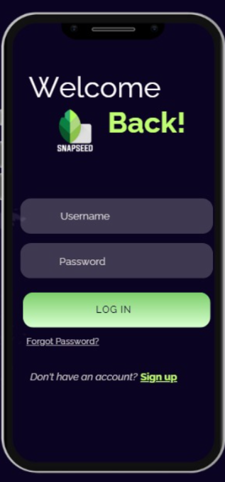
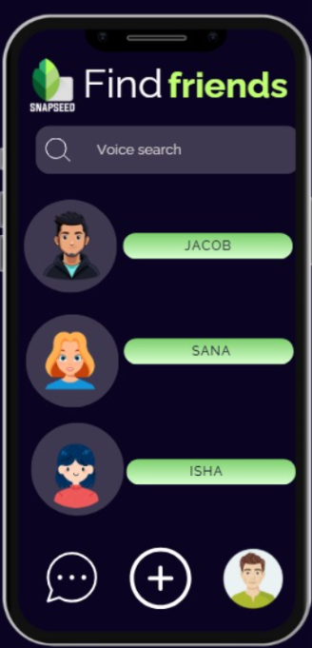

RESULT:
The prototype was successfully created using Proto.io. Users could navigate the screens easily and understand both familiar and new navigation elements.

