Sonar-android-client Jenkins configuration guide
Balázs Bakai

1. Manage Jenkins/Manage Plugins/Available
1A. Select and install this plugins: Jenkins Gradle plugin, Android Emulator Plugin
1B. Download now and install after restart
1C. Restart Jenkins when installation is complete and no jobs are running

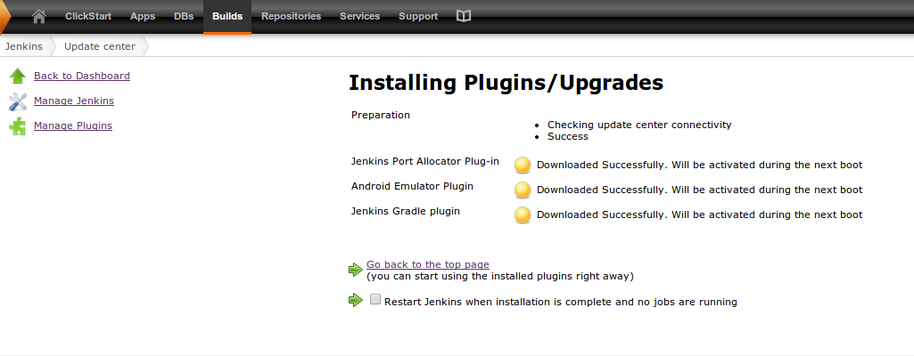

2. Manage Jenkins/Configure System/Gradle installations

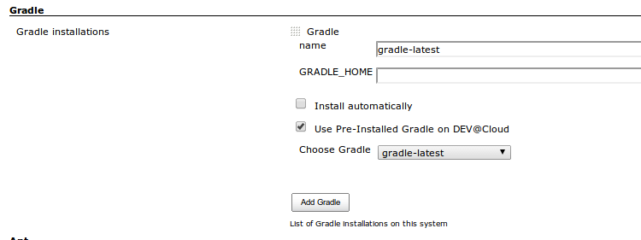

3. Manage Jenkins/Configure System/Android

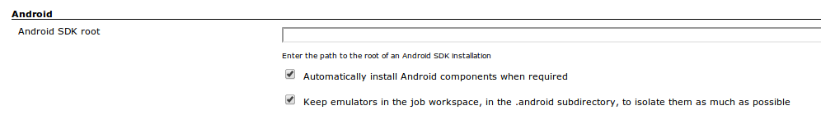

4. Jenkins/New Job

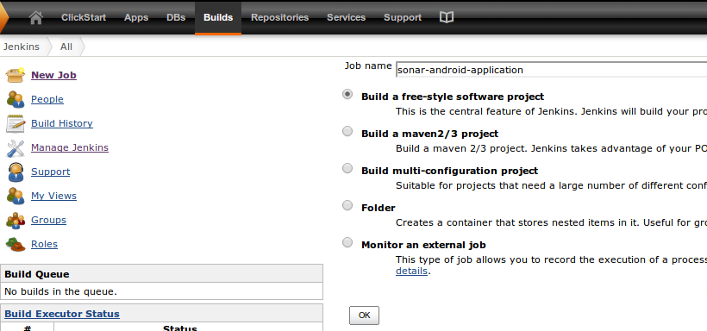

5. Jenkins/sonar-android-application-configure

5A. Source Code Management/GIT
Repository URL:https://github.com/SonarCommunity/sonar-android-application.git

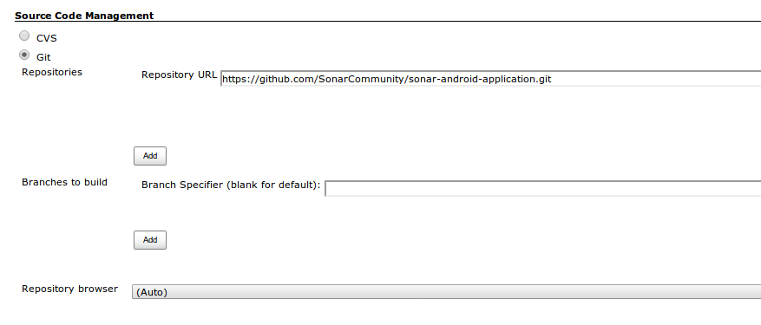

5B. Build/Add Build Step/Invoke Gradle Script
Tasks: clean build

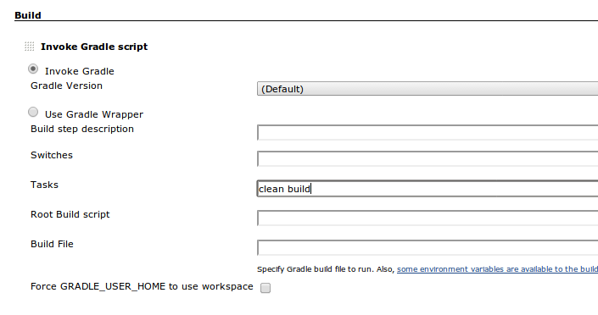

5C. Post Build Actions/Add Post Build Action/Archive the artifacts
Files to archive:
build/apk/sonar-android-application-debug-unaligned.apk,build/apk/sonar-android-application-release-unsigned.apk

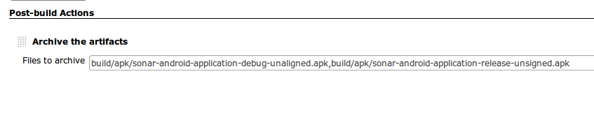
6. Jenkins/sonar-android-application/Build Now
See the console log → Successfull Build!

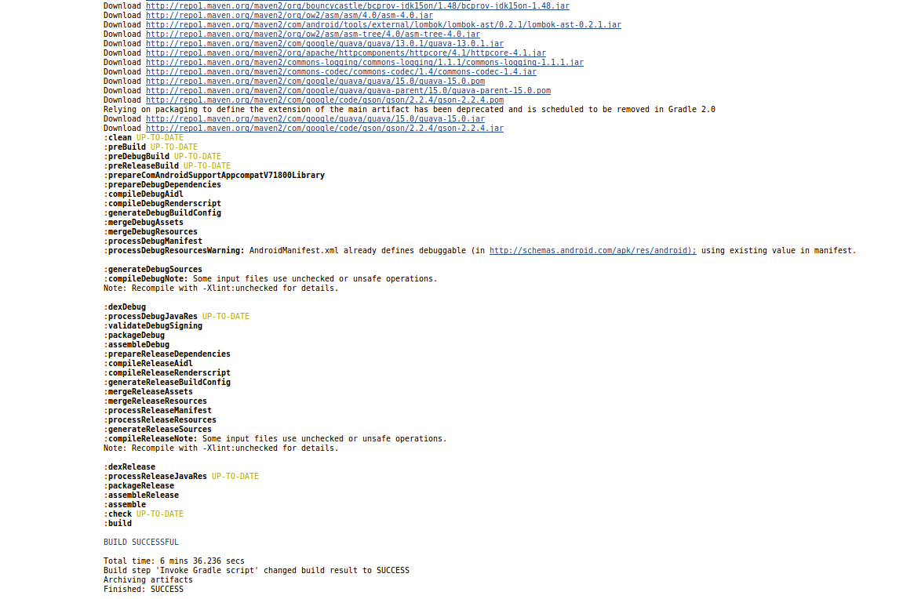
7. After you configure the Jenkins-Sonar Plugin, add an Invoke Standalone Sonar analysis to the job with these properties:

sonar.projectKey=sonar-android-application
sonar.projectName=sonar-android-application
sonar.projectVersion=1.0.0
sonar.language=java
sonar.branch=java
sonar.sources=src
sonar.binaries=build/classes/release/
sonar.libraries=libs/*.jar

