Team 6

Coco is the chat bot to go to if you have any questions about smart watches.

COCO-Chatbot

**Group members:**

* Esraa Badawi
* Esraa El-Kot
* Salma Sultan
* Sondos Ali

Table of Contents

Chatbot Domain 3

Ontology 3

Competency questions & Test cases 5

Question 1 5

Question 2 5

Question 3 5

Question 4 5

Question 5 6

Question 6 6

Training Question-Answers 6

Question 1 6

Question 2 6

Question 3 6

Question 4 7

Question 5 7

Question 6 7

Intent Development 7

General intents 7

Welcome 7

Default Fallback Intent 8

GetName 9

Thanks 10

Goodbye 11

Buy – yes 12

Buy – no 13

Smart watch specific intents 14

SW_Battery 14

SW_Features 15

SW_Featutres – more 16

SW_Manufacturers 17

SW_Price 18

SW_Sensors 18

SW_Stores 19

SW_Touchscreen 19

SW_Types 20

Types – Simple 21

Types – Classic 21

Types – PhoneFunc 22

Types – Sport 23

Types – later 23

Evaluation 24

Questions answers evaluation 24

Question 1 24

Question 2 25

Question 3 26

Question 4 27

Question 5 28

Question 6 29

Questions test cases summary 29

Human evaluation 30

Conversation Example 30

# Chatbot Domain

Answering users’ questions about smart watches.

# Ontology

Overall ontology of the whole topic:

Ontology of smart devices:

Ontology of places to buy smart devices from:

Ontology of smart device properties:

# Competency questions & Test cases

After evaluating the ontology of smart watch, the following questions were selected to limit the scope of the chatbot knowledge implementation. For every question 5 more variations of it were created to test the chatbot ability of answering similar question correctly.

## Question 1

|  |  |
| --- | --- |
| Question | What are the features included in smart watch? |
| Test cases | 1. What sensors are integrated in smart watch? 2. What are the benefits of buying smart watches? 3. How can smart watch improve my life? 4. Why do I need to buy smart watch? 5. Is smart watch useful? 6. why buy a smart watch? |

## Question 2

|  |  |
| --- | --- |
| Question | What is the expected battery life of smart watch? |
| Test cases | 1. How long can smart watch work? 2. How much time can smart watch battery last? 3. How often do I need to charge my smart watch? 4. When will the smart watch battery be damaged? 5. When do I need to change my smart watch battery? |

## Question 3

|  |  |
| --- | --- |
| Question | What companies produces smart watch? |
| Test cases | 1. Which companies are specialized in manufacturing of smart watches? 2. What are famous smart watches brands? 3. Who are the best companies around the world that make smart watches? 4. Who are the suppliers of smart watches? 5. What are the available tech companies that make smart watches? 6. Which groups provide smart watches? |

## Question 4

|  |  |
| --- | --- |
| Question | What are types of smart watch? |
| Test cases | 1. Do smart watches have many types? 2. Is there a smart watch without a touch screen? 3. What are different versions of smart watch? 4. What are different screen types of smart watch? 5. What are the available models of smart watches? 6. What are the latest models of smart watch? |

## Question 5

|  |  |
| --- | --- |
| Question | Where can I buy smart watch? |
| Answer | 1. What stores can I buy smart watch from? 2. What are the available places to buy smart watch? 3. Where can I purchase the best smart watch from? 4. Which places can I get smart watch from? 5. What are famous stores that I can buy smart watches from? 6. Which is the best place to buy smart watch? |

## Question 6

|  |  |
| --- | --- |
| Question | How much does smart watch cost? |
| Test cases | 1. How expensive is smart watch? 2. What is the price range of smart watch? 3. Is smart watches affordable? 4. What is the average budget of smart watch? 5. Which smart watch is the best in low price? |

# Training Question-Answers

The following are the selected questions answers.

## Question 1

|  |  |
| --- | --- |
| Question | What are the features included in smart watch? |
| Answer | Smartwatches come with a lot more functionality than regular digital models. They usually consist of a touch screen interface and are able to connect to your phone or the internet. would you like to know more? |
| Follow up answers | If the user asks for more features, more benefits will be presented to the user. |

## Question 2

|  |  |
| --- | --- |
| Question | What is the expected battery life of smart watch? |
| Answer | smartwatches batteries last up-to 7-8 hours on an average on a single charge. The total lifespan is 2.5-3 years. |

## Question 3

|  |  |
| --- | --- |
| Question | What companies produces smart watch? |
| Answer | Top 5 smart watch manufacturers are:  1-Apple  2-samsung  3-lenovo  4-Garmin  5-fitbit |

## Question 4

|  |  |
| --- | --- |
| Question | What are types of smart watch? |
| Answer | Smart sport watches, Classic smart watches, Simple smart watches, Smart watches with phone function, which one do you want to know more about? |
| Follow up answers | If the user asks for more information about any smart watch type, he will be presented with extra information about the selected smart watch type. |

## Question 5

|  |  |
| --- | --- |
| Question | Where can I buy smart watch? |
| Answer | you can make an order from Amazon or Jumia website. or you can visit any major Tech store to buy a smart watch. |

## Question 6

|  |  |
| --- | --- |
| Question | How much does smart watch cost? |
| Answer | The best smartwatches generally cost between $300 and $400. |

# Intent Development

Using Google DialogueFlow service for the chatbot development, a new chatbot agent was created using the following intents:

## General intents

### Welcome

**Description**

An intent to welcome the user, introduce the chatbot and ask the user for his name.

**Context**

**Training phrases**

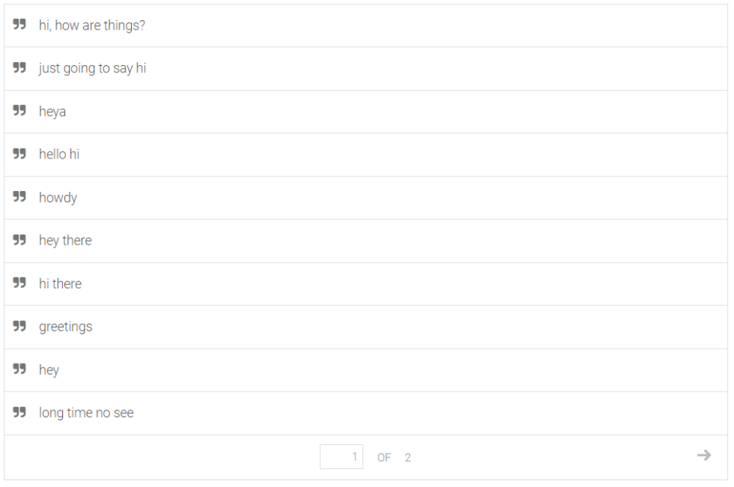

**Responses**

### Default Fallback Intent

**Description**

A default fallback intent for the chatbot activated when the user says something that the chatbot does not understand

**Context**

No context is required for this intent

**Training phrases**

No training phrases are required for this intent

**Responses**

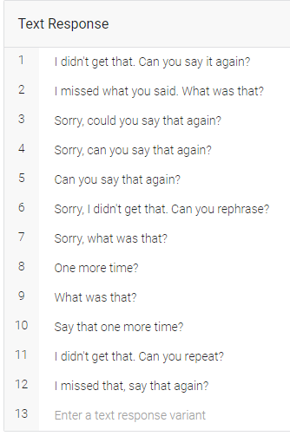

### GetName

**Description**

An intent to welcome the user using his name, activates “Person” context to keep track of the user’s name.

**Context**

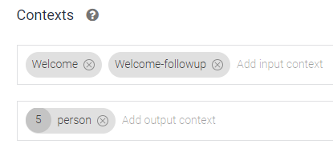

**Training phrases**

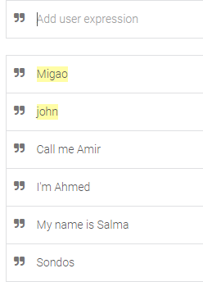

**Responses**

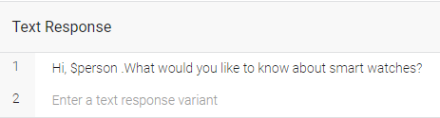

### Thanks

**Description**

An intent to reply to the users' gratitude for the chatbot’s help and asks the user if he will buy a smartwatch or not then it activates the “BuySW” context.

**Context**

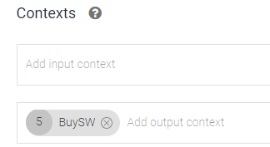

**Training phrases**

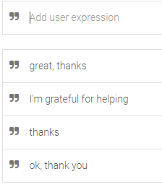

**Responses**

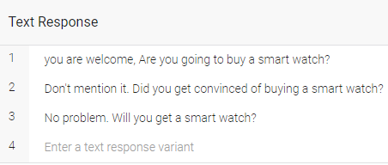

### Goodbye

**Description**

An intent to respond to user leaving, and asks if the user will buy a smart watch or not, so it activates the “BuySW” context

**Context**

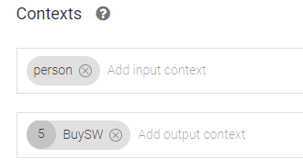

**Training phrases**

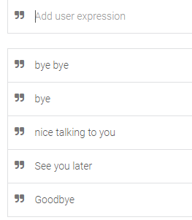

**Responses**

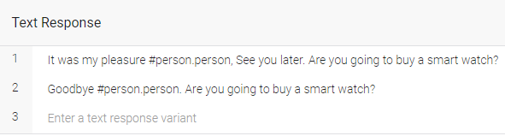

### Buy – yes

**Description**

An intent activated when the user answers to chatbot question about buying a smartwatch with an intent to buy a smartwatch.

**Context**

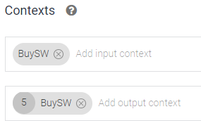

**Training phrases**

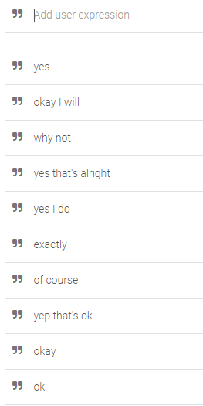

**Responses**

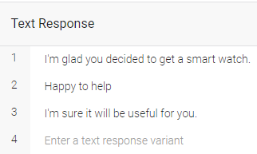

### Buy – no

**Description**

An intent activated when the user answers to chatbot question about buying a smartwatch with an intent to not buy a smartwatch.

**Context**

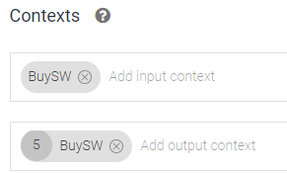

**Training phrases**

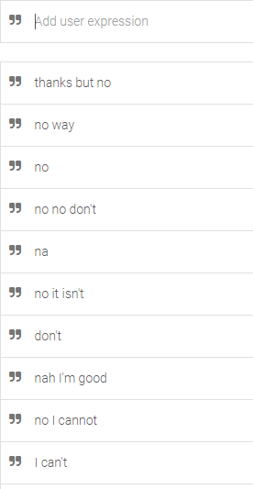

**Responses**

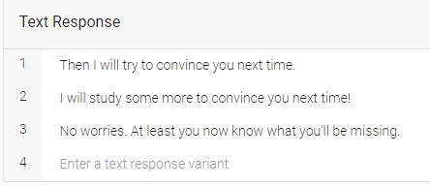

## Smart watch specific intents

### SW_Battery

**Description**

An intent to answer users’ questions about smartwatch battery.

**Context**

No specific input or output context exist for this intent

**Training phrases**

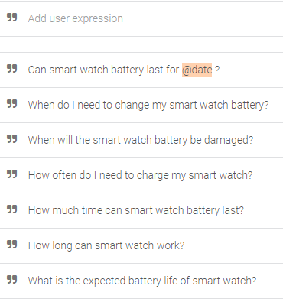

**Responses**

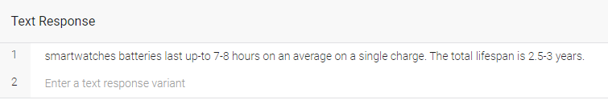

### SW_Features

**Description**

An intent to answer users’ questions about smartwatch features.

**Context**

**Training phrases**

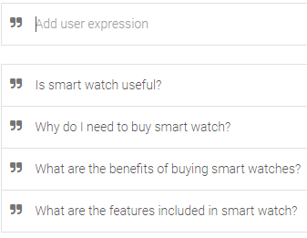

**Responses**

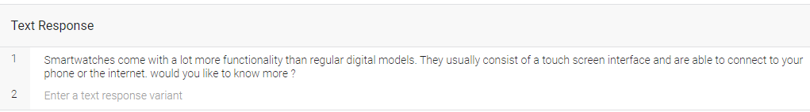

### SW_Featutres – more

**Description**

An intent to answer users’ questions about wanting to know more smartwatch features.

**Context**

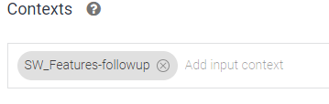

**Training phrases**

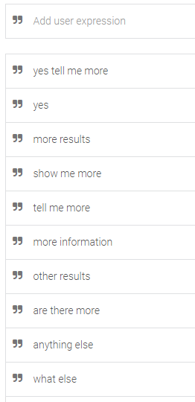

**Responses**

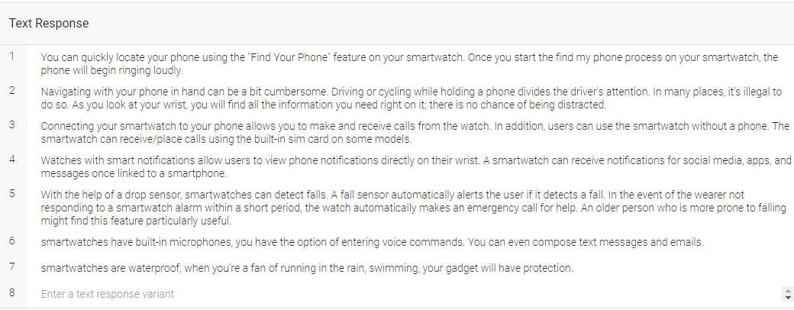

### SW_Manufacturers

**Description**

An intent to answer users’ questions about wanting to know about smartwatch manufacturers.

**Context**

No specific input or output context exist for this intent

**Training phrases**

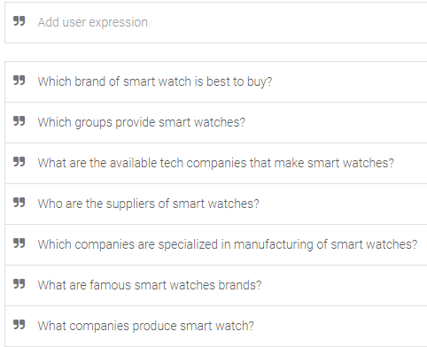

**Responses**

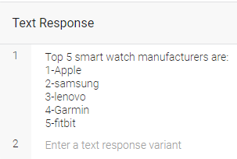

### SW_Price

**Description**

An intent to answer users’ questions about wanting to know about smartwatch prices.

**Context**

No specific input or output context exist for this intent

**Training phrases**

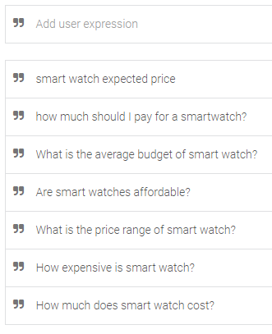

**Responses**

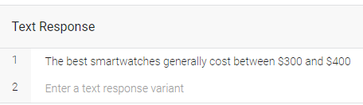

### SW_Sensors

**Description**

An intent to answer users’ questions about wanting to know about smartwatch sensors.

**Context**

No specific input or output context exist for this intent

**Training phrases**

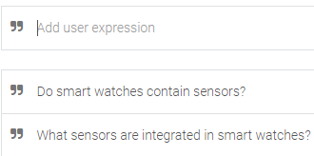

**Responses**

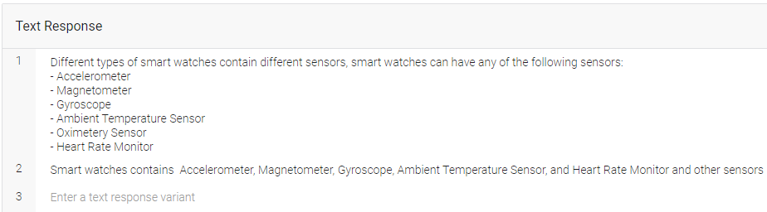

### SW_Stores

**Description**

An intent to answer users’ questions about wanting to know about where to buy smartwatch.

**Context**

No specific input or output context exist for this intent

**Training phrases**

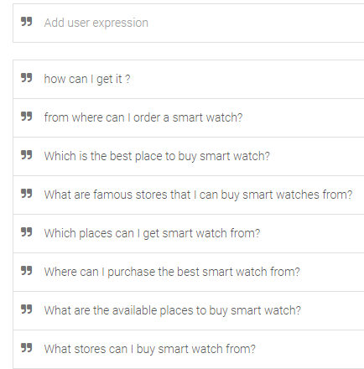

**Responses**

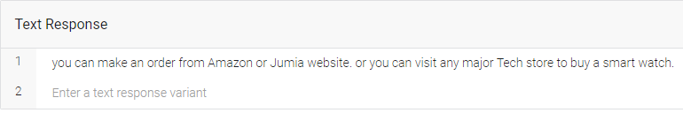

### SW_Touchscreen

**Description**

An intent to answer users’ questions about wanting to know about smartwatch having touchscreens or not.

**Context**

No specific input or output context exist for this intent

**Training phrases**

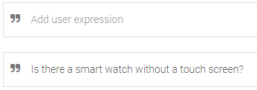

**Responses**

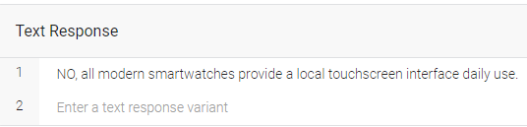

### SW_Types

**Description**

An intent to answer users’ questions about wanting to know about different smartwatch types.

**Context**

**Training phrases**

**Responses**

### Types – Simple

**Description**

An intent to answer users’ questions about wanting to know about simple smartwatch type.

**Context**

**Training phrases**

**Responses**

### Types – Classic

**Description**

An intent to answer users’ questions about wanting to know about classic smartwatch type.

**Context**

**Training phrases**

**Responses**

### Types – PhoneFunc

**Description**

An intent to provide the user with more information about the smart watch with phone functions, it is activated only when the “SW_Types-followup” context is active.

**Context**

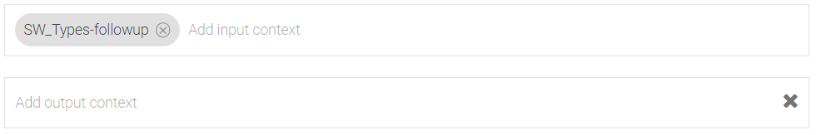

**Training phrases**

**Responses**

### Types – Sport

**Description**

An intent to provide the user with more information about the sports smart watch, it is activated only when the “SW_Types-followup” context is active.

**Context**

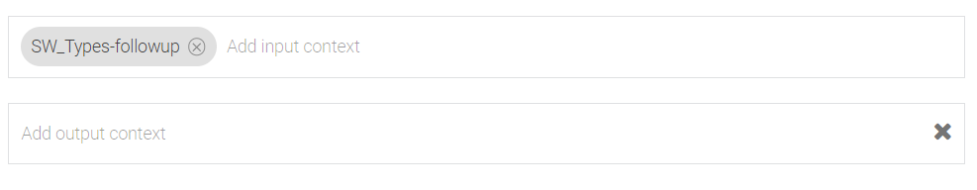

**Training phrases**

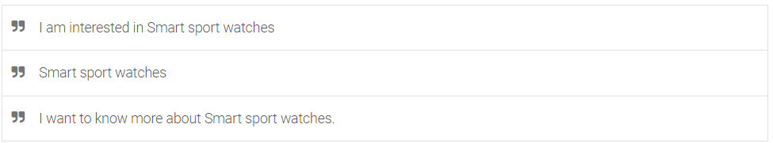

**Responses**

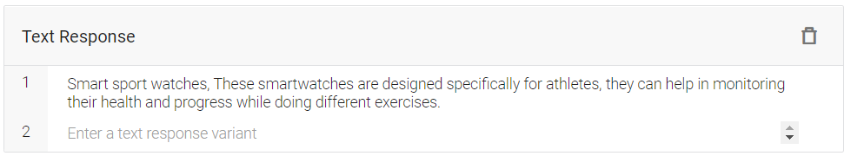

### Types – later

**Description**

An intent to handle user not wanting to ask about any specific smart watch type.

**Context**

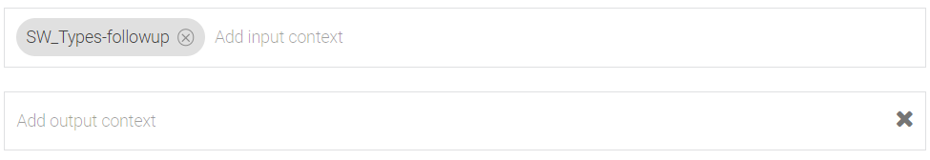

**Training phrases**

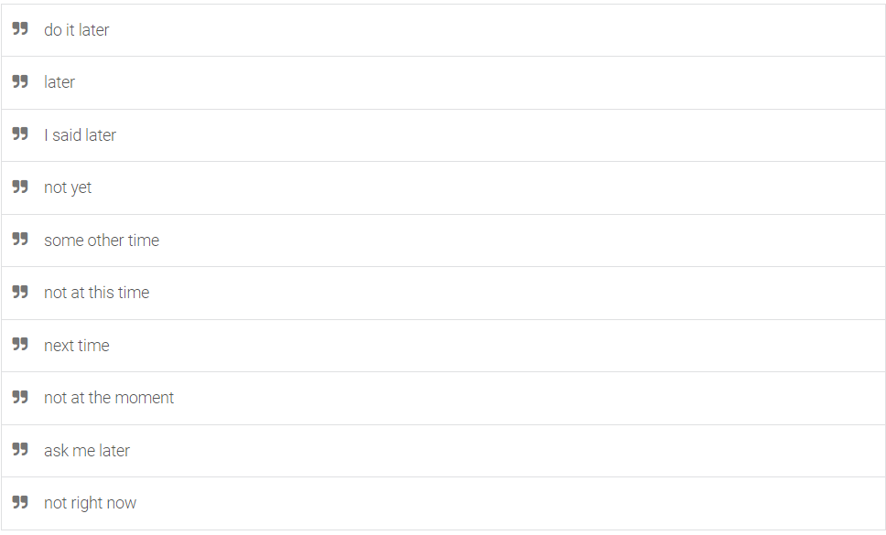

**Responses**

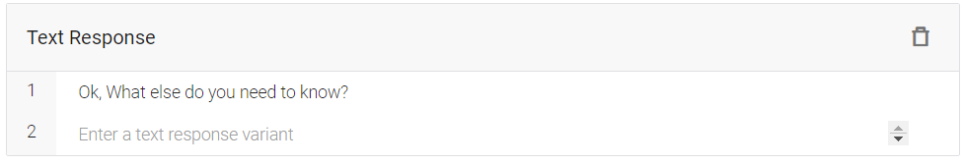

# Evaluation

The chatbot can be accessed through the following [link](https://bot.dialogflow.com/2900d3b8-789c-453c-b21a-8f5258f3d25a).

## Questions answers evaluation

### Question 1

|  |  |
| --- | --- |
| Question | What are the features included in smart watch? |
| Answer | Smartwatches come with a lot more functionality than regular digital models. They usually consist of a touch screen interface and are able to connect to your phone or the internet. would you like to know more? |
| Answer Evaluation | Correct answers, it’s relevant to the question. |

#### Test Cases for question 1

|  |  |
| --- | --- |
| TC1 | What sensors are integrated in smart watch? |
| Answer | Different types of smart watches contain different sensors. Smart watches can have any of the following sensors: - Accelerometer - Magnetometer - Gyroscope - Ambient Temperature Sensor - Oximetery Sensor - Heart Rate Monitor. |
| Answer Evaluation | Correct answers, it’s relevant to the question. |
| TC2 | What are the benefits of buying smart watches? |
| Answer | Smartwatches come with a lot more functionality than regular digital models. They usually consist of a touch screen interface and are able to connect to your phone or the internet. would you like to know more? |
| Answer Evaluation | Correct answers, it’s relevant to the question. |
| TC3 | How can smart watch improve my life? |
| Answer | smartwatches batteries last up-to 7-8 hours on an average on a single charge. The total lifespan is 2.5-3 years. |
| Answer Evaluation | Incorrect answer, it isn’t related to the question. |
| TC4 | Why do I need to buy smart watch? |
| Answer | Smartwatches come with a lot more functionality than regular digital models. They usually consist of a touch screen interface and are able to connect to your phone or the internet. would you like to know more ? |
| Answer Evaluation | Correct answers, it’s relevant to the question. |
| TC5 | Is smart watch useful? |
| Answer | Smartwatches come with a lot more functionality than regular digital models. They usually consist of a touch screen interface and are able to connect to your phone or the internet. would you like to know more ? |
| Answer Evaluation | Correct answers, it’s relevant to the question. |
| TC6 | why buy a smart watch? |
| Answer | you can make an order from Amazon or Jumia website. or you can visit any major Tech store to buy a smart watch. |
| Evaluation Answer | Incorrect answer, it isn’t related to the question. |

### Question 2

|  |  |
| --- | --- |
| Question | What is the expected battery life of smart watch? |
| Answer | smartwatches batteries last up-to 7-8 hours on an average on a single charge. The total lifespan is 2.5-3 years. |
| Answer Evaluation | Correct answer, it is relevant to the question. |

#### Test Cases for question 2

|  |  |
| --- | --- |
| TC1 | How long can smart watch work? |
| Answer | smartwatches batteries last up-to 7-8 hours on an average on a single charge. The total lifespan is 2.5-3 years. |
| Answer Evaluation | Correct answer, it is relevant to the question. |
| TC2 | How much time can smart watch battery last? |
| Answer | smartwatches batteries last up-to 7-8 hours on an average on a single charge. The total lifespan is 2.5-3 years. |
| Answer Evaluation | Correct answer, it is relevant to the question. |
| TC3 | How often do I need to charge my smart watch? |
| Answer | smartwatches batteries last up-to 7-8 hours on an average on a single charge. The total lifespan is 2.5-3 years. |
| Answer Evaluation | Correct answer, it is relevant to the question. |
| TC4 | When will the smart watch battery be damaged? |
| Answer | smartwatches batteries last up-to 7-8 hours on an average on a single charge. The total lifespan is 2.5-3 years. |
| Answer Evaluation | Correct answer, it is relevant to the question. |
| TC5 | When do I need to change my smart watch battery? |
| Answer | smartwatches batteries last up-to 7-8 hours on an average on a single charge. The total lifespan is 2.5-3 years. |
| Answer Evaluation | Correct answer, it is relevant to the question. |

### Question 3

|  |  |
| --- | --- |
| Question | What companies produces smart watch? |
| Answer | Top 5 smart watch manufacturers are: 1-Apple  2-samsung  3-lenovo  4-Garmin  5-fitbit |
| Answer Evaluation | Correct answer, it is relevant to the question. |

#### Test Cases for question 3

|  |  |
| --- | --- |
| TC1 | Which companies are specialized in manufacturing of smart watches? |
| Answer | Top 5 smart watch manufacturers are: 1-Apple  2-samsung  3-lenovo  4-Garmin  5-fitbit |
| Answer Evaluation | Correct answer, it is relevant to the question. |
| TC2 | What are famous smart watches brands? |
| Answer | Top 5 smart watch manufacturers are: 1-Apple  2-samsung  3-lenovo  4-Garmin  5-fitbit |
| Answer Evaluation | Correct answer, it is relevant to the question. |
| TC3 | Who are the best companies around the world that make smart watches? |
| Answer | Top 5 smart watch manufacturers are: 1-Apple  2-samsung  3-lenovo  4-Garmin  5-fitbit |
| Answer Evaluation | Correct answer, it is relevant to the question. |
| TC4 | Who are the best companies around the world that make smart watches? |
| Answer | Top 5 smart watch manufacturers are: 1-Apple  2-samsung  3-lenovo  4-Garmin  5-fitbit |
| Answer Evaluation | Correct answer, it is relevant to the question. |
| TC5 | What are the available tech companies that make smart watches? |
| Answer | Top 5 smart watch manufacturers are: 1-Apple  2-samsung  3-lenovo  4-Garmin  5-fitbit |
| Answer Evaluation | Correct answer, it is relevant to the question. |
| TC6 | Which groups provide smart watches? |
| Answer | Top 5 smart watch manufacturers are: 1-Apple  2-samsung  3-lenovo  4-Garmin  5-fitbit |
| Answer Evaluation | Correct answer, it is relevant to the question. |

### Question 4

|  |  |
| --- | --- |
| Question | What are types of smart watch? |
| Answer | Smart sport watches, Classic smart watches, Simple smart watches, Smart watches with phone function, which one do you want to know more about? |
| Answer Evaluation | Correct answer, it is relevant to the question. |

#### Test Cases for question 4

|  |  |
| --- | --- |
| TC1 | Do smart watches have many types? |
| Answer | Smart sport watches, Classic smart watches, Simple smart watches, Smart watches with phone function, which one do you want to know more about? |
| Answer Evaluation | Correct answer, it is relevant to the question. |
| TC2 | Is there a smart watch without a touch screen? |
| Answer | NO, all modern smartwatches provide a local touchscreen interface daily use. |
| Answer Evaluation | Correct answer, it is relevant to the question. |
| TC3 | What are different versions of smart watch? |
| Answer | Smart sport watches, Classic smart watches, Simple smart watches, Smart watches with phone function, which one do you want to know more about? |
| Answer Evaluation | Correct answer, it is relevant to the question. |
| TC4 | What are different screen types of smart watch? |
| Answer | Smart sport watches, Classic smart watches, Simple smart watches, Smart watches with phone function, which one do you want to know more about? |
| Answer Evaluation | Correct answer, it is relevant to the question. |
| TC5 | What are the available models of smart watches? |
| Answer | Smart sport watches, Classic smart watches, Simple smart watches, Smart watches with phone function, which one do you want to know more about? |
| Answer Evaluation | Correct answer, it is relevant to the question. |
| TC6 | What are the latest models of smart watch? |
| Answer | Smart sport watches, Classic smart watches, Simple smart watches, Smart watches with phone function, which one do you want to know more about? |
| Answer Evaluation | Correct answer, it is relevant to the question. |

### Question 5

|  |  |
| --- | --- |
| Question | Where can I buy smart watch? |
| Answer | you can make an order from Amazon or Jumia website. or you can visit any major Tech store to buy a smart watch. |
| Answer Evaluation | Correct answer, it is relevant to the question. |

#### Test Cases for question 5

|  |  |
| --- | --- |
| TC1 | What stores can I buy smart watch from? |
| Answer | you can make an order from Amazon or Jumia website. or you can visit any major Tech store to buy a smart watch. |
| Answer Evaluation | Correct answer, it is relevant to the question. |
| TC2 | What are the available places to buy smart watch? |
| Answer | you can make an order from Amazon or Jumia website. or you can visit any major Tech store to buy a smart watch. |
| Answer Evaluation | Correct answer, it is relevant to the question. |
| TC3 | Where can I purchase the best smart watch from? |
| Answer | you can make an order from Amazon or Jumia website. or you can visit any major Tech store to buy a smart watch. |
| Answer Evaluation | Correct answer, it is relevant to the question. |
| TC4 | Which places can I get smart watch from? |
| Answer | you can make an order from Amazon or Jumia website. or you can visit any major Tech store to buy a smart watch. |
| Answer Evaluation | Correct answer, it is relevant to the question. |
| TC5 | What are famous stores that I can buy smart watches from? |
| Answer | you can make an order from Amazon or Jumia website. or you can visit any major Tech store to buy a smart watch. |
| Answer Evaluation | Correct answer, it is relevant to the question. |
| TC6 | Which is the best place to buy smart watch? |
| Answer | you can make an order from Amazon or Jumia website. or you can visit any major Tech store to buy a smart watch. |
| Answer Evaluation | Correct answer, it is relevant to the question. |

### Question 6

|  |  |
| --- | --- |
| Question | How much does smart watch cost? |
| Answer | The best smartwatches generally cost between $300 and $400 |
| Answer Evaluation | Correct answer, it is relevant to the question. |

#### Test Cases for question 6

|  |  |
| --- | --- |
| TC1 | How expensive is smart watch? |
| Answer | The best smartwatches generally cost between $300 and $400 |
| Answer Evaluation | Correct answer, it is relevant to the question. |
| TC2 | What is the price range of smart watch? |
| Answer | The best smartwatches generally cost between $300 and $400 |
| Answer Evaluation | Correct answer, it is relevant to the question. |
| TC3 | Is smart watches affordable? |
| Answer | The best smartwatches generally cost between $300 and $400 |
| Answer Evaluation | Correct answer, it is relevant to the question. |
| TC4 | What is the average budget of smart watch? |
| Answer | The best smartwatches generally cost between $300 and $400 |
| Answer Evaluation | Correct answer, it is relevant to the question. |
| TC5 | Which smart watch is the best in low price? |
| Answer | The best smartwatches generally cost between $300 and $400 |
| Answer Evaluation | Correct answer, it is relevant to the question. |

### Questions test cases summary

Total questions asked: **34**

Irrelevant answers: **2**

## Human evaluation

From our evaluation of the chatbot performance, the following was noticed:

* When the chatbot welcomes the user and asks for his name, some names are not recognized.
* When the user asks for the reason to buy smart watches, one reason will be presented to the user, then if the user asks for more reasons another one will be presented, but if the user keeps writing more the chatbot gets into fallback intent and does not understand what the user is saying.

# Conversation Example

