SVP085 MODULAR SPLIT PLAN
Snorre A Platform Access
Sifab AS | SP-01415 | Rev 2 | 27 February 2026 | INTERNAL
______________________________________________________________________

1. The Problem
The SVP085 must be installed on Snorre A but does not fit through the platform access door as a complete unit. The frame is 48 mm too wide.
 | SVP085 | Door
Length | 5,258 mm | Max ~2,450 mm (corridor)
Width (frame) | 1,448 mm | 1,400 mm ← TOO WIDE
Width (feet) | 1,588 mm | 1,400 mm ← TOO WIDE
Height | 1,316 mm (1,367 offshore) | 2,200 mm ← FITS
Solution: Split the frame into 3 sections. Flow tube shipped from TruStop in wooden crate, fitted with transport wheels on platform, and rolled through the door. Frame sections flipped 90° on their side (756 mm wide) to pass through the door.

2. Platform Access Confirmed (Guidant, 27 Feb 2026)
Guidant (Torleif Espegard) provided site photos confirming:
- Welding is OK on platform (preferred before prover in position)
- 1.59 m width can work if ladder east of metering package is temporarily removed
- Transport route confirmed: through door, along corridor, turn west to installation
- Customer asks: "What do you envision for length and height?"
Our answer: Max 2,450 mm length per frame module. Frame sections ~756 mm high when flipped on side. Flow tube in wooden crate on wheels (~600-800 mm high).

Corridor photos from Snorre A:
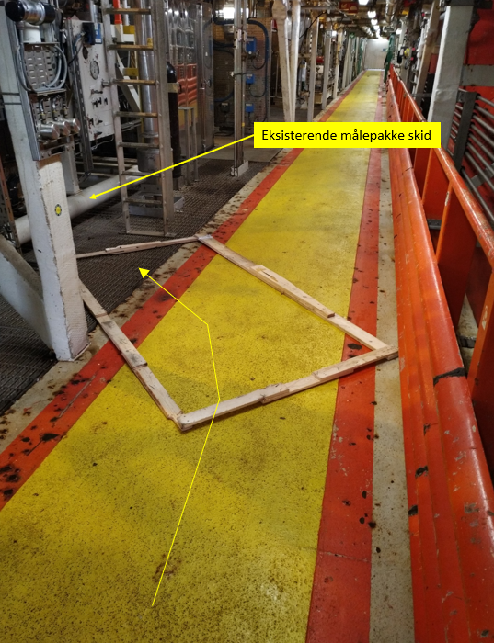  Existing metering skid & size template | 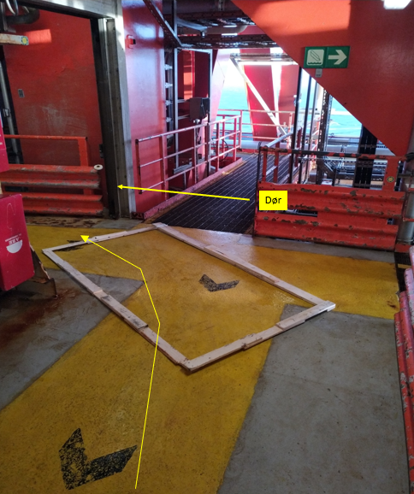  Access door (1.4m frame, 1.59m possible)
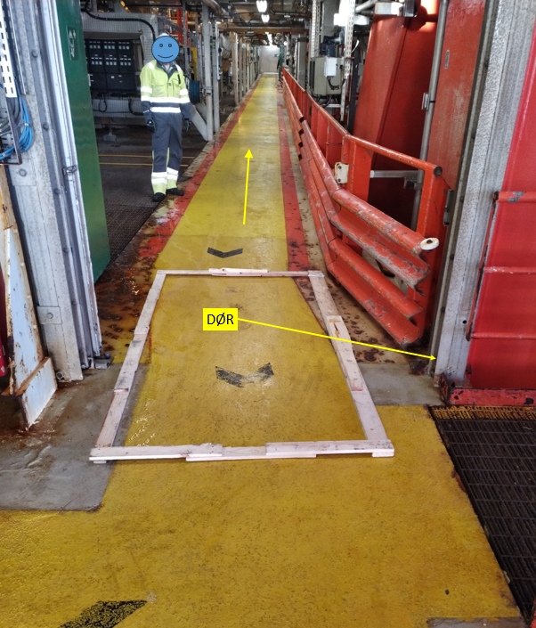  Corridor length view | 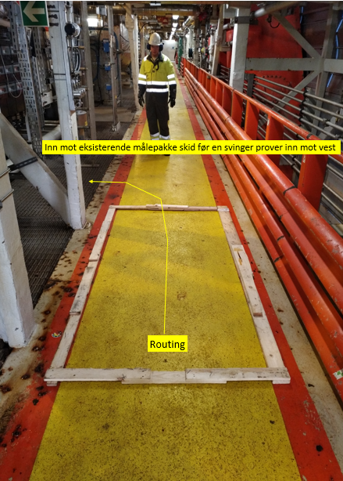  Transport routing toward installation

3. Split Concept
The prover is split into transport modules. The frame is cut into 3 sections at the bolted splice joints shown below. Hydraulic drive and controller/piping are removed and transported separately. Two scenarios are proposed for the flow tube:

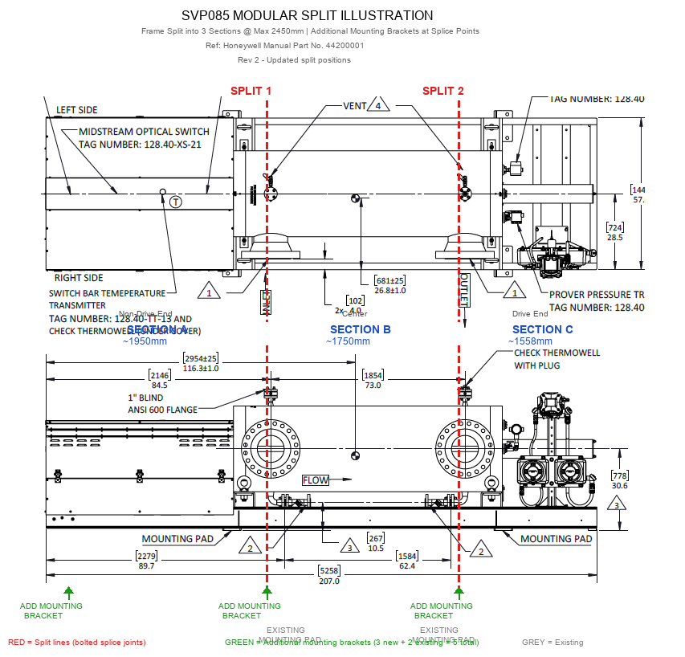
Annotated from Honeywell GA Drawing (Manual Part No. 44200001). Red = splice joints. Green = additional mounting brackets.

Scenario A: Flow tube as-is in wooden crate (recommended)
Flow tube shipped complete from TruStop in standard wooden crate. On platform, transport wheels fitted under crate and rolled straight through the door. Simplest and lowest risk option.
Item | Dimensions | Notes
Flow tube + end flanges in crate | ~2,900 x 600 x 600 mm | One crate, ~1,700-2,200 kg
Piston/rod assembly | Packed inside same crate or separate | Removed from tube for protection
Transport wheels | Fitted under crate on platform | Sifab supplies
Crate is ~2.9 m long (exceeds 2,450 mm frame module limit) but only ~600 mm wide — easily maneuverable through the 1.4 m door and along the corridor.

Scenario B: Remove end flanges + piston, pack in crates
End flanges and piston removed from flow tube at Sifab workshop. Tube body (~2,600 mm), flanges, and piston packed into 2 wooden crates. Tube crate is ~300 mm shorter than Scenario A and lighter. Flanges and RTJ faces protected separately.
Item | Dimensions | Notes
Crate 1: Tube body (no flanges) | ~2,700 x 500 x 500 mm | Lighter, narrower (~1,500-1,800 kg)
Crate 2: End flanges + piston + seals | ~800 x 600 x 600 mm | RTJ faces protected separately (~200-400 kg)
Transport wheels | Fitted under each crate on platform | Sifab supplies
Note: Removing end flanges requires Honeywell procedure. RTJ flange faces must be protected. Reassembly of flanges on platform adds offshore man-hours. Piston seal inspection required before reinstallation.

Common Modules (both scenarios)
Module | Contents | Size (transport) | Weight
2A | Frame - non-drive end (flipped 90°) | ~1,950 x 800 x 1,448 mm | ~400-500 kg
2B | Frame - center (flipped 90°) | ~1,750 x 800 x 1,448 mm | ~400-500 kg
2C | Frame - drive end (flipped 90°) | ~1,558 x 800 x 1,448 mm | ~400-500 kg
2D | Hydraulic drive unit | ~1,200 x 800 x 800 mm | ~500-800 kg
3 | Controller + piping | Various (< 1,200 mm wide) | ~400-700 kg

Key Engineering Points
- Flow tube body is ~2,600 mm (calibrated bore between detector switches: 2,954 mm). Transported as one piece in both scenarios — the tube is NOT cut or shortened.
- Frame sections flipped 90° on their side for transport (cross-section 756 x 1,448 mm). All frame modules < 2,450 mm.
- Hydraulic drive removed from frame to keep sections light and balanced.
- Bolted splice joints with precision dowel pins or machined register faces for ±0.5 mm alignment.
- Additional mounting brackets: 1 at far left end (non-drive end) + 2 at splice points = 3 new + 2 existing = 5 total. The left end bracket must be heavy-duty — the motor drives the piston back and forth through the flow tube, creating significant axial and dynamic loads at this end. This bracket must absorb the reaction forces from piston cycling.
- Water draw test (SAT) mandatory after reassembly to verify ≤0.020% repeatability.

4. Reference: SVP085 Dimensions (Honeywell Manual)
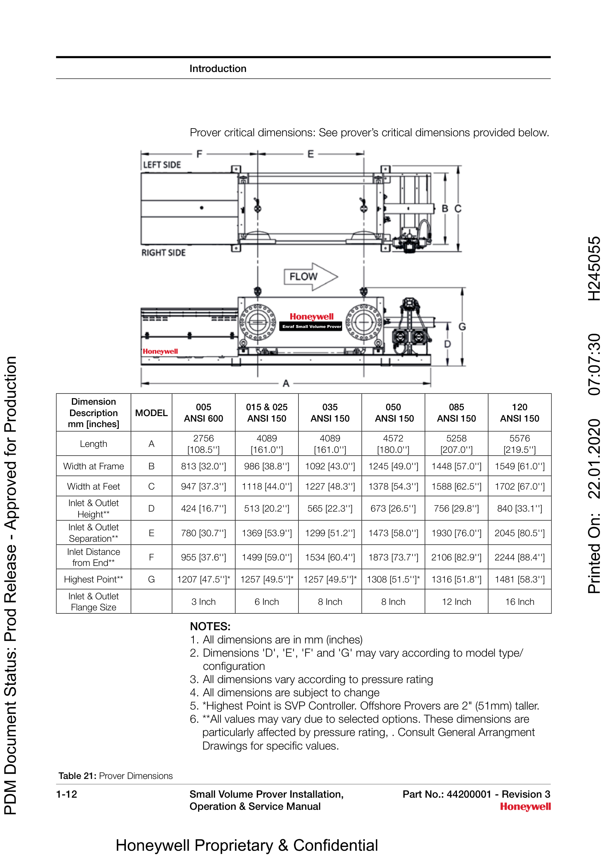
Table 21 from Honeywell Enraf Manual Part No. 44200001

5. Honeywell Scope (to be included in bid)
The modular split is Honeywell's scope of delivery. Sifab provides local workshop, offshore logistics, and Norsok oversight. Honeywell owns the engineering, disassembly, reassembly, SAT, and warranty.

What Honeywell must include:
- Frame designed with bolted splice joints from factory (not cut after build)
- Additional flow tube saddle supports at each splice location
- Flow tube: Scenario A — ship complete in wooden crate from TruStop (valve isolation, flange protection, VCI). Scenario B — remove end flanges + piston, pack in 2 crates. Both: crate must be suitable for transport wheels on platform.
- Hydraulic quick-disconnect couplings for drive removal/reinstallation
- Laser-marked alignment reference points at factory
- Complete disassembly/reassembly procedure with torque values and tolerances
- Honeywell personnel for disassembly (Sifab workshop, Sandnes) and reassembly (Snorre A)
- Water draw SAT after reassembly, witnessed by all parties + Justervesenet
- Warranty starts after successful SAT on Snorre A (min 28 months from commissioning)

6. Technical Queries for Honeywell
TQ# | Priority | Question
TQ-009 | CRITICAL | Provide detailed GA drawing of SVP085 with frame cross-section and foot details. Can frame width be reduced by removing feet?
TQ-010 | CRITICAL | Has Honeywell ever split an SVP for restricted offshore access? Share procedure/lessons learned.
TQ-011 | HIGH | Exact dry weight of SVP085 CL600 RTJ, broken down by component (flow tube, frame, drive, controller).
TQ-012 | CRITICAL | Can the flow tube be removed and reinstalled without affecting calibration? What alignment tolerances?
TQ-013 | HIGH | Will Honeywell warrant the split prover? Conditions?
TQ-016 | CRITICAL | Can the frame be designed from the start with bolted splice joints (design-for-split)?
TQ-020 | CRITICAL | Can Honeywell add saddle-type mounting points at each splice (4 total) without affecting calibration?
TQ-021 | CRITICAL | Exact flow tube length (bore only)? Wooden crate dimensions for transport? Crate must be suitable for fitting transport wheels underneath.

7. Next Steps
Action | Owner | Deadline
Send this plan + TQs to Honeywell (via Sidney Swart) | Tom | Before 4 March bid
Meeting with Honeywell to discuss split feasibility | Tom / Sondre | ASAP
Reply to Guidant: module dimensions (2,450 mm L x 756 mm H flipped) + confirm ~3.1 m crate can maneuver through corridor | Tom | This week
Honeywell to provide split concept drawing + weight breakdown + warranty terms | Honeywell | With bid
______________________________________________________________________
Sifab AS | Bedriftsveien 20, 4313 Sandnes | www.sifab.no

