Curriculum vitae with track record

* ROLE IN THE PROJECT Project manager [] Work package leader [] Project partner []

# * PERSONAL INFORMATION

|  |  |  |  |
| --- | --- | --- | --- |
| *Family name, First name: | Sondre Aa., Nilsen | | |
| *Date of birth: | 18.09.1989 | *Sex: | Male |
| *Nationality: | Norwegian | | |
| Researcher unique identifier(s) (ORCID, ResearcherID, etc.): | 0000-0002-3179-1277 | | |
| URL for personal website: | ... | | |

# * EDUCATION

|  |  |
| --- | --- |
|  | Name of faculty/department, name of university/institution, country |
| 2017-2020 | Ph.D., University of Bergen, Bergen, Norway |
| 2012-2017 | Cand. Psychol, University of Bergen, Bergen, Norway |

# * POSITIONS

## Current Position

|  |  |
| --- | --- |
|  | Job title/name of employer/country |
| 2020- | Senior Researcher, Regional Centre for Child and Youth Mental Health and Child Welfare (RKBU-Vest),  NORCE Norwegian Research Centre, Bergen, Norway |
| 2020- | Online Mentor/Supervisor, Høyskolen Kristiania, Oslo, Norway |
| 2019- | External Examiner, University of Tromsø, Norway |
| 2018- | External Examiner, University of Bergen, Norway |

## Previous positions held

|  |  |
| --- | --- |
|  | Job title/name of employer/country |
| 2017-2020 | Ph.D-Student, RKBU-Vest, Norwegian Research Centre NORCE, Bergen Norway |
| 2017-2018 | Clinical Psychologist (20% position), Kronstad DPS, OCD-Team, Bergen, Norway |
| 2013-2017 | Teaching Assistant, Faculty of Psychology, University of Bergen, Norway |
| 2013-2017 | Research Assistant (20% position), Uni Research Health, Bergen, Norway |

# FELLOWSHIPS, AWARDS AND PRIZES

|  |  |
| --- | --- |
|  | Name of institution/country |
| 2017-2020 | Extra foundation, project funding (Funding for Ph.D.) |
| 2018 | Summer scholarship for student Sunde, E.V., RKBU-Vest, Bergen, Norway |
| 2014-2016 | Summer scholarships, RKBU-Vest, Bergen, Norway |

# MOBILITY

# PROJECT MANAGEMENT EXPERIENCE

# SUPERVISION OF GRADUATE STUDENTS AND RESEARCH FELLOWS

|  |  |  |  |
| --- | --- | --- | --- |
|  | No. of | Master’s students/ Ph.D./Postdocs | Name of faculty/department/centre, name of university/institution/country |
| 2017- | 1 | Master | Faculty of Psychology, University of Bergen, Norway |

# TEACHING ACTIVITIES

|  |  |
| --- | --- |
|  |  |
| 2019 | Structural equation modeling with Lavaan, Katmandu,Nepal |
| 2017 | Mental health problems in childhood, RKBU-Vest, Bergen, Norway |
| 2013-2017 | Seminar leader in subjects Psyk 100, Psyk 101, Psyk 102, Exfac, University of Bergen, Norway |

# ORGANISATION OF MEETINGS

# INSTITUTIONAL RESPONSIBILITIES

# COMISSIONS OF TRUST

|  |  |
| --- | --- |
|  | Name of university/institution/country – and role |
| 2018 - | Reviewer Journal of Affective Disorders |

# Major collaborations

|  |  |
| --- | --- |
| Name of university/ institution/ faculty/ department/ centre, company/ governmental or non-governmental organisation | Topic |
| NORCE Norwegian research centre, Bergen Child study | Department of Psychosocial Science (UiB), Research group for public mental health |

### Track record

I have authored or co-authored a total of 6 publications. I am the first author of 3 peer reviewed journal articles and the senior author on 1. My articles have been cited 18 times, my *h*-index is 3 and my *i10*-index is 0 [according to Google Scholar](https://scholar.google.com/citations?user=bat21o8AAAAJ&hl=en). *(Updated 03.02.2020)*. Further details available upon request.

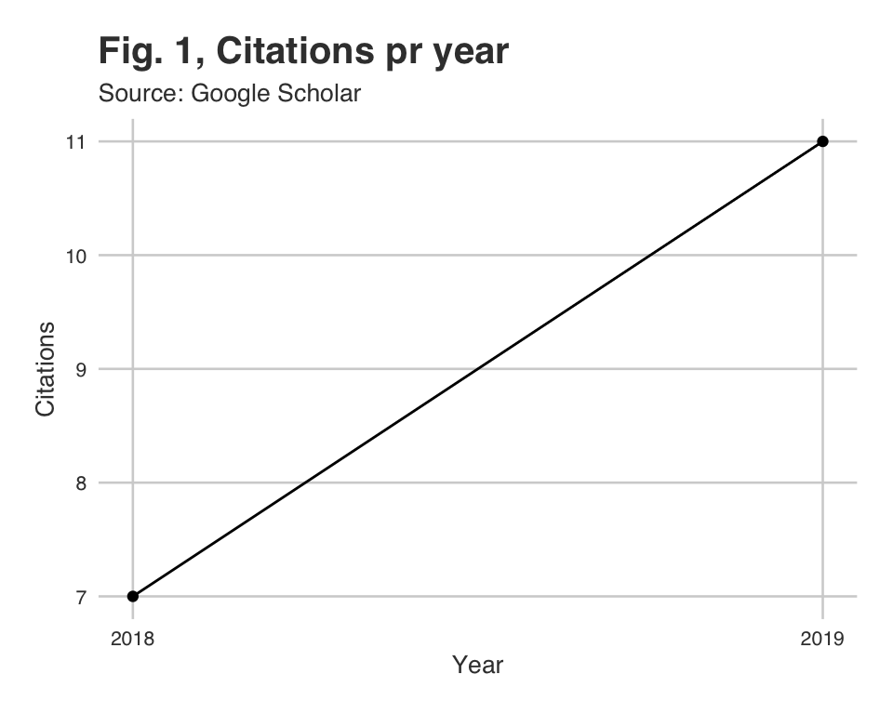

Selected publications:

[1] S. A. Nilsen, K. Breivik, B. Wold, et al. “Divorce and Family Structure in Norway: Associations with Adolescent Mental Health”. In: *Journal of Divorce & Remarriage* 59.3 (2018). DOI: [10.1080/10502556.2017.1402655](https://doi.org/10.1080/10502556.2017.1402655).

[2] S. A. Nilsen, M. Hysing, K. Breivik, et al. “Complex Families and Health Complaints among Adolescents: A Population-Based Cross-Sectional Study”. In: *Scandinavian Journal of Public Health* 0.0 (2019). DOI: [10.1177/1403494819893903](https://doi.org/10.1177/1403494819893903).

[3] S. A. Nilsen, K. Breivik, B. Wold, et al. “Divorce and Adolescent Academic Achievement: Heterogeneity in the Associations by Parental Education”. In: *Resubmitted to Plos One* (2020).

[4] L. B. Sandtorv, M. Hysing, M. Rognlid, et al. “Mental Health in School-Aged Children Prenatally Exposed to Alcohol and Other Substances”. En. In: *Subst Abuse* 11 (2017). DOI: [10.1177/1178221817718160](https://doi.org/10.1177/1178221817718160).

[5] L. B. Sandtorv, S. K. E. Fevang, S. A. Nilsen, et al. “Symptoms Associated with Attention Deficit/Hyperactivity Disorder and Autism Spectrum Disorders in School-Aged Children Prenatally Exposed to Substances”. In: *Substance abuse: research and treatment* 12 (2018). DOI: [10.1177/1178221818765773](https://doi.org/10.1177/1178221818765773).

[6] M. Nordmo, J. S. Hagen, V. B. Pedersen, et al. “How Changing Admission Practices Affect Sociodemographics, Satisfaction, Personality, Gender, and Dropout of Students in the Professional Psychologist Study Program in Norway”. In: *Scandinavian Psychologist* 5 (2018).

# LIST OF PUBLICATIONS

## PhD Thesis

[1] S. A. Nilsen. “After the Divorce: Academic Achievement, Mental Health, and Health Complaints in Adolescence Heterogeneous Associations by Parental Education, Family Structure, and Siblings”. Doctoral Dissertation. Department of Psychosocial Science, The University of Bergen, Norway: University of Bergen, 2019.

## Refereed research papers

[1] S. A. Nilsen, K. Breivik, B. Wold, et al. “Divorce and Adolescent Academic Achievement: Heterogeneity in the Associations by Parental Education”. In: *Resubmitted to Plos One* (2020).

[2] S. A. Nilsen, M. Hysing, K. Breivik, et al. “Complex Families and Health Complaints among Adolescents: A Population-Based Cross-Sectional Study”. In: *Scandinavian Journal of Public Health* 0.0 (2019). DOI: [10.1177/1403494819893903](https://doi.org/10.1177/1403494819893903).

[3] S. A. Nilsen, K. Breivik, B. Wold, et al. “Divorce and Family Structure in Norway: Associations with Adolescent Mental Health”. In: *Journal of Divorce & Remarriage* 59.3 (2018). DOI: [10.1080/10502556.2017.1402655](https://doi.org/10.1080/10502556.2017.1402655).

[4] M. Nordmo, J. S. Hagen, V. B. Pedersen, et al. “How Changing Admission Practices Affect Sociodemographics, Satisfaction, Personality, Gender, and Dropout of Students in the Professional Psychologist Study Program in Norway”. In: *Scandinavian Psychologist* 5 (2018).

[5] L. B. Sandtorv, S. K. E. Fevang, S. A. Nilsen, et al. “Symptoms Associated with Attention Deficit/Hyperactivity Disorder and Autism Spectrum Disorders in School-Aged Children Prenatally Exposed to Substances”. In: *Substance abuse: research and treatment* 12 (2018). DOI: [10.1177/1178221818765773](https://doi.org/10.1177/1178221818765773).

[6] L. B. Sandtorv, M. Hysing, M. Rognlid, et al. “Mental Health in School-Aged Children Prenatally Exposed to Alcohol and Other Substances”. En. In: *Subst Abuse* 11 (2017). DOI: [10.1177/1178221817718160](https://doi.org/10.1177/1178221817718160).

## Books and book chapters

## Conference proceedings

## Reports