CHAPTER 1 Introduction to the Study

# Background of the Study and Theoretical Framework

Using smartphones is one of the routines of children nowadays, making them busy and occupied during this pandemic. However, excessive and unnecessary screen time will lead to addiction and will likely result in inactivity and laziness on a daily basis (World Health Organization: WHO, 2019). In this state, self-control applications are popular given that it is used to help people stay-focused in every activity and keep them away from distractions. Needless to say, unmoderated screen time is unhealthy for the well-being of the children, which is mainly the concern of parents out there and highly wanted to enforce limits in their usage. Most of the time, children are wasting their time in using phones which is ineffective in contributing to an individual’s physical activities on a regular basis. This study will help address a person’s issues of lack of self-control and aid them to work on more productive activities. The concept of this study introduces features to help parents manage their child’s addiction as assistive technology.

Based on the data gathered by (Hiniker et al., 2016) it states that eleven parents said that they feel that establishing routine around screen time improves transitions from taking a break in their smartphones. Several parents have explained that their child can easily deviate from routine screen-time periods that occur at predictable times, but will resist ending the necessary screen-time periods. On the other hand, the experiment conducted by (2017, Lindström, E. & Nilsson, L.) shows that the "Forest: Stay Focused" mobile application gamification can motivate students to be more focused on their studies. With this concept, the Wisp: Assistive Application could as well help children to lessen the usage of their gadgets every time they perform the given tasks. The concept of this study will assist parents who are having a hard time disciplining their children especially on the too much screen-time spent using gadgets.

The inspiration behind the name of the application is from the Disney movie Brave where wisp serves as a guide to Princess Merida. Just like with the proposed idea of the researchers, Wisp also serves as guidance to children to become healthier in a way of engaging them in physical activity and to lessen their screen time.

The features of the proposed application are; account generation where you could create an account and choose a role whether the user is a parent or a child. A task management tool that implements a first in first out (FIFO) queue algorithm that would enable parents to add tasks to a specific child and there will be a corresponding reward through experience that could help the virtual wisp of the child to level up. The researchers will apply gamification, wherein the child will have a virtual pet in the form of Wisp that could gain experience every time the child accomplished a certain task.

In order to proceed with the study, a consultation with a child psychologist should be conducted to evaluate the graphical user interface of the child’s screen, analyzing the application’s approach towards the psychological effect of the children. As suggested, researchers were able to conduct consultation with Dr. Aimee Chua a child psychologist, in which the discussions included the validation of the application if it has able to meet the child-centered approach, the prioritization of the intrinsic motivation in terms of the incentive system, removing the leaderboard as it would create psychological conflict within the children in the household and would likely result to cheating in one of the users. Suggestions made by the said expert were highly taken into consideration in the prior implementation of the application.

# Theoretical Framework

Alongside with the aim of this study, this section provides the structure that holds and supports the theory of this research. The theory used in this study supports and correlates the intrinsic and extrinsic motivation with the use of game design theory, mechanics and factors of motivations involved in the study.

Researchers decided to anchor this research with the 2017 study conducted by Morten Kartevoll which discusses a presentation of several aspects of motivating factors in a game, as well as models and frameworks that might improve or assess the design of a game. Furthermore, the distinctions between extrinsic and intrinsic motivation are emphasized.

Extrinsic and Intrinsic motivation

In relation to the study, the researchers applied intrinsic motivation through in-game experience in which it supported the incentive system of the application. Based on the study (Kartevol, 2017) states that intrinsic motivation is concerned with what makes something enjoyable or rewarding in and of itself, rather than doing it for the purpose of an external benefit, whereas extrinsic motivation is concerned with completing an activity for the sake of the external benefit. According to Malone's theory of intrinsic motivation, good computer games or any other intrinsic circumstance contain three key categories: challenge, fantasy, and curiosity. A framework was developed from these categories, which is further detailed in the section below.

1. Challenge

Every game must have a challenge, which involves the use of an uncertain target. Goals should be self-evident or readily created. Goals that are either practical or based on imagination are frequently the finest. It is critical that the player get some type of performance feedback in order to determine whether or not they are moving closer to the destination.

1. Fantasy

According to Malone, fantasies are frequently used to make games more exciting. Fantasies can range in severity and can be both social and physical impossibilities. Fantasies should also be based on the player's requirements for fulfillment. Despite the fact that Malone points out that if it were feasible to build fantasies that met the demands of all types of individuals, games would have a wider audience.

1. Curiosity

By designing surroundings that are neither overly intricate nor overly simple in comparison to the player's experience and knowledge, the environment can attain an appropriate degree of informational complexity, which can excite and inspire player interest. Games may pique one's interest in a variety of ways and across a range of sensory and cognitive categories. The utilization of audio or visual effects can be used to pique the sensory interest of the audience. These effects can be utilized in a variety of ways, including as decorations, to improve imagination, as incentives, and as representation systems (represent information more easily than using words and numbers).

1. Flow

Csikszentmihalyi conducted significant studies on what makes activities and experiences pleasant in the 1990s. He defined flow as "so gratifying that people are willing to do it for its own sake, with little concern for what they will get out of it, even when it is difficult or dangerous", drawing similar parallels to the previously stated intrinsic motivation. Csikszentmihalyi defined a flow experience as having eight components:

1. A task that can be completed.
2. The ability to concentrate on a task.
3. That concentration is possible because the task has clear goals.
4. That concentration is possible because the task provides immediate feedback.
5. The ability to exercise a sense of control over actions.
6. A deep but effortless involvement that removes awareness of the frustrations of everyday life.
7. Concern for the self disappears, but the sense of self emerges stronger afterward.
8. The sense of the duration of time is altered.

Csikszentmihalyi meant that by combining these factors, a person would experience such deep satisfaction that the effort required to obtain it would be rewarded.

1. The GameFlow model

Kartevols study included the theory of the GameFlow model consisting of eight elements, concentration, challenge, skills, control, clear goals, feedback, immersion, and social interaction based on which were presented by Mihaly Csikszentmihalyi on his Flow and the psychology of discovery and invention (1996). This model calls for a game that should hold the player’s attention and concentration during a high workload while enjoying the challenges and tasks at hand that matches the perceived skill level of the player. Despite the circumstances, the player could feel total immersion into the task and to the game itself that allows the player to have reduced concern about time, their everyday life, and themselves.

1. Skinner’s box

Related to behaviorism, B.F. Skinner, an American psychologist, and behaviorist used reinforcement to strengthen what he called operant conditioning which he considered the rate of response as the most effective measure of response. The operant conditioning, often called Skinner’s box, was used to analyze schedules of reinforcement used in operant conditioning. Skinner used a box with a level that would deliver food to the animal through a gap in the wall. The animal was rewarded in different schedules: fixed interval schedule, fixed-ratio schedule, and random ratio schedule. The Fixed ratio schedule was proven to be the most effective as the animal could not predict a precise number of times it had to press the lever to be rewarded.

1. Self-determination

Richard M Ryan and Edward L Deci on their Self-determination theory and the facilitation of intrinsic motivation, social development, and well-being conducted in 2000 dives into the analysis of self-determination on how factors have an influence on intrinsic motivation, both enhancing and undermining it. Their research findings are the hypothesis of three psychological needs humans have, namely competence, autonomy, and relatedness. When these needs are satisfied, self-motivation and mental health are increased, while when the needs are not met motivation can be significantly diminished, as well as the wellbeing of the human. This self-determination theory is basically explaining human motivation towards doing a task or activity to being internally driven. Competence implies humans must have a sense of mastery over a situation or content, with mastery achieved through clear and visible goals. Autonomy refers to the feeling of being free and in control of one's own actions. Finally, relatedness gives the sense of being connected to others in various ways, such as through family or friends.

# Conceptual Framework

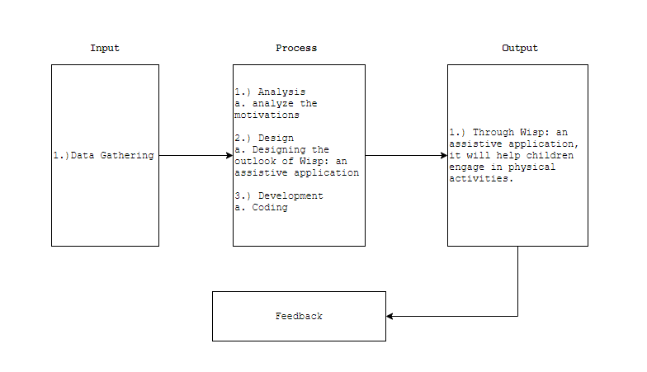

Figure 1: Conceptual Framework

The figure above illustrates the conceptual framework of the study wherein the first input will be the gathering of necessary data such as first name, last name, email, and password.

The next box illustrates the processes undergone by the researcher in developing the assistive application. This process comprises analyzing the motivations to stimulate children in doing physical tasks, designing the outlook of the application, and the development of Wisp that includes coding. The final output of this study will be a working assistive technology which is Wisp: an Assistive Application. The process will be a cycle in which the researchers will gather feedback after the development or implementation for further improvement of the application.

# Objectives of the Study

To develop an assistive application that incorporates gamification and aims to utilize the screen time of children to productivity and could help contribute to engaging in physical activities.

Specifically, it aims to:

1. To develop a task management module that implements a first in first out queue algorithm.

2. To develop a virtual pet game system that highlights parent-led and child-centered game approaches.

3. To create an in-game incentive system to motivate children in doing the tasks assigned.

4. To evaluate the application using ISO-IEC 25010 and questionnaires to verify if it helps children to engage in physical activities.

# Significance of the Study

Parents are particularly concerned about the negative impact smartphones can have on children, particularly in terms of their ability to learn interpersonal skills. The generalization of this study would be of great contribution to the vast knowledge in relation to children’s screen time usage which could be motivated in physical activities engagement. Vital results of this study could be highly significant and beneficial primarily to both parents and children not only encouraging kids with physical activities but building a solid foundation between parent and children relationship.

**Children**

The direct recipient of the output of this study is the children with excessive use of smartphones. Through the assistive application, children are engaged in household chores to promote physical activity and can motivate them through intrinsic rewards.

**Parents**

The research study benefits the parents of the children through being able to manage in minimizing their child’s usage of smartphones without compromising the parent-child relationship.

**Software Developers**

This study will serve as a basis for other software developers for future references regarding the first-in-first-out (FIFO) algorithm used in this assistive application that developers might incorporate in their application as well.

**Future Researchers**

This study will serve as their basis, guide, and reference for their future study. Thus, by the observation obtained and the analysis made in this study, future research might also be inclined to conduct further studies related to this.

# Definition of Terms

For better understanding, the following terms were defined conceptually and operationally:

**Children**

A son or daughter of human parents (Merriam Webster).

In this study, children are the ones who will execute tasks, level up their virtual pet, and build better habits to improve household responsibilities. The target age of children in this study ranges from 7-12.

**Experience**

Practical knowledge, skill, or practice is derived from direct observation of or participation in events or in a particular activity (Merriam Webster).

In this study, experience is a progression point of children in completing tasks and also their wisp will level up once they meet the limit of the progression.

**FIFO algorithm**

In computing and in systems theory, FIFO (an acronym for first in, first out) is a method for organizing the manipulation of a data structure (often, specifically a data buffer) where the oldest (first) entry, or "head" of the queue, is processed first. Such processing is analogous to service people in a queue area on a first-come, first-served basis, in the same sequence in which they had arrived at the queue's tail. (Wikipedia).

In this study, the FIFO algorithm is used for task scheduling of parents to their children. Indeed, the task process comes on a first-come, first-served basis.

**Gamification**

It is the process of adding games or game-like elements to something (such as a task) so as to encourage participation (Merriam Webster).

In this study, gamification is a game design element and game mechanics and is used to create engagement, solve problems, change behavior or create better experiences in the application.

**Parent**

A person who brings up and cares for another (Merriam Webster).

In this study, parents are the ones who give tasks to the children and they also reward their children upon completing tasks.

**Pet**

Kept or treated as a pet or a domesticated animal kept for pleasure rather than utility (Merriam Webster).

In the current study, the researchers utilized pet as a term to refer to the gamified Wisps as a virtual pet designated for a specific child in which the said pet will accumulate experience whenever the child finishes a task.

**Rewards**

Something that is given in return for good or evil done or received or that is offered or given for some service or attainment (Merriam Webster).

In this study, rewards are provided through in-game experience.

**Screen Time**

In (Merriam Webster), it is the time spent watching television, playing a video game, or using an electronic device with a screen (such as a smartphone or tablet).

In this study, it is the time spent by children in using their smartphones or tablets.

**Smartphone**

A cell phone that includes additional software functions such as email or an Internet browser (Merriam Webster).

Researchers used smartphones as a portable device used by children in this study with an age range of 7-12 that often leads to excessive screen time usage.

**Wisp**

The wisp is an atmospheric ghost light seen by travelers at night, especially over bogs, swamps, or marshes (Wikipedia).

In this study, the wisp is a virtual pet of the children in the application in which they can level up through obtaining experience in completing tasks.

# Delimitation of the Study

This study aimed to develop an assistive application that utilizes gamification and aims to reduce the screen time of children and could help contribute to engaging in physical activities.

Scope of the study centralized to children with an age range of 7-12 which primarily concerns children who engage in smartphone use and parents mostly stay-at-home individuals that cater household responsibilities.

The application implements the FIFO(first-in-first-out) algorithm in the task management module, a virtual pet gaming environment that focuses on both parent-led and child-centered game approaches and incentive system to motivate children in doing tasks.

The proposed assistive mobile application will run on the operating system version starting android (6.0). The application is internet-based since the functionality of the system is dependent on the internet.

CHAPTER 2 REVIEW OF RELATED STUDIES

## Review of Existing and Related Studies

This chapter includes ideas, finished thesis, generalizations or conclusions, journal articles, and methodologies. Those that were included in this chapter helps in familiarizing information that is relevant and similar to the present study.

**Review of Existing and Related Studies**

# **Screen Time**

**Screen time in children and adolescents: is there evidence to guide parents and policy?**

The rise of the digital environment is unquestionable. Children and young individuals in developed nations presently grow up with computers, tablets, and mobile phones intertwined with their advancement. There's no question that much more time has gone through online compared with past generations. Significant interest exists for the impacts of screen time, social media, and computerized amusement on different modern issues of child improvement, weight, and mental health. The general public and healthcare experts regularly see expanded screen time as negative, with frequent media reports on the unfavorable impacts on sleep, diet, social interaction, and family life. In any case, the evidence underlying this discernment is restricted and frequently clouded by confounding factors including socioeconomic grouping and negative associated practices (eg, snacking and decreased workout). So they suggested the amount of time a child or young individual spends on gadgets ought to be tailored to the person, with special attention when presenting innovation to younger infants or toddlers, and practical methods for sound and sensible techniques for how to best oversee screen time (Ashton J. et.al, 2019).

**Screen time and sleep among school-aged children and adolescents: A systematic literature review**

The researchers methodically examined and updated the scientific literature on the affiliation between screen time (e.g., tv, computers, video games, and gadgets) and sleep results among school-aged children and youths. The researchers looked into 67 think about distribution from 1999 to early 2014. The researchers found that screen time is antagonistically related to rest results (fundamentally shortened length and delayed timing) in 90% of studies. Some of the results shifted by sort of screen presentation, age of the member, sex, and day of the week (Hale L., 2015).

**Screen Time Tantrums: How Families Manage Screen Media Experiences for Toddlers and Preschoolers**

The study of Hineker et.al (2016) shows that parents set limits based on what technology makes it easier to execute. Indeed, parents blame technology for transitions when they need a scapegoat, and have consistently said that technology can also help to assist them when they claim screen time is over. Families encounter features that as helpful, offer possible limits and features that erode limits as deceptive and stressful. Moreover, the results of this study show that families value screen media for young children but want these experiences to come with limits. They prove that technology can be their ally or their foe, so future researchers have the chance to make design choices that are not the cause but the solution to tantrums (Hiniker, A. et.al, 2016).

**Beyond the Classroom: Do smartphones make us lazy?**

The article of Futterman (2015) states that for children aged 3-18, screen time should be limited to two hours a day. And, for two-year-olds and for younger adults, none at all. Research shows that prolonged frequent screen time can also encourage childhood obesity as well as irregular sleep habits, in addition to social and behavioral problems. Indeed, there is an issue when kids spend more time texting friends rather than getting together. Face-to-face interaction is a human need that starts and never goes away in infancy. Although these devices can provide great opportunities for learning, their use must be balanced with an equal amount of social interaction face-to-face.

# **Parental Control**

**Parental controls: advice for parents, researchers, and industry**

This research shows that in this process, parental controls will assist parents in the offline rule-setting and interactions between parent and child. Parenting issues will not be solved because ‘there is an app for that. Indeed, when baking a cake, parental controls are like timers. It's not going to substitute the actions of parents as amateur chefs, but it's just going to help them prevent the cake from burning. In addition, it acts as an assistive technology to provide guidance to parents and children when using the tools for the context of their everyday practices, child-parent relationship, and family values (Zaman, B. & Nouwen, M.,

2016).

First, this study calls for a more holistic approach to parental controls that goes beyond a one-sided emphasis on child safety to prevent over-control and overprotective parenting, which has been shown to have a negative effect on child growth. Second, it outlines potential avenues for research into parental mediation by emphasizing the need to refine current technological mediation evaluation tools, to concentrate more on how and when parents use parental controls, and how these tools can work (rather than just asking whether parents use them and whether they are effective), and to step beyond the generalized the notion of the parent as being an effective teacher (Zaman, B. & Nouwen, M., 2016).

**User Interface Design Model for Parental Control Application On Mobile Smartphone Using User-Centered Design Method**

This study presents the use of a content management framework on smartphones that can enhance children's and parents' collaboration. The value of the role of parents is to have an understanding of the content of the application so that children can interact well between parents and children. The user-centered design study model of the user interface design parental control application can be concluded from the analysis and implementation methods, including the parental control user interfaces which offer solutions to parent users' needs to teach children about the application's content. Parents and children should explore this material in a discussion. Indeed, the results of the study with an average of 94% percent were obtained at this level of usability testing for parents. This indicates that the user interface is well-designed and according to the user needs the parents are in parental control. Then, the user interfaces offer solutions to the user requirements of children in the selection of an application and provide parents with an appreciation of the content of the application

that will be used. The result of usability testing was obtained with an average of 90.4%. This shows that the user interface is built very well for children (Wardhana, S. et al., 2017).

# **Gamification**

**Forest App: Stay Focused**

In the paper of Lindstrom and Nilsson (2017) the result shows that the participants' focus did not deteriorate on the game-playing elements was removed. The researchers expected the results from participant group B would deteriorate upon removal of these elements. Although many participants did not find the application helpful for those to stay more focused, 80% of participants expressed that they felt more satisfied with their studies when they used the application than with the timer. However, this is difficult to assess then it is the participants themselves who have had to evaluate what they thought of their focus which can vary from person to person. It could be difficult to express what they think on a scale and it can be easier to describe it in text. Therefore, this study placed more emphasis on the participants' reasoning and analyzed their own formulated answers to a greater extent than looking at the mean of their perceived focus.

Indeed, the majority of participants were positive about the use of the application, one participant replied that he did not understand the idea with the application researchers used and that it was not special motivating. This may be because some may be more susceptible to game-determining elements than others which would be able to be investigated more in future research in the field. In this state, this study does not indicate any adverse effects on the user focus on whether they stop using gameplay in their studies, which is contrary to the results of previous studies. In addition to this suggests not the study that the application has motivated the user to study more.

**Gamification and Family Housework Applications**

The study of (Bjering, A. et.al 2018) states that building on the idea of gamification, a recent trend in apps is to target housework aiming to transform boring chores into entertaining activities. One reason for this is that many parents want their children to understand the duties that come with being a part of the family. Another point is that many children, as well as their parents, use applications on a daily basis to play, learn, and maintain social interaction. As a result, the acknowledgment that both housework and games are prevalent in many modern families has resulted in the development of apps that try to combine the two.

Moreover, the results of the study suggest that game designers must concentrate on cooperation and the whole family, instead of focusing on the individual side. Then, include mechanisms that enable parents and children to participate in activities together. Encourage families to discuss and agree on a set of family values. In this case, investigate how hybrid manipulable/constructive or constructive pedagogical designs can promote positive and enjoyable chore-doing behaviors. Allow the family to act as a team of "explorers," inspiring them to come up with new and better ways to solve problems, or even to come up with new tasks that can be completed.

**Designing Gamification in the Right Way**

The research study of (Kim, B., 2015) asserts that the game designers must consider at whom the gamification is directed and what the characteristics of the target group are. Indeed, there would be two kinds of people in gamification: those who are ready to play for extrinsic rewards and those who are not. Bartle’s player types have served as a general framework for other game researchers and a guideline for game designers, extrinsic rewards inspire those who are classified as "players." In comparison, intrinsic factors such as social relationships, self-expression and exploration, personal achievement and mastery, and a sense of purpose inspire the “socializer,” “free spirit” (a type similar to Bartle's “explorer”), “achiever,” and “philanthropist” to play. Certainly, these user types are theoretical abstractions, and individuals in the real world are going to exhibit features of several user types to varying degrees.

In connection to the researchers’ study, it is probable that providing external rewards, such as a prize or a gift certificate, will increase user participation and engagement for the “player” type. In this state, the cooperation and the collaboration of children in doing tasks will increase and they will be motivated each time they complete a task. Furthermore, when creating gamification, game designers must keep in mind that gamification does not create incentive or engagement on its own. People's buy-in is required for any gamification to succeed because they must care enough to participate. As a result, the more closely a gamification's goal aligns with a player's goal, the more effective the gamification will be. In addition, game designers must use gamification carefully, thoughtfully, and selectively, with a clear objective in mind, a detailed understanding of the target audience, the nature of the target activity, the good use of gamified learning content, and adequate and efficient rewards for the intended context.

**Improving User Experience with Gamification and Reward Systems**

The thesis of (Kartevoll, M. 2017) proclaims that children in Norway are now more likely to play games, with 77 percent of children aged 9 to 15 playing at least one or more electronic games on an average day in 2015. Statistics also show that children lack the incentive to do jobs, with less than half of children aged 9 to 15 helping with everyday housework in Norway in 2010. The research attempts to leverage the growing use of smartphones and tablets to empower and encourage more children to assist with housework through the use of gamification. However, the features of gamification are often poorly implemented, which weakens its purpose by having the opposite effect.

On the motivational side, the study suggests that every game must have a challenge, which necessitates the use of an unclear goal. Goals should be self-evident or readily produced. Goals that are either realistic or based on fantasy are often the best. It is critical that the player provides some form of performance feedback in order to determine whether or not they are coming closer to the goal. Another one is curiosity by designing environments that are neither too complicated nor too easy in relation to the player's experience and knowledge, the environment can attain an ideal level of informative complexity, which can foster and generate player curiosity.

On the reward side, as experience is often tied to a single avatar, it can also be the level of the player's account. Experience is rarely used to express skill; instead, it suggests the player's time and effort. Experience and level are often associated with one another, with one's level increasing after a certain number of experience points are accumulated. In connection with the researchers' study, experience points are gained by finishing a task and it will increase the children’s virtual pet level as it progresses.

On the side of the social aspect, the social aspects of an application can have a significant impact on user motivation. The elements of competing, cooperating, and connecting with other players, in general, may generate a desire to play games exclusively for social interaction. The ability to use these social aspects is to build a dependence between the applications and then what happens on a daily basis can improve the application's engagement and pleasure.

The result of the study of (Kartevoll, M. 2017) states that the more general question which was asked in the final part of the questionnaire had a high degree of participants agreeing to the statements. With 91% of the participants agreeing that they would have used the application at home if they had the chance, concluded with the experiment as a success. Especially, in relationship to the extension enhancing motivation, enjoyment, and engagement towards doing chores. As 82% of the participants additionally agreed with chores would have been more fun if they had used the application, and only 5% disagreed the statistics give an indication of the application working as intended.

Furthermore, the results from the user tests gave an indication of how effective gamification can be, hence contributing to the positive use of gamification to motivate, engage, and create enjoying content for children. Manage Extended application illustrates that chores can be motivating, engaging, and enjoyable for children by the use of a gamified reward model. Additionally, the extension contributes to the fact that for gamification to properly work the design needs to be well thought through.

**Using Gamification to Increase Adherence to Daily Living Routines**

The study conducted by (Kadison, L. S. 2015) asserts that HabitRPG enhances children's adherence to daily routine tasks without parental urging. These findings support the use of HabitRPG for children who love video games but struggle to complete daily routine tasks. According to the social validity measures, children and parents enjoyed using this program and acknowledged that it was beneficial for increasing children's task completion. The implication of this finding is that games like HabitRPG may be effective methods for getting children to participate in previously neglected routine daily activities. In addition, future studies should look at how the game affects parent-child interactions to see if it reduces coercive interactions while encouraging child self-management.

Moreover, gamification programs that use behavior analytic concepts (e.g., self-monitoring, in-game rewards for target behavior completion) may be effective in improving desired target behaviors.

# **FIFO Algorithm**

**Management Information Systems Development for Veterinary Hospital Patient Registration Using First In First Out Algorithm**

The study of (Fauziati, S. et. al 2016) centers on the patient registration system that required algorithms that are suitable with the service workflow in which they view to have a queuing system. With the use of information systems in a hospital, it’s expected to provide faster service and minimize the waiting time for the patients. Based on this problem in the study, the authors choose to use an algorithm First In First Out (FIFO) on the establishment of a registration information system where the patient who came first to the hospital is the one who enrolled first.

According to the study, proceedings of the national conference on research and PKM health has explained that the line model which can increase effectiveness and reduce the waiting time at the counter is a queue theory with First In First Out (FIFO) principle, where the first line queue will receive the service first. It is also described in a study of a queue theory that FIFO queue theory is one of the best to be used. The test results show the quality of software has been approved and meets the minimum requirement of the registration system in RSH Prof. Soeparwi with the total votes are 75.28% which is considered very helpful and in a way that they can reduce the time when processing the patient data. But there are also some drawbacks where the sub-system registration information is still unable to give priority to patients with emergency cases. The use of FIFO algorithms in the study of Fauziati et. al, suggests that using the FIFO algorithm can increase the effectiveness of faster queuing in which the first task will be served first without skipping and will be carried out sequentially in accordance with the queue sequence.

**Application of FIFO algorithm (first in first out) to simulation queue**

The journal article of (Manurung, 2019) states that most activities can be found in daily life. One of them is standing in a queue. Queuing is a tedious activity. Furthermore, the queues are not coordinated, and the officers do not pay attention to who is the first to queue. As a result, the simulation employs the first in first out algorithm to deal with problems in the queue. This algorithm will assist in determining who will be served first. Simulation is a technique used to implement a more accurate device estimation. The researchers use the first in, first out algorithm in this case. The first in, first out algorithm, i.e. first in, first out, is used. In this scenario, whoever is the first in line will be served first and finish first. It is hoped that doing so would aid in determining who will be served first.

Chapter 3 RESEARCH DESIGN AND METHODOLOGY

In this chapter, the researchers will discuss the description of the proposed study, methods and proposed enhancement. Then, components and design.

# Description of the Proposed Study

This study in general directs to both parents and especially to children that spend a huge amount of time wasted on their smartphones and gadgets that has led to an unhealthy habit and passive lifestyle. Children lounging for hours and unmotivated to do physical work as well as lack of engagement in doing household chores. This is where the study was put into action through an assistive application that allows children to be encouraged and motivated to engage in physical activities while utilizing their screen time in a productive way. Parents, on the other hand, would be able to direct and manage the screen time of their children in a creative way at which point the application serves as an intermediary to their children such as giving the task through the application and children would gain motivation to do so.

This study aims to develop a task management module that implements a first in first out (FIFO) queue algorithm along with integrating gamification in the form of a virtual pet game system, and incentive system to stimulate engagement and motivation to children. The researchers have implemented the FIFO queueing algorithm in order to manage tasks' arrival to children’s interface. Researchers included the development of a virtual pet game system that highlights parent-led and child-centered game approaches. Along with this, an incentive system was established to help motivate children in doing assigned tasks through the virtual pet of the child that gains experiences and advances its level. The researchers have used a labeled scaled-response questionnaire for feedback, a prototyping tool, and a programming language that is suited for the development of the proposed application.

Prior to the recommendation of the panelists to consult a child psychologist, the researchers applied in-game experience as intrinsic motivation in which Dr. Aimee Chua suggested. The in-game experience will support the virtual pet in increasing its level. As well as adding animations to the virtual pet to create excitement to child users.

* Assumptions and Preconditions

1. The participants will answer the questionnaire in an honest and candid manner.
2. The application shall provide parents to generate their own account for the application.
3. The application should provide the parent user the ability to add tasks for the child.
4. The application should provide the end-user the ability to display the tasks given to the child.

# Methods and Proposed Enhancements

Formal methods in computing science deal with using computers to aid in the intellectual tasks of designing, defining, and constructing software and hardware. Using formal logic to write specifications and prove that programs and processes implement them is one aspect of that work in which formal methodologies are mostly used to prove facts about algorithms and systems. The benefits of formalism include precision, abstraction, conciseness, and manipulability. Manipulations might include consistency checking and the generation of prototypes.

In this study, a formal method was applied to derive the correspondence of the application and specification to show that the application does what it is specified to do. The use of formal methods especially in the requirements phase has added gamification to the advantages of completeness and consistency of the assistive application. As to note that precision is a property of formal methods, it is made for the intention that it should precisely coincide with the aforementioned specifications above and that it meets the requirements particularly with the implementation of the First-in-first-out (FIFO) algorithm in the task management of the application.

First-in-first-out (FIFO) algorithm is a method for handling data structures where the first element is processed first and the newest element is processed last. FIFOs are often implemented when extracting data from an array or buffer. The researchers implemented the FIFO algorithm particularly for the queuing of tasks in the application where the first entry of the task allocated for a certain child is served first. FIFO is also used to provide efficient handling of the task management tool to determine the order.

The virtual pet system in this study is for the companionship of the child as he/she is doing the task assigned by their parent. The application highlights child-centered design which provides excitement as it includes pleasant colors and movements that make the virtual pet interactive to child users. Indeed, the virtual pet system will create a mindset to child users that they’re taking care of a real pet. The researchers used Rive as an animation tool in creating the effects and actions of the virtual pet. The virtual pet designs are bought from Freepik which is licensed for commercial use and projects.

The incentive system of the study is the experience points. The incentive system will create progression for the child users as they complete the task assigned by their parents. This will create intrinsic motivation for them as they accumulate experience per task. This intrinsic reward will create eagerness as they do their task and attain their goal of leveling up their virtual pet. The incentive system is paired with the task created by the parent. Consequently, the experience points will go in the progress bar as the child finishes each task and if the experience points will reach the needed maximum points it will proceed to the next level.

The expected data to be collected includes the ISO-IEC 25010 in which a product quality assessment scheme is built on the quality model. The quality model specifies which quality characteristics will be considered when assessing the properties of a software product. Certainly, the degree to which a system satisfies the expressed and implied needs of its various stakeholders, and thus provides value, is defined as its efficiency. The needs of those stakeholders (functionality, performance, compatibility, usability, reliability, security, maintainability, and portability) are precisely what are reflected in the quality model, which categorizes product quality into characteristics and sub-characteristics. The criteria are evaluated as “Very Good”, “Good”, “Fair”, “Poor”, “Very Poor”.

For statistical purposes, numerical weights were assigned as follows:

Weight Description

5 Very Good

4 Good

3 Fair

2 Poor

1 Very Poor

Moreover, the researchers will also evaluate the application by means of motivation, engagement, and enjoyment through Likert-scale questionnaires that will be given to parents and their children. The criteria are evaluated as “Strongly Agree”, “Agree”, “Undecided”, “Disagree”, “Strongly Disagree”.

For statistical purposes, numerical weights were assigned as follows:

Weight Description

5 Strongly Agree

4 Agree

3 Undecided

2 Disagree

1 Strongly Disagree

# Components and Design

## Software Architecture

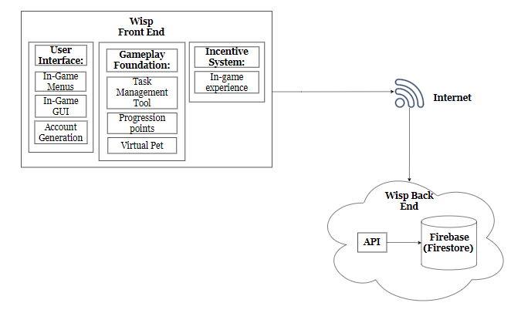

*Figure 2: Software Architecture*

Figure 2 shows the software architecture of the mobile application. The application’s front end will be supported with Flutter. On the user interface side, it is composed of in-game menus, in-game GUI, and account generation. The gameplay foundation is composed of the task management tool, progression points, and virtual pet. On the Incentive System, it is an in-game reward which is through gaming experience for the virtual pet to level up. On the other hand, the application’s back end will be supported by an API and Firebase (Firestore) as the cloud database.

## System Architecture

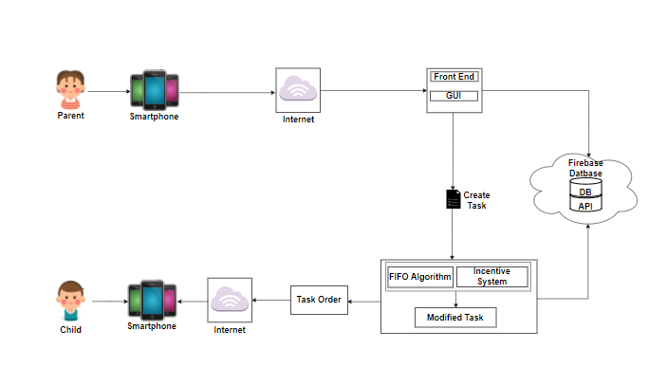

*Figure 3: System Architecture*

Figure 3 interprets the bird’s eye view of the application's system architecture. The process initiates when a parent uses the mobile application on a smartphone, connects to an internet either through Wifi or data services, and redirects the said user to the application's graphical user interface. Next in line, the parent proceeds on a page on creating tasks for his/her designated child. In the process of creating, the FIFO algorithm takes place in establishing the tasks and a corresponding incentive for each and will result in a modified task. Then, the child connects to the internet and login to the application to view the task created by their parent. For each data created, this will be stored through the Firebase Database.

## Database Design

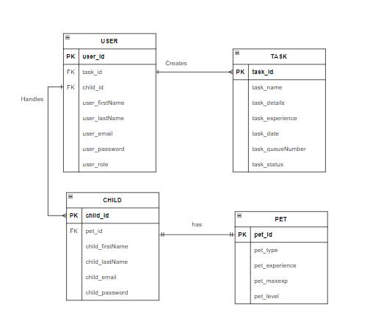

Figure 4: Database Design of the System

Figure 4 shows the relationship among entities, the user creates tasks and handles each child. The USER table has its primary key of user_id and consists of the user’s first name, last name, email, password and the role of the user. It also has two foreign keys of task_id and child_id coming from the TASK and CHILD table respectively. The TASK table contains the primary key of task_id with other attributes like the task name, task details, task experience, task date, task queue number and the task status.

On the other hand, every child must have a pet wherein the child table has the foreign key of pet_id. The CHILD table consists of the primary key of child_id and attributes of child first name, last name, email and password.

## Procedural and Object-Oriented Design

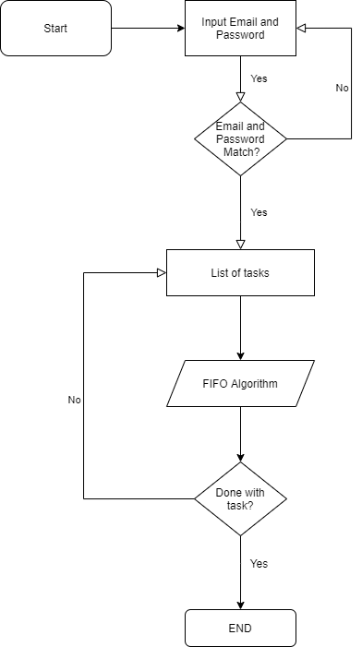

*Figure 5: Procedural Design for the Child*

Figure 5 shows the sequence of processes from the children’s point of view in accessing the mobile application. The order starts with also prompting the child with the logging in form where the child user is asked to input email and password details if he was already registered by his parent, considering that parents are the one to create the child’s account. If email does not match, child users have to reenter the details once again through checking if there is misspelled information that causes failure to access the account. On the other hand, if login details are matched, the user can access the account and will be prompted with the list of tasks created by his parents. These lists of tasks are next to be processed by the FIFO algorithm where the first task created is being served first on the list. This would also restrict children from skipping the first task. If the child user is done with the first task he may exit the application and end the process.

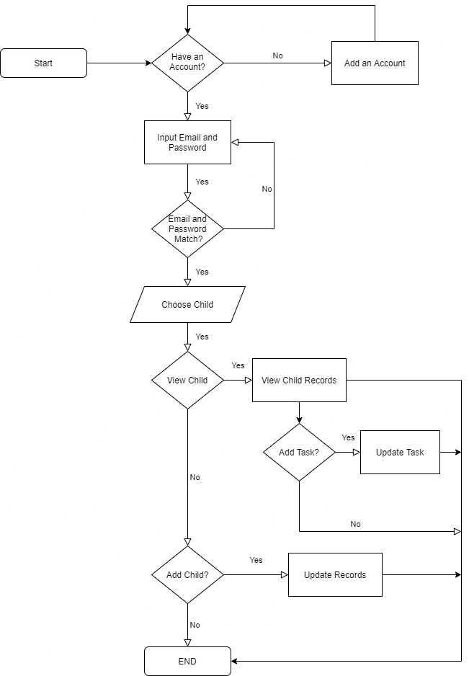

*Figure 6: Procedural Design for the Parent*

Figure 6 illustrates the procedural design of the Parent’s process in prompting the assistive mobile application. Parent user in upon starting the application, will be prompted with the logging in page wherein this will display the sign-in form for existing users to access their account through the input of their email and password, otherwise will be redirected to a new page if the user is new to the application and would have to add an account. For the said existing users, if the typed-in details do not match the registered email and password in the database, an error message is displayed where users need to re enter correctly the details once again. Although, if it matches, the user gains access and will proceed to the home screen. Next flow where a parent will have to choose a child. If he does have a child, he will have to view then choose from the existing list of children he has and would have the option to add tasks or not to a child. However, if the parent user does not have an existing child, the user will be redirected to the interface of adding a child. With this, the application will register the child to the database and updates the record and this is where the process ends.

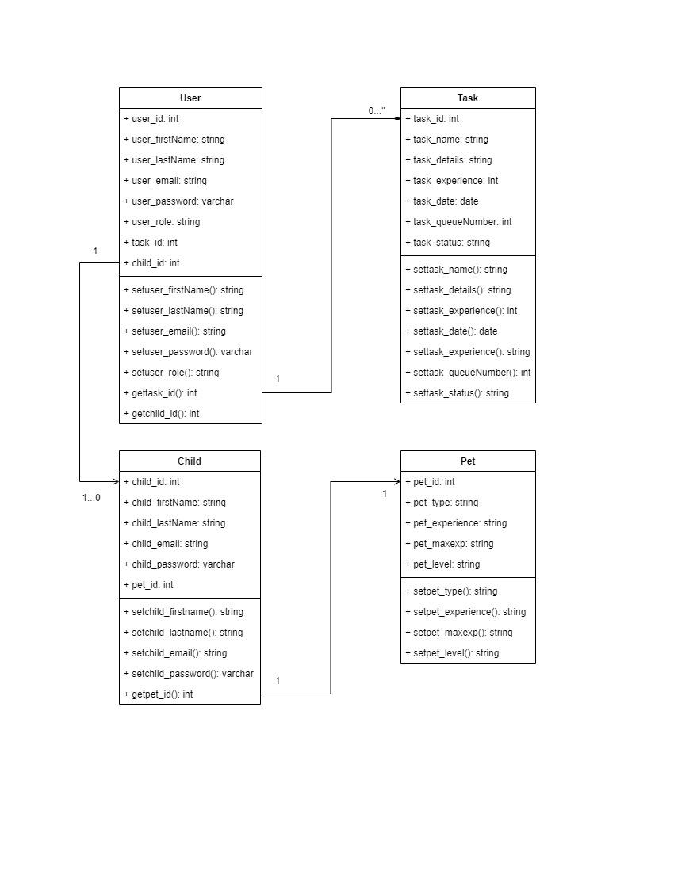

*Figure 7: UML design of the System*

Figure 7 shows a single user has a composition of multiple assigned tasks and associates of multiple children. While a single child associates a single pet.

## State Diagram Design

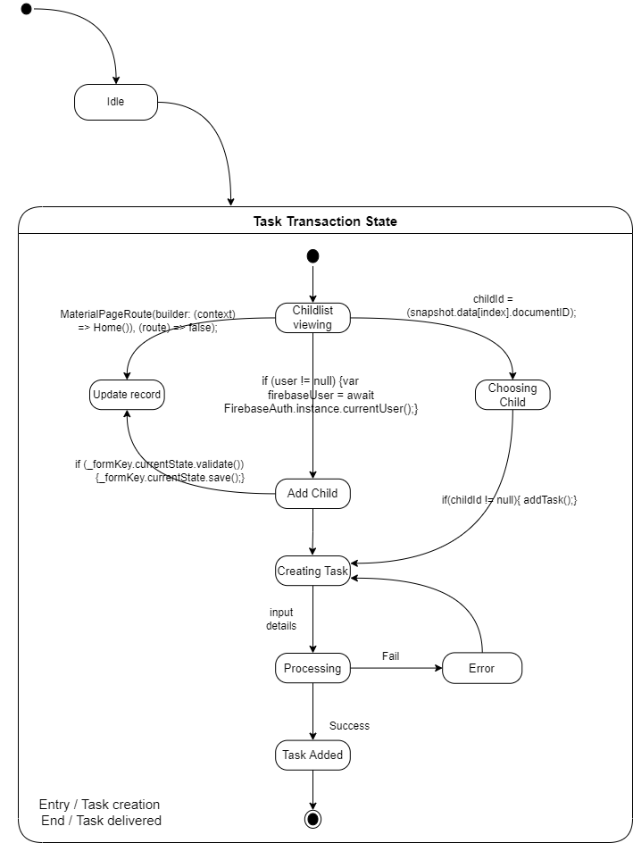

*Figure 8: State Diagram of the System*

Figure 8 shows the parent creating tasks for the child, each task includes task name, description, and an incentive experience. After the tasks are created, it will appear on the child’s screen and they will do the tasks assigned. If each task were completed, the virtual pet would gain experience. If the experience reaches the maximum points the virtual pet will level up.

## System Development Life Cycle

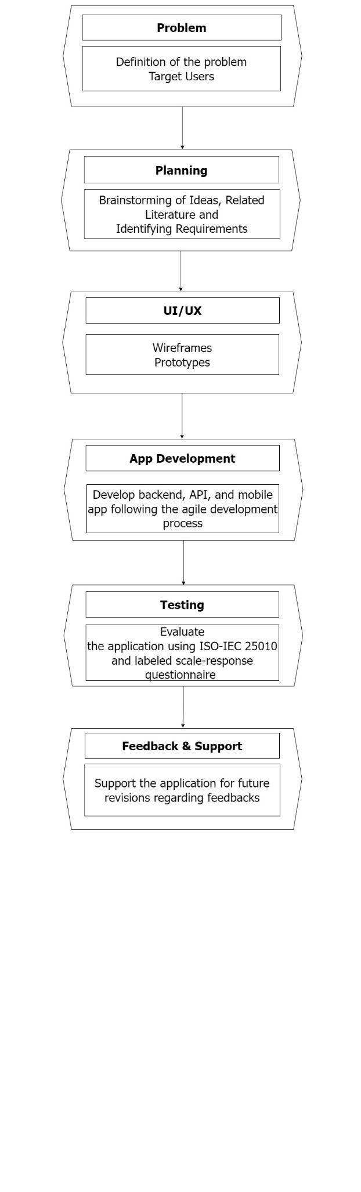

*Figure 9: SDLC Model of the proposed System*

The method of developing an assistive application can be separated into various life cycle stages, much like traditional software development. This can be accomplished using the methods that will be used in the study.

The Software Development Life Cycle (SDLC) is a method for producing high-quality, low-cost software in a small period of time. SDLC is a well-structured flow of phases that enables developers to efficiently produce high-quality software that has been thoroughly tested and is ready for production. The SDLC process aims to ensure the quality of software that meets the users’ expectations.

In this study, Wisp assistive application will use Agile Model SDLC. Iterative and gradual process models are combined in the Agile Model through delivering a working software product effectively that focuses on process adaptability and customer satisfaction. In addition, the Agile model has a flexible change process. Each iteration of agile SDLC consists of a development phase that moves from requirement gathering and analysis, designing the requirements, development, testing, deployment, and feedback.

CHAPTER 4 RESULTS AND DISCUSSION

This chapter presents the analysis and interpretation of data gathered through questionnaires. This study also achieved the child-centered game approach requirement with appropriate designs.

# Implementation

This section contains all of the implementation specifics, including the software used and some facilitation numbers.

The assistive application was implemented to make use of gamification that aims to utilize the screen time of children through assigning them various tasks, thus, engaging them in physical activities. Also, an implementation of gamification is in the form of a virtual pet game system that highlights a parent-led and child-centered game approach. The virtual pet includes eight characters and the design was made originally by the researchers.

The mobile application implementation will be deployed with the minimum requirements using the Android 6.0 version, CPU type of Quad-Core (or more), with at least CPU speed of Quad-core 1.2GHz, and 2.0 GB RAM. In terms of the stakeholder’s device connection, it should be able to work with a requirement of internet connection in either of the device’s Wi-Fi or 4G data services as the mobile application is online-dependent.

Along with the implementation of the assistive application, the development process was performed using Flutter API and Android Studio version 4.2.2. The implementation of the application’s database is synced in real-time with the use of the Firebase Database. On the other hand, the implementation of Wisp gamification is through Rive, which is an interactive animation tool.

The preceding figures are the collection of user interfaces of the application. These interfaces served as the front-end design of the application and intermediary communication to the user. The screenshotted pictures are the following:

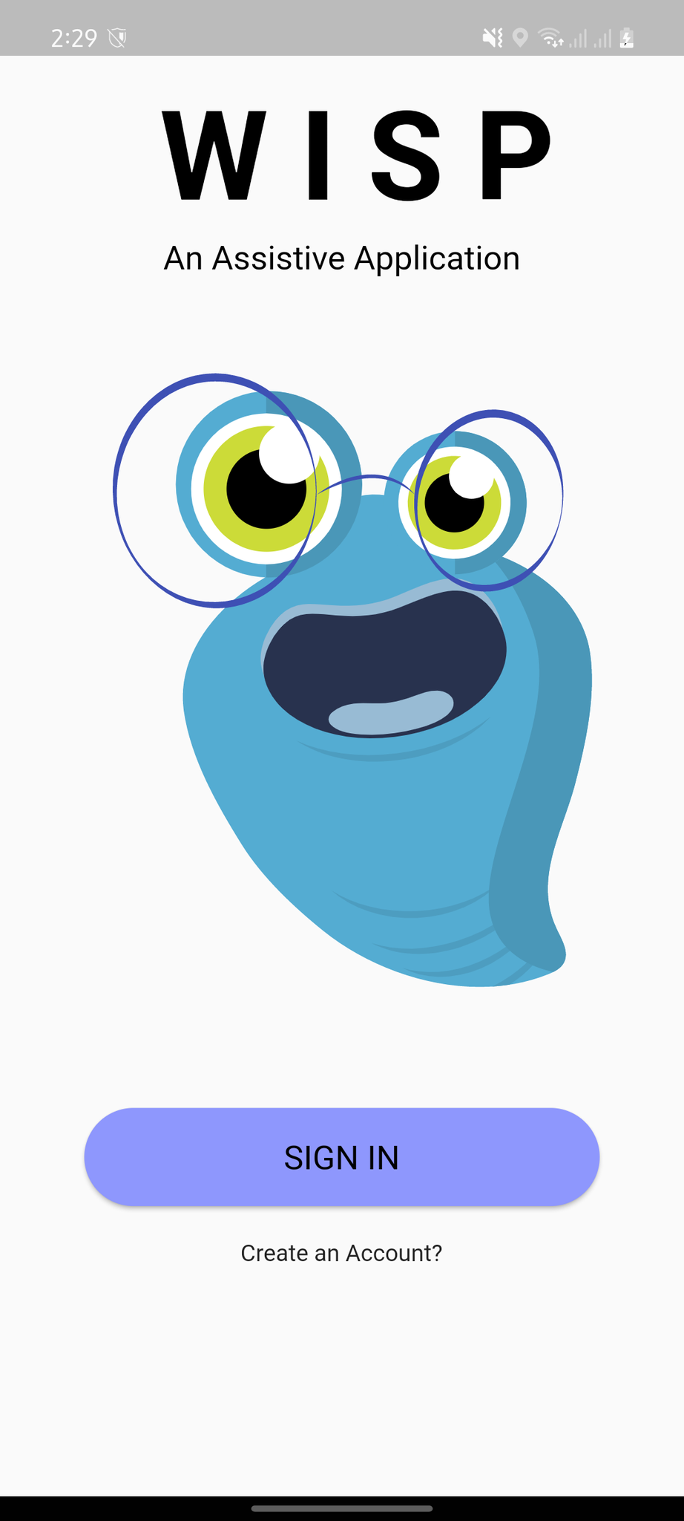

## Figure 10: Start Screen Interface

Figure 10 exhibits the starting screen, having the initial preview and impression for its users. The start screen flaunts its major logo and the signature blue wisp character placed in the center of the page. Below the logo is the sign-in button prompting the user for the next step it will take.

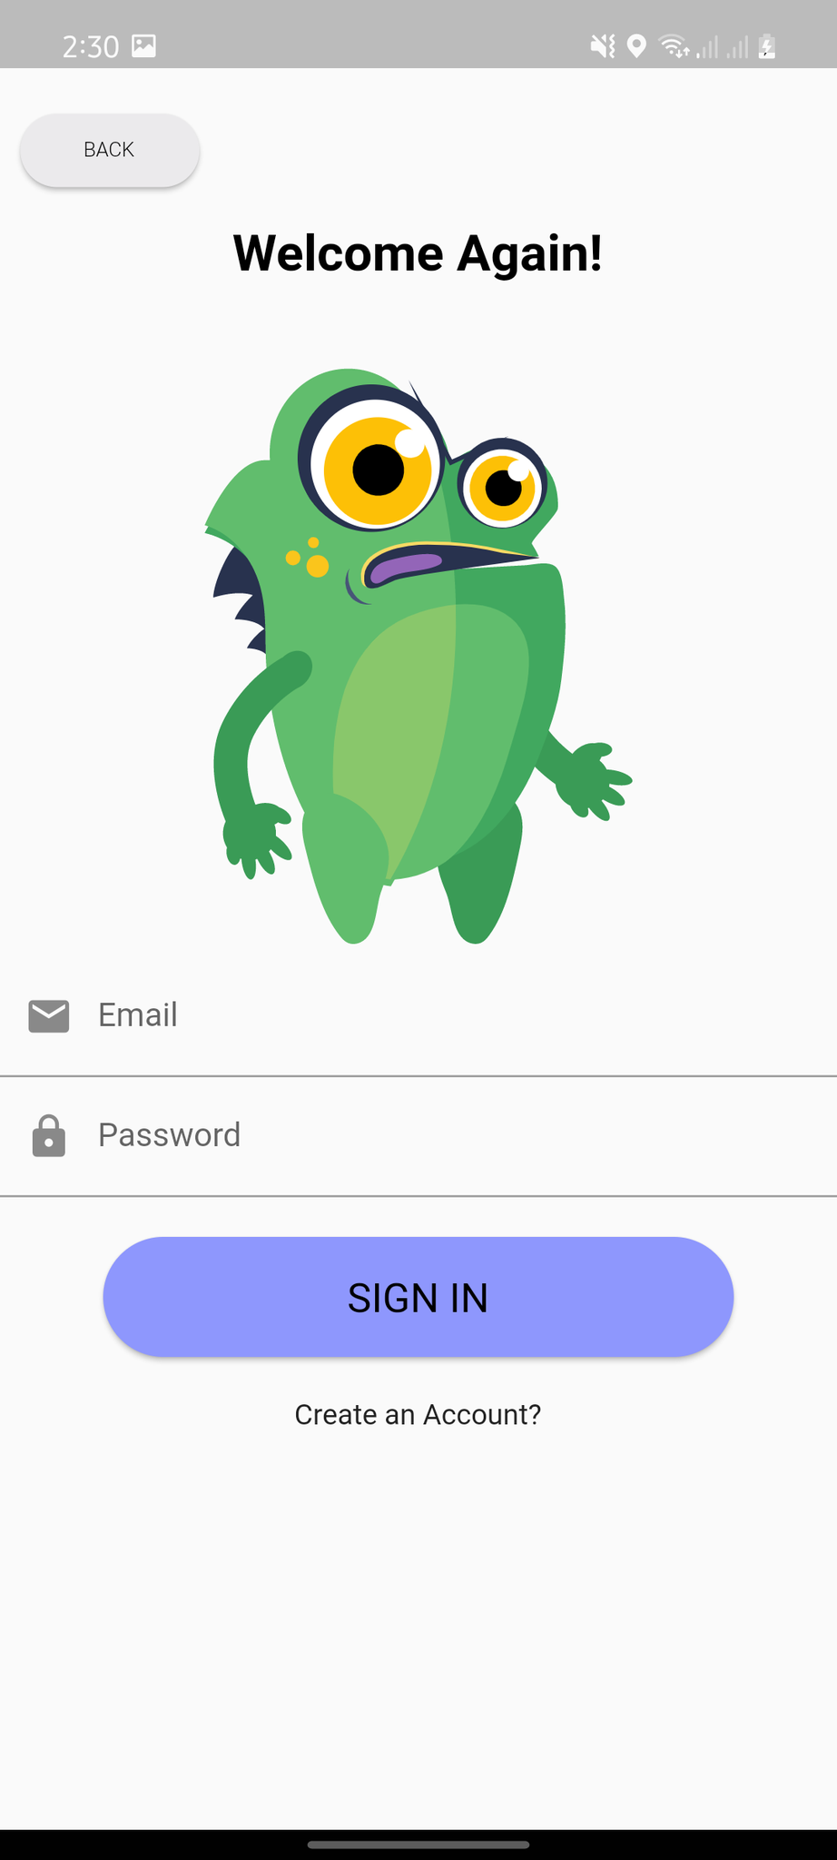

## Figure 11: Log-in Screen Interface

The above figure displays the sign-in screen of the assistive application. In this form, the user is required to fill up necessary details by providing a previously agreed-upon username and password in order to gain access. The log-in interface is welcomed with one of the animated wisps of the application adding more emphasis with a clean white background. A back option button is also visible if the user wishes to go back to the previous screen page.

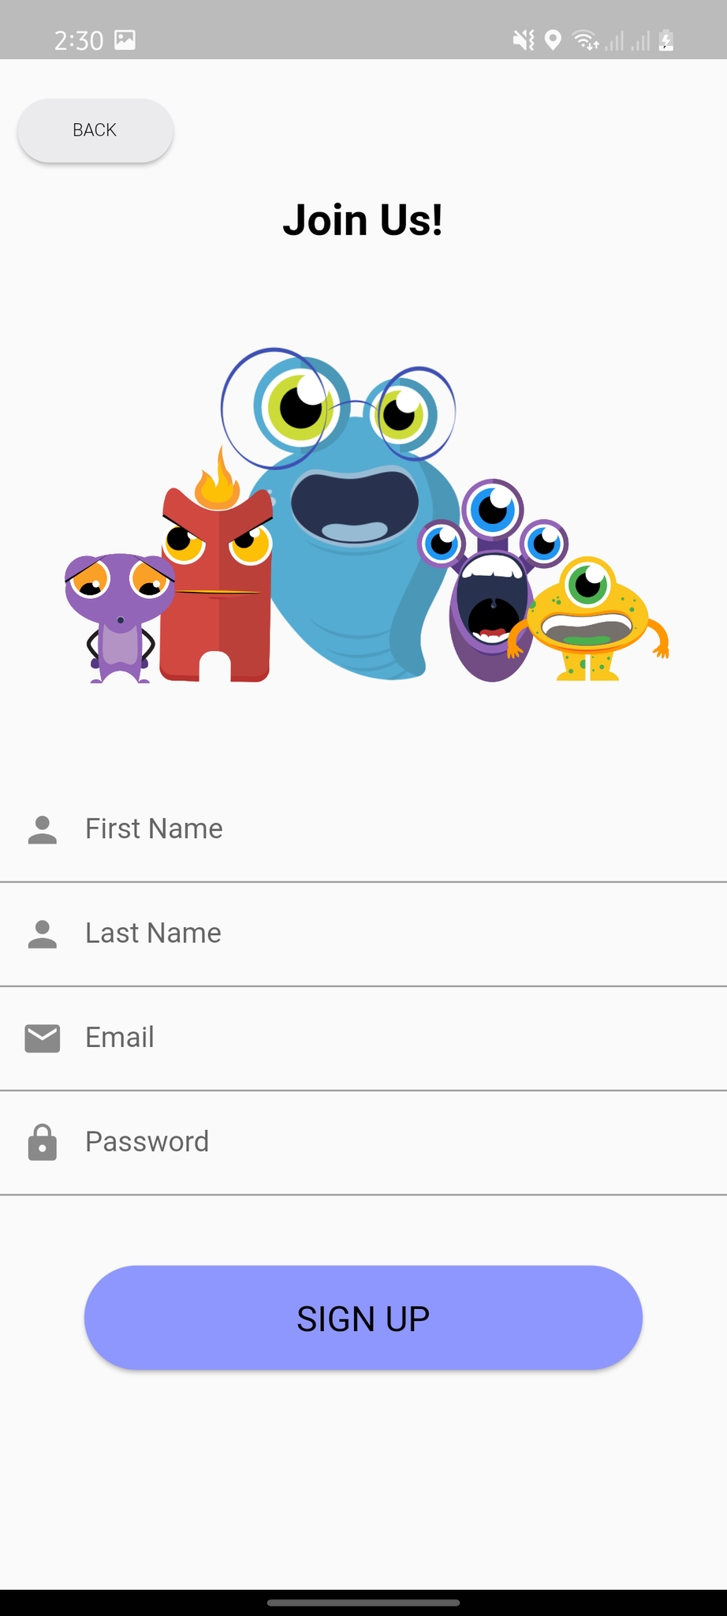

## Figure 12: Sign-up Screen Interface

Figure 12 sets forth the sign-up page along with 5 of its different wisp characters. Below the characters are short fill-out form details for users that will join the application. This will allow the user to create an account by initially filling out his first and last name, email address, and password for authentication purposes. All these details will be directed to the application's database — the firebase database.



## Figure 13: Home Screen Interface of Parent

This figure shows the home screen interface of the parent after logging in to the assistive application as you can see there are two wisps that correspond to the children of the parent which later be discussed in the next figure.

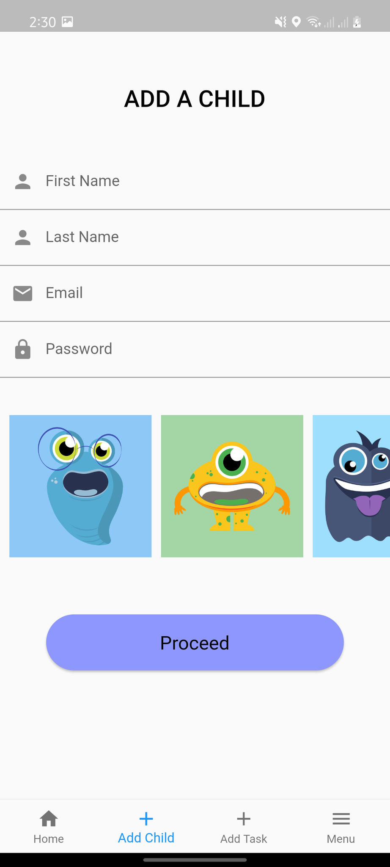

## Figure 14: Add Child Interface of Parent

This figure shows the add child interface of a parent in the assistive application wherein the parent will add the first name, last name, email, and password. After that, the parent will ask the child which wisp would he/she prefer. Then, after clicking proceed the child wisp will appear on the home screen.

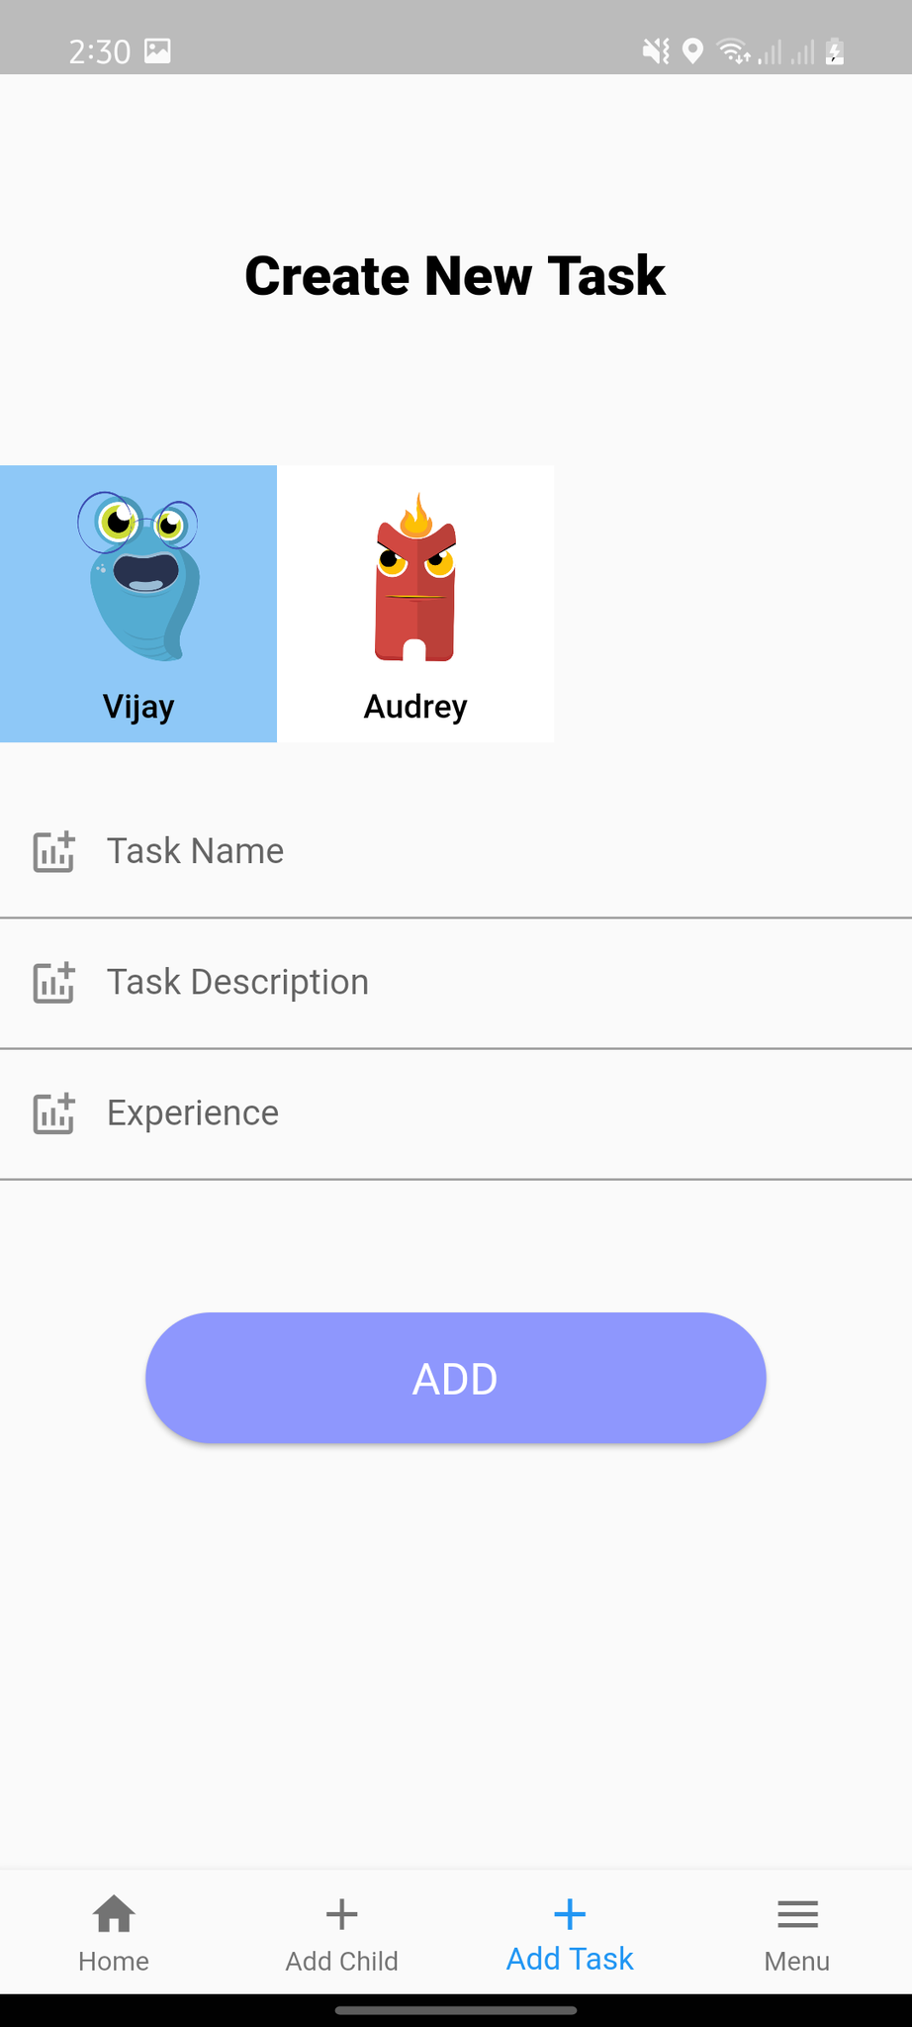

## Figure 15: Add Task Interface of Parent

This figure shows the add task interface of the parent in the assistive application wherein the parent will choose a specific child and add the following details: task name, task details, and task experience.

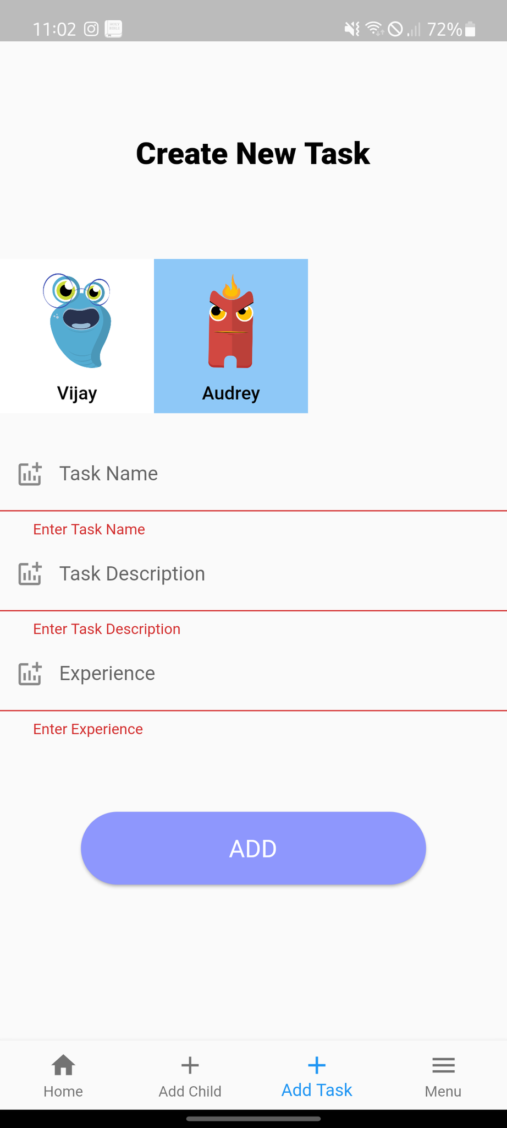

## Figure 16: Validator for Missing Details in Add Task Interface of Parent

This figure shows the validator in the add task interface to inform the parent every time there’s a blank text field in the form.

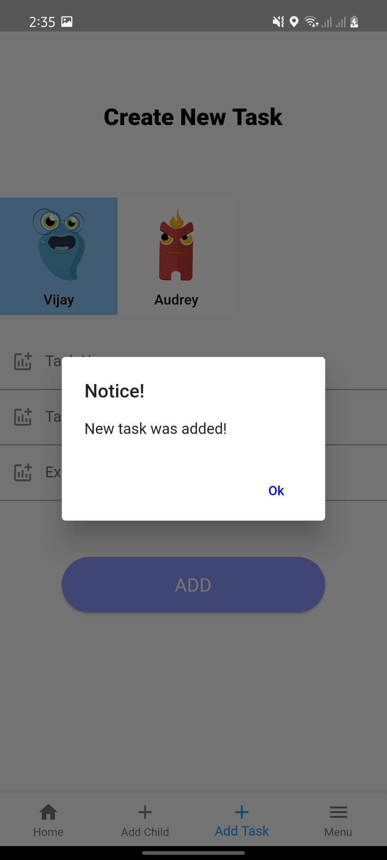

## Figure 17: Pop-up Dialog for Add Task Interface of Parent

This figure shows a pop-up dialog for adding a task interface to inform the parent that the task was successfully added.

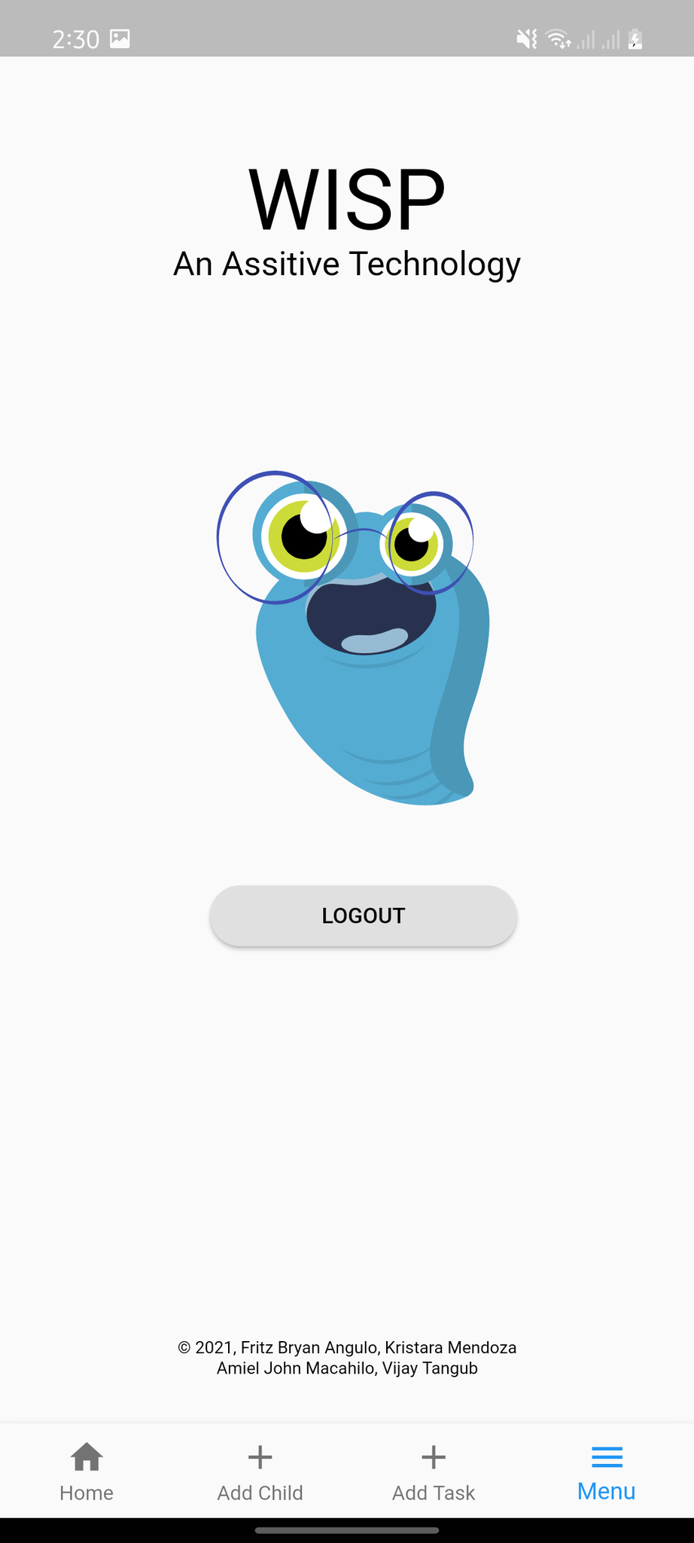

## Figure 18: Menu Screen Interface of Parent

Figure 18 displays the parent’s menu screen interface intended for the user if he chose to logout of his account.

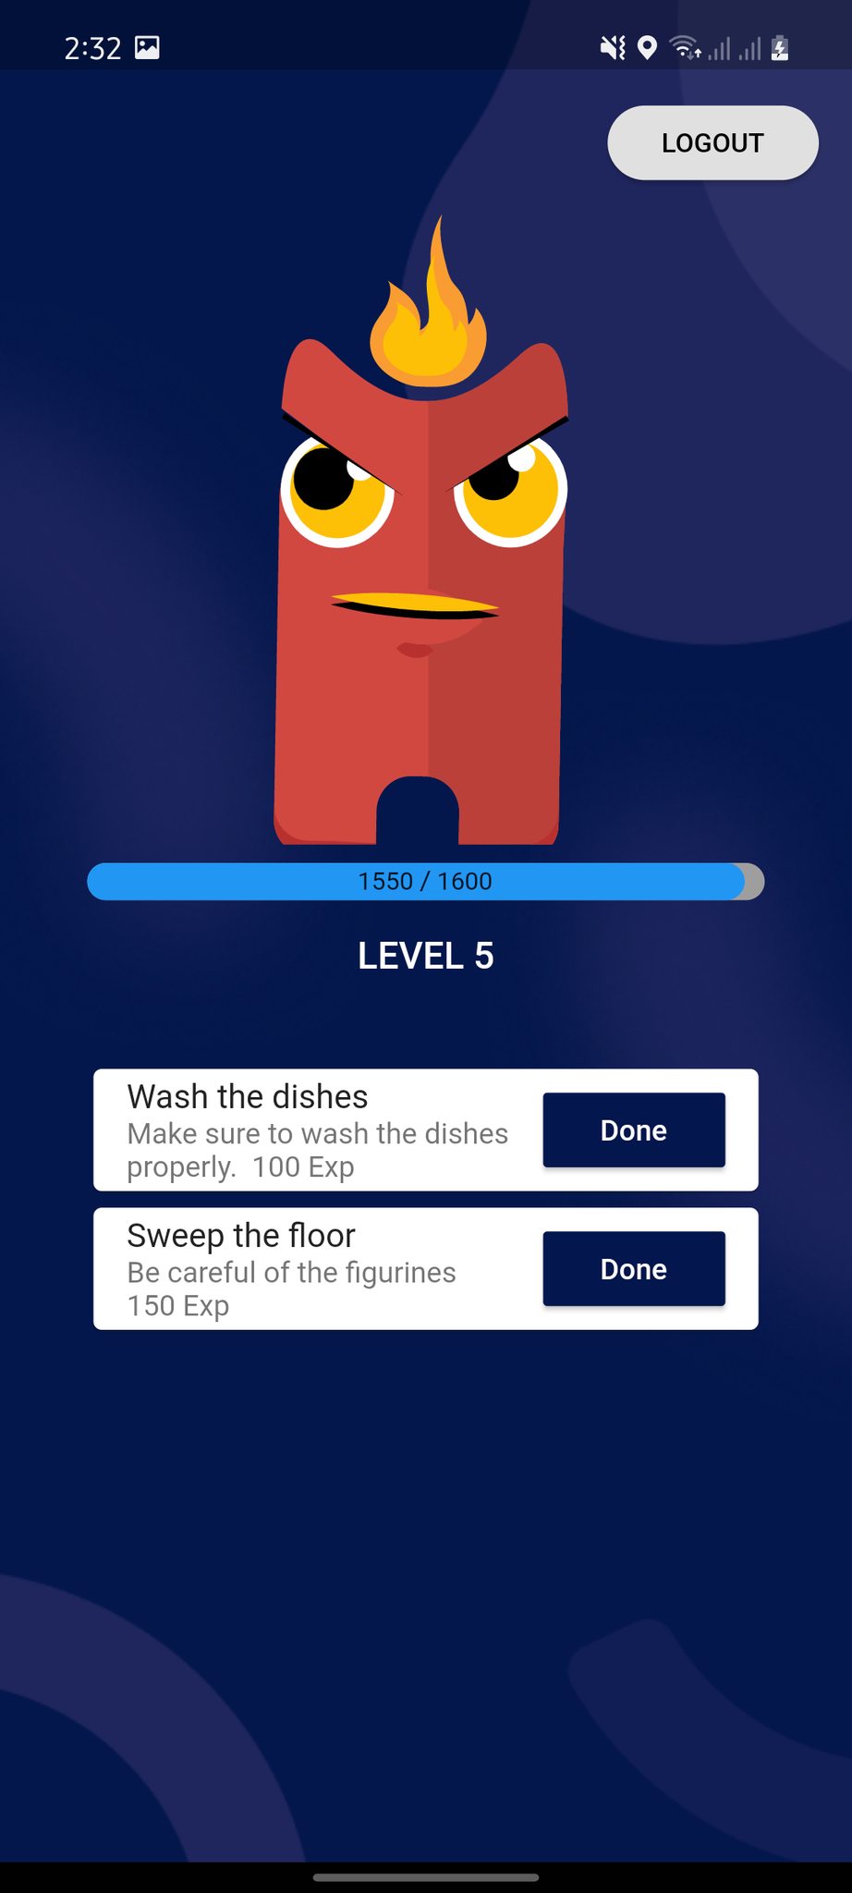

## Figure 19: Home Screen Interface of Child

The above figure shows the interface of the child’s home screen. On this page, the child is able to see the wisp pet he initially picked along with the pet’s progress and level. This is also where the child’s tasks are being displayed with their task details.

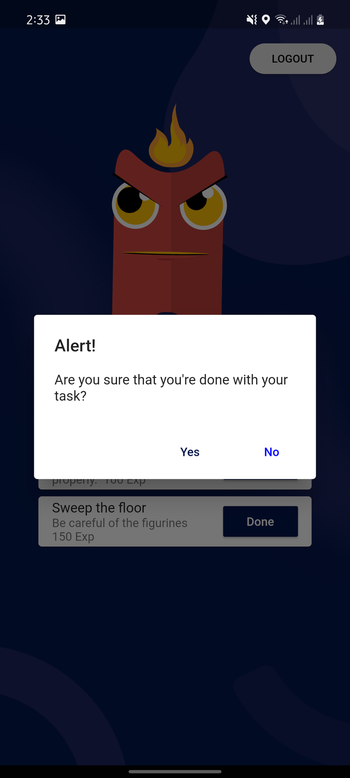

## Figure 20: Pop-up Dialog for First Task Interface of Child

Figure 20 presents pop-up dialog details. This confirmation message is intended for children when they click the “done” button on the first task from the list. This is to confirm if they have actually done the first task.

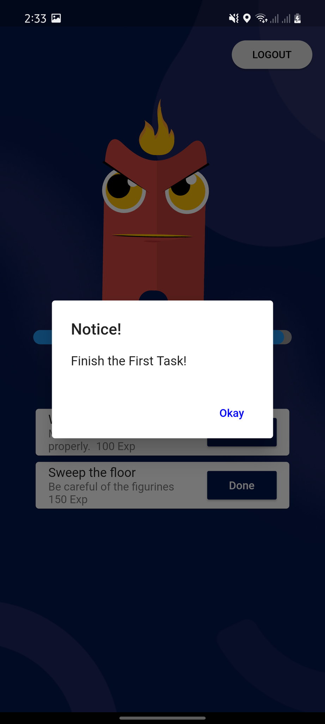

## Figure 21: Pop-up Dialog for Second and Remaining Tasks Interface of Child

This figure depicts the pop-up dialog for the second and remaining tasks. If a child does not complete the first task, he or she cannot move on to the second task. As a result, here is where the FIFO algorithm was implemented.

# 

# Results Interpretation and Analysis

In this study, a total of 47 respondents were randomly selected. A group of 20 parents and 27 children with an age range of 7-12 years old, took part in testing the application. To obtain the feedback of both parents and children, a questionnaire through google forms consisting of 10 questions for the child and 9 questions for the parents were made.

In addition, the only personal data that were collected are the sex, the name of the respondent which is optional, and their age since they are important for the implementation of the application which should be suitable for the age group.

The children and their parents were fully informed about the study's objective, the scope of its use of the results, and the purpose of its future usage. All questionnaires were completed at their respective homes when the child is in a calm emotional state. This is done to prevent results from being skewed by any anxiety or concern that children may have had.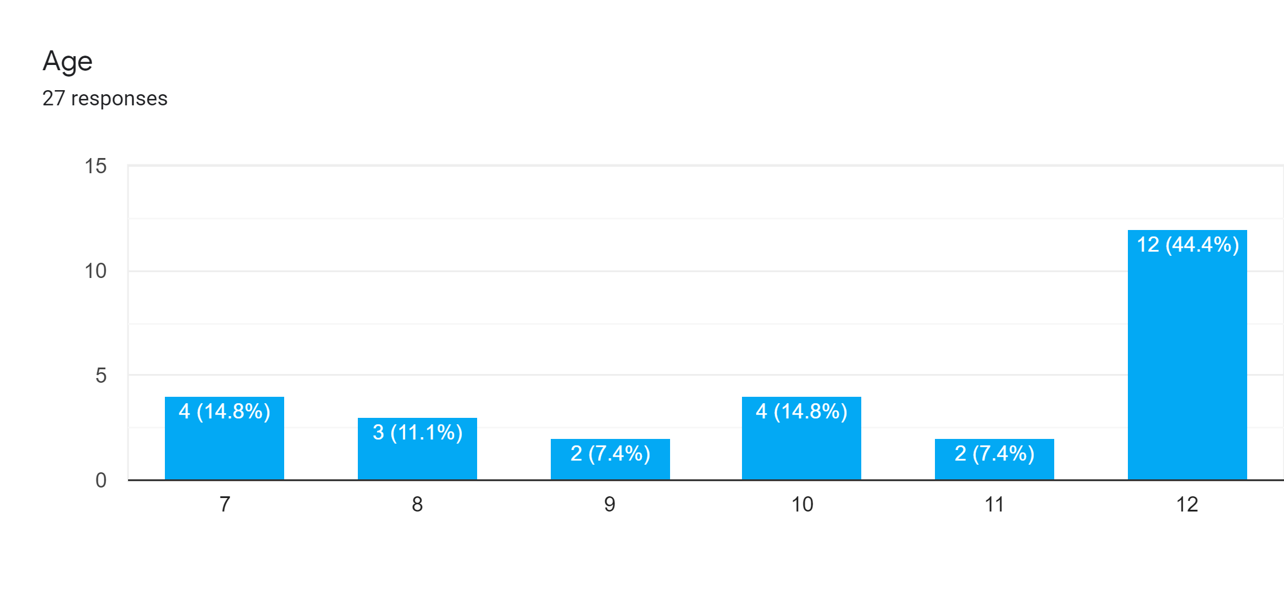

## *Figure* 22*: Age range of the children*

This figure shows that 14.8% are seven years old, 11.1% are eight years old, 7.4% are nine years old, 14.8% are 10 years old, 7.4% are eleven years old, and 44.4% are twelve years old.

Correspondence of Children towards the Wisp: Assistive Application When Taken as a Whole Group

| **Questions** | **SD** | **D** | **U** | **A** | **SA** | **Mean** | **Description** |
| --- | --- | --- | --- | --- | --- | --- | --- |
| I felt capable of doing tasks. | 0 | 0 | 0 | 8 | 19 | 4.70 | Strongly Agree |
| The application motivates me in doing chores at home. | 0 | 0 | 1 | 11 | 15 | 4.52 | Strongly Agree |
| The application characters are good for me | 0 | 0 | 0 | 5 | 22 | 4.81 | Strongly Agree |
| I was motivated to achieve the goals I had in the application | 0 | 0 | 2 | 9 | 16 | 4.52 | Strongly Agree |
| The application is fun to use | 0 | 0 | 1 | 8 | 18 | 4.63 | Strongly Agree |
| The application is cool and entertaining | 0 | 0 | 1 | 9 | 17 | 4.59 | Strongly Agree |
| I feel motivated when my pet is gaining experience | 0 | 0 | 1 | 4 | 22 | 4.78 | Strongly Agree |
| The application is easy to use and navigate | 0 | 0 | 1 | 9 | 17 | 4.59 | Strongly Agree |
| I was motivated to use the application because of the visual aid. | 0 | 0 | 0 | 10 | 17 | 4.63 | Strongly Agree |
| Chores would have been more fun if I had used the application | 0 | 0 | 1 | 9 | 17 | 4.59 | Strongly Agree |

## *Table 1: Children Questionnaire Results*

Legend:

Scales of Mean Description

5 - 4.1 Strongly Agree

4 - 3.1 Agree

3 - 2.1 Undecided

2 - 1.1 Disagree

1 Strongly Disagree

The correspondence of the children, age 7-12 years, towards the Wisp: an assistive application was determined by using the mean. The overall computed mean of the children’s correspondence was 4.64 which is ruled as a strongly agreed rate or has positive feedback. This concludes that the children are favorable with the entirety of the application and have a positive response with its potential. In addition, responses from questions do not have strongly disagree or disagree options from children indicating that none of them are dissatisfied with the application when taken as a whole group.

Specifically, findings show that out of the 10 questions, children had an overall correspondence of strongly agree in all items. Item no. 3 “The application characters are good for me.” had the highest mean of 4.81 which conveys that children are fascinated by the wisp characters and their animations, therefore, the results have satisfied the second objective of developing a virtual pet game system that is centralized in a child-centered approach. Impact to the children have been visible upon observations to them by the researchers during the feedback gathering, wherein the kid respondents commend the appearance of the pet characters. Children were able to choose from the 8 characters that best piques their interest and became fond of their chosen pet in the application and were even motivated to do tasks.

The second highest mean value of 4.78 on item no. 7 “I feel motivated when my pet is gaining experience.” which denotes that children were stimulated to get their tasks done as their pet continues to gain experience. This result reflected the 3rd objective of the study which is to create an in-game incentive system to motivate children in doing the tasks assigned and thus, efficiently fulfill them. Children were able to accomplish their tasks efficiently because they were engrossed with the thought that their pet is gaining more experience and advancing levels if they did more tasks. They attain that sense of accomplishment when they see their progress bar increasing which serves as their in-game incentive system.

Item no. 2 “The application motivates me in doing chores at home.” and item no. 4 “I was motivated to achieve the goals I had in the application” had both the lowest mean value of 4.52 but still falls under the strongly agreed range. This implies that the lower percentage of children are undecided if the application has motivated or encouraged them but on the contrary, other majority of children are highly motivated to do the tasks given to them through the application garnering higher scores on the agreeing options — agree and strongly agree. Table 1 shows the data.

Correspondence of Parents towards the Wisp: Assistive Application When Taken as a Whole Group

| **Questions** | **SD** | **D** | **U** | **A** | **SA** | **Mean** | **Description** |
| --- | --- | --- | --- | --- | --- | --- | --- |
| My child/children is/are doing the chores when they use the application | 0 | 0 | 1 | 8 | 11 | 4.75 | Strongly Agree |
| The functionality or features of the application is easy to understand. | 0 | 0 | 3 | 12 | 5 | 4.1 | Strongly Agree |
| The application helps my relationship towards my child | 0 | 0 | 4 | 7 | 9 | 4.25 | Strongly Agree |
| The application runs smoothly on my device. | 0 | 0 | 0 | 8 | 12 | 4.6 | Strongly Agree |
| Creating or adding tasks for my child is easy. | 0 | 0 | 0 | 4 | 16 | 4.8 | Strongly Agree |
| The first-in-first-out (FIFO) feature makes it easy for me to prioritize tasks that should come first. | 0 | 0 | 1 | 2 | 17 | 4.8 | Strongly Agree |
| I was easily taught how the application worked | 0 | 0 | 6 | 10 | 4 | 3.9 | Agree |
| I felt in control of what I was doing in the application | 0 | 0 | 6 | 6 | 8 | 4.1 | Strongly Agree |
| Generating my account and for my child is easy to understand and create. | 0 | 1 | 4 | 5 | 10 | 4.2 | Strongly Agree |

## *Table 2: Parent Questionnaire Results*

Legend:

Scales of Mean Description

5 - 4.1 Strongly Agree

4 - 3.1 Agree

3 - 2.1 Undecided

2 - 1.1 Disagree

1 Strongly Disagree

The correspondence of the parents towards the Wisp: Assistive application was calculated using mean. The overall computed mean of the parent’s feedback was 4.39 which indicates that it is strongly agreed with the application. As a result, parents admired the application and had a favorable response in its capability. Moreover, the findings in the study show that two out of the nine questions are item no.5 “Creating or adding tasks for my child is easy”, and item no.6 “The first-in-first-out (FIFO) feature makes it easy for me to prioritize tasks that should come first” had the highest mean of 4.8 which indicates that the objective 1 task management module that implements a first in first out queue algorithm is in line fulfilled and strongly agreed by the respondents. The results showed the impact towards the parents where they were able to list the tasks they wanted to hand over to their children efficiently and were satisfied that prioritized tasks can be done first by their child, given that kids would not be able to skip to the next tasks without completing the first one. Thus, item no.7 “I was easily taught how the application worked” was the lowest with 3.9 but falls under the agreed range, indicating that some of the parents have learnability issues with technology and some are not tech-savvy for the reason of the generation gap.

# System Evaluation Results

The system evaluation was conducted to the two experts. The researchers sent a letter with them and the data was collected through ISO 25010 evaluation form with the attached application.

| **Indicators** | | **VG** | **G** | **F** | **P** | **VP** | **Mean** |
| --- | --- | --- | --- | --- | --- | --- | --- |
| Completeness | The set of instructions all the specified task  and user objectives. | 0 | 1 | 1 | 0 | 0 | 3.5 |
| Correctness | The system provides correct results with the  needed degree of precision. | 2 | 0 | 0 | 0 | 0 | 5 |
| Appropriateness | The system provides the accomplishment of  specified tasks and objectives. | 1 | 1 | 0 | 0 | 0 | 4.5 |

## *Table 3: ISO 25010 - Functional Stability*

***Functional Stability.*** The results as shown in Table 3, concluded that assistive application has an overall functional stability mean value of 4.33. “Good” Completeness with 3.5 mean, “Very Good” correctness with 5.0 mean, and “Very Good” appropriateness with mean value of 4.5. Results indicate that the application is capable of offering functions that meet the implied needs.

| **Indicators** | | **VG** | **G** | **F** | **P** | **VP** | **Mean** |
| --- | --- | --- | --- | --- | --- | --- | --- |
| Maturity | A system, product or component meets for  reliability under normal operation. | 1 | 1 | 0 | 0 | 0 | 4.5 |
| Availability | A product or system is operational and  accessible when required for use. | 0 | 2 | 0 | 0 | 0 | 4.0 |
| Fault tolerance | A system, product or component operates as  intended despite the presence of hardware or  software results. | 0 | 2 | 0 | 0 | 0 | 4.0 |
| Recoverability | In the event of an interruption or a failure, a  product or system can recover the data and  establish the desired state of the system. | 0 | 0 | 2 | 0 | 0 | 3.0 |

## *Table 4: ISO 25010 - Reliability*

***Reliability.*** The results shown in table 4 revealed that the system has “Good” reliability based on its overall mean value of 3.88. “Very Good” Maturity with 4.5 mean, “Good” availability with 4.0 mean, “Good” fault tolerance with 4.0 mean, and “Fair” recoverability with 3.0 mean. This indicates that it meets the reliability indicators and the quality of performing consistently well.

| **Indicators** | | **VG** | **G** | **F** | **P** | **VP** | **Mean** |
| --- | --- | --- | --- | --- | --- | --- | --- |
| Adaptability | A product or system can effectively and  efficiently be adapted for different or evolving  hardware, software or other operational or  usage environments | 2 | 0 | 0 | 0 | 0 | 5.0 |
| Durability | A product or system can withstand  technology evolution and changes without  costly redesign, reconfiguration or recoding. | 0 | 1 | 1 | 0 | 0 | 3.5 |
| Installability | A product or system can be successfully  installed and/or uninstalled in a specified  environment. | 0 | 2 | 0 | 0 | 0 | 4.0 |
| Replaceability | A product can replace another specified  software product for the same purpose  in the same environment. | 0 | 0 | 2 | 0 | 0 | 3.0 |
| Affordability | A product or system can increase efficiency  and productivity by reducing the time and  costs involved in delivering instruction. | 1 | 1 | 0 | 0 | 0 | 4.5 |

## *Table 5: ISO 25010 - Portability*

***Portability.*** The above table illustrates the result that the application has an overall portability mean of 4.0. “Very Good” adaptability with 5.0 mean, “Good” durability with 3.5 mean, “Very Good” installability of 4.0, “Good” replaceability with 3.0 mean, and “Very Good” affordability with 4.5 mean value. This means that the application is capable of being transferred from one environment to another.

| **Indicators** | | **VG** | **G** | **F** | **P** | **VP** | **Mean** |
| --- | --- | --- | --- | --- | --- | --- | --- |
| Appropriate-ness Recognizabi-lity | Users can recognize whether a product or  the system is appropriate for their needs. | 1 | 1 | 0 | 0 | 0 | 4.5 |
| Learnability | A product or system enables the user to learn  how to use it with effectiveness, efficiency in  emergency situations. | 0 | 1 | 1 | 0 | 0 | 3.5 |
| Operability | A product or system is easy to operate,  control and appropriate to use. | 1 | 1 | 0 | 0 | 0 | 4.5 |
| User error protection | A product or system protects users against  making errors. | 0 | 0 | 2 | 0 | 0 | 3.0 |
| User interface aesthetics | A user interface enables pleasing and  satisfying interactions for the user. | 0 | 0 | 2 | 0 | 0 | 3.0 |
| Accessibility | A product or system can be used by people  with the widest range of characteristics and  capabilities to achieve a specified goal in a  specified context of use. | 0 | 2 | 0 | 0 | 0 | 4.0 |

## *Table 6: ISO 25010 - Usability*

***Usability.*** The results shown in table 6 displayed that the system has “Good” usability based on its overall mean value of 3.75. “Very Good” appropriateness recognizability with 4.5 mean, “Good” learnability with 4.0 mean, “Very Good” Operability with 4.5 mean, “Fair” user error protection with 3.0 mean, “Fair” user interface aesthetics with 3.0 mean, “Good” accessibility with 4.0 mean. This means that the system achieved a defined goal effectively, efficiently, and satisfactorily.

| **Indicators** | | **VG** | **G** | **F** | **P** | **VP** | **Mean** |
| --- | --- | --- | --- | --- | --- | --- | --- |
| Time-behavior | The response and processing times and  throughput rates of a product or system, when  performing its functions, meet requirements. | 0 | 0 | 2 | 0 | 0 | 3.0 |
| Resource  utilization | The amounts and types of resources used  by a product or system, when performing its  functions meet requirements. | 0 | 2 | 0 | 0 | 0 | 4.0 |
| Capacity | The maximum limits of the product or  system parameters meet requirements. | 2 | 0 | 0 | 0 | 0 | 5.0 |

## *Table 7: ISO 25010 - Performance Efficiency*

***Performance Efficiency.*** Results above have accumulated with an overall performance efficiency mean of 4.0. “Good” Time behavior of 3.0, “Very Good” resource utilization of 4.0, and capacity mean of 5.0. This means that the application has satisfied the required performance related to the number of resources used.

| **Indicators** | | **VG** | **G** | **F** | **P** | **VP** | **Mean** |
| --- | --- | --- | --- | --- | --- | --- | --- |
| Confidentiality | The prototype ensures that data are accessible only to those authorized to have access. | 0 | 1 | 1 | 0 | 0 | 3.5 |
| Integrity | A system, product, or component prevents unauthorized access to, or modification of, computer programs or data. | 0 | 2 | 0 | 0 | 0 | 4.0 |
| Non-repudiation | Actions or events can be proven to have taken place so that the events or actions cannot be repudiated later. | 0 | 2 | 0 | 0 | 0 | 4.0 |
| Accountability | The actions of an entity can be traced uniquely to the entity. | 0 | 1 | 1 | 0 | 0 | 3.5 |
| Authenticity | The identity of a subject or resources can be proved to be the one claimed. | 0 | 0 | 2 | 0 | 0 | 3.0 |

## *Table 8: ISO 25010 - Security*

***Security.*** Table 8 has an overall mean security value of 3.5 categorized as “Good”. “Good” confidentiality 3.5, “Very Good” integrity of 4.0, “Very good” non-repudiation with 4.0 mean, “Good” accountability of 3.5, and “Fair” authenticity mean value of 3.0. This generally means that the application is somehow able to protect information and data from security vulnerabilities.

| **Indicators** | | **VG** | **G** | **F** | **P** | **VP** | **Mean** |
| --- | --- | --- | --- | --- | --- | --- | --- |
| Co-existence | A product can perform its required  functions efficiently while sharing a common  environment and resources with other  products, without detrimental impact on any  other product | 1 | 0 | 1 | 0 | 0 | 3.0 |
| Interoperability | Two or more systems, products or  components can exchange information and  use the information that has been exchanged. | 1 | 1 | 0 | 0 | 0 | 4.5 |

## *Table 9: ISO 25010 - Compatibility*

***Compatibility***. The results shown in table 9 revealed that the system has “Good” compatibility based on its overall mean value of 3.75. “Fair” co-existence with 3.0 mean, and “Very Good” availability with 4.0 mean. This indicates that the system or component can exchange information with other products, systems or components, and/or perform its required functions while sharing the same hardware or software environment.

| **Indicators** | | **VG** | **G** | **F** | **P** | **VP** | **Mean** |
| --- | --- | --- | --- | --- | --- | --- | --- |
| Modularity | The application is composed of discrete components such that a change to one component has minimal impact on other components. | 0 | 0 | 2 | 0 | 0 | 3.0 |
| Reusability | An asset can be used in more than one system, or in building other assets. | 0 | 0 | 2 | 0 | 0 | 3.0 |
| Analyzability | It is possible to assess the impact on a product or system of an intended change to one or more of its parts, or to diagnose a product for deficiencies or causes of failures, or to identify parts to be modified. | 1 | 1 | 0 | 0 | 0 | 4.5 |
| Modifiability | The application can be effectively and  efficiently modified without introducing defects  or degrading existing product quality. | 0 | 0 | 2 | 0 | 0 | 3.0 |
| Testability | Test criteria can be established for an  application, product or component and tests  can be performed to determine whether those  criteria have been met. | 0 | 2 | 0 | 0 | 0 | 4.0 |

## *Table 10: ISO 25010 - Maintainability*

***Maintainability.*** The results shown in table 10 displayed that the system has “Good” maintainability based on its overall mean value of 3.5. “Fair” modularity with 3.0 mean, “Fair” reusability with 3.0 mean, “Very Good” analyzability with 4.5 mean, “Fair” modifiability with 3.0 mean, and “Good” testability with 4.0 mean. This means that the system achieved the degree of effectiveness and efficiency with which a product or system can be modified to improve it, correct it or adapt it to changes in the environment, and requirements.

| **ISO 25010** | **Overall Mean** | **Interpretation** |
| --- | --- | --- |
| Functional Stability | 4.33 | Very Good |
| Reliability | 3.88 | Good |
| Portability | 4.0 | Good |
| Usability | 3.75 | Good |
| Performance Efficiency | 4.0 | Good |
| Security | 3.6 | Good |
| Compatibility | 3.75 | Good |
| Maintainability | 3.5 | Good |

## *Table 11: Summary of ISO 25010*

Legend:

Scales of Mean Description

5 - 4.1 Very Good

4 - 3.1 Good

3 - 2.1 Fair

2 - 1.1 Poor

1 Very Poor

The results as shown in the above table indicates that the assistive application achieved an overall “Good” rating based on the ISO 25010 standard garnering an overall mean of 3.85. Precisely, among the eight quality requirements, Functional Stability has the highest mean value of 4.33 conforming within the range of the “very good” rating. The rest of the requirements which are reliability, portability, usability, performance efficiency, security, compatibility, and maintainability have attained a “Good” rating.

Results have satisfied the conducted quality evaluation and therefore attest to the application’s quality for providing implied needs to its users.

CHAPTER 5 SUMMARY, CONCLUSIONS, AND RECOMMENDATIONS

# Summary of the Proposed Study Design and Implementation

This study aimed to develop an assistive technology by implementing the First-in-first-out (FIFO) queue algorithm for the task management module and incorporating gamification in the form of animated characters, enabling them to engage in physical activities in which tasks are provided in the application.

Wisp assistive application was able to operate in full functionality, able to create an account for the parent, adding of child, as well as choosing which wisp characters their child desires and adding tasks with the implementation of the FIFO algorithm. The FIFO algorithm in the application had shown to queue efficiently the tasks provided for the children’s interface. The first task in the application when created by their parents will queue in first on the list, followed by the next tasks they created. If the child refuses to do the first task and opt to do the next one, the application will prompt a message indicating they need to finish the first task created. With this set up using the method of FIFO algorithm, the first task will be done first and will be removed from the list allowing for the next one to take over. Every task completed has a corresponding reward in the form of gaining experience for their wisp pet allowing them to level up.

The development process of the implementation of the Wisp: assistive application was carried out through making use of the Flutter API as well as utilizing Android Studio version 4.2.2. Storing and syncing in real-time of the application’s data between the users is done through Firebase Database. Gamification of the 8 wisp characters was animated with the use of Rive—interactive design and animation tool

The research will be of great help to engage children in doing physical activities by making use of their screen times into a productive task and motivating them with the child-centered approach of the application. Moreover, the assistive application can be utilized efficiently at home to also introduce children to productive household tasks promoting independence and instilling responsibility even at a young age and be able to recognize priorities that should be done first.

# Conclusions

After implementation and testing, the results of the proposed system have shown and it was able to meet its objectives as follows:

1. The task management module that implements a first in first out queue algorithm performed well and the child finished the task on an order basis.
2. The virtual pet game system that highlights parent-led and child-centered game approaches were indeed excellent to the child users. The animated wisp characters were able to stimulate the child’s motivation to finish each task given to them.
3. The in-game incentive system which is the in-game experience was able to provide motivation to child users when doing the task provided by their parents.
4. The overall performance of the system evaluated based on feedback was 4.64 overall mean for child users and 4.39 overall mean for parent users which indicates “Strongly Agree”. On the other hand, the overall performance of the system evaluated based on ISO 25010 Standard was 3.85 which indicates “Good”. Furthermore, the system was able to meet the needs and requirements of the end-users and IT experts.

# Recommendations

The following recommendations are suggested based on the observations and conclusions presented:

1. To include mini-games in the application for supplementary intrinsic motivation and for added chances for the wisp pet to gain experience.
2. To include a timer system for tasks to finish on a designated time limit.
3. To include a mood bar for virtual pets if the child does not complete his/her tasks.
4. To add the option of viewing history for the previous tasks completed.
5. To add a sharing option in which the user’s wisp account is able to connect with other social media accounts.

## 

References

Ashton J. et.al (2019, May 1). *Screen time in children and adolescents: is there evidence to guide parents and policy?*. Retrieved from: <https://www.thelancet.com/journals/lanchi/article/PIIS2352-4642(19)30062-8/fulltext>.

Bjering, A. B. K., Høiseth, M., & Alsos, O. A. (2015, September). Gamification and Family Housework Applications. In International Conference on Entertainment Computing (pp. 209-223). Springer, Cham. Retrieved from: https://link.springer.com/chapter/10.1007/978-3-319-24589-8_16

Futterman, L. (2015, August 25). *Beyond the Classroom: Do smartphones make us lazy?*. Retrieved from: <https://www.miamiherald.com/news/local/community/miami-dade/community-voices/article31717974.html?fbclid=IwAR3snjfJj9k__zZnL0ydyy72IOkrCwXR0p7elhowClrgqnYIes_mAIDzBTs>.

Hale L. (2015). *Screen time and sleep among school-aged children and adolescents: A systematic literature review*. Retrieved from: https://www.sciencedirect.com/science/article/abs/pii/S1087079214000811.

Hapsari, D., Permanasari, A., Fauziati, S., & Fitriana, I. (n.d.). Management Information Systems Development for Veterinary Hospital Patient Registration Using First In First Out Algorithm. Retrieved from website: https://repository.ugm.ac.id/139428/1/iBiomed_proceeding%202. pdf

Hiniker, A. et.al (2016, May). *Screen Time Tantrums: How Families Manage Screen Media Experiences for Toddlers and Preschoolers*. Retrieved from: <https://dl.acm.org/doi/10.1145/2858036.2858278>

Kadison, L. S. (2015). Using Gamification to Increase Adherence to Daily Living Routines. Retrieved from: https://scholarcommons.usf.edu/cgi/viewcontent.cgi?article=6711&context=etd.

Kartevoll, M. (2017). Improving User Experience with Gamification and Reward Systems (Master's thesis, NTNU). Retrieved from: <https://ntnuopen.ntnu.no/ntnu-xmlui/handle/11250/2456865>

Kim, B. (2015). Designing gamification in the right way. Library Technology Reports, 51(2), 29-35. Retrieved from: https://journals.ala.org/index.php/ltr/article/viewFile/5632/6952

Lindström, E. & Nilsson, L. (2017). *Forest: Stay Focused.* Retrieved from:[*https://www.diva-portal.org/smash/record.jsf?pid=diva2%3A1114594&dswid=8878*](https://www.diva-portal.org/smash/record.jsf?pid=diva2%3A1114594&dswid=8878)*.*

Manurung, J. (2019). APPLICATION OF FIFO ALGORITHM (FIRST IN FIRST OUT) TO SIMULATION QUEUE. INFOKUM, 7(2, Juni), 44-47. Retrieved from: *http://seaninstitute.org/infor/index.php/infokum/article/view/25/15*

Wardhana, S. et al. (2017) User Interface Design Model for Parental Control Application On Mobile Smartphone Using User Centered Design Method. Retrieved from: <https://www.researchgate.net/publication/320663410_User_interface_design_model_for_parental_control_application_on_mobile_smartphone_using_user_centered_design_method?fbclid=IwAR0X8boz3fRjUStscL_304m9sPugFvg-Ta_Y_60nBsEX6esRBzaWoIJnxgc>.

World Health Organization: WHO. (2019, April 24). To grow up healthy, children need to sit less and play more. Retrieved January 28, 2021, from Who.int website: <https://www.who.int/news/item/24-04-2019-to-grow-up-healthy-children-need-to-sit-less-and-play-more>

Zaman, B. & Nouwen, M. (2016). Parental controls: advice for parents, researchers and industry. Retrieved from: <http://eprints.lse.ac.uk/65388/1/__lse.ac.uk_storage_LIBRARY_Secondary_libfile_shared_repository_Content_EU%20Kids%20Online_EU_Kids_Online_Parental%20controls%20short%20report_2016.pdf>.

Appendices

# Appendix A

March 2, 2021

DOFITAS, CYRENE JR. S.

Associate Professor I

College on ICT – West Visayas State University

St. Luna, La Paz, Iloilo City

Dear Prof. Dofitas,

The undersigned are BS Information Technology Research 1/Thesis 1 students of CICT, this university. Our thesis/capstone project title is “Implementing First-in-First-Out (FIFO) Queue Algorithm for Task Scheduling of Wisp: An Anti-Lazy Application”.

Knowing of your expertise in research and on the subject matter, we would like to request you to be our **ADVISER**.

We are positively hoping for your acceptance. Kindly check the corresponding box and affix your signature in the space provided. Thank you very much.

Respectfully yours,

1. Angulo, Fritz Bryan N.,

2. Macahilo, Amiel John B.

3. Mendoza, Kristara C. ,

4. Tangub, Vijay,

PS:

Advisers are tasked to work with the students in providing direction and assistance as needed in their thesis/capstone project. They shall meet with the students weekly or as needed to provide direction, check on progress and assist in resolving problems until such a time that the students pass their defenses and submit their final requirements, as well as, preparing their evaluations and grades.

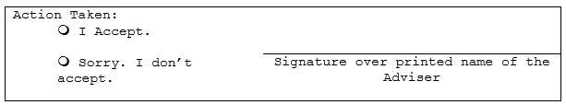

# Appendix B

March 2, 2021

SOLIDARIOS, MARK JOSEPH J.

Part-time Instructor

College on ICT – West Visayas State University

St. Luna, La Paz, Iloilo City

Dear Prof. Solidarios,

The undersigned are BS Information Technology Research 1/Thesis 1 students of CICT, this university. Our thesis/capstone project title is “Implementing First-in-First-Out (FIFO) Queue Algorithm for Task Scheduling of Wisp: An Anti-Lazy Application”.

Knowing of your expertise in research and on the subject matter, we would like to request you to be our **CO-ADVISER**.

We are positively hoping for your acceptance. Kindly check the corresponding box and affix your signature in the space provided. Thank you very much.

Respectfully yours,

1. Angulo, Fritz Bryan N.,

2. Macahilo, Amiel John B.

3. Mendoza, Kristara C. ,

4. Tangub, Vijay,

PS:

Advisers are tasked to work with the students in providing direction and assistance as needed in their thesis/capstone project. They shall meet with the students weekly or as needed to provide direction, check on progress and assist in resolving problems until such a time that the students pass their defenses and submit their final requirements, as well as, preparing their evaluations and grades.



# Appendix C

April 20, 2021

Dr. Aimee G. Chua

Faculty, College of Medicine

West Visayas State University

La Paz, Iloilo City

Dear Dr. Chua,

Good day!

We are third year BSIT students of College of Information and Communications Technology at West Visayas State University. We sincerely ask for your assistance from your good office for the validation of our thesis entitled: Implementing First-in-First-out (FIFO) algorithm for Wisp: An Anti-Lazy Application”.

The purpose is to clarify if our User Interface is child-friendly and to validate if our idea could help children to lessen their screen time.

We are looking forward to your positive response about this matter. Thank you so much.

Sincerely yours,

Vijay Tangub

Leader – Group 2

09212686059

vtangub@wvsu.edu.ph

Noted by:

Prof. Cyreneo Dofitas

Thesis Adviser

# Appendix D

November 17, 2021

Vicente, Celesamae T.

Assistant Professor, College of Computer Studies

Mindanao State University - Iligan Institute of Technology

Iligan City, Philippines

Dear Prof Vicente,

We, the researchers of the College of Information and Communications Technology, would like to request you of your time for the ISO 25010 standard to evaluate our proposed system for our undergraduate thesis entitled “Implementing First-In-First-Out (FIFO) Queue Algorithm for Task Scheduling of Wisp: An Assistive Application”. We will provide you with the evaluation form with the attached application along with our thesis documents from chapters 1-3.

A great pleasure of having you as our evaluator for our undergraduate thesis. If you have any questions please feel free to contact us in this email, it will be much appreciated.

Thank you very much

Respectfully yours,

Fritz Bryan N. Angulo

Amiel John Macahilo

Kristara Mendoza

Vijay Tangub

# Appendix E

November 17, 2021

Tidula, Jenel T.

CEO,

JT Sparks

Nanga, Guimbal, Iloilo

Dear Mr. Jenel,

We, the researchers of the College of Information and Communications Technology, would like to request you of your time for the ISO 25010 standard to evaluate our proposed system for our undergraduate thesis entitled “Implementing First-In-First-Out (FIFO) Queue Algorithm for Task Scheduling of Wisp: An Assistive Application”. We will provide you with the evaluation form with the attached application along with our thesis documents from chapters 1-3.

A great pleasure of having you as our evaluator for our undergraduate thesis. If you have any questions please feel free to contact us in this email, it will be much appreciated.

Thank you very much

Respectfully yours,

Fritz Bryan N. Angulo

Amiel John Macahilo

Kristara Mendoza

Vijay Tangub

# Appendix F

December 12, 2021

Padilla, Simoun Omar Dylan

Faculty, College of Arts and Sciences

West Visayas State University

La Paz, Iloilo City

Dear Mr. Padilla,

We, the researchers of the College of Information and Communications Technology, would like to request you of your time as our **English Editor** for our undergraduate thesis entitled “Implementing First-In-First-Out (FIFO) Queue Algorithm for Task Scheduling of Wisp: An Assistive Application”. We will provide you with a complete thesis document prior to the evaluation.

A great pleasure of having you as our english editor for our undergraduate thesis. If you have any questions please feel free to contact us in this email, it will be much appreciated.

Thank you very much

Respectfully yours,

Fritz Bryan N. Angulo

Amiel John Macahilo

Kristara Mendoza

# Vijay Tangub

# 

# Appendix GChart

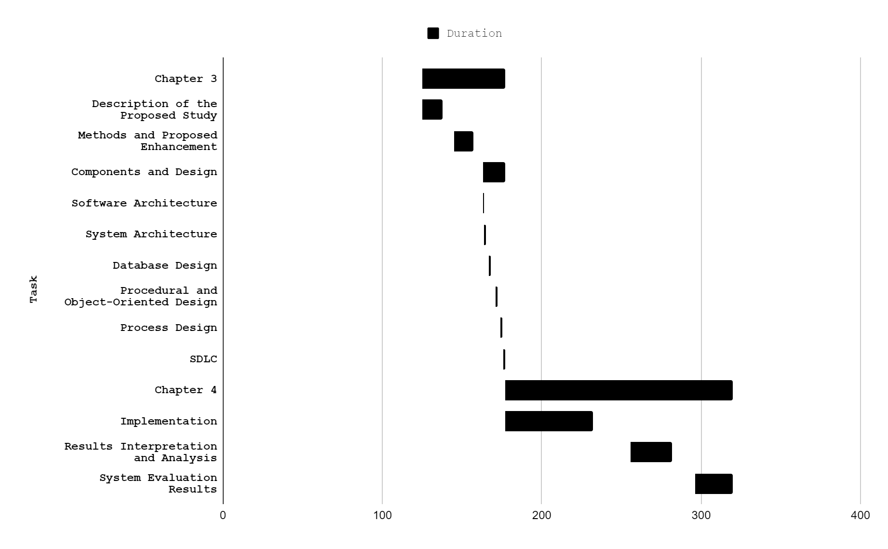

# 

# Chart

# Appendix H

| **User** | | | | | |
| --- | --- | --- | --- | --- | --- |
| **Field Name** | **Data type** | **Field Length** | **Constraint** | **Description** | **Required** |
| user_id | int | 50 | Primary key | user id, Auto generated | Yes |
| user_firstName | string | 20 | not null | user first name | Yes |
| user_lastName | string | 20 | not null | user last name | Yes |
| user_email | string | 30 | not null | user email | Yes |
| user_password | varchar | 30 | not null | user password | Yes |
| user_role | string | 20 | not null | user role | Yes |
| task_id | int | 50 | Foreign key | task id, Auto generated | Yes |
| child_id | int | 20 | Foreign key | child id, Auto generated | Yes |

# 

| **Pet** | | | | | |
| --- | --- | --- | --- | --- | --- |
| **Field Name** | **Data type** | **Field Length** | **Constraint** | **Description** | **Required** |
| pet_id | int | 50 | Primary key | pet id, Auto generated | Yes |
| pet_type | string | 20 | not null | wisp type | Yes |
| pet_experience | int | 5 | not null | wisp current experience | Yes |
| pet_level | int | 5 | not null | wisp current level | Yes |
| pet_maxexp | int | 20 | not null | wisp maximum experience | Yes |

# 

| **Task** | | | | | |
| --- | --- | --- | --- | --- | --- |
| **Field Name** | **Data type** | **Field Length** | **Constraint** | **Description** | **Required** |
| task_id | int | 50 | Primary key | task id, Auto generated | Yes |
| task_name | varchar | 50 | Not null | Name title of task | Yes |
| task_details | varchar | 100 | Not null | Description of task | Yes |
| task_experience | int | 3 | Not null | experience amount | Yes |
| child_id | varchar | 10 | Foreign key | child id, Auto generated | Yes |
| task_date | date | 50 | Not null | date of task | Yes |
| task_queueNumber | int | 3 | Not null | sequence of tasks | Yes |
| task_status | varchar | 10 | Not null | current stature of task | Yes |

# 

| **Child** | | | | | |
| --- | --- | --- | --- | --- | --- |
| **Field Name** | **Data type** | **Field Length** | **Constraint** | **Description** | **Required** |
| child_id | int | 50 | Primary key | pet id, Auto generated | Yes |
| child_firstName | string | 20 | not null | child first name | Yes |
| child_lastName | string | 20 | not null | child last name | Yes |
| child_email | string | 30 | not null | child email name | Yes |
| child_password | varchar | 30 | Foreign key | child password | Yes |
| pet_id | int | 50 | Foreign key | pet id, Auto generated | Yes |

# 

# Appendix I

# 

# Appendix J

StreamBuilder(

stream: firestore_task.where("child_id", isEqualTo:

userId).where( "task_status", isEqualTo:"in progress").orderBy("task_queueNumber",descending: false).snapshots(),

builder: (context, snapshot){

if(snapshot.hasError){

return Text("Error");

}

if(snapshot.connectionState ==

ConnectionState.waiting){

return Text("Loading ...");

}

if(snapshot.hasData){

return Container(

height: deviceHeight * 0.40,

width: deviceWidth * 0.80,

child: ListView.builder(shrinkWrap: true,

itemCount:snapshot.data.documents.length,

itemBuilder: (_, index) {

_buildPopupDialog(BuildContext

context) {

return AlertDialog(

title: const Text('Alert!'),

content: new Column(

mainAxisSize:

MainAxisSize.min,

crossAxisAlignment:

CrossAxisAlignment.start,

children: <Widget>[

Text("Are you sure that

you're done with your task?"),],),

actions: <Widget>[

new FlatButton(

onPressed: () {

deletetask(snapshot.data.documents[index].reference.documentID);

updatedExp = petExp +

int.parse("${snapshot.data.documents[index].data["task_experience"]}");

petExp = updatedExp;

print(petExp);

if(petExp < max){

updatePetExperience(petExp,

userId);

Navigator.of(context).pop();}

else{

updatePetExperience(petExp, userId);

updatedMax = max*2;

max = updatedMax;

petLevel++;

while(max<petExp){

updatedMax = max*2;

max = updatedMax;

petLevel++;}

updatePetLevel(petLevel,max ,userId);

Navigator.of(context).pop();},

textColor: Color(0xFF03164d),

child: const Text('Yes'),),

new FlatButton(

onPressed: () {

Navigator.of(context).pop();},

textColor: Color(0xFF0000Ff),

child: const Text('No'),)],);}

_buildPopupDialog_Fifo(BuildContext context) {

return AlertDialog(

title: const Text('Notice!'),

content: new Column(mainAxisSize: MainAxisSize.min,crossAxisAlignment: CrossAxisAlignment.start,

children: <Widget>[

Text("Finish the First Task!"),],),

actions: <Widget>[new

FlatButton(onPressed: () {Navigator.of(context).pop();}, textColor: Color(0xFF0000Ff),child: const Text('Okay'),),],);}

return Padding(padding: EdgeInsets.only(top: 0.0),

child: Card(

child: ListTile(

title:

Text(snapshot.data.documents[index].data["task_name"]),

subtitle:

Text("${snapshot.data.documents[index].data["task_details"]}${snapshot.data.documents[index].data["task_experience".toString()]}" +" Exp"),

trailing: Row(mainAxisSize:

MainAxisSize.min,

children: [

RaisedButton(

child: Text('Done', style: TextStyle(color: Colors.white,),

),

color: Color(0xFF03164d),

onPressed: () {

if(index == 0)

{

showDialog(context: context,builder: (BuildContext context) =>_buildPopupDialog(context),);

}

else

{

showDialog(context: context,builder: (BuildContext context) => _buildPopupDialog_Fifo(context),);

}

},),],),

),

),

);

}),

);

}

# Appendix K

**Wisp Parent & Child Questionnaire**

* Required

1. ROLE *

*Mark only one oval.*

Parent *Skip to parent questionnaire.*

Child *Skip to child questionnaire.*

**Child Questionnaire**

1. Name(Optional)



1. Age *



1. Sex *

*Mark only one oval.*

# Male

Female

1. I felt capable of doing tasks. *

*Mark only one oval.*

1 2 3 4 5



Strongly Disagree Strongly Agree



1. The application motivates me in doing chores at home *

*Mark only one oval.*

1 2 3 4 5



Strongly Disagree Strongly Agree



1. The application characters are good for me *

*Mark only one oval.*

1 2 3 4 5



Strongly Disagree Strongly Agree



1. I was motivated to achieve the goals I had in the application *

*Mark only one oval.*

1 2 3 4 5



Strongly Disagree Strongly Agree



1. The application is fun to use *

*Mark only one oval.*

1 2 3 4 5



Strongly Disagree Strongly Agree



1. The application is cool and entertaining *

*Mark only one oval.*

1 2 3 4 5



Strongly Disagree Strongly Agree



1. I feel motivated when my pet is gaining experience *

*Mark only one oval.*

1 2 3 4 5



Strongly Disagree Strongly Agree



1. The application is easy to use and navigate *

*Mark only one oval.*

1 2 3 4 5



Strongly Disagree Strongly Agree



1. I was motivated to use the application because of the visual aid. *

*Mark only one oval.*

1 2 3 4 5



Strongly Disagree Strongly Agree



1. Chores would have been more fun if I had used the application *

*Mark only one oval.*

1 2 3 4 5



Strongly Disagree Strongly Agree



# 

# 

# Appendix L

**Parent Questionnaire**

1. Name(Optional)



1. Age *



1. Sex *

*Mark only one oval.*

# Male

Female

1. My child/children is/are doing the chores when they use the application *

*Mark only one oval.*

1 2 3 4 5



Strongly Disagree Strongly Agree



1. The functionality or features of the application is easy to understand. *

*Mark only one oval.*

1 2 3 4 5



Strongly Disagree Strongly Agree



1. The application helps my relationship towards my child. *

*Mark only one oval.*

1 2 3 4 5



Strongly Disagree Strongly Agree



1. The application runs smoothly on my device. *

*Mark only one oval.*

1 2 3 4 5



Strongly Disagree Strongly Agree



1. Creating or adding tasks for my child is easy. *

*Mark only one oval.*

1 2 3 4 5



Strongly Disagree Strongly Agree



1. The first-in-first-out (FIFO) feature makes it easy for me to prioritize tasks that should come first. *

*Mark only one oval.*

1 2 3 4 5



Strongly Disagree Strongly Agree



1. I was easily taught how the application worked. *

*Mark only one oval.*

1 2 3 4 5



Strongly Disagree Strongly Agree



1. I felt in control of what I was doing in the application. *

*Mark only one oval.*

1 2 3 4 5



Strongly Disagree Strongly Agree



1. Generating my account and for my child is easy to understand and create. *

*Mark only one oval.*

1 2 3 4 5



Strongly Disagree Strongly Agree



# 

# Appendix M

Using the scale below evaluate the system by placing a check (✔) mark on the appropriate column.

5 — Very Good 4 — Good 3 — Fair 2 — Poor 1— Very Poor

1. Functional stability

| Indicators | | 5 | 4 | 3 | 2 | 1 |
| --- | --- | --- | --- | --- | --- | --- |
| Completeness | The set of instructions all the specified task and user objectives. |  |  |  |  |  |
| Correctness | The system provides correct results with the needed degree of precision. |  |  |  |  |  |
| Appropriateness | The system provides the accomplishment of specified tasks and objectives. |  |  |  |  |  |

1. Reliability

| Indicators | | 5 | 4 | 3 | 2 | 1 |
| --- | --- | --- | --- | --- | --- | --- |
| Maturity | A system, product or component meets for reliability under normal operation. |  |  |  |  |  |
| Availability | A product or system is operational and accessible when required for use. |  |  |  |  |  |
| Fault tolerance | A system, product or component operates as intended despite the presence of hardware or software results. |  |  |  |  |  |
| Recoverability | In the event of an interruption or a failure, a product or system can recover the data and establish the desired state of the system. |  |  |  |  |  |

1. Portability

| Indicators | | 5 | 4 | 3 | 2 | 1 |
| --- | --- | --- | --- | --- | --- | --- |
| Adaptability | A product or system can effectively and efficiently be adapted for different or evolving hardware, software or other operational or usage environments. |  |  |  |  |  |
| Durability | A product or system can withstand technology evolution and changes without costly redesign, reconfiguration or recoding. |  |  |  |  |  |
| Installability | A product or system can be successfully installed and/or uninstalled in a specified environment. |  |  |  |  |  |
| Replaceability | A product can replace another specified software product for the same purpose in the same environment. |  |  |  |  |  |
| Affordability | A product or system can increase efficiency and productivity by reducing the time and costs involved in delivering instruction. |  |  |  |  |  |

1. Usability

| Indicators | | 5 | 4 | 3 | 2 | 1 |
| --- | --- | --- | --- | --- | --- | --- |
| AppropriatenessRecognizability | Users can recognize whether a product or system is appropriate for their needs. |  |  |  |  |  |
| Learnability | A product or system enables the user to learn how to use it with effectiveness, efficiency in emergency situations. |  |  |  |  |  |
| Operability | A product or system is easy to operate, control and appropriate to use. |  |  |  |  |  |
| User error protection | A product or system protects users against making errors. |  |  |  |  |  |
| User interface aesthetics | A user interface enables pleasing and satisfying interactions for the user. |  |  |  |  |  |
| Accessibility | A product or system can be used by people with the widest range of characteristics and capabilities to achieve a specified goal in a specified context of use. |  |  |  |  |  |

1. Performance Efficiency

| Indicators | | 5 | 4 | 3 | 2 | 1 |
| --- | --- | --- | --- | --- | --- | --- |
| Time-behavior | The response and processing times and throughput rates of a product or system, when performing its functions, meet requirements. |  |  |  |  |  |
| Resource utilization | The amounts and types of resources used by a product or system, when performing its functions, meet requirements. |  |  |  |  |  |
| Capacity | The maximum limits of the product or system parameters meet requirements. |  |  |  |  |  |

1. Security

| Indicators | | 5 | 4 | 3 | 2 | 1 |
| --- | --- | --- | --- | --- | --- | --- |
| Confidentiality | The prototype ensures that data are accessible only to those authorized to have access. |  |  |  |  |  |
| Integrity | A system, product or component prevents unauthorized access to, or modification of, computer programs or data. |  |  |  |  |  |
| Non-repudiation | Actions or events can be proven to have taken place, so that the events or actions cannot be repudiated later. |  |  |  |  |  |
| Accountability | The actions of an entity can be traced uniquely to the entity. |  |  |  |  |  |
| Authenticity | The identity of a subject or resources can be proved to be the one claimed. |  |  |  |  |  |

1. Compatibility

| Indicators | | 5 | 4 | 3 | 2 | 1 |
| --- | --- | --- | --- | --- | --- | --- |
| Co-existence | A product can perform its required functions efficiently while sharing a common environment and resources with other products, without detrimental impact on any other product. |  |  |  |  |  |
| Interoperability | Two or more systems, products or components can exchange information and use the information that has been exchanged. |  |  |  |  |  |

1. Maintainability

| Indicators | | 5 | 4 | 3 | 2 | 1 |
| --- | --- | --- | --- | --- | --- | --- |
| Modularity | The application is composed of discrete components such that a change to one component has minimal impact on other components. |  |  |  |  |  |
| Reusability | An asset can be used in more than one system, or in building other assets. |  |  |  |  |  |
| Analyzability | It is possible to assess the impact on a product or system of an intended change to one or more of its parts, or to diagnose a product for deficiencies or causes of failures, or to identify parts to be modified. |  |  |  |  |  |
| Modifiability | The application can be effectively and efficiently modified without introducing defects or degrading existing product quality. |  |  |  |  |  |
| Testability | Test criteria can be established for an application, product or component and tests can be performed to determine whether those criteria have been met. |  |  |  |  |  |