deConfUSIon User Manual
  - Practical installation and analysis guide
Soner Caner Cagun
MPI for Biological Cybernetics
15 October 2026
Single 2D slices | 2D probe with step motor | Volumetric 3D probe
A practical route from the original recording through quality control and processing to reviewed visualization, regions, connectivity and groups.

Contents
1 Install and start 5
Prepare the toolbox 5
Check the active version 5
2 Choose the acquisition route 6
Keep these records 6
3 Load data into Studio 7
Loading from a server 8
4 A first single-slice 2D analysis 9
Compare branches fairly 9
5 Reconstruct a step-motor recording 10
Register and analyze source planes 10
6 Prepare a volumetric 3D recording 11
Use physical units consistently 11
7 Review quality control 12
8 Frame rejection and interpolation 13
9 Choose preprocessing deliberately 14
Chop and temporal reduction 14
Imregdemons 15
Temporal filters and drift 15
10 Review PCA ICA and regressors 16
Regressor analysis 17
11 Set baseline and signal windows 18
12 Use SCM GUI and fixed ROIs 19
Underlay and atlas context 20
13 Draw automatic SCM search masks 21
Read the painted support 22
Review candidates and export 22
14 Prepare masks and atlas registration 23
Mask Editor 23
Register one 2D source plane 24
15 Inspect movies and the 3D model 26
Time Course Viewer and Video GUI 26
Volumetric display 27
16 Compute functional connectivity 29
17 Import ROI results into Group Analysis 31
Choose a metric and biological unit 31
18 Use Standardized Analysis 32
19 Save export and reproduce 33
Final review checklist 33
20 Troubleshoot common problems 34
21 Essential terms and further reading 35
Acknowledgments 35
Acknowledgments and responsibility 36

Practical guide to installation and everyday analysis
Reference edition 15 October 2026
Translations of this handbook and the practical manual were produced using a large language model (LLM). Language and technical translation errors are possible. Check the English reference and MATLAB source when uncertain. MATLAB control labels, code identifiers, equations and original source excerpts are retained where necessary for exact matching. Translation does not independently validate an analysis.
deConfUSIon addresses a practical need in fUSI research: examining recordings and comparing analysis choices without requiring programming experience. Its MATLAB interface connects quality control, preprocessing, anatomical context and regional analysis through visible intermediate results. This supports exploratory work and helps researchers review how each choice affects the data. Scientific interpretation and quality review remain the researcher’s responsibility.
This guide takes a new user from a reconstructed functional ultrasound movie to inspected images, region time courses, connectivity and group summaries. It covers single 2D slices, sequential step-motor recordings and volumetric 3D probe data. Use the full handbook for mathematical derivations, all QC figures and the script reference.
Functional ultrasound imaging measures blood-related ultrasound fluctuations. A percentage signal change or correlation is an analysis result whose meaning depends on acquisition, timing, artifacts and the chosen spatial support. Keep the original scan and event log alongside every derived result.
The GUI examples illustrate controls and typical views. Their masks, time windows and display settings are examples, not a reviewed experimental protocol. Adapt every analysis choice to the acquisition, scientific question and independent quality review.

1 Install and start

Prepare the toolbox
1. Download the complete repository from GitHub, or clone it with Git. Keep the folder structure intact.
2. Place it on a local drive. Keep the root scripts, lib, atlas_tools, acquisition and theme_icons together. lib contains runtime functions and is essential.
3. Start MATLAB. The illustrated reference installation uses MATLAB R2023b on Windows. Functions such as image registration need their corresponding MATLAB toolbox; a missing-function error identifies a dependency to check.
4. Change MATLAB's current folder to the extracted deConfUSIon folder and run the following commands.
deConfUSIon_setup
deConfUSIon
Setup adds the supported runtime folders. Avoid adding the entire repository and backup folders with genpath: competing versions can make MATLAB call an older function. Keep backups outside the active MATLAB path.

Check the active version
Run which deConfUSIon -all if MATLAB opens an unexpected version. The first result should belong to your intended checkout. After replacing source files, reopen affected GUIs to load their updated callbacks.
Checkpoint: Studio opens, the intended toolbox path is active, and the complete runtime folders are present.

2 Choose the acquisition route
Table 1. 2 Choose the acquisition route
Acquisition | Expected movie layout | First action
Single 2D plane | Y by X by time | Load and verify the final time dimension
2D probe with step motor | Continuous stream or split files, then Y by X by Z by time | Reconstruct planes using motor timing
Volumetric 3D probe | Y by X by Z by time | Verify axis order, spacing and slice coverage

Y means rows, X means columns and the final dimension is time. A three-dimensional MATLAB array can be a 2D movie over time. It does not automatically represent a 3D anatomy volume. The repetition time, or TR, is the interval between analyzed samples. Changing TR changes time windows and filter frequencies.

Keep these records
Record the original file, animal/session identity, acquisition type, timing, event log, physical voxel spacing and chosen output folder. Save the processing sequence and its parameters. Preserve saved atlas packages and ROI sidecars together.

3 Load data into Studio
Figure 1. Studio workflow overview
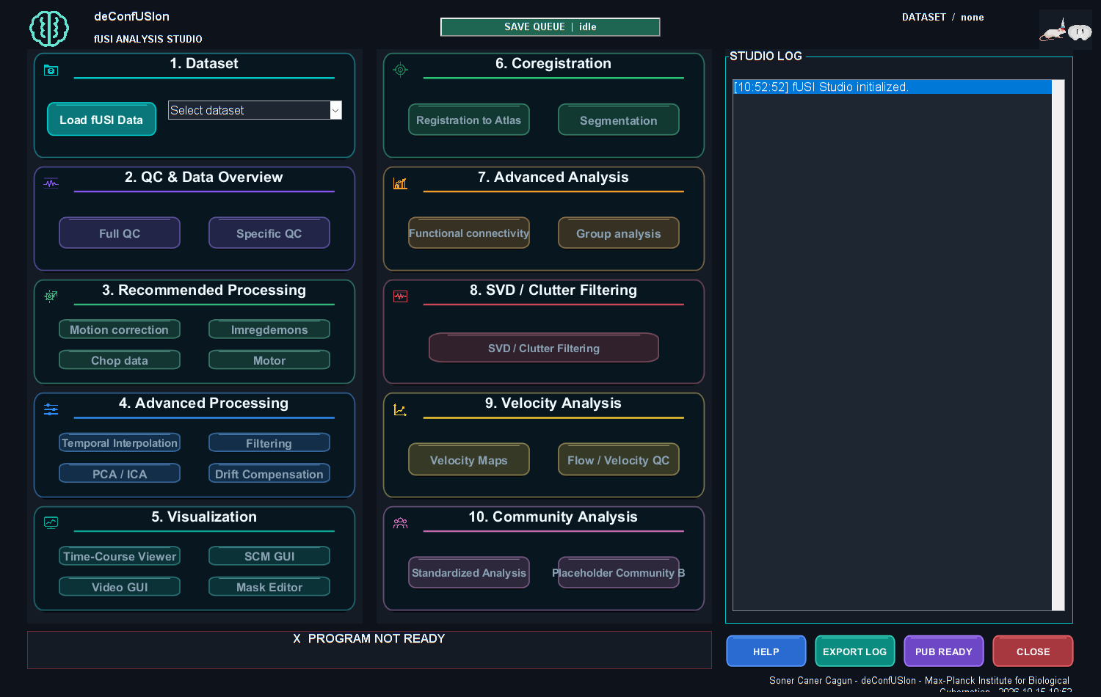

1. Click Load fUSI Data and choose the original acquisition or a saved deConfUSIon result.
2. Review the load options. Confirm dimensions, volume/frame count, TR and any warning about irregular timestamps.
3. Confirm the analysis output folder. A local output folder helps separate processing time from server write time.
4. Check the active dataset label before opening a viewer or applying a processing step.
5. Open Time-Course Viewer and inspect early, middle and late frames before correcting anything.

Loading from a server
A large network MAT file may first be copied into a local read cache. This is a disk copy that can be reused by another MATLAB session when the source still matches. The first transfer remains limited by the network; local parsing follows it. A different network drive letter does not by itself provide a faster connection.
Distinguish the stages shown in progress messages: source transfer, MAT reading, array preparation and GUI initialization. A copy reaching 100 percent is not the end of every later phase. Keep enough local disk space for the cache and saved derived results.
Checkpoint: You can identify the active dataset and its analyzed TR, and the raw movie has usable contrast and plausible orientation.

4 A first single-slice 2D analysis
1. Load the original 2D movie and confirm a Y by X by time layout.
2. Inspect the raw movie for displacement, jumps, saturation, dropouts and slow drift.
3. Run QC and review the frames that produced warnings.
4. Make a separate derived branch for one justified correction. Compare it with the raw recording using the same ROI and time interval.
5. Set baseline and signal windows from the event log, then open SCM GUI.
6. Prepare an inclusion mask and, if anatomical ROIs are required, register the slice to the atlas.
7. Review fixed or automatic ROIs and their traces before exporting.
8. Continue to FC or Group Analysis with the matching anatomy, timing and export files.

Compare branches fairly
Use the same anatomical support and baseline when comparing processing choices. Check response amplitude, latency, mean anatomy and motion. A smoother trace or lower variance alone does not show that the processing is better.
For a long pharmacological recording, first compare modest temporal reduction and correction of observed motion. For a short stimulation recording, retain enough samples across onset and recovery, and treat isolated artifacts selectively. Review component removal against independent evidence in either case.

5 Reconstruct a step-motor recording
A 2D probe with a motor acquires different planes at different times. Stacking them does not make them simultaneous. Use the original motor log and acquisition naming to establish plane order, dwell time and movement frames.
1. In Studio choose Motor, or the corresponding Standardized Analysis preset.
2. Select the continuous-stream or split-file route that matches the acquisition.
3. Enter the source slice count and frame/dwell information from the recording protocol.
4. Review the reconstructed dimensions and retained time indices.
5. Inspect the beginning and end of every reconstructed plane for a plane offset or movement contamination.
6. Save the reconstruction and its metadata before further processing.

Register and analyze source planes
Use the 2D coronal registration route for each acquired source plane. Keep source-slice indices separate from atlas-slice indices. Save the combined session with its transforms and underlays; keep relative subfolders together. A single-plane registration cannot label all source planes by stretching it along Z.
Inspect each plane in SCM/Video before searching a slice range. Correlation across sequentially acquired planes requires a justified time-alignment strategy.

6 Prepare a volumetric 3D recording
1. Load the matrix-probe movie and confirm Y, X, Z and time.
2. Check physical spacing, axis permutation and displayed laterality against acquisition records.
3. Inspect several nonempty planes at early, middle and late times. Empty boundary planes may reflect missing acquired coverage.
4. Run QC. Review component spatial patterns and time courses before selecting PCA/ICA removal.
5. Compare the corrected mean anatomy and raw time course with the input.
6. If using Imregdemons, choose the dimensional mode that matches the data; true 3D requires consistent geometry.
7. Recheck TR after temporal reduction, then choose valid filters and event windows.
8. Register the atlas and inspect multiple anatomical cuts before extracting labels or FC.

Use physical units consistently
Column spacing controls horizontal width; row spacing controls vertical height. A footprint of five columns by five rows need not be physically square. Confirm spacing before requesting an ROI in micrometres, a physical scale bar or a model slab thickness.
Checkpoint: The movie has the expected acquired slice support, correct analyzed timing and a consistent native-to-atlas geometry.

7 Review quality control
Figure 2. Frame rejection quality control
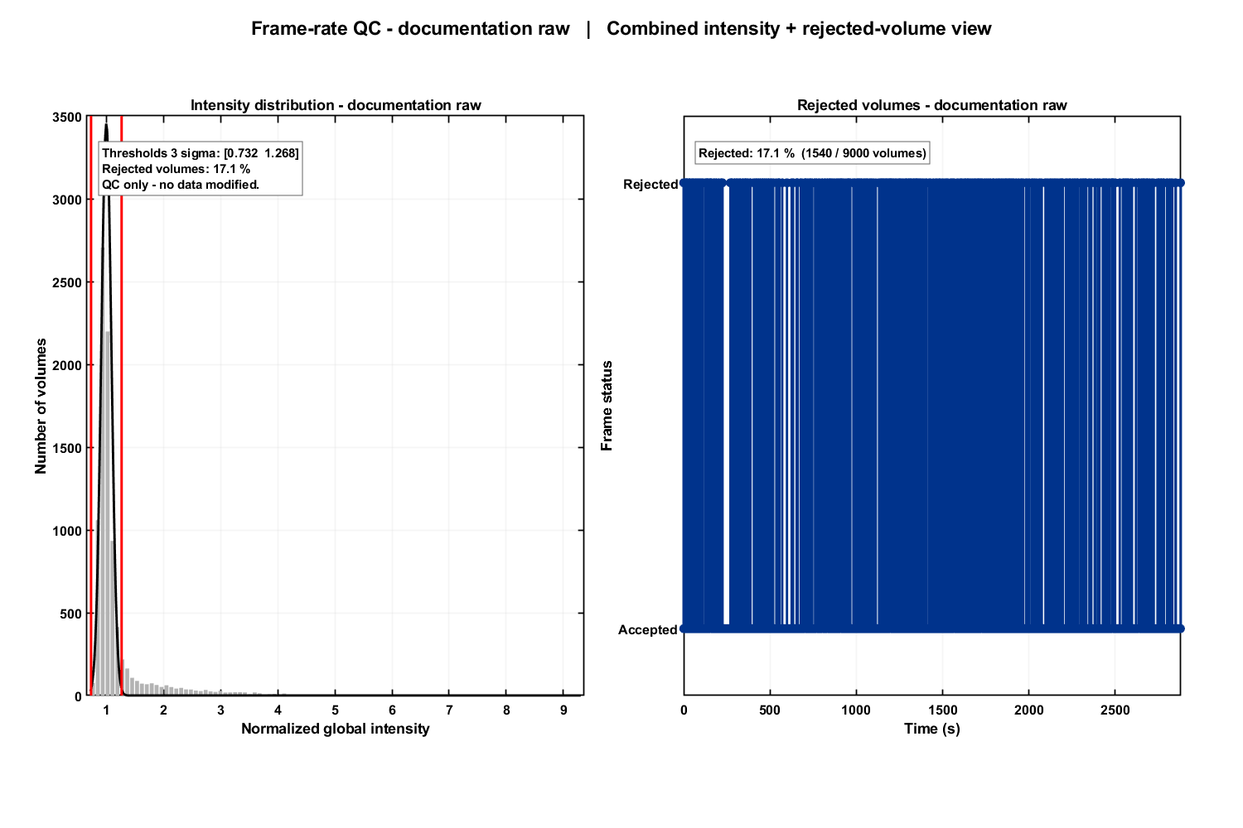
Run Full QC before selecting corrections. Start with global intensity over time, motion-related views, spatial stability and sample coverage. Review the raw movie around any flagged event. Irregular timestamps must be investigated before treating an FFT or FC interval as uniformly sampled.
Table 2. 7 Review quality control
Finding | Inspect next | Possible action to compare
One or a few global intensity jumps | Original frames and trigger/event log | Targeted frame rejection/interpolation
Sparse voxel spikes | Local traces and affected frames | Despike with reviewed settings
Anatomy changes position | Early/late images and landmarks | Appropriate motion correction
Slow trend | Warm-up, physiology, event timing and controls | Drift model or filter only if response remains identifiable
Missing region samples | Mask, acquired coverage and atlas alignment | Correct support or retain the result as missing

QC thresholds are screening rules. A flagged frame is not automatically invalid, and a smooth-looking trace is not automatically physiological. Save QC outputs and record accepted exclusions or corrections.

8 Frame rejection and interpolation
1. Open the frame-rejection/QC view for the selected dataset.
2. Review the threshold, flagged indices and the original movie around each event.
3. Decide which events are artifacts using acquisition and experimental evidence.
4. Apply the chosen correction to a derived dataset and save its record.
5. Compare original and corrected traces, including the time around each gap.
Interpolation estimates missing values from surrounding samples. It does not recover the original measurement or create independent information. Long gaps, rapid responses and nonstationary changes deserve special review. Keep the original usable-sample information with later analyses.
The line-outlier correction in Full QC is a separate screening/correction path. Do not assume every QC option means global frame rejection, and avoid applying the same correction twice without checking its record.

9 Choose preprocessing deliberately
Table 3. 9 Choose preprocessing deliberately
Step | Use when justified | Review afterward
Chop | Remove a known unusable beginning/end | Updated time origin and event coordinates
Temporal smoothing or block means | Reduce noise or very long movies | New TR and retained event bandwidth
Imregdemons | Correct observed spatial displacement | Landmarks, deformation and response preservation
Temporal filter | Retain a specified temporal band | Actual response, endpoints and mean handling
Despike | Treat sparse abnormal local samples | Preserved physiological peaks and local traces
PCA or ICA | Review structured components | Removed patterns, mean anatomy and retained response
Drift or regressor analysis | Model identified confounds or experimental predictors | Units, timing, collinearity and residuals

Apply one justified change at a time on a comparison branch. Save its settings and evaluate the same independently defined ROI before adding another step.

Chop and temporal reduction
Chopping the beginning shifts the time origin. Update event windows and document the removed duration. Averaging blocks of n input frames changes TR to n times the input TR. With a 0.32 s input, blocks of five produce 1.6 s samples; blocks of fifty produce 16 s samples and can hide short events. Choose the factor from the fastest event you need to resolve. Block averaging has limited anti-alias rejection.

Imregdemons
Choose 2D, per-slice or true 3D operation to match the acquisition. Review reference-frame choice, temporal reduction and deformation behavior. Compare reduced unregistered images with registered images so averaging is not mistaken for improved alignment. A cleaner alignment does not establish that a vascular response was preserved.

Temporal filters and drift
Enter cutoffs using the analyzed TR. A valid cutoff must lie below the Nyquist frequency, 1 divided by twice TR. Review the filter-response preview and endpoint behavior. High-pass filtering can remove a slow pharmacological response; low-pass filtering can blur stimulation onset. Restoring the mean does not restore dynamics removed by the filter. Treat temperature, physiology or instrument drift as hypotheses that need supporting records.

10 Review PCA ICA and regressors
Figure 3. PCA component review
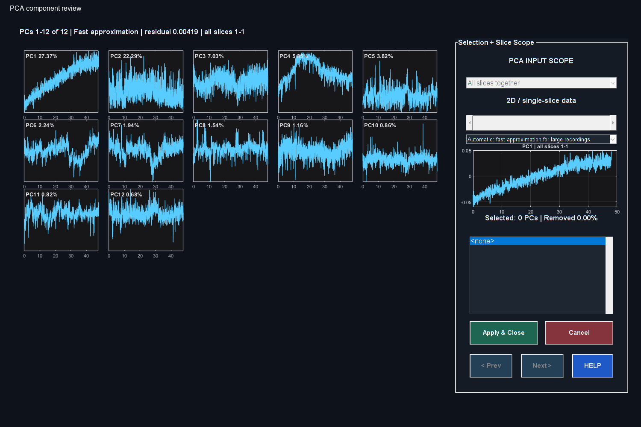

PCA finds orthogonal variance patterns. A component combines a spatial pattern and a temporal profile; its rank describes explained variance, not biological identity. PC1 is not automatically an artifact. ICA seeks statistically independent patterns and has its own convergence and interpretation checks.
1. Confirm the spatial scope and estimation method in the component GUI.
2. Inspect the component time course and available spatial information.
3. Compare timing with motion, acquisition events, physiology and stimulation.
4. Select only components supported by a clear rationale, then apply removal.
5. Let computation and saving finish. Compare the derived mean image, representative raw traces and the expected response with the original.
Component removal subtracts that pattern from all included samples according to its spatial weights. If the pattern contains response information, that response will also be altered. Preserve the original branch so the decision remains reviewable.

Regressor analysis
Match each regressor to the analyzed time axis and units. Review whether a predictor is experimental, physiological or a nuisance signal. Check lag/convolution settings when offered, the model rank and correlations between predictors. Two nearly identical response and drift regressors cannot be separated reliably by giving them different names. Inspect residuals and use independent controls before interpreting a fitted coefficient.

11 Set baseline and signal windows
Percentage signal change compares a time course with its chosen reference intensity. Choose a stable baseline with enough valid acquired samples and a meaningful denominator. Keep it consistent for comparisons unless the experimental design requires otherwise.
Table 4. 11 Set baseline and signal windows
Field or view | Timing convention to check
SCM baseline and signal controls | Seconds in the ordinary time view; verify any frame/volume mode
Automatic SCM search and plateau | Minutes within each selected scan
Group Analysis metric windows | Minutes in the displayed controls
Filters | Frequency in Hz based on analyzed TR

Review the active baseline source when using another scan or shared baseline. The reference changes amplitudes; it does not align anatomy or make sequential recordings simultaneous. Keep external baseline files and exported shared-baseline sidecars with the analysis.

12 Use SCM GUI and fixed ROIs
Figure 4. SCM ROI and time course
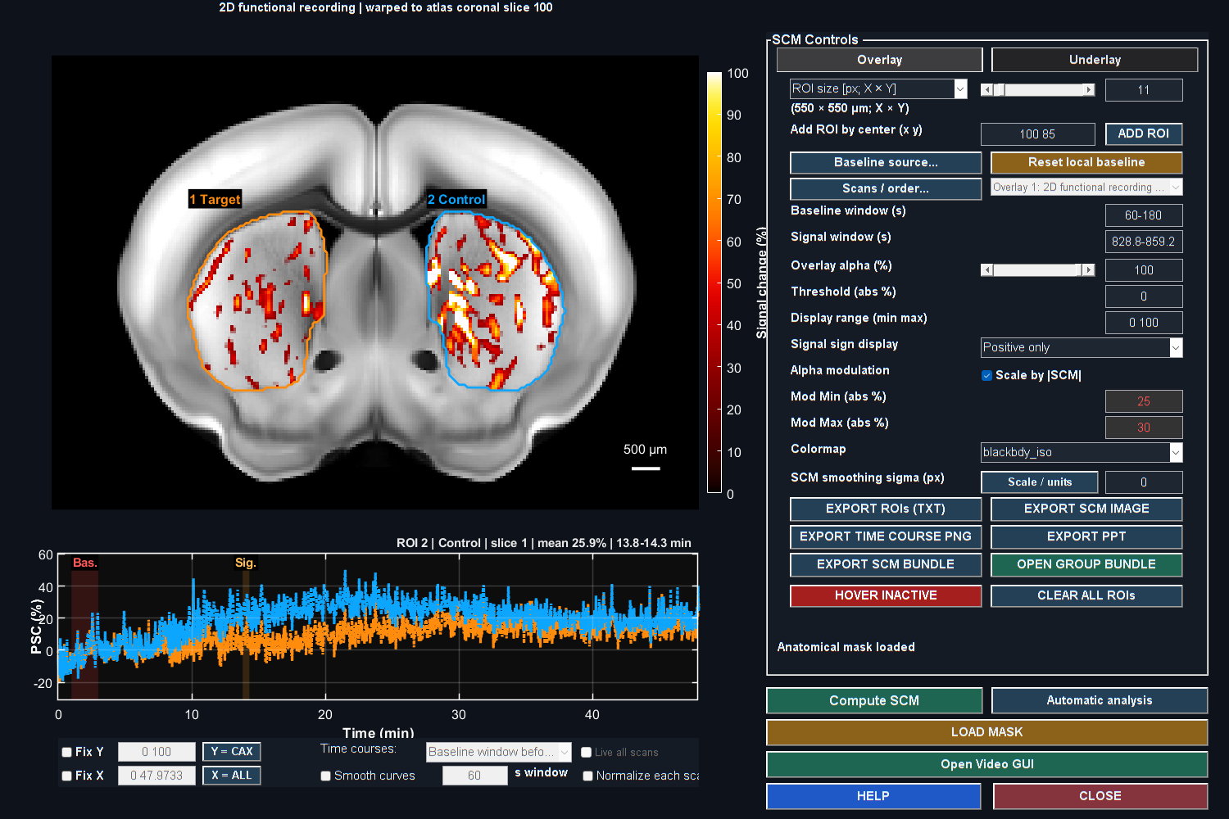

1. Open SCM GUI from the intended active dataset.
2. Confirm the displayed slice, baseline and signal windows.
3. Set the sign policy and a sensible percentage color range. Lower overlay opacity when anatomy is hidden.
4. Enter the ROI size and center, then use ADD ROI.
5. Inspect its outline and populated time course, including baseline and signal bands.
6. Save or export the intended ROI trace and its settings.
An ROI fixed independently of the response is different from an automatic maximum search. Choose the method before interpreting the endpoint. Reuse the same spatial support when comparing raw and processed branches.

Underlay and atlas context
Open Underlay to choose a saved atlas display mode or use Load new underlay and Load atlas. Inspect Histology, Vascular and Regions from the matching registration. A sharp underlay can remain attractive even when the functional movie was overprocessed; inspect the active raw array and trace separately. Reset to native before reusing native ROI coordinates.

13 Draw automatic SCM search masks
Figure 5. Target and Control painting
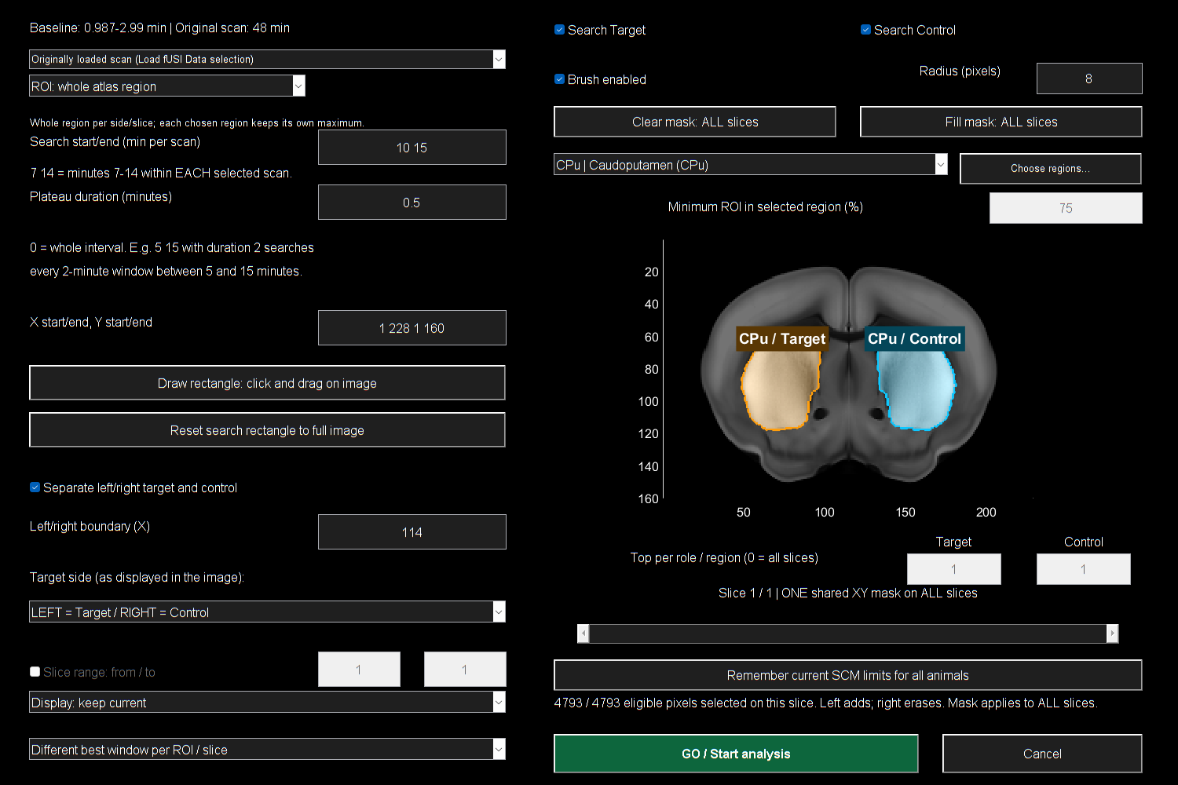

1. Open Automatic analysis, then Find and review ROI.
2. Choose square pixels, physical X/Y size or whole atlas region. Whole-region mode requires named atlas labels.
3. Enter search start/end and plateau duration in minutes per scan. A duration of zero uses the whole interval; a positive duration searches complete windows within it.
4. Choose Target, Control or both, and confirm image-side assignment and the split column.
5. Choose atlas region(s), coverage, rectangle and slice range as required.
6. Paint the intended restriction, review it, then click GO / Start analysis.

Read the painted support
Left-drag adds and right-drag erases. The first add starts empty; the first erase starts full. Clear painted area selects none; Fill painted area removes the paint restriction. Orange Target and cyan Control fills, with solid bright edges, show selected support. Dashed boundaries show broader eligibility. White role labels remain above the dark exclusion shade.
The same XY painting and rectangle apply across the searched slices. Review other planes before GO. Paint remains active when the brush is switched off. In atlas searches, the uploaded SCM display mask is ignored, but atlas tissue, paint, side, rectangle, valid samples and coverage still constrain the search. Without atlas labels the uploaded mask remains part of eligibility.

Review candidates and export
Click a candidate row to inspect its outline and time course. Checkboxes select export membership; they do not themselves request a new trace. Keep maxima exploratory unless selection was independent of the measured response. Export the intended per-role bundle, add a note and keep its parameter/audit files and sidecars together. Whole-region mode still honors restrictive paint and bounds.

14 Prepare masks and atlas registration

Mask Editor
Select the intended mask target before drawing: the anatomy/brain target and functional overlay target can serve different purposes. Confirm include/exclude convention, inspect the kept/excluded preview and save the required mask objects. A display mask and atlas search membership are not interchangeable.

Register one 2D source plane
Figure 6. Coronal registration controls
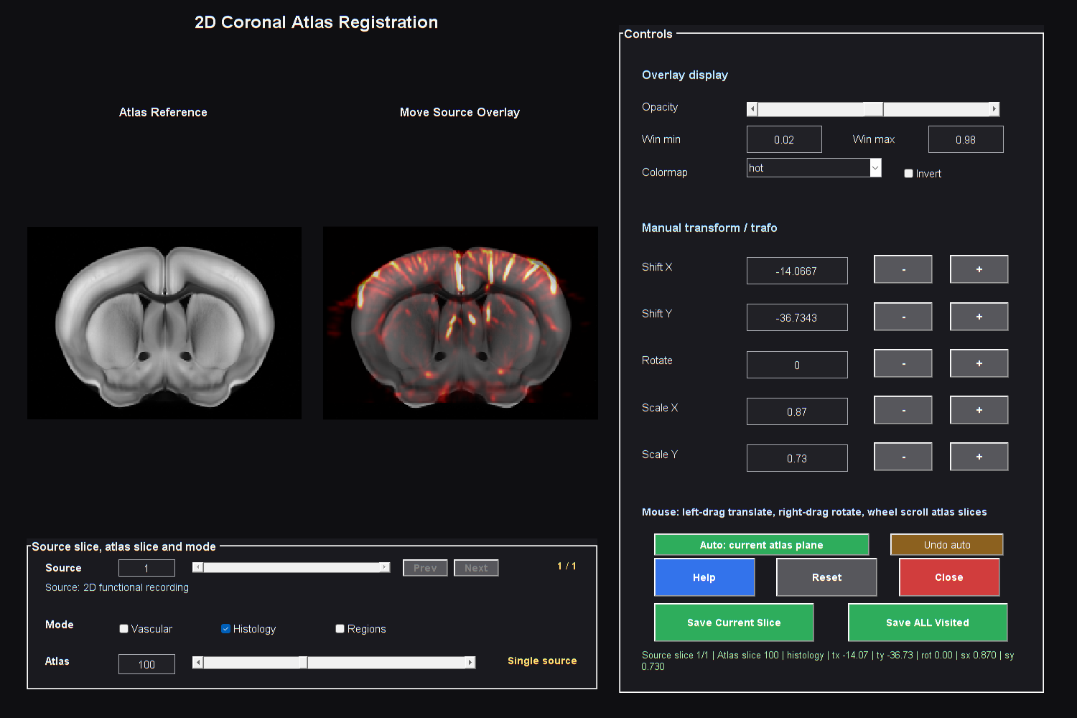

1. Open the 2D coronal registration route for the chosen source slice.
2. Confirm displayed orientation and laterality from acquisition records.
3. Select the matching atlas plane and adjust alignment using several landmarks.
4. Inspect boundaries and vascular/anatomical correspondence across the field.
5. Save explicitly. Keep the dated Slice folder, transform and underlay files together.
6. Reopen that package with Load atlas in SCM or Video and review the result.
For a motor stack repeat the source-plane mapping and preserve the combined session. For a true 3D probe use the 3D registration route and inspect coronal, sagittal and axial cuts. Verify spacing, permutation and acquired coverage before accepting it. A visually plausible slice is insufficient evidence of a correct whole-volume transform.

15 Inspect movies and the 3D model

Time Course Viewer and Video GUI
The Time-Course Viewer helps inspect the active movie and ROI traces. Start raw intensity display with neutral contrast and inspect representative frames. Video GUI combines the functional movie/PSC view with underlay and atlas context. Set frame/time, sign, percentage range and opacity deliberately.
1. Open Video from the intended result and choose a representative frame.
2. Open Underlay to load a replacement background or matching atlas package.
3. Check alignment and native/atlas coordinates before placing ROIs.
4. Use consistent display settings when comparing recordings.
5. Export a short movie first and review the result before a long export.

Volumetric display
Figure 7. Complete reference atlas views
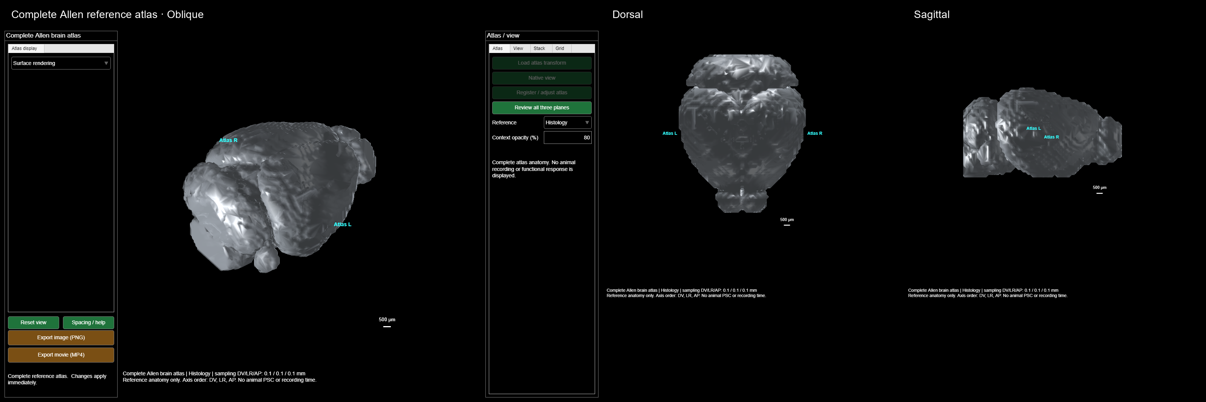

Use the 3D companion from Video for acquired-field volume, surface or coronal-stack displays. Confirm spacing and choose a backend appropriate to the data. Disable the PSC overlay to review anatomy alone; adjust the Doppler cutoff carefully so faint acquired support is not mistaken for absent tissue. Surfaces and gap/stagger/depth settings are presentation choices.
These views show the complete Allen reference atlas from three orientations. This is reference anatomy, not evidence of full coverage in an acquired scan. Use the acquired-data view to inspect the actual recording support. Blender is an optional external presentation tool; the current toolbox does not provide a native Blender scene/mesh exporter.

16 Compute functional connectivity
Figure 8. Region connectivity matrix
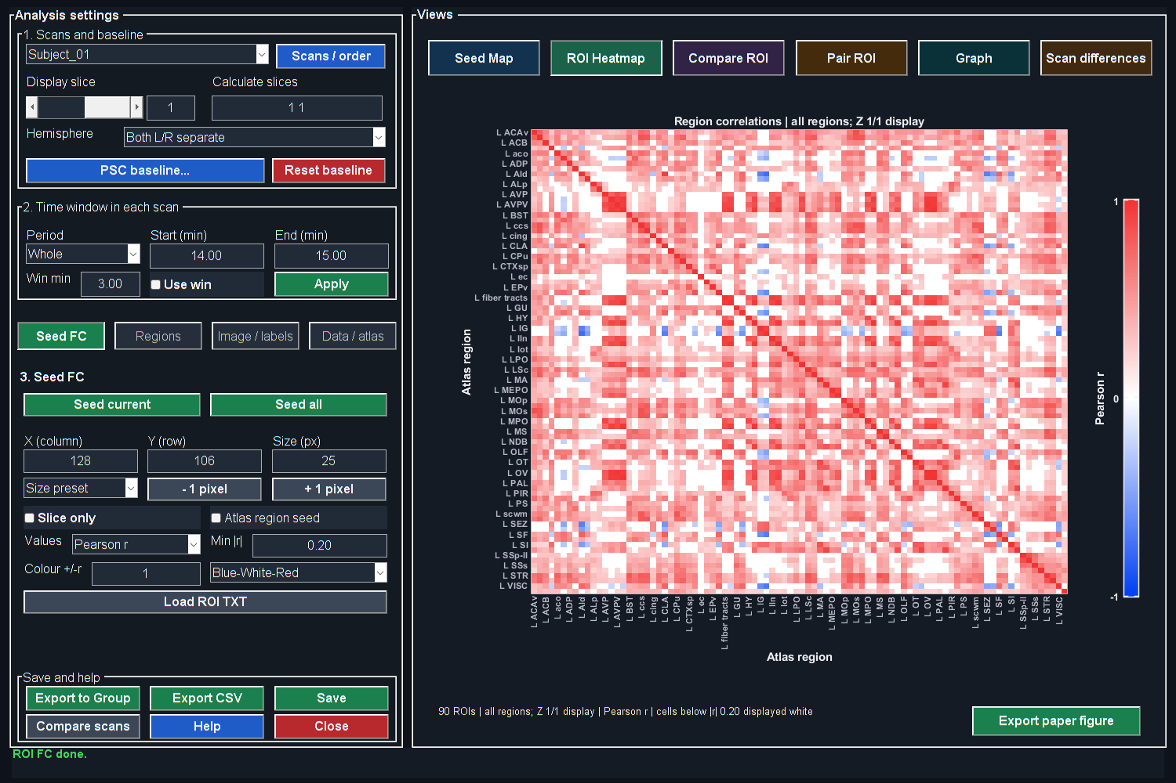

1. Open Functional Connectivity with the intended processed movie.
2. Load matching integer atlas regions or supported segmentation output. A colored histology picture alone does not define ROI membership.
3. Inspect label alignment, acquired coverage and voxel counts.
4. Choose merged Parent regions for a shorter regional list, or detailed labels when justified. Parent grouping and left/right hemisphere combination are separate settings.
5. Select the scan, period and local time interval. Verify TR and usable duration.
6. Press ROI current to recompute the selected region analysis, or the corresponding all-period action.
7. Review traces, matrix values, missing regions and graph settings before exporting.
Recompute after changing labels, period, TR or support. A valid nonconstant trace normally has self-correlation one; missing/constant regions should remain identifiable. Correlation reflects association and can change with motion, global component removal, filtering and task timing. A graph display threshold is not automatically a corrected significance test.
For scan comparisons, confirm period timing within each scan. For group FC, use independent animal-level results and inspect finite counts, correction settings and retained regions.

17 Import ROI results into Group Analysis
1. Open Group Analysis and choose the ROI/time-course route.
2. Click Add ROI / DATA and select one intended ensemble representation per recording/role. Do not import both equivalent mean and allROIs summaries as separate observations.
3. Verify animal, group, condition, role and PairID against the experimental record. Resolve unassigned rows.
4. Choose the metric and interval, then inspect the time-course preview.
5. Switch to Statistics and select a test matching the actual design and independent sample count.
6. Review counts, exclusions and multiplicity settings, then export tables and figures with their parameter record.

Choose a metric and biological unit
A fixed-interval mean describes a prespecified interval. A maximum-plateau endpoint searches complete windows for the largest mean and should be treated as exploratory unless prespecified independently. Keep search width and duration consistent across comparisons.
Several ROIs from one animal do not become several independent animals. A paired test needs verified matching identities. Use Test = None for a descriptive one-recording example. Display interpolation or smoothing does not create original measurements or independent sample size. Preserve baseline MAT sidecars with ROI TXT exports.

18 Use Standardized Analysis
1. Open Standardized Analysis in Studio and choose a preset matching acquisition and experimental state.
2. Review every checked step, its order and parameters. Click a row to edit its values; use the Run checkbox to include/exclude it.
3. Set baseline/signal windows, reduction factors and filter cutoffs for the actual recording.
4. Run the workflow and complete its interactive review stages. Some steps wait for a viewer to close.
5. Review final QC and outputs, and save the actual settings before processing more animals.
Presets are editable starting points. In particular, the current awake 3D preset E requests automated PC1 removal and substantial block reduction, with nsub 50. Inspect those choices and their effect on temporal resolution before using it. A preset name does not establish suitability for your experiment.
A fixed ROI protocol should contain independently chosen coordinates, dimensions and windows matching the current native or atlas grid. Changing a label does not transform its coordinates. Validate it on a known scan before repeated use.

19 Save export and reproduce
Keep the original acquisition and event log, derived datasets, processing parameters, analyzed TR/time origin, masks, atlas registration package and ROI definitions. Preserve export notes, audit text and shared-baseline MAT sidecars together. Copy complete folders when sharing an ROI bundle or registration session.
Large saves can include writing and verification phases after numerical processing. Review the final path and completion message. A network write may take longer than a local write of the same result. Keep enough disk space for temporary and complete files, and reopen a saved result before discarding an original working copy.

Final review checklist
1. Active dataset and original provenance are correct.
2. Timing, TR, event windows and physical geometry are documented.
3. QC decisions and component/filter choices have supporting evidence.
4. Baseline, mask, registration and ROI support match the endpoint.
5. Independent animal count, pairing and test match the study design.
6. Saved files, notes and sidecars can be reopened by another user.

20 Troubleshoot common problems
Table 5. 20 Troubleshoot common problems
Symptom | First checks
Loading takes minutes | Current transfer/read phase, network throughput, cache state and expanded data size
GUI changed after an update | Close/reopen it; check the active toolbox with which and remove competing backup paths
Raw movie looks flat after processing | Active array, display limits, mean-restoration choice and excessive component/filter removal
Painted mask seems ignored | Orange/cyan selected support, side, slice range, rectangle, atlas membership and footprint size
Whole atlas region is unavailable | Load named saved integer region labels and select a region
No ROI candidate fits | Paint/coverage intersections, ROI size, valid samples and selected time interval
FC has missing regions | Label alignment, acquired support, selected window and zero-variance traces
Group results have too many observations | Duplicate ensemble representations or ROIs counted as independent animals
Workflow appears paused | Interactive review window, save/verification phase and last status message

Record the active script path, source file, dimensions, TR, exact action and complete MATLAB error when reporting a problem. A screen image is useful together with those details. Reproduce on a preserved original before changing several options at once.

21 Essential terms and further reading
Table 6. 21 Essential terms and further reading
Term | Meaning
fUSI | Functional ultrasound imaging of blood-related signal fluctuations
TR | Time interval between analyzed frames or volumes
QC | Quality control and artifact screening
PSC | Percentage signal change relative to a chosen baseline
SCM | Signal-change map and its associated viewer
ROI | Region of interest with defined spatial membership
PCA | Principal component analysis of variance patterns
ICA | Independent component analysis
FC | Functional connectivity, here primarily correlation of time courses
SEM | Standard error of the mean across independent included observations
FDR | False discovery rate correction for the specified comparison family

For mathematical definitions, every QC output, detailed GUI controls and the complete script/function reference, open the deConfUSIon User Handbook supplied beside this guide. The handbook also contains the literature list and interpretation limits. A foundational fUSI reference is Macé et al., Functional ultrasound imaging of the brain, Nature Methods, 2011, DOI 10.1038/nmeth.1641.

Acknowledgments
deConfUSIon is developed by Soner Caner Cagun, MPI for Biological Cybernetics. ChatGPT/Codex assisted with documentation drafting, organization, figure annotation and software troubleshooting; the developer remains responsible for reviewing the software and scientific interpretation.

Acknowledgments and responsibility
ConfUSIus provides a complementary Python-based approach to fUSI analysis. deConfUSIon emphasizes a connected MATLAB GUI workflow for researchers who do not write code. Thanks are due to ConfUSIus developers Samuel Le Meur-Diebolt and Felipe Cybis Pereira, and José María Martínez de Paz from Émilie Macé’s laboratory, for discussions. The projects are independently developed.
Beta research software. No guarantee is given for the correctness of a particular analysis; no liability for incorrect data analysis to the extent permitted by law. Mandatory statutory liability is unaffected.

