deConfUSIon User Handbook
  - Complete operational mathematical and script reference
Soner Caner Cagun
MPI for Biological Cybernetics
29 October 2026
Single 2D slices | 2D probe with step motor | Volumetric 3D probe
A practical route from the original recording through quality control and processing to reviewed visualization, regions, connectivity and groups.

Contents
Reading routes 19
I. Foundations and installation 21
1. What functional ultrasound measures 21
2. Array dimensions, time and physical space 24
3. Install, start and identify the active version 26
4. Studio: the control center 29
II. Load and prepare acquisitions 32
5. Loading data and choosing output folders 32
6. A complete first 2D walkthrough 34
7. 2D probe with step motor: reconstruct before analyzing 38
8. Volumetric 3D probe: verify geometry and sampling 40
III. Quality control before correction 42
9. QC: decide what needs correction 42
10. Frame rejection, scrubbing and despiking 63
IV. Preprocessing and temporal models 67
11. Chop Data and event alignment 67
12. Temporal smoothing, block averaging and interpolation 68
13. Imregdemons: averaging and spatial motion correction 70
14. Temporal filtering and restoring the mean 72
15. PCA: component review and removal 79
16. ICA, SVD and drift compensation 85
17. Regressors, drift models and response protection 89
18. Baselines and percentage signal change 94
V. Visualize maps and movies 98
19. Time-Course Viewer: intensity, normalization and display contrast 98
20. SCM GUI: read the map before choosing an ROI 101
21. SCM underlays, saved atlases and mode switching 107
22. Automatic SCM: define the search deliberately 112
23. Automatic SCM: windows, review, exports and notes 120
24. Video GUI: movie, anatomy and overlays 125
25. The 3D brain/volume GUI 130
26. Coronal stacks, exports and Blender 134
VI. Masks, registration and segmentation 137
27. Mask Editor: support and anatomy are different objects 137
28. 2D coronal atlas registration: step by step 142
29. Segmentation and regional extraction 146
29a LightSuite guided atlas registration 148
VII. Functional connectivity 155
30. Functional connectivity: prepare a defensible input 155
31. FC: merged regions, hemispheres and ROI current 159
32. FC mathematics and interpretation 164
VIII. Group analysis and statistics 167
33. Group Analysis: import, assignment and time courses 167
34. Group metrics, statistics and outlier review 175
IX. Standardize a reviewed workflow 179
35. Fixed ROI protocols and standardized analysis 179
X. Troubleshooting and reproducibility 184
36. Troubleshooting by symptom 184
37. Reproducible analysis and publication checklist 186
XI. Glossary, literature and acknowledgments 189
38. Abbreviations and technical glossary 189
39. Literature and technical references 193
40. Acknowledgments and authorship 194
41. Analysis handover record 194
XII. MATLAB source reference 196
Current source additions 196
Acquisition module 205
Root module 226
Atlas Tools module 397
Atlas module 398
Connectivity module 423
Display module 444
Group module 459
Io module 462
Metadata module 477
Preprocessing module 485
Roi module 499
Volume module 520

List of figures
Figure 1. Studio workflow overview 29
Figure 2. Frame rejection QC 42
Figure 3. Burst intensity support 45
Figure 4. Burst temporal coverage 46
Figure 5. Global signal spectrum 47
Figure 6. Slow frequency detail 48
Figure 7. Spatial signal stability 49
Figure 8. Temporal intensity changes 50
Figure 9. Stability threshold trace 51
Figure 10. Stability value distribution 52
Figure 11. Intensity center movement 53
Figure 12. Exploratory contrast screening 54
Figure 13. Shared spatial fluctuations 55
Figure 14. Line outlier screening 56
Figure 15. Line replacement preview 57
Figure 16. Finite sample coverage 58
Figure 17. Coverage value distribution 59
Figure 18. Integrated diagnostic summary 60
Figure 19. Dominant variance spectrum 61
Figure 20. QC component time profiles 62
Figure 21. PCA temporal component review 79
Figure 22. Real PCA factor example 83
Figure 23. ICA component inspection 85
Figure 24. Active movie with robust contrast 98
Figure 25. Positive SCM and CPu ROIs 101
Figure 26. SCM measurement controls 104
Figure 27. Fixed ROI trace detail 105
Figure 28. SCM anatomy and overlay controls 107
Figure 29. Registered positive signal overlay 109
Figure 30. CPu target and control selection 112
Figure 31. Volumetric CPu atlas selection 114
Figure 32. Automatic search control detail 117
Figure 33. Candidate review and exports 120
Figure 34. CPu regions and matching traces 122
Figure 35. Positive signal change movie 125
Figure 36. Video anatomy and alpha controls 127
Figure 37. Registered positive video overlay 128
Figure 38. Complete atlas in three views 130
Figure 39. Calibrated coronal stack 134
Figure 40. Applied polygon inclusion mask 137
Figure 41. Mask editing control detail 140
Figure 42. Registration with robust Doppler contrast 142
Figure 43. Registration transform control detail 145
Guided LightSuite workspace 149
Landmark editor with save and activity indicators 152
Figure 44. FC anatomy control detail 157
Figure 45. Region connectivity matrix 159
Figure 46. Atlas granularity and support 160
Figure 47. Thresholded connectivity graph 163
Figure 48. Subject assignment and windows 167
Figure 49. Populated ROI preview 171
Figure 50. Individual recording trace detail 172
Figure 51. Statistics settings review 173
Figure 52. Editable workflow manager 180

List of tables
Table 1. Three acquisition cases overview 24
Table 2. A first analysis decision table overview 36
Table 3. Choosing among them overview 64
Table 4. 14. Temporal filtering and restoring the mean overview 72
Table 5. Transfer functions and cutoff meaning overview 75
Table 6. Regressor choices and assumptions overview 90
Table 7. Choose a rendering backend overview 131
Table 8. Implemented test choices overview 176
Table 9. Preset interpretation overview 181
Table 10. 36. Troubleshooting by symptom overview 184
Table 11. 38. Abbreviations and technical glossary overview 189
Table 12. Function overview - acquisition/vfUSI_StimBox_TTL_EACH_FRAME_OR_TRIGGER_ACCESSORIES_COMMAND.m 205
Table 13. Function overview - acquisition/vfUSI_StimBox_TTL_EACH_FRAME_OR_TRIGGER_ACCESSORIES_OBJECT.m 216
Table 14. Function overview - acquisition/vfUSI_StimBox_TTL_EACH_FRAME_OR_TRIGGER_ACCESSORIES_PARAMETERS.m 218
Table 15. Function overview - acquisition/vfusiSensoryConfig.m 224
Table 16. Function overview - acquisition/vfusiSensoryGUI.m 224
Table 17. Function overview - acquisition/vfusiSensoryRun.m 225
Table 18. Function overview - acquisition/vfusiValidateSensoryScan.m 226
Table 19. Function overview - addLog.m 226
Table 20. Function overview - AtlasRegistration.m 227
Table 21. Function overview - AutomaticSCM.m 230
Table 22. Function overview - blackbdy_iso.m 230
Table 23. Function overview - chooseMotionModern.m 231
Table 24. Function overview - ClutterFilter.m 232
Table 25. Function overview - computePSC.m 232
Table 26. Function overview - coreg.m 233
Table 27. Function overview - coreg_3d.m 236
Table 28. Function overview - coreg_coronal_2d.m 237
Table 29. Function overview - DataIO.m 241
Table 30. Function overview - datasetDropdownCallback.m 243
Table 31. Function overview - deConfUSIon.m 243
Table 33. Function overview - deConfUSIon_root.m 244
Table 34. Function overview - deConfUSIon_setup.m 244
Table 35. Function overview - deConfUSIon_signal.m 245
Table 36. Function overview - deConfUSIon_ui.m 246
Table 37. Function overview - deConfUSIon_utils.m 247
Table 38. Function overview - despike.m 249
Table 39. Function overview - Drift.m 249
Table 40. Function overview - DriftCompensation.m 250
Table 41. Function overview - filtering.m 250
Table 42. Function overview - frameRateQC.m 251
Table 43. Function overview - FunctionalConnectivity.m 252
Table 44. Function overview - fusi_fix_saved_format.m 271
Table 45. Function overview - fUSI_Live_Studio.m 272
Table 46. Function overview - fusi_make_clean.m 274
Table 47. Function overview - fusi_studio_callback.m 275
Table 48. Function overview - fusi_studio_GUI.m 275
Table 49. Function overview - fusiAtlasVolumeGUI.m 276
Table 50. Function overview - fusiVolumeGUI.m 276
Table 51. Function overview - GroupAnalysis.m 281
Table 52. Function overview - GroupAnalysis_Common.m 308
Table 53. Function overview - GroupAnalysis_FC.m 316
Table 54. Function overview - GroupAnalysis_Map.m 317
Table 55. Function overview - ica_denoise.m 320
Table 56. Function overview - imregdemons_preprocess.m 321
Table 57. Function overview - interpolate3D.m 322
Table 58. Function overview - interpolateRejectedVolumes.m 323
Table 59. Function overview - loadDataCallback.m 324
Table 60. Function overview - loadFUSIData.m 325
Table 61. Function overview - mapscan.m 326
Table 62. Function overview - mask.m 326
Table 63. Function overview - Motion.m 334
Table 64. Function overview - motor.m 334
Table 65. Function overview - moveimage.m 336
Table 66. Function overview - openNiftiSCM.m 337
Table 67. Function overview - pca_denoise.m 338
Table 68. Function overview - play_fusi_video_final.m 339
Table 69. Function overview - qc_fusi.m 350
Table 70. Function overview - readFileList.m 353
Table 71. Function overview - readFMRINifti.m 353
Table 72. Function overview - registration_ccf.m 354
Table 73. Function overview - registration_coronal_2d.m 358
Table 75. Function overview - run_fusi_studio.m 363
Table 76. Function overview - SCM_gui.m 363
Table 77. Function overview - SCM_static_gui.m 382
Table 78. Function overview - scrubbing.m 383
Table 79. Function overview - Segmentation.m 384
Table 80. Function overview - showScmVideoSetupDialog.m 388
Table 81. Function overview - standardizedAnalysis.m 390
Table 82. Function overview - studio_load_options_dark_dialog.m 392
Table 83. Function overview - studio_resolve_paths.m 394
Table 84. Function overview - temporalsmoothing.m 394
Table 85. Function overview - tryReadSCMroiExportTxt.m 395
Table 86. Function overview - viewFMRINifti.m 395
Table 87. Function overview - winter_brain_fsl.m 396
Table 88. Function overview - atlas_tools/deConfUSIon_reorder_FC_by_list.m 397
Table 89. Function overview - atlas_tools/save_correct_colors.m 397
Table 90. Function overview - lib/atlas/deConfUSIon_apply_rgb2acr.m 398
Table 91. Function overview - lib/atlas/deConfUSIon_auto_register_3d.m 398
Table 92. Function overview - lib/atlas/deConfUSIon_prepare_atlas.m 400
Table 93. Function overview - lib/atlas/deConfUSIon_region_groups.m 400
Table 94. Function overview - lib/atlas/fusiAtlasBrainMask.m 401
Table 95. Function overview - lib/atlas/fusiAtlasPairedTransformFile.m 402
Table 96. Function overview - lib/atlas/fusiAtlasRecordingGrid3D.m 402
Table 97. Function overview - lib/atlas/fusiAtlasReferenceSlabs.m 403
Table 98. Function overview - lib/atlas/fusiAtlasRegionCatalog.m 403
Table 99. Function overview - lib/atlas/fusiAtlasRegionGrouping.m 404
Table 100. Function overview - lib/atlas/fusiAtlasRegionInput.m 404
Table 101. Function overview - lib/atlas/fusiAtlasRegionInput2D.m 405
Table 102. Function overview - lib/atlas/fusiAtlasRegroupUnderlay3D.m 405
Table 103. Function overview - lib/atlas/fusiAtlasSearchContext.m 406
Table 104. Function overview - lib/atlas/fusiAtlasSizeMatrix.m 406
Table 105. Function overview - lib/atlas/fusiAtlasTransformFolder.m 407
Table 106. Function overview - lib/atlas/fusiAtlasUnderlayChoices.m 407
Table 107. Function overview - lib/atlas/fusiAtlasUnderlayDisplay3D.m 408
Table 108. Function overview - lib/atlas/fusiAtlasUnderlayLibrary2D.m 408
Table 109. Function overview - lib/atlas/fusiAtlasUnderlayView3D.m 409
Table 110. Function overview - lib/atlas/fusiBregmaAnchors.m 409
Table 111. Function overview - lib/atlas/fusiCachedAtlasUnderlay3D.m 410
Table 112. Function overview - lib/atlas/fusiCachedAtlasUnderlayView3D.m 410
Table 113. Function overview - lib/atlas/fusiChooseAtlasSource.m 411
Table 114. Function overview - lib/atlas/fusiChooseAtlasTransformFile.m 411
Table 115. Function overview - lib/atlas/fusiChooseUnderlayFile.m 412
Table 116. Function overview - lib/atlas/fusiCoronalSliceGuide.m 412
Table 117. Function overview - lib/atlas/fusiFindAtlasUnderlay3D.m 413
Table 118. Function overview - lib/atlas/fusiFindRegistrationExecutable.m 413
Table 119. Function overview - lib/atlas/fusiFitCoronalAnchors.m 414
Table 120. Function overview - lib/atlas/fusiImportSnapAdjustment.m 414
Table 121. Function overview - lib/atlas/fusiOpenSnapWorkspace.m 415
Table 122. Function overview - lib/atlas/fusiReadAtlasUnderlay3D.m 415
Table 123. Function overview - lib/atlas/fusiReadStepMotorUnderlays2D.m 416
Table 124. Function overview - lib/atlas/fusiRegionSearchMatch.m 416
Table 125. Function overview - lib/atlas/fusiRegistrationConfigureSlices.m 417
Table 126. Function overview - lib/atlas/fusiRegistrationDisplayVolume.m 417
Table 127. Function overview - lib/atlas/fusiRegistrationFeatures.m 418
Table 128. Function overview - lib/atlas/fusiRegistrationOverlayAlpha.m 418
Table 129. Function overview - lib/atlas/fusiRegistrationOverlayAppearance.m 419
Table 130. Function overview - lib/atlas/fusiRegistrationSliceSupport.m 419
Table 131. Function overview - lib/atlas/fusiSaveAtlasUnderlays3D.m 420
Table 132. Function overview - lib/atlas/fusiSaveStepMotorUnderlays2D.m 420
Table 133. Function overview - lib/atlas/fusiSnapOverlayWorkspace.m 421
Table 134. Function overview - lib/atlas/fusiSnapVesselContrast.m 421
Table 135. Function overview - lib/atlas/fusiUnderlayPickerOptions.m 422
Table 136. Function overview - lib/atlas/fusiWarpAtlasForDisplay.m 423
Table 137. Function overview - lib/connectivity/deConfUSIon_FC_find_stepmotor_txt_names.m 423
Table 138. Function overview - lib/connectivity/deConfUSIon_FC_force_layout.m 424
Table 139. Function overview - lib/connectivity/deConfUSIon_fc_jm_order.m 426
Table 140. Function overview - lib/connectivity/deConfUSIon_FC_layout.m 426
Table 141. Function overview - lib/connectivity/deConfUSIon_FC_make_slice_roi_result.m 427
Table 142. Function overview - lib/connectivity/deConfUSIon_FC_read_region_names_file.m 428
Table 143. Function overview - lib/connectivity/deConfUSIon_FC_remember_layout.m 429
Table 144. Function overview - lib/connectivity/deConfUSIon_FC_stepmotor_read_folder.m 430
Table 145. Function overview - lib/connectivity/deConfUSIon_find_stepmotor_seg_fc_files.m 431
Table 146. Function overview - lib/connectivity/fusiElectricalBlockAnalysis.m 432
Table 147. Function overview - lib/connectivity/fusiFCCompareScans.m 432
Table 148. Function overview - lib/connectivity/fusiFCCorrelationMatrix.m 433
Table 149. Function overview - lib/connectivity/fusiFCExcludeNonTissue.m 433
Table 150. Function overview - lib/connectivity/fusiFCExportPaperFigure.m 434
Table 151. Function overview - lib/connectivity/fusiFCFullRegionNames.m 434
Table 152. Function overview - lib/connectivity/fusiFCGroupMatrix.m 435
Table 153. Function overview - lib/connectivity/fusiFCGroupSelectPeriod.m 435
Table 154. Function overview - lib/connectivity/fusiFCImageGeometry.m 436
Table 155. Function overview - lib/connectivity/fusiFCLoadScan.m 436
Table 156. Function overview - lib/connectivity/fusiFCMergeNameTable.m 437
Table 157. Function overview - lib/connectivity/fusiFCNetworkPlot.m 437
Table 158. Function overview - lib/connectivity/fusiFCReadMask.m 438
Table 159. Function overview - lib/connectivity/fusiFCReferenceImages.m 438
Table 160. Function overview - lib/connectivity/fusiFCRegionBrowser.m 439
Table 161. Function overview - lib/connectivity/fusiFCRegionCatalog.m 439
Table 162. Function overview - lib/connectivity/fusiFCRegionSliceDialog.m 440
Table 163. Function overview - lib/connectivity/fusiFCRegionSliceResult.m 440
Table 164. Function overview - lib/connectivity/fusiFCScanComparisonDialog.m 441
Table 165. Function overview - lib/connectivity/fusiFCSmoothCorrelation.m 442
Table 166. Function overview - lib/connectivity/fusiFCStartDir.m 442
Table 167. Function overview - lib/connectivity/fusiFCValidateAtlasGroup.m 443
Table 168. Function overview - lib/connectivity/fusiFCWindowBounds.m 443
Table 169. Function overview - lib/display/deConfUSIon_fix_scm_video_dialog_fonts.m 444
Table 170. Function overview - lib/display/deConfUSIon_popup_autofit_apply.m 444
Table 171. Function overview - lib/display/deConfUSIon_popup_autofit_timer.m 445
Table 172. Function overview - lib/display/deConfUSIon_popup_polish_now.m 445
Table 173. Function overview - lib/display/fusiAutoMaskVolume3D.m 446
Table 174. Function overview - lib/display/fusiBaselineProgress.m 447
Table 175. Function overview - lib/display/fusiBaselineSourceDialog.m 448
Table 176. Function overview - lib/display/fusiCopyVideoMask.m 449
Table 177. Function overview - lib/display/fusiDrawRegionBoundaries.m 449
Table 178. Function overview - lib/display/fusiDrawScaleBar.m 450
Table 179. Function overview - lib/display/fusiFiniteDisplayLimits.m 450
Table 180. Function overview - lib/display/fusiLiveSearch.m 451
Table 181. Function overview - lib/display/fusiMovieDisplayLimits.m 451
Table 182. Function overview - lib/display/fusiOverlayAppearance.m 452
Table 183. Function overview - lib/display/fusiProgressDisplay.m 452
Table 184. Function overview - lib/display/fusiRegionAnnotations.m 453
Table 185. Function overview - lib/display/fusiRegionBoundaryOverlay.m 453
Table 186. Function overview - lib/display/fusiRegionBoundarySegments.m 454
Table 187. Function overview - lib/display/fusiRegionColorLUT.m 454
Table 188. Function overview - lib/display/fusiRegionLabelRGB.m 455
Table 189. Function overview - lib/display/fusiRegionListDialog.m 455
Table 190. Function overview - lib/display/fusiResizeDisplayLayer.m 456
Table 191. Function overview - lib/display/fusiScanSequenceDialog.m 456
Table 192. Function overview - lib/display/fusiStandardDopplerDisplay.m 457
Table 193. Function overview - lib/display/fusiVideoExportDialog.m 458
Table 194. Function overview - lib/group/gaDrawROISignificance.m 459
Table 195. Function overview - lib/group/gaFormatPValue.m 459
Table 196. Function overview - lib/group/gaInferAssignment.m 460
Table 197. Function overview - lib/group/gaMaximumPlateau.m 460
Table 198. Function overview - lib/group/gaOutlierScores.m 461
Table 199. Function overview - lib/group/plateauIntervalFrames.m 461
Table 200. Function overview - lib/io/deConfUSIon_finish_saves.m 462
Table 201. Function overview - lib/io/deConfUSIon_safe_preproc_save_path.m 462
Table 202. Function overview - lib/io/fusiAnalysisOutputPath.m 463
Table 203. Function overview - lib/io/fusiBaselineDatasets.m 463
Table 204. Function overview - lib/io/fusiBaselineFileInfo.m 464
Table 205. Function overview - lib/io/fusiBaselineRawStart.m 464
Table 206. Function overview - lib/io/fusiBaselineReadWindow.m 465
Table 207. Function overview - lib/io/fusiDesktopFolderCommand.m 465
Table 208. Function overview - lib/io/fusiExportSavedDialog.m 466
Table 209. Function overview - lib/io/fusiFindMovedDataPath.m 466
Table 210. Function overview - lib/io/fusiLoadMatVariables.m 467
Table 211. Function overview - lib/io/fusiLocalMatReadSource.m 467
Table 212. Function overview - lib/io/fusiModelAnalysisFolder.m 468
Table 213. Function overview - lib/io/fusiModelExportPath.m 468
Table 214. Function overview - lib/io/fusiMovieExportFolder.m 469
Table 215. Function overview - lib/io/fusiMovieExportIdentity.m 469
Table 216. Function overview - lib/io/fusiMovieExportSlices.m 470
Table 217. Function overview - lib/io/fusiMovieStage.m 470
Table 218. Function overview - lib/io/fusiOpenFolder.m 471
Table 219. Function overview - lib/io/fusiPaperMoviePath.m 471
Table 220. Function overview - lib/io/fusiPowerSlabCache.m 472
Table 221. Function overview - lib/io/fusiRebaseMovedStudioFiles.m 472
Table 222. Function overview - lib/io/fusiRememberDataRoot.m 473
Table 223. Function overview - lib/io/fusiResolveAnalysisFolder.m 473
Table 224. Function overview - lib/io/fusiSCMEnsembleHeader.m 474
Table 225. Function overview - lib/io/fusiUniqueOutputFolder.m 474
Table 226. Function overview - lib/io/fusiWriteAnalysisMAT.m 475
Table 227. Function overview - lib/io/fusiWriteTimecourseTable.m 475
Table 228. Function overview - lib/io/studioRequireTimeSeriesFile.m 476
Table 229. Function overview - lib/io/studioSaveDataset.m 477
Table 230. Function overview - lib/metadata/deConfUSIon_add_preproc_lazy_datasets.m 477
Table 231. Function overview - lib/metadata/deConfUSIon_best_visible_dataset_name.m 478
Table 232. Function overview - lib/metadata/deConfUSIon_commit_full_display_name.m 479
Table 233. Function overview - lib/metadata/deConfUSIon_compact_chain_name.m 479
Table 234. Function overview - lib/metadata/deConfUSIon_detect_modality.m 480
Table 235. Function overview - lib/metadata/deConfUSIon_display_from_file_context.m 480
Table 236. Function overview - lib/metadata/deConfUSIon_display_name_from_sources.m 481
Table 237. Function overview - lib/metadata/deConfUSIon_display_short_name.m 482
Table 238. Function overview - lib/metadata/deConfUSIon_fix_processing_name.m 482
Table 239. Function overview - lib/metadata/deConfUSIon_fix_studio_dataset_names.m 484
Table 240. Function overview - lib/metadata/deConfUSIon_read_processing_metadata.m 484
Table 241. Function overview - lib/metadata/deConfUSIon_write_full_display_metadata.m 485
Table 242. Function overview - lib/preprocessing/deConfUSIon_build_artifact_regressors.m 485
Table 243. Function overview - lib/preprocessing/deConfUSIon_build_compcor_regressors.m 486
Table 244. Function overview - lib/preprocessing/deConfUSIon_collapse_time.m 487
Table 245. Function overview - lib/preprocessing/deConfUSIon_drift_dialog.m 488
Table 246. Function overview - lib/preprocessing/deConfUSIon_drift_roi_picker.m 489
Table 247. Function overview - lib/preprocessing/deConfUSIon_driftcompensation_core.m 491
Table 248. Function overview - lib/preprocessing/deConfUSIon_pacap_common_drift_stats.m 492
Table 249. Function overview - lib/preprocessing/deConfUSIon_pacap_response_estimator.m 492
Table 250. Function overview - lib/preprocessing/deConfUSIon_spatial_cca_simple.m 493
Table 251. Function overview - lib/preprocessing/deConfUSIon_svd_clutter.m 494
Table 252. Function overview - lib/preprocessing/deConfUSIon_svd_clutter_gui.m 495
Table 253. Function overview - lib/preprocessing/fusiCommonModeTimecourses.m 498
Table 254. Function overview - lib/preprocessing/fusiDespikeVoxels.m 499
Table 255. Function overview - lib/roi/fusiBaselineRoiTrace.m 499
Table 256. Function overview - lib/roi/fusiReferenceTraceWindow.m 500
Table 257. Function overview - lib/roi/fusiRoiCurveCache.m 500
Table 258. Function overview - lib/roi/fusiSmoothTimecourse.m 501
Table 259. Function overview - lib/roi/scmAtlasRegionSelectionDialog.m 501
Table 260. Function overview - lib/roi/scmAtlasSearchMask.m 502
Table 261. Function overview - lib/roi/scmAutomaticDisplay.m 502
Table 262. Function overview - lib/roi/scmAutomaticROISelections.m 503
Table 263. Function overview - lib/roi/scmAutoSearchDialog.m 504
Table 264. Function overview - lib/roi/scmAwakeSearchWindow.m 506
Table 265. Function overview - lib/roi/scmCandidateOrder.m 506
Table 266. Function overview - lib/roi/scmCandidateRegionKey.m 507
Table 267. Function overview - lib/roi/scmCandidateTableColors.m 507
Table 268. Function overview - lib/roi/scmCompactROIAudit.m 508
Table 269. Function overview - lib/roi/scmExportNote.m 508
Table 270. Function overview - lib/roi/scmExportROIBundles.m 509
Table 271. Function overview - lib/roi/scmExportSearchParameters.m 509
Table 272. Function overview - lib/roi/scmExportSliceRange.m 510
Table 273. Function overview - lib/roi/scmPaintMask.m 510
Table 274. Function overview - lib/roi/scmProbeSpacing.m 511
Table 275. Function overview - lib/roi/scmPublishPpt.m 511
Table 276. Function overview - lib/roi/scmReadMaskEditorBundle.m 512
Table 277. Function overview - lib/roi/scmRebaseROIMapping.m 512
Table 278. Function overview - lib/roi/scmROI.m 513
Table 279. Function overview - lib/roi/scmROIWindowTag.m 514
Table 280. Function overview - lib/roi/scmSearchCandidates.m 514
Table 281. Function overview - lib/roi/scmSearchParameterSummary.m 515
Table 282. Function overview - lib/roi/scmSearchRegions.m 515
Table 283. Function overview - lib/roi/scmSearchScanSequence.m 516
Table 284. Function overview - lib/roi/scmSearchSlices.m 516
Table 285. Function overview - lib/roi/scmSearchWindows.m 517
Table 286. Function overview - lib/roi/scmSharedDisplay.m 517
Table 287. Function overview - lib/roi/scmSpatialCalibration.m 518
Table 288. Function overview - lib/roi/scmStaticROI.m 518
Table 289. Function overview - lib/roi/scmTopCandidates.m 519
Table 290. Function overview - lib/roi/scmWarpMappedSeries.m 519
Table 291. Function overview - lib/roi/scmWriteAtlasSelectionHeader.m 520
Table 292. Function overview - lib/volume/fusiApplyBaseline.m 520
Table 293. Function overview - lib/volume/fusiBaselineAcquisitionTR.m 521
Table 294. Function overview - lib/volume/fusiBaselineAlignReference.m 521
Table 295. Function overview - lib/volume/fusiBaselineNeedsRecalculation.m 522
Table 296. Function overview - lib/volume/fusiBaselineReference.m 522
Table 297. Function overview - lib/volume/fusiExportVolume.m 523
Table 298. Function overview - lib/volume/fusiMapAtlasSlabs.m 523
Table 299. Function overview - lib/volume/fusiScanSequence.m 524
Table 300. Function overview - lib/volume/fusiVolumeAtlasContext.m 525
Table 301. Function overview - lib/volume/fusiVolumeAtlasTransformFolder.m 526
Table 302. Function overview - lib/volume/fusiVolumeAutoAppearance.m 527
Table 303. Function overview - lib/volume/fusiVolumeBaseline.m 527
Table 304. Function overview - lib/volume/fusiVolumeCameraMotion.m 528
Table 305. Function overview - lib/volume/fusiVolumeColormap.m 528
Table 306. Function overview - lib/volume/fusiVolumeControlsLayout.m 529
Table 307. Function overview - lib/volume/fusiVolumeDecorations.m 529
Table 308. Function overview - lib/volume/fusiVolumeDisplayOrientation.m 530
Table 309. Function overview - lib/volume/fusiVolumeEditAtlasRegistration.m 530
Table 310. Function overview - lib/volume/fusiVolumeExportPreview.m 531
Table 311. Function overview - lib/volume/fusiVolumeGeometry.m 531
Table 312. Function overview - lib/volume/fusiVolumeMovieCanvas.m 532
Table 313. Function overview - lib/volume/fusiVolumeMovieEdge.m 533
Table 314. Function overview - lib/volume/fusiVolumePSCColormap.m 533
Table 315. Function overview - lib/volume/fusiVolumeRefitStackCamera.m 534
Table 316. Function overview - lib/volume/fusiVolumeRememberCamera.m 535
Table 317. Function overview - lib/volume/fusiVolumeReviewAtlas.m 535
Table 318. Function overview - lib/volume/fusiVolumeRGBA.m 536
Table 319. Function overview - lib/volume/fusiVolumeSequenceData.m 536
Table 320. Function overview - lib/volume/fusiVolumeSequencePlan.m 537
Table 321. Function overview - lib/volume/fusiVolumeSlabGeometry.m 537
Table 322. Function overview - lib/volume/fusiVolumeSlabMean.m 538
Table 323. Function overview - lib/volume/fusiVolumeSnapshot.m 538
Table 324. Function overview - lib/volume/fusiVolumeStackCamera.m 539
Table 325. Function overview - lib/volume/fusiVolumeStackLayout.m 539
Table 326. Function overview - lib/volume/fusiVolumeSurfaceMesh.m 540
Table 327. Function overview - lib/volume/fusiVolumeTextureSlices.m 540
Table 328. Function overview - lib/volume/fusiVolumeVoxelFaces.m 541
Table 329. Function overview - lib/volume/fusiVolumeWebMovieCanvas.m 541

From a first 2D recording to reviewed atlas ROIs, functional connectivity and group results. Includes separate acquisition guides for a single 2D plane, a 2D probe with a step motor, and a volumetric 3D probe.
This handbook describes the source in this repository. It is an operational and mathematical reference, not an assertion that every acquisition has valid anatomy, timing or physiology. The reproducibility checklist and worked examples are part of the workflow.

Reading routes
Follow the numbered workflow: load, inspect quality control, preprocess where justified, model the signal, visualize, define anatomical support, extract regions, analyze connectivity and groups, then automate a reviewed protocol. Single-plane 2D, step-motor and volumetric 3D acquisitions have separate preparation chapters.
The PDF uses Arial 11-point body text with 1.5 line spacing, linked hierarchical contents, lists of figures and tables, numbered equations and sidebar bookmarks. Wide real GUI plates can be enlarged; selected control details are provided separately. The searchable HTML edition carries the same chapter content and source reference.
The screenshots illustrate the MATLAB interfaces and their controls. Display choices are examples, not a recommended analysis protocol. Choose baseline, signal intervals, thresholds and registration settings from the scientific question and independent quality review. Color limits and opacity change visibility, not measured signal values.
The revised automatic-search plates select the caudoputamen (CPu), with orange Target and cyan Control support on the saved 2D histology registration. The volumetric selection plate uses the complete Allen reference atlas as an anatomical teaching example, not an acquired 3D scan. Selected maxima remain exploratory.
Figures document software behavior and interpretation limits, not a treatment effect. Original GUI pixels are preserved before separate numbered annotations or explicitly labelled crops are added. The unmodified acquisition and event log remain the reference for analysis decisions.
Reading tip: Keep the original acquisition, event log and processing record together. Use the workflow checkpoints before moving to a more complex GUI.
Chapter summary. Follow the numbered workflow: load, inspect quality control, preprocess where justified, model the signal, visualize, define anatomical support, extract regions, analyze connectivity and groups, then automate a reviewed protocol.
Important / practical tip. Check the stated assumptions and retain the corresponding source settings with the analysis record.
deConfUSIon addresses a practical need in fUSI research: examining recordings and comparing analysis choices without requiring programming experience. Its MATLAB interface connects quality control, preprocessing, anatomical context and regional analysis through visible intermediate results. This supports exploratory work and helps researchers review how each choice affects the data. Scientific interpretation and quality review remain the researcher’s responsibility.
Translations of this handbook and the practical manual were produced using a large language model (LLM). Language and technical translation errors are possible. Check the English reference and MATLAB source when uncertain. MATLAB control labels, code identifiers, equations and original source excerpts are retained where necessary for exact matching. Translation does not independently validate an analysis.
ConfUSIus provides a complementary Python-based approach to fUSI analysis. deConfUSIon emphasizes a connected MATLAB GUI workflow for researchers who do not write code. Thanks are due to ConfUSIus developers Samuel Le Meur-Diebolt and Felipe Cybis Pereira, and José María Martínez de Paz from Émilie Macé’s laboratory, for discussions. The projects are independently developed.
Beta research software. No guarantee is given for the correctness of a particular analysis; no liability for incorrect data analysis to the extent permitted by law. Mandatory statutory liability is unaffected.

I. Foundations and installation

1. What functional ultrasound measures
Functional ultrasound imaging uses the sensitivity of ultrafast Doppler imaging to blood-related ultrasound signals. Repeated plane-wave acquisitions, beamforming and clutter separation can reveal changes in vascular power that accompany hemodynamic responses. A power-Doppler image is a spatial sample of that vascular signal; a movie records its evolution. The foundational demonstration measured transient cerebral blood-volume changes and sensory responses Macé et al., 2011.
deConfUSIon generally starts from an image movie already reconstructed by the acquisition system. Loading a power-Doppler MAT file does not repeat the original beamforming or establish the scanner's clutter-filter settings. Preserve those acquisition settings with the experiment. The software's later PCA, ICA or SVD operations act on the loaded movie; they must not be described as the scanner's original IQ clutter separation unless that is actually the input being processed.

Doppler principle and power reconstruction
Equation (1)
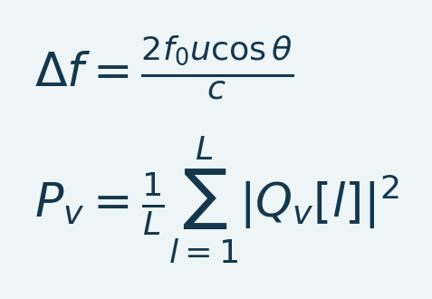
Variables and interpretation. Delta f is Doppler frequency shift in hertz, f_0 transmitted center frequency, u scatterer speed, theta the angle between flow and beam and c sound speed in the medium. The factor two accounts for pulse-echo propagation. P_v is an illustrative power estimate at voxel v from L retained ensemble samples Q_v[l], the filtered complex in-phase/quadrature echoes. The scanner may apply additional normalization and filtering; this formula does not calibrate loaded power into blood volume or flow velocity.
A moving scatterer produces a Doppler shift related to the beam-direction velocity component. Power Doppler aggregates filtered echo energy rather than directly mapping that shift to one calibrated velocity. Upstream tissue/blood separation, ensemble duration, gain and attenuation affect the resulting power. Neurovascular interpretation therefore depends on the acquisition and experimental context, not only the later percentage normalization [L1].
Section summary. A moving scatterer produces a Doppler shift related to the beam-direction velocity component.
Important / practical tip. Confirm whether the input is linear power, log intensity or normalized PSC before choosing a denominator.

A useful signal model
Think of each voxel as having a baseline vascular intensity, a response, noise and artifacts:
Equation (2)
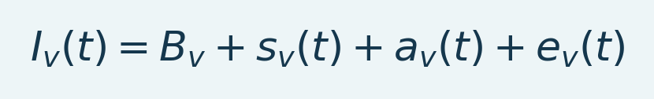
Variables and interpretation. v indexes a spatial voxel and t time. I is measured intensity, B baseline, s response, a additive artifact and e residual noise. All terms share intensity units. Motion can violate this additive approximation.
Here v denotes a spatial location. Motion can mix neighboring tissue into a voxel, so an additive artifact model is only a simplification. Probe pressure, anesthesia, systemic physiology, drift and vessel geometry can change the measurement. A change in Doppler power is not a direct count of neuronal spikes. Interpret the image through the acquisition and experimental design.
Section summary. Think of each voxel as having a baseline vascular intensity, a response, noise and artifacts:
Important / practical tip. Confirm whether the input is linear power, log intensity or normalized PSC before choosing a denominator.

What deConfUSIon provides
The toolbox connects loading, QC, preprocessing, baseline normalization, visualization, anatomical registration, ROI extraction, connectivity and group analysis. It preserves derived datasets so different processing decisions can be compared. Its GUIs make operations accessible, but clicking every available correction is not a recommended pipeline. Each operation should answer a QC finding or a prespecified analysis requirement.
Before continuing: know whether the file contains linear Doppler power, log intensity, already normalized PSC, or another signal. PSC denominators require a meaningful positive baseline. A convincing looking anatomy image cannot establish that the quantitative input is appropriate.
Source: loadFUSIData.m, computePSC.m, deConfUSIon.m.
Section summary. The toolbox connects loading, QC, preprocessing, baseline normalization, visualization, anatomical registration, ROI extraction, connectivity and group analysis.
Important / practical tip. Confirm whether the input is linear power, log intensity or normalized PSC before choosing a denominator.

Artifacts and temperature drift
Motion translates or deforms the vessel pattern; out-of-plane motion can replace sampled tissue. Respiration, cardiac pulsatility, systemic blood-pressure changes, anesthesia and probe pressure can alter Doppler intensity without a localized neural response. Injection can introduce movement or transient bubbles. Missing lines and burst frames are different problems from a slowly changing baseline.
Temperature is a plausible contributor to slow changes: warming of the probe, coupling medium or tissue can change acoustic propagation, while body-temperature changes can alter physiology. Temperature-dependent acoustic parameters have been investigated in ultrasound experiments [L10]. That literature does not establish the cause of drift in these particular fUSI scans. Record probe warm-up, animal temperature and timing; compare vehicle/control recordings before assigning a mechanism. A trend correlated with elapsed time is evidence of drift, not proof of heating.
A slow pharmacological response may occupy the same frequency range as drift. High-pass filtering can therefore remove the effect being studied. Prefer independent controls, measured confounds and response-aware sensitivity checks. A regression model cannot identify two indistinguishable time courses simply because they have different names.
Section summary. Motion translates or deforms the vessel pattern; out-of-plane motion can replace sampled tissue.
Important / practical tip. Confirm whether the input is linear power, log intensity or normalized PSC before choosing a denominator.

From Doppler power to interpretation
Repeated echoes are combined into images; clutter separation suppresses tissue contributions so blood-related fluctuations can be visualized. Neurovascular coupling links neural activity to hemodynamic changes, but the relationship depends on state, vessels and acquisition settings [L1]. The loaded movie is already an acquisition-system output. Its amplitude should not be interpreted as calibrated cerebral blood volume without the scanner-specific assumptions and calibration.
Preserve spatial anatomy and quantitative units. Inspect the raw movie, estimate usable support, review event timing and document operations that change temporal or spatial information.
Section and chapter summary. Repeated echoes are combined into images; clutter separation suppresses tissue contributions so blood-related fluctuations can be visualized. Confirm whether the input is linear power, log intensity or normalized PSC before choosing a denominator.
Important / practical tip. Confirm whether the input is linear power, log intensity or normalized PSC before choosing a denominator.

2. Array dimensions, time and physical space

Three acquisition cases
Table 1. Three acquisition cases overview
Acquisition | Internal movie | Meaning of the third spatial axis
Single 2D plane | [Y X T] | No acquired spatial Z axis
2D probe plus step motor | [Y X Z T] after reconstruction | Separately acquired source planes; verify their order and timing
Volumetric 3D probe | [Y X Z T] | Acquired volumetric grid; verify axis permutation and spacing

Y denotes rows, X columns and T time. A MATLAB array with three dimensions can represent a 2D time series [Y X T] or a static anatomical volume [Y X Z]. Interpret the dimensions from acquisition metadata; the number of array dimensions alone does not determine acquisition geometry.
Section summary. Y is row, X is column and T is the final dimension.
Important / practical tip. Verify final time axis, analyzed TR, plane order and physical spacing before any filtering or atlas work.

TR and duration
Equation (3)
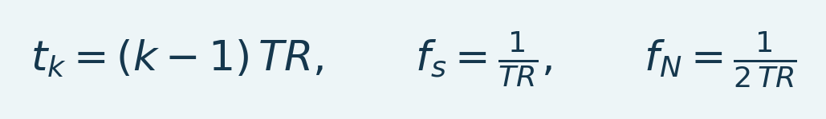
Variables and interpretation. k is a one-based sample index; t_k is nominal time in seconds. TR is analyzed sampling interval, f_s sampling frequency and f_N Nyquist frequency, both in hertz. Uniform sampling is assumed.
The final acquired sample occurs at (T-1)*TR. Some dialogs describe nominal acquisition duration as T*TR; an endpoint at nominal duration is clamped to the final sample where the implementation permits it. Review exported actual sample bounds. Do not interpret an inclusive endpoint as an extra measurement.
Block averaging n input frames changes the analyzed interval to n*TR. For example, a 0.48-second raw interval becomes 12 seconds after blocks of 25. Entering 0.48 into the analyzed-TR field for that result would make event times, filter cutoffs and FC windows wrong by a factor of 25.
Section summary. Verify final time axis, analyzed TR, plane order and physical spacing before any filtering or atlas work.
Important / practical tip. Verify final time axis, analyzed TR, plane order and physical spacing before any filtering or atlas work.

Irregular timestamps
A median repetition interval summarizes timing but does not make irregular acquisition times uniform. Check timestamps, trigger logs and gaps before frequency analysis. Integer-factor interpolation creates samples on an assumed uniform grid; it does not recover missing acquisition information or generally resolve irregular timing.
A median repetition interval summarizes timing but does not make irregular acquisition times uniform. Check timestamps, trigger logs and gaps before frequency analysis. Integer-factor interpolation creates samples on an assumed uniform grid; it does not recover missing acquisition information or generally resolve irregular timing.
Important / practical tip. Verify final time axis, analyzed TR, plane order and physical spacing before any filtering or atlas work.

Spacing and orientation
Pixel width is column spacing; pixel height is row spacing. An ROI of nx columns and ny rows has a cell-span footprint nx*dx by ny*dy. This is sampling geometry, not measured acoustic resolution. Keep physical units explicit. Atlas coordinates, native array axes and displayed left/right are different concepts. Confirm laterality from acquisition records; an image label alone is not evidence of anatomical side.
Source: loadFUSIData.m, scmSpatialCalibration.m, fusiVolumeGeometry.m, fusiFCWindowBounds.m.
Section and chapter summary. Pixel width is column spacing; pixel height is row spacing. Verify final time axis, analyzed TR, plane order and physical spacing before any filtering or atlas work.
Important / practical tip. Verify final time axis, analyzed TR, plane order and physical spacing before any filtering or atlas work.

3. Install, start and identify the active version

Install the repository
1. Place the complete repository in a stable working directory. For this installation it is D:\Github\deConfUSIon.
2. Keep run_fusi_studio.m, fusi_studio_GUI.m and fusi_studio_callback.m together at the root. Studio assembles those sources into a temporary runtime.
3. Keep atlas MAT files, atlas_tools, lib, documentation and acquisition helpers with the checkout. Do not place a backup checkout on the active MATLAB path.
4. Start MATLAB R2023b for the reference workflows in this handbook. Some older code targets earlier versions, but that does not establish that modern 3D rendering works on those releases.
5. Run the following in the MATLAB Command Window.
cd('C:\Toolboxes\deConfUSIon')
deConfUSIon_setup
deConfUSIon
Setup adds the active modules. Do not use addpath(genpath(pwd)): that can activate validation fixtures, backups and historical functions. If MATLAB reports an unexpected implementation, inspect which deConfUSIon -all, which SCM_gui -all and which loadFUSIData -all. The first selected files should belong to this checkout.
Section summary. Run deConfUSIon_setup; verify which resolves to this checkout and keep the backup off the active path.
Important / practical tip. Run deConfUSIon_setup; verify which resolves to this checkout and keep the backup off the active path.

Dependencies and optional features
MATLAB is required. Image Processing Toolbox supports registration and image processing; Signal Processing Toolbox supports the filter families; statistical features use the available MATLAB implementations or toolbox-specific code paths. Current volume rendering uses viewer3d and volshow when available and has a surface fallback. PowerPoint export has additional platform-specific dependencies. Check the installed products with ver; a missing optional exporter should not be confused with a failed numerical calculation.
The local validation in this edition ran on Windows R2023b. Native macOS validation remains a separate task. The compatibility notes describe platform-specific file opening and export support. Do not silently assume every legacy helper is supported on every OS.
Section summary. Run deConfUSIon_setup; verify which resolves to this checkout and keep the backup off the active path.
Important / practical tip. Run deConfUSIon_setup; verify which resolves to this checkout and keep the backup off the active path.

Updating a running session
An already-open GUI retains its nested callbacks. Editing a source file does not replace those closures. Finish or recover outstanding saves, then close and reopen the affected toolbox GUI to use the new implementation. Do not terminate a MATLAB session with unsaved results just to refresh a window. The save-status control and deConfUSIon_finish_saves support recovery.
Source: deConfUSIon_setup.m, run_fusi_studio.m, DataIO.m, deConfUSIon_finish_saves.m.
Section and chapter summary. Run deConfUSIon_setup; verify which resolves to this checkout and keep the backup off the active path. Run deConfUSIon_setup; verify which resolves to this checkout and keep the backup off the active path.
Important / practical tip. Run deConfUSIon_setup; verify which resolves to this checkout and keep the backup off the active path.

Operating systems and native exports
Windows with MATLAB R2023b remains the reference installation. Native MATLAB on Linux and macOS is supported by the source; end-to-end validation on those platforms is pending. Use the actual mounted data path rather than Windows drive letters. Linux movie exports use Motion JPEG AVI; Windows and macOS use MP4. On macOS and Linux, PPTX requires MATLAB Report Generator, and XLSX export does not use Excel COM styling. Live acquisition remains subject to scanner and hardware-driver support.

4. Studio: the control center
Figure 1. Studio workflow overview
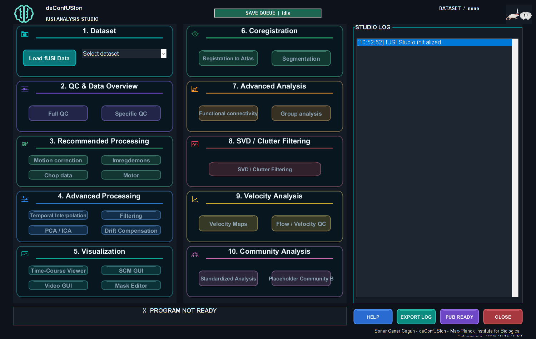
Actual MATLAB output from the reference workflow. Read the chapter steps for controls, input sampling, units and interpretation limits. The screenshot is a software example, not a validated biological result.

Studio contains the data-loading action, the active-dataset selector, preprocessing and analysis launchers, status and log. Work from the active dataset deliberately: two windows can display different processing stages of the same animal. A filename containing PC1 or LPF is useful context, but inspect its saved processing metadata when writing methods.

First launch sequence
1. Click Load fUSI Data.
2. Select the recording and inspect dimensions, timing and output folder in the load options.
3. Confirm that the raw recording is active. Read the log before launching another operation.
4. Open Time-Course Viewer and inspect representative frames.
5. Run Full QC. Save the QC report and write down which correction, if any, it motivates.
6. Apply one justified correction, inspect its output and compare with the parent dataset.
7. Continue to SCM, masks, registration or FC when their required inputs are ready.
Section summary. Read the active dataset label before launching a viewer or creating another derived branch.
Important / practical tip. Read the active dataset label before launching a viewer or creating another derived branch.

Dataset identity and provenance
Derived results retain a source dataset key, display name and output filename. A selection in Studio is not merely a display preset: it determines which array the next operation receives. Check the active label after processing. When sharing a result, include its actual MAT file and the processing chain rather than only a screenshot of the dropdown.
The source tree has several similarly named callback files. The authoritative Studio interface is assembled from the root GUI and callback sources; changing an unused standalone callback may have no effect on the running interface. The script appendix explains these relationships.
Section summary. Derived results retain a source dataset key, display name and output filename.
Important / practical tip. Read the active dataset label before launching a viewer or creating another derived branch.

Save status
Wait for Saved and verified before treating a result as portable. A completed calculation can exist in Studio while a write fails. In that case the array is retained for retry; do not rerun the analysis unless it is actually necessary. Keep MATLAB open until recovery succeeds. A completed .saving file and recovery record can be published after an interrupted rename; a partial file without a completion record is not a saved movie.
Source: fusi_studio_GUI.m, fusi_studio_callback.m, studioSaveDataset.m, DataIO.m.
Section and chapter summary. Wait for Saved and verified before treating a result as portable. Read the active dataset label before launching a viewer or creating another derived branch.
Important / practical tip. Read the active dataset label before launching a viewer or creating another derived branch.

II. Load and prepare acquisitions

5. Loading data and choosing output folders

Supported input concepts
The loader accepts supported MAT and NIfTI inputs, selects a primary image series and standardizes movie dimensions and metadata. MAT files may use classic binary storage or HDF5-based v7.3 storage. Inspect the actual format before choosing a reader. Format support does not by itself verify metadata, orientation or scientific suitability.
Prefer an explicitly named image array such as I, correct final time dimension, measured TR or physical timestamps, and spatial sampling metadata. A .mat extension alone says nothing about the dimensions, units or signal type inside. If a file contains multiple large arrays, confirm that the intended primary movie was selected.
Section summary. The loader accepts supported MAT and NIfTI inputs, selects a primary image series and standardizes the movie and metadata.
Important / practical tip. Separate network copy time from local MAT parsing; preserve the original until a complete verified cache exists.

Output organization
Raw acquisitions stay unchanged. Derived outputs belong under the matching analyzed-data recording folder. Typical subfolders include Preprocessing, QC, Visualization, Registration 2D, Registration 3D, ROI exports and Videos. The exact route is resolved by the current folder helpers and existing legacy output locations. Check the resolved path in Studio rather than creating a second unrelated animal folder by hand.
For a 2D coronal registration, each save can create a dated SliceNNN_... directory. Its transform and histology, vascular and region underlays form one registration package. Load Atlas and Load New Underlay now start at an actual saved plane when such a package exists. If you have several registrations, select the intended package explicitly; the most recent directory is a convenience, not an anatomical decision.
Section summary. Separate network copy time from local MAT parsing; preserve the original until a complete verified cache exists.
Important / practical tip. Separate network copy time from local MAT parsing; preserve the original until a complete verified cache exists.

What local caching means
Large network MAT files can be copied into a private local read cache before loading. A later MATLAB session can reuse a completed copy when the same source path, size and modification time match. This is a disk cache, not only a variable kept in the current MATLAB workspace. Original source provenance is retained. The cache is not a backup and can be evicted.
Initial loading can be limited by network throughput, compression and storage speed. A mapped drive letter does not identify the underlying hardware or guarantee performance. Compare transfer, file parsing, computation and result writing separately. Reusing a complete local cache avoids repeating the network transfer but still requires parsing the cached file.
Section summary. Large network MAT files can be copied into a private local read cache before loading.
Important / practical tip. Separate network copy time from local MAT parsing; preserve the original until a complete verified cache exists.

Reading progress correctly
The byte counter describes the current copy or read phase. Local parsing and metadata setup follow the network transfer. A phase reaching 100% does not imply that every later operation is finished. PCA progress reserves a save phase, reports written image chunks, and completes after verification. Remaining-time estimates are omitted when there is no measured rate for the current phase.
Source: loadFUSIData.m, fusiLoadMatVariables.m, fusiLocalMatReadSource.m, fusiResolveAnalysisFolder.m, fusiUnderlayPickerOptions.m.
Section and chapter summary. The byte counter describes the current copy or read phase. Separate network copy time from local MAT parsing; preserve the original until a complete verified cache exists.
Important / practical tip. Separate network copy time from local MAT parsing; preserve the original until a complete verified cache exists.

6. A complete first 2D walkthrough

Recording used in this handbook
Select a compatible single-plane 2D recording in the Load fUSI Data dialog.
For a 2D movie, verify [Y X T], numeric precision, memory footprint and timestamps in the loaded metadata. The in-memory array can occupy more space than the compressed file. A reduced or filtered branch has different temporal properties from the original. Check its timing explicitly rather than inferring it from a screenshot.
For a 2D movie, verify [Y X T], numeric precision, memory footprint and timestamps in the loaded metadata. The in-memory array can occupy more space than the compressed file. A reduced or filtered branch has different temporal properties from the original. Check its timing explicitly rather than inferring it from a screenshot.
Important / practical tip. Compare one justified processing change at a time on the same independently defined ROI.

Stage A: establish the input
1. Load the original scan through Studio and choose a local analyzed output folder if you are measuring processing speed independently of server writes.
2. Confirm 2D time-series dimensions and the TR. Note the timestamp warning for later resolution.
3. Open Time-Course Viewer. Start with Raw Intensity, neutral brightness/contrast and a representative middle frame.
4. Move through early, middle and late frames. Look for displacement, clipping, jumps, lost signal, pressure changes and drift.
5. Compare traces from tissue, a strong vessel and background. Background is not a physiological control ROI by itself.
Section summary. Compare one justified processing change at a time on the same independently defined ROI.
Important / practical tip. Compare one justified processing change at a time on the same independently defined ROI.

Stage B: process only a justified problem
Run Full QC. If there are isolated bad frames, inspect Frame Rejection; if there are sparse voxel spikes, inspect Despike; if the anatomy moves, compare registration. Do not use a slow low-pass filter as a substitute for reviewing spikes. Save the selected correction, then compare its image mean, frame traces and timing against the raw input. If block averaging was used, verify the updated TR before choosing any filter cutoff.
Section summary. Compare one justified processing change at a time on the same independently defined ROI.
Important / practical tip. Compare one justified processing change at a time on the same independently defined ROI.

Stage C: build the analysis view
Open SCM GUI from the intended dataset branch. Choose a stable baseline and a signal interval justified by the experiment. Inspect both sign modes and use a shared color range for comparisons. Keep display settings separate from the numerical endpoint; an attractive map does not validate a biological interpretation.
Section summary. Compare one justified processing change at a time on the same independently defined ROI.
Important / practical tip. Compare one justified processing change at a time on the same independently defined ROI.

Stage D: anatomy and ROIs
Prepare a mask if needed. Open Registration to Atlas, choose the 2D coronal route and review plane, laterality and alignment. Save explicitly. Back in SCM, choose Underlay, Load Atlas and the saved plane package. Review Histology, Vascular and Regions from the same registration. Use Automatic analysis to define a documented search or load an independently specified fixed protocol. Review candidates before checking them for export.
Section summary. Compare one justified processing change at a time on the same independently defined ROI.
Important / practical tip. Compare one justified processing change at a time on the same independently defined ROI.

Stage E: downstream results
Export a per-role ROI ensemble and its note. Keep all files in the export folder together. For Group Analysis load one mean or allROIs file per recording and role, not both. For FC load the matching integer regions, verify their alignment, select the period and press ROI current. Review the region granularity and hemisphere mode separately. Export processing metadata with the result.
Completion checkpoint: another user should be able to identify the original scan, selected processing result, analyzed TR, baseline, signal/search interval, ROI support, registration and export settings without asking you to reconstruct them from memory.
Section summary. Compare one justified processing change at a time on the same independently defined ROI.
Important / practical tip. Compare one justified processing change at a time on the same independently defined ROI.

A first analysis decision table
Table 2. A first analysis decision table overview
Recording goal | Starting comparison | Evidence before keeping it
Long pharmacological scan | Raw versus modest block reduction; demons for observed spatial drift | Enough onset samples, stable landmarks, no response-shaped trend removal
Short repeated stimulation | Raw versus targeted bad-frame treatment; review PCA for independently supported artifacts | Stimulus timing, response amplitude/latency and maps preserved
Resting-state FC | Timing/motion review, anatomically justified nuisance mask, explicit frequency band | Usable duration, region coverage and correlation sensitivity reported
Sequential motor acquisition | Reconstruct source-plane timing and geometry first | Plane order, step interval and sampling support verified

For a 0.32 s input, blocks of five produce 1.6 s samples. A 10 s event then spans about six samples; blocks of 50 produce 16 s samples and can obscure it. These numbers explain a trade-off, not an automatic recommended factor. Block means provide limited anti-alias rejection; evaluate the retained bandwidth and prefilter where necessary before reducing the sampling rate.
Section summary. For a 0.32 s input, blocks of five produce 1.6 s samples.
Important / practical tip. Compare one justified processing change at a time on the same independently defined ROI.

Compare processing branches fairly
1. Save initial QC and define one anatomical ROI before seeking the largest response.
2. Create a derived branch with one justified correction and its parameter record.
3. Compare the same ROI, baseline, time origin and color range in raw and derived branches.
4. Recheck motion, amplitude, latency, missing support and the global trace. Reduced variance alone is not success.
5. Keep the simpler branch if an extra correction has no defensible benefit. Review the final sequence before using Standardized Analysis on other animals.
Section and chapter summary. Compare one justified processing change at a time on the same independently defined ROI. Compare one justified processing change at a time on the same independently defined ROI.
Important / practical tip. Compare one justified processing change at a time on the same independently defined ROI.

7. 2D probe with step motor: reconstruct before analyzing
A step-motor acquisition samples several planes using a 2D probe. A reconstructed [Y X Z T] array can resemble a volumetric movie in memory while its planes were acquired at different times. Simultaneity, order and dwell timing must come from the acquisition protocol.

Continuous and split modes
The Motor engine supports a continuous [Y X T] stream with a known number of frames spent at each slice, and a split-folder mode that groups files by slice/time index. Its reconstruction logic is frame based; TR labels alone do not identify which slice a frame belongs to. Verify filenames and motor logs before choosing counts.
Section summary. The Motor engine supports a continuous [Y X T] stream with a known number of frames spent at each slice, and a split-folder mode that groups files by slice/time index.
Important / practical tip. Verify source-plane acquisition timing before treating reconstructed slices as a synchronous volume.

Reconstruction procedure
1. Preserve the original continuous movie or the complete split-file folder.
2. Choose Motor in Studio or the motor preset in Standardized Analysis.
3. Select continuous or split input and verify the expected number of source slices.
4. Enter dwell/frame counts and any initial-baseline convention from acquisition records.
5. Review the reported reconstruction dimensions, retained frames and time indices.
6. Inspect the first/last frame of every plane. Look for a one-slice offset or inclusion of movement frames.
7. Save the reconstructed result and motor metadata before applying other corrections.
8. Use per-slice 2D Imregdemons when that matches the acquisition. Do not treat motor planes as a simultaneously acquired 3D volume by default.
Section summary. Verify source-plane acquisition timing before treating reconstructed slices as a synchronous volume.
Important / practical tip. Verify source-plane acquisition timing before treating reconstructed slices as a synchronous volume.

Registration by source plane
Open the coronal registration workflow for the reconstructed stack. Select the correct source plane and its matching atlas plane, align and save it, then continue with the remaining acquired planes. SourceSlice index and AtlasSlice index are different quantities. A sequential source stack need not have equally spaced atlas indices.
The combined session stores the list of source indices, their transforms and underlays. Keep its session MAT, relative subpaths and AtlasUnderlays directory together. Missing transforms or duplicate source indices are errors, not an invitation to reuse the nearest plane silently. A saved single-plane registration cannot label multiple source planes by resizing along Z.
Section summary. Open the coronal registration workflow for the reconstructed stack.
Important / practical tip. Verify source-plane acquisition timing before treating reconstructed slices as a synchronous volume.

Downstream analysis
Load the session folder in SCM/Video to assemble only the saved source planes using their explicit mappings. Check each plane before searching all slices. FC can use supported step-motor label/name folders or segmentation outputs, but every region time course must retain its source timing and support. Correlations between sequentially acquired planes need an explicitly justified time-alignment strategy; visual stacking does not make them simultaneous.
Source: motor.m, registration_coronal_2d.m, fusiSaveStepMotorUnderlays2D.m, fusiReadStepMotorUnderlays2D.m, deConfUSIon_FC_stepmotor_read_folder.m.
Section and chapter summary. Load the session folder in SCM/Video to assemble only the saved source planes using their explicit mappings. Verify source-plane acquisition timing before treating reconstructed slices as a synchronous volume.
Important / practical tip. Verify source-plane acquisition timing before treating reconstructed slices as a synchronous volume.

8. Volumetric 3D probe: verify geometry and sampling
A matrix-probe recording is represented as [Y X Z T]: rows, columns, spatial planes and acquired volumes over time. Confirm all four meanings, physical spacing and timing before analysis. Compression changes file size, not the number of array elements; allow sufficient memory for the expanded array and processing buffers.

Recommended sequence
1. Load the raw matrix scan and review the detected axes, spacing, volume count and timestamps.
2. Inspect several nonempty planes at early/middle/late times. Empty boundary planes can be legitimate missing coverage.
3. Run Full QC, including time, motion, reliability and common-mode views as justified.
4. Review PCA/ICA components before removal, except where a prespecified automated protocol explicitly requests a component.
5. Inspect mean preservation and raw display after removal. Choose the corrected viewer rather than treating a cached PSC display as raw power.
6. If applying Imregdemons, select true 3D mode and justify its temporal block size.
7. Confirm the analyzed TR after reduction and choose valid filter settings.
8. Prepare mask and atlas registration, then inspect native and registered displays before extracting atlas ROIs or FC.
Section summary. Confirm geometry and slice support before applying a 3D transform or physical scale bar.
Important / practical tip. Confirm geometry and slice support before applying a 3D transform or physical scale bar.

3D registration
The registration GUI requires the native array permutation, physical sampling and laterality to be consistent with the atlas. Review coronal, axial and sagittal cuts, not just one attractive slice. A geometry correction must be applied consistently to anatomy and quantitative signal. Saved transforms record the mapping; the full atlas cannot simply be stretched through the acquired AP extent.
Native column1 side comes from acquisition knowledge. Confirm it in the geometry dialog. Axis names in the local model are grid axes until the saved atlas mapping establishes anatomical DV/LR/AP. A display flip changes the viewing convention; it must not silently change the saved transform or numerical ROI identity.
Section summary. The registration GUI requires the native array permutation, physical sampling and laterality to be consistent with the atlas.
Important / practical tip. Confirm geometry and slice support before applying a 3D transform or physical scale bar.

Registration acceptance checks
Check center and boundary planes in all three views, midline, cortex, ventricles and vascular landmarks. Inspect extrapolated atlas context outside the acquired field of view: it supplies reference anatomy but not measured functional signal. Save the chosen registration as a unique package and use its matching underlays/labels across SCM, Video, segmentation and FC.
Source: coreg_3d.m, registration_ccf.m, AtlasRegistration.m, fusiRegistrationDisplayVolume.m, fusiAtlasRegionInput.m.
Section and chapter summary. Check center and boundary planes in all three views, midline, cortex, ventricles and vascular landmarks. Confirm geometry and slice support before applying a 3D transform or physical scale bar.
Important / practical tip. Confirm geometry and slice support before applying a 3D transform or physical scale bar.

III. Quality control before correction

9. QC: decide what needs correction
Figure 2. Frame rejection QC
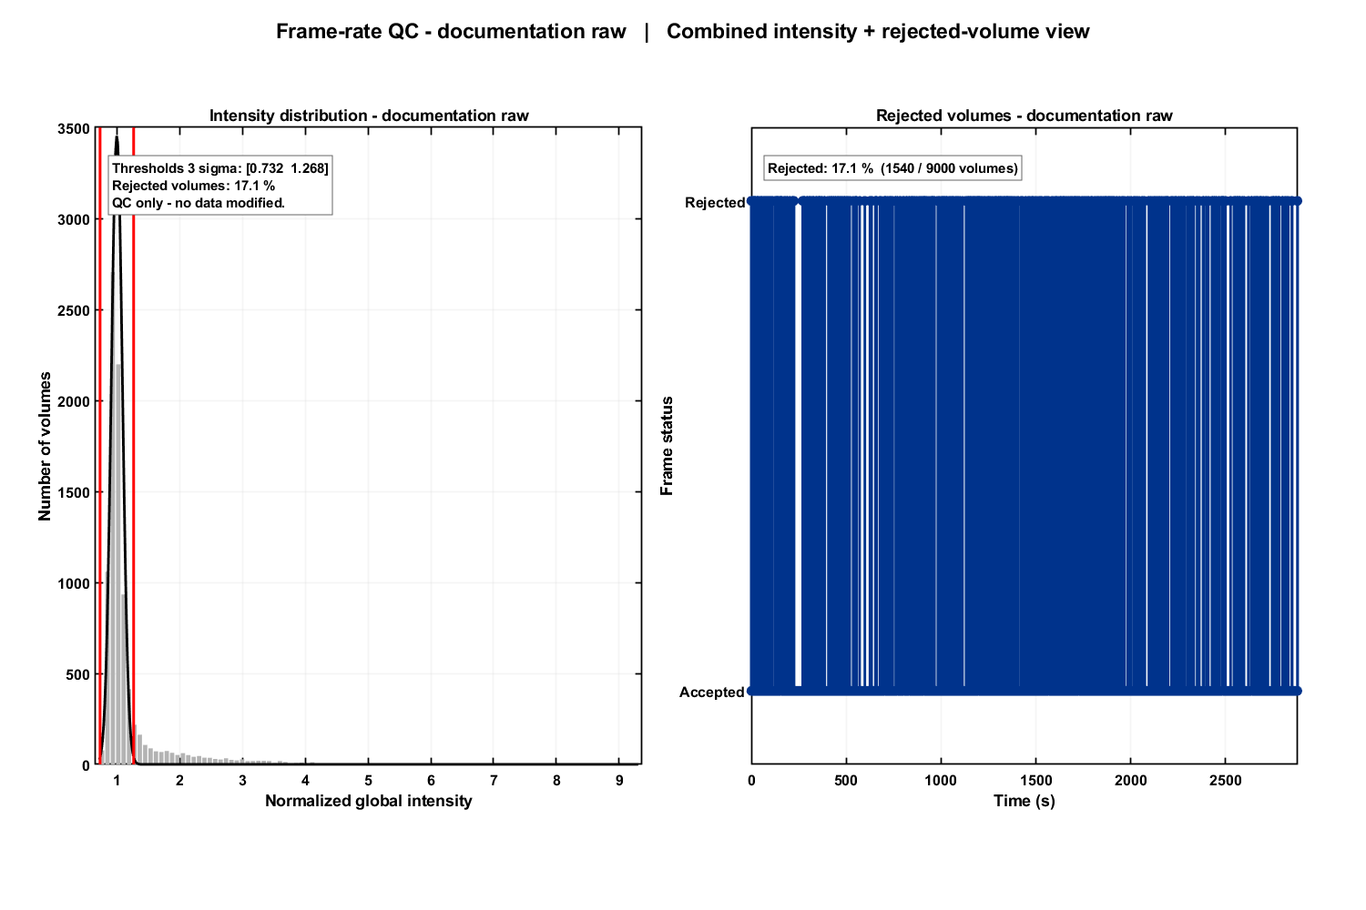
Actual MATLAB output from the reference workflow. Read the chapter steps for controls, input sampling, units and interpretation limits. The screenshot is a software example, not a validated biological result.
Full QC provides several views of the same acquisition. They are complementary: a high temporal SNR map can coexist with substantial motion, and a smooth global trace can hide a local bad line. Read the image, time traces and timing together.

Core quantities
Equation (4)
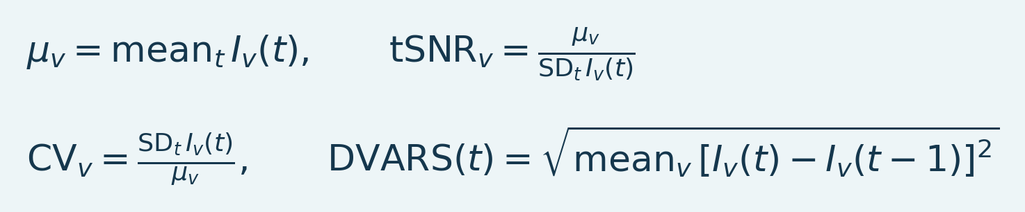
Variables and interpretation. mu_v is the temporal mean at voxel v and SD_t its sample temporal standard deviation. tSNR is their ratio and CV its reciprocal when defined. DVARS is the root mean squared successive-frame difference over included voxels; it has intensity units, not distance units.
These definitions describe the concepts; individual QC modules define their own masks, normalization, finite-sample handling and display limits. A ratio is unreliable when its denominator is near zero. A high common-mode correlation can reflect a real widespread response, systemic physiology or a shared artifact. It is a reason to investigate, not an automatic deletion rule.
Section summary. These definitions describe the concepts; individual QC modules define their own masks, normalization, finite-sample handling and display limits.
Important / practical tip. Open the raw movie at flagged times. A QC threshold is a screening rule, not biological ground truth.

How to read the report
1. Inspect spatial mean, variance and reliability coverage. Identify missing or permanently invalid tissue.
2. Inspect frame-rate/timestamp plots and acquisition gaps. Verify the time axis before spectral conclusions.
3. Compare global intensity and frame-change traces. Open the movie at suspicious times.
4. Look for isolated lines or slices rather than assuming a whole-frame failure.
5. Inspect PCA QC as a summary of dominant variance, then inspect component anatomy before removing anything.
6. Compare pre- and post-correction QC using the same settings. A reduction in noise metrics alone is insufficient if the response was also attenuated.
Section summary. Open the raw movie at flagged times. A QC threshold is a screening rule, not biological ground truth.
Important / practical tip. Open the raw movie at flagged times. A QC threshold is a screening rule, not biological ground truth.

Burst, CNR, common mode and reliability
Burst QC identifies intensity irregularity and coverage patterns. CNR is interpretable as a response-to-noise contrast only when valid stimulation/baseline information exists; a pseudo-CNR summary is not a task significance test. Common-mode QC compares spatial block time courses. Reliability reports finite support, and can summarize it by atlas region when a matching registration exists. Integrated QC combines diagnostic summaries; it does not replace inspection or establish an exclusion threshold for every experiment.
Record: dataset, QC flags, thresholds, inspected frames, rationale for any rejection, retained sample count and changes after correction. Apply exclusion criteria consistently across animals and conditions.
Source: qc_fusi.m, frameRateQC.m, fusiCommonModeTimecourses.m, gaOutlierScores.m.
This gallery illustrates the 18 plot types produced by the enabled Full QC modules, alongside the frame-rejection view. Use the plots together: a single metric does not distinguish every artifact from physiological signal. Reliability across recordings and atlas summaries require their own compatible inputs and review.
Section summary. Pseudo-CNR does not use verified stimulation labels and must not be reported as a task significance result.
Important / practical tip. Pseudo-CNR does not use verified stimulation labels and must not be reported as a task significance result.

Burst intensity support
Figure 3. Burst intensity support
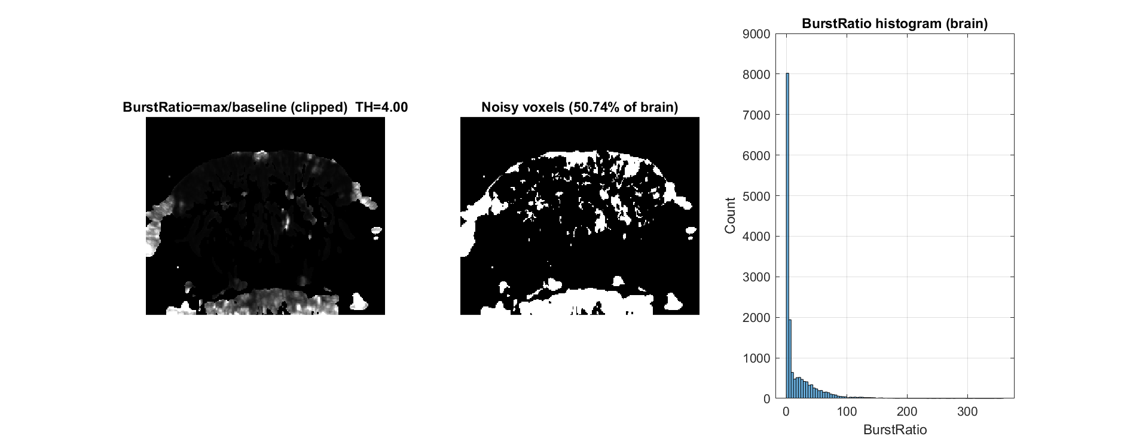
Full QC example. Read the map, corresponding time trace, axes and units together. Interpret spectral panels only after checking the acquisition timestamps.
Maximum-to-mean intensity and flagged support expose bursts; brightness alone is not an exclusion rule.
Inspection step: compare the plot with the original movie and complementary QC views before deciding whether correction is justified.
Section summary. Maximum-to-mean intensity and flagged support expose bursts; brightness alone is not an exclusion rule.
Important / practical tip. Open the raw movie at flagged times. A QC threshold is a screening rule, not biological ground truth.

Burst temporal coverage
Figure 4. Burst temporal coverage
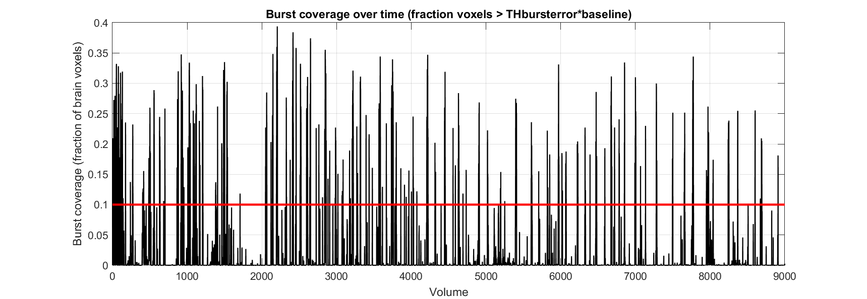
Full QC example. Read the map, corresponding time trace, axes and units together. Interpret spectral panels only after checking the acquisition timestamps.
Compare the affected fraction over time with the raw movie and event log.
Inspection step: compare the plot with the original movie and complementary QC views before deciding whether correction is justified.
Section summary. Compare the affected fraction over time with the raw movie and event log.
Important / practical tip. Finite sample coverage is different from test-retest reliability and biological signal validity.

Global signal spectrum
Figure 5. Global signal spectrum
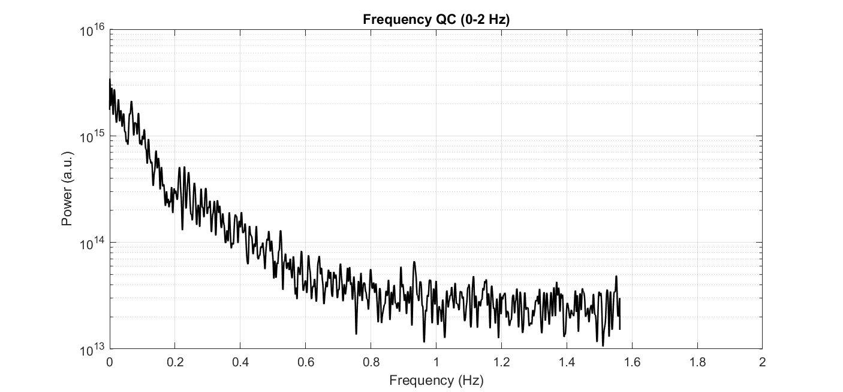
Full QC example. Read the map, corresponding time trace, axes and units together. Interpret spectral panels only after checking the acquisition timestamps.
Irregular timestamps make this median-TR spectrum diagnostic rather than a validated physiological frequency estimate.
Inspection step: compare the plot with the original movie and complementary QC views before deciding whether correction is justified.
Section summary. Irregular timestamps make this median-TR spectrum diagnostic rather than a validated physiological frequency estimate.
Important / practical tip. Irregular timestamps limit spectral inference. A spectrum calculated from a median interval is a diagnostic view, not proof of physiological frequency content.

Slow frequency detail
Figure 6. Slow frequency detail
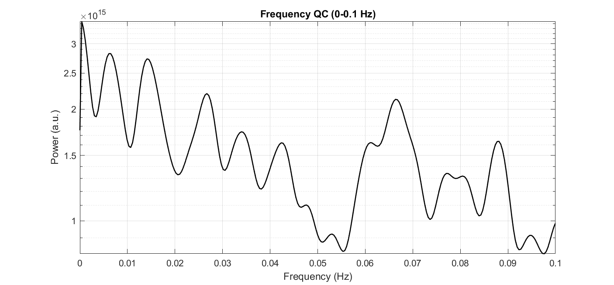
Full QC example. Read the map, corresponding time trace, axes and units together. Interpret spectral panels only after checking the acquisition timestamps.
Drift and sustained biological responses can occupy the same low-frequency range.
Inspection step: compare the plot with the original movie and complementary QC views before deciding whether correction is justified.
Section summary. Drift and sustained biological responses can occupy the same low-frequency range.
Important / practical tip. Irregular timestamps limit spectral inference. A spectrum calculated from a median interval is a diagnostic view, not proof of physiological frequency content.

Spatial signal stability
Figure 7. Spatial signal stability
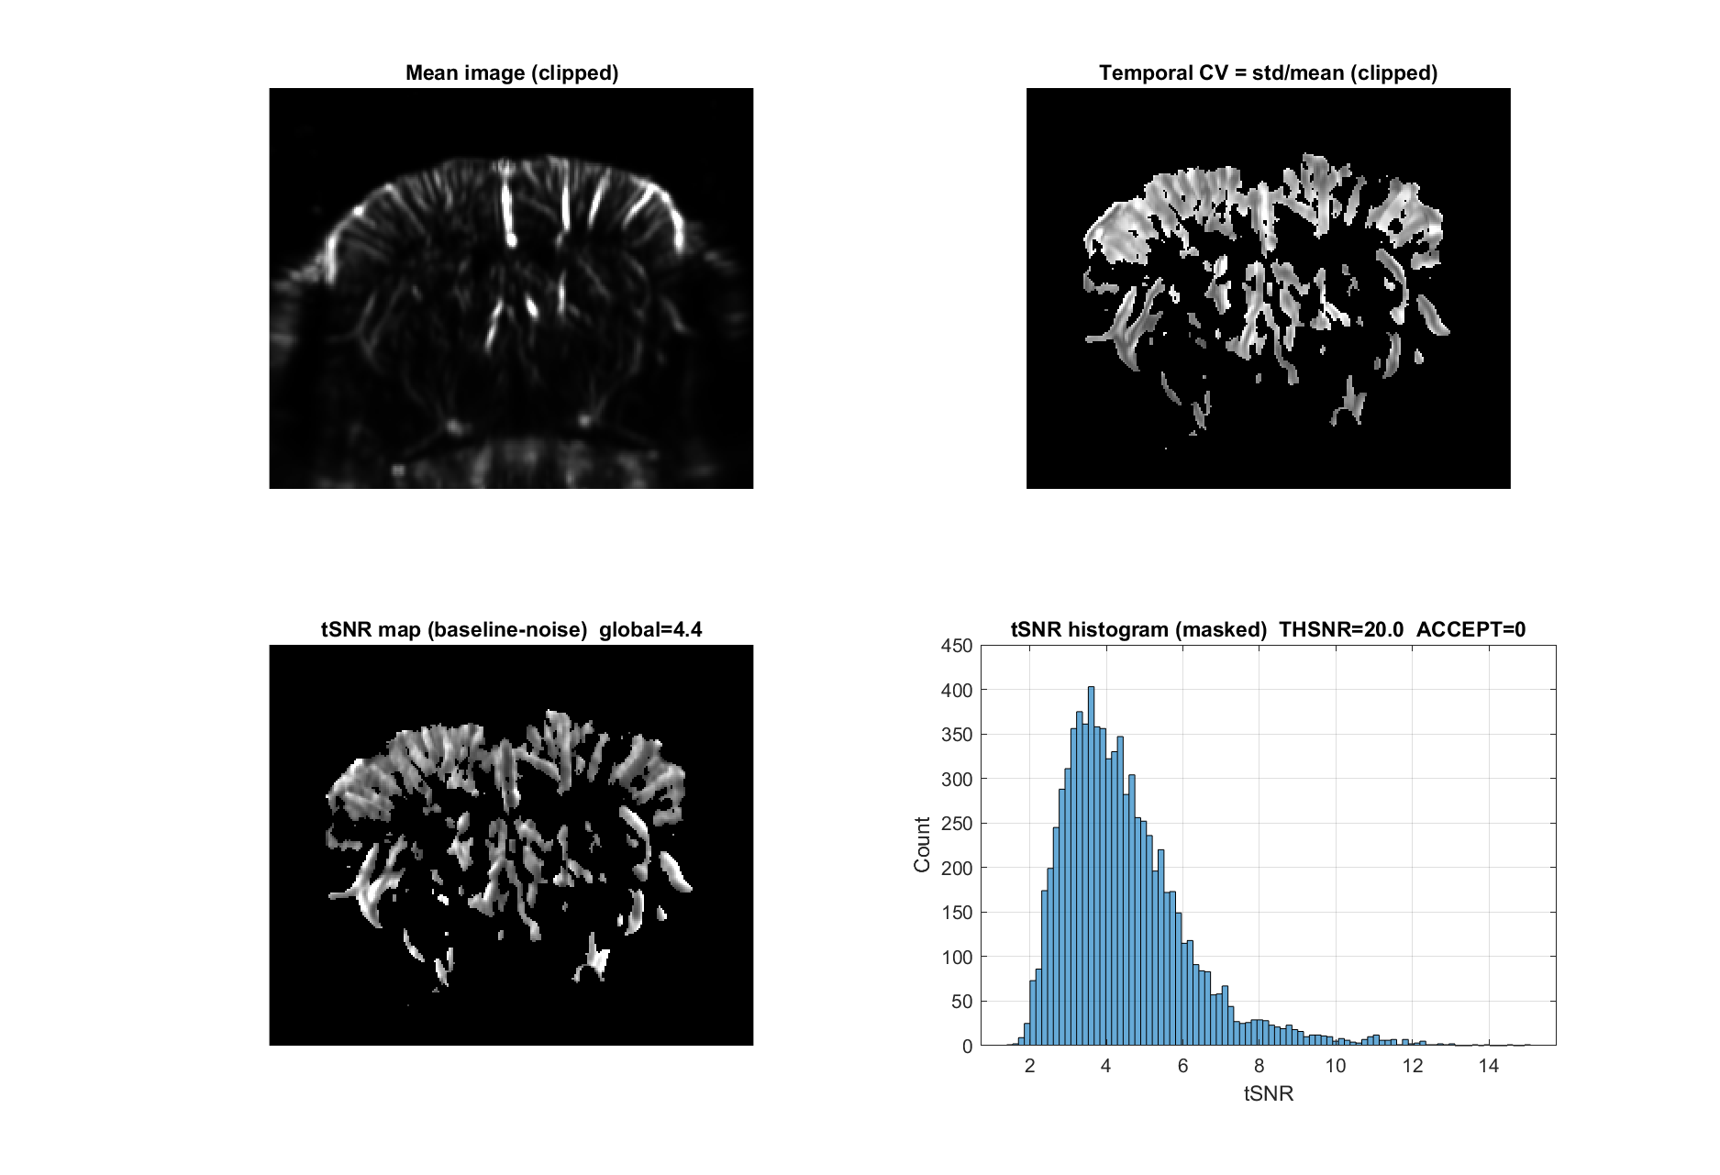
Full QC example. Read the map, corresponding time trace, axes and units together. Interpret spectral panels only after checking the acquisition timestamps.
Mean/noise ratios expose low signal and instability, but depend on support and denominator.
Inspection step: compare the plot with the original movie and complementary QC views before deciding whether correction is justified.
Section summary. Mean/noise ratios expose low signal and instability, but depend on support and denominator.
Important / practical tip. Open the raw movie at flagged times. A QC threshold is a screening rule, not biological ground truth.

Temporal intensity changes
Figure 8. Temporal intensity changes
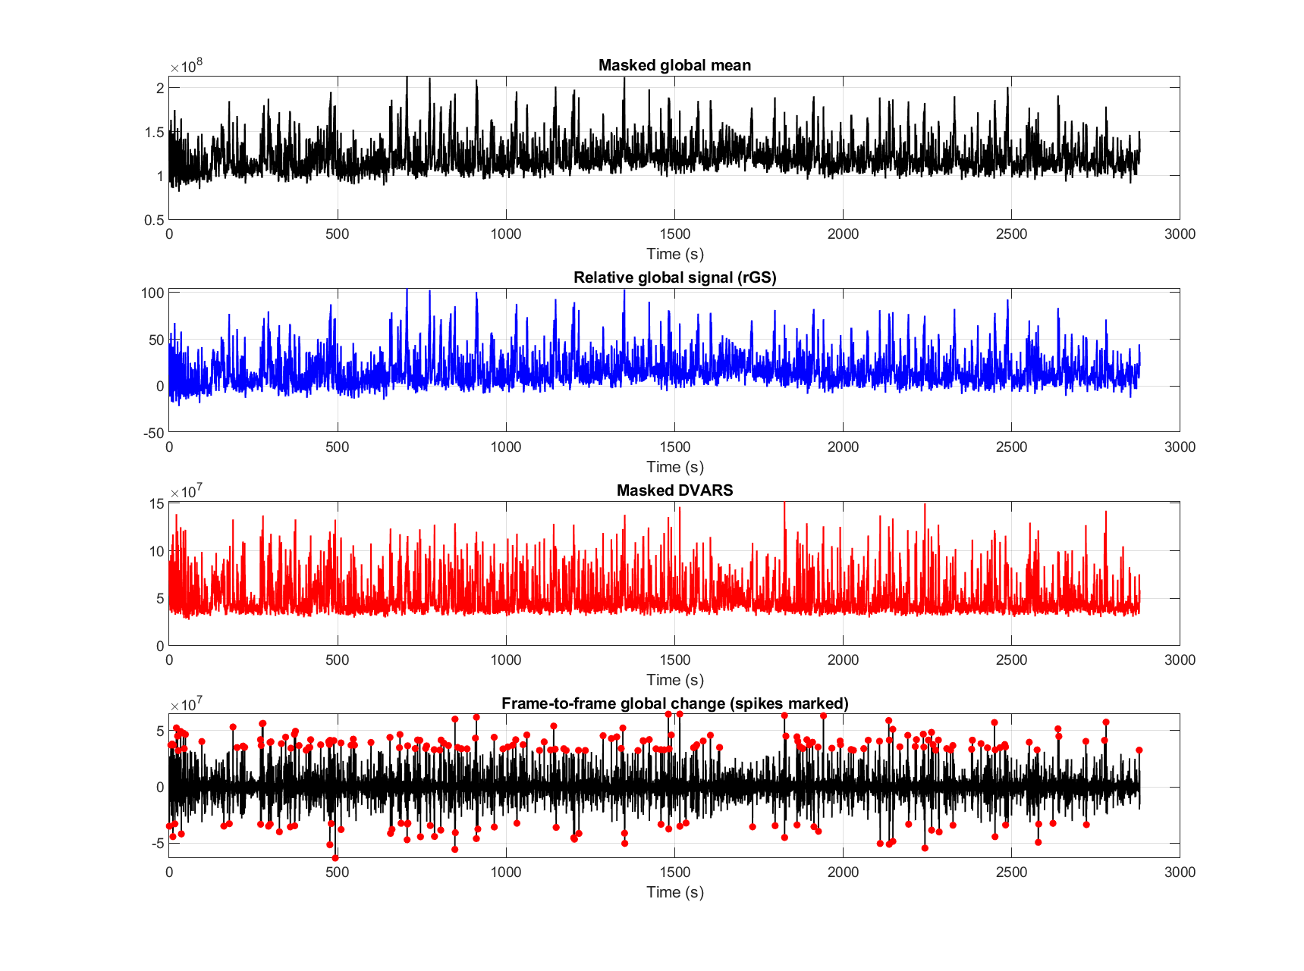
Full QC example. Read the map, corresponding time trace, axes and units together. Interpret spectral panels only after checking the acquisition timestamps.
Inspect abrupt global changes and frame differences in the original movie.
Inspection step: compare the plot with the original movie and complementary QC views before deciding whether correction is justified.
Section summary. Inspect abrupt global changes and frame differences in the original movie.
Important / practical tip. Open the raw movie at flagged times. A QC threshold is a screening rule, not biological ground truth.

Stability threshold trace
Figure 9. Stability threshold trace
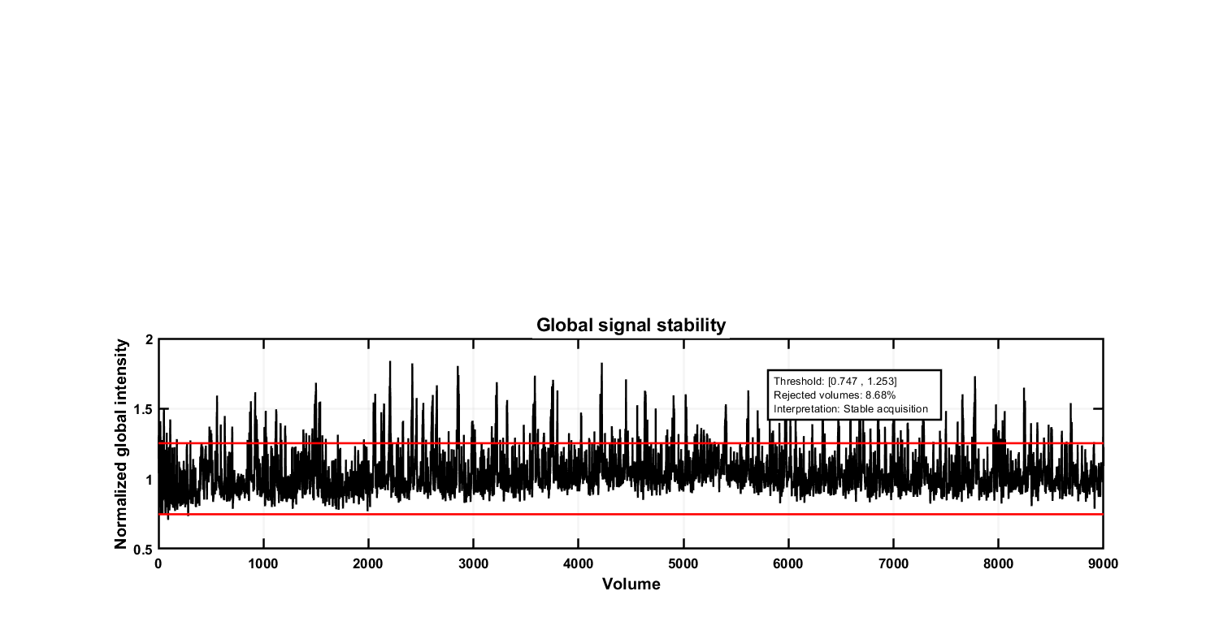
Full QC example. Read the map, corresponding time trace, axes and units together. Interpret spectral panels only after checking the acquisition timestamps.
Threshold crossings screen intensity departures rather than automatically identifying bad biology.
Inspection step: compare the plot with the original movie and complementary QC views before deciding whether correction is justified.
Section summary. Threshold crossings screen intensity departures rather than automatically identifying bad biology.
Important / practical tip. Open the raw movie at flagged times. A QC threshold is a screening rule, not biological ground truth.

Stability value distribution
Figure 10. Stability value distribution
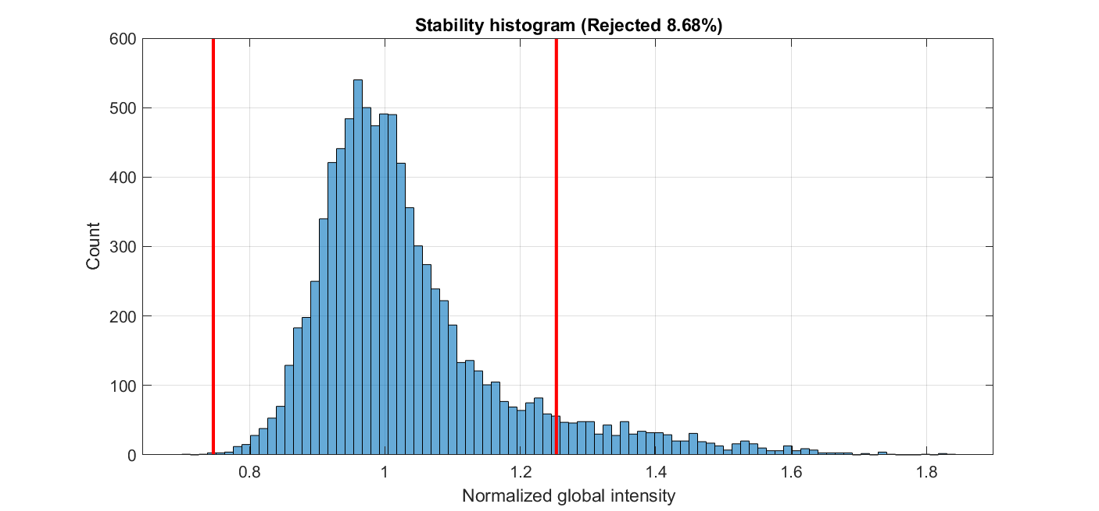
Full QC example. Read the map, corresponding time trace, axes and units together. Interpret spectral panels only after checking the acquisition timestamps.
A distribution hides event order; consult the matching time trace.
Inspection step: compare the plot with the original movie and complementary QC views before deciding whether correction is justified.
Section summary. A distribution hides event order; consult the matching time trace.
Important / practical tip. Open the raw movie at flagged times. A QC threshold is a screening rule, not biological ground truth.

Intensity center movement
Figure 11. Intensity center movement
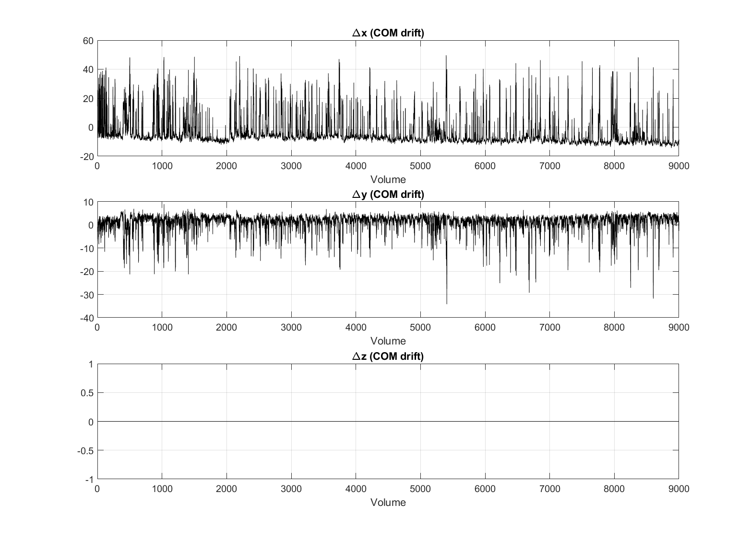
Full QC example. Read the map, corresponding time trace, axes and units together. Interpret spectral panels only after checking the acquisition timestamps.
Intensity-weighted center shifts use array coordinates, not calibrated rigid motion displacement.
Inspection step: compare the plot with the original movie and complementary QC views before deciding whether correction is justified.
Section summary. Intensity-weighted center shifts use array coordinates, not calibrated rigid motion displacement.
Important / practical tip. Open the raw movie at flagged times. A QC threshold is a screening rule, not biological ground truth.

Exploratory contrast screening
Figure 12. Exploratory contrast screening
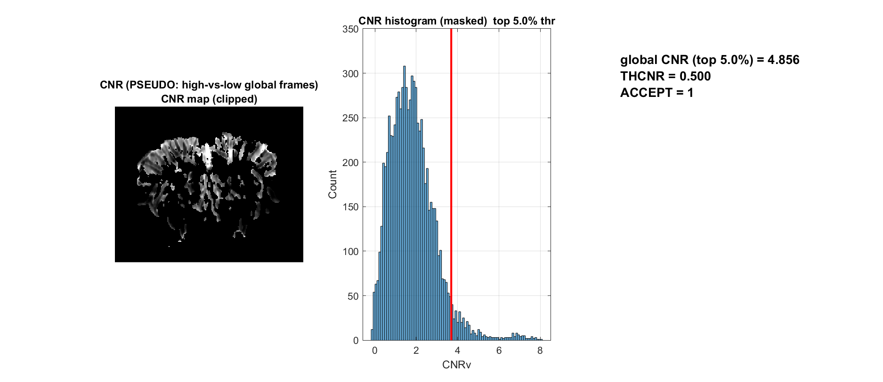
Full QC example. Read the map, corresponding time trace, axes and units together. Interpret spectral panels only after checking the acquisition timestamps.
Pseudo-CNR compares global intensity states. It is an exploratory contrast measure, not a test of a task effect or statistical significance.
Inspection step: compare the plot with the original movie and complementary QC views before deciding whether correction is justified.
Section summary. Pseudo-CNR does not use verified stimulation labels and must not be reported as a task significance result.
Important / practical tip. Pseudo-CNR does not use verified stimulation labels and must not be reported as a task significance result.

Shared spatial fluctuations
Figure 13. Shared spatial fluctuations
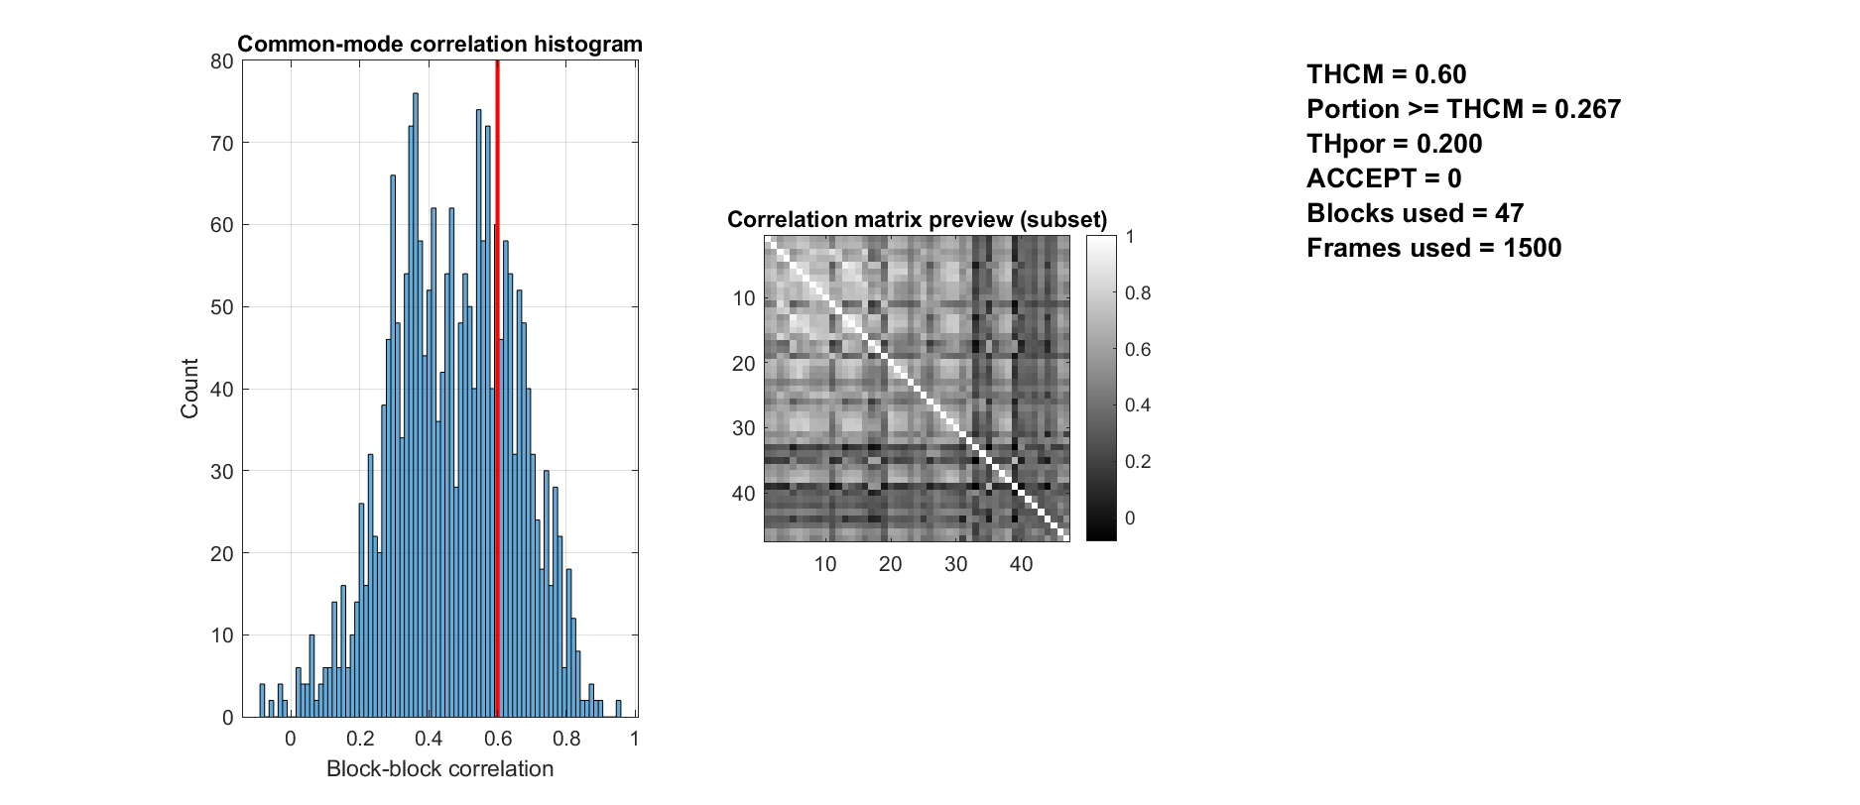
Full QC example. Read the map, corresponding time trace, axes and units together. Interpret spectral panels only after checking the acquisition timestamps.
Block correlation can reflect common physiology, response or artifact.
Inspection step: compare the plot with the original movie and complementary QC views before deciding whether correction is justified.
Section summary. Block correlation can reflect common physiology, response or artifact.
Important / practical tip. Open the raw movie at flagged times. A QC threshold is a screening rule, not biological ground truth.

Line outlier screening
Figure 14. Line outlier screening
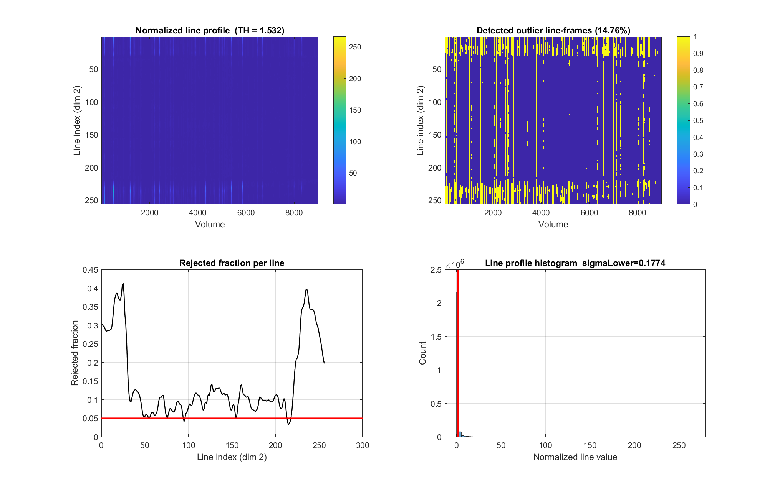
Full QC example. Read the map, corresponding time trace, axes and units together. Interpret spectral panels only after checking the acquisition timestamps.
Line-by-time patterns reveal localized failures diluted in a whole-frame mean.
Inspection step: compare the plot with the original movie and complementary QC views before deciding whether correction is justified.
Section summary. Line-by-time patterns reveal localized failures diluted in a whole-frame mean.
Important / practical tip. Open the raw movie at flagged times. A QC threshold is a screening rule, not biological ground truth.

Line replacement preview
Figure 15. Line replacement preview
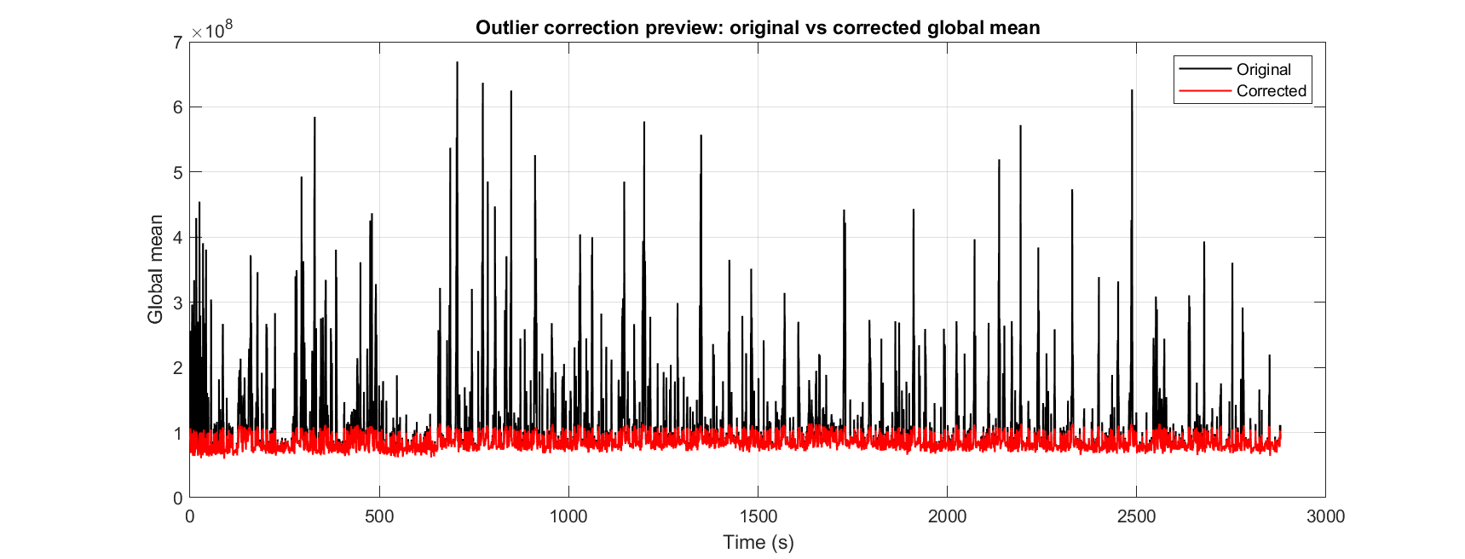
Full QC example. Read the map, corresponding time trace, axes and units together. Interpret spectral panels only after checking the acquisition timestamps.
The plot compares detected content with an optional replacement preview. Review the original movie before accepting any correction; a visually smooth replacement does not recover an observed measurement.
Inspection step: compare the plot with the original movie and complementary QC views before deciding whether correction is justified.
Section summary. Open the raw movie at flagged times. A QC threshold is a screening rule, not biological ground truth.
Important / practical tip. Open the raw movie at flagged times. A QC threshold is a screening rule, not biological ground truth.

Finite sample coverage
Figure 16. Finite sample coverage
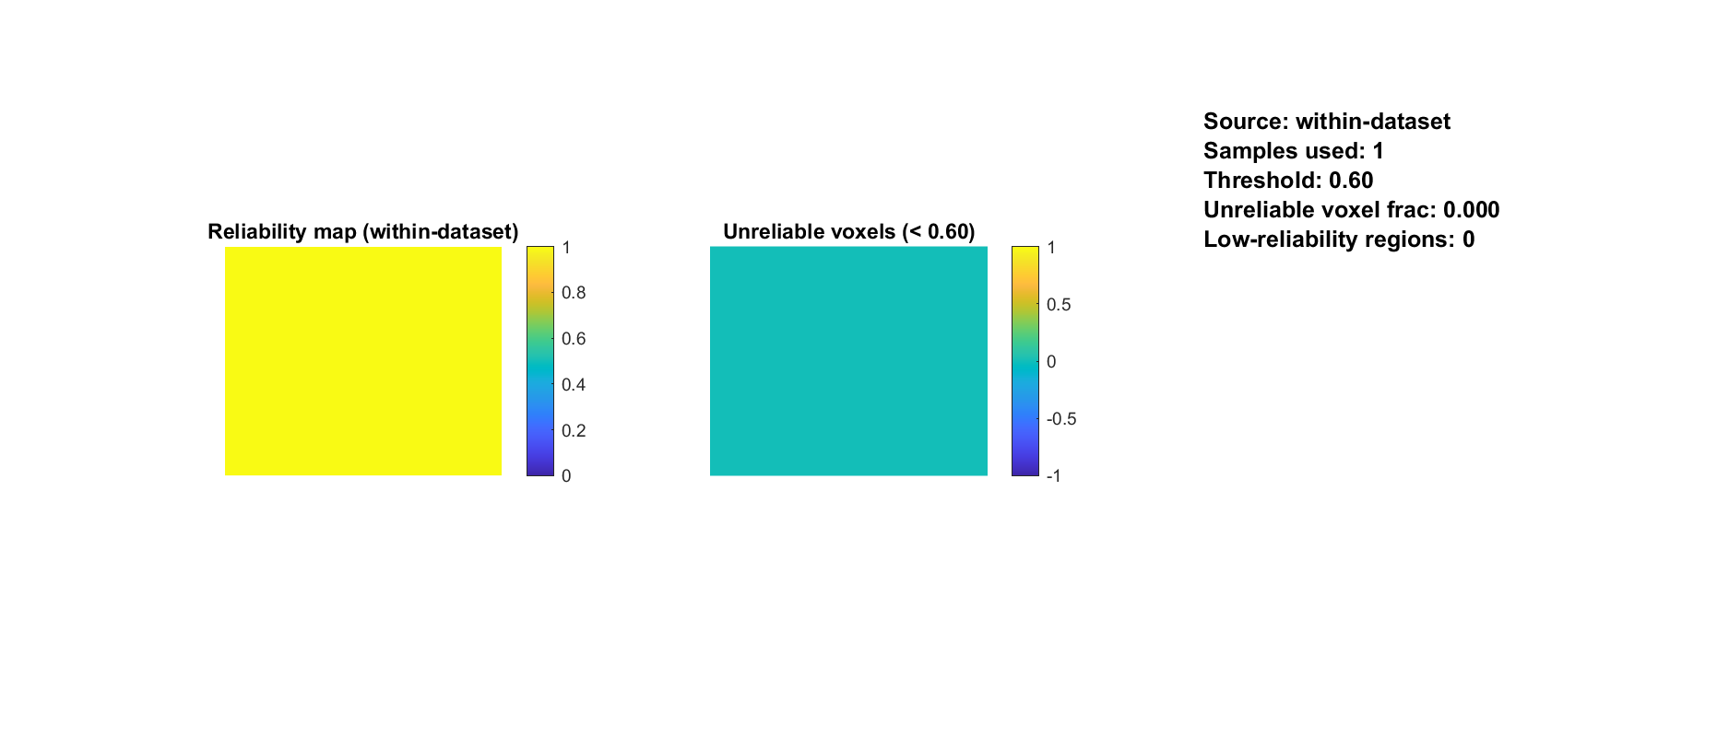
Full QC example. Read the map, corresponding time trace, axes and units together. Interpret spectral panels only after checking the acquisition timestamps.
Within-scan finite support is not test-retest reliability across independent animals.
Inspection step: compare the plot with the original movie and complementary QC views before deciding whether correction is justified.
Section summary. Within-scan finite support is not test-retest reliability across independent animals.
Important / practical tip. Finite sample coverage is different from test-retest reliability and biological signal validity.

Coverage value distribution
Figure 17. Coverage value distribution
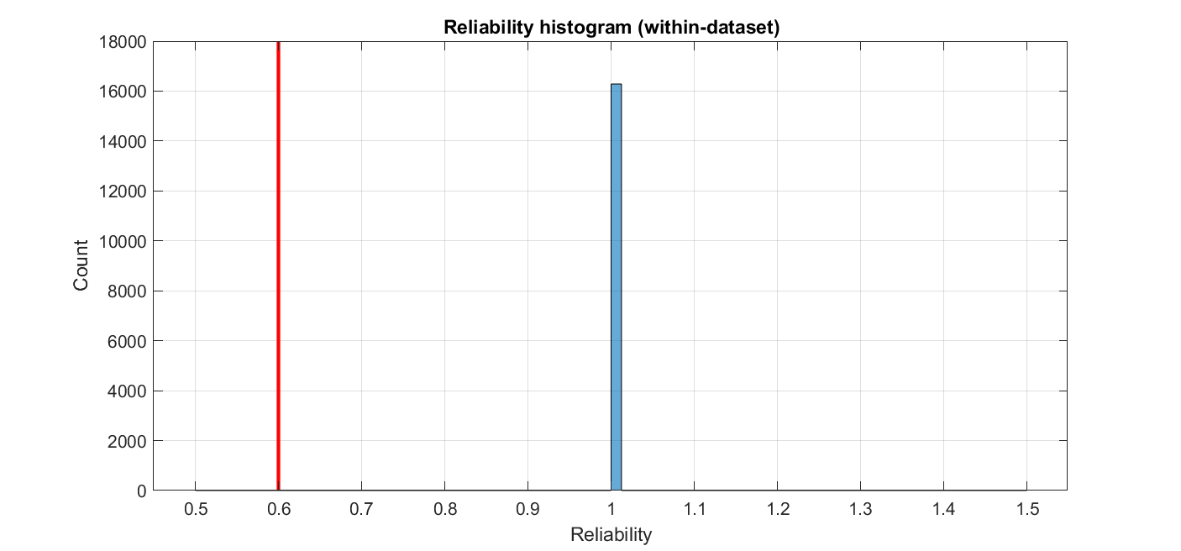
Full QC example. Read the map, corresponding time trace, axes and units together. Interpret spectral panels only after checking the acquisition timestamps.
Finite samples can still be corrupted by motion or nonspecific signal.
Inspection step: compare the plot with the original movie and complementary QC views before deciding whether correction is justified.
Section summary. Finite samples can still be corrupted by motion or nonspecific signal.
Important / practical tip. Finite sample coverage is different from test-retest reliability and biological signal validity.

Integrated diagnostic summary
Figure 18. Integrated diagnostic summary
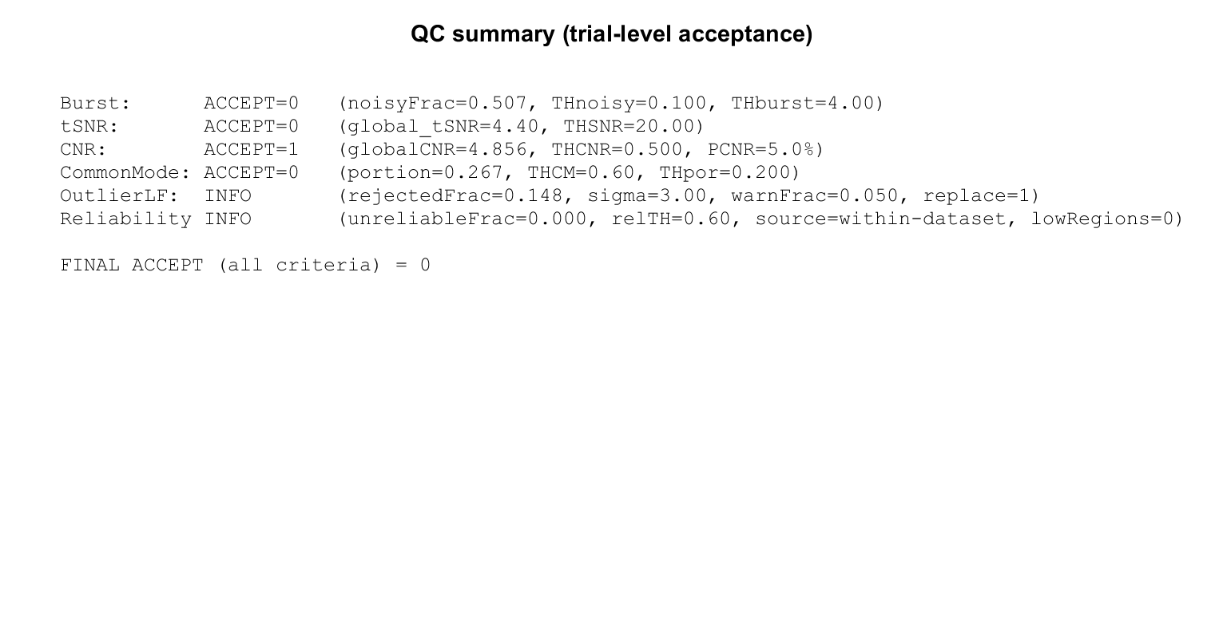
Full QC example. Read the map, corresponding time trace, axes and units together. Interpret spectral panels only after checking the acquisition timestamps.
ACCEPT is the implementation screening result, not a universal publication criterion.
Inspection step: compare the plot with the original movie and complementary QC views before deciding whether correction is justified.
Section summary. ACCEPT is the implementation screening result, not a universal publication criterion.
Important / practical tip. Open the raw movie at flagged times. A QC threshold is a screening rule, not biological ground truth.

Dominant variance spectrum
Figure 19. Dominant variance spectrum
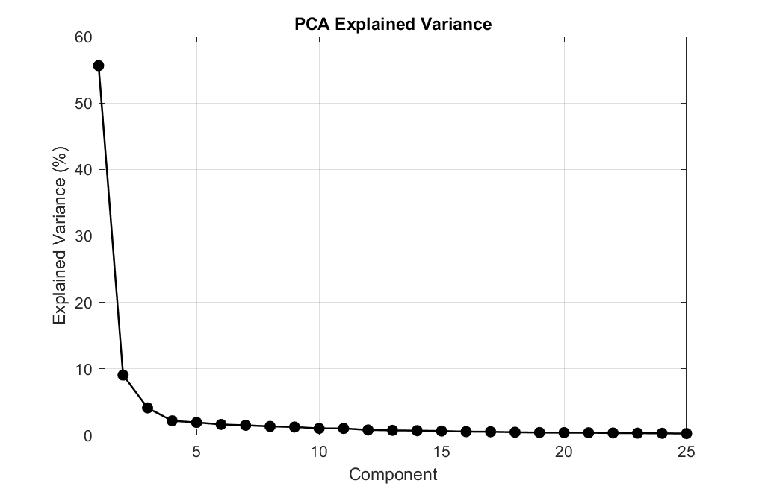
Full QC example. Read the map, corresponding time trace, axes and units together. Interpret spectral panels only after checking the acquisition timestamps.
QC uses documented spatial/time sampling caps, distinct from full-movie PCA removal.
Inspection step: compare the plot with the original movie and complementary QC views before deciding whether correction is justified.
Section summary. QC uses documented spatial/time sampling caps, distinct from full-movie PCA removal.
Important / practical tip. Irregular timestamps limit spectral inference. A spectrum calculated from a median interval is a diagnostic view, not proof of physiological frequency content.

QC component time profiles
Figure 20. QC component time profiles
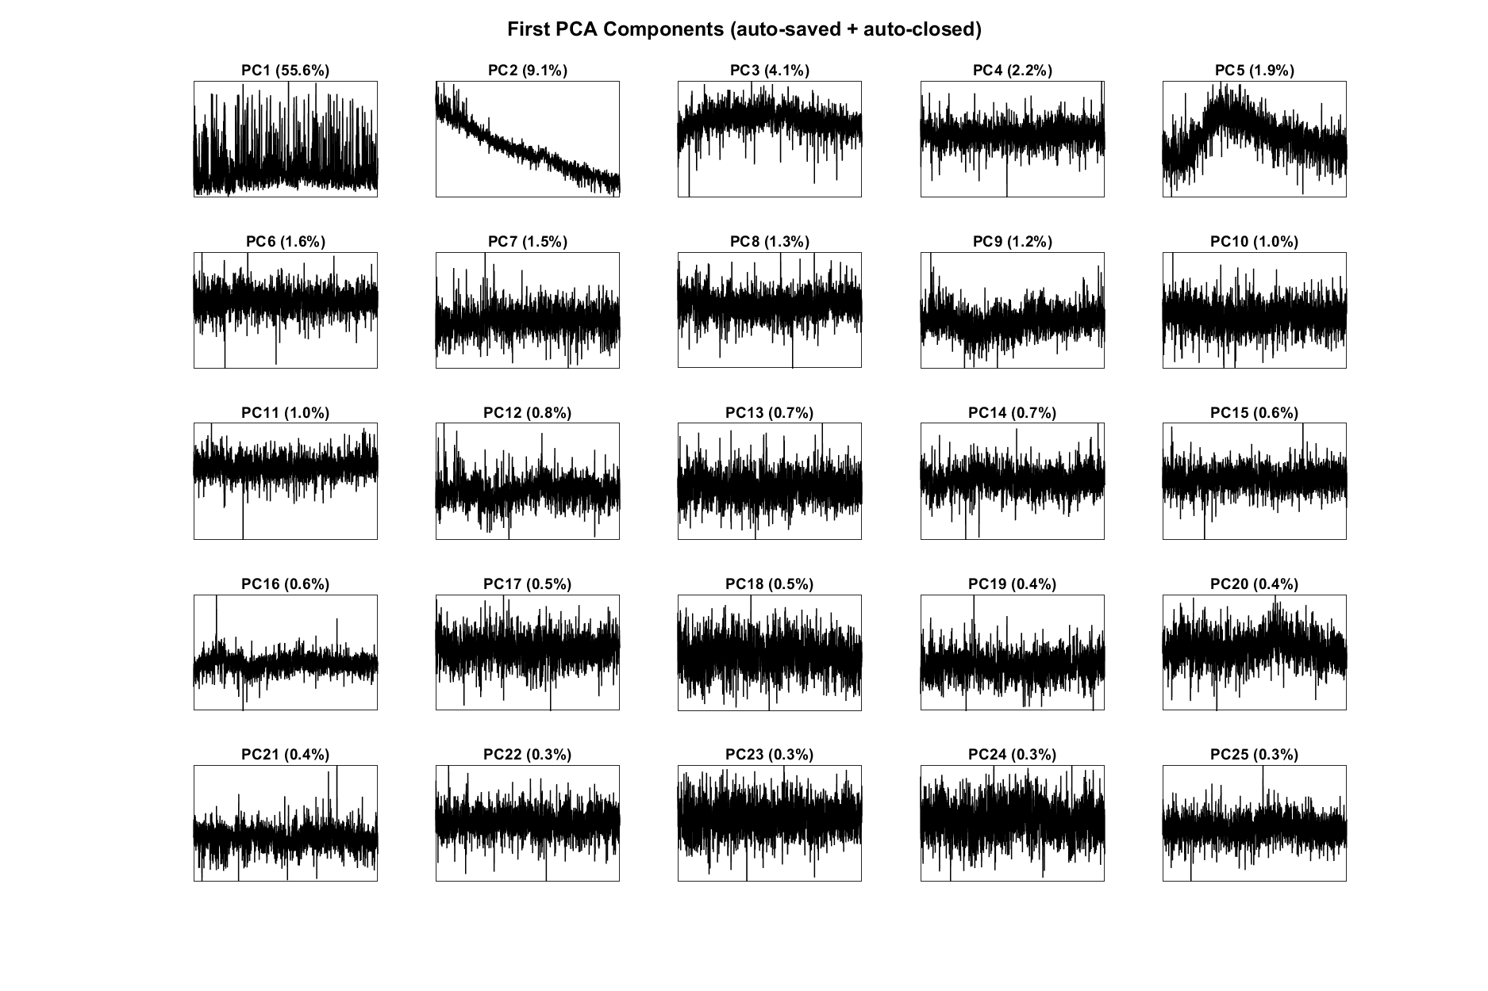
Full QC example. Read the map, corresponding time trace, axes and units together. Interpret spectral panels only after checking the acquisition timestamps.
Rank measures variance; it does not classify an artifact or justify automatic deletion.
Inspection step: compare the plot with the original movie and complementary QC views before deciding whether correction is justified.
Section and chapter summary. Rank measures variance; it does not classify an artifact or justify automatic deletion. Open the raw movie at flagged times. A QC threshold is a screening rule, not biological ground truth.
Important / practical tip. Open the raw movie at flagged times. A QC threshold is a screening rule, not biological ground truth.

10. Frame rejection, scrubbing and despiking

Frame rejection
Open Motion correction, choose Frame rejection, inspect the global-intensity QC and thresholds, and review the corresponding movie frames before applying interpolation. In the current engine, the global mean uses finite samples. It is divided by a median reference. The scale estimate uses deviations below the reference, with fallback estimates when necessary, and the default threshold multiplier is three.
Equation (5)
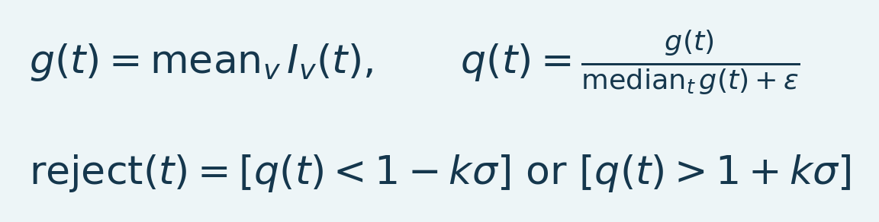
Variables and interpretation. g is frame mean intensity over finite voxels, q its median-normalized value and epsilon a conceptual zero-division safeguard. sigma is the detector scale estimated from lower-reference deviations with fallbacks. k is the threshold multiplier. Brackets denote a Boolean rejection flag.
The selected direction can be high only, low only or both. This is an intensity-outlier rule, not a displacement estimate. A sustained hemodynamic increase can alter the trace too. Review the flagged frames against the experimental timeline before accepting the mask.
Rejected frames are replaced along time using neighboring good frames; leading and trailing runs clamp to the nearest valid support. The shape and timing grid are preserved. Replaced samples are estimates, not new independent measurements. Record the count and indices and check whether a large contiguous missing interval makes the desired analysis untenable.
Section summary. Open Motion correction , choose Frame rejection , inspect the global-intensity QC and thresholds, and review the corresponding movie frames before applying interpolation.
Important / practical tip. Record gap lengths and original usable samples; interpolation does not recover lost observations.

Scrubbing
Scrubbing targets high-change frames using the selected frame-difference metric, such as DVARS, and interpolates according to its options. A frame can pass global intensity QC yet fail a motion-change metric. Inspect both the detection signal and the replacement effect. Preserve the original recording to assess sensitivity to the criterion.
Section summary. Scrubbing targets high-change frames using the selected frame-difference metric, such as DVARS, and interpolates according to its options.
Important / practical tip. Record gap lengths and original usable samples; interpolation does not recover lost observations.

Despiking
Despike operates voxel by voxel using a temporal median and median-absolute-deviation scale. It replaces detected values by the selected implementation's temporal interpolation. The current implementation processes bounded chunks; that changes memory use and speed, not the intended voxel-wise detection rule. Its endpoint extrapolation differs from the clamped whole-frame replacement path, so the two operations are not interchangeable.
Section summary. Despike operates voxel by voxel using a temporal median and median-absolute-deviation scale.
Important / practical tip. Record gap lengths and original usable samples; interpolation does not recover lost observations.

Choosing among them
Table 3. Choosing among them overview
Observation | Inspect first | Main limitation
Whole-frame intensity excursion | Frame rejection | A physiological response can also change intensity
Abrupt frame-to-frame displacement/change | Scrubbing and movie | Detection does not spatially realign tissue
Sparse isolated voxel transients | Despike | Sustained artifacts may not be sparse spikes
Smooth anatomical displacement | Spatial registration | Nonrigid warping can alter anatomy and interpolation

Do not apply all four automatically. Inspect residuals and the response of interest. Record interpolation and rejection before applying a frequency filter, because a spike contributes energy across many frequencies.
Source: Motion.m, frameRateQC.m, scrubbing.m, despike.m, fusiDespikeVoxels.m, deConfUSIon_signal.m.
Section summary. Record gap lengths and original usable samples; interpolation does not recover lost observations.
Important / practical tip. Record gap lengths and original usable samples; interpolation does not recover lost observations.

Why frame rejection is needed
A corrupted frame can dominate a temporal average, covariance matrix or fitted component. Rejection marks an acquisition as unreliable; interpolation substitutes an estimate for algorithms requiring a regular finite series. It does not recover the lost observation. Long/repeated gaps can make an epoch unsuitable for inference even when the replacement movie looks smooth.
The detector responds to global intensity departures, not measured millimeter displacement. A genuine widespread response may cross a threshold. Inspect flagged frames and their relationship to stimulation/injection. Keep flags and gap lengths with exports; reason about information using original usable observations.
Equation (6)
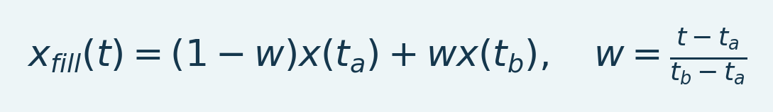
Variables and interpretation. t_a/t_b are nearest retained times bracketing t. x(t_a)/x(t_b) are measured endpoints, w the fractional location and x_fill the interpolated estimate. Distinct valid endpoints are required; the formula does not describe endpoint extrapolation.
For an interior gap this joins retained endpoints. Frame-rejection interpolation clamps boundary runs to the nearest available value; the separate despiking path can linearly extrapolate endpoints. Neither recovers a measured response during a long missing interval.
Section and chapter summary. A corrupted frame can dominate a temporal average, covariance matrix or fitted component. Record gap lengths and original usable samples; interpolation does not recover lost observations.
Important / practical tip. Record gap lengths and original usable samples; interpolation does not recover lost observations.

IV. Preprocessing and temporal models

11. Chop Data and event alignment
Chop Data removes time from the beginning and/or end of the active recording. It does not estimate motion or repair an intensity jump. Enter durations in seconds, inspect how many frames they correspond to at the active TR, apply, then check the new dataset and time axis.
The derived recording retains the relationship to original frame indices and timestamps while its displayed time begins at zero. Therefore a stimulus at 300 seconds in the original recording is not still at 300 seconds if the first 60 seconds were removed. Update all downstream baseline, signal and FC windows to the derived recording's coordinate system.

A numerical example
At TR 0.32 seconds, removing the first 100 frames removes 32 seconds of nominal acquisition time. The first retained frame originally occurred at 32 seconds; the derived display starts it at zero. If the event log remains in original scanner time, subtract the crop offset or use the retained timestamp mapping. Never shift an event twice simply because both the filename and a metadata field mention chopping.
Section summary. At TR 0.32 seconds, removing the first 100 frames removes 32 seconds of nominal acquisition time.
Important / practical tip. Update the time origin and event coordinates when removing the beginning of a recording.

Before using the result
Check that the remaining acquisition fully covers baseline and response. Avoid a baseline cut so short that only a few frames remain after later block averaging. Reopen QC for the retained segment. Derived raw/normalized datasets and event annotations should all refer to the same time origin.
Source: Motion.m, embedded Chop Data callback in fusi_studio_GUI.m.
Section and chapter summary. Check that the remaining acquisition fully covers baseline and response. Update the time origin and event coordinates when removing the beginning of a recording.
Important / practical tip. Update the time origin and event coordinates when removing the beginning of a recording.

12. Temporal smoothing, block averaging and interpolation
These operations affect time differently. A sliding smoother retains the number of frames; block averaging reduces it; display interpolation increases the number of plotted samples without increasing acquired information.

Sliding mean
Equation (7)
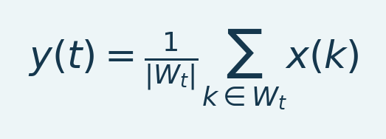
Variables and interpretation. x is input, y smoothed output and W_t the included indices around time t. |W_t| is their number; all signal terms retain the input units. Endpoints depend on available support.
The window is specified in physical time and converted to samples. Wider windows reduce rapid variation and can attenuate the response. Inspect edge behavior and the actual window reported in metadata. Overlapping windows share data, so neighboring output samples are correlated.
Section summary. The window is specified in physical time and converted to samples.
Important / practical tip. Calculate the resulting TR before choosing a block factor; preserve enough samples across the fastest event.

Block mean or median
Equation (8)
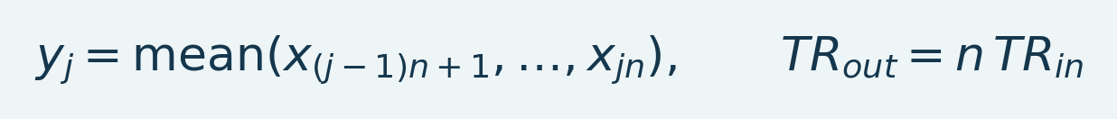
Variables and interpretation. y_j is block j of input x, n the original frames per full block. TR_in and TR_out are input/output intervals. Median blocks use the same timing change but a different statistic.
The median alternative is nonlinear and can behave differently around transients. A remainder shorter than a complete block may be dropped by the selected processing route; record the retained frame count. Downsampling must be justified with respect to the frequency content you want to preserve. A block operation is not a substitute for examining aliasing or acquisition irregularity.
Section summary. The median alternative is nonlinear and can behave differently around transients.
Important / practical tip. Calculate the resulting TR before choosing a block factor; preserve enough samples across the fastest event.

Temporal interpolation
Linear interpolation estimates values between recorded samples. With integer factor N, the display interval decreases to TR/N, while original acquired samples remain the scientific support. More interpolated frames make a movie smoother but do not provide a higher independent sample size or a faster hemodynamic response.
The PSC engine's integer-factor interpolation assumes a uniform input interval. For genuine irregular timestamps, first establish a justified resampling procedure from the original time vector. Do not describe integer upsampling as a correction of dropped acquisition triggers unless that correction was actually performed and checked.
Section summary. Calculate the resulting TR before choosing a block factor; preserve enough samples across the fastest event.
Important / practical tip. Calculate the resulting TR before choosing a block factor; preserve enough samples across the fastest event.

Recommended decisions
Use the smallest smoothing window justified by the question. Review a known transient before and after. When block averaging is combined with Imregdemons, distinguish the temporal reduction from the spatial registration; both occur in that workflow. Confirm the updated Nyquist frequency before applying LPF, HPF or band-pass filtering.
Source: temporalsmoothing.m, computePSC.m, imregdemons_preprocess.m, deConfUSIon_collapse_time.m.
Section and chapter summary. Use the smallest smoothing window justified by the question. Calculate the resulting TR before choosing a block factor; preserve enough samples across the fastest event.
Important / practical tip. Calculate the resulting TR before choosing a block factor; preserve enough samples across the fastest event.

13. Imregdemons: averaging and spatial motion correction
Imregdemons aligns moving images to a fixed reference through a displacement field. MATLAB supports 2D and 3D registration; smoothing of the accumulated field controls its spatial regularity MathWorks documentation.

What this workflow actually does
1. Divide time into complete blocks of nsub frames.
2. Reduce each block by mean or median.
3. Build the reference from the first up to ten reduced frames.
4. Register each reduced frame to that reference.
5. Return the registered series and the multiplied TR, with QC outputs when selected.
For [Y X T] input, the registration is 2D. For a true [Y X Z T] volume it is 3D. Step-motor mode registers each acquired plane independently over time. Choose the mode according to the acquisition, not just the array dimensionality.
Section summary. For [Y X T] input, the registration is 2D.
Important / practical tip. Compare reduced unregistered and registered frames so averaging is not mistaken for improved alignment.

Mathematical interpretation
Equation (9)
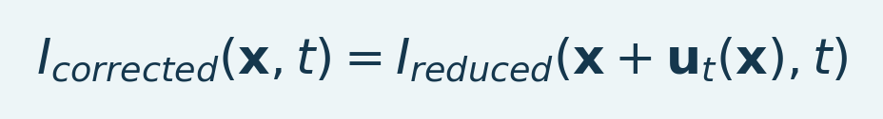
Variables and interpretation. x is spatial position, u_t(x) the displacement for resampling at time t. I_reduced is the temporally reduced movie and I_corrected the resampled result. Coordinate direction and units follow MATLAB geometry; this is a conceptual pull-resampling equation.
The displacement field u_t maps sampling locations for the moving image. Resampling can alter local intensities through interpolation and boundary fill. The operation does not simply subtract an artifact trace. It is not expected to preserve each voxel's temporal mean exactly after moving tissue between voxel locations.
Section summary. The displacement field u_t maps sampling locations for the moving image.
Important / practical tip. Compare reduced unregistered and registered frames so averaging is not mistaken for improved alignment.

Review procedure
Open early, middle and late reduced frames with a stable display range. Compare vessel landmarks, cortex and brain boundaries. Inspect displacement and registration QC if present. Excessively flexible warps can deform anatomy or absorb real response-related appearance changes; a better looking overlay alone is insufficient evidence. Compare against the unregistered reduced series to distinguish averaging from registration.
Section summary. Open early, middle and late reduced frames with a stable display range.
Important / practical tip. Compare reduced unregistered and registered frames so averaging is not mistaken for improved alignment.

Parameters and performance
nsub controls temporal reduction; regSmooth controls displacement-field smoothing rather than a temporal cutoff. Increasing nsub can reduce registration work but also reduces temporal resolution. Compute the new interval as TRout = nsub × TRin, then verify the Nyquist frequency before selecting a temporal passband.
Full-volume nonrigid registration can legitimately take time. Progress should identify the current frame/volume or motor plane. Do not interpret a long nonrigid registration as a reason to choose scientifically unsuitable downsampling. The performance report distinguishes full-record operations from shorter registration checks.
Source: imregdemons_preprocess.m, Studio Imregdemons callback, deConfUSIon_ui.m.
Section and chapter summary. Compare reduced unregistered and registered frames so averaging is not mistaken for improved alignment. Compare reduced unregistered and registered frames so averaging is not mistaken for improved alignment.
Important / practical tip. Compare reduced unregistered and registered frames so averaging is not mistaken for improved alignment.

14. Temporal filtering and restoring the mean
Open Filtering, select a family, type and valid cutoff frequencies, inspect the frequency response, and keep Preserve voxel mean enabled when the output is intended for ordinary Doppler PSC. Review TR first.
Table 4. 14. Temporal filtering and restoring the mean overview
Family | Interpretation
Butterworth | Smooth passband; default family
Chebyshev I | Passband ripple; passband edge specification
Chebyshev II | Stopband ripple; stopband edge specification
Elliptic | Passband and stopband ripple with a sharp transition
FIR Hamming | Finite impulse response; order controls transition width
FFT bins | Symmetric finite-record frequency mask; periodic-boundary assumptions

Mean-preserving filtering
Equation (10)
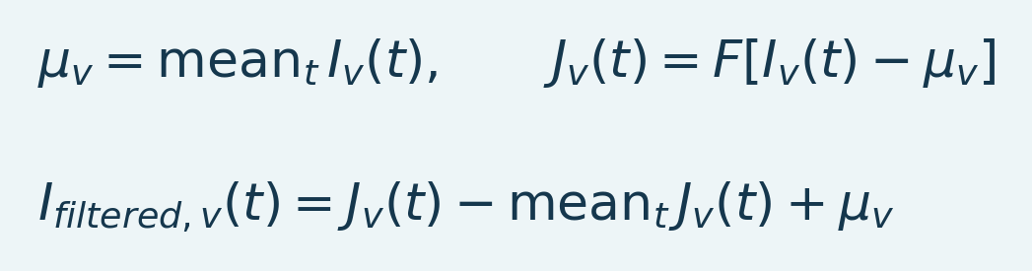
Variables and interpretation. mu_v is original voxel mean, F the temporal filter and J its output on centered input. Subtracting J's temporal mean and restoring mu_v explicitly preserves that level. I_filtered is the output; restoration cannot restore removed biological frequency content.
Preserving the mean explicitly retains DC even for high-pass or band-pass settings. This is intentional when a positive Doppler baseline is needed for PSC. With mean preservation disabled, a centered output can have a near-zero baseline and should not be normalized as though it were positive raw power.
Forward/backward filtering has zero phase in its supported formulation and magnitude response |H(f)|^2; it changes the effective order and attenuation MathWorks filtfilt documentation. The current filter implementation uses stable sections where appropriate and records the actual settings. A short recording may be too short for the required padding; an explicit error is preferable to silently switching to a different phase response.
Section summary. Preserving the mean explicitly retains DC even for high-pass or band-pass settings.
Important / practical tip. Use the analyzed TR and inspect actual response/endpoint QC; mean restoration does not restore removed dynamics.

Avoid common mistakes
Cutoffs must be below 1/(2*TR). A 20-second analyzed interval has Nyquist 0.025 Hz, so 0.2 Hz is invalid. A 0.001-Hz low-pass strongly suppresses a 60-second periodic response whose fundamental is about 0.0167 Hz. Choose the band from the experimental timescale, not visual smoothness.
Frame spikes have broad spectral content. LPF can spread a spike into a slow transient. Review motion and interpolation before filtering. Missing/nonfinite voxel time courses are recorded rather than silently treated as complete clean signals. Frames outside a selected trimmed interval remain governed by that route's settings; inspect the saved frame range.
Section summary. Use the analyzed TR and inspect actual response/endpoint QC; mean restoration does not restore removed dynamics.
Important / practical tip. Use the analyzed TR and inspect actual response/endpoint QC; mean restoration does not restore removed dynamics.

Scripted example
opts = struct('method','butter','type','low','FcHigh',0.1, ...
'order',4,'restoreMean',true,'saveQC',true);
[J, stats] = filtering(I, TR, analysedFolder, opts);
This example specifies an API, not a universal cutoff. Confirm a uniform verified sampling interval and sufficient length before running it.
Source: filtering.m, temporal filtering notes.
Section summary. This example specifies an API, not a universal cutoff.
Important / practical tip. Use the analyzed TR and inspect actual response/endpoint QC; mean restoration does not restore removed dynamics.

Transfer functions and cutoff meaning
Equation (11)
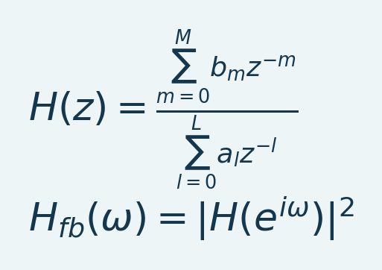
Variables and interpretation. z is complex transform variable; b_m/a_l are numerator/denominator coefficients with orders M/L. omega is radians per sample, 2*pi*f*TR for frequency f in hertz. H is single-pass response and H_fb ideal interior forward-backward response for real coefficients. Finite-record endpoint treatment modifies this idealization.
The coefficients define an infinite impulse response (IIR) filter when the denominator has feedback terms. A finite impulse response (FIR) filter has a finite convolution kernel. Normalize a MATLAB cutoff by the Nyquist frequency using the analyzed TR after block reduction. Forward-backward filtering removes interior phase delay but changes magnitude response and retains endpoint transients [L4]. Use APIs available in R2023b; newer online options may not exist in that release.
Table 5. Transfer functions and cutoff meaning overview
Family | Mathematical design idea | Practical consequence
Butterworth | Maximally flat analog prototype transformed to the digital band | Smooth monotone response; inspect two-pass attenuation
Chebyshev I | Equiripple passband using a Chebyshev polynomial | Steeper transition trades against retained-band ripple
Chebyshev II | Inverse-Chebyshev design with stopband ripple | Specify attenuation and inspect the retained band
Elliptic | Ripple in both passband and stopband | Narrow transition; ringing/amplitude trade-offs
Hamming FIR | Window a finite ideal-response kernel | Longer kernels need more data and affect boundaries
FFT mask | Multiply Fourier coefficients by frequency weights | Sharp edges can ring; periodic extension matters

Families have different cutoff conventions. The code delegates design to MATLAB and records family, order, cutoff and mean restoration. Inspect actual frequency-response QC and family-specific specifications [L3, L5].
Equation (12)
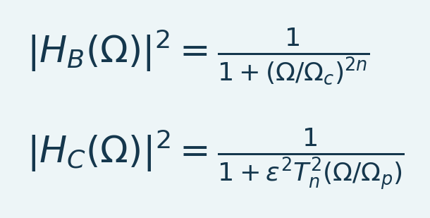
Variables and interpretation. Omega is analog angular frequency, Omega_c Butterworth cutoff and Omega_p Chebyshev-I passband edge. n is prototype order, epsilon controls ripple and T_n is the degree-n Chebyshev polynomial. H_B/H_C are analog prototypes. Evaluate transformed digital responses on the analyzed grid.
These are analog low-pass prototypes for Butterworth and Chebyshev I. Digital design transforms frequencies; do not substitute hertz directly into an analog angular-frequency expression. Chebyshev II and elliptic designs impose different rational approximation constraints. Evaluate their digital responses from the general transfer function.
Equation (13)
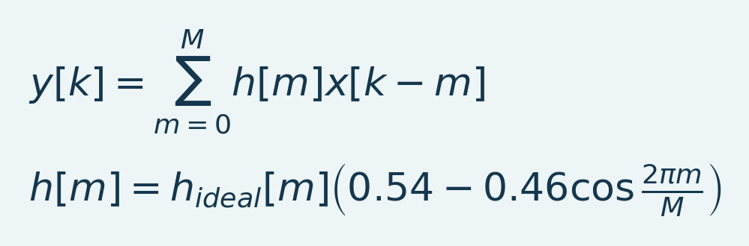
Variables and interpretation. k is output index and m tap index from zero to order M. x is input, h finite kernel and y convolution output. h_ideal is the truncated ideal response; the Hamming factor tapers endpoints. Actual coefficients also follow band and normalization choices.
This illustrates Hamming-window FIR construction. An FFT mask instead inverse-transforms the data spectrum multiplied by selected weights. A sharp frequency boundary does not establish a physiological boundary between signal and artifact.
Section summary. The coefficients define an infinite impulse response (IIR) filter when the denominator has feedback terms.
Important / practical tip. Use the analyzed TR and inspect actual response/endpoint QC; mean restoration does not restore removed dynamics.

Fourier masks and boundary assumptions
Equation (14)
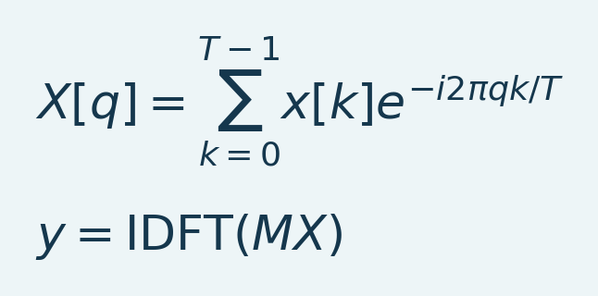
Variables and interpretation. T is the number of time samples, k sample index, q frequency-bin index and i the imaginary unit. x is the input trace, X its discrete Fourier transform, M the bin-wise frequency mask and y the reconstructed output. IDFT denotes the inverse transform. Real reconstructions require conjugate-symmetric frequency weighting; physical bin frequencies depend on T and analyzed TR.
The FFT implementation selects symmetric frequency bins so the real input has a real reconstruction. A finite-record transform treats the record as periodically extended. A mismatch between the last and first samples spreads spectral content; hard mask edges produce long temporal kernels. Compare endpoints and sustained responses in the resulting movie. FFT masking is not equivalent to every IIR/FIR design with similarly named band limits.
Section summary. The FFT implementation selects symmetric frequency bins so the real input has a real reconstruction.
Important / practical tip. Use the analyzed TR and inspect actual response/endpoint QC; mean restoration does not restore removed dynamics.

Select a band from the scientific question
For sustained drug responses, compare unfiltered and mean-preserving low-pass branches before considering high-pass/band-pass. For FC, report band limits and usable duration, and compare a reasonable alternative nuisance strategy. fUSI denoising choices can affect connectivity; no single pipeline is optimal for every experiment [L8].
Section and chapter summary. For sustained drug responses, compare unfiltered and mean-preserving low-pass branches before considering high-pass/band-pass. Use the analyzed TR and inspect actual response/endpoint QC; mean restoration does not restore removed dynamics.
Important / practical tip. Use the analyzed TR and inspect actual response/endpoint QC; mean restoration does not restore removed dynamics.

15. PCA: component review and removal
Figure 21. PCA temporal component review
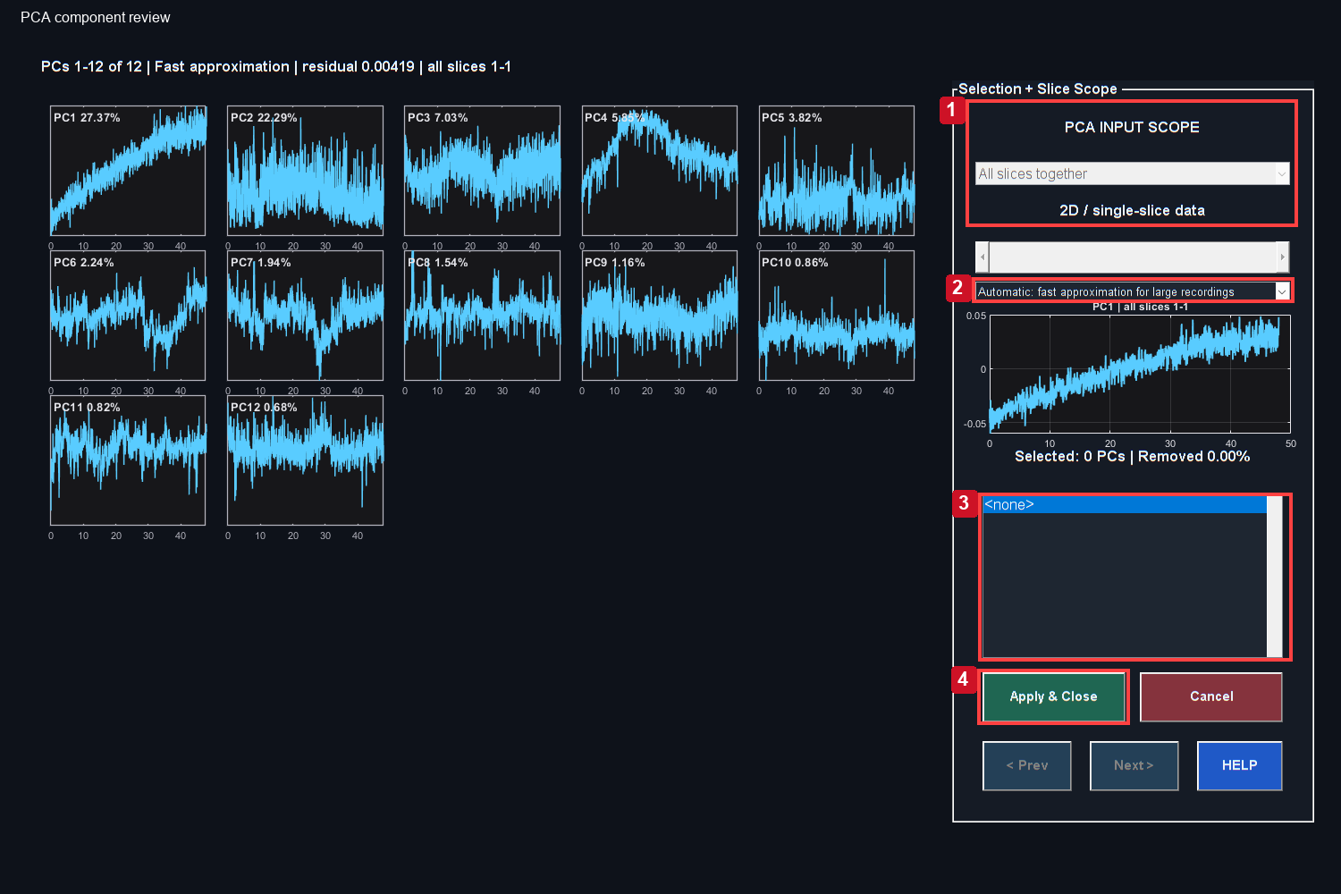
The actual PCA GUI provides temporal previews and removal controls. It does not contain the separate mathematical spatial-weight map discussed in the text.
Controls: 1. Confirm spatial scope; 2. Numerical estimation method; 3. Selected removal set; 4. Apply reviewed removal and save.

PCA separates dominant orthogonal directions of variance in a centered voxel-by-time matrix. It can identify shared motion or physiological patterns, but component number alone does not identify an artifact.
Equation (15)
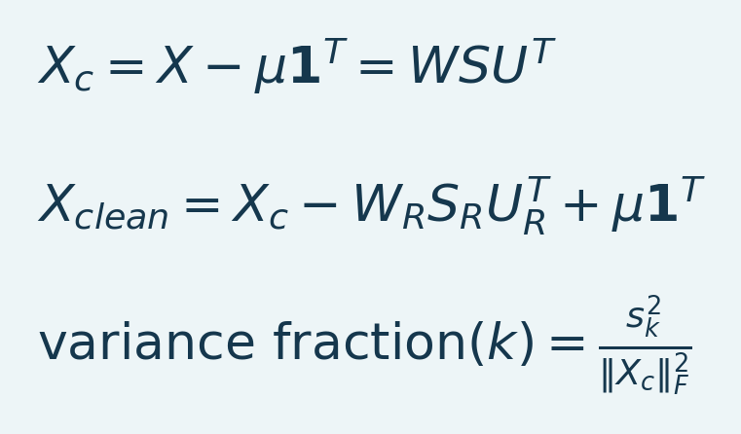
Variables and interpretation. X has V voxel rows and T time columns. mu is V-by-1 voxel means and 1 a T-by-1 ones vector. X_c is centered input. W holds spatial orthonormal columns, S singular values s_k, and U temporal orthonormal columns. Subscript R selects removed components. The Frobenius norm squared is total centered energy; X_clean restores means after subtraction.
R is the set of components selected for removal. The default voxel-centering route restores the saved voxel means. A global-centering option has a different model. Removed variance is not equivalent to removed artifact fraction or recovered neural signal.

Click-by-click review
1. Select the intended raw or processed dataset in Studio.
2. Open PCA / ICA and choose PCA.
3. Confirm the animal, dataset, number of components and slice scope.
4. Inspect each candidate component's time course and compare transient times with the movie and QC. The current PCA GUI presents temporal previews; it does not show the spatial weight matrix. Do not describe that window as a spatial component-map viewer. Spatial basis inspection requires a separate source-level analysis; ICA's spatial preview belongs to its different model.
5. Select only the components justified by a documented criterion. Compare a retained-PC1 analysis when a global component could contain the response of interest.
6. Click Apply & Close. Watch removal, mean restoration, dataset preparation and saving progress.
7. Wait for saved and ready, then verify the new active label and reopen the movie/QC.
Section summary. Do not remove PCs by rank alone. Compare their timing with independent artifact and experimental evidence.
Important / practical tip. Do not remove PCs by rank alone. Compare their timing with independent artifact and experimental evidence.

Exact and approximate computation
The temporal basis engine selects a deterministic randomized method for large matrices or long recordings; smaller cases can use exact PCA. An exact option remains available. Approximation settings, seed and residual are recorded. A small residual evaluates the numerical basis approximation, not anatomical validity. Closely spaced weak components may differ between exact and approximate solutions.
Section summary. The temporal basis engine selects a deterministic randomized method for large matrices or long recordings; smaller cases can use exact PCA.
Important / practical tip. Do not remove PCs by rank alone. Compare their timing with independent artifact and experimental evidence.

Slice scope
An all-slice decomposition models shared variance across the selected volume. A slice-specific decomposition analyzes one plane and places its result back into the original movie while retaining other planes. The selected scope is recorded. These are different scientific operations even if the same component number is removed.
Section summary. An all-slice decomposition models shared variance across the selected volume.
Important / practical tip. Do not remove PCs by rank alone. Compare their timing with independent artifact and experimental evidence.

Progress and apparent completion
Removal is only part of the workflow. The bar reserves its final portion for saving, writes the image in bounded chunks, verifies the MAT dataset and then publishes the final filename. A server write can remain slower than the calculation. Cancellation is available during removal; the durable save phase is not interrupted midway by the Cancel button. Save failures retain the result for recovery.
The October repair also prevents the Time-Course Viewer from substituting an old cached PSC array for the active Doppler movie. A blank-looking Raw Intensity view after PCA should therefore be checked with the current reopened viewer, neutral controls and the correct active dataset, before assuming the mean was lost.
Source: pca_denoise.m, deConfUSIon_signal.m, studioSaveDataset.m, fusiWriteAnalysisMAT.m, DataIO.m.
Section summary. Do not remove PCs by rank alone. Compare their timing with independent artifact and experimental evidence.
Important / practical tip. Do not remove PCs by rank alone. Compare their timing with independent artifact and experimental evidence.

PCA intuition: one map times one profile
Arrange the movie as voxels by time. Mean-center each voxel so the decomposition describes fluctuations around its own mean. The first component contributes the most centered variance; subsequent components describe orthogonal remaining patterns [L2]. Orthogonality is a geometric constraint; statistical independence is stronger and is not guaranteed by PCA.
A component contributes a spatial weight multiplied by a temporal profile. Positive and negative excursions express opposite signs of that pattern. Flipping both factors changes no reconstructed data. A profile summarizes the analyzed voxels; it is not one anatomical voxel's trace.
Equation (16)
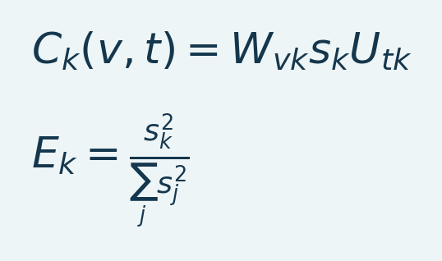
Variables and interpretation. k indexes a component, v voxel and t time. W_vk is spatial weight, U_tk temporal basis value and s_k singular value. C_k is that contribution in signal units, E_k its full centered-energy fraction. The sum includes all singular values j; truncated bases need recorded total energy.
For a truncated decomposition, use recorded full centered energy rather than silently normalizing only retained components. PC1 can contain motion, physiology, drift or a true widespread response. Its rank is not an artifact label.
Section summary. Do not remove PCs by rank alone. Compare their timing with independent artifact and experimental evidence.
Important / practical tip. Do not remove PCs by rank alone. Compare their timing with independent artifact and experimental evidence.

Spatial weights and temporal profiles
Figure 22. Real PCA factor example
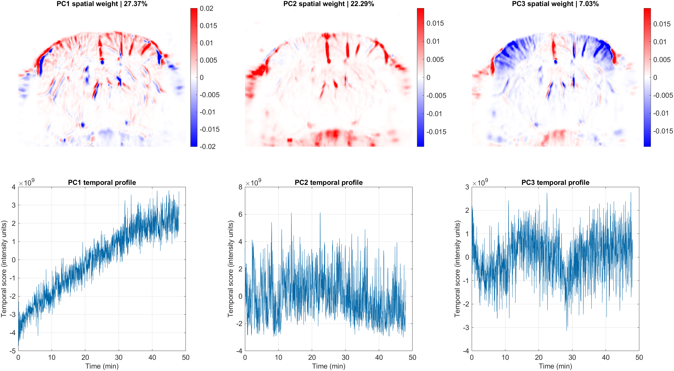
Scientific plot from the toolbox basis engine on the stated 2D teaching branch. Each column pairs spatial weights with a temporal score. Signed weights are not activation labels; no component is classified or removed here.
This independently rendered scientific plot uses the same 2D teaching branch and the toolbox temporal-basis engine. It is not a screenshot of a hidden GUI panel. Each column pairs one spatial weight map with its temporal score. Red and blue indicate opposite loading signs, not positive/negative activation. Map color limits use the 99th percentile of absolute weights for display; the numerical factorization is unchanged. Fractions use the full centered energy.
Read one column vertically: multiply its spatial weight by its temporal score to recover that component's contribution. Broad common patterns need independent interpretation. None of these components is labelled as an artifact or selected for removal in this teaching figure.
Section summary. This independently rendered scientific plot uses the same 2D teaching branch and the toolbox temporal-basis engine.
Important / practical tip. Do not remove PCs by rank alone. Compare their timing with independent artifact and experimental evidence.

What removal changes
Removal subtracts the entire spatial-by-temporal contribution from included samples with voxel-specific weights, rather than one identical waveform from every voxel. The engine restores the intended voxel mean. The original remains available for another branch; the removed contribution is absent from the derived result. Repeating removal on a cleaned branch is a new operation.
Change the removal set by returning to the original branch. Compare an independently defined ROI in original/derived data. If task timing overlaps a component, removal can attenuate biology. A short stimulation is not by itself a reason to delete PC1.
Section summary. Removal subtracts the entire spatial-by-temporal contribution from included samples with voxel-specific weights, rather than one identical waveform from every voxel.
Important / practical tip. Do not remove PCs by rank alone. Compare their timing with independent artifact and experimental evidence.

PCA matrix conventions
This manual consistently uses voxel-by-time matrices, W for the spatial basis and U for the temporal basis, matching the implementation. Other texts may transpose the matrix and exchange factor names. Transpose dimensions consistently when comparing equations. The PCA GUI shows temporal previews; a mathematical spatial map is not an additional GUI panel.
Randomized low-rank estimation accelerates computation with recorded numerical checks; it is not random frame removal [L6].
Section and chapter summary. Do not remove PCs by rank alone. Compare their timing with independent artifact and experimental evidence. Do not remove PCs by rank alone. Compare their timing with independent artifact and experimental evidence.
Important / practical tip. Do not remove PCs by rank alone. Compare their timing with independent artifact and experimental evidence.

16. ICA, SVD and drift compensation
Figure 23. ICA component inspection
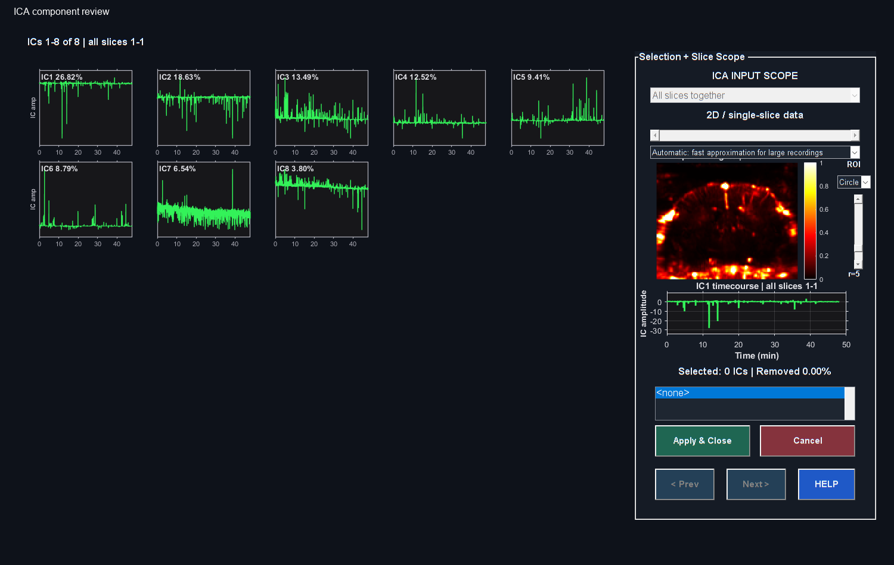
Actual MATLAB output from the reference workflow. Read the chapter steps for controls, input sampling, units and interpretation limits. The screenshot is a software example, not a validated biological result.

ICA
ICA seeks components with statistical independence under its model, rather than only orthogonality. The implementation uses a compact temporal representation and iterative estimation, and reports convergence information. Independent components are not guaranteed to correspond to individual physiological sources. Sign and ordering can change without a change in the underlying decomposition meaning.
In matrix form the retained-rank model is X_centered approximately A*S, with spatial mixing weights in A and component time courses in S. Removing selected components subtracts A_R*S_R before restoring the chosen mean. This implementation whitens a compact temporal basis and applies symmetric FastICA with a tanh nonlinearity. Its component energy proxy is useful for ordering, but is not a unique fraction of independently explained variance in the PCA sense.
Open PCA / ICA, choose ICA, inspect component maps and time courses, select a justified set and apply. Review convergence and parameters. A nonconverged result deserves investigation before interpretation. Cancel retains the input. Record slice scope, number of components, iteration limit, tolerance and selected components in the analysis record.
Section summary. ICA seeks components with statistical independence under its model, rather than only orthogonality.
Important / practical tip. Check convergence and the retained response; ICA energy ordering is not PCA explained variance.

SVD clutter/variance removal
SVD represents a matrix as a sum of rank-one terms. Selecting a singular-value range removes a chosen subspace. On a reconstructed Doppler movie, this is a post-reconstruction operation; it does not recreate IQ information that was not loaded. Review the effect on response amplitude, spatial structure and common-mode variance.
Empty boundary planes can occur in matrix recordings. The current per-slice SVD route skips signal-empty planes unchanged and records them, while an entirely empty dataset remains an error. A skipped plane is not an estimated physiological result. Review its acquisition coverage separately.
Section summary. SVD represents a matrix as a sum of rank-one terms.
Important / practical tip. Check convergence and the retained response; ICA energy ordering is not PCA explained variance.

Drift compensation
Drift compensation estimates a slow baseline trend by its selected model and reference/anchor strategy. It can remove genuine slow hemodynamic effects if those effects overlap the assumed drift timescale. Compare the estimated trend with the injection or stimulus timeline. Inspect raw and corrected traces with the same y-axis and baseline definition.
Section summary. Drift compensation estimates a slow baseline trend by its selected model and reference/anchor strategy.
Important / practical tip. Check convergence and the retained response; ICA energy ordering is not PCA explained variance.

Smooth trend bases and DCT removal
Equation (17)
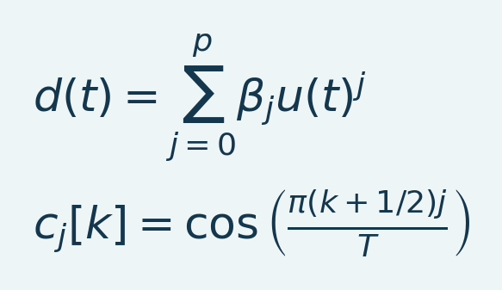
Variables and interpretation. d(t) is fitted drift at time t, u(t) a scaled dimensionless time coordinate, p polynomial order and beta_j fitted coefficients. For the DCT basis, k runs from zero to T-1 acquired samples and j selects a cosine order. c_j is its sampled basis column, shown without normalization. The selected order/frequency subset and fitted support determine which trends are removed.
Polynomial drift uses a scaled time coordinate to improve conditioning. Anchor fits use selected reference windows; baseline-only extrapolation becomes sensitive to small slope errors far beyond the fitted interval. Robust fits reweight residuals, and spline methods use local piecewise-linear basis functions instead of powers. A response can still be absorbed when its time course resembles the chosen trend space. DCT high-pass removes selected slow cosine directions; it has no mechanism for distinguishing slow biology from slow nuisance.
Section summary. Polynomial drift uses a scaled time coordinate to improve conditioning.
Important / practical tip. Check convergence and the retained response; ICA energy ordering is not PCA explained variance.

Combining decomposition and filtering
Order matters: PCA after filtering models the variance that survived that filter; filtering after PCA filters the reconstructed residual. A globally correlated physiological response can be attenuated by both. Define the order before group comparisons and report it. A sensitivity analysis that retains disputed components is more informative than choosing the order that makes the desired result look strongest.
Source: ica_denoise.m, deConfUSIon_svd_clutter.m, deConfUSIon_svd_clutter_gui.m, driftCompensation.m and the inventory entries for drift helpers.
Section summary. Order matters: PCA after filtering models the variance that survived that filter; filtering after PCA filters the reconstructed residual.
Important / practical tip. Check convergence and the retained response; ICA energy ordering is not PCA explained variance.

ICA and singular-value thresholds
Equation (18)
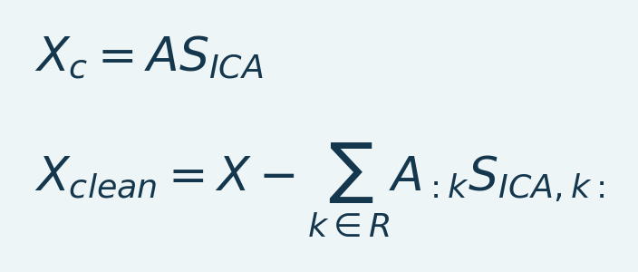
Variables and interpretation. X_c is centered voxel-by-time movie, A voxel-by-component mixing and S_ICA component-by-time profiles. R selects removed components. Each outer product is a spatiotemporal contribution with consistent scaling. The code handles mean restoration and slice scope.
ICA seeks statistical independence under a model. Solutions depend on whitening, non-Gaussian contrasts, convergence and component count, and have scale/sign/permutation ambiguities. Its energy ordering is not PCA explained variance. Removing a component can remove shared response.
SVD thresholding removes singular contributions. An elbow, energy or coherence recommendation is a review aid, not a ground-truth separator between artifact and brain signal. The SVD GUI processes the loaded movie; its percentages are not scanner IQ clutter settings.
Section and chapter summary. Check convergence and the retained response; ICA energy ordering is not PCA explained variance. Check convergence and the retained response; ICA energy ordering is not PCA explained variance.
Important / practical tip. Check convergence and the retained response; ICA energy ordering is not PCA explained variance.

17. Regressors, drift models and response protection
The drift dialog exposes Joint GLM, reference-mask and CompCor methods. Related engines implement injection-artifact bases, custom regressors and spatial canonical correlation analysis (CCA). In Studio, open the advanced preprocessing actions and choose Drift Compensation. In its dialog choose the method and review the method-specific controls. Saved method/options define the reproducible specification.

Design matrix and nuisance subtraction
Equation (19)
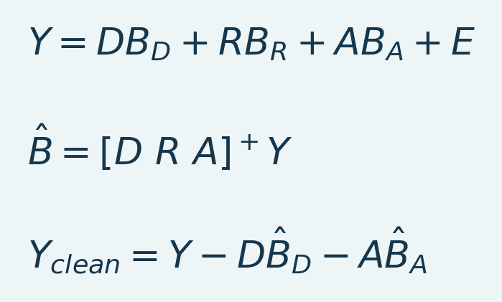
Variables and interpretation. Y is time by voxels, D drift design, R protected response and A additional nuisance columns. B blocks are fitted coefficients, E residual variation and + a pseudoinverse. The code checks rank before least squares. Final baseline/run-mean restoration is a separate recorded step.
Regression uses time by voxels, the transpose of the PCA movie convention. D describes drift, R an explicit protected response, and A additional nuisance columns. The GLM jointly fits these columns in voxel chunks, removing designated nuisance predictions while retaining modeled response. Final baseline/run-mean restoration follows restoreMode. The code checks rank and warns about high cross-block correlation. Protection preserves the specified response span, not every unmodeled biological effect.
Section summary. Regression uses time by voxels, the transpose of the PCA movie convention.
Important / practical tip. Investigate rank/collinearity warnings; indistinguishable nuisance and response cannot be separated reliably.

Regressor choices and assumptions
Table 6. Regressor choices and assumptions overview
Choice | Source of time course | Assumption to check
Polynomial/anchor | Smooth time basis and selected reference periods | Reference periods do not contain sustained response
Reference mask | Mean of independently justified noise mask | Mask captures nuisance without target signal
aCompCor | PCs of anatomical noise region | Noise anatomy and registration are valid
tCompCor | PCs of high-variance/noise candidates | High variance is not automatically artifact
Global regression | Whole supported movie mean | True widespread signal may be removed
Custom | MAT/CSV/TXT columns, one row per analyzed frame | Same length, time origin, TR and independent provenance
Spatial CCA | Shared temporal modes in brain/noise regions after whitening | Shared variation is adequately identified as nuisance
Injection basis | Event-related transient/persistent terms | Artifact can be distinguished from true response

CompCor originated in fMRI [L7]. fUSI evaluations motivate anatomically justified masks [L8]; CCA-based denoising has also been studied [L9]. The local implementation is not asserted to reproduce every published pipeline.
Section summary. Investigate rank/collinearity warnings; indistinguishable nuisance and response cannot be separated reliably.
Important / practical tip. Investigate rank/collinearity warnings; indistinguishable nuisance and response cannot be separated reliably.

Protected response basis
Equation (20)
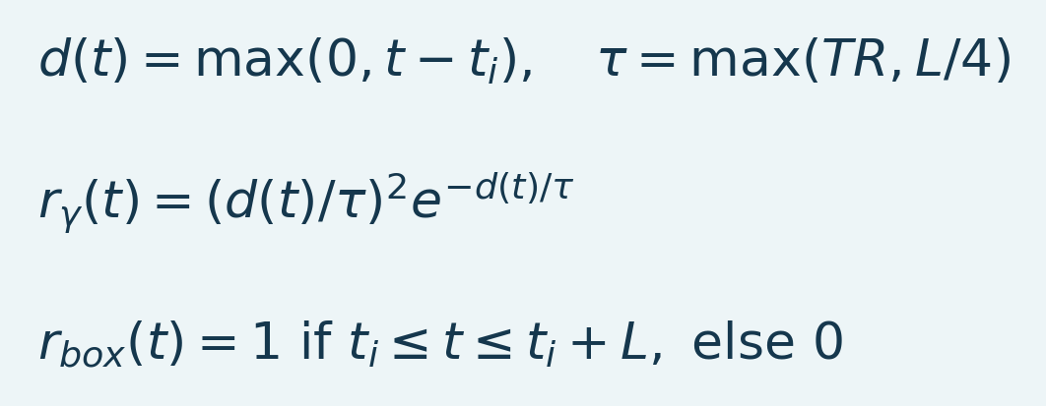
Variables and interpretation. t/t_i are acquisition/injection times in seconds, L assumed response duration, TR analyzed interval and tau gamma time constant. d is nonnegative time since injection. r_gamma/r_box are unnormalized columns; the code peak-normalizes and smooths the box over a window related to L/8. These are model assumptions.
The gamma and box-like columns are peak-normalized; the box is smoothed with a window related to L/8. Gamma is zero before injection. This is a phenomenological response basis, not calibrated pharmacokinetics. Set timing from experiment logs and compare plausible shape/trend choices.
Section summary. The gamma and box-like columns are peak-normalized; the box is smoothed with a window related to L/8.
Important / practical tip. Investigate rank/collinearity warnings; indistinguishable nuisance and response cannot be separated reliably.

CompCor projection and CCA interpretation
Equation (21)
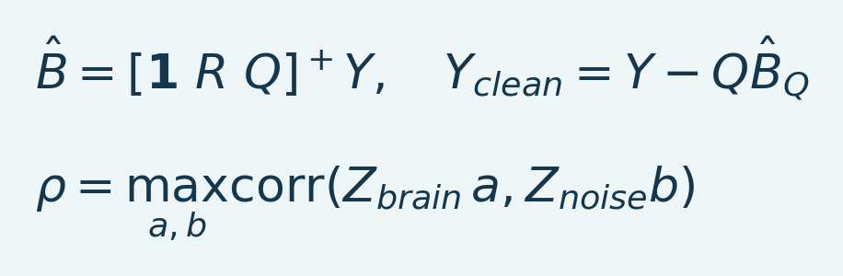
Variables and interpretation. Y is time by voxels, 1 an intercept column, R protected response columns, Q nuisance components and B_Q their fitted coefficient rows. + denotes a pseudoinverse; the implemented solve checks rank. In CCA, Z_brain and Z_noise represent the two temporally aligned variable sets, a and b their projection weights and rho the maximal correlation under unit-variance projection constraints. Whitening and retained ranks control the numerical solution.
CompCor supplies Q from selected noise-region principal components, optionally after response protection. The implementation jointly includes the intercept and protected columns; only nuisance predictions are removed. CCA instead seeks shared linear time variation between separately whitened brain/noise matrices. The expression describes the canonical objective; the helper uses SVD-based whitening and returns temporal nuisance modes for regression. Rank truncation, anatomical masks and response overlap determine what can be separated.
Section summary. CompCor supplies Q from selected noise-region principal components, optionally after response protection.
Important / practical tip. Investigate rank/collinearity warnings; indistinguishable nuisance and response cannot be separated reliably.

Practical regressor workflow
1. Review timing/motion. Define noise anatomy independently, not by selecting voxels that erase a result.
2. Set baseline, injection and duration in analyzed seconds. Custom regressor rows must match the reduced sampling grid.
3. Start with a small justified design. Investigate duplicate columns, rank failures and collinearity warnings.
4. Inspect measured trace, nuisance prediction, retained response and residual, with an independent ROI/control where possible.
5. Compare the endpoint with raw and simpler branches. Record masks, design columns, fitted periods, restoration mode and warnings.
Section summary. Investigate rank/collinearity warnings; indistinguishable nuisance and response cannot be separated reliably.
Important / practical tip. Investigate rank/collinearity warnings; indistinguishable nuisance and response cannot be separated reliably.

PACAP delayed estimator
The PACAP estimator separates an assumed early protected response from later delayed contributions using explicit early-end/delayed-start times and a strictness-dependent basis. A real late response can be classified as nuisance. More strict correction does not establish greater biological accuracy. Inspect beta/amplitude outputs and independent controls, not only the cleaned movie.
Source: lib/preprocessing/deConfUSIondriftcompensationcore.m, deConfUSIondriftdialog.m, deConfUSIonbuildartifactregressors.m, deConfUSIonbuildcompcorregressors.m, deConfUSIonspatialccasimple.m, deConfUSIonpacapresponseestimator.m.
Section and chapter summary. The PACAP estimator separates an assumed early protected response from later delayed contributions using explicit early-end/delayed-start times and a strictness-dependent basis. Investigate rank/collinearity warnings; indistinguishable nuisance and response cannot be separated reliably.
Important / practical tip. Investigate rank/collinearity warnings; indistinguishable nuisance and response cannot be separated reliably.

18. Baselines and percentage signal change
Percentage signal change makes a signal relative to a chosen reference. It does not remove every confound, correct motion or prove a statistical effect.
Equation (22)
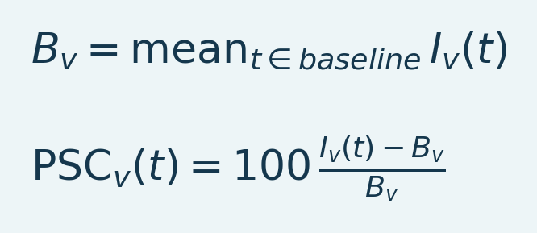
Variables and interpretation. B_v is the mean of valid baseline samples at voxel v, I_v(t) current intensity and PSC percentage change. The factor 100 converts a fraction to percent. A meaningful positive baseline and adequate support are required.
The PSC engine requires a finite positive voxel baseline; invalid baseline locations remain invalid. A near-zero denominator produces unstable percentages even if the source image looks attractive after contrast adjustment. Inspect the baseline image and the number of retained samples, especially after substantial temporal averaging.

Rebaselining an already normalized movie
If an original PSC movie was normalized to another baseline, a new mean b_v in those PSC units gives:
Equation (23)
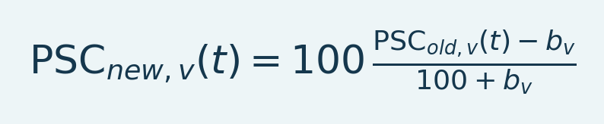
Variables and interpretation. PSC_old is the original percentage series and b_v its mean over the new reference interval. PSC_new uses that new intensity baseline. The 100+b_v denominator rescales the reference; subtracting b_v alone differs.
The denominator is 100+b_v, not b_v. SCM display and ROI export use the compatible rebase so the plot and exported trace refer to the same reference. Do not normalize an exported rebased ROI a second time in Group Analysis; the text header indicates its normalization status.
Section summary. If an original PSC movie was normalized to another baseline, a new mean b_v in those PSC units gives:
Important / practical tip. Use a meaningful positive reference with enough valid samples and the correct experiment time origin.

Local versus shared external reference
A local reference uses a window in the displayed recording. A shared reference can use a separately loaded scan's raw or processed Doppler baseline. This permits a later scan's sustained offset relative to scan 1 to remain visible. A later scan with constant power 120 relative to a reference 100 has PSC+20%, even if the later scan has no within-scan variation.
In SCM or Video Overlay, choose Baseline source..., select another scan/shared reference, choose the source processing dataset, verify its acquisition and analyzed TR, enter its baseline interval, and apply. The source baseline grid must match the target geometry or have an explicitly supported mapping. A later scan's time axis remains its own; reference time is not concatenated onto the target acquisition.
Section summary. A local reference uses a window in the displayed recording.
Important / practical tip. Use a meaningful positive reference with enough valid samples and the correct experiment time origin.

Choosing a baseline
Choose a stable interval justified by the protocol, before examining which window maximizes the desired response. Ensure sufficient acquired samples and avoid known motion, injection artifacts or clipped signal. Apply the same rule across groups. Record the entered and actual frame-aligned windows, source scan, selected processing chain and reference type.
Exported shared-reference arrays are stored once in adjacent BaselineReference_*.mat files. Keep these with the ROI texts. They preserve the complete reference without repeating megabytes of numeric audit arrays in every TXT header. The JSON retains the sidecar filename and variable/field references.
Source: computePSC.m, fusiBaselineReference.m, fusiBaselineSelector.m, scmROI.m, scmCompactROIAudit.m; shared reference guide.
Section and chapter summary. Choose a stable interval justified by the protocol, before examining which window maximizes the desired response. Use a meaningful positive reference with enough valid samples and the correct experiment time origin.
Important / practical tip. Use a meaningful positive reference with enough valid samples and the correct experiment time origin.

V. Visualize maps and movies

19. Time-Course Viewer: intensity, normalization and display contrast
Figure 24. Active movie with robust contrast
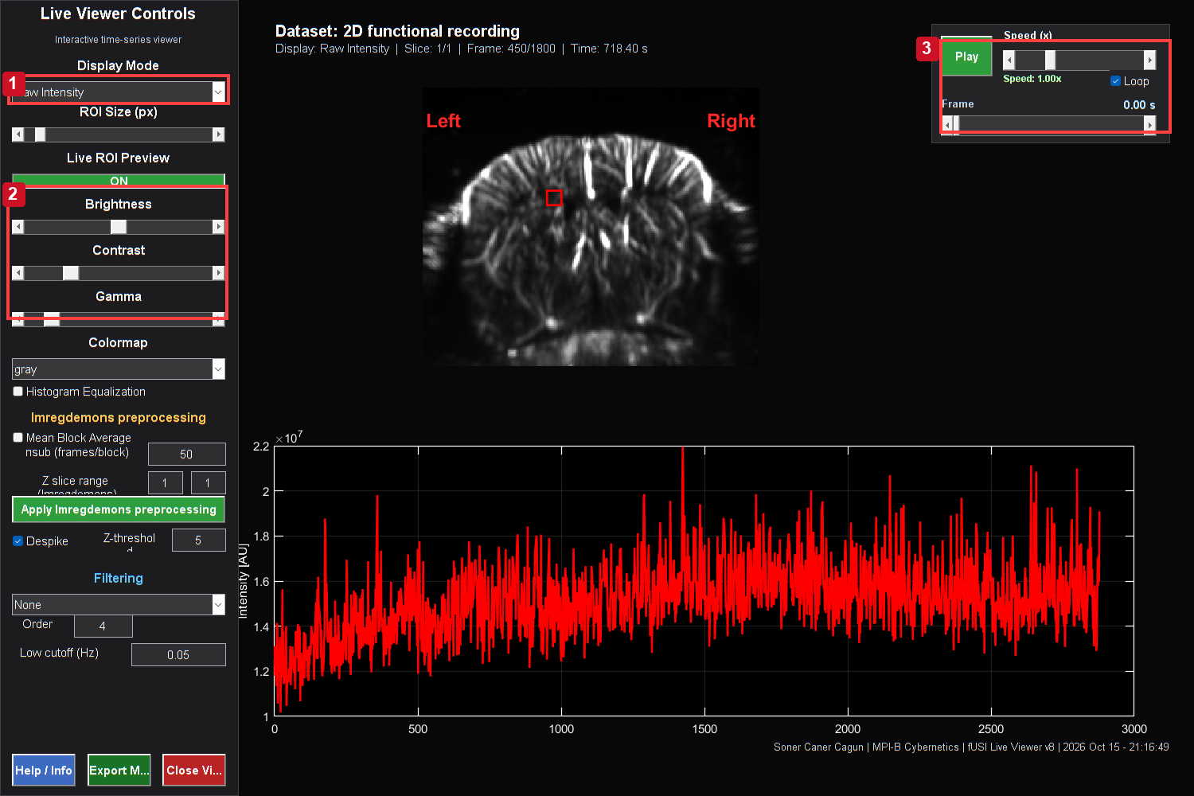
Actual Time-Course Viewer on the stated teaching branch. The Raw view uses a fixed robust per-slice contrast window. Compare frames at the same settings; a display window changes brightness, not the measured movie.
Controls: 1. Raw / normalized / PSC view; 2. Neutral appearance controls; 3. Playback and acquired frame.

The Time-Course Viewer combines a movie with ROI traces, playback and display controls. Start with the correct active dataset. Raw Intensity now reads that dataset's I array, not a stale cached PSC field left by a previous SCM calculation.

Modes
Raw Intensity uses fixed display limits across time for each acquired slice. Limits are estimated robustly from a bounded deterministic sample of the movie. This keeps dim 3D planes visible without renormalizing every raw frame. Normalized uses frame-specific robust contrast, useful for inspecting anatomy but unsuitable for judging global amplitude changes by brightness alone. % Signal Change displays normalized fluctuations; its plotted baseline settings must be reviewed.
Default contrast and gamma are neutral (1). Brightness/contrast/gamma, histogram equalization and grayscale mapping affect the displayed picture. They do not restore a scientific mean to a centered dataset or reverse a filter. If the raw movie looks blank, first reset appearance, try Normalized, inspect the source label and compare numeric mean/range before applying another processing operation.
Section summary. Raw Intensity uses fixed display limits across time for each acquired slice.
Important / practical tip. Check the active raw array numerically before interpreting contrast changes as lost intensity.

ROI inspection
Set ROI size, enable live preview if desired, and inspect tissue at representative locations. Pin ROIs when comparing over time. Record fixed support and slice. A per-trace normalized curve emphasizes shape and should not be confused with raw intensity or absolute PSC. Export the appropriate units and baseline information.
Section summary. Set ROI size, enable live preview if desired, and inspect tissue at representative locations.
Important / practical tip. Check the active raw array numerically before interpreting contrast changes as lost intensity.

Diagnosing contrast loss
1. Check the active dataset and whether it represents Doppler, PSC or centered residuals.
2. Reopen the viewer after a source update so its callbacks are current.
3. Use neutral display controls and inspect a nonempty acquired slice.
4. Compare the mean image and finite intensity percentiles before/after processing.
5. For filters, check Preserve voxel mean. For PCA, check center mode and saved mean restoration.
6. For Imregdemons, inspect interpolation/boundary changes and the temporal block operation separately.
Mean-preserving filters and voxel-centered PCA should retain their intended baseline within numeric precision. Spatial registration can legitimately move intensity between voxels. A good fixed anatomical underlay is useful context, but it is a separate image and cannot prove the current movie's units.
Source: fUSI_Live_Studio.m, fusiMovieDisplayLimits.m, fusiFiniteDisplayLimits.m, Studio liveViewerCallback.
Section and chapter summary. Mean-preserving filters and voxel-centered PCA should retain their intended baseline within numeric precision. Check the active raw array numerically before interpreting contrast changes as lost intensity.
Important / practical tip. Check the active raw array numerically before interpreting contrast changes as lost intensity.

20. SCM GUI: read the map before choosing an ROI
Figure 25. Positive SCM and CPu ROIs
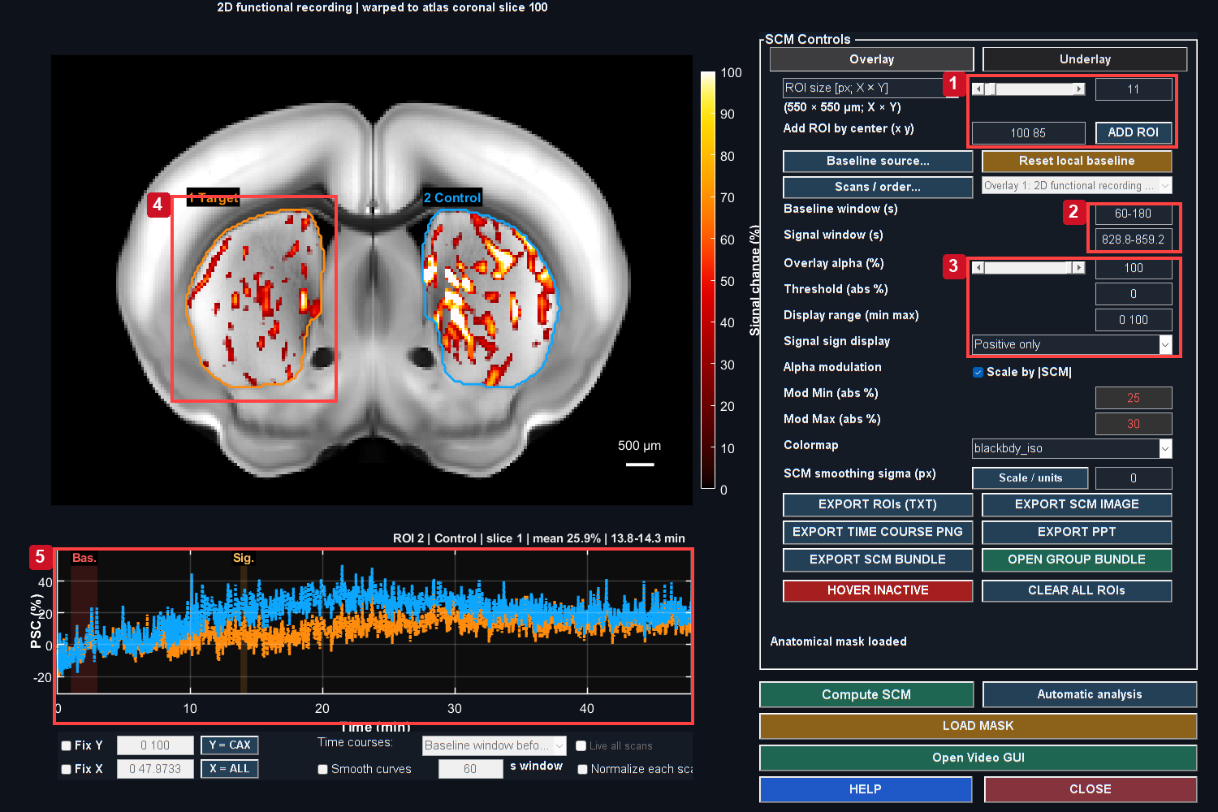
Positive-only PSC is displayed from 0 to 100%, with alpha increasing from zero at 25% to full opacity at 30%. This display choice does not change measured PSC and can hide small responses. Orange and cyan outlines identify the atlas-defined CPu Target and Control. Baseline and selected signal intervals are marked on the matching traces.
Controls: 1. Set ROI size and center; ADD ROI; 2. Baseline and signal in seconds; 3. Opacity, range and sign are display controls; 4. CPu Target boundary; 5. Populated ROI trace and time windows.

SCM means signal-change map. It combines an anatomical underlay with a map summarized over a selected response interval. The time-course plot displays the corresponding ROI signal over the recording. A spatially bright maximum is not a p-value.

Main workflow
1. Open SCM GUI from the desired Studio dataset.
2. Confirm the dataset, slice, baseline and signal interval. Verify whether the time controls use seconds or volume indices.
3. Click Compute SCM after changing the relevant settings, or use controls that explicitly recompute on commit.
4. Choose positive, negative or signed display. Negative-magnitude mode can show absolute negative signal; read the legend rather than interpreting its colors as positive activation.
5. Adjust color limits, alpha and anatomy display to inspect the map. These are presentation settings; keep them consistent for visual comparisons.
6. Set the ROI size and verify its physical X/Y footprint. Add fixed ROIs or open Automatic analysis for a documented exploratory search.
7. Inspect time courses and actual ROI support, then export with parameters and notes.
Section summary. Keep the same ROI support and baseline when comparing branches; opacity and color limits are display choices.
Important / practical tip. Keep the same ROI support and baseline when comparing branches; opacity and color limits are display choices.

Display math versus measurement
For a response map m_v, a signed color lookup maps its value through the chosen color limits. Alpha modulation can make large absolute PSC more opaque:
Equation (24)
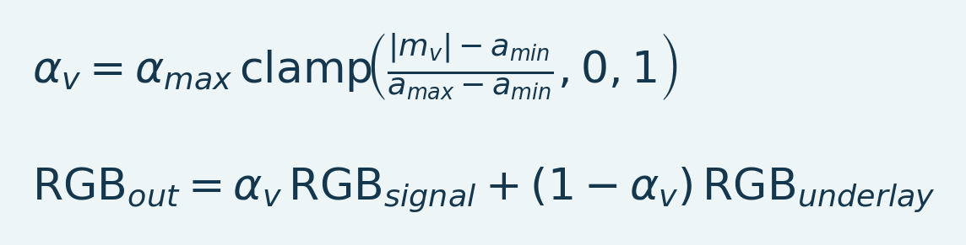
Variables and interpretation. m_v is displayed map value, a_min/a_max opacity breakpoints and alpha_max maximum opacity. clamp confines a value to zero through one. RGB terms are color triplets. Blending changes display, not exported numerical samples.
The exact display path also includes sign/threshold masks and optional smoothing. This composition changes the picture, not the recorded ROI endpoint. Increasing alpha or narrowing a color range must not be described as increasing the measured effect.
Section summary. For a response map m_v , a signed color lookup maps its value through the chosen color limits.
Important / practical tip. Keep the same ROI support and baseline when comparing branches; opacity and color limits are display choices.

A fixed-support ROI trace
An exported automatic ROI contains a fixed set of spatial samples. Its rebased voxel traces are averaged with equal voxel weight. Missing samples propagate according to that fixed-support contract rather than silently shrinking the ROI at each time point. This is important when comparing means: a curve that changes membership over time can change even if every retained voxel is constant.
Source: SCM_gui.m, computePSC.m, scmROI.m.
Section summary. An exported automatic ROI contains a fixed set of spatial samples.
Important / practical tip. Keep the same ROI support and baseline when comparing branches; opacity and color limits are display choices.

Read a populated map and trace
Figure 26. SCM measurement controls
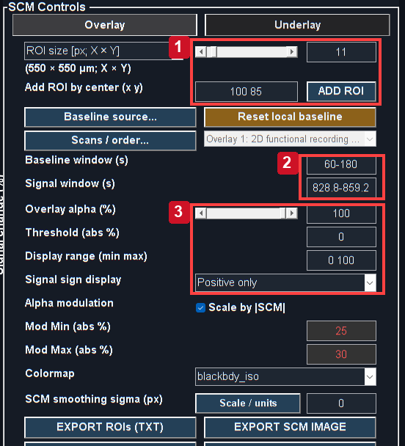
Actual MATLAB output from the reference workflow. Read the chapter steps for controls, input sampling, units and interpretation limits. The screenshot is a software example, not a validated biological result.
Detail crop of the real Overlay panel. Set support and windows first, then tune display appearance.
Figure 27. Fixed ROI trace detail
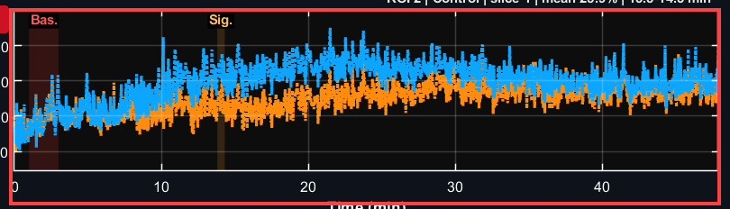
Actual MATLAB output from the reference workflow. Read the chapter steps for controls, input sampling, units and interpretation limits. The screenshot is a software example, not a validated biological result.

Detail crop of the real trace panel; no samples have been redrawn. Time bands show the chosen reference and signal windows.
1. Set ROI size and center in Overlay, then ADD ROI. Hover alone is not a saved ROI.
2. Enter baseline/signal bounds and Compute SCM. Read the percent colorbar and inspect both signs.
3. Adjust opacity and display range for readability; these do not alter exported samples. A display threshold is not a significance threshold.
4. Inspect the whole trace. A time-averaged map can hide transients and drift.
5. Export coordinates/support and metadata with the trace. Reuse the same ROI for processing comparisons.
Section and chapter summary. Keep the same ROI support and baseline when comparing branches; opacity and color limits are display choices. Keep the same ROI support and baseline when comparing branches; opacity and color limits are display choices.
Important / practical tip. Keep the same ROI support and baseline when comparing branches; opacity and color limits are display choices.

21. SCM underlays, saved atlases and mode switching
Figure 28. SCM anatomy and overlay controls
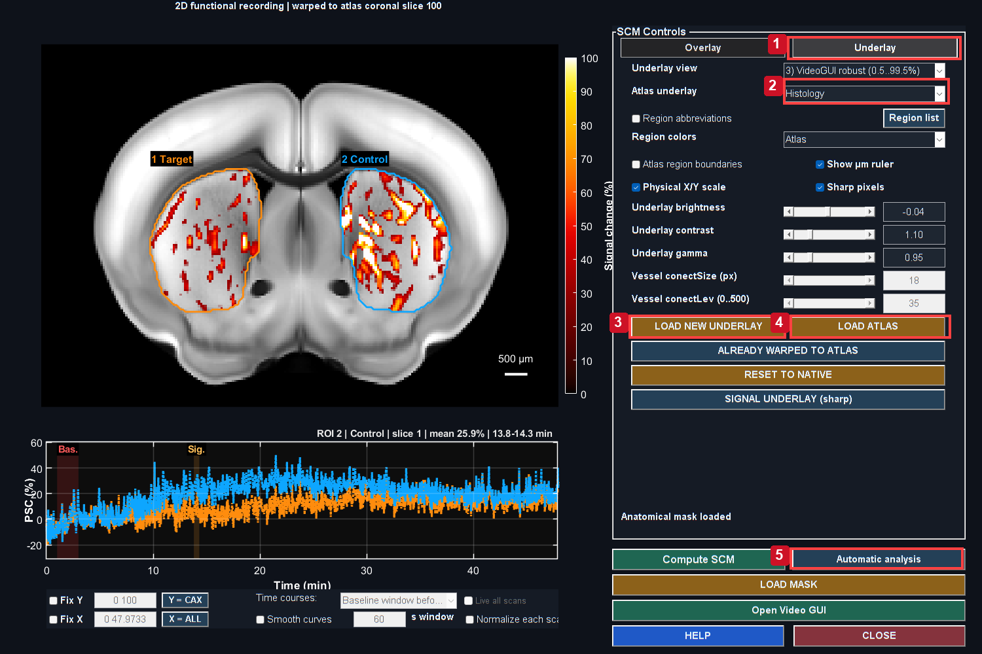
Positive-only PSC is displayed from 0 to 100%, with alpha increasing from zero at 25% to full opacity at 30%. This display choice does not change measured PSC and can hide small responses. The Underlay panel loads replacement anatomy or a compatible atlas package. The Overlay panel controls sign, color limits and transparency.
Controls: 1. Open Underlay; 2. Choose saved atlas display mode; 3. Load new underlay; 4. Load matching atlas package; 5. Open automatic analysis.

Load a 2D atlas correctly
1. Open the Underlay tab.
2. Click LOAD ATLAS.
3. Choose Single file for a saved histology, vascular, regions or transform MAT, or Folder for its package.
4. The picker starts in the matching recording's registration route, including dated Slice... children. Select the intended registration if several exist.
5. Confirm the transformed anatomy and functional overlap. Do not accept the result because the image merely fills the window.
6. Use Atlas underlay to switch between Histology, Vascular, Regions: all and Regions: merged when the package supplies those choices.

Figure 29. Registered positive signal overlay
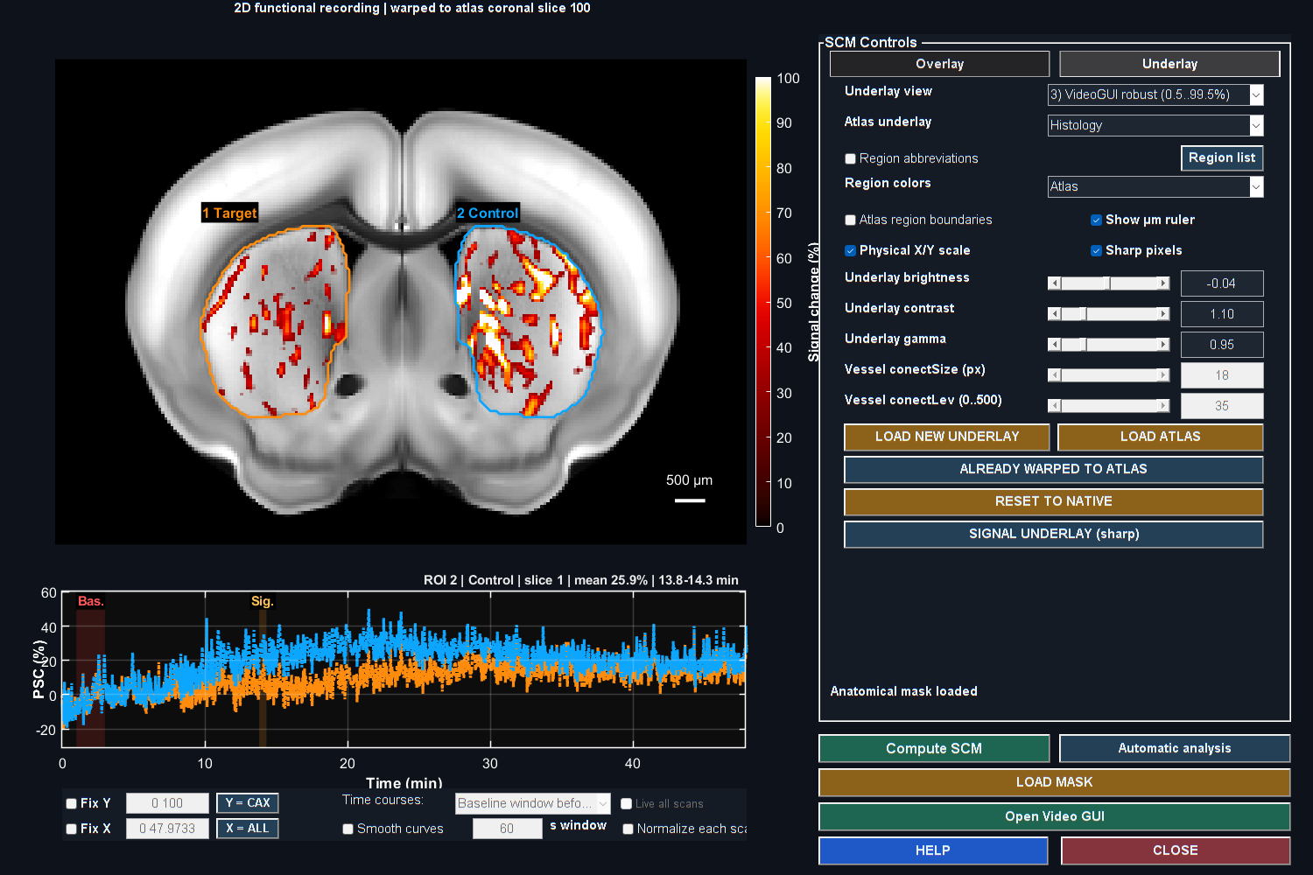
Positive-only PSC is displayed from 0 to 100%, with alpha increasing from zero at 25% to full opacity at 30%. This display choice does not change measured PSC and can hide small responses. Histology supplies anatomical context; registration must be reviewed independently using landmarks.

The labels used for ROI searching are numerical integer labels from the saved registration, not colors inferred from the displayed image. Histology and vascular modes can retain the associated region-search context. Changing the displayed underlay within one registration should preserve that alignment and context. Loading unrelated native anatomy is a different operation and may clear atlas-specific context deliberately.
Section summary. The labels used for ROI searching are numerical integer labels from the saved registration, not colors inferred from the displayed image.
Important / practical tip. Reopen the matching saved registration and verify landmarks; a sharp underlay is not alignment evidence.

Load New Underlay
LOAD NEW UNDERLAY accepts a supported saved image or Mask Editor bundle through its file picker. A plain replacement image must match the expected native or registered grid; a supported registration package supplies the required transform. The application must not arbitrarily resize an anatomical label plane to make it fit. A correct-looking but stretched atlas would assign wrong tissue to ROIs.
Section summary. LOAD NEW UNDERLAY accepts a supported saved image or Mask Editor bundle through its file picker.
Important / practical tip. Reopen the matching saved registration and verify landmarks; a sharp underlay is not alignment evidence.

Whole-region controls and grey fields
Whole atlas region mode uses named labels instead of a rectangular ROI size, so the pixel-size and minimum-coverage fields are intentionally inapplicable. The region selector must still be available. Load a registered Regions source if no numerical labels exist. Select at least one named region; “all labelled brain tissue” is not a substitute for a chosen region in whole-region mode.
The October fixes finalize an unfinished brush stroke when another search control is changed, preventing an abandoned drag from keeping GO disabled. Rectangle top-N entries are restored when leaving whole-region mode. If a current GUI still exhibits the old behavior, finish its analysis/save and reopen it to load the changed nested callbacks.
Section summary. Whole atlas region mode uses named labels instead of a rectangular ROI size, so the pixel-size and minimum-coverage fields are intentionally inapplicable.
Important / practical tip. Reopen the matching saved registration and verify landmarks; a sharp underlay is not alignment evidence.

Reset to native
RESET TO NATIVE restores the native movie, initial native underlay and native geometry from the viewer snapshot. It clears the atlas mapping and its region context. Reopen a native ROI definition if it depended on the registered grid. A coordinate from an atlas display must not be reused as a native coordinate without the appropriate mapping.
Source: SCM_gui.m, fusiChooseAtlasSource.m, fusiUnderlayPickerOptions.m, fusiAtlasUnderlayLibrary2D.m, fusiAtlasRegionInput2D.m.
Section and chapter summary. RESET TO NATIVE restores the native movie, initial native underlay and native geometry from the viewer snapshot. Reopen the matching saved registration and verify landmarks; a sharp underlay is not alignment evidence.
Important / practical tip. Reopen the matching saved registration and verify landmarks; a sharp underlay is not alignment evidence.

22. Automatic SCM: define the search deliberately
Figure 30. CPu target and control selection
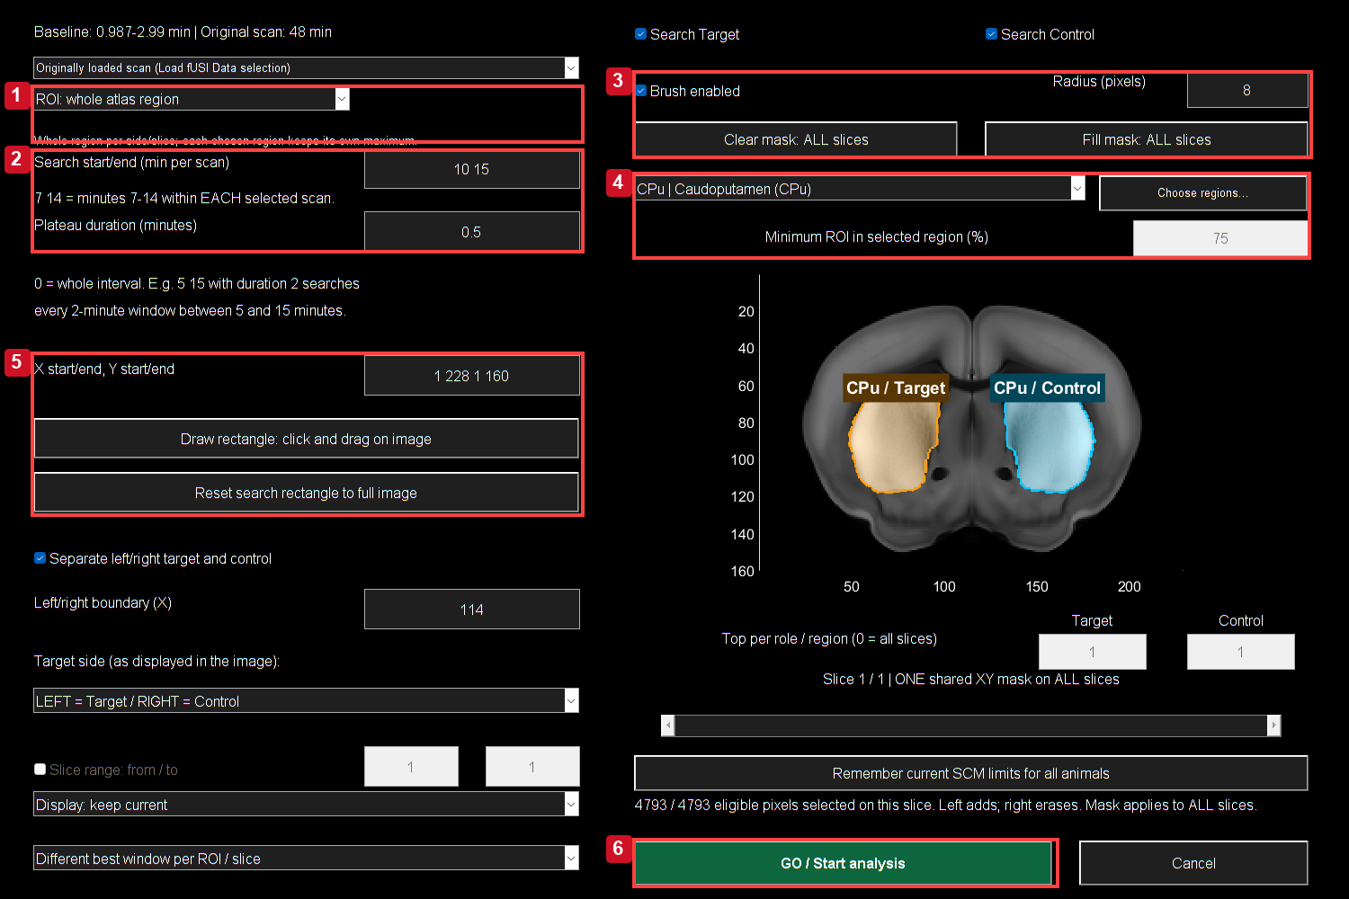
The actual anatomical search dialog selects CPu / Caudoputamen and ROI: whole atlas region. Orange Target and cyan Control occupy the corresponding image sides. Fill retains the atlas restriction. The 10–15 min search and 0.5 min plateau demonstrate exploratory selection, not independent effect confirmation.
Controls: 1. Choose ROI mode and size; 2. Minutes per scan and plateau duration; 3. Brush radius, clear and fill; 4. Atlas region and coverage rules; 5. Rectangle and coordinate bounds; 6. Review accepted support, then GO.

Open Automatic analysis, choose Find and review ROI, then configure the black anatomical search dialog. This is an exploratory maximum search unless the spatial and temporal hypothesis was specified independently. The fixed-protocol option is described in the next chapter.

Time and roles
Enter Search start/end in minutes per scan. Enter a Plateau duration in minutes. Duration 0 averages the selected interval; a positive duration tests complete frame-aligned windows inside it. The example 5 10 with duration 1 searches one-minute plateaus between minutes 5 and 10. It does not mean frames 5-10 or a one-minute response beginning at minute 1.
Enable Target, Control or both. Target side refers to image-left/image-right. Confirm anatomical laterality separately. The left/right boundary is an X column coordinate. If only one role is searched, review the selected side so a role is not silently interpreted as “all tissue.”
Section summary. Inspect accepted painted support after releasing the pointer and after switching modes.
Important / practical tip. Inspect accepted painted support after releasing the pointer and after switching modes.

Spatial eligibility
Choose square pixels, physical X/Y size, or whole atlas region. For physical size, confirm calibrated row/column spacing and the rounded native-pixel footprint. Draw a search rectangle or use the full image. Select atlas regions individually or with Choose regions.... Multiple regions remain separate searches; they are not collapsed into one region with one global winner.
Use the brush to add with left-drag and erase with right-drag. The first add stroke starts from empty; the first erase stroke starts from full. Clear painted area selects none; Fill painted area selects all. Painting and rectangle bounds apply to every searched slice. The accepted intersection with eligible tissue has a translucent orange Target or cyan Control fill and a solid bright pixel edge. Excluded pixels are darkened. White role labels remain above the shading. Dashed outlines describe the broader eligible region; they do not mean that every outlined pixel is painted. The status line reports the selected/eligible pixel counts for the previewed slice.

Figure 31. Volumetric CPu atlas selection
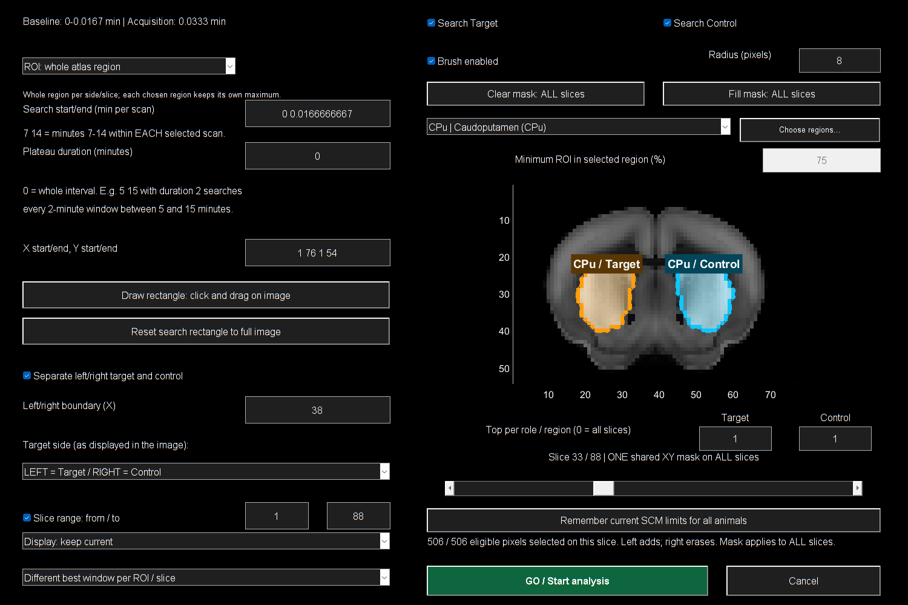
Actual search dialog using the complete Allen reference atlas, displayed with stride 3 for a bounded preview. CPu is selected by its named atlas labels. The slice range demonstrates volumetric anatomical restrictions; this is reference anatomy, not an acquired functional movie or a biological result.

Section summary. Choose square pixels, physical X/Y size, or whole atlas region.
Important / practical tip. Inspect accepted painted support after releasing the pointer and after switching modes.

Atlas coverage and masks
Rectangular atlas ROIs must meet the selected coverage, normally 75-100% of pixels in the named region. Remaining pixels can lie in neighboring labelled brain tissue, while avoiding excluded ventricles and other excluded labels. Atlas searches ignore the uploaded SCM display mask, but still require valid acquired baseline/window samples and the selected paint, rectangle and side. Without atlas labels the uploaded mask remains part of search eligibility. A painted patch outside that eligibility does not automatically override it.
Whole-region support is the selected atlas region intersected with the search constraints and side. Review whether the chosen paint/rectangle clips it: “whole” does not undo a restrictive search mask. Exports retain the actual support.
Section summary. Rectangular atlas ROIs must meet the selected coverage, normally 75-100% of pixels in the named region.
Important / practical tip. Finite sample coverage is different from test-retest reliability and biological signal validity.

Search objective
Equation (25)
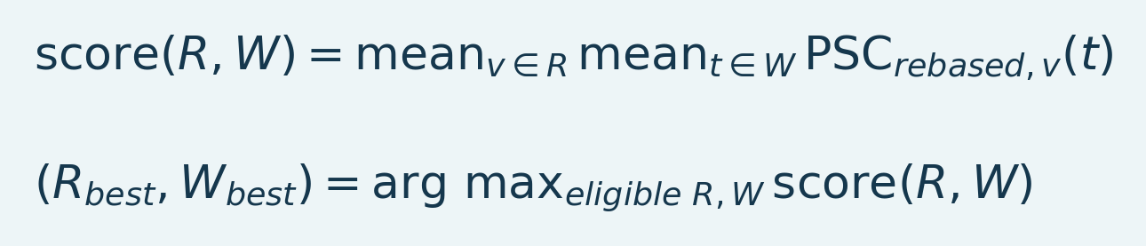
Variables and interpretation. R is spatial ROI, W a time window and PSC_rebased the series using the selected reference. score averages over fixed support and time. arg max finds the largest eligible pair, an exploratory selection that can bias effect estimates.
The engine requires fixed sample support and complete valid windows for candidate scoring. Rectangular candidates use bounded box sums for efficiency. Larger search spaces provide more chances for a high maximum, so use the same search rule across comparisons. A maximum selected from response data is biased upward relative to a prespecified ROI/window endpoint.
Source: scmAutoSearchDialog.m, scmSearchRegions.m, scmSearchWindows.m, scmSearchCandidates.m, AutomaticSCM.m.
Section summary. The engine requires fixed sample support and complete valid windows for candidate scoring.
Important / practical tip. Inspect accepted painted support after releasing the pointer and after switching modes.

Drawing and mode-switch checklist
Figure 32. Automatic search control detail
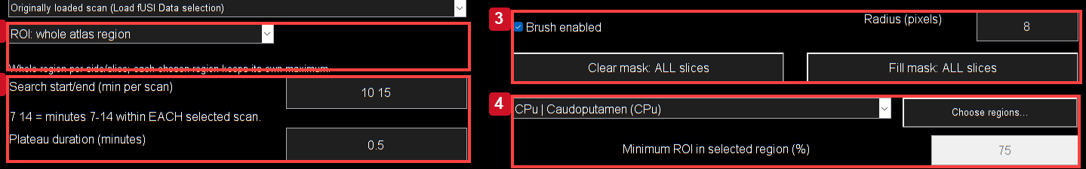
Native-pixel detail from the current anatomical search dialog. Choose ROI mode/size, enter search and plateau times in minutes, then configure brush and atlas constraints. Clear starts a new inclusion area; Fill removes the paint restriction while retaining other eligibility rules.

Detail crop of mode, time, painting and atlas constraints. Units here are minutes per scan, distinct from SCM baseline/signal fields in seconds.
1. Load the matching saved registration, then open Automatic analysis. Check anatomy and source slice.
2. Set mode and time interval. Whole atlas region uses region membership; box/brush modes have their own eligible support controls.
3. Clear before defining a fresh inclusion area. Left-drag adds; right-drag erases. Inspect accepted support after releasing.
4. Review painting, rectangle, slice/side, valid acquired samples and atlas coverage. In atlas mode the uploaded SCM display mask is ignored; without atlas labels it remains part of eligibility.
5. Switch modes and recheck enabled fields. Grey can mean inapplicable; returning to a box mode should restore size/Top-N controls.
6. Press GO after reviewing area/timing. Select a candidate row to show its outline and trace. Check export membership separately.
Drawing fixes are shared by 2D and 3D paths. If a mode sequence still fails, record its exact order, slice, mask and registration. A checked export box by itself does not request a trace redraw.
Section and chapter summary. Detail crop of mode, time, painting and atlas constraints. Inspect accepted painted support after releasing the pointer and after switching modes.
Important / practical tip. Inspect accepted painted support after releasing the pointer and after switching modes.

Rank complete atlas regions across slices
In SCM GUI > Automatic analysis, choose Atlas: rank whole regions across slices. Set the signal interval, acquired slice range and number of top Target and Control regions; 0 includes all regions. This mode uses registered integer region labels from a standard or LightSuite atlas, even when histology or vascular anatomy is displayed.
Choose separate image sides and the Target side, or combine the sides. Draw midline defines a straight or slanted dividing line across the searched slices; Remove / combine sides removes that boundary. These controls describe displayed image sides, not automatically inferred anatomical laterality. ROI-size, brush and rectangular search restrictions do not apply to this whole-region mode.
Rank by the interval mean or by the peak of each regional mean curve, selecting increases, decreases or absolute change. Each regional trace averages one fixed set of eligible voxels across the selected slices. Voxels require a valid baseline and finite samples throughout the signal interval. Minimum usable coverage defaults to 75% and can be set from 75% to 100%; it refers to labelled voxels in the acquired slices, not the complete reference atlas.
The review table reports region names, signed signal change, rank, voxel counts, slice span and usable coverage. Click a row to preview its slice, atlas-shaped outline and trace. Mark / export boxes initially remain unchecked. Dashed outlines are temporary previews; solid outlines identify checked regions. Edit Role to reassign Target or Control, and use Clear selection to unmark results.
Pair same region on opposite side previews the matching atlas region using the same scan, signal and baseline windows, and slice range. Checking a Target retains its matching Control; unchecking releases that automatic selection unless the Control was selected independently. Missing coverage is reported rather than replaced with an unrelated region. Matching Controls remain available below the Control top-N cutoff. This display and selection pairing does not choose a statistical test.
Export tables + curves saves CSV summaries and time courses plus a MAT audit with settings, atlas/source provenance, omitted regions and fixed voxel indices. Standard checked-ROI TXT and bundle exports retain selected regions and edited roles. Attached scans are ranked separately using scan-relative times; short scans are reported without shortening the requested interval. Ranking is exploratory and does not establish statistical significance.

23. Automatic SCM: windows, review, exports and notes
Figure 33. Candidate review and exports
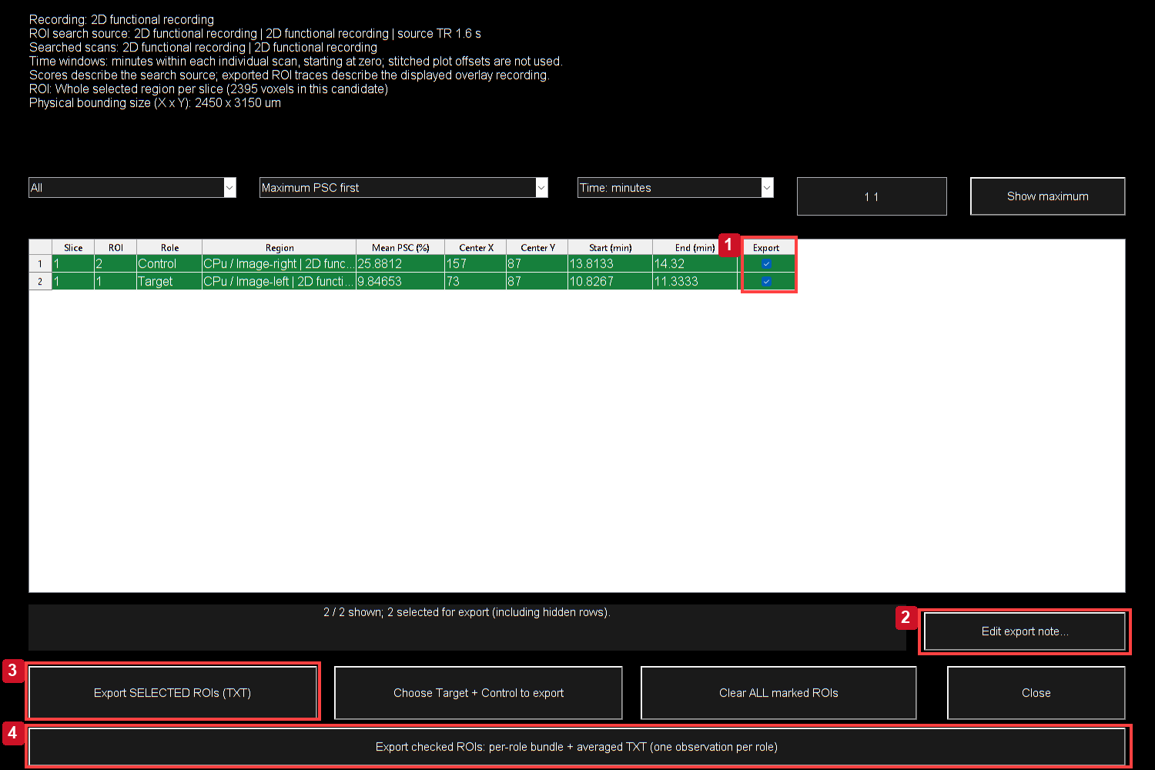
Rows contain exploratory spatial/time maxima. Select a row for its outline/trace, use checkboxes for export membership, then preserve notes and audit files with the ensemble.
Controls: 1. Check candidates for export; 2. Edit export note; 3. Export individual selected traces; 4. Export per-role ensemble bundle.

Independent and shared windows
The independent option allows a different best plateau per ROI/region/slice. Shared-window mode first finds the globally strongest eligible candidate, then re-searches each requested region/role at that exact common window. Control is therefore measured at the common selected time, but the source window remains selected from the response data. Shared timing does not turn exploratory selection into a confirmatory endpoint.
Window endpoints are frame aligned. A positive plateau of duration d generally uses ceil(d/TR)+1 samples to include both endpoints. If the plateau equals the entire search width, the engine uses the acquired samples inside that interval as its single candidate. Duration 0 uses its whole-interval route. Read actual exported times, especially with coarse TR.
Section summary. The independent option allows a different best plateau per ROI/region/slice.
Important / practical tip. Select a row to inspect its trace, then check export membership; avoid counting ROI files as animals.

Candidate review
Figure 34. CPu regions and matching traces
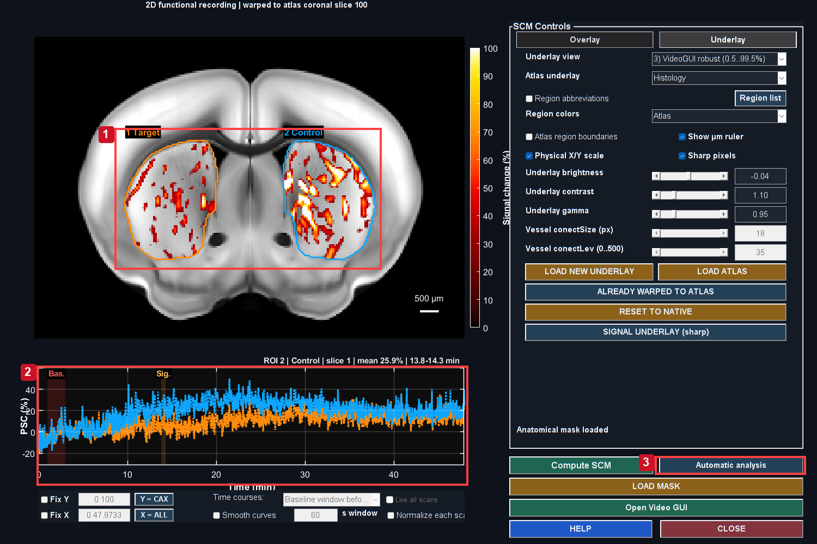
Positive-only PSC is displayed from 0 to 100%, with alpha increasing from zero at 25% to full opacity at 30%. This display choice does not change measured PSC and can hide small responses. Only CPu support is included in this display. Target and Control follow the atlas region boundary; their matching time courses remain visible. The selected maxima are exploratory and must not serve as independent confirmatory statistics.
Controls: 1. Candidate role outlines; 2. Matching target/control traces; 3. Reopen search to change constraints.

Target and control are exploratory image-side roles within the same recording. Their colored outlines match the populated traces; neither is an independent control animal. Atlas searches can include tissue outside the uploaded SCM display mask, as stated in the search dialog.
1. Read the parameter summary at the top.
2. Filter by role, slice range or time units as needed.
3. Click a candidate row to inspect its spatial support and selected interval in SCM.
4. Check the Export checkbox only for ROIs you intend to export. Checking it should not switch the current preview or reread the full movie.
5. Investigate very large PSC values; the red-text warning is a review cue, not an automatic exclusion rule.
6. Click Edit export note... and describe anatomy, acquisition issues, selection rationale or protocol deviations.
7. Choose individual selected ROI TXT or a per-role bundle, according to the downstream unit of observation.
Section summary. Target and control are exploratory image-side roles within the same recording.
Important / practical tip. Select a row to inspect its trace, then check export membership; avoid counting ROI files as animals.

Per-role ensemble math
Equation (26)
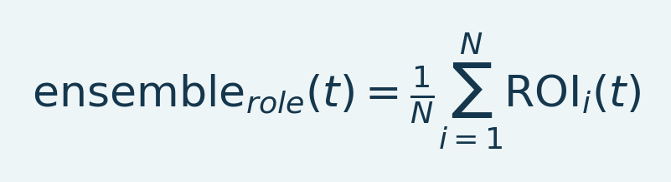
Variables and interpretation. N counts selected ROI traces in one role; ROI_i(t) is trace i on the compatible grid. The ensemble is their equal-weight average. N is not an independent-animal count for ROIs from one recording.
Every selected ROI has equal weight in this ensemble. An individual ROI trace averages its fixed voxel support; the ensemble does not then reweight members by ROI size. The maximum of an ensemble curve need not equal the average of each member's independently selected maximum.
Section summary. Every selected ROI has equal weight in this ensemble.
Important / practical tip. Select a row to inspect its trace, then check export membership; avoid counting ROI files as animals.

Files to keep
The bundle has paired allROIs and mean TXT exports per role. Column3 is the same ensemble PSC in both; allROIs additionally includes each member curve. Analysis_Parameters.txt records search settings. note.txt contains the editable human note. External baseline payloads reside in adjacent MAT sidecars. Keep the complete folder together. Existing user notes are not overwritten; individual exports also have set-specific note files.
Section summary. The bundle has paired allROIs and mean TXT exports per role.
Important / practical tip. Select a row to inspect its trace, then check export membership; avoid counting ROI files as animals.

Group Analysis rule
Load either mean or allROIs for a recording/role, never both. The repeated member columns are not extra independent animals. If one animal has several scans or roles, choose a paired, repeated-measure or aggregation strategy consistent with the design. File count must not be mistaken for biological replicate count.
Source: scmExportROIBundles.m, scmExportSearchParameters.m, scmExportNote.m, scmCompactROIAudit.m, fusiSCMEnsembleHeader.m.
Section and chapter summary. Load either mean or allROIs for a recording/role, never both. Select a row to inspect its trace, then check export membership; avoid counting ROI files as animals.
Important / practical tip. Select a row to inspect its trace, then check export membership; avoid counting ROI files as animals.

24. Video GUI: movie, anatomy and overlays
Figure 35. Positive signal change movie
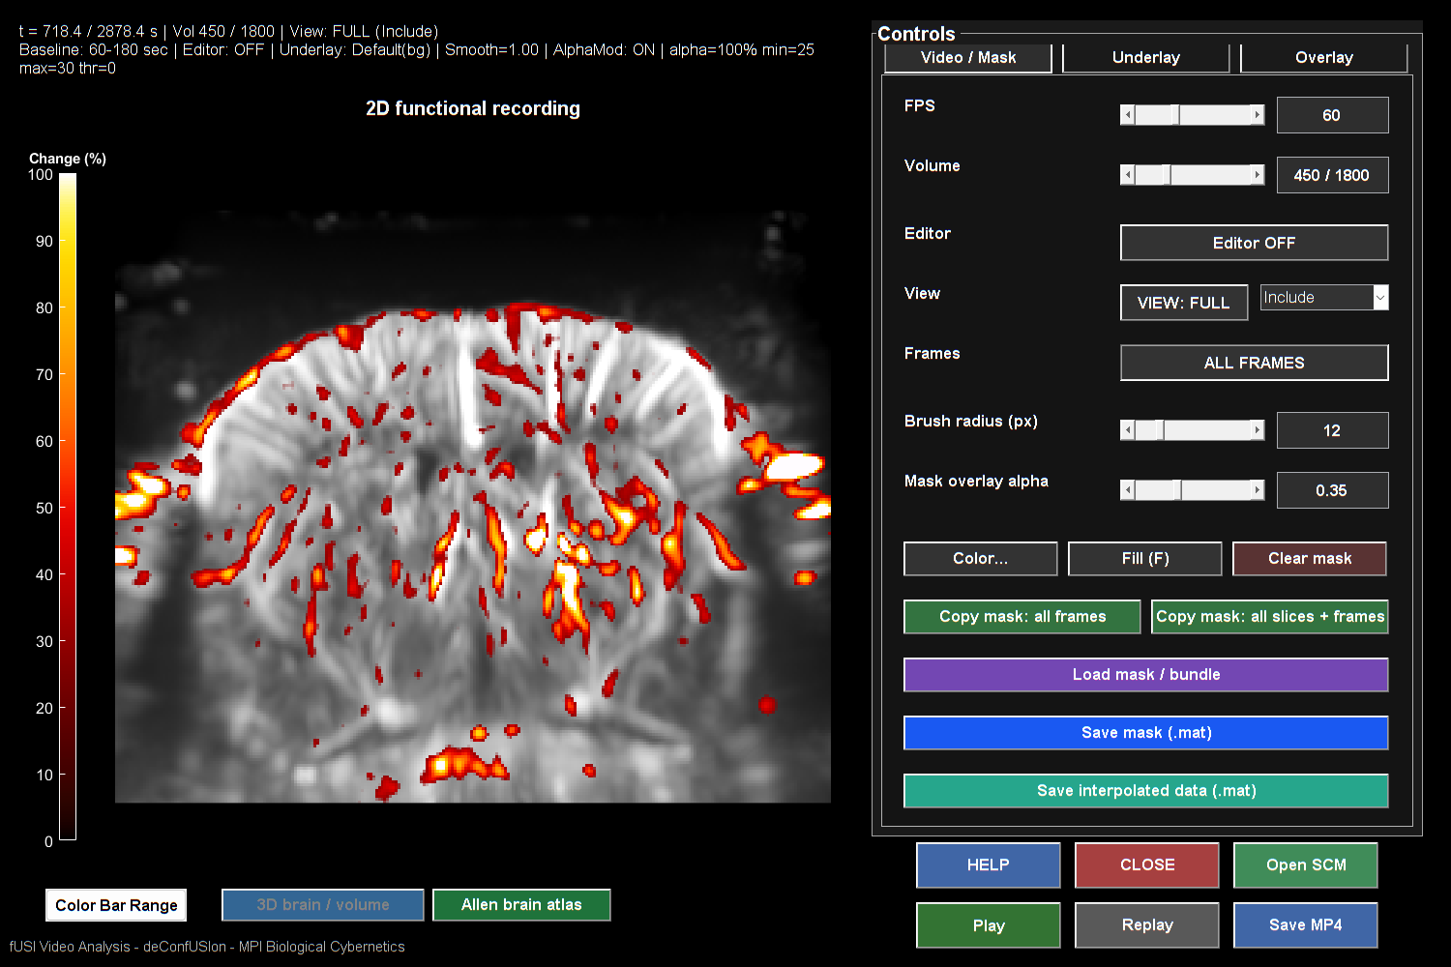
Positive-only PSC is displayed from 0 to 100%, with alpha increasing from zero at 25% to full opacity at 30%. This display choice does not change measured PSC and can hide small responses. The frame selector and time label identify the acquired time; the background preserves Doppler anatomy.

Video GUI displays a time-varying PSC overlay on a chosen anatomy image. The raw Time-Course Viewer is a different interface. A good Video underlay and a poor Raw Intensity view can therefore have different display causes; they do not by themselves establish that mean restoration failed.

Basic sequence
1. Open Video GUI from the selected Studio dataset.
2. Confirm baseline and analyzed TR.
3. In Overlay choose sign, color range, threshold, alpha and optional smoothing.
4. Step through frames before starting playback. Inspect baseline, event and recovery periods.
5. In Underlay choose anatomy source and display mode. Brightness/contrast/gamma affect anatomy presentation.
6. Load a new underlay or saved atlas when required, then inspect alignment.
7. Use Save MP4 only after the displayed support, timing and colors are understood.
Section summary. Use shared sign, percent limits and opacity for comparisons; inspect a short movie export first.
Important / practical tip. Use shared sign, percent limits and opacity for comparisons; inspect a short movie export first.

Load atlas and underlay
Figure 36. Video anatomy and alpha controls
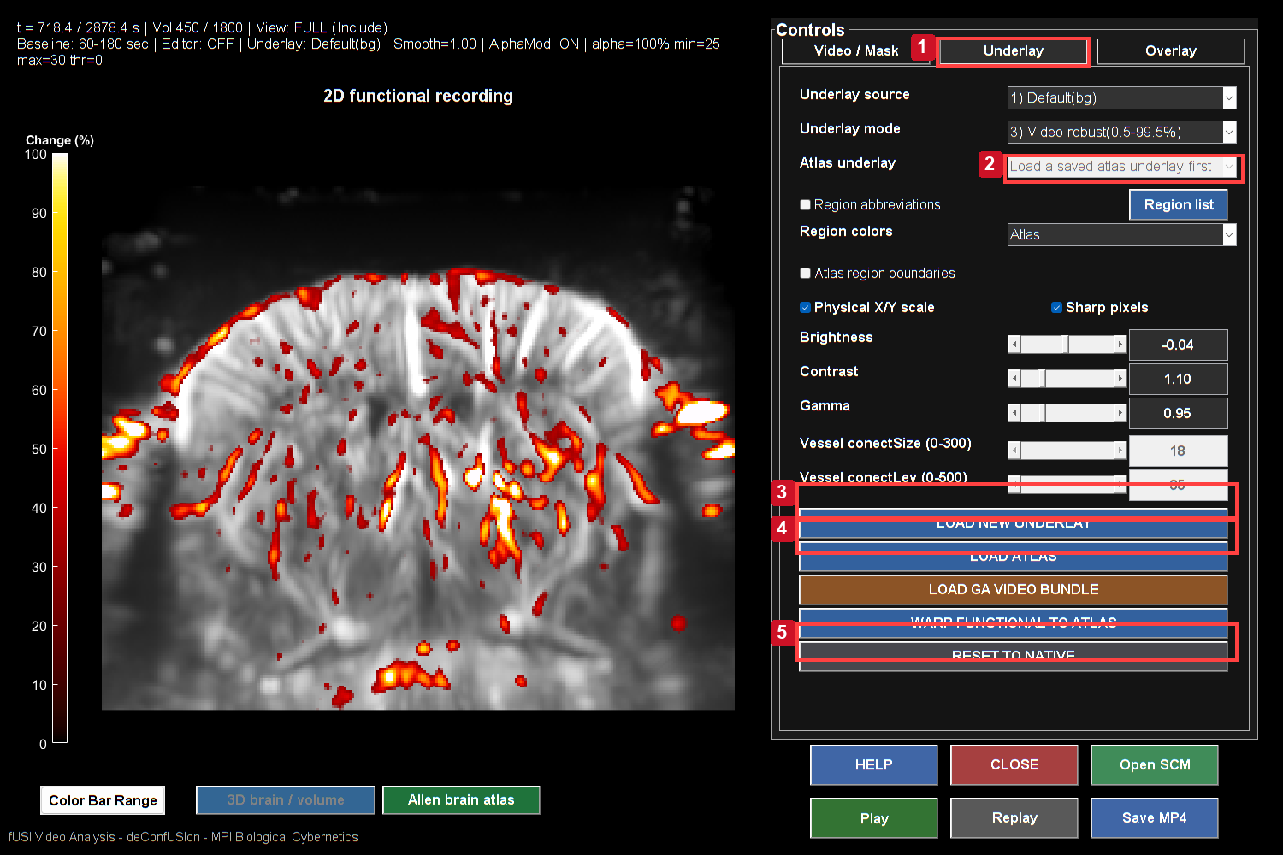
Positive-only PSC is displayed from 0 to 100%, with alpha increasing from zero at 25% to full opacity at 30%. This display choice does not change measured PSC and can hide small responses. Load new underlay and Load atlas replace anatomical context; the alpha ramp is set in Overlay. Keep these settings fixed for a visual comparison.
Controls: 1. Open Underlay controls; 2. Saved atlas display mode; 3. Load a new underlay; 4. Load matching atlas package; 5. Restore native geometry.
LOAD ATLAS offers a saved file or package folder. LOAD NEW UNDERLAY opens a supported underlay file. Both use the current recording's registration lookup; saved 2D Slice packages and supported step-motor/3D bundles are recognized. The Atlas underlay menu switches the package's available anatomical modes.
Figure 37. Registered positive video overlay
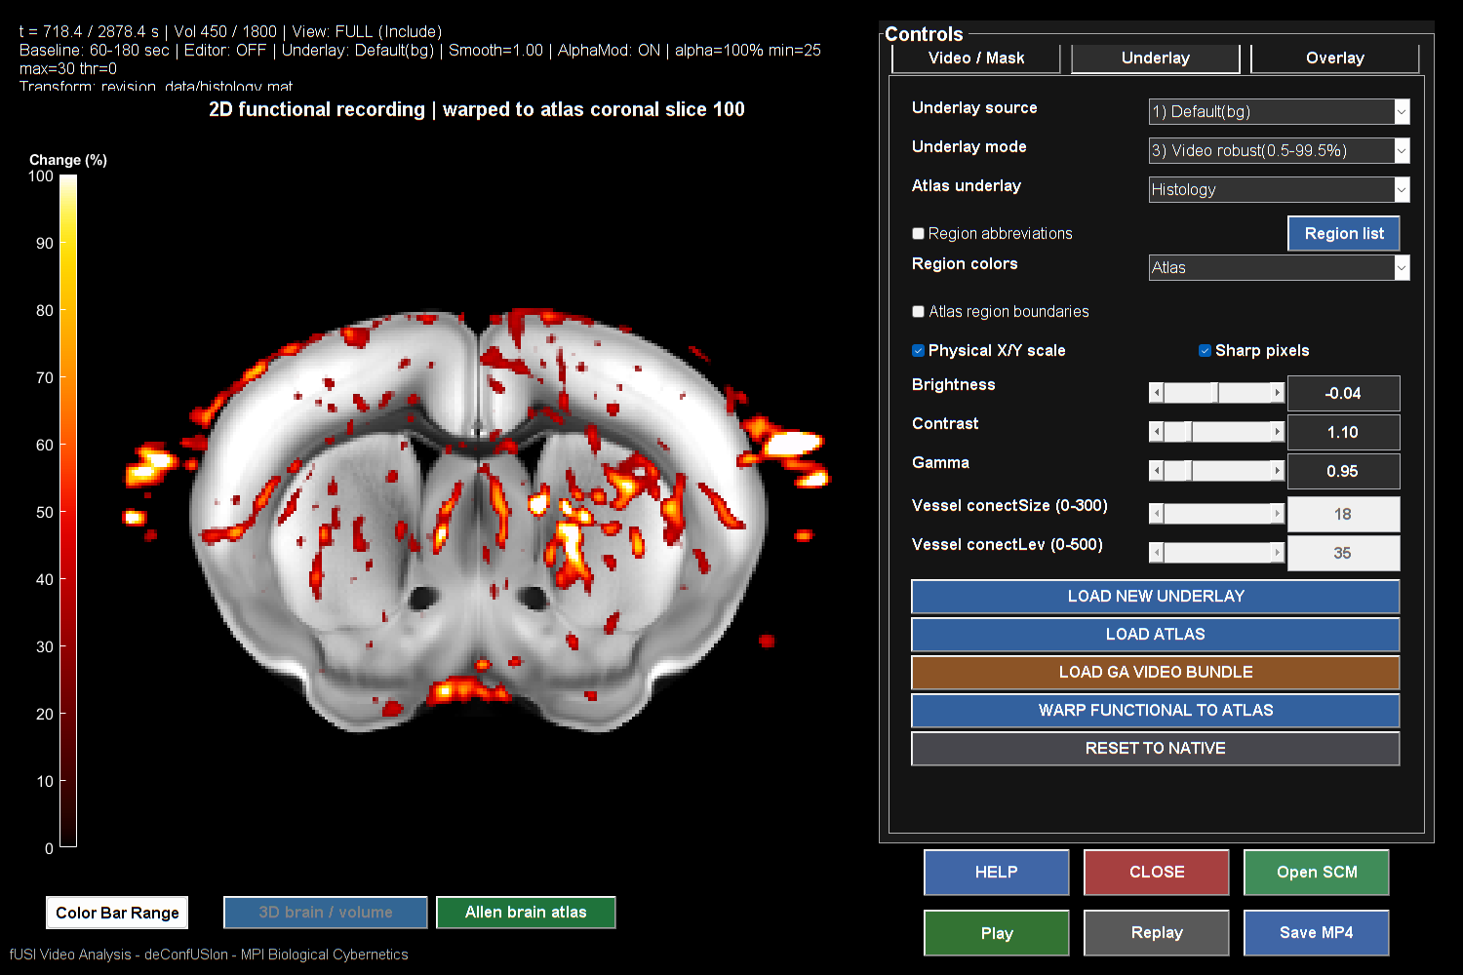
Positive-only PSC is displayed from 0 to 100%, with alpha increasing from zero at 25% to full opacity at 30%. This display choice does not change measured PSC and can hide small responses. A saved histology registration supplies the background. Sharp anatomy does not itself validate registration.

Choosing a new background image is not an instruction to invent a new warp. A mismatched image must have a valid supported transform. Review the transform's source and output grid. Reset to Native restores the original display coordinate system.
Section summary. LOAD ATLAS offers a saved file or package folder.
Important / practical tip. Use shared sign, percent limits and opacity for comparisons; inspect a short movie export first.

Movie exports
The export keeps geometry and canvas size fixed across acquired volumes. A companion presentation/paper movie can have a different information strip, but should not resize the anatomy between frames. Export settings record dataset label, baseline, TR, selected slices and timing. New runs use unique output subfolders. Check a decoded exported movie before publication: verify frame count, acquisition time labels, scale, overlay content and whether a sequence spans several scans.
Playback may skip display frames when rendering falls behind; export uses its selected frame plan. A visually smooth movie is not evidence that every acquired frame was displayed live. Display interpolation changes the animation, not the number of acquired observations.
Source: play_fusi_video_final.m, fusiVideoExportDialog.m, fusiMovieExportFolder.m, save/export notes.
Section summary. The export keeps geometry and canvas size fixed across acquired volumes.
Important / practical tip. Use shared sign, percent limits and opacity for comparisons; inspect a short movie export first.

Readable masked movies
Underlay controls load saved anatomy; Overlay controls set percent range, sign, threshold and opacity. Compare clips with the same settings/interval. Inspect first, middle and last frames of a short preview before exporting a long movie.
Important / practical tip. Use shared sign, percent limits and opacity for comparisons; inspect a short movie export first.

25. The 3D brain/volume GUI
Figure 38. Complete atlas in three views
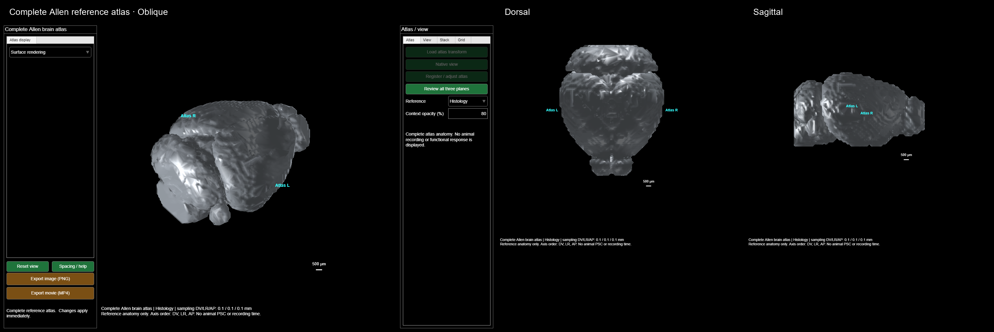
Actual complete Allen atlas viewer in oblique, dorsal and sagittal orientations. Surface rendering and display sampling bound the preview cost. This is whole reference anatomy rather than the partial field of an acquired scan. Use the camera presets, drag to rotate, scroll to zoom, and Export rotation for a movie. Atlas motion does not establish subject registration.

Open the model from Video GUI's 3D action for a matrix/volume recording. The model combines acquired PSC, baseline/Video anatomy and optional atlas context. It uses the same selected signal color mapping; vessel opacity and camera geometry add another layer of presentation.

Choose a rendering backend
Table 7. Choose a rendering backend overview
Backend | Use | Review point
Volume rendering | Translucent voxel anatomy and PSC | Opaque vessels/atlas can hide deep signal
Surface rendering | Threshold contours or unsmoothed voxel faces | Threshold and mesh complexity affect appearance/runtime
Coronal slice stack | Expose interior PSC in selected slabs | Slab averaging and depth exaggeration must be reported

The available graphics backend depends on MATLAB and hardware. A surface fallback should retain the same source geometry and signal meaning. Do not interpret a fallback as newly estimated anatomy.
Section summary. The available graphics backend depends on MATLAB and hardware.
Important / practical tip. Review acquired voxel support; surface thresholds and colors are presentation settings, not new anatomy.

Control sequence
1. Verify row/column/slice spacing and units. Use acquisition metadata, not appearance, to set millimeters.
2. Choose Frame or Interval mean, then select acquired frame/time bounds.
3. Select the source slice range and exclusions. Review whether a mask is applied to signal and/or anatomy.
4. Choose Video underlay or Baseline Doppler and its appearance preset.
5. Start with moderate vessel opacity and inspect PSC visibility. Auto balance affects display, not values.
6. Set PSC range, sign, alpha modulation and threshold consistently with Video.
7. Confirm left/right, view convention and physical scale bar.
8. Rotate, zoom and inspect more than one view before exporting.
Section summary. Review acquired voxel support; surface thresholds and colors are presentation settings, not new anatomy.
Important / practical tip. Review acquired voxel support; surface thresholds and colors are presentation settings, not new anatomy.

Exact support and color meaning
An interval mean uses acquired samples and requires the selected spatial support to remain valid over its window. Interpolated movie frames do not provide extra independent observations. Color uses the selected PSC scale; the model does not renormalize each frame's RGB to make it bright. An atlas surface outside measured coverage must not be colored as measured response.
Section summary. An interval mean uses acquired samples and requires the selected spatial support to remain valid over its window.
Important / practical tip. Review acquired voxel support; surface thresholds and colors are presentation settings, not new anatomy.

Performance expectations
Changing appearance should reuse prepared anatomy when geometry and support have not changed. Changing time should read the selected signal rather than recomputing an entire recording mean. Surface/voxel rendering can be expensive when every voxel is visible; use a scientifically transparent display threshold or slice-stack view for navigation, while retaining the quantitative source.
Live playback follows the requested clock and can skip display frames when rendering is slower. Exports include their selected acquired-frame plan. Save movies after reviewing the first/last frames, a known response frame and the settings sidecar. Report crop, spacing, thresholds, colors, sign, timing and any depth exaggeration with the figure.
Source: fusiVolumeGUI.m, fusiVolumeSnapshot.m, fusiVolumeRGBA.m, fusiVolumeAutoAppearance.m, fusiExportVolume.m.
Section and chapter summary. Changing appearance should reuse prepared anatomy when geometry and support have not changed. Review acquired voxel support; surface thresholds and colors are presentation settings, not new anatomy.
Important / practical tip. Review acquired voxel support; surface thresholds and colors are presentation settings, not new anatomy.

26. Coronal stacks, exports and Blender
Figure 39. Calibrated coronal stack
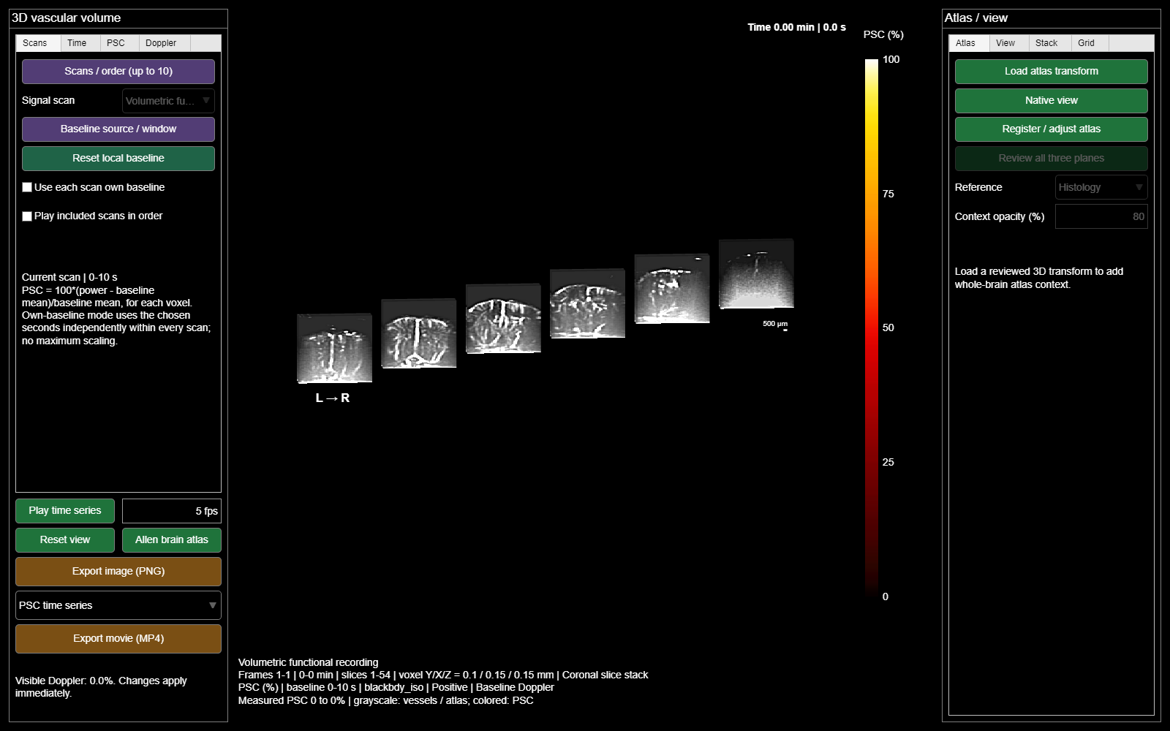
Actual coronal-stack display of the same 3D derivative and geometry, with PSC overlay disabled. Tiles retain their source-plane origin; gap, stagger and depth exaggeration are presentation choices. This is not a reconstructed complete atlas brain.

Coronal stack workflow
Choose Coronal slice stack in the model. Set source/atlas slice range, tile count and slab definition. Slice-count and physical-width slab modes have different meanings. Check displayed slab ranges and the actual included planes. Larger stacks can be arranged in rows. Fixed time rows can compare the same sections at several acquired times; read the actual nearest-frame times in the caption.
Depth gain/exaggeration changes the picture. Use1 for physical slab thickness, and report a larger value if it is used for clarity. In-plane scale bars do not automatically explain an exaggerated out-of-plane dimension. Camera presets are display orientations, not new registrations.
Section summary. Keep calibration and export settings with images; external Blender presentation does not add measured resolution.
Important / practical tip. Keep calibration and export settings with images; external Blender presentation does not add measured resolution.

Current toolbox exports
The model supports its implemented image/movie and settings exports through fusiExportVolume. A rotating camera movie and a PSC time-series movie answer different visual questions; the combined option moves both. Check acquisition time labels and camera motion separately. Export to a unique analyzed-data folder and keep the settings sidecar.
Section summary. The model supports its implemented image/movie and settings exports through fusiExportVolume .
Important / practical tip. Keep calibration and export settings with images; external Blender presentation does not add measured resolution.

What “Blender model” means here
The current source implements the 3D viewer in MATLAB. Blender is not required to calculate PSC, draw the model, register to the atlas or export the supported movies. The reviewed source does not contain a native Blender scene-generation or numerical MATLAB-to-Blender mesh export pipeline. This handbook therefore does not invent a “Send to Blender” button.
Blender can be an optional final presentation environment if an independently generated, verified mesh/volume exchange is supplied. Its official import/export reference lists supported formats. Format capability alone does not establish that deConfUSIon writes that format or that a mesh preserves quantitative PSC.
Section summary. The current source implements the 3D viewer in MATLAB.
Important / practical tip. Keep calibration and export settings with images; external Blender presentation does not add measured resolution.

Optional external presentation checklist
Before using externally generated anatomy in Blender, document source atlas/license, native and atlas coordinate systems, units, origin, axis permutation and transform direction. Verify at least three asymmetric landmarks after import. Keep the numerical analysis in its original coordinate system. If converting to a surface, record threshold, interpolation and smoothing; if baking colors, record their PSC mapping and range. Do not infer missing interior voxel values from a colored surface.
Preserve a master numerical result and an editable external presentation scene separately. Any annotations, lighting, camera movement, transparency or artistic smoothing belong in the figure methods. External rendering should not be described as a new statistical analysis.
Source: fusiVolumeGUI.m, fusiExportVolume.m; Blender's linked official documentation for its separate application.
Section and chapter summary. Before using externally generated anatomy in Blender, document source atlas/license, native and atlas coordinate systems, units, origin, axis permutation and transform direction. Keep calibration and export settings with images; external Blender presentation does not add measured resolution.
Important / practical tip. Keep calibration and export settings with images; external Blender presentation does not add measured resolution.

VI. Masks, registration and segmentation

27. Mask Editor: support and anatomy are different objects
Figure 40. Applied polygon inclusion mask
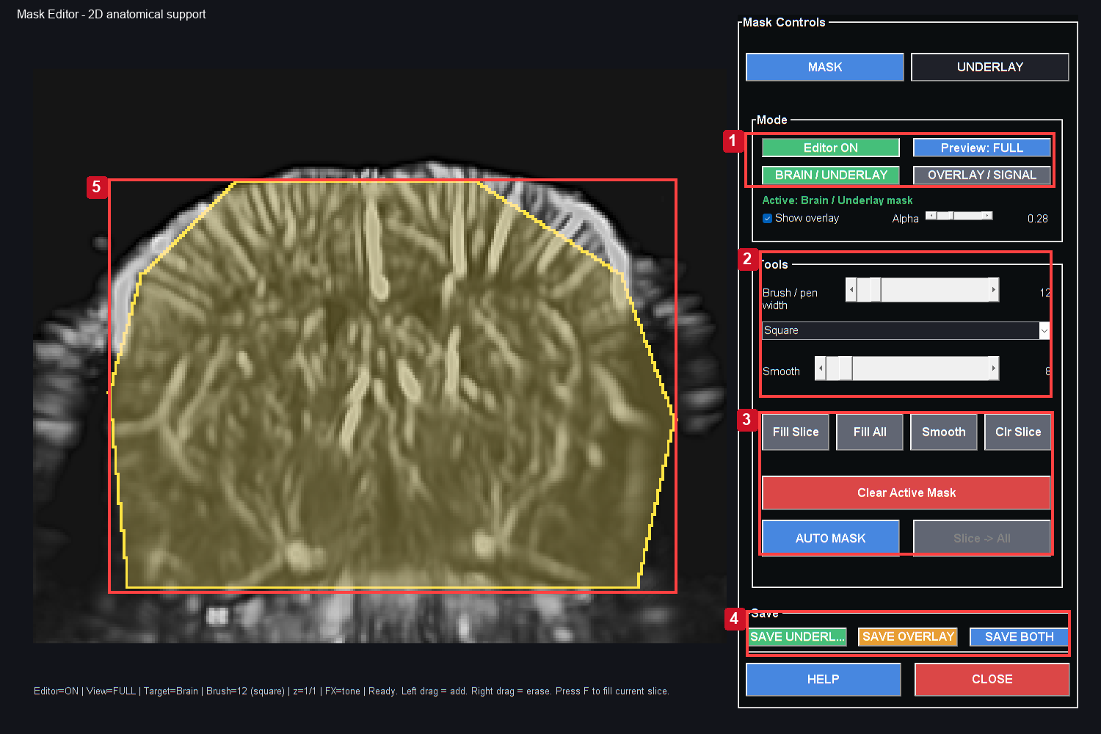
Yellow support shows the example polygon in the active Brain/Underlay target. Select the target, inspect kept/excluded preview, then save the required mask objects. This is an illustrative mask, not validated anatomy.
Controls: 1. Confirm active mask target; 2. Brush shape and smoothing; 3. Fill, clear and auto mask; 4. Save the required mask objects; 5. Applied illustrative inclusion polygon.

Mask Editor prepares anatomical display references and explicit spatial include/exclude support. A processed underlay image can make vessels easier to see without changing the quantitative movie. A signal mask controls which samples are eligible for a selected operation; the brain mask and overlay mask can serve different roles.

Practical workflow
1. Launch Mask Editor on the intended dataset.
2. Confirm the source anatomy and slice. Choose display settings that expose the brain boundary and vessels.
3. Draw or load the intended brain/overlay support. Verify include/exclude meaning explicitly.
4. Inspect more than one slice for a stack. A plausible mask on one plane may be wrong on another.
5. Save the bundle and note its grid, source and processing state.
6. Load the bundle into SCM/Video/FC through their supported route; review the imported support and underlay separately.
Section summary. Check the active target and include/exclude convention before painting or saving both masks.
Important / practical tip. Check the active target and include/exclude convention before painting or saving both masks.

Common misconceptions
An intensity threshold can hide faint background for display; it is not a validated anatomical segmentation. An attractive saved brainImage does not prove that its mask has the desired membership. Display enhancement and normalized grayscale values should not be substituted for raw linear Doppler in PSC calculations.
The bundle can contain brain and overlay masks with explicit include flags. FC combines relevant support according to its import contract, and rejects a mismatched grid rather than arbitrarily resizing it. Review the saved native/atlas coordinate space. If the movie was cropped, warped or reduced in spatial dimensions after drawing, the previous mask may no longer match.
Section summary. An intensity threshold can hide faint background for display; it is not a validated anatomical segmentation.
Important / practical tip. Check the active target and include/exclude convention before painting or saving both masks.

QC checks
Compare the mask boundary to real anatomy at early and late times to identify motion out of support. Inspect permanent missing regions and empty edge slices. Keep excluded tissue separate from invalid acquisition samples in the record. A region excluded for one animal should not silently disappear from a group matrix without a coverage report.
Source: mask.m, scmReadMaskEditorBundle.m, fusiCopyVideoMask.m, FC mask import helpers.
Section summary. Compare the mask boundary to real anatomy at early and late times to identify motion out of support.
Important / practical tip. Check the active target and include/exclude convention before painting or saving both masks.

Applied inclusion masks
Figure 41. Mask editing control detail
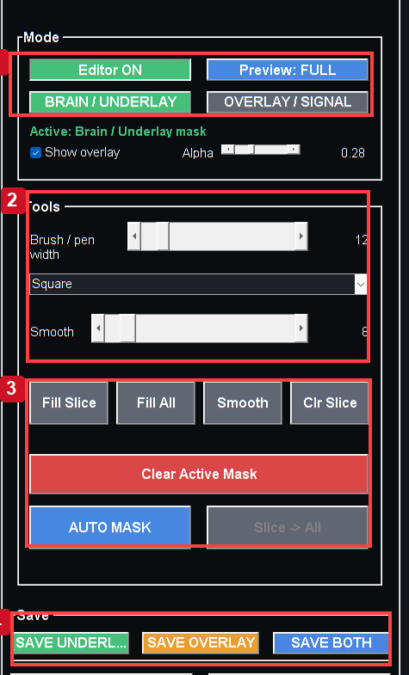
Actual MATLAB output from the reference workflow. Read the chapter steps for controls, input sampling, units and interpretation limits. The screenshot is a software example, not a validated biological result.

Detail crop of the actual target, painting and save controls. Follow the numbered target-to-save sequence.
The revised editor opens with an explicit teaching polygon in Brain/Underlay and Overlay/Signal. Inclusion is a stored data object rather than a decorative outline; this example requires anatomical review before analysis.
1. Select Brain/Underlay for anatomical support or Overlay/Signal for signal restriction. Check the active-target label.
2. Left-drag adds and right-drag erases. Review anatomy, not only bright vessels.
3. Inspect kept/excluded preview areas and accidental holes.
4. Save Both when both masks are required; reopen the bundle in SCM and check support after geometry changes.
5. Review every used 3D plane. Copying a plane to all slices is an explicit assumption.
Section and chapter summary. Detail crop of the actual target, painting and save controls. Check the active target and include/exclude convention before painting or saving both masks.
Important / practical tip. Check the active target and include/exclude convention before painting or saving both masks.

Geometric masks for volumetric probe data
In Mask Editor, Auto: Rectangular (3D probe) proposes straight-edged coverage; Auto: Ellipse (rounded) proposes an oval, and Anatomical (intensity) follows the Doppler envelope. Review and resize the preview before applying it. Overlay masks default to Follow slice size, fitting each slice separately; turn this off for one fixed box. Underlay masks default to fixed geometry. Smooth: All slices processes each plane independently, whereas Current slice limits the operation. Empty slices remain empty and an existing brain mask restricts overlay smoothing. Apply mask updates the editor; SAVE UNDERLAY / OVERLAY / BOTH saves the result.

28. 2D coronal atlas registration: step by step
Figure 42. Registration with robust Doppler contrast
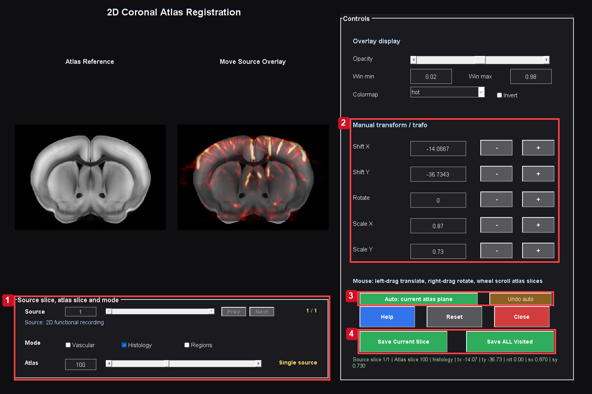
Actual coronal registration GUI after the raw-Doppler contrast repair. A robust 1st–99th percentile display window prevents isolated bright values from compressing tissue contrast. The source array, transformation model and registration objective are unchanged. Review landmarks, geometry and all relevant source planes before explicitly saving.
Controls: 1. Choose source plane, atlas plane and anatomy; 2. Translation, rotation and independent scales; 3. Optional automatic adjustment; review landmarks; 4. Save current slice or all visited slices.

Registration links the acquired plane to an atlas plane. It cannot create missing coverage or guarantee that a chosen coronal level is correct. Review cortical contours, ventricles, midline, large vessels and the acquisition angle using independent knowledge.

Before opening
Confirm the anatomical source image, pixel spacing and laterality. Use a stable Doppler mean or reviewed anatomical reference rather than a response-selected hot spot. Record whether data were moved by preprocessing and whether the registration is intended for the native or corrected grid.
Section summary. Confirm the anatomical source image, pixel spacing and laterality.
Important / practical tip. Review multiple landmarks and laterality, save explicitly and reopen the same package downstream.

Manual workflow
1. In Studio choose Registration to Atlas, then the single-plane coronal route.
2. Select the functional/anatomical source and verify its source slice.
3. Choose Histology, Vascular or Regions as the atlas view and locate the plausible AP plane.
4. Adjust position, scale and rotation using the visible controls. Review the actual overlay rather than only numeric values.
5. Alternate anatomical modes and check several landmarks. A vascular match and a histological match supply different visual information.
6. Confirm that left and right correspond to the acquisition. Do not use symmetry alone to decide laterality.
7. Save explicitly. Closing without save can return no registration; that is intentional.
8. Keep the transform and underlay package together. Reopen it in SCM/Video to review the applied result.
Section summary. Review multiple landmarks and laterality, save explicitly and reopen the same package downstream.
Important / practical tip. Review multiple landmarks and laterality, save explicitly and reopen the same package downstream.

Transform convention
The saved 2D affine matrix uses MATLAB's row-vector affine convention:
Equation (27)
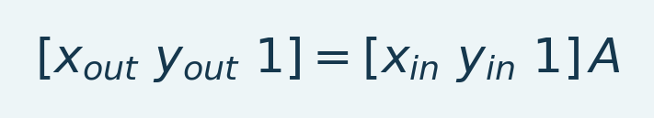
Variables and interpretation. x_in/y_in are input column/row coordinates, x_out/y_out transformed coordinates and A the homogeneous affine matrix. The trailing 1 permits translation. Physical units need associated geometry; label transforms need membership-preserving interpolation.
Intensity images use an appropriate continuous interpolator; integer labels use nearest-neighbor sampling. To bring atlas labels back to a native grid, the supported helper uses the inverse saved transform and the saved source size. It must not resize the atlas plane through the native field of view by dimension matching alone.
Section summary. The saved 2D affine matrix uses MATLAB's row-vector affine convention:
Important / practical tip. Review multiple landmarks and laterality, save explicitly and reopen the same package downstream.

Saved package
Reg2D records source/output sizes, matrix, atlas slice, source slice and images/metadata. The dated Slice directory includes histology, vascular and regions underlays and region names where available. These files refer to one registration. Mixing histology from one date with regions from another can produce plausible pictures but incorrect ROI assignment.
Source: registration_coronal_2d.m, fusiAtlasRegionInput2D.m, fusiAtlasUnderlayLibrary2D.m.
Section summary. Reg2D records source/output sizes, matrix, atlas slice, source slice and images/metadata.
Important / practical tip. Review multiple landmarks and laterality, save explicitly and reopen the same package downstream.

Alignment acceptance, in order
Figure 43. Registration transform control detail
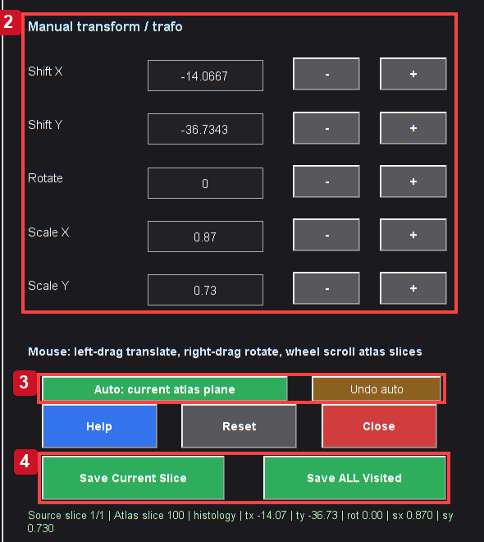
Actual MATLAB output from the reference workflow. Read the chapter steps for controls, input sampling, units and interpretation limits. The screenshot is a software example, not a validated biological result.

Detail crop of the real transformation and explicit-save controls. Check source-plane identity before adjusting alignment.
Review the functional boundary, dorsal/ventral extent, midline and recognizable landmarks. A histological underlay can be sharp while alignment is wrong. Inspect low-opacity overlays and alternate underlays; one matching landmark is insufficient.
Confirm source plane before changing translation, rotation and scale. Save in Registration2D, reopen that package in SCM/Video and recheck landmarks. Label membership and image interpolation serve different purposes. Smooth displayed contours do not establish acquired-voxel anatomical precision.
Section and chapter summary. Detail crop of the real transformation and explicit-save controls. Review multiple landmarks and laterality, save explicitly and reopen the same package downstream.
Important / practical tip. Review multiple landmarks and laterality, save explicitly and reopen the same package downstream.

29. Segmentation and regional extraction
Segmentation extracts region-level time courses from an aligned label map. The geometry and label table determine membership; the anatomy display's colors do not. Review labels on the functional grid before extraction.

Workflow
1. Choose the desired active functional dataset and baseline convention.
2. Open Segmentation.
3. Select a supported source movie and matching atlas/registration labels.
4. Choose the resolution: labels as saved/detailed, supported merged parent regions, or the distinct broader family grouping when that is the intended analysis.
5. Review hemisphere handling and minimum/valid support.
6. Run extraction and inspect counts, missing regions and representative curves.
7. Save its MAT/CSV or supported exports and retain the registration and settings used.
Loading already merged RegionsMerged and selecting labels as saved avoids applying an unintended second broad grouping. Loading RegionsAll and explicitly selecting parent grouping supplies an alternative route. Detailed and coarse-family labels should not be mixed across animals as though their names denoted identical support.
Section summary. Loading already merged Regions Merged and selecting labels as saved avoids applying an unintended second broad grouping.
Important / practical tip. Transform integer labels with a membership-preserving method and inspect coverage at the acquired resolution.

Regional mean
Equation (28)
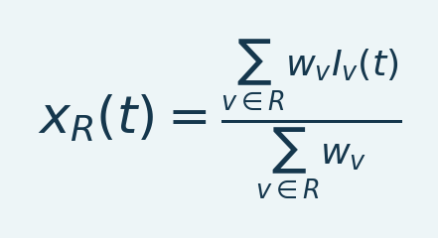
Variables and interpretation. R is selected support, w_v nonnegative weights, I_v(t) voxel intensity and x_R the weighted mean. Unit weights give arithmetic averaging. The denominator must be positive and finite/support rules consistent between comparisons.
For an ordinary equal-voxel mean, eligible voxels have equal weights. Hemispheres or subregions combined from saved means need count-aware weighting to reproduce a combined voxel mean. Record membership/counts and how missing samples are handled in the selected export. A regional mean may suppress focal responses or mix opposing signs; inspect spatial maps too.
Section summary. For an ordinary equal-voxel mean, eligible voxels have equal weights.
Important / practical tip. Transform integer labels with a membership-preserving method and inspect coverage at the acquired resolution.

Registration limits
Nearest-neighbor interpolation preserves integer label identity, but boundaries on a coarse acquired grid can still have partial-volume ambiguity. A label with a handful of acquired voxels may not be comparable to a well-covered region in another animal. Atlas context outside acquisition coverage is not a valid source of regional signal. Include coverage information in any group result.
Source: Segmentation.m, fusiAtlasRegionInput.m, fusiAtlasRegionInput2D.m, fusiAtlasRegionGrouping.m.
Section and chapter summary. Nearest-neighbor interpolation preserves integer label identity, but boundaries on a coarse acquired grid can still have partial-volume ambiguity. Transform integer labels with a membership-preserving method and inspect coverage at the acquired resolution.
Important / practical tip. Transform integer labels with a membership-preserving method and inspect coverage at the acquired resolution.

29a LightSuite guided atlas registration
Open Registration to Atlas > LightSuite (beta), or run deConfUSIon_LightSuite. This optional route registers volumetric Doppler anatomy to a vascular reference. Check dependencies, the animal and scan, and measured voxel spacing in millimetres before starting.

Follow the guided workflow
Continue automatically between steps is enabled by default. Preparation opens orientation confirmation, then landmark editing. Save pairs (S) keeps editing; the green Save + continue to fit button finishes editing and starts fitting. Accept + save all outputs maps anatomy and exports the atlas package. Disable automatic continuation to run individual steps.
1. 1 Prepare + start: build a median anatomy from the current Doppler recording, using its original geometry. Do not prepare registration from a percentage-change movie.
2. 2 Confirm orientation: compare sample and vascular atlas; confirm AP, DV, ML and laterality. Closing leaves this step unconfirmed.
3. 3 Edit landmarks: distribute reliable matching features throughout the acquired volume; complete or cancel every pending pair before saving.
4. 4 Fit registration: affine and B-spline fitting report stage and iteration progress. fUS defaults are a 1.6 mm B-spline grid and landmark weight 0.1.
5. 5 Review + accept: compare vessels, boundaries and coverage on several coronal, horizontal and sagittal slices. Rejecting or closing does not export.
6. 6 Save all outputs: acceptance automatically saves mapped anatomy, native region labels, available vascular/histology backgrounds and editable tissue masks. SAVED identifies the output folder.

Guided LightSuite workspace
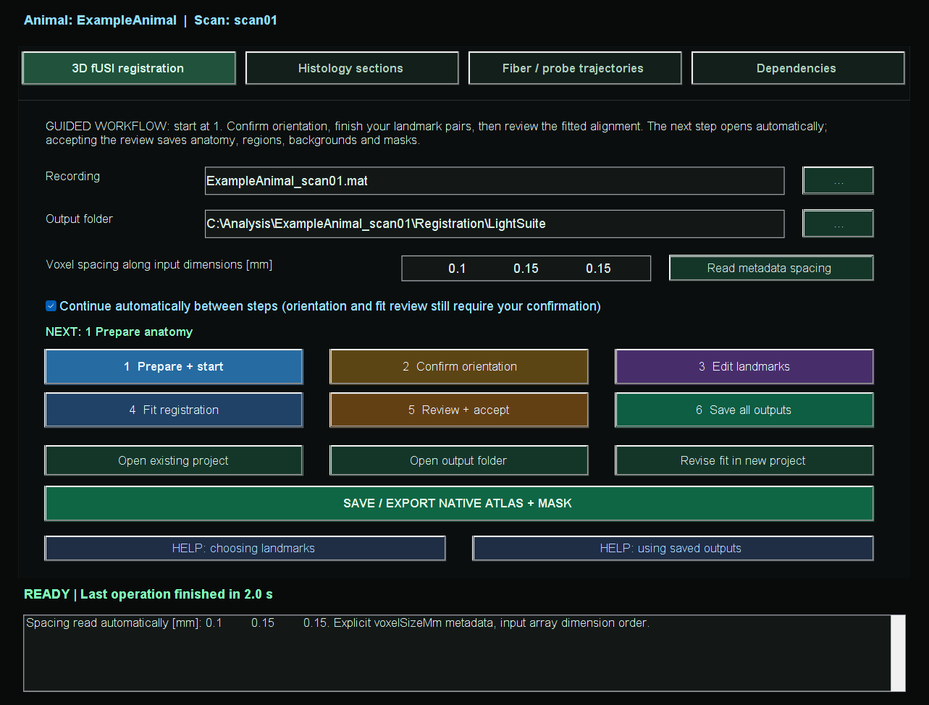
Actual guided workspace with anonymized example identifiers. Coloured numbered buttons perform analysis; the current step is emphasized. Green controls save results and blue Help controls open instructions. This is an interface example, not an accepted registration.

Check dependencies and recording geometry
Use Dependencies > Install / complete setup to install the supported Windows open-source dependencies outside the toolbox in deConfUSIon_ExternalTools. The installer preserves upstream licenses and does not install licensed MATLAB products or change the global MATLAB path. LightSuite requires MATLAB R2022b or newer and its reported toolboxes; the documented deConfUSIon reference remains R2023b. CZI import additionally requires BioformatsImage and OME Bio-Formats; TIFF does not. Cortical flatmaps are not enabled by this adapter.
The Recording field can use the active Studio dataset, including its current in-memory processing result. Check that the input is Doppler anatomy rather than a percentage-change movie. Spacing is read from supported metadata and verified beamformer profiles; the status identifies its source. Unsupported headers require measured millimetres along the original array dimensions. Numerical magnitude alone never defines units. Confirm the signed orientation onto AP, DV and ML; closing orientation confirmation cancels that step.
Load edited underlay... opens the recording's Visualization folder and accepts a Mask Editor MAT bundle on the same native grid. It changes the anatomy shown for landmark placement; fitting retains the original anatomical template and native coordinates. Mask Editor standard is the default landmark contrast. Sample contrast, atlas contrast and atlas opacity affect only the display. Complete or cancel pending point pairs before saving.

Choose and edit reliable landmarks
Prefer distinctive vessel bifurcations and junctions identifiable in both sample and vascular atlas. Clear midline, ventricle boundaries and characteristic brain contours may help. Check features in multiple views; distribute pairs across AP, DV, ML and both imaged hemispheres. Do not force matches outside acquired coverage.
The paper reports a median of 219 user landmarks per mouse, not a required threshold. Five noncoplanar pairs are only the numerical minimum. Add confident, distributed matches in rounds and check unused anatomical features after fitting. Neither point count nor a low fitting residual establishes anatomical accuracy.
In Mark matching points mode, right-click an image to undo the last click. Undoing an atlas point keeps its sample pending for correction; another right-click cancels that sample. Delete selected pair removes both points. Zoom and pan retain their normal mouse controls.
BUSY identifies the operation; READY means the editor accepts input. UNSAVED CHANGES and PENDING POINT differ from SAVED with a timestamp. Important Command Window messages have bold stage labels, time, animal, scan and file path. Marker edits do not recalculate image enhancement.

Landmark editor with save and activity indicators
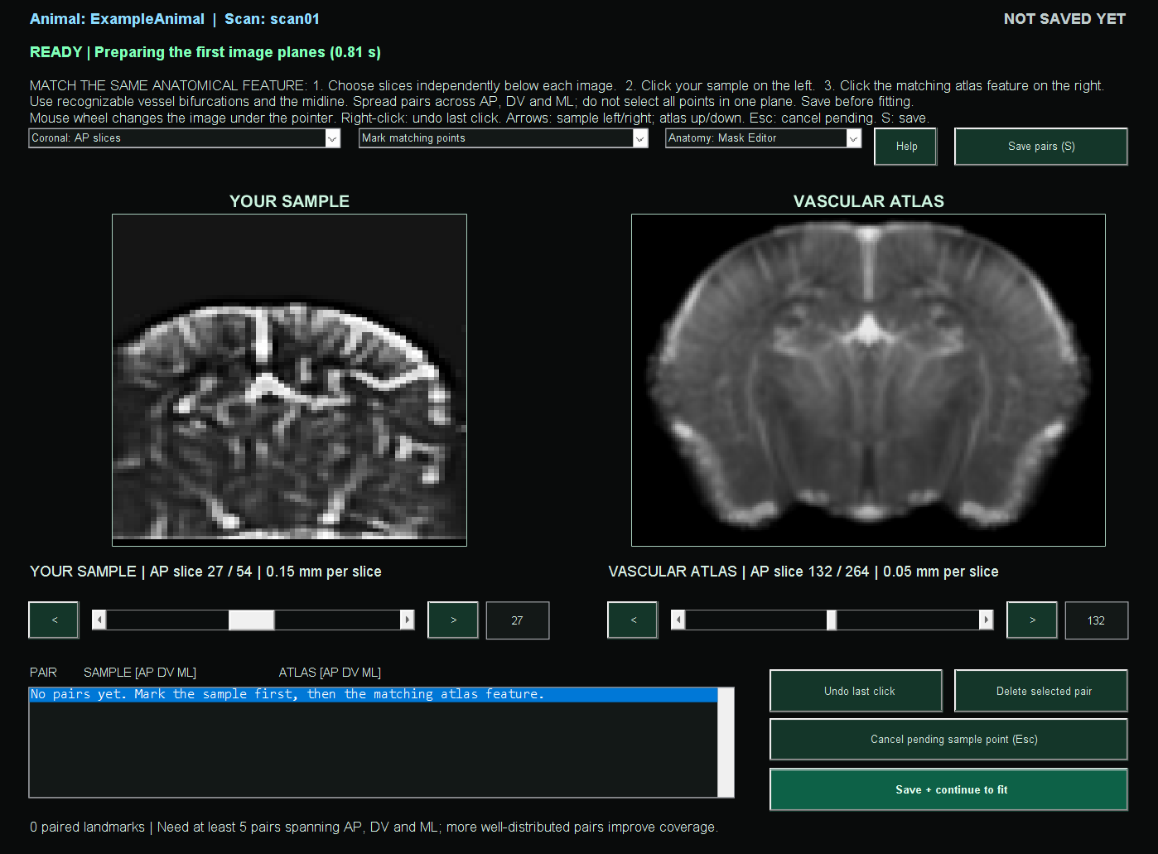
Actual paired editor with acquired Doppler anatomy and the published vascular reference. Identifiers are anonymized; no matched points or registration acceptance are implied. The header, save badge, activity line and green Save + continue button identify the current task.

Load saved outputs
In SCM or Video choose Underlay > LOAD ATLAS > LightSuite folder and select the project. Normal folder loads standard registrations; Single file remains available. Atlas underlay offers Vascular, Histology and Regions when installed and exported, preserving native functional data and anatomical region context.
Keep LightSuite_Native_Regions.mat and LightSuite_Native_Backgrounds.mat together. Regions includes IDs, names and hemisphere masks. LightSuite_Native_Mask.mat supplies anatomy and an editable tissue mask to Mask Editor. anatomy_in_atlas.mat is mapped anatomy for QC, not a functional movie. Retain the complete session and transform chain.
Older labels-only projects generate missing backgrounds once from their accepted saved fit when the complete project and dependencies are available, without refitting. A standalone old region file cannot recreate images. Histology needs the Allen CCF2020 average template; install with -IncludeHistology and export again if absent.

Re-register and load the exact saved version
Use Open existing project > Re-register (new version) to save another fit in a timestamped Registration_yyyyMMdd_HHmmss_SSS subfolder while preserving the previous fit. Edit copied landmarks retains editable pairs; Recheck orientation starts orientation confirmation without carrying pairs into a changed coordinate system. Fitted projects open read-only. Review and accept the new fit, then load that exact revision in SCM. Selecting a parent with multiple complete revisions opens a version chooser; an incomplete revision is not offered.
Inspect affine and nonlinear overlays in coronal, horizontal and sagittal views, including unused anatomy, acquired boundaries and laterality. Review saved landmark residuals and the AP/DV/ML span of the point set. A small inverse round-trip error or many landmarks does not prove anatomical accuracy. If numerical acceptance fails, Rebuild inverse + recheck prepares a separate candidate; it replaces the existing inverse only if the unchanged checks pass.
SCM starts with Show atlas outside acquired field unchecked. Enable it to inspect the full reference; the dashed box separates acquired tissue from reference-only anatomy. Recorded anatomy is available when the native mask bundle includes the original template. Changing the background, affine/nonlinear stage or display extent does not create functional coverage or change native ROI coordinates. Keep the full registration package and use matching grids when loading regions into SCM, Video, Mask Editor or the volume viewer.

Method scope and interpretation
Native outputs require the original recording grid. Cropping, resampling, reorientation or another scan requires an appropriate registration. Use versioned re-registration to revise a fit without overwriting it. Numerical inverse checks complement, rather than replace, anatomical review.
The preprint constructs a within-mouse anatomy from aligned repeated sessions before atlas registration. This workspace prepares a median template from the selected recording and does not automatically reproduce that multi-session construction. Expression mapping and implant tracing require suitable histology or fluorescence data.

LightSuite citation and acknowledgment
We acknowledge Dimokratis Karamanlis and all LightSuite coauthors for the original framework, methods and resources. Cite their preprint alongside deConfUSIon and the relevant atlas references. It was posted on 14 October 2026 and had not been peer reviewed. These integration screenshots do not reproduce paper figures.
Karamanlis D, Xie Y, Foucher CG, Alappat M, Masood A, Dimitropoulou I, Pivron LAF, Martínez de Paz JM, Macé E, Gaspari S, El-Boustani S. LightSuite: scalable atlas registration and cell detection across the central nervous system. bioRxiv (2026). doi:10.64898/2026.10.13.757638.
Brunner et al. (2021). Whole-brain functional ultrasound imaging in awake head-fixed mice. Nature Protocols 16, 3547-3571. doi:10.1038/s41596-021-00548-8. LightSuite resources: Zenodo 21338217 (CC BY 4.0).
LightSuite | LightSuite fUS

VII. Functional connectivity

30. Functional connectivity: prepare a defensible input
Functional connectivity (FC) measures statistical association between time courses. It is different from response amplitude in SCM. Two regions can both respond strongly to a stimulus without a change in their residual association; a common task waveform or systemic artifact can also produce correlation without direct interaction.

Preparation
1. Select the intended processed dataset and verify its analyzed TR and duration.
2. Resolve irregular timing before interpreting frequency-selective or uniformly sampled FC calculations.
3. Use a reviewed tissue mask. Varying background noise can correlate and is not meaningful brain coverage.
4. Load the matching anatomical underlay and integer region labels from the same registration.
5. Check laterality and several slices. A correctly sized array can still be in the wrong coordinate system.
6. Prespecify the time period, preprocessing, region granularity and hemisphere policy.
7. Compute and review FC before exporting it to Group Analysis.
Section summary. Review motion, valid duration and atlas support before ROI current; inspect pair traces alongside matrices.
Important / practical tip. Review motion, valid duration and atlas support before ROI current; inspect pair traces alongside matrices.

GUI organization
The settings pages include data/atlas, analysis and display/export controls. Start in Data / atlas. Histology / image loads a display reference; Region labels loads numerical membership. These are different inputs. Region names supplies names for compatible labels; a text name list does not itself assign voxels to anatomy. Choose regions... limits the region selection used for displayed/selected analyses; inspect the resulting matrix dimensions.
Section summary. The settings pages include data/atlas, analysis and display/export controls.
Important / practical tip. Review motion, valid duration and atlas support before ROI current; inspect pair traces alongside matrices.

Timing and epochs
Whole recording is the current default period. Before, During and After challenge use the configured challenge boundaries. An optional epoch-length limit trims the selected period according to its definition; it does not shift time to a concatenated scan origin. Check actual bounds and frame counts. A three-minute interval at a 12-second analyzed TR contains only about 15 sample intervals, which is a small basis for a stable correlation estimate.
Source: FunctionalConnectivity.m, fusiFCWindowBounds.m, fusiFCStartDir.m; paper workflow.
Section summary. Review motion, valid duration and atlas support before ROI current; inspect pair traces alongside matrices.
Important / practical tip. Review motion, valid duration and atlas support before ROI current; inspect pair traces alongside matrices.

Matrix before graph
Figure 44. FC anatomy control detail
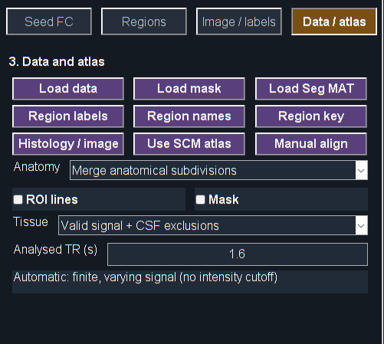
Actual MATLAB output from the reference workflow. Read the chapter steps for controls, input sampling, units and interpretation limits. The screenshot is a software example, not a validated biological result.

Detail crop of the real Data/Atlas settings page. Choose compatible labels, granularity and support before recomputing ROI current.
A matrix displays included pairs and missing/invalid regions. Choose Parent for a compact anatomical overview, recompute ROI current and inspect pair traces/support. Graph edge absence may mean thresholding rather than no measured correlation. Report threshold and matrix together.
Data/Atlas controls define anatomy/granularity; period controls define analyzed time. Changing grouping does not select a scientifically valid time window.
Section and chapter summary. Review motion, valid duration and atlas support before ROI current; inspect pair traces alongside matrices. Review motion, valid duration and atlas support before ROI current; inspect pair traces alongside matrices.
Important / practical tip. Review motion, valid duration and atlas support before ROI current; inspect pair traces alongside matrices.

31. FC: merged regions, hemispheres and ROI current
Figure 45. Region connectivity matrix
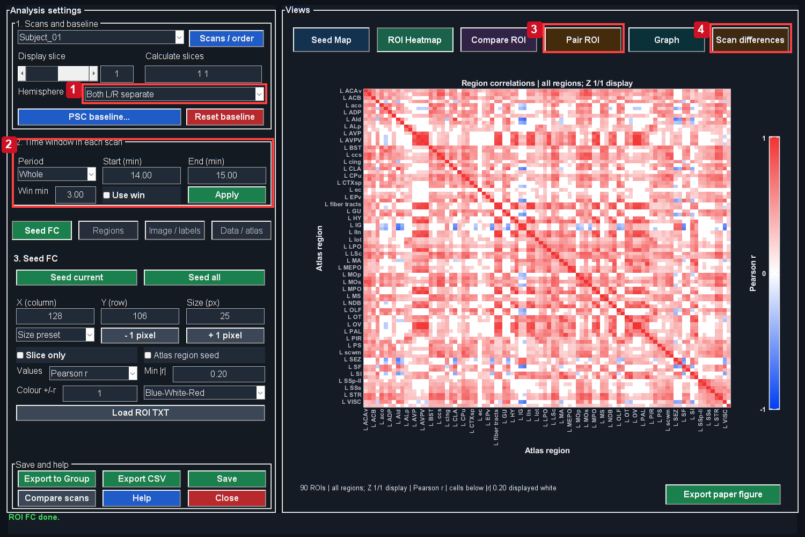
Actual MATLAB output from the reference workflow. Read the chapter steps for controls, input sampling, units and interpretation limits. The screenshot is a software example, not a validated biological result.
Controls: 1. Hemisphere handling; 2. Recording time period; 3. Inspect a pair; 4. Compare scans.

Reduce the number of subdivisions
Figure 46. Atlas granularity and support
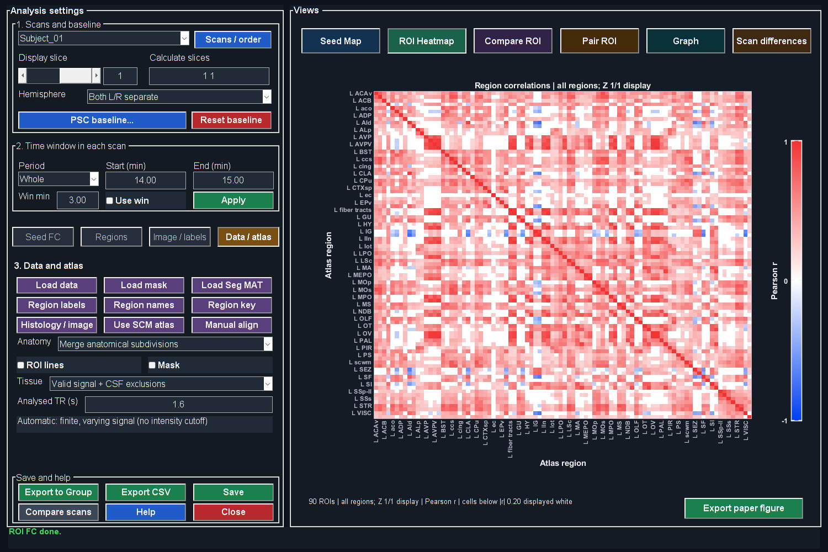
Actual MATLAB output from the reference workflow. Read the chapter steps for controls, input sampling, units and interpretation limits. The screenshot is a software example, not a validated biological result.

In Data / atlas, use the granularity menu:
• Merge anatomical subdivisions groups supported labels by their recorded parent description. This is the default for saved registered region inputs in this edition.
• Detailed subdivisions restores the original detailed registration labels when they are available.
The parent grouping is conservative: it uses explicit name structure, such as comma-delimited subdivisions, and the toolbox's named caudoputamen rule. It is not a complete anatomical ontology traversal or an arbitrary reduction to a chosen number of regions. A different broad-family segmentation option has different scientific meaning.
For single-plane data, load its saved Regions underlay or coronal Reg 2D MAT. The saved affine maps the region plane onto the correct functional grid. For 3D, select RegionsAll or RegionsMerged from the reviewed registration. Labels and their names travel together. A merged-only package cannot recover lost subdivisions unless the corresponding detailed source exists.
Section summary. In Data / atlas , use the granularity menu:
Important / practical tip. Recompute ROI current after membership changes; region granularity and hemisphere mode are separate.

Recompute after changing membership
Changing granularity invalidates existing ROI/seed results. Click ROI current again. Inspect names, counts, missing regions and matrix dimensions before comparing the new matrix with the previous one. The same correlation values must not be relabeled with a different atlas membership.
If the granularity menu is disabled for a bare imported ROI map, load the saved registered Regions/Reg2D package. Arbitrary numeric labels or a name list alone do not necessarily supply the original detailed anatomy needed for reversible grouping.
Section summary. Recompute ROI current after membership changes; region granularity and hemisphere mode are separate.
Important / practical tip. Recompute ROI current after membership changes; region granularity and hemisphere mode are separate.

Hemisphere modes are separate
Left only, Right only, Both, Left-vs-Right and Merged govern hemisphere handling. “Merge anatomical subdivisions” combines label subdivisions; “Merged” hemisphere mode combines corresponding left/right tissue. Using both can reduce the matrix further, but asks a different question from retaining lateralized regions.
When hemispheres are merged, the combined time course uses voxel-count weighting of the left/right means, equivalent to a mean over their combined support. It is not generally the arithmetic average of two region correlations. Left-vs-Right produces a rectangular matrix; some pair/map views require a square-compatible mode and explain that restriction.
Section summary. Left only, Right only, Both, Left-vs-Right and Merged govern hemisphere handling.
Important / practical tip. Recompute ROI current after membership changes; region granularity and hemisphere mode are separate.

Step-by-step FC computation
1. Load matching anatomy and numerical labels.
2. Inspect merged/default granularity and choose a different one only for a justified hypothesis.
3. Select hemisphere and region list.
4. Verify the time interval and any baseline/normalization options.
5. Click ROI current.
6. Review Heatmap, Graph and selected pair time courses. Inspect the number of finite samples and voxel support.
7. Export the bundle with parameters and names. Recompute after changing TR, period, baseline, labels or support.

Figure 47. Thresholded connectivity graph
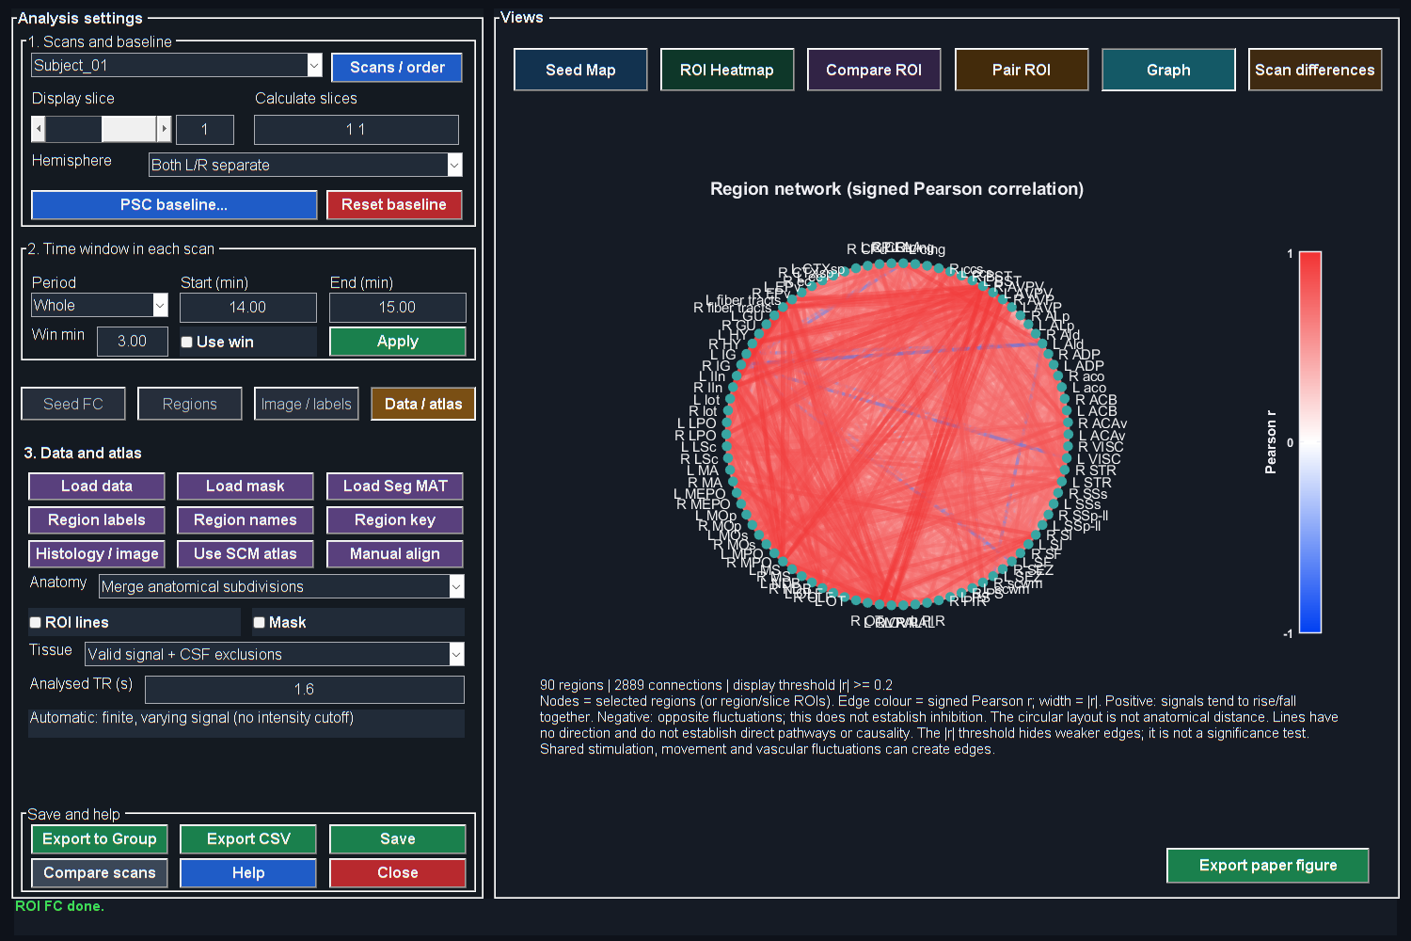
Actual MATLAB output from the reference workflow. Read the chapter steps for controls, input sampling, units and interpretation limits. The screenshot is a software example, not a validated biological result.

Source: FunctionalConnectivity.m, fusiAtlasRegionGrouping.m, fusiAtlasRegionInput2D.m, fusiFCRegionBrowser.m.
Section and chapter summary. Recompute ROI current after membership changes; region granularity and hemisphere mode are separate. Recompute ROI current after membership changes; region granularity and hemisphere mode are separate.
Important / practical tip. Recompute ROI current after membership changes; region granularity and hemisphere mode are separate.

32. FC mathematics and interpretation
For a fixed region R, the region signal is a voxel mean on the selected valid support. Pairwise Pearson correlation compares centered time courses:
Equation (29)
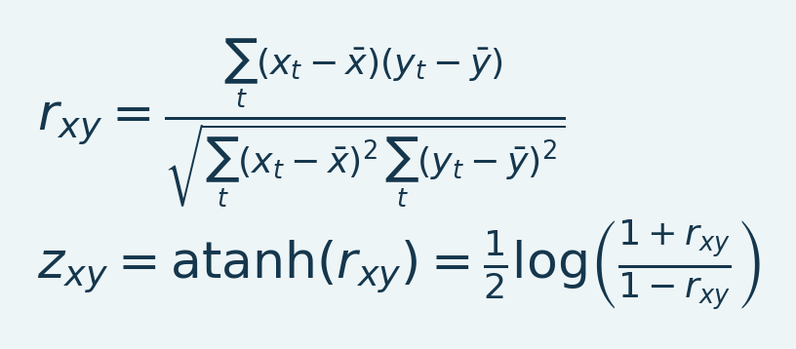
Variables and interpretation.x_t/y_t are paired finite samples and bars their means. r_xy is dimensionless Pearson correlation. Its Fisher transform is z_xy = atanh(r_xy), requiring -1 < r_xy < 1; z_xy itself is unbounded. Temporal dependence affects inference and effective information.
Pearson r lies between -1 and 1 when defined. A constant trace has no defined correlation. Fisher z is useful for combining correlation estimates, but it is not a voxel activation z-score. Values at exactly plus/minus 1 require numerical handling before transformation; inspect the source result rather than interpreting an infinite transform literally. MATLAB's correlation reference describes linear and rank alternatives; the GUI calculations documented here use their implemented Pearson paths.

Seed-to-voxel FC
A seed ROI provides one time course. Each eligible voxel is correlated with it over the selected interval. The seed size and mask affect that time course. A displayed correlation threshold is a visualization choice unless the exported analysis explicitly defines a statistical test and its correction.
Section summary. Correlation measures association, not direction or causation; temporal dependence affects inference.
Important / practical tip. Correlation measures association, not direction or causation; temporal dependence affects inference.

ROI-to-ROI matrix
Each cell compares a pair of region means. The diagonal of a valid nonconstant region is normally 1. Symmetry is expected for a square Pearson matrix using the same pairwise support, while a left-vs-right view can be rectangular. Missing labels, insufficient samples and zero variance should remain identifiable rather than being converted into apparent zero connectivity.
Section summary. Correlation measures association, not direction or causation; temporal dependence affects inference.
Important / practical tip. Correlation measures association, not direction or causation; temporal dependence affects inference.

Correlation is affected by processing
Global component removal can change signs and common variance. Filtering changes autocorrelation and the available frequency content. Spatial smoothing can mix neighboring regions. Shared task responses can create correlation. A uniform rescaling by a positive constant does not change Pearson r, but a changed baseline mask or voxel membership can change a region mean and therefore its FC.
Section summary. Global component removal can change signs and common variance.
Important / practical tip. Correlation measures association, not direction or causation; temporal dependence affects inference.

Group inference and effective sample size
The acquisition time points are not necessarily independent after hemodynamic smoothing and filtering. Increasing interpolation frames does not increase effective independent information. Between-animal FC inference should use independent animals and a consistent preprocessing/region definition. Group FC routines use subject-level Fisher-z values for their supported statistical summaries; inspect finite subject counts and FDR outputs per edge.
For a one-sample edge comparison across animals, the shared helper uses t = mean(z)/(SD(z)/sqrt(n)) with n-1 degrees of freedom and a two-sided p-value. Its square-matrix FDR path excludes the diagonal and corrects finite unique upper-triangle edges, then mirrors the results. If sorted eligible p-values are p_(1) ... p_(m), the monotone Benjamini-Hochberg adjusted values are q_(i) = min(1, min over j>=i of m*p_(j)/j). The correction family is those eligible edges, not every ROI/window analysis performed in the experiment. Missing/constant edges and their sample counts remain reviewable.
Section summary. The acquisition time points are not necessarily independent after hemodynamic smoothing and filtering.
Important / practical tip. Correlation measures association, not direction or causation; temporal dependence affects inference.

Graphs
A graph threshold controls which edges are visible. It is not a demonstration of causal direction or a complete network model. Keep edge thresholds, sign policy, region list and color limits consistent when comparing groups. Report missing nodes and retained coverage, not only the visually strongest network.
Source: FunctionalConnectivity.m, deConfUSIon_signal.m FC statistics/FDR actions, GroupAnalysis_FC.m, fusiFCNetworkPlot.m.
Section and chapter summary. Correlation measures association, not direction or causation; temporal dependence affects inference. Correlation measures association, not direction or causation; temporal dependence affects inference.
Important / practical tip. Correlation measures association, not direction or causation; temporal dependence affects inference.

VIII. Group analysis and statistics

33. Group Analysis: import, assignment and time courses
Figure 48. Subject assignment and windows
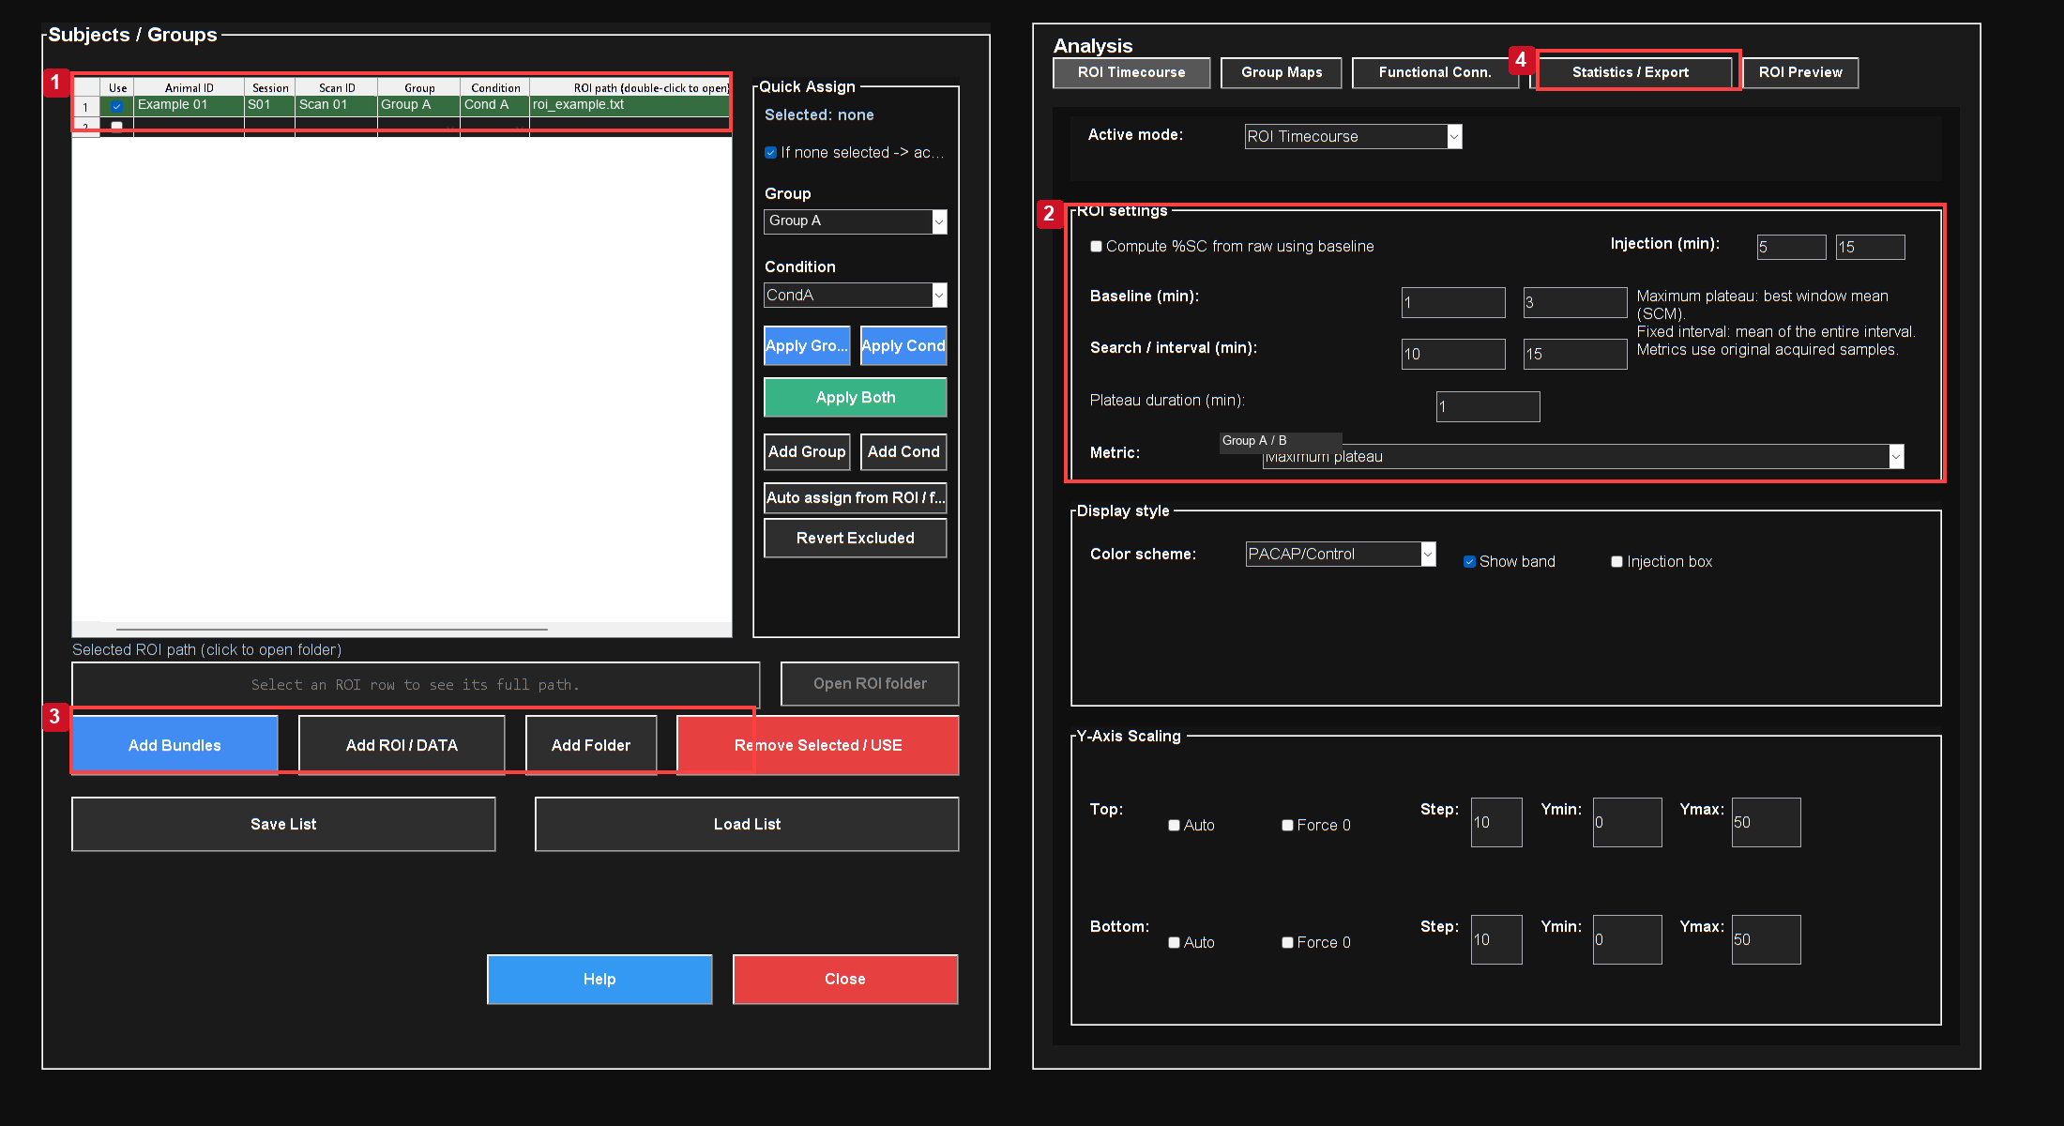
Actual MATLAB output from the reference workflow. Read the chapter steps for controls, input sampling, units and interpretation limits. The screenshot is a software example, not a validated biological result.
Controls: 1. Assign real animal/session/scan; 2. Baseline and metric in minutes; 3. Import ROI and bundle files; 4. Review Statistics and Export.

The illustrated import contains two roles from one recording and still shows N/A identity cells. Fill those from the experimental record before any group inference. These rows are a file-import demonstration, not two independent animals.

Import sequence
1. Open Group Analysis and choose the ROI/time-course route.
2. Click Add ROI / DATA and select the intended ROI TXT files.
3. Use one mean or allROIs file per recording/role. Do not import both equivalent ensemble summaries.
4. Inspect every row's full file path, animal, group, condition, role and PairID where relevant.
5. Resolve Unassigned/Needs assignment rows. Automatic inference is a starting point; verify it against the experimental record.
6. Mark included rows deliberately, choose the summary metric and interval, and preview.
7. Switch to Statistics after selecting an appropriate design and test.
Section summary. Assign real animal and condition identifiers; several ROIs in one animal do not increase independent n.
Important / practical tip. Assign real animal and condition identifiers; several ROIs in one animal do not increase independent n.

Assignment rules
Explicit saved ROI labels take precedence over filename and parent-folder hints. Target/PACAP and Control/Ringer/Vehicle names have supported mappings, but an experiment folder containing both names must not override an explicit file label. Conflicts remain visible for correction. Manual assignments are retained during ordinary refreshes. Auto assign from ROI / file explicitly reapplies inference to selected/all relevant rows.
Section summary. Explicit saved ROI labels take precedence over filename and parent-folder hints.
Important / practical tip. Assign real animal and condition identifiers; several ROIs in one animal do not increase independent n.

Time alignment
Curves can be interpolated onto a common physical-time grid for visualization. This does not turn missing acquired points into original measurements. The metric calculation uses each recording's original acquired samples and its original timestamp precision, so adding an animal with a different TR should not change another animal's plateau endpoint.
Section summary. Curves can be interpolated onto a common physical-time grid for visualization.
Important / practical tip. Assign real animal and condition identifiers; several ROIs in one animal do not increase independent n.

Mean and SEM
Equation (30)
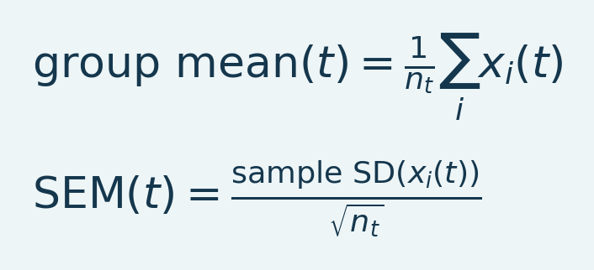
Variables and interpretation. x_i(t) is independent unit i at time t; n_t counts available finite units. Sample SD measures spread, and SEM divides by sqrt(n_t). Several ROIs in one animal do not create several independent units.
n_t is the number of finite included animal values at that time. SEM requires at least two and is not a 95% confidence interval. Variable coverage makes n_t change over time; inspect the count rather than assuming every plotted point contains the same animals.
Section summary. n_t is the number of finite included animal values at that time.
Important / practical tip. Assign real animal and condition identifiers; several ROIs in one animal do not increase independent n.

Performance and large headers
The current importer reads the recognized ROI ensemble schema without parsing repeated baseline payloads as table data. New exports keep shared baseline arrays in sidecars. Do not delete audit text manually to make an old file load faster. Unknown legacy formats retain their fallback reader. The original files stay unchanged.
The file picker remembers its last selected folder. Double-clicking a path cell or using Open ROI folder helps inspect the exact source. Adding a TXT should not rerun every plot merely because the subject list changed. A heavy Excel or movie export is a separate operation from switching Time Course/Statistics tabs.
Source: GroupAnalysis.m, GroupAnalysis_Common.m, gaInferAssignment.m, fusiSCMEnsembleHeader.m.
Section summary. The current importer reads the recognized ROI ensemble schema without parsing repeated baseline payloads as table data.
Important / practical tip. Assign real animal and condition identifiers; several ROIs in one animal do not increase independent n.

A recording is not a group study
The populated preview shows how exported ROI time courses and summary values appear in Group Analysis. Several ROIs from one recording remain measurements within the same biological unit, not independent animals. This display is descriptive; uncertainty and inference require the appropriate independent-sample design.
Correct animal, condition, group and pairing identifiers in the import table. Set windows, Run Analysis and inspect ROI Preview; review the specified test under Statistics/Export. Retain insufficient-replication warnings rather than inventing subjects.

Figure 49. Populated ROI preview
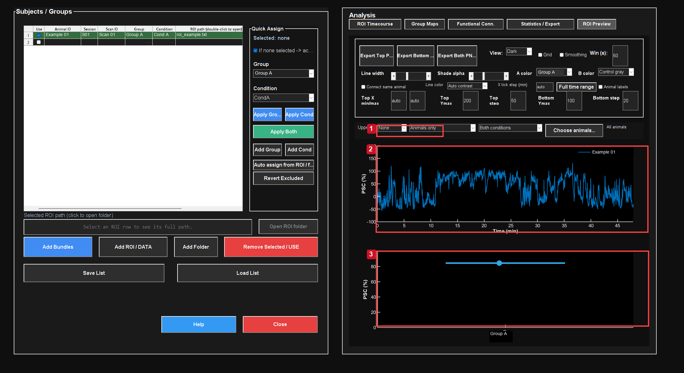
A real exported trace is plotted descriptively. The reference is one animal/recording; the number of ROI files must not be used as independent sample count.
Controls: 1. Choose individual-animal view; 2. Inspect measured trace and axes; 3. One metric per independent observation.
The preview shows the imported recording and selected metric window. It is not a fabricated multi-animal result.
Figure 50. Individual recording trace detail
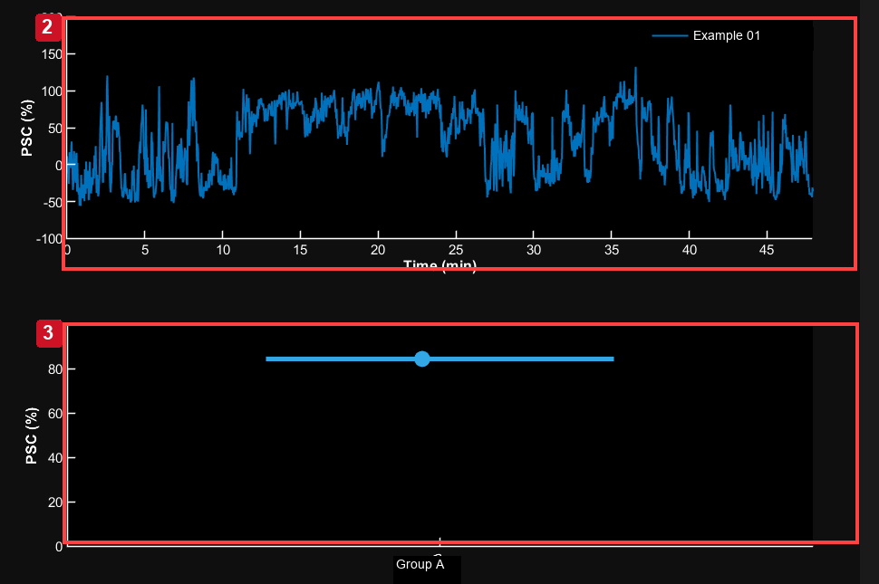
Actual MATLAB output from the reference workflow. Read the chapter steps for controls, input sampling, units and interpretation limits. The screenshot is a software example, not a validated biological result.
Detail crop of the actual Group Analysis preview. Test is None for this one-recording example; selected-window metrics are descriptive.
Figure 51. Statistics settings review
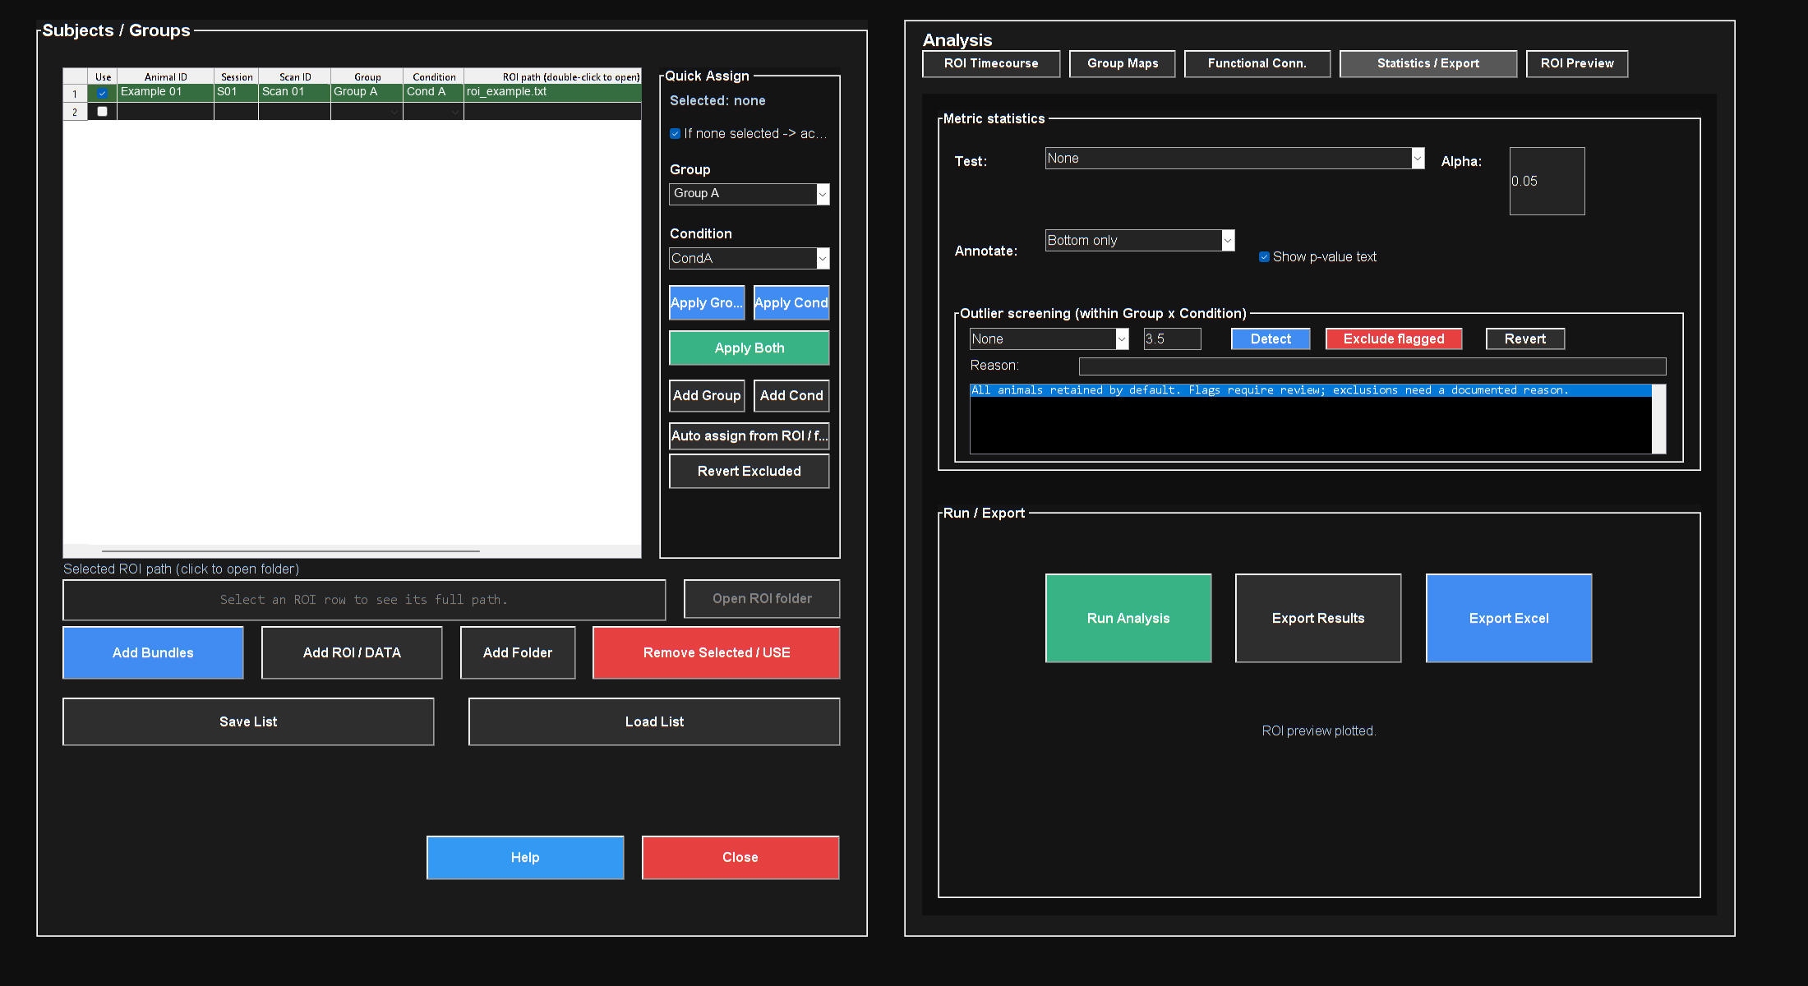
Actual MATLAB output from the reference workflow. Read the chapter steps for controls, input sampling, units and interpretation limits. The screenshot is a software example, not a validated biological result.

Review test, pairing and export settings. Single-recording replication limits still apply.
The populated preview shows how exported ROI time courses and summary values appear in Group Analysis. Several ROIs from one recording remain measurements within the same biological unit, not independent animals. This display is descriptive; uncertainty and inference require the appropriate independent-sample design.
Important / practical tip. Assign real animal and condition identifiers; several ROIs in one animal do not increase independent n.

Assign concentrations and display titrations
In Group Analysis > ROI Preview, choose Titration in the Bottom dropdown, then Assign doses.... Select the animal/scan rows for a dose, choose a concentration from the fixed 1/2/5 series between 1 pM and 10 µM, and click Assign selected. Individual Concentration cells also use dropdowns. Custom typed doses are unavailable; legacy off-list assignments remain visible until replaced or cleared.
Choose the source Group for aCSF; Auto recognizes aCSF, Vehicle and Control. Control rows do not need a dose. Source Group and Condition labels remain unchanged, while the plotted control category is aCSF. If the control Group has several Conditions, select one explicitly. The plot places aCSF first, followed by ascending doses with equal spacing by default; log spacing is optional. Unassigned treatment rows are reported and omitted.
Each titration dot is the animal mean of unique source scans within that category, and group means weight animals equally. Selected aCSF scans are pooled within animal irrespective of any older concentration assignment. Treatment Group and Condition combinations stay separate. Several ROIs or repeated scans do not become independent animals. Titration mode does not fit a dose-response model or run the generic pooled ROI test and Group-by-Condition outlier screening.
Error bars default to None; choose SEM or SD in Assign doses... when needed. The Legend checkbox shows or hides the live legend in the upper-right corner. Point edges match their fill colors. Save List / Load List retains assignments, selected comparisons and display choices. Correct Animal ID values before connecting repeated animals; connecting lines change the display and do not select paired statistics.

Select dose comparisons and statistical tests
Comparisons... supports dose-versus-aCSF tests, adjacent doses and any pair of displayed categories. On first use, all dose-versus-aCSF comparisons are selected. The default is an unpaired, equal-variance Student t-test with the one-tailed alternative dose > aCSF. Student vs aCSF restores those defaults for an older list. Test and Tail update checked rows; individual comparisons can instead use Welch, paired or two-sided tests.
Tests use the animal means shown by the dots. Paired tests run only when explicitly selected and match Animal IDs. Independent tests retain their independence assumption and report overlapping animal IDs rather than silently changing the test. Review sample counts, unavailable results and the experimental design. Saved selections are retained, including intentionally clearing every comparison.
Annotations show stars and rounded p-values together by default; for example, 0.00776 appears as ** p = 0.008. Calculations and result tables retain full precision. Star thresholds use the unrounded p-value: *** for p ≤ 0.001, ** for p ≤ 0.01 and * for p ≤ 0.05. Extra digits near these thresholds prevent inconsistent labels. Stars-only display is available. Unadjusted p-values are the default; Holm and Bonferroni apply to the selected comparison family and adjusted values are labelled p_adj. Hiding annotations does not change that family.

34. Group metrics, statistics and outlier review

Maximum plateau versus fixed interval
Maximum plateau finds each recording's complete frame-aligned window with the highest arithmetic mean inside the chosen search interval. Fixed interval mean averages the specified interval and disables the plateau-duration field. Display smoothing does not change these metrics.
Equation (31)
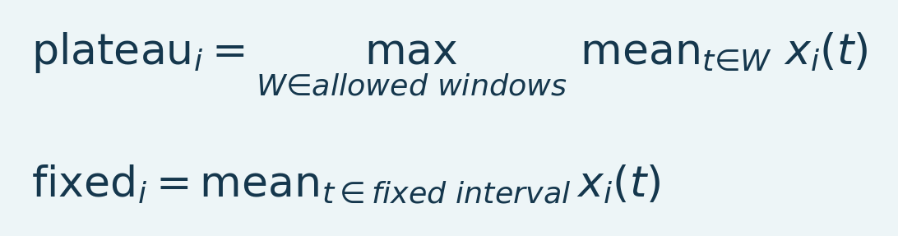
Variables and interpretation. x_i is an individual trace, W ranges over eligible complete windows of stated duration, plateau_i their maximum mean, and fixed_i the mean of a prespecified interval. Selecting and measuring on the same data requires selection-bias interpretation.
A maximum is an exploratory endpoint and grows with the opportunities searched. Prespecify search width and duration consistently. Prefer a fixed interval for a prespecified sustained-response hypothesis. Missing/short recordings remain missing when no valid window fits; review the reported list instead of silently dropping them.
Section summary. Maximum plateau finds each recording's complete frame-aligned window with the highest arithmetic mean inside the chosen search interval.
Important / practical tip. Use prespecified intervals and report multiplicity; maximum-window selection can inflate effects.

Choose the biological unit
Independent two-group tests require independent animals. A paired test requires matched PairID/animal identities and one appropriate value per member of each pair. Repeated scans or several ROIs from the same animal do not become independent subjects by occupying separate rows. Aggregate or choose a repeated-measure strategy outside the available simple test if that is what the design requires.
Section summary. Use prespecified intervals and report multiplicity; maximum-window selection can inflate effects.
Important / practical tip. Use prespecified intervals and report multiplicity; maximum-window selection can inflate effects.

Implemented test choices
Table 8. Implemented test choices overview
Test | Question and assumptions
None | Descriptive output only
One-sample t vs 0 | Mean of one group differs from 0; review distribution and independence
Student two-sample t | Independent groups, common-variance model
Welch two-sample t | Independent groups, unequal-variance standard error
Paired t | Within-pair mean difference differs from 0
One-way ANOVA | Omnibus comparison across group means under its variance model

For Welch's comparison:
Equation (32)
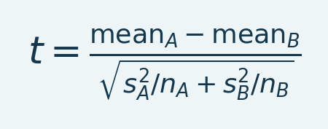
Variables and interpretation. mean_A/mean_B are group means, s_A/s_B sample standard deviations and n_A/n_B independent counts. t is the Welch statistic; degrees of freedom use Welch-Satterthwaite. Paired analysis uses within-pair differences instead.
The degrees of freedom use the Welch-Satterthwaite expression. Student's test pools within-group variance and uses nA+nB-2 degrees of freedom. A paired t-test is a one-sample test of matched differences. The GUI reports effect difference, confidence interval where defined, sample counts, missing counts and p-value. Degenerate variance and insufficient support produce warnings or unavailable results.
Section summary. Use prespecified intervals and report multiplicity; maximum-window selection can inflate effects.
Important / practical tip. Use prespecified intervals and report multiplicity; maximum-window selection can inflate effects.

Multiplicity and honest reporting
The ROI endpoint test's p-value is unadjusted across multiple analyses unless an explicit correction is performed. Selecting many ROIs/windows/tests and reporting only the smallest p-value increases false-positive risk. FC/voxel group routines have their own FDR paths; do not assume that an FC q-value corrects every ROI endpoint comparison too.
Outlier screening should identify a problem to investigate. Do not remove an animal because its response opposes the hypothesis. Retain raw points, documented criteria, before/after sensitivity and reasons for exclusion. Report the test, tail, alpha, effect, interval, biological sample size and missingness along with the p-value.
Source: GroupAnalysis_Common.m, gaMaximumPlateau.m, plateauIntervalFrames.m, gaOutlierScores.m, gaFormatPValue.m.
Section and chapter summary. The ROI endpoint test's p-value is unadjusted across multiple analyses unless an explicit correction is performed. Use prespecified intervals and report multiplicity; maximum-window selection can inflate effects.
Important / practical tip. Use prespecified intervals and report multiplicity; maximum-window selection can inflate effects.

Preview publication figures before exporting
Export Top..., Export Bottom... and Export Both... open publication previews for time courses, ordinary group comparisons and titrations. Compare Compact (85 × 75 mm), Square (90 × 90 mm) and Wide (140 × 90 mm) layouts. Choose Light or Dark; the initial scheme follows the visible ROI Preview. Axis labels, tick labels and p-values share the publication font size, and axis strokes use a consistent thickness. Marker sizes are scaled for the physical figure dimensions.
Click and drag a p-value label or bracket to move them together before saving. Reset p-value positions restores automatic placement. Positions are retained when switching layouts and used in the exported figure. The manually selected y minimum and maximum remain exact; comparison brackets have a separate annotation area above the data.
Show legend toggles the export legend, and Legend position places it above the plot or in an inside corner. The default export position is above the plot. Corner placement may overlap data, so inspect the preview after moving it. Preview and saved output use the same rendering path, including the chosen theme and legend settings.
Choose PNG at 600 dpi, vector PDF, or both, then continue to the export folder. Excel export includes source assignments, animal means, dose summaries, selected comparisons, raw and adjusted p-values, and included animal IDs. Reported confidence intervals are pointwise, not simultaneous intervals for the whole family. Retain the saved list and parameter record with the figures.

IX. Standardize a reviewed workflow

35. Fixed ROI protocols and standardized analysis

Fixed ROI protocol
Automatic analysis > Load fixed protocol reads a JSON protocol whose geometry and coordinates must match the current anatomy. This is useful when target/control locations and windows were chosen independently of the measured response. The implementation validates grid size, coordinates, baseline and signal coverage before writing outputs. It does not silently shrink a fixed ROI around missing samples to make it pass.
Use the protocol schema documented in automatic SCM notes and the AutomaticSCM.m source. Copy a reviewed example and preserve its version and reference dimensions. A protocol prepared on an atlas grid is not automatically valid on a native movie or another registration. Changing only the label in JSON does not move its ROI to a different brain region.
Section summary. Automatic analysis > Load fixed protocol reads a JSON protocol whose geometry and coordinates must match the current anatomy.
Important / practical tip. Inspect and edit every preset before applying it to a new acquisition or experimental timing.

Standardized Analysis manager
Figure 52. Editable workflow manager
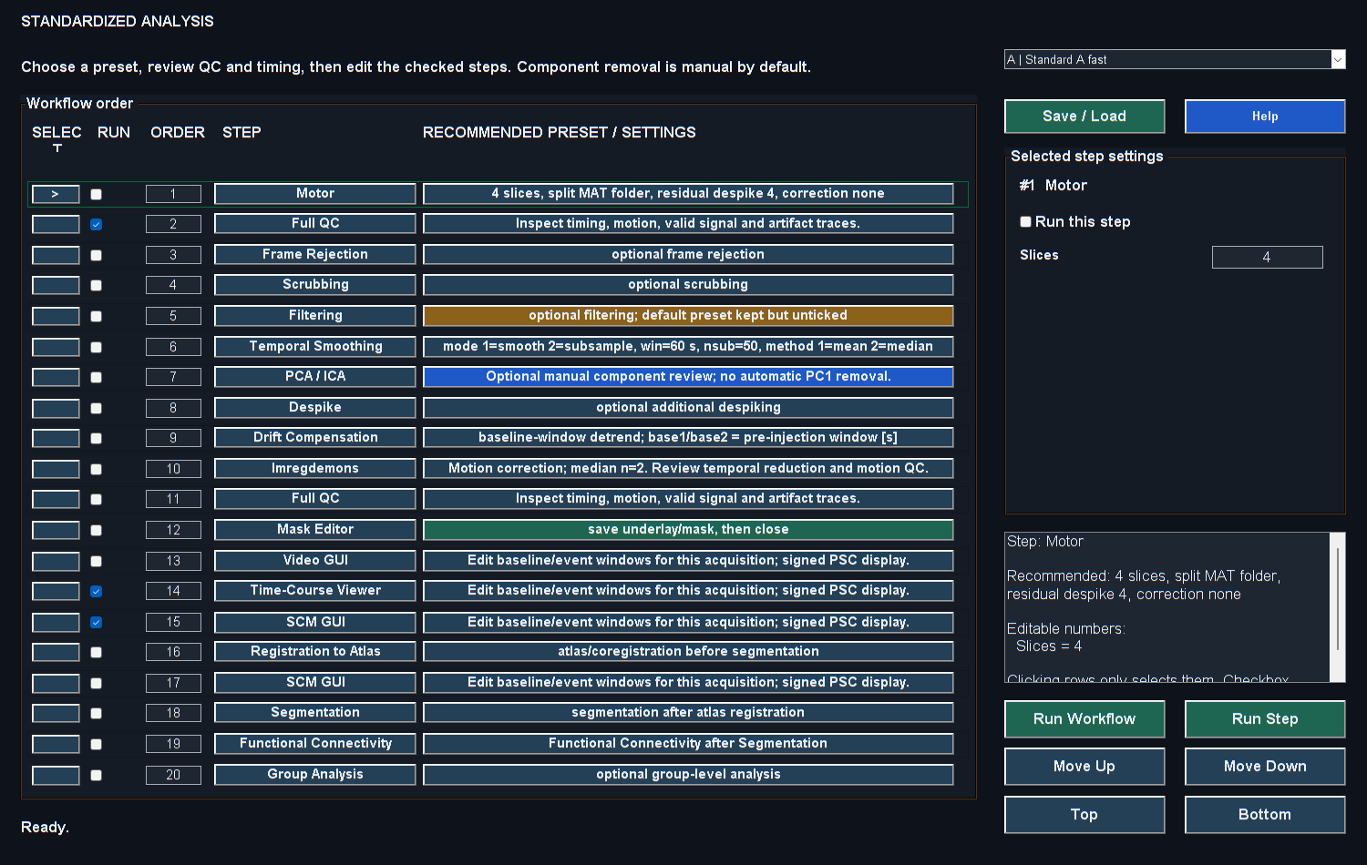
Actual MATLAB output from the reference workflow. Read the chapter steps for controls, input sampling, units and interpretation limits. The screenshot is a software example, not a validated biological result.

1. Open Standardized Analysis from Studio.
2. Choose the preset matching acquisition and experimental state.
3. Review every checked step, its order and the active parameters. Unchecked steps can retain values without running.
4. Click a row to edit its parameters. Use the Run checkbox to include/exclude it; row selection alone is not a command to run the step.
5. Set baseline/signal windows and filter frequencies for the actual acquisition. Example defaults are not universal scientific recommendations.
6. Start the workflow and review interactive stages. Some steps wait until their viewer is closed; an open review window is not necessarily a hung pipeline.
7. Save the final settings and processing metadata with the analysis record.
Section summary. Inspect and edit every preset before applying it to a new acquisition or experimental timing.
Important / practical tip. Inspect and edit every preset before applying it to a new acquisition or experimental timing.

Preset interpretation
Table 9. Preset interpretation overview
Key | Purpose
A | Fast screening: QC and core viewers
B | Longer guided review, registration and downstream analysis
C | 2D awake workflow
D | 2D anesthetized workflow
E | Awake 3D workflow with explicit automated PC1 removal and substantial averaging settings
F | Anesthetized 3D workflow
G | Motor reconstruction and downstream review

Preset E is an important exception to manual component review: the current source explicitly requests PC1 removal and nsub 50. Inspect those choices and their temporal consequences before running it. A preset name is not evidence that every included correction is appropriate for a specific experiment.
Section summary. Preset E is an important exception to manual component review: the current source explicitly requests PC1 removal and nsub 50.
Important / practical tip. Inspect and edit every preset before applying it to a new acquisition or experimental timing.

Review the current automated presets
H | Awake fast injections runs Frame Rejection at 3 sigma with interpolation on the original time grid, automatic PC1 removal across slices with voxel means restored, median blocks of 50 followed by Imregdemons, and SCM GUI. SCM starts positive-only at 0–50%, alpha modulation 5–10%, baseline 30–60 s and signal 700–900 s. Frame QC is saved without opening preview windows.
I | Low-pass / Reject / Imreg50 runs a 0.01 Hz, order-2, zero-phase Butterworth low-pass filter with voxel means preserved, Frame Rejection at 3 sigma with interpolation, then median blocks of 50 and Imregdemons. It does not automatically open SCM. J | Reject / PC1-5 / Imreg50 / SCM uses the H sequence but removes PCs 1–5 and opens SCM with a 7–14 min signal interval.
These presets automatically choose the registration mode for 2D, step-motor or 3D inputs. Median blocks of 50 multiply analyzed TR by 50. A timing check precedes processing; review every step, filter cutoff, component choice and event window for the current acquisition. Defaults are editable starting points and do not establish biological suitability. Reopen Standardized Analysis after replacing source files.

Modifying the workflow
Use the manager's per-step controls first. For scripted inspection, steps = standardizedAnalysis('C') returns a preset definition without launching its GUI. Maintain a versioned copy of any source-level changes to presetSteps and the step schema. Do not add an unknown field and assume a callback uses it: trace the callback's option handling in the assembled Studio sources. Record the changed fields, rationale and a comparison with the parent workflow. Avoid changing numerical defaults simply to make the output look smoother.
Source: standardizedAnalysis.m, fusi_studio_GUI.m, fusi_studio_callback.m.
Section and chapter summary. Inspect and edit every preset before applying it to a new acquisition or experimental timing. Inspect and edit every preset before applying it to a new acquisition or experimental timing.
Important / practical tip. Inspect and edit every preset before applying it to a new acquisition or experimental timing.

X. Troubleshooting and reproducibility

36. Troubleshooting by symptom
Table 10. 36. Troubleshooting by symptom overview
Symptom | Check first | Likely causes / next action
First network load takes minutes | Source size, adapter and copy counter | Network transfer or compressed MAT parsing; compare local/cache timing
Second load still copies | Source identity, size/mtime, available cache | Cache eviction, changed file, alternate path or incomplete first copy
PCA bar looks complete but waits | Current status and save path | Removal finished but durable save remains; current version reports chunked saving
Raw image blank after PCA | Active I versus cached PSC; display limits | Old callback selecting cached PSC, aggressive contrast or a dim/empty slice
Filtered data have near-zero baseline | Preserve voxel mean and input units | Centered filter output is not ordinary Doppler power for PSC
Automatic SCM GO disabled after drawing | End gesture and change a search control | Old interrupted-drag state; reopen current GUI after update
Painted region yields no ROI | ROI footprint and all eligibility intersections | Too small paint, restrictive side/rectangle, invalid samples or mask/atlas coverage
Whole region size/coverage fields grey | Named labels and ROI mode | Those fields are inapplicable to whole-region support; select a named region
Atlas picker opens a parent folder | Actual saved package and active recording | No saved plane found, stale retained path, or a different scan selected
Atlas looks stretched | Saved source/output grids and transform | Unsupported resizing, wrong native/atlas input or wrong registration package
New underlay erases atlas context | Source kind | Plain unrelated anatomy differs from switching within one saved registration
FC lists too many regions | Granularity versus hemisphere mode | Choose merged subdivisions, then recompute ROI current
FC correlation undefined | Finite count and variance | Constant signal, missing support, too short interval or invalid masks
Group TXT import slow | Header schema and sidecars | Old repeated baseline audit payload; current reader has a bounded recognized-header path
Group result changes after adding files | Row units, metric and original time grids | Accidental duplicate observations, reassignment or changed analysis settings
Model hides deep PSC | Vessel/atlas opacity and backend | Ray occlusion or threshold choice; inspect stack/surface view and PSC-only mode
Model slow during navigation | Backend, geometry, visible voxel/surface count | Heavy upload/mesh work; inspect control timings and prepared-anatomy reuse
Save failed but result is in Studio | Output availability and save status | Retry/recover the retained result; do not discard MATLAB memory prematurely

A disciplined diagnostic sequence
Reproduce one operation on one known dataset. Record the exact active path, shape, TR, signal units, MATLAB release, output drive and last visible stage. Separate disk read, calculation, redraw and save. Compare a local output with a network output without changing the numerical parameters. Inspect the MATLAB error report and the relevant callback version. Do not apply multiple speculative fixes at once.
Section and chapter summary. Reproduce one symptom on a preserved original and record the active source path and precise error. Reproduce one symptom on a preserved original and record the active source path and precise error.
Important / practical tip. Reproduce one symptom on a preserved original and record the active source path and precise error.

37. Reproducible analysis and publication checklist

Minimum analysis record
• Original scan identifier, file path, file format, dimensions, class and acquisition provenance.
• Signal units, timestamp source, acquisition TR, irregularity/gaps and any explicit resampling.
• Spatial sampling, native axis permutation and laterality confirmation.
• Ordered processing operations with parameters, selected components, rejected/interpolated indices and retained counts.
• Derived MAT filenames and verified save status.
• Baseline source, entered and actual sample bounds, and external reference sidecars.
• Mask definitions, include/exclude flags, registration package, region grouping and actual support.
• SCM search or fixed-protocol definitions, plateau duration, candidate ranking and selection rationale.
• FC period, hemisphere mode, region list, sample counts and preprocessing sensitivity.
• Biological replicate identity, pairing, test, effect, interval, missingness and multiplicity handling.
• Display/export settings, color ranges, physical scale, smoothing and any 3D depth exaggeration.
• Source revision, local modifications and analysis notes.
Section summary. Retain input, timing, processing options, masks, atlas package and exported sidecars as one analysis record.
Important / practical tip. Retain input, timing, processing options, masks, atlas package and exported sidecars as one analysis record.

Review performance and output integrity
Verify a representative input before committing a complete study to a processing workflow. Check dimensions, finite values, timestamps, registration direction and saved-file readback. A successful software check does not establish biological validity or guarantee every option on unseen inputs. Preserve the original and review derived branches independently.
Review interactive drawing, masks, atlas loading and sign modes on the intended acquisition geometry. Inspect a short movie export before exporting a long sequence. Use the saved metadata and settings to reproduce the view. Distinguish display responsiveness, computational runtime and scientific correctness when reporting an issue.
Verify a representative input before committing a complete study to a processing workflow. Check dimensions, finite values, timestamps, registration direction and saved-file readback. A successful software check does not establish biological validity or guarantee every option on unseen inputs. Preserve the original and review derived branches independently.
Important / practical tip. Retain input, timing, processing options, masks, atlas package and exported sidecars as one analysis record.

Performance context
Initial loading can be limited by network throughput, compression and storage speed. A mapped drive letter does not identify the underlying hardware or guarantee performance. Compare transfer, file parsing, computation and result writing separately. Reusing a complete local cache avoids repeating the network transfer but still requires parsing the cached file.
Initial loading can be limited by network throughput, compression and storage speed. A mapped drive letter does not identify the underlying hardware or guarantee performance. Compare transfer, file parsing, computation and result writing separately. Reusing a complete local cache avoids repeating the network transfer but still requires parsing the cached file.
Important / practical tip. Retain input, timing, processing options, masks, atlas package and exported sidecars as one analysis record.

Implementation reference
Consult the MATLAB source appendix for function interfaces and implementation details. Record the software revision, options and timing when comparing performance.
The documentation structure is inspired by the separation of user guide, graphical interface, examples and API reference on ConfUSIus. It is a separate software project; its Python APIs and workflows are not deConfUSIon commands. External scientific/software references cited in this handbook support their stated concepts; toolbox behavior is checked against this repository.
Section and chapter summary. Read 2D/3D verification , performance repairs , 3D loading details , and the current October 15 repair report . Retain input, timing, processing options, masks, atlas package and exported sidecars as one analysis record.
Important / practical tip. Retain input, timing, processing options, masks, atlas package and exported sidecars as one analysis record.

XI. Glossary, literature and acknowledgments

38. Abbreviations and technical glossary
The glossary covers authored guide terminology and common source interfaces. Literal variable names, file extensions and atlas region acronyms retain their source meaning; region names are defined in the atlas name table. A two-dimensional or three-dimensional acquisition counts spatial axes, not the array's time axis.
Table 11. 38. Abbreviations and technical glossary overview
Abbreviation | Expansion and explanation
2D / 3D / 4D | Two / three / four dimensional; a volumetric movie has three spatial axes plus time
aCompCor / tCompCor | Anatomical / temporal component-based noise correction; PCs from anatomical noise / variability-selected regions
aCSF | Artificial cerebrospinal fluid; an experimental vehicle, distinct from anatomical CSF
ANOVA | Analysis of variance; comparison of means under specified design assumptions
AP / ML / DV | Anterior-posterior / medial-lateral / dorsal-ventral anatomical axes
API | Application programming interface; callable software contract
AUC | Area under curve; integral with specified time window and units
BOLD / fMRI | Blood oxygenation level dependent / functional magnetic resonance imaging; different signal/modality from fUSI
CCA | Canonical correlation analysis; correlated linear projections between variable sets
CCF | Common Coordinate Framework; atlas reference space
CI | Confidence interval; interval from a specified repeated-sampling procedure
CNR | Contrast-to-noise ratio; difference scaled by noise; pseudo-CNR lacks verified task timing
COM | Center of mass; here an intensity-weighted center in array coordinates
CompCor | Component-based noise correction; regression of selected noise-region PCs
CPU / GPU | Central / graphics processing unit; compute devices with distinct memory/graphics roles
CSV / TSV / TXT | Comma-separated / tab-separated / plain-text files; verify delimiter and headers
CV | Coefficient of variation; standard deviation divided by mean
DC | Direct-current component; temporal zero-frequency level
DCT | Discrete cosine transform; cosine basis for frequency/trend models
DVARS | Root mean square temporal derivative across voxels; frame-change diagnostic, not displacement
FC | Functional connectivity; statistical dependence between measured time courses
FDR / BH | False discovery rate / Benjamini-Hochberg multiple-testing procedure
FFT / DFT | Fast Fourier transform / discrete Fourier transform; algorithm / finite frequency representation
FIR / IIR | Finite / infinite impulse response; filter families defined by response kernels
FPS | Frames per second; playback rate can differ from acquisition rate
fUS / fUSI | Functional ultrasound / functional ultrasound imaging; ultrasound hemodynamic imaging
FWHM | Full width at half maximum; a width definition for a response/kernel
GLM / OLS | General linear model / ordinary least squares; linear design / coefficient fitting
GUI / UI | Graphical user interface / user interface; controls and displayed views
GSR | Global signal regression; regression of whole-support mean signal
HDF5 | Hierarchical Data Format version 5; storage underlying MATLAB v7.3 MAT
HPF / LPF / BPF | High-pass / low-pass / band-pass filter; retains a selected frequency region
Hz / s / min | Hertz / seconds / minutes; cycles per second and time units
ICA | Independent component analysis; decomposition with independence assumptions
ID | Identifier; explicit identity for animal, recording, condition or region
IQ | In-phase and quadrature; complex ultrasound samples, distinct from a reconstructed movie
IRLS | Iteratively reweighted least squares; robust fitting with residual-dependent weights
MAT / MATLAB | MATLAB data-file format / MathWorks numerical computing environment
MB / GB | Megabytes / gigabytes; decimal byte units unless MiB/GiB are specified
MiB / GiB | Mebibytes / gibibytes; binary units of 2^20 / 2^30 bytes
MPI | Max Planck Institute; institutional abbreviation in the attribution
NaN / Inf | Not a number / infinity; special values requiring finite-support handling
PACAP | Pituitary adenylate cyclase-activating polypeptide; experiment-specific context
PC / PCA | Principal component / principal component analysis; orthogonal variance decomposition
PDF / HTML | Portable Document Format / HyperText Markup Language; handbook formats
PNG / MP4 | Portable Network Graphics / MPEG-4 container; image / movie formats
PSD | Power spectral density; frequency-dependent power with stated normalization
PSC | Percentage signal change; difference relative to a specified baseline
QC | Quality control; review of acquisition, processing and analysis assumptions
RAM | Random-access memory; working memory distinct from file storage
RGB / RGBA | Red-green-blue / red-green-blue-alpha; color and optional opacity channels
ROI | Region of interest; explicit spatial support for measurement
SCM | Signal-change map; spatial summary of percentage signal change over a chosen interval
JSON | JavaScript Object Notation; structured text for settings and audit records
DOI | Digital object identifier; persistent scholarly reference identifier
PID / OS | Process identifier / operating system; identifies a MATLAB session / host software environment
LR | Left-right; orientation convention requiring acquisition confirmation
AI | Artificial intelligence; here the acknowledged writing/development assistance
SD / SEM | Standard deviation / standard error of mean; spread / uncertainty with a stated replication unit
SHA-256 | Secure Hash Algorithm with 256-bit digest; file-identity comparison
SNR / tSNR | Signal-to-noise ratio / temporal SNR; depends on signal/noise and support definitions
SOS | Second-order sections; stable representation of digital filters
SVD | Singular value decomposition; orthogonal factorization underlying PCA
TR | Repetition/sampling interval in seconds; changes after block reduction
WM / CSF | White matter / cerebrospinal fluid; anatomical noise candidates requiring validation
Z-score | Deviation from mean in standard-deviation units; distinct from spatial Z

39. Literature and technical references
L identifiers connect explanations to these sources. Literature motivates interpretation; the local checked implementation defines toolbox behavior. Online docs may describe releases newer than R2023b. Accessed 15 October 2026.
1. [L1] Macé E et al. (2011). Functional ultrasound imaging of the brain. Nature Methods 8, 662-664. Article record.
2. [L2] Jolliffe IT, Cadima J (2016). Principal component analysis: a review and recent developments. Philosophical Transactions A 374, 20150202. DOI 10.1098/rsta.2015.0202. Article.
3. [L3] MathWorks. Butterworth filter design. butter.
4. [L4] MathWorks. Zero-phase digital filtering. filtfilt. Use syntax supported in R2023b.
5. [L5] MathWorks. Digital filter design. Overview, IIR methods, Hamming FIR.
6. [L6] Halko N, Martinsson PG, Tropp JA (2011). Finding structure with randomness: probabilistic algorithms for constructing approximate matrix decompositions. SIAM Review 53, 217-288. Author preprint.
7. [L7] Behzadi Y et al. (2007). A component based noise correction method (CompCor) for BOLD and perfusion based fMRI. NeuroImage 37, 90-101. Article.
8. [L8] Le Meur-Diebolt S et al. (2026). Robust functional ultrasound imaging in the awake and behaving brain: a systematic framework for motion artifact removal. Imaging Neuroscience 4. DOI 10.1162/IMAG.a.1191. Primary research article. Experiment-specific evidence for denoising/FC sensitivity.
9. [L9] Faure F et al. (2025). Functional ultrasound (fUS) detects mild cerebral alterations using canonical correlation analysis denoising and dynamic functional connectivity analysis. Imaging Neuroscience. DOI 10.1162/IMAG.a.128. Article record.
10. [L10] Suomi V, Han Y, Konofagou E, Cleveland RO (2016). The effect of temperature dependent tissue parameters on acoustic radiation force induced displacements. Physics in Medicine and Biology 61, 7427-7447. DOI 10.1088/0031-9155/61/20/7427. Research preprint. General ultrasound evidence, not a diagnosis of drift in these fUSI scans.
11. [L11] MathWorks. imregdemons. Demons deformable image registration.
12. [L12] MathWorks. corr. Correlation computation; temporal dependence remains an inference issue.
13. [L13] Blender Foundation. Import/export manual. External presentation workflow; no native toolbox Blender scene export currently exists.

40. Acknowledgments and authorship
We acknowledge Dimokratis Karamanlis and all LightSuite coauthors for the original framework, methods and resources. Cite their preprint alongside deConfUSIon and the relevant atlas references. It was posted on 14 October 2026 and had not been peer reviewed. These integration screenshots do not reproduce paper figures.
Karamanlis D, Xie Y, Foucher CG, Alappat M, Masood A, Dimitropoulou I, Pivron LAF, Martínez de Paz JM, Macé E, Gaspari S, El-Boustani S. LightSuite: scalable atlas registration and cell detection across the central nervous system. bioRxiv (2026). doi:10.64898/2026.10.13.757638.
Soner Caner Cagun — MPI for Biological Cybernetics. Attribution identifies the project context and does not imply institutional approval of every analysis choice.
ChatGPT, used through Codex, assisted with source inspection, drafting, mathematical explanations, handbook formatting and capture or annotation of MATLAB windows. AI assistance is acknowledged as a tool, not listed as an author. Scientific interpretation, independent anatomy and event review, citation verification and publication approval remain with the human authors.

41. Analysis handover record
Record scan identity/checksum, acquisition type, shape, analyzed TR, time origin, spacing, events, preprocessing and QC rationale. Include baseline/response windows, mask/atlas files, grouping, ROI selection, independent replication unit, model/test settings, software version and export folder. A colleague should be able to reproduce decisions without reconstructing them from screenshots.

XII. MATLAB source reference

Current source additions
The following index covers source modules added after the earlier detailed appendix snapshot. Filenames are exact MATLAB identifiers. It is a navigation index, not a command sequence or a reason to call private helpers directly. Launch the supported GUIs and retain the full lib folder. The repository source is authoritative for current function declarations and line positions.
The public LightSuite launcher opens the optional registration workspace.

deConfUSIon_LightSuite.m
deConfUSIon_LightSuite.m
Atlas helpers manage readable labels and intensity limits for anatomical displays.

lib/atlas/fusiAtlasDisplayAcronym.m
lib/atlas/fusiAtlasDisplayAcronym.m

lib/atlas/fusiAtlasIntensityLimits.m
lib/atlas/fusiAtlasIntensityLimits.m
Display helpers support editable geometric masks, slice bounds, pointers and mask smoothing.

lib/display/fusiGeometricMaskDialog.m
lib/display/fusiGeometricMaskDialog.m

lib/display/fusiGeometricMaskVolume.m
lib/display/fusiGeometricMaskVolume.m

lib/display/fusiImagePointer.m
lib/display/fusiImagePointer.m

lib/display/fusiSliceMaskBounds.m
lib/display/fusiSliceMaskBounds.m

lib/display/fusiSmoothMaskVolume.m
lib/display/fusiSmoothMaskVolume.m
Group helpers implement animal and recording identity, titration assignments and tests, draggable comparison annotations and publication previews/exports.

lib/group/gaAnimalIdentity.m
lib/group/gaAnimalIdentity.m

lib/group/gaExportBrackets.m
lib/group/gaExportBrackets.m

lib/group/gaGroupPublication.m
lib/group/gaGroupPublication.m

lib/group/gaPublicationExport.m
lib/group/gaPublicationExport.m

lib/group/gaPublicationLegend.m
lib/group/gaPublicationLegend.m

lib/group/gaPublicationTheme.m
lib/group/gaPublicationTheme.m

lib/group/gaRecordingIdentity.m
lib/group/gaRecordingIdentity.m

lib/group/gaSignificanceStars.m
lib/group/gaSignificanceStars.m

lib/group/gaSyncAnimalPairIDs.m
lib/group/gaSyncAnimalPairIDs.m

lib/group/gaTitration.m
lib/group/gaTitration.m

lib/group/gaTitrationBrackets.m
lib/group/gaTitrationBrackets.m

lib/group/gaTitrationCategories.m
lib/group/gaTitrationCategories.m

lib/group/gaTitrationComparisonDialog.m
lib/group/gaTitrationComparisonDialog.m

lib/group/gaTitrationComparisonSpecs.m
lib/group/gaTitrationComparisonSpecs.m

lib/group/gaTitrationComparisons.m
lib/group/gaTitrationComparisons.m

lib/group/gaTitrationDialog.m
lib/group/gaTitrationDialog.m

lib/group/gaTitrationDoseChoices.m
lib/group/gaTitrationDoseChoices.m

lib/group/gaTitrationExport.m
lib/group/gaTitrationExport.m

lib/group/gaTitrationExportDialog.m
lib/group/gaTitrationExportDialog.m

lib/group/gaTitrationPlot.m
lib/group/gaTitrationPlot.m

lib/group/gaTitrationPreviewLayout.m
lib/group/gaTitrationPreviewLayout.m

lib/group/gaTitrationPublication.m
lib/group/gaTitrationPublication.m
I/O helpers select native movie output and construct the process environment for external tools.

lib/io/fusiMovieOutput.m
lib/io/fusiMovieOutput.m

lib/io/fusiNativeProcessEnvironment.m
lib/io/fusiNativeProcessEnvironment.m
LightSuite helpers prepare anatomy and geometry, manage landmarks and registration versions, run fitting, review transforms and provide native atlas/background outputs.

lib/lightsuite/compat/addElastixRepoPaths.m
lib/lightsuite/compat/addElastixRepoPaths.m

lib/lightsuite/compat/cbrewer.m
lib/lightsuite/compat/cbrewer.m

lib/lightsuite/compat/registrationPointsToAtlas.m
lib/lightsuite/compat/registrationPointsToAtlas.m

lib/lightsuite/fusiLightSuite.m
lib/lightsuite/fusiLightSuite.m

lib/lightsuite/fusiLightSuiteAnatomyReview.m
lib/lightsuite/fusiLightSuiteAnatomyReview.m

lib/lightsuite/fusiLightSuiteAtlasDisplay.m
lib/lightsuite/fusiLightSuiteAtlasDisplay.m

lib/lightsuite/fusiLightSuiteAtlasSampling.m
lib/lightsuite/fusiLightSuiteAtlasSampling.m

lib/lightsuite/fusiLightSuiteAtlasToNative.m
lib/lightsuite/fusiLightSuiteAtlasToNative.m

lib/lightsuite/fusiLightSuiteBuildInverse.m
lib/lightsuite/fusiLightSuiteBuildInverse.m

lib/lightsuite/fusiLightSuiteChoice.m
lib/lightsuite/fusiLightSuiteChoice.m

lib/lightsuite/fusiLightSuiteChooseAtlasProject.m
lib/lightsuite/fusiLightSuiteChooseAtlasProject.m

lib/lightsuite/fusiLightSuiteConfig.m
lib/lightsuite/fusiLightSuiteConfig.m

lib/lightsuite/fusiLightSuiteCopyNativeAtlas.m
lib/lightsuite/fusiLightSuiteCopyNativeAtlas.m

lib/lightsuite/fusiLightSuiteDependencies.m
lib/lightsuite/fusiLightSuiteDependencies.m

lib/lightsuite/fusiLightSuiteDisplayBounds.m
lib/lightsuite/fusiLightSuiteDisplayBounds.m

lib/lightsuite/fusiLightSuiteFitProgress.m
lib/lightsuite/fusiLightSuiteFitProgress.m

lib/lightsuite/fusiLightSuiteGUI.m
lib/lightsuite/fusiLightSuiteGUI.m

lib/lightsuite/fusiLightSuiteHistologyAtlas.m
lib/lightsuite/fusiLightSuiteHistologyAtlas.m

lib/lightsuite/fusiLightSuiteIdentity.m
lib/lightsuite/fusiLightSuiteIdentity.m

lib/lightsuite/fusiLightSuiteInputSpacing.m
lib/lightsuite/fusiLightSuiteInputSpacing.m

lib/lightsuite/fusiLightSuiteLabelWindow.m
lib/lightsuite/fusiLightSuiteLabelWindow.m

lib/lightsuite/fusiLightSuiteLandmarkHelp.m
lib/lightsuite/fusiLightSuiteLandmarkHelp.m

lib/lightsuite/fusiLightSuiteLandmarkResiduals.m
lib/lightsuite/fusiLightSuiteLandmarkResiduals.m

lib/lightsuite/fusiLightSuiteLandmarkUnderlay.m
lib/lightsuite/fusiLightSuiteLandmarkUnderlay.m

lib/lightsuite/fusiLightSuiteLandmarks.m
lib/lightsuite/fusiLightSuiteLandmarks.m

lib/lightsuite/fusiLightSuiteLog.m
lib/lightsuite/fusiLightSuiteLog.m

lib/lightsuite/fusiLightSuiteNativeBackgrounds.m
lib/lightsuite/fusiLightSuiteNativeBackgrounds.m

lib/lightsuite/fusiLightSuiteNativeFiles.m
lib/lightsuite/fusiLightSuiteNativeFiles.m

lib/lightsuite/fusiLightSuiteOrientation.m
lib/lightsuite/fusiLightSuiteOrientation.m

lib/lightsuite/fusiLightSuitePaths.m
lib/lightsuite/fusiLightSuitePaths.m

lib/lightsuite/fusiLightSuitePrepareAdapters.m
lib/lightsuite/fusiLightSuitePrepareAdapters.m

lib/lightsuite/fusiLightSuiteProjectStart.m
lib/lightsuite/fusiLightSuiteProjectStart.m

lib/lightsuite/fusiLightSuiteReadMetadata.m
lib/lightsuite/fusiLightSuiteReadMetadata.m

lib/lightsuite/fusiLightSuiteReadNifti.m
lib/lightsuite/fusiLightSuiteReadNifti.m

lib/lightsuite/fusiLightSuiteRegionInput.m
lib/lightsuite/fusiLightSuiteRegionInput.m

lib/lightsuite/fusiLightSuiteRegistrationReview.m
lib/lightsuite/fusiLightSuiteRegistrationReview.m

lib/lightsuite/fusiLightSuiteReviewVolumes.m
lib/lightsuite/fusiLightSuiteReviewVolumes.m

lib/lightsuite/fusiLightSuiteRunElastix.m
lib/lightsuite/fusiLightSuiteRunElastix.m

lib/lightsuite/fusiLightSuiteSpacing.m
lib/lightsuite/fusiLightSuiteSpacing.m

lib/lightsuite/fusiLightSuiteStyle.m
lib/lightsuite/fusiLightSuiteStyle.m

lib/lightsuite/fusiLightSuiteUnderlayLibrary.m
lib/lightsuite/fusiLightSuiteUnderlayLibrary.m

lib/lightsuite/fusiLightSuiteVisualizationFolder.m
lib/lightsuite/fusiLightSuiteVisualizationFolder.m
ROI helpers rank complete atlas regions, match opposite-side counterparts, retain scan-specific support and export regional traces and audit records.

lib/roi/scmAtlasCounterpart.m
lib/roi/scmAtlasCounterpart.m

lib/roi/scmAtlasRankingCandidates.m
lib/roi/scmAtlasRankingCandidates.m

lib/roi/scmAtlasRankingDialog.m
lib/roi/scmAtlasRankingDialog.m

lib/roi/scmAtlasRankingReview.m
lib/roi/scmAtlasRankingReview.m

lib/roi/scmCandidateExportTrace.m
lib/roi/scmCandidateExportTrace.m

lib/roi/scmExportAtlasRanking.m
lib/roi/scmExportAtlasRanking.m

lib/roi/scmROIEnsembles.m
lib/roi/scmROIEnsembles.m

lib/roi/scmRankAtlasRegions.m
lib/roi/scmRankAtlasRegions.m

lib/roi/scmRankAtlasRoles.m
lib/roi/scmRankAtlasRoles.m

lib/roi/scmRankAtlasScanSequence.m
lib/roi/scmRankAtlasScanSequence.m

lib/roi/scmSearchSideMasks.m
lib/roi/scmSearchSideMasks.m

lib/roi/scmSelectScanCandidates.m
lib/roi/scmSelectScanCandidates.m
Volume helpers load matching LightSuite atlas context, progress, revision choices and native mask bundles.

lib/volume/fusiVolumeAtlasLink.m
lib/volume/fusiVolumeAtlasLink.m

lib/volume/fusiVolumeAtlasProgress.m
lib/volume/fusiVolumeAtlasProgress.m

lib/volume/fusiVolumeAtlasSourcePopup.m
lib/volume/fusiVolumeAtlasSourcePopup.m

lib/volume/fusiVolumeLightSuiteContext.m
lib/volume/fusiVolumeLightSuiteContext.m

lib/volume/fusiVolumeLightSuiteSelection.m
lib/volume/fusiVolumeLightSuiteSelection.m

lib/volume/fusiVolumeReadMaskBundle.m
lib/volume/fusiVolumeReadMaskBundle.m
This appendix covers the active MATLAB inventory. Each file begins with a function overview. Span counts physical source lines from a function declaration to the next declaration (or end of file), including comments and blank lines. For nested functions this is a declaration span, not a syntactic body size or executable-line count. It avoids falsely assigning nested callback bodies to a parent. Purposes use adjacent source comments where available; otherwise a name-based local-function label is explicitly used. Static caller maps can miss dynamic dispatch.

Acquisition module

acquisition/vfUSI_StimBox_TTL_EACH_FRAME_OR_TRIGGER_ACCESSORIES_COMMAND.m
Table 12. Function overview - acquisition/vfUSI_StimBox_TTL_EACH_FRAME_OR_TRIGGER_ACCESSORIES_COMMAND.m
Function | Source span / lines | Function purpose
vfUSI_StimBox_TTL_EACH_FRAME_OR_TRIGGER_ACCESSORIES_COMMAND | 1-1084 / 1084 | ASCII safe, MATLAB 2017b compatible Backend runner used by the GUI entry file. WHAT THIS VERSION DOES
localCleanup | 1085-1133 / 49 | Local function/callback: local Cleanup.
localProcessRFBridge | 1134-1316 / 183 | Safe bridge for echoScan processRF. Some OpenfUS / echoScan versions expect the processRF callback to return RF data, but the collaborator-style pp.newImage callback...
localGetHighResFrameCount | 1317-1334 / 18 | Local function/callback: local Get High Res Frame Count.
localGetHighResDopplerElapsed | 1335-1348 / 14 | Local function/callback: local Get High Res Doppler Elapsed.
localRunVendorDopplerAnatomy | 1349-1419 / 71 | V7 NATIVE COMPANY DOPPLER ANATOMY Do not redraw SCAN.doppler output ourselves. The company GUI applies additional display/processing steps that are not exposed in the...
localBuildVendorCaptureMetadata | 1420-1443 / 24 | Local function/callback: local Build Vendor Capture Metadata.
localStructNumeric | 1444-1454 / 11 | Local function/callback: local Struct Numeric.
localVendorAxesSignature | 1455-1476 / 22 | Local function/callback: local Vendor Axes Signature.
localVendorSignatureChanged | 1477-1487 / 11 | Local function/callback: local Vendor Signature Changed.
localCaptureVendorDisplayedImage | 1488-1524 / 37 | Local function/callback: local Capture Vendor Displayed Image.
localRunBModeLive | 1525-1618 / 94 | V7 native B-mode discovery includes classic uicontrols, hidden toolbar tools, toggle tools and menus. V6 looked only at uicontrols and therefore could miss the actual...
localBModeStopTimer | 1619-1636 / 18 | Local function/callback: local BMode Stop Timer.
localTimerAlreadyFired | 1637-1647 / 11 | Local function/callback: local Timer Already Fired.
localDeleteTimerSafe | 1648-1656 / 9 | Local function/callback: local Delete Timer Safe.
localFindVendorGraphicsControl | 1657-1729 / 73 | Local function/callback: local Find Vendor Graphics Control.
localGraphicsControlText | 1730-1747 / 18 | Local function/callback: local Graphics Control Text.
localInvokeVendorGraphicsControl | 1748-1777 / 30 | Local function/callback: local Invoke Vendor Graphics Control.
localExecuteGraphicsCallback | 1778-1792 / 15 | Local function/callback: local Execute Graphics Callback.
localLogVendorGraphicsCandidates | 1793-1824 / 32 | Local function/callback: local Log Vendor Graphics Candidates.
localRestoreHiddenHandles | 1825-1828 / 4 | Local function/callback: local Restore Hidden Handles.
localFindVendorBModeLiveControl | 1829-1861 / 33 | Local function/callback: local Find Vendor BMode Live Control.
localFindVendorGenericLiveControl | 1862-1892 / 31 | Local function/callback: local Find Vendor Generic Live Control.
localFindVendorLiveStopControl | 1893-1916 / 24 | Local function/callback: local Find Vendor Live Stop Control.
localLogVendorLiveCandidates | 1917-1939 / 23 | Local function/callback: local Log Vendor Live Candidates.
localFindVendorBModeControl | 1940-2021 / 82 | Local function/callback: local Find Vendor BMode Control.
localInvokeControlCallback | 2022-2063 / 42 | Local function/callback: local Invoke Control Callback.
localCallbackToText | 2064-2082 / 19 | Local function/callback: local Callback To Text.
localSafeGet | 2083-2090 / 8 | Local function/callback: local Safe Get.
localAnyToText | 2091-2115 / 25 | Local function/callback: local Any To Text.
localIsOurControllerFigure | 2116-2129 / 14 | Local function/callback: local Is Our Controller Figure.
localGetFigureName | 2130-2140 / 11 | Local function/callback: local Get Figure Name.
localIsInputCountError | 2141-2156 / 16 | Local function/callback: local Is Input Count Error.
localShowDopplerSingleImagePreview | 2157-2222 / 66 | V7 LOW-RES DOPPLER DISPLAY - COMPANY STYLE PRESERVATION The controller must NOT choose a colormap, gamma, CLim or colorbar. Those belong to the already-open company...
localMapDopplerToVendorDisplayDomain | 2223-2264 / 42 | Local function/callback: local Map Doppler To Vendor Display Domain.
localRobustRange | 2265-2277 / 13 | Local function/callback: local Robust Range.
localRefreshVendorDisplayControls | 2278-2318 / 41 | Local function/callback: local Refresh Vendor Display Controls.
localBuildDopplerPreviewImage | 2319-2346 / 28 | Local function/callback: local Build Doppler Preview Image.
localIsLowResAnatomyPreset | 2347-2367 / 21 | The automatic Doppler quick-anatomy preset is exactly the combination requested in the GUI: 5 images and nblocksImage=16, with no accessory stimulation or motor...
localReduceDopplerToStaticAnatomy | 2368-2387 / 20 | #ok Keep the last completed Doppler image/volume. This is closer to what the native OpenfUS live/single-image window leaves on screen and avoids motion blur...
localFindVendorDisplayAxes | 2388-2503 / 116 | V5: choose the large acquisition axes, NOT the OpenfUS logo/banner.
localShowHighResPreview | 2504-2725 / 222 | V7 high-resolution anatomy viewer. DISPLAY ONLY: the saved matrix I is never altered by these controls. Neutral/default appearance follows the supplied company HR2D...
localViewerSliderLabel | 2726-2733 / 8 | Local function/callback: local Viewer Slider Label.
localViewerSlider | 2734-2738 / 5 | Local function/callback: local Viewer Slider.
localHighResSliderChanged | 2739-2746 / 8 | Local function/callback: local High Res Slider Changed.
localHighResScroll | 2747-2757 / 11 | Local function/callback: local High Res Scroll.
localHighResKeyPress | 2758-2778 / 21 | Local function/callback: local High Res Key Press.
localHighResControlsChanged | 2779-2823 / 45 | Local function/callback: local High Res Controls Changed.
localHighResResetCompany | 2824-2845 / 22 | Local function/callback: local High Res Reset Company.
localHighResUpdateViewer | 2846-2895 / 50 | Local function/callback: local High Res Update Viewer.
localHighResShowGrid | 2896-2928 / 33 | Local function/callback: local High Res Show Grid.
localHighResSaveView | 2929-2968 / 40 | Local function/callback: local High Res Save View.
localHighResAttachSavedFile | 2969-2980 / 12 | Local function/callback: local High Res Attach Saved File.
localHighResDisplayTransform | 2981-3021 / 41 | V7 company-like per-displayed-image default with signed/complex rescue. The supplied HR2D demo applies sqrt(sqrt(sqrt(Ihq))) and then caxis('auto') to THAT image. V5...
localHighResCompanyTransform | 3022-3032 / 11 | Display magnitude is intentionally used for robustness. For normal company HR2D data (which are already non-negative) abs() is a no-op. For HR3D reconstructions...
localHighResCompanyLimits | 3033-3067 / 35 | Local function/callback: local High Res Company Limits.
localViewerLog | 3068-3082 / 15 | Local function/callback: local Viewer Log.
localLogHighResMetadataMode | 3083-3105 / 23 | Local function/callback: local Log High Res Metadata Mode.
localGetImagingMode | 3106-3140 / 35 | Local function/callback: local Get Imaging Mode.
localApplyDefaults | 3141-3462 / 322 | Local function/callback: local Apply Defaults.
localApplyBackwardCompatibility | 3463-3517 / 55 | Local function/callback: local Apply Backward Compatibility.
localValidateConfig | 3518-3659 / 142 | Local function/callback: local Validate Config.
localBuildStimBoxFrameSets | 3660-3683 / 24 | Local function/callback: local Build Stim Box Frame Sets.
localBuildStimBoxTriggerFrames | 3684-3705 / 22 | Local function/callback: local Build Stim Box Trigger Frames.
localResolveStimLineFrames | 3706-3737 / 32 | Local function/callback: local Resolve Stim Line Frames.
localBuildPulsePalTriggerFrames | 3738-3775 / 38 | Local function/callback: local Build Pulse Pal Trigger Frames.
localOpenMotor | 3776-3803 / 28 | IMPORTANT: no "import zaber.motion..." here. MATLAB resolves import statements when the FILE IS PARSED, not when the function runs. A static import therefore makes...
localIsZaberAvailable | 3804-3836 / 33 | Runtime check for the Zaber Motion toolbox. Kept separate so every motor entry point can guard itself cheaply.
localBuildMotorPositions | 3837-3890 / 54 | Local function/callback: local Build Motor Positions.
localBuildMotorPlan | 3891-3960 / 70 | Local function/callback: local Build Motor Plan.
localMoveMotorBeforeStableScan | 3961-4001 / 41 | Local function/callback: local Move Motor Before Stable Scan.
localStartMotorMoveAsync | 4002-4028 / 27 | Issue a move WITHOUT waiting for it to finish, so the caller can do useful work (saving the previous MAT file) while the stage travels.
localFinishMotorMove | 4029-4059 / 31 | Block until a previously issued asynchronous move has completed, apply the settle pause, then read back the position.
localOpenStimBoxPort | 4060-4089 / 30 | Local function/callback: local Open Stim Box Port.
localMakeSaveName | 4090-4169 / 80 | sessionTag is used as the cache key for the scan index counter. Save path: Data<saveowner><xpname><xp_name>_scanN[_StimBox][_ElectricalStim][_Motor].mat...
localGetNextAnatomyIndex | 4170-4188 / 19 | Local function/callback: local Get Next Anatomy Index.
localAskSaveAnatomy | 4189-4220 / 32 | Local function/callback: local Ask Save Anatomy.
localMakeFileNameUnique | 4221-4245 / 25 | Local function/callback: local Make File Name Unique.
localSaveAcqInfo | 4246-4270 / 25 | The data file holds only I, metadata and events, matching the scanner GUI exactly. A loader that scans variables would otherwise pick md over metadata and misread the...
localBuildCompanyVars | 4271-4343 / 73 | SAVE-FORMAT COMPATIBILITY The scanner GUI saves three variables: I, metadata, events where "metadata" holds ONLY the scanner's own fields
localEmptyEvents | 4344-4351 / 8 | Matches the GUI format exactly: image is an empty double, text an empty cell.
localReliableSaveMat | 4352-4446 / 95 | Rebuild the scanner-native variables so the file matches the GUI format.
localFastSaveMat | 4447-4506 / 60 | Rebuild the scanner-native variables so the file matches the GUI format.
localAppendMotorPositionToSaveName | 4507-4540 / 34 | Local function/callback: local Append Motor Position To Save Name.
localAppendSplitSliceToSaveName | 4541-4549 / 9 | Local function/callback: local Append Split Slice To Save Name.
localAddMotorMetadata | 4550-4622 / 73 | Local function/callback: local Add Motor Metadata.
localAppendContinuousMotorToSaveName | 4623-4631 / 9 | Local function/callback: local Append Continuous Motor To Save Name.
localBuildDeviceSuffix | 4632-4661 / 30 | Local function/callback: local Build Device Suffix.
localGetNextScanIndex | 4662-4715 / 54 | IMPORTANT: Use one common scan counter across ALL scan files in this experiment folder, regardless of device suffix such as _Motor, _StimBox, SBM, etc. SPEED NOTE...
localMakeJournalText | 4716-4733 / 18 | Local function/callback: local Make Journal Text.
localWriteScanInfoText | 4734-4889 / 156 | Local function/callback: local Write Scan Info Text.
localWriteSplitSessionSummaryText | 4890-4993 / 104 | Local function/callback: local Write Split Session Summary Text.
localMotorTag | 4994-5016 / 23 | Local function/callback: local Motor Tag.
localPrintSummary | 5017-5088 / 72 | Local function/callback: local Print Summary.
localCalcTRSec | 5089-5104 / 16 | TR = nblocksImage x (seconds per block unit) 2D probe : 0.02 s per unit 3D probe : 0.03 s per unit trUnitSec is optional so that any older call site still works.
localGetTRUnit | 5105-5127 / 23 | Resolve seconds-per-block from cfg, preferring an explicit value.
localIs3DProbe | 5128-5138 / 11 | Local function/callback: local Is3DProbe.
localSafePause | 5139-5144 / 6 | Local function/callback: local Safe Pause.
localGetAcquiredFrameCount | 5145-5182 / 38 | Number of acquired frames / volumes. 2D probe : I is [Z X T] -> last dimension is time 3D probe : I is [Z X Y T] -> last dimension is still time Time is the...
localStopRequested | 5183-5193 / 11 | Local function/callback: local Stop Requested.
localGuiStatus | 5194-5202 / 9 | Local function/callback: local Gui Status.
localGuiLog | 5203-5211 / 9 | Local function/callback: local Gui Log.
localGuiPreview | 5212-5221 / 10 | Local function/callback: local Gui Preview.
localGuiFrame | 5222-5230 / 9 | Local function/callback: local Gui Frame.
localGuiTrial | 5231-5239 / 9 | Local function/callback: local Gui Trial.
localGuiMotor | 5240-5251 / 12 | Local function/callback: local Gui Motor.
localOpenPulsePalRobust | 5252-5284 / 33 | Force-close any stale MATLAB PulsePal session first
localKillCOMPortRobust | 5285-5321 / 37 | Local function/callback: local Kill COMPort Robust.
localBootstrapPulsePalDefaults | 5322-5361 / 40 | Local function/callback: local Bootstrap Pulse Pal Defaults.
localIsPulsePalReady | 5362-5398 / 37 | Local function/callback: local Is Pulse Pal Ready.
localClosePulsePalRobust | 5399-5424 / 26 | Local function/callback: local Close Pulse Pal Robust.
localProgramPulsePal | 5425-5483 / 59 | Local function/callback: local Program Pulse Pal.
localGuiTiming | 5484-5492 / 9 | Local function/callback: local Gui Timing.
localGetMotorAcqMode | 5493-5518 / 26 | Local function/callback: local Get Motor Acq Mode.
localProgramPulsePalParamChecked | 5519-5530 / 12 | Local function/callback: local Program Pulse Pal Param Checked.
localShouldUseProcessRF | 5531-5577 / 47 | Local function/callback: local Should Use Process RF.
localBuildContinuousMotorCallbackPlan | 5578-5634 / 57 | Local function/callback: local Build Continuous Motor Callback Plan.
localPPSet | 5635-5644 / 10 | Local function/callback: local PPSet.
localPrepareSplitMotorSessionFolder | 5645-5696 / 52 | Local function/callback: local Prepare Split Motor Session Folder.
localGetNextSplitMotorSessionIndex | 5697-5728 / 32 | Local function/callback: local Get Next Split Motor Session Index.
localSetObjPropIfExists | 5729-5737 / 9 | Local function/callback: local Set Obj Prop If Exists.
localBuildBlockFrameList | 5738-5770 / 33 | Local function/callback: local Build Block Frame List.
localCleanFrameVector | 5771-5781 / 11 | Local function/callback: local Clean Frame Vector.
localGetNumericField | 5782-5795 / 14 | Local function/callback: local Get Numeric Field.
localGetLogicalField | 5796-5813 / 18 | Local function/callback: local Get Logical Field.
localFramesToLegacySpec | 5814-5831 / 18 | Local function/callback: local Frames To Legacy Spec.
localFramesToLegacyPulsePalStart | 5832-5839 / 8 | Local function/callback: local Frames To Legacy Pulse Pal Start.
localStimBoxSummaryText | 5840-5858 / 19 | Local function/callback: local Stim Box Summary Text.
localNormalizeJournalNote | 5859-5882 / 24 | Local function/callback: local Normalize Journal Note.
localOnOff | 5883-5890 / 8 | Local function/callback: local On Off.
localSafeText | 5891-5905 / 15 | Local function/callback: local Safe Text.
localGetFieldIfExists | 5906-5914 / 9 | Local function/callback: local Get Field If Exists.
localPulsePalSummaryText | 5915-5923 / 9 | Local function/callback: local Pulse Pal Summary Text.
localMotorSummaryText | 5924-5934 / 11 | Local function/callback: local Motor Summary Text.
localNumToStr | 5935-5945 / 11 | Local function/callback: local Num To Str.
localResolveScannerAndFileService | 5946-6024 / 79 | Local function/callback: local Resolve Scanner And File Service.
localFallbackWriteJournal | 6025-6056 / 32 | Local function/callback: local Fallback Write Journal.
localShiftStimBoxFramesToCurrentAcq | 6057-6077 / 21 | Local function/callback: local Shift Stim Box Frames To Current Acq.
localShiftFrameVectorToCurrentAcq | 6078-6089 / 12 | Local function/callback: local Shift Frame Vector To Current Acq.

ASCII safe, MATLAB 2017b compatible Backend runner used by the GUI entry file. WHAT THIS VERSION DOES 1) Keeps backward compatibility with the older config structure. 2) Supports independent enable/disable for: - StimBox - PulsePal - Step motor 3) Uses explicit per-trial schedules built here and passed to the object. 4) Supports TRUE ABSOLUTE motor start/end positions in mm. 5) Uses a safe processRF bridge: - the callback returns RF data unchanged - scheduling side effects are handled inside...
Interface: function vfUSI_StimBox_TTL_EACH_FRAME_OR_TRIGGER_ACCESSORIES_COMMAND(cfg)
Referenced by: acquisition/vfUSI_StimBox_TTL_EACH_FRAME_OR_TRIGGER_ACCESSORIES_PARAMETERS.m
Uses: acquisition/vfUSI_StimBox_TTL_EACH_FRAME_OR_TRIGGER_ACCESSORIES_OBJECT.m; acquisition/vfusiSensoryConfig.m; acquisition/vfusiSensoryRun.m; acquisition/vfusiValidateSensoryScan.m
Open source | 6089 physical file lines; 139 declarations.

acquisition/vfUSI_StimBox_TTL_EACH_FRAME_OR_TRIGGER_ACCESSORIES_OBJECT.m
Table 13. Function overview - acquisition/vfUSI_StimBox_TTL_EACH_FRAME_OR_TRIGGER_ACCESSORIES_OBJECT.m
Function | Source span / lines | Function purpose
vfUSI_StimBox_TTL_EACH_FRAME_OR_TRIGGER_ACCESSORIES_OBJECT | 172-177 / 6 | Entry function; see file purpose.
prepareTrial | 178-244 / 67 | Local function/callback: prepare Trial.
newImage | 245-358 / 114 | DUAL-CONTRACT CALLBACK The company reference object is: function newImage(PO, imag) i.e. echoScan passes the FRAME INDEX and expects no output.
close | 359-379 / 21 | Local function/callback: close.
localHandleStimBox | 380-452 / 73 | Local function/callback: local Handle Stim Box.
localUpdateStimBoxCompactLog | 453-499 / 47 | Local function/callback: local Update Stim Box Compact Log.
localHandlePulsePal | 500-521 / 22 | Local function/callback: local Handle Pulse Pal.
localHandleMotorSchedule | 522-565 / 44 | Local function/callback: local Handle Motor Schedule.
localMoveMotorToIndex | 566-575 / 10 | Local function/callback: local Move Motor To Index.
localMoveMotorToPosition | 576-625 / 50 | Local function/callback: local Move Motor To Position.
localBuildBlockFrameList | 626-665 / 40 | Local function/callback: local Build Block Frame List.
localBuildPulsePalTriggerFrames | 666-689 / 24 | Local function/callback: local Build Pulse Pal Trigger Frames.
localBuildMotorPlan | 690-784 / 95 | Local function/callback: local Build Motor Plan.
localShouldFire | 785-799 / 15 | Local function/callback: local Should Fire.
localFrameInList | 800-807 / 8 | Local function/callback: local Frame In List.
localCleanFrameVector | 808-822 / 15 | Local function/callback: local Clean Frame Vector.
localWriteChar | 823-853 / 31 | Local function/callback: local Write Char.
localEmitEvent | 854-868 / 15 | Local function/callback: local Emit Event.
objSafeRound | 869-875 / 7 | Local function/callback: obj Safe Round.

ASCII safe MATLAB 2017b compatible Per-frame callback object for: SCAN.doppler(...,'processRF',@obj.newImage) Supports: - StimBox triggers - PulsePal triggers - GUI frame updates - user stop requests - motor scheduling inside a trial CALLBACK CONTRACT IN THIS VERSION The OpenfUS reference object is: function newImage(PO, imag) where imag is the FRAME INDEX and nothing is returned. newImage here handles both contracts: - uses the supplied value as the frame index when it looks like one...
Interface: classdef vfUSI_StimBox_TTL_EACH_FRAME_OR_TRIGGER_ACCESSORIES_OBJECT < handle
Referenced by: acquisition/vfUSI_StimBox_TTL_EACH_FRAME_OR_TRIGGER_ACCESSORIES_COMMAND.m
Uses: No static references recorded; inspect dynamic dispatch.
Open source | 875 physical file lines; 19 declarations.

acquisition/vfUSI_StimBox_TTL_EACH_FRAME_OR_TRIGGER_ACCESSORIES_PARAMETERS.m
Table 14. Function overview - acquisition/vfUSI_StimBox_TTL_EACH_FRAME_OR_TRIGGER_ACCESSORIES_PARAMETERS.m
Function | Source span / lines | Function purpose
localLaunchMainGUI | 13-1176 / 1164 | Entry function; see file purpose.
localBuildColors | 1177-1223 / 47 | Local function/callback: local Build Colors.
localPreviewSlider | 1224-1236 / 13 | V16: generous label band above a thicker slider; tuned for Windows HiDPI. This prevents labels from being clipped/overlapped on Windows HiDPI.
localSafeGuiPreview | 1237-1247 / 11 | Local function/callback: local Safe Gui Preview.
localSetPreview | 1248-1302 / 55 | Local function/callback: local Set Preview.
localPreviewPlane | 1303-1307 / 5 | Local function/callback: local Preview Plane.
localPreviewGridShape | 1308-1331 / 24 | Local function/callback: local Preview Grid Shape.
localPreviewMontage | 1332-1369 / 38 | Local function/callback: local Preview Montage.
localResetPreviewDisplay | 1370-1384 / 15 | Local function/callback: local Reset Preview Display.
localUpdatePreviewDisplay | 1385-1421 / 37 | Local function/callback: local Update Preview Display.
localPreviewModeLabel | 1422-1431 / 10 | Local function/callback: local Preview Mode Label.
localSaveCurrentPreview | 1432-1519 / 88 | Local function/callback: local Save Current Preview.
localPreviewSavedText | 1520-1535 / 16 | Multi-line filename display: avoids clipping long timestamped B-Mode names.
localRefreshPreviewSaveCfgFromGui | 1536-1552 / 17 | Local function/callback: local Refresh Preview Save Cfg From Gui.
localVendorIsBlocked | 1553-1560 / 8 | Local function/callback: local Vendor Is Blocked.
localVendorIsBlockedNow | 1561-1578 / 18 | Immediate read-only safety check used when START/SAVE is clicked, so a company acquisition begun just before the next 0.75-s timer tick cannot be accidentally overlapped.
localGetPreviewDisplaySettings | 1579-1587 / 9 | Local function/callback: local Get Preview Display Settings.
localNextBModeIndex | 1588-1600 / 13 | Local function/callback: local Next BMode Index.
localNextPreviewIndex | 1601-1614 / 14 | Local function/callback: local Next Preview Index.
localUpdateScanTrialNaming | 1615-1634 / 20 | Local function/callback: local Update Scan Trial Naming.
localMakeMiniInfoPanel | 1635-1656 / 22 | Local function/callback: local Make Mini Info Panel.
localMakeMiniInfoText | 1657-1672 / 16 | Local function/callback: local Make Mini Info Text.
localMakeLabeledEdit | 1673-1699 / 27 | Local function/callback: local Make Labeled Edit.
localMakeLabeledPopup | 1700-1727 / 28 | Local function/callback: local Make Labeled Popup.
localRefreshAllSummaries | 1728-1737 / 10 | Local function/callback: local Refresh All Summaries.
localSwitchPulsePalTab | 1738-1763 / 26 | Local function/callback: local Switch Pulse Pal Tab.
localRestorePulsePalTab | 1764-1777 / 14 | Local function/callback: local Restore Pulse Pal Tab.
localRefreshStimBoxPanel | 1778-1821 / 44 | Local function/callback: local Refresh Stim Box Panel.
localRefreshPulsePalPanel | 1822-1869 / 48 | Local function/callback: local Refresh Pulse Pal Panel.
localOnMotorAcqModeChanged | 1870-1895 / 26 | Local function/callback: local On Motor Acq Mode Changed.
localRefreshMotorPanel | 1896-1971 / 76 | Local function/callback: local Refresh Motor Panel.
localSetHandleGroup | 1972-1989 / 18 | Local function/callback: local Set Handle Group.
localUpdateTRDisplay | 1990-2033 / 44 | Local function/callback: local Update TRDisplay.
localCalcSecToFrames | 2034-2051 / 18 | Local function/callback: local Calc Sec To Frames.
localCalcFramesToSec | 2052-2069 / 18 | Local function/callback: local Calc Frames To Sec.
localIsZaberAvailableGUI | 2070-2104 / 35 | Runtime check for the Zaber Motion toolbox. Deliberately does NOT use an import statement: MATLAB resolves imports at parse time, which would prevent this GUI from...
localGetTR | 2105-2120 / 16 | Local function/callback: local Get TR.
localGetTRUnit | 2121-2146 / 26 | Seconds per nblocksImage unit. 2D probe -> 0.02 3D probe -> 0.03
localGetProbeType | 2147-2170 / 24 | Returns '2D' or '3D'.
localGetAcquisitionMode | 2171-2201 / 31 | Canonical values: doppler / functional / bmode_live / highres2d / highres3d
localPreparePreviewForMode | 2202-2233 / 32 | Local function/callback: local Prepare Preview For Mode.
localOnAcqModeChanged | 2234-2391 / 158 | Local function/callback: local On Acq Mode Changed.
localEstimateMotorPositions | 2392-2419 / 28 | Local function/callback: local Estimate Motor Positions.
localEstimateMotorVisitsPerTrial | 2420-2437 / 18 | Local function/callback: local Estimate Motor Visits Per Trial.
localBuildAbsolutePositionList | 2438-2460 / 23 | Local function/callback: local Build Absolute Position List.
localBuildCycleStarts | 2461-2474 / 14 | Local function/callback: local Build Cycle Starts.
localOnMotorFieldChanged | 2475-2485 / 11 | Local function/callback: local On Motor Field Changed.
localTryReadMotorPos | 2486-2594 / 109 | Local function/callback: local Try Read Motor Pos.
localOnStart | 2595-2728 / 134 | Local function/callback: local On Start.
localOnStop | 2729-2743 / 15 | Local function/callback: local On Stop.
localOnClose | 2744-2764 / 21 | Local function/callback: local On Close.
localStartVendorMonitor | 2765-2781 / 17 | Local function/callback: local Start Vendor Monitor.
localStopVendorMonitor | 2782-2791 / 10 | Local function/callback: local Stop Vendor Monitor.
localVendorMonitorTick | 2792-2917 / 126 | Read-only watcher. It NEVER invokes a company acquisition callback.
localPreparePreviewForExternalRun | 2918-2942 / 25 | Local function/callback: local Prepare Preview For External Run.
localCanonicalPreviewMode | 2943-2951 / 9 | Local function/callback: local Canonical Preview Mode.
localExternalModeLabel | 2952-2965 / 14 | Local function/callback: local External Mode Label.
localLoadDefaults | 2966-3069 / 104 | Local function/callback: local Load Defaults.
localCollectCfg | 3070-3249 / 180 | Local function/callback: local Collect Cfg.
localParseNumeric | 3250-3256 / 7 | Local function/callback: local Parse Numeric.
localParseNumericNoError | 3257-3266 / 10 | Local function/callback: local Parse Numeric No Error.
localSetBusy | 3267-3298 / 32 | Local function/callback: local Set Busy.
localSetStatus | 3299-3323 / 25 | Local function/callback: local Set Status.
localSetReady | 3324-3339 / 16 | Local function/callback: local Set Ready.
localSetFrame | 3340-3393 / 54 | Local function/callback: local Set Frame.
localSetTrial | 3394-3403 / 10 | Local function/callback: local Set Trial.
localSetMotor | 3404-3427 / 24 | Local function/callback: local Set Motor.
localSetCurrentPos | 3428-3446 / 19 | Local function/callback: local Set Current Pos.
localAppendLog | 3447-3458 / 12 | Local function/callback: local Append Log.
localWrapLogText | 3459-3477 / 19 | Pre-wrap log lines so the narrow right-side listbox never requires horizontal scrolling. Long unbroken tokens are hard-wrapped.
localSafeGuiStatus | 3478-3491 / 14 | Local function/callback: local Safe Gui Status.
localSafeGuiLog | 3492-3498 / 7 | Local function/callback: local Safe Gui Log.
localSafeGuiFrame | 3499-3520 / 22 | Local function/callback: local Safe Gui Frame.
localSafeGuiTrial | 3521-3527 / 7 | Local function/callback: local Safe Gui Trial.
localSafeGuiMotor | 3528-3541 / 14 | Local function/callback: local Safe Gui Motor.
localSafeGuiTiming | 3542-3592 / 51 | Local function/callback: local Safe Gui Timing.
localSafeStopRequested | 3593-3608 / 16 | Local function/callback: local Safe Stop Requested.
localInitLiveTRStats | 3609-3630 / 22 | Local function/callback: local Init Live TRStats.
localResetLiveTR | 3631-3655 / 25 | Local function/callback: local Reset Live TR.
localUpdateLiveTRFromFrame | 3656-3774 / 119 | Local function/callback: local Update Live TRFrom Frame.
localShowHelpWindow | 3775-3855 / 81 | Local function/callback: local Show Help Window.
getNextSplitMotorSessionFolder | 3856-3885 / 30 | Creates next available split-motor session folder: Session001SplitMotor, Session002SplitMotor, ...
localEditJournalNote | 3886-3935 / 50 | Local function/callback: local Edit Journal Note.
localUpdateJournalNoteButton | 3936-3964 / 29 | Local function/callback: local Update Journal Note Button.
localNum2Str | 3965-3975 / 11 | Local function/callback: local Num2Str.

V23: V22 stable acquisition + expanded users + UI title polish + journal defaults - Functional fUSI forces the lightweight processRF frame callback so the top-right progress and measured Live dt update during the scan. - Progress shows frame/target, percent and elapsed seconds. - Callback UI refresh is automatically throttled to roughly once per second. UTF-8 safe, MATLAB 2017b compatible GUI ENTRY SCRIPT Keep this filename unchanged because the encrypted launcher may call it.
Interface: function localLaunchMainGUI()
Referenced by: No static references recorded; inspect dynamic dispatch.
Uses: acquisition/vfUSI_StimBox_TTL_EACH_FRAME_OR_TRIGGER_ACCESSORIES_COMMAND.m; acquisition/vfusiSensoryConfig.m; acquisition/vfusiSensoryGUI.m
Open source | 3975 physical file lines; 85 declarations.

acquisition/vfusiSensoryConfig.m
Table 15. Function overview - acquisition/vfusiSensoryConfig.m
Function | Source span / lines | Function purpose
vfusiSensoryConfig | 1-15 / 15 | Optional accessories. Missing settings leave the existing scanner untouched.

Optional accessories. Missing settings leave the existing scanner untouched.
Interface: function c=vfusiSensoryConfig(c)
Referenced by: acquisition/vfUSI_StimBox_TTL_EACH_FRAME_OR_TRIGGER_ACCESSORIES_COMMAND.m; acquisition/vfUSI_StimBox_TTL_EACH_FRAME_OR_TRIGGER_ACCESSORIES_PARAMETERS.m; acquisition/vfusiSensoryGUI.m; acquisition/vfusiSensoryRun.m
Uses: No static references recorded; inspect dynamic dispatch.
Open source | 15 physical file lines; 1 declarations.

acquisition/vfusiSensoryGUI.m
Table 16. Function overview - acquisition/vfusiSensoryGUI.m
Function | Source span / lines | Function purpose
vfusiSensoryGUI | 1-59 / 59 | Companion configuration/test panel; opening it cannot start the scanner.
grid | 60-62 / 3 | Local function/callback: grid.
add | 63-70 / 8 | Local function/callback: add.
choosePreset | 71-80 / 10 | Local function/callback: choose Preset.
collect | 81-117 / 37 | Local function/callback: collect.
saveSettings | 118-125 / 8 | Local function/callback: save Settings.
importJSON | 126-135 / 10 | Local function/callback: import JSON.
mergeProtocol | 136-145 / 10 | Local function/callback: merge Protocol.
launch | 146-183 / 38 | Local function/callback: launch.

Companion configuration/test panel; opening it cannot start the scanner.
Interface: function fig=vfusiSensoryGUI(parent,override)
Referenced by: acquisition/vfUSI_StimBox_TTL_EACH_FRAME_OR_TRIGGER_ACCESSORIES_PARAMETERS.m
Uses: acquisition/vfusiSensoryConfig.m; acquisition/vfusiSensoryRun.m
Open source | 183 physical file lines; 9 declarations.

acquisition/vfusiSensoryRun.m
Table 17. Function overview - acquisition/vfusiSensoryRun.m
Function | Source span / lines | Function purpose
vfusiSensoryRun | 7-13 / 7 | Entry function; see file purpose.
ping | 14-28 / 15 | Local function/callback: ping.
begin | 29-38 / 10 | Local function/callback: begin.
frame | 39-50 / 12 | Local function/callback: frame.
metadata | 51-55 / 5 | Local function/callback: metadata.
finish | 56-71 / 16 | Local function/callback: finish.
delete | 72-76 / 5 | Local function/callback: delete.
protocolHash | 77-81 / 5 | Local function/callback: protocol Hash.
send | 82-86 / 5 | Local function/callback: send.
log | 87-93 / 7 | Local function/callback: log.

One software start per acquired stream; RF/image arrays never modified.
Interface: classdef vfusiSensoryRun < handle
Referenced by: acquisition/vfUSI_StimBox_TTL_EACH_FRAME_OR_TRIGGER_ACCESSORIES_COMMAND.m; acquisition/vfusiSensoryGUI.m
Uses: acquisition/vfusiSensoryConfig.m
Open source | 93 physical file lines; 10 declarations.

acquisition/vfusiValidateSensoryScan.m
Table 18. Function overview - acquisition/vfusiValidateSensoryScan.m
Function | Source span / lines | Function purpose
vfusiValidateSensoryScan | 1-23 / 23 | Entry function; see file purpose.

The first callback can occur after the first acquired frame has completed.
Interface: function vfusiValidateSensoryScan(cfg)
Referenced by: acquisition/vfUSI_StimBox_TTL_EACH_FRAME_OR_TRIGGER_ACCESSORIES_COMMAND.m
Uses: No static references recorded; inspect dynamic dispatch.
Open source | 23 physical file lines; 1 declarations.

Root module

addLog.m
Table 19. Function overview - addLog.m
Function | Source span / lines | Function purpose
addLog | 1-85 / 85 | addLog.m - fallback logger for deConfUSIon / fUSI Studio MATLAB 2017b compatible.

addLog.m - fallback logger for deConfUSIon / fUSI Studio MATLAB 2017b compatible.
Interface: function addLog(msg)
Referenced by: coreg_3d.m; fusi_studio_GUI.m
Uses: No static references recorded; inspect dynamic dispatch.
Open source | 85 physical file lines; 1 declarations.

AtlasRegistration.m
Table 20. Function overview - AtlasRegistration.m
Function | Source span / lines | Function purpose
AtlasRegistration | 1-20 / 20 | Automatic linear atlas alignment. Transforms remain compatible with the toolbox's affine3d/Transformation.mat convention (moving -> atlas voxels).
settingsDialog | 21-76 / 56 | Local function/callback: settings Dialog.
run | 77-103 / 27 | Local function/callback: run.
cancel | 104-104 / 1 | Local function/callback: cancel.
engineChanged | 105-109 / 5 | Local function/callback: engine Changed.
geometryDialog | 110-152 / 43 | Confirm array order and independent spacings; never infer a left/right flip.
accept | 153-188 / 36 | Local function/callback: accept.
cancel | 189-191 / 3 | Local function/callback: cancel.
registerVolume | 192-384 / 193 | Inputs are already resampled/oriented by interpolate3D. All registration here uses that same atlas grid; the acquired 4D samples are never modified.
chooseInitial3D | 385-433 / 49 | Compare the box center with intensity-centroid/AP offsets on the existing oriented physical grid. Never introduce a reflection or change scan spacing.
coverageScore | 434-457 / 24 | Local function/callback: coverage Score.
coverageNMI | 458-464 / 7 | Local function/callback: coverage NMI.
refineCoverage3D | 465-516 / 52 | Bounded deterministic rigid increments. The same metric and physical grid are used for either engine, including partial matrix-probe coverage.
score | 517-533 / 17 | Local function/callback: score.
volumeCentroid | 534-542 / 9 | Winsorized weights reduce domination by one very bright vessel or artifact.
registerPlane | 543-598 / 56 | Deterministic bounded similarity search on full source pixels. Prewarping into the atlas before optimization would permanently crop a partial FOV. Incremental...
score | 599-609 / 11 | Local function/callback: score.
planeIncrement | 610-615 / 6 | Local function/callback: plane Increment.
matlabFit | 616-625 / 10 | Local function/callback: matlab Fit.
defaults | 626-635 / 10 | Local function/callback: defaults.
sampleReference | 636-640 / 5 | Local function/callback: sample Reference.
robustVolume | 641-652 / 12 | Local function/callback: robust Volume.
normalizedMI | 653-660 / 8 | Local function/callback: normalized MI.
writeNifti | 661-667 / 7 | Local function/callback: write Nifti.
writeMatrix | 668-673 / 6 | Local function/callback: write Matrix.
runProcess | 674-691 / 18 | Launch directly with an argument list: no shell quoting, PATH mutations or visible command window, including executable names containing spaces.
progress | 692-696 / 5 | Local function/callback: progress.
checkCancel | 697-702 / 6 | Local function/callback: check Cancel.
findGreedy | 703-706 / 4 | Local function/callback: find Greedy.
warpSeries | 707-742 / 36 | Apply the same native -> resampled/oriented -> atlas mapping in every consumer. Legacy matrices without geometry retain their direct-grid use.
prepareAnatomy | 743-758 / 16 | Prepared coronal stacks use the bundled atlas order [AP DV LR]. Legacy paper inputs retain the original interpolation and flip/permute contract.
planeMatrix | 759-769 / 11 | MATLAB volume coordinates are [DV AP LR] for atlas data [AP DV LR].
previewCuts | 770-777 / 8 | Reslice only the three visible planes for a responsive drag preview.
sample | 778-785 / 8 | Local function/callback: sample.
findSnap | 786-789 / 4 | Local function/callback: find Snap.
exportReview | 790-866 / 77 | A separate review bundle never overwrites the accepted Transformation.mat.
writeReviewNifti | 867-875 / 9 | Atlas = AP x DV x LR; NIfTI spatial axes = LR x AP x DV.
uniqueValues | 876-879 / 4 | Local function/callback: unique Values.
removeWork | 880-889 / 10 | Delete only this invocation's immediate temporary files; never recurse.
label | 890-894 / 5 | Local function/callback: label.
button | 895-899 / 5 | Local function/callback: button.

Automatic linear atlas alignment. Transforms remain compatible with the toolbox's affine3d/Transformation.mat convention (moving -> atlas voxels).
Interface: function varargout = AtlasRegistration(action,varargin)
Referenced by: coreg_3d.m; lib/atlas/fusiWarpAtlasForDisplay.m; lib/volume/fusiVolumeEditAtlasRegistration.m; registration_ccf.m; 1 more in code map
Uses: deConfUSIon_setup.m; deConfUSIon_ui.m; interpolate3D.m; lib/atlas/fusiAtlasBrainMask.m; 7 more in code map
Open source | 899 physical file lines; 41 declarations.

AutomaticSCM.m
Table 21. Function overview - AutomaticSCM.m
Function | Source span / lines | Function purpose
AutomaticSCM | 1-80 / 80 | Entry function; see file purpose.
window | 81-89 / 9 | Local function/callback: window.
searchROI | 90-191 / 102 | Search raw, exactly rebased PSC; display alpha/smoothing never participates.
frame | 192-195 / 4 | Local function/callback: frame.
average | 196-208 / 13 | Local function/callback: average.
scmWindow | 209-215 / 7 | Local function/callback: scm Window.
boxSum | 216-220 / 5 | Local function/callback: box Sum.

Fixed-protocol export, or an explicit exploratory peak search via 'search'. Coordinates refer to the exact current SCM array, before display rendering.
Interface: function result = AutomaticSCM(PSC,TR,protocol,outDir,fileLabel)
Referenced by: lib/roi/scmSearchCandidates.m; SCM_gui.m
Uses: deConfUSIon_setup.m; deConfUSIon_signal.m; lib/roi/scmROI.m; lib/roi/scmSearchWindows.m
Open source | 220 physical file lines; 7 declarations.

blackbdy_iso.m
Table 22. Function overview - blackbdy_iso.m
Function | Source span / lines | Function purpose
blackbdy_iso | 1-286 / 286 | blackbdyiso FSLeyes "blackbdyiso" colormap (0..1 RGB) Usage: cm = blackbdyiso(); % 256 cm = blackbdyiso(n); % resampled to n rows MATLAB 2017b compatible.

blackbdyiso FSLeyes "blackbdyiso" colormap (0..1 RGB) Usage: cm = blackbdyiso(); % 256 cm = blackbdyiso(n); % resampled to n rows MATLAB 2017b compatible.
Interface: function cm = blackbdy_iso(n)
Referenced by: GroupAnalysis.m; GroupAnalysis_Map.m; lib/volume/fusiVolumeColormap.m; play_fusi_video_final.m; 2 more in code map
Uses: No static references recorded; inspect dynamic dispatch.
Open source | 286 physical file lines; 1 declarations.

chooseMotionModern.m
Table 23. Function overview - chooseMotionModern.m
Function | Source span / lines | Function purpose
chooseMotionModern | 1-65 / 65 | Modern, compact motion-correction chooser used by the Studio. Method-specific panels keep controls aligned and readable at small sizes.
methodChanged | 66-74 / 9 | Local function/callback: method Changed.
setDescription | 75-81 / 7 | Local function/callback: set Description.
start | 82-94 / 13 | Local function/callback: start.
cancel | 95-95 / 1 | Local function/callback: cancel.
edit | 96-96 / 1 | Local function/callback: edit.
popup | 97-97 / 1 | Local function/callback: popup.
label | 98-102 / 5 | Local function/callback: label.
onoff | 103-104 / 2 | Local function/callback: onoff.

Modern, compact motion-correction chooser used by the Studio. Method-specific panels keep controls aligned and readable at small sizes.
Interface: function cfg=chooseMotionModern(parent)
Referenced by: Motion.m
Uses: deConfUSIon_ui.m
Open source | 104 physical file lines; 9 declarations.

ClutterFilter.m
Table 24. Function overview - ClutterFilter.m
Function | Source span / lines | Function purpose
ClutterFilter | 1-12 / 12 | ClutterFilter Public entry point for SVD clutter filtering and QC GUI.

ClutterFilter Public entry point for SVD clutter filtering and QC GUI.
Interface: function varargout=ClutterFilter(action,varargin)
Referenced by: No static references recorded; inspect dynamic dispatch.
Uses: deConfUSIon_setup.m; lib/preprocessing/deConfUSIon_svd_clutter.m; lib/preprocessing/deConfUSIon_svd_clutter_gui.m
Open source | 12 physical file lines; 1 declarations.

computePSC.m
Table 25. Function overview - computePSC.m
Function | Source span / lines | Function purpose
computePSC | 1-201 / 201 | computePSC (UPDATED: supports 2D + matrix probe 3D) Classic PSC pipeline. Supports input: - 2D probe: I = [Y X T]
interpFilmND | 202-258 / 57 | interpFilmND - integer-factor temporal interpolation along last dim Keeps endpoints: nFrames = (nVols-1)*N + 1 Input: Output:
lpf_time_chunks_3d | 259-279 / 21 | PSC: [Y X T] -> filter along T
lpf_time_chunks_4d | 280-300 / 21 | PSC: [Y X Z T] -> filter along T
smoothFiniteFrame | 301-312 / 12 | Keep invalid baselines invalid without spreading NaNs into valid tissue.
baselineProgress | 313-315 / 3 | Local function/callback: baseline Progress.

Baseline normalization and optional viewer preparation. Handles the final time dimension consistently for single-plane and volumetric movies.
Interface: function proc = computePSC(I, TR, par, baseline)
Referenced by: fusi_studio_callback.m; fusi_studio_GUI.m; lib/connectivity/fusiFCLoadScan.m; lib/volume/fusiApplyBaseline.m; 1 more in code map
Uses: deConfUSIon_setup.m; deConfUSIon_signal.m; lib/volume/fusiBaselineReference.m
Open source | 315 physical file lines; 6 declarations.

coreg.m
Table 26. Function overview - coreg.m
Function | Source span / lines | Function purpose
coreg | 1-61 / 61 | coreg.m Unified atlas-registration launcher Updated robust version - MATLAB 2017b + 2023b compatible - ASCII-safe
showUnifiedCoregLauncher | 62-252 / 191 | Local function/callback: show Unified Coreg Launcher.
makeLegendText | 253-265 / 13 | Local function/callback: make Legend Text.
onModeChanged | 266-276 / 11 | Local function/callback: on Mode Changed.
onListClick | 277-286 / 10 | Local function/callback: on List Click.
getSelectedIndex | 287-294 / 8 | Local function/callback: get Selected Index.
updateSelectedText | 295-306 / 12 | Local function/callback: update Selected Text.
onRefresh | 307-317 / 11 | Local function/callback: on Refresh.
onStart | 318-335 / 18 | Local function/callback: on Start.
onCancel | 336-343 / 8 | Local function/callback: on Cancel.
onKey | 344-359 / 16 | Local function/callback: on Key.
collectCoregSourceCandidates | 360-454 / 95 | Local function/callback: collect Coreg Source Candidates.
addCandidate | 455-469 / 15 | Local function/callback: add Candidate.
isCoregSourceCandidate | 470-509 / 40 | Local function/callback: is Coreg Source Candidate.
matHasPreferredSourceVars | 510-535 / 26 | Local function/callback: mat Has Preferred Source Vars.
isNumericClassName | 536-541 / 6 | Local function/callback: is Numeric Class Name.
collectFilesRecursiveFiltered | 542-571 / 30 | Local function/callback: collect Files Recursive Filtered.
cleanFolderCell | 572-593 / 22 | Local function/callback: clean Folder Cell.
chooseDefaultCandidateIndex | 594-607 / 14 | Local function/callback: choose Default Candidate Index.
sortCoregCandidates | 608-633 / 26 | Local function/callback: sort Coreg Candidates.
makeCoregDisplayName | 634-675 / 42 | Local function/callback: make Coreg Display Name.
classifyCoregFile | 676-698 / 23 | Local function/callback: classify Coreg File.
normalizeCoregMode | 699-711 / 13 | Local function/callback: normalize Coreg Mode.
getCoregGoodNameTerms | 712-717 / 6 | Local function/callback: get Coreg Good Name Terms.
getCoregSkipFolderTerms | 718-726 / 9 | Local function/callback: get Coreg Skip Folder Terms.
folderLooksCoregSourceLike | 727-733 / 7 | Local function/callback: folder Looks Coreg Source Like.
pathHasAnyTerm | 734-745 / 12 | Local function/callback: path Has Any Term.
nameHasAnyTerm | 746-757 / 12 | Local function/callback: name Has Any Term.
isImageFileLocal | 758-765 / 8 | Local function/callback: is Image File Local.
isNiftiFileLocal | 766-771 / 6 | Local function/callback: is Nifti File Local.
endsWithLowerLocal | 772-782 / 11 | Local function/callback: ends With Lower Local.
normalizePathKey | 783-801 / 19 | Local function/callback: normalize Path Key.
colorizeCoregLabels | 802-860 / 59 | Local function/callback: colorize Coreg Labels.
inferAnalysedFromRaw | 861-875 / 15 | Local function/callback: infer Analysed From Raw.

coreg.m Unified atlas-registration launcher Updated robust version - MATLAB 2017b + 2023b compatible - ASCII-safe - Pure MATLAB source selector (no Java list dependency) - Launches Simple 2D coronal or Complex 3D atlas registration Usage: RegOut = coreg(studio) RegOut = coreg(studio,'2d') RegOut = coreg(studio,'3d')
Interface: function RegOut = coreg(studio, mode)
Referenced by: fusi_studio_GUI.m
Uses: coreg_3d.m; coreg_coronal_2d.m; deConfUSIon_setup.m
Open source | 875 physical file lines; 34 declarations.

coreg_3d.m
Table 27. Function overview - coreg_3d.m
Function | Source span / lines | Function purpose
coreg_3d | 1-431 / 431 | Entry function; see file purpose.
logCoregMessage | 432-469 / 38 | Local function/callback: log Coreg Message.
collectAnatomyFiles | 470-529 / 60 | Local function/callback: collect Anatomy Files.
collectFunctionalFilesRecursive | 530-560 / 31 | Local function/callback: collect Functional Files Recursive.
collectFilesRecursive | 561-591 / 31 | Local function/callback: collect Files Recursive.
isAllowedFunctionalFile | 592-625 / 34 | Local function/callback: is Allowed Functional File.
hasLikelyImageContent | 626-658 / 33 | Local function/callback: has Likely Image Content.
makeDisplayName | 659-703 / 45 | Local function/callback: make Display Name.
inferAnalysedFromRaw | 704-726 / 23 | Local function/callback: infer Analysed From Raw.
endsWithLower | 727-737 / 11 | Local function/callback: ends With Lower.
detectAnatomyCandidatesFromMat | 738-872 / 135 | Local function/callback: detect Anatomy Candidates From Mat.
includeSourceCalibration | 873-884 / 12 | Local function/callback: include Source Calibration.
loadNiftiMaybeGz | 885-926 / 42 | Local function/callback: load Nifti Maybe Gz.
isImageFile | 927-933 / 7 | Local function/callback: is Image File.
load2DImageAsVolume | 934-954 / 21 | Local function/callback: load2DImage As Volume.
joinDims | 955-964 / 10 | Local function/callback: join Dims.

fUSI Studio - Atlas Coregistration ASCII only MATLAB 2017b compatible Main behavior: - Lets you select an anatomy/anatomical reference file (for example your BrainOnly_*.mat with brainImage) - Opens registration GUI - Saves/loads Transformation.mat in: AnalysedData/Registration/Transformation.mat - Collects RAW + ANALYSED + Registration functional candidates for preview/register dropdown in registration_ccf
Interface: function Transf = coreg_3d(studio, forcedAnatomyFile, startAutomatic)
Referenced by: coreg.m
Uses: addLog.m; AtlasRegistration.m; deConfUSIon_setup.m; lib/atlas/deConfUSIon_prepare_atlas.m; 5 more in code map
Open source | 964 physical file lines; 16 declarations.

coreg_coronal_2d.m
Table 28. Function overview - coreg_coronal_2d.m
Function | Source span / lines | Function purpose
coreg_coronal_2d | 1-174 / 174 | coregcoronal2d.m Simple manual 2D coronal atlas registration launcher. Updated for 2D step-motor / multi-slice data: - No separate source-slice chooser popup is...
buildFunctionalCandidates | 175-215 / 41 | Local function/callback: build Functional Candidates.
collectStudioFunctionalCandidates | 216-270 / 55 | Local function/callback: collect Studio Functional Candidates.
collectDirectFilesFromStudio | 271-303 / 33 | Local function/callback: collect Direct Files From Studio.
collectSourceFiles | 304-344 / 41 | Local function/callback: collect Source Files.
makeSourceDisplayLabel | 345-350 / 6 | Local function/callback: make Source Display Label.
classifySourceFile | 351-368 / 18 | Local function/callback: classify Source File.
collectFilesRecursiveFiltered | 369-392 / 24 | Local function/callback: collect Files Recursive Filtered.
folderShouldBeSkipped | 393-397 / 5 | Local function/callback: folder Should Be Skipped.
isRecognizedSourceExtension | 398-402 / 5 | Local function/callback: is Recognized Source Extension.
isAllowedSourceFile | 403-428 / 26 | Local function/callback: is Allowed Source File.
hasLikelySourceContent | 429-464 / 36 | Local function/callback: has Likely Source Content.
collectFunctionalFilesRecursive | 465-489 / 25 | Local function/callback: collect Functional Files Recursive.
collectFilesRecursive | 490-509 / 20 | Local function/callback: collect Files Recursive.
isAllowedFunctionalFile | 510-533 / 24 | Local function/callback: is Allowed Functional File.
hasLikelyFunctionalContent | 534-568 / 35 | Local function/callback: has Likely Functional Content.
makeDisplayName | 569-603 / 35 | Local function/callback: make Display Name.
loadSourceAs2D | 604-668 / 65 | Local function/callback: load Source As2D.
makeCurrentSourceLabel | 669-677 / 9 | Local function/callback: make Current Source Label.
pickPreferredSourceCandidate | 678-716 / 39 | Local function/callback: pick Preferred Source Candidate.
detect2DCandidatesFromMat | 717-745 / 29 | Local function/callback: detect2DCandidates From Mat.
appendSourceCandidatesFromValue | 746-775 / 30 | Local function/callback: append Source Candidates From Value.
addCandidateIfImageLike | 776-799 / 24 | Local function/callback: add Candidate If Image Like.
chooseBestMaskStackForSource | 800-833 / 34 | Local function/callback: choose Best Mask Stack For Source.
tryConvertMaskToStack | 834-860 / 27 | Local function/callback: try Convert Mask To Stack.
chooseBestMaskForSource | 861-871 / 11 | Local function/callback: choose Best Mask For Source.
extractMaskSlice | 872-891 / 20 | Local function/callback: extract Mask Slice.
choose2DSlice | 892-937 / 46 | Local function/callback: choose2DSlice.
choose2DSliceFromStack | 938-994 / 57 | Kept for compatibility. The updated workflow bypasses this popup.
renderSlice | 995-1005 / 11 | Local function/callback: render Slice.
onEdit | 1006-1011 / 6 | Local function/callback: on Edit.
onSlider | 1012-1015 / 4 | Local function/callback: on Slider.
onMiddle | 1016-1019 / 4 | Local function/callback: on Middle.
onOK | 1020-1026 / 7 | Local function/callback: on OK.
onCancel | 1027-1036 / 10 | Local function/callback: on Cancel.
isLikelyRGBCandidate | 1037-1042 / 6 | Local function/callback: is Likely RGBCandidate.
rgbToGrayDouble | 1043-1051 / 9 | Local function/callback: rgb To Gray Double.
choosePreviousRegistrationIfWanted | 1052-1083 / 32 | Local function/callback: choose Previous Registration If Wanted.
collectRegistration2DFiles | 1084-1111 / 28 | Local function/callback: collect Registration2DFiles.
makeRegistrationDisplayName | 1112-1127 / 16 | Local function/callback: make Registration Display Name.
chooseSourceFileDialog | 1128-1176 / 49 | Local function/callback: choose Source File Dialog.
onListSelect | 1177-1185 / 9 | Local function/callback: on List Select.
updateDetail | 1186-1194 / 9 | Local function/callback: update Detail.
onOK | 1195-1201 / 7 | Local function/callback: on OK.
onCancel | 1202-1207 / 6 | Local function/callback: on Cancel.
onKey | 1208-1220 / 13 | Local function/callback: on Key.
splitSourceTypeAndLocation | 1221-1238 / 18 | Local function/callback: split Source Type And Location.
inferAnalysedFromRaw | 1239-1253 / 15 | Local function/callback: infer Analysed From Raw.
endsWithLower | 1254-1264 / 11 | Local function/callback: ends With Lower.
loadNiftiMaybeGz | 1265-1296 / 32 | Local function/callback: load Nifti Maybe Gz.
isImageFile | 1297-1303 / 7 | Local function/callback: is Image File.
isNiftiFile | 1304-1309 / 6 | Local function/callback: is Nifti File.
load2DImage | 1310-1320 / 11 | Local function/callback: load2DImage.
joinDims | 1321-1329 / 9 | Local function/callback: join Dims.
startsWithLocal | 1330-1338 / 9 | Local function/callback: starts With Local.
normalizePathKey | 1339-1354 / 16 | Local function/callback: normalize Path Key.
sortSourceEntries | 1355-1393 / 39 | Local function/callback: sort Source Entries.
pathHasAnyTerm | 1394-1405 / 12 | Local function/callback: path Has Any Term.
nameHasAnyTerm | 1406-1417 / 12 | Local function/callback: name Has Any Term.
folderLooksSourceLike | 1418-1423 / 6 | Local function/callback: folder Looks Source Like.
getSourceGoodNameTerms | 1424-1430 / 7 | Local function/callback: get Source Good Name Terms.
getSourceBadNameTerms | 1431-1438 / 8 | Local function/callback: get Source Bad Name Terms.
getSourceSkipFolderTerms | 1439-1446 / 8 | Local function/callback: get Source Skip Folder Terms.
rescale01Local | 1447-1459 / 13 | Local function/callback: rescale01Local.
isNumericClassName | 1460-1463 / 4 | Local function/callback: is Numeric Class Name.

coregcoronal2d.m Simple manual 2D coronal atlas registration launcher. Updated for 2D step-motor / multi-slice data: - No separate source-slice chooser popup is opened by default. - Full source stack is passed to registrationcoronal2d.m. - Source slice switching happens inside the main 2D registration GUI. - Saves per-source-slice Reg2D transformations. ASCII only MATLAB 2017b compatible
Interface: function Reg2D = coreg_coronal_2d(studio, forcedSourceFile)
Referenced by: coreg.m
Uses: deConfUSIon_setup.m; lib/atlas/deConfUSIon_prepare_atlas.m; lib/preprocessing/deConfUSIon_collapse_time.m; registration_coronal_2d.m
Open source | 1463 physical file lines; 65 declarations.

DataIO.m
Table 29. Function overview - DataIO.m
Function | Source span / lines | Function purpose
DataIO | 1-249 / 249 | Durable analysis saves, plus compatibility with previously queued saves. 'save' and legacy 'enqueue' return only after the final MAT exists. Its staging file stays...
preparePayload | 250-271 / 22 | Save consistent labels with the result, not a cached label from its parent.
refreshQueue | 272-275 / 4 | Local function/callback: refresh Queue.
finishQueue | 276-284 / 9 | Local function/callback: finish Queue.
updateSaveStatus | 285-295 / 11 | Local function/callback: update Save Status.
writeRecoveryRecord | 296-306 / 11 | Publish the small record atomically; a half-written JSON is not a commit.
publishCompleteStage | 307-355 / 49 | Recovery never loads the movie into memory and never overwrites a result.
verifyCompleteFile | 356-377 / 22 | Local function/callback: verify Complete File.
removeRecoveryRecord | 378-384 / 7 | Local function/callback: remove Recovery Record.
publishWithoutOverwrite | 385-389 / 5 | No REPLACE_EXISTING: a destination created during copying is also safe.

Durable save and recovery dispatcher. Publishes only verified complete MAT files; retains incomplete stages/results for explicit recovery.
Interface: function varargout=DataIO(action,varargin)
Referenced by: deConfUSIon_ui.m; fusi_studio_callback.m; fusi_studio_GUI.m; lib/io/deConfUSIon_finish_saves.m; 3 more in code map
Uses: deConfUSIon_setup.m; deConfUSIon_ui.m; lib/io/deConfUSIon_finish_saves.m; lib/io/fusiWriteAnalysisMAT.m; 1 more in code map
Open source | 389 physical file lines; 10 declarations.

datasetDropdownCallback.m
Table 30. Function overview - datasetDropdownCallback.m
Function | Source span / lines | Function purpose
datasetDropdownCallback | 1-16 / 16 | Entry function; see file purpose.
localGetName | 17-27 / 11 | Local function/callback: local Get Name.
localShort | 28-33 / 6 | Local function/callback: local Short.

Internal public entry points, major guis and compatibility dispatchers. See its interface and callers for its specific workflow role.
Interface: function datasetDropdownCallback(src,~)
Referenced by: fusi_studio_GUI.m
Uses: No static references recorded; inspect dynamic dispatch.
Open source | 33 physical file lines; 3 declarations.

deConfUSIon.m
Table 31. Function overview - deConfUSIon.m
Function | Source span / lines | Function purpose
deConfUSIon | 1-22 / 22 | deConfUSIon - main launcher for deConfUSIon / fUSI Studio. This directly calls runfusistudio because the split GUI runtime still depends on fusistudioGUI.m +...

Public launcher. Starts the configured toolbox entry point; use it instead of calling an assembled temporary runtime.
Interface: function deConfUSIon()
Referenced by: No static references recorded; inspect dynamic dispatch.
Uses: deConfUSIon_setup.m
Open source | 22 physical file lines; 1 declarations.

deConfUSIon_root.m
Table 33. Function overview - deConfUSIon_root.m
Function | Source span / lines | Function purpose
deConfUSIon_root | 1-4 / 4 | Resource paths stay anchored here when implementation helpers move folders.

Resource paths stay anchored here when implementation helpers move folders.
Interface: function root=deConfUSIon_root()
Referenced by: deConfUSIon_setup.m; lib/atlas/deConfUSIon_apply_rgb2acr.m; lib/atlas/deConfUSIon_prepare_atlas.m; lib/atlas/fusiAtlasRegroupUnderlay3D.m; 6 more in code map
Uses: No static references recorded; inspect dynamic dispatch.
Open source | 4 physical file lines; 1 declarations.

deConfUSIon_setup.m
Table 34. Function overview - deConfUSIon_setup.m
Function | Source span / lines | Function purpose
deConfUSIon_setup | 1-24 / 24 | Add only active modules. Never genpath backups, validation or other tools.

Adds the active root and module paths while excluding historical/validation paths. Avoid genpath for ordinary startup.
Interface: function root=deConfUSIon_setup()
Referenced by: atlas_tools/deConfUSIon_reorder_FC_by_list.m; atlas_tools/save_correct_colors.m; AtlasRegistration.m; AutomaticSCM.m; 51 more in code map
Uses: deConfUSIon_root.m
Open source | 24 physical file lines; 1 declarations.

deConfUSIon_signal.m
Table 35. Function overview - deConfUSIon_signal.m
Function | Source span / lines | Function purpose
deConfUSIon_signal | 1-16 / 16 | Shared, GUI-independent numerical contracts. Time is the last dimension.
initializeMotorTiming | 17-31 / 15 | Only call immediately after reconstruction, before any temporal averaging.
reconcileTiming | 32-104 / 73 | Reconcile legacy derivatives with the currently confirmed acquisition TR. This changes metadata only; it never stretches or resamples the signal.
interpolateFrames | 105-143 / 39 | Local function/callback: interpolate Frames.
makePSC | 144-153 / 10 | Local function/callback: make PSC.
rebasePSC | 154-163 / 10 | Exact percent change relative to a new baseline, from existing PSC. 100*(P-B)/(100+B); works without retaining another raw movie.
validateFrames | 164-170 / 7 | Local function/callback: validate Frames.
finiteMean | 171-176 / 6 | Local function/callback: finite Mean.
fcStats | 177-197 / 21 | Two-sided one-sample Student t on independent subject Fisher Z values.
temporalBasis | 198-276 / 79 | Exact components for short recordings; bounded-pass randomized SVD for long recordings in auto mode. options.method='exact' requests exact PCA.
multiply | 277-293 / 17 | Local function/callback: multiply.
tick | 294-305 / 12 | Local function/callback: tick.
closeDecompositionProgress | 306-308 / 3 | Local function/callback: close Decomposition Progress.

Shared, GUI-independent numerical contracts. Time is the last dimension.
Interface: function varargout = deConfUSIon_signal(action, varargin)
Referenced by: AutomaticSCM.m; computePSC.m; fusi_studio_callback.m; fusi_studio_GUI.m; 6 more in code map
Uses: deConfUSIon_setup.m; deConfUSIon_ui.m
Open source | 308 physical file lines; 13 declarations.

deConfUSIon_ui.m
Table 36. Function overview - deConfUSIon_ui.m
Function | Source span / lines | Function purpose
deConfUSIon_ui | 1-19 / 19 | Shared deConfUSIon presentation and context help, version 2026-09-06.
openProgress | 20-38 / 19 | Local function/callback: open Progress.
updateProgress | 39-62 / 24 | Local function/callback: update Progress.
closeProgress | 63-66 / 4 | Local function/callback: close Progress.
installLiveEdit | 67-73 / 7 | Native edit controls keep normal mouse selection and Ctrl+A behavior.
datedLabel | 74-107 / 34 | Local function/callback: dated Label.
releaseEdit | 108-125 / 18 | Local function/callback: release Edit.
palette | 126-136 / 11 | Local function/callback: palette.
styleFigure | 137-200 / 64 | Local function/callback: style Figure.
datasetLabel | 201-233 / 33 | Local function/callback: dataset Label.
identityHeader | 234-242 / 9 | Local function/callback: identity Header.
showHelp | 243-321 / 79 | Local function/callback: show Help.
localHelpSections | 322-392 / 71 | Return compact, consistently structured help for every module. The first item is the italic introduction; subsequent items are numbered cards.
openManual | 393-403 / 11 | Local function/callback: open Manual.
presentFigure | 404-446 / 43 | Size once, on the owning Studio's monitor; never poll or move user windows.

Shared deConfUSIon presentation and context help, version 2026-09-06.
Interface: function varargout=deConfUSIon_ui(action,varargin)
Referenced by: AtlasRegistration.m; chooseMotionModern.m; DataIO.m; deConfUSIon_signal.m; 32 more in code map
Uses: DataIO.m; deConfUSIon_setup.m; lib/display/fusiProgressDisplay.m
Open source | 446 physical file lines; 15 declarations.

deConfUSIon_utils.m
Table 37. Function overview - deConfUSIon_utils.m
Function | Source span / lines | Function purpose
deConfUSIon_utils | 1-24 / 24 | Consolidated stateless naming, display and filesystem helpers.
buildFooterLabel | 25-32 / 8 | Local function/callback: build Footer Label.
shortenMiddle | 33-88 / 56 | shortenMiddle Safely shorten long labels/paths by preserving beginning and end. Needed by SCM / Video setup dialogs and dropdown labels.
studio_mkdir | 89-93 / 5 | Local function/callback: studio mkdir.
deConfUSIon_pcaica_scope_tag | 94-104 / 11 | Local function/callback: de Conf USIon pcaica scope tag.
deConfUSIon_is_bad_display_name | 105-118 / 14 | True if visible name looks like an internal temporary/preproc key.
deConfUSIon_make_loaded_display_name | 119-144 / 26 | Visible RAW label for Studio dropdown. Preferred: animalscanXraw, e.g. 1005scan3raw.
deConfUSIon_full_ordered_label_for_dataset | 145-161 / 17 | Return a stable ordered processing-chain label without truncation.
deConfUSIon_view_aspect | 162-234 / 73 | DECONFUSIONVIEWASPECT In-plane display aspect ratio for fUSI images. Used as set(ax,'DataAspectRatio',[1 a 1]), with a = dX/dY. One column pixel then occupies...
deConfUSIon_force_fullscreen_fig | 235-280 / 46 | deConfUSIonforcefullscreen_fig Opens normal MATLAB figure GUIs in a large/maximized window. MATLAB 2017b + 2023b compatible.

Consolidated stateless naming, display and filesystem helpers.
Interface: function varargout=deConfUSIon_utils(action,varargin)
Referenced by: fUSI_Live_Studio.m; fusi_studio_callback.m; fusi_studio_GUI.m; GroupAnalysis.m; 8 more in code map
Uses: deConfUSIon_setup.m; lib/connectivity/deConfUSIon_FC_force_layout.m; lib/connectivity/deConfUSIon_FC_remember_layout.m; lib/connectivity/deConfUSIon_FC_stepmotor_read_folder.m; 7 more in code map
Open source | 280 physical file lines; 10 declarations.

despike.m
Table 38. Function overview - despike.m
Function | Source span / lines | Function purpose
despike | 1-105 / 105 | VOXEL-WISE MAD DESPIKING (STABLE VERSION)

VOXEL-WISE MAD DESPIKING (STABLE VERSION)
Interface: function [out, stats] = despike(data, zthr, saveRoot, tag)
Referenced by: fusi_studio_GUI.m
Uses: deConfUSIon_setup.m; deConfUSIon_ui.m; lib/preprocessing/fusiDespikeVoxels.m
Open source | 105 physical file lines; 1 declarations.

Drift.m
Table 39. Function overview - Drift.m
Function | Source span / lines | Function purpose
Drift | 1-22 / 22 | Drift Single public entry point for drift and artifact workflows. Compatibility wrappers remain available for older scripts, while new code can call...

Drift Single public entry point for drift and artifact workflows. Compatibility wrappers remain available for older scripts, while new code can call Drift('core'|'pacap'|'stats'|'artifact'|'compcor'|'cca',...).
Interface: function varargout=Drift(action,varargin)
Referenced by: No static references recorded; inspect dynamic dispatch.
Uses: deConfUSIon_setup.m; DriftCompensation.m; lib/preprocessing/deConfUSIon_build_artifact_regressors.m; lib/preprocessing/deConfUSIon_build_compcor_regressors.m; 3 more in code map
Open source | 22 physical file lines; 1 declarations.

DriftCompensation.m
Table 40. Function overview - DriftCompensation.m
Function | Source span / lines | Function purpose
DriftCompensation | 1-44 / 44 | DriftCompensation Public entry point for drift compensation workflows. [Icorr,stats] = DriftCompensation('run',I,TR,exportPath,opts) cfg =...

DriftCompensation Public entry point for drift compensation workflows. [Icorr,stats] = DriftCompensation('run',I,TR,exportPath,opts) cfg = DriftCompensation('dialog',defaults) stats = DriftCompensation('stats',stats,Icorr,I,TR,opts) The legacy deConfUSIon_* files remain compatibility backends for existing projects; new code should use this short, discoverable module entry point. Preserve the historical numeric-first call signature while exposing the shorter named actions for new code.
Interface: function varargout = DriftCompensation(action,varargin)
Referenced by: Drift.m; fusi_studio_GUI.m
Uses: deConfUSIon_setup.m; lib/preprocessing/deConfUSIon_drift_dialog.m; lib/preprocessing/deConfUSIon_driftcompensation_core.m; lib/preprocessing/deConfUSIon_pacap_common_drift_stats.m; 1 more in code map
Open source | 44 physical file lines; 1 declarations.

filtering.m
Table 41. Function overview - filtering.m
Function | Source span / lines | Function purpose
filtering | 1-494 / 494 | fUSI Studio - Temporal filtering (IIR, FIR, and discrete FFT) MATLAB 2017b+ compatible. PATCH PURPOSE
getOpt | 495-502 / 8 | Local function/callback: get Opt.
scalarNum | 503-518 / 16 | Local function/callback: scalar Num.
boolScalar | 519-542 / 24 | Local function/callback: bool Scalar.
safePrintPng | 543-551 / 9 | Local function/callback: safe Print Png.
makeSkipStats | 552-596 / 45 | Local function/callback: make Skip Stats.
showTemporalFilterSetup | 597-652 / 56 | Local function/callback: show Temporal Filter Setup.
rowControl | 653-659 / 7 | Local function/callback: row Control.
methodChanged | 660-665 / 6 | Local function/callback: method Changed.
readOptions | 666-679 / 14 | Local function/callback: read Options.
refresh | 680-722 / 43 | Local function/callback: refresh.
onRun | 723-732 / 10 | Local function/callback: on Run.
onReset | 733-739 / 7 | Local function/callback: on Reset.
onCancel | 740-740 / 1 | Local function/callback: on Cancel.
onKey | 741-744 / 4 | Local function/callback: on Key.

Temporal filter families, valid cutoffs, zero-phase/FFT handling, optional mean preservation and recorded filter QC.
Interface: function [I_filt, stats] = filtering(I, TR, exportPath, opts)
Referenced by: fusi_studio_GUI.m
Uses: deConfUSIon_setup.m; deConfUSIon_ui.m
Open source | 744 physical file lines; 15 declarations.

frameRateQC.m
Table 42. Function overview - frameRateQC.m
Function | Source span / lines | Function purpose
frameRateQC | 1-173 / 173 | frameRateQC Single-window diagnostic frame-rate / rejected-volume QC. Shows ONE combined QC figure per run: left = intensity distribution right = rejected volumes...

frameRateQC Single-window diagnostic frame-rate / rejected-volume QC. Shows ONE combined QC figure per run: left = intensity distribution right = rejected volumes over time
Interface: function QC = frameRateQC(I, TR, tag, savePNG, opts)
Referenced by: fusi_studio_GUI.m
Uses: deConfUSIon_setup.m; deConfUSIon_ui.m
Open source | 173 physical file lines; 1 declarations.

FunctionalConnectivity.m
Table 43. Function overview - FunctionalConnectivity.m
Function | Source span / lines | Function purpose
FunctionalConnectivity | 1-2595 / 2595 | FunctionalConnectivity.m fUSI Studio - Functional Connectivity GUI MATLAB 2017b compatible, ASCII-only. Updated Soner/HUMoR version
onAnalysisSliceRange | 2596-2609 / 14 | Local function/callback: on Analysis Slice Range.
onClose | 2610-2620 / 11 | Local function/callback: on Close.
onMouseWheel | 2621-2639 / 19 | Local function/callback: on Mouse Wheel.
setStatus | 2640-2653 / 14 | Local function/callback: set Status.
onHelp | 2654-2658 / 5 | Local function/callback: on Help.
scanProgress | 2659-2661 / 3 | Local function/callback: scan Progress.
onAnalysedTR | 2662-2681 / 20 | Local function/callback: on Analysed TR.
includedFCScans | 2682-2686 / 5 | Local function/callback: included FCScans.
onManageScans | 2687-2724 / 38 | Local function/callback: on Manage Scans.
initialiseScanSequence | 2725-2732 / 8 | Local function/callback: initialise Scan Sequence.
onBaselineSource | 2733-2752 / 20 | Local function/callback: on Baseline Source.
onResetBaseline | 2753-2760 / 8 | Local function/callback: on Reset Baseline.
onHideOverlays | 2761-2764 / 4 | Local function/callback: on Hide Overlays.
onPearsonLimit | 2765-2769 / 5 | Local function/callback: on Pearson Limit.
onColourMap | 2770-2772 / 3 | Local function/callback: on Colour Map.
clearScanComparison | 2773-2775 / 3 | Local function/callback: clear Scan Comparison.
onSeedSizePreset | 2776-2778 / 3 | Local function/callback: on Seed Size Preset.
onSeedSmaller | 2779-2779 / 1 | Local function/callback: on Seed Smaller.
onSeedLarger | 2780-2780 / 1 | Local function/callback: on Seed Larger.
changeSeedSize | 2781-2783 / 3 | Local function/callback: change Seed Size.
onRulerSettings | 2784-2790 / 7 | Local function/callback: on Ruler Settings.
onCompareScans | 2791-2836 / 46 | Local function/callback: on Compare Scans.
onComputeScanComparison | 2837-2839 / 3 | Local function/callback: on Compute Scan Comparison.
onSaveScanComparison | 2840-2843 / 4 | Local function/callback: on Save Scan Comparison.
refreshScanComparisonView | 2844-2873 / 30 | Local function/callback: refresh Scan Comparison View.
saveScanComparison | 2874-2880 / 7 | Local function/callback: save Scan Comparison.
onOpenRegionKey | 2881-2891 / 11 | Local function/callback: on Open Region Key.
onAtlasGranularity | 2892-2905 / 14 | Local function/callback: on Atlas Granularity.
onSelectHeatmapSeed | 2906-2919 / 14 | Local function/callback: on Select Heatmap Seed.
onStrongestHeatmap | 2920-2929 / 10 | Local function/callback: on Strongest Heatmap.
onResetView | 2930-2977 / 48 | Local function/callback: on Reset View.
switchTab | 2978-3013 / 36 | Local function/callback: switch Tab.
restoreGoodLayoutAfterSeg | 3014-3022 / 9 | HUMORRESTOREGOODFCLAYOUTAFTERSEGFUNCTION20260527
restoreLater | 3023-3029 / 7 | Local function/callback: restore Later.
localOneShotForceLayout | 3030-3037 / 8 | Local function/callback: local One Shot Force Layout.
localOneShotForceLayoutRun | 3038-3043 / 6 | Local function/callback: local One Shot Force Layout Run.
onSubject | 3044-3058 / 15 | Local function/callback: on Subject.
onSliceBoxEdit | 3059-3074 / 16 | Local function/callback: on Slice Box Edit.
onSliceRegionOnly | 3075-3090 / 16 | Local function/callback: on Slice Region Only.
onROIScope | 3091-3099 / 9 | Local function/callback: on ROIScope.
onRegionSlices | 3100-3119 / 20 | Local function/callback: on Region Slices.
onOverlaySmoothing | 3120-3129 / 10 | Local function/callback: on Overlay Smoothing.
onSliceSlider | 3130-3148 / 19 | Local function/callback: on Slice Slider.
onSliceEdit | 3149-3164 / 16 | Local function/callback: on Slice Edit.
refreshSliceViews | 3165-3170 / 6 | Local function/callback: refresh Slice Views.
onSeedEdit | 3171-3187 / 17 | Local function/callback: on Seed Edit.
onSliceOnly | 3188-3195 / 8 | Local function/callback: on Slice Only.
onSeedDisplay | 3196-3206 / 11 | Local function/callback: on Seed Display.
onColorSettings | 3207-3229 / 23 | Local function/callback: on Color Settings.
onUnderlayStyle | 3230-3251 / 22 | Local function/callback: on Underlay Style.
onFlipAtlasLR | 3252-3270 / 19 | Local function/callback: on Flip Atlas LR.
onFlipAtlasUD | 3271-3289 / 19 | Local function/callback: on Flip Atlas UD.
onFlipUnderlayLR | 3290-3297 / 8 | Local function/callback: on Flip Underlay LR.
onFlipUnderlayUD | 3298-3305 / 8 | Local function/callback: on Flip Underlay UD.
onSeedThr | 3306-3315 / 10 | Local function/callback: on Seed Thr.
onROIThr | 3316-3327 / 12 | Local function/callback: on ROIThr.
onROISpace | 3328-3334 / 7 | Local function/callback: on ROISpace.
onROIOrder | 3335-3348 / 14 | Local function/callback: on ROIOrder.
onTopN | 3349-3359 / 11 | Local function/callback: on Top N.
onComparePagePrev | 3360-3367 / 8 | Local function/callback: on Compare Page Prev.
onComparePageNext | 3368-3386 / 19 | Local function/callback: on Compare Page Next.
onCompareSort | 3387-3395 / 9 | Local function/callback: on Compare Sort.
onCompareROI | 3396-3405 / 10 | Local function/callback: on Compare ROI.
onPair | 3406-3409 / 4 | Local function/callback: on Pair.
onUnderlay | 3410-3434 / 25 | Local function/callback: on Underlay.
onOverlay | 3435-3454 / 20 | Local function/callback: on Overlay.
onAtlasLine | 3455-3461 / 7 | Local function/callback: on Atlas Line.
onMaskLine | 3462-3468 / 7 | Local function/callback: on Mask Line.
onShowHemisphere | 3469-3478 / 10 | Local function/callback: on Show Hemisphere.
onRegionNames | 3479-3481 / 3 | Local function/callback: on Region Names.
onRegionMode | 3482-3519 / 38 | Local function/callback: on Region Mode.
onEpochMode | 3520-3529 / 10 | Local function/callback: on Epoch Mode.
onEpochEdit | 3530-3537 / 8 | Local function/callback: on Epoch Edit.
onEpochApply | 3538-3583 / 46 | Local function/callback: on Epoch Apply.
readEpochGuiToState | 3584-3617 / 34 | Local function/callback: read Epoch Gui To State.
onMapClick | 3618-3666 / 49 | Local function/callback: on Map Click.
selectSeedPosition | 3667-3679 / 13 | Local function/callback: select Seed Position.
onSeedRegionMode | 3680-3683 / 4 | Local function/callback: on Seed Region Mode.
onMaskPolicy | 3684-3693 / 10 | Local function/callback: on Mask Policy.
onCompareMapClick | 3694-3725 / 32 | Local function/callback: on Compare Map Click.
onLoadData | 3726-3751 / 26 | Local function/callback: on Load Data.
onLoadMask | 3752-3768 / 17 | Local function/callback: on Load Mask.
onWarpAtlasLabels | 3769-3839 / 71 | Local function/callback: on Warp Atlas Labels.
onUseSCMAtlasWarp | 3840-3946 / 107 | Local function/callback: on Use SCMAtlas Warp.
onManualAlignLabels | 3947-3973 / 27 | Local function/callback: on Manual Align Labels.
onLoadAtlas | 3974-4114 / 141 | Local function/callback: on Load Atlas.
onLoadNames | 4115-4222 / 108 | Local function/callback: on Load Names.
onLoadSegmentation | 4223-4309 / 87 | Local function/callback: on Load Segmentation.
onLoadUnderlay | 4310-4354 / 45 | Local function/callback: on Load Underlay.
onLoadScmROI | 4355-4373 / 19 | Local function/callback: on Load Scm ROI.
onComputeSeedCurrent | 4374-4392 / 19 | Local function/callback: on Compute Seed Current.
onComputeSeedAll | 4393-4409 / 17 | Local function/callback: on Compute Seed All.
computeSeed | 4410-4443 / 34 | Local function/callback: compute Seed.
onComputeROICurrent | 4444-4459 / 16 | Local function/callback: on Compute ROICurrent.
onComputePeriods | 4460-4484 / 25 | Local function/callback: on Compute Periods.
onComputeROIAll | 4485-4502 / 18 | Local function/callback: on Compute ROIAll.
computeROI | 4503-4529 / 27 | Local function/callback: compute ROI.
onExportCSV | 4530-4549 / 20 | Local function/callback: on Export CSV.
onSaveAll | 4550-4608 / 59 | Local function/callback: on Save All.
onExportGroupAnalysis | 4609-4654 / 46 | Local function/callback: on Export Group Analysis.
refreshAll | 4655-4748 / 94 | Local function/callback: refresh All.
refreshVisibleView | 4749-4757 / 9 | Local function/callback: refresh Visible View.
refreshSeedView | 4758-4889 / 132 | Local function/callback: refresh Seed View.
refreshHeatmapView | 4890-4990 / 101 | Local function/callback: refresh Heatmap View.
refreshCompareView | 4991-5128 / 138 | Local function/callback: refresh Compare View.
refreshPairView | 5129-5210 / 82 | Local function/callback: refresh Pair View.
refreshGraphView | 5211-5229 / 19 | Local function/callback: refresh Graph View.
onExportPaperFigure | 5230-5252 / 23 | Local function/callback: on Export Paper Figure.
onMatrixTickMode | 5253-5257 / 5 | Local function/callback: on Matrix Tick Mode.
onClearCustomRegions | 5258-5269 / 12 | Local function/callback: on Clear Custom Regions.
currentRegionCatalog | 5270-5283 / 14 | Local function/callback: current Region Catalog.
onCustomRegionList | 5284-5313 / 30 | Local function/callback: on Custom Region List.
updateROIDropdowns | 5314-5330 / 17 | Local function/callback: update ROIDropdowns.
fc_compare_slice | 5331-5381 / 51 | Local function/callback: fc compare slice.
fc_display_correlation | 5382-5385 / 4 | Local function/callback: fc display correlation.
fc_panel | 5386-5391 / 6 | Local function/callback: fc panel.
fc_view | 5392-5396 / 5 | Local function/callback: fc view.
fc_label | 5397-5402 / 6 | Local function/callback: fc label.
fc_if | 5403-5406 / 4 | Local function/callback: fc if.
fc_defaults | 5407-5436 / 30 | Local function/callback: fc defaults.
fc_initial_underlay_mode | 5437-5446 / 10 | Local function/callback: fc initial underlay mode.
fc_make_subjects | 5447-5463 / 17 | Local function/callback: fc make subjects.
fc_empty_subject | 5464-5484 / 21 | Local function/callback: fc empty subject.
fc_one_subject | 5485-5587 / 103 | Local function/callback: fc one subject.
fc_apply_registered_regions | 5588-5620 / 33 | Local function/callback: fc apply registered regions.
fc_get_functional | 5621-5646 / 26 | Local function/callback: fc get functional.
fc_force4d | 5647-5657 / 11 | Local function/callback: fc force4d.
fc_size3 | 5658-5661 / 4 | Local function/callback: fc size3.
fc_fit_volume | 5662-5687 / 26 | Local function/callback: fc fit volume.
fc_validate_mask_grid | 5688-5693 / 6 | Local function/callback: fc validate mask grid.
fc_startup_masks | 5694-5725 / 32 | Local function/callback: fc startup masks.
fc_auto_mask | 5726-5729 / 4 | Local function/callback: fc auto mask.
fc_ask_common_atlas | 5730-5747 / 18 | Local function/callback: fc ask common atlas.
fc_start_dir | 5748-5751 / 4 | Local function/callback: fc start dir.
fc_uigetfile_start | 5752-5762 / 11 | Local function/callback: fc uigetfile start.
fc_pick_data_from_mat | 5763-5791 / 29 | Local function/callback: fc pick data from mat.
fc_pick_volume | 5792-5807 / 16 | Local function/callback: fc pick volume.
fc_volume_from_any | 5808-5816 / 9 | Local function/callback: fc volume from any.
fc_read_atlas_any | 5817-5851 / 35 | Local function/callback: fc read atlas any.
fc_rmdir_safe | 5852-5855 / 4 | Local function/callback: fc rmdir safe.
fc_pick_atlas_volume | 5856-5893 / 38 | Local function/callback: fc pick atlas volume.
fc_atlas_volume_from_any | 5894-5908 / 15 | Local function/callback: fc atlas volume from any.
fc_score_atlas_candidate | 5909-5924 / 16 | Local function/callback: fc score atlas candidate.
fc_looks_like_roi_label_map | 5925-5943 / 19 | Local function/callback: fc looks like roi label map.
fc_read_underlay | 5944-6008 / 65 | Local function/callback: fc read underlay.
fc_pick_underlay_from_mat | 6009-6017 / 9 | Local function/callback: fc pick underlay from mat.
fc_pick_underlay_from_struct | 6018-6060 / 43 | Local function/callback: fc pick underlay from struct.
fc_underlay_unique_count | 6061-6072 / 12 | Local function/callback: fc underlay unique count.
fc_is_binary_mask | 6073-6084 / 12 | Local function/callback: fc is binary mask.
fc_underlay_candidate | 6085-6101 / 17 | Local function/callback: fc underlay candidate.
fc_resize2 | 6102-6109 / 8 | Local function/callback: fc resize2.
fc_resize_rgb | 6110-6117 / 8 | Local function/callback: fc resize rgb.
fc_read_scm_roi | 6118-6137 / 20 | Local function/callback: fc read scm roi.
fc_seed_box_position | 6138-6142 / 5 | Local function/callback: fc seed box position.
fc_seed_bounds | 6143-6154 / 12 | Local function/callback: fc seed bounds.
fc_seed_fc | 6155-6191 / 37 | Local function/callback: fc seed fc.
fc_roi_fc | 6192-6248 / 57 | Local function/callback: fc roi fc.
fc_corr_matrix | 6249-6252 / 4 | Local function/callback: fc corr matrix.
fc_current_matrix | 6253-6407 / 155 | Region-mode aware matrix builder. Slice ROIs ON means selected-slice ROI FC is recomputed before L/R mode is applied.
fc_region_mode_from_state | 6408-6427 / 20 | Local function/callback: fc region mode from state.
fc_region_mode_to_popup_value | 6428-6438 / 11 | Local function/callback: fc region mode to popup value.
fc_region_side_from_name_label | 6439-6463 / 25 | Local function/callback: fc region side from name label.
fc_merge_lr_timecourses | 6464-6507 / 44 | Local function/callback: fc merge lr timecourses.
fc_region_merge_key | 6508-6522 / 15 | Local function/callback: fc region merge key.
fc_region_fullname_no_lr | 6523-6532 / 10 | Local function/callback: fc region fullname no lr.
fc_display_ts_for_index | 6533-6549 / 17 | Local function/callback: fc display ts for index.
fc_display_index_from_raw_label | 6550-6575 / 26 | Local function/callback: fc display index from raw label.
fc_display_values_to_raw | 6576-6588 / 13 | Local function/callback: fc display values to raw.
fc_display_labels_from_meta | 6589-6596 / 8 | Local function/callback: fc display labels from meta.
fc_roi_name | 6597-6618 / 22 | Local function/callback: fc roi name.
fc_time_idx | 6619-6625 / 7 | Local function/callback: fc time idx.
fc_flip_underlay_in_state | 6626-6647 / 22 | Local function/callback: fc flip underlay in state.
fc_get_underlay | 6648-6714 / 67 | Local function/callback: fc get underlay.
fc_fast_median_time | 6715-6725 / 11 | Local function/callback: fc fast median time.
fc_display_ready_rgb | 6726-6742 / 17 | Local function/callback: fc display ready rgb.
fc_underlay_to_rgb | 6743-6797 / 55 | Local function/callback: fc underlay to rgb.
fc_sharpen2d | 6798-6808 / 11 | Local function/callback: fc sharpen2d.
fc_mat2gray_safe | 6809-6819 / 11 | Local function/callback: fc mat2gray safe.
fc_clip01_percentile | 6820-6832 / 13 | Local function/callback: fc clip01 percentile.
fc_vessel_enhance_simple | 6833-6848 / 16 | Local function/callback: fc vessel enhance simple.
fc_atlas_slice | 6849-6856 / 8 | Local function/callback: fc atlas slice.
fc_line_overlay | 6857-6868 / 12 | Local function/callback: fc line overlay.
fc_map_rgb | 6869-6881 / 13 | Local function/callback: fc map rgb.
fc_get_cmap | 6882-6900 / 19 | Local function/callback: fc get cmap.
fc_colorbar_legend | 6901-7004 / 104 | Robust colorbar legend. Fixes duplicate tick errors when zero is at the color limit edge.
fc_bwr | 7005-7013 / 9 | Local function/callback: fc bwr.
fc_rank_vector | 7014-7034 / 21 | Local function/callback: fc rank vector.
fc_compare_export_table | 7035-7042 / 8 | Local function/callback: fc compare export table.
fc_write_matrix_csv | 7043-7055 / 13 | Local function/callback: fc write matrix csv.
fc_write_compare_csv | 7056-7063 / 8 | Local function/callback: fc write compare csv.
fc_csv | 7064-7067 / 4 | Local function/callback: fc csv.
fc_save_axis | 7068-7079 / 12 | Local function/callback: fc save axis.
fc_slider_step | 7080-7083 / 4 | Local function/callback: fc slider step.
fc_clip | 7084-7087 / 4 | Local function/callback: fc clip.
fc_z | 7088-7092 / 5 | Local function/callback: fc z.
fc_corr_scalar | 7093-7098 / 6 | Local function/callback: fc corr scalar.
fc_atanh_safe | 7099-7102 / 4 | Local function/callback: fc atanh safe.
fc_result_time_min | 7103-7131 / 29 | Local function/callback: fc result time min.
fc_extract_seg_time_min | 7132-7192 / 61 | Local function/callback: fc extract seg time min.
fc_prctile | 7193-7201 / 9 | Local function/callback: fc prctile.
fc_ax | 7202-7210 / 9 | Local function/callback: fc ax.
fc_nodata | 7211-7217 / 7 | Local function/callback: fc nodata.
fc_underlay_list | 7218-7225 / 8 | Local function/callback: fc underlay list.
fc_underlay_value | 7226-7251 / 26 | Local function/callback: fc underlay value.
fc_abbrev_list | 7252-7260 / 9 | Local function/callback: fc abbrev list.
fc_roi_abbrev | 7261-7288 / 28 | Local function/callback: fc roi abbrev.
fc_abbrev_only_list | 7289-7296 / 8 | Local function/callback: fc abbrev only list.
fc_roi_abbrev_only | 7297-7316 / 20 | Local function/callback: fc roi abbrev only.
fc_epoch_mode_to_popup_value | 7317-7326 / 10 | Local function/callback: fc epoch mode to popup value.
fc_epoch_label | 7327-7345 / 19 | Local function/callback: fc epoch label.
fc_epoch_window_sec | 7346-7407 / 62 | Local function/callback: fc epoch window sec.
fc_apply_epoch_to_roi_result | 7408-7442 / 35 | Local function/callback: fc apply epoch to roi result.
fc_matrix_tick_indices | 7443-7486 / 44 | Default display: show all labels. User can still choose Auto/Every N.
fc_set_matrix_ticks | 7487-7533 / 47 | Local function/callback: fc set matrix ticks.
fc_pair_color | 7534-7556 / 23 | Local function/callback: fc pair color.
fc_draw_roi_abbrev_on_map | 7557-7585 / 29 | Local function/callback: fc draw roi abbrev on map.
fc_view_mode_to_value | 7586-7595 / 10 | Local function/callback: fc view mode to value.
fc_join | 7596-7601 / 6 | Local function/callback: fc join.
fc_log | 7602-7610 / 9 | Local function/callback: fc log.
fc_make_group_bundle | 7611-7768 / 158 | FCMAKEGROUP_BUNDLE Standardized subject-level FC export for GroupAnalysis. Important: - Pearson r is stored as R. - Fisher z = atanh(r) is stored as Z.
fc_segmentation_start_dir | 7769-7833 / 65 | Prefer deConfUSIon Segmentation or loaded analysis folder for Load Seg MAT.
fc_read_segmentation_result | 7834-8192 / 359 | TRUE-LR Segmentation loader. If Seg.labelMap contains signed labels, this loads Seg.Left + Seg.Right as separate FC regions: negative labels = left, positive labels =...
fc_repair_signed_label_map | 8193-8219 / 27 | Repair label maps while preserving signed left/right labels. This also fixes old files where int32 negative labels were accidentally saved as uint32.
fc_is_background_region | 8220-8262 / 43 | Local function/callback: fc is background region.
fc_apply_region_visibility | 8263-8331 / 69 | Local function/callback: fc apply region visibility.
fc_region_keep_indices | 8332-8348 / 17 | Local function/callback: fc region keep indices.
fc_checkbox_select_dialog | 8349-8354 / 6 | Local function/callback: fc checkbox select dialog.
fc_checkbox_select_two_dialog | 8355-8359 / 5 | Local function/callback: fc checkbox select two dialog.
fc_help_dialog | 8360-8371 / 12 | Local function/callback: fc help dialog.
fc_help_text | 8372-8431 / 60 | Local function/callback: fc help text.
deConfUSIon_FC_build_slice_bundle | 8432-8503 / 72 | Local function/callback: de Conf USIon FC build slice bundle.
deConfUSIon_FC_find_stepmotor_txt_names | 8504-8580 / 77 | Recursively finds AtlasRegions_slice*.txt and other region-name files.
localFiles | 8581-8596 / 16 | Local function/callback: local Files.
localMerge | 8597-8609 / 13 | Local function/callback: local Merge.
localExt | 8610-8614 / 5 | Local function/callback: local Ext.
localShort | 8615-8626 / 12 | Local function/callback: local Short.
deConfUSIon_FC_slice_keep_indices | 8627-8685 / 59 | Local function/callback: de Conf USIon FC slice keep indices.
fc_compare_slice_note | 8686-8718 / 33 | Local function/callback: fc compare slice note.
fc_label_mask_for_slice | 8719-8734 / 16 | Local function/callback: fc label mask for slice.
fc_region_names_from_region_struct | 8735-8761 / 27 | Local function/callback: fc region names from region struct.
fc_slice_filter_text | 8762-8780 / 19 | Local function/callback: fc slice filter text.
fc_noarg_startup_deconfusion | 8781-8834 / 54 | Local function/callback: fc noarg startup deconfusion.
fc_noarg_pick_from_struct_deconfusion | 8835-8869 / 35 | Local function/callback: fc noarg pick from struct deconfusion.
fc_noarg_candidate_ok_deconfusion | 8870-8891 / 22 | Local function/callback: fc noarg candidate ok deconfusion.
fc_export_group_analysis_bundle_interactive_v3 | 8892-8964 / 73 | Struct-safe rich FC export for GroupAnalysis. Avoids subscripted assignment between dissimilar structures.
fc_make_group_bundle_safe_v3 | 8965-9045 / 81 | Local function/callback: fc make group bundle safe v3.
fc_enrich_group_bundle_v3 | 9046-9091 / 46 | Local function/callback: fc enrich group bundle v3.
fc_settings_v3 | 9092-9108 / 17 | Local function/callback: fc settings v3.
fc_subject_template_v3 | 9109-9119 / 11 | Local function/callback: fc subject template v3.
fc_current_roi_result_v3 | 9120-9140 / 21 | Local function/callback: fc current roi result v3.
fc_slice_results_v3 | 9141-9149 / 9 | Local function/callback: fc slice results v3.
fc_collect_seed_results_v3 | 9150-9180 / 31 | Local function/callback: fc collect seed results v3.
fc_seed_template_v3 | 9181-9186 / 6 | Local function/callback: fc seed template v3.
fc_collect_all_epochs_v3 | 9187-9238 / 52 | Local function/callback: fc collect all epochs v3.
fc_r2z_v3 | 9239-9247 / 9 | Local function/callback: fc r2z v3.
fc_get_v3 | 9248-9258 / 11 | Local function/callback: fc get v3.
fc_getn_v3 | 9259-9270 / 12 | Local function/callback: fc getn v3.
fc_getc_v3 | 9271-9286 / 16 | Local function/callback: fc getc v3.
fc_cellstr_v3 | 9287-9300 / 14 | Local function/callback: fc cellstr v3.
fc_safe_text_v3 | 9301-9307 / 7 | Local function/callback: fc safe text v3.
fc_export_group_analysis_bundle_auto_v4 | 9308-9360 / 53 | Auto-save FC bundle for GroupAnalysis without folder dialog.
fc_auto_scanroot_v4 | 9361-9402 / 42 | Best guess of the respective scan folder.
fc_auto_make_bundle_v4 | 9403-9526 / 124 | Local function/callback: fc auto make bundle v4.
fc_settings_auto_v4 | 9527-9548 / 22 | Local function/callback: fc settings auto v4.
fc_subject_template_auto_v4 | 9549-9559 / 11 | Local function/callback: fc subject template auto v4.
fc_current_roi_auto_v4 | 9560-9572 / 13 | Local function/callback: fc current roi auto v4.
fc_slice_results_auto_v4 | 9573-9582 / 10 | Local function/callback: fc slice results auto v4.
fc_seed_results_auto_v4 | 9583-9611 / 29 | Local function/callback: fc seed results auto v4.
fc_seed_template_auto_v4 | 9612-9617 / 6 | Local function/callback: fc seed template auto v4.
fc_all_epochs_auto_v4 | 9618-9669 / 52 | Local function/callback: fc all epochs auto v4.
fc_compare_roi_auto_v4 | 9670-9704 / 35 | Local function/callback: fc compare roi auto v4.
fc_r2z_auto_v4 | 9705-9713 / 9 | Local function/callback: fc r2z auto v4.
fc_get_auto_v4 | 9714-9724 / 11 | Local function/callback: fc get auto v4.
fc_getn_auto_v4 | 9725-9734 / 10 | Local function/callback: fc getn auto v4.
fc_getc_auto_v4 | 9735-9750 / 16 | Local function/callback: fc getc auto v4.
fc_cellstr_auto_v4 | 9751-9764 / 14 | Local function/callback: fc cellstr auto v4.
fc_safe_text_auto_v4 | 9765-9771 / 7 | Local function/callback: fc safe text auto v4.
fc_small_saved_popup_auto_v4 | 9772-9794 / 23 | Small plain notification popup: no blue icon, no OK button.
localClosePopup | 9795-9800 / 6 | Local function/callback: local Close Popup.
fc_notification_deleted | 9801-9807 / 7 | Local function/callback: fc notification deleted.
deConfUSIon_FCGA_enrichBundle_SAFE_20260617 | 9808-9846 / 39 | Enrich FC GA bundle with spatial maps and sliceResults if available in export workspace.
deConfUSIon_FCGA_findSpatialMap_SAFE_20260617 | 9847-9865 / 19 | Local function/callback: de Conf USIon FCGA find Spatial Map SAFE 20260617.
deConfUSIon_FCGA_findSliceResults_SAFE_20260617 | 9866-9886 / 21 | Local function/callback: de Conf USIon FCGA find Slice Results SAFE 20260617.
fc_auto_apply_label_transform_20260622 | 9887-9922 / 36 | Apply saved atlas-registration transform to ROI label maps before FC display/export. Default assumes Transf.M maps scan/native data -> atlas space, therefore labels...
fc_find_transformation_file_20260622 | 9923-9967 / 45 | Local function/callback: fc find transformation file 20260622.
fc_warp_label_volume_manual_20260622 | 9968-10001 / 34 | Local function/callback: fc warp label volume manual 20260622.
fc_warp_label_slice_manual_20260622 | 10002-10010 / 9 | Local function/callback: fc warp label slice manual 20260622.
fc_warp_label_slice_with_matrix_manual_20260622 | 10011-10019 / 9 | Local function/callback: fc warp label slice with matrix manual 20260622.
fc_extract_transform_matrix_manual_20260622 | 10020-10039 / 20 | Local function/callback: fc extract transform matrix manual 20260622.
fc_find_transform_files_manual_20260622 | 10040-10064 / 25 | Local function/callback: fc find transform files manual 20260622.
fc_to_matlab_affine_matrix_20260622 | 10065-10101 / 37 | Converts common image-transform convention to MATLAB affine2d/affine3d convention. MATLAB affine2d wants final column [0;0;1]. MATLAB affine3d wants final column...
fc_manual_align_labels_gui_20260622 | 10102-10177 / 76 | Local function/callback: fc manual align labels gui 20260622.
fc_manual_build_label_volume_20260623 | 10178-10225 / 48 | Local function/callback: fc manual build label volume 20260623.
fc_manual_get_underlay_slice_20260622 | 10226-10256 / 31 | Local function/callback: fc manual get underlay slice 20260622.
fc_manual_align_update_20260622 | 10257-10284 / 28 | Local function/callback: fc manual align update 20260622.
fc_manual_contrast_20260622 | 10285-10292 / 8 | Local function/callback: fc manual contrast 20260622.
fc_manual_align_drag_start_20260622 | 10293-10295 / 3 | Local function/callback: fc manual align drag start 20260622.
fc_manual_align_drag_move_20260622 | 10296-10298 / 3 | Local function/callback: fc manual align drag move 20260622.
fc_manual_align_drag_stop_20260622 | 10299-10301 / 3 | Local function/callback: fc manual align drag stop 20260622.
fc_manual_align_params_20260622 | 10302-10308 / 7 | Local function/callback: fc manual align params 20260622.
fc_manual_align_nudge_20260622 | 10309-10318 / 10 | Local function/callback: fc manual align nudge 20260622.
fc_manual_align_reset_20260622 | 10319-10321 / 3 | Local function/callback: fc manual align reset 20260622.
fc_manual_align_apply_current_20260622 | 10322-10326 / 5 | Local function/callback: fc manual align apply current 20260622.
fc_manual_align_apply_20260622 | 10327-10331 / 5 | Local function/callback: fc manual align apply 20260622.
fc_manual_align_saveclose_20260622 | 10332-10334 / 3 | Local function/callback: fc manual align saveclose 20260622.
fc_manual_align_save_to_subject_20260622 | 10335-10349 / 15 | Local function/callback: fc manual align save to subject 20260622.
fc_manual_align_cancel_20260622 | 10350-10352 / 3 | Local function/callback: fc manual align cancel 20260622.
fc_manual_align_transform_slice_20260622 | 10353-10357 / 5 | Local function/callback: fc manual align transform slice 20260622.
fc_manual_align_boundary_xy_20260622 | 10358-10368 / 11 | Local function/callback: fc manual align boundary xy 20260622.
fc_target_size_from_fc_20260623 | 10369-10399 / 31 | Local function/callback: fc target size from fc 20260623.
fc_load_scm_warped_atlas_20260623 | 10400-10423 / 24 | Local function/callback: fc load scm warped atlas 20260623.
fc_scm_candidate_dirs_20260623 | 10424-10455 / 32 | Local function/callback: fc scm candidate dirs 20260623.
fc_unique_existing_dirs_20260623 | 10456-10467 / 12 | Local function/callback: fc unique existing dirs 20260623.
fc_first_existing_dir_20260623 | 10468-10476 / 9 | Local function/callback: fc first existing dir 20260623.
fc_find_scm_candidate_files_20260623 | 10477-10496 / 20 | Local function/callback: fc find scm candidate files 20260623.
fc_recursive_mat_files_20260623 | 10497-10522 / 26 | Local function/callback: fc recursive mat files 20260623.
fc_try_load_scm_file_20260623 | 10523-10544 / 22 | Local function/callback: fc try load scm file 20260623.
fc_extract_label_volume_20260623 | 10545-10569 / 25 | Local function/callback: fc extract label volume 20260623.
fc_collect_numeric_label_candidates_20260623 | 10570-10600 / 31 | Local function/callback: fc collect numeric label candidates 20260623.
fc_collect_slice_array_candidates_20260623 | 10601-10637 / 37 | Local function/callback: fc collect slice array candidates 20260623.
fc_score_label_candidate_20260623 | 10638-10677 / 40 | Local function/callback: fc score label candidate 20260623.
fc_fit_label_volume_20260623 | 10678-10699 / 22 | Local function/callback: fc fit label volume 20260623.
fc_extract_scm_meta_20260623 | 10700-10710 / 11 | Local function/callback: fc extract scm meta 20260623.
fc_find_meta_field_20260623 | 10711-10738 / 28 | Local function/callback: fc find meta field 20260623.
fc_find_rgb_volume_20260623 | 10739-10769 / 31 | Local function/callback: fc find rgb volume 20260623.
fc_getc_any_20260623 | 10770-10781 / 12 | Local function/callback: fc getc any 20260623.
fc_safe_subject_assign_20260623 | 10782-10837 / 56 | Safe assignment into FC GroupAnalysis bundle subject arrays. MATLAB errors if struct arrays have different fields. This helper unions fields.
fc_struct_add_missing_fields_20260623 | 10838-10856 / 19 | Local function/callback: fc struct add missing fields 20260623.
fc_blank_struct_with_fields_20260623 | 10857-10863 / 7 | Local function/callback: fc blank struct with fields 20260623.
fc_union_fieldnames_20260623 | 10864-10881 / 18 | Local function/callback: fc union fieldnames 20260623.
fc_validate_slice_range | 10882-10888 / 7 | Local function/callback: fc validate slice range.
fc_selection_catalog | 10889-10894 / 6 | Local function/callback: fc selection catalog.

Seed and region Pearson FC with atlas input, region/hemisphere controls, epochs, comparisons and group export.
Interface: function fig = FunctionalConnectivity(dataIn, saveRoot, tag, opts)
Referenced by: fusi_studio_GUI.m
Uses: deConfUSIon_setup.m; deConfUSIon_ui.m; lib/atlas/fusiAtlasRegionCatalog.m; lib/atlas/fusiAtlasRegionGrouping.m; 42 more in code map
Open source | 10894 physical file lines; 333 declarations.

fusi_fix_saved_format.m
Table 44. Function overview - fusi_fix_saved_format.m
Function | Source span / lines | Function purpose
fusi_fix_saved_format | 1-93 / 93 | FUSIFIXSAVED_FORMAT Make already-acquired files load like GUI files. DRY RUN BY DEFAULT. Nothing is written until you pass 'Apply', true. The problem The scanner...
localFixOne | 94-194 / 101 | Local function/callback: local Fix One.
localBuildCompanyVars | 195-240 / 46 | Fields added by the acquisition script. Everything else is treated as scanner-native, so unknown scanner fields survive automatically.
localParseArgs | 241-260 / 20 | Local function/callback: local Parse Args.
localCollectFiles | 261-289 / 29 | Local function/callback: local Collect Files.
localTag | 290-297 / 8 | Local function/callback: local Tag.
localNumList | 298-309 / 12 | Local function/callback: local Num List.

FUSIFIXSAVED_FORMAT Make already-acquired files load like GUI files. DRY RUN BY DEFAULT. Nothing is written until you pass 'Apply', true. The problem The scanner GUI saves three variables: I, metadata, events where "metadata" holds only the scanner's own fields: imageDim, imageSize, imageType, origen, t0, tag, time, voxelSize The acquisition script saved only: with those scanner fields buried among ~40 extra acquisition fields. A loader looking for "metadata" found nothing, fell back to...
Interface: function fusi_fix_saved_format(target, varargin)
Referenced by: No static references recorded; inspect dynamic dispatch.
Uses: No static references recorded; inspect dynamic dispatch.
Open source | 309 physical file lines; 7 declarations.

fUSI_Live_Studio.m
Table 45. Function overview - fUSI_Live_Studio.m
Function | Source span / lines | Function purpose
fUSI_Live_Studio | 1-721 / 721 | fUSI_Live_Studio Clean GUI refresh of the live viewer. Same overall functionality, improved styling/layout only. ASCII-safe.
updateMousePos | 722-730 / 9 | Local function/callback: update Mouse Pos.
jumpFrame_A | 731-738 / 8 | Local function/callback: jump Frame A.
togglePlay_A | 739-748 / 10 | Local function/callback: toggle Play A.
stepPlayback_A | 749-777 / 29 | Local function/callback: step Playback A.
doDespikeMAD | 778-815 / 38 | Local function/callback: do Despike MAD.
doFiltering | 816-854 / 39 | Local function/callback: do Filtering.
setDisplayFrame | 855-858 / 4 | Local function/callback: set Display Frame.
selectDisplayROI | 859-871 / 13 | Programmatic counterpart of hover + click, in displayed XY pixels. Reuse the interactive extraction (including its displayed Y flip).
updateFrame | 872-984 / 113 | Local function/callback: update Frame.
mouseClick | 985-1072 / 88 | Local function/callback: mouse Click.
keyPressHandler | 1073-1097 / 25 | Local function/callback: key Press Handler.
mouseWheelScroll | 1098-1107 / 10 | Local function/callback: mouse Wheel Scroll.
toggleLiveROI | 1108-1119 / 12 | Local function/callback: toggle Live ROI.
setGabrielUse | 1120-1123 / 4 | Local function/callback: set Gabriel Use.
reloadWithGabriel | 1124-1250 / 127 | Local function/callback: reload With Gabriel.
togglePSCpanel | 1251-1265 / 15 | Local function/callback: toggle PSCpanel.
toggleBandpass | 1266-1275 / 10 | Local function/callback: toggle Bandpass.
recalcPSCfunc | 1276-1300 / 25 | Local function/callback: recalc PSCfunc.
getAnalysedVideosDir | 1301-1512 / 212 | Local function/callback: get Analysed Videos Dir.
hasNonAscii | 1513-1525 / 13 | Local function/callback: has Non Ascii.
makeSafeAsciiFileName | 1526-1559 / 34 | Local function/callback: make Safe Ascii File Name.
liveViewerSafeMp4File | 1560-1588 / 29 | HUMOR_LIVE_MP4_LOCAL_VIDEOS_ONLY_PATCH_V2 Keep file inside videosDir. Do not use emergency external folders.
makeShortSafeAsciiFileName | 1589-1622 / 34 | HUMOR_LIVE_MP4_SAFE_PATH_PATCH_V1
liveViewerSimpleHash | 1623-1637 / 15 | HUMOR_LIVE_MP4_SAFE_PATH_PATCH_V1
exportVideoCB | 1638-1909 / 272 | Local function/callback: export Video CB.
restoreAfterExport | 1910-1978 / 69 | Local function/callback: restore After Export.
showHelpWindow | 1979-2053 / 75 | Local function/callback: show Help Window.
cleanup | 2054-2079 / 26 | Local function/callback: cleanup.
normalizeVol | 2080-2096 / 17 | Local function/callback: normalize Vol.
studio_fit_popup_children_to_window | 2097-2223 / 127 | Local function/callback: studio fit popup children to window.

Time-Course Viewer for the active movie. Displays intensity/normalized/PSC views and ROI traces with fixed per-slice raw contrast.
Interface: function fig = fUSI_Live_Studio(I, TR, metadata, datasetName)
Referenced by: fusi_studio_callback.m
Uses: deConfUSIon_setup.m; deConfUSIon_ui.m; deConfUSIon_utils.m; imregdemons_preprocess.m; 2 more in code map
Open source | 2223 physical file lines; 31 declarations.

fusi_make_clean.m
Table 46. Function overview - fusi_make_clean.m
Function | Source span / lines | Function purpose
fusi_make_clean | 1-106 / 106 | FUSIMAKECLEAN Rewrite acquired files in the scanner GUI variable set. DRY RUN BY DEFAULT. Nothing is written or deleted until 'Apply', true. Background The scanner...
localCleanOne | 107-247 / 141 | Local function/callback: local Clean One.
localScannerFieldsFromMd | 248-290 / 43 | Everything the acquisition script added is dropped; the rest is treated as scanner-native so future scanner fields survive.
localReportStrays | 291-303 / 13 | Local function/callback: local Report Strays.
localParseArgs | 304-329 / 26 | Local function/callback: local Parse Args.
localCollectFiles | 330-384 / 55 | Local function/callback: local Collect Files.
localTag | 385-392 / 8 | Local function/callback: local Tag.
localNumList | 393-404 / 12 | Local function/callback: local Num List.

FUSIMAKECLEAN Rewrite acquired files in the scanner GUI variable set. DRY RUN BY DEFAULT. Nothing is written or deleted until 'Apply', true. Background The scanner GUI saves exactly three variables: I, metadata, events The acquisition script saved I and md, where md held the scanner metadata plus ~40 extra acquisition fields. Loaders that scan the variables pick md instead of metadata, misread the geometry, and show 64 slices instead of 54 with the wrong orientation. This rewrites each...
Interface: function fusi_make_clean(target, varargin)
Referenced by: No static references recorded; inspect dynamic dispatch.
Uses: No static references recorded; inspect dynamic dispatch.
Open source | 404 physical file lines; 8 declarations.

fusi_studio_callback.m
Table 47. Function overview - fusi_studio_callback.m
Function | Source span / lines | Function purpose
fusi_studio_callback | 1-22 / 22 | fusistudiocallback - callback/helper source part 2 of the split Studio This is a valid MATLAB file that stores one source chunk for the split deConfUSIon / fUSI...
localExtractSource | 23-5546 / 5524 | Local function/callback: local Extract Source.

Callbacks assembled into Studio, including viewer and SCM/Video launching. Raw Time-Course Viewer input is the active I array.
Interface: function out = fusi_studio_callback(action)
Referenced by: run_fusi_studio.m
Uses: computePSC.m; DataIO.m; deConfUSIon_signal.m; deConfUSIon_ui.m; 15 more in code map
Open source | 5546 physical file lines; 2 declarations.

fusi_studio_GUI.m
Table 48. Function overview - fusi_studio_GUI.m
Function | Source span / lines | Function purpose
fusi_studio_GUI | 1-22 / 22 | fusistudioGUI - GUI/source part 1 of the split Studio This is a valid MATLAB file that stores one source chunk for the split deConfUSIon / fUSI Studio. Run...
localExtractSource | 23-6913 / 6891 | Local function/callback: local Extract Source.

Studio construction and embedded preprocessing callbacks. This is an active source, including PCA application/save progress.
Interface: function out = fusi_studio_GUI(action)
Referenced by: run_fusi_studio.m
Uses: addLog.m; computePSC.m; coreg.m; DataIO.m; 42 more in code map
Open source | 6913 physical file lines; 2 declarations.

fusiAtlasVolumeGUI.m
Table 49. Function overview - fusiAtlasVolumeGUI.m
Function | Source span / lines | Function purpose
fusiAtlasVolumeGUI | 1-29 / 29 | Inspect the complete Allen reference without a scan or a registration.
normalize | 30-35 / 6 | Local function/callback: normalize.

Inspect the complete Allen reference without a scan or a registration.
Interface: function fig=fusiAtlasVolumeGUI(atlas,maxDimension)
Referenced by: fusiVolumeGUI.m; play_fusi_video_final.m
Uses: deConfUSIon_setup.m; fusiVolumeGUI.m; lib/atlas/fusiAtlasBrainMask.m
Open source | 35 physical file lines; 2 declarations.

fusiVolumeGUI.m
Table 50. Function overview - fusiVolumeGUI.m
Function | Source span / lines | Function purpose
fusiVolumeGUI | 1-296 / 296 | Companion native-space viewer for Video GUI matrix/3D recordings.
addLabel | 297-301 / 5 | Local function/callback: add Label.
place | 302-304 / 3 | Local function/callback: place.
refreshSequenceWidgets | 305-317 / 13 | Local function/callback: refresh Sequence Widgets.
getVolumeSequence | 318-318 / 1 | Local function/callback: get Volume Sequence.
getVolumeData | 319-319 / 1 | Local function/callback: get Volume Data.
manageVolumeSequence | 320-332 / 13 | Local function/callback: manage Volume Sequence.
selectVolumeScan | 333-335 / 3 | Local function/callback: select Volume Scan.
normaliseVolumeScans | 336-340 / 5 | Local function/callback: normalise Volume Scans.
changeVolumeBaseline | 341-359 / 19 | Local function/callback: change Volume Baseline.
resetVolumeBaseline | 360-363 / 4 | Local function/callback: reset Volume Baseline.
sequenceScopeChanged | 364-366 / 3 | Local function/callback: sequence Scope Changed.
sequenceError | 367-369 / 3 | Local function/callback: sequence Error.
setVolumeScan | 370-407 / 38 | Local function/callback: set Volume Scan.
volumeScanProgress | 408-411 / 4 | Local function/callback: volume Scan Progress.
motionSettings | 412-414 / 3 | Local function/callback: motion Settings.
changed | 415-432 / 18 | Local function/callback: changed.
stackChanged | 433-436 / 4 | Local function/callback: stack Changed.
stackViewChanged | 437-446 / 10 | Local function/callback: stack View Changed.
stackAnglesChanged | 447-449 / 3 | Local function/callback: stack Angles Changed.
applyStackCamera | 450-457 / 8 | Local function/callback: apply Stack Camera.
stackPoints | 458-471 / 14 | Local function/callback: stack Points.
fitStack | 472-482 / 11 | Local function/callback: fit Stack.
markerChanged | 483-488 / 6 | Local function/callback: marker Changed.
markerPositionChanged | 489-491 / 3 | Local function/callback: marker Position Changed.
stackTabSelected | 492-494 / 3 | Local function/callback: stack Tab Selected.
rulerUnitChanged | 495-500 / 6 | Local function/callback: ruler Unit Changed.
rulerLengthUm | 501-504 / 4 | Local function/callback: ruler Length Um.
showPSCOnly | 505-507 / 3 | Local function/callback: show PSCOnly.
followChanged | 508-511 / 4 | Local function/callback: follow Changed.
syncVideo | 512-517 / 6 | Local function/callback: sync Video.
loadDisplay | 518-523 / 6 | Local function/callback: load Display.
showDetails | 524-535 / 12 | Local function/callback: show Details.
refresh | 536-753 / 218 | Local function/callback: refresh.
newBackend | 754-769 / 16 | Local function/callback: new Backend.
timeFields | 770-777 / 8 | Local function/callback: time Fields.
drawVolume | 778-814 / 37 | Local function/callback: draw Volume.
resizeVolume | 815-820 / 6 | Local function/callback: resize Volume.
drawSurface | 821-881 / 61 | Local function/callback: draw Surface.
surfacePatch | 882-887 / 6 | Local function/callback: surface Patch.
addPSC | 888-900 / 13 | Local function/callback: add PSC.
drawVoxelPSC | 901-919 / 19 | Local function/callback: draw Voxel PSC.
surfaceScroll | 920-927 / 8 | Local function/callback: surface Scroll.
installSurfaceInteractions | 928-932 / 5 | Local function/callback: install Surface Interactions.
beginOrbit | 933-943 / 11 | Local function/callback: begin Orbit.
dragOrbit | 944-947 / 4 | Local function/callback: drag Orbit.
orbit | 948-960 / 13 | Local function/callback: orbit.
endOrbit | 961-963 / 3 | Local function/callback: end Orbit.
excludeSourceSlices | 964-972 / 9 | Local function/callback: exclude Source Slices.
drawStack | 973-1147 / 175 | Local function/callback: draw Stack.
installVolumeInteractions | 1148-1151 / 4 | Local function/callback: install Volume Interactions.
rotateVector | 1152-1154 / 3 | Local function/callback: rotate Vector.
rulerLabel | 1155-1158 / 4 | Local function/callback: ruler Label.
alignCamera | 1159-1175 / 17 | Local function/callback: align Camera.
setCameraPreset | 1176-1197 / 22 | Local function/callback: set Camera Preset.
cameraMoved | 1198-1205 / 8 | Local function/callback: camera Moved.
updateDecorations | 1206-1225 / 20 | Local function/callback: update Decorations.
updateOrientationMarker | 1226-1256 / 31 | Local function/callback: update Orientation Marker.
layoutLegend | 1257-1266 / 10 | Local function/callback: layout Legend.
resizeSurface | 1267-1272 / 6 | Local function/callback: resize Surface.
cameraState | 1273-1280 / 8 | Local function/callback: camera State.
restoreCamera | 1281-1287 / 7 | Local function/callback: restore Camera.
resetCamera | 1288-1292 / 5 | Local function/callback: reset Camera.
loadAtlasContext | 1293-1301 / 9 | Local function/callback: load Atlas Context.
installAtlasContext | 1302-1340 / 39 | Local function/callback: install Atlas Context.
clearAtlasContext | 1341-1345 / 5 | Local function/callback: clear Atlas Context.
adjustAtlasContext | 1346-1351 / 6 | Local function/callback: adjust Atlas Context.
reviewAtlasContext | 1352-1358 / 7 | Local function/callback: review Atlas Context.
playbackInfo | 1359-1369 / 11 | Local function/callback: playback Info.
setFrame | 1370-1379 / 10 | Local function/callback: set Frame.
setExportFrame | 1380-1386 / 7 | Local function/callback: set Export Frame.
finishExportFrame | 1387-1389 / 3 | Local function/callback: finish Export Frame.
restorePlayback | 1390-1397 / 8 | Local function/callback: restore Playback.
togglePlayback | 1398-1415 / 18 | Local function/callback: toggle Playback.
startPlaybackTimer | 1416-1427 / 12 | Local function/callback: start Playback Timer.
advancePlayback | 1428-1455 / 28 | Local function/callback: advance Playback.
fpsChanged | 1456-1464 / 9 | Local function/callback: fps Changed.
playbackPeriod | 1465-1467 / 3 | Local function/callback: playback Period.
playbackError | 1468-1472 / 5 | Local function/callback: playback Error.
stopPlayback | 1473-1477 / 5 | Local function/callback: stop Playback.
cleanupPlayback | 1478-1480 / 3 | Local function/callback: cleanup Playback.
waitRender | 1481-1483 / 3 | Local function/callback: wait Render.
playbackActive | 1484-1486 / 3 | Local function/callback: playback Active.
exportProgress | 1487-1494 / 8 | Local function/callback: export Progress.
exportSelectedMovie | 1495-1498 / 4 | Local function/callback: export Selected Movie.
exportView | 1499-1545 / 47 | Local function/callback: export View.
usesSequence | 1546-1549 / 4 | Local function/callback: uses Sequence.
clearExportSelection | 1550-1556 / 7 | Local function/callback: clear Export Selection.
polarityName | 1557-1559 / 3 | Local function/callback: polarity Name.
baselineLimits | 1560-1562 / 3 | Local function/callback: baseline Limits.
onOff | 1563-1565 / 3 | Local function/callback: on Off.
theme | 1566-1574 / 9 | Local function/callback: theme.

Interactive acquired/atlas volume viewer with volume, surface and coronal-stack backends and recorded display/export settings.
Interface: function fig = fusiVolumeGUI(data)
Referenced by: fusiAtlasVolumeGUI.m; play_fusi_video_final.m
Uses: deConfUSIon_setup.m; fusiAtlasVolumeGUI.m; lib/atlas/fusiAtlasReferenceSlabs.m; lib/atlas/fusiAtlasTransformFolder.m; 40 more in code map
Open source | 1574 physical file lines; 92 declarations.

GroupAnalysis.m
Table 51. Function overview - GroupAnalysis.m
Function | Source span / lines | Function purpose
GroupAnalysis | 10-1326 / 1317 | GroupAnalysis.m Reduced modular main GUI for fUSI Studio Group Analysis MATLAB 2017b + 2023b compatible This file is intentionally smaller.
closeMe | 1327-1351 / 25 | Local function/callback: close Me.
onCellSelect | 1352-1365 / 14 | Local function/callback: on Cell Select.
onOpenROIFolder | 1366-1372 / 7 | Local function/callback: on Open ROIFolder.
openROIFolderForRow | 1373-1391 / 19 | Local function/callback: open ROIFolder For Row.
installROIPathDoubleClick | 1392-1408 / 17 | CellSelectionCallback does not fire when a selected cell is clicked again. Listen to actual mouse clicks on the classic table instead.
onROIPathDoubleClick | 1409-1426 / 18 | Local function/callback: on ROIPath Double Click.
onCellEdit | 1427-1443 / 17 | Local function/callback: on Cell Edit.
onApplyAllToggle | 1444-1449 / 6 | Local function/callback: on Apply All Toggle.
onQuickGroupChanged | 1450-1458 / 9 | Local function/callback: on Quick Group Changed.
onApplyGroup | 1459-1479 / 21 | Local function/callback: on Apply Group.
onApplyCond | 1480-1496 / 17 | Local function/callback: on Apply Cond.
onApplyBoth | 1497-1515 / 19 | Local function/callback: on Apply Both.
onAddGroup | 1516-1526 / 11 | Local function/callback: on Add Group.
onAutoAssign | 1527-1542 / 16 | Local function/callback: on Auto Assign.
onAddCond | 1543-1553 / 11 | Local function/callback: on Add Cond.
onHelp | 1554-1573 / 20 | Local function/callback: on Help.
onAddFiles | 1574-1599 / 26 | Local function/callback: on Add Files.
onAddBundles | 1600-1634 / 35 | Local function/callback: on Add Bundles.
onAddFolder | 1635-1655 / 21 | Local function/callback: on Add Folder.
onRemoveSelected | 1656-1690 / 35 | Local function/callback: on Remove Selected.
onSaveList | 1691-1707 / 17 | Local function/callback: on Save List.
onLoadList | 1708-1742 / 35 | Local function/callback: on Load List.
onRevertExcluded | 1743-1761 / 19 | Local function/callback: on Revert Excluded.
onTabClicked | 1762-1793 / 32 | Local function/callback: on Tab Clicked.
onModeChanged | 1794-1806 / 13 | Local function/callback: on Mode Changed.
onROIChanged | 1807-1821 / 15 | Editing the plateau duration explicitly selects the metric that uses it; otherwise the old default Robust Peak silently ignored it.
onROIPlotDisplayChanged | 1822-1831 / 10 | Local function/callback: on ROIPlot Display Changed.
onChooseROIAnimals | 1832-1852 / 21 | Local function/callback: on Choose ROIAnimals.
onStyleChanged | 1853-1873 / 21 | Local function/callback: on Style Changed.
onPreviewStyleChanged | 1874-1885 / 12 | Local function/callback: on Preview Style Changed.
onSmoothChanged | 1886-1894 / 9 | Local function/callback: on Smooth Changed.
onPreviewFullTime | 1895-1900 / 6 | Local function/callback: on Preview Full Time.
onPairColorChanged | 1901-1917 / 17 | Local function/callback: on Pair Color Changed.
onPlotScaleChanged | 1918-1924 / 7 | Local function/callback: on Plot Scale Changed.
onMapDisplayChanged | 1925-1935 / 11 | Local function/callback: on Map Display Changed.
onLoadCustomUnderlay | 1936-1979 / 44 | Local function/callback: on Load Custom Underlay.
onMapSliceEdit | 1980-1994 / 15 | Local function/callback: on Map Slice Edit.
onMapScrollWheel | 1995-2044 / 50 | Local function/callback: on Map Scroll Wheel.
redrawMapAfterSliceChangeLocal | 2045-2059 / 15 | Local function/callback: redraw Map After Slice Change Local.
ensureMapSliceStateForRowLocal | 2060-2079 / 20 | Local function/callback: ensure Map Slice State For Row Local.
updateMapSliceTextLocal | 2080-2093 / 14 | Local function/callback: update Map Slice Text Local.
onPreviewSelectedBundle | 2094-2109 / 16 | Local function/callback: on Preview Selected Bundle.
onMapPreviewPopup | 2110-2122 / 13 | Local function/callback: on Map Preview Popup.
onMapPreviewSideChanged | 2123-2137 / 15 | Local function/callback: on Map Preview Side Changed.
onComputeGroupMaps | 2138-2179 / 42 | Local function/callback: on Compute Group Maps.
onExportGroupMapData | 2180-2195 / 16 | Local function/callback: on Export Group Map Data.
onExportGroupMapDataSCM | 2196-2211 / 16 | Local function/callback: on Export Group Map Data SCM.
onExportGroupMapPNG | 2212-2232 / 21 | Local function/callback: on Export Group Map PNG.
onExportGroupMapPPT | 2233-2248 / 16 | Local function/callback: on Export Group Map PPT.
onLoadFCGroupBundles | 2249-2262 / 14 | Local function/callback: on Load FCGroup Bundles.
onScanFCGroupFolder | 2263-2281 / 19 | Local function/callback: on Scan FCGroup Folder.
loadFCFileListIntoState | 2282-2325 / 44 | Local function/callback: load FCFile List Into State.
refreshFCGroupPopups | 2326-2345 / 20 | Local function/callback: refresh FCGroup Popups.
onComputeGroupFC | 2346-2367 / 22 | Local function/callback: on Compute Group FC.
onFCPeriod | 2368-2378 / 11 | Local function/callback: on FCPeriod.
updateFCTabPreview | 2379-2420 / 42 | Local function/callback: update FCTab Preview.
onExportGroupFC | 2421-2435 / 15 | Local function/callback: on Export Group FC.
onStatsChanged | 2436-2460 / 25 | Local function/callback: on Stats Changed.
onOutlierChanged | 2461-2478 / 18 | Local function/callback: on Outlier Changed.
onDetectOutliers | 2479-2507 / 29 | Local function/callback: on Detect Outliers.
onExcludeOutliers | 2508-2540 / 33 | A failed recalculation must never exclude stale flags.
onRun | 2541-2601 / 61 | Local function/callback: on Run.
onExport | 2602-2625 / 24 | Local function/callback: on Export.
onExportExcel | 2626-2639 / 14 | Local function/callback: on Export Excel.
onExportPreviewPNG | 2640-2679 / 40 | Local function/callback: on Export Preview PNG.
updateManualTabs | 2680-2695 / 16 | Local function/callback: update Manual Tabs.
refreshTable | 2696-2730 / 35 | Local function/callback: refresh Table.
syncSubjFromTable | 2731-2745 / 15 | Local function/callback: sync Subj From Table.
updateSelLabel | 2746-2771 / 26 | Local function/callback: update Sel Label.
updateOutlierBox | 2772-2784 / 13 | Local function/callback: update Outlier Box.
clearPreview | 2785-2807 / 23 | Local function/callback: clear Preview.
updatePreview | 2808-2905 / 98 | Local function/callback: update Preview.
refreshMapBundlePopup | 2906-2932 / 27 | Local function/callback: refresh Map Bundle Popup.
syncMapPreviewSideUI | 2933-2942 / 10 | Local function/callback: sync Map Preview Side UI.
updateMapSideSummaryTable | 2943-2974 / 32 | Local function/callback: update Map Side Summary Table.
previewBundleRow | 2975-3015 / 41 | Local function/callback: preview Bundle Row.
updateMapTabPreview | 3016-3037 / 22 | Local function/callback: update Map Tab Preview.
callMap | 3038-3046 / 9 | Local function/callback: call Map.
callFC | 3047-3177 / 131 | GAFCPARAMETERNAMEFIX20260504 Adaptive wrapper for GroupAnalysisFC. Some GroupAnalysis_FC versions expect positional inputs, others expect name-value inputs....
callCommon | 3178-3192 / 15 | Local function/callback: call Common.
setStatusText | 3193-3206 / 14 | Local function/callback: set Status Text.
setStatus | 3207-3221 / 15 | Local function/callback: set Status.
mkBtn | 3222-3228 / 7 | Local function/callback: mk Btn.
mkTabBtn | 3229-3236 / 8 | Local function/callback: mk Tab Btn.
defaultOutDir | 3237-3255 / 19 | Local function/callback: default Out Dir.
mkYControlsSimple | 3256-3296 / 41 | Local function/callback: mk YControls Simple.
addPairEditsDark | 3297-3313 / 17 | Local function/callback: add Pair Edits Dark.
gaInstallEditSelection | 3314-3350 / 37 | Keep native mouse dragging / Ctrl+A; double-click selects the whole number, including its sign and decimal part. Hidden tabs create their Java peers when shown, so...
gaBindEditSelection | 3351-3373 / 23 | Local function/callback: ga Bind Edit Selection.
gaEditSelectWholeValue | 3374-3381 / 8 | Local function/callback: ga Edit Select Whole Value.
gaSetEditString | 3382-3392 / 11 | Reassigning String, even to the same value, clears the native selection. Keep equivalent numeric formatting while syncing the other axis controls.
strtrimSafe | 3393-3404 / 12 | Local function/callback: strtrim Safe.
safeNum | 3405-3411 / 7 | Local function/callback: safe Num.
logicalCellValue | 3412-3428 / 17 | Local function/callback: logical Cell Value.
clampSelRows | 3429-3437 / 9 | Local function/callback: clamp Sel Rows.
logicalCol | 3438-3444 / 7 | Local function/callback: logical Col.
colAsStr | 3445-3451 / 7 | Local function/callback: col As Str.
uniqueStable | 3452-3462 / 11 | Local function/callback: unique Stable.
mergeUniqueStable | 3463-3474 / 12 | Local function/callback: merge Unique Stable.
setPopupToString | 3475-3489 / 15 | Local function/callback: set Popup To String.
getSelectedPopupString | 3490-3504 / 15 | Local function/callback: get Selected Popup String.
sanitizeTableStruct | 3505-3537 / 33 | Local function/callback: sanitize Table Struct.
ensureRowPacapSideSize | 3538-3558 / 21 | Local function/callback: ensure Row Pacap Side Size.
findROIPathJavaTable | 3559-3573 / 15 | Identify the subject table among the other tables in the Group Analysis GUI.
makeUITableDisplayData | 3574-3592 / 19 | Local function/callback: make UITable Display Data.
subjToUITable | 3593-3616 / 24 | Local function/callback: subj To UITable.
applyUITableToSubj | 3617-3634 / 18 | Local function/callback: apply UITable To Subj.
stripUITablePlaceholders | 3635-3651 / 17 | Local function/callback: strip UITable Placeholders.
buildTableRowColorsDisplay | 3652-3675 / 24 | Local function/callback: build Table Row Colors Display.
deriveRowStatus | 3676-3691 / 16 | Local function/callback: derive Row Status.
simplifyFileLabel | 3692-3701 / 10 | Local function/callback: simplify File Label.
bundlePresenceLabel | 3702-3712 / 11 | Local function/callback: bundle Presence Label.
getTargetRows | 3713-3723 / 11 | Local function/callback: get Target Rows.
mapConditionFromGroup | 3724-3738 / 15 | Local function/callback: map Condition From Group.
getSmartBrowseDir | 3739-3770 / 32 | Local function/callback: get Smart Browse Dir.
addFileSmartLight | 3771-3805 / 35 | Local function/callback: add File Smart Light.
addBundleAsNewRow | 3806-3825 / 20 | Local function/callback: add Bundle As New Row.
assignBundleToRow | 3826-3845 / 20 | Local function/callback: assign Bundle To Row.
getDefaultGroupLocal | 3846-3854 / 9 | Local function/callback: get Default Group Local.
getDefaultCondLocal | 3855-3863 / 9 | Local function/callback: get Default Cond Local.
isLikelyBundleFile | 3864-3880 / 17 | Local function/callback: is Likely Bundle File.
findActiveROIRowsLocal | 3881-3891 / 11 | Local function/callback: find Active ROIRows Local.
findActiveBundleRowsLocal | 3892-3909 / 18 | Local function/callback: find Active Bundle Rows Local.
findBundleDisplayRowsLocal | 3910-3919 / 10 | Local function/callback: find Bundle Display Rows Local.
readPreviewAxisControlsLocal | 3920-3997 / 78 | Local function/callback: read Preview Axis Controls Local.
previewAxisNumLocal | 3998-4016 / 19 | Local function/callback: preview Axis Num Local.
readROISettingsFromUI | 4017-4037 / 21 | Local function/callback: read ROISettings From UI.
readStatsSettingsFromUI | 4038-4052 / 15 | Local function/callback: read Stats Settings From UI.
readPlotScaleSettingsFromUI | 4053-4096 / 44 | Read ROI Preview Y-axis controls directly from the GUI.
applyPreviewLightDarkToUI | 4097-4166 / 70 | Apply Light/Dark preview mode to the actual ROI Preview tab widgets.
readMapSettingsFromUI | 4167-4230 / 64 | Local function/callback: read Map Settings From UI.
inferMapSliceCountFromBundleLocal | 4231-4281 / 51 | Local function/callback: infer Map Slice Count From Bundle Local.
defaultMapSliceFromBundleLocal | 4282-4299 / 18 | Local function/callback: default Map Slice From Bundle Local.
buildCurrentMapDisplayLocal | 4300-4315 / 16 | Local function/callback: build Current Map Display Local.
makeMapRenderStructLocal | 4316-4339 / 24 | Local function/callback: make Map Render Struct Local.
fcNoDataLocal | 4340-4348 / 9 | Local function/callback: fc No Data Local.
makeRowKeysLocal | 4349-4356 / 8 | Local function/callback: make Row Keys Local.
shortPathForTable | 4357-4366 / 10 | Local function/callback: short Path For Table.
guessSubjectID | 4367-4386 / 20 | Local function/callback: guess Subject ID.
extractMetaFromSources | 4387-4413 / 27 | Local function/callback: extract Meta From Sources.
parseMetaSingleText | 4414-4426 / 13 | Pure filename parsing: reuse metadata for unchanged paths/IDs between table refreshes. No file content or statistical/group assignment is cached here.
parseMetaSingleTextUncached | 4427-4537 / 111 | Local function/callback: parse Meta Single Text Uncached.
extractRowMetaLight | 4538-4554 / 17 | Local function/callback: extract Row Meta Light.
displayScanID | 4555-4561 / 7 | Local function/callback: display Scan ID.
makeAuditMatchKey | 4562-4622 / 61 | Stable matching key for Excel audit export.
exportOnePreview | 4623-4687 / 65 | Repaired fail-safe ROI preview plotter. - Replots from S.lastROI when available. - Falls back to reading active ROI TXT files from S.subj(:,7). - Fixes light/dark...
ga_get_roi_preview_data | 4688-4695 / 8 | Preview and Run use the same normalization, grid, metrics and statistics.
ga_plot_roi_top | 4696-4732 / 37 | Local function/callback: ga plot roi top.
ga_plot_roi_bottom | 4733-4853 / 121 | Local function/callback: ga plot roi bottom.
ga_read_roi_txt | 4854-4991 / 138 | Robust SCM ROI TXT time-course reader. New SCM exports contain: # PSC_REBASED: 1 Old SCM exports do not. For those files the BaselineWindow header is
ga_apply_preview_x | 4992-5012 / 21 | Local function/callback: ga apply preview x.
ga_apply_preview_grid | 5013-5037 / 25 | Local function/callback: ga apply preview grid.
ga_draw_injection_box_final | 5038-5076 / 39 | Local function/callback: ga draw injection box final.
ga_bool | 5077-5092 / 16 | Local function/callback: ga bool.
ga_unique_stable | 5093-5105 / 13 | Local function/callback: ga unique stable.
ga_sort_groups | 5106-5120 / 15 | Local function/callback: ga sort groups.
ga_display_group_names | 5121-5132 / 12 | Local function/callback: ga display group names.
ga_nanmean | 5133-5144 / 12 | Local function/callback: ga nanmean.
ga_nanstd | 5145-5167 / 23 | Local function/callback: ga nanstd.
ga_welch_p | 5168-5183 / 16 | Local function/callback: ga welch p.
ga_tcdf | 5184-5196 / 13 | Local function/callback: ga tcdf.
ga_stars | 5197-5210 / 14 | Local function/callback: ga stars.
ga_jitter | 5211-5217 / 7 | Local function/callback: ga jitter.
gaPrevTop | 5218-5243 / 26 | Local function/callback: ga Prev Top.
gaPrevBottom | 5244-5270 / 27 | Local function/callback: ga Prev Bottom.
gaPrevStatsText | 5271-5275 / 5 | Local function/callback: ga Prev Stats Text.
gaPrevClear | 5276-5282 / 7 | Local function/callback: ga Prev Clear.
gaPrevColors | 5283-5286 / 4 | Local function/callback: ga Prev Colors.
gaPrevField | 5287-5291 / 5 | Local function/callback: ga Prev Field.
gaPrevSmooth | 5292-5307 / 16 | Local function/callback: ga Prev Smooth.
gaPrevGroupColor | 5308-5316 / 9 | Local function/callback: ga Prev Group Color.
gaPrevMakeField | 5317-5321 / 5 | Local function/callback: ga Prev Make Field.
gaPrevDisplayNames | 5322-5329 / 8 | Local function/callback: ga Prev Display Names.
gaPrevDisplayName | 5330-5334 / 5 | Local function/callback: ga Prev Display Name.
gaPrevApplyY | 5335-5378 / 44 | Local function/callback: ga Prev Apply Y.
gaPrevStars | 5379-5384 / 6 | Local function/callback: ga Prev Stars.
savePreviewPNGLocal | 5385-5429 / 45 | Save ROI preview as PNG using the same renderer as the GUI preview.
stylePreviewPNGForSlides | 5430-5461 / 32 | PNGs are usually reduced to a half-slide panel. Increase the typography before rasterizing; extra DPI alone does not make labels larger on slides.
assignGroupColorsWithMode | 5462-5571 / 110 | Robust group color assignment for ROI preview and exports. Accepts old and new call styles.
gaFieldAny_cleanfix | 5572-5586 / 15 | Local function/callback: ga Field Any cleanfix.
gaText_cleanfix | 5587-5598 / 12 | Local function/callback: ga Text cleanfix.
gaColor_cleanfix | 5599-5650 / 52 | Local function/callback: ga Color cleanfix.
ga_preview_style_from_gui | 5651-5784 / 134 | Local function/callback: ga preview style from gui.
GA_exportGroupMeanSCMBundle_Interactive | 5785-5841 / 57 | Export Group Maps result either as an SCM-compatible MAT bundle or as PPT.
GA_export_get_map_bundle_local | 5842-5921 / 80 | Local function/callback: GA export get map bundle local.
GA_export_capture_map_png_local | 5922-5937 / 16 | Local function/callback: GA export capture map png local.
GA_export_make_preview_png_local | 5938-5969 / 32 | Local function/callback: GA export make preview png local.
GA_export_write_ppt_local | 5970-6069 / 100 | GAexportwritepptlocal Robust SCM-style PPT writer for GroupAnalysis. Primary path: mlreportgen.ppt, same safe style as SCM_gui. Fallback path: ActiveX using...
GA_export_resize2d_local | 6070-6099 / 30 | Local function/callback: GA export resize2d local.
GA_export_mat2gray_local | 6100-6115 / 16 | Local function/callback: GA export mat2gray local.
GA_scm_print_error | 6116-6133 / 18 | Local function/callback: GA scm print error.
ga_draw_sig_bar_lower_plot | 6134-6137 / 4 | Local function/callback: ga draw sig bar lower plot.
ga_sig_stars_local | 6138-6153 / 16 | Local function/callback: ga sig stars local.
GA_find_best_timeseries_local | 6154-6177 / 24 | Local function/callback: GA find best timeseries local.
scan_value | 6178-6215 / 38 | Local function/callback: scan value.
GA_normalize_timeseries_candidate_local | 6216-6285 / 70 | Local function/callback: GA normalize timeseries candidate local.
GA_score_timeseries_candidate_local | 6286-6318 / 33 | Local function/callback: GA score timeseries candidate local.
GA_fit_image_local | 6319-6359 / 41 | Local function/callback: GA fit image local.
GA_resizeLike_PATCH_V4 | 6360-6384 / 25 | Local function/callback: GA resize Like PATCH V4.
GA_alphaModFixFromCData_20260504 | 6385-6423 / 39 | Strict SCM-style alpha safety wrapper. Keeps AlphaData numeric in [0,1] and removes black zero-valued overlay pixels.
GA_loadUnderlayAndOverlayMask_20260504 | 6424-6495 / 72 | Local function/callback: GA load Underlay And Overlay Mask 20260504.
walkStruct | 6496-6541 / 46 | Local function/callback: walk Struct.
scoreUnderlay | 6542-6558 / 17 | Local function/callback: score Underlay.
scoreMask | 6559-6571 / 13 | Local function/callback: score Mask.
isBinaryish | 6572-6596 / 25 | Local function/callback: is Binaryish.
shortFileOnly_20260504 | 6597-6612 / 16 | Local function/callback: short File Only 20260504.
localGA_motorExportIntegratedV6 | 6613-6634 / 22 | Integrated multi-slice step-motor GroupAnalysis exporter. No external helper files required.
localGA_exportVideoBundleV6 | 6635-6663 / 29 | Local function/callback: local GA export Video Bundle V6.
localGA_exportSCMBundleV6 | 6664-6707 / 44 | Local function/callback: local GA export SCMBundle V6.
localGA_askPPTOptionsV6 | 6708-6786 / 79 | SCM-style motor PPT options for GroupAnalysis. Uses GroupAnalysis GUI settings for caxis/alpha/modulation/polarity.
localGA_buildGroupBundleV6 | 6787-6872 / 86 | Local function/callback: local GA build Group Bundle V6.
localGA_computeWindowMapsV6 | 6873-6884 / 12 | Local function/callback: local GA compute Window Maps V6.
localGA_writeMotorPPTV6 | 6885-7013 / 129 | SCM_gui-like motor PPT export for GroupAnalysis group mean maps. Slide order: info slide, then slice 1 windows, slice 2 windows, etc. Each slide contains up to 6...
localGA_writePPTObjectsV6 | 7014-7095 / 82 | Local function/callback: local GA write PPTObjects V6.
localGA_addPictureFitV6 | 7096-7115 / 20 | Insert image while preserving aspect ratio. Prevents stretched brain panels.
localGA_setSlideBlackV6 | 7116-7125 / 10 | Local function/callback: local GA set Slide Black V6.
localGA_addTextV6 | 7126-7137 / 12 | Local function/callback: local GA add Text V6.
localGA_writePPTSlidePNGs_V6 | 7138-7150 / 13 | Local function/callback: local GA write PPTSlide PNGs V6.
localGA_renderFallbackSlideV6 | 7151-7201 / 51 | Local function/callback: local GA render Fallback Slide V6.
localGA_makeInfoPNGV6 | 7202-7242 / 41 | Local function/callback: local GA make Info PNGV6.
localGA_makeInfoTextV6 | 7243-7268 / 26 | Local function/callback: local GA make Info Text V6.
localGA_makeColorbarPNGV6 | 7269-7300 / 32 | Local function/callback: local GA make Colorbar PNGV6.
localGA_renderTilePNGV6 | 7301-7334 / 34 | Local function/callback: local GA render Tile PNGV6.
localGA_polarityModeV11 | 7335-7351 / 17 | SCM_gui signMode equivalent: 1 positive, 2 negative, 3 signed positive+negative.
localGA_colorLimitsV11 | 7352-7383 / 32 | Local function/callback: local GA color Limits V11.
localGA_scmColormapsV11 | 7384-7439 / 56 | Exact SCMgui-style colormap selection. positive: blackbdyiso if available, else hot. negative-only magnitude: black at 0, winter at high magnitude. signed: winter...
localGA_overlayRGBV6 | 7440-7530 / 91 | V11: exact SCM_gui-style sign handling and alpha modulation for PPT export.
localGA_brainMaskFromUnderlayV11 | 7531-7546 / 16 | Local function/callback: local GA brain Mask From Underlay V11.
localGA_colorizeV6 | 7547-7553 / 7 | Local function/callback: local GA colorize V6.
localGA_underlayRGBV6 | 7554-7560 / 7 | Local function/callback: local GA underlay RGBV6.
localGA_cmapForOptsV6 | 7561-7578 / 18 | V11: colorbar matches exact SCM-style overlay rendering.
localGA_loadBundleV6 | 7579-7587 / 9 | Local function/callback: local GA load Bundle V6.
localGA_getPSCFieldV6 | 7588-7592 / 5 | Local function/callback: local GA get PSCField V6.
localGA_normalizePSCV6 | 7593-7602 / 10 | Local function/callback: local GA normalize PSCV6.
localGA_getTRV6 | 7603-7609 / 7 | Local function/callback: local GA get TRV6.
localGA_getUnderlayStackV6 | 7610-7632 / 23 | Local function/callback: local GA get Underlay Stack V6.
localGA_fitUnderlayV6 | 7633-7649 / 17 | Local function/callback: local GA fit Underlay V6.
localGA_fitPSCToTargetV6 | 7650-7659 / 10 | Local function/callback: local GA fit PSCTo Target V6.
localGA_resize2V6 | 7660-7664 / 5 | Local function/callback: local GA resize2V6.
localGA_readDisplayOptsV6 | 7665-7749 / 85 | Local function/callback: local GA read Display Opts V6.
localGA_collectBundlesV6 | 7750-7763 / 14 | Local function/callback: local GA collect Bundles V6.
localGA_rowInfoV6 | 7764-7772 / 9 | Local function/callback: local GA row Info V6.
localGA_toLogicalV6 | 7773-7776 / 4 | Local function/callback: local GA to Logical V6.
localGA_secToIdxV6 | 7777-7780 / 4 | Local function/callback: local GA sec To Idx V6.
localGA_parseRangeV6 | 7781-7802 / 22 | Local function/callback: local GA parse Range V6.
localGA_parseNumListV6 | 7803-7806 / 4 | Local function/callback: local GA parse Num List V6.
localGA_smartStartDirV6 | 7807-7811 / 5 | Local function/callback: local GA smart Start Dir V6.
localGA_phaseLabelV6 | 7812-7815 / 4 | Local function/callback: local GA phase Label V6.
localGA_prctileV6 | 7816-7820 / 5 | Local function/callback: local GA prctile V6.
localGA_smooth2V6 | 7821-7825 / 5 | Local function/callback: local GA smooth2V6.
localGA_mkdirV6 | 7826-7826 / 1 | Local function/callback: local GA mkdir V6.
localGA_localNameV6 | 7827-7827 / 1 | Local function/callback: local GA local Name V6.
localGA_stripExtV6 | 7828-7828 / 1 | Local function/callback: local GA strip Ext V6.
localGA_setStatusBestEffortV6 | 7829-7859 / 31 | Local function/callback: local GA set Status Best Effort V6.
ensureFCRowFilesSizeGA_TARGETED | 7860-7877 / 18 | Local function/callback: ensure FCRow Files Size GA TARGETED.
fcRowFilesForN_TARGETED | 7878-7890 / 13 | Local function/callback: fc Row Files For N TARGETED.
isFCGABundleFile_TARGETED | 7891-7910 / 20 | Local function/callback: is FCGABundle File TARGETED.
deriveRowStatusWithFC_TARGETED | 7911-7933 / 23 | Local function/callback: derive Row Status With FC TARGETED.
findFCGARow_TARGETED | 7934-7959 / 26 | Local function/callback: find FCGARow TARGETED.
inferGroupFromText_TARGETED | 7960-7963 / 4 | Local function/callback: infer Group From Text TARGETED.
syncFCGroupsFromTable_TARGETED | 7964-7981 / 18 | Local function/callback: sync FCGroups From Table TARGETED.
fcGroupCountsText_TARGETED | 7982-8001 / 20 | Local function/callback: fc Group Counts Text TARGETED.
exportGroupFCResults_TARGETED | 8002-8039 / 38 | Local function/callback: export Group FCResults TARGETED.
findExistingFCGARow_SINGLE_20260616 | 8040-8066 / 27 | Local function/callback: find Existing FCGARow SINGLE 20260616.
computeSingleGroupFC_SINGLE_20260616 | 8067-8116 / 50 | Local function/callback: compute Single Group FC SINGLE 20260616.
setSingleFCAxis_SINGLE_20260616 | 8117-8129 / 13 | Local function/callback: set Single FCAxis SINGLE 20260616.
mean3nan_SINGLE_20260616 | 8130-8139 / 10 | Local function/callback: mean3nan SINGLE 20260616.
pOneSampleApprox_SINGLE_20260616 | 8140-8143 / 4 | Local function/callback: p One Sample Approx SINGLE 20260616.
popupString_SINGLE_20260616 | 8144-8154 / 11 | Local function/callback: popup String SINGLE 20260616.
popupIndex_SINGLE_20260616 | 8155-8159 / 5 | Local function/callback: popup Index SINGLE 20260616.
roiName_SINGLE_20260616 | 8160-8175 / 16 | Local function/callback: roi Name SINGLE 20260616.
alignFCSubjectsToCommonROIs_SINGLE_DIRECT_20260617 | 8176-8246 / 71 | Local function/callback: align FCSubjects To Common ROIs SINGLE DIRECT 20260617.
getFCLabels_SINGLE_DIRECT_20260617 | 8247-8260 / 14 | Local function/callback: get FCLabels SINGLE DIRECT 20260617.
getFCNames_SINGLE_DIRECT_20260617 | 8261-8285 / 25 | Local function/callback: get FCNames SINGLE DIRECT 20260617.
getFCMatrices_SINGLE_DIRECT_20260617 | 8286-8311 / 26 | Local function/callback: get FCMatrices SINGLE DIRECT 20260617.
computeSingleGroupFC_ADV_20260617 | 8312-8367 / 56 | Single-group FC-GA with animal, group, slice filtering.
alignFCSubjectsWithOptions_ADV_20260617 | 8368-8424 / 57 | Local function/callback: align FCSubjects With Options ADV 20260617.
getFCMatricesForSlice_ADV_20260617 | 8425-8428 / 4 | Local function/callback: get FCMatrices For Slice ADV 20260617.
getMatrixFromStruct_ADV_20260617 | 8429-8444 / 16 | Local function/callback: get Matrix From Struct ADV 20260617.
cmapFC_ADV_20260617 | 8445-8469 / 25 | Local function/callback: cmap FC ADV 20260617.
fcCmapBlueWhite_20260622 | 8470-8474 / 5 | Local function/callback: fc Cmap Blue White 20260622.
fcCmapBlueWhiteRed_20260622 | 8475-8483 / 9 | Local function/callback: fc Cmap Blue White Red 20260622.
findROIOverlayMap_ADV_20260617 | 8484-8581 / 98 | ROISELECTEDSLICEUNSQUASHFIX_20260623 Prefer trusted subject-level 3D spatial maps. When Slice 1/2/3/4 is selected, extract the selected plane from that 3D map...
fcGAOverlaySelectedSubject_UNSQUASH_20260623 | 8582-8602 / 21 | Local function/callback: fc GAOverlay Selected Subject UNSQUASH 20260623.
fcGAWantedSlice_UNSQUASH_20260623 | 8603-8612 / 10 | Local function/callback: fc GAWanted Slice UNSQUASH 20260623.
fcGAIsGoodSpatial2D_UNSQUASH_20260623 | 8613-8627 / 15 | Local function/callback: fc GAIs Good Spatial2D UNSQUASH 20260623.
fcGAIsGoodSpatial3D_UNSQUASH_20260623 | 8628-8641 / 14 | Local function/callback: fc GAIs Good Spatial3D UNSQUASH 20260623.
refreshFCSlicePopup_CLEAN_20260617 | 8642-8709 / 68 | ROIOVERLAYSLICETARGETFIX_20260623 Show true anatomical slices, not duplicated raw sliceResults count.
exportFCHighResPNG_ADV_20260617 | 8710-8734 / 25 | Local function/callback: export FCHigh Res PNG ADV 20260617.
refreshFCRegionPopups_SAFE_20260617 | 8735-8756 / 22 | Local function/callback: refresh FCRegion Popups SAFE 20260617.
selectFCAnimals_SAFE_20260617 | 8757-8780 / 24 | Local function/callback: select FCAnimals SAFE 20260617.
showFCRegionNames_SAFE_20260617 | 8781-8809 / 29 | Local function/callback: show FCRegion Names SAFE 20260617.
fcTriggerPreview_SAFE_20260617 | 8810-8823 / 14 | Local function/callback: fc Trigger Preview SAFE 20260617.
fcMakeLabels_SAFE_20260617 | 8824-8831 / 8 | Local function/callback: fc Make Labels SAFE 20260617.
fcSide_SAFE_20260617 | 8832-8838 / 7 | Local function/callback: fc Side SAFE 20260617.
fcStripSideForHemi_SAFE_20260617 | 8839-8846 / 8 | Local function/callback: fc Strip Side For Hemi SAFE 20260617.
fcGetLabels_SAFE_20260617 | 8847-8855 / 9 | Local function/callback: fc Get Labels SAFE 20260617.
fcGetNames_SAFE_20260617 | 8856-8876 / 21 | Local function/callback: fc Get Names SAFE 20260617.
fcNanMean_SAFE_20260617 | 8877-8881 / 5 | Local function/callback: fc Nan Mean SAFE 20260617.
fcNanStd_SAFE_20260617 | 8882-8886 / 5 | Local function/callback: fc Nan Std SAFE 20260617.
fcApplyY_SAFE_20260617 | 8887-8918 / 32 | Local function/callback: fc Apply Y SAFE 20260617.
fcGARefreshNameTable_20260622 | 8919-8921 / 3 | Local function/callback: fc GARefresh Name Table 20260622.
fcGASetShownInclude_20260622 | 8922-8924 / 3 | Local function/callback: fc GASet Shown Include 20260622.
fcGAApplyNameTableSelection_20260622 | 8925-8930 / 6 | Local function/callback: fc GAApply Name Table Selection 20260622.
fcNiceName_SAFE_20260617 | 8931-8952 / 22 | Local function/callback: fc Nice Name SAFE 20260617.
fcNameParts_SAFE_20260622 | 8953-8987 / 35 | Local function/callback: fc Name Parts SAFE 20260622.
plotROIOverlay_ADV_20260617 | 8988-9087 / 100 | ROISELECTEDSLICEUNSQUASHFIX_20260623
fcGAOverlayLockAspect_UNSQUASH_20260623 | 9088-9103 / 16 | Local function/callback: fc GAOverlay Lock Aspect UNSQUASH 20260623.
fcGAOverlayClickAny_20260623 | 9104-9164 / 61 | Local function/callback: fc GAOverlay Click Any 20260623.
fcGAOverlayScrollAny_20260623 | 9165-9225 / 61 | Local function/callback: fc GAOverlay Scroll Any 20260623.
fcGACleanFinalLayout_20260624 | 9226-9381 / 156 | Final polished FC-GA top layout with equal row spacing.
fcGASetLabelPos_20260624 | 9382-9394 / 13 | Local function/callback: fc GASet Label Pos 20260624.
fcGAFindControlText_20260624 | 9395-9417 / 23 | Local function/callback: fc GAFind Control Text 20260624.
fcGAFindButtonExact_20260624 | 9418-9430 / 13 | Local function/callback: fc GAFind Button Exact 20260624.
fcGAFindButtonContains_20260624 | 9431-9444 / 14 | Local function/callback: fc GAFind Button Contains 20260624.
fcGASetCtrlPos_20260624 | 9445-9455 / 11 | Local function/callback: fc GASet Ctrl Pos 20260624.
fcGAFixRow2Overlap_FORCE_20260624 | 9456-9522 / 67 | Force-separate Subject/View/Hemi/Color/Labels row to remove black popup overlaps.
fcGAFindTextExact_FORCE_20260624 | 9523-9542 / 20 | Local function/callback: fc GAFind Text Exact FORCE 20260624.
fcGASetText_FORCE_20260624 | 9543-9558 / 16 | Local function/callback: fc GASet Text FORCE 20260624.
fcGASetPopup_FORCE_20260624 | 9559-9573 / 15 | Local function/callback: fc GASet Popup FORCE 20260624.
attachFCGABundlesToTable_USE_ROW_20260624 | 9574-9678 / 105 | Attach FC-GA bundles to the intended existing table row. Priority: 1) selected row(s) 2) checked Use row(s) 3) fallback name/file matching Never creates new rows.
fcga_get_use_attach_rows_20260624 | 9679-9742 / 64 | Get target rows for FC-GA loading.
fcga_find_row_with_fc_file_20260624 | 9743-9762 / 20 | Local function/callback: fcga find row with fc file 20260624.
fcga_sync_loaded_fc_from_rows_20260624 | 9763-9803 / 41 | Sync loaded FC subject metadata from the row where its FC file is attached.
fcga_row_list_txt_20260624 | 9804-9818 / 15 | Local function/callback: fcga row list txt 20260624.
fcga_merge_fc_state_keep_previous_20260624 | 9819-9890 / 72 | Merge newly loaded FC bundle(s) into existing loaded FC state. This prevents loading row 2 from deleting row 1 FC-GA information.
fcga_subject_key_20260624 | 9891-9908 / 18 | Local function/callback: fcga subject key 20260624.
fcga_restore_previous_fc_rows_20260624 | 9909-9928 / 20 | Restore old per-row FC attachments if the new load accidentally cleared them.
fcga_struct_array_assign_union_20260624 | 9929-9955 / 27 | Assign rec into struct array S even if fields differ.
fcga_struct_union_fields_20260624 | 9956-9965 / 10 | Local function/callback: fcga struct union fields 20260624.
fcga_add_missing_fields_20260624 | 9966-9974 / 9 | Local function/callback: fcga add missing fields 20260624.
fcga_blank_struct_20260624 | 9975-9982 / 8 | Local function/callback: fcga blank struct 20260624.
refreshFCSubjectPopup_ADV_20260617 | 9983-10022 / 40 | SUBJECTN0FIX_20260623 If FC bundles are loaded but lastFC is an empty struct, do NOT display Group mean (n=0). Use S.FC.subjects until a real compute result exists.
fcGARefreshSubjectPopupDetailed_20260624 | 10023-10059 / 37 | SUBJECTN0FIX_20260623 Self-healing subject popup: if R has no subjectNames but S.FC.subjects exists, build the dropdown directly from the loaded FC bundle subjects.
fcGASubjectDisplayName_20260624 | 10060-10081 / 22 | Local function/callback: fc GASubject Display Name 20260624.
fcGAShortFileName_20260624 | 10082-10098 / 17 | Local function/callback: fc GAShort File Name 20260624.
fcGAUseSelectedSubject_20260624 | 10099-10132 / 34 | Local function/callback: fc GAUse Selected Subject 20260624.
plotSeedProfile_ADV_20260617 | 10133-10178 / 46 | Local function/callback: plot Seed Profile ADV 20260617.
fcGAResetPlotAxes_20260624 | 10179-10191 / 13 | Local function/callback: fc GAReset Plot Axes 20260624.
fcGAApplyValueAxis_20260624 | 10192-10206 / 15 | Local function/callback: fc GAApply Value Axis 20260624.
fcGAValueLabel_20260624 | 10207-10217 / 11 | Local function/callback: fc GAValue Label 20260624.
fcGAGetPlotColor_20260624 | 10218-10235 / 18 | Local function/callback: fc GAGet Plot Color 20260624.
fcGASelectLightShade_20260624 | 10236-10246 / 11 | Local function/callback: fc GASelect Light Shade 20260624.
updateFCTabPreview_ADV_20260617 | 10247-10408 / 162 | FC-GA preview update with correct group mean / individual animal logic.
fcGADefaultDisplayFisher_20260624 | 10409-10430 / 22 | Fisher z is the better default for group-level FC averaging. Applied once per GUI instance; user can still switch manually to Pearson r.
fcGASubjectLabelsFromR_20260624 | 10431-10440 / 10 | Local function/callback: fc GASubject Labels From R 20260624.
fcGATickLabelsCompact_20260624 | 10441-10461 / 21 | Local function/callback: fc GATick Labels Compact 20260624.
fcGAExtractAnimalFromLabel_20260624 | 10462-10477 / 16 | Local function/callback: fc GAExtract Animal From Label 20260624.
fcGAMeanSem_20260624 | 10478-10485 / 8 | Local function/callback: fc GAMean Sem 20260624.
fcExportLargeView_GA_20260622 | 10486-10496 / 11 | Local function/callback: fc Export Large View GA 20260622.
fcGALargeCopyString_20260624 | 10497-10507 / 11 | Local function/callback: fc GALarge Copy String 20260624.
fcGALargeValue_20260624 | 10508-10512 / 5 | Local function/callback: fc GALarge Value 20260624.
fcGALargeMakePopup_20260624 | 10513-10519 / 7 | Local function/callback: fc GALarge Make Popup 20260624.
fcGALargeMakeText_20260624 | 10520-10524 / 5 | Local function/callback: fc GALarge Make Text 20260624.
fcGAIsAlphaChoice_20260624 | 10525-10529 / 5 | Local function/callback: fc GAIs Alpha Choice 20260624.
showFCLargeView_GA_20260622 | 10530-10564 / 35 | Large FC-GA window with Subject and ROI subset selector restored.
plotAnimalPairValues_ADV_20260617 | 10565-10628 / 64 | Animal pair values: individual animals as circles, group mean as horizontal bar between animals.
plotROIPairSummary_ADV_20260617 | 10629-10702 / 74 | ROI pair summary: individual animals as circles, mean as horizontal bar.
fcGAAutoValueYLim_20260624 | 10703-10738 / 36 | Respect Y: Auto. If Auto is off, use manual Y controls.
fcGAFmtTicks_20260624 | 10739-10755 / 17 | Local function/callback: fc GAFmt Ticks 20260624.
fcGAEnsureROISelector_20260624 | 10756-10804 / 49 | Adds/restores ROI selector in the normal FC-GA GUI.
fcGAGetROISelectorItems_20260624 | 10805-10819 / 15 | Local function/callback: fc GAGet ROISelector Items 20260624.
fcGAGetROISelectorChoice_20260624 | 10820-10838 / 19 | Local function/callback: fc GAGet ROISelector Choice 20260624.
fcGAROISelectorChanged_20260624 | 10839-10860 / 22 | Local function/callback: fc GAROISelector Changed 20260624.
fcGAROIManualPick_20260624 | 10861-10904 / 44 | Select/unselect up to 20 benchmark ROIs manually.
fcGAGetManualROIIdx_20260624 | 10905-10915 / 11 | Local function/callback: fc GAGet Manual ROIIdx 20260624.
fcGASelectedOrTopROIIdx_20260622 | 10916-11004 / 89 | ROI subset selector. Output is alphabetically sorted so heatmap Y axis is A-to-Z top-to-bottom.
fcGARegionSortKeys_20260624 | 11005-11017 / 13 | Local function/callback: fc GARegion Sort Keys 20260624.
fcGAAlphaSortIdx_20260624 | 11018-11028 / 11 | Local function/callback: fc GAAlpha Sort Idx 20260624.
fcGATopIdx_20260624 | 11029-11043 / 15 | Local function/callback: fc GATop Idx 20260624.
fcGAColormap_LOCAL_20260624 | 11044-11067 / 24 | Local function/callback: fc GAColormap LOCAL 20260624.
fcGADrawHeatmapGrid_LOCAL_20260624 | 11068-11079 / 12 | Local function/callback: fc GADraw Heatmap Grid LOCAL 20260624.
fcGAHeatmapFontSmall_20260624 | 11080-11090 / 11 | Compatibility hook. Title/colorbar font sizes are now protected in plotFCMatrix.
fcGAInstallHeatmapScroll_20260624 | 11091-11103 / 13 | Heatmap scrolling: Ctrl+scroll zooms; normal scroll pages alphabetic blocks.
fcGAHeatmapScrollPage_20260624 | 11104-11141 / 38 | Local function/callback: fc GAHeatmap Scroll Page 20260624.
fcGAHeatmapZoom_20260624 | 11142-11173 / 32 | Ctrl+scroll zoom into heatmap around mouse position.
fcGALargeReplot_20260622 | 11174-11200 / 27 | Large replot with ROI selector callback and Ctrl-scroll zoom support.
fcGAInstallOverlayClickAnyMode_20260624 | 11201-11219 / 19 | Robust click-to-set-seed for ROI overlay in normal and large view.
fcGAOverlayClickAnyMode_20260624 | 11220-11262 / 43 | Local function/callback: fc GAOverlay Click Any Mode 20260624.
fcGAGetOverlayLabelMap_20260624 | 11263-11283 / 21 | Find the best atlas/ROI label volume available in R, S.lastFC, or S.FC.subjects.
fcGACollectLabelCandidates_20260624 | 11284-11317 / 34 | Local function/callback: fc GACollect Label Candidates 20260624.
fcGAAddLabelCandidate_20260624 | 11318-11335 / 18 | Local function/callback: fc GAAdd Label Candidate 20260624.
fcGALabelCandidateScore_20260624 | 11336-11358 / 23 | Local function/callback: fc GALabel Candidate Score 20260624.
fcGAGetImageSizeFromAxes_20260624 | 11359-11371 / 13 | Local function/callback: fc GAGet Image Size From Axes 20260624.
fcGAFindClickedLabel_20260624 | 11372-11406 / 35 | Local function/callback: fc GAFind Clicked Label 20260624.
fcGAReadLabelAround_20260624 | 11407-11428 / 22 | Local function/callback: fc GARead Label Around 20260624.
fcGASetSeedByLabel_20260624 | 11429-11450 / 22 | Local function/callback: fc GASet Seed By Label 20260624.
fcGACurrentSliceIndex_20260624 | 11451-11482 / 32 | Local function/callback: fc GACurrent Slice Index 20260624.
fcGAHeatLabels_20260624 | 11483-11508 / 26 | Heatmap labels. Merged names are already base-only, but strip side prefixes again for safety.
fcGAStripSidePrefix_20260624 | 11509-11521 / 13 | Local function/callback: fc GAStrip Side Prefix 20260624.
fcGAEnsureHemiCallbacks_20260625 | 11522-11539 / 18 | SMALLHEMIREFRESHFIX20260623 Make sure changing Hemi/View/Display/etc. really refreshes the normal FC-GA plot.
fcGARequestPreviewRefresh_20260625 | 11540-11575 / 36 | SMALLHEMIREFRESHFIX20260623 Robust refresh for both normal/small FC-GA panel and Large view.
applyHemisphereMode_ADV_20260617 | 11576-11671 / 96 | SMALLHEMIREFRESHFIX20260623 Correct FC-GA hemisphere computation. All = full matrix. Merged L+R = collapse L/R homologues into base ROI names. Left...
fcGAHemiMask_20260625 | 11672-11701 / 30 | Detect side from names such as RAAA, LAAA, RightAAA, AAAR, etc.
fcGAHemiSideBase_20260625 | 11702-11745 / 44 | Local function/callback: fc GAHemi Side Base 20260625.
fcGAMergeHemisphereMatrix_20260625 | 11746-11780 / 35 | Collapse L/R homologues into one matrix per base region.
fcGANanMeanVec_20260625 | 11781-11786 / 6 | Local function/callback: fc GANan Mean Vec 20260625.
fcGAReconcileHemiLabels_20260625 | 11787-11800 / 14 | For merged mode, use collapsed base ROI names/labels returned by applyHemisphereMode.
plotFCMatrix_CLEAN_20260617 | 11801-11843 / 43 | Heatmap plotter with hemisphere-aware axis labels.
fcGAAxisNamesForHemi_20260625 | 11844-11862 / 19 | Local function/callback: fc GAAxis Names For Hemi 20260625.
fcGAHeatLabels_20260625 | 11863-11886 / 24 | SMALLHEMIREFRESHFIX20260623 Labels for heatmap. Strip side prefixes when title/axis already defines side.

Subject/ROI import and group-analysis interface. Retains assignment, metric, display and statistical settings.
Interface: function hFig = GroupAnalysis(varargin)
Referenced by: fusi_studio_GUI.m
Uses: blackbdy_iso.m; deConfUSIon_setup.m; deConfUSIon_signal.m; deConfUSIon_ui.m; 14 more in code map
Open source | 11886 physical file lines; 402 declarations.

GroupAnalysis_Common.m
Table 52. Function overview - GroupAnalysis_Common.m
Function | Source span / lines | Function purpose
GroupAnalysis_Common | 1-36 / 36 | Entry function; see file purpose.
ga_print_module_error_local | 37-63 / 27 | Print full module errors in Command Window.
resolveLocalActionName_GA_dispatch | 64-111 / 48 | Local function/callback: resolve Local Action Name GA dispatch.
mkBtn | 112-118 / 7 | Local function/callback: mk Btn.
mkTabBtn | 119-126 / 8 | Local function/callback: mk Tab Btn.
defaultOutDir | 127-134 / 8 | Local function/callback: default Out Dir.
sanitizeFilename | 135-148 / 14 | Local function/callback: sanitize Filename.
flipud_any | 149-159 / 11 | Local function/callback: flipud any.
strtrimSafe | 160-171 / 12 | Local function/callback: strtrim Safe.
safeNum | 172-178 / 7 | Local function/callback: safe Num.
logicalCellValue | 179-196 / 18 | Local function/callback: logical Cell Value.
clampSelRows | 197-205 / 9 | Local function/callback: clamp Sel Rows.
logicalCol | 206-216 / 11 | Local function/callback: logical Col.
colAsStr | 217-223 / 7 | Local function/callback: col As Str.
uniqueStable | 224-235 / 12 | Local function/callback: unique Stable.
sanitizeTableStruct | 236-269 / 34 | Local function/callback: sanitize Table Struct.
mergeUniqueStable | 270-281 / 12 | Local function/callback: merge Unique Stable.
subjToUITable | 282-300 / 19 | Local function/callback: subj To UITable.
applyUITableToSubj | 301-328 / 28 | Local function/callback: apply UITable To Subj.
deriveRowStatus | 329-359 / 31 | Local function/callback: derive Row Status.
fixAxesInset | 360-368 / 9 | Local function/callback: fix Axes Inset.
previewColors | 369-378 / 10 | Local function/callback: preview Colors.
styleAxesMode | 379-398 / 20 | Local function/callback: style Axes Mode.
recolorAxesText | 399-408 / 10 | Local function/callback: recolor Axes Text.
moveTitleUp | 409-417 / 9 | Local function/callback: move Title Up.
titleYForStyle | 418-425 / 8 | Local function/callback: title YFor Style.
deleteAllColorbars | 426-433 / 8 | Local function/callback: delete All Colorbars.
hardClearAx | 434-462 / 29 | Local function/callback: hard Clear Ax.
buildTableRowColorsDisplay | 463-491 / 29 | Local function/callback: build Table Row Colors Display.
simplifyROIFileLabel | 492-528 / 37 | Local function/callback: simplify ROIFile Label.
bundlePresenceLabel | 529-543 / 15 | Local function/callback: bundle Presence Label.
resolveDisplayGroupNames | 544-601 / 58 | Local function/callback: resolve Display Group Names.
groupRowColorGA | 602-632 / 31 | Local function/callback: group Row Color GA.
tern | 633-640 / 8 | Local function/callback: tern.
makeRowKeys | 641-652 / 12 | Local function/callback: make Row Keys.
exportGroupAnalysisExcelWorkbook | 653-693 / 41 | Local function/callback: export Group Analysis Excel Workbook.
writeExcelSheetCompat | 694-708 / 15 | Local function/callback: write Excel Sheet Compat.
buildROIStatisticsSheetForExcel | 709-740 / 32 | Local function/callback: build ROIStatistics Sheet For Excel.
buildExclusionHistorySheetForExcel | 741-755 / 15 | Local function/callback: build Exclusion History Sheet For Excel.
buildMetadataSheetForExcel | 756-799 / 44 | Local function/callback: build Metadata Sheet For Excel.
buildOutlierAuditSheetForExcel | 800-906 / 107 | Local function/callback: build Outlier Audit Sheet For Excel.
extractRowMetaForExcel | 907-938 / 32 | Local function/callback: extract Row Meta For Excel.
extractRowMetaLight | 939-972 / 34 | Local function/callback: extract Row Meta Light.
deriveAuditRowState | 973-988 / 16 | Local function/callback: derive Audit Row State.
buildConditionWideSheetForExcel | 989-1091 / 103 | Local function/callback: build Condition Wide Sheet For Excel.
appendGroupedRows | 1092-1125 / 34 | Local function/callback: append Grouped Rows.
sortMetadataRows | 1126-1142 / 17 | Local function/callback: sort Metadata Rows.
sortSubjectIdxForMetadata | 1143-1161 / 19 | Local function/callback: sort Subject Idx For Metadata.
readROITxtHeaderMeta | 1162-1277 / 116 | Local function/callback: read ROITxt Header Meta.
conditionRankForExport | 1278-1288 / 11 | Local function/callback: condition Rank For Export.
safeKeyStr | 1289-1300 / 12 | Local function/callback: safe Key Str.
logicalToText | 1301-1312 / 12 | Local function/callback: logical To Text.
yesNoText | 1313-1320 / 8 | Local function/callback: yes No Text.
styleGroupAnalysisWorkbook | 1321-1583 / 263 | Local function/callback: style Group Analysis Workbook.
excelRGB | 1584-1587 / 4 | Local function/callback: excel RGB.
excelColLetter | 1588-1598 / 11 | Local function/callback: excel Col Letter.
tcdf_local | 1599-1622 / 24 | Local function/callback: tcdf local.
fcdf_local | 1623-1634 / 12 | Local function/callback: fcdf local.
nanmean_local | 1635-1645 / 11 | Local function/callback: nanmean local.
nanstd_local | 1646-1660 / 15 | Local function/callback: nanstd local.
repSize | 1661-1664 / 4 | Local function/callback: rep Size.
tryReadSCMroiExportTxt | 1665-1802 / 138 | Robust SCM ROI TXT time-course reader. New SCM exports contain: # PSC_REBASED: 1 Old SCM exports do not. For those files the BaselineWindow header is
loadPipelineStruct | 1803-1816 / 14 | Local function/callback: load Pipeline Struct.
pullFields | 1817-1822 / 6 | Local function/callback: pull Fields.
readROITxt | 1823-1831 / 9 | Local function/callback: read ROITxt.
roiMeanTimecourse | 1832-1883 / 52 | Local function/callback: roi Mean Timecourse.
extractROITC_fromDataAndROI | 1884-1894 / 11 | Local function/callback: extract ROITC from Data And ROI.
extractROITC_legacyMat | 1895-1958 / 64 | Robust legacy ROI MAT reader. MATLAB 2017b-safe and intentionally simple.
trimmedMean | 1959-1975 / 17 | Local function/callback: trimmed Mean.
robustPeak | 1976-2008 / 33 | Local function/callback: robust Peak.
plateauMean | 2009-2021 / 13 | Fixed requested window; count expected samples on the actual grid, including positions outside the recording. Missing tails must still fail coverage.
roiExpectedGridSamples | 2022-2028 / 7 | floor(duration/dt)+1 overcounts off-grid intervals by one sample.
drawSEM | 2029-2044 / 16 | One quadrilateral per valid adjacent sample pair. NaNs cannot invalidate the whole band or bridge missing intervals; dense unsmoothed traces do not require...
excelPastelColor | 2045-2058 / 14 | Local function/callback: excel Pastel Color.
applyExcelBoxBorder | 2059-2066 / 8 | Local function/callback: apply Excel Box Border.
excelCellChar | 2067-2082 / 16 | Local function/callback: excel Cell Char.
isGroupAName | 2083-2087 / 5 | Local function/callback: is Group AName.
isGroupBName | 2088-2092 / 5 | Local function/callback: is Group BName.
extractDataSummaryQuick | 2093-2119 / 27 | Local function/callback: extract Data Summary Quick.
computeStats | 2120-2234 / 115 | Local function/callback: compute Stats.
oneSampleT_vec | 2235-2247 / 13 | Local function/callback: one Sample T vec.
studentT_equalVar_vec | 2248-2261 / 14 | Local function/callback: student T equal Var vec.
welchT_vec | 2262-2275 / 14 | Local function/callback: welch T vec.
oneWayANOVA_metric | 2276-2306 / 31 | Local function/callback: one Way ANOVA metric.
detectOutliers | 2307-2322 / 16 | Local function/callback: detect Outliers.
makeCacheKey | 2323-2326 / 4 | Local function/callback: make Cache Key.
getCachedROIEntry | 2327-2388 / 62 | Robust cached ROI timecourse reader.
validateROIMetricSettings | 2389-2409 / 21 | Local function/callback: validate ROIMetric Settings.
reportROIMetricCoverage | 2410-2434 / 25 | Local function/callback: report ROIMetric Coverage.
runROITimecourseAnalysis | 2435-2623 / 189 | Local function/callback: run ROITimecourse Analysis.
nanmedian_local | 2624-2652 / 29 | Local function/callback: nanmedian local.
extractMetaFromSources | 2653-2686 / 34 | Local function/callback: extract Meta From Sources.
parseMetaSingleText | 2687-2818 / 132 | Local function/callback: parse Meta Single Text.
makeUITableDisplayData | 2819-2838 / 20 | Local function/callback: make UITable Display Data.
stripUITablePlaceholders | 2839-2885 / 47 | Local function/callback: strip UITable Placeholders.
mapConditionFromGroup | 2886-2911 / 26 | Local function/callback: map Condition From Group.
sortGroupNamesStableGA | 2912-2946 / 35 | Local function/callback: sort Group Names Stable GA.
getSmartBrowseDir | 2947-3010 / 64 | Local function/callback: get Smart Browse Dir.
guessSubjectID | 3011-3043 / 33 | Local function/callback: guess Subject ID.
studio_resolve_paths | 3044-3088 / 45 | Local function/callback: studio resolve paths.
guessAnalysedRoot | 3089-3117 / 29 | Local function/callback: guess Analysed Root.
safeMkdirIfNeeded | 3118-3124 / 7 | Local function/callback: safe Mkdir If Needed.
sanitizeName | 3125-3179 / 55 | Standalone safe filename/folder sanitizer. Do not call sanitizeFilename here, because sanitizeFilename may be nested inside GroupAnalysis and invisible to file-level...
updatePreviewAxes | 3180-3216 / 37 | Safe fallback for GroupAnalysis ROI preview axes styling. This is intentionally simple and GUI-safe.
exportOnePreview | 3217-3232 / 16 | Local ROI preview renderer used by GroupAnalysis.m and GroupAnalysis_Common.m.
gaPrevTop | 3233-3259 / 27 | Local function/callback: ga Prev Top.
gaPrevBottom | 3260-3296 / 37 | Local function/callback: ga Prev Bottom.
pairLinePalette | 3297-3302 / 6 | Local function/callback: pair Line Palette.
connectAnimalPoints | 3303-3346 / 44 | Only unique, explicit Animal IDs are paired. Never guess from filenames, merge similarly named animals, or average duplicate sessions/ROIs.
applyTimeTicks | 3347-3352 / 6 | Local function/callback: apply Time Ticks.
gaPrevStatsText | 3353-3357 / 5 | Local function/callback: ga Prev Stats Text.
gaPrevClear | 3358-3364 / 7 | Local function/callback: ga Prev Clear.
gaPrevColors | 3365-3368 / 4 | Local function/callback: ga Prev Colors.
gaPrevField | 3369-3373 / 5 | Local function/callback: ga Prev Field.
gaPrevSmooth | 3374-3389 / 16 | Local function/callback: ga Prev Smooth.
gaPrevGroupColor | 3390-3398 / 9 | Local function/callback: ga Prev Group Color.
gaPrevMakeField | 3399-3403 / 5 | Local function/callback: ga Prev Make Field.
gaPrevDisplayNames | 3404-3411 / 8 | Local function/callback: ga Prev Display Names.
gaPrevDisplayName | 3412-3416 / 5 | Local function/callback: ga Prev Display Name.
gaPrevApplyY | 3417-3438 / 22 | Local function/callback: ga Prev Apply Y.
gaPrevStars | 3439-3444 / 6 | Local function/callback: ga Prev Stars.
assignGroupColorsWithMode | 3445-3554 / 110 | Robust group color assignment for ROI preview and exports. Accepts old and new call styles.
gaFieldAny_cleanfix | 3555-3569 / 15 | Local function/callback: ga Field Any cleanfix.
gaText_cleanfix | 3570-3581 / 12 | Local function/callback: ga Text cleanfix.
gaColor_cleanfix | 3582-3627 / 46 | Local function/callback: ga Color cleanfix.
makeAuditMatchKey | 3628-3642 / 15 | GAEXCELAUDITMATCHKEYFIX_20260504 Robust row key used by Excel export / outlier audit matching.
localAuditCellToStr | 3643-3676 / 34 | Local function/callback: local Audit Cell To Str.
pairedMetricDifferences | 3677-3704 / 28 | Explicit PairID takes priority; empty PairIDs fall back to Animal ID.
roiAnimalCatalog | 3705-3722 / 18 | Local function/callback: roi Animal Catalog.
drawROITimecourseCurves | 3723-3802 / 80 | Display choices never alter the group mean, plateau values or statistics.
roiAnimalConditionMatches | 3803-3815 / 13 | Explicit row conditions take precedence over the fallback group mapping.

Shared group readers, time-course calculations, metrics, statistical formulas and exports dispatched by action.
Interface: function varargout = GroupAnalysis_Common(action, varargin)
Referenced by: GroupAnalysis.m
Uses: deConfUSIon_setup.m; lib/group/gaDrawROISignificance.m; lib/group/gaFormatPValue.m; lib/group/gaMaximumPlateau.m; 2 more in code map
Open source | 3815 physical file lines; 131 declarations.

GroupAnalysis_FC.m
Table 53. Function overview - GroupAnalysis_FC.m
Function | Source span / lines | Function purpose
GroupAnalysis_FC | 5-33 / 29 | Entry function; see file purpose.
ga_print_module_error_local | 34-60 / 27 | Print full module errors in Command Window.
resolveLocalActionName_GA_dispatch | 61-108 / 48 | Local function/callback: resolve Local Action Name GA dispatch.
findFCBundlesRecursive | 109-138 / 30 | Local function/callback: find FCBundles Recursive.
isFCGroupBundleFile | 139-161 / 23 | Local function/callback: is FCGroup Bundle File.
getCachedFCBundle | 162-194 / 33 | Local function/callback: get Cached FCBundle.
loadFCGroupBundlesFromFiles | 195-332 / 138 | Local function/callback: load FCGroup Bundles From Files.
makeDefaultFCNames | 333-339 / 7 | Local function/callback: make Default FCNames.
inferFCGroupFromText | 340-351 / 12 | Local function/callback: infer FCGroup From Text.
strtrimSafe | 352-363 / 12 | Local function/callback: strtrim Safe.
makeCacheKey | 364-367 / 4 | Local function/callback: make Cache Key.

Group FC bundle loading, subject/edge summaries and connectivity export paths.
Interface: function varargout = GroupAnalysis_FC(action, varargin)
Referenced by: GroupAnalysis.m
Uses: deConfUSIon_setup.m; lib/connectivity/fusiFCGroupSelectPeriod.m
Open source | 367 physical file lines; 11 declarations.

GroupAnalysis_Map.m
Table 54. Function overview - GroupAnalysis_Map.m
Function | Source span / lines | Function purpose
GroupAnalysis_Map | 2-47 / 46 | GroupAnalysis_Map - self-contained map backend for modular GroupAnalysis. MATLAB 2017b + 2023b compatible.
localPackOut | 48-55 / 8 | Local function/callback: local Pack Out.
localGetCachedGroupBundle | 56-92 / 37 | Local function/callback: local Get Cached Group Bundle.
localBuildPreviewMapFromBundle | 93-122 / 30 | GASTEPMOTORSCMMAPPATCH_V1
localHasExportedMap | 123-132 / 10 | Local function/callback: local Has Exported Map.
localGetExportedMap | 133-143 / 11 | Local function/callback: local Get Exported Map.
localRecomputeMapFromPSC | 144-180 / 37 | Integrated V6 robust for single-slice [Y X T], step-motor [Y X Z T], and static maps.
localResolvePreviewUnderlay | 181-220 / 40 | Local function/callback: local Resolve Preview Underlay.
localGetBundleUnderlayByMode | 221-253 / 33 | Local function/callback: local Get Bundle Underlay By Mode.
localMapPolarityModeV11 | 254-270 / 17 | SCMgui signMode equivalent for GroupAnalysisMap display.
localMapColorLimitsV11 | 271-300 / 30 | Local function/callback: local Map Color Limits V11.
localMapSCMColormapsV11 | 301-338 / 38 | Local function/callback: local Map SCMColormaps V11.
localMapColorizeV11 | 339-353 / 15 | Local function/callback: local Map Colorize V11.
localRenderPSCOverlay | 354-464 / 111 | V11: exact SCM_gui-style sign handling and alpha modulation for live GroupAnalysis display.
localRunPSCMapAnalysis | 465-510 / 46 | Local function/callback: local Run PSCMap Analysis.
localLoadGroupUnderlayFile | 511-527 / 17 | Local function/callback: local Load Group Underlay File.
localExportMapDisplayPNG | 528-540 / 13 | Local function/callback: local Export Map Display PNG.
localBuildGroupAnalysisVideoExportGA | 541-560 / 20 | Local function/callback: local Build Group Analysis Video Export GA.
localApplySliceFromStateToBundle | 561-574 / 14 | Local function/callback: local Apply Slice From State To Bundle.
localExportGroupMapPPTCompat | 575-604 / 30 | Compatibility handler for old map-backend PPT export action.
localApplyHemisphereFlip | 605-623 / 19 | Local function/callback: local Apply Hemisphere Flip.
localSqueeze2D | 624-638 / 15 | Local function/callback: local Squeeze2D.
localPickZ | 639-653 / 15 | Local function/callback: local Pick Z.
localAnyTo2D | 654-669 / 16 | Local function/callback: local Any To2D.
localResizeLike | 670-686 / 17 | Local function/callback: local Resize Like.
localToRGB | 687-698 / 12 | Local function/callback: local To RGB.
localToGray | 699-712 / 14 | Local function/callback: local To Gray.
localFlipUD | 713-717 / 5 | Local function/callback: local Flip UD.
localSmooth2D | 718-725 / 8 | Local function/callback: local Smooth2D.
localNanMean3 | 726-733 / 8 | Local function/callback: local Nan Mean3.
localNanMedian3 | 734-746 / 13 | Local function/callback: local Nan Median3.
localGetCharField | 747-751 / 5 | Local function/callback: local Get Char Field.
localGetNumField | 752-757 / 6 | Local function/callback: local Get Num Field.
localGetVecField | 758-769 / 12 | Local function/callback: local Get Vec Field.
localGetLogicalField | 770-774 / 5 | Local function/callback: local Get Logical Field.
strtrimSafeLocal | 775-781 / 7 | Local function/callback: strtrim Safe Local.
onExportGroupMapPPT_fromMain | 782-903 / 122 | Parser-safe Group Map PPT export helper.

GAAUTOERRORPRINTPATCH_V1
Interface: function varargout = GroupAnalysis_Map(action, varargin)
Referenced by: GroupAnalysis.m
Uses: blackbdy_iso.m; deConfUSIon_setup.m; winter_brain_fsl.m
Open source | 903 physical file lines; 37 declarations.

ica_denoise.m
Table 55. Function overview - ica_denoise.m
Function | Source span / lines | Function purpose
ica_denoise | 1-110 / 110 | ICA_DENOISE V12 — integrated all-slice / slice-specific recompute GUI
computeICA | 111-142 / 32 | Local function/callback: compute ICA.
ica_v12_gui | 143-198 / 56 | Local function/callback: ica v12 gui.
scopeChanged | 199-208 / 10 | Local function/callback: scope Changed.
renderPage | 209-226 / 18 | Local function/callback: render Page.
basisChanged | 227-230 / 4 | Local function/callback: basis Changed.
onCellClick | 231-237 / 7 | Local function/callback: on Cell Click.
previewComponent | 238-298 / 61 | Local function/callback: preview Component.
enhanceIcaMapClean | 299-324 / 26 | Local function/callback: enhance Ica Map Clean.
updateRoiControls | 325-334 / 10 | Local function/callback: update Roi Controls.
onMapHover | 335-355 / 21 | Local function/callback: on Map Hover.
onMapClick | 356-405 / 50 | Local function/callback: on Map Click.
drawRoiOverlay | 406-435 / 30 | Local function/callback: draw Roi Overlay.
clearHoverRoi | 436-440 / 5 | Local function/callback: clear Hover Roi.
clearFixedRoi | 441-445 / 5 | Local function/callback: clear Fixed Roi.
local_prctile | 446-459 / 14 | Local function/callback: local prctile.
refreshSelectionUI | 460-466 / 7 | Local function/callback: refresh Selection UI.
prevPage | 467-467 / 1 | Local function/callback: prev Page.
nextPage | 468-468 / 1 | Local function/callback: next Page.
applyAndClose | 469-469 / 1 | Local function/callback: apply And Close.
cancelAndClose | 470-470 / 1 | Local function/callback: cancel And Close.
onKey | 471-476 / 6 | Local function/callback: on Key.
onScrollWheel | 477-489 / 13 | Local function/callback: on Scroll Wheel.
showHelp | 490-490 / 1 | Local function/callback: show Help.
scopeLabel | 491-493 / 3 | Local function/callback: scope Label.
getIdx | 494-497 / 4 | Local function/callback: get Idx.
onoff | 498-506 / 9 | Local function/callback: onoff.
fastica_symm | 507-552 / 46 | Local function/callback: fastica symm.
emptyStats | 553-570 / 18 | Local function/callback: empty Stats.
onoff | 571-574 / 4 | Local function/callback: onoff.

Slice-aware ICA component estimation, review and removal, with convergence information and retained input on cancel.
Interface: function [newData, stats] = ica_denoise(dataIn, saveRoot, tag, opts)
Referenced by: fusi_studio_GUI.m
Uses: deConfUSIon_setup.m; deConfUSIon_signal.m; deConfUSIon_ui.m; deConfUSIon_utils.m
Open source | 574 physical file lines; 30 declarations.

imregdemons_preprocess.m
Table 56. Function overview - imregdemons_preprocess.m
Function | Source span / lines | Function purpose
imregdemons_preprocess | 1-357 / 357 | imregdemons_preprocess Supports: - 3D input: Iin [Y X T] - 4D input: Iin [Y X Z T]
globalMedianOverTime | 358-365 / 8 | Local function/callback: global Median Over Time.
reduceTo2D | 366-372 / 7 | Local function/callback: reduce To2D.
detectStepMotorMode | 373-408 / 36 | Conservative auto-detection. Explicit user flag wins. Otherwise look for common motor keywords/flags.
structHasMotorKeyword | 409-444 / 36 | Local function/callback: struct Has Motor Keyword.
hasMotorKeyword | 445-460 / 16 | Local function/callback: has Motor Keyword.
toLogicalLocal | 461-476 / 16 | Local function/callback: to Logical Local.
runDemonsSafe | 477-536 / 60 | HUMORIMREGSAFEMOTORPATCH_V2 Safe wrapper around imregdemons for small step-motor slices.

Temporal block reduction followed by 2D, per-plane or true 3D demons registration and associated QC.
Interface: function out = imregdemons_preprocess(Iin, TRin, opts)
Referenced by: fUSI_Live_Studio.m; fusi_studio_GUI.m
Uses: deConfUSIon_setup.m; deConfUSIon_ui.m
Open source | 536 physical file lines; 8 declarations.

interpolate3D.m
Table 57. Function overview - interpolate3D.m
Function | Source span / lines | Function purpose
interpolate3D | 1-79 / 79 | interpolate3D (ROBUST) Paper-faithful intent: - Resample scan.Data to atlas.VoxelSize - Then flip/permute axes to match atlas orientation (same as paper code)
sanitizeVoxelSize | 80-91 / 12 | Local function/callback: sanitize Voxel Size.

interpolate3D (ROBUST) Paper-faithful intent: - Resample scan.Data to atlas.VoxelSize - Then flip/permute axes to match atlas orientation (same as paper code) Fixes: - Avoids meshgrid/meshgridvectors issues by using ndgrid + interpn - Sanitizes VoxelSize (handles NaN/Inf/<=0) - Guards empty/invalid target sizes MATLAB 2017b compatible
Interface: function scanInt = interpolate3D(atlas, scan)
Referenced by: AtlasRegistration.m; lib/atlas/deConfUSIon_auto_register_3d.m
Uses: deConfUSIon_setup.m
Open source | 91 physical file lines; 2 declarations.

interpolateRejectedVolumes.m
Table 58. Function overview - interpolateRejectedVolumes.m
Function | Source span / lines | Function purpose
interpolateRejectedVolumes | 1-25 / 25 | interpolateRejectedVolumes Interpolate rejected volumes along time (Urban/Montaldo style) INPUT I : [nz x nx x nVols]

interpolateRejectedVolumes Interpolate rejected volumes along time (Urban/Montaldo style) INPUT I : [nz x nx x nVols] outliers : logical [nVols x 1] OUTPUT Iout : same size as I LOGIC: IDENTICAL to fusivideosoner10 Author: Soner Caner Cagun Refactor: Naman Jain
Interface: function Iout = interpolateRejectedVolumes(I, outliers)
Referenced by: fusi_studio_GUI.m
Uses: deConfUSIon_setup.m; deConfUSIon_signal.m; deConfUSIon_ui.m
Open source | 25 physical file lines; 1 declarations.

loadDataCallback.m
Table 59. Function overview - loadDataCallback.m
Function | Source span / lines | Function purpose
loadDataCallback | 1-138 / 138 | Entry function; see file purpose.
localLog | 139-162 / 24 | Local function/callback: local Log.
localStatus | 163-177 / 15 | Local function/callback: local Status.
localUnlock | 178-189 / 12 | Local function/callback: local Unlock.
localRefreshDropdown | 190-213 / 24 | Local function/callback: local Refresh Dropdown.
localGetName | 214-224 / 11 | Local function/callback: local Get Name.
localShort | 225-231 / 7 | Local function/callback: local Short.
localDefaultStart | 232-246 / 15 | Local function/callback: local Default Start.
localRoots | 247-264 / 18 | Local function/callback: local Roots.
localMkdir | 265-268 / 4 | Local function/callback: local Mkdir.
localDetectProbe | 269-285 / 17 | Local function/callback: local Detect Probe.
localCleanName | 286-292 / 7 | Local function/callback: local Clean Name.

Internal public entry points, major guis and compatibility dispatchers. See its interface and callers for its specific workflow role.
Interface: function loadDataCallback(src,~)
Referenced by: No static references recorded; inspect dynamic dispatch.
Uses: lib/io/fusiResolveAnalysisFolder.m; lib/io/studioRequireTimeSeriesFile.m; lib/metadata/deConfUSIon_add_preproc_lazy_datasets.m; loadFUSIData.m; 1 more in code map
Open source | 292 physical file lines; 12 declarations.

loadFUSIData.m
Table 60. Function overview - loadFUSIData.m
Function | Source span / lines | Function purpose
loadFUSIData | 1-452 / 452 | loadFUSIData Robust fUSI data loader with TR / time inference INPUT dataFile : full path to .mat / .nii / .nii.gz
getFileTypeKey | 453-467 / 15 | Local function/callback: get File Type Key.
convertNiftiToI | 468-488 / 21 | Local function/callback: convert Nifti To I.
findBestImagingVariable | 489-516 / 28 | Local function/callback: find Best Imaging Variable.
collectImagingCandidates | 517-647 / 131 | Local function/callback: collect Imaging Candidates.
scoreImagingCandidate | 648-723 / 76 | Local function/callback: score Imaging Candidate.
firstPositiveScalarFound | 724-734 / 11 | Local function/callback: first Positive Scalar Found.
firstNumericVectorFound | 735-745 / 11 | Local function/callback: first Numeric Vector Found.
searchByNames | 746-850 / 105 | Local function/callback: search By Names.
inferProbeTypeFromLoadedArray | 851-898 / 48 | Local function/callback: infer Probe Type From Loaded Array.
tryFieldValue | 899-937 / 39 | Local function/callback: try Field Value.
localLoadSelected | 938-967 / 30 | Avoid loading every large alternative movie/processed array in a MAT file.
reportProgress | 968-971 / 4 | Local function/callback: report Progress.
localTimeScale | 972-992 / 21 | Local function/callback: local Time Scale.

Loads supported acquisition files, resolves primary image arrays, dimensions, timing and metadata, with optional measured loading information.
Interface: function [data, meta, timing] = loadFUSIData(dataFile, fallbackTR, progress)
Referenced by: fusi_studio_callback.m; fusi_studio_GUI.m; lib/connectivity/fusiFCLoadScan.m; loadDataCallback.m
Uses: deConfUSIon_setup.m; lib/io/fusiFindMovedDataPath.m; lib/io/fusiLoadMatVariables.m; lib/io/fusiRememberDataRoot.m; 1 more in code map
Open source | 992 physical file lines; 14 declarations.

mapscan.m
Table 61. Function overview - mapscan.m
Function | Source span / lines | Function purpose
mapscan | 24-41 / 18 | Entry function; see file purpose.
cuts | 42-62 / 21 | Local function/callback: cuts.
setData | 63-80 / 18 | Local function/callback: set Data.
rgbfunc | 81-110 / 30 | Local function/callback: rgbfunc.

Urban Lab - NERF empowered by imec, KU Leuven and VIB Mace Lab - Max Planck institute of Neurobiology Authors: G. MONTALDO, E. MACE Review & test: C.BRUNNER, M. GRILLET September 2020
Interface: classdef mapscan < handle
Referenced by: registration_ccf.m
Uses: deConfUSIon_setup.m
Open source | 110 physical file lines; 4 declarations.

mask.m
Table 62. Function overview - mask.m
Function | Source span / lines | Function purpose
mask | 1-541 / 541 | mask.m - fUSI Studio Mask Editor MATLAB 2017b / 2023b compatible PURPOSE - Draw a brain / underlay mask - Draw an overlay / signal mask - Save both into ONE MAT bundle
makeText | 542-564 / 23 | Local function/callback: make Text.
makeButton | 565-577 / 13 | Local function/callback: make Button.
makeSlider | 578-819 / 242 | Local function/callback: make Slider.
resolveRegistration2DStartPath | 820-955 / 136 | Local function/callback: resolve Registration2DStart Path.
onToggleEditor | 956-968 / 13 | Local function/callback: on Toggle Editor.
onTogglePreview | 969-980 / 12 | Local function/callback: on Toggle Preview.
onTargetBrain | 981-986 / 6 | Local function/callback: on Target Brain.
onTargetOverlay | 987-992 / 6 | Local function/callback: on Target Overlay.
updateTargetUI | 993-1004 / 12 | Local function/callback: update Target UI.
onTabSelect | 1005-1009 / 5 | Local function/callback: on Tab Select.
updateTabUI | 1010-1023 / 14 | Local function/callback: update Tab UI.
onShowOverlayToggle | 1024-1028 / 5 | Local function/callback: on Show Overlay Toggle.
onOverlayAlphaChange | 1029-1035 / 7 | Local function/callback: on Overlay Alpha Change.
onUnderlayMode | 1036-1067 / 32 | Local function/callback: on Underlay Mode.
onLoadExternal | 1068-1085 / 18 | Local function/callback: on Load External.
loadExternalUnderlayInteractive | 1086-1129 / 44 | Local function/callback: load External Underlay Interactive.
onGlobalScaling | 1130-1135 / 6 | Local function/callback: on Global Scaling.
onDbEdit | 1136-1154 / 19 | Local function/callback: on Db Edit.
updateDbControlsEnabled | 1155-1171 / 17 | Local function/callback: update Db Controls Enabled.
onSliceChange | 1172-1179 / 8 | Local function/callback: on Slice Change.
onScrollWheel | 1180-1205 / 26 | Local function/callback: on Scroll Wheel.
onDisplayChange | 1206-1220 / 15 | Local function/callback: on Display Change.
onCmapChange | 1221-1226 / 6 | Local function/callback: on Cmap Change.
onAdvancedUnderlayChange | 1227-1241 / 15 | Local function/callback: on Advanced Underlay Change.
onResetUnderlayFX | 1242-1256 / 15 | Local function/callback: on Reset Underlay FX.
syncAdvancedControls | 1257-1271 / 15 | Local function/callback: sync Advanced Controls.
updateAdvancedControlsEnabled | 1272-1301 / 30 | Local function/callback: update Advanced Controls Enabled.
saveCurrentDisplayPreset | 1302-1324 / 23 | Local function/callback: save Current Display Preset.
loadDisplayPreset | 1325-1349 / 25 | Local function/callback: load Display Preset.
syncDisplayControlsFromState | 1350-1364 / 15 | Local function/callback: sync Display Controls From State.
onBrushChange | 1365-1371 / 7 | Local function/callback: on Brush Change.
onShapeChange | 1372-1378 / 7 | Local function/callback: on Shape Change.
onSmoothSize | 1379-1383 / 5 | Local function/callback: on Smooth Size.
onSmooth | 1384-1395 / 12 | Local function/callback: on Smooth.
onFillSlice | 1396-1407 / 12 | Local function/callback: on Fill Slice.
onFillAll | 1408-1422 / 15 | Local function/callback: on Fill All.
onCopySliceToAll | 1423-1456 / 34 | Local function/callback: on Copy Slice To All.
onAutoMask | 1457-1560 / 104 | Local function/callback: on Auto Mask.
restoreAutoMaskPointer | 1561-1564 / 4 | Local function/callback: restore Auto Mask Pointer.
onClearSlice | 1565-1575 / 11 | Local function/callback: on Clear Slice.
onClearMask | 1576-1587 / 12 | Local function/callback: on Clear Mask.
onSaveBrain | 1588-1591 / 4 | Local function/callback: on Save Brain.
onSaveOverlay | 1592-1595 / 4 | Local function/callback: on Save Overlay.
onSaveBoth | 1596-1599 / 4 | Local function/callback: on Save Both.
saveMaskBundle | 1600-1884 / 285 | Local function/callback: save Mask Bundle.
onKey | 1885-1896 / 12 | Local function/callback: on Key.
onHelp | 1897-1976 / 80 | Local function/callback: on Help.
onCloseReturn | 1977-2027 / 51 | Local function/callback: on Close Return.
notifyStudioReady | 2028-2067 / 40 | Local function/callback: notify Studio Ready.
onMouseDown | 2068-2103 / 36 | Local function/callback: on Mouse Down.
onMouseUp | 2104-2108 / 5 | Local function/callback: on Mouse Up.
onMouseMove | 2109-2142 / 34 | Local function/callback: on Mouse Move.
stopPainting | 2143-2150 / 8 | Local function/callback: stop Painting.
renderNow | 2151-2234 / 84 | Local function/callback: render Now.
buildDisplayUnderlay | 2235-2263 / 29 | Local function/callback: build Display Underlay.
buildBrainImageForSave_native | 2264-2280 / 17 | Local function/callback: build Brain Image For Save native.
updateTitle | 2281-2285 / 5 | Local function/callback: update Title.
updateStatus | 2286-2310 / 25 | Local function/callback: update Status.
fxLabel | 2311-2326 / 16 | Local function/callback: fx Label.
renderBrushPreview | 2327-2356 / 30 | Local function/callback: render Brush Preview.
deleteBrushPreview | 2357-2364 / 8 | Local function/callback: delete Brush Preview.
disp2raw | 2365-2376 / 12 | Local function/callback: disp2raw.
paintSegmentRaw | 2377-2388 / 12 | Local function/callback: paint Segment Raw.
stampAtRaw | 2389-2431 / 43 | Local function/callback: stamp At Raw.
setPixelsDisk | 2432-2463 / 32 | Local function/callback: set Pixels Disk.
invalidateBrushCache | 2464-2470 / 7 | Local function/callback: invalidate Brush Cache.
getBrushKernel | 2471-2489 / 19 | Local function/callback: get Brush Kernel.
isCursorOverAxes | 2490-2502 / 13 | Local function/callback: is Cursor Over Axes.
getCursorXYdisp | 2503-2514 / 12 | Local function/callback: get Cursor XYdisp.
computeUnderlayVolume | 2515-2593 / 79 | Local function/callback: compute Underlay Volume.
underlayMeanLinear | 2594-2602 / 9 | Local function/callback: underlay Mean Linear.
underlayMaxLinear | 2603-2611 / 9 | Local function/callback: underlay Max Linear.
underlayStandardizedEqualized | 2612-2631 / 20 | Local function/callback: underlay Standardized Equalized.
equalizeImageVasc_local | 2632-2690 / 59 | Local function/callback: equalize Image Vasc local.
underlayMedianLinear | 2691-2704 / 14 | Local function/callback: underlay Median Linear.
underlayMIP_Z_ofMeanT | 2705-2722 / 18 | Local function/callback: underlay MIP Z of Mean T.
underlayImregdemonsMeanDB | 2723-2742 / 20 | Local function/callback: underlay Imregdemons Mean DB.
pickSubsampleIdx | 2743-2751 / 9 | Local function/callback: pick Subsample Idx.
loadUnderlayAny | 2752-2801 / 50 | Local function/callback: load Underlay Any.
squeezeTo2Dor3D | 2802-2810 / 9 | Local function/callback: squeeze To2Dor3D.
fitUnderlayToDims | 2811-2843 / 33 | Local function/callback: fit Underlay To Dims.
fitExternalUnderlayToDims | 2844-2869 / 26 | Local function/callback: fit External Underlay To Dims.
fitMaskToDims | 2870-2917 / 48 | Local function/callback: fit Mask To Dims.
resize2D | 2918-2929 / 12 | Local function/callback: resize2D.
resize2DKeepAspectPad | 2930-2963 / 34 | Local function/callback: resize2DKeep Aspect Pad.
tryLoadMasksFromScmBundleFile | 2964-3039 / 76 | If selected MAT is an SCM_GroupExport bundle, load its mask fields into Mask Editor so the overlay mask can be modified/drawn.
pickNumericFromMat | 3040-3077 / 38 | SCM-aware MAT picker for Mask Editor external underlays. Supports normal MaskEditor bundles and SCM_GroupExport bundles.
scmMask_pickUnderlayFromStruct | 3078-3137 / 60 | Local function/callback: scm Mask pick Underlay From Struct.
scmMask_extractNumericImage | 3138-3172 / 35 | Local function/callback: scm Mask extract Numeric Image.
scmMask_pscToUnderlay | 3173-3195 / 23 | Local function/callback: scm Mask psc To Underlay.
scmMask_getFirstNumericField | 3196-3219 / 24 | Local function/callback: scm Mask get First Numeric Field.
scale01 | 3220-3248 / 29 | Local function/callback: scale01.
safePercentile | 3249-3275 / 27 | Local function/callback: safe Percentile.
scaleFixed | 3276-3288 / 13 | Local function/callback: scale Fixed.
applyVesselEnhanceMaybe | 3289-3328 / 40 | Local function/callback: apply Vessel Enhance Maybe.
applySoftToneMaybe | 3329-3352 / 24 | Local function/callback: apply Soft Tone Maybe.
applyDisplayAdjust | 3353-3376 / 24 | Local function/callback: apply Display Adjust.
mapToRGB | 3377-3403 / 27 | Local function/callback: map To RGB.
gaussBlur2D | 3404-3421 / 18 | Local function/callback: gauss Blur2D.
brushOutlinePoly | 3422-3452 / 31 | Local function/callback: brush Outline Poly.
brushShapeName | 3453-3467 / 15 | Local function/callback: brush Shape Name.
autoMaskInput | 3468-3488 / 21 | Robust per-slice normalization tied to the data currently shown. Percentiles avoid a single hot vessel or noisy voxel dominating the threshold estimate.
makeBrushKernel | 3489-3506 / 18 | Local function/callback: make Brush Kernel.
shapeToPopupValue | 3507-3513 / 7 | Local function/callback: shape To Popup Value.
popupValueToShape | 3514-3520 / 7 | Local function/callback: popup Value To Shape.
fillHolesAllSafe | 3521-3530 / 10 | Local function/callback: fill Holes All Safe.
findHolesNoIPT | 3531-3582 / 52 | Local function/callback: find Holes No IPT.
smoothMaskSafe | 3583-3601 / 19 | Local function/callback: smooth Mask Safe.
edgeMask | 3602-3610 / 9 | Local function/callback: edge Mask.
erodeBinarySafe | 3611-3623 / 13 | Local function/callback: erode Binary Safe.
dilateBinarySafe | 3624-3636 / 13 | Local function/callback: dilate Binary Safe.
binaryCloseSafe | 3637-3646 / 10 | Local function/callback: binary Close Safe.
buildProcessedUnderlayForSave_native | 3647-3658 / 12 | Local function/callback: build Processed Underlay For Save native.
shortenLabel | 3659-3668 / 10 | Local function/callback: shorten Label.
safeFileStem | 3669-3684 / 16 | Local function/callback: safe File Stem.
maskEditorShortOutputFile | 3685-3723 / 39 | HUMORMASKMOTORSAFESAVEPATCHV1
maskEditorTempSaveFile | 3724-3742 / 19 | HUMORMASKMOTORSAFESAVEPATCHV1
deConfUSIon_auto_mask_slice | 3743-3785 / 43 | Otsu threshold + largest connected component on a 0-1 display image. restrictMask (optional) limits both the threshold estimate and the result, so an overlay mask can...
deConfUSIon_otsu_level | 3786-3821 / 36 | Otsu threshold of values already scaled to 0-1. Base MATLAB only.
deConfUSIon_largest_component | 3822-3885 / 64 | Keep only the largest 4-connected component.
deConfUSIon_shrink_mask | 3886-3920 / 35 | Erode the mask inward by nPix voxels (4-connected).

mask.m - fUSI Studio Mask Editor MATLAB 2017b / 2023b compatible PURPOSE - Draw a brain / underlay mask - Draw an overlay / signal mask - Save both into ONE MAT bundle IMPORTANT SAVE LOGIC SAVE BRAIN: mask / loadedMask = brainMask SAVE OVERLAY: mask / loadedMask = overlayMask SAVE BOTH: brainMask / underlayMask = brain region overlayMask / signalMask = display restriction region mask / loadedMask = overlayMask ADVANCED UNDERLAY RESTORE - Two right-side tabs: Mask and Underlay - Restored...
Interface: function out = mask(varargin)
Referenced by: FunctionalConnectivity.m; fusi_studio_callback.m; GroupAnalysis.m; lib/connectivity/fusiFCExcludeNonTissue.m; 11 more in code map
Uses: deConfUSIon_setup.m; deConfUSIon_ui.m; deConfUSIon_utils.m; lib/display/fusiAutoMaskVolume3D.m; 1 more in code map
Open source | 3920 physical file lines; 122 declarations.

Motion.m
Table 63. Function overview - Motion.m
Function | Source span / lines | Function purpose
Motion | 1-11 / 11 | Motion-artifact workflow selection and physical-time cropping.
chopDialog | 12-24 / 13 | Local function/callback: chop Dialog.
apply | 25-31 / 7 | Local function/callback: apply.
chop | 32-63 / 32 | Local function/callback: chop.

Motion-artifact workflow selection and physical-time cropping.
Interface: function varargout=Motion(action,varargin)
Referenced by: fusi_studio_GUI.m
Uses: chooseMotionModern.m; deConfUSIon_setup.m; deConfUSIon_ui.m
Open source | 63 physical file lines; 4 declarations.

motor.m
Table 64. Function overview - motor.m
Function | Source span / lines | Function purpose
motor | 1-217 / 217 | MOTOR RECONSTRUCTION (FRAME-BASED, TWO MODES, STUDIO-SAFE) Supports: 1) Continuous mode - One long raw movie [Y x X x T]
localFolderLooksLikeSplitMotor | 218-247 / 30 | Local function/callback: local Folder Looks Like Split Motor.
localMotorDefaults | 248-291 / 44 | Local function/callback: local Motor Defaults.
localBuildContinuousRaw | 292-470 / 179 | Local function/callback: local Build Continuous Raw.
localBuildSplitRaw | 471-785 / 315 | Local function/callback: local Build Split Raw.
localApplyCorrectionAndDespike | 786-896 / 111 | Local function/callback: local Apply Correction And Despike.
localWriteContinuousRawQC | 897-947 / 51 | Local function/callback: local Write Continuous Raw QC.
localWriteSplitSourceQC | 948-999 / 52 | Local function/callback: local Write Split Source QC.
localWriteReconstructedQC | 1000-1062 / 63 | Local function/callback: local Write Reconstructed QC.
localLoadMovieFromMat | 1063-1130 / 68 | Local function/callback: local Load Movie From Mat.
localForce3DMovie | 1131-1168 / 38 | Local function/callback: local Force3DMovie.
localInferSplitFileInfo | 1169-1238 / 70 | Local function/callback: local Infer Split File Info.
localAssignMissingTimeIndices | 1239-1271 / 33 | Local function/callback: local Assign Missing Time Indices.
localSortSplitEntries | 1272-1286 / 15 | Local function/callback: local Sort Split Entries.
localTrimMovieBlock | 1287-1303 / 17 | Local function/callback: local Trim Movie Block.
localGetMetaField | 1304-1344 / 41 | Local function/callback: local Get Meta Field.
localMeanTrace | 1345-1349 / 5 | Local function/callback: local Mean Trace.
localRunningMedian | 1350-1365 / 16 | Local function/callback: local Running Median.
localMotorDialog | 1366-1564 / 199 | Local function/callback: local Motor Dialog.
localPreset188 | 1565-1569 / 5 | Local function/callback: local Preset188.
localBrowseFolder | 1570-1587 / 18 | Local function/callback: local Browse Folder.
localRefreshMode | 1588-1618 / 31 | Local function/callback: local Refresh Mode.
localOK | 1619-1692 / 74 | Local function/callback: local OK.
localCancel | 1693-1707 / 15 | Local function/callback: local Cancel.

Frame-based reconstruction of sequential 2D probe motor acquisitions, from continuous or split inputs.
Interface: function [I3D, motorInfo] = motor(I, TR, qcFolder, opts)
Referenced by: fusi_studio_GUI.m; lib/metadata/deConfUSIon_display_name_from_sources.m
Uses: deConfUSIon_setup.m
Open source | 1707 physical file lines; 24 declarations.

moveimage.m
Table 65. Function overview - moveimage.m
Function | Source span / lines | Function purpose
moveimage | 38-69 / 32 | Entry function; see file purpose.
refresh | 70-81 / 12 | Local function/callback: refresh.
setImageData | 82-109 / 28 | Local function/callback: set Image Data.
resetTransform | 110-123 / 14 | Local function/callback: reset Transform.
isDragging | 124-127 / 4 | Local function/callback: is Dragging.
pendingTransform | 128-135 / 8 | Local function/callback: pending Transform.
armCallbacks | 136-161 / 26 | Local function/callback: arm Callbacks.
startDrag | 162-189 / 28 | Local function/callback: start Drag.
mouseMove | 190-230 / 41 | Local function/callback: mouse Move.
mouseUp | 231-254 / 24 | Local function/callback: mouse Up.
clearMotionCallbacks | 255-262 / 8 | Local function/callback: clear Motion Callbacks.
safeDisableModes | 263-268 / 6 | Local function/callback: safe Disable Modes.
searchImageInChildren | 269-283 / 15 | Local function/callback: search Image In Children.
isIdentity3x3 | 284-292 / 9 | Local function/callback: is Identity3x3.
rotz2D | 293-299 / 7 | Local function/callback: rotz2D.

Robust image mover for HUMoR registration GUI MATLAB 2017b compatible, ASCII-safe Left mouse drag = translate overlay Right mouse drag = rotate overlay Drag can start from the overlay image OR the axes underneath. This avoids cases where transparent alpha, atlas underlay, or axes hit-testing prevents the image ButtonDownFcn from firing.
Interface: classdef moveimage < handle
Referenced by: registration_ccf.m
Uses: No static references recorded; inspect dynamic dispatch.
Open source | 299 physical file lines; 15 declarations.

openNiftiSCM.m
Table 66. Function overview - openNiftiSCM.m
Function | Source span / lines | Function purpose
openNiftiSCM | 1-36 / 36 | Import an existing 3D map into SCM without temporal renormalization.

Import an existing 3D map into SCM without temporal renormalization.
Interface: function fig=openNiftiSCM(path,kind,sliceAxis)
Referenced by: viewFMRINifti.m
Uses: deConfUSIon_setup.m; readFMRINifti.m; SCM_gui.m
Open source | 36 physical file lines; 1 declarations.

pca_denoise.m
Table 67. Function overview - pca_denoise.m
Function | Source span / lines | Function purpose
pca_denoise | 1-151 / 151 | PCA_DENOISE V12 — integrated all-slice / slice-specific recompute GUI The first PCA/ICA popup only chooses method. This GUI handles slice scope.
reportApplyProgress | 152-159 / 8 | Local function/callback: report Apply Progress.
computePCA | 160-188 / 29 | Local function/callback: compute PCA.
pca_v12_gui | 189-239 / 51 | Local function/callback: pca v12 gui.
scopeChanged | 240-251 / 12 | Local function/callback: scope Changed.
renderPage | 252-269 / 18 | Local function/callback: render Page.
onCellClick | 270-276 / 7 | Local function/callback: on Cell Click.
basisChanged | 277-280 / 4 | Local function/callback: basis Changed.
previewComponent | 281-283 / 3 | Local function/callback: preview Component.
refreshSelectionUI | 284-287 / 4 | Local function/callback: refresh Selection UI.
prevPage | 288-288 / 1 | Local function/callback: prev Page.
nextPage | 289-289 / 1 | Local function/callback: next Page.
applyAndClose | 290-290 / 1 | Local function/callback: apply And Close.
cancelAndClose | 291-291 / 1 | Local function/callback: cancel And Close.
onKey | 292-297 / 6 | Local function/callback: on Key.
onScrollWheel | 298-310 / 13 | Local function/callback: on Scroll Wheel.
showHelp | 311-311 / 1 | Local function/callback: show Help.
scopeLabel | 312-314 / 3 | Local function/callback: scope Label.
getIdx | 315-318 / 4 | Local function/callback: get Idx.
onoff | 319-327 / 9 | Local function/callback: onoff.
emptyStats | 328-343 / 16 | Local function/callback: empty Stats.
onoff | 344-347 / 4 | Local function/callback: onoff.

Voxel/global centering, temporal-basis PCA review, selected-component subtraction and restoration of the intended mean.
Interface: function [newData, stats] = pca_denoise(dataIn, saveRoot, tag, opts)
Referenced by: fusi_studio_GUI.m
Uses: deConfUSIon_setup.m; deConfUSIon_signal.m; deConfUSIon_ui.m; deConfUSIon_utils.m
Open source | 347 physical file lines; 22 declarations.

play_fusi_video_final.m
Table 68. Function overview - play_fusi_video_final.m
Function | Source span / lines | Function purpose
play_fusi_video_final | 1-694 / 694 | Entry function; see file purpose.
timerTick | 695-730 / 36 | Local function/callback: timer Tick.
switchTab | 731-767 / 37 | Local function/callback: switch Tab.
layoutUI | 768-838 / 71 | Local function/callback: layout UI.
adaptiveGap | 839-849 / 11 | Local function/callback: adaptive Gap.
layoutVideoTab | 850-925 / 76 | Local function/callback: layout Video Tab.
layoutUnderTab | 926-1002 / 77 | Local function/callback: layout Under Tab.
layoutOverlayTab | 1003-1088 / 86 | Local function/callback: layout Overlay Tab.
buildDisplayedOverlay | 1089-1165 / 77 | Local function/callback: build Displayed Overlay.
render | 1166-1356 / 191 | Local function/callback: render.
loadGroupVideoBundleCB | 1357-1583 / 227 | Local function/callback: load Group Video Bundle CB.
fpsSliderChanged | 1584-1587 / 4 | Local function/callback: fps Slider Changed.
volSliderChanged | 1588-1591 / 4 | Local function/callback: vol Slider Changed.
brushSliderChanged | 1592-1595 / 4 | Local function/callback: brush Slider Changed.
maskAlphaSliderChanged | 1596-1599 / 4 | Local function/callback: mask Alpha Slider Changed.
setFPS | 1600-1613 / 14 | Local function/callback: set FPS.
scrubVol | 1614-1625 / 12 | Local function/callback: scrub Vol.
toggleEditor | 1626-1632 / 7 | Local function/callback: toggle Editor.
toggleViewMasked | 1633-1639 / 7 | Local function/callback: toggle View Masked.
setIncludeExclude | 1640-1645 / 6 | Local function/callback: set Include Exclude.
toggleApplyAll | 1646-1652 / 7 | Local function/callback: toggle Apply All.
setBrush | 1653-1659 / 7 | Local function/callback: set Brush.
pickColor | 1660-1667 / 8 | Local function/callback: pick Color.
clearMaskAll | 1668-1673 / 6 | Local function/callback: clear Mask All.
setOverlayAlpha | 1674-1680 / 7 | Local function/callback: set Overlay Alpha.
applyMaskToAllFrames | 1681-1692 / 12 | Local function/callback: apply Mask To All Frames.
applyMaskToAllSlices | 1693-1704 / 12 | Local function/callback: apply Mask To All Slices.
underSrcChanged | 1705-1717 / 13 | Local function/callback: under Src Changed.
underModeChanged | 1718-1724 / 7 | Local function/callback: under Mode Changed.
underSliderChanged | 1725-1745 / 21 | Local function/callback: under Slider Changed.
updateUnderlayEnable | 1746-1754 / 9 | Local function/callback: update Underlay Enable.
overlaySignModeChanged | 1755-1777 / 23 | Local function/callback: overlay Sign Mode Changed.
overlayMapChanged | 1778-1793 / 16 | Local function/callback: overlay Map Changed.
overlayRangeApply | 1794-1828 / 35 | Local function/callback: overlay Range Apply.
overlayThrSliderChanged | 1829-1834 / 6 | Local function/callback: overlay Thr Slider Changed.
overlayThrEditChanged | 1835-1848 / 14 | Local function/callback: overlay Thr Edit Changed.
overlayAlphaSliderChanged | 1849-1856 / 8 | Local function/callback: overlay Alpha Slider Changed.
overlayAlphaModToggle | 1857-1862 / 6 | Local function/callback: overlay Alpha Mod Toggle.
overlaySmoothSliderChanged | 1863-1870 / 8 | Local function/callback: overlay Smooth Slider Changed.
overlaySmoothEditChanged | 1871-1884 / 14 | Local function/callback: overlay Smooth Edit Changed.
overlayModMinEdit | 1885-1898 / 14 | Local function/callback: overlay Mod Min Edit.
overlayModMaxEdit | 1899-1912 / 14 | Local function/callback: overlay Mod Max Edit.
updateOverlayEnable | 1913-1925 / 13 | Local function/callback: update Overlay Enable.
playPause | 1926-1948 / 23 | Local function/callback: play Pause.
replayVid | 1949-1970 / 22 | Local function/callback: replay Vid.
mouseScrollSlice | 1971-1993 / 23 | Local function/callback: mouse Scroll Slice.
browseSlice | 1994-1999 / 6 | Local function/callback: browse Slice.
isPointerOverImageAxis | 2000-2018 / 19 | Local function/callback: is Pointer Over Image Axis.
openVolume3D | 2019-2051 / 33 | Local function/callback: open Volume3D.
volumeDisplaySettings | 2052-2058 / 7 | Local function/callback: volume Display Settings.
getBaselineState | 2059-2062 / 4 | Local function/callback: get Baseline State.
getScanSequence | 2063-2066 / 4 | Local function/callback: get Scan Sequence.
refreshScanSequenceControls | 2067-2082 / 16 | Local function/callback: refresh Scan Sequence Controls.
manageScanSequence | 2083-2110 / 28 | Local function/callback: manage Scan Sequence.
removeSequenceApplyingFlag | 2111-2114 / 4 | Local function/callback: remove Sequence Applying Flag.
overlayScanChanged | 2115-2193 / 79 | Local function/callback: overlay Scan Changed.
stopVideoPlayback | 2194-2198 / 5 | Local function/callback: stop Video Playback.
videoPlaybackActive | 2199-2201 / 3 | Local function/callback: video Playback Active.
sequenceMovieChanged | 2202-2216 / 15 | Local function/callback: sequence Movie Changed.
videoPlaybackInfo | 2217-2227 / 11 | Local function/callback: video Playback Info.
setVideoPlaybackFrame | 2228-2241 / 14 | Local function/callback: set Video Playback Frame.
videoScanName | 2242-2245 / 4 | Local function/callback: video Scan Name.
sequenceUnderlayChanged | 2246-2269 / 24 | Local function/callback: sequence Underlay Changed.
baselineSourceChanged | 2270-2316 / 47 | Local function/callback: baseline Source Changed.
resetLocalBaseline | 2317-2321 / 5 | Local function/callback: reset Local Baseline.
openSCM | 2322-2365 / 44 | Local function/callback: open SCM.
saveVideo | 2366-2857 / 492 | Local function/callback: save Video.
finishVideoExport | 2858-2861 / 4 | Local function/callback: finish Video Export.
restoreVideoScan | 2862-2868 / 7 | Local function/callback: restore Video Scan.
deleteExportFigure | 2869-2874 / 6 | Local function/callback: delete Export Figure.
saveMaskMat | 2875-2929 / 55 | Local function/callback: save Mask Mat.
saveInterpolatedMat | 2930-2955 / 26 | Local function/callback: save Interpolated Mat.
showHelpDialog | 2956-3001 / 46 | Local function/callback: show Help Dialog.
mouseDown | 3002-3020 / 19 | Local function/callback: mouse Down.
mouseUp | 3021-3025 / 5 | Local function/callback: mouse Up.
mouseMoveVideo | 3026-3043 / 18 | Local function/callback: mouse Move Video.
applyPaintAtCursor | 3044-3074 / 31 | Local function/callback: apply Paint At Cursor.
keyPressHandler | 3075-3091 / 17 | Local function/callback: key Press Handler.
fillRegion | 3092-3100 / 9 | Local function/callback: fill Region.
fillAtXY | 3101-3114 / 14 | Local function/callback: fill At XY.
autoMask | 3115-3157 / 43 | Local function/callback: auto Mask.
fillRegionAtSeed | 3158-3209 / 52 | Local function/callback: fill Region At Seed.
setColorbarRange | 3210-3251 / 42 | Local function/callback: set Colorbar Range.
onCloseVideo | 3252-3261 / 10 | Local function/callback: on Close Video.
disposeVideoTimer | 3262-3270 / 9 | Local function/callback: dispose Video Timer.
getUnderlayFull | 3271-3297 / 27 | Local function/callback: get Underlay Full.
computeUnderlayFromI | 3298-3341 / 44 | Local function/callback: compute Underlay From I.
getBg2DForSlice | 3342-3378 / 37 | Local function/callback: get Bg2DFor Slice.
processUnderlay | 3379-3407 / 29 | Local function/callback: process Underlay.
vesselEnhanceStrong | 3408-3437 / 30 | Local function/callback: vessel Enhance Strong.
diskKernel | 3438-3448 / 11 | Local function/callback: disk Kernel.
toRGB | 3449-3457 / 9 | Local function/callback: to RGB.
loadUnderlayFile | 3458-3505 / 48 | Local function/callback: load Underlay File.
pickNumericFromMat | 3506-3558 / 53 | Local function/callback: pick Numeric From Mat.
squeezeTo2Dor3D | 3559-3564 / 6 | Local function/callback: squeeze To2Dor3D.
toGray | 3565-3578 / 14 | Local function/callback: to Gray.
getCmap | 3579-3687 / 109 | Local function/callback: get Cmap.
extractGroupVideoBundleStruct | 3688-3719 / 32 | Local function/callback: extract Group Video Bundle Struct.
onoff | 3720-3727 / 8 | Local function/callback: onoff.
tern | 3728-3735 / 8 | Local function/callback: tern.
sliceString | 3736-3743 / 8 | Local function/callback: slice String.
imageAppearanceChanged | 3744-3747 / 4 | Local function/callback: image Appearance Changed.
syncImageAxesToCurrentFrame | 3748-3819 / 72 | Local function/callback: sync Image Axes To Current Frame.
makeBrushMask | 3820-3824 / 5 | Local function/callback: make Brush Mask.
mat2gray_safe | 3825-3835 / 11 | Local function/callback: mat2gray safe.
clip01_percentile | 3836-3855 / 20 | Local function/callback: clip01 percentile.
prctile_fallback | 3856-3879 / 24 | Local function/callback: prctile fallback.
loadMaskBundleCB | 3880-3943 / 64 | Local function/callback: load Mask Bundle CB.
normalizeMaskInputForVideo | 3944-4072 / 129 | Local function/callback: normalize Mask Input For Video.
expandMaskToVideoSize | 4073-4141 / 69 | Local function/callback: expand Mask To Video Size.
resizeLogical2D | 4142-4157 / 16 | Local function/callback: resize Logical2D.
fitBundleUnderlayToVideo | 4158-4262 / 105 | Local function/callback: fit Bundle Underlay To Video.
readMaskFileForVideo | 4263-4299 / 37 | Local function/callback: read Mask File For Video.
deriveBrainMaskFromUnderlayVideo | 4300-4352 / 53 | Local function/callback: derive Brain Mask From Underlay Video.
getStartPath | 4353-4394 / 42 | Local function/callback: get Start Path.
warpFunctionalToAtlasCB | 4395-4487 / 93 | Local function/callback: warp Functional To Atlas CB.
warpFunctionalToAtlasSingleFile | 4488-4611 / 124 | Local function/callback: warp Functional To Atlas Single File.
warpFunctionalToAtlasStepMotorFolder | 4612-4736 / 125 | Local function/callback: warp Functional To Atlas Step Motor Folder.
resetWarpToNativeCB | 4737-4783 / 47 | Local function/callback: reset Warp To Native CB.
resetAfterDataSpaceChange | 4784-4842 / 59 | Local function/callback: reset After Data Space Change.
extractAtlasWarpStruct | 4843-4911 / 69 | Local function/callback: extract Atlas Warp Struct.
warpDataSeriesToAtlas | 4912-4999 / 88 | Local function/callback: warp Data Series To Atlas.
videoSliceMapping | 5000-5008 / 9 | Local function/callback: video Slice Mapping.
warpDataSeriesToAtlasStepMotorVideo | 5009-5137 / 129 | Local function/callback: warp Data Series To Atlas Step Motor Video.
collectStepMotorRegistration2DTransformsVideo | 5138-5228 / 91 | Local function/callback: collect Step Motor Registration2DTransforms Video.
listMatFilesRecursiveVideo | 5229-5238 / 10 | Local function/callback: list Mat Files Recursive Video.
walkDir | 5239-5272 / 34 | Local function/callback: walk Dir.
parseStepMotorSourceIndexVideo | 5273-5327 / 55 | Local function/callback: parse Step Motor Source Index Video.
scoreStepMotorTransformFileVideo | 5328-5353 / 26 | Local function/callback: score Step Motor Transform File Video.
showRegionList | 5354-5366 / 13 | Local function/callback: show Region List.
updateRegionLabels | 5367-5389 / 23 | Local function/callback: update Region Labels.
regionAppearanceChanged | 5390-5393 / 4 | Local function/callback: region Appearance Changed.
refreshRegistered2DUnderlays | 5394-5410 / 17 | Local function/callback: refresh Registered2DUnderlays.
underlayData | 5411-5416 / 6 | Local function/callback: underlay Data.
atlasUnderlayChoiceCB | 5417-5428 / 12 | Local function/callback: atlas Underlay Choice CB.
refreshAtlasUnderlayChoices | 5429-5444 / 16 | Local function/callback: refresh Atlas Underlay Choices.
apply3DAtlasWarp | 5445-5470 / 26 | Local function/callback: apply3DAtlas Warp.
applyStepMotorUnderlayBundleVideo | 5471-5497 / 27 | Local function/callback: apply Step Motor Underlay Bundle Video.
loadAtlasUnderlayFolderCB | 5498-5527 / 30 | Local function/callback: load Atlas Underlay Folder CB.
loadNewUnderlayCB | 5528-5693 / 166 | Local function/callback: load New Underlay CB.
validateAndPrepareUnderlay | 5694-5707 / 14 | Local function/callback: validate And Prepare Underlay.
fitUnderlayToCurrentDisplay | 5708-5773 / 66 | Local function/callback: fit Underlay To Current Display.
centerCropPad2D | 5774-5792 / 19 | Local function/callback: center Crop Pad2D.
fitRegionLabelsToCurrentDisplay | 5793-5819 / 27 | Local function/callback: fit Region Labels To Current Display.
forceRgbToSize | 5820-5843 / 24 | Local function/callback: force Rgb To Size.
applyUnderlayMeta | 5844-5886 / 43 | Local function/callback: apply Underlay Meta.
doesUnderlayMatchTransformOutput | 5887-5903 / 17 | Local function/callback: does Underlay Match Transform Output.
getBestTransformForUnderlay | 5904-6013 / 110 | Local function/callback: get Best Transform For Underlay.
addDirCandidate | 6014-6022 / 9 | Local function/callback: add Dir Candidate.
addFileCandidate | 6023-6038 / 16 | Local function/callback: add File Candidate.
scoreTransformCandidateVideo | 6039-6079 / 41 | Local function/callback: score Transform Candidate Video.
uniquePathListVideo | 6080-6097 / 18 | Local function/callback: unique Path List Video.
getUnderlayStartPath | 6098-6103 / 6 | Local function/callback: get Underlay Start Path.
readUnderlayFile | 6104-6149 / 46 | Local function/callback: read Underlay File.
defaultUnderlayMeta | 6150-6157 / 8 | Local function/callback: default Underlay Meta.
extractUnderlayFromMatStruct | 6158-6282 / 125 | Local function/callback: extract Underlay From Mat Struct.
tryExtractSpecialUnderlayStruct | 6283-6355 / 73 | Local function/callback: try Extract Special Underlay Struct.
warpUnderlayForCurrentDisplay | 6356-6406 / 51 | Local function/callback: warp Underlay For Current Display.
doesUnderlayMatchCurrentDisplay | 6407-6416 / 10 | Local function/callback: does Underlay Match Current Display.
doesUnderlayMatchOriginalDisplay | 6417-6426 / 10 | Local function/callback: does Underlay Match Original Display.
hasAtlasDisplay | 6427-6430 / 4 | Local function/callback: has Atlas Display.
resizeVideoDisplayLayer | 6431-6436 / 6 | Local function/callback: resize Video Display Layer.
regionColorForDisplay | 6437-6444 / 8 | Local function/callback: region Color For Display.
restoreAtlasDisplayContext | 6445-6475 / 31 | Local function/callback: restore Atlas Display Context.
renderUnderlayRGB | 6476-6492 / 17 | Local function/callback: render Underlay RGB.
convertUnderlayToColorRGB | 6493-6537 / 45 | Local function/callback: convert Underlay To Color RGB.
makeRegionColorLUT | 6538-6557 / 20 | Local function/callback: make Region Color LUT.
ensureUnderlayStateFields | 6558-6572 / 15 | Local function/callback: ensure Underlay State Fields.
setPopupByName | 6573-6587 / 15 | Local function/callback: set Popup By Name.
askAndApply2DWarpDirection | 6588-6659 / 72 | Ask once whether to use saved affine matrix or its inverse. For your current symptom, inverse is the first thing to test.
askAndApply2DWarpDirectionToRegListVideo | 6660-6679 / 20 | Local function/callback: ask And Apply2DWarp Direction To Reg List Video.
apply2DWarpDirectionToMatrixVideo | 6680-6810 / 131 | Convert saved 2D transform to a MATLAB affine2d-compatible matrix. MATLAB affine2d requires translation in the LAST ROW:
isValidMatlabAffine2DVideo | 6811-6825 / 15 | Local function/callback: is Valid Matlab Affine2DVideo.
prepareFunctionalSliceForReg2DVideo | 6826-6865 / 40 | Local function/callback: prepare Functional Slice For Reg2DVideo.
buildSingleFixedAtlasUnderlayVideo | 6866-6903 / 38 | HUMORVIDEOUNDERLAYBUILDERSPATCH_20260518B Single-slice Reg2D atlas warp: use fixed target underlay from the Reg2D MAT.
buildStepMotorFixedAtlasUnderlayOnlyVideo | 6904-6956 / 53 | Local function/callback: build Step Motor Fixed Atlas Underlay Only Video.
extractFixedAtlasUnderlayFromReg2DFileVideo | 6957-7017 / 61 | Local function/callback: extract Fixed Atlas Underlay From Reg2DFile Video.
acceptFixedAtlasCandidateVideo | 7018-7111 / 94 | Local function/callback: accept Fixed Atlas Candidate Video.
rgbToGrayVideo | 7112-7126 / 15 | Local function/callback: rgb To Gray Video.
fitPlaneToSizeVideo | 7127-7150 / 24 | Local function/callback: fit Plane To Size Video.
hasUsableUnderlaySignalVideo | 7151-7176 / 26 | Local function/callback: has Usable Underlay Signal Video.
makeFunctionalContrastFallbackUnderlayVideo | 7177-7203 / 27 | Local function/callback: make Functional Contrast Fallback Underlay Video.
forceStepMotorAtlasGrayUnderlayVideo | 7204-7232 / 29 | Local function/callback: force Step Motor Atlas Gray Underlay Video.
getTransformStartPathVideo | 7233-7258 / 26 | Local function/callback: get Transform Start Path Video.
getDatasetRootForVideoSelectors | 7259-7291 / 33 | Local function/callback: get Dataset Root For Video Selectors.
normalizeSelectorRootVideo | 7292-7316 / 25 | Local function/callback: normalize Selector Root Video.
firstExistingDirVideo | 7317-7332 / 16 | Local function/callback: first Existing Dir Video.
compactIndexListVideo | 7333-7363 / 31 | Local function/callback: compact Index List Video.
safeStr | 7364-7376 / 13 | Local function/callback: safe Str.

PSC movie viewer, atlas/underlay loading, shared baseline selection, sequence playback and movie export; launches the 3D companion.
Interface: function fig = play_fusi_video_final( ...
Referenced by: fusi_studio_callback.m; SCM_gui.m
Uses: blackbdy_iso.m; deConfUSIon_setup.m; deConfUSIon_ui.m; deConfUSIon_utils.m; 47 more in code map
Open source | 7376 physical file lines; 189 declarations.

qc_fusi.m
Table 69. Function overview - qc_fusi.m
Function | Source span / lines | Function purpose
qc_fusi | 1-1111 / 1111 | qc_fusi -- fUSI Studio QC engine (MATLAB 2017b) Keeps existing QC plots and ADDS paper-style / Python-style QC: - Burst error QC (ratio map + noisy voxels + coverage...
setFlagDefault | 1112-1117 / 6 | Local function/callback: set Flag Default.
setDefault | 1118-1123 / 6 | Local function/callback: set Default.
ensureDir | 1124-1129 / 6 | Local function/callback: ensure Dir.
sanitizeTag | 1130-1141 / 12 | Local function/callback: sanitize Tag.
getFrame | 1142-1151 / 10 | Local function/callback: get Frame.
getFrameRaw | 1152-1160 / 9 | Local function/callback: get Frame Raw.
meanStdOverTime_streaming | 1161-1183 / 23 | Local function/callback: mean Std Over Time streaming.
maxOverTime_streaming | 1184-1192 / 9 | Local function/callback: max Over Time streaming.
makeBrainMask | 1193-1206 / 14 | Local function/callback: make Brain Mask.
maskedGlobalMean_streaming | 1207-1215 / 9 | Local function/callback: masked Global Mean streaming.
computeDVARS_streaming | 1216-1232 / 17 | Local function/callback: compute DVARS streaming.
reduceTo2D | 1233-1240 / 8 | Local function/callback: reduce To2D.
clipForDisplay | 1241-1254 / 14 | Local function/callback: clip For Display.
detrendSafe | 1255-1268 / 14 | Local function/callback: detrend Safe.
psdSafe | 1269-1296 / 28 | Local function/callback: psd Safe.
plotPSD | 1297-1310 / 14 | Local function/callback: plot PSD.
meanOverFrames_streaming | 1311-1325 / 15 | Local function/callback: mean Over Frames streaming.
stdOverFrames_streaming | 1326-1342 / 17 | Local function/callback: std Over Frames streaming.
getBaselineStimFrames | 1343-1368 / 26 | Local function/callback: get Baseline Stim Frames.
pseudoStimBaselineFromGlobal | 1369-1382 / 14 | Local function/callback: pseudo Stim Baseline From Global.
commonMode_blockCorr | 1383-1419 / 37 | Local function/callback: common Mode block Corr.
detrendColumns | 1420-1431 / 12 | Local function/callback: detrend Columns.
ylineCompat | 1432-1470 / 39 | Local function/callback: yline Compat.
computeCOMDrift_streaming | 1471-1552 / 82 | Local function/callback: compute COMDrift streaming.
meanOverDims1and3 | 1553-1567 / 15 | Local function/callback: mean Over Dims1and3.
nanMedianLocal | 1568-1577 / 10 | Local function/callback: nan Median Local.
replaceLineOutlierFrames | 1578-1644 / 67 | Local function/callback: replace Line Outlier Frames.
castLikeInput | 1645-1664 / 20 | Local function/callback: cast Like Input.
computeWithinDatasetReliability | 1665-1678 / 14 | Local function/callback: compute Within Dataset Reliability.
computeReliabilityFromList | 1679-1723 / 45 | Local function/callback: compute Reliability From List.
summarizeReliabilityByAtlas | 1724-1781 / 58 | Local function/callback: summarize Reliability By Atlas.
deConfUSIon_force_png_white_background | 1782-1794 / 13 | Disabled. Previous alpha post-processing could turn PNGs fully white. White background is now handled directly before print/save.
deConfUSIon_save_qc_png_white | 1795-1932 / 138 | Save QC figure as true RGB PNG with white background. Avoids MATLAB saveas/print transparency and dark-margin issues.
deConfUSIon_style_rejected_qc_axis | 1933-1994 / 62 | Make rejected-volume QC axes readable in GUI and saved PNG.

Full QC engine: timing, spatial/temporal summaries, motion, burst, CNR, common mode and reliability modules.
Interface: function qc_fusi(data, meta, exportPath, opts)
Referenced by: fusi_studio_GUI.m
Uses: deConfUSIon_setup.m; lib/preprocessing/fusiCommonModeTimecourses.m
Open source | 1994 physical file lines; 35 declarations.

readFileList.m
Table 70. Function overview - readFileList.m
Function | Source span / lines | Function purpose
readFileList | 1-101 / 101 | readFileList Parse JM selected-region list and map acronyms to atlas indices. Usage: D = readFileList('listselectedregions.txt', atlas.infoRegions); Output D is a...
localGetField | 102-111 / 10 | Local function/callback: local Get Field.
localToCellstr | 112-129 / 18 | Local function/callback: local To Cellstr.
localCleanToken | 130-133 / 4 | Local function/callback: local Clean Token.

readFileList Parse JM selected-region list and map acronyms to atlas indices. Usage: D = readFileList('listselectedregions.txt', atlas.infoRegions); Output D is a struct array with fields: group - group/microregion acronym from the first token on each data line parts - atlas.infoRegions indices for the matched acronym(s) line - original cleaned list line comment - trailing // comment, if present Lines beginning with // are section headers and are skipped. Lines beginning with % define...
Interface: function D = readFileList(listFile, infoRegions)
Referenced by: atlas_tools/deConfUSIon_reorder_FC_by_list.m; lib/atlas/deConfUSIon_prepare_atlas.m
Uses: No static references recorded; inspect dynamic dispatch.
Open source | 133 physical file lines; 4 declarations.

readFMRINifti.m
Table 71. Function overview - readFMRINifti.m
Function | Source span / lines | Function purpose
readFMRINifti | 1-13 / 13 | Read physical NIfTI values without resampling or reorienting voxel data.

Read physical NIfTI values without resampling or reorienting voxel data.
Interface: function [V,info] = readFMRINifti(path)
Referenced by: loadFUSIData.m; openNiftiSCM.m; SCM_static_gui.m; viewFMRINifti.m
Uses: No static references recorded; inspect dynamic dispatch.
Open source | 13 physical file lines; 1 declarations.

registration_ccf.m
Table 72. Function overview - registration_ccf.m
Function | Source span / lines | Function purpose
registration_ccf | 163-277 / 115 | Entry function; see file purpose.
buildGUI | 278-902 / 625 | Local function/callback: build GUI.
bumpControlFonts | 903-917 / 15 | Local function/callback: bump Control Fonts.
restartMove | 918-933 / 16 | Local function/callback: restart Move.
anyDragging | 934-937 / 4 | Local function/callback: any Dragging.
getCurrentTransform | 938-959 / 22 | Local function/callback: get Current Transform.
apply | 960-977 / 18 | Local function/callback: apply.
refresh | 978-1107 / 130 | Local function/callback: refresh.
onShowAtlasUnderlay | 1108-1113 / 6 | Local function/callback: on Show Atlas Underlay.
onOverlayChanged | 1114-1162 / 49 | Local function/callback: on Overlay Changed.
onDisplayPreset | 1163-1174 / 12 | Local function/callback: on Display Preset.
applyOverlayColormap | 1175-1195 / 21 | Local function/callback: apply Overlay Colormap.
onPlaneEdited | 1196-1215 / 20 | Local function/callback: on Plane Edited.
onRegionGrouping | 1216-1224 / 9 | Local function/callback: on Region Grouping.
onAtlasMode | 1225-1245 / 21 | Local function/callback: on Atlas Mode.
onShowLines | 1246-1250 / 5 | Local function/callback: on Show Lines.
onApply | 1251-1273 / 23 | Local function/callback: on Apply.
onAutoRegister | 1274-1333 / 60 | Local function/callback: on Auto Register.
onSemiAutomatic | 1334-1441 / 108 | Local function/callback: on Semi Automatic.
finishSemi | 1442-1449 / 8 | Local function/callback: finish Semi.
finishAutoSetup | 1450-1453 / 4 | Local function/callback: finish Auto Setup.
finishAuto | 1454-1465 / 12 | Local function/callback: finish Auto.
onSnapReference | 1466-1469 / 4 | Local function/callback: on Snap Reference.
referenceSliceDefaults | 1470-1493 / 24 | Carry the automatic fit's usable range into manual matching. A scan fitted on 15-45 should offer 15/30/45, not its bad ends.
onScaleNudge | 1494-1507 / 14 | Local function/callback: on Scale Nudge.
setSnapReference | 1508-1514 / 7 | Local function/callback: set Snap Reference.
onReviewSnap | 1515-1544 / 30 | Local function/callback: on Review Snap.
finishReview | 1545-1549 / 5 | Drain repeated clicks while the review guard is still active.
previewAlignment | 1550-1567 / 18 | Local function/callback: preview Alignment.
installMatrix | 1568-1576 / 9 | Clear uncommitted mouse drags before applying a replacement matrix, otherwise the old drag would be applied a second time.
onUndoAuto | 1577-1585 / 9 | Local function/callback: on Undo Auto.
onSaveAs | 1586-1594 / 9 | Local function/callback: on Save As.
onImportSnap | 1595-1617 / 23 | Local function/callback: on Import Snap.
onSaveProposal | 1618-1633 / 16 | Legacy explicit export API; never called by automatic fitting or GUI buttons. Automatic computation is not anatomical review.
onSave | 1634-1678 / 45 | Local function/callback: on Save.
onPreviewFunctional | 1679-1704 / 26 | Local function/callback: on Preview Functional.
onRegisterFunctional | 1705-1751 / 47 | Local function/callback: on Register Functional.
showPreviewFigure | 1752-1797 / 46 | Local function/callback: show Preview Figure.
onHelp | 1798-1854 / 57 | Local function/callback: on Help.
publishPreview | 1855-1864 / 10 | Local function/callback: publish Preview.
queuePreview | 1865-1875 / 11 | Coalesce rapid nudges. Never rebuild an atlas model inside a mouse-release or size-edit callback.
onLivePreview | 1876-1879 / 4 | Local function/callback: on Live Preview.
flushPreview | 1880-1885 / 6 | Local function/callback: flush Preview.
cancelPreview | 1886-1890 / 5 | Local function/callback: cancel Preview.
onClose | 1891-1902 / 12 | Local function/callback: on Close.
onScroll | 1903-1941 / 39 | Local function/callback: on Scroll.
getAxesUnderPointer | 1942-1961 / 20 | Local function/callback: get Axes Under Pointer.
clampIndices | 1962-1984 / 23 | Local function/callback: clamp Indices.
log | 1985-1999 / 15 | Local function/callback: log.
equalizeImages | 2000-2024 / 25 | Local function/callback: equalize Images.
build3DrotationMatrix | 2025-2035 / 11 | Local function/callback: build3Drotation Matrix.
clampToNumel | 2036-2045 / 10 | Local function/callback: clamp To Numel.
addLines | 2046-2060 / 15 | Local function/callback: add Lines.
safeDeleteGraphics | 2061-2075 / 15 | Local function/callback: safe Delete Graphics.
safeIsDragging | 2076-2087 / 12 | Local function/callback: safe Is Dragging.
isvalidHandleObj | 2088-2097 / 10 | Local function/callback: isvalid Handle Obj.
safeResetMove | 2098-2107 / 10 | Local function/callback: safe Reset Move.
loadFunctionalCandidateFile | 2108-2138 / 31 | Local function/callback: load Functional Candidate File.
detectBestFunctionalFromMat | 2139-2257 / 119 | Local function/callback: detect Best Functional From Mat.
makePreviewScan | 2258-2286 / 29 | Local function/callback: make Preview Scan.
registerFullOrStaticScan | 2287-2333 / 47 | Local function/callback: register Full Or Static Scan.
drawOverlayPreview | 2334-2351 / 18 | Local function/callback: draw Overlay Preview.
getOverlayCmap | 2352-2367 / 16 | Local function/callback: get Overlay Cmap.
estimateDisplayRange01 | 2368-2391 / 24 | Local function/callback: estimate Display Range01.
rescaleSafe | 2392-2406 / 15 | Local function/callback: rescale Safe.
endsWithLowerLocal | 2407-2417 / 11 | Local function/callback: ends With Lower Local.
loadNiftiMaybeGzLocal | 2418-2461 / 44 | Local function/callback: load Nifti Maybe Gz Local.
joinDimsLocal | 2462-2473 / 12 | Local function/callback: join Dims Local.
safeFileStem | 2474-2491 / 18 | Local function/callback: safe File Stem.
stripNiiGzExt | 2492-2522 / 31 | Local function/callback: strip Nii Gz Ext.
register_data | 2523-2544 / 22 | Local function/callback: register data.
interpolate3D | 2545-2622 / 78 | interpolate3D (ROBUST) Paper-faithful intent: - Resample scan.Data to atlas.VoxelSize - Then flip/permute axes to match atlas orientation (same as paper code)
sanitizeVoxelSize | 2623-2634 / 12 | Local function/callback: sanitize Voxel Size.

3D atlas registration GUI with calibrated geometry, multi-plane review and saved registration context.
Interface: classdef registration_ccf < handle
Referenced by: coreg_3d.m; lib/volume/fusiVolumeEditAtlasRegistration.m
Uses: AtlasRegistration.m; deConfUSIon_setup.m; deConfUSIon_ui.m; lib/atlas/deConfUSIon_apply_rgb2acr.m; 18 more in code map
Open source | 2634 physical file lines; 73 declarations.

registration_coronal_2d.m
Table 73. Function overview - registration_coronal_2d.m
Function | Source span / lines | Function purpose
registration_coronal_2d | 1-635 / 635 | registration_coronal_2d.m Coronal atlas registration with automatic refinement and manual review. Updated for 2D step-motor / multi-slice data: - One larger GUI.
getCurrentSourceImage | 636-645 / 10 | Local function/callback: get Current Source Image.
getCurrentSourceMask | 646-676 / 31 | Local function/callback: get Current Source Mask.
saveCurrentSourceState | 677-697 / 21 | Local function/callback: save Current Source State.
restoreSourceStateOrDefault | 698-724 / 27 | Local function/callback: restore Source State Or Default.
switchSourceSlice | 725-755 / 31 | Local function/callback: switch Source Slice.
onSourceSliceSlider | 756-759 / 4 | Local function/callback: on Source Slice Slider.
onSourceSliceEdit | 760-767 / 8 | Local function/callback: on Source Slice Edit.
onSourcePrev | 768-771 / 4 | Local function/callback: on Source Prev.
onSourceNext | 772-775 / 4 | Local function/callback: on Source Next.
createTransformRows | 776-784 / 9 | Local function/callback: create Transform Rows.
makeRow | 785-818 / 34 | Local function/callback: make Row.
renderAll | 819-902 / 84 | Local function/callback: render All.
updateModeCheckboxes | 903-908 / 6 | Local function/callback: update Mode Checkboxes.
onModeCheckbox | 909-920 / 12 | Local function/callback: on Mode Checkbox.
onSliceSlider | 921-925 / 5 | Local function/callback: on Slice Slider.
onSliceEdit | 926-934 / 9 | Local function/callback: on Slice Edit.
onScrollWheel | 935-948 / 14 | Local function/callback: on Scroll Wheel.
onOpacity | 949-953 / 5 | Local function/callback: on Opacity.
onDisplayEdit | 954-976 / 23 | Local function/callback: on Display Edit.
onTxEdit | 977-977 / 1 | Local function/callback: on Tx Edit.
onTyEdit | 978-978 / 1 | Local function/callback: on Ty Edit.
onRotEdit | 979-979 / 1 | Local function/callback: on Rot Edit.
onSxEdit | 980-980 / 1 | Local function/callback: on Sx Edit.
onSyEdit | 981-982 / 2 | Local function/callback: on Sy Edit.
onTxMinus | 983-983 / 1 | Local function/callback: on Tx Minus.
onTxPlus | 984-984 / 1 | Local function/callback: on Tx Plus.
onTyMinus | 985-985 / 1 | Local function/callback: on Ty Minus.
onTyPlus | 986-986 / 1 | Local function/callback: on Ty Plus.
onRotMinus | 987-987 / 1 | Local function/callback: on Rot Minus.
onRotPlus | 988-988 / 1 | Local function/callback: on Rot Plus.
onSxMinus | 989-989 / 1 | Local function/callback: on Sx Minus.
onSxPlus | 990-990 / 1 | Local function/callback: on Sx Plus.
onSyMinus | 991-991 / 1 | Local function/callback: on Sy Minus.
onSyPlus | 992-993 / 2 | Local function/callback: on Sy Plus.
onAutomaticPlane | 994-1031 / 38 | Local function/callback: on Automatic Plane.
finishAutomatic | 1032-1039 / 8 | Local function/callback: finish Automatic.
onUndoAutomatic | 1040-1045 / 6 | Local function/callback: on Undo Automatic.
onReset | 1046-1057 / 12 | Local function/callback: on Reset.
onUseSpacingEstimate | 1058-1062 / 5 | Local function/callback: on Use Spacing Estimate.
onSaveTrafo | 1063-1095 / 33 | Local function/callback: on Save Trafo.
onSaveAllTrafos | 1096-1103 / 8 | Local function/callback: on Save All Trafos.
saveCurrentFullPackage | 1104-1137 / 34 | Local function/callback: save Current Full Package.
saveAllVisitedFullPackages | 1138-1239 / 102 | Local function/callback: save All Visited Full Packages.
saveReg2DFullPackage | 1240-1266 / 27 | Local function/callback: save Reg2DFull Package.
verifyFilesExist | 1267-1277 / 11 | Local function/callback: verify Files Exist.
logTrafoDetails | 1278-1285 / 8 | Local function/callback: log Trafo Details.
getSourceSliceIndexForStatus | 1286-1289 / 4 | Local function/callback: get Source Slice Index For Status.
isSourceMultiSlice | 1290-1293 / 4 | Local function/callback: is Source Multi Slice.
getSourceSliceStatusText | 1294-1301 / 8 | Local function/callback: get Source Slice Status Text.
onHelp | 1302-1358 / 57 | Local function/callback: on Help.
onFigureButtonDown | 1359-1368 / 10 | Local function/callback: on Figure Button Down.
isPointerInsideAxes | 1369-1380 / 12 | Local function/callback: is Pointer Inside Axes.
enableDragHitTesting | 1381-1401 / 21 | Local function/callback: enable Drag Hit Testing.
onStartDrag | 1402-1426 / 25 | Local function/callback: on Start Drag.
onDragMotion | 1427-1440 / 14 | Local function/callback: on Drag Motion.
onStopDrag | 1441-1448 / 8 | Local function/callback: on Stop Drag.
onClose | 1449-1460 / 12 | Local function/callback: on Close.
buildReg2D | 1461-1465 / 5 | Local function/callback: build Reg2D.
buildReg2DFromState | 1466-1556 / 91 | Local function/callback: build Reg2DFrom State.
saveReg2DWithFixedAtlas | 1557-1609 / 53 | Local function/callback: save Reg2DWith Fixed Atlas.
logMessage | 1610-1625 / 16 | Local function/callback: log Message.
saveAtlasUnderlaysLocal | 1626-1672 / 47 | Local function/callback: save Atlas Underlays Local.
makeSignedHemisphereLabels2D | 1673-1684 / 12 | Local function/callback: make Signed Hemisphere Labels2D.
buildSliceRegionList | 1685-1725 / 41 | Local function/callback: build Slice Region List.
writeRegionListTextFile | 1726-1741 / 16 | Local function/callback: write Region List Text File.
safeCellStr | 1742-1754 / 13 | Local function/callback: safe Cell Str.
getAtlasSliceNumeric | 1755-1772 / 18 | Local function/callback: get Atlas Slice Numeric.
getAtlasSliceRGB | 1773-1802 / 30 | Local function/callback: get Atlas Slice RGB.
parseOrKeep | 1803-1809 / 7 | Local function/callback: parse Or Keep.
compactIndexListLocal | 1810-1839 / 30 | Local function/callback: compact Index List Local.
buildAffine2D | 1840-1854 / 15 | Local function/callback: build Affine2D.
applyDisplay | 1855-1865 / 11 | Local function/callback: apply Display.
grayToRGB | 1866-1874 / 9 | Local function/callback: gray To RGB.
labelToRGB | 1875-1890 / 16 | Local function/callback: label To RGB.
getSliceSaveDir | 1891-1907 / 17 | Local function/callback: get Slice Save Dir.
rescale01 | 1908-1920 / 13 | Local function/callback: rescale01.
simplePerimeter | 1921-1932 / 12 | Local function/callback: simple Perimeter.
onOff | 1933-1942 / 10 | onOff Small local helper. This fixes the error: "Undefined function 'onOff' for input arguments of type 'logical'".

Interactive single-plane/source-plane coronal alignment and explicit saved transform/underlay packages.
Interface: function Reg2Dout = registration_coronal_2d(atlas, src2D, sourceInfo, initialReg, saveDir, funcCandidates, defaultFuncIndex, logFcn)
Referenced by: coreg_coronal_2d.m; registration_ccf.m
Uses: AtlasRegistration.m; deConfUSIon_setup.m; deConfUSIon_ui.m; lib/atlas/deConfUSIon_apply_rgb2acr.m; 5 more in code map
Open source | 1942 physical file lines; 79 declarations.

run_fusi_studio.m
Table 75. Function overview - run_fusi_studio.m
Function | Source span / lines | Function purpose
run_fusi_studio | 1-160 / 160 | runfusistudio - clean launcher for split deConfUSIon / fUSI Studio. MATLAB 2017b + 2023b compatible. Source files kept in toolbox root: fusistudioGUI.m...

Assembles the root GUI and callback sources into the executable Studio runtime. Both source files must stay together.
Interface: function run_fusi_studio()
Referenced by: No static references recorded; inspect dynamic dispatch.
Uses: DataIO.m; deConfUSIon_setup.m; fusi_studio_callback.m; fusi_studio_GUI.m; 2 more in code map
Open source | 160 physical file lines; 1 declarations.

SCM_gui.m
Table 76. Function overview - SCM_gui.m
Function | Source span / lines | Function purpose
SCM_gui | 1-898 / 898 | SCM_gui - fUSI Studio SCM viewer/controller MATLAB 2017b + 2023b compatible, ASCII-safe. Expected PSC dimensions:
switchTab | 899-913 / 15 | Local function/callback: switch Tab.
layoutUI | 914-1010 / 97 | Local function/callback: layout UI.
scrollControls | 1011-1015 / 5 | Local function/callback: scroll Controls.
spatialScaleAxisChanged | 1016-1016 / 1 | Local function/callback: spatial Scale Axis Changed.
resizeSCM | 1017-1017 / 1 | Local function/callback: resize SCM.
closeSCM | 1018-1019 / 2 | Local function/callback: close SCM.
layoutOverlay | 1020-1084 / 65 | Local function/callback: layout Overlay.
setRowEditOverlay | 1085-1089 / 5 | Local function/callback: set Row Edit Overlay.
setRowSliderOverlay | 1090-1097 / 8 | Local function/callback: set Row Slider Overlay.
layoutUnder | 1098-1141 / 44 | Local function/callback: layout Under.
setRowSliderUnder | 1142-1152 / 11 | Local function/callback: set Row Slider Under.
getBaselineState | 1153-1156 / 4 | Local function/callback: get Baseline State.
refreshScanSequenceControls | 1157-1171 / 15 | Local function/callback: refresh Scan Sequence Controls.
getScanSequence | 1172-1175 / 4 | Local function/callback: get Scan Sequence.
manageScanSequence | 1176-1209 / 34 | Local function/callback: manage Scan Sequence.
removeSequenceApplyingFlag | 1210-1212 / 3 | Local function/callback: remove Sequence Applying Flag.
normalizeScansChanged | 1213-1219 / 7 | Local function/callback: normalize Scans Changed.
overlayScanChanged | 1220-1294 / 75 | Local function/callback: overlay Scan Changed.
procOrRetainedBG | 1295-1303 / 9 | Local function/callback: proc Or Retained BG.
baselineSourceChanged | 1304-1371 / 68 | Local function/callback: baseline Source Changed.
resetLocalBaseline | 1372-1378 / 7 | Local function/callback: reset Local Baseline.
candidateForBaseline | 1379-1391 / 13 | Local function/callback: candidate For Baseline.
onWindowEdited | 1392-1427 / 36 | Refresh persistent and hover ROIs from the same source used by export.
windowKeyPress | 1428-1437 / 10 | Local function/callback: window Key Press.
roiXYNoop | 1438-1439 / 2 | Local function/callback: roi XYNoop.
sliceChanged | 1440-1452 / 13 | Local function/callback: slice Changed.
unfreezeHover | 1453-1460 / 8 | Local function/callback: unfreeze Hover.
setHoverActive | 1461-1473 / 13 | Local function/callback: set Hover Active.
setROIsize | 1474-1481 / 8 | Local function/callback: set ROIsize.
onRoiSizeEdited | 1482-1491 / 10 | Local function/callback: on Roi Size Edited.
roiSizeModeChanged | 1492-1502 / 11 | Local function/callback: roi Size Mode Changed.
roiPhysicalEdited | 1503-1511 / 9 | Local function/callback: roi Physical Edited.
imageAppearanceChanged | 1512-1515 / 4 | Local function/callback: image Appearance Changed.
currentROISpacingUm | 1516-1528 / 13 | Local function/callback: current ROISpacing Um.
updateROIPhysicalSize | 1529-1565 / 37 | Local function/callback: update ROIPhysical Size.
roiCoordinateText | 1566-1573 / 8 | Local function/callback: roi Coordinate Text.
roiXYKey | 1574-1582 / 9 | Local function/callback: roi XYKey.
mouseMove | 1583-1601 / 19 | Local function/callback: mouse Move.
queueHover | 1602-1613 / 12 | Local function/callback: queue Hover.
renderPendingHover | 1614-1639 / 26 | Local function/callback: render Pending Hover.
disposeHoverTimer | 1640-1647 / 8 | Local function/callback: dispose Hover Timer.
mouseClick | 1648-1660 / 13 | Local function/callback: mouse Click.
mouseScroll | 1661-1670 / 10 | Local function/callback: mouse Scroll.
renderPendingSlice | 1671-1675 / 5 | Local function/callback: render Pending Slice.
browseSlice | 1676-1685 / 10 | Local function/callback: browse Slice.
addRoiFromXY | 1686-1700 / 15 | Local function/callback: add Roi From XY.
addRoiAtCenter | 1701-1736 / 36 | Local function/callback: add Roi At Center.
finishRoiAdd | 1737-1745 / 9 | Local function/callback: finish Roi Add.
removeNearestRoi | 1746-1769 / 24 | Local function/callback: remove Nearest Roi.
pruneRoiGraphics | 1770-1777 / 8 | Local function/callback: prune Roi Graphics.
removeGraphicsForId | 1778-1786 / 9 | Local function/callback: remove Graphics For Id.
roiBounds | 1787-1800 / 14 | Local function/callback: roi Bounds.
computeSCM | 1801-1838 / 38 | Local function/callback: compute SCM.
scaleSettings | 1839-1884 / 46 | Local function/callback: scale Settings.
rulerVisibilityChanged | 1885-1891 / 7 | Local function/callback: ruler Visibility Changed.
updateSpatialScale | 1892-1914 / 23 | Local function/callback: update Spatial Scale.
alphaModToggled | 1915-1926 / 12 | Local function/callback: alpha Mod Toggled.
updateView | 1927-1956 / 30 | Local function/callback: update View.
buildDisplayedOverlay | 1957-2004 / 48 | Local function/callback: build Displayed Overlay.
underlayModeChanged | 2005-2011 / 7 | Local function/callback: underlay Mode Changed.
underlaySliderChanged | 2012-2026 / 15 | Local function/callback: underlay Slider Changed.
updateUnderlayControlsEnable | 2027-2032 / 6 | Local function/callback: update Underlay Controls Enable.
updateSliceIndicators | 2033-2045 / 13 | Local function/callback: update Slice Indicators.
updateInfoLines | 2046-2059 / 14 | Local function/callback: update Info Lines.
onoff | 2060-2066 / 7 | Local function/callback: onoff.
loadMaskCB | 2067-2143 / 77 | Local function/callback: load Mask CB.
applyMaskEditorBundleLocal | 2144-2224 / 81 | Local function/callback: apply Mask Editor Bundle Local.
showRegionList | 2225-2233 / 9 | Local function/callback: show Region List.
updateRegionLabels | 2234-2253 / 20 | Local function/callback: update Region Labels.
regionAppearanceChanged | 2254-2257 / 4 | Local function/callback: region Appearance Changed.
refreshRegistered2DUnderlays | 2258-2285 / 28 | Local function/callback: refresh Registered2DUnderlays.
underlayData | 2286-2295 / 10 | Local function/callback: underlay Data.
atlasUnderlayChoiceCB | 2296-2313 / 18 | Local function/callback: atlas Underlay Choice CB.
refreshAtlasUnderlayChoices | 2314-2327 / 14 | Local function/callback: refresh Atlas Underlay Choices.
loadAtlasUnderlayFolderCB | 2328-2380 / 53 | Local function/callback: load Atlas Underlay Folder CB.
applyStepMotorUnderlayBundle | 2381-2400 / 20 | Local function/callback: apply Step Motor Underlay Bundle.
loadNewUnderlayCB | 2401-2686 / 286 | Local function/callback: load New Underlay CB.
warpFunctionalToAtlasCB | 2687-2782 / 96 | Local function/callback: warp Functional To Atlas CB.
warpFunctionalToAtlasSingleFile | 2783-2852 / 70 | Local function/callback: warp Functional To Atlas Single File.
warpFunctionalToAtlasStepMotorFolder | 2853-2964 / 112 | Local function/callback: warp Functional To Atlas Step Motor Folder.
resetWarpToNativeCB | 2965-3002 / 38 | Local function/callback: reset Warp To Native CB.
resetNativeUnderlay | 3003-3023 / 21 | Local function/callback: reset Native Underlay.
setTitleAtlas | 3024-3036 / 13 | Local function/callback: set Title Atlas.
resetRoisAndRefreshAfterDataChange | 3037-3129 / 93 | Local function/callback: reset Rois And Refresh After Data Change.
roiDefinitionsForCurrentView | 3130-3145 / 16 | Local function/callback: roi Definitions For Current View.
installROIDefinitions | 3146-3169 / 24 | Local function/callback: install ROIDefinitions.
autoFixStartupAtlasUnderlayIfNeeded | 3170-3214 / 45 | Local function/callback: auto Fix Startup Atlas Underlay If Needed.
refreshDimsAfterPSCChange | 3215-3240 / 26 | Local function/callback: refresh Dims After PSCChange.
syncSCMImageGeometry | 3241-3271 / 31 | A changed CData size does not update an image object's coordinate span. Both layers must share the complete current grid, including atlas edges.
automaticAnalysisCB | 3272-3294 / 23 | Local function/callback: automatic Analysis CB.
automaticPeakROI | 3295-3439 / 145 | Local function/callback: automatic Peak ROI.
showCandidateReview | 3440-3479 / 40 | Local function/callback: show Candidate Review.
ctl | 3480-3483 / 4 | Local function/callback: ctl.
refresh | 3484-3513 / 30 | Local function/callback: refresh.
updateExportAppearance | 3514-3525 / 12 | Avoid replacing Data after checkbox edits. Preserve the native viewport around recoloring too: MATLAB also resets it for colors.
markForExport | 3526-3537 / 12 | Local function/callback: mark For Export.
exportSelected | 3538-3543 / 6 | Local function/callback: export Selected.
editExportNote | 3544-3548 / 5 | Local function/callback: edit Export Note.
exportBundles | 3549-3566 / 18 | Local function/callback: export Bundles.
reviewSlice | 3567-3576 / 10 | Local function/callback: review Slice.
showMaximum | 3577-3582 / 6 | Local function/callback: show Maximum.
displayCandidate | 3583-3594 / 12 | Local function/callback: display Candidate.
replaceUnsavedAutomaticROIs | 3595-3614 / 20 | Local function/callback: replace Unsaved Automatic ROIs.
clearAllMarkedROIs | 3615-3628 / 14 | Local function/callback: clear All Marked ROIs.
exportPair | 3629-3646 / 18 | Local function/callback: export Pair.
showAutomaticWindow | 3647-3651 / 5 | Local function/callback: show Automatic Window.
closeCandidateReviews | 3652-3658 / 7 | Local function/callback: close Candidate Reviews.
exportROIsCB | 3659-3815 / 157 | Local function/callback: export ROIs CB.
releaseRoiExportLock | 3816-3820 / 5 | Local function/callback: release Roi Export Lock.
exportSCMImageCB | 3821-3898 / 78 | Local function/callback: export SCMImage CB.
releaseSingleScmExportLock | 3899-3903 / 5 | Local function/callback: release Single Scm Export Lock.
exportTimecoursePngCB | 3904-3954 / 51 | Local function/callback: export Timecourse Png CB.
exportScmSeries1minCB | 3955-4281 / 327 | Local function/callback: export Scm Series1min CB.
releaseSeriesExportLock | 4282-4287 / 6 | Local function/callback: release Series Export Lock.
renderSingleScmSlidePNG | 4288-4321 / 34 | Local function/callback: render Single Scm Slide PNG.
renderSlideMontagePNG | 4322-4392 / 71 | Local function/callback: render Slide Montage PNG.
writePptFromSlidePNGs | 4393-4433 / 41 | Local function/callback: write Ppt From Slide PNGs.
writePptFromSlidePNGsWithEditableTiles | 4434-4514 / 81 | Local function/callback: write Ppt From Slide PNGs With Editable Tiles.
deleteStagedPptLocal | 4515-4522 / 8 | Only the writer's private staging file is disposable. Exported images and any previously published deck must survive a failed export.
canUsePptApi | 4523-4531 / 9 | Local function/callback: can Use Ppt Api.
chooseShortPptPath | 4532-4535 / 4 | Local function/callback: choose Short Ppt Path.
chooseShortSinglePptPath | 4536-4539 / 4 | Local function/callback: choose Short Single Ppt Path.
exportForGroupAnalysisCB | 4540-4629 / 90 | Local function/callback: export For Group Analysis CB.
askAtlasUnderlayChoiceLocal | 4630-4660 / 31 | Local function/callback: ask Atlas Underlay Choice Local.
buildAtlasUnderlayLibrarySingleLocal | 4661-4682 / 22 | Local function/callback: build Atlas Underlay Library Single Local.
buildAtlasUnderlayLibraryStepMotorLocal | 4683-4714 / 32 | Local function/callback: build Atlas Underlay Library Step Motor Local.
buildStepMotorAtlasUnderlayByModeLocal | 4715-4760 / 46 | Local function/callback: build Step Motor Atlas Underlay By Mode Local.
readAtlasUnderlayModeFromRegFileLocal | 4761-4789 / 29 | Local function/callback: read Atlas Underlay Mode From Reg File Local.
extractModeUnderlayFromStructLocal | 4790-4817 / 28 | Local function/callback: extract Mode Underlay From Struct Local.
getAtlasModeFieldsLocal | 4818-4842 / 25 | Local function/callback: get Atlas Mode Fields Local.
acceptAtlasModeCandidateLocal | 4843-4917 / 75 | Local function/callback: accept Atlas Mode Candidate Local.
findExternalAtlasUnderlayFileLocal | 4918-4944 / 27 | Local function/callback: find External Atlas Underlay File Local.
fillMissingUnderlayPlanesLocal | 4945-4966 / 22 | Local function/callback: fill Missing Underlay Planes Local.
metaForAtlasModeLocal | 4967-4974 / 8 | Local function/callback: meta For Atlas Mode Local.
packAtlasUnderlayEntryLocal | 4975-4984 / 10 | Local function/callback: pack Atlas Underlay Entry Local.
emptyAtlasUnderlayLibraryLocal | 4985-4992 / 8 | Local function/callback: empty Atlas Underlay Library Local.
selectUnderlayFromLibraryLocal | 4993-5014 / 22 | Local function/callback: select Underlay From Library Local.
currentOutputSizeFromDataLocal | 5015-5022 / 8 | Local function/callback: current Output Size From Data Local.
getAtlasStackDepthLocal | 5023-5035 / 13 | Local function/callback: get Atlas Stack Depth Local.
applyRecommendedUnderlayDisplayForModeLocal | 5036-5073 / 38 | Local function/callback: apply Recommended Underlay Display For Mode Local.
rememberNativeUnderlayAppearance | 5074-5078 / 5 | Local function/callback: remember Native Underlay Appearance.
syncUnderlayAppearanceControls | 5079-5088 / 10 | Local function/callback: sync Underlay Appearance Controls.
ensureAtlasUnderlayLibraryForExportLocal | 5089-5119 / 31 | Local function/callback: ensure Atlas Underlay Library For Export Local.
safeSaveScmGroupBundleLocal | 5120-5217 / 98 | PATCH_SCM_SAFE_SAVE_V2
tryOneScmBundleSaveLocal | 5218-5292 / 75 | Local function/callback: try One Scm Bundle Save Local.
isWritableFolderScmLocal | 5293-5308 / 16 | Local function/callback: is Writable Folder Scm Local.
uniqueMatFileNameScmLocal | 5309-5324 / 16 | Local function/callback: unique Mat File Name Scm Local.
sanitizeBundleForMatSaveLocal | 5325-5328 / 4 | Local function/callback: sanitize Bundle For Mat Save Local.
sanitizeOneValueForMatSaveLocal | 5329-5376 / 48 | Local function/callback: sanitize One Value For Mat Save Local.
convertLargeBundleArraysToSingleLocal | 5377-5404 / 28 | Local function/callback: convert Large Bundle Arrays To Single Local.
convertNumericToSingleIfLargeLocal | 5405-5413 / 9 | Local function/callback: convert Numeric To Single If Large Local.
makeEmergencySlimBundleLocal | 5414-5434 / 21 | Local function/callback: make Emergency Slim Bundle Local.
openGroupBundleCB | 5435-5458 / 24 | Local function/callback: open Group Bundle CB.
isScmGroupBundleFileLocal | 5459-5490 / 32 | Local function/callback: is Scm Group Bundle File Local.
loadScmGroupBundleLocal | 5491-5530 / 40 | Local function/callback: load Scm Group Bundle Local.
applyScmGroupBundleLocal | 5531-5738 / 208 | 1) Load PSC data from bundle
applyDisplaySettingsFromGroupBundleLocal | 5739-5845 / 107 | Local function/callback: apply Display Settings From Group Bundle Local.
getGroupBundleOpenStartPathLocal | 5846-5863 / 18 | Local function/callback: get Group Bundle Open Start Path Local.
applyExportWindowPatches | 5864-5891 / 28 | Local function/callback: apply Export Window Patches.
openVideo | 5892-5923 / 32 | Local function/callback: open Video.
atlasDisplayContext | 5924-5928 / 5 | Local function/callback: atlas Display Context.
restoreAtlasDisplayContext | 5929-5955 / 27 | Local function/callback: restore Atlas Display Context.
showScmVideoSetupDialogLocal | 5956-5977 / 22 | Local function/callback: show Scm Video Setup Dialog Local.
showHelp | 5978-6006 / 29 | Local function/callback: show Help.
computeRoiPSC_atSlice | 6007-6019 / 13 | Local function/callback: compute Roi PSC at Slice.
computeHoverPSC | 6020-6053 / 34 | Local function/callback: compute Hover PSC.
rectangleDifference | 6054-6060 / 7 | Four non-overlapping strips; the shared interior needs no data read.
hoverWindowSums | 6061-6075 / 15 | Local function/callback: hover Window Sums.
computeRoiPSC_idx | 6076-6099 / 24 | Local function/callback: compute Roi PSC idx.
cachedBaseline | 6100-6108 / 9 | Local function/callback: cached Baseline.
windowMean | 6109-6121 / 13 | Read only the selected slice/window, in bounded time chunks.
selectedBaselineFrames | 6122-6131 / 10 | Local function/callback: selected Baseline Frames.
redrawROIsForCurrentSlice | 6132-6146 / 15 | Local function/callback: redraw ROIs For Current Slice.
drawRoiForCurrentSlice | 6147-6178 / 32 | Local function/callback: draw Roi For Current Slice.
deleteIfValid | 6179-6185 / 7 | Local function/callback: delete If Valid.
referenceCandidate | 6186-6198 / 13 | Local function/callback: reference Candidate.
hasReferenceSamples | 6199-6205 / 7 | Local function/callback: has Reference Samples.
referenceTraceShown | 6206-6209 / 4 | Local function/callback: reference Trace Shown.
sequenceTraceShown | 6210-6215 / 6 | Local function/callback: sequence Trace Shown.
sequenceWindows | 6216-6226 / 11 | Local function/callback: sequence Windows.
referenceTraceModeChanged | 6227-6239 / 13 | Local function/callback: reference Trace Mode Changed.
setLiveCurve | 6240-6248 / 9 | Local function/callback: set Live Curve.
liveAllScansChanged | 6249-6253 / 5 | Local function/callback: live All Scans Changed.
stitchRoiTrace | 6254-6303 / 50 | Local function/callback: stitch Roi Trace.
closeCurveReadProgress | 6304-6309 / 6 | Local function/callback: close Curve Read Progress.
referenceSeriesBytes | 6310-6314 / 5 | Local function/callback: reference Series Bytes.
smoothDisplayCurve | 6315-6317 / 3 | Local function/callback: smooth Display Curve.
timecourseSmoothingChanged | 6318-6325 / 8 | Local function/callback: timecourse Smoothing Changed.
shortScanLabel | 6326-6335 / 10 | Local function/callback: short Scan Label.
tcAxisModeChanged | 6336-6346 / 11 | Local function/callback: tc Axis Mode Changed.
tcYFromCax | 6347-6352 / 6 | Local function/callback: tc YFrom Cax.
tcXAll | 6353-6360 / 8 | Local function/callback: tc XAll.
applyTimecourseAxisMode | 6361-6375 / 15 | Local function/callback: apply Timecourse Axis Mode.
getAutoTcLimits | 6376-6400 / 25 | Local function/callback: get Auto Tc Limits.
traceBounds | 6401-6407 / 7 | Local function/callback: trace Bounds.
applyTimecourseXTicks | 6408-6427 / 20 | Local function/callback: apply Timecourse XTicks.
drawTimeWindows | 6428-6504 / 77 | Local function/callback: draw Time Windows.
getPSCForSlice | 6505-6512 / 8 | Local function/callback: get PSCFor Slice.
isValidBundleUnderlayForCurrentScm | 6513-6566 / 54 | Local function/callback: is Valid Bundle Underlay For Current Scm.
prepareBundleUnderlayForCurrentScm | 6567-6598 / 32 | Local function/callback: prepare Bundle Underlay For Current Scm.
getBg2DForSlice | 6599-6636 / 38 | Local function/callback: get Bg2DFor Slice.
fitUnderlayPlaneToCurrentDisplay | 6637-6666 / 30 | Local function/callback: fit Underlay Plane To Current Display.
getMaskForCurrentSlice | 6667-6670 / 4 | Local function/callback: get Mask For Current Slice.
getMaskForSlice | 6671-6679 / 9 | Local function/callback: get Mask For Slice.
fitBundleMaskToCurrentScm | 6680-6707 / 28 | Local function/callback: fit Bundle Mask To Current Scm.
SCM_localMaskToMapSize_20260504 | 6708-6761 / 54 | Robust mask fitter for SCM maps loaded from GroupAnalysis bundles.
resizeMask2D | 6762-6774 / 13 | Local function/callback: resize Mask2D.
collapseMaskForSlice | 6775-6794 / 20 | Local function/callback: collapse Mask For Slice.
deriveMaskFromUnderlay | 6795-6829 / 35 | Local function/callback: derive Mask From Underlay.
makeNativeFallbackUnderlayFromPSC | 6830-6847 / 18 | Local function/callback: make Native Fallback Underlay From PSC.
renderUnderlayRGB | 6848-6858 / 11 | Local function/callback: render Underlay RGB.
currentUnderlayDisplayRGB | 6859-6883 / 25 | Local function/callback: current Underlay Display RGB.
updateSCMUnderlayDisplay | 6884-6888 / 5 | Local function/callback: update SCMUnderlay Display.
processUnderlay | 6889-6915 / 27 | Local function/callback: process Underlay.
vesselEnhanceStrong | 6916-6928 / 13 | Local function/callback: vessel Enhance Strong.
diskKernel | 6929-6933 / 5 | Local function/callback: disk Kernel.
convertUnderlayToColorRGB | 6934-6956 / 23 | Local function/callback: convert Underlay To Color RGB.
makeRegionColorLUT | 6957-6966 / 10 | Local function/callback: make Region Color LUT.
setOverlayColormap | 6967-6971 / 5 | Local function/callback: set Overlay Colormap.
getCmap | 6972-7015 / 44 | Local function/callback: get Cmap.
interpAnchors | 7016-7024 / 9 | Local function/callback: interp Anchors.
uigetfileStartIn | 7025-7036 / 12 | Local function/callback: uigetfile Start In.
scmSafeCdBack | 7037-7043 / 7 | Local function/callback: scm Safe Cd Back.
getMaskStartPath | 7044-7072 / 29 | Best folder for LOAD MASK / LOAD BUNDLE. Mask Editor exports and SCM/Video underlay-overlay bundles are usually in Visualization, so Visualization should stay first.
getTransformStartPath | 7073-7097 / 25 | Best folder for WARP FUNCTIONAL TO ATLAS. CoronalRegistration2D*.mat should usually be in Registration2D.
getUnderlayStartPathFast | 7098-7103 / 6 | Local function/callback: get Underlay Start Path Fast.
apply3DAtlasWarp | 7104-7127 / 24 | Local function/callback: apply3DAtlas Warp.
getStartPath | 7128-7144 / 17 | Local function/callback: get Start Path.
getDatasetRootForSelectors | 7145-7168 / 24 | Local function/callback: get Dataset Root For Selectors.
normalizeSelectorRoot | 7169-7178 / 10 | Local function/callback: normalize Selector Root.
firstExistingDir | 7179-7189 / 11 | Local function/callback: first Existing Dir.
readUnderlayFile | 7190-7214 / 25 | Local function/callback: read Underlay File.
defaultUnderlayMeta | 7215-7218 / 4 | Local function/callback: default Underlay Meta.
extractUnderlayFromMatStruct | 7219-7293 / 75 | Local function/callback: extract Underlay From Mat Struct.
signalUnderlayCB | 7294-7333 / 40 | Local function/callback: signal Underlay CB.
validateAndPrepareUnderlay | 7334-7339 / 6 | Local function/callback: validate And Prepare Underlay.
applyUnderlayMeta | 7340-7389 / 50 | Local function/callback: apply Underlay Meta.
ensureUnderlayStateFields | 7390-7396 / 7 | Local function/callback: ensure Underlay State Fields.
readScmBundleFile | 7397-7462 / 66 | Local function/callback: read Scm Bundle File.
readMask | 7463-7495 / 33 | Local function/callback: read Mask.
force2DOutputSizeFromTargetUnderlay | 7496-7525 / 30 | Local function/callback: force2DOutput Size From Target Underlay.
askAndApply2DWarpDirection | 7526-7595 / 70 | Ask once whether to use saved affine matrix or its inverse. For your current symptom, inverse is the first thing to test.
askAndApply2DWarpDirectionToRegList | 7596-7614 / 19 | Local function/callback: ask And Apply2DWarp Direction To Reg List.
apply2DWarpDirectionToMatrix | 7615-7724 / 110 | Convert saved 2D transform to a MATLAB affine2d-compatible matrix. MATLAB affine2d requires translation in the LAST ROW:
isValidMatlabAffine2D | 7725-7737 / 13 | Local function/callback: is Valid Matlab Affine2D.
extractAtlasWarpStruct | 7738-7780 / 43 | Local function/callback: extract Atlas Warp Struct.
warpFunctionalSeriesToAtlas | 7781-7862 / 82 | Local function/callback: warp Functional Series To Atlas.
warpFunctionalSeriesToAtlasStepMotor | 7863-8001 / 139 | Local function/callback: warp Functional Series To Atlas Step Motor.
collectStepMotorRegistration2DTransforms | 8002-8099 / 98 | Local function/callback: collect Step Motor Registration2DTransforms.
listMatFilesRecursive | 8100-8109 / 10 | Local function/callback: list Mat Files Recursive.
walkDir | 8110-8147 / 38 | Local function/callback: walk Dir.
parseStepMotorSourceIndex | 8148-8202 / 55 | Local function/callback: parse Step Motor Source Index.
scoreStepMotorTransformFile | 8203-8241 / 39 | Local function/callback: score Step Motor Transform File.
getStepMotorTransformStartPath | 8242-8276 / 35 | Local function/callback: get Step Motor Transform Start Path.
underlayMatchesTargetDims | 8277-8351 / 75 | Local function/callback: underlay Matches Target Dims.
compactIndexList | 8352-8383 / 32 | Local function/callback: compact Index List.
setTitleAtlasStepMotor | 8384-8414 / 31 | Local function/callback: set Title Atlas Step Motor.
acceptAtlasUnderlayCandidate | 8415-8524 / 110 | Local function/callback: accept Atlas Underlay Candidate.
rgbToGrayLocal | 8525-8539 / 15 | Local function/callback: rgb To Gray Local.
fitPlaneToSizeLocal | 8540-8565 / 26 | Local function/callback: fit Plane To Size Local.
acceptFixedAtlasCandidate | 8566-8661 / 96 | Local function/callback: accept Fixed Atlas Candidate.
prepareFunctionalSliceForReg2D | 8662-8707 / 46 | Ensure functional slice matches the source image used during registration. Your metadata says sourceSize = [267 256]. If PSC slice is [256 267], SCM is using...
hasUsableUnderlaySignal | 8708-8733 / 26 | Local function/callback: has Usable Underlay Signal.
makeFunctionalContrastFallbackUnderlay | 8734-8761 / 28 | Local function/callback: make Functional Contrast Fallback Underlay.
warpUnderlayForCurrentDisplay | 8762-8797 / 36 | Local function/callback: warp Underlay For Current Display.
doesUnderlayMatchCurrentDisplay | 8798-8802 / 5 | Local function/callback: does Underlay Match Current Display.
doesUnderlayMatchOriginalDisplay | 8803-8807 / 5 | Local function/callback: does Underlay Match Original Display.
doesUnderlayMatchTransformOutput | 8808-8816 / 9 | Local function/callback: does Underlay Match Transform Output.
getBestTransformForUnderlay | 8817-8860 / 44 | Local function/callback: get Best Transform For Underlay.
addDirCandidate | 8861-8863 / 3 | Local function/callback: add Dir Candidate.
addFileCandidate | 8864-8866 / 3 | Local function/callback: add File Candidate.
scoreTransformCandidate | 8867-8884 / 18 | Local function/callback: score Transform Candidate.
uniquePathList | 8885-8898 / 14 | Local function/callback: unique Path List.
isPointerOverImageAxis | 8899-8908 / 10 | Local function/callback: is Pointer Over Image Axis.
guessAnalysedRoot | 8909-8924 / 16 | Local function/callback: guess Analysed Root.
containsCompat | 8925-8928 / 4 | Local function/callback: contains Compat.
getSimpleExportPaths | 8929-8941 / 13 | Local function/callback: get Simple Export Paths.
getGroupBundleExportPathsLocal | 8942-8979 / 38 | Clean SCM GroupAnalysis export location. Important for step-motor data: do NOT save bundles deep inside the current scan/split-motor folder. Instead, save centrally...
getCentralAnalysedRootForGroupBundlesLocal | 8980-8992 / 13 | Local function/callback: get Central Analysed Root For Group Bundles Local.
makeShortGroupBundleOutFileLocal | 8993-9005 / 13 | Short filename avoids Windows/MATLAB long-path save errors.
deriveGroupBundleMetaLocal | 9006-9064 / 59 | Local function/callback: derive Group Bundle Meta Local.
safeParFieldLocal | 9065-9069 / 5 | Local function/callback: safe Par Field Local.
getCurrentPopupStringLocal | 9070-9078 / 9 | Local function/callback: get Current Popup String Local.
safeMkdirIfNeeded | 9079-9085 / 7 | Local function/callback: safe Mkdir If Needed.
makeFullTitle | 9086-9089 / 4 | Local function/callback: make Full Title.
getAnimalID | 9090-9108 / 19 | Local function/callback: get Animal ID.
shortenMiddle | 9109-9113 / 5 | Local function/callback: shorten Middle.
shortenPath | 9114-9118 / 5 | Local function/callback: shorten Path.
sanitizeName | 9119-9124 / 6 | Local function/callback: sanitize Name.
askExportLabel | 9125-9146 / 22 | Local function/callback: ask Export Label.
sanitizeExportTag | 9147-9154 / 8 | Local function/callback: sanitize Export Tag.
findPopupIndexByName | 9155-9165 / 11 | Local function/callback: find Popup Index By Name.
getStr | 9166-9173 / 8 | Local function/callback: get Str.
parseRangeSafe | 9174-9182 / 9 | Local function/callback: parse Range Safe.
parseAxisPair | 9183-9189 / 7 | Local function/callback: parse Axis Pair.
clamp | 9190-9193 / 4 | Local function/callback: clamp.
isfiniteScalar | 9194-9197 / 4 | Local function/callback: isfinite Scalar.
toRGB | 9198-9202 / 5 | Local function/callback: to RGB.
smooth2D_gauss | 9203-9217 / 15 | Local function/callback: smooth2D gauss.
mat2gray_safe | 9218-9223 / 6 | Local function/callback: mat2gray safe.
clip01_percentile | 9224-9231 / 8 | Local function/callback: clip01 percentile.
prctile_fallback | 9232-9237 / 6 | Local function/callback: prctile fallback.
isAtlasLikeUnderlayFile | 9238-9266 / 29 | Local function/callback: is Atlas Like Underlay File.
SCM_normalizeGroupBundlePSC_PATCH_V4 | 9267-9344 / 78 | Robustly normalize SCM GroupAnalysis bundles so SCM_gui can reopen them.

Signal-change maps, anatomy/atlas context, fixed and exploratory ROI review, baseline changes, traces and exports.
Interface: function fig = SCM_gui(PSC, bg, TR, par, baseline, nVolsOrig, varargin)
Referenced by: fusi_studio_callback.m; openNiftiSCM.m; play_fusi_video_final.m
Uses: AutomaticSCM.m; blackbdy_iso.m; deConfUSIon_setup.m; deConfUSIon_signal.m; 70 more in code map
Open source | 9344 physical file lines; 305 declarations.

SCM_static_gui.m
Table 77. Function overview - SCM_static_gui.m
Function | Source span / lines | Function purpose
SCM_static_gui | 1-62 / 62 | Static SCM mode: spatial measurements only; no invented samples or TR.
ctl | 63-67 / 5 | Local function/callback: ctl.
redraw | 68-105 / 38 | Local function/callback: redraw.
clickROI | 106-108 / 3 | Local function/callback: click ROI.
addROI | 109-117 / 9 | Local function/callback: add ROI.
loadUnderlay | 118-134 / 17 | Local function/callback: load Underlay.
exportBundle | 135-141 / 7 | Local function/callback: export Bundle.
exportROI | 142-150 / 9 | Local function/callback: export ROI.
exportImage | 151-155 / 5 | Local function/callback: export Image.

Static SCM mode: spatial measurements only; no invented samples or TR.
Interface: function fig=SCM_static_gui(V,bg,par)
Referenced by: SCM_gui.m
Uses: blackbdy_iso.m; deConfUSIon_setup.m; lib/roi/scmStaticROI.m; readFMRINifti.m; 1 more in code map
Open source | 155 physical file lines; 9 declarations.

scrubbing.m
Table 78. Function overview - scrubbing.m
Function | Source span / lines | Function purpose
scrubbing | 1-208 / 208 | SCRUBBING (MEMORY-SAFE) - Detection: DVARS or Global Signal - Interp : Linear or PCHIP Optional trimming Full QC PNG saving
showScrubbingSetupDialog | 209-530 / 322 | Dark one-window setup dialog for scrubbing. MATLAB 2017b compatible. Defaults: - Detection: DVARS - Interpolation: Linear
toggleTrim | 531-542 / 12 | Local function/callback: toggle Trim.
onRecommended | 543-551 / 9 | Local function/callback: on Recommended.
onRun | 552-596 / 45 | Local function/callback: on Run.
onCancel | 597-605 / 9 | Local function/callback: on Cancel.

SCRUBBING (MEMORY-SAFE) - Detection: DVARS or Global Signal - Interp : Linear or PCHIP Optional trimming Full QC PNG saving MATLAB 2017b compatible
Interface: function [out, stats] = scrubbing(data, TR, saveRoot, tag, cfgIn)
Referenced by: fusi_studio_GUI.m
Uses: deConfUSIon_setup.m; deConfUSIon_ui.m; mask.m
Open source | 605 physical file lines; 6 declarations.

Segmentation.m
Table 79. Function overview - Segmentation.m
Function | Source span / lines | Function purpose
Segmentation | 1-258 / 258 | Segmentation.m HUMoR fUSI Studio atlas-based segmentation / region-time extraction. MATLAB 2017b + 2023b compatible, ASCII-safe. IMPORTANT IDEA
showSegmentationSetupDialog | 259-625 / 367 | Local function/callback: show Segmentation Setup Dialog.
makeText | 626-639 / 14 | Local function/callback: make Text.
makeEdit | 640-653 / 14 | Local function/callback: make Edit.
getBg | 654-663 / 10 | Local function/callback: get Bg.
updateSummary | 664-686 / 23 | Local function/callback: update Summary.
onAtlasChanged | 687-705 / 19 | Local function/callback: on Atlas Changed.
onLoadSource | 706-721 / 16 | Local function/callback: on Load Source.
onLoadAtlas | 722-751 / 30 | Local function/callback: on Load Atlas.
chooseStepMotorFolder | 752-783 / 32 | Local function/callback: choose Step Motor Folder.
autoFindReg2D | 784-795 / 12 | Local function/callback: auto Find Reg2D.
presetActiveI | 796-801 / 6 | Local function/callback: preset Active I.
presetRegistered | 802-806 / 5 | Local function/callback: preset Registered.
presetManualLabels | 807-811 / 5 | Local function/callback: preset Manual Labels.
presetStepReg2D | 812-816 / 5 | Local function/callback: preset Step Reg2D.
presetBaseline | 817-824 / 8 | Local function/callback: preset Baseline.
onRun | 825-868 / 44 | Local function/callback: on Run.
onCancel | 869-875 / 7 | Local function/callback: on Cancel.
onKey | 876-886 / 11 | Local function/callback: on Key.
shortTxt | 887-898 / 12 | Local function/callback: short Txt.
loadSegmentationFunctionalSource | 899-950 / 52 | Local function/callback: load Segmentation Functional Source.
loadRegisteredSegmentationFile | 951-1003 / 53 | Local function/callback: load Registered Segmentation File.
force4DForSegmentation | 1004-1023 / 20 | Local function/callback: force4DFor Segmentation.
loadSegmentationLabelMap | 1024-1094 / 71 | Local function/callback: load Segmentation Label Map.
loadLabelMapFile | 1095-1196 / 102 | Local function/callback: load Label Map File.
findPreferredLabelField | 1197-1239 / 43 | Local function/callback: find Preferred Label Field.
looksLikeLabelMap | 1240-1279 / 40 | Local function/callback: looks Like Label Map.
pickAtlasFromData | 1280-1297 / 18 | Local function/callback: pick Atlas From Data.
dataHasAtlasField | 1298-1316 / 19 | Local function/callback: data Has Atlas Field.
buildStepMotorReg2DSegmentationInput | 1317-1443 / 127 | Local function/callback: build Step Motor Reg2DSegmentation Input.
processOneReg2D | 1444-1523 / 80 | Local function/callback: process One Reg2D.
applyReg2DToStackLocal | 1524-1550 / 27 | Local function/callback: apply Reg2DTo Stack Local.
autoFindReg2DFiles | 1551-1566 / 16 | Local function/callback: auto Find Reg2DFiles.
recursiveDirMat | 1567-1587 / 21 | Local function/callback: recursive Dir Mat.
sortReg2DFiles | 1588-1603 / 16 | Local function/callback: sort Reg2DFiles.
parseSourceIndex | 1604-1615 / 12 | Local function/callback: parse Source Index.
makeSignedHemisphereLabels2DLocal | 1616-1629 / 14 | Local function/callback: make Signed Hemisphere Labels2DLocal.
extractRegionTimecourses | 1630-1737 / 108 | Local function/callback: extract Region Timecourses.
aggregateCoarseRegions | 1738-1775 / 38 | Combine detailed region traces with voxel-count weighting. NaN rows remain excluded at each time point, so a missing small label cannot bias a family.
weightedFamilyValue | 1776-1782 / 7 | Local function/callback: weighted Family Value.
zscoreBaselineMatrix | 1783-1825 / 43 | Robust baseline z-scoring for region x time matrices. Important fix: If the baseline standard deviation is zero/NaN for a region, the old implementation made the...
computePSC4DLocal | 1826-1838 / 13 | Local function/callback: compute PSC4DLocal.
baselineSecondsToFrames | 1839-1863 / 25 | Local function/callback: baseline Seconds To Frames.
loadAllenAtlasLocal | 1864-1900 / 37 | Local function/callback: load Allen Atlas Local.
atlasRegionNames | 1901-1965 / 65 | Local function/callback: atlas Region Names.
resizeLabelVolumeNearest | 1966-1983 / 18 | Local function/callback: resize Label Volume Nearest.
squeezeTo3DLabels | 1984-1997 / 14 | Local function/callback: squeeze To3DLabels.
writeRegionTimeCSV | 1998-2019 / 22 | Local function/callback: write Region Time CSV.
writeRegionTableCSV | 2020-2035 / 16 | Local function/callback: write Region Table CSV.
makeSegmentationHeatmap | 2036-2063 / 28 | Local function/callback: make Segmentation Heatmap.
csvClean | 2064-2075 / 12 | Local function/callback: csv Clean.
getTRFromData | 2076-2085 / 10 | Local function/callback: get TRFrom Data.
getStructString | 2086-2095 / 10 | Local function/callback: get Struct String.
getRegistrationDir | 2096-2107 / 12 | Local function/callback: get Registration Dir.
getRegistration2DDir | 2108-2119 / 12 | Local function/callback: get Registration2DDir.
uigetfileStart | 2120-2133 / 14 | Local function/callback: uigetfile Start.
localFileName | 2134-2143 / 10 | Local function/callback: local File Name.
isNiiGzFile | 2144-2147 / 4 | Local function/callback: is Nii Gz File.
cleanupTmpDir | 2148-2156 / 9 | Local function/callback: cleanup Tmp Dir.
segmentProgress | 2157-2161 / 5 | Local function/callback: segment Progress.
logMsg | 2162-2169 / 8 | Local function/callback: log Msg.
nanmeanLocal | 2170-2178 / 9 | Local function/callback: nanmean Local.
nanstdLocal | 2179-2204 / 26 | Local function/callback: nanstd Local.
deConfUSIon_apply_region_names_to_region | 2205-2235 / 31 | Replace generic Region N names using an external name table.
deConfUSIon_read_region_names_file | 2236-2288 / 53 | Local function/callback: de Conf USIon read region names file.
localRegion | 2289-2303 / 15 | Local function/callback: local Region.

Region extraction from compatible functional movies and saved atlas labels, with grouping/hemisphere handling and exports.
Interface: function Seg = Segmentation(studio, data, logFcn, settings)
Referenced by: fusi_studio_GUI.m
Uses: deConfUSIon_setup.m; lib/atlas/deConfUSIon_prepare_atlas.m; lib/atlas/deConfUSIon_region_groups.m; lib/atlas/fusiAtlasRegionCatalog.m; 5 more in code map
Open source | 2303 physical file lines; 66 declarations.

showScmVideoSetupDialog.m
Table 80. Function overview - showScmVideoSetupDialog.m
Function | Source span / lines | Function purpose
showScmVideoSetupDialog | 1-222 / 222 | Entry function; see file purpose.
onOpen | 223-332 / 110 | Local function/callback: on Open.
onCancel | 333-345 / 13 | Local function/callback: on Cancel.
pickInputVolume | 346-379 / 34 | Local function/callback: pick Input Volume.
underlayMeanLinear | 380-398 / 19 | Local function/callback: underlay Mean Linear.
underlayMedianLinear | 399-421 / 23 | Local function/callback: underlay Median Linear.
underlayStandardizedEqualized | 422-452 / 31 | Local function/callback: underlay Standardized Equalized.
equalizeImageVasc_local | 453-517 / 65 | Local function/callback: equalize Image Vasc local.
buildRecommendedDisplay | 518-544 / 27 | Local function/callback: build Recommended Display.
buildLinearDisplay | 545-559 / 15 | Local function/callback: build Linear Display.
recommendedDisplayDefaults | 560-588 / 29 | Local function/callback: recommended Display Defaults.
linearDisplayDefaults | 589-608 / 20 | Local function/callback: linear Display Defaults.
scaleFixed | 609-625 / 17 | Local function/callback: scale Fixed.
scale01_local | 626-650 / 25 | Local function/callback: scale01 local.
safePercentile | 651-683 / 33 | Local function/callback: safe Percentile.
applyDisplayAdjust | 684-710 / 27 | Local function/callback: apply Display Adjust.
applySoftToneMaybe | 711-737 / 27 | Local function/callback: apply Soft Tone Maybe.
gaussBlur2D | 738-757 / 20 | Local function/callback: gauss Blur2D.
pickInputContext | 758-772 / 15 | Local function/callback: pick Input Context.
resolveSetupUnderlayStartPath | 773-777 / 5 | Local function/callback: resolve Setup Underlay Start Path.
addCand | 778-844 / 67 | Local function/callback: add Cand.
loadUnderlayAny | 845-889 / 45 | Local function/callback: load Underlay Any.
squeezeTo2Dor3D | 890-897 / 8 | Local function/callback: squeeze To2Dor3D.
fitUnderlayToVolumeDims | 898-911 / 14 | Local function/callback: fit Underlay To Volume Dims.
fitUnderlayToDimsLocal | 912-941 / 30 | Local function/callback: fit Underlay To Dims Local.
resize2DLocal | 942-953 / 12 | Local function/callback: resize2DLocal.
pickNumericFromMat | 954-1017 / 64 | If wrapped bundle exists, prefer searching inside it first
pickSubsampleIdx | 1018-1027 / 10 | Local function/callback: pick Subsample Idx.

UNDERLAY CHOICES 1 = Default (current SCM / Video bg) 2 = Mean of ACTIVE dataset 3 = Median of ACTIVE dataset 4 = External underlay file 5 = Recommended Standard (same as Mask Editor default)
Interface: function cfg = showScmVideoSetupDialog(modeName, defaultBaseStart, defaultBaseEnd, defaultUnderlayIdx, varargin)
Referenced by: SCM_gui.m
Uses: deConfUSIon_setup.m; deConfUSIon_ui.m
Open source | 1027 physical file lines; 28 declarations.

standardizedAnalysis.m
Table 81. Function overview - standardizedAnalysis.m
Function | Source span / lines | Function purpose
standardizedAnalysis | 1-165 / 165 | Programmatic preset query: steps = standardizedAnalysis('A') through ('G').
buildRows | 166-229 / 64 | Local function/callback: build Rows.
refreshRows | 230-252 / 23 | Local function/callback: refresh Rows.
selectRow | 253-264 / 12 | Local function/callback: select Row.
toggleRun | 265-275 / 11 | Local function/callback: toggle Run.
editOrder | 276-291 / 16 | Local function/callback: edit Order.
moveSelected | 292-307 / 16 | Local function/callback: move Selected.
moveSelectedTo | 308-327 / 20 | Local function/callback: move Selected To.
refreshSelectedPanel | 328-383 / 56 | Local function/callback: refresh Selected Panel.
editParam | 384-399 / 16 | Local function/callback: edit Param.
editFilterFamily | 400-407 / 8 | Local function/callback: edit Filter Family.
onRunWorkflow | 408-484 / 77 | Local function/callback: on Run Workflow.
onRunSelectedStep | 485-521 / 37 | Local function/callback: on Run Selected Step.
onOptionAFast | 522-532 / 11 | Local function/callback: on Option AFast.
onOptionBDetailed | 533-543 / 11 | Local function/callback: on Option BDetailed.
onSaveLoad | 544-568 / 25 | Local function/callback: on Save Load.
setStatus | 569-578 / 10 | Local function/callback: set Status.
makeDefaultSteps | 579-636 / 58 | Local function/callback: make Default Steps.
emptyStep | 637-647 / 11 | Local function/callback: empty Step.
makeStep | 648-663 / 16 | Local function/callback: make Step.
renumberSteps | 664-669 / 6 | Local function/callback: renumber Steps.
insertStepAt | 670-682 / 13 | Local function/callback: insert Step At.
relevantFields | 683-704 / 22 | Local function/callback: relevant Fields.
fieldLabels | 705-735 / 31 | Local function/callback: field Labels.
sanitizeValue | 736-770 / 35 | Local function/callback: sanitize Value.
makeDetailText | 771-787 / 17 | Local function/callback: make Detail Text.
normalizeLoadedSteps | 788-803 / 16 | Local function/callback: normalize Loaded Steps.
triggerStudioStep | 804-883 / 80 | Local function/callback: trigger Studio Step.
requireSavedStepResult | 884-901 / 18 | A cancelled or internally caught preprocessing error can return normally. Do not continue the pipeline on its unchanged parent dataset in that case.
setStdStepAppdata | 902-918 / 17 | Local function/callback: set Std Step Appdata.
clearStdStepAppdata | 919-939 / 21 | Local function/callback: clear Std Step Appdata.
stepCandidates | 940-982 / 43 | Local function/callback: step Candidates.
cleanLabel | 983-991 / 9 | Local function/callback: clean Label.
setStudioReady | 992-1010 / 19 | Local function/callback: set Studio Ready.
waitForInteractiveStep | 1011-1035 / 25 | Local function/callback: wait For Interactive Step.
deconf_optA_steps | 1036-1080 / 45 | DECONFOPTAV1 - Option A fast path. PCA (drop component 1, all slices, auto-applied) -> Imregdemons (median, n = 50) -> SCM GUI (baseline 30-60 s, display 0-50 %,...
onPresetChanged | 1081-1087 / 7 | Local function/callback: on Preset Changed.
presetSteps | 1088-1139 / 52 | Local function/callback: preset Steps.
validatePresetData | 1140-1159 / 20 | Local function/callback: validate Preset Data.

Editable guided workflow and preset definitions A-G. The single-letter query returns a preset for inspection.
Interface: function out = standardizedAnalysis(studioFig)
Referenced by: fusi_studio_GUI.m
Uses: DataIO.m; deConfUSIon_setup.m; deConfUSIon_ui.m
Open source | 1159 physical file lines; 39 declarations.

studio_load_options_dark_dialog.m
Table 82. Function overview - studio_load_options_dark_dialog.m
Function | Source span / lines | Function purpose
studio_load_options_dark_dialog | 1-159 / 159 | studioloadoptionsdarkdialog Dark modern Load Dataset popup for HUMoR / fUSI Studio. MATLAB 2017b + 2023b compatible.
onDefaultTR | 160-167 / 8 | Local function/callback: on Default TR.
onCustomTR | 168-179 / 12 | Local function/callback: on Custom TR.
onAutoOut | 180-188 / 9 | Local function/callback: on Auto Out.
onCustomOut | 189-197 / 9 | Local function/callback: on Custom Out.
onBrowse | 198-209 / 12 | Local function/callback: on Browse.
onProceed | 210-248 / 39 | Local function/callback: on Proceed.
onCancel | 249-257 / 9 | Local function/callback: on Cancel.
localProbeInfoPatch16 | 258-309 / 52 | Local function/callback: local Probe Info Patch16.
localFindFileTRPatch16 | 310-393 / 84 | Local function/callback: local Find File TRPatch16.
localRecursiveFindTRPatch16 | 394-432 / 39 | Local function/callback: local Recursive Find TRPatch16.
localTRFromValuePatch16 | 433-475 / 43 | Local function/callback: local TRFrom Value Patch16.
localGoodTRPatch16 | 476-485 / 10 | Local function/callback: local Good TRPatch16.
localLastNamePatch16 | 486-498 / 13 | Local function/callback: local Last Name Patch16.
localNameEqualsAnyPatch16 | 499-510 / 12 | Local function/callback: local Name Equals Any Patch16.
localStructSummaryPatch16 | 511-550 / 40 | Local function/callback: local Struct Summary Patch16.
localHasAnyPatch16 | 551-565 / 15 | Local function/callback: local Has Any Patch16.
localToCharPatch16 | 566-576 / 11 | Local function/callback: local To Char Patch16.

studioloadoptionsdarkdialog Dark modern Load Dataset popup for HUMoR / fUSI Studio. MATLAB 2017b + 2023b compatible.
Interface: function [TR, datasetFolder, wasCancelled, probeType, defaultTR] = studio_load_options_dark_dialog(initialTR, autoDatasetFolder, analysedRoot, datasetName, probeTypeIn, defaultTRIn, data, meta, fullInputFile)
Referenced by: fusi_studio_GUI.m; loadDataCallback.m
Uses: deConfUSIon_setup.m; deConfUSIon_ui.m
Open source | 576 physical file lines; 18 declarations.

studio_resolve_paths.m
Table 83. Function overview - studio_resolve_paths.m
Function | Source span / lines | Function purpose
studio_resolve_paths | 1-75 / 75 | Entry function; see file purpose.
local_dataset_type | 76-111 / 36 | Local function/callback: local dataset type.
local_dataset_tag | 112-139 / 28 | Local function/callback: local dataset tag.
strip_leading_type | 140-159 / 20 | Local function/callback: strip leading type.
studio_clean_name | 160-176 / 17 | Local function/callback: studio clean name.

Internal public entry points, major guis and compatibility dispatchers. See its interface and callers for its specific workflow role.
Interface: function P = studio_resolve_paths(par, fileLabel, exportRootOverride)
Referenced by: fusi_studio_GUI.m
Uses: deConfUSIon_setup.m
Open source | 176 physical file lines; 5 declarations.

temporalsmoothing.m
Table 84. Function overview - temporalsmoothing.m
Function | Source span / lines | Function purpose
temporalsmoothing | 1-271 / 271 | temporalsmoothing Two modes in one file: 1) Sliding temporal smoothing - centered moving average

temporalsmoothing Two modes in one file: 1) Sliding temporal smoothing - centered moving average - endpoint replication - output length equals input length 2) Block averaging / subsampling - non-overlapping temporal blocks - output length is reduced - output TR becomes TR * winVol - supports MEAN or MEDIAN block reduction Supports: - 3D input: [Y X T] - 4D input: [Y X Z T] Usage: [Iout, stats] = temporalsmoothing(I, TR, winSec) [Iout, stats] = temporalsmoothing(I, TR, winSec, opts) Required:...
Interface: function [Iout, stats] = temporalsmoothing(Iin, TR, winSec, opts)
Referenced by: fusi_studio_GUI.m
Uses: deConfUSIon_setup.m
Open source | 271 physical file lines; 1 declarations.

tryReadSCMroiExportTxt.m
Table 85. Function overview - tryReadSCMroiExportTxt.m
Function | Source span / lines | Function purpose
tryReadSCMroiExportTxt | 1-50 / 50 | Tries to read SCMgui ROI export txt: - header lines begin with '#' - table columns: timesec time_min PSC Returns ok=false if not readable / not in expected format.

Tries to read SCMgui ROI export txt: - header lines begin with '#' - table columns: timesec time_min PSC Returns ok=false if not readable / not in expected format.
Interface: function [ok, tMin, psc] = tryReadSCMroiExportTxt(fname)
Referenced by: No static references recorded; inspect dynamic dispatch.
Uses: deConfUSIon_setup.m; lib/io/fusiSCMEnsembleHeader.m
Open source | 50 physical file lines; 1 declarations.

viewFMRINifti.m
Table 86. Function overview - viewFMRINifti.m
Function | Source span / lines | Function purpose
viewFMRINifti | 1-57 / 57 | Independent NIfTI viewer: never changes Studio/fUSI state or colormaps.
move | 58-60 / 3 | Local function/callback: move.
drawSlices | 61-76 / 16 | Local function/callback: draw Slices.
setRange | 77-83 / 7 | Local function/callback: set Range.
onOff | 84-86 / 3 | Local function/callback: on Off.

Independent NIfTI viewer: never changes Studio/fUSI state or colormaps.
Interface: function fig = viewFMRINifti(path)
Referenced by: SCM_static_gui.m
Uses: deConfUSIon_setup.m; openNiftiSCM.m; readFMRINifti.m
Open source | 86 physical file lines; 5 declarations.

winter_brain_fsl.m
Table 87. Function overview - winter_brain_fsl.m
Function | Source span / lines | Function purpose
winter_brain_fsl | 1-285 / 285 | winterbrainfsl FSLeyes-derived winter brain colormap. Returns an n x 3 RGB colormap in [0,1]. Usage: cm = winterbrainfsl;

winterbrainfsl FSLeyes-derived winter brain colormap. Returns an n x 3 RGB colormap in [0,1]. Usage: cm = winterbrainfsl; cm = winterbrainfsl(256);
Interface: function cm = winter_brain_fsl(n)
Referenced by: GroupAnalysis.m; GroupAnalysis_Map.m; lib/volume/fusiVolumeColormap.m; play_fusi_video_final.m; 1 more in code map
Uses: No static references recorded; inspect dynamic dispatch.
Open source | 285 physical file lines; 1 declarations.

Atlas Tools module

atlas_tools/deConfUSIon_reorder_FC_by_list.m
Table 88. Function overview - atlas_tools/deConfUSIon_reorder_FC_by_list.m
Function | Source span / lines | Function purpose
deConfUSIon_reorder_FC_by_list | 1-21 / 21 | deConfUSIonreorderFCbylist JM example wrapper for FC matrices.

deConfUSIonreorderFCbylist JM example wrapper for FC matrices.
Interface: function [FC_reordered, selected_regions, acr_reordered, D] = deConfUSIon_reorder_FC_by_list(FC, atlas, listFile)
Referenced by: No static references recorded; inspect dynamic dispatch.
Uses: deConfUSIon_setup.m; readFileList.m
Open source | 21 physical file lines; 1 declarations.

atlas_tools/save_correct_colors.m
Table 89. Function overview - atlas_tools/save_correct_colors.m
Function | Source span / lines | Function purpose
save_correct_colors | 1-37 / 37 | savecorrectcolors Add/fix atlas.infoRegions.rgb from JM rgb2acr.xlsx. Usage: atlas = savecorrectcolors('allenbrainatlas.mat','rgb2acr.xlsx'); atlas =...

savecorrectcolors Add/fix atlas.infoRegions.rgb from JM rgb2acr.xlsx. Usage: atlas = savecorrectcolors('allenbrainatlas.mat','rgb2acr.xlsx'); atlas = savecorrectcolors(atlasStruct,'rgb2acr.xlsx','atlasrgbfixed.mat');
Interface: function atlas = save_correct_colors(atlasFile, rgbFile, outFile)
Referenced by: No static references recorded; inspect dynamic dispatch.
Uses: deConfUSIon_setup.m; lib/atlas/deConfUSIon_apply_rgb2acr.m
Open source | 37 physical file lines; 1 declarations.

Atlas module

lib/atlas/deConfUSIon_apply_rgb2acr.m
Table 90. Function overview - lib/atlas/deConfUSIon_apply_rgb2acr.m
Function | Source span / lines | Function purpose
deConfUSIon_apply_rgb2acr | 1-40 / 40 | Apply the supplied ABA ontology HEX/acronym table without changing labels.
readColors | 41-72 / 32 | Local function/callback: read Colors.
hexRGB | 73-79 / 7 | Local function/callback: hex RGB.

Apply the supplied ABA ontology HEX/acronym table without changing labels.
Interface: function atlas=deConfUSIon_apply_rgb2acr(atlas,rgbFile)
Referenced by: atlas_tools/save_correct_colors.m; lib/atlas/deConfUSIon_prepare_atlas.m; lib/atlas/fusiSaveAtlasUnderlays3D.m; lib/display/fusiRegionColorLUT.m; 2 more in code map
Uses: deConfUSIon_root.m
Open source | 79 physical file lines; 3 declarations.

lib/atlas/deConfUSIon_auto_register_3d.m
Table 91. Function overview - lib/atlas/deConfUSIon_auto_register_3d.m
Function | Source span / lines | Function purpose
deConfUSIon_auto_register_3d | 1-296 / 296 | deConfUSIonautoregister_3d Automatic initial atlas registration for deConfUSIon. Produces a Transformation struct in EXACTLY the convention used by...
matFromParams | 297-317 / 21 | Build the 4x4 for affine3d (row-vector convention: [x y z 1] * M). Rotation and scale act about the fixed-volume centroid C, which keeps rotation decoupled from...
transMat | 318-323 / 6 | Local function/callback: trans Mat.
warpVol | 324-333 / 10 | Local function/callback: warp Vol.
downs | 334-340 / 7 | Local function/callback: downs.
unpackParams | 341-346 / 6 | Local function/callback: unpack Params.
nmiScore | 347-384 / 38 | Normalised mutual information on the union of the two supports. Returns 1 for independent images, higher for aligned ones.
entropyLocal | 385-390 / 6 | Local function/callback: entropy Local.
volMoments | 391-420 / 30 | Centroid and per-axis RMS extent of the suprathreshold support.
safeRatio | 421-431 / 11 | Local function/callback: safe Ratio.
normalizeVol | 432-447 / 16 | Local function/callback: normalize Vol.
prctileLocal | 448-457 / 10 | Local function/callback: prctile Local.
fitToSize | 458-476 / 19 | Centre-pad or centre-crop V to tgt without rescaling intensities.
deg2radLocal | 477-481 / 5 | Local function/callback: deg2rad Local.
joinSize | 482-486 / 5 | Local function/callback: join Size.
setDefault | 487-493 / 7 | Local function/callback: set Default.
logMsg | 494-501 / 8 | Local function/callback: log Msg.

deConfUSIonautoregister3d Automatic initial atlas registration for deConfUSIon. Produces a Transformation struct in EXACTLY the convention used by registrationccf, so the result can be handed straight to the GUI as the initial transform and then refined by hand: Transf.M 4x4, used as affine3d(M) with row-vector convention Transf.size output grid size = size(atlas reference volume) registration_ccf sets R.T0 = Transf.M, with scale = [1 1 1] and Trot = eye(4), so the GUI opens showing this...
Interface: function [Transf, info] = deConfUSIon_auto_register_3d(atlas, scananatomy, opts)
Referenced by: No static references recorded; inspect dynamic dispatch.
Uses: interpolate3D.m; lib/metadata/deConfUSIon_detect_modality.m
Open source | 501 physical file lines; 17 declarations.

lib/atlas/deConfUSIon_prepare_atlas.m
Table 92. Function overview - lib/atlas/deConfUSIon_prepare_atlas.m
Function | Source span / lines | Function purpose
deConfUSIon_prepare_atlas | 1-42 / 42 | deConfUSIonprepareatlas Automatic JM atlas color/order preparation. This does not change atlas geometry. It adds corrected rgb fields and stores selected/reordered...
localFindJmAtlasFiles | 43-57 / 15 | Prefer root if present, otherwise atlas_tools.

deConfUSIonprepareatlas Automatic JM atlas color/order preparation. This does not change atlas geometry. It adds corrected rgb fields and stores selected/reordered region indices in atlas.deConfUSIon.
Interface: function atlas = deConfUSIon_prepare_atlas(atlas, atlasPath)
Referenced by: coreg_3d.m; coreg_coronal_2d.m; Segmentation.m
Uses: deConfUSIon_root.m; lib/atlas/deConfUSIon_apply_rgb2acr.m; lib/atlas/deConfUSIon_region_groups.m; readFileList.m
Open source | 57 physical file lines; 2 declarations.

lib/atlas/deConfUSIon_region_groups.m
Table 93. Function overview - lib/atlas/deConfUSIon_region_groups.m
Function | Source span / lines | Function purpose
deConfUSIon_region_groups | 1-31 / 31 | deConfUSIonregiongroups Stable coarse atlas grouping for ROI summaries. The voxel atlas is unchanged; this returns a map that callers can use to aggregate detailed...
localNames | 32-45 / 14 | Local function/callback: local Names.

deConfUSIonregiongroups Stable coarse atlas grouping for ROI summaries. The voxel atlas is unchanged; this returns a map that callers can use to aggregate detailed labels into broad anatomical families.
Interface: function G = deConfUSIon_region_groups(infoRegions, mode)
Referenced by: lib/atlas/deConfUSIon_prepare_atlas.m; Segmentation.m
Uses: No static references recorded; inspect dynamic dispatch.
Open source | 45 physical file lines; 2 declarations.

lib/atlas/fusiAtlasBrainMask.m
Table 94. Function overview - lib/atlas/fusiAtlasBrainMask.m
Function | Source span / lines | Function purpose
fusiAtlasBrainMask | 1-12 / 12 | Atlas labels are table indices in the bundled atlas: index 1 is background. Other atlases may use zero background. Consult names rather than assuming every nonzero...

Atlas labels are table indices in the bundled atlas: index 1 is background. Other atlases may use zero background. Consult names rather than assuming every nonzero index represents brain, which creates a rectangular surface.
Interface: function mask=fusiAtlasBrainMask(atlas,regions)
Referenced by: AtlasRegistration.m; fusiAtlasVolumeGUI.m; lib/atlas/fusiAtlasReferenceSlabs.m; lib/volume/fusiMapAtlasSlabs.m; 1 more in code map
Uses: No static references recorded; inspect dynamic dispatch.
Open source | 12 physical file lines; 1 declarations.

lib/atlas/fusiAtlasPairedTransformFile.m
Table 95. Function overview - lib/atlas/fusiAtlasPairedTransformFile.m
Function | Source span / lines | Function purpose
fusiAtlasPairedTransformFile | 1-18 / 18 | Resolve an existing exact transform; otherwise retain the embedded affine.

Resolve an existing exact transform; otherwise retain the embedded affine.
Interface: function file=fusiAtlasPairedTransformFile(meta,underlayFile)
Referenced by: lib/atlas/fusiChooseAtlasTransformFile.m; play_fusi_video_final.m; SCM_gui.m
Uses: No static references recorded; inspect dynamic dispatch.
Open source | 18 physical file lines; 1 declarations.

lib/atlas/fusiAtlasRecordingGrid3D.m
Table 96. Function overview - lib/atlas/fusiAtlasRecordingGrid3D.m
Function | Source span / lines | Function purpose
fusiAtlasRecordingGrid3D | 1-35 / 35 | Atlas XY with one coronal AP sample per acquired source slice.

Atlas XY with one coronal AP sample per acquired source slice.
Interface: function [Tgrid,info]=fusiAtlasRecordingGrid3D(T)
Referenced by: lib/atlas/fusiAtlasUnderlayDisplay3D.m; lib/atlas/fusiAtlasUnderlayView3D.m; lib/atlas/fusiFindAtlasUnderlay3D.m
Uses: No static references recorded; inspect dynamic dispatch.
Open source | 35 physical file lines; 1 declarations.

lib/atlas/fusiAtlasReferenceSlabs.m
Table 97. Function overview - lib/atlas/fusiAtlasReferenceSlabs.m
Function | Source span / lines | Function purpose
fusiAtlasReferenceSlabs | 1-19 / 19 | Static full-resolution atlas slabs, without adapting them as animal data.

Static full-resolution atlas slabs, without adapting them as animal data.
Interface: function slabs=fusiAtlasReferenceSlabs(atlas,centers,thicknessUm,reference)
Referenced by: fusiVolumeGUI.m
Uses: lib/atlas/fusiAtlasBrainMask.m
Open source | 19 physical file lines; 1 declarations.

lib/atlas/fusiAtlasRegionCatalog.m
Table 98. Function overview - lib/atlas/fusiAtlasRegionCatalog.m
Function | Source span / lines | Function purpose
fusiAtlasRegionCatalog | 1-21 / 21 | Integer label IDs are authoritative; display colors never define regions.

Integer label IDs are authoritative; display colors never define regions.
Interface: function [catalog,excluded]=fusiAtlasRegionCatalog(labels,info)
Referenced by: FunctionalConnectivity.m; lib/atlas/fusiAtlasRegionInput.m; lib/atlas/fusiAtlasRegionInput2D.m; lib/atlas/fusiSaveAtlasUnderlays3D.m; 5 more in code map
Uses: No static references recorded; inspect dynamic dispatch.
Open source | 21 physical file lines; 1 declarations.

lib/atlas/fusiAtlasRegionGrouping.m
Table 99. Function overview - lib/atlas/fusiAtlasRegionGrouping.m
Function | Source span / lines | Function purpose
fusiAtlasRegionGrouping | 1-27 / 27 | Conservative parent-name grouping. Preserve detailed source atlas labels.

Conservative named-parent grouping of explicit atlas subdivisions; preserves source mapping and relevant region metadata.
Interface: function [labels,info,mapping]=fusiAtlasRegionGrouping(atlas,mode)
Referenced by: FunctionalConnectivity.m; lib/atlas/fusiAtlasRegroupUnderlay3D.m; lib/atlas/fusiAtlasUnderlayLibrary2D.m; lib/atlas/fusiSaveAtlasUnderlays3D.m; 2 more in code map
Uses: No static references recorded; inspect dynamic dispatch.
Open source | 27 physical file lines; 1 declarations.

lib/atlas/fusiAtlasRegionInput.m
Table 100. Function overview - lib/atlas/fusiAtlasRegionInput.m
Function | Source span / lines | Function purpose
fusiAtlasRegionInput | 1-40 / 40 | Sample a saved 3D region bundle on its actual recording grid, never stretch the complete atlas through the acquired AP range by resizing its indices.

Sample a saved 3D region bundle on its actual recording grid, never stretch the complete atlas through the acquired AP range by resizing its indices.
Interface: function [matched,labels,meta]=fusiAtlasRegionInput(S,targetSize,space)
Referenced by: FunctionalConnectivity.m; Segmentation.m
Uses: lib/atlas/fusiAtlasRegionCatalog.m; lib/atlas/fusiAtlasUnderlayView3D.m; lib/atlas/fusiReadAtlasUnderlay3D.m
Open source | 40 physical file lines; 1 declarations.

lib/atlas/fusiAtlasRegionInput2D.m
Table 101. Function overview - lib/atlas/fusiAtlasRegionInput2D.m
Function | Source span / lines | Function purpose
fusiAtlasRegionInput2D | 1-72 / 72 | Keep coronal labels on their saved grid, or map back with the saved A. Never resize an atlas plane to the native functional recording.

Keep coronal labels on their saved grid, or map back with the saved A. Never resize an atlas plane to the native functional recording.
Interface: function [matched,labels,meta]=fusiAtlasRegionInput2D(S,targetSize,space)
Referenced by: FunctionalConnectivity.m
Uses: lib/atlas/fusiAtlasRegionCatalog.m
Open source | 72 physical file lines; 1 declarations.

lib/atlas/fusiAtlasRegroupUnderlay3D.m
Table 102. Function overview - lib/atlas/fusiAtlasRegroupUnderlay3D.m
Function | Source span / lines | Function purpose
fusiAtlasRegroupUnderlay3D | 1-39 / 39 | Offer both label granularities for legacy Regions.mat bundles in memory.

Offer both label granularities for legacy Regions.mat bundles in memory.
Interface: function [U,meta]=fusiAtlasRegroupUnderlay3D(U,meta,grouping)
Referenced by: lib/atlas/fusiAtlasSearchContext.m; play_fusi_video_final.m; SCM_gui.m
Uses: deConfUSIon_root.m; lib/atlas/fusiAtlasRegionGrouping.m; lib/display/fusiRegionColorLUT.m
Open source | 39 physical file lines; 1 declarations.

lib/atlas/fusiAtlasSearchContext.m
Table 103. Function overview - lib/atlas/fusiAtlasSearchContext.m
Function | Source span / lines | Function purpose
fusiAtlasSearchContext | 1-32 / 32 | Keep numerical labels available while viewing histology or vasculature.

Keep numerical labels available while viewing histology or vasculature.
Interface: function ctx=fusiAtlasSearchContext(bundle,space,previous)
Referenced by: play_fusi_video_final.m; SCM_gui.m
Uses: lib/atlas/fusiAtlasRegroupUnderlay3D.m; lib/atlas/fusiCachedAtlasUnderlay3D.m; lib/atlas/fusiCachedAtlasUnderlayView3D.m
Open source | 32 physical file lines; 1 declarations.

lib/atlas/fusiAtlasSizeMatrix.m
Table 104. Function overview - lib/atlas/fusiAtlasSizeMatrix.m
Function | Source span / lines | Function purpose
fusiAtlasSizeMatrix | 1-7 / 7 | Row-vector affine scaling about the mapped scan center, in DV/AP/LR order.

Row-vector affine scaling about the mapped scan center, in DV/AP/LR order.
Interface: function M=fusiAtlasSizeMatrix(factors,center)
Referenced by: registration_ccf.m
Uses: No static references recorded; inspect dynamic dispatch.
Open source | 7 physical file lines; 1 declarations.

lib/atlas/fusiAtlasTransformFolder.m
Table 105. Function overview - lib/atlas/fusiAtlasTransformFolder.m
Function | Source span / lines | Function purpose
fusiAtlasTransformFolder | 1-45 / 45 | Remember transform location per recording folder, never across animals.

Remember transform location per recording folder, never across animals.
Interface: function folder=fusiAtlasTransformFolder(par,transformFile,rememberFolder,forSave)
Referenced by: fusiVolumeGUI.m; lib/atlas/fusiFindAtlasUnderlay3D.m; lib/atlas/fusiUnderlayPickerOptions.m; lib/volume/fusiVolumeEditAtlasRegistration.m
Uses: lib/io/fusiAnalysisOutputPath.m; lib/io/fusiModelAnalysisFolder.m
Open source | 45 physical file lines; 1 declarations.

lib/atlas/fusiAtlasUnderlayChoices.m
Table 106. Function overview - lib/atlas/fusiAtlasUnderlayChoices.m
Function | Source span / lines | Function purpose
fusiAtlasUnderlayChoices | 1-17 / 17 | Switch only within the explicitly loaded registration's dated bundle.

Switch only within the explicitly loaded registration's dated bundle.
Interface: function [names,files,selected,groupings]=fusiAtlasUnderlayChoices(file)
Referenced by: play_fusi_video_final.m; SCM_gui.m
Uses: No static references recorded; inspect dynamic dispatch.
Open source | 17 physical file lines; 1 declarations.

lib/atlas/fusiAtlasUnderlayDisplay3D.m
Table 107. Function overview - lib/atlas/fusiAtlasUnderlayDisplay3D.m
Function | Source span / lines | Function purpose
fusiAtlasUnderlayDisplay3D | 1-34 / 34 | Sample the full reference atlas for display, independently of PSC sampling.
getSlice | 35-57 / 23 | Local function/callback: get Slice.
getLabels | 58-63 / 6 | Local function/callback: get Labels.

Sample the full reference atlas for display, independently of PSC sampling.
Interface: function display=fusiAtlasUnderlayDisplay3D(U,meta,space)
Referenced by: lib/atlas/fusiAtlasUnderlayView3D.m
Uses: lib/atlas/fusiAtlasRecordingGrid3D.m; lib/display/fusiRegionColorLUT.m
Open source | 63 physical file lines; 3 declarations.

lib/atlas/fusiAtlasUnderlayLibrary2D.m
Table 108. Function overview - lib/atlas/fusiAtlasUnderlayLibrary2D.m
Function | Source span / lines | Function purpose
fusiAtlasUnderlayLibrary2D | 1-71 / 71 | Read each registered motor plane independently; never stretch AP labels.
legacyReferenceSpacing | 72-89 / 18 | Old Reg2D files use this toolbox's fixed coronal atlas grid. Verify the full reference dimensions before recovering its calibration, once per file.

Read each registered motor plane independently; never stretch AP labels.
Interface: function [entries,names,ctx]=fusiAtlasUnderlayLibrary2D(files,targetSize)
Referenced by: lib/atlas/fusiReadStepMotorUnderlays2D.m; lib/atlas/fusiSaveStepMotorUnderlays2D.m; play_fusi_video_final.m; SCM_gui.m
Uses: deConfUSIon_root.m; lib/atlas/fusiAtlasRegionGrouping.m
Open source | 89 physical file lines; 2 declarations.

lib/atlas/fusiAtlasUnderlayView3D.m
Table 109. Function overview - lib/atlas/fusiAtlasUnderlayView3D.m
Function | Source span / lines | Function purpose
fusiAtlasUnderlayView3D | 1-31 / 31 | Preview anatomy in native coordinates; warp view keeps acquired slice count.

Preview anatomy in native coordinates; warp view keeps acquired slice count.
Interface: function [V,viewMeta,Tgrid,info]=fusiAtlasUnderlayView3D(U,meta,space)
Referenced by: FunctionalConnectivity.m; lib/atlas/fusiAtlasRegionInput.m; lib/atlas/fusiCachedAtlasUnderlayView3D.m
Uses: lib/atlas/fusiAtlasRecordingGrid3D.m; lib/atlas/fusiAtlasUnderlayDisplay3D.m; lib/display/fusiRegionColorLUT.m
Open source | 31 physical file lines; 1 declarations.

lib/atlas/fusiBregmaAnchors.m
Table 110. Function overview - lib/atlas/fusiBregmaAnchors.m
Function | Source span / lines | Function purpose
fusiBregmaAnchors | 1-13 / 13 | AP positive anterior to bregma; atlas AP indices increase posteriorly.

AP positive anterior to bregma; atlas AP indices increase posteriorly.
Interface: function seed=fusiBregmaAnchors(sourceSlices,apEndpointsMm,bregmaIndex,spacingUm,atlasCount)
Referenced by: registration_ccf.m
Uses: No static references recorded; inspect dynamic dispatch.
Open source | 13 physical file lines; 1 declarations.

lib/atlas/fusiCachedAtlasUnderlay3D.m
Table 111. Function overview - lib/atlas/fusiCachedAtlasUnderlay3D.m
Function | Source span / lines | Function purpose
fusiCachedAtlasUnderlay3D | 1-21 / 21 | Bounded shared cache; invalidate if the saved file changes on disk.

Bounded shared cache; invalidate if the saved file changes on disk.
Interface: function [matched,U,meta]=fusiCachedAtlasUnderlay3D(file)
Referenced by: FunctionalConnectivity.m; lib/atlas/fusiAtlasSearchContext.m; lib/atlas/fusiFindAtlasUnderlay3D.m; play_fusi_video_final.m; 1 more in code map
Uses: lib/atlas/fusiReadAtlasUnderlay3D.m
Open source | 21 physical file lines; 1 declarations.

lib/atlas/fusiCachedAtlasUnderlayView3D.m
Table 112. Function overview - lib/atlas/fusiCachedAtlasUnderlayView3D.m
Function | Source span / lines | Function purpose
fusiCachedAtlasUnderlayView3D | 1-25 / 25 | Entry function; see file purpose.
displayImplementation | 26-34 / 9 | Local function/callback: display Implementation.

Cached nested display callbacks carry their creating workspace. Rebuild them after display-code updates instead of calling a newer nested function with an older workspace (which may not contain its new sliceCache).
Interface: function [V,viewMeta,Tgrid,info]=fusiCachedAtlasUnderlayView3D(U,meta,space)
Referenced by: lib/atlas/fusiAtlasSearchContext.m; play_fusi_video_final.m; SCM_gui.m
Uses: lib/atlas/fusiAtlasUnderlayView3D.m
Open source | 34 physical file lines; 2 declarations.

lib/atlas/fusiChooseAtlasSource.m
Table 113. Function overview - lib/atlas/fusiChooseAtlasSource.m
Function | Source span / lines | Function purpose
fusiChooseAtlasSource | 1-19 / 19 | Classic MATLAB requires separate file/folder pickers; choose the kind once.

Classic MATLAB requires separate file/folder pickers; choose the kind once.
Interface: function [path,options]=fusiChooseAtlasSource(par,root,transformFile,lastFile,dialogs)
Referenced by: play_fusi_video_final.m; SCM_gui.m
Uses: lib/atlas/fusiUnderlayPickerOptions.m
Open source | 19 physical file lines; 1 declarations.

lib/atlas/fusiChooseAtlasTransformFile.m
Table 114. Function overview - lib/atlas/fusiChooseAtlasTransformFile.m
Function | Source span / lines | Function purpose
fusiChooseAtlasTransformFile | 1-31 / 31 | Explicit selection, starting at this recording's paired/last transform.

Explicit selection, starting at this recording's paired/last transform.
Interface: function [file,options]=fusiChooseAtlasTransformFile(par,root,currentFile,lastUnderlay,dialogFcn)
Referenced by: play_fusi_video_final.m; SCM_gui.m
Uses: lib/atlas/fusiAtlasPairedTransformFile.m; lib/atlas/fusiUnderlayPickerOptions.m
Open source | 31 physical file lines; 1 declarations.

lib/atlas/fusiChooseUnderlayFile.m
Table 115. Function overview - lib/atlas/fusiChooseUnderlayFile.m
Function | Source span / lines | Function purpose
fusiChooseUnderlayFile | 1-8 / 8 | Use one file filter and an explicit full initial path in both viewers.

Use one file filter and an explicit full initial path in both viewers.
Interface: function [file,options]=fusiChooseUnderlayFile(par,root,transformFile,lastFile,dialogFcn)
Referenced by: play_fusi_video_final.m; SCM_gui.m
Uses: lib/atlas/fusiUnderlayPickerOptions.m
Open source | 8 physical file lines; 1 declarations.

lib/atlas/fusiCoronalSliceGuide.m
Table 116. Function overview - lib/atlas/fusiCoronalSliceGuide.m
Function | Source span / lines | Function purpose
fusiCoronalSliceGuide | 1-28 / 28 | Relative AP sampling guidance, not an anatomical bregma assignment.

Relative AP sampling guidance, not an anatomical bregma assignment.
Interface: function guide=fusiCoronalSliceGuide(spec,selected)
Referenced by: registration_coronal_2d.m
Uses: No static references recorded; inspect dynamic dispatch.
Open source | 28 physical file lines; 1 declarations.

lib/atlas/fusiFindAtlasUnderlay3D.m
Table 117. Function overview - lib/atlas/fusiFindAtlasUnderlay3D.m
Function | Source span / lines | Function purpose
fusiFindAtlasUnderlay3D | 1-62 / 62 | The explicitly selected underlay carries its own exact 3D affine.
fromExplicitFile | 63-107 / 45 | Local function/callback: from Explicit File.

The explicitly selected underlay carries its own exact 3D affine.
Interface: function bundle=fusiFindAtlasUnderlay3D(par,root,transformFile,lastFile,shape)
Referenced by: play_fusi_video_final.m; SCM_gui.m
Uses: deConfUSIon_root.m; lib/atlas/fusiAtlasRecordingGrid3D.m; lib/atlas/fusiAtlasTransformFolder.m; lib/atlas/fusiCachedAtlasUnderlay3D.m; 2 more in code map
Open source | 107 physical file lines; 2 declarations.

lib/atlas/fusiFindRegistrationExecutable.m
Table 118. Function overview - lib/atlas/fusiFindRegistrationExecutable.m
Function | Source span / lines | Function purpose
fusiFindRegistrationExecutable | 1-38 / 38 | Discover native ITK-SNAP/Greedy, including macOS app bundles and Homebrew.

Discover native ITK-SNAP/Greedy, including macOS app bundles and Homebrew.
Interface: function exe=fusiFindRegistrationExecutable(kind,platform,extra)
Referenced by: AtlasRegistration.m
Uses: No static references recorded; inspect dynamic dispatch.
Open source | 38 physical file lines; 1 declarations.

lib/atlas/fusiFitCoronalAnchors.m
Table 119. Function overview - lib/atlas/fusiFitCoronalAnchors.m
Function | Source span / lines | Function purpose
fusiFitCoronalAnchors | 1-43 / 43 | Fit ONE coherent volume transform from manually accepted 2D coronal planes. Coordinates match affine3d for atlas arrays [AP DV LR]: [DV AP LR 1].

Fit ONE coherent volume transform from manually accepted 2D coronal planes. Coordinates match affine3d for atlas arrays [AP DV LR]: [DV AP LR 1].
Interface: function [M,report]=fusiFitCoronalAnchors(anchors,planeSize,voxelSizeUm)
Referenced by: registration_ccf.m; registration_coronal_2d.m
Uses: No static references recorded; inspect dynamic dispatch.
Open source | 43 physical file lines; 1 declarations.

lib/atlas/fusiImportSnapAdjustment.m
Table 120. Function overview - lib/atlas/fusiImportSnapAdjustment.m
Function | Source span / lines | Function purpose
fusiImportSnapAdjustment | 1-44 / 44 | ITK-SNAP fixed->moving physical transform on the ALREADY ALIGNED review overlay. Compose its inverse with the native->atlas proposal, once only.

ITK-SNAP fixed->moving physical transform on the ALREADY ALIGNED review overlay. Compose its inverse with the native->atlas proposal, once only.
Interface: function [M,report]=fusiImportSnapAdjustment(file,proposalFile,currentM)
Referenced by: registration_ccf.m
Uses: No static references recorded; inspect dynamic dispatch.
Open source | 44 physical file lines; 1 declarations.

lib/atlas/fusiOpenSnapWorkspace.m
Table 121. Function overview - lib/atlas/fusiOpenSnapWorkspace.m
Function | Source span / lines | Function purpose
fusiOpenSnapWorkspace | 1-58 / 58 | Start the native viewer with its own Qt environment (verify a window on Windows).

Start the native viewer with its own Qt environment (verify a window on Windows).
Interface: function process=fusiOpenSnapWorkspace(executable,workspace)
Referenced by: AtlasRegistration.m; registration_ccf.m
Uses: No static references recorded; inspect dynamic dispatch.
Open source | 58 physical file lines; 1 declarations.

lib/atlas/fusiReadAtlasUnderlay3D.m
Table 122. Function overview - lib/atlas/fusiReadAtlasUnderlay3D.m
Function | Source span / lines | Function purpose
fusiReadAtlasUnderlay3D | 1-19 / 19 | Explicit bundle marker avoids guessing whether a three-slice image is RGB.

Explicit bundle marker avoids guessing whether a three-slice image is RGB.
Interface: function [matched,U,meta]=fusiReadAtlasUnderlay3D(S)
Referenced by: FunctionalConnectivity.m; lib/atlas/fusiAtlasRegionInput.m; lib/atlas/fusiCachedAtlasUnderlay3D.m; lib/atlas/fusiFindAtlasUnderlay3D.m; 2 more in code map
Uses: No static references recorded; inspect dynamic dispatch.
Open source | 19 physical file lines; 1 declarations.

lib/atlas/fusiReadStepMotorUnderlays2D.m
Table 123. Function overview - lib/atlas/fusiReadStepMotorUnderlays2D.m
Function | Source span / lines | Function purpose
fusiReadStepMotorUnderlays2D | 1-49 / 49 | Resolve only the explicitly selected motor session; never mix save dates.

Resolve only the explicitly selected motor session; never mix save dates.
Interface: function bundle=fusiReadStepMotorUnderlays2D(path)
Referenced by: play_fusi_video_final.m; SCM_gui.m
Uses: lib/atlas/fusiAtlasUnderlayLibrary2D.m
Open source | 49 physical file lines; 1 declarations.

lib/atlas/fusiRegionSearchMatch.m
Table 124. Function overview - lib/atlas/fusiRegionSearchMatch.m
Function | Source span / lines | Function purpose
fusiRegionSearchMatch | 1-14 / 14 | Allen uses "area" for many cortical structures; accept familiar cortex names.

Allen uses "area" for many cortical structures; accept familiar cortex names.
Interface: function keep=fusiRegionSearchMatch(acronyms,names,query)
Referenced by: lib/connectivity/fusiFCRegionBrowser.m; lib/connectivity/fusiFCRegionSliceDialog.m; lib/roi/scmAtlasRegionSelectionDialog.m
Uses: No static references recorded; inspect dynamic dispatch.
Open source | 14 physical file lines; 1 declarations.

lib/atlas/fusiRegistrationConfigureSlices.m
Table 125. Function overview - lib/atlas/fusiRegistrationConfigureSlices.m
Function | Source span / lines | Function purpose
fusiRegistrationConfigureSlices | 1-30 / 30 | Convert ORIGINAL source slice numbers into the prepared AP coordinate grid.

Convert ORIGINAL source slice numbers into the prepared AP coordinate grid.
Interface: function [cfg,initial]=fusiRegistrationConfigureSlices(cfg,g,preparedSize,initial,atlasSize)
Referenced by: registration_ccf.m
Uses: No static references recorded; inspect dynamic dispatch.
Open source | 30 physical file lines; 1 declarations.

lib/atlas/fusiRegistrationDisplayVolume.m
Table 126. Function overview - lib/atlas/fusiRegistrationDisplayVolume.m
Function | Source span / lines | Function purpose
fusiRegistrationDisplayVolume | 1-30 / 30 | Registration anatomy display only; optimizer always uses original power.

Registration anatomy display only; optimizer always uses original power.
Interface: function D=fusiRegistrationDisplayVolume(V,preset)
Referenced by: registration_ccf.m
Uses: lib/display/fusiStandardDopplerDisplay.m
Open source | 30 physical file lines; 1 declarations.

lib/atlas/fusiRegistrationFeatures.m
Table 127. Function overview - lib/atlas/fusiRegistrationFeatures.m
Function | Source span / lines | Function purpose
fusiRegistrationFeatures | 1-8 / 8 | Local anatomical contrast retains vessel/low-intensity patterns as well as the outer envelope. The result is an optimization feature, not anatomy.

Local anatomical contrast retains vessel/low-intensity patterns as well as the outer envelope. The result is an optimization feature, not anatomy.
Interface: function D=fusiRegistrationFeatures(V)
Referenced by: AtlasRegistration.m
Uses: No static references recorded; inspect dynamic dispatch.
Open source | 8 physical file lines; 1 declarations.

lib/atlas/fusiRegistrationOverlayAlpha.m
Table 128. Function overview - lib/atlas/fusiRegistrationOverlayAlpha.m
Function | Source span / lines | Function purpose
fusiRegistrationOverlayAlpha | 1-5 / 5 | Keep dim acquisition background transparent, without changing anatomy.

Keep dim acquisition background transparent, without changing anatomy.
Interface: function a=fusiRegistrationOverlayAlpha(v,window,opacity)
Referenced by: registration_ccf.m
Uses: No static references recorded; inspect dynamic dispatch.
Open source | 5 physical file lines; 1 declarations.

lib/atlas/fusiRegistrationOverlayAppearance.m
Table 129. Function overview - lib/atlas/fusiRegistrationOverlayAppearance.m
Function | Source span / lines | Function purpose
fusiRegistrationOverlayAppearance | 1-14 / 14 | Appearance only, applied to cached cuts. Registration intensities stay intact.

Appearance only, applied to cached cuts. Registration intensities stay intact.
Interface: function [D,alpha]=fusiRegistrationOverlayAppearance(raw,window,gain,gamma,opacity,invert)
Referenced by: registration_ccf.m
Uses: No static references recorded; inspect dynamic dispatch.
Open source | 14 physical file lines; 1 declarations.

lib/atlas/fusiRegistrationSliceSupport.m
Table 130. Function overview - lib/atlas/fusiRegistrationSliceSupport.m
Function | Source span / lines | Function purpose
fusiRegistrationSliceSupport | 1-24 / 24 | Keep the prepared volume's origin intact; ignore bad AP planes in fitting.

Keep the prepared volume's origin intact; ignore bad AP planes in fitting.
Interface: function [mask,report]=fusiRegistrationSliceSupport(V,cfg)
Referenced by: AtlasRegistration.m; registration_ccf.m
Uses: No static references recorded; inspect dynamic dispatch.
Open source | 24 physical file lines; 1 declarations.

lib/atlas/fusiSaveAtlasUnderlays3D.m
Table 131. Function overview - lib/atlas/fusiSaveAtlasUnderlays3D.m
Function | Source span / lines | Function purpose
fusiSaveAtlasUnderlays3D | 1-59 / 59 | Fixed atlas anatomy and labels paired with one explicitly saved affine.
writeRegions | 60-88 / 29 | Local function/callback: write Regions.

Fixed atlas anatomy and labels paired with one explicitly saved affine.
Interface: function bundle=fusiSaveAtlasUnderlays3D(atlas,Transf,transformFile)
Referenced by: registration_ccf.m
Uses: lib/atlas/deConfUSIon_apply_rgb2acr.m; lib/atlas/fusiAtlasRegionCatalog.m; lib/atlas/fusiAtlasRegionGrouping.m; lib/display/fusiRegionColorLUT.m; 2 more in code map
Open source | 88 physical file lines; 2 declarations.

lib/atlas/fusiSaveStepMotorUnderlays2D.m
Table 132. Function overview - lib/atlas/fusiSaveStepMotorUnderlays2D.m
Function | Source span / lines | Function purpose
fusiSaveStepMotorUnderlays2D | 1-47 / 47 | Save full atlas planes in source-slice order beside one reviewed session.

Save full atlas planes in source-slice order beside one reviewed session.
Interface: function bundle=fusiSaveStepMotorUnderlays2D(session,sessionFile)
Referenced by: registration_coronal_2d.m
Uses: lib/atlas/fusiAtlasUnderlayLibrary2D.m; lib/io/fusiAnalysisOutputPath.m
Open source | 47 physical file lines; 1 declarations.

lib/atlas/fusiSnapOverlayWorkspace.m
Table 133. Function overview - lib/atlas/fusiSnapOverlayWorkspace.m
Function | Source span / lines | Function purpose
fusiSnapOverlayWorkspace | 1-13 / 13 | ITK-SNAP registry format. Sticky=true displays anatomy ON the atlas. This is per-review workspace metadata; no global SNAP preferences change.
entry | 14-16 / 3 | Local function/callback: entry.
layer | 17-49 / 33 | Local function/callback: layer.
escape | 50-53 / 4 | Local function/callback: escape.

ITK-SNAP registry format. Sticky=true displays anatomy ON the atlas. This is per-review workspace metadata; no global SNAP preferences change.
Interface: function filename=fusiSnapOverlayWorkspace(folder,atlasFile,anatomyFile,contrast)
Referenced by: AtlasRegistration.m
Uses: lib/atlas/fusiSnapVesselContrast.m
Open source | 53 physical file lines; 4 declarations.

lib/atlas/fusiSnapVesselContrast.m
Table 134. Function overview - lib/atlas/fusiSnapVesselContrast.m
Function | Source span / lines | Function purpose
fusiSnapVesselContrast | 1-17 / 17 | Display-only robust window and gamma for the already-aligned SNAP overlay. Curve coordinates are normalized to the complete image intensity range, as required by...

Display-only robust window and gamma for the already-aligned SNAP overlay. Curve coordinates are normalized to the complete image intensity range, as required by ITK-SNAP's DisplayMapping/Curve registry (not raw values).
Interface: function profile=fusiSnapVesselContrast(volume)
Referenced by: AtlasRegistration.m; lib/atlas/fusiSnapOverlayWorkspace.m
Uses: No static references recorded; inspect dynamic dispatch.
Open source | 17 physical file lines; 1 declarations.

lib/atlas/fusiUnderlayPickerOptions.m
Table 135. Function overview - lib/atlas/fusiUnderlayPickerOptions.m
Function | Source span / lines | Function purpose
fusiUnderlayPickerOptions | 1-50 / 50 | Find this recording's saved underlays without scanning other animals.
annotate | 51-59 / 9 | Local function/callback: annotate.
scanPaths | 60-72 / 13 | Rebuild from the active descriptor, without stale original-scan hints.
hasRegistration | 73-78 / 6 | Local function/callback: has Registration.
recordingOptions | 79-219 / 141 | Local function/callback: recording Options.
finish | 220-223 / 4 | Local function/callback: finish.
isBundle | 224-227 / 4 | Local function/callback: is Bundle.
hasAtlasFiles | 228-233 / 6 | Local function/callback: has Atlas Files.
datasetRoot | 234-244 / 11 | A dated bundle, registration folder or visualization folder is a child.

Find this recording's saved underlays without scanning other animals.
Interface: function options=fusiUnderlayPickerOptions(par,root,transformFile,lastFile)
Referenced by: lib/atlas/fusiChooseAtlasSource.m; lib/atlas/fusiChooseAtlasTransformFile.m; lib/atlas/fusiChooseUnderlayFile.m; lib/atlas/fusiFindAtlasUnderlay3D.m; 4 more in code map
Uses: lib/atlas/fusiAtlasTransformFolder.m; lib/io/fusiAnalysisOutputPath.m; lib/io/fusiFindMovedDataPath.m; lib/io/fusiModelAnalysisFolder.m; 2 more in code map
Open source | 244 physical file lines; 9 declarations.

lib/atlas/fusiWarpAtlasForDisplay.m
Table 136. Function overview - lib/atlas/fusiWarpAtlasForDisplay.m
Function | Source span / lines | Function purpose
fusiWarpAtlasForDisplay | 1-17 / 17 | Apply native geometry and affine once, then present coronal atlas slices.

Apply native geometry and affine once, then present coronal atlas slices.
Interface: function Y=fusiWarpAtlasForDisplay(X,T,missingOutside)
Referenced by: lib/roi/scmReadMaskEditorBundle.m; lib/roi/scmWarpMappedSeries.m; play_fusi_video_final.m; SCM_gui.m
Uses: AtlasRegistration.m
Open source | 17 physical file lines; 1 declarations.

Connectivity module

lib/connectivity/deConfUSIon_FC_find_stepmotor_txt_names.m
Table 137. Function overview - lib/connectivity/deConfUSIon_FC_find_stepmotor_txt_names.m
Function | Source span / lines | Function purpose
deConfUSIon_FC_find_stepmotor_txt_names | 1-74 / 74 | deConfUSIonFCfindstepmotortxt_names Recursively finds readable atlas/region-name TXT/CSV/TSV/MAT files for step-motor FC.
localFiles | 75-90 / 16 | Local function/callback: local Files.
localReadRegionNames | 91-159 / 69 | Local function/callback: local Read Region Names.
localFromStruct | 160-186 / 27 | Local function/callback: local From Struct.
localFromTable | 187-211 / 25 | Local function/callback: local From Table.
localMerge | 212-224 / 13 | Local function/callback: local Merge.
localUnique | 225-232 / 8 | Local function/callback: local Unique.
localShort | 233-236 / 4 | Local function/callback: local Short.

deConfUSIonFCfindstepmotortxt_names Recursively finds readable atlas/region-name TXT/CSV/TSV/MAT files for step-motor FC.
Interface: function out = deConfUSIon_FC_find_stepmotor_txt_names(folder)
Referenced by: fusi_studio_GUI.m
Uses: No static references recorded; inspect dynamic dispatch.
Open source | 236 physical file lines; 8 declarations.

lib/connectivity/deConfUSIon_FC_force_layout.m
Table 138. Function overview - lib/connectivity/deConfUSIon_FC_force_layout.m
Function | Source span / lines | Function purpose
deConfUSIon_FC_force_layout | 1-127 / 127 | Stable/idempotent FC GUI layout fixer. Repeated calls produce the same layout. No timers, no callbacks, no wrappers.
localIsHandle | 128-131 / 4 | Local function/callback: local Is Handle.
localGet | 132-136 / 5 | Local function/callback: local Get.
localFindPanelByTitle | 137-150 / 14 | Local function/callback: local Find Panel By Title.
localFindSeedDisplayPanel | 151-170 / 20 | Local function/callback: local Find Seed Display Panel.
localFindPopupContaining | 171-185 / 15 | Local function/callback: local Find Popup Containing.
localFindByTag | 186-198 / 13 | Local function/callback: local Find By Tag.
localMoveText | 199-205 / 7 | Local function/callback: local Move Text.
localMoveTextContains | 206-219 / 14 | Local function/callback: local Move Text Contains.
localMoveControlByString | 220-227 / 8 | Local function/callback: local Move Control By String.
localMoveEditExact | 228-241 / 14 | Local function/callback: local Move Edit Exact.
localMoveButton | 242-248 / 7 | Local function/callback: local Move Button.
localRenameButton | 249-255 / 7 | Local function/callback: local Rename Button.
localHideAllButtons | 256-262 / 7 | Local function/callback: local Hide All Buttons.
localShowFirstButton | 263-269 / 7 | Local function/callback: local Show First Button.
localHideDuplicateButtons | 270-276 / 7 | Local function/callback: local Hide Duplicate Buttons.
localLabel | 277-283 / 7 | Local function/callback: local Label.
localClassifySeedEdits | 284-312 / 29 | Local function/callback: local Classify Seed Edits.

Stable/idempotent FC GUI layout fixer. Repeated calls produce the same layout. No timers, no callbacks, no wrappers.
Interface: function deConfUSIon_FC_force_layout(fig)
Referenced by: deConfUSIon_utils.m; FunctionalConnectivity.m
Uses: deConfUSIon_ui.m; lib/connectivity/deConfUSIon_FC_layout.m
Open source | 312 physical file lines; 18 declarations.

lib/connectivity/deConfUSIon_fc_jm_order.m
Table 139. Function overview - lib/connectivity/deConfUSIon_fc_jm_order.m
Function | Source span / lines | Function purpose
deConfUSIon_fc_jm_order | 1-47 / 47 | deConfUSIonfcjm_order Reorder FC ROI names according to JM list. The function returns ord into the input arrays. Unmatched regions are kept after matched regions...
localFindJmListFile | 48-55 / 8 | Local function/callback: local Find Jm List File.
localReadJmTokens | 56-77 / 22 | Local function/callback: local Read Jm Tokens.
localCleanName | 78-84 / 7 | Local function/callback: local Clean Name.

deConfUSIonfcjm_order Reorder FC ROI names according to JM list. The function returns ord into the input arrays. Unmatched regions are kept after matched regions in their original order.
Interface: function [ord, ok, score] = deConfUSIon_fc_jm_order(labels, names, listFile)
Referenced by: FunctionalConnectivity.m
Uses: deConfUSIon_root.m
Open source | 84 physical file lines; 4 declarations.

lib/connectivity/deConfUSIon_FC_layout.m
Table 140. Function overview - lib/connectivity/deConfUSIon_FC_layout.m
Function | Source span / lines | Function purpose
deConfUSIon_FC_layout | 1-150 / 150 | Shared scan/time controls, clearly selected pages and readable fields.
panel | 151-153 / 3 | Local function/callback: panel.
selectPage | 154-156 / 3 | Local function/callback: select Page.
block | 157-159 / 3 | Local function/callback: block.
put | 160-175 / 16 | Local function/callback: put.
label | 176-180 / 5 | Local function/callback: label.
row | 181-185 / 5 | Local function/callback: row.
fixedRow | 186-188 / 3 | Local function/callback: fixed Row.
inline | 189-194 / 6 | Local function/callback: inline.
hemiField | 195-197 / 3 | Local function/callback: hemi Field.
handles | 198-205 / 8 | Local function/callback: handles.
placeCallbacks | 206-208 / 3 | Local function/callback: place Callbacks.
buttons | 209-209 / 1 | Local function/callback: buttons.
buttonsAt | 210-210 / 1 | Local function/callback: buttons At.
controls | 211-213 / 3 | Local function/callback: controls.
fields | 214-224 / 11 | Local function/callback: fields.
onoff | 225-225 / 1 | Local function/callback: onoff.

Shared scan/time controls, clearly selected pages and readable fields.
Interface: function deConfUSIon_FC_layout(fig,rangeCallback)
Referenced by: FunctionalConnectivity.m; lib/connectivity/deConfUSIon_FC_force_layout.m; lib/connectivity/deConfUSIon_FC_remember_layout.m
Uses: No static references recorded; inspect dynamic dispatch.
Open source | 225 physical file lines; 17 declarations.

lib/connectivity/deConfUSIon_FC_make_slice_roi_result.m
Table 141. Function overview - lib/connectivity/deConfUSIon_FC_make_slice_roi_result.m
Function | Source span / lines | Function purpose
deConfUSIon_FC_make_slice_roi_result | 1-230 / 230 | True slice-specific ROI FC result. Recomputes ROI time courses from selected Z slice and preserves L/R labels.
localROINameFromBase | 231-260 / 30 | Local function/callback: local ROIName From Base.
localIsBackground | 261-275 / 15 | Local function/callback: local Is Background.
localCorr | 276-279 / 4 | Local function/callback: local Corr.
localResizeNearest | 280-296 / 17 | Local function/callback: local Resize Nearest.

True slice-specific ROI FC result. Recomputes ROI time courses from selected Z slice and preserves L/R labels.
Interface: function res = deConfUSIon_FC_make_slice_roi_result(s,subIdx,resIn,zSel)
Referenced by: FunctionalConnectivity.m
Uses: lib/connectivity/fusiFCCorrelationMatrix.m
Open source | 296 physical file lines; 5 declarations.

lib/connectivity/deConfUSIon_FC_read_region_names_file.m
Table 142. Function overview - lib/connectivity/deConfUSIon_FC_read_region_names_file.m
Function | Source span / lines | Function purpose
deConfUSIon_FC_read_region_names_file | 1-94 / 94 | Robust FC region-name reader. Supports files like AtlasRegionsslice111.txt, CSV/TSV, MAT, Segmentation*.mat.
localFromMat | 95-146 / 52 | Local function/callback: local From Mat.
localFromRegion | 147-185 / 39 | Local function/callback: local From Region.
localFromInfoRegions | 186-229 / 44 | Local function/callback: local From Info Regions.
localUnique | 230-240 / 11 | Local function/callback: local Unique.

Robust FC region-name reader. Supports files like AtlasRegionsslice111.txt, CSV/TSV, MAT, Segmentation*.mat.
Interface: function T = deConfUSIon_FC_read_region_names_file(fullFile)
Referenced by: FunctionalConnectivity.m; fusi_studio_callback.m; fusi_studio_GUI.m; lib/connectivity/deConfUSIon_FC_stepmotor_read_folder.m
Uses: No static references recorded; inspect dynamic dispatch.
Open source | 240 physical file lines; 5 declarations.

lib/connectivity/deConfUSIon_FC_remember_layout.m
Table 143. Function overview - lib/connectivity/deConfUSIon_FC_remember_layout.m
Function | Source span / lines | Function purpose
deConfUSIon_FC_remember_layout | 1-28 / 28 | Capture/restore the good FC GUI layout so Load Seg MAT does not shrink fonts.
localCapture | 29-51 / 23 | Local function/callback: local Capture.
localAddItem | 52-72 / 21 | Local function/callback: local Add Item.
localRestore | 73-95 / 23 | Local function/callback: local Restore.
localGet | 96-100 / 5 | Local function/callback: local Get.
localFindPanelByTitle | 101-114 / 14 | Local function/callback: local Find Panel By Title.
localFindDisplayPanel | 115-132 / 18 | Local function/callback: local Find Display Panel.

Capture/restore the good FC GUI layout so Load Seg MAT does not shrink fonts.
Interface: function deConfUSIon_FC_remember_layout(fig,mode)
Referenced by: deConfUSIon_utils.m; FunctionalConnectivity.m
Uses: lib/connectivity/deConfUSIon_FC_layout.m
Open source | 132 physical file lines; 7 declarations.

lib/connectivity/deConfUSIon_FC_stepmotor_read_folder.m
Table 144. Function overview - lib/connectivity/deConfUSIon_FC_stepmotor_read_folder.m
Function | Source span / lines | Function purpose
deConfUSIon_FC_stepmotor_read_folder | 1-130 / 130 | Recursively finds step-motor region TXT/CSV/MAT names and per-slice atlas labels.
localFiles | 131-146 / 16 | Local function/callback: local Files.
localMerge | 147-159 / 13 | Local function/callback: local Merge.
localReadLabelMap | 160-187 / 28 | Local function/callback: local Read Label Map.
localLooksLabel | 188-195 / 8 | Local function/callback: local Looks Label.
localFitVolume | 196-215 / 20 | Local function/callback: local Fit Volume.
localResize2D | 216-234 / 19 | Local function/callback: local Resize2D.
localIndex | 235-242 / 8 | Local function/callback: local Index.
localMTime | 243-246 / 4 | Local function/callback: local MTime.
localExt | 247-250 / 4 | Local function/callback: local Ext.
localShort | 251-255 / 5 | Local function/callback: local Short.
localShort2 | 256-259 / 4 | Local function/callback: local Short2.
localYesNo | 260-262 / 3 | Local function/callback: local Yes No.

Recursively finds step-motor region TXT/CSV/MAT names and per-slice atlas labels.
Interface: function out = deConfUSIon_FC_stepmotor_read_folder(folder,Y,X,Z,preferredNameFile)
Referenced by: deConfUSIon_utils.m; FunctionalConnectivity.m
Uses: lib/connectivity/deConfUSIon_FC_read_region_names_file.m
Open source | 262 physical file lines; 13 declarations.

lib/connectivity/deConfUSIon_find_stepmotor_seg_fc_files.m
Table 145. Function overview - lib/connectivity/deConfUSIon_find_stepmotor_seg_fc_files.m
Function | Source span / lines | Function purpose
deConfUSIon_find_stepmotor_seg_fc_files | 1-90 / 90 | Auto-detect step-motor Reg2D, Segmentation, label-map and region-name files. MATLAB 2017b compatible.
localRecursiveFiles | 91-108 / 18 | Local function/callback: local Recursive Files.
localHasAny | 109-118 / 10 | Local function/callback: local Has Any.
localNameScore | 119-127 / 9 | Local function/callback: local Name Score.
localAdd | 128-140 / 13 | Local function/callback: local Add.
localPickBest | 141-153 / 13 | Local function/callback: local Pick Best.
localSortReg2D | 154-165 / 12 | Local function/callback: local Sort Reg2D.
localParseSourceIndex | 166-180 / 15 | Local function/callback: local Parse Source Index.
localFileName | 181-190 / 10 | Local function/callback: local File Name.
localExt | 191-198 / 8 | Local function/callback: local Ext.
localShort | 199-205 / 7 | Local function/callback: local Short.

Auto-detect step-motor Reg2D, Segmentation, label-map and region-name files. MATLAB 2017b compatible.
Interface: function info = deConfUSIon_find_stepmotor_seg_fc_files(rootDir)
Referenced by: fusi_studio_GUI.m; Segmentation.m
Uses: No static references recorded; inspect dynamic dispatch.
Open source | 205 physical file lines; 11 declarations.

lib/connectivity/fusiElectricalBlockAnalysis.m
Table 146. Function overview - lib/connectivity/fusiElectricalBlockAnalysis.m
Function | Source span / lines | Function purpose
fusiElectricalBlockAnalysis | 1-33 / 33 | Descriptive cycle averages for the 25-min hindpaw stimulation protocol. signal is [acquired frames x ROI/voxel traces], before display smoothing. This does not...

Descriptive cycle averages for the 25-min hindpaw stimulation protocol. signal is [acquired frames x ROI/voxel traces], before display smoothing. This does not estimate an HRF or provide significance tests.
Interface: function result=fusiElectricalBlockAnalysis(signal,TR,config)
Referenced by: No static references recorded; inspect dynamic dispatch.
Uses: No static references recorded; inspect dynamic dispatch.
Open source | 33 physical file lines; 1 declarations.

lib/connectivity/fusiFCCompareScans.m
Table 147. Function overview - lib/connectivity/fusiFCCompareScans.m
Function | Source span / lines | Function purpose
fusiFCCompareScans | 1-9 / 9 | Align signed atlas identities before subtracting; never compare row positions.

Align signed atlas identities before subtracting; never compare row positions.
Interface: function result=fusiFCCompareScans(A,B,rowA,colA,rowB,colB)
Referenced by: FunctionalConnectivity.m
Uses: No static references recorded; inspect dynamic dispatch.
Open source | 9 physical file lines; 1 declarations.

lib/connectivity/fusiFCCorrelationMatrix.m
Table 148. Function overview - lib/connectivity/fusiFCCorrelationMatrix.m
Function | Source span / lines | Function purpose
fusiFCCorrelationMatrix | 1-14 / 14 | Pearson correlations for complete, nonconstant time-course columns. Undefined correlations remain NaN, including their diagonal entries.

Pearson correlations for complete, nonconstant time-course columns. Undefined correlations remain NaN, including their diagonal entries.
Interface: function [R,valid]=fusiFCCorrelationMatrix(X)
Referenced by: FunctionalConnectivity.m; lib/connectivity/deConfUSIon_FC_make_slice_roi_result.m; lib/connectivity/fusiFCRegionSliceResult.m
Uses: No static references recorded; inspect dynamic dispatch.
Open source | 14 physical file lines; 1 declarations.

lib/connectivity/fusiFCExcludeNonTissue.m
Table 149. Function overview - lib/connectivity/fusiFCExcludeNonTissue.m
Function | Source span / lines | Function purpose
fusiFCExcludeNonTissue | 1-31 / 31 | Rebuild on the functional grid without rejecting low / negative PSC means.

Rebuild on the functional grid without rejecting low / negative PSC means.
Interface: function subj=fusiFCExcludeNonTissue(subj)
Referenced by: FunctionalConnectivity.m; lib/connectivity/fusiFCLoadScan.m
Uses: mask.m
Open source | 31 physical file lines; 1 declarations.

lib/connectivity/fusiFCExportPaperFigure.m
Table 150. Function overview - lib/connectivity/fusiFCExportPaperFigure.m
Function | Source span / lines | Function purpose
fusiFCExportPaperFigure | 1-30 / 30 | Export the displayed selected FC matrix + signed network, with source data.

Export the displayed selected FC matrix + signed network, with source data.
Interface: function files=fusiFCExportPaperFigure(result,folder)
Referenced by: FunctionalConnectivity.m
Uses: lib/connectivity/fusiFCNetworkPlot.m
Open source | 30 physical file lines; 1 declarations.

lib/connectivity/fusiFCFullRegionNames.m
Table 151. Function overview - lib/connectivity/fusiFCFullRegionNames.m
Function | Source span / lines | Function purpose
fusiFCFullRegionNames | 1-24 / 24 | Anatomical names for selectors; retain hemisphere identity without truncation.

Anatomical names for selectors; retain hemisphere identity without truncation.
Interface: function out=fusiFCFullRegionNames(names,T)
Referenced by: FunctionalConnectivity.m; lib/connectivity/fusiFCRegionCatalog.m; lib/connectivity/fusiFCRegionSliceResult.m
Uses: No static references recorded; inspect dynamic dispatch.
Open source | 24 physical file lines; 1 declarations.

lib/connectivity/fusiFCGroupMatrix.m
Table 152. Function overview - lib/connectivity/fusiFCGroupMatrix.m
Function | Source span / lines | Function purpose
fusiFCGroupMatrix | 1-25 / 25 | Align every matrix to signed whole-volume region IDs, even on sparse slices.

Align every matrix to signed whole-volume region IDs, even on sparse slices.
Interface: function [R,Z]=fusiFCGroupMatrix(subj,sliceMode)
Referenced by: GroupAnalysis.m
Uses: No static references recorded; inspect dynamic dispatch.
Open source | 25 physical file lines; 1 declarations.

lib/connectivity/fusiFCGroupSelectPeriod.m
Table 153. Function overview - lib/connectivity/fusiFCGroupSelectPeriod.m
Function | Source span / lines | Function purpose
fusiFCGroupSelectPeriod | 1-19 / 19 | Never substitute a different epoch when the requested period was not saved.

Never substitute a different epoch when the requested period was not saved.
Interface: function subjects=fusiFCGroupSelectPeriod(subjects,period)
Referenced by: GroupAnalysis.m; GroupAnalysis_FC.m
Uses: No static references recorded; inspect dynamic dispatch.
Open source | 19 physical file lines; 1 declarations.

lib/connectivity/fusiFCImageGeometry.m
Table 154. Function overview - lib/connectivity/fusiFCImageGeometry.m
Function | Source span / lines | Function purpose
fusiFCImageGeometry | 1-46 / 46 | Retain pixel coordinates for ROI selection while displaying physical aspect.

Retain pixel coordinates for ROI selection while displaying physical aspect.
Interface: function fusiFCImageGeometry(ax,spacingUm,sz,opt)
Referenced by: FunctionalConnectivity.m
Uses: lib/display/fusiDrawScaleBar.m
Open source | 46 physical file lines; 1 declarations.

lib/connectivity/fusiFCLoadScan.m
Table 155. Function overview - lib/connectivity/fusiFCLoadScan.m
Function | Source span / lines | Function purpose
fusiFCLoadScan | 1-51 / 51 | Keep the selected movie plus at most one working movie; never concatenate scans.

Keep the selected movie plus at most one working movie; never concatenate scans.
Interface: function s=fusiFCLoadScan(s,index,progress)
Referenced by: FunctionalConnectivity.m
Uses: computePSC.m; lib/connectivity/fusiFCExcludeNonTissue.m; lib/io/fusiBaselineFileInfo.m; lib/io/fusiFindMovedDataPath.m; 2 more in code map
Open source | 51 physical file lines; 1 declarations.

lib/connectivity/fusiFCMergeNameTable.m
Table 156. Function overview - lib/connectivity/fusiFCMergeNameTable.m
Function | Source span / lines | Function purpose
fusiFCMergeNameTable | 1-16 / 16 | A TXT acronym list must not erase full names supplied by its registration.

A TXT acronym list must not erase full names supplied by its registration.
Interface: function T=fusiFCMergeNameTable(T,registered)
Referenced by: FunctionalConnectivity.m
Uses: No static references recorded; inspect dynamic dispatch.
Open source | 16 physical file lines; 1 declarations.

lib/connectivity/fusiFCNetworkPlot.m
Table 157. Function overview - lib/connectivity/fusiFCNetworkPlot.m
Function | Source span / lines | Function purpose
fusiFCNetworkPlot | 1-29 / 29 | Undirected signed region network; threshold is descriptive, not a p-value.

Undirected signed region network; threshold is descriptive, not a p-value.
Interface: function [g,h]=fusiFCNetworkPlot(ax,R,names,threshold,limit,cmap,columns)
Referenced by: FunctionalConnectivity.m; lib/connectivity/fusiFCExportPaperFigure.m
Uses: No static references recorded; inspect dynamic dispatch.
Open source | 29 physical file lines; 1 declarations.

lib/connectivity/fusiFCReadMask.m
Table 158. Function overview - lib/connectivity/fusiFCReadMask.m
Function | Source span / lines | Function purpose
fusiFCReadMask | 1-25 / 25 | Decode include/exclude semantics while keeping the saved spatial grid.

Decode include/exclude semantics while keeping the saved spatial grid.
Interface: function mask=fusiFCReadMask(payload,targetSize)
Referenced by: FunctionalConnectivity.m
Uses: lib/roi/scmReadMaskEditorBundle.m
Open source | 25 physical file lines; 1 declarations.

lib/connectivity/fusiFCReferenceImages.m
Table 159. Function overview - lib/connectivity/fusiFCReferenceImages.m
Function | Source span / lines | Function purpose
fusiFCReferenceImages | 1-17 / 17 | Prepare static reference volumes once, rather than reducing I4 on scrolling.

Prepare static reference volumes once, rather than reducing I4 on scrolling.
Interface: function s=fusiFCReferenceImages(s,metadata)
Referenced by: FunctionalConnectivity.m
Uses: lib/roi/scmSpatialCalibration.m
Open source | 17 physical file lines; 1 declarations.

lib/connectivity/fusiFCRegionBrowser.m
Table 160. Function overview - lib/connectivity/fusiFCRegionBrowser.m
Function | Source span / lines | Function purpose
fusiFCRegionBrowser | 1-19 / 19 | Readable abbreviation/full-name key, available before FC is calculated.
update | 20-23 / 4 | Local function/callback: update.
closeKey | 24-25 / 2 | Local function/callback: close Key.

Readable abbreviation/full-name key, available before FC is calculated.
Interface: function f=fusiFCRegionBrowser(names,labels,counts,titleText)
Referenced by: FunctionalConnectivity.m
Uses: lib/atlas/fusiRegionSearchMatch.m; lib/display/fusiLiveSearch.m
Open source | 25 physical file lines; 3 declarations.

lib/connectivity/fusiFCRegionCatalog.m
Table 161. Function overview - lib/connectivity/fusiFCRegionCatalog.m
Function | Source span / lines | Function purpose
fusiFCRegionCatalog | 1-15 / 15 | Keep selector indices separate from signed anatomical IDs.

Keep selector indices separate from signed anatomical IDs.
Interface: function catalog=fusiFCRegionCatalog(names,T,labels,atlas)
Referenced by: FunctionalConnectivity.m; lib/connectivity/fusiFCRegionSliceDialog.m
Uses: lib/connectivity/fusiFCFullRegionNames.m
Open source | 15 physical file lines; 1 declarations.

lib/connectivity/fusiFCRegionSliceDialog.m
Table 162. Function overview - lib/connectivity/fusiFCRegionSliceDialog.m
Function | Source span / lines | Function purpose
fusiFCRegionSliceDialog | 1-31 / 31 | Search anatomical regions and add explicit region/slice pairs for 3D FC.
label | 32-34 / 3 | Local function/callback: label.
button | 35-37 / 3 | Local function/callback: button.
filter | 38-42 / 5 | Local function/callback: filter.
add | 43-59 / 17 | Local function/callback: add.
render | 60-68 / 9 | Local function/callback: render.
selectRows | 69-69 / 1 | Local function/callback: select Rows.
remove | 70-70 / 1 | Local function/callback: remove.
accept | 71-76 / 6 | Local function/callback: accept.
cancel | 77-78 / 2 | Local function/callback: cancel.

Search anatomical regions and add explicit region/slice pairs for 3D FC.
Interface: function [chosen,ok]=fusiFCRegionSliceDialog(subj,initial,sliceRange,minVox)
Referenced by: FunctionalConnectivity.m
Uses: lib/atlas/fusiRegionSearchMatch.m; lib/connectivity/fusiFCRegionCatalog.m; lib/connectivity/fusiFCRegionSliceResult.m; lib/display/fusiLiveSearch.m; 2 more in code map
Open source | 78 physical file lines; 10 declarations.

lib/connectivity/fusiFCRegionSliceResult.m
Table 163. Function overview - lib/connectivity/fusiFCRegionSliceResult.m
Function | Source span / lines | Function purpose
fusiFCRegionSliceResult | 1-37 / 37 | One simultaneous trace per signed anatomical region and explicitly chosen Z. Composite IDs are exact doubles, stable across order/subjects, and distinguish the same...

One simultaneous trace per signed anatomical region and explicitly chosen Z. Composite IDs are exact doubles, stable across order/subjects, and distinguish the same anatomical label on different slices. They are NOT atlas IDs.
Interface: function res=fusiFCRegionSliceResult(subj,selections,timeIdx,minVox)
Referenced by: FunctionalConnectivity.m; lib/connectivity/fusiFCRegionSliceDialog.m
Uses: lib/connectivity/fusiFCCorrelationMatrix.m; lib/connectivity/fusiFCFullRegionNames.m; mask.m
Open source | 37 physical file lines; 1 declarations.

lib/connectivity/fusiFCScanComparisonDialog.m
Table 164. Function overview - lib/connectivity/fusiFCScanComparisonDialog.m
Function | Source span / lines | Function purpose
fusiFCScanComparisonDialog | 1-11 / 11 | Entry function; see file purpose.
make | 12-15 / 4 | Local function/callback: make.
accept | 16-16 / 1 | Local function/callback: accept.
cancel | 17-18 / 2 | Local function/callback: cancel.
deleteIfValid | 19-19 / 1 | Local function/callback: delete If Valid.

Internal fc labels, seeds, layouts, sequence and group-bundle helpers. See its interface and callers for its specific workflow role.
Interface: function pair=fusiFCScanComparisonDialog(names,current)
Referenced by: No static references recorded; inspect dynamic dispatch.
Uses: deConfUSIon_ui.m
Open source | 19 physical file lines; 5 declarations.

lib/connectivity/fusiFCSmoothCorrelation.m
Table 165. Function overview - lib/connectivity/fusiFCSmoothCorrelation.m
Function | Source span / lines | Function purpose
fusiFCSmoothCorrelation | 1-14 / 14 | Display-only, normalized in-plane Gaussian smoothing of signed Pearson r. Excluded/undefined pixels stay undefined; no smoothing across Z or time.

Display-only, normalized in-plane Gaussian smoothing of signed Pearson r. Excluded/undefined pixels stay undefined; no smoothing across Z or time.
Interface: function out=fusiFCSmoothCorrelation(values,includeMask,sigma)
Referenced by: FunctionalConnectivity.m
Uses: No static references recorded; inspect dynamic dispatch.
Open source | 14 physical file lines; 1 declarations.

lib/connectivity/fusiFCStartDir.m
Table 166. Function overview - lib/connectivity/fusiFCStartDir.m
Function | Source span / lines | Function purpose
fusiFCStartDir | 1-23 / 23 | Use the same recording-aware atlas resolver as SCM and Video.

Use the same recording-aware atlas resolver as SCM and Video.
Interface: function folder=fusiFCStartDir(subj,opts)
Referenced by: FunctionalConnectivity.m; fusi_studio_GUI.m
Uses: lib/atlas/fusiUnderlayPickerOptions.m
Open source | 23 physical file lines; 1 declarations.

lib/connectivity/fusiFCValidateAtlasGroup.m
Table 167. Function overview - lib/connectivity/fusiFCValidateAtlasGroup.m
Function | Source span / lines | Function purpose
fusiFCValidateAtlasGroup | 1-18 / 18 | Parent IDs and detailed IDs are different label spaces, even when numeric IDs happen to coincide. Never combine them in a group matrix.

Parent IDs and detailed IDs are different label spaces, even when numeric IDs happen to coincide. Never combine them in a group matrix.
Interface: function fusiFCValidateAtlasGroup(subjects)
Referenced by: GroupAnalysis.m
Uses: No static references recorded; inspect dynamic dispatch.
Open source | 18 physical file lines; 1 declarations.

lib/connectivity/fusiFCWindowBounds.m
Table 168. Function overview - lib/connectivity/fusiFCWindowBounds.m
Function | Source span / lines | Function purpose
fusiFCWindowBounds | 1-26 / 26 | Absolute recording times; optional length trims the selected period.

Absolute recording times; optional length trims the selected period.
Interface: function [t0,t1,name]=fusiFCWindowBounds(s,TR,nT)
Referenced by: No static references recorded; inspect dynamic dispatch.
Uses: No static references recorded; inspect dynamic dispatch.
Open source | 26 physical file lines; 1 declarations.

Display module

lib/display/deConfUSIon_fix_scm_video_dialog_fonts.m
Table 169. Function overview - lib/display/deConfUSIon_fix_scm_video_dialog_fonts.m
Function | Source span / lines | Function purpose
deConfUSIon_fix_scm_video_dialog_fonts | 1-157 / 157 | Final SCM/Video setup popup layout helper.

Final SCM/Video setup popup layout helper.
Interface: function deConfUSIon_fix_scm_video_dialog_fonts(figHandle)
Referenced by: deConfUSIon_utils.m; fusi_studio_GUI.m
Uses: No static references recorded; inspect dynamic dispatch.
Open source | 157 physical file lines; 1 declarations.

lib/display/deConfUSIon_popup_autofit_apply.m
Table 170. Function overview - lib/display/deConfUSIon_popup_autofit_apply.m
Function | Source span / lines | Function purpose
deConfUSIon_popup_autofit_apply | 1-10 / 10 | Direct wrapper for HUMoR popup auto-fit.

Direct wrapper for HUMoR popup auto-fit.
Interface: function deConfUSIon_popup_autofit_apply(hFig)
Referenced by: fusi_studio_callback.m; fusi_studio_GUI.m
Uses: deConfUSIon_ui.m
Open source | 10 physical file lines; 1 declarations.

lib/display/deConfUSIon_popup_autofit_timer.m
Table 171. Function overview - lib/display/deConfUSIon_popup_autofit_timer.m
Function | Source span / lines | Function purpose
deConfUSIon_popup_autofit_timer | 1-32 / 32 | deConfUSIonpopupautofit_timer Stable version: auto-polishes general setup popups, but NEVER touches Atlas Segmentation windows. This prevents segmentation popup...
localTick | 33-80 / 48 | Local function/callback: local Tick.
localStopTimers | 81-95 / 15 | Local function/callback: local Stop Timers.

deConfUSIonpopupautofit_timer Stable version: auto-polishes general setup popups, but NEVER touches Atlas Segmentation windows. This prevents segmentation popup vibration.
Interface: function deConfUSIon_popup_autofit_timer(action)
Referenced by: run_fusi_studio.m
Uses: deConfUSIon_ui.m
Open source | 95 physical file lines; 3 declarations.

lib/display/deConfUSIon_popup_polish_now.m
Table 172. Function overview - lib/display/deConfUSIon_popup_polish_now.m
Function | Source span / lines | Function purpose
deConfUSIon_popup_polish_now | 1-47 / 47 | deConfUSIonpopuppolishnow NO-VIBRATE PATCH: do not call HUMoRsegmentationpopupfix_now() here. That second helper resizes the segmentation popup to a different...
localClassifyPopup | 48-85 / 38 | Local function/callback: local Classify Popup.
localHasAny | 86-95 / 10 | Local function/callback: local Has Any.
localPolishFigure | 96-179 / 84 | Local function/callback: local Polish Figure.
localFitOnScreen | 180-194 / 15 | Local function/callback: local Fit On Screen.
localStyle | 195-218 / 24 | Local function/callback: local Style.
localApplyFontsAndControls | 219-308 / 90 | Local function/callback: local Apply Fonts And Controls.
localPolishSegmentationSpecific | 309-395 / 87 | Extra layout cleanup for the Atlas Segmentation popup. NO-VIBRATE PATCH: apply figure size only once per popup.

deConfUSIonpopuppolishnow NO-VIBRATE PATCH: do not call HUMoRsegmentationpopupfixnow() here. That second helper resizes the segmentation popup to a different size, and the autofit timer can make the popup grow/shrink repeatedly. HUMoRSEGMENTATIONPATCH30BCALL NO-VIBRATE PATCH: removed direct segmentation popup resizing call. deConfUSIonpopuppolish_now Enlarges and polishes selected HUMoR/fUSI popup windows. Size is applied once per popup. Fonts/controls can be refreshed safely.
Interface: function deConfUSIon_popup_polish_now(h)
Referenced by: deConfUSIon_utils.m; fusi_studio_GUI.m
Uses: deConfUSIon_ui.m
Open source | 395 physical file lines; 8 declarations.

lib/display/fusiAutoMaskVolume3D.m
Table 173. Function overview - lib/display/fusiAutoMaskVolume3D.m
Function | Source span / lines | Function purpose
fusiAutoMaskVolume3D | 1-100 / 100 | A continuous anatomical proposal from Doppler, independent of display tone. It is not an atlas segmentation: retain manual editing and review per slice.

A continuous anatomical proposal from Doppler, independent of display tone. It is not an atlas segmentation: retain manual editing and review per slice.
Interface: function [mask,report]=fusiAutoMaskVolume3D(U,sensitivity,spacingUm,restrictMask)
Referenced by: mask.m
Uses: mask.m
Open source | 100 physical file lines; 1 declarations.

lib/display/fusiBaselineProgress.m
Table 174. Function overview - lib/display/fusiBaselineProgress.m
Function | Source span / lines | Function purpose
fusiBaselineProgress | 1-44 / 44 | A readable, cancellable progress view. Percentages reflect real work.
label | 45-48 / 4 | Local function/callback: label.
update | 49-71 / 23 | Local function/callback: update.
checkCancelled | 72-74 / 3 | Local function/callback: check Cancelled.
cancelProcessing | 75-79 / 5 | Local function/callback: cancel Processing.
progressClock | 80-83 / 4 | Local function/callback: progress Clock.
elapsedText | 84-86 / 3 | Local function/callback: elapsed Text.
deleteProgress | 87-89 / 3 | Local function/callback: delete Progress.

A readable, cancellable progress view. Percentages reflect real work.
Interface: function varargout=fusiBaselineProgress(action,varargin)
Referenced by: FunctionalConnectivity.m; fusiVolumeGUI.m; lib/display/fusiBaselineSourceDialog.m; lib/volume/fusiApplyBaseline.m; 3 more in code map
Uses: deConfUSIon_ui.m
Open source | 89 physical file lines; 8 declarations.

lib/display/fusiBaselineSourceDialog.m
Table 175. Function overview - lib/display/fusiBaselineSourceDialog.m
Function | Source span / lines | Function purpose
fusiBaselineSourceDialog | 1-44 / 44 | Pick RAW once, list its saved analyses immediately, read only at Apply.
control | 45-48 / 4 | Local function/callback: control.
modeChanged | 49-55 / 7 | Local function/callback: mode Changed.
pickRaw | 56-68 / 13 | Local function/callback: pick Raw.
selectDataset | 69-87 / 19 | Local function/callback: select Dataset.
timingChanged | 88-92 / 5 | Local function/callback: timing Changed.
makeReference | 93-108 / 16 | Local function/callback: make Reference.
loadReference | 109-117 / 9 | Local function/callback: load Reference.
showRef | 118-125 / 8 | Local function/callback: show Ref.
saveReference | 126-131 / 6 | Local function/callback: save Reference.
apply | 132-144 / 13 | Local function/callback: apply.
cancel | 145-146 / 2 | Local function/callback: cancel.
deleteIfValid | 147-149 / 3 | Local function/callback: delete If Valid.

Pick RAW once, list its saved analyses immediately, read only at Apply.
Interface: function baseline=fusiBaselineSourceDialog(current,TR,shape,startPath,context)
Referenced by: FunctionalConnectivity.m; fusiVolumeGUI.m; play_fusi_video_final.m; SCM_gui.m
Uses: deConfUSIon_ui.m; lib/display/fusiBaselineProgress.m; lib/io/fusiBaselineDatasets.m; lib/io/fusiBaselineFileInfo.m; 5 more in code map
Open source | 149 physical file lines; 13 declarations.

lib/display/fusiCopyVideoMask.m
Table 176. Function overview - lib/display/fusiCopyVideoMask.m
Function | Source span / lines | Function purpose
fusiCopyVideoMask | 1-11 / 11 | Copy the current spatial mask; preserve its include/exclude interpretation.

Copy the current spatial mask; preserve its include/exclude interpretation.
Interface: function M=fusiCopyVideoMask(M,slice,frame,allSlices)
Referenced by: play_fusi_video_final.m
Uses: No static references recorded; inspect dynamic dispatch.
Open source | 11 physical file lines; 1 declarations.

lib/display/fusiDrawRegionBoundaries.m
Table 177. Function overview - lib/display/fusiDrawRegionBoundaries.m
Function | Source span / lines | Function purpose
fusiDrawRegionBoundaries | 1-5 / 5 | Visible parent-region contours, calculated only for the displayed plane.

Visible parent-region contours, calculated only for the displayed plane.
Interface: function handles=fusiDrawRegionBoundaries(ax,L)
Referenced by: registration_ccf.m
Uses: lib/display/fusiRegionBoundarySegments.m
Open source | 5 physical file lines; 1 declarations.

lib/display/fusiDrawScaleBar.m
Table 178. Function overview - lib/display/fusiDrawScaleBar.m
Function | Source span / lines | Function purpose
fusiDrawScaleBar | 1-29 / 29 | A single calibrated horizontal bar in the current image's pixel grid.

A single calibrated horizontal bar in the current image's pixel grid.
Interface: function handles=fusiDrawScaleBar(ax,spacingUm,lengthUm,enabled)
Referenced by: lib/connectivity/fusiFCImageGeometry.m; SCM_gui.m
Uses: No static references recorded; inspect dynamic dispatch.
Open source | 29 physical file lines; 1 declarations.

lib/display/fusiFiniteDisplayLimits.m
Table 179. Function overview - lib/display/fusiFiniteDisplayLimits.m
Function | Source span / lines | Function purpose
fusiFiniteDisplayLimits | 1-8 / 8 | Bounded deterministic 1-99% display limits. Never modifies the signal.

Bounded deterministic 1-99% display limits. Never modifies the signal.
Interface: function limits=fusiFiniteDisplayLimits(A)
Referenced by: fUSI_Live_Studio.m; lib/display/fusiMovieDisplayLimits.m
Uses: No static references recorded; inspect dynamic dispatch.
Open source | 8 physical file lines; 1 declarations.

lib/display/fusiLiveSearch.m
Table 180. Function overview - lib/display/fusiLiveSearch.m
Function | Source span / lines | Function purpose
fusiLiveSearch | 1-5 / 5 | Classic edits commit String on focus loss. Track key events for live search.
committed | 6-9 / 4 | Local function/callback: committed.
press | 10-32 / 23 | Local function/callback: press.
released | 33-38 / 6 | Local function/callback: released.

Classic edits commit String on focus loss. Track key events for live search.
Interface: function fusiLiveSearch(h,changed)
Referenced by: lib/connectivity/fusiFCRegionBrowser.m; lib/connectivity/fusiFCRegionSliceDialog.m; lib/roi/scmAtlasRegionSelectionDialog.m
Uses: No static references recorded; inspect dynamic dispatch.
Open source | 38 physical file lines; 4 declarations.

lib/display/fusiMovieDisplayLimits.m
Table 181. Function overview - lib/display/fusiMovieDisplayLimits.m
Function | Source span / lines | Function purpose
fusiMovieDisplayLimits | 1-11 / 11 | Fixed contrast over time, separately for each acquired plane. Sample at most twenty time points instead of sorting a complete multi-GB movie.

Fixed contrast over time, separately for each acquired plane. Sample at most twenty time points instead of sorting a complete multi-GB movie.
Interface: function limits=fusiMovieDisplayLimits(I)
Referenced by: fUSI_Live_Studio.m
Uses: lib/display/fusiFiniteDisplayLimits.m
Open source | 11 physical file lines; 1 declarations.

lib/display/fusiOverlayAppearance.m
Table 182. Function overview - lib/display/fusiOverlayAppearance.m
Function | Source span / lines | Function purpose
fusiOverlayAppearance | 1-34 / 34 | Video GUI's display transfer, shared with the 3D viewer. No data changes.

Video GUI's display transfer, shared with the 3D viewer. No data changes.
Interface: function [dispMap,alphaMap,rgb] = fusiOverlayAppearance(rawMap,s,baseMask)
Referenced by: fusiVolumeGUI.m; lib/volume/fusiVolumeReviewAtlas.m; lib/volume/fusiVolumeRGBA.m
Uses: No static references recorded; inspect dynamic dispatch.
Open source | 34 physical file lines; 1 declarations.

lib/display/fusiProgressDisplay.m
Table 183. Function overview - lib/display/fusiProgressDisplay.m
Function | Source span / lines | Function purpose
fusiProgressDisplay | 1-74 / 74 | Display the current transfer/read phase, not a weighted pipeline fraction. Existing two-argument progress callbacks remain compatible. Counts in the loader's status...
durationText | 75-80 / 6 | Local function/callback: duration Text.

Display the current transfer/read phase, not a weighted pipeline fraction. Existing two-argument progress callbacks remain compatible. Counts in the loader's status text carry the real byte/frame progress through wrappers that scale the overall fraction for the rest of the Studio transaction.
Interface: function [display,state]=fusiProgressDisplay(fraction,stage,elapsed,state)
Referenced by: deConfUSIon_ui.m
Uses: No static references recorded; inspect dynamic dispatch.
Open source | 80 physical file lines; 2 declarations.

lib/display/fusiRegionAnnotations.m
Table 184. Function overview - lib/display/fusiRegionAnnotations.m
Function | Source span / lines | Function purpose
fusiRegionAnnotations | 1-36 / 36 | Cache per-slice positions and reuse text objects during atlas browsing.
labelPositions | 37-52 / 16 | Local function/callback: label Positions.

Cache per-slice positions and reuse text objects during atlas browsing.
Interface: function fusiRegionAnnotations(ax,L,info,shown,key,xData,yData)
Referenced by: play_fusi_video_final.m; SCM_gui.m
Uses: lib/atlas/fusiAtlasRegionCatalog.m
Open source | 52 physical file lines; 2 declarations.

lib/display/fusiRegionBoundaryOverlay.m
Table 185. Function overview - lib/display/fusiRegionBoundaryOverlay.m
Function | Source span / lines | Function purpose
fusiRegionBoundaryOverlay | 1-26 / 26 | Entry function; see file purpose.

Internal shared gui presentation, contrast, progress and drawing helpers. See its interface and callers for its specific workflow role.
Interface: function fusiRegionBoundaryOverlay(ax,L,shown,key,xData,yData)
Referenced by: play_fusi_video_final.m; SCM_gui.m
Uses: lib/display/fusiRegionBoundarySegments.m
Open source | 26 physical file lines; 1 declarations.

lib/display/fusiRegionBoundarySegments.m
Table 186. Function overview - lib/display/fusiRegionBoundarySegments.m
Function | Source span / lines | Function purpose
fusiRegionBoundarySegments | 1-9 / 9 | One NaN-separated line traces categorical boundaries at voxel edges.

One NaN-separated line traces categorical boundaries at voxel edges.
Interface: function [x,y]=fusiRegionBoundarySegments(L)
Referenced by: lib/display/fusiDrawRegionBoundaries.m; lib/display/fusiRegionBoundaryOverlay.m
Uses: No static references recorded; inspect dynamic dispatch.
Open source | 9 physical file lines; 1 declarations.

lib/display/fusiRegionColorLUT.m
Table 187. Function overview - lib/display/fusiRegionColorLUT.m
Function | Source span / lines | Function purpose
fusiRegionColorLUT | 1-25 / 25 | Region 0 and named atlas background are black, independently of PSC colors.

Region 0 and named atlas background are black, independently of PSC colors.
Interface: function lut=fusiRegionColorLUT(info,n,scheme)
Referenced by: lib/atlas/fusiAtlasRegroupUnderlay3D.m; lib/atlas/fusiAtlasUnderlayDisplay3D.m; lib/atlas/fusiAtlasUnderlayView3D.m; lib/atlas/fusiSaveAtlasUnderlays3D.m; 3 more in code map
Uses: lib/atlas/deConfUSIon_apply_rgb2acr.m
Open source | 25 physical file lines; 1 declarations.

lib/display/fusiRegionLabelRGB.m
Table 188. Function overview - lib/display/fusiRegionLabelRGB.m
Function | Source span / lines | Function purpose
fusiRegionLabelRGB | 1-10 / 10 | Entry function; see file purpose.

Internal shared gui presentation, contrast, progress and drawing helpers. See its interface and callers for its specific workflow role.
Interface: function rgb=fusiRegionLabelRGB(labels,info,scheme)
Referenced by: play_fusi_video_final.m; SCM_gui.m
Uses: lib/display/fusiRegionColorLUT.m
Open source | 10 physical file lines; 1 declarations.

lib/display/fusiRegionListDialog.m
Table 189. Function overview - lib/display/fusiRegionListDialog.m
Function | Source span / lines | Function purpose
fusiRegionListDialog | 1-20 / 20 | Entry function; see file purpose.
filterRegions | 21-26 / 6 | Local function/callback: filter Regions.
clearSearch | 27-28 / 2 | Local function/callback: clear Search.

Internal shared gui presentation, contrast, progress and drawing helpers. See its interface and callers for its specific workflow role.
Interface: function fusiRegionListDialog(labels,info)
Referenced by: play_fusi_video_final.m; SCM_gui.m
Uses: lib/atlas/fusiAtlasRegionCatalog.m
Open source | 28 physical file lines; 3 declarations.

lib/display/fusiResizeDisplayLayer.m
Table 190. Function overview - lib/display/fusiResizeDisplayLayer.m
Function | Source span / lines | Function purpose
fusiResizeDisplayLayer | 1-23 / 23 | Display layers share the same first/last pixel centers and ROI coordinates.

Display layers share the same first/last pixel centers and ROI coordinates.
Interface: function resized=fusiResizeDisplayLayer(layer,shape,method,bounds)
Referenced by: play_fusi_video_final.m
Uses: No static references recorded; inspect dynamic dispatch.
Open source | 23 physical file lines; 1 declarations.

lib/display/fusiScanSequenceDialog.m
Table 191. Function overview - lib/display/fusiScanSequenceDialog.m
Function | Source span / lines | Function purpose
fusiScanSequenceDialog | 1-52 / 52 | Add up to ten raw scans; pick a saved power dataset without loading movies.
ctrl | 53-57 / 5 | Local function/callback: ctrl.
refresh | 58-70 / 13 | Local function/callback: refresh.
selectRow | 71-78 / 8 | Local function/callback: select Row.
toggleInclude | 79-79 / 1 | Local function/callback: toggle Include.
selectAll | 80-80 / 1 | Local function/callback: select All.
selectNone | 81-81 / 1 | Local function/callback: select None.
move | 82-86 / 5 | Local function/callback: move.
sortRows | 87-87 / 1 | Local function/callback: sort Rows.
removeRow | 88-91 / 4 | Local function/callback: remove Row.
pickRaw | 92-100 / 9 | Local function/callback: pick Raw.
addRow | 101-114 / 14 | Local function/callback: add Row.
normalizationChanged | 115-119 / 5 | Local function/callback: normalization Changed.
accept | 120-128 / 9 | Local function/callback: accept.
atlasSharingChanged | 129-139 / 11 | Local function/callback: atlas Sharing Changed.
cancel | 140-141 / 2 | Local function/callback: cancel.
deleteDialogFigure | 142-142 / 1 | Local function/callback: delete Dialog Figure.

Add up to ten raw scans; pick a saved power dataset without loading movies.
Interface: function result=fusiScanSequenceDialog(q,b,startPath,purpose)
Referenced by: FunctionalConnectivity.m; fusiVolumeGUI.m; play_fusi_video_final.m; SCM_gui.m
Uses: deConfUSIon_ui.m; lib/io/fusiBaselineDatasets.m; lib/volume/fusiBaselineAlignReference.m; lib/volume/fusiScanSequence.m
Open source | 142 physical file lines; 17 declarations.

lib/display/fusiStandardDopplerDisplay.m
Table 192. Function overview - lib/display/fusiStandardDopplerDisplay.m
Function | Source span / lines | Function purpose
fusiStandardDopplerDisplay | 1-21 / 21 | Mask Editor's standard equalized-Doppler display preset, for one native coronal plane. Display only: never feed these pixels into quantitative PSC.

Mask Editor's standard equalized-Doppler display preset, for one native coronal plane. Display only: never feed these pixels into quantitative PSC.
Interface: function U=fusiStandardDopplerDisplay(power)
Referenced by: lib/atlas/fusiRegistrationDisplayVolume.m; lib/volume/fusiVolumeSnapshot.m
Uses: No static references recorded; inspect dynamic dispatch.
Open source | 21 physical file lines; 1 declarations.

lib/display/fusiVideoExportDialog.m
Table 193. Function overview - lib/display/fusiVideoExportDialog.m
Function | Source span / lines | Function purpose
fusiVideoExportDialog | 1-23 / 23 | Choose export scope independently of the playback checkbox.
control | 24-28 / 5 | Local function/callback: control.
refresh | 29-40 / 12 | Local function/callback: refresh.
accept | 41-47 / 7 | Local function/callback: accept.
cancel | 48-49 / 2 | Local function/callback: cancel.
deleteFigure | 50-50 / 1 | Local function/callback: delete Figure.

Choose export scope independently of the playback checkbox.
Interface: function result=fusiVideoExportDialog(q,nSlices,currentSlice,currentLabel,isVolume)
Referenced by: fusiVolumeGUI.m; play_fusi_video_final.m
Uses: deConfUSIon_ui.m; lib/io/fusiMovieExportSlices.m; lib/volume/fusiScanSequence.m
Open source | 50 physical file lines; 6 declarations.

Group module

lib/group/gaDrawROISignificance.m
Table 194. Function overview - lib/group/gaDrawROISignificance.m
Function | Source span / lines | Function purpose
gaDrawROISignificance | 1-42 / 42 | One label above a bracket, with a pixel-sized gap and reserved headroom.

One label above a bracket, with a pixel-sized gap and reserved headroom.
Interface: function gaDrawROISignificance(ax,R,S,color)
Referenced by: GroupAnalysis.m; GroupAnalysis_Common.m
Uses: lib/group/gaFormatPValue.m
Open source | 42 physical file lines; 1 declarations.

lib/group/gaFormatPValue.m
Table 195. Function overview - lib/group/gaFormatPValue.m
Function | Source span / lines | Function purpose
gaFormatPValue | 1-14 / 14 | Journal display: three decimal places; never modify the numeric test.

Journal display: three decimal places; never modify the numeric test.
Interface: function label=gaFormatPValue(p)
Referenced by: GroupAnalysis.m; GroupAnalysis_Common.m; lib/group/gaDrawROISignificance.m
Uses: No static references recorded; inspect dynamic dispatch.
Open source | 14 physical file lines; 1 declarations.

lib/group/gaInferAssignment.m
Table 196. Function overview - lib/group/gaInferAssignment.m
Function | Source span / lines | Function purpose
gaInferAssignment | 1-67 / 67 | Prefer ROI metadata to file name, then inspect parents nearest-first. Never infer a treatment from an experiment folder naming both treatments.
classify | 68-79 / 12 | Local function/callback: classify.

Prefer ROI metadata to file name, then inspect parents nearest-first. Never infer a treatment from an experiment folder naming both treatments.
Interface: function [group,condition,reason]=gaInferAssignment(file)
Referenced by: GroupAnalysis.m
Uses: lib/io/fusiSCMEnsembleHeader.m
Open source | 79 physical file lines; 2 declarations.

lib/group/gaMaximumPlateau.m
Table 197. Function overview - lib/group/gaMaximumPlateau.m
Function | Source span / lines | Function purpose
gaMaximumPlateau | 1-38 / 38 | Maximum arithmetic mean of complete, frame-aligned windows (Automatic SCM).

Maximum arithmetic mean of complete, frame-aligned windows (Automatic SCM).
Interface: function [value,coverage,window] = gaMaximumPlateau(y,tMin,s0,s1,duration)
Referenced by: GroupAnalysis_Common.m
Uses: lib/group/plateauIntervalFrames.m
Open source | 38 physical file lines; 1 declarations.

lib/group/gaOutlierScores.m
Table 198. Function overview - lib/group/gaOutlierScores.m
Function | Source span / lines | Function purpose
gaOutlierScores | 1-76 / 76 | Exploratory screening within Group x Condition, never pooled treatments.

Exploratory screening within Group x Condition, never pooled treatments.
Interface: function [flag,z,notes,report] = gaOutlierScores(x,subjects,method,threshold)
Referenced by: GroupAnalysis_Common.m
Uses: No static references recorded; inspect dynamic dispatch.
Open source | 76 physical file lines; 1 declarations.

lib/group/plateauIntervalFrames.m
Table 199. Function overview - lib/group/plateauIntervalFrames.m
Function | Source span / lines | Function purpose
plateauIntervalFrames | 1-14 / 14 | Samples inside a nominal full-search plateau; never extend its boundaries. A scan of N regularly sampled frames covers N*dt, although its last sample is at (N-1)*dt....

Samples inside a nominal full-search plateau; never extend its boundaries. A scan of N regularly sampled frames covers N*dt, although its last sample is at (N-1)*dt. Permit that final acquisition bin, but not a missing tail.
Interface: function idx=plateauIntervalFrames(t,w,timestampTolerance)
Referenced by: lib/group/gaMaximumPlateau.m; lib/roi/scmSearchWindows.m
Uses: No static references recorded; inspect dynamic dispatch.
Open source | 14 physical file lines; 1 declarations.

Io module

lib/io/deConfUSIon_finish_saves.m
Table 200. Function overview - lib/io/deConfUSIon_finish_saves.m
Function | Source span / lines | Function purpose
deConfUSIon_finish_saves | 1-24 / 24 | Finish/retry retained results without running PCA or registration again. Works with an already-open Studio, including an older assembled runtime.

Finish/retry retained results without running PCA or registration again. Works with an already-open Studio, including an older assembled runtime.
Interface: function deConfUSIon_finish_saves()
Referenced by: DataIO.m
Uses: DataIO.m
Open source | 24 physical file lines; 1 declarations.

lib/io/deConfUSIon_safe_preproc_save_path.m
Table 201. Function overview - lib/io/deConfUSIon_safe_preproc_save_path.m
Function | Source span / lines | Function purpose
deConfUSIon_safe_preproc_save_path | 1-93 / 93 | Short physical filename to avoid Windows/network path errors. The readable chain is stored in displayNameFull/preprocDisplayName.
local_join | 94-101 / 8 | Local function/callback: local join.
local_hash | 102-112 / 11 | Local function/callback: local hash.

Short physical filename to avoid Windows/network path errors. The readable chain is stored in displayNameFull/preprocDisplayName.
Interface: function savePath = deConfUSIon_safe_preproc_save_path(preFolder, fullName, keyName, opTag)
Referenced by: deConfUSIon_utils.m; fusi_studio_GUI.m
Uses: No static references recorded; inspect dynamic dispatch.
Open source | 112 physical file lines; 3 declarations.

lib/io/fusiAnalysisOutputPath.m
Table 202. Function overview - lib/io/fusiAnalysisOutputPath.m
Function | Source span / lines | Function purpose
fusiAnalysisOutputPath | 1-6 / 6 | Mirror acquisition folders for output without changing any source files.

Mirror acquisition folders for output without changing any source files.
Interface: function out=fusiAnalysisOutputPath(in)
Referenced by: AtlasRegistration.m; coreg_3d.m; FunctionalConnectivity.m; lib/atlas/fusiAtlasTransformFolder.m; 10 more in code map
Uses: No static references recorded; inspect dynamic dispatch.
Open source | 6 physical file lines; 1 declarations.

lib/io/fusiBaselineDatasets.m
Table 203. Function overview - lib/io/fusiBaselineDatasets.m
Function | Source span / lines | Function purpose
fusiBaselineDatasets | 1-16 / 16 | Reuse Studio's dataset names/scanner without changing the active dataset.

Reuse Studio's dataset names/scanner without changing the active dataset.
Interface: function [entries,analysisFolder]=fusiBaselineDatasets(rawFile,analysisFolder)
Referenced by: lib/display/fusiBaselineSourceDialog.m; lib/display/fusiScanSequenceDialog.m
Uses: lib/io/fusiResolveAnalysisFolder.m; lib/metadata/deConfUSIon_add_preproc_lazy_datasets.m
Open source | 16 physical file lines; 1 declarations.

lib/io/fusiBaselineFileInfo.m
Table 204. Function overview - lib/io/fusiBaselineFileInfo.m
Function | Source span / lines | Function purpose
fusiBaselineFileInfo | 1-47 / 47 | Inspect a reference without reading its multi-GB movie. Studio I stays native.
smallScalar | 48-50 / 3 | Local function/callback: small Scalar.

Inspect a reference without reading its multi-GB movie. Studio I stays native.
Interface: function info=fusiBaselineFileInfo(file)
Referenced by: lib/connectivity/fusiFCLoadScan.m; lib/display/fusiBaselineSourceDialog.m; lib/roi/fusiBaselineRoiTrace.m; lib/volume/fusiScanSequence.m
Uses: lib/io/fusiLocalMatReadSource.m
Open source | 50 physical file lines; 2 declarations.

lib/io/fusiBaselineRawStart.m
Table 205. Function overview - lib/io/fusiBaselineRawStart.m
Function | Source span / lines | Function purpose
fusiBaselineRawStart | 1-15 / 15 | Start in the current animal's raw recording folder, never AnalysedData.

Start in the current animal's raw recording folder, never AnalysedData.
Interface: function path=fusiBaselineRawStart(par,fallback)
Referenced by: FunctionalConnectivity.m; fusiVolumeGUI.m; lib/display/fusiBaselineSourceDialog.m; play_fusi_video_final.m; 1 more in code map
Uses: No static references recorded; inspect dynamic dispatch.
Open source | 15 physical file lines; 1 declarations.

lib/io/fusiBaselineReadWindow.m
Table 206. Function overview - lib/io/fusiBaselineReadWindow.m
Function | Source span / lines | Function purpose
fusiBaselineReadWindow | 1-39 / 39 | Read only baseline frames from v7.3 files, in bounded chunks.

Read only baseline frames from v7.3 files, in bounded chunks.
Interface: function r=fusiBaselineReadWindow(info,TR,window,provenance,progress)
Referenced by: lib/display/fusiBaselineSourceDialog.m; lib/volume/fusiScanSequence.m
Uses: lib/io/fusiLocalMatReadSource.m
Open source | 39 physical file lines; 1 declarations.

lib/io/fusiDesktopFolderCommand.m
Table 207. Function overview - lib/io/fusiDesktopFolderCommand.m
Function | Source span / lines | Function purpose
fusiDesktopFolderCommand | 1-12 / 12 | Argument lists for native folder opening; paths are never shell commands.

Argument lists for native folder opening; paths are never shell commands.
Interface: function args=fusiDesktopFolderCommand(folder,platform)
Referenced by: lib/io/fusiOpenFolder.m
Uses: No static references recorded; inspect dynamic dispatch.
Open source | 12 physical file lines; 1 declarations.

lib/io/fusiExportSavedDialog.m
Table 208. Function overview - lib/io/fusiExportSavedDialog.m
Function | Source span / lines | Function purpose
fusiExportSavedDialog | 1-17 / 17 | Nonmodal confirmation; explicit folder opening only when clicked.

Nonmodal confirmation; explicit folder opening only when clicked.
Interface: function dialog=fusiExportSavedDialog(files,seconds)
Referenced by: FunctionalConnectivity.m; fusiVolumeGUI.m; play_fusi_video_final.m
Uses: lib/io/fusiOpenFolder.m
Open source | 17 physical file lines; 1 declarations.

lib/io/fusiFindMovedDataPath.m
Table 209. Function overview - lib/io/fusiFindMovedDataPath.m
Function | Source span / lines | Function purpose
fusiFindMovedDataPath | 1-45 / 45 | Resolve moved sessions or Windows paths beneath explicitly opened project roots.

Resolve moved sessions or Windows paths beneath explicitly opened project roots.
Interface: function path=fusiFindMovedDataPath(path,roots)
Referenced by: lib/atlas/fusiUnderlayPickerOptions.m; lib/connectivity/fusiFCLoadScan.m; lib/io/fusiRebaseMovedStudioFiles.m; lib/roi/fusiBaselineRoiTrace.m; 3 more in code map
Uses: No static references recorded; inspect dynamic dispatch.
Open source | 45 physical file lines; 1 declarations.

lib/io/fusiLoadMatVariables.m
Table 210. Function overview - lib/io/fusiLoadMatVariables.m
Function | Source span / lines | Function purpose
fusiLoadMatVariables | 1-44 / 44 | Preserve load(file,names{:}) values, with bounded partial reads when supported.
copyProgress | 45-48 / 4 | Local function/callback: copy Progress.

Preserve load(file,names{:}) values, with bounded partial reads when supported.
Interface: function [S,timing]=fusiLoadMatVariables(file,names,progress)
Referenced by: fusi_studio_callback.m; loadFUSIData.m
Uses: lib/io/fusiLocalMatReadSource.m
Open source | 48 physical file lines; 2 declarations.

lib/io/fusiLocalMatReadSource.m
Table 211. Function overview - lib/io/fusiLocalMatReadSource.m
Function | Source span / lines | Function purpose
fusiLocalMatReadSource | 1-67 / 67 | Stage large network MAT files with sequential I/O before HDF5 reads. The source is never changed. Cache identity includes path, size and mtime; only a completely...
copySequential | 68-84 / 17 | Local function/callback: copy Sequential.
pruneCache | 85-94 / 10 | Local function/callback: prune Cache.

Stage large network MAT files with sequential I/O before HDF5 reads. The source is never changed. Cache identity includes path, size and mtime; only a completely copied, verified file is published in our temp folder. options.force/cacheRoot allow isolated fixtures and diagnostics.
Interface: function [readFile,cached,cacheState] = fusiLocalMatReadSource(file,progress,options)
Referenced by: lib/io/fusiBaselineFileInfo.m; lib/io/fusiBaselineReadWindow.m; lib/io/fusiLoadMatVariables.m; lib/volume/fusiScanSequence.m
Uses: No static references recorded; inspect dynamic dispatch.
Open source | 94 physical file lines; 3 declarations.

lib/io/fusiModelAnalysisFolder.m
Table 212. Function overview - lib/io/fusiModelAnalysisFolder.m
Function | Source span / lines | Function purpose
fusiModelAnalysisFolder | 1-42 / 42 | Prefer Studio's selected analysed dataset, never its acquired input folder.

Prefer Studio's selected analysed dataset, never its acquired input folder.
Interface: function root=fusiModelAnalysisFolder(par)
Referenced by: coreg_3d.m; fusi_studio_GUI.m; fusiVolumeGUI.m; lib/atlas/fusiAtlasTransformFolder.m; 3 more in code map
Uses: No static references recorded; inspect dynamic dispatch.
Open source | 42 physical file lines; 1 declarations.

lib/io/fusiModelExportPath.m
Table 213. Function overview - lib/io/fusiModelExportPath.m
Function | Source span / lines | Function purpose
fusiModelExportPath | 1-15 / 15 | An explicit export creates an analysed-dataset dated output folder.

An explicit export creates an analysed-dataset dated output folder.
Interface: function [filename,identity]=fusiModelExportPath(par,label,extension,movieType,includeSequence)
Referenced by: fusiVolumeGUI.m
Uses: lib/io/fusiMovieExportFolder.m
Open source | 15 physical file lines; 1 declarations.

lib/io/fusiMovieExportFolder.m
Table 214. Function overview - lib/io/fusiMovieExportFolder.m
Function | Source span / lines | Function purpose
fusiMovieExportFolder | 1-32 / 32 | Reserve one readable, unique folder per export; keep full source identity.

Reserve one readable, unique folder per export; keep full source identity.
Interface: function [folder,identity]=fusiMovieExportFolder(par,label,category,maxLeafLength,includeSequence)
Referenced by: lib/io/fusiModelExportPath.m; play_fusi_video_final.m
Uses: lib/io/fusiModelAnalysisFolder.m; lib/io/fusiMovieExportIdentity.m; lib/io/fusiUniqueOutputFolder.m
Open source | 32 physical file lines; 1 declarations.

lib/io/fusiMovieExportIdentity.m
Table 215. Function overview - lib/io/fusiMovieExportIdentity.m
Function | Source span / lines | Function purpose
fusiMovieExportIdentity | 1-65 / 65 | Export provenance uses the active signal scan, regardless of the underlay. Descriptors/labels only: naming never reads a movie array from disk.
entry | 66-75 / 10 | Local function/callback: entry.
hasProcessing | 76-78 / 3 | Local function/callback: has Processing.
fieldText | 79-86 / 8 | Local function/callback: field Text.

Export provenance uses the active signal scan, regardless of the underlay. Descriptors/labels only: naming never reads a movie array from disk.
Interface: function identity=fusiMovieExportIdentity(par,label,includeSequence)
Referenced by: lib/io/fusiMovieExportFolder.m
Uses: lib/metadata/deConfUSIon_compact_chain_name.m; lib/metadata/deConfUSIon_read_processing_metadata.m; lib/volume/fusiScanSequence.m
Open source | 86 physical file lines; 4 declarations.

lib/io/fusiMovieExportSlices.m
Table 216. Function overview - lib/io/fusiMovieExportSlices.m
Function | Source span / lines | Function purpose
fusiMovieExportSlices | 1-22 / 22 | Parse explicit slice numbers and inclusive ranges without evaluating code.

Parse explicit slice numbers and inclusive ranges without evaluating code.
Interface: function slices=fusiMovieExportSlices(selection,nSlices)
Referenced by: fusiVolumeGUI.m; lib/connectivity/fusiFCRegionSliceDialog.m; lib/display/fusiVideoExportDialog.m; play_fusi_video_final.m
Uses: No static references recorded; inspect dynamic dispatch.
Open source | 22 physical file lines; 1 declarations.

lib/io/fusiMovieStage.m
Table 217. Function overview - lib/io/fusiMovieStage.m
Function | Source span / lines | Function purpose
fusiMovieStage | 1-16 / 16 | Keep the Windows MPEG-4 encoder off long paths and network shares. Final files still belong to the selected analysed-data export directory.
commit | 17-33 / 17 | Java NIO uses Unicode Windows paths, including paths that exceed the legacy encoder / command-shell limit. No shell copy command.
cleanup | 34-44 / 11 | Local function/callback: cleanup.

Keep the Windows MPEG-4 encoder off long paths and network shares. Final files still belong to the selected analysed-data export directory.
Interface: function stage=fusiMovieStage(files)
Referenced by: lib/volume/fusiExportVolume.m; play_fusi_video_final.m
Uses: deConfUSIon_root.m
Open source | 44 physical file lines; 3 declarations.

lib/io/fusiOpenFolder.m
Table 218. Function overview - lib/io/fusiOpenFolder.m
Function | Source span / lines | Function purpose
fusiOpenFolder | 1-8 / 8 | Open a saved directory in Explorer, Finder or the Linux file manager.

Open a saved directory in Explorer, Finder or the Linux file manager.
Interface: function process=fusiOpenFolder(folder)
Referenced by: GroupAnalysis.m; lib/io/fusiExportSavedDialog.m
Uses: lib/io/fusiDesktopFolderCommand.m
Open source | 8 physical file lines; 1 declarations.

lib/io/fusiPaperMoviePath.m
Table 219. Function overview - lib/io/fusiPaperMoviePath.m
Function | Source span / lines | Function purpose
fusiPaperMoviePath | 1-5 / 5 | Entry function; see file purpose.

Internal input/output, folder resolution, caching, saving and trace readers. See its interface and callers for its specific workflow role.
Interface: function file=fusiPaperMoviePath(original)
Referenced by: lib/volume/fusiExportVolume.m; play_fusi_video_final.m
Uses: No static references recorded; inspect dynamic dispatch.
Open source | 5 physical file lines; 1 declarations.

lib/io/fusiPowerSlabCache.m
Table 220. Function overview - lib/io/fusiPowerSlabCache.m
Function | Source span / lines | Function purpose
fusiPowerSlabCache | 1-24 / 24 | Bounded read-only cache: nearby ROIs reuse native slices or raw-data tiles. No more than 128 MB is retained and each read is at most 16 MB.

Bounded read-only cache: nearby ROIs reuse native slices or raw-data tiles. No more than 128 MB is retained and each read is at most 16 MB.
Interface: function slab=fusiPowerSlabCache(info,lo,hi,frames)
Referenced by: lib/roi/fusiBaselineRoiTrace.m
Uses: No static references recorded; inspect dynamic dispatch.
Open source | 24 physical file lines; 1 declarations.

lib/io/fusiRebaseMovedStudioFiles.m
Table 221. Function overview - lib/io/fusiRebaseMovedStudioFiles.m
Function | Source span / lines | Function purpose
fusiRebaseMovedStudioFiles | 1-11 / 11 | Update small path fields only; image arrays and save-queue state stay intact.
fields | 12-17 / 6 | Local function/callback: fields.

Update small path fields only; image arrays and save-queue state stay intact.
Interface: function studio=fusiRebaseMovedStudioFiles(studio)
Referenced by: fusi_studio_callback.m; fusi_studio_GUI.m; run_fusi_studio.m
Uses: lib/io/fusiFindMovedDataPath.m
Open source | 17 physical file lines; 2 declarations.

lib/io/fusiRememberDataRoot.m
Table 222. Function overview - lib/io/fusiRememberDataRoot.m
Function | Source span / lines | Function purpose
fusiRememberDataRoot | 1-12 / 12 | Remember only explicitly opened project roots, for moved cross-platform paths.

Remember only explicitly opened project roots, for moved cross-platform paths.
Interface: function fusiRememberDataRoot(file)
Referenced by: loadFUSIData.m
Uses: No static references recorded; inspect dynamic dispatch.
Open source | 12 physical file lines; 1 declarations.

lib/io/fusiResolveAnalysisFolder.m
Table 223. Function overview - lib/io/fusiResolveAnalysisFolder.m
Function | Source span / lines | Function purpose
fusiResolveAnalysisFolder | 1-26 / 26 | One shared RawData -> AnalysedData mapping for Studio and baseline selection.
hasDatasets | 27-33 / 7 | Local function/callback: has Datasets.

One shared RawData -> AnalysedData mapping for Studio and baseline selection.
Interface: function P=fusiResolveAnalysisFolder(rawFile)
Referenced by: FunctionalConnectivity.m; fusi_studio_GUI.m; fusiVolumeGUI.m; lib/atlas/fusiUnderlayPickerOptions.m; 6 more in code map
Uses: No static references recorded; inspect dynamic dispatch.
Open source | 33 physical file lines; 2 declarations.

lib/io/fusiSCMEnsembleHeader.m
Table 224. Function overview - lib/io/fusiSCMEnsembleHeader.m
Function | Source span / lines | Function purpose
fusiSCMEnsembleHeader | 1-38 / 38 | Fast access to the fixed SCM ensemble schema, including old huge audits. ROI_MEMBERS is audit-only JSON. Assignment and numeric columns are outside it, so neither...

Fast access to the fixed SCM ensemble schema, including old huge audits. ROI_MEMBERS is audit-only JSON. Assignment and numeric columns are outside it, so neither importing a role nor reading its trace needs that payload.
Interface: function header=fusiSCMEnsembleHeader(fid,findTable)
Referenced by: GroupAnalysis.m; GroupAnalysis_Common.m; lib/group/gaInferAssignment.m; tryReadSCMroiExportTxt.m
Uses: No static references recorded; inspect dynamic dispatch.
Open source | 38 physical file lines; 1 declarations.

lib/io/fusiUniqueOutputFolder.m
Table 225. Function overview - lib/io/fusiUniqueOutputFolder.m
Function | Source span / lines | Function purpose
fusiUniqueOutputFolder | 1-9 / 9 | Reserve a new output directory, including two saves within one millisecond.

Reserve a new output directory, including two saves within one millisecond.
Interface: function folder=fusiUniqueOutputFolder(parent,name)
Referenced by: FunctionalConnectivity.m; lib/atlas/fusiSaveAtlasUnderlays3D.m; lib/io/fusiMovieExportFolder.m; registration_ccf.m; 1 more in code map
Uses: lib/io/fusiAnalysisOutputPath.m
Open source | 9 physical file lines; 1 declarations.

lib/io/fusiWriteAnalysisMAT.m
Table 226. Function overview - lib/io/fusiWriteAnalysisMAT.m
Function | Source span / lines | Function purpose
fusiWriteAnalysisMAT | 1-29 / 29 | Write a MATLAB-compatible scalar newData struct with bounded image chunks. Small/unusual payloads retain MATLAB save(). The caller owns verification and atomic...
report | 30-33 / 4 | Local function/callback: report.

Writes large single/double image fields to a MATLAB-compatible scalar newData struct in bounded HDF5 chunks. The caller verifies and publishes.
Interface: function fusiWriteAnalysisMAT(file,payload,progress,options)
Referenced by: DataIO.m
Uses: No static references recorded; inspect dynamic dispatch.
Open source | 33 physical file lines; 2 declarations.

lib/io/fusiWriteTimecourseTable.m
Table 227. Function overview - lib/io/fusiWriteTimecourseTable.m
Function | Source span / lines | Function purpose
fusiWriteTimecourseTable | 1-16 / 16 | Write time-course columns efficiently without one fprintf call per sample. Bounded blocks keep temporary memory small for long acquisitions.

Write time-course columns efficiently without one fprintf call per sample. Bounded blocks keep temporary memory small for long acquisitions.
Interface: function fusiWriteTimecourseTable(fid,timeSec,timeMin,values)
Referenced by: SCM_gui.m
Uses: No static references recorded; inspect dynamic dispatch.
Open source | 16 physical file lines; 1 declarations.

lib/io/studioRequireTimeSeriesFile.m
Table 228. Function overview - lib/io/studioRequireTimeSeriesFile.m
Function | Source span / lines | Function purpose
studioRequireTimeSeriesFile | 1-14 / 14 | Studio Load always imports a dataset, never substitutes a separate viewer. Keep asking for a time series if a spatial NIfTI summary was selected.

Studio Load always imports a dataset, never substitutes a separate viewer. Keep asking for a time series if a spatial NIfTI summary was selected.
Interface: function path=studioRequireTimeSeriesFile(path)
Referenced by: fusi_studio_GUI.m; loadDataCallback.m
Uses: No static references recorded; inspect dynamic dispatch.
Open source | 14 physical file lines; 1 declarations.

lib/io/studioSaveDataset.m
Table 229. Function overview - lib/io/studioSaveDataset.m
Function | Source span / lines | Function purpose
studioSaveDataset | 1-14 / 14 | Retain completed analysis in Studio before disk I/O can fail or dispatch UI.

Retains the completed dataset in Studio, drops tagged stale viewer caches and performs the durable save with an optional progress callback.
Interface: function studio=studioSaveDataset(fig,studio,key,progress)
Referenced by: fusi_studio_GUI.m
Uses: DataIO.m
Open source | 14 physical file lines; 1 declarations.

Metadata module

lib/metadata/deConfUSIon_add_preproc_lazy_datasets.m
Table 230. Function overview - lib/metadata/deConfUSIon_add_preproc_lazy_datasets.m
Function | Source span / lines | Function purpose
deConfUSIon_add_preproc_lazy_datasets | 1-177 / 177 | Fast scanner for saved preprocessing and explicit PSC analysis datasets. Performance rules: - never load newData during Studio startup - never write into...
local_unique_folders | 178-191 / 14 | Local function/callback: local unique folders.
local_registered_paths | 192-209 / 18 | Local function/callback: local registered paths.
local_is_registered | 210-219 / 10 | Local function/callback: local is registered.
local_key | 220-236 / 17 | Local function/callback: local key.

Fast scanner for saved preprocessing and explicit PSC analysis datasets. Performance rules: - never load newData during Studio startup - never write into preprocessing MAT files while refreshing dropdowns - read only small naming/provenance fields (including legacy newData) - cache metadata by filename, byte size and modification time
Interface: function studio = deConfUSIon_add_preproc_lazy_datasets(studio)
Referenced by: fusi_studio_GUI.m; lib/io/fusiBaselineDatasets.m; loadDataCallback.m
Uses: lib/metadata/deConfUSIon_display_short_name.m; lib/metadata/deConfUSIon_read_processing_metadata.m
Open source | 236 physical file lines; 5 declarations.

lib/metadata/deConfUSIon_best_visible_dataset_name.m
Table 231. Function overview - lib/metadata/deConfUSIon_best_visible_dataset_name.m
Function | Source span / lines | Function purpose
deConfUSIon_best_visible_dataset_name | 1-43 / 43 | Robust visible dataset name for Studio dropdowns.
localClean | 44-50 / 7 | Local function/callback: local Clean.

Robust visible dataset name for Studio dropdowns.
Interface: function nameOut = deConfUSIon_best_visible_dataset_name(seedName, dataStruct, matFile)
Referenced by: fusi_studio_callback.m; lib/metadata/deConfUSIon_commit_full_display_name.m; lib/metadata/deConfUSIon_fix_studio_dataset_names.m; lib/metadata/deConfUSIon_write_full_display_metadata.m
Uses: deConfUSIon_utils.m; lib/metadata/deConfUSIon_display_from_file_context.m; lib/metadata/deConfUSIon_display_name_from_sources.m
Open source | 50 physical file lines; 2 declarations.

lib/metadata/deConfUSIon_commit_full_display_name.m
Table 232. Function overview - lib/metadata/deConfUSIon_commit_full_display_name.m
Function | Source span / lines | Function purpose
deConfUSIon_commit_full_display_name | 1-25 / 25 | Append stable full and dropdown metadata after the MAT file exists.

Append stable full and dropdown metadata after the MAT file exists.
Interface: function fullName = deConfUSIon_commit_full_display_name(matFile, dataStruct, fallbackName)
Referenced by: No static references recorded; inspect dynamic dispatch.
Uses: lib/metadata/deConfUSIon_best_visible_dataset_name.m; lib/metadata/deConfUSIon_display_short_name.m
Open source | 25 physical file lines; 1 declarations.

lib/metadata/deConfUSIon_compact_chain_name.m
Table 233. Function overview - lib/metadata/deConfUSIon_compact_chain_name.m
Function | Source span / lines | Function purpose
deConfUSIon_compact_chain_name | 1-39 / 39 | Clean user-facing dataset chain names without deleting scan IDs.

Clean user-facing dataset chain names without deleting scan IDs.
Interface: function out = deConfUSIon_compact_chain_name(in)
Referenced by: deConfUSIon_utils.m; fusi_studio_GUI.m; lib/io/fusiMovieExportIdentity.m; lib/metadata/deConfUSIon_fix_processing_name.m
Uses: No static references recorded; inspect dynamic dispatch.
Open source | 39 physical file lines; 1 declarations.

lib/metadata/deConfUSIon_detect_modality.m
Table 234. Function overview - lib/metadata/deConfUSIon_detect_modality.m
Function | Source span / lines | Function purpose
deConfUSIon_detect_modality | 1-143 / 143 | deConfUSIondetectmodality Classify a deConfUSIon anatomy/scan volume as one of: '2dsingle' : single imaging plane (nZ == 1) '2dmotor' : step-motor stack, few...

deConfUSIondetectmodality Classify a deConfUSIon anatomy/scan volume as one of: '2dsingle' : single imaging plane (nZ == 1) '2dmotor' : step-motor stack, few slices, coarse z spacing '3d_probe' : matrix-probe volume, many slices, near-isotropic z INPUT anatomic : struct with .Data [Y X Z] and optional .VoxelSize [z x y] studio : optional studio struct (used only for extra hints) OUTPUT info.modality : one of the strings above info.nZ : number of slices info.zRatio : z spacing / mean...
Interface: function info = deConfUSIon_detect_modality(anatomic, studio)
Referenced by: lib/atlas/deConfUSIon_auto_register_3d.m
Uses: No static references recorded; inspect dynamic dispatch.
Open source | 143 physical file lines; 1 declarations.

lib/metadata/deConfUSIon_display_from_file_context.m
Table 235. Function overview - lib/metadata/deConfUSIon_display_from_file_context.m
Function | Source span / lines | Function purpose
deConfUSIon_display_from_file_context | 1-50 / 50 | Build readable name for saved/lazy preprocessing files when metadata is missing.

Build readable name for saved/lazy preprocessing files when metadata is missing.
Interface: function displayName = deConfUSIon_display_from_file_context(matFile, fallbackStem)
Referenced by: lib/metadata/deConfUSIon_best_visible_dataset_name.m
Uses: No static references recorded; inspect dynamic dispatch.
Open source | 50 physical file lines; 1 declarations.

lib/metadata/deConfUSIon_display_name_from_sources.m
Table 236. Function overview - lib/metadata/deConfUSIon_display_name_from_sources.m
Function | Source span / lines | Function purpose
deConfUSIon_display_name_from_sources | 1-176 / 176 | Build readable Studio dropdown labels without losing animal/scan identity. Examples: 1005scan3raw 1005scan3frameRej20260527104500...
local_drift_tag | 177-237 / 61 | Detailed Drift Compensation label for Studio and Load Data dropdowns.
local_numtag | 238-243 / 6 | Local function/callback: local numtag.
local_animal | 244-257 / 14 | Local function/callback: local animal.
local_scan | 258-273 / 16 | Local function/callback: local scan.
local_session | 274-284 / 11 | Local function/callback: local session.
local_slice | 285-311 / 27 | Local function/callback: local slice.
local_has_frame_rej | 312-315 / 4 | Local function/callback: local has frame rej.
local_scrub_tag | 316-329 / 14 | Local function/callback: local scrub tag.
local_despike_tag | 330-354 / 25 | Local function/callback: local despike tag.
local_component_tag | 355-383 / 29 | Local function/callback: local component tag.
local_range | 384-401 / 18 | Local function/callback: local range.
local_dedupe_ops | 402-429 / 28 | Local function/callback: local dedupe ops.
local_fallback_identity | 430-452 / 23 | Local function/callback: local fallback identity.
local_clean | 453-476 / 24 | Local function/callback: local clean.

Build readable Studio dropdown labels without losing animal/scan identity. Examples: 1005scan3raw 1005scan3frameRej20260527104500 1005scan3scrubDVARSlinear20260527104500 1005scan3despikez520260527_104500
Interface: function label = deConfUSIon_display_name_from_sources(seedName, dataStruct, matFile)
Referenced by: deConfUSIon_utils.m; fusi_studio_callback.m; lib/metadata/deConfUSIon_best_visible_dataset_name.m; lib/metadata/deConfUSIon_display_short_name.m
Uses: motor.m
Open source | 476 physical file lines; 15 declarations.

lib/metadata/deConfUSIon_display_short_name.m
Table 237. Function overview - lib/metadata/deConfUSIon_display_short_name.m
Function | Source span / lines | Function purpose
deConfUSIon_display_short_name | 1-90 / 90 | Central user-facing name used by Studio dropdowns. Short means cleaned/canonical; the chain is not hard-truncated.

Central user-facing name used by Studio dropdowns. Short means cleaned/canonical; the chain is not hard-truncated.
Interface: function label = deConfUSIon_display_short_name(nameIn, dataStruct, matFile)
Referenced by: DataIO.m; fusi_studio_callback.m; fusi_studio_GUI.m; lib/metadata/deConfUSIon_add_preproc_lazy_datasets.m; 3 more in code map
Uses: lib/metadata/deConfUSIon_display_name_from_sources.m
Open source | 90 physical file lines; 1 declarations.

lib/metadata/deConfUSIon_fix_processing_name.m
Table 238. Function overview - lib/metadata/deConfUSIon_fix_processing_name.m
Function | Source span / lines | Function purpose
deConfUSIon_fix_processing_name | 1-41 / 41 | Ensure user-facing dataset names preserve applied processing steps. Especially fixes: motor -> PCA -> imregdemons where PCA was missing after reload.
local_pca_tag | 42-59 / 18 | Local function/callback: local pca tag.
local_ica_tag | 60-77 / 18 | Local function/callback: local ica tag.
local_range_tag | 78-97 / 20 | Local function/callback: local range tag.
local_insert_before_late_ops | 98-135 / 38 | If imreg/filter/etc happened after PCA/ICA but PCA was missing, insert before later ops.
local_compact | 136-155 / 20 | Local function/callback: local compact.
deConfUSIon_display_from_file_context | 156-241 / 86 | Build readable name for saved/lazy preprocessing files when metadata is bad. Preprocessing files are NEVER called raw.
deConfUSIon_is_bad_display_name | 242-282 / 41 | True if name looks like an internal short physical filename/key.
deConfUSIon_is_preproc_mat_path | 283-300 / 18 | True for saved processed/lazy preprocessing MAT files.

Ensure user-facing dataset names preserve applied processing steps. Especially fixes: motor -> PCA -> imregdemons where PCA was missing after reload.
Interface: function nameOut = deConfUSIon_fix_processing_name(nameIn, dataStruct, matFile)
Referenced by: fusi_studio_callback.m
Uses: deConfUSIon_utils.m; lib/metadata/deConfUSIon_compact_chain_name.m
Open source | 300 physical file lines; 9 declarations.

lib/metadata/deConfUSIon_fix_studio_dataset_names.m
Table 239. Function overview - lib/metadata/deConfUSIon_fix_studio_dataset_names.m
Function | Source span / lines | Function purpose
deConfUSIon_fix_studio_dataset_names | 1-93 / 93 | Fast in-memory dropdown metadata repair. Important: this function must never write to preprocessing MAT files. It is called whenever the dataset dropdown is refreshed.

Fast in-memory dropdown metadata repair. Important: this function must never write to preprocessing MAT files. It is called whenever the dataset dropdown is refreshed.
Interface: function studio = deConfUSIon_fix_studio_dataset_names(studio)
Referenced by: fusi_studio_callback.m
Uses: lib/metadata/deConfUSIon_best_visible_dataset_name.m; lib/metadata/deConfUSIon_display_short_name.m
Open source | 93 physical file lines; 1 declarations.

lib/metadata/deConfUSIon_read_processing_metadata.m
Table 240. Function overview - lib/metadata/deConfUSIon_read_processing_metadata.m
Function | Source span / lines | Function purpose
deConfUSIon_read_processing_metadata | 1-26 / 26 | Read only small provenance fields from a v7.3 result, never its image array. Legacy files can have stale top-level labels that disagree with newData.
readFields | 27-47 / 21 | Local function/callback: read Fields.

Read only small provenance fields from a v7.3 result, never its image array. Legacy files can have stale top-level labels that disagree with newData.
Interface: function d = deConfUSIon_read_processing_metadata(file)
Referenced by: lib/io/fusiMovieExportIdentity.m; lib/metadata/deConfUSIon_add_preproc_lazy_datasets.m
Uses: No static references recorded; inspect dynamic dispatch.
Open source | 47 physical file lines; 2 declarations.

lib/metadata/deConfUSIon_write_full_display_metadata.m
Table 241. Function overview - lib/metadata/deConfUSIon_write_full_display_metadata.m
Function | Source span / lines | Function purpose
deConfUSIon_write_full_display_metadata | 1-35 / 35 | Append stable display metadata after a preprocessing MAT is saved.

Append stable display metadata after a preprocessing MAT is saved.
Interface: function deConfUSIon_write_full_display_metadata(matFile, dataStruct)
Referenced by: deConfUSIon_utils.m
Uses: lib/metadata/deConfUSIon_best_visible_dataset_name.m; lib/metadata/deConfUSIon_display_short_name.m
Open source | 35 physical file lines; 1 declarations.

Preprocessing module

lib/preprocessing/deConfUSIon_build_artifact_regressors.m
Table 242. Function overview - lib/preprocessing/deConfUSIon_build_artifact_regressors.m
Function | Source span / lines | Function purpose
deConfUSIon_build_artifact_regressors | 1-66 / 66 | Build injection/bubble artifact regressors and optional spatial CCA regressors.
localLoadCustom | 67-87 / 21 | Local function/callback: local Load Custom.
localPCs | 88-97 / 10 | Local function/callback: local PCs.
localMask | 98-102 / 5 | Local function/callback: local Mask.
localResidual | 103-106 / 4 | Local function/callback: local Residual.
localOrtho | 107-113 / 7 | Local function/callback: local Ortho.
localMaxCorr | 114-118 / 5 | Local function/callback: local Max Corr.
localZ | 119-122 / 4 | Local function/callback: local Z.
localGet | 123-125 / 3 | Local function/callback: local Get.

Build injection/bubble artifact regressors and optional spatial CCA regressors.
Interface: function [A,info] = deConfUSIon_build_artifact_regressors(Y, spatialSize, finiteMask, t, opts, R)
Referenced by: Drift.m; lib/preprocessing/deConfUSIon_driftcompensation_core.m
Uses: lib/preprocessing/deConfUSIon_spatial_cca_simple.m
Open source | 125 physical file lines; 9 declarations.

lib/preprocessing/deConfUSIon_build_compcor_regressors.m
Table 243. Function overview - lib/preprocessing/deConfUSIon_build_compcor_regressors.m
Function | Source span / lines | Function purpose
deConfUSIon_build_compcor_regressors | 1-107 / 107 | Build Global / tCompCor / aCompCor / Random / Low-variance CompCor regressors.
localProtect | 108-111 / 4 | Local function/callback: local Protect.
localMask | 112-116 / 5 | Local function/callback: local Mask.
localVoxelStd | 117-122 / 6 | Local function/callback: local Voxel Std.
localResidual | 123-126 / 4 | Local function/callback: local Residual.
localOrtho | 127-136 / 10 | Local function/callback: local Ortho.
localZ | 137-143 / 7 | Local function/callback: local Z.
localMaxCorr | 144-150 / 7 | Local function/callback: local Max Corr.
localMaxCorrPerVoxel | 151-157 / 7 | Local function/callback: local Max Corr Per Voxel.
localGet | 158-160 / 3 | Local function/callback: local Get.

Build Global / tCompCor / aCompCor / Random / Low-variance CompCor regressors.
Interface: function [Q,info] = deConfUSIon_build_compcor_regressors(Y, spatialSize, finiteMask, baseMean, t, bIdx, opts, R)
Referenced by: Drift.m; lib/preprocessing/deConfUSIon_driftcompensation_core.m
Uses: No static references recorded; inspect dynamic dispatch.
Open source | 160 physical file lines; 10 declarations.

lib/preprocessing/deConfUSIon_collapse_time.m
Table 244. Function overview - lib/preprocessing/deConfUSIon_collapse_time.m
Function | Source span / lines | Function purpose
deConfUSIon_collapse_time | 1-92 / 92 | deConfUSIoncollapsetime Collapse a 4D matrix-probe dataset [Y X Z T] into a 3D anatomical volume [Y X Z] suitable for atlas registration. ONLY acts on 4D input. 3D...

deConfUSIoncollapsetime Collapse a 4D matrix-probe dataset [Y X Z T] into a 3D anatomical volume [Y X Z] suitable for atlas registration. ONLY acts on 4D input. 3D input is returned untouched, because [Y X Z] (a small volume) and [Y X T] (a 2D time series) cannot be told apart reliably and guessing would silently destroy data. USAGE V = deConfUSIoncollapsetime(D) V = deConfUSIoncollapsetime(D, 'p90') % default V = deConfUSIoncollapsetime(D, 'mean') V = deConfUSIoncollapsetime(D,...
Interface: function [V, note] = deConfUSIon_collapse_time(D, method)
Referenced by: coreg_3d.m; coreg_coronal_2d.m
Uses: No static references recorded; inspect dynamic dispatch.
Open source | 92 physical file lines; 1 declarations.

lib/preprocessing/deConfUSIon_drift_dialog.m
Table 245. Function overview - lib/preprocessing/deConfUSIon_drift_dialog.m
Function | Source span / lines | Function purpose
deConfUSIon_drift_dialog | 1-243 / 243 | Drift Compensation dialog with inline CompCor / GLM artefact / CCA options. No second popup after Run.
mkLab | 244-248 / 5 | Local function/callback: mk Lab.
mkBtn | 249-252 / 4 | Local function/callback: mk Btn.
mkEd | 253-257 / 5 | Local function/callback: mk Ed.
defStr | 258-260 / 3 | Local function/callback: def Str.
hintStr | 261-267 / 7 | Local function/callback: hint Str.
setSel | 268-268 / 1 | Local function/callback: set Sel.
setOrder | 269-269 / 1 | Local function/callback: set Order.
setRestore | 270-270 / 1 | Local function/callback: set Restore.
toggleMethodScope | 271-276 / 6 | Local function/callback: toggle Method Scope.
cancelClose | 277-280 / 4 | Local function/callback: cancel Close.
hideAll | 281-293 / 13 | Local function/callback: hide All.
place | 294-334 / 41 | Local function/callback: place.
paintAll | 335-366 / 32 | Local function/callback: paint All.
callPicker | 367-379 / 13 | Local function/callback: call Picker.
pickROI | 380-386 / 7 | Local function/callback: pick ROI.
pickArtifactROI | 387-393 / 7 | Local function/callback: pick Artifact ROI.
pickCCANoiseROI | 394-400 / 7 | Local function/callback: pick CCANoise ROI.
onBrowse | 401-408 / 8 | Local function/callback: on Browse.
refreshLists | 409-441 / 33 | Local function/callback: refresh Lists.
onOK | 442-556 / 115 | Local function/callback: on OK.

Drift Compensation dialog with inline CompCor / GLM artefact / CCA options. No second popup after Run.
Interface: function cfg = deConfUSIon_drift_dialog(defaults)
Referenced by: DriftCompensation.m; fusi_studio_GUI.m
Uses: lib/preprocessing/deConfUSIon_drift_roi_picker.m
Open source | 556 physical file lines; 21 declarations.

lib/preprocessing/deConfUSIon_drift_roi_picker.m
Table 246. Function overview - lib/preprocessing/deConfUSIon_drift_roi_picker.m
Function | Source span / lines | Function purpose
deConfUSIon_drift_roi_picker | 1-387 / 387 | deConfUSIon - interactive aCompCor / reference ROI brush picker Display: SCM/Video-style log-median Doppler underlay.
onBrushSlider | 388-393 / 6 | Local function/callback: on Brush Slider.
onBrushEdit | 394-405 / 12 | Local function/callback: on Brush Edit.
onApplyAll | 406-410 / 5 | Local function/callback: on Apply All.
onSliceSlider | 411-414 / 4 | Local function/callback: on Slice Slider.
setSlice | 415-420 / 6 | Local function/callback: set Slice.
onMouseWheel | 421-451 / 31 | Local function/callback: on Mouse Wheel.
onKeyPress | 452-482 / 31 | Local function/callback: on Key Press.
onMouseDown | 483-507 / 25 | Local function/callback: on Mouse Down.
onMouseUp | 508-514 / 7 | Local function/callback: on Mouse Up.
onMouseMove | 515-522 / 8 | Local function/callback: on Mouse Move.
updatePreview | 523-548 / 26 | Local function/callback: update Preview.
paintAtPointer | 549-580 / 32 | Local function/callback: paint At Pointer.
brushBounds | 581-590 / 10 | Local function/callback: brush Bounds.
pointerXY | 591-598 / 8 | Local function/callback: pointer XY.
pointerOnAxes | 599-603 / 5 | Coordinate checking works reliably even when the transparent overlay is the object below the pointer.
onAutoLow | 604-625 / 22 | Local function/callback: on Auto Low.
onClearSlice | 626-630 / 5 | Local function/callback: on Clear Slice.
onClearAll | 631-635 / 5 | Local function/callback: on Clear All.
onInvertSlice | 636-640 / 5 | Local function/callback: on Invert Slice.
refreshScene | 641-656 / 16 | Local function/callback: refresh Scene.
refreshInfo | 657-667 / 11 | Local function/callback: refresh Info.
onOK | 668-689 / 22 | Local function/callback: on OK.
onCancel | 690-703 / 14 | Local function/callback: on Cancel.
localSubsample | 704-711 / 8 | Local function/callback: local Subsample.
localScmDisplay | 712-760 / 49 | Match FunctionalConnectivity SCM-log/median defaults: logGain=2, percentile 0.5-99.7, sharpness=0.35, contrast=1.10, brightness=-0.04 and gamma=0.95.
localPercentile | 761-786 / 26 | Local function/callback: local Percentile.

deConfUSIon - interactive aCompCor / reference ROI brush picker Display: SCM/Video-style log-median Doppler underlay. Interaction: Left click / drag : add brush area Right click / drag : remove brush area Mouse wheel : change slice ROI size slider/edit: change square brush size in pixels Uses base MATLAB only. No Image Processing Toolbox is required.
Interface: function mask = deConfUSIon_drift_roi_picker(I, varargin)
Referenced by: lib/preprocessing/deConfUSIon_drift_dialog.m
Uses: No static references recorded; inspect dynamic dispatch.
Open source | 786 physical file lines; 27 declarations.

lib/preprocessing/deConfUSIon_driftcompensation_core.m
Table 247. Function overview - lib/preprocessing/deConfUSIon_driftcompensation_core.m
Function | Source span / lines | Function purpose
deConfUSIon_driftcompensation_core | 1-795 / 795 | deConfUSIon - Signal Drift Compensation Engine (v2) MATLAB 2017b - 2023b. No toolbox dependencies beyond base MATLAB. WHY SEVERAL METHODS EXIST
localDefault | 796-801 / 6 | Local function/callback: local Default.
localVander | 802-809 / 8 | Local function/callback: local Vander.
localSafeMean | 810-822 / 13 | Local function/callback: local Safe Mean.
nanmeanCompat | 823-829 / 7 | Local function/callback: nanmean Compat.

deConfUSIon - Signal Drift Compensation Engine (v2) MATLAB 2017b - 2023b. No toolbox dependencies beyond base MATLAB. WHY SEVERAL METHODS EXIST In pharmacological fUSI the drug response is SLOW, i.e. it lives in the same frequency band as the drift. Anything that separates them purely by frequency (high-pass, DCT, aggressive polynomials) removes the response together with the drift. The methods below differ in HOW they tell the two apart: by time window, by robustness, by space, or by...
Interface: function [I_corr, stats] = deConfUSIon_driftcompensation_core(I, TR, exportPath, opts)
Referenced by: DriftCompensation.m
Uses: lib/preprocessing/deConfUSIon_build_artifact_regressors.m; lib/preprocessing/deConfUSIon_build_compcor_regressors.m; mask.m
Open source | 829 physical file lines; 5 declarations.

lib/preprocessing/deConfUSIon_pacap_common_drift_stats.m
Table 248. Function overview - lib/preprocessing/deConfUSIon_pacap_common_drift_stats.m
Function | Source span / lines | Function purpose
deConfUSIon_pacap_common_drift_stats | 1-76 / 76 | Adds common driftcompensation stats fields expected by fusistudioGUI.
localMean | 77-85 / 9 | Local function/callback: local Mean.
localMedian | 86-104 / 19 | Local function/callback: local Median.
localRange | 105-112 / 8 | Local function/callback: local Range.

Adds common driftcompensation stats fields expected by fusistudioGUI.
Interface: function stats = deConfUSIon_pacap_common_drift_stats(stats,I,outI,TR,opts)
Referenced by: Drift.m; DriftCompensation.m
Uses: No static references recorded; inspect dynamic dispatch.
Open source | 112 physical file lines; 4 declarations.

lib/preprocessing/deConfUSIon_pacap_response_estimator.m
Table 249. Function overview - lib/preprocessing/deConfUSIon_pacap_response_estimator.m
Function | Source span / lines | Function purpose
deConfUSIon_pacap_response_estimator | 1-233 / 233 | Early PACAP protected / delayed drift estimator. Keeps early PACAP component and removes later delayed component.
localEarlyPACAPBasis | 234-259 / 26 | Local function/callback: local Early PACAPBasis.
localDelayedBasis | 260-283 / 24 | Local function/callback: local Delayed Basis.
localArtifactBasis | 284-317 / 34 | Recommended default: only short injection artefact, not persistent/plateau.
localResidual | 318-322 / 5 | Local function/callback: local Residual.
localOrtho | 323-333 / 11 | Local function/callback: local Ortho.
localZ | 334-343 / 10 | Local function/callback: local Z.
localMaxCorr | 344-350 / 7 | Local function/callback: local Max Corr.
localNanMean | 351-359 / 9 | Local function/callback: local Nan Mean.
localNanMedian | 360-380 / 21 | Local function/callback: local Nan Median.
localGet | 381-387 / 7 | Local function/callback: local Get.

Early PACAP protected / delayed drift estimator. Keeps early PACAP component and removes later delayed component.
Interface: function [outI, stats] = deConfUSIon_pacap_response_estimator(I,TR,exportPath,opts)
Referenced by: Drift.m; DriftCompensation.m
Uses: No static references recorded; inspect dynamic dispatch.
Open source | 387 physical file lines; 11 declarations.

lib/preprocessing/deConfUSIon_spatial_cca_simple.m
Table 250. Function overview - lib/preprocessing/deConfUSIon_spatial_cca_simple.m
Function | Source span / lines | Function purpose
deConfUSIon_spatial_cca_simple | 1-42 / 42 | Paper-style fUS spatial CCA: functional area vs noise area. Uses separate SVD whitening and returns common temporal modes as nuisance regressors.
localZvox | 43-48 / 6 | Local function/callback: local Zvox.
localSubsample | 49-52 / 4 | Local function/callback: local Subsample.
localMask | 53-57 / 5 | Local function/callback: local Mask.
localResidual | 58-61 / 4 | Local function/callback: local Residual.
localOrtho | 62-68 / 7 | Local function/callback: local Ortho.
localGet | 69-71 / 3 | Local function/callback: local Get.

Paper-style fUS spatial CCA: functional area vs noise area. Uses separate SVD whitening and returns common temporal modes as nuisance regressors.
Interface: function [A,info] = deConfUSIon_spatial_cca_simple(Y, spatialSize, finiteMask, opts, R)
Referenced by: Drift.m; lib/preprocessing/deConfUSIon_build_artifact_regressors.m
Uses: No static references recorded; inspect dynamic dispatch.
Open source | 71 physical file lines; 7 declarations.

lib/preprocessing/deConfUSIon_svd_clutter.m
Table 251. Function overview - lib/preprocessing/deConfUSIon_svd_clutter.m
Function | Source span / lines | Function purpose
deConfUSIon_svd_clutter | 1-63 / 63 | deConfUSIonsvdclutter Spatiotemporal SVD clutter filtering. [Iout,stats,model] = deConfUSIonsvdclutter(I,TR,opts) I must be [Y X T] or [Y X Z T], with time last....
localDefaults | 64-90 / 27 | Local function/callback: local Defaults.
localBuildModel | 91-136 / 46 | Local function/callback: local Build Model.
localEmptyBlock | 137-145 / 9 | Local function/callback: local Empty Block.
localComputeBlock | 146-212 / 67 | Local function/callback: local Compute Block.
localApplyModel | 213-232 / 20 | Local function/callback: local Apply Model.
localApplyBlock | 233-258 / 26 | Local function/callback: local Apply Block.
localRejectCount | 259-268 / 10 | Local function/callback: local Reject Count.
localStatsFromModel | 269-315 / 47 | Local function/callback: local Stats From Model.
localFrequencyMetrics | 316-336 / 21 | Local function/callback: local Frequency Metrics.
localElbow | 337-350 / 14 | Local function/callback: local Elbow.
localFillNonfinite | 351-357 / 7 | Local function/callback: local Fill Nonfinite.
localMaskForJoint | 358-371 / 14 | Local function/callback: local Mask For Joint.
localMaskForSlice | 372-383 / 12 | Local function/callback: local Mask For Slice.
localCheckModel | 384-393 / 10 | Local function/callback: local Check Model.
localCastLike | 394-399 / 6 | Local function/callback: local Cast Like.

deConfUSIonsvdclutter Spatiotemporal SVD clutter filtering. [Iout,stats,model] = deConfUSIonsvdclutter(I,TR,opts) I must be [Y X T] or [Y X Z T], with time last. The exact Demene et al. clutter filter is intended for beamformed complex IQ cine data before Power-Doppler integration. Applying SVD to real Power-Doppler/fUSI time series is experimental and can remove genuine global haemodynamic signal. Important opts fields: cutoffPercent : first percentage of temporal singular vectors...
Interface: function [Iout, stats, model] = deConfUSIon_svd_clutter(I, TR, opts)
Referenced by: ClutterFilter.m; lib/preprocessing/deConfUSIon_svd_clutter_gui.m
Uses: No static references recorded; inspect dynamic dispatch.
Open source | 399 physical file lines; 16 declarations.

lib/preprocessing/deConfUSIon_svd_clutter_gui.m
Table 252. Function overview - lib/preprocessing/deConfUSIon_svd_clutter_gui.m
Function | Source span / lines | Function purpose
deConfUSIon_svd_clutter_gui | 1-163 / 163 | deConfUSIonsvdclutter_gui Dark SVD/clutter filtering QC window. Left: controls. Right: singular spectrum, frequency diagnostic, retained and removed power, first...
onCompute | 164-182 / 19 | Local function/callback: on Compute.
updateSelectedSliceQC | 183-197 / 15 | Local function/callback: update Selected Slice QC.
drawQC | 198-242 / 45 | Local function/callback: draw QC.
updateRecommendation | 243-257 / 15 | Local function/callback: update Recommendation.
onUseRecommendation | 258-267 / 10 | Local function/callback: on Use Recommendation.
onApply | 268-306 / 39 | Local function/callback: on Apply.
onExport | 307-331 / 25 | Local function/callback: on Export.
exportQcInternal | 332-353 / 22 | Local function/callback: export Qc Internal.
onPlay | 354-369 / 16 | Local function/callback: on Play.
onSliceChanged | 370-378 / 9 | Local function/callback: on Slice Changed.
markRecompute | 379-383 / 5 | Local function/callback: mark Recompute.
onSlider | 384-390 / 7 | Local function/callback: on Slider.
onPercentEdit | 391-397 / 7 | Local function/callback: on Percent Edit.
onCountEdit | 398-406 / 9 | Local function/callback: on Count Edit.
getPercent | 407-412 / 6 | Local function/callback: get Percent.
setPercent | 413-420 / 8 | Local function/callback: set Percent.
collectOptions | 421-431 / 11 | Local function/callback: collect Options.
getScope | 432-435 / 4 | Local function/callback: get Scope.
getCenterMode | 436-439 / 4 | Local function/callback: get Center Mode.
currentSignature | 440-443 / 4 | Local function/callback: current Signature.
getSelectedBlock | 444-448 / 5 | Local function/callback: get Selected Block.
setControlsEnabled | 449-456 / 8 | Local function/callback: set Controls Enabled.
setStatus | 457-461 / 5 | Local function/callback: set Status.
onClose | 462-473 / 12 | Local function/callback: on Close.
computePreview | 474-507 / 34 | Local function/callback: compute Preview.
computeSweep | 508-554 / 47 | Local function/callback: compute Sweep.
globalCoherence | 555-567 / 13 | Local function/callback: global Coherence.
buildSmallMovie | 568-593 / 26 | Local function/callback: build Small Movie.
playMovie | 594-610 / 17 | Local function/callback: play Movie.
showMap | 611-616 / 6 | Local function/callback: show Map.
resetAxis | 617-621 / 5 | Local function/callback: reset Axis.
makeAxis | 622-626 / 5 | Local function/callback: make Axis.
darkLegend | 627-635 / 9 | Local function/callback: dark Legend.
mkLabel | 636-641 / 6 | Local function/callback: mk Label.
mkButton | 642-647 / 6 | Local function/callback: mk Button.
getSlice | 648-656 / 9 | Local function/callback: get Slice.
percentToK | 657-660 / 4 | Local function/callback: percent To K.
powerDb | 661-667 / 7 | Local function/callback: power Db.
previewSummary | 668-674 / 7 | Local function/callback: preview Summary.
localPercentile | 675-683 / 9 | Local function/callback: local Percentile.
scopeLabel | 684-687 / 4 | Local function/callback: scope Label.
shortText | 688-692 / 5 | Local function/callback: short Text.
safeName | 693-698 / 6 | Local function/callback: safe Name.
ternary | 699-701 / 3 | Local function/callback: ternary.

deConfUSIonsvdclutter_gui Dark SVD/clutter filtering QC window. Left: controls. Right: singular spectrum, frequency diagnostic, retained and removed power, first kept component, and threshold-sweep QC. The exact Demene et al. method is intended for complex IQ cine data before Power-Doppler integration. Real Power-Doppler/fUSI input is allowed but is labelled experimental because global haemodynamic responses can be removed.
Interface: function [Iout, statsOut, applied] = deConfUSIon_svd_clutter_gui(I, TR, datasetName, opts)
Referenced by: ClutterFilter.m; fusi_studio_GUI.m
Uses: deConfUSIon_utils.m; lib/preprocessing/deConfUSIon_svd_clutter.m
Open source | 701 physical file lines; 45 declarations.

lib/preprocessing/fusiCommonModeTimecourses.m
Table 253. Function overview - lib/preprocessing/fusiCommonModeTimecourses.m
Function | Source span / lines | Function purpose
fusiCommonModeTimecourses | 1-28 / 28 | Same fixed spatial blocks and mask means as QC, without copying a full double 3D frame for every block at every time point.

Same fixed spatial blocks and mask means as QC, without copying a full double 3D frame for every block at every time point.
Interface: function [tc,tidx]=fusiCommonModeTimecourses(I,maskVol,Nblock,maxFrames)
Referenced by: qc_fusi.m
Uses: No static references recorded; inspect dynamic dispatch.
Open source | 28 physical file lines; 1 declarations.

lib/preprocessing/fusiDespikeVoxels.m
Table 254. Function overview - lib/preprocessing/fusiDespikeVoxels.m
Function | Source span / lines | Function purpose
fusiDespikeVoxels | 1-37 / 37 | Bounded MAD detection, retaining the original per-voxel interpolation. flat is the single-precision [voxel x time] working array used by despike.

Bounded MAD detection, retaining the original per-voxel interpolation. flat is the single-precision [voxel x time] working array used by despike.
Interface: function [flat, spikesPerFrame, spikeCounts] = fusiDespikeVoxels(flat, zthr, onProgress)
Referenced by: despike.m
Uses: No static references recorded; inspect dynamic dispatch.
Open source | 37 physical file lines; 1 declarations.

Roi module

lib/roi/fusiBaselineRoiTrace.m
Table 255. Function overview - lib/roi/fusiBaselineRoiTrace.m
Function | Source span / lines | Function purpose
fusiBaselineRoiTrace | 1-71 / 71 | Read only this ROI from reference power; retain the reference's sampled TR.
referenceInfo | 72-83 / 12 | Local function/callback: reference Info.

Read only this ROI from reference power; retain the reference's sampled TR.
Interface: function series=fusiBaselineRoiTrace(r,c,wholeScan,progress)
Referenced by: lib/volume/fusiScanSequence.m; SCM_gui.m
Uses: lib/io/fusiBaselineFileInfo.m; lib/io/fusiFindMovedDataPath.m; lib/io/fusiPowerSlabCache.m; lib/roi/fusiRoiCurveCache.m
Open source | 83 physical file lines; 2 declarations.

lib/roi/fusiReferenceTraceWindow.m
Table 256. Function overview - lib/roi/fusiReferenceTraceWindow.m
Function | Source span / lines | Function purpose
fusiReferenceTraceWindow | 1-7 / 7 | Display reference before current t=0; preserve source times separately.

Display reference before current t=0; preserve source times separately.
Interface: function w=fusiReferenceTraceWindow(r,wholeScan)
Referenced by: SCM_gui.m
Uses: No static references recorded; inspect dynamic dispatch.
Open source | 7 physical file lines; 1 declarations.

lib/roi/fusiRoiCurveCache.m
Table 257. Function overview - lib/roi/fusiRoiCurveCache.m
Function | Source span / lines | Function purpose
fusiRoiCurveCache | 1-17 / 17 | Reuse individual file-backed curves across scan ordering and ROI redraws.

Reuse individual file-backed curves across scan ordering and ROI redraws.
Interface: function series=fusiRoiCurveCache(action,key,series)
Referenced by: lib/roi/fusiBaselineRoiTrace.m
Uses: No static references recorded; inspect dynamic dispatch.
Open source | 17 physical file lines; 1 declarations.

lib/roi/fusiSmoothTimecourse.m
Table 258. Function overview - lib/roi/fusiSmoothTimecourse.m
Function | Source span / lines | Function purpose
fusiSmoothTimecourse | 1-12 / 12 | Centred sliding mean, in seconds; never smooth across scan breaks or NaNs.

Centred sliding mean, in seconds; never smooth across scan breaks or NaNs.
Interface: function y=fusiSmoothTimecourse(xMinutes,y,windowSeconds)
Referenced by: SCM_gui.m
Uses: No static references recorded; inspect dynamic dispatch.
Open source | 12 physical file lines; 1 declarations.

lib/roi/scmAtlasRegionSelectionDialog.m
Table 259. Function overview - lib/roi/scmAtlasRegionSelectionDialog.m
Function | Source span / lines | Function purpose
scmAtlasRegionSelectionDialog | 1-29 / 29 | Search and tick regions without losing selections when the list is filtered.
control | 30-33 / 4 | Local function/callback: control.
refresh | 34-36 / 3 | Local function/callback: refresh.
refreshQuery | 37-45 / 9 | Local function/callback: refresh Query.
updateStatus | 46-52 / 7 | Local function/callback: update Status.
tick | 53-62 / 10 | Local function/callback: tick.
selectVisible | 63-66 / 4 | Local function/callback: select Visible.
clearSelections | 67-67 / 1 | Local function/callback: clear Selections.
allChanged | 68-68 / 1 | Local function/callback: all Changed.
accept | 69-74 / 6 | Local function/callback: accept.
cancel | 75-76 / 2 | Local function/callback: cancel.
deleteValid | 77-77 / 1 | Local function/callback: delete Valid.

Search and tick regions without losing selections when the list is filtered.
Interface: function [regions,accepted]=scmAtlasRegionSelectionDialog(catalog,selected,multiple,titleText)
Referenced by: FunctionalConnectivity.m; lib/roi/scmAutoSearchDialog.m
Uses: deConfUSIon_ui.m; lib/atlas/fusiRegionSearchMatch.m; lib/display/fusiLiveSearch.m
Open source | 77 physical file lines; 12 declarations.

lib/roi/scmAtlasSearchMask.m
Table 260. Function overview - lib/roi/scmAtlasSearchMask.m
Function | Source span / lines | Function purpose
scmAtlasSearchMask | 1-11 / 11 | Entry function; see file purpose.

Internal scm search, fixed spatial support, audit and roi exports. See its interface and callers for its specific workflow role.
Interface: function [tissue,selected,description]=scmAtlasSearchMask(opt,z,shape)
Referenced by: lib/roi/scmSearchRegions.m
Uses: No static references recorded; inspect dynamic dispatch.
Open source | 11 physical file lines; 1 declarations.

lib/roi/scmAutomaticDisplay.m
Table 261. Function overview - lib/roi/scmAutomaticDisplay.m
Function | Source span / lines | Function purpose
scmAutomaticDisplay | 1-24 / 24 | Display-only scaling; never fed back into ROI scoring or exported traces. One profile for the entire animal, across all selected slices/windows.
average | 25-33 / 9 | Local function/callback: average.

Display-only scaling; never fed back into ROI scoring or exported traces. One profile for the entire animal, across all selected slices/windows.
Interface: function profile=scmAutomaticDisplay(A,candidates,opt,maskForSlice)
Referenced by: SCM_gui.m
Uses: lib/roi/scmSearchRegions.m
Open source | 33 physical file lines; 2 declarations.

lib/roi/scmAutomaticROISelections.m
Table 262. Function overview - lib/roi/scmAutomaticROISelections.m
Function | Source span / lines | Function purpose
scmAutomaticROISelections | 1-10 / 10 | Older/manual-only viewers may have no audit appdata, hence numeric [].

Older/manual-only viewers may have no audit appdata, hence numeric [].
Interface: function selections=scmAutomaticROISelections(fig)
Referenced by: SCM_gui.m
Uses: No static references recorded; inspect dynamic dispatch.
Open source | 10 physical file lines; 1 declarations.

lib/roi/scmAutoSearchDialog.m
Table 263. Function overview - lib/roi/scmAutoSearchDialog.m
Function | Source span / lines | Function purpose
scmAutoSearchDialog | 1-124 / 124 | Anatomy-only editor. Drawing never blocks callbacks or waits for extra clicks.
control | 125-130 / 6 | Local function/callback: control.
label | 131-133 / 3 | Local function/callback: label.
editrow | 134-137 / 4 | Local function/callback: editrow.
button | 138-138 / 1 | Local function/callback: button.
updateScanTiming | 139-152 / 14 | Local function/callback: update Scan Timing.
collect | 153-186 / 34 | Local function/callback: collect.
roleTicks | 187-195 / 9 | Local function/callback: role Ticks.
rolePopup | 196-198 / 3 | Local function/callback: role Popup.
atlasRegionChanged | 199-203 / 5 | Local function/callback: atlas Region Changed.
chooseAtlasRegions | 204-213 / 10 | Local function/callback: choose Atlas Regions.
updateRegionChoice | 214-221 / 8 | Local function/callback: update Region Choice.
roiModeChanged | 222-240 / 19 | Local function/callback: roi Mode Changed.
onoff | 241-241 / 1 | Local function/callback: onoff.
rangeMode | 242-245 / 4 | Local function/callback: range Mode.
changeSlice | 246-249 / 4 | Local function/callback: change Slice.
rememberDisplay | 250-257 / 8 | Local function/callback: remember Display.
scroll | 258-261 / 4 | Local function/callback: scroll.
preview | 262-354 / 93 | A popup/edit can consume mouse-up when the pointer leaves the canvas. Commit the existing gesture before applying a UI change.
arm | 355-359 / 5 | Local function/callback: arm.
point | 360-360 / 1 | Local function/callback: point.
pointerInput | 361-379 / 19 | An optional reader makes real dialog callbacks testable without moving the user's cursor. Studio uses the native input below.
mouseDown | 380-399 / 20 | Local function/callback: mouse Down.
mouseMove | 400-415 / 16 | Local function/callback: mouse Move.
mouseUp | 416-418 / 3 | Local function/callback: mouse Up.
finishStroke | 419-446 / 28 | Local function/callback: finish Stroke.
key | 447-449 / 3 | Local function/callback: key.
reset | 450-453 / 4 | Local function/callback: reset.
brushMode | 454-459 / 6 | Local function/callback: brush Mode.
fillPaint | 460-462 / 3 | Local function/callback: fill Paint.
paintTo | 463-472 / 10 | Local function/callback: paint To.
updatePaintShade | 473-489 / 17 | Local function/callback: update Paint Shade.
paintStatus | 490-494 / 5 | Local function/callback: paint Status.
brushRadiusChanged | 495-497 / 3 | Local function/callback: brush Radius Changed.
updateBrushCursor | 498-506 / 9 | Local function/callback: update Brush Cursor.
hideBrushCursor | 507-509 / 3 | Local function/callback: hide Brush Cursor.
accept | 510-569 / 60 | Local function/callback: accept.

Anatomical search editor: brush, rectangle, regions, roles, time windows and mode validation before candidate computation.
Interface: function opt=scmAutoSearchDialog(ctx)
Referenced by: SCM_gui.m
Uses: lib/atlas/fusiAtlasRegionCatalog.m; lib/roi/scmAtlasRegionSelectionDialog.m; lib/roi/scmPaintMask.m; lib/roi/scmROI.m; 5 more in code map
Open source | 569 physical file lines; 37 declarations.

lib/roi/scmAwakeSearchWindow.m
Table 264. Function overview - lib/roi/scmAwakeSearchWindow.m
Function | Source span / lines | Function purpose
scmAwakeSearchWindow | 1-12 / 12 | Never shorten the requested three-minute plateau to fit a short recording.

Never shorten the requested three-minute plateau to fit a short recording.
Interface: function [window,ok,note]=scmAwakeSearchWindow(TR,nT)
Referenced by: SCM_gui.m
Uses: lib/roi/scmSearchWindows.m
Open source | 12 physical file lines; 1 declarations.

lib/roi/scmCandidateOrder.m
Table 265. Function overview - lib/roi/scmCandidateOrder.m
Function | Source span / lines | Function purpose
scmCandidateOrder | 1-16 / 16 | Return original candidate indices; view sorting must never change ROI IDs.

Return original candidate indices; view sorting must never change ROI IDs.
Interface: function order=scmCandidateOrder(candidates,role,sliceRange,sortMode)
Referenced by: SCM_gui.m
Uses: No static references recorded; inspect dynamic dispatch.
Open source | 16 physical file lines; 1 declarations.

lib/roi/scmCandidateRegionKey.m
Table 266. Function overview - lib/roi/scmCandidateRegionKey.m
Function | Source span / lines | Function purpose
scmCandidateRegionKey | 1-7 / 7 | Atlas identity remains separate when ranking several selected regions.

Atlas identity remains separate when ranking several selected regions.
Interface: function key=scmCandidateRegionKey(c)
Referenced by: lib/roi/scmSearchScanSequence.m; lib/roi/scmTopCandidates.m
Uses: No static references recorded; inspect dynamic dispatch.
Open source | 7 physical file lines; 1 declarations.

lib/roi/scmCandidateTableColors.m
Table 267. Function overview - lib/roi/scmCandidateTableColors.m
Function | Source span / lines | Function purpose
scmCandidateTableColors | 1-45 / 45 | Repaint the legacy candidate table without changing its viewport or data.
findPane | 46-60 / 15 | Local function/callback: find Pane.
restoreCallback | 61-63 / 3 | Local function/callback: restore Callback.

Repaint the legacy candidate table without changing its viewport or data.
Interface: function scmCandidateTableColors(tbl,colors,preserve)
Referenced by: SCM_gui.m
Uses: No static references recorded; inspect dynamic dispatch.
Open source | 63 physical file lines; 3 declarations.

lib/roi/scmCompactROIAudit.m
Table 268. Function overview - lib/roi/scmCompactROIAudit.m
Function | Source span / lines | Function purpose
scmCompactROIAudit | 1-33 / 33 | Preserve full external baselines once in MAT, with portable JSON links. Runtime candidates remain unchanged; only their exported audit is compact.

Preserve full external baselines once in MAT, with portable JSON links. Runtime candidates remain unchanged; only their exported audit is compact.
Interface: function [out,context]=scmCompactROIAudit(candidates,folder,context)
Referenced by: lib/roi/scmExportROIBundles.m; SCM_gui.m
Uses: No static references recorded; inspect dynamic dispatch.
Open source | 33 physical file lines; 1 declarations.

lib/roi/scmExportNote.m
Table 269. Function overview - lib/roi/scmExportNote.m
Function | Source span / lines | Function purpose
scmExportNote | 1-10 / 10 | A human-readable companion; never overwrite an existing user's notes.

A human-readable companion; never overwrite an existing user's notes.
Interface: function file=scmExportNote(folder,label,note,filename)
Referenced by: lib/roi/scmExportROIBundles.m; SCM_gui.m
Uses: No static references recorded; inspect dynamic dispatch.
Open source | 10 physical file lines; 1 declarations.

lib/roi/scmExportROIBundles.m
Table 270. Function overview - lib/roi/scmExportROIBundles.m
Function | Source span / lines | Function purpose
scmExportROIBundles | 1-66 / 66 | Each role is ONE observation. Both exports contain the same equal-weight mean as PSC column 3; the bundle additionally preserves every member trace.

Each role is ONE observation. Both exports contain the same equal-weight mean as PSC column 3; the bundle additionally preserves every member trace.
Interface: function [files,folder]=scmExportROIBundles(A,TR,candidates,root,fileLabel,note)
Referenced by: SCM_gui.m
Uses: lib/io/fusiAnalysisOutputPath.m; lib/roi/scmCompactROIAudit.m; lib/roi/scmExportNote.m; lib/roi/scmExportSearchParameters.m; 3 more in code map
Open source | 66 physical file lines; 1 declarations.

lib/roi/scmExportSearchParameters.m
Table 271. Function overview - lib/roi/scmExportSearchParameters.m
Function | Source span / lines | Function purpose
scmExportSearchParameters | 1-17 / 17 | Entry function; see file purpose.

Internal scm search, fixed spatial support, audit and roi exports. See its interface and callers for its specific workflow role.
Interface: function file=scmExportSearchParameters(folder,candidates,source,skipped,name)
Referenced by: lib/roi/scmExportROIBundles.m; SCM_gui.m
Uses: No static references recorded; inspect dynamic dispatch.
Open source | 17 physical file lines; 1 declarations.

lib/roi/scmExportSliceRange.m
Table 272. Function overview - lib/roi/scmExportSliceRange.m
Function | Source span / lines | Function purpose
scmExportSliceRange | 1-17 / 17 | SCMEXPORTSLICERANGE Validate an inclusive range before creating export files. Slice numbers remain the original dataset indices in exported images/PPT.
parseScalar | 18-27 / 10 | Local function/callback: parse Scalar.

SCMEXPORTSLICERANGE Validate an inclusive range before creating export files. Slice numbers remain the original dataset indices in exported images/PPT.
Interface: function slices = scmExportSliceRange(firstSlice, lastSlice, nSlices)
Referenced by: SCM_gui.m
Uses: No static references recorded; inspect dynamic dispatch.
Open source | 27 physical file lines; 2 declarations.

lib/roi/scmPaintMask.m
Table 273. Function overview - lib/roi/scmPaintMask.m
Function | Source span / lines | Function purpose
scmPaintMask | 1-14 / 14 | Continuous round stroke in image coordinates, including its caps.

Continuous round stroke in image coordinates, including its caps.
Interface: function mask=scmPaintMask(mask,fromXY,toXY,radius,erase)
Referenced by: lib/roi/scmAutoSearchDialog.m
Uses: mask.m
Open source | 14 physical file lines; 1 declarations.

lib/roi/scmProbeSpacing.m
Table 274. Function overview - lib/roi/scmProbeSpacing.m
Function | Source span / lines | Function purpose
scmProbeSpacing | 1-16 / 16 | Verified beamformer grids from the two user-supplied sequence files. cp.bf is in mm in this scanner; element pitch cp.probe.dx is NOT voxel pitch.

Verified beamformer grids from the two user-supplied sequence files. cp.bf is in mm in this scanner; element pitch cp.probe.dx is NOT voxel pitch.
Interface: function c=scmProbeSpacing(which)
Referenced by: lib/roi/scmSpatialCalibration.m; SCM_gui.m
Uses: No static references recorded; inspect dynamic dispatch.
Open source | 16 physical file lines; 1 declarations.

lib/roi/scmPublishPpt.m
Table 275. Function overview - lib/roi/scmPublishPpt.m
Function | Source span / lines | Function purpose
scmPublishPpt | 1-39 / 39 | SCMPUBLISHPPT Publish a complete SCM presentation without replacing old work. The writer stages beside the final destination so a failed write never appears as a...

SCMPUBLISHPPT Publish a complete SCM presentation without replacing old work. The writer stages beside the final destination so a failed write never appears as a completed PPT and publication can use a same-volume move.
Interface: function scmPublishPpt(stagedPath, finalPath, expectedSlides)
Referenced by: SCM_gui.m
Uses: No static references recorded; inspect dynamic dispatch.
Open source | 39 physical file lines; 1 declarations.

lib/roi/scmReadMaskEditorBundle.m
Table 276. Function overview - lib/roi/scmReadMaskEditorBundle.m
Function | Source span / lines | Function purpose
scmReadMaskEditorBundle | 1-43 / 43 | Decode Mask Editor exports without confusing display pixels with raw data. Accept old exports, nested-only bundles and compact-save top-level fields.
pick | 44-52 / 9 | Local function/callback: pick.
readInclude | 53-69 / 17 | Local function/callback: read Include.
alignBundle | 70-122 / 53 | A native mask can be loaded after the functional series was atlas-warped. Use the applied mapping, never resize/reorder unrelated masks by shape.

Decode Mask Editor exports without confusing display pixels with raw data. Accept old exports, nested-only bundles and compact-save top-level fields.
Interface: function [B, report] = scmReadMaskEditorBundle(S,varargin)
Referenced by: FunctionalConnectivity.m; lib/connectivity/fusiFCReadMask.m; lib/volume/fusiVolumeSequenceData.m; play_fusi_video_final.m; 1 more in code map
Uses: lib/atlas/fusiWarpAtlasForDisplay.m; lib/roi/scmROI.m
Open source | 122 physical file lines; 4 declarations.

lib/roi/scmRebaseROIMapping.m
Table 277. Function overview - lib/roi/scmRebaseROIMapping.m
Function | Source span / lines | Function purpose
scmRebaseROIMapping | 1-25 / 25 | Keep the atlas grid fixed while placing a different physical acquisition.

Keep the atlas grid fixed while placing a different physical acquisition.
Interface: function mapping=scmRebaseROIMapping(mapping,source,target)
Referenced by: lib/roi/scmSearchScanSequence.m; lib/volume/fusiVolumeSequenceData.m; play_fusi_video_final.m; SCM_gui.m
Uses: lib/roi/scmROI.m; lib/volume/fusiScanSequence.m
Open source | 25 physical file lines; 1 declarations.

lib/roi/scmROI.m
Table 278. Function overview - lib/roi/scmROI.m
Function | Source span / lines | Function purpose
scmROI | 1-12 / 12 | ROI sizing and fixed-support trace/export contract. X = columns, Y = rows.
resolveSize | 13-33 / 21 | Local function/callback: resolve Size.
trace | 34-63 / 30 | Local function/callback: trace.
writeSize | 64-81 / 18 | Local function/callback: write Size.
sliceMask | 82-88 / 7 | Local function/callback: slice Mask.
mapDefinitions | 89-171 / 83 | Pull discrete ROI membership through the same transform used by PSC. A tilted coronal ROI can occupy multiple acquired planes. It remains one ROI, with a volume mask...
mapGeometryKey | 172-185 / 14 | Local function/callback: map Geometry Key.
directNativeMatrix | 186-202 / 17 | Compose legacy orientation/resampling with its saved intrinsic affine. Evaluate a basis so row-vector MATLAB XYZ conventions stay explicit.

ROI sizing and fixed-support trace/export contract. X = columns, Y = rows.
Interface: function varargout=scmROI(action,varargin)
Referenced by: AutomaticSCM.m; lib/roi/scmAutoSearchDialog.m; lib/roi/scmExportROIBundles.m; lib/roi/scmReadMaskEditorBundle.m; 2 more in code map
Uses: mask.m
Open source | 202 physical file lines; 8 declarations.

lib/roi/scmROIWindowTag.m
Table 279. Function overview - lib/roi/scmROIWindowTag.m
Function | Source span / lines | Function purpose
scmROIWindowTag | 1-19 / 19 | Filename provenance in minutes. Do not infer a search from a manual ROI.

Filename provenance in minutes. Do not infer a search from a manual ROI.
Interface: function tag=scmROIWindowTag(signalSec,selection)
Referenced by: lib/roi/scmExportROIBundles.m; SCM_gui.m
Uses: No static references recorded; inspect dynamic dispatch.
Open source | 19 physical file lines; 1 declarations.

lib/roi/scmSearchCandidates.m
Table 280. Function overview - lib/roi/scmSearchCandidates.m
Function | Source span / lines | Function purpose
scmSearchCandidates | 1-68 / 68 | Shared mode uses the globally strongest eligible ROI's plateau, then re-searches every region at that exact common window (including controls).

Shared mode uses the globally strongest eligible ROI's plateau, then re-searches every region at that exact common window (including controls).
Interface: function [candidates,skipped]=scmSearchCandidates(A,TR,cfg,opt,slices,maskForSlice,progress)
Referenced by: lib/roi/scmSearchScanSequence.m; SCM_gui.m
Uses: AutomaticSCM.m; lib/roi/scmSearchRegions.m
Open source | 68 physical file lines; 1 declarations.

lib/roi/scmSearchParameterSummary.m
Table 281. Function overview - lib/roi/scmSearchParameterSummary.m
Function | Source span / lines | Function purpose
scmSearchParameterSummary | 1-62 / 62 | Readable audit of the actual search, shared by review and TXT exports.
choose | 63-65 / 3 | Local function/callback: choose.

Readable audit of the actual search, shared by review and TXT exports.
Interface: function textOut=scmSearchParameterSummary(candidates,skipped,source)
Referenced by: SCM_gui.m
Uses: lib/volume/fusiBaselineReference.m
Open source | 65 physical file lines; 2 declarations.

lib/roi/scmSearchRegions.m
Table 282. Function overview - lib/roi/scmSearchRegions.m
Function | Source span / lines | Function purpose
scmSearchRegions | 1-59 / 59 | Image coordinates: X = column, Y = row. Never infer anatomical laterality.

Image coordinates: X = column, Y = row. Never infer anatomical laterality.
Interface: function regions=scmSearchRegions(opt,z,include)
Referenced by: lib/roi/scmAutomaticDisplay.m; lib/roi/scmAutoSearchDialog.m; lib/roi/scmSearchCandidates.m
Uses: lib/roi/scmAtlasSearchMask.m
Open source | 59 physical file lines; 1 declarations.

lib/roi/scmSearchScanSequence.m
Table 283. Function overview - lib/roi/scmSearchScanSequence.m
Function | Source span / lines | Function purpose
scmSearchScanSequence | 1-78 / 78 | Search scan-relative seconds, keeping strongest ROI per region/role/slice.

Search scan-relative seconds, keeping strongest ROI per region/role/slice.
Interface: function [candidates,skipped]=scmSearchScanSequence(currentPSC,TR,q,b,cfg,opt,slices,maskFcn,ctx,progress)
Referenced by: SCM_gui.m
Uses: lib/roi/scmCandidateRegionKey.m; lib/roi/scmRebaseROIMapping.m; lib/roi/scmSearchCandidates.m; lib/roi/scmWarpMappedSeries.m; 2 more in code map
Open source | 78 physical file lines; 1 declarations.

lib/roi/scmSearchSlices.m
Table 284. Function overview - lib/roi/scmSearchSlices.m
Function | Source span / lines | Function purpose
scmSearchSlices | 1-15 / 15 | Resolve inclusive search bounds while retaining legacy all/current options.

Resolve inclusive search bounds while retaining legacy all/current options.
Interface: function slices=scmSearchSlices(opt,nz)
Referenced by: lib/roi/scmAutoSearchDialog.m; SCM_gui.m
Uses: No static references recorded; inspect dynamic dispatch.
Open source | 15 physical file lines; 1 declarations.

lib/roi/scmSearchWindows.m
Table 285. Function overview - lib/roi/scmSearchWindows.m
Function | Source span / lines | Function purpose
scmSearchWindows | 1-28 / 28 | Sliding plateaus are frame-aligned. A plateau equal to the search duration has one candidate: all samples inside the requested interval.

Sliding plateaus are frame-aligned. A plateau equal to the search duration has one candidate: all samples inside the requested interval.
Interface: function [starts,width]=scmSearchWindows(w,duration,TR,T)
Referenced by: AutomaticSCM.m; lib/roi/scmAutoSearchDialog.m; lib/roi/scmAwakeSearchWindow.m
Uses: lib/group/plateauIntervalFrames.m
Open source | 28 physical file lines; 1 declarations.

lib/roi/scmSharedDisplay.m
Table 286. Function overview - lib/roi/scmSharedDisplay.m
Function | Source span / lines | Function purpose
scmSharedDisplay | 1-19 / 19 | Explicitly remembered numerical limits; no per-animal rescaling.

Explicitly remembered numerical limits; no per-animal rescaling.
Interface: function profile=scmSharedDisplay(action,profile)
Referenced by: lib/roi/scmAutoSearchDialog.m; SCM_gui.m
Uses: No static references recorded; inspect dynamic dispatch.
Open source | 19 physical file lines; 1 declarations.

lib/roi/scmSpatialCalibration.m
Table 287. Function overview - lib/roi/scmSpatialCalibration.m
Function | Source span / lines | Function purpose
scmSpatialCalibration | 1-59 / 59 | Spacing is sampling, NOT measured acoustic resolution. Never guess units.

Spacing is sampling, NOT measured acoustic resolution. Never guess units.
Interface: function c=scmSpatialCalibration(par)
Referenced by: coreg_3d.m; deConfUSIon_utils.m; fusiVolumeGUI.m; lib/connectivity/fusiFCReferenceImages.m; 4 more in code map
Uses: lib/roi/scmProbeSpacing.m
Open source | 59 physical file lines; 1 declarations.

lib/roi/scmStaticROI.m
Table 288. Function overview - lib/roi/scmStaticROI.m
Function | Source span / lines | Function purpose
scmStaticROI | 1-18 / 18 | Raw, finite voxel statistics, independent of threshold/display smoothing.

Raw, finite voxel statistics, independent of threshold/display smoothing.
Interface: function r=scmStaticROI(V,z,xy,width)
Referenced by: SCM_static_gui.m
Uses: No static references recorded; inspect dynamic dispatch.
Open source | 18 physical file lines; 1 declarations.

lib/roi/scmTopCandidates.m
Table 289. Function overview - lib/roi/scmTopCandidates.m
Function | Source span / lines | Function purpose
scmTopCandidates | 1-34 / 34 | Rank independently per atlas region and role, one candidate per slice.

Rank independently per atlas region and role, one candidate per slice.
Interface: function selected=scmTopCandidates(candidates,counts)
Referenced by: SCM_gui.m
Uses: lib/roi/scmCandidateRegionKey.m
Open source | 34 physical file lines; 1 declarations.

lib/roi/scmWarpMappedSeries.m
Table 290. Function overview - lib/roi/scmWarpMappedSeries.m
Function | Source span / lines | Function purpose
scmWarpMappedSeries | 1-24 / 24 | Reapply the already chosen geometry without changing atlas/ROI state.

Reapply the already chosen geometry without changing atlas/ROI state.
Interface: function Y=scmWarpMappedSeries(X,mapping,targetShape)
Referenced by: lib/roi/scmSearchScanSequence.m; lib/volume/fusiVolumeSequenceData.m; play_fusi_video_final.m; SCM_gui.m
Uses: lib/atlas/fusiWarpAtlasForDisplay.m
Open source | 24 physical file lines; 1 declarations.

lib/roi/scmWriteAtlasSelectionHeader.m
Table 291. Function overview - lib/roi/scmWriteAtlasSelectionHeader.m
Function | Source span / lines | Function purpose
scmWriteAtlasSelectionHeader | 1-18 / 18 | Entry function; see file purpose.

Internal scm search, fixed spatial support, audit and roi exports. See its interface and callers for its specific workflow role.
Interface: function scmWriteAtlasSelectionHeader(fid,c,members)
Referenced by: lib/roi/scmExportROIBundles.m; SCM_gui.m
Uses: No static references recorded; inspect dynamic dispatch.
Open source | 18 physical file lines; 1 declarations.

Volume module

lib/volume/fusiApplyBaseline.m
Table 292. Function overview - lib/volume/fusiApplyBaseline.m
Function | Source span / lines | Function purpose
fusiApplyBaseline | 1-16 / 16 | Recompute from absolute power; keep the viewer's existing temporal grid.

Recompute from absolute power; keep the viewer's existing temporal grid.
Interface: function proc=fusiApplyBaseline(I,TR,par,baseline,nFrames)
Referenced by: play_fusi_video_final.m; SCM_gui.m
Uses: computePSC.m; lib/display/fusiBaselineProgress.m
Open source | 16 physical file lines; 1 declarations.

lib/volume/fusiBaselineAcquisitionTR.m
Table 293. Function overview - lib/volume/fusiBaselineAcquisitionTR.m
Function | Source span / lines | Function purpose
fusiBaselineAcquisitionTR | 1-12 / 12 | Viewer TR may contain block averaging; prefer the current raw confirmation.

Viewer TR may contain block averaging; prefer the current raw confirmation.
Interface: function [TR,confirmed]=fusiBaselineAcquisitionTR(context,viewerTR,isMatrix)
Referenced by: lib/display/fusiBaselineSourceDialog.m; lib/volume/fusiScanSequence.m
Uses: No static references recorded; inspect dynamic dispatch.
Open source | 12 physical file lines; 1 declarations.

lib/volume/fusiBaselineAlignReference.m
Table 294. Function overview - lib/volume/fusiBaselineAlignReference.m
Function | Source span / lines | Function purpose
fusiBaselineAlignReference | 1-35 / 35 | Place matching physical voxels; never stretch a different-depth acquisition.
unwrap | 36-40 / 5 | Local function/callback: unwrap.

Place matching physical voxels; never stretch a different-depth acquisition.
Interface: function [r,note]=fusiBaselineAlignReference(r,targetShape,sourceGeometry,targetGeometry)
Referenced by: lib/display/fusiBaselineSourceDialog.m; lib/display/fusiScanSequenceDialog.m; lib/volume/fusiScanSequence.m
Uses: No static references recorded; inspect dynamic dispatch.
Open source | 40 physical file lines; 2 declarations.

lib/volume/fusiBaselineNeedsRecalculation.m
Table 295. Function overview - lib/volume/fusiBaselineNeedsRecalculation.m
Function | Source span / lines | Function purpose
fusiBaselineNeedsRecalculation | 1-10 / 10 | PSC depends on the mean map/window, not scan ordering or signal windows.

PSC depends on the mean map/window, not scan ordering or signal windows.
Interface: function changed=fusiBaselineNeedsRecalculation(before,after)
Referenced by: play_fusi_video_final.m; SCM_gui.m
Uses: lib/volume/fusiBaselineReference.m
Open source | 10 physical file lines; 1 declarations.

lib/volume/fusiBaselineReference.m
Table 296. Function overview - lib/volume/fusiBaselineReference.m
Function | Source span / lines | Function purpose
fusiBaselineReference | 1-51 / 51 | Shared, absolute Doppler baseline. Never derive a reference from local PSC.

Shared, absolute Doppler baseline. Never derive a reference from local PSC.
Interface: function varargout=fusiBaselineReference(action,varargin)
Referenced by: computePSC.m; FunctionalConnectivity.m; fusiVolumeGUI.m; lib/display/fusiBaselineSourceDialog.m; 7 more in code map
Uses: deConfUSIon_signal.m
Open source | 51 physical file lines; 1 declarations.

lib/volume/fusiExportVolume.m
Table 297. Function overview - lib/volume/fusiExportVolume.m
Function | Source span / lines | Function purpose
fusiExportVolume | 1-182 / 182 | Export only the 3D scene, legend and caption; retain settings alongside it.
captureScene | 183-210 / 28 | Local function/callback: capture Scene.
notifyProgress | 211-218 / 8 | Local function/callback: notify Progress.
updateDecorations | 219-225 / 7 | Local function/callback: update Decorations.
lockControls | 226-229 / 4 | Local function/callback: lock Controls.
finishExport | 230-237 / 8 | Local function/callback: finish Export.
removeTemporaryCapture | 238-241 / 4 | Local function/callback: remove Temporary Capture.
restorePlaybackFrame | 242-245 / 4 | Local function/callback: restore Playback Frame.
restoreVolumeCamera | 246-255 / 10 | Local function/callback: restore Volume Camera.

Export only the 3D scene, legend and caption; retain settings alongside it.
Interface: function report=fusiExportVolume(fig, filename, nFrames, movieType)
Referenced by: fusiVolumeGUI.m
Uses: lib/io/fusiAnalysisOutputPath.m; lib/io/fusiMovieStage.m; lib/io/fusiPaperMoviePath.m; lib/volume/fusiVolumeCameraMotion.m; 2 more in code map
Open source | 255 physical file lines; 9 declarations.

lib/volume/fusiMapAtlasSlabs.m
Table 298. Function overview - lib/volume/fusiMapAtlasSlabs.m
Function | Source span / lines | Function purpose
fusiMapAtlasSlabs | 1-55 / 55 | Sample only the requested full-resolution atlas slabs from a native frame. Never allocate a full atlas-sized movie or invent PSC outside acquisition.

Sample only the requested full-resolution atlas slabs from a native frame. Never allocate a full atlas-sized movie or invent PSC outside acquisition.
Interface: function [slabs,cache]=fusiMapAtlasSlabs(S,atlas,g,M,centers,thicknessUm,reference,cache)
Referenced by: lib/volume/fusiVolumeAtlasContext.m
Uses: lib/atlas/fusiAtlasBrainMask.m
Open source | 55 physical file lines; 1 declarations.

lib/volume/fusiScanSequence.m
Table 299. Function overview - lib/volume/fusiScanSequence.m
Function | Source span / lines | Function purpose
fusiScanSequence | 1-24 / 24 | Small scan descriptors, shared normalization and physical ROI correspondence.
initialise | 25-58 / 34 | Local function/callback: initialise.
emptyDescriptor | 59-63 / 5 | Local function/callback: empty Descriptor.
originalKey | 64-67 / 4 | Local function/callback: original Key.
describe | 68-84 / 17 | Local function/callback: describe.
includeReference | 85-99 / 15 | Local function/callback: include Reference.
commonBaseline | 100-108 / 9 | Local function/callback: common Baseline.
sequenceLayout | 109-118 / 10 | Local function/callback: sequence Layout.
sequenceTrace | 119-152 / 34 | Local function/callback: sequence Trace.
loadScan | 153-199 / 47 | Local function/callback: load Scan.
prepare | 200-246 / 47 | Local function/callback: prepare.
localReference | 247-253 / 7 | Local function/callback: local Reference.
mapROI | 254-276 / 23 | Local function/callback: map ROI.
mapVolume | 277-284 / 8 | Local function/callback: map Volume.
gridOffset | 285-295 / 11 | Local function/callback: grid Offset.
includedScans | 296-298 / 3 | Local function/callback: included Scans.
mapSeries | 299-306 / 8 | Local function/callback: map Series.
sortScans | 307-315 / 9 | Local function/callback: sort Scans.
acquisitionTime | 316-328 / 13 | Local function/callback: acquisition Time.
geometry | 329-333 / 5 | Local function/callback: geometry.
scanLabel | 334-337 / 4 | Local function/callback: scan Label.

Small scan descriptors, shared normalization and physical ROI correspondence.
Interface: function varargout=fusiScanSequence(action,varargin)
Referenced by: FunctionalConnectivity.m; fusiVolumeGUI.m; lib/atlas/fusiUnderlayPickerOptions.m; lib/connectivity/fusiFCLoadScan.m; 10 more in code map
Uses: computePSC.m; lib/io/fusiBaselineFileInfo.m; lib/io/fusiBaselineReadWindow.m; lib/io/fusiFindMovedDataPath.m; 6 more in code map
Open source | 337 physical file lines; 21 declarations.

lib/volume/fusiVolumeAtlasContext.m
Table 300. Function overview - lib/volume/fusiVolumeAtlasContext.m
Function | Source span / lines | Function purpose
fusiVolumeAtlasContext | 1-72 / 72 | Lazy native -> atlas display mapper. Never materialize an atlas-sized 4D.
mapSlabs | 73-76 / 4 | Local function/callback: map Slabs.
mapFrame | 77-93 / 17 | Local function/callback: map Frame.
sample | 94-99 / 6 | Local function/callback: sample.
normalize | 100-104 / 5 | Local function/callback: normalize.

Lazy native -> atlas display mapper. Never materialize an atlas-sized 4D.
Interface: function context=fusiVolumeAtlasContext(data,transformFile,atlas,maxDimension,previous)
Referenced by: fusiVolumeGUI.m
Uses: deConfUSIon_root.m; lib/atlas/fusiAtlasBrainMask.m; lib/volume/fusiMapAtlasSlabs.m
Open source | 104 physical file lines; 5 declarations.

lib/volume/fusiVolumeAtlasTransformFolder.m
Table 301. Function overview - lib/volume/fusiVolumeAtlasTransformFolder.m
Function | Source span / lines | Function purpose
fusiVolumeAtlasTransformFolder | 1-41 / 41 | Start the 3D transform picker at the active scan's analysed registration.
inside | 42-45 / 4 | Local function/callback: inside.
isRaw | 46-48 / 3 | Local function/callback: is Raw.

Start the 3D transform picker at the active scan's analysed registration.
Interface: function folder=fusiVolumeAtlasTransformFolder(par,transformFile)
Referenced by: fusiVolumeGUI.m
Uses: lib/io/fusiModelAnalysisFolder.m; lib/io/fusiResolveAnalysisFolder.m; lib/volume/fusiScanSequence.m
Open source | 48 physical file lines; 3 declarations.

lib/volume/fusiVolumeAutoAppearance.m
Table 302. Function overview - lib/volume/fusiVolumeAutoAppearance.m
Function | Source span / lines | Function purpose
fusiVolumeAutoAppearance | 1-21 / 21 | Deterministic baseline-only display profile, stable over movie frames.

Deterministic baseline-only display profile, stable over movie frames.
Interface: function profile=fusiVolumeAutoAppearance(S)
Referenced by: fusiVolumeGUI.m; lib/volume/fusiVolumeRGBA.m
Uses: No static references recorded; inspect dynamic dispatch.
Open source | 21 physical file lines; 1 declarations.

lib/volume/fusiVolumeBaseline.m
Table 303. Function overview - lib/volume/fusiVolumeBaseline.m
Function | Source span / lines | Function purpose
fusiVolumeBaseline | 1-25 / 25 | Reference anatomy/vascular signal from the SAME baseline as Video PSC.

Reference anatomy/vascular signal from the SAME baseline as Video PSC.
Interface: function [u,info] = fusiVolumeBaseline(data)
Referenced by: fusiVolumeGUI.m; lib/volume/fusiVolumeSequenceData.m
Uses: lib/volume/fusiBaselineReference.m
Open source | 25 physical file lines; 1 declarations.

lib/volume/fusiVolumeCameraMotion.m
Table 304. Function overview - lib/volume/fusiVolumeCameraMotion.m
Function | Source span / lines | Function purpose
fusiVolumeCameraMotion | 1-14 / 14 | Camera motion only; no functional interpolation or change of PSC values.
rotate | 15-17 / 3 | Local function/callback: rotate.

Camera motion only; no functional interpolation or change of PSC values.
Interface: function [position,up]=fusiVolumeCameraMotion(position,target,up,seconds,opt)
Referenced by: fusiVolumeGUI.m; lib/volume/fusiExportVolume.m
Uses: No static references recorded; inspect dynamic dispatch.
Open source | 17 physical file lines; 2 declarations.

lib/volume/fusiVolumeColormap.m
Table 305. Function overview - lib/volume/fusiVolumeColormap.m
Function | Source span / lines | Function purpose
fusiVolumeColormap | 1-19 / 19 | Match Video's named palettes. Inherited custom maps are passed directly.

Match Video's named palettes. Inherited custom maps are passed directly.
Interface: function cm=fusiVolumeColormap(name,n)
Referenced by: fusiVolumeGUI.m
Uses: blackbdy_iso.m; winter_brain_fsl.m
Open source | 19 physical file lines; 1 declarations.

lib/volume/fusiVolumeControlsLayout.m
Table 306. Function overview - lib/volume/fusiVolumeControlsLayout.m
Function | Source span / lines | Function purpose
fusiVolumeControlsLayout | 1-30 / 30 | Compact persistent controls. Each tab contains one task, not a long list.
make | 31-54 / 24 | Local function/callback: make.

Compact persistent controls. Each tab contains one task, not a long list.
Interface: function fusiVolumeControlsLayout(fig,left,root,old,C,atlasOnly)
Referenced by: fusiVolumeGUI.m
Uses: No static references recorded; inspect dynamic dispatch.
Open source | 54 physical file lines; 2 declarations.

lib/volume/fusiVolumeDecorations.m
Table 307. Function overview - lib/volume/fusiVolumeDecorations.m
Function | Source span / lines | Function purpose
fusiVolumeDecorations | 1-117 / 117 | Calibrated screen ruler and camera-following atlas hemisphere labels. Viewer3D uses an orthographic frustum fitted to the volume's bounding sphere. This matches...
spatialLabel | 118-123 / 6 | Local function/callback: spatial Label.
onOff | 124-126 / 3 | Local function/callback: on Off.

Calibrated screen ruler and camera-following atlas hemisphere labels. Viewer3D uses an orthographic frustum fitted to the volume's bounding sphere. This matches R2023b's native ScaleBar, with a user-selected length.
Interface: function fusiVolumeDecorations(panel,viewer,ax,S,enabled,lengthUm,legendPanel,displayUnit,showAxes,placement)
Referenced by: fusiVolumeGUI.m
Uses: No static references recorded; inspect dynamic dispatch.
Open source | 126 physical file lines; 3 declarations.

lib/volume/fusiVolumeDisplayOrientation.m
Table 308. Function overview - lib/volume/fusiVolumeDisplayOrientation.m
Function | Source span / lines | Function purpose
fusiVolumeDisplayOrientation | 1-19 / 19 | Presentation only. Never change native samples or the saved atlas affine.

Presentation only. Never change native samples or the saved atlas affine.
Interface: function orientation=fusiVolumeDisplayOrientation(S,nativeSide,confirmed,choice)
Referenced by: fusiVolumeGUI.m
Uses: No static references recorded; inspect dynamic dispatch.
Open source | 19 physical file lines; 1 declarations.

lib/volume/fusiVolumeEditAtlasRegistration.m
Table 309. Function overview - lib/volume/fusiVolumeEditAtlasRegistration.m
Function | Source span / lines | Function purpose
fusiVolumeEditAtlasRegistration | 1-36 / 36 | Reuse the existing three-plane manual/automatic editor for this native scan.
saved | 37-40 / 4 | Local function/callback: saved.

Reuse the existing three-plane manual/automatic editor for this native scan.
Interface: function R=fusiVolumeEditAtlasRegistration(data,transformFile,onSaved,onPreview)
Referenced by: fusiVolumeGUI.m
Uses: AtlasRegistration.m; deConfUSIon_root.m; lib/atlas/fusiAtlasTransformFolder.m; lib/roi/scmSpatialCalibration.m; 1 more in code map
Open source | 40 physical file lines; 2 declarations.

lib/volume/fusiVolumeExportPreview.m
Table 310. Function overview - lib/volume/fusiVolumeExportPreview.m
Function | Source span / lines | Function purpose
fusiVolumeExportPreview | 1-19 / 19 | Progress and Cancel share the native movie window. Controls sit outside the captured scene, so the visible preview is the actual encoded model.
update | 20-30 / 11 | Local function/callback: update.
isCancelled | 31-33 / 3 | Local function/callback: is Cancelled.
cancel | 34-37 / 4 | Local function/callback: cancel.
closePreview | 38-41 / 4 | Local function/callback: close Preview.

Progress and Cancel share the native movie window. Controls sit outside the captured scene, so the visible preview is the actual encoded model.
Interface: function preview=fusiVolumeExportPreview(source,filename,total,window,stripHeight)
Referenced by: lib/volume/fusiExportVolume.m
Uses: No static references recorded; inspect dynamic dispatch.
Open source | 41 physical file lines; 5 declarations.

lib/volume/fusiVolumeGeometry.m
Table 311. Function overview - lib/volume/fusiVolumeGeometry.m
Function | Source span / lines | Function purpose
fusiVolumeGeometry | 1-20 / 20 | Sampling comes from metadata; reference sequence constants are not a PSF.
constant | 21-25 / 5 | Local function/callback: constant.

Sampling comes from metadata; reference sequence constants are not a PSF.
Interface: function info=fusiVolumeGeometry(par,shape,sequencePath)
Referenced by: fusiVolumeGUI.m
Uses: lib/roi/scmSpatialCalibration.m
Open source | 25 physical file lines; 2 declarations.

lib/volume/fusiVolumeMovieCanvas.m
Table 312. Function overview - lib/volume/fusiVolumeMovieCanvas.m
Function | Source span / lines | Function purpose
fusiVolumeMovieCanvas | 1-65 / 65 | Native graphics canvas for surface/slab movies, avoiding web-app capture. Clone the actual displayed geometry/textures, camera and overlays. PSC is never recalculated...
relativePosition | 66-68 / 3 | Local function/callback: relative Position.
sync | 69-140 / 72 | Local function/callback: sync.
capture | 141-169 / 29 | Local function/callback: capture.
captureNative | 170-188 / 19 | Local function/callback: capture Native.
showFrame | 189-196 / 8 | Local function/callback: show Frame.
restoreAnnotations | 197-200 / 4 | Local function/callback: restore Annotations.
closeCanvas | 201-204 / 4 | Local function/callback: close Canvas.
closeOnFailure | 205-208 / 4 | Local function/callback: close On Failure.
effectiveVisible | 209-218 / 10 | Local function/callback: effective Visible.

Native graphics canvas for surface/slab movies, avoiding web-app capture. Clone the actual displayed geometry/textures, camera and overlays. PSC is never recalculated or downsampled here. Volumes use synchronous OpenGL voxel-plane compositing, avoiding stale asynchronous viewer3d screenshots.
Interface: function canvas=fusiVolumeMovieCanvas(source,state,showPreview)
Referenced by: lib/volume/fusiExportVolume.m
Uses: lib/volume/fusiVolumeMovieEdge.m; lib/volume/fusiVolumeTextureSlices.m
Open source | 218 physical file lines; 10 declarations.

lib/volume/fusiVolumeMovieEdge.m
Table 313. Function overview - lib/volume/fusiVolumeMovieEdge.m
Function | Source span / lines | Function purpose
fusiVolumeMovieEdge | 1-5 / 5 | Entry function; see file purpose.

Internal 3d data preparation, appearance, model controls and export. See its interface and callers for its specific workflow role.
Interface: function edge=fusiVolumeMovieEdge(fig,displaySize)
Referenced by: lib/volume/fusiVolumeMovieCanvas.m
Uses: No static references recorded; inspect dynamic dispatch.
Open source | 5 physical file lines; 1 declarations.

lib/volume/fusiVolumePSCColormap.m
Table 314. Function overview - lib/volume/fusiVolumePSCColormap.m
Function | Source span / lines | Function purpose
fusiVolumePSCColormap | 1-6 / 6 | Preserve the quantitative Video LUT exactly. Strengthening opacity must never recolor a low PSC or change the meaning of the selected color range. Retain the second...

Preserve the quantitative Video LUT exactly. Strengthening opacity must never recolor a low PSC or change the meaning of the selected color range. Retain the second argument for existing renderer callers.
Interface: function map=fusiVolumePSCColormap(map,clearOverlay)
Referenced by: fusiVolumeGUI.m; lib/volume/fusiVolumeRGBA.m
Uses: No static references recorded; inspect dynamic dispatch.
Open source | 6 physical file lines; 1 declarations.

lib/volume/fusiVolumeRefitStackCamera.m
Table 315. Function overview - lib/volume/fusiVolumeRefitStackCamera.m
Function | Source span / lines | Function purpose
fusiVolumeRefitStackCamera | 1-9 / 9 | Fit a changed layout while retaining rotation and relative user zoom.
span | 10-14 / 5 | Local function/callback: span.

Fit a changed layout while retaining rotation and relative user zoom.
Interface: function camera=fusiVolumeRefitStackCamera(camera,oldPoints,newPoints,viewport)
Referenced by: fusiVolumeGUI.m
Uses: No static references recorded; inspect dynamic dispatch.
Open source | 14 physical file lines; 2 declarations.

lib/volume/fusiVolumeRememberCamera.m
Table 316. Function overview - lib/volume/fusiVolumeRememberCamera.m
Function | Source span / lines | Function purpose
fusiVolumeRememberCamera | 1-17 / 17 | Persist a native viewer3d camera event for subsequent edits and export.

Persist a native viewer3d camera event for subsequent edits and export.
Interface: function fusiVolumeRememberCamera(viewer,event)
Referenced by: fusiVolumeGUI.m
Uses: No static references recorded; inspect dynamic dispatch.
Open source | 17 physical file lines; 1 declarations.

lib/volume/fusiVolumeReviewAtlas.m
Table 317. Function overview - lib/volume/fusiVolumeReviewAtlas.m
Function | Source span / lines | Function purpose
fusiVolumeReviewAtlas | 1-33 / 33 | Orthogonal slices share one 3D transform; no independent plane alignment.
drawPlane | 34-59 / 26 | Local function/callback: draw Plane.
cut | 60-66 / 7 | Local function/callback: cut.

Orthogonal slices share one 3D transform; no independent plane alignment.
Interface: function fig=fusiVolumeReviewAtlas(S,display)
Referenced by: fusiVolumeGUI.m
Uses: lib/display/fusiOverlayAppearance.m
Open source | 66 physical file lines; 3 declarations.

lib/volume/fusiVolumeRGBA.m
Table 318. Function overview - lib/volume/fusiVolumeRGBA.m
Function | Source span / lines | Function purpose
fusiVolumeRGBA | 1-88 / 88 | Explicit straight-alpha composition; reuse Video's PSC transfer exactly.

Explicit straight-alpha composition; reuse Video's PSC transfer exactly.
Interface: function [rgb,alpha,info,v,background] = fusiVolumeRGBA(S,s,background)
Referenced by: fusiVolumeGUI.m
Uses: lib/display/fusiOverlayAppearance.m; lib/volume/fusiVolumeAutoAppearance.m; lib/volume/fusiVolumePSCColormap.m
Open source | 88 physical file lines; 1 declarations.

lib/volume/fusiVolumeSequenceData.m
Table 319. Function overview - lib/volume/fusiVolumeSequenceData.m
Function | Source span / lines | Function purpose
fusiVolumeSequenceData | 1-58 / 58 | Load one power scan, compute its selected PSC baseline, retain display grid.

Load one power scan, compute its selected PSC baseline, retain display grid.
Interface: function [next,q]=fusiVolumeSequenceData(data,q,index,progress,maskFile)
Referenced by: fusiVolumeGUI.m
Uses: lib/roi/scmReadMaskEditorBundle.m; lib/roi/scmRebaseROIMapping.m; lib/roi/scmWarpMappedSeries.m; lib/volume/fusiScanSequence.m; 1 more in code map
Open source | 58 physical file lines; 1 declarations.

lib/volume/fusiVolumeSequencePlan.m
Table 320. Function overview - lib/volume/fusiVolumeSequencePlan.m
Function | Source span / lines | Function purpose
fusiVolumeSequencePlan | 1-16 / 16 | Compact movie timeline; never concatenate or preload the power movies.

Compact movie timeline; never concatenate or preload the power movies.
Interface: function p=fusiVolumeSequencePlan(q)
Referenced by: fusiVolumeGUI.m; play_fusi_video_final.m
Uses: lib/volume/fusiScanSequence.m
Open source | 16 physical file lines; 1 declarations.

lib/volume/fusiVolumeSlabGeometry.m
Table 321. Function overview - lib/volume/fusiVolumeSlabGeometry.m
Function | Source span / lines | Function purpose
fusiVolumeSlabGeometry | 1-23 / 23 | Lateral tissue walls for an averaged coronal slab. Pixel edges are exact. Front/back textures are separate; holes and exterior background stay open.

Lateral tissue walls for an averaged coronal slab. Pixel edges are exact. Front/back textures are separate; holes and exterior background stay open.
Interface: function [mesh,indices]=fusiVolumeSlabGeometry(mask,sampling,thicknessMm,origin)
Referenced by: fusiVolumeGUI.m
Uses: No static references recorded; inspect dynamic dispatch.
Open source | 23 physical file lines; 1 declarations.

lib/volume/fusiVolumeSlabMean.m
Table 322. Function overview - lib/volume/fusiVolumeSlabMean.m
Function | Source span / lines | Function purpose
fusiVolumeSlabMean | 1-23 / 23 | Physical coronal slabs. Missing/excluded voxels never become zero PSC.

Physical coronal slabs. Missing/excluded voxels never become zero PSC.
Interface: function slabs=fusiVolumeSlabMean(S,centers,thicknessUm)
Referenced by: fusiVolumeGUI.m
Uses: No static references recorded; inspect dynamic dispatch.
Open source | 23 physical file lines; 1 declarations.

lib/volume/fusiVolumeSnapshot.m
Table 323. Function overview - lib/volume/fusiVolumeSnapshot.m
Function | Source span / lines | Function purpose
fusiVolumeSnapshot | 1-137 / 137 | Prepare a native-grid 3D view without changing the source arrays. PSC uses acquired samples, not additional interpolated time points. Missing data/masked samples...

Prepare a native-grid 3D view without changing the source arrays. PSC uses acquired samples, not additional interpolated time points. Missing data/masked samples remain missing; the mean requires full voxel support.
Interface: function S = fusiVolumeSnapshot(data, opt, anatomy)
Referenced by: fusiVolumeGUI.m
Uses: lib/display/fusiStandardDopplerDisplay.m; mask.m
Open source | 137 physical file lines; 1 declarations.

lib/volume/fusiVolumeStackCamera.m
Table 324. Function overview - lib/volume/fusiVolumeStackCamera.m
Function | Source span / lines | Function purpose
fusiVolumeStackCamera | 1-19 / 19 | Fit displayed slabs at a selectable oblique angle; never modify data.

Fit displayed slabs at a selectable oblique angle; never modify data.
Interface: function camera=fusiVolumeStackCamera(bounds,viewport,angles,points)
Referenced by: fusiVolumeGUI.m
Uses: No static references recorded; inspect dynamic dispatch.
Open source | 19 physical file lines; 1 declarations.

lib/volume/fusiVolumeStackLayout.m
Table 325. Function overview - lib/volume/fusiVolumeStackLayout.m
Function | Source span / lines | Function purpose
fusiVolumeStackLayout | 1-23 / 23 | Compact separated slabs. A long diagonal is split into readable strips.

Compact separated slabs. A long diagonal is split into readable strips.
Interface: function layout=fusiVolumeStackLayout(count,timeRows,tileSize,viewport,columns,automatic,gap,rise)
Referenced by: fusiVolumeGUI.m
Uses: No static references recorded; inspect dynamic dispatch.
Open source | 23 physical file lines; 1 declarations.

lib/volume/fusiVolumeSurfaceMesh.m
Table 326. Function overview - lib/volume/fusiVolumeSurfaceMesh.m
Function | Source span / lines | Function purpose
fusiVolumeSurfaceMesh | 1-13 / 13 | Bound preview mesh cost without resampling or modifying analysis data.

Bound preview mesh cost without resampling or modifying analysis data.
Interface: function fv=fusiVolumeSurfaceMesh(V,threshold,spacing,slices,maxFaces)
Referenced by: fusiVolumeGUI.m
Uses: No static references recorded; inspect dynamic dispatch.
Open source | 13 physical file lines; 1 declarations.

lib/volume/fusiVolumeTextureSlices.m
Table 327. Function overview - lib/volume/fusiVolumeTextureSlices.m
Function | Source span / lines | Function purpose
fusiVolumeTextureSlices | 1-55 / 55 | Synchronous OpenGL volume compositing for movies. Texture every acquired voxel plane, retaining the displayed RGB, alpha and physical transform. This is a slice...

Synchronous OpenGL volume compositing for movies. Texture every acquired voxel plane, retaining the displayed RGB, alpha and physical transform. This is a slice compositor rather than viewer3d's asynchronous ray caster.
Interface: function fusiVolumeTextureSlices(ax,volume,viewer,viewportSize)
Referenced by: lib/volume/fusiVolumeMovieCanvas.m
Uses: No static references recorded; inspect dynamic dispatch.
Open source | 55 physical file lines; 1 declarations.

lib/volume/fusiVolumeVoxelFaces.m
Table 328. Function overview - lib/volume/fusiVolumeVoxelFaces.m
Function | Source span / lines | Function purpose
fusiVolumeVoxelFaces | 1-24 / 24 | Exposed voxel faces, without interpolation, smoothing, or mesh reduction.

Exposed voxel faces, without interpolation, smoothing, or mesh reduction.
Interface: function [mesh,indices]=fusiVolumeVoxelFaces(mask,spacing,slices)
Referenced by: fusiVolumeGUI.m
Uses: No static references recorded; inspect dynamic dispatch.
Open source | 24 physical file lines; 1 declarations.

lib/volume/fusiVolumeWebMovieCanvas.m
Table 329. Function overview - lib/volume/fusiVolumeWebMovieCanvas.m
Function | Source span / lines | Function purpose
fusiVolumeWebMovieCanvas | 1-30 / 30 | A compact export-only viewer avoids snapshotting controls on every frame. Reuse the same viewer3d volume renderer and full-resolution RGBA arrays.
relativePosition | 31-33 / 3 | Local function/callback: relative Position.
sync | 34-53 / 20 | Local function/callback: sync.
capture | 54-56 / 3 | Local function/callback: capture.
closeCanvas | 57-59 / 3 | Local function/callback: close Canvas.
closeOnFailure | 60-63 / 4 | Local function/callback: close On Failure.
effectiveVisible | 64-70 / 7 | Local function/callback: effective Visible.

A compact export-only viewer avoids snapshotting controls on every frame. Reuse the same viewer3d volume renderer and full-resolution RGBA arrays.
Interface: function canvas=fusiVolumeWebMovieCanvas(source,state,scale)
Referenced by: No static references recorded; inspect dynamic dispatch.
Uses: No static references recorded; inspect dynamic dispatch.
Open source | 70 physical file lines; 7 declarations.

