**Student Name: Lillian Sones**

SQL Final Course Project

For this project, you will create a database called Company. To get started, do the following:

* 1. Create the Company database and its tables
  2. [Populate the tables in the Company database by running this script](https://prcc0-my.sharepoint.com/:u:/g/personal/spreston_prcc_edu/EXPrqcXque5FtHATCQfLC5sBWvwHBSj1DnJe95ej1Mm6WQ?e=kzlzQm)

The following is a diagram representing the tables in the Company database and how the tables are related.

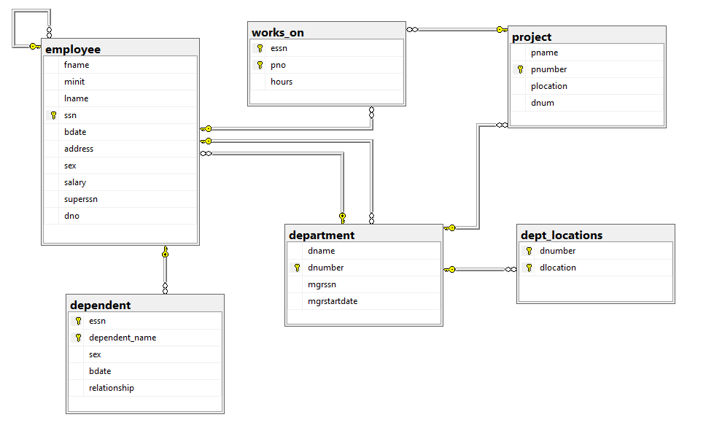

# Instructions

## Update this file to include the following:

1. Screenshot of the database and tables in SQL Server (20 points)
2. Screenshots of the SQL script and the output of the scripts. **Please size your output to include just the script and the results**. It is possible to accomplish this in Word. Make sure all columns in your output results have a name. (4 points for each pair of SQL script and output = 100 total possible points)
3. Submit this file updated with all required screenshots as described above. Make sure your name is included.

Scripts and Tables

Employee

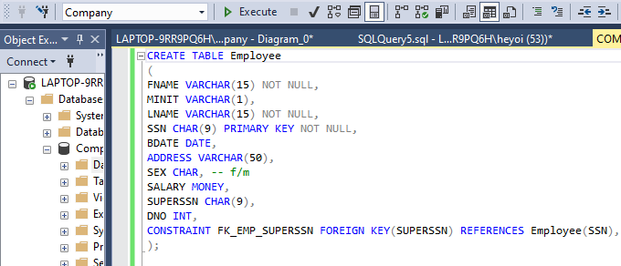

(After running all of these tables I ran this code to make a constraint that was having an error)

Dependent

Department

Works_on



Dept_location

Project

DATABASE DIAGRAM

## Write SQL statements to accomplish the following.

1. Select and display the birthdate and address of the employee(s) whose name is John B. Smith

1. Select and display the name and address of all employees who work for the Research department.

1. For every project located in Stafford, list the project number, the controlling department number, and the department manager's last name, address, and birthdate.

1. Select and display the names of each employee who works in all projects controlled by department 5

1. Make a list of all project numbers for projects that involve an employee whose last name is Smith either as a worker or as a manager of the department that controls the project.

1. Select and display the names of all employees who have two or more dependents.

1. Table

   Description automatically generated with low confidenceSelect and display the names of employees who have no dependents.

1. List the names of managers who have at least one dependent.

1. For each employee, select and display the employee's first and last name and the first and last name of his or her immediate supervisor

1. Select and display the distinct salary values

1. Show the resulting salaries if every employee working on the ProductX project is given a 10% raise.

1. Select and display a list of employees and the projects they are working on, ordered by department and, within each department, ordered alphabetically by last name, first name

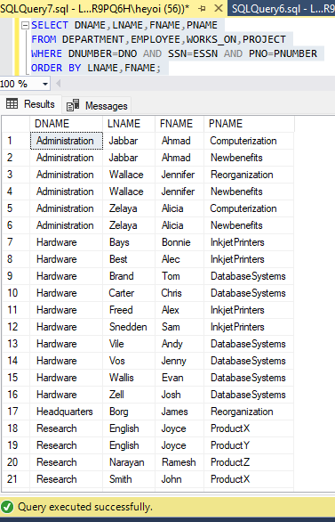

1. Select and display the name of each employee who has a dependent with the same first name and same

1. Select and display the social security numbers of all employees who work on project numbers 1, 2, or 3.

1. Find the sum of the salaries of all employees, the maximum salary, the minimum salary, and the average salary.

1. Find the sum of the salaries of all employees of the Research department, as well as the maximum salary, the minimum salary, and the average salary in this department.
2. Select and display the total number of employees in the company.

1. Select and display the total number of employees in the Research department.

1. Count the number of distinct salary values in the database.

1. For each department, select and display the department number, the number of employees in the department, and their average salary

1. For each project, select and display the project number, the project name, and the number of employees who work on that project.

1. For each project on which more than two employees work, select and display the project number, the project name, and the number of employees who work on the project.

1. For each project, select and display the project number, the project name, and the number of employees from department 5 who work on the project.

1. For each department that has more than five employees, select and display the department number and the number of its employees who are making more than $40,000.

