Soneso GmbH
ICO Payment
Lumenshine- „ICO Payment for arbitrary coins”– V. 1.1

Table of Contents
1. Table of Changes 3
2. Introduction 4
2.1 Purpose 4
2.2 Intended Audience 4
2.3 Scope 4
3. General idea 4
4. Placing a new order 5
4.1 Overview 5
5. Viewing existing orders 13
5.1 Overview 13
5.1.1 Details for status “Waiting for payment” 15
5.1.2 Details for status “Wrong payment” 17
5.1.3 Details for the status “Payment received” 17
5.1.4 Details for status “Completed” 19
5.1.5 Status “Rejected” 20
6. Processing orders at login 23
7. Images 25

Table of Changes

Version | Description | Changed by | Changed on
1.0 | First version | Christian Rogobete | 16.07.2018
1.1 | Update of general process | Christian Rogobete | 17.07.2018

Introduction

Purpose

This specification describes the payment process in an ICO by using the Lumenshine Tool Suite and Wallet.

Intended Audience

The intended audience for this document are Soneso & partner companies project managers, designers, server and client developers, product testers and documentation writers.

Scope

The application is used as a wallet based on the stellar network. In addition, ICO specific features can be displayed, so that the Lumenshine wallet can optionally be used for the sale of specific tokens. It allows users to register, create stellar accounts and use it for transactions. The wallet is supposed to offer the highest possible usability. For example, the user should not have to enter stellar account secrets for transactions, the wallet should persist over multiple devices, it should support the different tokens provided in the stellar network and offer other features such as the possibility to create shared accounts.
This document describes the functionality and the screens of the payment process including wallet and admin frontend as well as definition of the backend interfaces.

General idea

This chapter describes the general idea behind the payment process. The single use cases with the corresponding functionality are described in detail in further chapters.
The user must be logged in to be able to order ICO coins/assets/tokens. To do so she places an ICO coin order. When placing an order the user can select the currency she would like to use (such as BTC, ETH or XLM) for purchasing the arbitrary tokens. As soon as the user placed an order, the deposit address is displayed to her.
The user must send the exact amount of currency displayed in the order to the deposit address. If the amount does not match, then the order is not filled and the user is informed. In this case, the received amount will automatically be refunded to the user (less any transaction costs). Each ICO Phase has a limited number of coins. After these are consumed, no further order can be filled. That's why the rule "First pay first serve" applies. If a user sends a payment that can no longer be accepted, it will be refunded less any transaction costs.
As soon as the payment has been received on the deposit address, the payment can be initiated. The user is informed and must enter his password, so that the wallet and the trustline to the arbitrary coin can be created. Since the wallet needs to be funded, the wallet and trustline is only creates after receiving the user’s payment. If the user is logged out when informed, the wallet and trustline is created on next login.
As soon as the wallet and the trustline have been crated, the ordered coins/assets will be transferred to the user and the order will be marked as filled.

Placing a new order

Overview

To place a new order, the user presses the “Order coins” button of the ICO card displayed in his client.
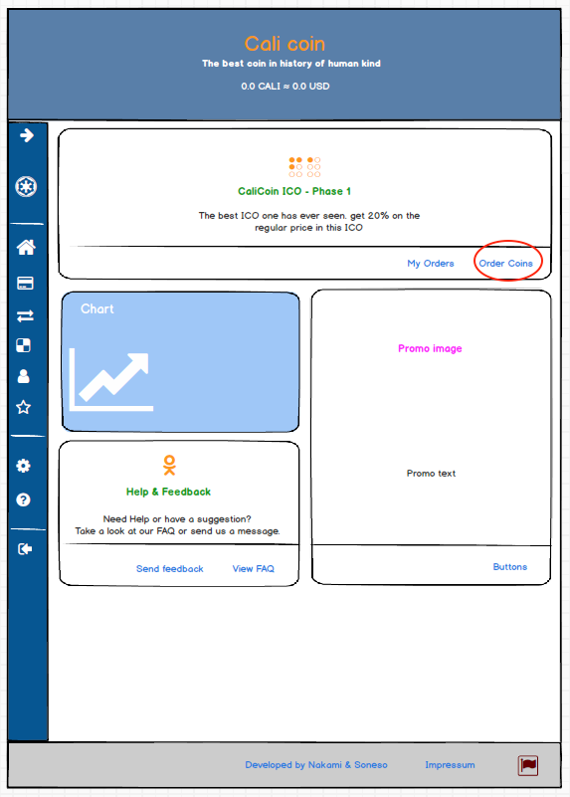
Image 1 –Mockup of web client showing the ICO card and order button
As soon as the user presses the “Order Coins” button, the ICO card expands vertically and shows the “New order” form in the expanded area.

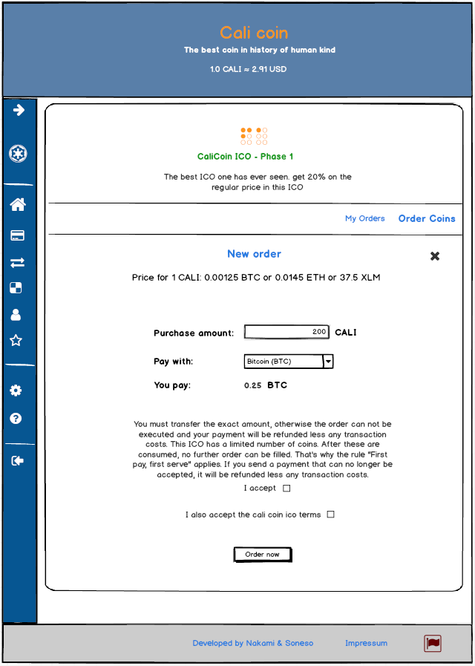
Image 2 –Mockup of web client showing the expanded ICO card for a new order

The view displays the price for one unit of the token in all available currencies. Below of that, the user can choose how much of the arbitrary coins he would like to purchase. Below of that he can select the currency that he would like to use to pay for the coins. Depending on the price per unit, the client automatically calculates how much of the selected currency the user needs to pay. Also, an info and accept checkboxes are displayed. As soon as the user filled the form, she can press the “Order now” button. By doing so, the order is placed and the client displays the deposit address for the payment.
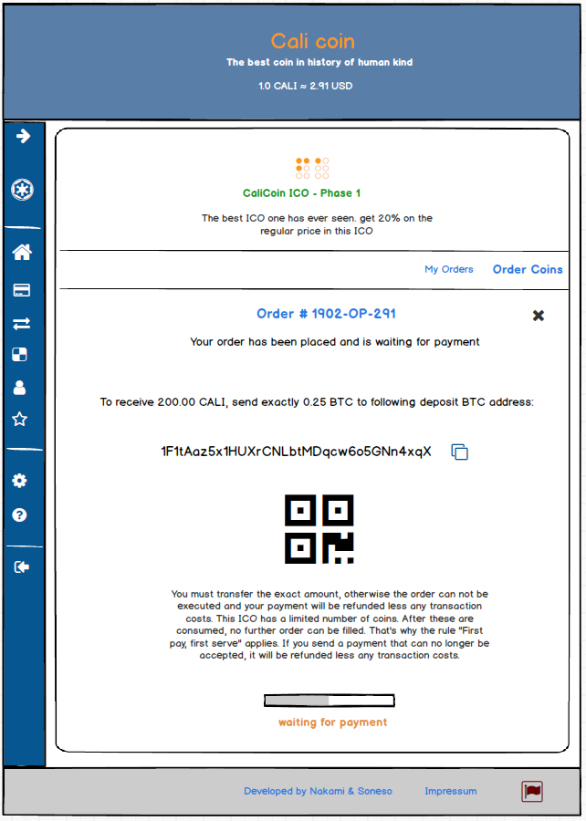
Image 3 –Mockup of web client showing the deposit address for a placed order

It shows the order number in the title and informs the user how to proceed. In the lower part of the screen, a progress bar is displayed, informing the user that the system is waiting for her payment.
If the user sends the payment, the server will find out that the payment has been received on the deposit address. It will validate the received amount by comparing it to the amount from the order. If the amounts do not match, the server informs the client, which in turn informs the user that the order could not be completed and the received amount has been refunded.

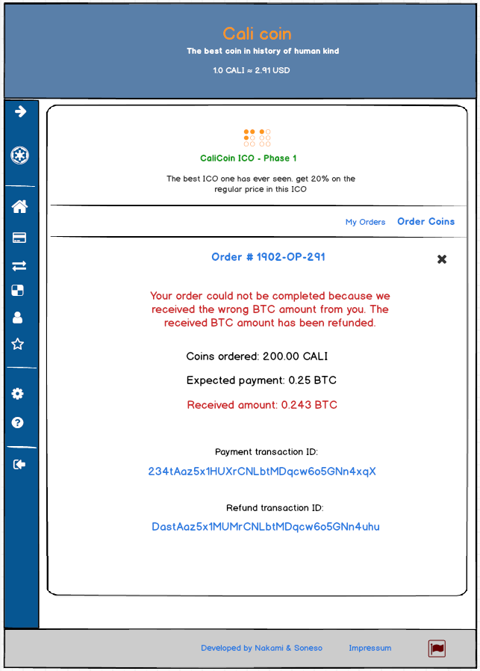
Image 4 –Mockup of web client showing the deposit address for a placed order

The client displays the transaction IDs of the payment and refund as a link, so that the user see the error and refund in the corresponding blockchain.
If the user transferred the correct amount, the server will inform the client and the client will request the user’s password, so that the user next can grab his coins.
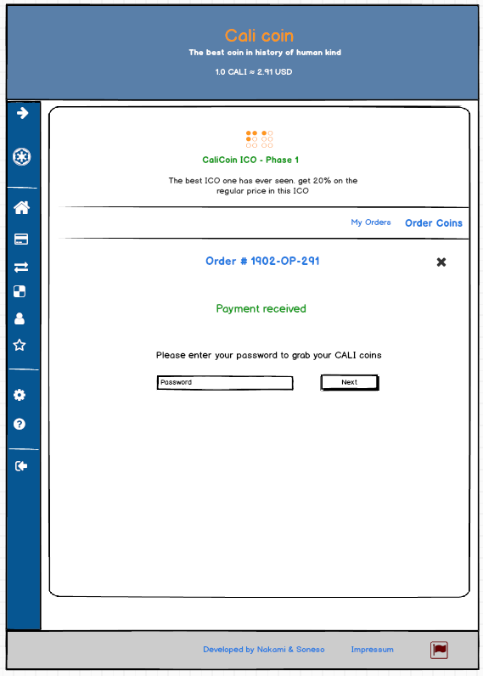
Image 5 –Mockup of web client showing the payment received screen

As soon as the user enters his password and presses the “Next” button, the client will receive from the server the needed trustline transaction and will sign it with the master key of the user’s wallet. It will then send it back to the server. The server in turn will create and fund the wallet and then add the trustline. As soon as the trustline has been added, the server will transfer the corresponding amount of arbitrary coins to the user’s wallet. During this process, the client displays a waiting screen to the user.
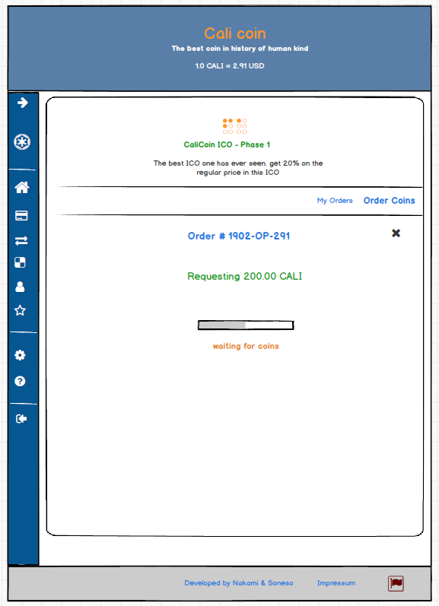
Image 6 –Mockup of web client showing the requesting coins screen

As soon as the order is filled, the server informs the client and this in turn informs the user.
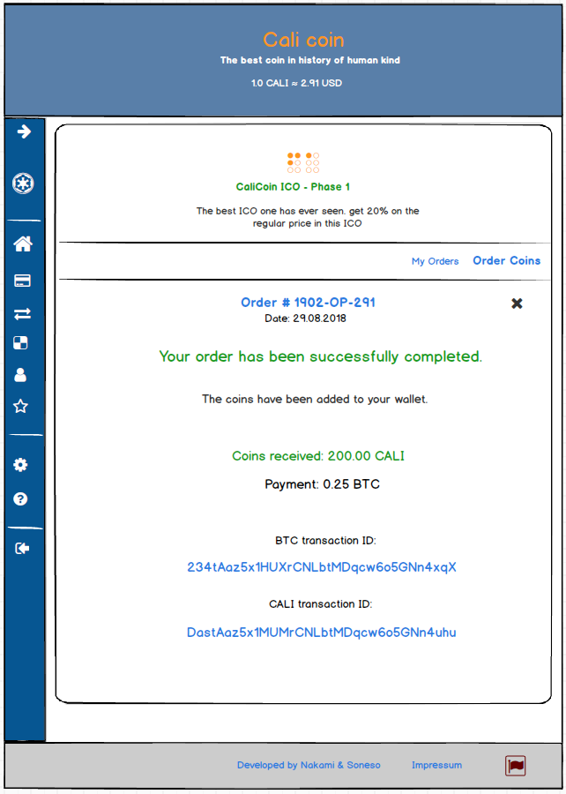
Image 7 –Mockup of web client showing the requesting coins screen

The client displays the order details including the transaction ids as links so that the user can always see them in the corresponding blockchain.
If the limited amount of coins is consumed, no more new orders can be placed. Existing orders that cannot be filled are marked as rejected. If the user already sent the payment for the order, it will be automatically refunded. The client informs the user by following screen.
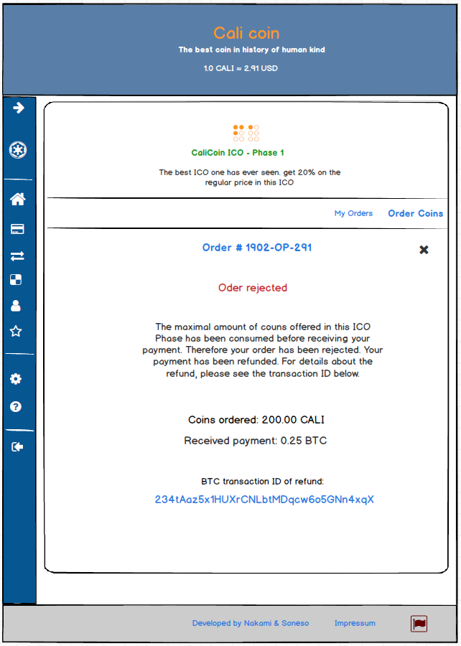
Image 8 –Mockup of web client showing the payed order rejected

The screen displays the transaction id of the refund as a link, so that the user can see it in the corresponding blockchain.
If the order cannot be filled due to the consumed coins and the user did not already send the payment, no refund is needed. The client only informs the user about the rejected order.
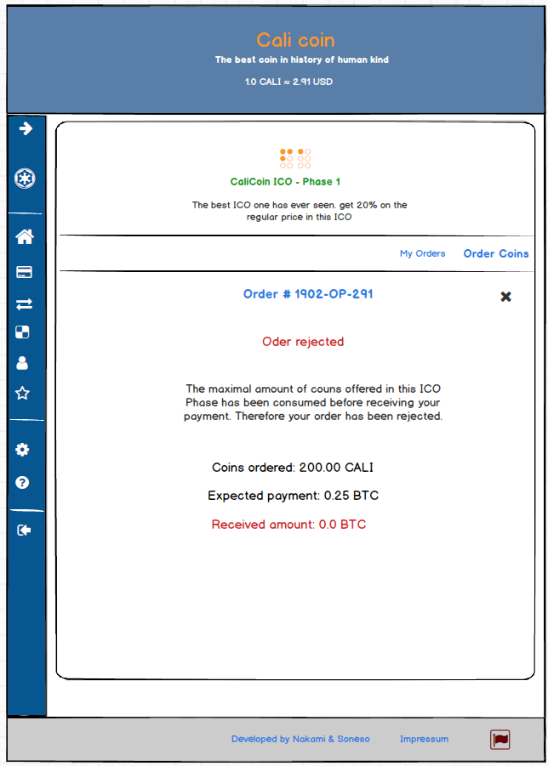
Image 9 –Mockup of web client showing the unpaid order rejected

Viewing existing orders

Overview

The user can always see his orders by pressing the “My Orders” button in the ICO wallet card. As soon as pressed, the ICO card will expand and will show the list of orders placed by the user.
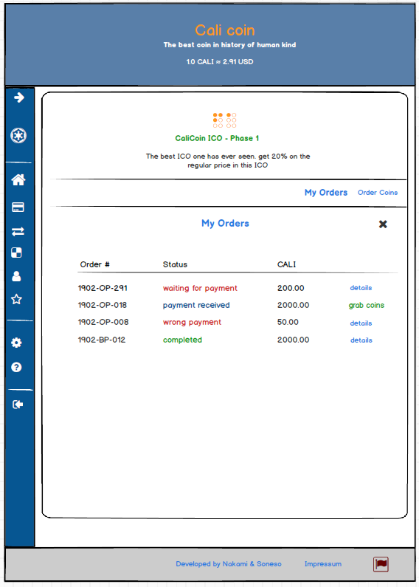
Image 10 –Mockup of web client showing my orders screen

The table shows all orders, displays their status, amount of coins ordered and an action button in each row. Following order status are possible:
- Waiting for payment
- Payment received
- Wrong payment
- Completed
- Rejected (ICO amount consumed)

The client displays a “details” action button in each row, expect when the status of the order is “Payment received”. In this case, it displays a “grab coins” action button.
If the user presses the “details” button, the details of the order will be displayed. Depending on the status of the order, the client displays different screens in the expanded area of the card, replacing the table.
If the user presses the “grab coins” action button, the corresponding screen will be displayed, where the user can enter his password to grab the coins.
Each of the “details” and “grab coins” screens provide a back button, so that the user can directly go back to the list of his orders. The user can also go back by pressing the “My orders” button in the wallet card again.

Details for status “Waiting for payment”

Like for a new order, the details screen for an order having the status “Waiting for payment” displays the deposit address and information for the user on how to send the payment.
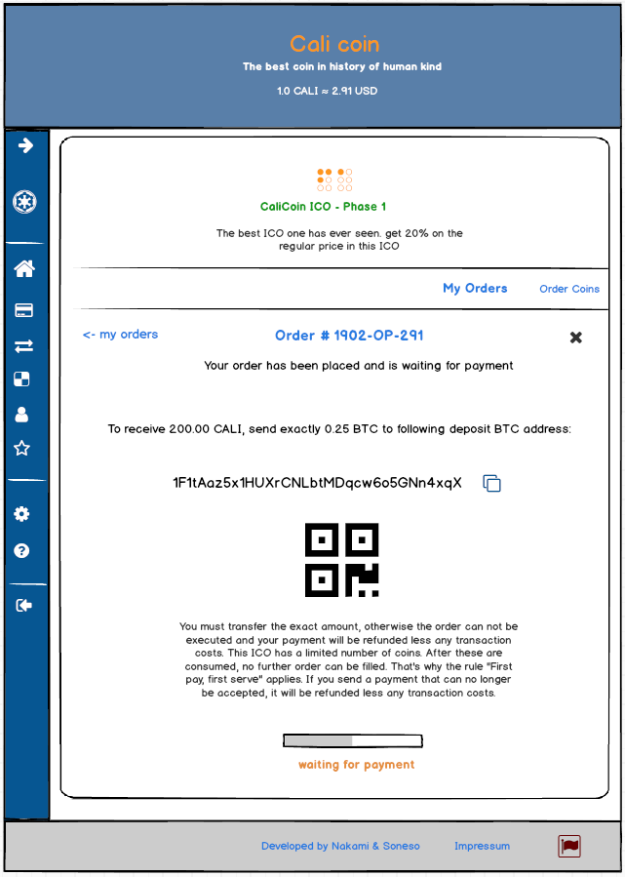
Image 11 –Mockup of web client showing the details of an order with status “waiting for payment”

As soon as the screen is displayed, the client starts listening for events from the server regarding the displayed order, so that it can continue the process as described in the chapter “Placing a new order”.
In case of invalid or missing payment the system will change the status of the order and the client will display the corresponding details screen.

Details for status “Wrong payment”

Like in the new order process, the client displays the information about the wrong payment and informs the user about the refund.
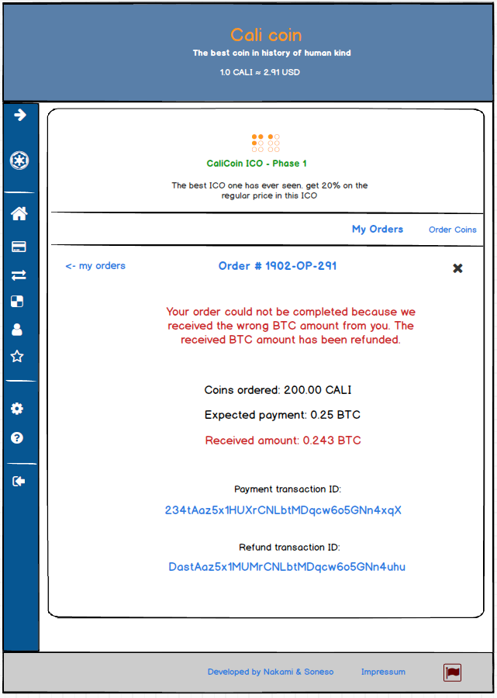
Image 12 –Mockup of web client showing the details of an order with status “wrong payment”

Details for the status “Payment received”

If the user presses the button “grab coins” for an order having the status “Payment received”, such like in the new order process, the client will request the user to insert his password to garb his coins.
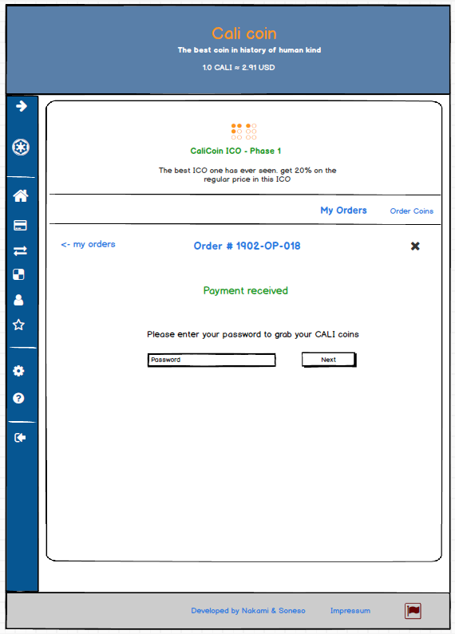
Image 13 –Mockup of web client showing the details of an order with status “payment received”

As soon as the user enters his password and presses the “Next” button, the client will receive from the server the needed trustline transaction and will sign it with the master key of the user’s wallet. It will then send it back to the server. The server in turn will create and fund the wallet and then add the trustline. As soon as the trustline has been added, the server will transfer the corresponding amount of arbitrary coins to the user’s wallet. During this process, the client displays a waiting screen to the user.
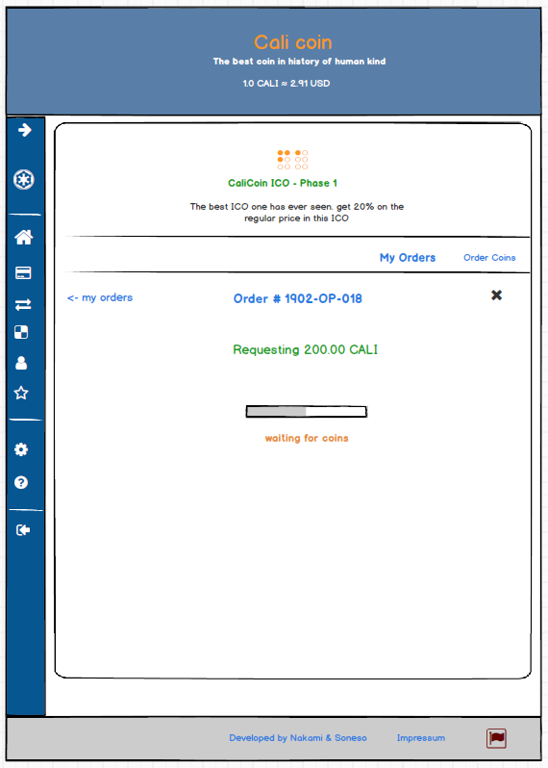
Image 14 –Mockup of web client showing the requesting coins screen in the details of an order

As soon as the order is filled, the server informs the client that the status of the order has been changed to “completed” and the client in turn will replace the details view.

Details for status “Completed”

If an order has been completed/filled, the client displays the available information about the order including the transaction id links for the transactions that have been executed.
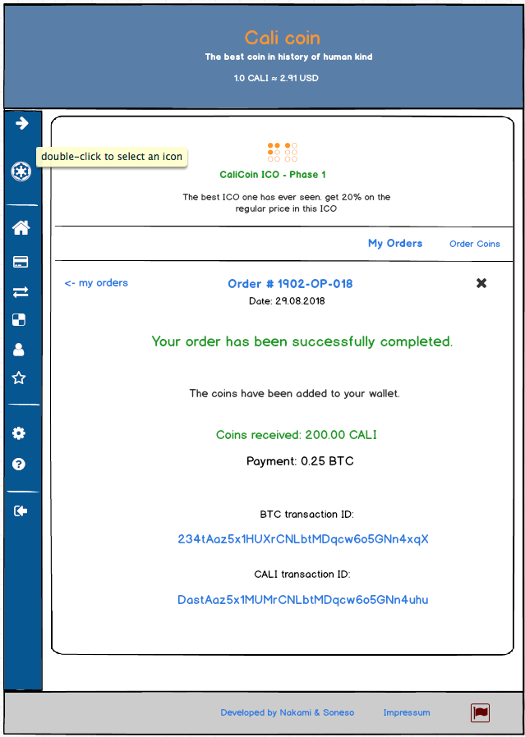
Image 15 –Mockup of web client showing the details of an order with status “completed”

Status “Rejected”

If the maximal amount of coins of the ICO phase has been consumed, all orders having the status: “Waiting for payment” will be changed by the system to status “Rejected”. Orders with status “Payment received” are handled depending on when the payment has been received by the system. If the payment has been received before the maximum amount of coins has been consumed, they remain in the status “Payment received”. If the payment has been received after the maximum amount of coins has been consumed, the system will change their status to “Rejected” and will refund the received payment automatically. The next mockup shows an example of my orders list after the maximal amount of coins has been consumed.
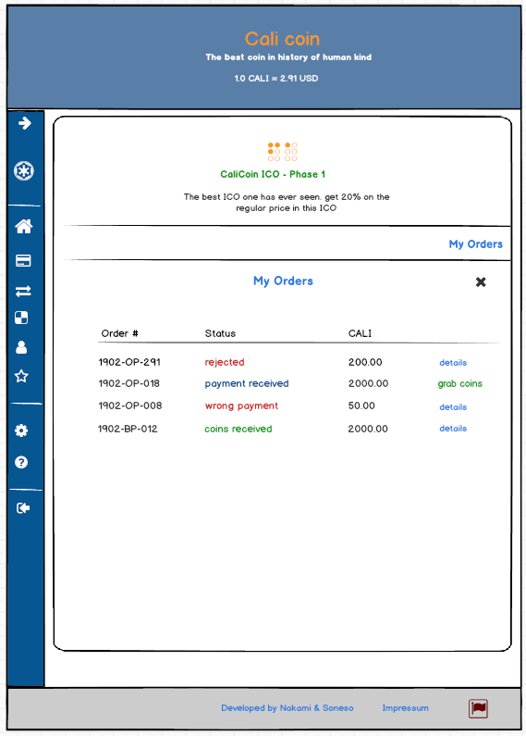
Image 16 –Mockup of web client showing my orders screen after the maximal number of coins has been consumed
No order with status “Waiting for payment” can exist. Also, the button “Order coins” of the ICO card is not displayed any more. If the user presses the details button of a rejected order, the client displays different info depending if the user send a payment or not.
If the user did not already send the payment, no refund is needed. The client only informs the user about the rejected order.
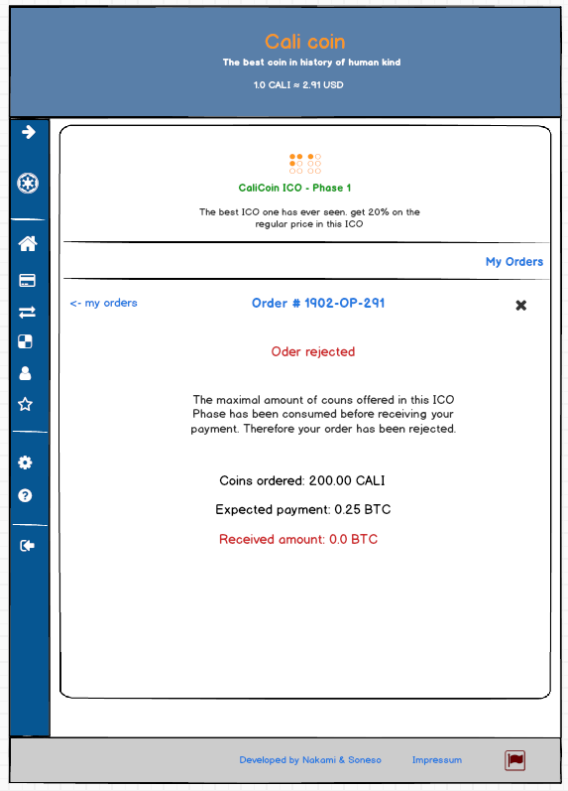
Image 17 –Mockup of web client showing the unpaid order rejected (my orders)

If the user already sent the payment for the order, it will be automatically refunded. The client informs the user by following details screen.
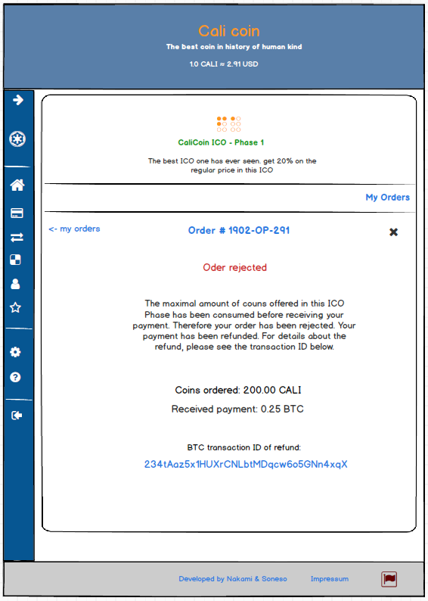
Image 18 –Mockup of web client showing the payed order rejected (my orders)

Processing orders at login

When the user loges in, the client will request the list of orders with the status “payment received” from the server. If the list is empty, the user will be redirected to the dashboard. Otherwise, If the list is not empty the client will display processing screen (like wallet setup) and will immediately start requesting coins for each order from the list. The client will process the orders sequentially, showing following screen:
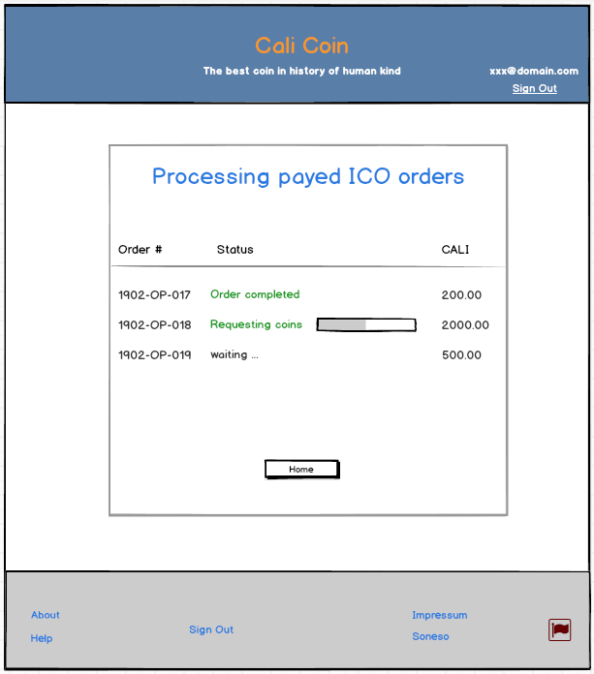
Image 19 –Mockup of web client showing the details of an order with status “completed”
As soon as an order is completed it will mark it as completed. While waiting to be processed the orders in the list are marked as “waiting …”. As soon as the system finished processing all orders from the list it will automatically redirect the user to the dashboard. If the user doesn’t want to wait for the client to process the orders, she can press the “Home” button. The client will interrupt the process and redirect the user to the dashboard.

Images

Image 1 –Mockup of web client showing the ICO card and order button 5
Image 2 –Mockup of web client showing the expanded ICO card for a new order 6
Image 3 –Mockup of web client showing the deposit address for a placed order 7
Image 4 –Mockup of web client showing the deposit address for a placed order 8
Image 5 –Mockup of web client showing the payment received screen 9
Image 6 –Mockup of web client showing the requesting coins screen 10
Image 7 –Mockup of web client showing the requesting coins screen 11
Image 8 –Mockup of web client showing the payed order rejected 12
Image 9 –Mockup of web client showing the unpaid order rejected 13
Image 10 –Mockup of web client showing my orders screen 14
Image 11 –Mockup of web client showing the details of an order with status “waiting for payment” 16
Image 12 –Mockup of web client showing the details of an order with status “wrong payment” 17
Image 13 –Mockup of web client showing the details of an order with status “payment received” 18
Image 14 –Mockup of web client showing the requesting coins screen in the details of an order 19
Image 15 –Mockup of web client showing the details of an order with status “completed” 20
Image 16 –Mockup of web client showing my orders screen after the maximal number of coins has been consumed 21
Image 17 –Mockup of web client showing the unpaid order rejected (my orders) 22
Image 18 –Mockup of web client showing the payed order rejected (my orders) 23
Image 19 –Mockup of web client showing the details of an order with status “completed” 24

