Twitter

1. database table schema

1) user

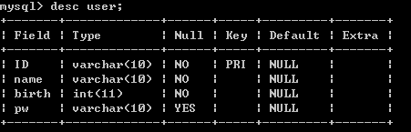

2) follow

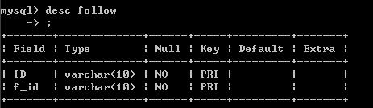

3) board

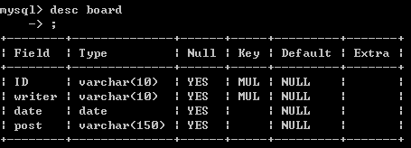

2. JDBC code

1). To register, use ‘addUser’ insert id, name, birth, pw in user table

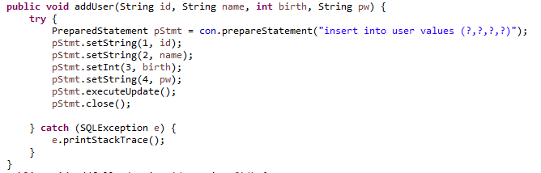

2) To check id and pw are correct, use ‘checkUser’(use procedure).

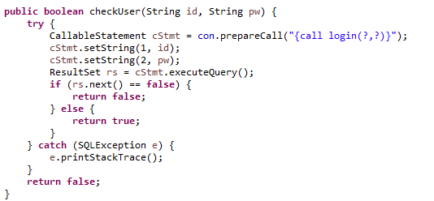

3) ‘IndividualBoard’ method is used to return individual’s board.

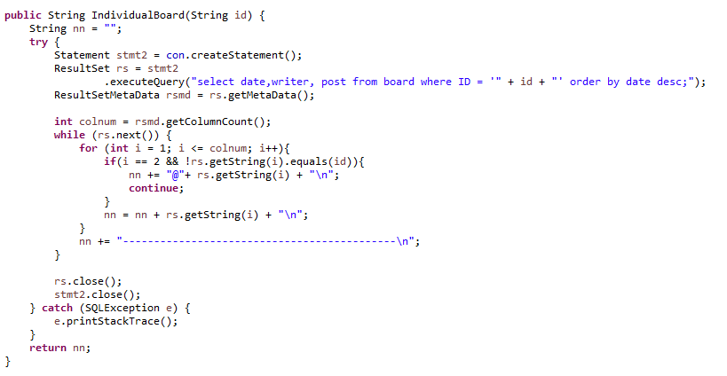

4) ‘addfollow’ is used to add follower.

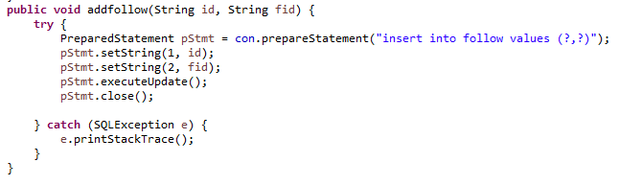

5) This method check follow table(already follow relation).

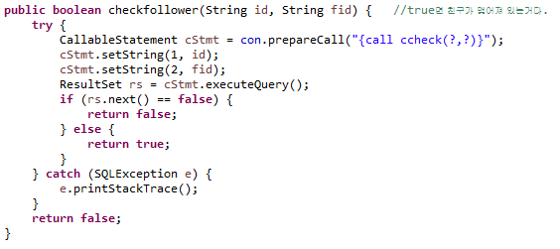

6) When user want to disconnect some follower, this method is used.

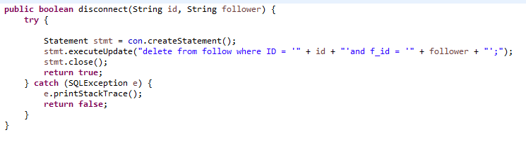

7) show my follower.

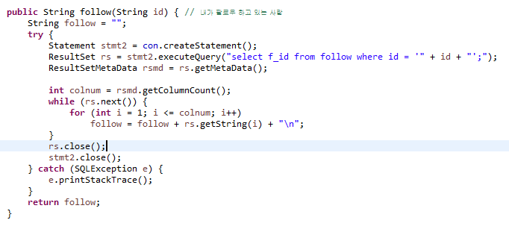

8) show users who follow this user

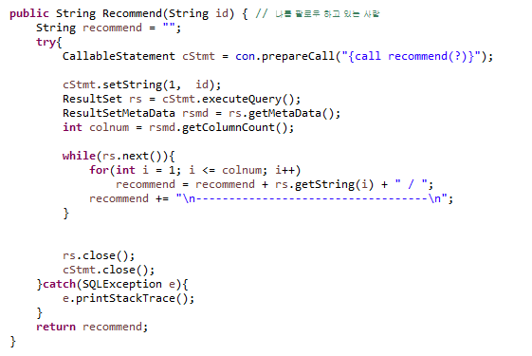

9) Edit password.

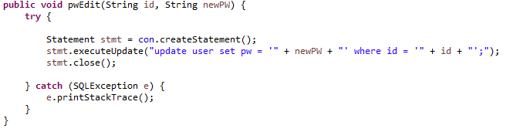

<Execution>

1. Log in

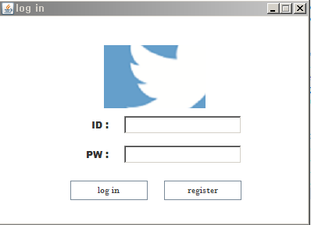

2. Register

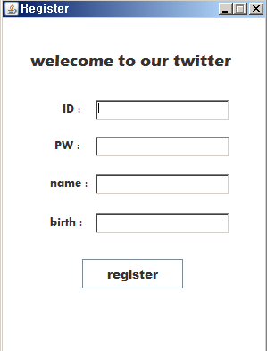

3. user board

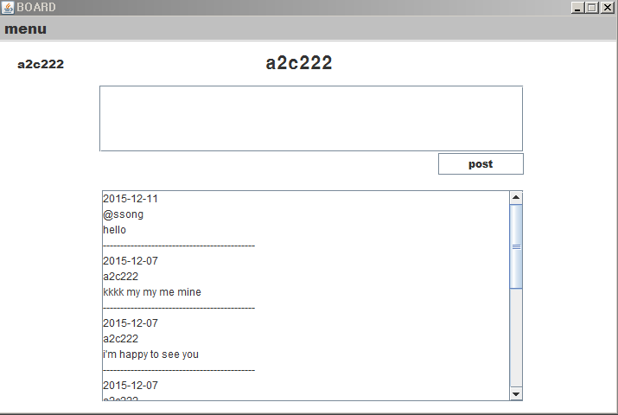

4. other's board

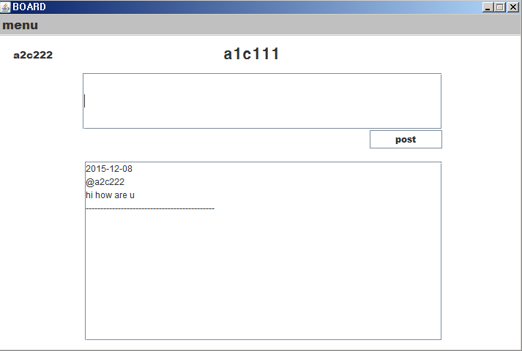

5. follower

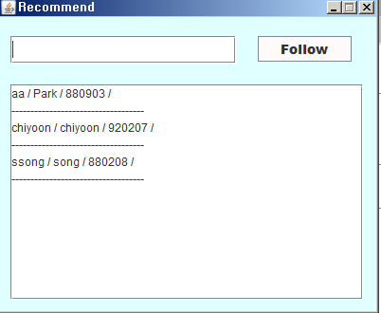

6. following

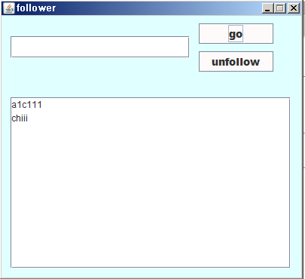

7. Search

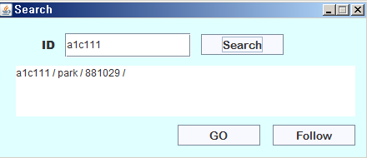

8. edit pw

