21500362 songJinBeom

Java Final Project

1. Class Diagram

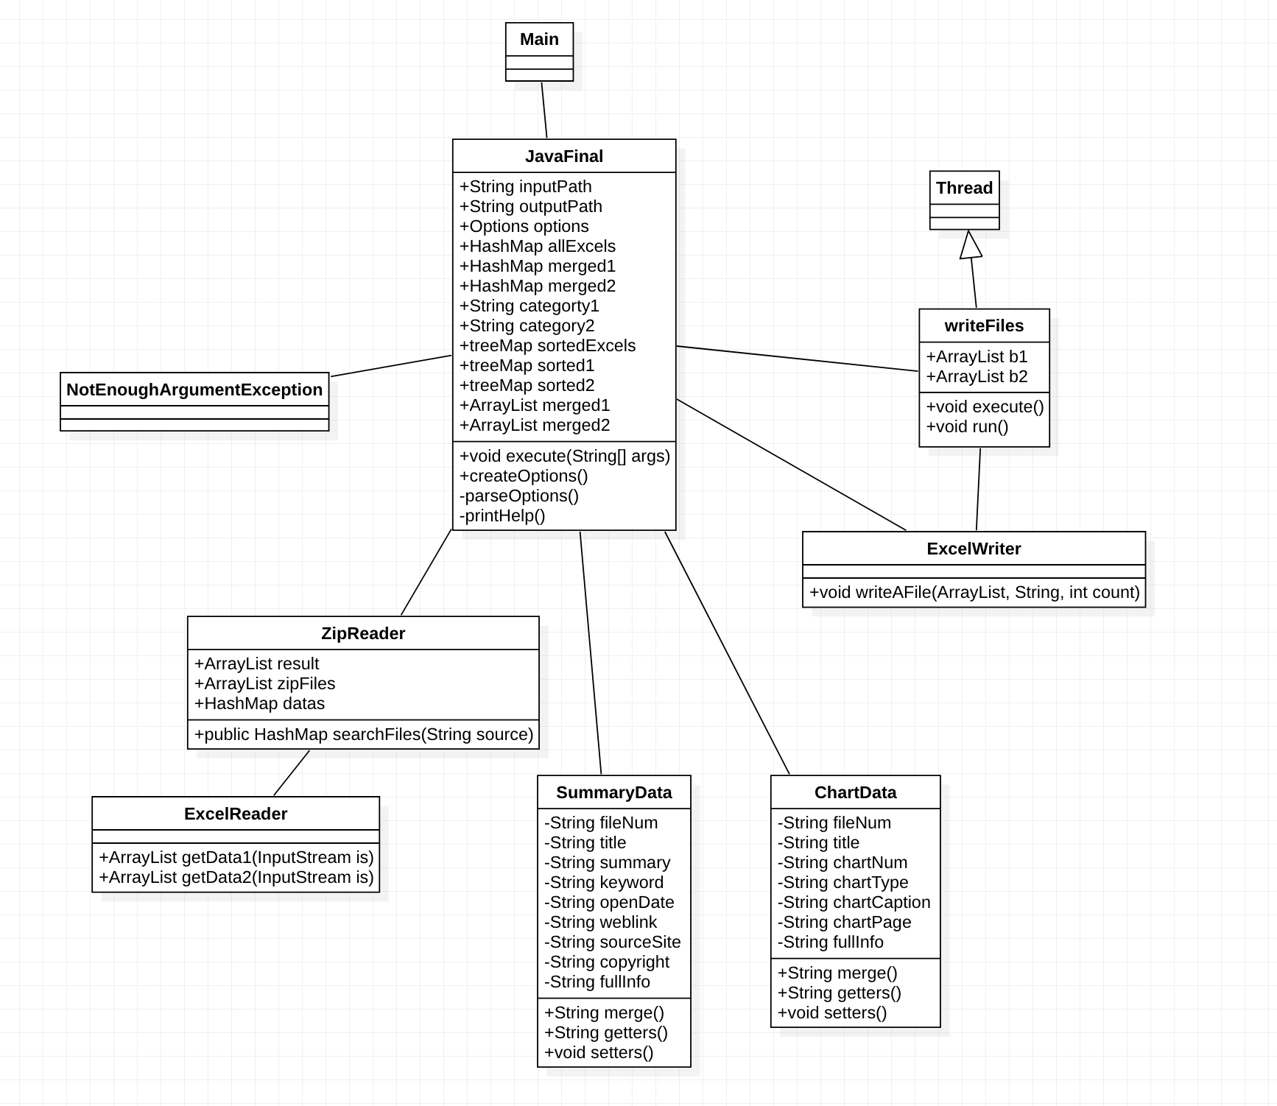

My StarUML program can’t write the collections parameter. I’m so sorry

(ArrayList<String> , HashMap<String, ArrayList<String>>, Map<String, ArrayList<String>)

|  |
| --- |
| Main |
|  |
|  |

Main class just make JavaFinal instance and run the execute method

User insert args which has inputPath(data folder) and outputPath(result)

|  |
| --- |
| JavaFinal |
| String inputPath  String outputPath  Boolean help  Options options  HashMap<String, ArrayList<String>> allExcels  HashMap<String, ArrayList<String>> excel1  HashMap<String, ArrayList<String>> excel2  ArrayList<String> toBeMerged  ArrayList<String> merged1  ArrayList<String> merged2  String category1  String category2  Map<String, ArrayList<String>> sorted1  Map<String, ArrayList<String>> sorted2  ArrayList<String>> t  SummaryData sd1  ChartData cd1 |
| Public execute(String[] args);  Options createOptions()  Boolean pareseOption(Options options, String[] args)  printHelp(Options options) |

This class is the main part of this project

It receives args which has the input and output data information using Apache

If user doesn’t insert correct args, it occurs NotEnoughArgumentException which is my one exception

It make ZipReader instance with inputPath and get the information from zipfiles and save the ArrayList at the hashMap allExcels.

And class sorts the allExcel HashMap into sortedMap by TreeMap to sortedExcels.

There are two types of excel files in our Data.Zip. it will be distributed by the key.

For example one type will have the key 000X-1 and another type will have the key 000X-2.

So we need to separate the sortedExcels and merge the same type arrayList

Class separate the two types Arraylists by the key which ends 1 or not and save at sorted1 / sorted2

Class will use the SummaryData instance and ChartData instance to split the info and merge the same type infomations. And each information will be saved at merged1/merged2

Finally It will use the Instance of ExcelWriter and save the each in two result.csv

First type will be saved in result1.csv which has summary information

Second type will be saved in result2.csv which has chart and picture information

|  |
| --- |
| ZipReader |
| ArrayList<String> result  ArrayList<ZipFile> zipFiles;  HashMap<String, ArrayList<String>> datas; |
| HashMap<String, ArrayList<String>> searchFiles(String source) |

This class read the files in zipFile and separate the two types excels in zipfiles

So it save the key as 000X-1 or 000X-2

It call ExcelReader and use getData1 or getData2 method which read ExcelFiles

And it return HashMap value which contain excel information ArrayList

|  |
| --- |
| ExcelReader |
|  |
| ArrayList<String> getData1(InputStream is)  ArrayList<String> getData2(InputStream is) |

This class is read info in Excel files

if there are null row, this program will not the save that info

and it return ArrayList value

|  |
| --- |
| SummaryData |
| Private String fileNum  Private String title  Private String summary  Private String keyword  Private String openDate  Private String weblink  Private String sourceSite  Private String copyright  Private String fullInfo |
| Public SummaryData(String info, String key)  Public String merge()  Public getter/setter methods |

This class will analysis Summary type information.

By using split(“,”) and merged the information in string

Merge method will merge the all String value in this instance and return merged string value

|  |
| --- |
| ChartData |
| Private String fileNum  Private String title  Private String chartNum  Private String chartType  Private String chartCaption  Private String chartPage  Private String fullInfo |
| Public ChartData(String info, String key)  Public String merge()  Public getter/setter methods |

This class will analysis Chart type information

By using split(“,”) and merged the information in string

Merge method will merge the all String value in this instance and return merged string value

|  |
| --- |
| ExcelWriter |
|  |
| Public void writeAFile(ArrayList<String> lines, String targetFile, int count) |

This class make the result csv file

By using printWriter and in my code, it will make two another result data

|  |
| --- |
| NotEnoughArgumentException |
|  |
| Public NotEnoughArgumentException() |

If user insert wrong args, it will be occured

|  |
| --- |
| WriteFiles |
| ArrayList<String> b1  ArrayList<String> b2  String outputPath  Int count |
| Public WriteFiles(ArrayList<String>a1, ArrayList<String b1>, String outputPath)  Public void excute()  Public void run |

This is the class which use the threads for saving result files

It will distribute the type and make different result csv (result1, result2)

I couldn’t make the perfect thread system so I write the code in WriteFiles class but it doesn’t work well

Thank you for this semester