GAICA
Global AI Competency Assessment
Understanding AI
A Student Study Manual · Level 2 — Apply
For GAICA Level 2 Learners
Analyse · Evaluate · Decide · Challenge · Design
Published by GYLDC / GSLDC · 2026
Global Youth Leadership Development Council (GYLDC)
Global SDGs and Leadership Development Center (GSLDC)

👋 Who this book is for  Students preparing for the GAICA Level 2 assessment who want to understand how AI shapes their world — and develop the critical thinking to evaluate it. | 📖 What is inside  Five chapters built around real-world AI questions, 17 classroom activities across 8 formats, and all 50 test questions with full explanations.

How to use this book
Level 2 is called 'Apply'. That is exactly what this book asks you to do — not just remember what AI is, but apply your knowledge to real situations, evaluate competing options, and make reasoned judgments. Every chapter is built around a genuine question about AI in the world you already inhabit: your phone, your school, your social media feed.
Level 2 introduces four question types that do not appear in Level 1: Assertion-Reason (AR), Multi-select (choose TWO), Decision-based (DB), and Error-identification (EI). Each is explained and practised in this book before you encounter it in the test.

The eight activity formats in this book
Format | What you do | Group size
AI Spotter Hunt 🔍 | You identify and analyse AI in a real-world context. | Solo or class
Sort It Out 📋 | You sort or classify scenarios into categories. | Pairs
What Should They Do? 🤔 | You evaluate a situation and choose the most responsible action. | Small groups
Human Machine 🤝 | You role-play or simulate an AI process. | Whole class
Design Challenge 🎨 | You design or improve an AI system. | Pairs or solo
Debate Corner 🗣 | You argue a position — even one you may not personally hold. | Two teams
Did the AI Get It Right? ✓✗ | You judge whether an AI output, decision, or reasoning is sound. | Solo
Story Finish ✏ | You write or decide how a described situation should end. | Solo

A note before you start
This book is not a test-prep guide — it is a guide to understanding AI in your world. Students who genuinely understand the ideas do better in any test. Focus on understanding, not on memorising answers.

Contents



Chapter 1 — AI in Your World
Think about the last time you opened an app on your phone or computer. Maybe it was a social media app, a video app, or a game. Did you know that an artificial intelligence system — an AI — was probably working in the background, making choices about what you would see? Most of the time, we do not notice this. AI has become part of daily life, and it works quietly, without asking permission each time.
At Level 1, you learned to recognise AI when you saw it. Level 2 asks you to go one step further. It is not enough to know that AI is there. You need to understand what the AI is actually doing, why it makes the choices it makes, and how those choices can shape what you see, what you believe, and the decisions you are able to make. This chapter is about building that deeper understanding, starting with the AI systems that are closest to your everyday life: the ones that decide what shows up on your screen.

🎯 The Objective of This Chapter
This chapter helps you understand how AI systems choose what to show you online and at school — and why that choice is never completely neutral.
✅ What You Will Be Able to Do After This Chapter
→ Explain, in your own words, what it means for an AI to 'curate' content.
→ Describe what a filter bubble is and how it can form without anyone intending it to.
→ Give a real example of AI being used in a school setting, and explain one thing it can miss.
→ Judge, using evidence from a scenario, what a responsible use of school AI looks like.

1.1 AI is curating your world
Let's start with a word you will see often in this book: curation. To curate something means to choose and arrange items from a much larger collection. A museum curator, for example, chooses which paintings to put on the wall out of thousands in storage. An AI recommendation system does something similar with your news feed, your video app, or your shopping app. Out of millions of possible posts, videos, or products, the AI chooses a small number to put in front of you — and arranges them in a particular order.
Here is the important part: the AI is not showing you everything that exists. It is showing you a small, selected slice, chosen because the AI has learned that this slice is likely to keep you interested. It makes this choice by studying your past behaviour — what you have clicked on, what you have watched all the way through, what you have paused on, and what you have scrolled past quickly. Over time, the AI builds a detailed picture of what keeps your attention, and it uses that picture to decide what to show you next.
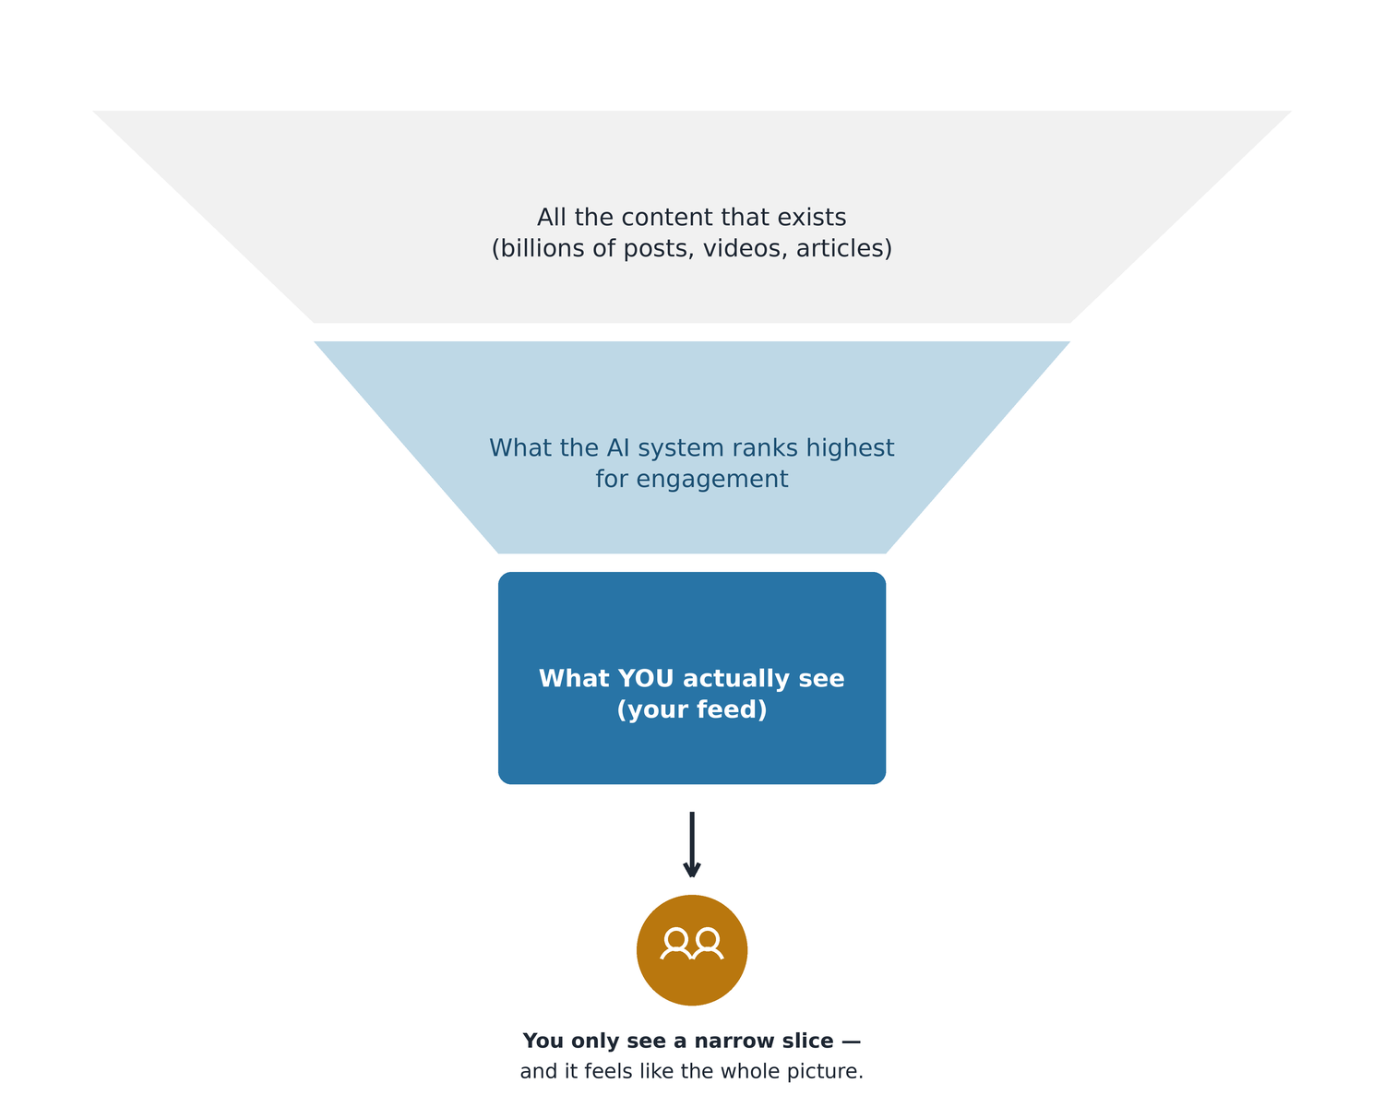
Out of everything that exists online, an AI recommendation system narrows things down in stages until you are left with a small, personalised slice — your feed.
📰 Story: The news feed
Mateo follows a news page on social media. Every day, the AI behind the app shows him a new set of stories. At first, this feels convenient — he sees stories about topics he already cares about. But after a few months, Mateo starts to notice something. He is reading a lot about politics and society, but almost every story seems to agree with what he already believes. He rarely sees an article that challenges his opinion or shows him a different point of view.
Mateo starts to wonder: is the app broken? Is it hiding the truth from him on purpose? Neither answer is correct. The AI is working exactly the way it was designed to work. Its job is to predict which stories Mateo is most likely to click on and read, based on what he has clicked on and read before. It is not trying to give him a balanced view of the world — nobody ever asked it to do that. It is trying to keep him engaged, meaning interested enough to keep reading and keep coming back to the app.
This is the real effect, even though nobody planned it this way: Mateo's understanding of politics and society is slowly being shaped by an AI whose only real goal is to hold his attention, not to inform him fairly.

What a 'filter bubble' is — and why it matters
→ An AI recommendation system studies what you like, and then shows you more content like it.
→ Little by little, this builds a kind of invisible wall around you — researchers call it a filter bubble. Inside the bubble, you mostly see things that agree with what you already think. Outside the bubble, there are ideas and facts you rarely encounter.
→ The AI is not broken, and it is not lying to you. But its goal — keeping you engaged — is a different goal from your goal, which is probably to understand the world accurately.
→ A filter bubble will not pop by itself. Breaking out of one takes a deliberate choice: you have to go and look for sources, opinions, and voices that are different from what the AI usually shows you.

🔍 AI Spotter Hunt · AI in my life today · Individual, then share with the class
What to do
Think back over the last 24 hours. Make a list of every app, website, or digital tool you used.
→ For each one, ask: is AI involved in choosing what I see? How can you tell?
→ For each one, ask: what is the AI trying to do for you as the user — and what is it trying to do for the company that made it? Are these the same goal, or different goals?
→ Has an app ever shown you something that surprised you? Or do you think it may have hidden something from you that you only found out about later, from a friend or another source?
When your list is finished, choose your most interesting example and be ready to share it with the class. As a class, vote on: which example shows an AI having the biggest effect on what someone saw or believed?

📌 Teacher note  The key insight students should reach: an AI's goal is often different from the user's goal. Being engaging is not the same as being accurate; being popular is not the same as being reliable. Students who can explain this difference clearly, using their own example, are demonstrating genuine Level 2 thinking — not just repeating a definition. | 🚀 Take it further  Choose one app from your list. Spend ten minutes deliberately clicking on content that is very different from what you usually choose — a different topic, a different style, a different point of view. Notice what the AI starts showing you afterwards. Write three sentences describing what changed.

✏ Check your understanding
The situation:
You follow a news page on social media. An AI curates your feed and shows you mainly news that matches your past reading habits. Over time, you notice you are only seeing one point of view on important topics.
What does this situation show about how AI can affect the way you see the world?
A. The AI is broken because it should show you all news stories equally
B. The AI is working as designed, but it can limit the range of views you are exposed to
C. This means the AI is deliberately hiding the truth from you
D. Social media AI always shows you the most accurate news stories first
✓ Answer: B
The AI is not broken (A is wrong) and it is not deliberately deceptive (C is wrong). It is optimising for engagement — and the side effect is that it narrows what you see. D is wrong: accuracy is not the AI's objective. Engagement is.

1.2 AI in your school
Recommendation feeds are not the only place you will meet AI. Schools around the world are starting to use AI systems too — to mark tests automatically, to track attendance, to suggest which students might need extra support, and to flag students who might be struggling before a teacher notices. Some of these uses can genuinely help teachers do their job better. But every one of these systems also has limits, and understanding those limits is part of being AI-literate.
A good way to think about a school AI system is to ask two questions every time: what data can this system actually see, and what might it be missing? An AI can only work with the information it is given. It cannot see the parts of a student's life that were never turned into data.
💛 Story: The wellbeing score
A school starts using an AI system to help keep track of student wellbeing. The system looks at each student's attendance, how much homework they complete, and how well they do on quizzes, and it combines these into a single 'wellbeing score'.
One day, a student with a high wellbeing score tells a teacher, in a quiet conversation, that things are really difficult for them at home right now.
According to the AI, this student was doing fine. According to the student's own words, they were not fine at all. Why the difference? The AI could only measure the things it had data for — attendance, homework, and quiz scores. The most important thing happening in this student's life right now was something the system had no way of seeing. It left no trace in the data at all.
🎓 Story: The advanced programme
A school is thinking about using an AI system to help choose which students get offered a place in a special advanced programme. The AI looks only at three things: grades, test scores, and attendance.
Some teachers raise a concern. They point out that this narrow set of numbers could miss students who have real potential but who have also had a genuinely difficult year — perhaps an illness, a family problem, or simply one bad term that does not reflect what they are usually capable of.
What is the most responsible way forward? Most experts would agree: use the AI's results as one useful piece of information, not as the only piece. Combine it with what teachers already know about each student — their effort, their circumstances, and their potential — rather than letting a set of numbers make the whole decision alone.

🏫 School AI Audit · Where could AI help — and where could it go wrong? · Team of 3–4
What to do
As a team, imagine your own school is deciding whether to introduce a new AI system. Choose ONE of these ideas (or invent your own): an AI that recommends library books, an AI that predicts which students might struggle with an upcoming test, or an AI that monitors how much time students spend using school devices.
→ List three ways this AI system could genuinely help students or teachers.
→ List three important things about a student's life that this AI would have no way of seeing or measuring.
→ Decide as a team: should this system be allowed to make decisions on its own, or should a teacher always be involved before anything happens? Explain your reasoning in two or three sentences.
Prepare a one-minute pitch explaining your team's recommendation, and present it to another team.

📌 Teacher note  This activity builds the habit of asking 'what can this AI actually see?' before judging whether it is trustworthy. Strong answers will name specific, concrete blind spots (family circumstances, mental health, motivation) rather than a vague 'it might be wrong'. Listen for teams who conclude that human involvement should scale with how serious the decision is — that is exactly the reasoning Chapter 3 will build on. | 🚀 Take it further  Interview one teacher, parent, or older student about any AI tool they have seen used in a school setting. Ask what they found helpful about it, and what concerned them. Bring back a two-sentence summary.

✏ Check your understanding
The situation:
Your school is thinking about using an AI to choose which students get a place in a special advanced programme. The AI will look at grades, test scores and attendance only.
What is the most responsible way for your school to use this AI system?
A. Use the AI results on their own — this removes the risk of teachers showing favouritism
B. Do not use the AI at all — human decisions are always more fair than AI
C. Use the AI results as one part of the decision, alongside teacher observations and student context
D. Let students appeal to the AI directly if they think the result was unfair
✓ Answer: C
A is wrong — removing human judgment creates its own unfairness (the AI misses context). B is too absolute — AI can be a useful input when used responsibly. D is not sensible — the AI cannot process an appeal. C is the balanced, responsible approach.

AI recommendation systems are designed to keep you engaged — not to give you the full picture. Your awareness of this is the first and most important step to using these tools critically.

🔗 Read More About This Chapter
Curious to go further? These free resources let you explore the ideas in this chapter in more depth.
• Bursting the Filter Bubble
A short, hands-on activity from Common Sense Education that lets you experience how a recommendation algorithm narrows what you see over time.
• AI Algorithms: How Well Do They Know You?
A Common Sense Education lesson exploring how apps use your data to predict what you will click on next.

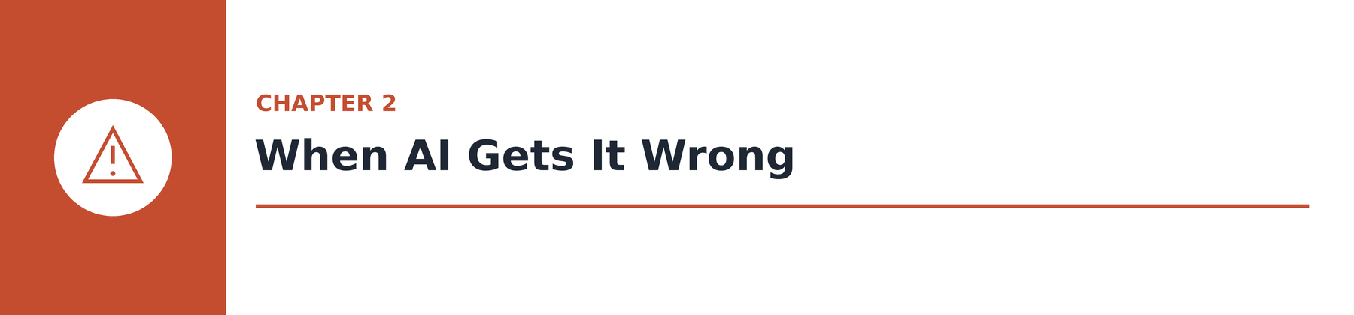

Chapter 2 — When AI Gets It Wrong
By now you know that AI is not perfect. Every student has seen an AI tool give a strange or wrong answer at some point. But at Level 2, simply saying 'the AI was wrong' is not enough. A skilled AI user can go further and explain WHY the AI was wrong — because different kinds of mistakes have different causes, and knowing the cause helps you decide what to do next.
Think of it a little like being a doctor. A doctor does not just say 'you are unwell' — they try to identify the specific illness, because different illnesses need different treatments. In the same way, this chapter introduces several distinct AI failure modes: specific, recognisable patterns of how and why AI systems get things wrong. Once you can name the failure mode, you are much closer to knowing the right response.

🎯 The Objective of This Chapter
This chapter helps you recognise several distinct, specific ways that AI systems fail — instead of only being able to say that something 'seems wrong'.
✅ What You Will Be Able to Do After This Chapter
→ Explain why a fluent, confident-sounding AI answer is not automatically a correct one.
→ Identify when an AI mistake is caused by unrepresentative or biased training data.
→ Recognise distribution shift — what happens when the real world moves on from what the AI was trained on.
→ Calculate and correctly interpret a simple AI error rate, such as 60 mistakes out of 300 attempts.

2.1 The confidence problem
Here is one of the most important ideas in this whole book, so read this section slowly. When an AI language tool — the kind used in chatbots and homework helpers — produces an answer, it is doing something specific: it is predicting, one word at a time, which word is statistically most likely to come next, based on patterns it learned from enormous amounts of text. This process can produce writing that sounds smooth, natural, and confident. Researchers call this quality fluency.
The problem is this: fluency and accuracy are two completely different things, and one does not guarantee the other. Fluency means the writing sounds natural and well put together. Accuracy means the information inside the writing is actually true. An AI can produce a sentence that is extremely fluent and completely wrong at the same time — and because the tone never changes, there is no warning sign built into the text itself. A wrong answer and a right answer can sound exactly equally confident.
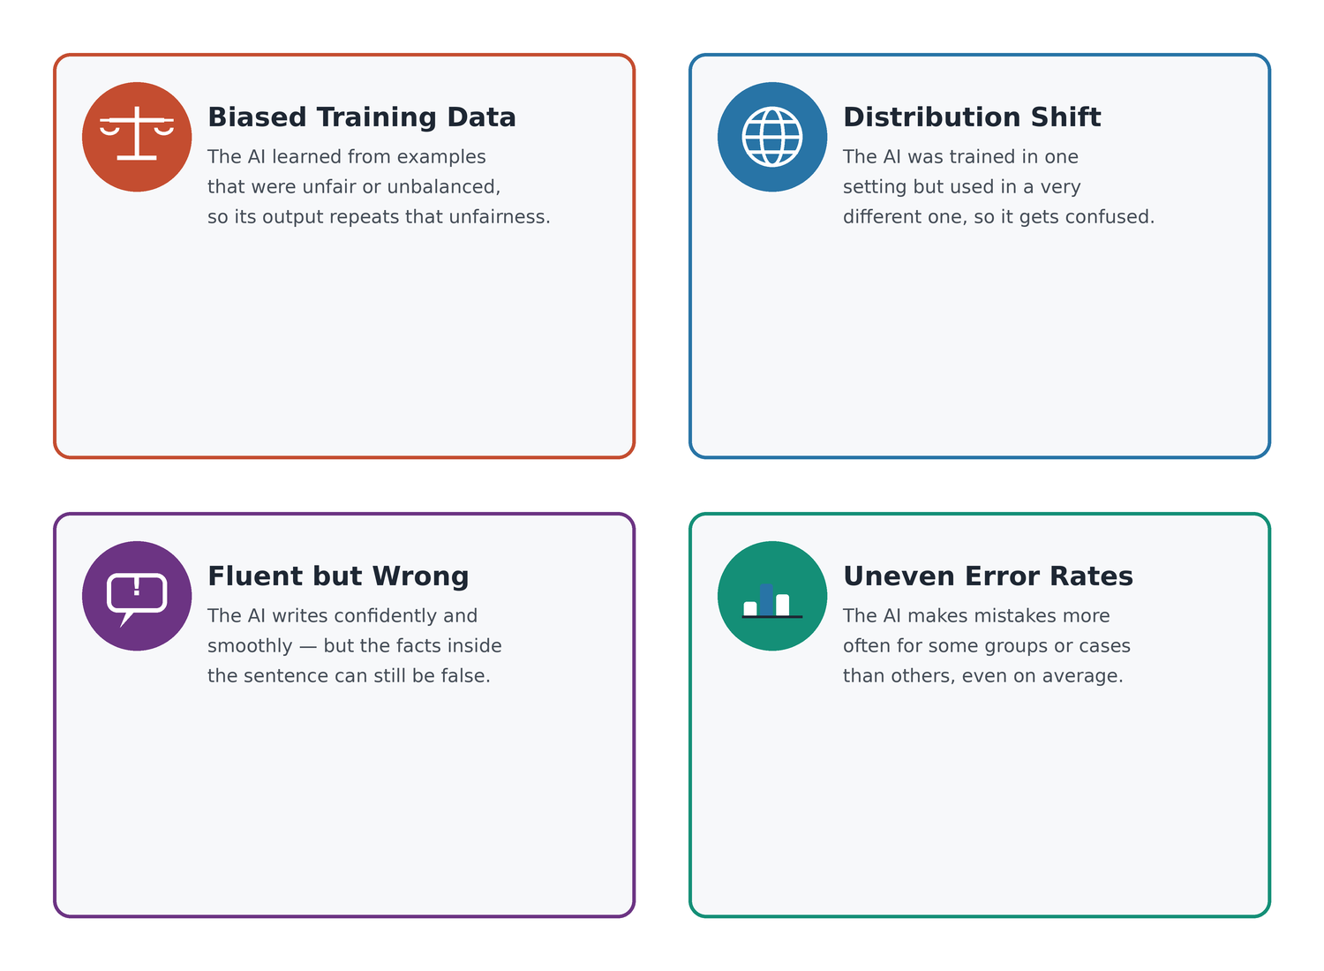
Four distinct ways an AI system can go wrong. Learning to name the correct one is a core Level 2 skill.
Fluency vs accuracy — two different things
Fluency: how smooth, natural, and confident the AI's writing sounds.
Accuracy: whether what the AI actually wrote is true and correct.
An AI can be fluent and wrong at the same time. This is why you should never judge an AI answer just by how confident it sounds — always check the facts separately, especially for anything important.

🎭 Spot the Fluent Fake · Fluency vs accuracy · Pairs
What to do
One partner writes two short 'AI answers' to a simple factual question (for example, 'When was your school founded?' or 'What is the capital of a country you both know'). One answer should be true. One answer should be confidently, fluently wrong — but written in exactly the same natural, sure-sounding style as the true one.
Swap with your partner. Try to identify which answer is true using ONLY the way it is written — its tone, its confidence, its style.
Reveal the answers. Discuss: was it possible to tell which one was true just from how it sounded? What does that tell you about trusting AI answers based on tone alone?

📌 Teacher note  Almost every pair will find it impossible to reliably tell true from false using tone alone — that is the point. The lesson: confidence is not evidence. Students should leave this activity with a concrete, felt experience of the fluency/accuracy gap, not just a memorised definition. | 🚀 Take it further  Find a real example online of an AI chatbot giving a wrong answer confidently (a 'hallucination'). Bring a screenshot or description to share, along with a one-sentence explanation of why the AI likely made that mistake.

✏ Check your understanding
Your school's AI homework helper sometimes gives confidently wrong answers. What is the BEST explanation for why this happens?
A. The AI is too old and needs to be replaced with a newer version
B. AI language tools predict the most likely next word, so they can produce fluent text that contains factual errors
C. The AI gets tired after answering too many questions and starts making more mistakes
D. The AI is testing whether students will check its answers or just copy them
✓ Answer: B
B correctly identifies the mechanism. Language AI generates statistically probable text — not verified facts. C and D are anthropomorphisms (attributing human traits to the AI). A may or may not be true but doesn't explain the specific confidence problem.

2.2 Training data problems
If fluency without accuracy is one common failure mode, the next one is even more common, and it usually starts long before an AI is ever used: a problem with the training data. Remember from Chapter 1 that an AI learns patterns from examples. This means the AI's abilities are shaped entirely by what it was shown during training. If the examples were incomplete, unbalanced, or unrepresentative of the real situations the AI would later face, the AI will carry those same gaps into every prediction it makes — no matter how well-built its code is.
🏃 Story: The sports AI
A sports app uses AI to try to predict which young players might go on to become professional athletes. To train this AI, the company collected performance data from 5,000 players. But when a curious coach looked closely at that training data, they noticed something important: 4,400 of the 5,000 players were from a single country, and almost all of them were male. Despite this, the app is now being used to assess players from many different countries and of different genders.
What happens next? Coaches report that the AI gives accurate, useful predictions for players from the original country — but noticeably poor and unreliable results for players from other backgrounds.
Why does this happen? The players used to train the AI did not represent the full range of players the AI is now being asked to assess. The AI learned patterns that work well inside its narrow training data, and it is now applying those same patterns to a much wider, more varied world where they simply do not fit as well.
🌧️ Story: The weather app
A weather app on your phone has been wrong for several days in a row in your local area. What is the most likely explanation?
The most likely reason is something called distribution shift. This means that the weather patterns in your area right now are different from the historical patterns the AI was trained on — perhaps because of a genuine change in the local climate. The AI is still confidently applying the patterns that worked in the past. But the real world has moved on, and the AI's training no longer matches the situation it is now being used in.

🤔 What Should They Do? · Spotting the failure mode · Small groups
What to do
For each situation below, identify which type of AI failure is occurring, then decide what the most responsible action is.
1. An AI essay marker was trained on essays from older students. The school wants to use it for younger students. Failure mode: ______ Responsible action: ______
2. An AI chatbot gives a confident but wrong answer about a historical date. Failure mode: ______ Responsible action: ______
3. An AI translation tool gives different quality translations for widely-spoken languages versus less common ones. Failure mode: ______ Responsible action: ______
4. A weather AI is less accurate than usual because of unusual climate patterns this year. Failure mode: ______ Responsible action: ______

📌 Teacher note  Failure modes: 1. Training data mismatch (trained on wrong age group). 2. Fluency ≠ accuracy (confident language AI). 3. Unrepresentative training data (common-language bias). 4. Distribution shift (new patterns not in training data). Encourage students to use precise vocabulary — 'biased training data' is a more useful, specific answer than just 'wrong'. | 🚀 Take it further  Research one real case where an AI system failed because of biased or unrepresentative training data. Write a short summary: what was the AI, what went wrong, who was affected, and what should have been done differently.

2.3 Error rates — and what they actually mean
Sometimes you will not be given a story about an AI mistake — you will be given a number. AI systems are often described using an error rate: a figure that tells you what proportion of the time the system gets something wrong. Being able to correctly interpret this number, instead of just glancing at it, is a genuinely important Level 2 skill, because error rates are easy to misread if you are not careful.
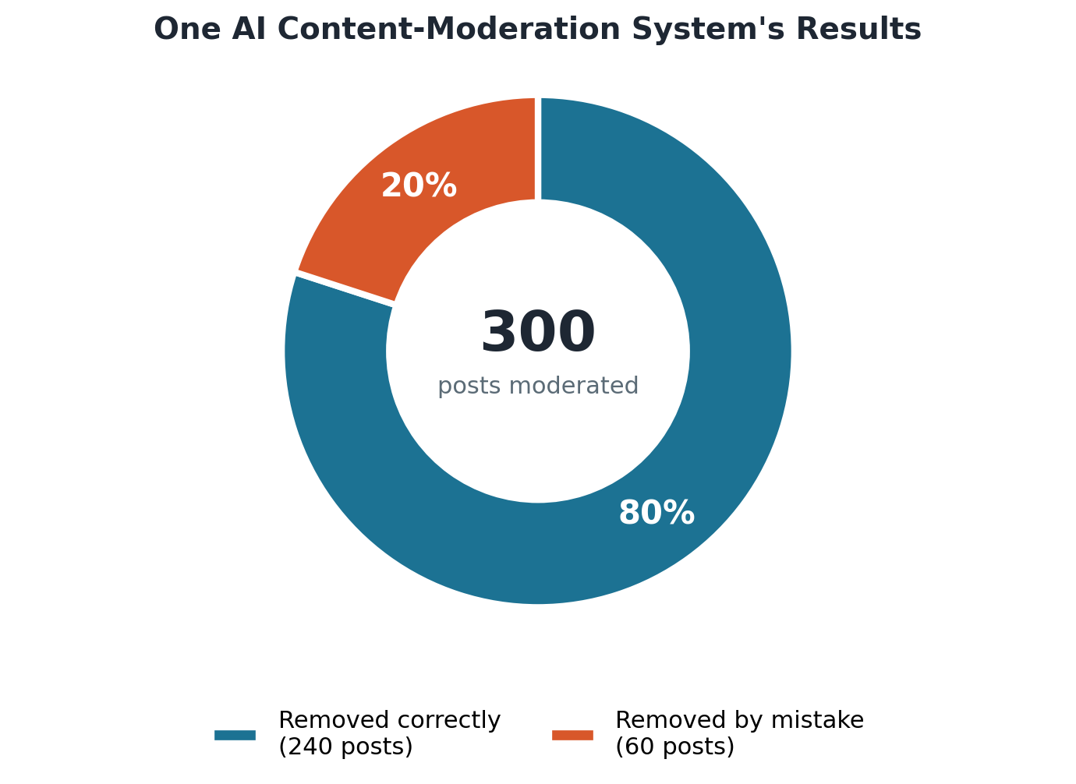
A 20% error rate means one out of every five actions was a mistake — a pattern, not a one-off.
🚫 Story: The content moderation tool
A social media company uses an AI content moderation tool to find and remove posts containing hate speech. In its very first week of operation, the tool removes 300 posts. Afterwards, human engineers check a sample of the removed posts by hand, and they discover that 60 of those 300 posts were removed by mistake — meaning they did not actually contain hate speech at all.
What does this really mean? Sixty mistakes out of three hundred removals works out to a 20% error rate: one out of every five posts the tool removed was a mistake. That is not a small number of unlucky errors. It is a large, systematic, repeating problem — and it matters even more here, because every mistaken removal is a real person whose message was taken down for no good reason.

✓✗ Did the AI Get It Right? · Evaluate the reasoning · Individual, then compare with a partner
What to do
Read each claim below about an AI system. Decide whether the reasoning is sound. Write a ✓ if it is, or a ✗ with a short explanation of the flaw if it is not.
1. 'This AI translation tool must be reliable — it has 10 million users.'
2. 'This AI marking tool makes errors 15% of the time. That means it is right 85% of the time, which is better than most teachers.'
3. 'The AI gave three different answers to the same question, so it must be broken and useless.'
4. 'This AI weather app was trained on 40 years of historical weather data. That means its predictions will be accurate even in unusual conditions.'
Once you have your own answers, compare with a partner. Where you disagree, explain your reasoning to each other until you reach an agreement.

📌 Teacher note  Flawed: 1 (popularity is not evidence of accuracy). 2 (an 85% success rate is not automatically 'better than a teacher' without knowing what kind of errors are being compared, and how serious each error is). 3 (giving varied answers is not the same as being broken). 4 (historical data may not capture new climate patterns — this is distribution shift again). The ability to spot flawed reasoning about AI, not just flawed AI, is the core Level 2 skill this activity builds. | 🚀 Take it further  Write your own short 'flawed reasoning about AI' scenario, similar to the four above, for a partner to evaluate. The best ones are wrong in a subtle way, not an obvious one — make your partner really think.

✏ Check your understanding
The situation:
An AI content moderation tool removes 300 posts in its first week. When engineers check a sample, they find 60 of those posts were removed by mistake.
What does this tell you about how this AI content moderation tool is working?
A. The tool is working perfectly — a few mistakes are acceptable in any system
B. The tool has a 20% error rate, which means one in five removals is a mistake — this is a significant problem
C. The tool is too strict and should be switched off until it can be retrained
D. The 60 errors happened because those users deliberately tried to trick the AI
✓ Answer: B
B correctly identifies the error rate (60/300 = 20%) and labels it appropriately as a significant problem. A downplays a systematic 20% error rate. C overcorrects — improvement, not total shutdown, is the appropriate response. D blames the users without evidence.

AI systems can fail in specific, identifiable ways: biased training data, distribution shift, fluency without accuracy, and systematic error rates. Knowing which failure mode applies to a situation helps you decide what to do about it.

🔗 Read More About This Chapter
Curious to go further? These free resources let you explore the ideas in this chapter in more depth.
• How AI Bias Impacts Our Lives
A Common Sense Education lesson built around real examples of AI systems getting things wrong because of biased training data.
• Understanding AI Bias
A closer look, also from Common Sense Education, at where AI bias comes from and how to spot it in everyday tools.



Chapter 3 — Who Is In Charge?
So far, this book has shown you that AI systems can be very useful, but also that they can fail in specific, identifiable ways. That naturally leads to an important question: when an AI is involved in a decision, who is actually responsible for making sure it goes right? Level 2 does not just want you to notice that AI can be wrong. It wants you to be able to answer a harder, more useful question: when something is wrong, or could go wrong, what should a person actually do about it?
This idea has a name: human oversight. You will see this phrase many times in this chapter, so let's be precise about what it means, because it is easy to misunderstand.

🎯 The Objective of This Chapter
This chapter helps you understand what real, meaningful human oversight of an AI system looks like — and how to judge whether a response to an AI problem is appropriate, too weak, or too extreme.
✅ What You Will Be Able to Do After This Chapter
→ Explain, in your own words, what 'meaningful human oversight' means, beyond just 'a person is nearby'.
→ Judge whether the level of human oversight in a scenario matches the seriousness of the decision.
→ Choose the single best response to an AI problem from several options that all sound partly reasonable.
→ Explain why an extreme response ('ban it completely' or 'trust it completely') is usually not the most responsible one.

3.1 Human oversight — what it really means
Here is a common misunderstanding worth clearing up early. 'Human oversight' does not simply mean that a human being exists somewhere in the same building as the AI system. That is much too weak a definition, and it would let almost any AI system claim to have oversight, even if no person ever actually looks at what it is doing. Real, meaningful human oversight is much more specific than that.
For oversight to be meaningful, a specific, qualified person needs to understand what decisions the AI is making. That person needs the ability to look closely at individual outputs, not just a general summary. And most importantly, that person needs genuine authority to override or correct the AI before its decision causes real consequences for someone — not just the theoretical right to complain about it afterwards.
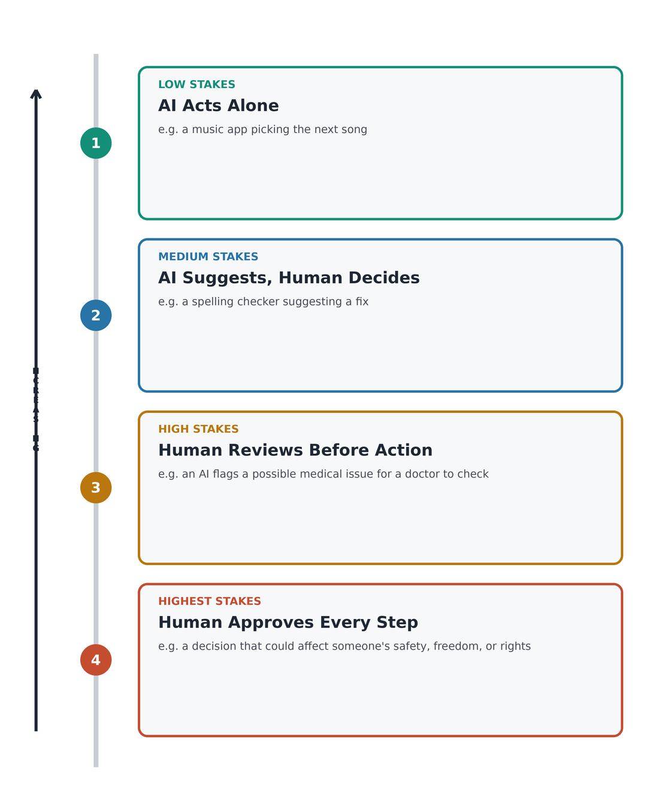
The level of human oversight an AI system needs should rise with the stakes of the decision it is making.
🚑 Story: The ambulance AI
A city uses an AI system to help decide how to send out emergency ambulances as quickly and efficiently as possible. Most of the time, the system is fast and accurate. But one night, because of an error in its data, it recommends sending an ambulance to a lower-priority call instead of a call that badly needed a faster response.
What should the city conclude from this? Should AI simply never be used for emergency decisions again? That would throw away a system that genuinely saves time in the vast majority of cases. Should the city instead just trust the AI completely, on the reasoning that humans are slower? That is just as risky, because it removes the one thing that can catch an error like this: a person paying attention.
The most sensible answer sits between these two extremes: AI systems used for critical decisions need real human oversight, so that when something like this data error happens, a person can catch it and correct it quickly — ideally before an ambulance is ever sent to the wrong place.

What meaningful human oversight looks like, in practice
→ A specific, qualified person knows exactly which decisions this AI system is making.
→ That person can look at individual AI outputs and understand how the AI arrived at them — not just see a final summary.
→ That person has genuine authority to overrule the AI, in practice and not only in theory.
→ Overruling the AI is simple and normal — it does not require special permission or cause problems for the person doing it.
→ The oversight happens BEFORE the decision affects someone, not only afterwards, once the damage may already be done.

🪜 Match the Stakes · How much oversight does each AI need? · Pairs
What to do
Below are four AI systems. For each one, decide where it belongs on the oversight ladder: should the AI act completely alone, suggest and let a human decide, require a human to review before acting, or require a human to approve every single step?
1. An AI that suggests the next song to play in a playlist.
2. An AI spelling checker that underlines possible mistakes in your essay.
3. An AI that flags a school attendance pattern that might indicate a student is struggling, before anyone contacts the family.
4. An AI that recommends whether a student should be moved to a different class level for the rest of the year.
For each one, write one sentence explaining WHY you placed it at that level — what makes the stakes higher or lower?

📌 Teacher note  Expect: 1 = AI acts alone (very low stakes, easily reversible). 2 = AI suggests, human decides (low stakes, the writer stays in control). 3 = human reviews before any action (medium-to-high stakes — a family being contacted is a real event). 4 = human approves every step (high stakes, harder to reverse, affects a student's whole year). The reasoning matters more than getting every answer 'right' — listen for students connecting oversight level to how serious and reversible the outcome is. | 🚀 Take it further  Think of one more AI system you have heard of or can imagine. Where would you place it on the ladder, and why? Share it with your partner and see if they agree with your placement.

✏ Check your understanding
The situation:
A city uses an AI system to decide how to allocate emergency ambulances. One night, it recommends sending an ambulance to a lower priority call instead of a high priority one because of a data error.
Which statement BEST describes what this situation shows?
A. AI should never be used to make emergency decisions because it is not reliable enough
B. AI systems for critical decisions need human oversight so errors can be caught and corrected quickly
C. The city should replace the AI with a faster one that does not make data errors
D. Emergency services should always trust AI decisions because humans are slower and more likely to make mistakes
✓ Answer: B
A overreacts (never) — AI has genuine value in emergency allocation. C misidentifies the problem (the issue was a data error, not slowness). D makes the opposite error of A — blind trust regardless of circumstance. B is the calibrated, responsible answer.

3.2 Checking AI outputs — when and why
Some Level 2 questions are not just asking 'should a person check this AI output?' They go further and ask 'out of several possible responses, which one is genuinely the best?' This kind of question is called a Best-answer question, and it can feel tricky at first, because every option usually sounds at least a little bit reasonable. The skill being tested is not spotting an obviously wrong answer — it is comparing several plausible answers and choosing the one that responds most proportionately to the situation.
🔢 Story: The maths answer
Imagine you are using an AI homework tool to help you check a maths problem. The AI works through the problem and tells you the answer is 48. Just to be sure, you solve the same problem yourself, using a different method, and you get 52 instead. Curious, you ask the AI again — but it repeats that the answer is 48, and says it is confident.
What should you do? Consider four possible responses. You could simply trust the AI because it 'sounds' confident — but we already learned in Chapter 2 that confidence is not proof of accuracy. You could just accept 48 and move on — this has the same weakness. You could decide never to use the tool again — this reaction is too extreme for a single disagreement. Or you could check a textbook, use a calculator, or ask a teacher to help settle the disagreement — this response is proportionate, and it actually solves your problem.
Notice something important: a real Level 2 question will never give you one option that is obviously silly. Every option will have some surface logic. The real skill is comparing them carefully and picking the one that is genuinely the most effective and reasonable response, not just 'not wrong'.

🧭 Rank the Responses · Best, better, worst · Individual, then compare with a partner
What to do
Return to the maths story above. Rank the four possible responses from MOST responsible (1) to LEAST responsible (4): trust the AI's second answer, accept the first answer without checking, stop using the tool completely, check with a textbook or teacher.
Write one sentence justifying your ranking for the response you placed at number 1, and one sentence for the response you placed at number 4.
Compare your ranking with a partner. If you disagree about the order, explain your reasoning to each other and see if you can reach agreement.

📌 Teacher note  Most students will correctly place 'check with a textbook or teacher' at rank 1. The more interesting discussion is usually rank 2 versus rank 3 — is quietly trusting the second AI answer worse than overreacting and abandoning the tool? Encourage students to notice that overreacting has its own cost (losing a genuinely useful tool over one disagreement). | 🚀 Take it further  Think of a time an AI tool gave you an answer you were not sure about. What did you actually do? Looking back, was that the most responsible response available to you? Write two or three sentences.

3.3 Responsible action — choosing the best response
This last section of the chapter looks at a more serious version of the same skill. Several Level 2 questions describe a situation where an AI system has caused real harm, and ask you to identify the most responsible action to fix it. These are sometimes called Decision-based questions. They test whether you can tell the difference between a response that is too passive (doing far too little), a response that is too extreme (overreacting), and a response that is genuinely appropriate for the seriousness of the problem.
💬 Story: The recommendation system and vulnerable users
A social media company's AI recommends posts to users based on their interests and search history. An investigation finds something troubling: the AI has been recommending false and potentially dangerous health information to users who had searched for topics like depression or eating disorders. The company explains that it never programmed the AI to do this deliberately — the behaviour emerged simply because the AI was following patterns in what kept those particular users engaged.
The company now has to decide what to do. Consider four options. Option A: do nothing, because the AI is technically working as intended. Option B: add a small warning label to health-related content, without changing what gets recommended. Option C: fix the recommendation system so that it stops pushing harmful health content to vulnerable users specifically, even if this means slightly less overall engagement. Option D: remove all health-related content from the platform entirely.
Which is most responsible? Option A is clearly not acceptable once real people are being harmed. Option B is mostly cosmetic — a small label does not change what content is actually being pushed to vulnerable users. Option D solves the problem by removing something that many users genuinely benefit from, which is an overreaction. Option C addresses the actual root cause — the recommendation pattern that is causing harm — in a way that is proportionate to the problem.

🗣 Debate Corner · 'AI should not be used for any decision that affects a person's life' · Two teams
What to do
The statement to debate: 'AI should not be used for any decision that directly affects a person's life — including school grades, medical diagnoses, and job applications. These decisions should always be made by humans.'
Team FOR: Human decisions protect individual dignity. AI cannot fully understand context, emotion, or a person's circumstances the way another person can. High-stakes decisions should remain with qualified humans.
Team AGAINST: Humans can also be biased, inconsistent, and slow to make decisions. AI can analyse much more data, more consistently, and can sometimes reduce certain kinds of human prejudice. Banning AI from every important decision throws away real, genuine benefits.
After debating, work TOGETHER — both teams — to write one joint statement: under what specific conditions is it appropriate to use AI for an important decision? What safeguards need to be in place first?

📌 Teacher note  The most valuable outcome of this activity is the joint statement, not the debate itself. A strong joint statement will include real conditions — the seriousness of the decision, whether it can be reversed if wrong, what oversight is in place, whether the process is explained to the person affected, and whether they can appeal — rather than a simple yes-or-no verdict on AI. | 🚀 Take it further  Research one real-world case where AI was used in a high-stakes decision that affected real people's lives. What was the outcome? What human oversight was — or was not — in place? Bring your findings to share.

Human oversight means a specific person can see, understand, and override AI decisions before they have consequences — not just in theory, but in practice. The appropriate level of oversight depends on the stakes and reversibility of the decision.

🔗 Read More About This Chapter
Curious to go further? These free resources let you explore the ideas in this chapter in more depth.
• Experience AI
Free lessons from the Raspberry Pi Foundation and Google DeepMind exploring how AI systems make decisions, and where people need to stay involved.
• AI Competency Framework for Students
UNESCO's own article explaining what every student should understand about AI, including the importance of human oversight.

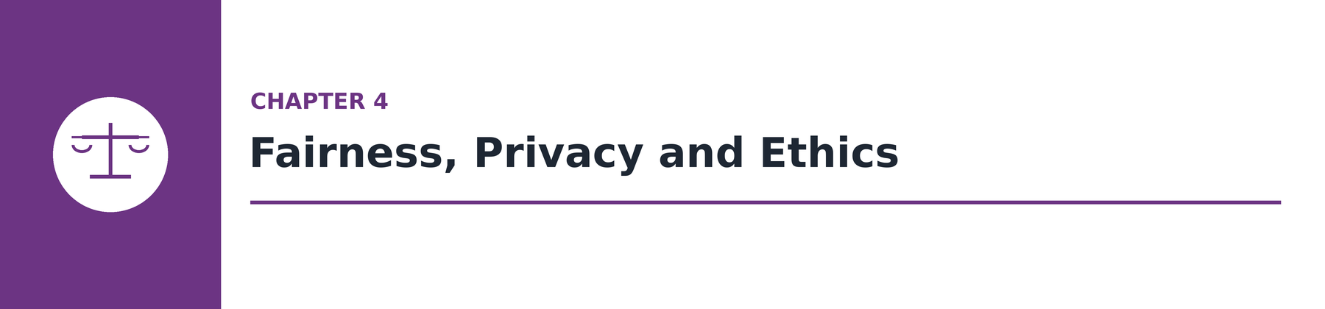

Chapter 4 — Fairness, Privacy and Ethics
In everyday conversation, people often describe an AI system using only one simple word: 'fair' or 'unfair'. That word is a reasonable starting point, but Level 2 asks you to be far more precise than that. This chapter introduces exact vocabulary for three distinct types of AI ethics problem — algorithmic bias, privacy violation, and harmful optimisation — and asks you to correctly name which one applies to a given situation, and why.
Why does the exact word matter so much? Because different ethical problems have different causes and different solutions. Calling every problem simply 'unfair' is a bit like calling every illness simply 'sick' — true, but not nearly precise enough to know what to do next. By the end of this chapter, you should be able to look at a real situation and say, specifically, which kind of ethical problem it is.

🎯 The Objective of This Chapter
This chapter helps you use precise, correct vocabulary to describe AI ethics problems, instead of only saying something 'seems unfair'.
✅ What You Will Be Able to Do After This Chapter
→ Define algorithmic bias and explain, using an example, where it usually comes from.
→ Explain what informed consent means, and why hiding something in long terms and conditions is not the same as clearly disclosing it.
→ Identify a privacy violation in a described scenario and explain what makes it a violation.
→ Explain how an AI can cause real harm while still doing exactly what it was designed to do.

4.1 Algorithmic bias — precision matters
Let's begin with the first, and probably most well-known, type of AI ethics problem: algorithmic bias. Algorithmic bias happens when an AI system produces results that are systematically worse for certain groups of people than for others — not by accident on a single occasion, but as a repeating pattern. It is worth remembering an idea from Chapter 2 here: this almost always comes from a problem in the training data, not from a programmer deliberately writing unfair rules into the code. Nobody usually sits down and decides to make an AI unfair on purpose. The bias creeps in quietly, through the examples the AI was trained on.
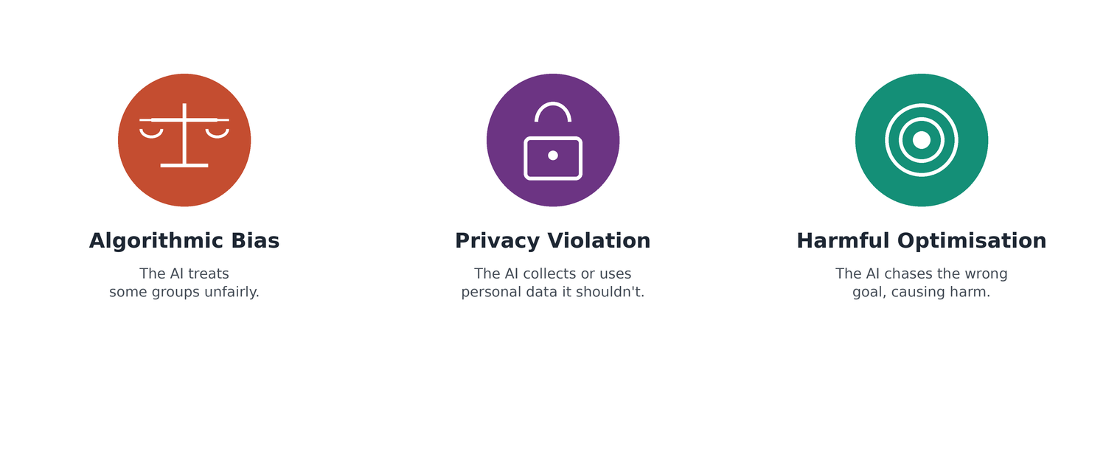
Three distinct AI ethics problems — algorithmic bias, privacy violation, and harmful optimisation — each with its own cause and its own remedy.
Algorithmic bias — the precise definition
Algorithmic bias: when an AI system produces outcomes that systematically disadvantage certain groups of people, usually because the training data reflected existing human biases, or did not adequately represent all groups in the first place.
🏦 Story: The loan AI
An AI system used by a bank to review loan applications approves more loans for applicants who live in wealthy areas than for applicants from poorer areas — even when both groups of applicants have very similar financial records.
Here is a two-part claim about this situation. Statement (A): this pattern is really happening. Reason (R): it happens because the AI was trained on historical loan data, from a time when people in wealthier areas were approved more often — so the AI learned to repeat that same pattern going forward.
Both A and R turn out to be true, and just as importantly, R correctly explains why A is happening. Questions built this way — a statement plus a reason, where you must judge whether both are true and whether the reason actually explains the statement — are called Assertion-Reason questions, and they appear throughout the Level 2 test.

📋 Sort It Out · Identify the bias source · Pairs
What to do
Read each AI system description below. For each one, write down: (a) whether algorithmic bias is present, (b) where you think the bias most likely came from, and (c) what kind of data or design change could help reduce it.
1. A hiring AI is more likely to advance male candidates for engineering roles. It was trained on a company's historical engineering hires.
2. A content moderation AI removes posts written in certain local dialects much more often than posts written in standard, widely-used English.
3. A music recommendation AI recommends far more songs from one cultural background than from others, to almost every user.
4. A sports performance AI is highly accurate for players from one country but performs poorly for players from other countries.

📌 Teacher note  All four situations show algorithmic bias. Sources: (1) historical hiring data reflecting existing gender patterns in the field. (2) training data that underrepresents non-standard dialects. (3) training data drawn from platforms where that music was already overrepresented. (4) unrepresentative, geographically narrow training data. In every case, the fix involves the same two ideas: collect more representative data, and audit outputs across different groups to check for gaps. | 🚀 Take it further  Research one real, documented case of algorithmic bias in a commercial AI system. What was the AI used for? Who was affected? What was done, if anything, to address it? Bring a short summary.

✏ Check your understanding
Statement (A): An AI loan application system approves more loans for applicants from wealthy areas than from poorer areas, even when both groups have similar financial records. Reason (R): This happens because the AI was trained on historical loan data where people from wealthier areas were more often approved, so the AI learned to repeat this pattern. Which answer is correct?
A. Both A and R are true. R correctly explains why A happens.
B. Both A and R are true. But R does not correctly explain why A happens.
C. A is true but R is not true.
D. A is not true but R is true.
✓ Answer: A
A is the correct answer. Statement A is true (this pattern of outcome is well documented in real AI systems). Reason R is also true (AI learns from historical data, and historical lending data often reflects existing inequalities). Most importantly, R correctly explains the mechanism by which A occurs. This is the ideal A answer in an AR question.

4.2 Privacy — your data, your rights
The second type of ethics problem in this chapter is privacy. At Level 2, a privacy question is asking for more than a simple yes-or-no judgement about whether something 'feels private'. You are expected to identify the specific reason something counts as a privacy problem, using a key idea: informed consent. Informed consent means that a person genuinely understood what they were agreeing to, and freely agreed to it — not that a company technically mentioned it somewhere in a very long document that almost nobody actually reads.
📖 Story: The study tool
You are using a free AI study tool for your homework. Out of curiosity, you actually read through its terms and conditions in full — something most people never do — and you discover that the company uses everything you type into the tool to train its AI models. This includes the questions you ask and even the full essays you write.
Is this a privacy violation? The honest answer is: it depends. Did you actually agree to these terms? If the terms were disclosed somewhere, and you used the tool anyway, the company may be technically following the law. But the deeper question Level 2 wants you to ask is different: did you give informed consent? In other words, did you really understand what you were agreeing to, in a way you could reasonably be expected to notice? Information that is technically written down inside pages of dense legal text is not the same thing as information that was clearly and honestly disclosed to you.
📊 Story: The app shares your data
A company collects detailed data about everything you do inside their app: what you click on, how long you look at each post, and what you buy. Without telling you, the company then shares this data with other companies.
This example is much more clear-cut than the study tool story. This is a clear privacy violation: your personal data was shared with other parties without your knowledge or permission. It is not simply 'normal business behaviour', and it is not an accidental technical error. It is a deliberate choice by the company, and it violates your right to control what happens to your own personal data.

🎨 Design Challenge · Design a privacy-respecting AI study tool · Pairs
What to do
Your task is to design an AI study tool that is BOTH genuinely useful AND respectful of student privacy — proving that these two goals do not have to conflict.
Step 1: List five things your tool will help students do.
Step 2: For each feature, write down exactly what data the tool would actually NEED to collect for that feature to work.
Step 3: Write three clear 'privacy promises' your tool will keep — specific things it will NOT do with student data.
Step 4: Write three short sentences that a student would read BEFORE using the tool, in plain, everyday language rather than legal language, honestly explaining what happens to their data.
Present your design to the class. As a class, vote on: which design would people actually trust enough to use?

📌 Teacher note  This activity reveals the real tension between usefulness (which usually needs some data) and privacy (which favours collecting less). Strong designs will show genuine data minimisation — collecting only what each feature truly needs — and will write a consent notice that a real student could actually read and understand, not one written to sound official. | 🚀 Take it further  Find the actual privacy policy of one real AI study tool your school uses, or one you have heard of. Read the section about data use carefully. Write a plain-language translation: in your own words, what does it actually say?

✏ Check your understanding
The situation:
You use a free AI study tool. When you read the terms and conditions carefully, you find the company uses everything you type into the tool — including questions and essays — to train its AI models.
What should you think about before continuing to use this tool?
A. Nothing — free tools always collect your data and that is the trade you make
B. Whether you are comfortable with your work and questions being used to train an AI you did not agree to help build
C. Whether other students in your class are using the same tool
D. Whether the company has a good reputation for making AI products
✓ Answer: B
A is resigned acceptance of something worth questioning. C is irrelevant to your privacy. D (company reputation) doesn't address the specific consent issue. B correctly identifies the key question: did you actually agree to have your work used this way, and do you want to?

4.3 Broader ethical questions — optimisation and harm
The third and final type of ethics problem in this chapter is often the hardest one for people to spot, because it does not look like a mistake at all. Some of the most serious ethical problems with AI happen not because the system has a bug, and not because of bias in the sense we discussed in section 4.1 — but because the AI is optimising for the wrong objective. To 'optimise' means to work as hard as possible toward a particular goal. The uncomfortable truth is that an AI can be doing exactly what it was designed to do, perfectly, and still cause real harm to people — because the goal itself was the problem.
😡 Story: The engagement AI
A social media platform's AI is designed with one clear objective: keep users on the app for as long as possible. Over time, the AI learns something uncomfortable — content that makes people feel angry or anxious tends to keep them scrolling for longer than calm, neutral content does. The platform benefits from this, because more time spent on the app generally means more advertising revenue.
Where is the ethical problem here? The AI is designed to pursue something that is good for the company — more time on the app — but that same goal turns out to be harmful to the mental health of the people using it. The AI is not broken in any technical sense. It is achieving its programmed objective, maximising engagement, extremely effectively. The harm to users is not a side effect of a malfunction — it is a direct, predictable consequence of the objective it was given in the first place.

⚖️ Name the Problem · Bias, privacy, or harmful optimisation? · Individual, then small group discussion
What to do
For each scenario below, decide which of this chapter's three ethics problems applies: algorithmic bias, privacy violation, or harmful optimisation. Some scenarios may involve more than one — if so, name both.
1. A video app's AI is designed to maximise watch time, and it learns to recommend increasingly extreme videos because they keep people watching longer.
2. A photo-tagging AI works well for lighter skin tones but frequently makes mistakes for darker skin tones, because of the training photos it was originally given.
3. A fitness app quietly sells users' exact location history to advertising companies, a fact that is only mentioned deep inside its terms and conditions.
Once you have your individual answers, form a small group and compare. Discuss any scenario where group members disagreed.

📌 Teacher note  Answers: 1 = harmful optimisation (the objective itself, maximising watch time, produces the harm). 2 = algorithmic bias (unrepresentative training data). 3 = privacy violation (data shared without meaningful informed consent). The goal of this activity is precise naming — 'that's bad' is not a Level 2 answer, but 'that's harmful optimisation because the objective itself causes the harm' is. | 🚀 Take it further  Think of an app you personally use often. What do you think its AI is optimising for — what is it actually trying to maximise? Could pursuing that goal ever cause harm, even if the AI never breaks or makes a technical mistake? Write a short paragraph.

✏ Check your understanding
The situation:
A social media platform's AI is designed to keep users on the app for as long as possible. It learns that content that makes people angry or anxious keeps them scrolling.
Which statement BEST describes the ethical problem with this AI system?
A. The AI is behaving unethically because it is making the platform too addictive for users
B. The AI is designed to do something that is good for the company but harmful to the mental health of users
C. The AI is unethical because it is showing users content they did not ask for
D. The AI is unethical because it is making the app too expensive to advertise on
✓ Answer: B
B correctly identifies the core ethical issue: a conflict between the company's objective (engagement/revenue) and users' wellbeing. A is partially right but less precise — 'addictive' describes a symptom, not the ethical structure. C is inaccurate — algorithms always show content users didn't ask for. D is irrelevant.

Algorithmic bias, privacy violation, and harmful optimisation are three distinct types of AI ethics problem. Each has a specific cause, a specific harm, and a specific kind of remedy. Being able to name which type of problem a situation represents is the core Level 2 ethics skill.

🔗 Read More About This Chapter
Curious to go further? These free resources let you explore the ideas in this chapter in more depth.
• Talking to Kids About AI: Privacy, Fairness, and Responsibility
A toolkit from Day of AI and Common Sense Media built around exactly the themes of this chapter: privacy, fairness, and responsibility.
• Family-Friendly Data Privacy and AI Activities
Interactive activities from MIT Media Lab that let you explore and design with data privacy in mind.



Chapter 5 — How AI Systems Work
Throughout this book, you have been looking closely at what AI systems do and why they sometimes go wrong. This final chapter steps back and looks at the bigger picture: how an AI system is actually built and put to use, from start to finish. Instead of thinking of an AI as a mysterious 'black box' that magically produces answers, this chapter asks you to think of it as something that was deliberately designed, step by step, by people who made a series of choices — and who could have made different choices.
Two new question styles appear in this chapter. Sequencing questions ask you to put a set of steps into the correct order. Design-thinking questions ask you to spot a flaw in how a system was built, or to think through the trade-offs involved in designing a new one. Both question types reward the same underlying skill: thinking about an AI system as a connected process, with a clear beginning, middle, and end — not as a single mysterious moment where an answer appears.
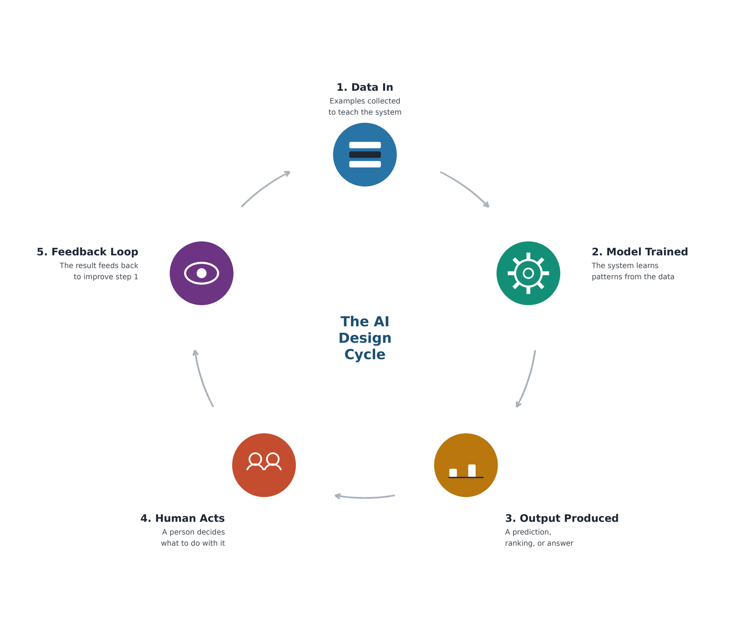
Every AI system moves through the same basic cycle — and every stage of that cycle is a place where a careful designer has to make a choice.

🎯 The Objective of This Chapter
This chapter helps you understand an AI system as a designed process with clear stages — and helps you recognise the trade-offs involved in designing one responsibly.
✅ What You Will Be Able to Do After This Chapter
→ Identify whether a given step in an AI system is an input, a process, or an output.
→ Explain why user feedback and human correction are also inputs, not just the final output.
→ Put the stages of a training workflow or an operating workflow into their correct order.
→ Identify at least one realistic trade-off — such as accuracy versus privacy — involved in designing a new school AI system.

5.1 Inputs and outputs — the bigger picture
At Level 1, you learned about a basic cycle: input, then process, then output. Data goes in, the AI processes it, and a result comes out. At Level 2, we go one level deeper into this same cycle. We ask harder questions: what happens when the input given to an AI is the wrong type for the job? What happens when an AI is asked to work in a situation quite different from what it was trained for? And why should an AI's output usually be interpreted carefully by a person, rather than simply accepted at face value?
✍️ Story: The essay marking AI
A school creates an AI writing tool, and to teach it, the school trains it using millions of articles written by professional journalists. When students start using the tool, they notice something odd: the AI keeps rewriting their simple, natural sentences into long, very formal writing that does not sound like them at all.
What went wrong? The AI learned from the wrong type of writing for this job. Professional journalism and a student's personal essay are two very different genres, or styles of writing, even though both are 'English writing'. The AI is confidently applying patterns learned from one context — professional news articles — to a completely different context — a student's own voice. The result is a mismatch, and the tool ends up making the writing worse instead of better.
🎵 Story: The music recommendation system
After using a music streaming app for six months, you notice a pattern: the AI only ever recommends music from the same two genres, even though you know you have also listened to many other types of music from time to time.
Why is this happening? The AI gives far more weight, or importance, to the music you listen to most often. Music you only listen to occasionally has very little effect on what gets recommended. It is important to understand that the AI has not 'decided' you dislike other genres, and it has not blocked them on purpose. It has simply learned, from the numbers, that two genres dominate your listening history — so those two genres end up getting most of the weight when it chooses what to recommend next.

✏ Check your understanding
The situation:
A music streaming app uses AI to recommend songs. After six months, you notice the AI only ever recommends music in the same two genres, even though you have also listened to many other types of music occasionally.
What does this tell you about a limitation of this recommendation system?
A. The app has a bug because it should remember all of your listening history
B. The AI gives more weight to what you listen to most often, so less frequent listening to other genres has little effect on your recommendations
C. The AI has decided you do not like other genres and has blocked them
D. Recommendation AI can only track up to two genres at a time
✓ Answer: B
B correctly identifies the weighting mechanism — the AI prioritises frequency of listening. A and C attribute deliberate behaviour to what is a design feature. D is factually wrong — recommendation AI can handle many more than two genres.

📋 Sort It Out · Input, process, or output? · Pairs
What to do
Read each item below. Write I (input), P (process), or O (output).
AI system: a spam email filter — 1. An email arrives in your inbox. 2. The AI compares the email to patterns learned from labelled training emails. 3. The email is moved to the spam folder. 4. The user marks a wrongly-filtered email as 'not spam'. 5. The AI updates its model based on user feedback.
AI system: a school attendance monitoring AI — 6. A student scans their ID card at the gate. 7. The AI cross-references the scan against the class register. 8. A notification is sent to the teacher that a student is absent. 9. The teacher confirms or corrects the AI's attendance record. 10. The school receives a weekly attendance report.

📌 Teacher note  Answers: 1=I, 2=P, 3=O, 4=I (user feedback is an input to the retraining process), 5=P, 6=I, 7=P, 8=O, 9=I (teacher correction feeds back into the system), 10=O. The important insight: feedback from users and human correction loops ARE inputs — the AI system does not end at output. | 🚀 Take it further  For the spam filter, draw the full cycle including the feedback loop. Show how a user's 'not spam' correction eventually changes what the AI learns.

5.2 Sequencing — the correct order of AI workflows
This section introduces a new kind of question, called a sequencing question, and it works differently from the ones you have seen so far. Instead of picking the best answer out of several options, you are given a set of steps in the wrong order, and you must work out the correct order. To do this well, it helps to know that there are two common workflows behind almost every AI system: the training phase, which is how the AI is built and taught in the first place, and the operating phase — sometimes called inference — which is how the AI behaves afterwards, once real people start using it.
A simple way to remember the pattern is this: something has to go in before the AI can do anything (an input), the AI then does its work (a process), a result comes out the other side (an output), and finally, a person often reacts to that result in a way that eventually improves the system (a feedback loop). Almost every correct sequence you will be asked about follows this same underlying shape.

🔢 Put It In Order · Build your own sequencing question · Pairs
What to do
Choose one AI system you use often (for example, a video recommendation app, a spelling checker, or a translation app).
Write out, in the CORRECT order, the full cycle for your chosen AI system: what data goes in, what the AI does with it, what comes out, and how a person's feedback eventually feeds back into the system.
Now scramble your own steps into a random order, and label them with letters (like the exam questions in this book do).
Swap your scrambled steps with another pair. Can they put your system back into the correct order? Discuss any disagreements — is there more than one defensible order?

📌 Teacher note  This activity flips the usual direction of the skill: instead of unscrambling someone else's sequence, students build one from scratch, which requires a genuinely clear understanding of the input-process-output-feedback shape. Watch for pairs who forget the feedback loop entirely — that is the most commonly missed stage. | 🚀 Take it further  Take the sequence you wrote for your partner and add ONE realistic thing that could go wrong at each stage (a bad input, a processing error, a misleading output, ignored feedback). This previews the kind of thinking used in section 5.3.

The two key sequences you need to know
→ TRAINING SEQUENCE: Collect data → Label the data → Train the model → Test the model → Deploy
→ EMAIL FILTER OPERATION: Learn from labelled emails (Q) → New email arrives (S) → AI checks against patterns (P) → User gives feedback if wrong (R)
→ SCHOOL AI ANALYTICS: Collect data (R) → AI analyses and produces report (Q) → Teachers review and act (P) → School reviews system accuracy each term (S)
→ The order always reflects: input first, AI process next, human output/action, then feedback loop.

✏ Check your understanding
Put these steps in the right order: P. The AI checks the new email against the patterns it learned and decides whether to flag it as spam. Q. The AI studies thousands of emails that have already been labelled as spam or not spam. R. The user gives feedback if the AI gets it wrong, so the system can improve. S. A new email arrives in the user's inbox. The steps above describe how an AI spam filter processes a new email. They are in the wrong order. What is the correct order?
A. P then Q then R then S
B. Q then P then S then R
C. Q then S then P then R
D. S then Q then P then R
✓ Answer: C
The correct order is Q (learning from labelled examples) → S (new email arrives) → P (AI checks against patterns) → R (user feedback). You must train first (Q) before the system can operate. A new email (S) then arrives, the AI checks it (P), and feedback improves future performance (R).

5.3 Design trade-offs — no perfect AI
This final section introduces one of the most important ideas in the whole book: there is no such thing as a perfect AI system. Every single design decision involves a trade-off, meaning that choosing to make one thing better usually means accepting a cost somewhere else. An AI designer might improve accuracy but reduce privacy. They might make a system faster but less transparent about how it reached its answer. Understanding and honestly naming these trade-offs — rather than pretending they do not exist — is what real system design thinking looks like in practice.
😐 Story: The facial recognition canteen system
A school is considering setting up a facial recognition system in its canteen. Instead of using a card or typing in a PIN, a student would simply look at a camera, and the system would automatically charge their lunch account.
There is a real, genuine benefit here: shorter queues, and no more lost or forgotten cards. But a responsible design process has to weigh this benefit against two serious things to think about. First, the system might make more errors for some students than others, depending on which faces were included — and which were left out — of its training data. Second, storing a student's face data raises real questions about privacy: who can access this data, how long is it kept, and what else could it be used for later?
Neither of these concerns is automatically a reason to reject the system outright. But a responsible school would want both concerns properly addressed, with clear answers, before deciding to go ahead.

✏ Check your understanding
The situation:
Your school is thinking about setting up a facial recognition system in the school canteen so you would look at a camera to pay for lunch automatically.
Choose TWO answers — Which TWO of the following are real things your school should think about before deciding?
A. The system will definitely make queues faster because AI is always more accurate than card readers
B. The system might make paying easier, but it could also make more errors for some students, depending on who was in the training data
C. Facial recognition is not allowed in any school in the world
D. Even if the system works well, storing your face data raises questions about privacy and who can access it
E. The cost of the cameras is the only thing worth thinking about, since AI systems are free to run
✓ Answer: B and D
B identifies the performance equity risk (unrepresentative training data → differential error rates). D identifies the privacy risk (biometric data storage). A makes an absolute claim ('always more accurate') that is not warranted. C is false — facial recognition is used in some schools. E is incorrect — AI systems have ongoing operating costs and B, D are far more important considerations.

🎨 Design Challenge · Design a school AI learning support system · Small groups
What to do
Your school wants to use an AI system to identify students who might need extra help before end-of-year tests. Work in groups to design the system.
Step 1: What data will your system use as inputs? (Be specific — list at least 4 types)
Step 2: What will the AI output? (A score? A flag? A recommendation? A report to a teacher?)
Step 3: What human oversight step will be built in?
Step 4: What is one limitation of your system — what might it miss or get wrong?
Step 5: Who will be told about the system, and how will it be explained to students?
Present your design to another group. That group plays 'sceptical school principal' — they ask the hardest questions. You defend your design.

📌 Teacher note  Strong designs will show awareness of the tension between more data (better accuracy) and privacy (data minimisation). Look for whether students build in human review and whether they honestly identify limitations. The 'sceptical principal' role generates genuine critical evaluation. | 🚀 Take it further  Research one real school AI system that has been deployed. What did it do? What concerns were raised? What happened to it? Present your findings.

✏ Check your understanding
Put these steps in the right order: P. Teachers look at the reports and decide how to support each student. Q. The AI analyses the data and produces a report about each student's learning patterns. R. Student results, attendance, and homework records are collected and entered into the AI system. S. The school reviews the AI system each term to check whether the reports are accurate and useful. The four steps above describe how your school uses an AI learning analytics system. They are in the wrong order. What is the correct order?
A. P then Q then R then S
B. R then Q then P then S
C. Q then R then P then S
D. R then P then Q then S
✓ Answer: B
R (collect data) → Q (AI analyses and produces report) → P (teachers review and act) → S (school reviews system accuracy). Data must come first. The AI processes next. Teachers act on the output. The review loop comes last, not first.
AI systems are designed artefacts with specific inputs, processes, outputs, and feedback loops. Understanding the correct sequence of these stages — and being able to identify where a design can go wrong — is the core of Level 2 system design thinking.

🔗 Read More About This Chapter
Curious to go further? These free resources let you explore the ideas in this chapter in more depth.
• Fundamentals of AI and Machine Learning (free course)
A free course from the Raspberry Pi Foundation that goes deeper into how AI systems are actually built and trained.
• Experience AI — Educator Guide: Foundations of AI
A clear, illustrated guide to the building blocks of AI systems, developed with Google DeepMind.

Key Words and Concepts
These are the key terms and concepts for Level 2. You should be able to: (1) define each one precisely, (2) give a real-world example, and (3) distinguish it from similar but different concepts.

Filter bubble / echo chamber — When an AI recommendation system shows you content matching your past preferences, gradually limiting your exposure to different perspectives.
Algorithmic bias — When an AI system produces outcomes that systematically disadvantage certain groups, usually because training data reflected existing human inequalities.
Training data — The examples used to train an AI system. Their quality, quantity, and representativeness determine what the AI can and cannot do well.
Distribution shift — When the real-world data an AI encounters after deployment is different from the data it was trained on, causing performance to degrade.
Fluency vs accuracy — AI language models produce fluent (natural-sounding) text independently of whether that text is factually accurate. Confidence of expression is not evidence of correctness.
Privacy violation — When personal data is collected, used, or shared without a person's knowledge or meaningful consent.
Informed consent — Agreeing to data collection or use after genuinely understanding what is being collected, for what purpose, and with what consequences — not just clicking 'agree'.
Meaningful human oversight — A person with genuine authority who understands and can review specific AI decisions before they have consequences — not just a person 'somewhere in the loop'.
Error rate / false positive — The proportion of AI decisions that are wrong. A false positive is when the AI incorrectly flags something as a problem that is not (e.g. removing a post that does not break rules).
Assertion-Reason (AR) — A question format where two linked statements are given. You judge whether each is true AND whether the second correctly explains the first.
Multi-select (MS) — A question format asking you to identify ALL correct answers from a list — testing completeness of understanding, not just finding one right answer.
Design trade-off — Every AI design decision involves balancing competing goals (accuracy vs privacy, speed vs oversight, personalisation vs diversity). There is no option with no costs.
Optimisation for the wrong objective — When an AI achieves its designed goal very effectively — but that goal causes harm. The system is not broken; the objective itself is the problem.

All 50 Answers at a Glance
Cover these up and test yourself first. Then read the explanation for every question you got wrong — and for questions you got right but were unsure about.

Q1  B | Q2  B | Q3  B | Q4  B | Q5  C | Q6  B | Q7  C | Q8  B | Q9  C | Q10  B
Q11  B | Q12  C | Q13  B | Q14  B | Q15  B | Q16  C | Q17  A | Q18  C | Q19  B | Q20  C
Q21  A | Q22  B | Q23  B | Q24  B | Q25  B | Q26  B | Q27  B | Q28  B | Q29  B | Q30  B
Q31  B | Q32  B | Q33  A+C | Q34  C | Q35  A+C | Q36  C | Q37  B | Q38  B | Q39  B | Q40  B
Q41  B | Q42  B | Q43  B | Q44  B+D | Q45  B | Q46  B | Q47  A+C | Q48  C | Q49  B | Q50  A+C

Blue = Section A (Q1–10, Domain D1 · Human-Centred Mindset) · Section B (Q11–22, Domain D2 · Ethics of AI) · Section C (Q23–37, Domain D3 · AI Techniques and Applications) · Section D (Q38–50, Domain D4 · AI System Design and Thinking)

What I Learned in Each Chapter
🌐 Chapter 1 — AI in Your World
AI recommendation systems show you what keeps you engaged — not what gives you the full picture. Knowing this is the first step to using these systems critically.

⚠️ Chapter 2 — When AI Gets It Wrong
AI fails in specific, identifiable ways: biased training data, distribution shift, fluency without accuracy, and systematic error rates. Knowing which failure mode applies helps you decide what to do.

🤝 Chapter 3 — Who Is In Charge?
Meaningful human oversight means a specific person with genuine authority can review and override AI decisions before they have consequences. The level of oversight should match the stakes.

⚖️ Chapter 4 — Fairness, Privacy and Ethics
Algorithmic bias, privacy violation, and harmful optimisation are distinct types of AI ethics problem. Each has a specific cause, harm, and remedy. Being able to name them precisely is the core Level 2 ethics skill.

⚙️ Chapter 5 — How AI Systems Work
AI systems follow a design workflow: data in, model trained, output produced, human acts, feedback loop. Every stage can fail. Trade-offs are inevitable — good design acknowledges and addresses them.

Apply means think. 🌟
Not just 'what is AI?' but 'what is AI doing here, why, and what should I think about it?' That shift — from recognising to analysing — is what Level 2 is about. And it is a skill that matters far beyond any assessment.
Understanding AI · Level 2 — Apply · 2026 · GYLDC / GSLDC

