**CS401 Final Project Documentation**

A20354898

Wanglin Song

1. **Problem Specifications**

The project requires us to write an application to read data (including integers, floating point numbers and strings from input file), create lists (each list only contains one single type of data) from the input data.

Then we need to be able to sort the data lists (using at least 3 types of sorting algorithm, bubble sort, merge sort and heap sort) and search data from lists (using linear sort and binary search).

Furthermore, we should be able to modify existing lists and still be able to perform sort/search functions on them.

1. **Software Specifications**

There are 6 components in the main application:

1. A data-entry hash-table called “data”, that stores lists of data read from files. We can grab a certain list by calling its key(index) in the hash-table. The data-entry hash-table can also rehash when it reaches 75% of its maximum capacity.
2. A console prompter (called “promp”) that read user input data from keyboard, parse it into different kinds of data (integer, floating point number or string) and return it.
3. A file parser (called “parser”) that read data from file to create new lists or extend existing lists.
4. An object (called “ops”) that contains the commonly used operations of main menu and returns the operation option entered by the user.
5. A data searcher (called “searcher”) that could do linear search and binary search to obtain index of target elements from a list in the data pile.
6. A data searcher (called “sorter”) that could sort a given list in the data pile with 4 types of sorting algorithms: bubble sort, merge sort, heap sort and quick sort.

The list structure used by the application is an array-based list (referenced from the textbook) that support access, linear search and unlimited capacity.

Run the “main” function in default package to use the application.

1. **Design diagram document and pseudo-code**

Design diagram:

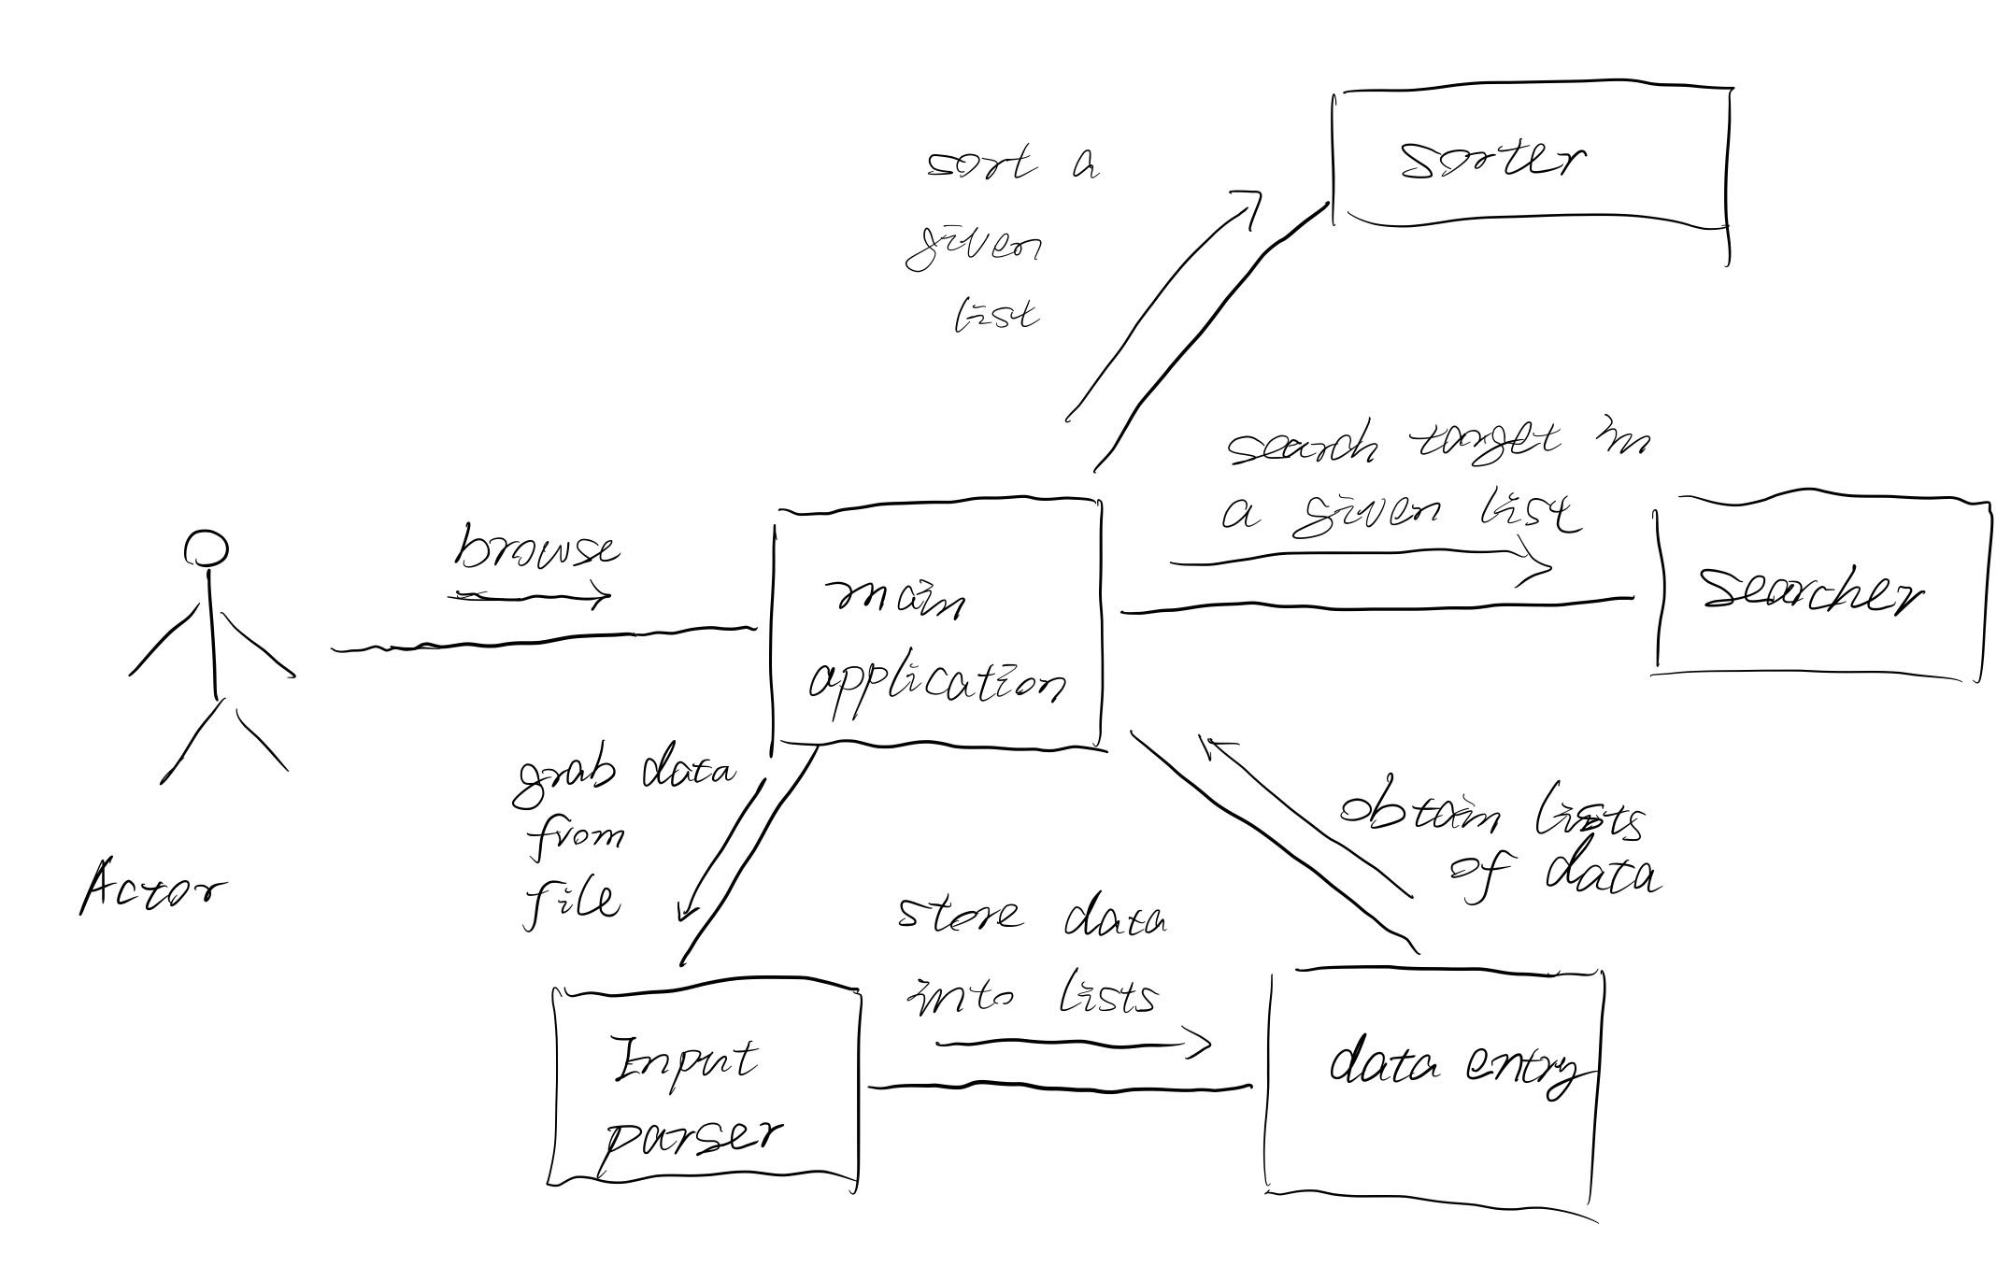

Pseudo-code for 3 types of sorting:

***def*** *bubbleSort(arr):  
 n = len(arr)* ***for*** *i* ***in*** *range(n):* ***for*** *j* ***in*** *range(0, n-i-1):* ***if*** *arr[j] > arr[j+1]:  
 arr[j], arr[j+1] = arr[j+1], arr[j]****def*** *mergeSort(nums):* ***if*** *len(nums)<2:* ***return*** *mid = len(nums)//2  
 L, R = nums[:mid], nums[mid:]  
 mergeSort(L)  
 mergeSort(R)  
 i, j, k = 0, 0, 0* ***while*** *i < len(L)* ***and*** *j <len(R):* ***if*** *L[i] < R[j]:  
 nums[k] = L[i]  
 i += 1* ***else****:  
 nums[k] = R[j]  
 j += 1  
 k += 1* ***while*** *i < len(L):  
 nums[k] = L[i]  
 i += 1  
 k += 1* ***while*** *j < len(R):  
 nums[k] = R[j]  
 j += 1  
 k += 1****def*** *heapSort(arr):* ***def*** *heapify(nums, n, i):  
 largest, l, r = i, 2 * i + 1, 2 * i + 2* ***if*** *l < n* ***and*** *nums[i] < nums[l]:  
 largest = l* ***if*** *r < n* ***and*** *nums[largest] < nums[r]:  
 largest = r* ***if*** *largest != i:  
 nums[i], nums[largest] = nums[largest], nums[i]  
 heapify(nums, n, largest)  
 n = len(arr)* ***for*** *i* ***in*** *range(n, -1, -1):  
 heapify(arr, n, i)* ***for*** *i* ***in*** *range(n - 1, 0, -1):  
 arr[i], arr[0] = arr[0], arr[i] # swap  
 heapify(arr, i, 0)*

1. **Source code (see project directory)**
2. **Operation document:**

Run the main function under default package. It should give you 5 options:

1. read a list of data from file into data map and print it out,
2. search data from an existing list in the data map
3. show an existing list in the data map
4. sort an existing list in the data map (bubble sort, merge sort, heap sort and quick sort are available for selection. The performance statistics of sorting algorithm is printed at the end).
5. modify an existing list in the data map (add more data from file, remove or replace data at a given index)
6. exit the searching and sorting application.

Note that for modifying an existing list, it is recommended that you print out the list to see the data type of the list, so you don’t add different type of data into the list.

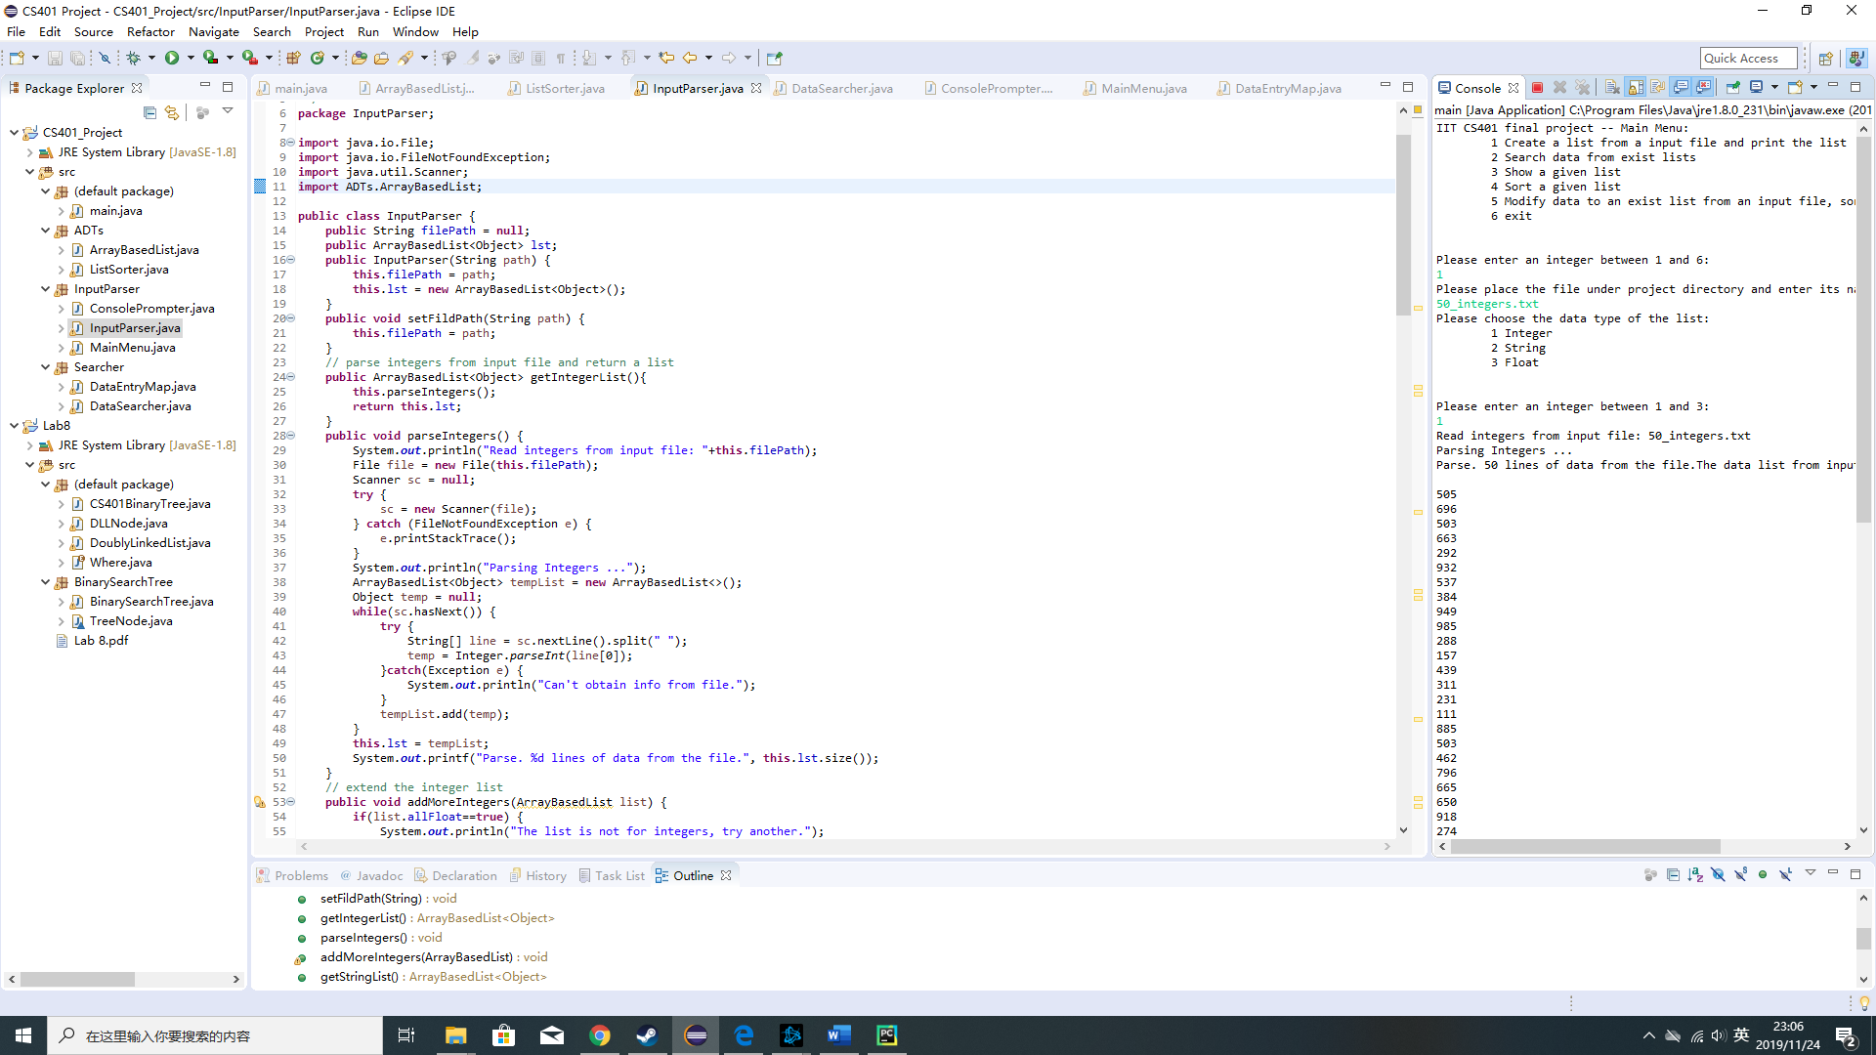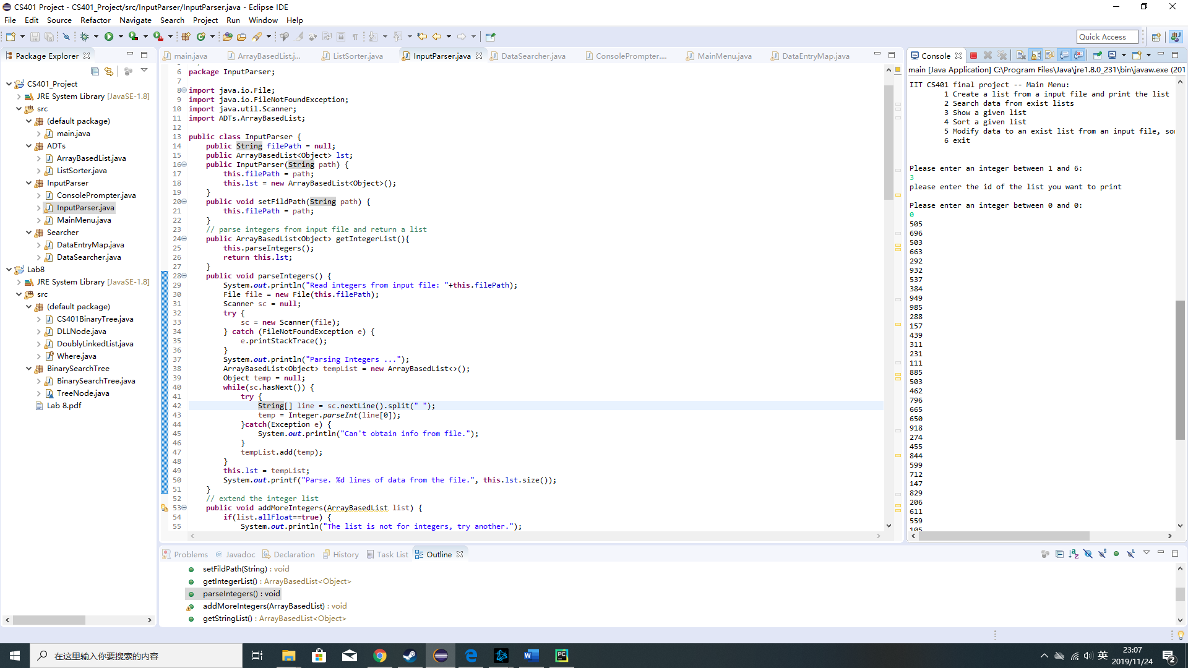

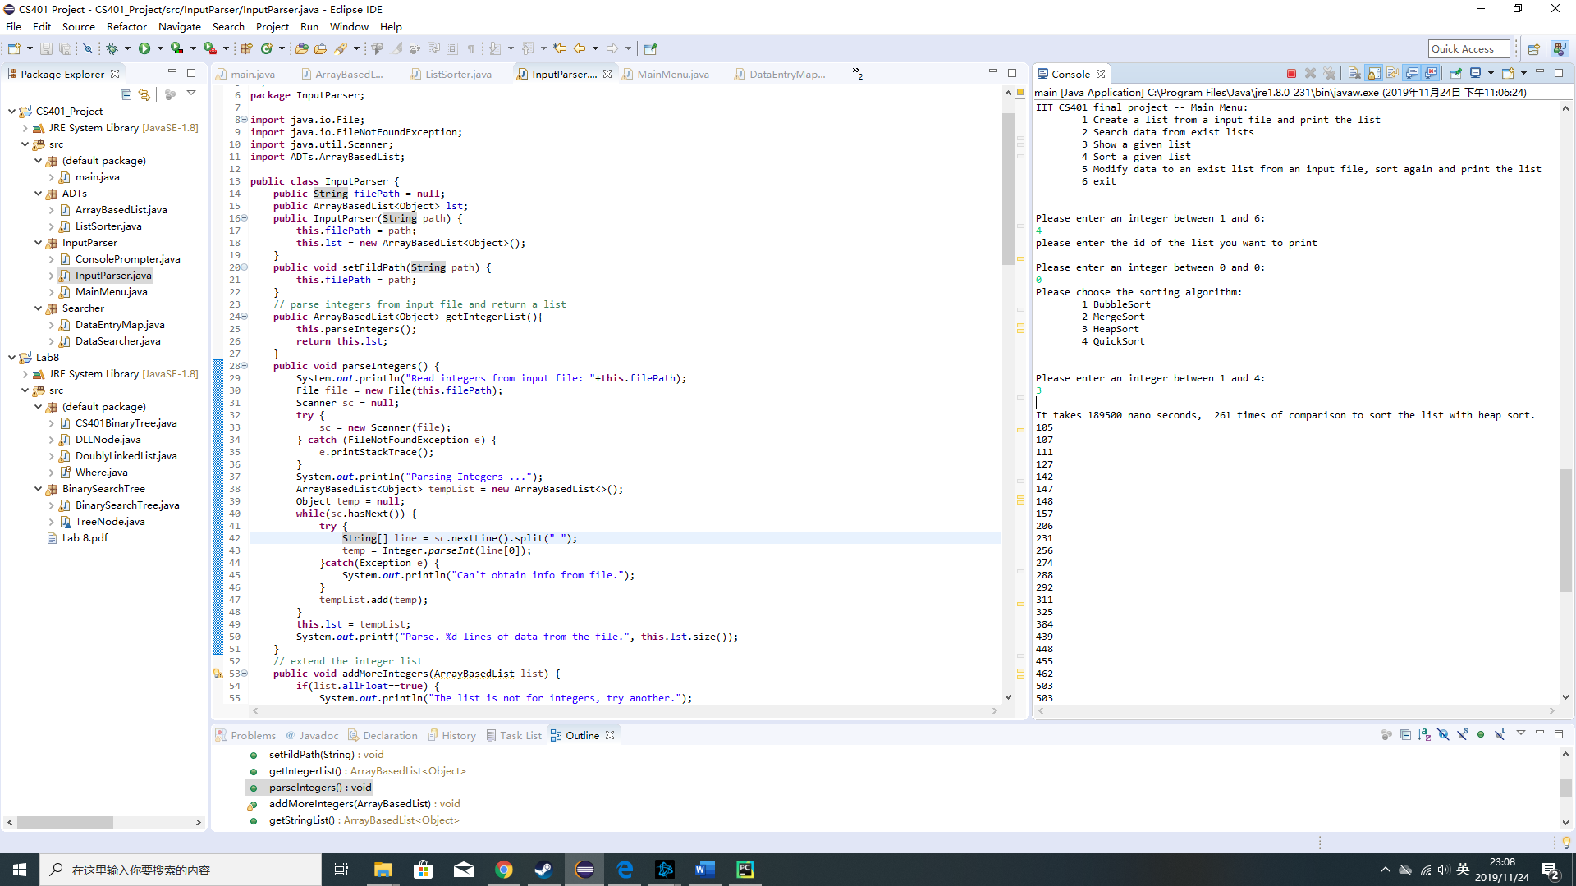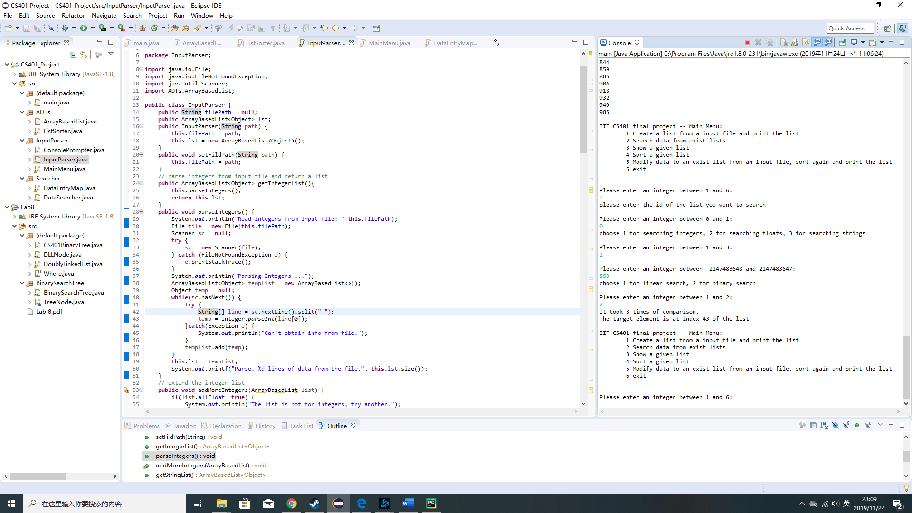

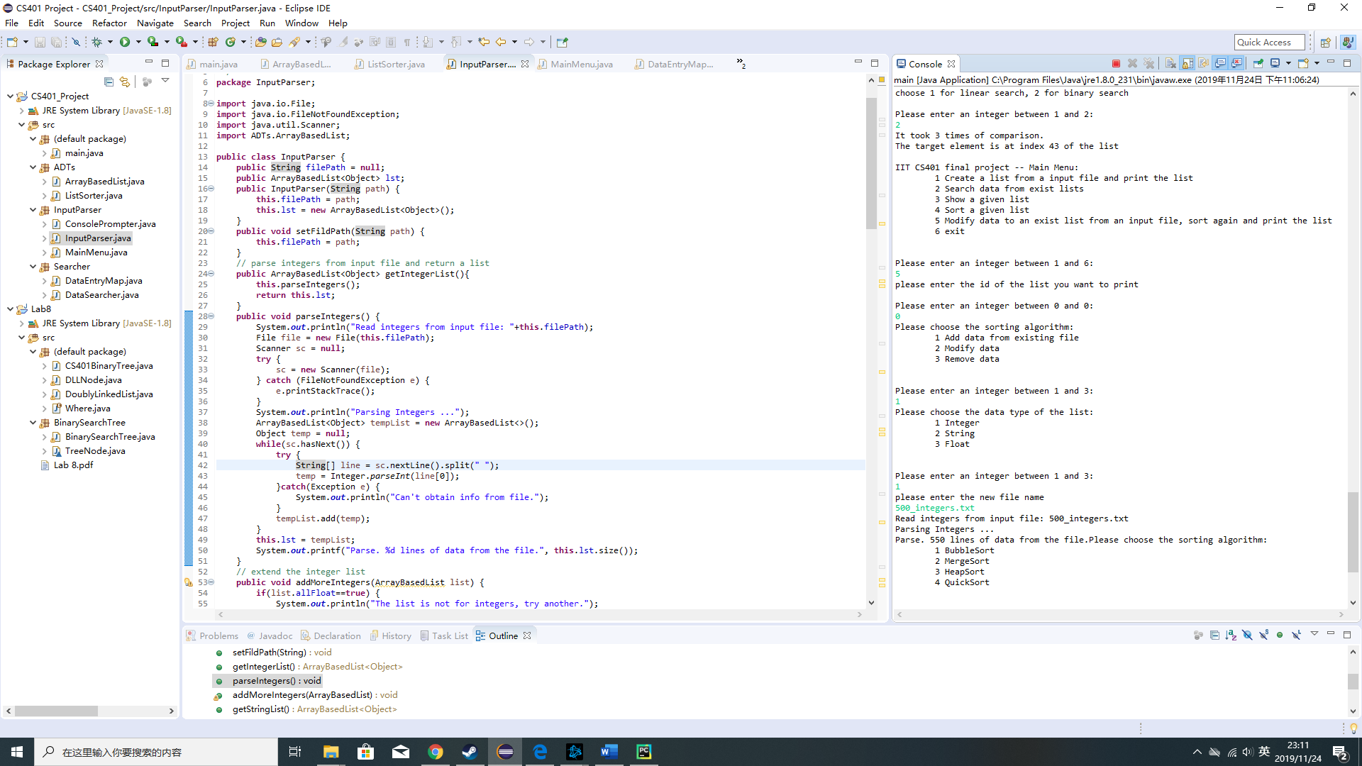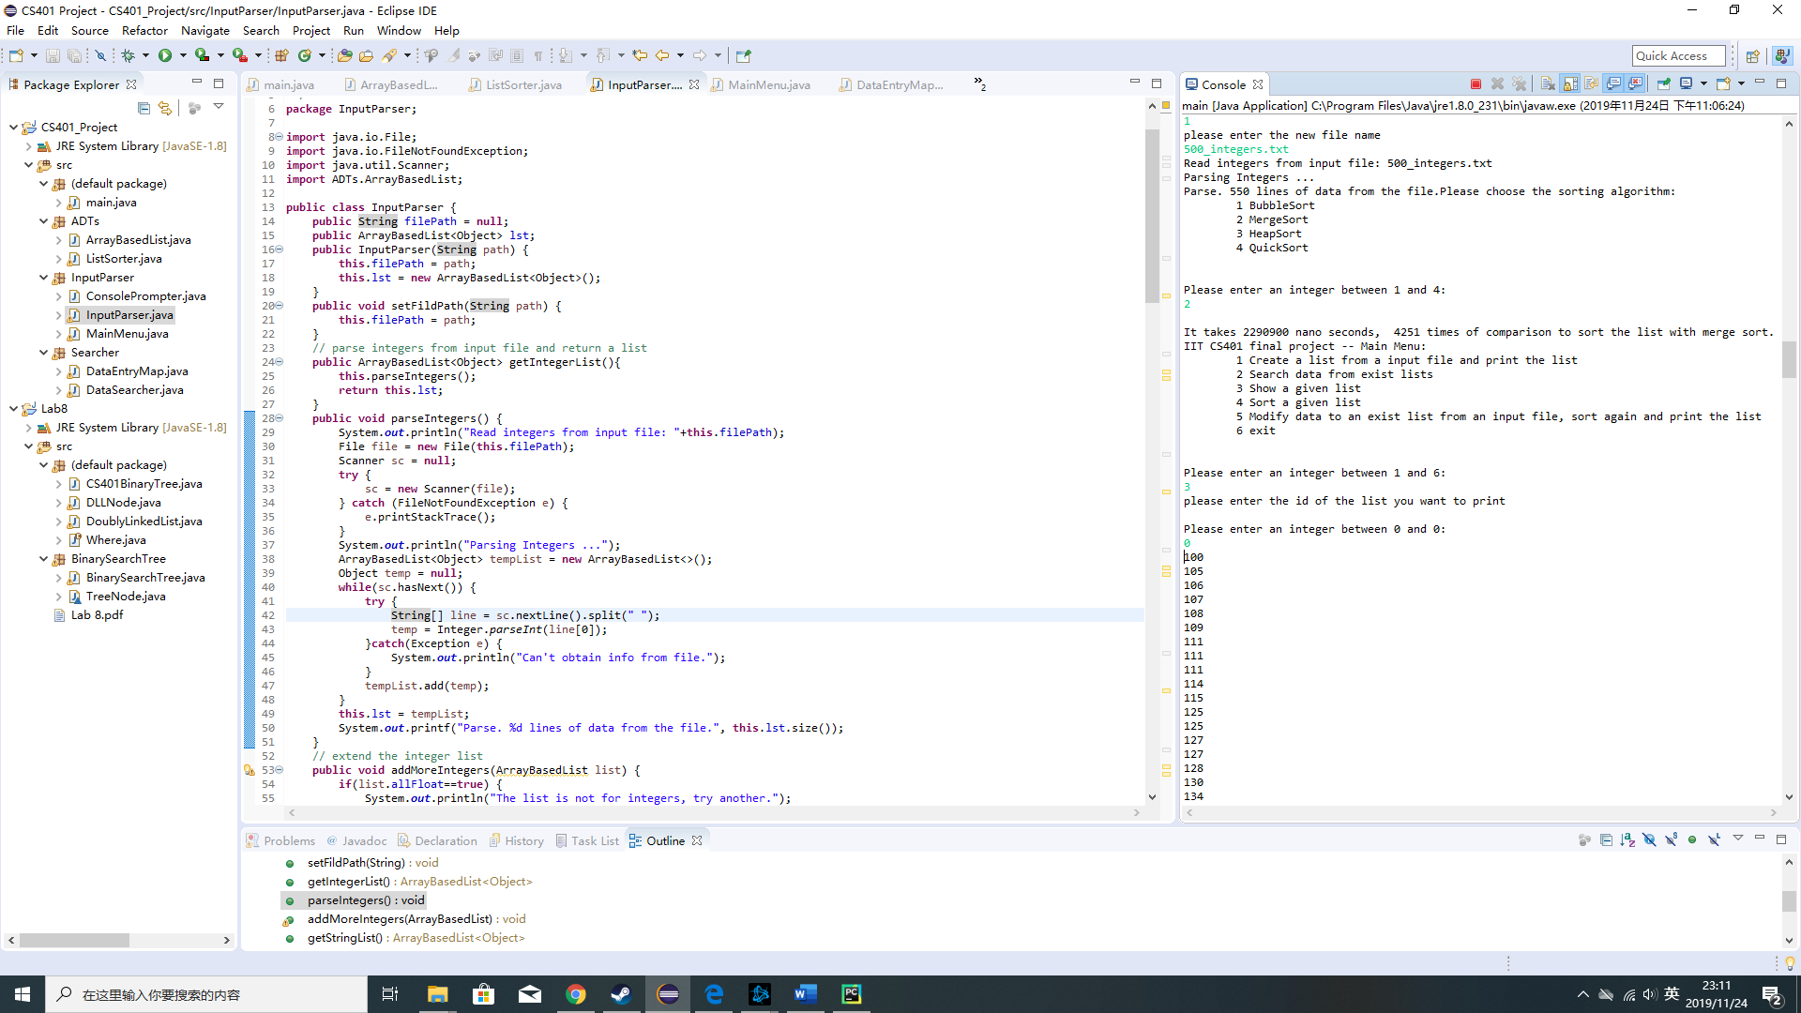

1. **Testing document:**The sample input files (txt format) are in the file directory. N (50, 500 or 1000) integers, floating point numbers or strings in the text files.
2. **Future improvement:**Specify the type of data stored in a list, so we can prevent adding different types of data into one single list.

Add GUI for the application.

Implement additional sorting algorithm for the application.

1. **Project schedule:**11.03 ~ 11.10: high level design and pseudo code. Separate the tasks into different components.

11.11 ~ 11.17: low level implementation of sorting and searching algorithm

11.18 ~ 11.24: low level implementation of user I/O and menu. Complete software documentation and add more comments.