README.md

**What BugBuilder does?**

BugBuilder is a tool for extracting complete and concise bug-fixing patches from human-written patches in version control systems.

**How to obtain BugBuilder?**

BugBuilder can be obtained from <https://github.com/jiangyanjie/BugBuilder> (This repository is permanently stored and publicly available).

**What does the replication package contain?**

***/Implementation:*** The source code of BugBuilder (Java).

***/EvaluationData:*** The patches generated by BugBuilder in the evaluation as well as their explanations.

**/*EvaluationData*/matchedPatches**: Patches generated by BugBuilder that are identical to those in Defects4J

***/EvaluationData*/mismatchedAndUnconcisePatches**: Unconcise patches generated by BugBuilder

***/EvaluationData*/mismatchedButConcisePatches:** Concise patches generated by BugBuilder that are different from those in Defects4J, and the justification/explanation for the conciseness (presented as README files accompanying the patches).

**Dependency (tools/libraries required by BugBuilder):**

Defects4J

The detailed information of Defects4J can be found at <https://github.com/rjust/defects4j#steps-to-set-up-defects4j>

Installation and initialization of Defects4J

1. Clone Defects4J:

-- git clone https://github.com/rjust/defects4j

1. Initialize Defects4J:

-- cd defects4j

-- cpanm --installdeps .

-- ./init.sh

1. Add Defects4J’s executables to your PATH:

--export PATH=$PATH:”path2defects4j”/framework/bin

1. Check installation:

--defects4j info -p Lang

**Step-by-step construction for running BugBuilder**

Illustrating with an example (Bug 26 of project Lang)

1. Preparation
   * Initialization of parameters in SpecialVersion.sh (Lines 22-25):

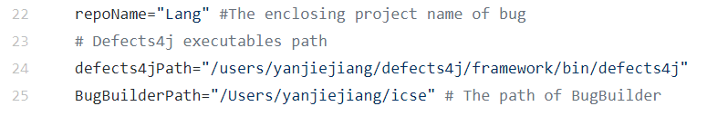

* + Initialization of parameters in Setting.java

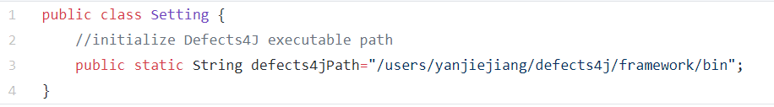

1. Checkout source code to the specified version
   * cd BugBuilder/icse/src
   * ./SpecialVersion.sh
2. Run getDiffCommit.java
   * Javac getDiffCommit.java
   * Java getDiffCommit

**Output:**

If there is a complete and concise bug-fixing patch, the output will report only one

“Failing tests: 0”