**《数据库系统实验》**

**实验报告**

|  |  |
| --- | --- |
| 题目 | 实验4 |
| 姓名 | 宋渝杰 |
| 学号 | 18340146 |
| 班级 | 计科六班 |

**一、实验环境：**

win10+MySQL 8.0

**二、实验内容与完成情况：**

**第73页“实验内容与要求”第1题：**

先创建数据库和表、输入数据，代码如下：

create database jxgl;

use jxgl;

# 建表

create table student

(sno varchar(7),

sname varchar(5),

sage numeric(2,0),

ssex varchar(1),

sdept varchar(5),

primary key(sno));

create table course

(cno varchar(4),

cname varchar(6),

cpno varchar(4),

ccredit numeric(1,0),

primary key(cno));

create table sc

(sno varchar(7),

cno varchar(4),

grade int,

primary key(sno,cno),

foreign key(sno) references student(sno),

foreign key(cno) references course(cno));

# 加入课本数据和部分自创数据

insert into student values('2005001','钱横',18,'男','Cs');

insert into student values('2005002','王林',19,'女','Cs');

insert into student values('2005003','李民',20,'男','Is');

insert into student values('2005004','赵欣然',16,'女','Ma');

insert into student values('2005005','刘备',25,'男','Wa');

insert into course values('1','数据库系统','5',4);

insert into course values('2','数学分析',null,2);

insert into course values('3','信息系统导论','1',3);

insert into course values('4','操作系统原理','6',3);

insert into course values('5','数据结构','7',4);

insert into course values('6','数据处理基础',null,4);

insert into course values('7','C语言','6',3);

insert into sc values('2005001','1',87);

insert into sc values('2005002','1',82);

insert into sc values('2005003','1',92);

insert into sc values('2005004','1',82);

insert into sc values('2005005','1',null);

insert into sc values('2005001','2',67);

insert into sc values('2005002','2',95);

insert into sc values('2005001','3',90);

insert into sc values('2005003','3',88);

insert into sc values('2005001','4',90);

insert into sc values('2005001','5',78);

insert into sc values('2005001','7',55);

**题目1：**检索年龄大于 23 岁的男学生的学号和姓名

**代码：**

select sno,sname

from student

where sage > 23 and ssex = '男';

**结果：**由于数据中加入且仅有这条数据，因此结果合理

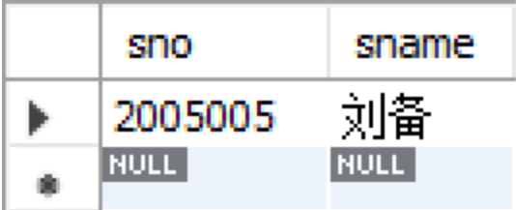

**题目2：**检索至少选修一门课程的女学生姓名

**代码：**

select sname

from student

where ssex = '女' and sno in

(select sno

from sc);

**结果：**

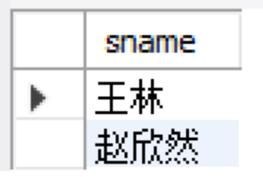

**题目3：**检索王林不学的课程的课程号

**代码：**

select cno

from course

where cno not in

(select cno

from sc

where sno =

(select sno

from student

where sname = '王林'));

**结果：**

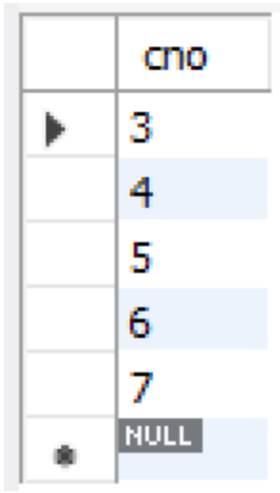

**题目4：**检索至少选修两门课程的学生学号

**代码：**

select sno

from sc

group by sno

having count(sno) >= 2;

**结果：**由于数据中加入了许多新的选课数据，因此结果合理

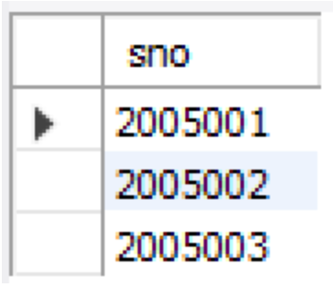

**题目5：**检索全部学生都选修的课程的课程号和课程名

**代码：**

select cno,cname

from course

where cno in

(select cno

from sc

group by cno

having count(sno) =

(select count(sno)

from student));

**结果：**由于数据中加入了许多新的选课数据，因此结果合理

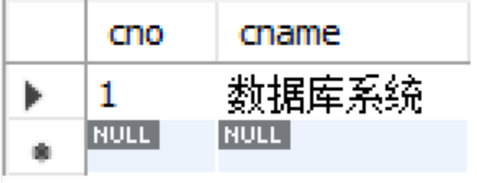

**题目6：**检索选修了所有3学分课程的学生平均成绩

**代码：**

select avg(grade)

from sc

where sno in

(select sno

from sc

where cno in

(select cno

from course

where ccredit = 3)

group by sno

having count(cno) =

(select count(cno)

from course

where ccredit = 3));

**结果：**只有学生钱横选修了所有 3 学分课程，他的平均成绩为 (87+67+90+90+78+55)/6 = 77.8333，结果合理

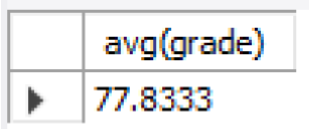

**第73页“实验内容与要求”第2题：**

**题目1：**统计有学生选修的课程门数

**代码：**

select count(cno)

from course

where cno in

(select cno

from sc);

**结果：**

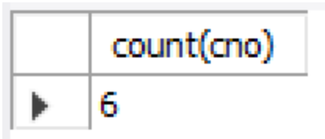

**题目2：**求选修4号课程的学生的平均年龄

**代码：**

select avg(sage)

from student

where sno in

(select sno

from sc

where cno = 4);

**结果：**

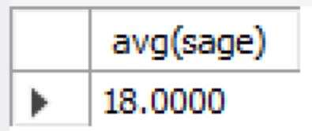

**题目3：**求学分为3的每门课程的学生平均成绩

**代码：**

select cno,avg(grade)

from sc

where cno in

(select cno

from course

where ccredit = 3)

group by cno;

**结果：**

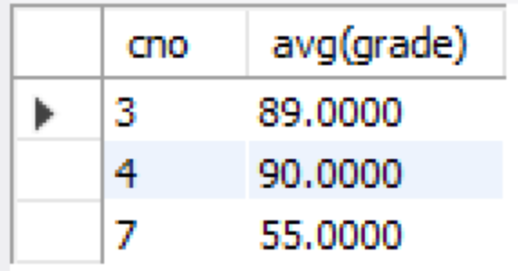

**题目4：**统计每门课程的学生选修人数，要求超过3人的课程才统计，要求输出课程号和选修人数，查询结果按人数降序排列，若人数相同，按课程号升序排列

**代码：**

select cno,count(sno) as c

from course natural join sc

group by cno

having count(sno) > 3

order by c desc,cno;

**结果：**

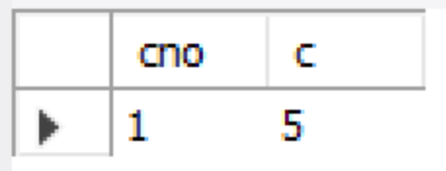

**题目5：**检索学号比“王林”同学大而年龄比她小的学生姓名

**代码：**

select sname

from student

where sno > (select sno from student where sname = '王林') and sage < (select sage from student where sname = '王林');

**结果：**

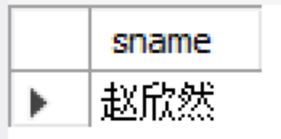

**题目6：**检索姓名以“王”开头的所有学生的姓名和年龄

**代码：**

select sname,sage

from student

where sname like '王%';

**结果：**

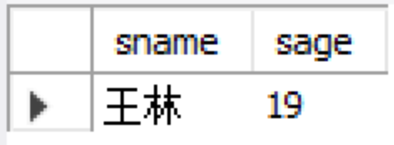

**题目7：**在sc表中检索成绩为空值的学生的学号和课程号

**代码：**

select sno,cno

from sc

where grade is null;

**结果：**由于数据中加入且仅有这条数据，因此结果合理

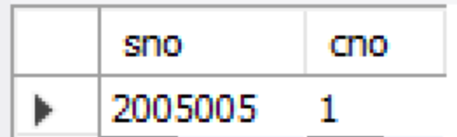

**题目8：**求年龄大于女学生平均年龄的男学生的姓名和年龄

**代码：**

select sname,sage

from student

where ssex = '男' and sage >

(select avg(sage)

from student

where ssex = '女');

**结果：**

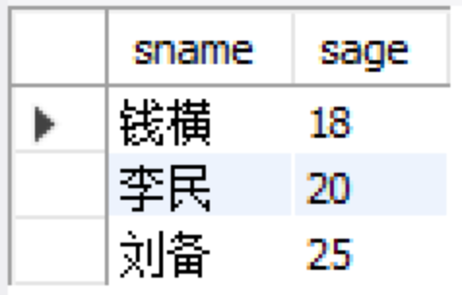

**题目9：**求年龄大于所有女学生年龄的男学生的姓名和年龄

**代码：**

select sname,sage

from student

where ssex = '男' and sage > all

(select sage

from student

where ssex = '女');

**结果：**

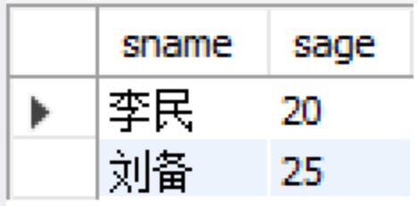

**题目10：**检索选修4门以上课程的学生总成绩（不统计不及格课程），并要求按总成绩的降序排列出来

**代码：**

select sum(grade) as s

from sc

where grade >= 60

group by sno

having count(cno) > 4

order by s desc;

**结果：**只有学生钱横选修了4门以上课程，他的总成绩为87+67+90+90+78（不加上不及格的55分）= 412，结果合理

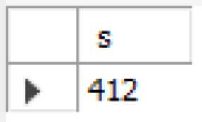

**三、实验心得：**

本次实验总体来说内容较多，涉及 select 的许多知识点，比较综合，难度也比较大。其中最麻烦的部分在于 where、group by 和 having 语句的综合应用，当然为了添加合适的数据以及检查是否正确也花费了不少精力和时间。