Energy Mix Transition: Global and National Trends in Low-carbon Electricity (1985–2023)
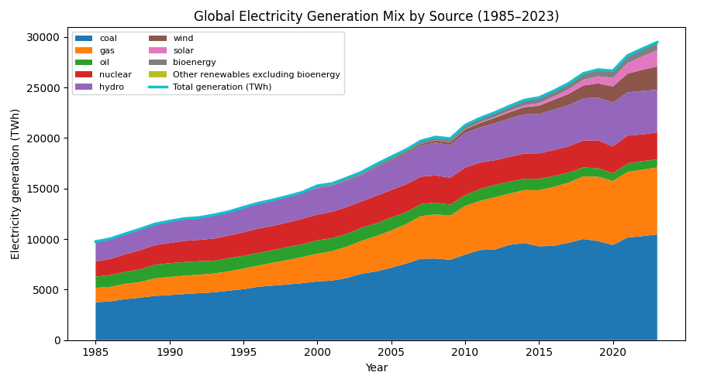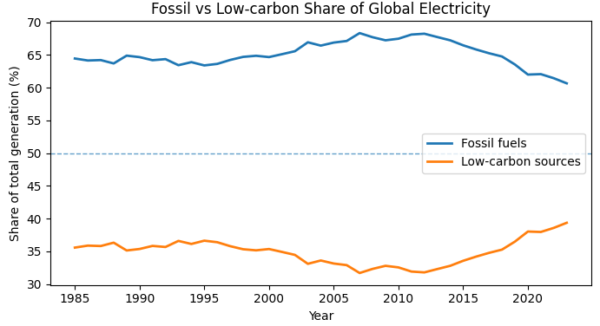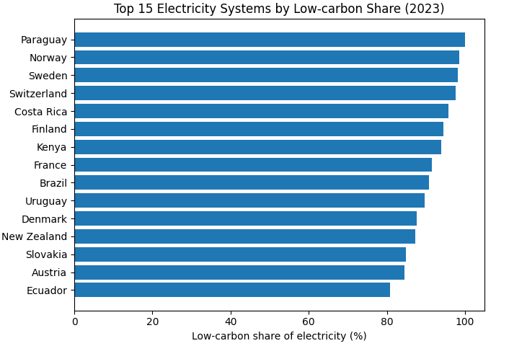
Legend
- Colors represent electricity sources including coal, gas, oil, nuclear, hydro, wind, solar, bioenergy, and other renewables.
- Stacked areas represent electricity generation in terawatt-hours (TWh), whereas lines show total output or relative shares.
- The main figure uses small multiples:
  - Each panel represents one major economy.
  - The horizontal axis shows the year (1985–2023).
  - The vertical axis indicates the percentage of electricity generated from low-carbon sources.
- Low-carbon electricity is defined as the sum of nuclear and all renewable sources.
- Consistent color encoding and shared axes allow direct comparison across countries.
Findings
- Global electricity demand more than doubled since 1985, driven by economic development and population growth.
- Low-carbon electricity—especially wind and solar—accelerated sharply after 2010, becoming the largest source of new clean power additions.
- Fossil fuels remain dominant worldwide, but their share has gradually declined as renewables expand.
- Among major economies, the European Union exhibits the highest and most stable low-carbon share, exceeding 60% in recent years.
- The United States shows moderate improvement, while China’s low-carbon share rises rapidly after 2010 following large-scale renewable deployment.
- India remains the most fossil-dependent of the four economies, reflecting slower renewable integration.

Data & Method
Data Source
- Kaggle dataset: electricity-prod-source-stacked.csv, containing annual electricity generation by source for global and national entities.
- Includes coal, gas, oil, nuclear, hydro, wind, solar, bioenergy, and other renewables from 1985 to 2023.
Processing
- Cleaned column names and removed redundant descriptors.
- Aggregated low-carbon electricity: nuclear + hydro + wind + solar + bioenergy + other renewables.
- Computed total generation and respective shares for each entity and year.
Metrics
- Low-carbon share = (nuclear + renewables) / total generation.
- Fossil share = (coal + gas + oil) / total generation.
Visualization
- Implemented in Python using pandas, matplotlib, and seaborn.
- Stacked area chart → visualizes long-term structural change.
- Line chart → compares fossil and low-carbon shares globally.
- Horizontal bar chart → highlights cross-country rankings.
- Small-multiples → enable clear side-by-side comparison of major economies.

Significance Statement
Electricity generation is one of the world’s largest contributors to greenhouse gas emissions; therefore, understanding the pace and direction of its decarbonization is essential for evaluating global climate progress. Low-carbon electricity forms the backbone of economy-wide net-zero strategies because electrification of transport, heating, and industry depends heavily on clean power supplies.
The visualization clarifies not only global progress but also the substantial disparities between countries. Some systems have already surpassed 90% low-carbon electricity, proving the technical feasibility of deep decarbonization. Others—including major emerging economies—still rely heavily on coal and gas. By presenting long-term trends alongside cross-country comparisons, the figure supports policy analysis, investment planning, and public communication around the energy transition.

GitHub repository
https://github.com/Songheng-HE/Final_Project

