Developing a Regionalized Representative Building Stock Model for Germany

Şirin Alibaş

Fraunhofer Institute for Systems and Innovation Research ISI

Breslauer Straße 48, 76139 Karlsruhe | Germany

sirin.alibas@isi.fraunhofer.de

Songmin Yu

Fraunhofer Institute for Systems and Innovation Research ISI

Breslauer Straße 48, 76139 Karlsruhe | Germany

songmin.yu@isi.fraunhofer.de

Abstract

According to statistics, the German building sector is directly responsible for 16% of the GHG emissions in the country (Federal Climate Protection Act), as well as roughly 40% of the total final energy consumption. More than 70% of heating rely on fossil fuels. The building sector is a key pillar of the green energy transition in Germany. To model the decarbonization of the sector and support policy-making, a reliable and consistent representation of the heterogeneous buildings and technologies in the stock is needed. In this study, we develop a regionalized representative building stock model for Germany by making use of different sources, incl. (1) Census survey data at various geographic levels, (2) findings from the TABULA project about residential buildings, (3) non-residential building stock dataset (dataNWG) developed by the Institute for Housing and Environment (IWU), (4) built environment data from the Global Human Settlement Layer (GHSL) varying from 10 m to 1 km geographic resolution, and (5) data from research papers and the public reports by IWU and the German Energy Agency (dena). As a result, the building stock model includes a population of “representative buildings” (RBs), each of which has detailed information on its sector, type, construction period, geometry (surface area and orientation) and thermal efficiency (U-value) of components, heating system and technology, and location in terms of the NUTS 3 region and settlement types (e.g., urban center, sub-urban, rural cluster, etc.). The number of buildings that each RB represents is also estimated for aggregating the results to different regional levels. Finally, the energy demand of the building stock model is calculated according to the simple hourly method of the DIN EN ISO 13790. The energy demand is then updated with user behavior parameters such as internal set temperatures, occupancy profiles etc. and heating system conversion efficiencies to obtain the final energy consumption. The final energy consumption is compared with the statistics in a base year at the national level. This representative building stock model can serve as the foundation for developing agent-based energy demand projection models for the German building sector. Based on the high geographic resolution, such models have the potential to analyze the effects of the development of infrastructure, e.g., district heating network and gas grid, on the transformation of the building stock.

**Keywords**: building stock; modeling; open data; regionalization

Introduction

In 2021, there were around 21.4 M buildings for residence as well as public and commercial service purposes [1]. The Federal Climate Protection Act (Klimaschutzgesetz (KSG)) attributes 16% of the country’s greenhouse gas emissions to the use phase of buildings. Approximately 75% of the total energy consumed in the building sector was required for heating in 2021, more than 70% of which was supplied by fossil fuels, and the direct fossil fuel demand amounted to roughly 570 TWh [1]. Overall, the German building sector has great potential to decarbonize and deliver major contribution to the climate neutrality targets of the country. The federal state of Germany has been forming policies, such as the KSG and the Building Energy Act (Gebäudeenergiegesetz (GEG)), to steer the building sector in a climate neutral direction. Planning the transition to a cleaner economy requires the development of scenarios and strategies, where the characteristics of the sectors and regions, implications of policies, as well as limits of resources and other aspects are taken into account.

In this paper, we aim to develop a representative building stock model for Germany with high technical granularity and geographic resolution, which can be further used to analyze the transition of the building sector and support policy design. For this, different sources of open data need to be used.

First is the latest published Census survey data, which gives the number of residential buildings in Germany at national, state, district, county/city and local administrative unit level as well as at 100m x 100m grid cell (hectare) resolution according to the number of dwellings present in the building, construction period, ownership type, type of heating system and type of building construction [2]. In the hectare level survey data, a considerable amount of data corresponding to the mentioned properties of a hectare are missing due to data unavailability, and the values given under a property of a hectare can deviate from the actual number in certain cases due to data protection reasons.

Second, Global Human Settlement Layer (GHSL) defines built-up surface as the gross surface bounded by a building wall perimeter, i.e. the building footprint. The GHSL dataset *GHS BUILT-S*, is a spatial raster depicting and forecasting the distribution of built-up surfaces between 1975 and 2030 in 5 year intervals according to the functional use (residential or non-residential) [3]. Furthermore, they also classify the built-up residential and non-residential surfaces by building height in the dataset *GHS BUILT-C* [4]. This dataset is a spatial raster depicting the grid cells of 100m² by functional use and building height classifications of below 3m, 3-6m, 6-15m, 15-30m and above 30m. Moreover, GHSL applies a degree of urbanization methodology to population and built-up surface data to come up with the *GHS-SMOD* dataset that covers and projects the years between 1975 and 2030 [5]. It defines seven settlement types: urban center, dense urban cluster, semi-dense urban cluster, suburban or per-urban, rural cluster, low density rural and very low density rural; and classifies 1km² grid cells according to the settlement types. Datasets of such high spatial resolution can provide the flexibility to capture and integrate various environmental (such as different emission constraints per settlement type) and infrastructural (such as availability of DH grid, gas and/or electricity distribution grid, etc.) details.

Third, in annual or bi-annual reports on the building sector, the German Energy Agency (dena) publishes many details about the building stock of Germany based on a combination of statistics and own calculations. Total number of buildings according to building type and construction period for both residential and non-residential building stock [6], as well as building type and construction period details on the average dwelling size and the number of dwellings in residential buildings [7] are given in these reports.

Furthermore, based on the Census survey and the data collected on their own, the Institute for Housing and Environment (IWU) also gives many insights into the residential and non-residential building stock of Germany. The residential building typology study shows the distribution of residential buildings, dwellings and floor area to different construction periods within the defined building types. This study also includes findings from the TABULA project, where building typologies (defined according to building type and construction period) are assigned with detailed technical parameters such as U-values and surface area of building components, surface area of windows by orientation, etc. [8]. These findings from the TABULA project are later evaluated for averages according to different properties and dependencies among the parameters [9]. IWU’s data collection study on residential buildings contains information on the renovation rates of building components and heating systems; while, also containing information on the region (three major parts of Germany) and construction period (three major construction periods) of buildings, as well as the heating system and technologies [10]. IWU conducted a data collection study for non-residential buildings as well, which estimated the total number of non-residential buildings in Germany and the heating systems in these buildings according to defined building types and construction periods [11]. The non-residential building dataset (dataNWG) also provides the average floor area and the average surface areas of building components according to building type and construction period. In the dena report of 2023, the distribution of five types of non-residential buildings (out of the eleven types in dataNWG) are given according to finer construction periods than those published with the dataNWG dataset of IWU [1].

These open data sources above provide a solid foundation for developing a building stock model. However, scattered across different platforms, they capture different aspects of the building stock in different formats, structures, and geographic resolutions. Besides, they are sometimes incomplete due to reasons of unavailability, privacy etc. This versatility also carries the risk of some data being inconsistent with each other.

In this paper, we attempt to make use of the data from the available open sources in a consistent, understandable, reproducible and holistic manner, where we fill the data gaps by reasonable assumptions, as introduced in the ***Methodology*** section. We aim that in this way, the building stock can be realistically represented by a model, and its future development and energy demand can be transparently simulated. In the ***Results*** section, the building stock model is viewed and validated in terms of number of buildings, floor area, total final energy consumption for heating, energetic performance of buildings, as well as average specific final energy consumption for heating per building type. Finally, we discuss the advantages and shortcomings of the study together with an outlook on how the model can be improved and developed further in the ***Discussion*** and ***Conclusion*** sections.

Methodology

The representative building stock model for Germany is generated with a bottom-up approach.

First, the whole German building stock is classified according to four id’s: region, sector, subsector, and type. Each combination of these four id’s refers to a segment of the whole building stock. In total, we have 19649 building segments in the model.

* *‘id_region’* incl. 401 NUTS 3 regions in Germany [12].
* *‘id_sector’* incl. residential and non-residential sectors.
* *‘id_subsector’* , incl. residential and the sectors A-S according to NACE, rev. 2 [13], 17 in total.
* *‘id_building­_type’* incl. 5 residential building types according to total number of dwellings in the building, and non-residential building types such as office buildings, education buildings, etc., 16 in total.

Secondly, for each building segment, we estimate the number of buildings ($N_{real}$). Then, for representativeness, each segment is modelled by $N_{model}$“representative buildings” (RBs), where $N_{model}=0.1×N_{real}$. Based on the first four id’s, each RB is further assigned with heterogeneous properties below. As a result, by aggregating the data (e.g., energy demand) of all the RBs, we can calculate the results at different levels.

* ‘*id_building_construction_period’* from “before 1900” to “after 2011” at intervals of ten years.
* ‘*id_building_location’* according to seven settlement types [5].
* Building size, e.g., height, number of floors, floor area, and window area.
* Building efficiency, i.e., U-values of the four main building components.
* Type of heating system and technologies.

Table 1 provides an overview of the data sources we used in this study to develop the model for both residential and non-residential sectors. The detailed methodologies are introduced in the following sections.

Table 1. Data sources used in developing the representative building stock model for Germany

|  |  |  |
| --- | --- | --- |
| **Characteristic** | **Residential Buildings** | **Non-residential Buildings** |
| Building number | Census survey data at NUTS 3-level [2], projected by growth of built-up residential surface from GHSL [3] and calibrated to the numbers given in the dena building report of the relevant year [6]. Distribution of buildings to different construction periods within the building types from IWU [8], differentiated by three major regions of Germany from IWU [10]. | The total number of buildings in Germany from IWU [11] distributed to NUTS 2 regions according to the number of employees per subsector [14] and further to NUTS 3 regions based on built-up non-residential area from GHSL [3]. The shares of different construction periods within building types from IWU [11] with the help of the dena reports [1,6]. |
| Building location | Spatial join of the GHSL dataset on settlement types according to the degree of urbanization [5] with Census survey data at hectare level [2]. | Distribution of number of buildings to the settlement types by the degree of urbanization of the non-residential built-up surface area from GHSL [3,5]. |
| Building size | For all buildings, the height of the building (number of floors) is assigned based on (1) classification of built-up surface area per height ranges at hectare level from GHSL [4], which we spatially join with the dataset on settlement types from GHSL [5], and (2) average floor height.  For residential buildings, the size of dwellings are assigned according to the building type and construction period based on the reports from IWU [8] and dena [7]. For non-residential buildings, the average floor area of the building is assigned according to the building type and construction period based on the data from IWU [11]. | |
| Building efficiency | Average U-values of the main building components at the decade of construction from the results of the TABULA project [9]. We develop the renovation history of the building components based on the empirical data on their service life [15]. | Average U-values of the main building components according to the building construction period from IWU [11]. We develop the renovation history of the building components based on the empirical data on their service life [15]. |
| Heating system & technology | Census survey data at hectare level for heating system type [2]. Share of heating technologies within the building type as well as within the construction periods from IWU [10]. | Distribution of fossil and district heating as well as electric heating to different building types and construction periods from IWU [11]. |

Building number

The numbers of buildings are estimated for all building segments based on the sources and procedures for residential and non-residential sectors as introduced below.

Residential Buildings

We take the number of residential buildings from Census 2011 according to their classification [2]. According to the number of dwellings found in the building, we define the building types of 1 to 5 (see Table 2). The growth of the stock in each NUTS 3 region from 2010 until 2020 is projected using the growth rate of built-up residential surfaces between 2010 and 2020 from the GHSL [3]. Prior to the projection, we aggregate the built-up residential surface area found in the *GHS BUILT-S* dataset at 100m resolution to NUTS 3 level for geographic compatibility. Since the growth rates are originally for built-up surface area instead of number of buildings, we determine a calibration factor from the ratio of total number of buildings in Germany in 2020 per building type [6] and the projected total number of buildings in Germany in 2020 per building type. We apply the global calibration factor to the projected total number of buildings in each NUTS 3 region. The number of buildings in the years between 2010 and 2020 are calculated via interpolation per building type.

Table 2. Structure of Census data [2] on number of residential buildings according to building type

|  |  |  |  |  |  |
| --- | --- | --- | --- | --- | --- |
| Region | Building type | | | | |
| Building with 1 dwelling (Type 1) | Building with 2 dwellings (Type 2) | Building with 3-6 dwellings (Type 3) | Building with 7-12 dwellings (Type 4) | Building with 13+ dwellings (Type 5) |
| … | … | … | … | … | … |

To add the *id_building_construction_period*, we use again the numbers published in the latest Census survey data [2] for NUTS 3 regions in Germany; however, the building type dimension is missing. So, we use the proportion of buildings belonging to the construction periods within the total of each building type as given by IWU [8]. We counteract the inconsistency of construction period classifications between the two sources and our definition by allocating the number of buildings linearly to the years within the period of the source and summing up the years belonging to the desired construction period. The number of buildings after 2010, which are not covered by either source, are derived by subtracting the buildings as of 2010 from the projected total number of buildings by 2020.

Non-residential Buildings

Within the ENOB:dataNWG project, IWU published the number of non-residential buildings in Germany that are in the scope of the GEG, according to the main function of the building and three main construction periods [11]. We define the types of non-residential buildings in line with the definition of IWU: office, administrative or official buildings (Type 6), buildings for research and university teaching (Type 7), health and care buildings (Type 8), school, day care center and other childcare buildings (Type 9), buildings for culture and leisure activity (Type 10), sports buildings (Type 11), accommodation or lodging buildings, gastronomy or catering buildings (Type 12), production, workshop, warehouse or factory buildings (Type 13), commercial buildings (Type 14), technical buildings (supply and disposal) (Type 15), transportation buildings (Type 16). The main construction periods are buildings constructed: until end of 1978, between 1979 and 2010, and after 2010. We reallocate the buildings to the construction periods defined for this study linearly. We calculate the number of buildings of type $i$ in subsector $a$ (${NB}_{a,i}$) per NUTS 2 region in the following way:

* First, we calculate the total floor area in subsector $a$ (${FA}_{a}$), by multiplying (1) the number of employees (${NE}_{a}$) from Eurostat (NUTS 2 region-specific) [14] and (2) the assumed average floor area demand per employee (${FAE}_{a}$) ($m^{2}$/employee), as shown in Table 3.
* Second, the total floor area in subsector $a$ $({FA}_{a})$ is allocated to different building types. The assumptions on the share of floor area of building type $i$ within the subsector $a$ ($x_{i,a}$) are developed based on expert assumptions [16] and simplified as shown in Table 4. As a result, we have the floor area per region per building type.
* Third, to calculate the number of the type $i$ buildings in subsector $a$ (${NB}_{a,i}$), we divide its total floor area calculated above by the average thermally conditioned floor area per building (${FAB}_{i}$) ($m^{2}/building$) given by IWU [11].

As a result, we have ${NB}_{a,i}={{FA}_{a}∙x_{i,a}}/{{FAB}_{i}}={{NE}_{a}∙{FAE}_{a}∙x_{i,a}}/{{FAB}_{i}}$. Finally, the NUTS 2 level ${NB}_{a,i}$ is allocated to its NUTS 3 regions proportional to the built-up non-residential surface in each NUTS 3 region [2].

Table 3. Assumption on the average specific floor area of a subsector (m²/employee) between 2015 and 2020[1]

|  |  |  |  |  |  |  |  |  |  |
| --- | --- | --- | --- | --- | --- | --- | --- | --- | --- |
|  | | Subsectors according to NACE Rev. 2 | | | | | | | |
| G | I | H, J | K | Q | P | O | A,B,C,D,E,F,L,M,N,R,S |
| NUTS 1 region | DE1 | 103 | 113 | 24 | 28 | 40 | 122 | 61 | 61 |
| DE2 | 110 | 120 | 25 | 30 | 43 | 130 | 65 | 65 |
| DE3 | 40 | 43 | 9 | 11 | 15 | 47 | 23 | 23 |
| DE4 | 129 | 140 | 29 | 35 | 50 | 152 | 76 | 76 |
| DE5 | 17 | 18 | 6 | 8 | 7 | 20 | 10 | 10 |
| DE6 | 55 | 60 | 13 | 15 | 22 | 65 | 33 | 33 |
| DE7 | 89 | 97 | 20 | 24 | 35 | 105 | 53 | 53 |
| DE8 | 133 | 145 | 30 | 36 | 52 | 157 | 79 | 79 |
| DE9 | 156 | 170 | 36 | 43 | 61 | 185 | 92 | 92 |
| DEA | 122 | 133 | 28 | 33 | 48 | 144 | 72 | 72 |
| DEB | 103 | 113 | 24 | 28 | 40 | 122 | 61 | 61 |
| DEC | 146 | 160 | 33 | 40 | 57 | 173 | 86 | 86 |
| DED | 114 | 125 | 26 | 31 | 45 | 135 | 68 | 68 |
| DEE | 112 | 122 | 26 | 31 | 44 | 133 | 66 | 66 |
| DEF | 98 | 107 | 22 | 27 | 38 | 116 | 58 | 58 |
| DEG | 107 | 116 | 24 | 29 | 42 | 126 | 63 | 63 |

**Table 4. Assumption on the shares of non-residential building types within the total buildings of a subsector**

|  |  |  |  |  |  |  |  |  |  |  |  |  |  |
| --- | --- | --- | --- | --- | --- | --- | --- | --- | --- | --- | --- | --- | --- |
| $$x_{i,a}$$ | | Building type | | | | | | | | | | |  |
| 6 | 7 | 8 | 9 | 10 | 11 | 12 | 13 | 14 | 15 | 16 | Total |
| Subsectors according to NACE Rev. 2 | A |  | 0.15 |  |  |  |  |  | 0.85 |  |  |  | 1.0 |
| B,C,D,E |  |  |  |  |  |  |  | 0.98 |  | 0.02 |  | 1.0 |
| F |  |  |  |  |  |  |  | 0.98 |  | 0.02 |  | 1.0 |
| G | 0.1 |  |  |  |  |  |  | 0.05 | 0.85 |  |  | 1.0 |
| H | 0.2 |  |  |  |  |  |  | 0.47 | 0.18 |  | 0.15 | 1.0 |
| I |  |  |  |  |  |  | 1.0 |  |  |  |  | 1.0 |
| J | 0.38 | 0.3 |  |  |  |  |  | 0.2 |  |  | 0.12 | 1.0 |
| K | 1.0 |  |  |  |  |  |  |  |  |  |  | 1.0 |
| L | 1.0 |  |  |  |  |  |  |  |  |  |  | 1.0 |
| M | 0.89 | 0.1 |  |  |  |  |  | 0.01 |  |  |  | 1.0 |
| N | 0.6 |  |  |  | 0.25 |  |  | 0.15 |  |  |  | 1.0 |
| O | 0.7 |  |  |  | 0.16 | 0.14 |  |  |  |  |  | 1.0 |
| P |  | 0.1 |  | 0.8 | 0.05 | 0.05 |  |  |  |  |  | 1.0 |
| Q |  |  | 0.9 |  | 0.025 | 0.05 | 0.025 |  |  |  |  | 1.0 |
| R |  |  |  |  | 0.5 | 0.5 |  |  |  |  |  | 1.0 |
| S | 0.51 |  |  |  | 0.17 | 0.25 |  |  |  | 0.07 |  | 1.0 |

Building location according to settlement type

We adopt the classification of settlement types in *GHS-SMOD* dataset of the GHSL and assign the settlement type that the RB is found in as the *id_building_location* of the RB [9].

Residential Buildings

The Census survey data on the number of buildings per building type (see Table 2) at hectare level is spatially joined with the map of settlement types at 1 km resolution from the GHSL data [2,5]. The resulting dataset is aggregated at NUTS 3 level and gives the total number of buildings per building type and settlement type in each NUTS 3 region of Germany. Figure 1 summarizes the dataset at the national level.

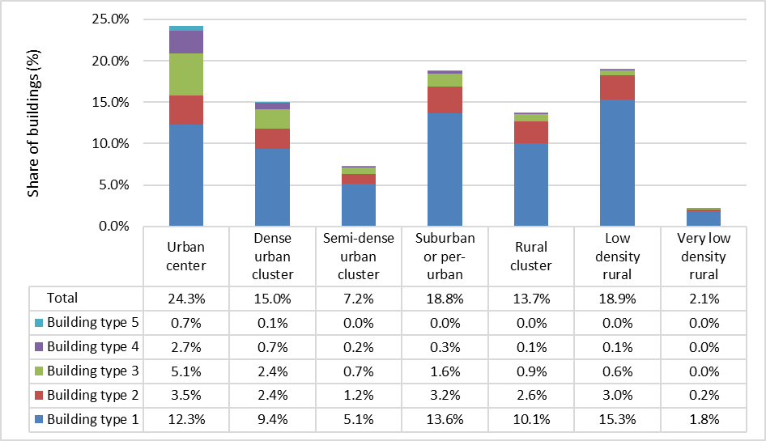

Figure . Distribution of German residential buildings to different settlement types

Non-residential Buildings

The built-up non-residential surface area from the *GHS BUILT-S* dataset is spatially joined with the *GHS-SMOD* dataset of the settlement types and aggregated at NUTS 3 level [3,5]. There is no distribution key for assigning the non-residential building types differently to the settlement types; therefore, all non-residential building types (Type 6-16) in the same NUTS 3 region have the same distribution to the settlement types, as shown in Table 5.

Table 5. Distribution of German non-residential buildings to different location types

|  |  |  |  |  |  |  |  |
| --- | --- | --- | --- | --- | --- | --- | --- |
|  | Urban center | Dense urban cluster | Semi-dense urban cluster | Suburban or per-urban | Rural cluster | Low density rural | Very low density rural |
| Building type 6 - 16 | 26% | 10% | 3% | 16% | 5% | 22% | 18% |

Building size

The size of a RB is characterized mainly by: (1) height, i.e. number of floors, and (2) total floor area.

Building Height

Using the building height classifications of the *GHS-BUILT-C* dataset as our *id_building_height*, we spatially join the *GHS-BUILT-C* with the *GHS-SMOD* data[5]. The resulting dataset is aggregated at NUTS 3 level and it gives the built-up surface area in a region by sector, settlement type and height interval. We also convert the boundaries of the height intervals to number of floors by taking the average floor height of 3m. We, then, randomly assign the number of floors of the RB ($n_{floor}$) by uniform distribution within the range of the *id_building_height*.

Floor Area in Residential Buildings

The total floor area of a residential RB, ${FA}_{RB}$, is derived from:

* the number of dwellings in the building ($ND_{RB}$) which is randomly assigned by uniform distribution within the range of dwellings defined by *id_building_type*,
* the average dwelling area (${\overline{FA}}_{i, c}$) according to the building type $(i)$ of the RB and the construction period ($c$) of the RB based on the reports from IWU and dena [7, 8].

As a result, we have ${FA}_{RB}=ND_{RB}·{\overline{FA}}_{i, c}$. Moreover, the area of one floor (${FA}_{floor}$) is calculated by ${FA}_{floor}= {FA}_{RB}/n_{floor}$, where we assume each floor has the same floor area.

Other geometric properties of the RB are derived based on the calculated floor areas. From the TABULA building typology database, we calculate ratios of the wall, window, roof and basement surface area to the total floor area or area of one floor, differentiated at building type, height and construction period [9]. Using these ratios, we calculate the total exterior wall and window surface area based on the ${FA}_{RB}$, and the total roof and basement surface area based on the ${FA}_{floor}$. Other relevant information like the window surface areas per orientation are also calculated in a similar way.

Floor Area in Non-residential Buildings

Non-residential buildings are assumed to have one unit, meaning the unit area is equal to the total building area. The average thermally conditioned floor areas from IWU according to building type and construction period are used here as input [11]. Similar to the method described for residential buildings, we divide the total floor area by the number of floors to get the area of one floor.

The IWU non-residential building typology database also gives information on the total surface areas of exterior wall, window, roof and basement per building type and construction period [11]. We calculate and use the ratio of these component areas to the total building area as input to assign the non-residential RBs with the relevant area information. Share of window areas per orientation are derived from the residential buildings, as there is no information on the window area per orientation from the original source.

Efficiency/energy performance of the building

Energy performance or efficiency of a building is characterized by its specific heating demand, i.e., the intensity of space heating demand (kWh/m2a). We define *id_building_efficiency_class* from 1 to 9 and match specific energy demand intervals from 0-250+ kWh/m² to the efficiency classes, accordingly.

Thermal transmittance (U-value) of the main building components (wall, window, roof and basement) play a significant role in the final space heating demand of a building. We use the average U-values of the building components by decade of construction from the evaluation of the TABULA project [9] and define a range of U-values that is available in the market in that decade for residential building construction or renovation. Similarly, we use the average U-values of the building components by construction period from the dataNWG by IWU for non-residential buildings [11]. As a result, we create input data on the average U-values of building components available in the market spanning from 1900 to 2019 per building type as well as according to new building construction or building renovation. Here, the aim is that new buildings have insulation standards or criteria and therefore, components used for new construction may differ from the components chosen for building renovation in terms of thermal transmittance.

Table 6. Weighted average lifetime of four building components

|  |  |  |  |  |
| --- | --- | --- | --- | --- |
|  | Exterior wall | Window | Roof | Basement |
| Lifetime (year) | 51 | 25 | 39 | 74 |

We create the renovation history of the RB by assigning each building component with a technical lifetime (see Table 6) based on empirical data on service life probability [15] and triggering renovation of the component at the end of lifetime. We apply an exogenous probability that a component is not renovated even though the component reaches end of lifetime in order to represent a more realistic renovation behavior.

The space heating and cooling demand are estimated based on the simple hourly method of ISO 13790 [19]. Following the method with a minimum internal set temperature of 20°C and assuming full occupancy, we obtain the space heating demand and can determine *id_building_efficiency_class* of the RB. Based on this, we determine and assign customized internal set temperatures per building type and efficiency class in order to take into account partial heating that is especially seen in poorly insulated buildings [20,21].

Finally, for each dwelling in the residential building, we assign a household drawn from a synthetic population. The households are configured with hot water demand and building occupancy profiles, in hourly resolution. The profiles are calculated based on the FLEX-Behavior model [22].

To each of the single unit in a non-residential building, we also assign a unit user (company) with hot water demand profiles developed based on generic profiles from the HOTMAPS project[2]. The values are calibrated to the national consumption. After the customization of internal set temperatures and occupancy behavior, heating system efficiencies etc. are taken into account and the final energy consumption of the RB for space heating and hot water is calculated. This is later used to analyze the energy performance of the building stock.

Heating system & technology

We develop the information on heating of a RB in three steps.

* First, an *id_heating_system* is assigned which determines whether the building has district heating (DH), central (or block) heating, individual unit heating, or single room heating.
* Second, from a list of possible heating technologies associated with the type of heating system, an *id_heating_technology* is assigned, which further decides the energy carrier or conversion process.
* Third, a building is probable to be assigned a secondary heating technology, which assists the main heating technology by providing a certain part of the demand. So far, we define two possible secondary heating technologies: solar thermal and direct electric heating.

The aim of this approach is to capture the infrastructure information such as DH at the heating system level.

Residential Buildings

The Census survey data gives the count of heating systems by type in each hectare [2]. We spatially join the *GHS-SMOD* data [5] with the Census data, and aggregate the count of heating systems per location type within each NUTS 3 region to establish our input dataset on the heating systems.

The data on heating technology shares of buildings according to building type ($x_{HT,i}$) and separately according to construction period ($x_{HT,c}$) are available from IWU [10]. We obtain the fraction of heating technologies according to building type and construction period ($f_{HT,i,c}$) by the operation below.

$$f_{HT,i,c}=\frac{{NB}_{i}}{{NB}_{total}}·x_{HT,i}·\frac{x_{HT,c}}{\sum_{c=0}^{n}{x_{HT,c}}}$$

Note that the sum of the fractions do not add up to 1. The heating technology share is calculated by $f_{HT,i,c}/\sum{f_{HT,i,c}}$. We assume each NUTS 3 region allocates their heating systems to heating technologies by the calculated national fractions.

Solar thermal and direct electric heating are possible secondary heating technologies. A secondary heating technology does not provide heat to the building on its own, but assists the main heating technology by providing a certain share of the demand. Secondary heating technologies are separately assigned to the RB. Here, the share of residential buildings that have solar thermal are given according to two main building types and three main construction periods by IWU [10]. We assume that the buildings that have direct electric individual unit heating [10] all have this technology as the secondary heating technology. RBs are assigned a secondary heating technology randomly, where the probability is in line with the calculated shares.

Each heating technology comes with its associated energy carrier and energy conversion efficiency specific to the energy carrier. Using the conversion efficiency and the contribution of main and secondary heating technologies to the heat demand, we calculate the final energy demand.

Non-residential Buildings

The data on heating of non-residential buildings is less specific than the residential buildings. The data from IWU provides the number of heating systems according to system type of fossil heating (including DH) or electric heating, building type and construction period at national level [11]. We apply the share of non-electricity energy carriers in the final energy consumption for space heating [23] to the count of fossil heating systems [11]. The result is the non-electric heating technology shares per building type and construction period. The electric heating systems are split into heat pump and direct electric heating technologies using the share of ambient heat in the final energy consumption [24]. The national distribution applies for all NUTS 3 regions.

As opposed to the residential buildings, there is no empirical data on non-residential heating system distribution per NUTS 3 region and settlement type. For this reason, we firstly assume that only DH or central (or block) heating is possible for non-residential buildings as heating system type. Within the central heating systems, the split into possible heating technologies are assumed to be parallel to the energy carrier consumption [24]. We assume each NUTS 3 region allocates their heating systems to heating technologies by the calculated national fractions. Moreover, we assume that the DH infrastructure could be shared with residential buildings. Therefore, we take the DH and central heating system distribution per NUTS 3 region and settlement type from residential buildings and apply to non-residential buildings.

Results

The building stock model contains approximately 450,000 RBs in total for Germany. In this section, the results from the building stock model in 2019 that can be validated with published data are shown. There are different indicators for residential and non-residential buildings, as the choice of indicators is also strongly bound by the available data. The results and their validation are only at national level within the scope of this paper.

Residential Buildings

The following paragraphs show the results from the building stock model with regards to the total floor area and the total number of buildings and dwellings, as well as specific energy consumption and final energy consumption in residential buildings. The calculated values are compared to available statistics or statistical projections.

Total Floor Area

The total floor area (million m²) from the building stock model is comparatively shown with the projection for 2019 from Destatis as reference [25] (see Table 7).

Table 7. Total floor area of residential buildings (million m²)

|  |  |  |  |  |  |
| --- | --- | --- | --- | --- | --- |
|  | Type 1 & 2 | Type 3 | Type 4 | Type 5 | Total |
| Building Stock Model | 2,306.3 | 707.2 | 549.0 | 316.7 | 3,879.2 |
| Reference projection 2019 | 2,305.9 | 715.2 | 558.9 | 328.3 | 3,908.3 |
| Difference (model – reference value) | 0.34 | -8.04 | -9.85 | -11.56 | -29.10 |
| Relative difference (difference/statistical value) | 0.01% | -1.1% | -1.8% | -3.5% | -0.7% |

Total Number of Buildings

The total number of buildings by three building types from the building stock model and the reference projection for 2019 from Destatis [25] are shown in Table 8.

Table 8. Total number of residential buildings (thousand buildings)

|  |  |  |  |  |
| --- | --- | --- | --- | --- |
|  | Type 1 | Type 2 | Type 3-5 | Total |
| Building Stock Model | 12,800.0 | 3,177.6 | 3,264.0 | 19,241.6 |
| Reference projection 2019 [25] | 12,786.5 | 3,141.0 | 3,233.4 | 19,161.0 |
| Difference (model – reference value) | 13.5 | 36.6 | 30.5 | 80.6 |
| Relative difference (difference/reference value) | 0.1% | 1.2% | 0.9% | 0.4% |

Total Number of Dwellings

The total number of dwellings from the building stock model and the reference projection for 2019 from Destatis [25] are shown in Table 9. We can compare only the total as there is no differentiation by type of building in the reference source.

Table 9. Total number of dwellings (thousand dwellings)

|  |  |  |  |  |
| --- | --- | --- | --- | --- |
|  | Building Stock Model | Reference projection 2019 | Difference (model – reference) | Relative difference (difference/reference) |
| Total | 41,495.8 | 42,512.8 | -1,017.0 | -2.4% |

Energy Performance of Buildings

The categorization of buildings according to specific energy consumption for space heating and hot water (kWh/m²) demonstrates the energy performance of the building stock. In the methodology section, the creation of the renovation history of RBs was explained. In Table 10, the renovation rates of building components for the German (DE) residential building stock between 2010-2015 are shown as published by IWU [10]. The corresponding total renovation rate, calculated based on component-specific renovation rates and component weights as given in the IWU report, is 1.38%. The renovation rates of building components in the building stock model are calculated with the same definition and compared in Table 10. The corresponding total renovation rate is 0.97% from the model.

**Table 10. Renovation rate of building components between 2010-2015**

|  |  |  |  |  |  |  |  |  |
| --- | --- | --- | --- | --- | --- | --- | --- | --- |
|  | Wall | | Window | | Roof | | Basement | |
|  | DE | Hesse | DE | Hesse | DE | Hesse | DE | Hesse |
| Building Stock Model | 0.90% | 0.96% | 1.74% | 1.73% | 1.22% | 1.30% | 0.47% | 0.52% |
| Reference [10] | 1.16 +/- 0.09% | 1.09 +/- 0.08% | 3.45 +/- 0.13% | 3.49 +/- 0.15% | 1.77 +/- 0.10% | 1.82 +/- 0.12% | 0.49 +/- 0.05% | 0.55 +/- 0.12% |

The IWU data collection study also includes a special section on the German state of Hesse and the renovation rates are reported also specific to this state in this section [10]. Even though we have not been able to provide the regional details of the building stock model due to lack of data available for validation as well as the limited scope of this paper, we provide the Hesse-specific renovation rates of building components for a brief comparison in Table 10. The corresponding total renovation rates are 1.39% and 1.02% from IWU and from the model, respectively.

Figure 2 shows the distribution of modelled (generated) buildings to specific energy consumption (for heating) intervals, side by side with reference statistics from Figure 45 of dena 2016 Building Report [7].

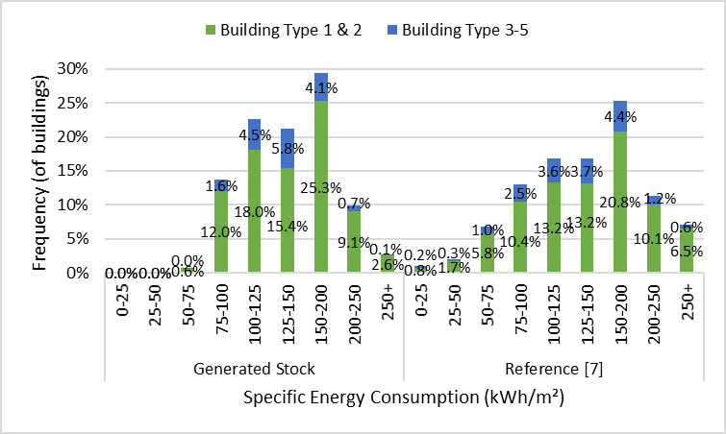

Figure . Distribution of buildings to specific energy consumption intervals: building stock model vs. reference

Average Specific Energy Consumption

We also compare the average specific final energy consumption for heating from the model by building type and construction periods to the reference values given in Figure 44 of the dena report [7] (see Figure 3). The values in the report reflect the building useful floor area, AN, which equals on average 1.2 to 1.35 times the living area (AWFL). For comparability, we adopt the factor of 1.2 between AN and AWFL when calculating the value from our building stock model. The report does not include averages of the newest construction period (after 2009).

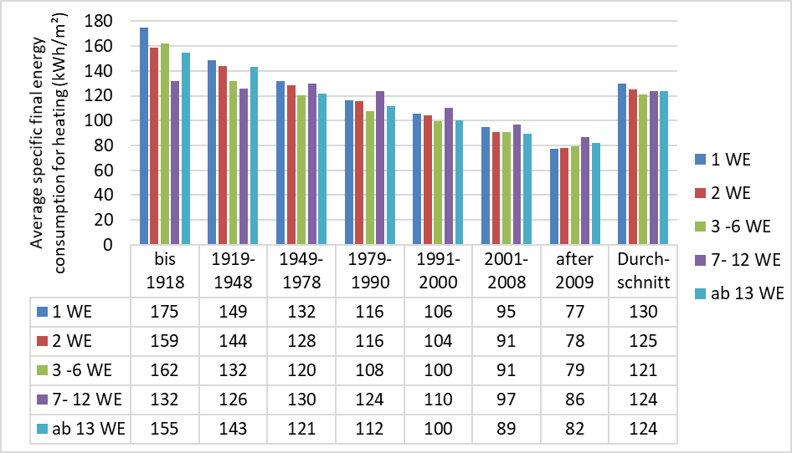

Figure . Average specific final energy consumption for heating of the building stock model[3]

**Final Energy Consumption**

Final energy consumption of the modelled (generated) residential building stock is compared to reference statistics of 2019 from the Federal Ministry of Economic Affairs and Climate Action (BMWK) on Figure 4 [26].

***Non-residential Buildings***

**Final Energy Consumption**

Final energy consumption of the modelled (generated) non-residential building stock is compared to reference statistics of 2019 from the energy balances of AGEB [23][4] on Figure 5.

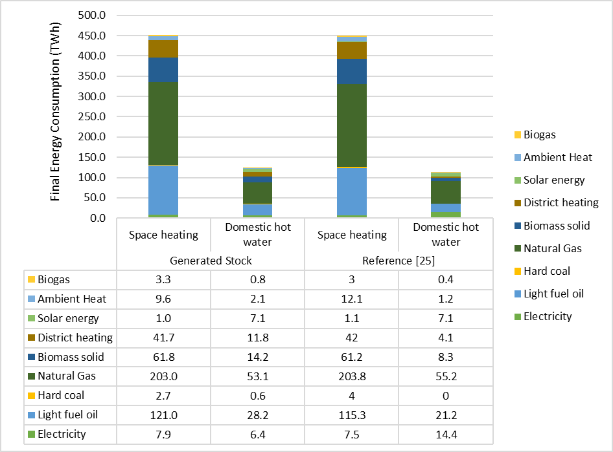

Figure . Final energy consumption of the modelled residential building stock and reference statistics

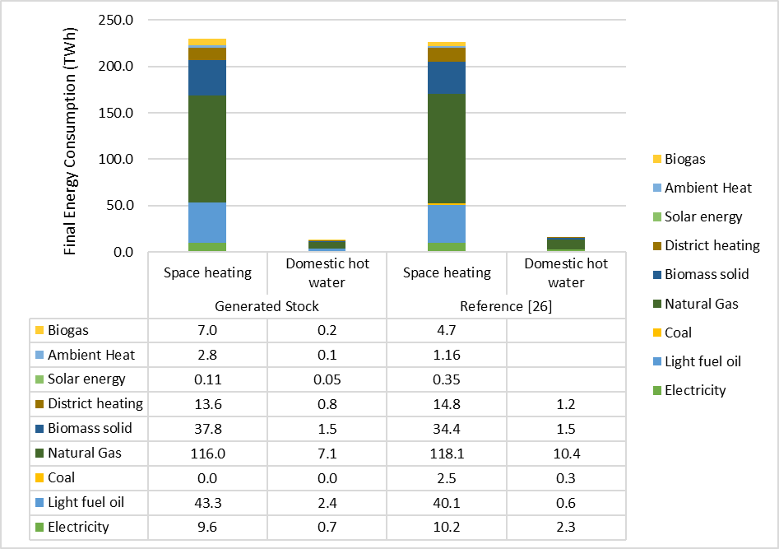

Figure 5. Final energy consumption of the modelled non-residential building stock and reference statistics

Discussion

As shown in the ***Results*** section, the overall quality of the building stock model can be assessed from the three perspectives introduced below.

First, regarding the number of buildings and floor area. The building stock model at national level is comparable to the reference values from statistics. The total residential floor area is 0.7% below the reference, with building types 3-5 being 1.1 to 3.5% below the reference areas. The total number of dwellings is 2.4% below and the total number of buildings is 0.4% above the reference. Keeping in mind that the reference values are also statistical projections based on the latest available Census survey of 2011, the residential building stock model is successful in representing the number of buildings and dwellings as well as the total floor area in 2019. In general, the number of modelled non-residential buildings are in line with the references from IWU, with at most 3.5% relative difference. However, the data from IWU is already used in developing the non-residential building stock in the model. Due to lack of statistical data from different sources, a healthier validation cannot be done at the moment.

Second, regarding the energy performance of buildings, the distribution of the residential buildings to specific energy consumption intervals for heating is mostly in line with those published by dena [7]. The share of buildings in the intervals are at most 6% above or below the corresponding reference. In general, the building stock model has more buildings accumulated in the mid-intervals (between 75-200 kWh/m²), while the reference has a more spread distribution. The model is missing buildings in first two intervals (up to 50 kWh/m²), which shows that the RBs belonging to the newest construction period are not assigned with building components as efficient as in reality. Similarly, there are less RBs in the worst performance intervals (250+ kWh/m²) than the reference. Considering that the renovation rates of the modelled building stock are below the rates that were published by the data collection study of IWU [10], we conclude that there is improvement potential for representing the efficiency of the building stock better. Besides, we also see that the difference between average specific energy consumption for heating in the modelled residential buildings and the statistics vary across construction periods and building types. Overall, the averages are below the statistics for the first four building types, while the average of building type 5 is 7% above the statistical value. Meanwhile, averages of all building types in the earliest and latest construction periods are above the statistical reference, and the averages in the construction periods from 1919 to 2000 have the relative difference stretching from below 20% to above 20% of the reference average. The relative differences of buildings per each energy consumption interval are lower than the differences seen in the average specific energy consumption comparison. This suggests that the total floor area of building types per construction period needs to be validated and its calibration should be improved.

Third, the final energy demand for space heating and hot water in the modelled residential buildings is in line with 2019 statistics. There is only 2.5% difference in total, majorly due to the 10% difference in the calculated hot water demand. The unit user assignment and hot water profiles can be separately validated to improve this comparison. The final energy consumption for space heating and hot water in the modelled non-residential buildings is 2.1% above the 2019 statistics. Since there is not many data sources on non-residential buildings, it is difficult to validate the non-residential stock model. Validation of the energy consumption at subsector level could make the reasons of this difference clearer.

Finally, the model is also subject to a number of limitations. The major one is the uncertainty of the parameters used to generate the building stock model. As we mostly do not work with survey data, but make use of the estimated data from different sources, we cannot conduct a meaningful quantitative analysis on the uncertainty. Qualitatively, the uncertainty can raise from the following aspects:

1. All the parameter values that we cite from existing studies, for example, the U-values of residential building components, the average floor area of dwellings for specific building types and construction periods, the ratio between area of the building components and floor area, the number and floor area of different non-residential buildings, etc. The values of some of these parameters come with error ranges, such as those developed by IWU based on the survey data, which should be included in the analysis. However, some parameters such as those on exemplary building geometries from the findings of the TABULA project are not representative and do not come with statistical error ranges.
2. All the parameter values that are inserted for calculation based on assumptions or expert guesses, for example, the floor height of 3m that we assume for all types of buildings, etc. For these parameter values, we do not have empirical information on the distribution; so, the impact of their uncertainty on the final results cannot be quantitatively assessed. So, sensitivity analysis should be conducted for them if the main conclusions developed based on the model rely on their values.
3. To generate a realistic building stock for the year of 2019, we reproduced the renovation history for each representative building based on the service life logic: the building components are first initialized with the U-values available in the construction year of the building, then until the base year 2019, they can be renovated (also for several times) if their lifetime was reached. The U-values are also assumed to be updated according to the available options in the market when the renovation is assumed to happen. Such logic can also bring uncertainty to the generated building stock.

Apart from the limitation of uncertainty analysis, the key model results should be further validated, especially with regional data, as the study aims to develop a regionalized building stock model. However, the energy demand of both residential and non-residential sectors are only calibrated at the national level so far. The validity at higher geographical resolution should be checked and improved. Besides, there are still deviations in the energy demand by energy carriers, which can be improved by calibrating the shares of different heating system and technologies. To provide insights on infrastructure development, the data on district heating and gas grid also needs to be incorporated. Finally, the modeling and calibration of the behavioral aspects, for example, the demand pattern of unit users in the building (i.e., households and companies) can be improved, for example by adopting relevant user profiles from the DIN V 18599 norm for non-residential buildings. The information on the ownership of the building can also be added, which can be useful when developing scenarios of building renovation and technology diffusion pathways.

Conclusion

This study contributes to the relevant research by developing a regionalized building stock model for Germany, covering 16 building types in both residential and non-residential sectors, which can serve as a foundation for scenario-based analyses of transition pathways. Different data sources are harmonized in a consistent manner, covering multiple aspects of the building stock, including number of buildings, location by settlement type and NUTS 3 region, size, and efficiency level, as well as the shares of different heating systems and technologies. The key model results are compared with statistics or data from different sources. The final energy consumption for space heating and hot water are also calculated and compared with energy balances.

An extension of this work is to develop an agent-based building stock model for Germany. The representative buildings generated in this model are “building agents” and assigned with relevant properties and behaviors. Their decisions on building renovation and technology replacement are simulated and aggregated to different levels to show the decarbonization pathways of the building sector under different technology and policy scenarios.

References

[1] Deutsche Energie-Agentur GmbH, DENA-GEBÄUDEREPORT 2023: Zahlen, Daten, Fakten zum Klimaschutz im Gebäudebestand, Berlin, 2022.

[2] Statistische Ämter des Bundes und der Länder, Zensus 2011: Vielfältiges Deutschland: Zensus 2011: Endgültige Ergebnisse (2016).

[3] M. Pesaresi, GHS-BUILT-S R2023A - GHS built-up surface grid, derived from Sentinel2 composite and Landsat, multitemporal (1975-2030), European Commission, Joint Research Centre (JRC), 2023.

[4] M. Pesaresi, P. Politis, GHS-BUILT-C R2023A - GHS Settlement Characteristics, derived from Sentinel2 composite (2018) and other GHS R2023A data, European Commission, Joint Research Centre (JRC), 2023.

[5] M. Schiavina, M. Melchiorri, M. Pesaresi, GHS-SMOD R2023A - GHS settlement layers, application of the Degree of Urbanisation methodology (stage I) to GHS-POP R2023A and GHS-BUILT-S R2023A, multitemporal (1975-2030), European Commission, Joint Research Centre (JRC), 2023.

[6] Deutsche Energie-Agentur GmbH, DENA-GEBÄUDEREPORT 2022: Zahlen, Daten, Fakten (2021).

[7] Deutsche Energie-Agentur GmbH, Der dena-Gebäudereport 2016: Statistiken und Analysen zur Energieeffizienz im Gebäudebestand, Berlin, 2016.

[8] T. Loga, B. Stein, N. Diefenbach, R. Born, Deutsche Wohngebäudetypologie: Beispielhafte Maßnahmen zur Verbesserung der Energieeffizienz von typischen Wohngebäuden, Darmstadt, Germany, 2015.

[9] T. Loga, K. Müller, K. Reifschläger, B. Stein, Evaluation of the TABULA Database: Comparison of Typical Buildings and Heat Supply Systems 20 European Countries, Darmstadt, Germany, 2015.

[10] H. Cischinsky, N. Diefenbach, Datenerhebung Wohngebäudebestand 2016: Datenerhebung zu den energetischen Merkmalen und Modernisierungsraten im deutschen und hessischen Wohngebäudebestand, Darmstadt, Germany, 2018.

[11] M. Hörner, H. Cischinsky, J. Bischof, S. Schwarz, M. Behnisch, G. Meinel, G. Spars, R. Busch, Forschungsdatenbank NichtWohnGebäude: Repräsentative Primärdatenerhebung zur statistisch validen Erfassung und Auswertung der Struktur und der energetischen Qualität des Nichtwohngebäudebestands in Deutschland. ENOB: dataNWG, 2022.

[12] Statistical regions in the European Union and partner countries: NUTS and statistical regions 2021, twentiethtwenty-second edition, Publications Office of the European Union, Luxembourg, 2022.

[13] NACE Rev.2: Statistical classification of economic activities in the European Community, Office for Official Publications of the European Communities, Luxembourg, 2008.

[14] Eurostat, Population by status in employment, NACE Rev. 2 activity and NUTS 2 region, 2015.

[15] K. Goulouti, D. Favre, M. Giorgi, P. Padey, A. Galimshina, G. Habert, S. Lasvaux, Dataset of service life data for 100 building elements and technical systems including their descriptive statistics and fitting to lognormal distribution, Data Brief 36 (2021) 107062. https://doi.org/10.1016/j.dib.2021.107062.

[16] M. Jakob, G. Catenazzi, R. Forster, T. Egli, T. Kaiser, R. Looser, M. Melliger, C. Nägeli, U. Reiter, M. Soini, B. Sunarjo, Erweiterung des Gebäudeparkmodells gemäss SIA-Effizienzpfad Energie: Schlussbericht, Zürich, 2016.

[17] M. Jakob, T. Fleiter, G. Catenazzi, Ex-ante estimation of the EU Ecodesign Directive’s impact on the long-term electricity demand of the tertiary sector, in: Rethink, renew, restart, eceee, Stockholm, 2013, pp. 2125–2136.

[18] M. Hörner, M. Rodenfels, H. Cischinsky, M. Behnisch, R. Busch, G. Spars, Forschungsdatenbank NichtWohnGebäude: Der Bestand der Nichtwohngebäude in Deutschland ist vermessen (3. und finale Hochrechnung). ENOB: dataNWG, 2021.

[19] DIN, Energy performance of buildings – Calculation of energy use for space heating and cooling: German version EN ISO 13790:2008, DIN Deutsches Institut für Normung e.V., Berlin 91.140.10, 2008.

[20] F. Schröder, J. Reiß, H. Erhorn, C. Ohlwärter, EnEV aktuell | Energieeffizienz (2010).

[21] M. Sunikka-Blank, R. Galvin, Introducing the prebound effect: the gap between performance and actual energy consumption, Building Research & Information 40 (2012) 260–273. https://doi.org/10.1080/09613218.2012.690952.

[22] Songmin Yu, Philipp Mascherbauer, Thomas Haupt, Kevan Skorna, Hannah Rickmann, Maksymilian Kochański, Lukas Kranzl, Modeling households' behavior, energy system operation, and interaction in the energy community, Unpublished, 2023.

[23] C. Rohde, S. Arnold-Keifer, Erstellung von Anwendungsbilanzen für die Jahre 2021 bis 2023 für die Sektoren Industrie und GHD: Studie für die Arbeitsgemeinschaft Energiebilanzen e.V. (AGEB) (2023).

[24] Eurostat, Complete energy balances, Eurostat, 2022.

[25] Statistisches Bundesamt, Gebäude und Wohnungen: Bestand an Wohnungen und Wohngebäuden - Bauabgang von Wohnungen und Wohngebäuden - Lange Reihen ab 1969 - 2021, 2022.

[26] BMWK, Zahlen und Fakten: Energiedaten. Excel sheet, 2022. http://www.bmwi.de/Navigation/DE/Themen/energiedaten.html (accessed 11/2022).

Acknowledgements

This work was financially supported by the German Federal Ministry for Economic Affairs and Climate Action (BMWK) within the accompanying scientific research project RokiG2050, grant number 03EWB002A.

1. Note that ${FAE}_{a}$ is specific to each NUTS 1 region and year. The values are based on [17] and developed after an iterative process in order to calibrate the total number of buildings calculated by the explained method to the number of buildings per state as given by IWU [18].
2. Ali Aydemir and David Schilling, in Hotmaps Wiki, CM Heat load profiles (September 2020.) [www.hotmaps-project.eu](http://www.hotmaps-project.eu)
3. The building types are shown in their German abbreviations, as given in the reference report [7]. The five types correspond to the building types 1-5 that is shown in Table 2, in the given order.
4. The energy carriers biogas, ambient heat and solar energy are not separately reported. The total consumption of these carriers are taken from Eurostat [24] and written under space heating in Figure 5.