Instructions Lab 2

# Installation

The second part of this lab requires the use of SENAnalyser, which is a java application. It is installed by being extracted to a folder (of your choice – but remember the location). When extracted, your chosen folder location should look like this:

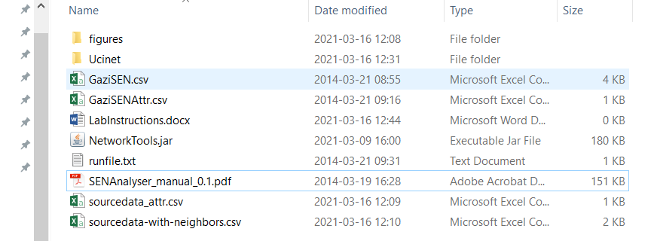

Please make sure the subfolder “figures” is there.

Then, open a command prompt (for example, by typing “cmd” in Windows search). It looks like this:

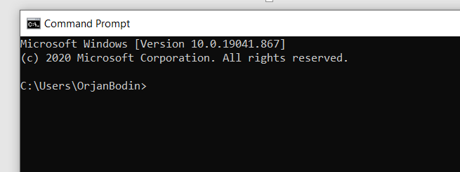

Then, change the file location of the command prompt to where you extracted the files. You can do this by using the file explorer and copy the file location of the extracted files using the right mouse button and selected “copy address as text” (when the cursor is located in the red circle in figure below).

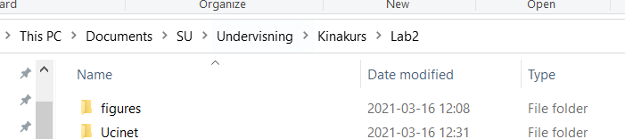

Then, go back to the command prompt and type “cd” followed by the address you just copied (by pressing the right mouse button when having the cursor at the command prompt). If everything works as planned, you should have changed location to where the files were extracted.



Now, open the file “runfile.txt” and copy and paste the text string in the file to the command prompt (“java -cp NetworkTools.jar -Xms500m -Xmx2000m su.syseco.jnetworktools.motif.MotifComparator GaziSEN.csv GaziSENAttr.csv 1 1 1 50”)



You should now see lots of text in the command window, and after a while a windows opens up.

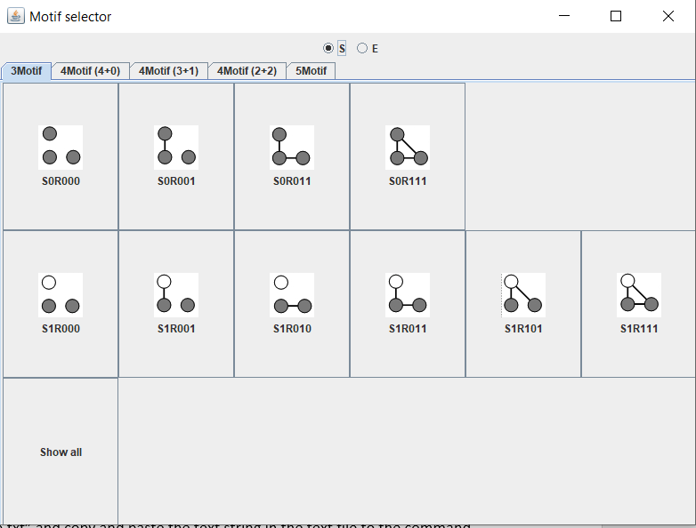

If you have gotten this far, your computer is ready for lab 2!

# Part 1 – Explorations using Ucinet

Open the files ‘GaziSEN’ and ‘GaziSENAttr’ (in the folder “Ucinet”). These files include the network from Lab 1, although the ecological network (fish species and trophic interactions) is more detailed.

Make sure the social actors (fishermen groups) are marked using a different color.

You can clarify the distinction between social and ecological nodes by selecting Layout-Group by Attribute-Categorical Attribute and selecting the attribute “GaziSENAttr” (distinguish actors from fish species).

Use Ucinet to explore and reflect on the following:

1. What are the most connected nodes (social and ecological)?
2. Think about what different centralities mean for different types of nodes
3. What types of links make any given node more central than other (social, ecological, or social-ecological)?
   1. Elaborate what different types of links mean in terms of node centrality (point 2)
4. Are there any subgroups? What defines them, if any groups are to be found?
5. Anything else of interest?

Repeat the same exercise for the other case (Madagascar) using the files ‘sourcedata-with-neighbors’ and ‘sourcedata_attr’.

# Part 2 – Using SENAnalyser to investigate frequencies of motifs

Type “java -cp NetworkTools.jar -Xms500m -Xmx2000m su.syseco.jnetworktools.motif.MotifComparator GaziSEN.csv GaziSENAttr.csv 1 1 1 50” at the command prompt (see installation instructions above)

Investigate how often these six motifs occur in the network (from Lecture 3)

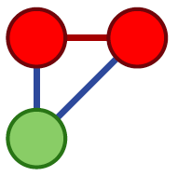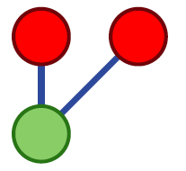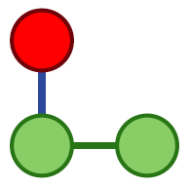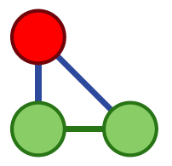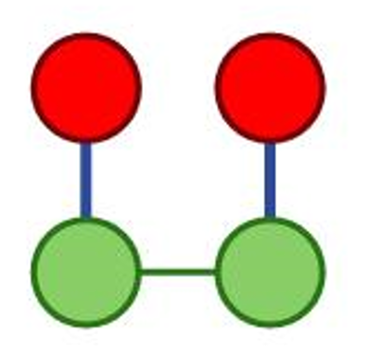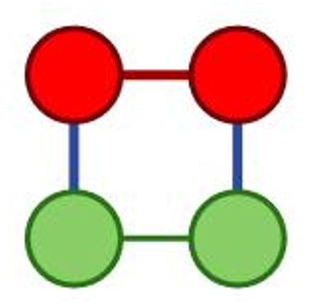

Observe that the type of node being in minority (in the fig above, the red social node) will give name to the motif (see further in the manual “SENAnalyser_manual_0.1”). You will see which one is analyzed in the text provided at the command prompt

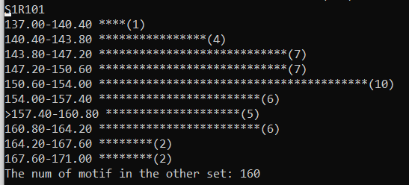

The fig above shows the motif with one social node (hence starts with S). The bars represent the frequency distribution in the randomly generated networks (the null model). The “>” shows the frequency in the empirical network (also in the text “….in the other set:”).

Do the same thing for the Madagascar network (the run command is found in “runfile.txt”).

1. Compare the frequencies (relative to the random distributions, respectively).
2. What does this all mean? Management implications?

Investigate any other motif of your choice, explore and think about management implications!