Institutional shifts and sustainable water use of the Yellow River Basin

Shuang Song

Huiyu Wen

*Shuai Wang

Xutong Wu

Graeme S. Cumming

Bojie Fu

# 1 INTRODUCTION

Widespread freshwater scarcity and overuse challenge the sustainability of large river basins, resulting in systematic risks to economies, societies, and ecosystems globally1–4. With steadily increasing demand, competition for water causes depletion of freshwater globally and calls for an urgent transformation of the governance system by considering water use conservation5–7. Despite worldwide trying to govern water, however, degradation of large river basins is not easily reversible because of few alignments between practice and theory in successful water governance cases.8–10.

The Yellow River Basin (YRB), the fifth large river worldwide, is known for its irreplaceable role in the social-economic development of China, and thus also drastically interference by anthropogenic stress. Supporting irrigation and population with only water resources of China (data from <http://www.yrcc.gov.cn>, last access: ), the overburdened Yellow River depleted in consecutive years, resulting in substantial ecological, economic and social crisis (e.g., wetland shrink, agriculture reduction, and scramble for water). Intense water use, accounting for about of Yellow River surface runoff in the 1980s, was remarked as the significant reason for the degradation. Furthermore, human interferences such as soil conservation and water conservancy project boosted water withdrawal and then stressed the water scarcity of the Yellow River. In the context of future climate change, the contradiction between supplies and demands of water resources in the YRB will become more prominent. Therefore, balancing ecological and developing demands in such a human-dominated basin is a problem for China in terms of water governance throughout and for large rivers worldwide.

Chinese authorities implemented several ambitious water management practices in the YRB in the last century to relieve the water stress, such as reservoir regulation, South-to-north Water Diversion Project (WDP), and Water Allocation Scheme since 1987 (87-WAS), and the Unified Basinal Regulation since 1998 (98-UBR). Through those efforts, ecological restoration of wetlands and estuary delta in the YRB without drying up for over is widely considered a considerable river management achievement. Different from the engineering that provides further water supply, institutional strategies like the 87-WAS (assign water quotas for provinces in the YRB) and the 98-UBR (the provinces had to be allowed to use water by the Yellow River Conservancy Commission, YRCC) mainly focused on limiting demands of water use. Such institutions (policies, laws, and norms) can influence regional sustainability by changing the structure of the coupled human and natural system, including interplays between social actors, ecological units, or between social and ecological system elements11–14. Understanding those complex interlinkages, therefore, is crucial for developing strategies to effectively manage natural resources and enhance the resilience of social-ecological systems (SES)15. However, while literature had well evaluated and quantified the effects of engineering solutions beforehand, there are few attempts to assess institutional contributions to successful water governance.

In addition to widespread recognition of the rising importance of institutions as an approach to water sustainable use within large river basins (especially transboundary rivers like the YRB), their specific effects are still in open discussion16–18. Effective (“matched” or “fit”) institutions operate at appropriate spatial, temporal, and functional scales to manage and balance different relationships and interactions between human and water systems, therefore, supporting (but not guaranteeing) the sustainability of SES7,19. Some institutional shifts have desirable water governance outcomes (e.g., the Ecological Water Diversion Project in Heihe River Basin, China7 and collaborative water governance systems in Europe20). However, shifting institutions in a large, complex river basin may create or destroy hundreds of different connections between social agents and ecological units, where matched social-ecological structures are not ubiquitous. Therefore, the role of institutional shifts in the water governance achievement of the YRB and their impacts on water use is still uncertain without an understanding of SES structures. Here, by abstracting changes in official documents following institutional shifts (the 87-WAS and the 98-UBR), we depicted the SES structures of the YRB from 1979 to 2008. Then, we use Differenced Synthetic Control (DSC) method, which considers economic growth and natural background, to estimate theoretical water use scenarios without the institutional shifts (*Methods* and *Appendix*). By further interpreting the differences of the effects in the YRB, we explored the mechanisms linking SESs structure and outcomes for a deeper understanding of institutions’ role in water governance worldwide.

# 2 RESULTS

## 2.1 Institutional shifts and structures

The institutional shifts in 1987 (87-WAS) and 1998 (98-UBR) were two widely recognized milestones in restricting water use among national water governance practices (*Appendix* ). Until the 87-WAS, stakeholders (the provinces in the YRB) had free access to the YR water resources for development, but there were geographic and temporal differences between freshwater demand and availability. As a compounded result of development, the provinces such as Shandong, Henan, and Inner Mongolia used more water resources in the YRB with larger economies (primarily for irrigation agriculture). For shrinking water deficits, national authorities proposed in 87-WAS allocating specific water quotas between provinces (or regions) along the YR basin (Table [tab:quota]). However, the controversial scheme helped little in turning the water depletion around until another strategy attempted to strengthen the responsibilities of the YRCC in integrated water management in 1998 (the 98-UBR). Therefore, our analysis period spans from 1979 (emergence of river depletion) to 2008 (a further polish of the 98-UBR), with the SESs shifted between three varying institutions (Figure 1).

We selected institutional regulatory documents on water use issued by national ministries (for validation to both watershed and regional agents) and then extracted the interactions between the agents involved (*Appendix* ). Before 1987, the YRCC had no links to the provinces regarding water use, and the provinces could link to the Yellow River reaches directly (Figure 1). However, according to the extracted information from the 87-WAS, the YRCC started to report water use from the provinces. Furthermore, information from the 98-UBR documents demonstrated that the provinces had to apply their plan for an annual water use license instead of direct access to the Yellow River water. Thus, there have been links between the YRCC and the provinces since the strengthening responsibilities of the YRCC in 1998.

image

**Figure 1.** Institutional shifts and related SES structures in the Yellow River Basin (YRB). **A.** The YBR crosses $10$ provinces or the same-level administrative regions, $8$ of which are highly relying on the water resources from the YRB (see Appendix secS1 Table~\ref{tab:quota}). The national administrations are the ultimate authority in issuing water governance policies, which are often implemented by basin-level agency (the Yellow River Conservancy Commission, YRCC) and each province-level agency. **B.** Provincial administrative agencies are the major stakeholders. Since the 87-WAS, with surface water withdrawal from the Yellow River restricted by specific quotas, each stakeholder plan and use water resources for development. However, the natural hydrological processes are connected. Although the institutions focus mainly on surface water (Sur.), it can also influence groundwater inside (Gro.) or water resources outside (Sur. and Gro.') through systematic socio-hydrological processes within the YRB. The YRCC only monitors water withdrawals at that time. **C.** Institutional shifts and following structures changes (details in \textit{Appendix \nameref{secS1}}). (1) From 1979 to 1987, water resources were freely accessible to each stakeholder (denoted by red circles) from the connected ecological unit (the reach of Yellow River, denoted by the blue circles). (2) After 1987-WAS, the YRCC (the yellow circles) was monitoring (the dot-line links) river reaches with the water use quota. (3) Since the 98-UBR, stakeholders have to apply for water use licenses from the YRCC (the connections between the red and yellow circles).

## 2.2 Institutional shifts impact on water use

[result-1-p2] Our estimation of theoretical water use suggests that the institutional shift in 1987 (87-WAS) stimulated the provinces to withdraw more water than would have been used without an institutional shift (Figure 2A). From 1988 to 1998, on average, while the estimation of annual water use only suggests billion , the observed water use of the YRB provinces reached billion in sum, increased. However, after the institution shifted again in 1998 (98-UBR), the trend of increasing water use appeared to be effectively suppressed. From 1998 to 2008, the total observed water use decreased by billion per year, while the estimation of water use still suggests billion increases (Figure 2 B). The increased water uses after 87-WAS aligns with the fact that badly drying-up of the surface streamflow from 1987 to 1998, which was an obvious touchstone of river degradation and environmental crisis (Figure 2C). On the other hand, the 98-UBR ended river depletion, despite the intensity of droughts still increasing for decades (from after 87-WAS to after 98-UBR on average) (Figure 2C).

image

**Figure 2.** Effects of two institutional shifts on water resources use and allocation in the Yellow River Basin (YRB). **A.** water uses of the YRB before and after the institutional shift in 1987 (87-WAS); **B.** water uses of the YRB before and after the institutional shift in 1998 (98-UBR). While the blue lines are statistic water use data, the grey ones are the estimation from the Differenced Synthetic Control method with economic and environmental background controlled. **C.** Drought intensity in the YRB and drying up events of the Yellow River. The size of the grey bubbles denotes the length of a drying upstream.

## 2.3 Heterogeneous institutional effects

Our results also suggest differences between patterns of provinces in their responses to the two institutional regulating. During the decade after the 87-WAS, the major water-using provinces (e.g., Inner Mongolia, Henan, Shandong) had apparent accelerations (Figure 3). The proportion of increased (or decreased) water use for each province (over the estimated water use by the model) has a significant correlation (partial correlation coefficient is , ) to the actual water use from the Yellow River. On average, the major water users (Shandong, Inner Mongolia, Henan, and Ningxia) used more water use than the prediction from 1987 to 1998. By contrast, after the 98-UBR (from 1998 to 2008), almost all provinces have seen evident ( on average) declines in water use. Furthermore, the regulated water use of provinces was irrelevant (partial correlation coefficient is , ) with their water use from the Yellow River in proportions.

image

**Figure 3.** Regulating differences for provinces in the YRB. Red (the 87-WAS) and green bars (the 98-UBR) denote an increased or decreased ratio for the actual water use over the estimation from the model in a decade after the institutional shift. The grey bars indicate the proportions of actual water use for each province to their total water use in a decade after the institutional shift. The triangles mark the water quotas assigned in the institution, scaled into ratios by dividing by their sum, too.

# 3 DISCUSSION

[discussion-1] We quantitatively demonstrated that the 98-UBR decreased, but the 87-WAS increased YRB’s water use. The results challenged the previous analyses (they used to suggest that the 87-WAS “has little practical effect”) because theoretically, the DSC method would show few differences between estimation and observation for a blank policy21,22. However, the significant net effect suggests the institutional shift (87-WAS) followed by backfired more water use even after controlling the environmental and economic variables (see *Appendix* Table [tab:variables]). The speeding up water use aligns with the sigh from then: the tragedy of frequently scrambling for water appeared in some provinces23. On the contrary, 98-UBR reduced the tragedy of water competition considerably by water licenses, so many studies attributed the restoration from river depletion mainly to the successful institutional shift24–26.

We proposed that for these institutional shifts’ divergent outcomes regarding water use, the key factors long ignored can be institutional structure changes. The structural building blocks we depicted in Figure 1, which were also reported in various types of SESs worldwide15,27,28, and here twice reframed by the institutional shifts. Before the 98-UBR, the SES structure (i.e., fragment ecological units are linked to separate social actors) is more likely to be mismatched because isolated actors generally struggle with holistically maintaining interconnected ecosystems29–32. On the contrary, institutional alignments since the 98-UBR improved YRCC’s authority in water use regulation to match the YRB in scale, thus leading to social-ecological fit and good outcomes -a “scale-matched” example7,33. Despite other reasons for the non-ideal effect of the 87-WAS being widely discussed25 (such as enforcement, feasibility, and equity), few radical improvements in the 98-UBR suggest an over-attention paid to non-structural impacts.

[discussion-2] Different individual provinces’ water-use responses to the institutional shifts also support influences from SES structures. Our results show that the correlation between current water use and changed (increased or decreased) water use was significant after the 87-WAS. This “major users use more” pattern supports the hypothesis that separated stakeholder (individual province here) decides on linked ecological units for output maximization (water use). Therefore, we theoretically abstracted the SES structures and analyzed how different structures shape different outcomes with provincial heterogeneity. Assuming that water is the factor input with decreasing marginal output of each province, we discuss the marginal return and optimal water use under three different cases (analogy to Figure 1 C, see  Figure 1, detailed derivation in *Appendix*). The incentive for water overuse (compared to the water quotas) in each province derives from the mismatch between the benefits and costs of water use. Until water-use decisions are consolidated into unified management, each stakeholder’s expectation that current water use helps bargain for a favorable water quota may intensify the incentive of water use, leading to higher water use. Therefore, the water users with higher capability are more stimulated by institutional shifts and away from the theoretically optimal water use under the unified allocation. Our model interprets the results from structural perspectives: excessive water use incentive induces the acceleration of extracting resources for future economic growth, and a unified institution is indispensable for sustainable water use.

Figure 1: A. The relationship of marginal benefits and water use of individual province under varying cases (case 1 to case 3, corresponding to the different SES structures in Figure [structure]) Major water users’ theoretically optimal water use is also larger (see and ).

**Figure 4.** The relationship of marginal benefits and water use of individual province under varying cases (case 1 to case 3, corresponding to the different SES structures in Figure 1) Major water users’ theoretically optimal water use is also larger (see and ).

Our above theoretical discussion also aligns with the evolution of the institutions in the YRB. When links The water quotas of 87-WAS (or the initial water rights) went through a stage of “bargaining” among stakeholders (from 1982 to 1987)7,34, where each province attempted to demonstrate its development potential related to water use. The bargaining was also a process for matching their water shares to economic volume because the major water users (like Shandong and Henan) need more water than their quota (if only considering economic potentials when designing the institution)35. Furthermore, those with more current water use might have greater bargaining power in water use allocation because of information asymmetry between decision-makers and stakeholders. Therefore, stakeholders had considerable incentives to prevent water quotas from hindering their economic potential, which aligns with the fact that they appeared to the higher central government for larger shares7,34. On the contrary, after YRCC as governing agent coordinated between stakeholders since 98-UBR, the external appeal of provinces for larger quotas turned into internal innovation to improve water efficiency (e.g., drastically increased water-conserving equipment)36,37. Then, the YRCC, the authority for approving water applications from all stakeholders, could adjust water use quotas according to the river conditions of the whole basin. The 98-UBR thus led to expected institutional outcomes at a basin scale, indicating that successful governance of SES emerged by indirectly (or vertically) creating links between different stakeholders.

## 3.1 LIMITATION, INSIGHTS AND IMPLICATIONS

We explored these causal linkages between the SES structures and sustainability (outcomes) by quasi-natural experiments (the institutional shifts) of the YRB, which provides a unique case for two main reasons: (1) The top-down institutional shifts induced sharp changes in SES structures in the YRB, enabling us to estimate their net effects quantitatively. (2) Since few basins experienced such radical institutional shifts more than once, the YRB provides comparable settings for understanding the structural changes of SESs.

In complex coupled human-nature systems, however, our approach also has inevitable limitations: (1) The contributions of economic growth and institutional shifts are still incomparable because of intertwined causality (institutional changes can also influence the relative economic variables). Still, our quasi-experiment approach focused on and proved that a change in water use trajectory follows the YRB’s unique institutional shifts. (2) When applying the DSC method, it is difficult to rule out the effects of other policies over the same time breakpoints (1987 and 1998). However, since the analysis had agreed on the importance of the two institutional shifts of 87-WAS and 98-UBR in water governance38, our results on their effects still provide insights for understanding water governance.

Our results and discussion deepen the understanding of SES structure and strengthen the basic knowledge that the mismatched structure (isolated stakeholders with the fragmentation of ecology) is not conducive to institutional solutions14,39,40. Moreover, we report how another structure contributed to successful governance -the subsequent success of the 98-UBR institutional shift theoretically and practically proved the importance of social-ecological fit again. For sustainability in the future, therefore, it is necessary to emphasize the necessity of strengthening connections between stakeholders by agents consistent with the scale of the ecological system. From these perspectives, we give two scenarios based on the marginal benefit model (see *Appendix* ), which can inspire institutional design on how to reduce mismatches. For example, water rights transfers can be another way to emerge horizontal links between stakeholders that also have the potential to result in better water governance. In addition, the policymakers can propose more dynamic and flexible institutions to increase the adaptation of stakeholders to respond to changing SES context40.

The structural building blocks that led to different outcomes are recurring motifs in global SESs, so our proposed mechanism is crucial to governing such coupled systems. Calls for a redesign of water allocation institutions in the YRB in recent years also illustrate the importance of institutional solutions to sustainability (see *Appendix* )41. Given the changing environmental context, outdated and inflexible water quotas can no longer meet the demands of sustainable development34. Thus, the Chinese government has embarked on a plan to redesign its decades-old water allocation institution (see *Appendix*). These initiatives can benefit from our analysis by actively incorporating social-ecological matched building blocks when developing a new institutional shift for sustainability14. Moreover, our research provides a cautionary tale of how institutions can be double-edged42, while insights from the YRB can be a valuable guideline for SESs worldwide43,44.

# 4 CONCLUSION

Intense water use in one of the most anthropogenic interfered large river basins, the Yellow River Basin (YRB), once led to overburdened drying up but finally had a successful restoration by sequential water governance practices. Focusing on two water-demand institutions (87-WAS and the 98-UBR), we quantitatively analyzed how institutional shifts played a role in the water governance achievement of the YRB. Shifting throughout different SES structures framed by them, the observed water use of the YRB provinces had a increase than expected during the decade after the 87-WAS. Then, water use significantly decreased by billion per year since the 98-UBR, while the model still suggests a billion annual increase in expectation. Finally, as differences in stakeholders’ response to the institutional shifts, water use rises after the 87-WAS in provinces with more water uses (e.g., Inner Mongolia, Henan, and Shandong) while shrunk in nearly all provinces after the 98-UBR. Since the above results closely align with interpretations from a mathematical marginal benefits model, we can link the structures (widespread building blocks) and outcomes (goals of the institution, i.e., limiting water demands) by these quasi-natural experiments of the YRB. We demonstrate that social-ecological fits lead to successful governance where reducing independent stakeholders linked to fragmentation is an essential primary mechanism for good SES outcomes.

# 5 MATERIALS AND METHODS

We first abstract the SES structures of water used in the YRB from 1979 to 2008, where two institutional shifts split the period into three pieces. For preprocessing the data, we use Principal Components Analysis (PCA) method to reduce the dimensionality of variables affecting the total water use. We then estimated the net effects of two institutional shifts on total water use, changing trends, and differences of the YRB’s provinces, by Differenced Synthetic Control (DSC) method45. Finally, for discussion, we created an economic model based on marginal revenue to provide the observed pattern of water use changes with a theoretical interpretation.

## 5.1 Portraying structures

We apply the network14 approach to portray SES structures by abstracting relationships between ecological units (river reaches), stakeholders (provinces), and the administrative unit (the YRCC) into general building blocks (or motifs) (see Figure 2), from the official documents. Empirical studies have suggested that such widespread building blocks in SES are the key to the functioning of structures, and the network-based approach is to abstract connections between entities into links and nodes15,27,46. In this study, we examined the official documents of the two institutional shifts of concern (87-WAS and 98-UBR, see *Appendix* for details). Besides the ecologically connected river reaches, the agents (provinces and the YRCC) are abstracted as nodes, and their required interactions regarding water use are summarized as links. The 1987-WAS requires the YRCC to monitor each river’s reach, while the 1998-UBR requires direct interactions (through water use licenses) between the YRCC and the provinces. Therefore, we linked the YRCC unit to each ecological unit after 87-WAS and each province unit after the 98-UBR. We try to approve that focusing on SES structures rather than institutional details can reasonably interpret the differences caused by institutional shifts in the YRB.

## 5.2 Dataset and preprocessing

We choose datasets and variables to compare on actual and estimated water use of the YRB. The actual water uses are accessible in China’s provincial annual water consumption dataset from the National Water Resources Utilization Survey, whose details are accessible from Zhou (2020)47. To estimate the water use of the YRB by assuming there were no effects from institutional shifts, we focused on variables from five categories (environmental, economic, domestic, and technological) water use factors. Their specific items and origins are listed in Table [tab:variables].

Among the total data-accessible provinces (or regions) assigned quotas in the 87-WAS and the 98-UBR, we dropped Sichuan, Tianjin, and Beijing because of their trivial water use from the YRB (see *Appendix* Table [tab:quota]). We then divided the dataset into a “target group” and a “control group”, treating provinces involved in water quota as the target group and other provinces as the control group for applying the DSC.

Using the normalized data of all variables, we performed the PCA reduction to capture explained variance by principal components *Appendix*. Bayan had proved that combining PCA and DSC can raise the robustness of causal inference48. We first applied the Zero-Mean normalization (unit variance), as the variables’ units are far different. Then, we apply PCA to the multi-year average of each province, using the Elbow method to decide the number of the principal components (*Appendix  Figure**[fig:elbow]*). Finally, we transform the dataset and input the dimensions-reduced output into the DSC model.

## 5.3 Differenced Synthetic Control

We estimate water use without institutional shifts effect using the Differenced Synthetic Control (DSC) method. The DSC method is an effective identification strategy for estimating the net effect of historical events or policy interventions on aggregate units (such as cities, regions, and countries) by constructing a comparable control unit21,22,49.

This method aims to evaluate the effects of policy change that are not random across units but focuses on some of them (i.e., institutional shifts in the YRB here). By re-weighting units to match the pre-trend for the treated and control units, the DSC method imputes post-treatment control outcomes for the treated unit(s) by constructing a synthetic version of the treated unit(s) equal to a convex combination of control units. Therefore, the synthetic and actual version difference can be estimated as a net effect for a treated unit.

In practice, all treated units (i.e., provinces) were affected by institutional shifts in 1987 and 1998, each taken as the “shifted” time within two individually analyzed periods : 1979-1998; 1987-2008. We include each province in the YRB (, see ) as the treated unit separately, as multiple treated units approach had been widely applied50. Then, we consider the units observed in time periods with the remaining units are untreated provinces from outside. We define to represent the number of pre-treatment periods () and the number post-treatment periods (), such that . The treated unit is exposed to the institutional shift in every post-treatment period , unaffected by the institutional shift in all preceding periods . Then, any weighted average of the control units is a synthetic control and can be represented by a () vector of weights , with . Among them, by introduce a () diagonal, semidefinite matrix that signifies the relative importance of each covariate, the DSC method procedure for finding the optimal synthetic control () is expressed as follows:

|  |  |
| --- | --- |
|  |  |

where is the vector of weights that minimizes the difference between the pre-treatment characteristics of the treated unit and the synthetic control, given . That is, depends on the choice of –hence the notation . Therefore, we choose to be the that results in that minimizes the following expression:

|  |  |
| --- | --- |
|  |  |

That is the minimum difference between the outcome of the treated unit and the synthetic control in the pre-treatment period, where is a () matrix containing every observation of the outcome for the treated unit in the pre-treatment period. Similarly, let be a () matrix containing the outcome for each control unit in the pre-treatment period, and is the number of variables in the datasets. The DSC method generalizes the difference-in-differences estimator and allows for time-varying individual-specific unobserved heterogeneity, with double robustness properties51,52.

## 5.4 Economic model

To infer the mechanisms underlying the results, we developed an economic model based on marginal revenue to analyze how the institutional shift could have led to differences in water use.

**Assumption 1**. *(Water-dependent production) Because of irreplaceability, water is assumed to be the only input of the production function with two types of production efficiency.*

**Assumption 2**. *(Ecological cost allocation) Under the assumption that the ecology is a single entity for the whole basin involved, the cost of water use is equally assigned to each province.*

**Assumption 3**. *(Multi-period settings) There are multiple settings periods with a constant discount factor for the expectation of future water use.*

Under the above-simplified assumptions, we demonstrate three cases -corresponding to the abstracted SES structures (Figure 1), inference of how SES structure alters the expected marginal benefits and costs of provinces making decisions. As one of the possible interpretations for the causality between SES structure and institutional effects, the derivation of the model based on the above three assumptions can be found in *Appendix*, and some simple model-based extensions are involved in *Appendix*.

[appendix]

# 6 S1: Contexts of institutional shifts

We aim to abstract the water allocating institutions from the description in official documents with necessary context into SES building blocks (Figure 2) Widespread building blocks in SES are the key to the functioning of structures, and a network-based description is a widely used way to depict them by abstracting links and nodes15,27,46.

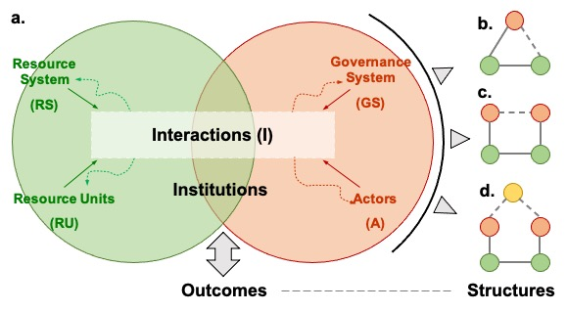

Figure 2: Framework for understanding linkages between SES structures and outcomes. **a.** The general framework for analyzing social-ecological systems (SESs) (adapted from Ostrom39). Institutions embedded in SESs may reshape structures by changing the interactions between core subsystems, resulting in different outcomes. Three typical types of abstracted SES structures are shown as **b.**, **c.** and **d.** (adapted from Bodin, 2017)14. Red circles indicate social actors, and green ones indicate ecological components. Connection (ties between two ecological components), collaboration (ties between two social actors), or management (ties between a social actor and an ecological component) exist when gray lines link two units. According to empirical evidence, the gray dashed lines show aligned SES structures that are more likely to achieve a desirable outcome.

Water allocation institutions are widespread in large river basin management programs throughout the world (see *Appendix* Figure [fig:world])53. This was the first basin in China for which a water resource allocation institution was created, and institutional shifts can be traced through several documents released by the Chinese government (at the national level)34:

* **1982**: The provinces and the Yellow River Water Conservancy Commission (YRCC) are required to develop a water resource plan for the Yellow River34,54.
* **1987**: Implementation of the Allocation Plan. ([http://www.mwr.gov.cn](http://www.gov.cn/zhengce/content/2011-03/30/content_3138.htm), last access: ).
* **1998**: Implementation of unified regulation. ([http://www.mwr.gov.cn](http://www.mwr.gov.cn/ztpd/2013ztbd/2013fxkh/fxkhswcbcs/cs/flfg/201304/t20130411_433489.html), last access: ).
* **2008**: Provinces are asked to draw up new water resources plans for the YRB to further refine water allocations34,54.
* **2021**: A call for redesigning the water allocation institution ([http://www.ccgp.gov.cn](http://www.ccgp.gov.cn/cggg/zygg/gkzb/202107/t20210721_16591901.htm), last access: ).

Since 1982, administrations attemptted to design a quota institution, and the 2008 document marked the maturity of the scheme (complete establishment of basin-level, provincial, and district water quotas). Between the period, two significant institutional shits can be analyzed by using the 1987 (87-WAS) and 1998 (98-UBR) documents.

The official documents in 1987 ([http://www.mwr.gov.cn](http://www.gov.cn/zhengce/content/2011-03/30/content_3138.htm), last access: ) convey the following key points:

* The policy is aimed at related provinces (or regions at the same administrative level).
* Depletion of the river is identified as the first consideration of this institution.
* Provinces are encouraged to develop their water use plans based on a quota system.
* Water in short supply is a common phenomenon in relevant provinces (regions).

The official documents in 1998 ([http://www.mwr.gov.cn](http://www.mwr.gov.cn/ztpd/2013ztbd/2013fxkh/fxkhswcbcs/cs/flfg/201304/t20130411_433489.html), last access: ) convey the following key points:

* The document points out that not only provinces and autonomous regions involved in water resources management (see *Article 3*), the provinces’ and regions’ water use shall be declared, organized, and supervised by the YRCC (*Article 11 and Chapter III to Chapter V, and Chapter VII*).
* Creating the overall plan of water use in the upper, middle, and lower reaches is identified as the first consideration of this institution (*Article 1*).
* With the same quota as used in the 1987 policy, provinces were encouraged to further distribute their quota into lower-level administrations (see *Article 6 and Article 41*).
* They emphasize that supply is determined by total quantity, and water use should not exceed the quota proposed in 1987 (see *Article 2*).

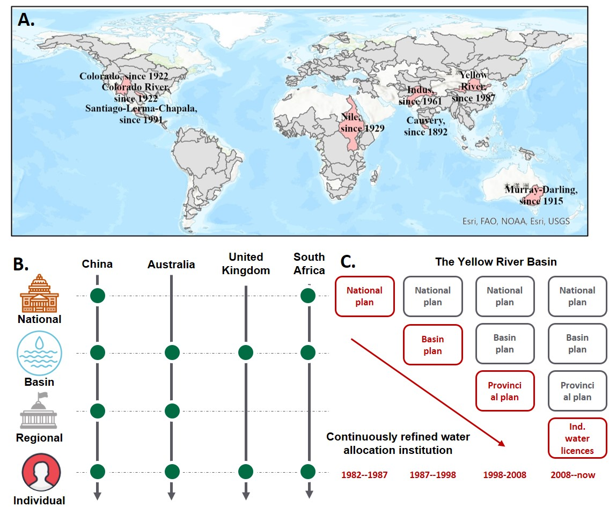

Based on the above documents, we abstracted the structural changes of SES (see *Appendix S2*) after the two institutional changes, as shown in Figure 1 C.

[a]  
[b]

# 7 S2: Robustness of DSC method

Explanatory variables are the key to constructing a robust synthetic control method. We used a total of variables related to water consumption Table [tab:variables], which datasets have been used in previous studies to explain changes in water use in China47. In addition, we selected principal components as input by the elbow method because selection in autocorrelated variables reduces dimensions and then enhances the robustness of the DSC (Figure [fig:elbow]).

There are two approaches to validity testing of the DSC: (1) comparing the post-treated and pre-treated reconstructions and (2) testing robustness through placebo analysis. For (1), differences between each province and their synthetic are significant in post-treated periods and small in pre-treated periods (Figure [fig:87panel] and figure [fig:98panel]), which show good reconstructions of their water use changes’ estimation. For (2), we applied the in-place placebo analysis described by49. In most provinces, ratios of post-MSPE to pre-MSPE are higher than the median of other placebo units, which suggests the institutional shifts in treated time (1987 and 1998 here) influenced them more than most of the other provinces (figure [fig:87placebo], figure [fig:98placebo], Table [tab:DSC_summary]).

image

image

image

image

image

|  |  |  |  |  |  |  |  |  |
| --- | --- | --- | --- | --- | --- | --- | --- | --- |
|  | 1987-WAS | | | | 1998-UBR | | | |
| Provinces | Pre-RMSPE | Post-RMSPE | Ratio | Significant | Pre-RMSPE | Post-RMSPE | Ratio | Significant |
| Qinghai | 0.016 | 0.231 | 14.606 | True | 0.230 | 1.170 | 5.096 | True |
| Gansu | 0.056 | 1.307 | 23.265 | True | 0.244 | 0.841 | 3.448 | True |
| Ningxia | 0.097 | 0.944 | 9.697 | True | 0.332 | 1.091 | 3.284 | True |
| Neimeng | 0.335 | 3.846 | 11.479 | True | 1.320 | 1.183 | 0.896 | False |
| Shanxi | 0.208 | 0.675 | 3.241 | False | 0.264 | 0.401 | 1.520 | False |
| Shaanxi | 0.181 | 0.572 | 3.164 | False | 0.096 | 0.724 | 7.579 | True |
| Henan | 0.210 | 3.207 | 15.292 | True | 1.222 | 2.479 | 2.029 | False |
| Shandong | 0.209 | 1.840 | 8.785 | True | 0.431 | 1.517 | 3.516 | True |

[a]

# 8 S3: Optimization model for water use

#### 8.0.0.1 Setup

To understand the mechanisms through which the SES structure impacts provincial water use, we developed a dynamic economic model to analyze how institutional mismatch could have led to the changes in water use, especially among provinces with high incentives for excess water use. Specifically, we modeled individual provincial decision-making in water resources before quota execution.

We proposed three intuitive and general assumptions:

**Assumption 4**. *(Water-dependent production) Because of irreplaceability, water is assumed to be the only input of the production function with two types of production efficiency. The production function of a high-incentive province is , and the production function of a low-incentive province is (). F(x) is continuous, , , , and . The production output is under perfect competition, with a constant unit price of .*

**Assumption 5**. *(Ecological cost allocation) Under the assumption that the ecology is a single entity for the whole basin involved in provinces, the cost of water use is equally assigned to each province under any water use. The unit cost of water is a constant .*

**Assumption 6**. *(Multi-period settings) There are infinite periods with a constant discount factor lying in (0,1). There is no cross-period smoothing in water use.*

Under the above assumptions, we can demonstrate three cases to simulate the water use decision-making and water use patterns in a whole basin.

Under the above assumptions, we can demonstrate three cases consisting of local governments in a whole basin to simulate their water use decision-making and water use patterns.

**Case 1**. *Dentralized decision: This case corresponds to a situation without any high-level water allocation institution.*

*When each province independently decides on its water use, the optimal water use in province satisfies:*

*,*

*where and denote high-incentive and low-incentive provinces, respectively.*

*When the decisions in different periods are independent, for = , then:*

**Case 2**. *Mismatched decision: This case corresponds to a mismatched institution.*

*The water quota is determined at =0 and imposed in =1,2,... Under the subjective expectation of each province that current water use may influence the future water allocation determined by high-level authorities, the total quota is a constant denoted as Q, and the quota for province is determined in a proportional form:*

*.*

*Under a scenario with decentralized decision-making with a water quota, given other provinces’ decisions on water use remain unchanged, the optimal water use of province at =0 satisfies:*

*,*

*where denotes a high-incentive province and denotes a low-incentive province.*

**Case 3**. *Matched institution: This case corresponds to the institution under which water use in a basin is centrally managed.*

*When the provinces decide on water use as a unified whole (e.g., the central government completely decides and controls the water use in each province), the optimal water use of province satisfies:*

*.*

We propose Proposition 1 and Proposition 2:

Proposition 1: Compared with the decentralized institution, a matched institution with unified management decreases total water use.

The optimal water use under the three cases implies that mismatched institutions cause incentive distortions and lead to resource overuse.

Proposition 2: Water overuse is higher among provinces with high water use incentives than low- water use incentives under a mismatched institution.

The intuition for this proposition is straightforward in that all provinces would use up their allocated quota under a relatively small . As production efficiency increases, the marginal benefits of a unit quota increase, and the quota would provide higher future benefits for a pre-emptive water use strategy. Provinces with high production efficiency have higher optimal water use values under the decentralized decision. The divergence in water use would be exaggerated when the water quota is expected to be implemented with greater competition.

Extensions of the model are shown in Supplementary Material S3.

Appendix: Water Use Optimization

**Case 1**. *Centralized decision*

*When the N provinces decide on water uses as a unity, the marginal cost is C, equal to its fixed unit cost. The water use of province aims to maximize . Hence, satisfies , i.e., , where A denotes for a high-incentive province and for a low-incentive province.*

**Case 2**. *Decentralized decision*

*When each of the N provinces independently decides on its water use, the marginal cost of water use would be as a result of cost-sharing with others. Hence, the optimal water use in province i at period t, denoted as , satisfies , i.e., . Since is monotonically decreasing, .*

**Case 3**. *Forward-looking decentralized decision under quota restrictions*

*When the water quota would constrain future water use, the dynamic optimization problem of province i is shown as follows. In , there would be no relevant cost when the quota is bound that each province takes ongoing costs of regardless of the allocation. Therefore, it is sufficient to consider only the total water quota is less than total water use in Case 2 since a “too large” quota doesn’t make sense for ecological policies.*

*First-order condition:*

*where is the differential function of .*

*The optimal water use in province i at t=0 satisfies , i.e., .*

*Since and , , taken others’ water use as given. Since the provincial water use decisions are exactly symmetric, total water use would increase when each province has higher incentives for current water use.*

*Proof of Proposition 1:*

*Because and is monotonically decreasing, based on a comparison of costs and benefits for stakeholders (provinces) in the three cases,*

*.*

*The result of indicates that individual rationality would deviate from collective rationality under unclear property rights where a water user is fully responsible for the relevant costs. The result of*

*The difference between and stems from two parts: the effect of the marginal returns and the effect of the marginal costs. First, the “shadow value” provides additional marginal returns of water use in = 0, which increases the incentives of water overuse by encouraging bargaining for a larger quota. Second, the future cost of water use would be degraded from to an irrelevant cost.*

*Proof of Proposition 2:*

*Since , , Eq.(xxx) implies a positive relation between and A, when , and other provinces’ water use are taken as given.*

*The difference between and (i.e., ) represents the incentive of water overuse derived from an expectation of water quota allocation. The incentive of water overuse increases by A.*

# 9 S4: Model extensions

Using the general economic model (see the Methods section in the main text), we also explored the response of stakeholders to water quota policies. We considered two additional scenarios for stakeholders: technology growth and one that felt different valuations through time (via the discount rate) of economic benefits and ecological costs. In the following scenarios, the cost is assumed to be untransferable, which could be fully allocated to the one incurring the water use. Explaining plausible scenarios for these stakeholders will help us better understand the causes of water overuse and potential solutions. We argue that water overuse remains robust even if a complete and equitable system.

**Case 4**. *Forward-looking decentralized decision, taken ecology cost into considerations*

*Even if the negative externality of water overuse is eliminated by “fair” ecology cost of , it is possible that the future growth opportunities and “remote" ecological costs provide enough incentive for the sprint. Water overuse has the value of future economic benefits by slacking the water use constraint in the future. The heterogeneous production efficiency is omitted in this section, and we set A=1.*

*(a) technology growth*

*Assume that there is an exogenous technology growth rate of g in the scenario of provinces bargaining for water use under total quota , with unit price of output , unit cost , and discount factor . For simplicity, consider a finite-period water use optimization:*

*We depict the relationship between multi-period profit and water use in different horizons in Figure**3* *, and thus find out the optimal water use pattern under technology growth. The higher marginal water output might create enough incentive to offset the untransferable cost since a higher allocated quota provides growth option value. On the other hand, as the provincial decision is under a longer horizon, there is a more significant sprint effect due to higher accumulated yield and relatively tighter water use constraints over time.*

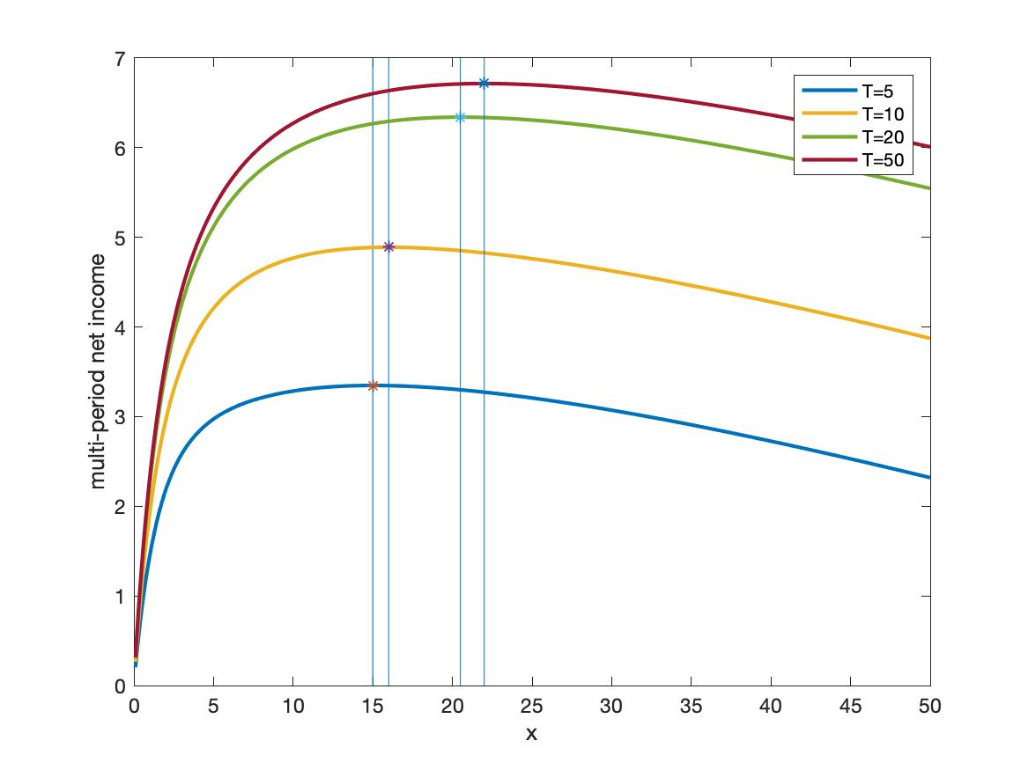

Figure 3: Figure 2: Multi-period optimization of optimal water use under technology growth. The figure depicts the relationship of multi-period benefits of province and water use under Case 3 with technology growth. Assume , , , , , , and .

*(b) Economic benefits and “remote” ecological costs with different discount factors*

*Assuming that there is a high discount rate for economic benefits and a low discount rate for ecological costs, in the scenario of provinces bargaining for water use under total quota , with unit price of output , unit cost , discount factor and (). For simplicity, consider the following finite-period water use optimization, noting the water use of province at period :*

*We depict the relationship of multi-period net income and water use in different horizons in Figure**4* *, and thus find out the optimal water use pattern under “remote” ecological costs. The higher discounted ecological costs might create enough incentive to set off the untransferable cost. On the other hand, as the provincial decision is under a longer horizon, a more significant sprint effect is due to a higher accumulated yield.*

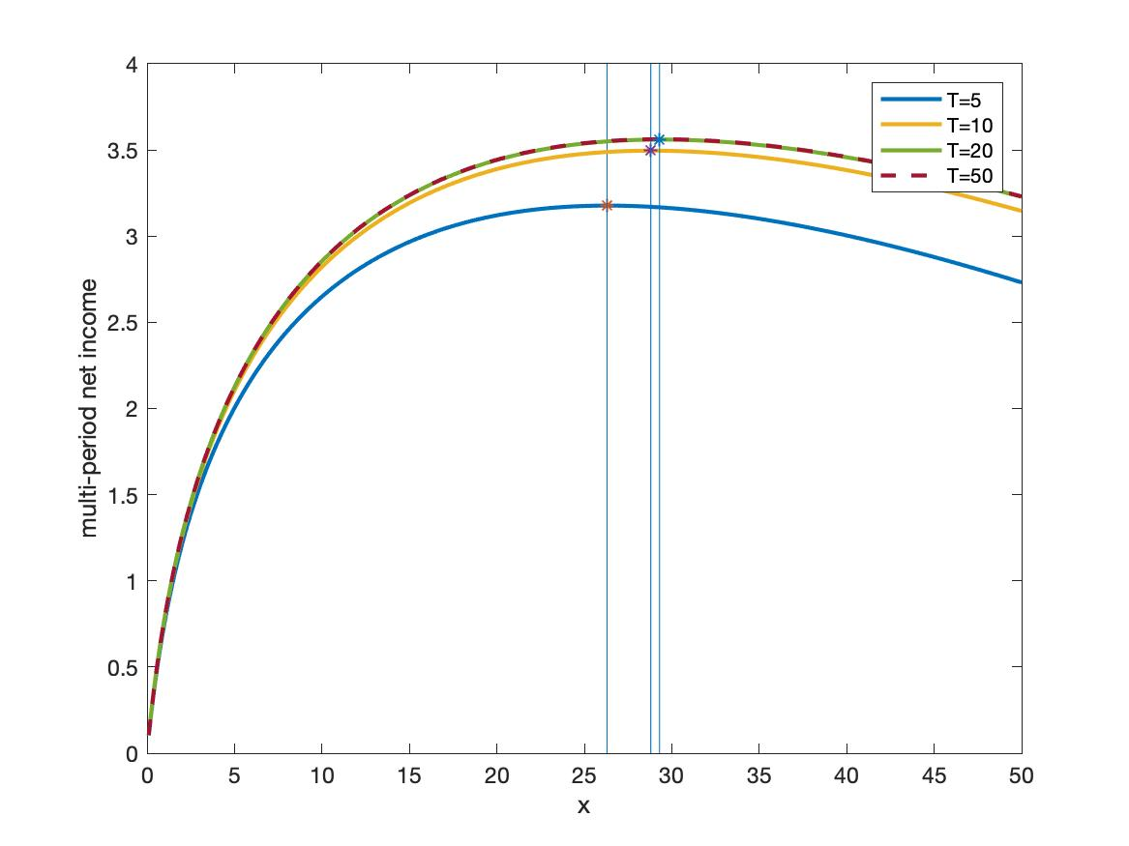

Figure 4: Figure 3: Multi-period optimization of water use under “remote” ecological cost. The figure depicts the relationship of multi-period benefits of province and water use under Case 3 with “remote” ecological cost. Assume , , , , , , and .

[bib]

# Reference

1. Distefano, T. & Kelly, S. [Are we in deep water? Water scarcity and its limits to economic growth](https://doi.org/10.1016/j.ecolecon.2017.06.019). *Ecological Economics* **142**, 130–147 (2017).

2. Dolan, F. *et al.* [Evaluating the economic impact of water scarcity in a changing world](https://doi.org/10.1038/s41467-021-22194-0). *Nat. Commun.* **12**, 1915 (2021).

3. Xu, Z. *et al.* [Assessing progress towards sustainable development over space and time](https://doi.org/10.1038/s41586-019-1846-3). *Nature* **577**, 74–78 (2020).

4. Mekonnen, M. M. & Hoekstra, A. Y. [Four billion people facing severe water scarcity](https://doi.org/10.1126/sciadv.1500323). *Sci. Adv.* **2**, e1500323 (2016).

5. Gleick, P. H. & Palaniappan, M. [Peak water limits to freshwater withdrawal and use](https://doi.org/10.1073/pnas.1004812107). *PNAS* **107**, 11155–11162 (2010).

6. Ziolkowska, J. R. & Peterson, J. M. *Competition for Water Resources: Experiences and Management Approaches in the US and Europe*. (Elsevier, 2016).

7. Wang, S. *et al.* [Alignment of social and ecological structures increased the ability of river management](https://doi.org/10.1016/j.scib.2019.07.016). *Sci. Bull.* **64**, 1318–1324 (2019).

8. Giuliani, M. & Castelletti, A. [Assessing the value of cooperation and information exchange in large water resources systems by agent-based optimization](https://doi.org/10.1002/wrcr.20287). *Water Resour. Res.* **49**, 3912–3926 (2013).

9. Falkenmark, M., Wang-Erlandsson, L. & RockstrÖm, J. [Understanding of water resilience in the Anthropocene](https://doi.org/10.1016/j.hydroa.2018.100009). *Journal of Hydrology X* **2**, 100009 (2019).

10. Jaeger, W. K. *et al.* [Scope and limitations of drought management within complex human-natural systems](https://doi.org/10.1038/s41893-019-0326-y). *Nat. Sustain.* **2**, 710–717 (2019).

11. *Institutions and environmental change: Principal findings, applications, and research frontiers*. (MIT Press, 2008).

12. Cumming, G. S. *et al.* [Advancing understanding of natural resource governance: A post-Ostrom research agenda](https://doi.org/10.1016/j.cosust.2020.02.005). *Current Opinion in Environmental Sustainability* **44**, 26–34 (2020).

13. Lien, A. M. [The institutional grammar tool in policy analysis and applications to resilience and robustness research](https://doi.org/10.1016/j.cosust.2020.02.004). *Current Opinion in Environmental Sustainability* **44**, 1–5 (2020).

14. Bodin, O. [Collaborative environmental governance: Achieving collective action in social-ecological systems](https://doi.org/10.1126/science.aan1114). *Science* **357**, eaan1114 (2017).

15. Kluger, L. C., Gorris, P., Kochalski, S., Mueller, M. S. & Romagnoni, G. [Studying human–nature relationships through a network lens: A systematic review](https://doi.org/10.1002/pan3.10136). *People Nat.* **2**, 1100–1116 (2020).

16. Agrawal, A. [Sustainable Governance of Common-Pool Resources: Context, Methods, and Politics](https://doi.org/10.1146/annurev.anthro.32.061002.093112). *Annu. Rev. Anthropol.* **32**, 243–262 (2003).

17. Persha, L., Agrawal, A. & Chhatre, A. [Social and Ecological Synergy: Local Rulemaking, Forest Livelihoods, and Biodiversity Conservation](https://www.science.org/doi/abs/10.1126/science.1199343). *Science* (2011).

18. Agrawal, A. [Common Property Institutions and Sustainable Governance of Resources](https://doi.org/10.1016/S0305-750X(01)00063-8). *World Development* **29**, 1649–1672 (2001).

19. Epstein, G. *et al.* [Institutional fit and the sustainability of social–ecological systems](https://doi.org/10.1016/j.cosust.2015.03.005). *Current Opinion in Environmental Sustainability* **14**, 34–40 (2015).

20. Green, O., Garmestani, A., van Rijswick, H. & Keessen, A. [EU Water Governance: Striking the Right Balance between Regulatory Flexibility and Enforcement?](https://doi.org/10.5751/ES-05357-180210) *Ecol. Soc.* **18**, (2013).

21. Abadie, A., Diamond, A. & Hainmueller, J. [Comparative Politics and the Synthetic Control Method: Comparative Politics and the Synthetic Control Method](https://doi.org/10.1111/ajps.12116). *American Journal of Political Science* **59**, 495–510 (2015).

22. Hill, A. D., Johnson, S. G., Greco, L. M., O’Boyle, E. H. & Walter, S. L. [Endogeneity: A Review and Agenda for the Methodology-Practice Divide Affecting Micro and Macro Research](https://doi.org/10.1177/0149206320960533). *Journal of Management* **47**, 105–143 (2021).

23. Shou-long, M. [Institutional analysis under the depletion of the Yellow River](https://kns.cnki.net/kcms/detail/detail.aspx?dbcode=CJFD&dbname=CJFD2000&filename=ZWQW200020021&uniplatform=NZKPT&v=2rrGzyi0e_w91jdi27jR8I9gdp_Btpa0PKT3pUMZ0ofAYfVyv_Xr7VeoiesoGTxP). *Chin. Foreign Corp. Cult.* 58–61 (2000).

24. Chen, C., Jia-jia, G. & Da-jun, S. [Water resources allocation and re-allocation of the Yellow River Basin](https://kns.cnki.net/kcms/detail/detail.aspx?dbcode=CJFD&dbname=CJFDLAST2021&filename=ZRZY202104015&uniplatform=NZKPT&v=tQHwxd2_O0DqVtXGxGXcwW5OsqQTjg6OYnfyCjw5KZ9N0rc-WLgZBBQvZ0UYeVHC). *Resour. Sci.* **43**, 799–812 (2021).

25. Hu An-gang, W. Y. Institutional failure is an important reason for the depletion of the Yellow River. *Rev. Econ. Res.* 31 (2002) doi:[10.16110/j.cnki.issn2095-3151.2002.63.035](https://doi.org/10.16110/j.cnki.issn2095-3151.2002.63.035).

26. Xin-dai, A., Qing, S. & Yong-qi, C. [Prospect of water right system establishment in Yellow River Basin](https://kns.cnki.net/kcms/detail/detail.aspx?dbcode=CJFD&dbname=CJFD2007&filename=SLZG200719038&uniplatform=NZKPT&v=5q38Jxp-3Q0FuG3N3kMKdCVt0LTbHDN93vRDqJTzRQsrS0ejKhnJTBGXaCwppoYC). *CHINA WATER Resour.* 66–69 (2007).

27. Guerrero, A., Bodin, Ö., McAllister, R. & Wilson, K. [Achieving social-ecological fit through bottom-up collaborative governance: An empirical investigation](https://doi.org/10.5751/ES-08035-200441). *Ecol. Soc.* **20**, (2015).

28. Bodin, Ö. & TengÖ, M. [Disentangling intangible social–ecological systems](https://doi.org/10.1016/j.gloenvcha.2012.01.005). *Global Environmental Change* **22**, 430–439 (2012).

29. Sayles, J. S. & Baggio, J. A. [Social–ecological network analysis of scale mismatches in estuary watershed restoration](https://doi.org/10.1073/pnas.1604405114). *Proc Natl Acad Sci USA* **114**, E1776–E1785 (2017).

30. Sayles, J. S. Social-ecological network analysis for sustainability sciences: A systematic review and innovative research agenda for the future. *Env. Res Lett* 19 (2019) doi:[10.1088/1748-9326/ab2619](https://doi.org/10.1088/1748-9326/ab2619).

31. Cai, H., Chen, Y. & Gong, Q. [Polluting thy neighbor: Unintended consequences of China’s pollution reduction mandates](https://doi.org/10.1016/j.jeem.2015.01.002). *Journal of Environmental Economics and Management* **76**, 86–104 (2016).

32. Bergsten, A. *et al.* [Identifying governance gaps among interlinked sustainability challenges](https://doi.org/10.1016/j.envsci.2018.10.007). *Environmental Science & Policy* **91**, 27–38 (2019).

33. Cumming, G. S. & Dobbs, K. A. Quantifying Social-Ecological Scale Mismatches Suggests People Should Be Managed at Broader Scales Than Ecosystems. *One Earth* S2590332220303511 (2020) doi:[10.1016/j.oneear.2020.07.007](https://doi.org/10.1016/j.oneear.2020.07.007).

34. Wang, Y. *et al.* [Review of the Implementation of the Yellow River Water Allocation Scheme for Thirty Years](https://doi.org/10.3969/j.issn.1000-1379.2019.09.002). *Yellow River* **41**, 6–19 (2019).

35. Qi-ting, Z., Bin-bin, W., Wei, Z. & Jun-xia, M. [A method of water distribution in transboundary rivers and the new calculation scheme of the Yellow River water distribution](https://doi.org/10.18402/resci.2020.01.04). *Resour. Sci.* **42**, 37–45 (2020).

36. Krieger, J. H. [Progress in Ground Water Replenishment in Southern California](https://doi.org/10.1002/j.1551-8833.1955.tb19237.x). *J. Am. Water Works Assoc.* **47**, 909–913 (1955).

37. Ostrom, E. *Governing the Commons: The Evolution of Institutions for Collective Action*. (Cambridge University Press, 1990). doi:[10.1017/CBO9780511807763](https://doi.org/10.1017/CBO9780511807763).

38. Ya-hua, W. [Transformation of Water Conservancy Governance : From Traditional to Sustainable Development — Preliminary Evaluation of the Yellow River Flood Control ( 2000-2004 )](https://kns.cnki.net/kcms/detail/detail.aspx?dbcode=CPFD&dbname=CPFDLAST2016&filename=QHGY201209014012&uniplatform=NZKPT&v=Bwk0hYRJ7ziEdGfxvemrTMKrjPTzH4Eo1DrLR8HROmek2wUapLVRKu8ulzwRM-9u4bRXGtuK1kU%3d). *Natl. Cond. Rep. Vol. VIII 2005 I* 141–158 (2012).

39. Ostrom, E. [A General Framework for Analyzing Sustainability of Social-Ecological Systems](https://doi.org/10.1126/science.1172133). *Science* **325**, 419–422 (2009).

40. Reyers, B., Folke, C., Moore, M.-L., Biggs, R. & Galaz, V. [Social-Ecological Systems Insights for Navigating the Dynamics of the Anthropocene](https://doi.org/10.1146/annurev-environ-110615-085349). *Annu. Rev. Environ. Resour.* **43**, 267–289 (2018).

41. Yu, W. *et al.* Adaptability assessment and promotion strategy of the Yellow River Water Allocation Scheme. *Adv. Water Sci.* **30**, 632–642 (2019).

42. Hegwood, M., Langendorf, R. E. & Burgess, M. G. Why win–wins are rare in complex environmental management. *Nat Sustain* 1–7 (2022) doi:[10.1038/s41893-022-00866-z](https://doi.org/10.1038/s41893-022-00866-z).

43. Muneepeerakul, R. & Anderies, J. M. [Strategic behaviors and governance challenges in social‐ecological systems](https://doi.org/10.1002/2017EF000562). *Earth’s Future* **5**, 865–876 (2017).

44. Leslie, H. M. *et al.* [Operationalizing the social-ecological systems framework to assess sustainability](https://doi.org/10.1073/pnas.1414640112). *Proc. Natl. Acad. Sci.* **112**, 5979–5984 (2015).

45. Arkhangelsky, D., Athey, S., Hirshberg, D. A., Imbens, G. W. & Wager, S. [Synthetic Difference-in-Differences](https://doi.org/10.1257/aer.20190159). *Am. Econ. Rev.* **111**, 4088–4118 (2021).

46. Bodin, Ö., Barnes, M. L., McAllister, R. R. J., Rocha, J. C. & Guerrero, A. M. [Social–Ecological Network Approaches in Interdisciplinary Research: A Response to Bohan et al. And Dee et al.](https://doi.org/10.1016/j.tree.2017.06.003) *Trends Ecol. Evol.* **32**, 547–549 (2017).

47. Zhou, F. *et al.* [Deceleration of China’s human water use and its key drivers](https://doi.org/10.1073/pnas.1909902117). *Proc Natl Acad Sci USA* **117**, 7702–7711 (2020).

48. Bayani, M. *Robust Pca Synthetic Control*. <https://papers.ssrn.com/abstract=3920293> (2021).

49. Abadie, A., Diamond, A. & Hainmueller, J. [Synthetic Control Methods for Comparative Case Studies: Estimating the Effect of California’s Tobacco Control Program](https://doi.org/10.1198/jasa.2009.ap08746). *Journal of the American Statistical Association* **105**, 493–505 (2010).

50. Abadie, A. [Using Synthetic Controls: Feasibility, Data Requirements, and Methodological Aspects](https://doi.org/10.1257/jel.20191450). *Journal of Economic Literature* **59**, 391–425 (2021).

51. Billmeier, A. & Nannicini, T. [Assessing Economic Liberalization Episodes: A Synthetic Control Approach](https://doi.org/10.1162/REST_a_00324). *The Review of Economics and Statistics* **95**, 983–1001 (2013).

52. Smith, B. [The resource curse exorcised: Evidence from a panel of countries](https://doi.org/10.1016/j.jdeveco.2015.04.001). *J. Dev. Econ.* **116**, 57–73 (2015).

53. Speed, R. & Asian Development Bank. [*Basin water allocation planning: Principles, procedures, and approaches for basin allocation planning*](http://www.adb.org/sites/default/files/pub/2013/basic-water-allocation-planning.pdf). (Asian Development Bank, GIWP, UNESCO, and WWF-UK, 2013).

54. Wang, Z. & Zheng, Z. [Things and Current Significance of the Yellow River Water Allocation Scheme in 1987](https://doi.org/10.3969/j.issn.1000-1379.2019.10.019). *Yellow River* **41**, 109–127 (2019).