Understanding and avoiding institutional mismatches in large river basins

Shuang Song $​^{1,2}$, Huiyu Wen $​^{3}$, Shuai Wang $​^{1,2}$, Graeme S. Cumming $​^{4}$& Bojie Fu $​^{1,2}$

Increasing competition for water is challenging management institutions in large river basins around the world. Those that successfully support sustainable water resource use both realign and are structurally well-aligned with water provisioning and social-ecological demands. However, what constitutes a well-aligned institution in this context is poorly understood. We analysed institutional shifts in water resource allocation, exploiting two quasi-natural experiments of in the Yellow River Basin, China. Paradoxically, an institution that was intended to prevent water overuse resulted in social-ecological structure mismatches, with sharp 164% increase beyond expected total water use. Novel application of an economic model suggested that this “sprint effect” and resulting ecological crisis were driven by incentive distortion that led to each province trying to pre-empt quotas for potential long-term benefits. Our analysis highlights the need for water management in large river basins to carefully evaluate structures’ effects and account for the possibility of incentive distortion.

$​^{1}$ State Key Laboratory of Earth Surface Processes and Resource Ecology, Faculty of Geographical Science, Beijing Normal University, Beijing 100875, P.R. China

$​^{2}$ Institute of Land Surface System and Sustainability, Faculty of Geographical Science, Beijing Normal University, Beijing 100875, P.R. China

$​^{3}$ Hanqing Advanced Institute of Economics and Finance, Renmin University of China, Beijing 100875, P.R. China

$​^{4}$ ARC Centre of Excellence for Coral Reef Studies, James Cook University, Townsville 4811, QLD, Australia

# Introduction

Emerging competition for water is an urgent problem in water governance, as widespread water scarcity and over-use are resulting in huge impacts on economies, societies, and ecosystems . Water is a key Common-Pool Resource (CPR) that couples socioeconomic and ecological systems . Interest conflicts often occur on the allocation of non-exclusive and competitive CPR, remaining open discussions on natural resources governance and sustainability where institutions can play a key role. Water governance and particularly water resource allocation policies, is often accompanied by long-term changes in human-water relationships and redistribution of benefits . Although governments in many of the world’s large river basins have tried to resolve competition for water through institutional design, it is still unclear how it effects socio-hydrological feedbacks and SES outcomes.

Institutions (such as policies, laws and norms) can influence regional sustainability by changing SES structure and dynamics . These include inter-relationships and interactions between social actors, between ecological units, or between social and ecological system elements . Effective institutions operate at appropriate spatial, temporal and functional scales to manage and balance these different relationships and interactions . From the perspective of SES outcomes, matched institutions support (but do not guarantee) sustainability .

Some kinds of institution have been shown to support desirable outcomes in water-centred SESs (e.g., Ecological Water Diversion Project in Heihe River Basin, China ; collaborative water governance in Europe ). At the same time, other undesired and unsustainable outcomes (e.g., failures in environmental regulation of highly polluting industries; or tragedy of the commons when pursuing more water resources), with considerable ecological welfare loss, have attracted much attention . A vast of empirical and statistical researches indicate that maintenance of an ecological-oriented institution is partially based on a matched SES structure, consisting alignments between social stakeholders and ecological components . However, despite widespread recognition of the rising importance of integrated water resources management in solving water competitions in the world’s large river basins, few analyses focus on the mechanisms of institution-based solutions. Deeper understanding of SES structures that remains unsolved in previous literature is twofold: (i) the causal link of SES structures and outcomes; (ii) the mechanism of the SES alignments, especially the coordination of each participants’ incentives. The knowledge gaps limit understanding of institutional design, and may reduce the speed and transfer of new knowledge and experience for improving the sustainability of comprehensive water resources management.

In order to disentangle the relationship between SES structure and outcome, we analyse how a institutional shift led to a structural mismatch with unsustainable water use and unintended ecological deterioration. Two sharp shifts of the SES structure, in 1987 and 1998 respectively, provide unique settings exploiting quasi-natural experiments of a large river basin -the Yellow River Basin (YRB) in China. Following severe drying up, the institutional shift in 1987 opened up attempts to control water use through quotas, with the goal of alleviating the conflict between supply and demand and achieve sustainable development. However, our results show that this initiative actually accelerated water withdrawals, resulting in an unintended “sprint effect” until the next major institutional shift in 1998. An economic model indicates that the sprint effect would be caused by incentive distortion. We contribute to the mechanisms of the relationship between institutions, SES structures and outcomes in sustainability. Raising potential concerns for ecological system collapses under structural mismatches, our findings are consistent with the urgent calls for dynamic design for water use allocation to achieve sustainability.

# Institutions and SES structures

Institutions may shape structure of SES and abstracting it is the first step towards understanding the mechanisms linking structures and outcomes in SES (Figure 1A). For example, institutions may create a structure that identified as a horizontal match linking with good SES outcomes, if it encourages collaboration between different actors managing connected ecological components (Figure 1B). Institutions for vertical management may benefit multi-layered SES matches by coordinating the horizontal relationship (Figure 1C). Under the above theoretical framework, however, prior empirical evidences are simply attributions without reliable mechanisms, and thus failed to fully echo the highly abstracted SES structures. As river basins are geospatial complete regions closely connected by ecological processes with multiple stakeholders, we fill these important gaps by studying the SES structure regarding river basin management.

Specifically, we explore the causal linkages between the SES structures and sustainability (outcomes) by quasi-natural experiments of Yellow River Basin (YRB) in China, since it provide a representative and unique setting of SES structural shifts by the following two main reasons. First, the sharp structural shifts in YRB enable us to quantitatively estimate the net effects induced by institutional design regarding water use, more precisely. Institutions that determine water allocation include bottom-up agreements or social norms as well as top-down quotas or regulations, with different effects on SES structure . Top-down regulations can trigger immediate institutional shifts and sharp SES structural changes . Compared with gradual process induced by a bottom-up institution shift, it substantially diminishes potential disruptions from unobservable factors in the quantitative analysis of SES, and improve the reliability of our causal link between SES structure and outcome. Second, by comparing the net effects of three different structures split by two institutional shifts of YRB, we can also have better understanding of the key to structural alignments under the “basin fixed effect”. Although socio-economic units within the basin benefit from water resources in large river basins all over the world and many locations showing increased levels of regulation, few basins have radical SES structure changes many times(see *Appendix Figure S1-A*). Thus, the YRB provides a valuable opportunity of self-comparison in SES structures.

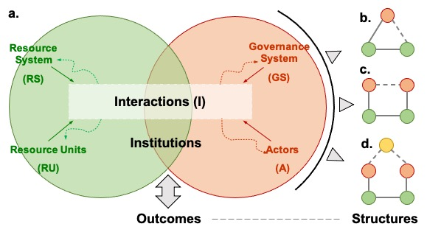

Framework for understanding linkages between SES structures and outcomes. **a.** The general framework for analysing social-ecological systems (adapted from Ostrom, 2009). Institutions embedded in SES may reshape structures by changing the interactions between core subsystems, result in different outcomes. Three typical types of abstracted SES structures are shown as **b.**, **c.** and **d.** (adapted from Bodin, 2017). While red circles indicate social actors, green ones indicate ecological components. Connection (ties between two ecological components), collaboration (ties between two social actors) or management (ties between a social actor and an ecological component) exist when two units linked by grey line. According to empirical evidences, when grey dot lines exist, aligned SES structures usually result in a desirable outcome.

# Context of institutional shifts

The Yellow River, whose basin is also the cradle of Chinese civilization, is the fifth longest river in the world. It supports $9.7\%$ of China’s irrigations with only $2.6\%$ of its total water resources (data from <http://www.yrcc.gov.cn>, last access: 28 February 2021). However, after years of free access to water by provinces along the river (Figure 1 A and B), surface water consumption of the Yellow River was close to $80\%$ of its runoff by the 1980s and rising . Reductions in runoff since 1972 damaged the ecology of the YRB and restricted its economic development . Therefore, with typical top-down institutional structures in China (Appendix Figure S1-B), relatively integrated water allocation regulations proposed successively across different levels in the YRB (Figure 1 A). These include the national government, the basin management agency, the provinces, the cities, and even the districts (see Figure 1 B-D). These policies at different stages of institutional development triggered abrupt changes in the SES structure of the YRB with different outcomes (see Appendix A and Figure S1-C).

In the beginning, Chinese government issued instructions to the Yellow River Water Conservancy Commission (YRCC), the basin agency of the YRB, requiring it to design a water allocation scheme and at the same time requiring the provinces along the Yellow River to carry out water resources planning (see Appendix A1) (see *Appendix A1*) . The Chinese government started to assigned water quotas to the relevant provinces in 1987, but did not create a unit to coordinate water division between them (Figure 1 **A** and **C**). The mandate of the YRCC during this period was only to report on and analyse water consumption in the YRB . However, since reductions in river flow indicated an unintended SES outcome (Figure 1 E), the Chinese government pushed a policy reform in 1998 that required all provinces to apply for licenses to use water from the YRCC, allowing the council to directly regulate their water use (see *Appendix A1* and Figure 1 A and D). After the 1998 policy succeeded in curbing water extraction (Figure 1 E), since 2008 it has been further refined. The relevant provinces created a more detailed allocation plan and finally formed the present water allocation institutions of the YRB (see *Appendix A1*). Therefore, in our study period (from 1975 to 2008), the system shifted between three different SES structures (Figure 1 **B** to **D**). The sharp and unintended decline in the ecological condition of the Yellow River from 1987 to 1998 indicates an institutional mismatch during this period (Figure 1 the shadowed time periods).

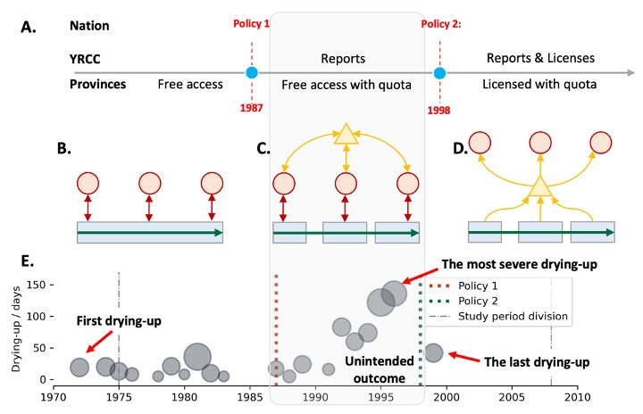

Institution shifts and related SES structures in the Yellow River Basin (YRB). **A.** The national government changed YRB management policies and institutions in 1987 and 1998 respectively (see Appendix A). As a result, the Yellow River Conservancy Commission (YRCC) and the provinces acted differently in different periods. Taken together, three different SES structures exist successively in the YRB: **B.** 1975-1987: Without any constraint, water resources were freely accessible to each stakeholder (province in this case, denoted by red circles), from a one-way but connected ecological unit (the Yellow River, denoted by the blue rectangle) during this period. **C.** 1987-1998: After the implementation of policy 1 in 1987 (see Appendix A1), each user is assigned a quota to withdraw the river’s surface water resources and the YRCC (yellow triangle) is tasked with reporting on water quota use. **D.** 1998-2008: After the implementation of policy 2 (see Appendix A1), stakeholders had to apply for water resources from the YRCC, which then licensed water use according to the quota. Under this institution, the YRCC had direct two-way connections between provinces and ecological components. **E.** Drying-up situations of the Yellow River. The size of circles indicates the length of drying-up section $\left(km\right)$ and the y-axis indicates the time span of a certain drying-up year. Both Policy 1 and Policy 2 were put forward to solve this ecological crisis (see Appendix A for details). The mismatch created by Policy 1 correlates clearly with the unintended outcome in the second (grey-shaded) period.

# Sprint effect induced by the mismatched institution

Our results suggest that the institutional shift in 1987 stimulated the provinces to use far more water than would have been used without policy effects (Figure 2A), with an increase of $164\%$ over the expectation (Figure 2B). However, the relative share of water use was not changed, denoting proportionally similar water use increases between different regions (Figure 2C). After the SES structure changed again in 1998, the trend of increasing water use appeared to be effectively suppressed (Figure 2 D), with total water consumption decreasing $-260\%$ relative to expectations (Figure 2 E). At this stage, however, the reduction in water use came mainly from the provinces with large water consumption, such as Henan and Shandong (Figure 2 E), so the proportion of used water of regions became more similar (Figure 2 F). In conclusion, the water allocation policy curbed water use in 1998, while the 1987-1998 institutional mismatches stimulated a significant increase in total water use for all related provinces. Over this decade, “sprint” responses to institutional change appear to have created a race in which each province began to use more water than they needed.

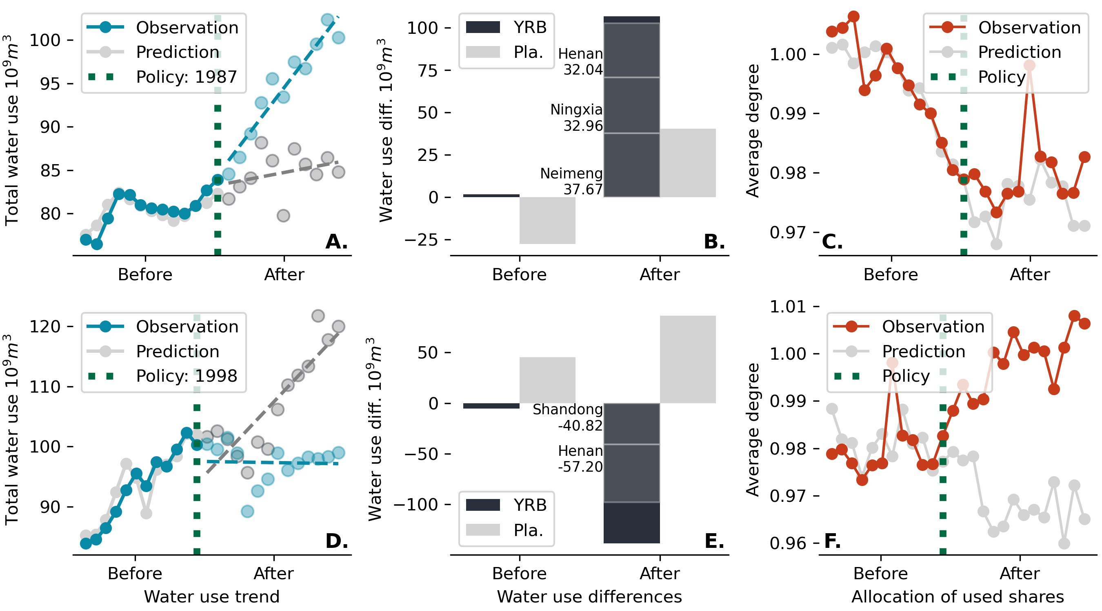

Effects of two institutional shifts (**A** to **C**: entering the mismatched SES structure in 1987; **D** to **E**: exiting the mismatching in 1998) on water resources use and allocation in the Yellow River Basin (YRB). **A** and **D**: Impact of institutional shift on water use trends in the YRB. Blue points are actual water use, grey are predicted under a scenario with unconstrained water use (see methods). **B** and **E**: Impact of institutional shift on total water use. Dark bars indicate the difference between the actual and predicted water use in specific study periods. Grey bars are the expected water use, simulated by setting up placebo experiments (null models) (see methods). **C** and **F**: Impact of institutional shift on water allocation equity (see **methods**). Red lines indicate the index calculated from actual water use data; grey lines indicate predicted water use under a scenario with unconstrained water use.

# Incentive distortion causes the sprint effect

Theoretically, our economic model suggests that different kinds of institutional shift would lead to different optimal water uses (Figure 3 **Panel A.**), and diagnoses the cause of the sprint effect as incentive distortion. Compared with decentralized water allocation institution before 1987, the presence of central management (by YRCC here, after 1998) can effectively reduce the marginal ecological costs (see Table 1 the **methods** for a detailed proof). The unintended sprint effect (from 1987 to 1998) is caused by both a declining marginal cost (shift from fixed unit cost to irrelevant cost) and increased marginal returns due to future water use benefits (see Table 1 the **methods** for a detailed proof). The institution thus triggers an incentive distortion that runs counter to the intention of sustainable water use. Further, the strength of the sprint effect is positively correlated with the size and the horizon of the water use quota because of incentive distortion increases as there are larger future benefits (Figure 3 **Panel B.**).

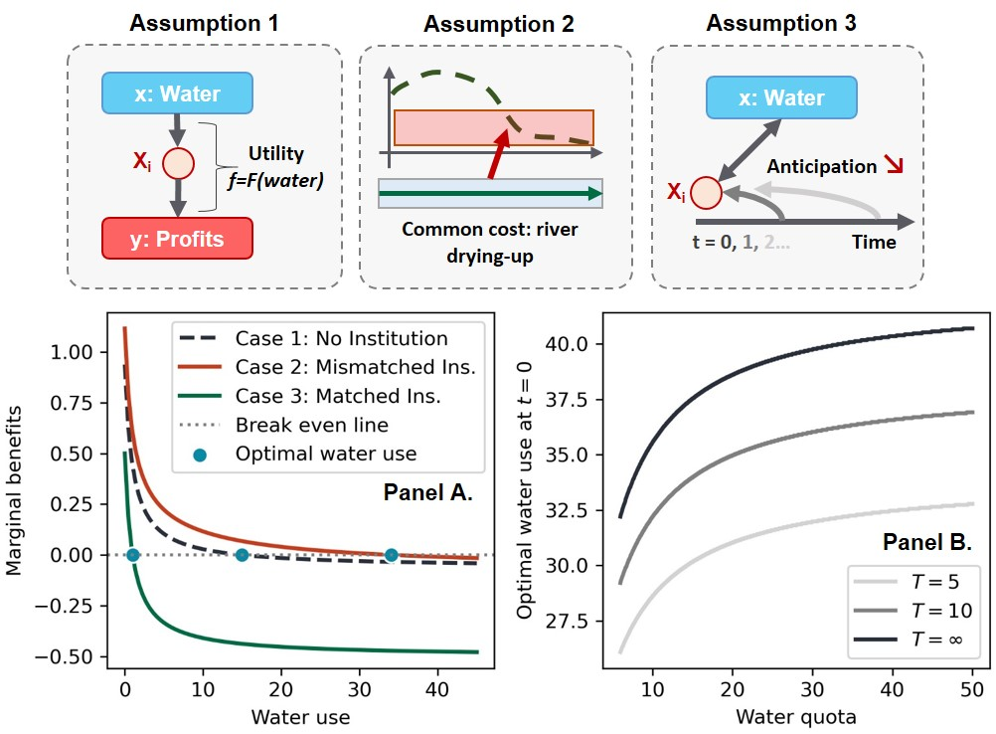

**Assumption 1:** (Production) Assuming that water is the only input of the homogenous production function F(x) of each province. Under diminishing marginal returns assumption, and $F\left(x\right)$ is continuous, $F'\left(0\right)=∞$, $F'\left(∞\right)=0$. The production output is under perfect competition, with constant unit price of P. **Assumption 2:** (Cost function) Assuming that the ecology is a unity for the whole basin, the cost of water use is equally assigned to each province under any water use. The unit cost of water is a constant C. **Assumption 3:** (Multi-period setting) There are infinite periods with constant discount factor $β$ lying in (0,1) with no cross-period smoothing in water uses. **Panel A.** The relationship of marginal benefits and water use of province $i$ at $t=0$ under different cases (case 1 to case 3 corresponding to different SES structures in Figure 1 in order, respectively). Assuming $F\left(x\right)=ln\left(1+x\right)$, $N=8$, $P=1$, $C=0.5$, and $β=0.4$ as an example. In Case 3, others’ water use is taken as given, equal to the optimal water use under Case 2. The horizontal coordinate of each intersection of marginal benefits and break-even line represents the optimal water use under each case. **Panel B.** The relationship of optimal water use of province $i$ and total quota under Case 3. The settings are the same as notes of the panel A. The table shows marginal returns (in red) and marginal costs (in green) for different cases.

# Discussion

We have shown how a mismatched allocation institution would lead to an accelerated depletion of water resources (“sprint effect”) due to incentive distortion. The sprint effect is a special case faced by common-pool resource systems, where institutional mismatches create an even stronger incentive for each resource user to withdraw resources . Previous studies suggested that institutions are often the key to avoid the collapse of a “common-pool resource” system, but the emergence of a sprint effect shows that an institution with structural mismatches can also be the trigger that accelerates system collapse . In practice, although affected provinces do not directly encourage excessive resource use, they are more likely to give the green light to resource withdrawals because of incentive distortions. As a result, while competing for potential water quotas (or, to demonstrate that they need a greater share of available water), provinces hide the ecological costs behind economic development.

There is no doubt that with increasingly fierce competition for water, more and more SESs are developing new institutions for water allocation (whether through self-organization or government intervention). Adoption of an overall quota plays an important role in preventing over-use of common-pool resources. However, the sprint effect due to incentive distortion implies a trade-off between long-term SES benefits and current stability, and the proportion of available resources allocated under quota schemes matters when institutions change. According to our analysis of plausible scenario assumptions based on our general economic model, the sprint effect will be reinforced when stakeholders anticipate that technological advances will amplify the benefits of water quotas in the future (see *Appendix F1*). However, if an institution allowed stakeholders to compensate for the shadow value (i.e., potential returns sacrificed due to water constraints and water scarcity) of future water use, incentive distortion would be less devastating (e.g., through water rights transfer). Policymakers can also weaken the sprint effect by increasing the frequency of quota updates, supporting the idea that a more dynamic institution that responds to changing conditions (see *Appendix F2*) will adapt more effectively to its social-ecological context.

For the YRB, calls for a re-design of water allocation institutions in recent years also illustrate the importance of dynamic quota setting. Following the institutional reforms of 1998, the Yellow River has not dried up since 1999. However, given recent changes in the YRB, its rigid resource allocation scheme can no longer meet the new demands of economic development. The Chinese government has embarked on an ambitious plan to re-design its decades-old water allocation institution. Other SESs around the world face similar problems in establishing successful resource allocation institutions. These initiatives can learn from our analysis by actively considering and incorporating social-ecological complexity and incentive structures in developing new approaches that avoid unsustainable outcomes. Our research provides a cautionary tale of how institutions can act as a double-edged sword when trying to attain sustainability.

# Methods

We estimate and analyse the net effects of two SES structural change to water use. The actual water use of the Yellow River Basin was proxied by the sum of the water use of the target group provinces (i.e., the historical water use change influenced by the two institutional changes). To quantify water use, we used the control group data and synthetic control methods to estimate possible trends of water use without institutional shifts. In addition, as a robustness test, we conducted a matched placebo test to exclude the effects of other factors that are contemporaneous with the institutional shifts. Finally, we created an economic model based on marginal revenue to provide a theoretical explanation for the “sprint effect” phenomenon we found. A brief technical route organization is shown in *Appendix Figure S1*

## Dataset and variables

We use China’s provincial annual water consumption data set from 1978 to 2012. This publicly available dataset was obtained from the National Water Resources Utilization Survey; details are accessible from Zhou (2020) . A total of 10 provinces or regions have been directly affected by the water allocation institutional shifts in the YRB, accounting for $8.6\%$ of the total population of China (in 1990). Eight provinces have been particularly affected because of their greater dependence on the water resources from the Yellow River (see *Appendix Figure C1*). Therefore, we divided the dataset into a “target group” and a “control group”, treating provinces that were greatly affected as the target group $\left(n=8\right)$ and provinces that were not affected by the institutional shifts as the potential control group $\left(n=20\right)$.

We were concerned with two features of water use in the YRB: total water use, and diversification of water allocation. The actual water uses are given by the dataset, but when the synthetic control method is used to predict the water use of the control group, other independent influences need to be considered. Thus, we used economic features that are highly related to water used to extrapolate demand (such as agriculture, industry, service industry, and domestics, see Appendix Table 1 for a brief introduction and statistical information). To measuring resource allocation diversification between the upper, middle and lower reaches, we used the “entropy” as a simple index,



Where $p_{i}$ is the proportion of water uses for region i to the total water uses in the basin. The larger the index, the more average is the proportion of water resources actually used between the upper, middle and lower reaches.

## Synthetic Control

Synthetic Control is an effective identification strategy for estimating the net effect of historical events or policy interventions on aggregate units (such as cities, regions and countries) by constructing a comparable control unit. In this study, each of the units (i.e., provinces) in the target group were affected by institutional shifts in 1987 and 1998 respectively, so these two times were taken as the “shifted” time $t_{0}$. The synthetic control method generates the control unit by assigning a weight matrix $W$ to units of the potential control group, so that the target unit and its control unit are similar in each variable before $t_{0}$, i.e.,

$$\text{min}\left(V_{i}^{t<t_{0}}-W_{i}*F_{control}^{t<t_{0}}\right)$$

where $V_{i}$ is a vector indicates all features of a certain unit $i$ of the target group, and $F_{control}$ is a matrix consisted by all features and units of the potential control group. $W_{i}$ is the weight matrix for target unit $i$, and we minimize the Root Mean Square Error (RMSE) to calculate it in this study by Synth package in R. All codes are accessible in the repository.

In this way, based on the idea of dimensionality reduction, we constructed a series of comparable control units that were most similar in characteristics to the treated units. Since the units of control group were not affected by the institutional shifts, the result $M_{i}*WU_{control}$ after giving the same weight to the water use of the control group could be considered a reasonable estimation of the untreated situation. Then, the net effect of water allocation institutional shift was estimated by the difference of post water uses between the treated group and the control group, compared with the ex-post water use difference.

## Placebo Test

As a robustness test, the Placebo Test is suitable because the Synthetic Control method neglects the influences of overall changes in factors in the same year by simply dividing time periods according to institutional shifts. Three steps were required to apply a Placebo Test: (1) For each province in the target group, we calculated the Euclidean distance of vectors between all provinces in the potential control group. (2) After ranking the distances, the three provinces with the most similar economic context were used to generate an average paired treatment target unit. (3) We performed the same Synthetic Control analysis for this paired target (i.e., the potential control group excluding the three constituent provinces of step 2). In this way we theoretically constructed a pseudo-treated unit and performed the same Synthetic Control treatments. Since these placebo tests were directed at units unaffected by the institutional shifts, the results can be regarded as a reasonable baseline expectation or null model from which to assess the changes caused by other factors.

## Economic model

In order to understand the mechanisms underlying the empirical results, we developed a dynamic economic model to analyse how institutional change could have led to the sprint effect in water use. Specifically, we modelled individual provincial decision-making in water resources before quota execution. This analysis implied that the underlying driver of CPR overuse was incentive distortion.

In developing the model, we highlight main features of YRB, water use institutions of 1987 and 1998, and propose three intuitive and common assumptions.

**Assumption 1**. *(Water-dependent production) For simplification, water is the only input of the homogenous production function $F\left(x\right)$ of each province because of its irreplaceability. $F\left(x\right)$ is continuous and satisfies Inada Conditions, i.e., $F'\left(x\right)>0,F″\left(x\right)<0$ (diminishing marginal returns assumption), $F'\left(0\right)=∞$, $F'\left(∞\right)=0$. The production output is under perfect competition, with constant unit price of $P$.*

**Assumption 2**. *(Ecological cost allocation) Assuming that the ecology is a single entity for the whole basin, the cost of water use is equally assigned to each province under any water use. The unit cost of water is a constant $C$.*

**Assumption 3**. *(Multi-period settings) There are infinite periods with constant discount factor $β$ lying in (0,1). There is no cross-period smoothing in water uses.*

Under the above assumptions, we can demonstrate three cases consisting of local governments in YRB to imitate their water use decision-making and water use patterns, which provide theoretical support for the empirical sprint effect:

**Case 1**. *decentralized institution This case corresponds to a situation without any high-level water allocation institution (before 1987, see Figure**1* *B).*

*When each province independently decides on its water use, the optimal water use ${\hat{x}}_{i}^{*}$ in province $i$ satisfies: $F'\left(x\right)=\frac{C}{P⋅N}$*

*When the decisions in different periods are independent, for $t=0,1,2…$, then: ${\hat{x}}_{it}^{*}={\hat{x}}_{i}^{*}$*

**Case 2**. *Mismatched institution This case corresponds to the mismatched institution ($1987∼1998$, see Figure**1* *C).*

*The water quota is determined at $t=0$ and imposed in $t=1,2,…$ The total quota is a constant denoted as $Q$, and the quota for province $i$ is determined in a proportional form: $Q_{i}=Q⋅\frac{x_{i}}{x_{i}+\begin{matrix}∑x_{-i}\end{matrix}}$*

*Under decentralized decisions with water quota institution, given other provinces’ water use decision unchanged, the optimal water use ${\tilde{x}}_{i0}^{*}$ of province $i$ at $t=0$ satisfies:*

$F'\left(x_{i,0}\right)=\frac{C}{P⋅N}-\frac{β}{1-β}⋅f\left(Q⋅\frac{x_{i,0}}{\begin{matrix}x_{i,0}+∑x_{-i,0}\end{matrix}}\right)⋅Q⋅\frac{\begin{matrix}∑x_{-i,0}\end{matrix}}{{\left(\begin{matrix}x_{i,0}+∑x_{-i,0}\end{matrix}\right)}^{2}}$*.*

*When the future water use would be constrained by the water quota, the dynamic optimization problem of province $i$ is shown as follows:*

$$max P⋅F\left(x_{i,0}\right)-\frac{C⋅\begin{matrix}∑x_{i,0}+x_{-i,0}\end{matrix}}{N}+βP⋅F\left(x_{i,1}\right)+β^{2}P⋅F\left(x_{i,2}\right)+...$$

$$=P⋅F\left(x_{i,0}\right)-C⋅\frac{x_{i,0}+\begin{matrix}∑x_{-i,0}\end{matrix}}{N}+\frac{β}{1-β}P⋅F\left(Q⋅\frac{x_{i,0}}{x_{i,0}+\begin{matrix}∑x_{-i,0}\end{matrix}}\right)$$

*First-order condition: $P⋅F'\left(x_{i,0}\right)-\frac{C}{N}+\frac{β}{1-β}\left[P⋅f\left(Q⋅\frac{x_{i,0}}{x_{i,0}+\begin{matrix}∑x_{-i,0}\end{matrix}}\right)⋅Q⋅\frac{\begin{matrix}∑x_{-i,0}\end{matrix}}{{\left(x_{i,0}+\begin{matrix}∑x_{-i,0}\end{matrix}\right)}^{2}}\right]=0$*

*where $f\left(⋅\right)$ is the differential function of $F\left(⋅\right)$.*

*The optimal water use in province i at t=0 ${\tilde{x}}_{i,0}^{*}$ satisfies $P⋅F'\left(x_{i,0}\right)=\frac{C}{N}-\frac{β}{1-β}⋅P⋅f\left(Q⋅\frac{x_{i,0}}{x_{i,0}+\begin{matrix}∑x_{-i,0}\end{matrix}}\right)⋅Q⋅\frac{\begin{matrix}∑x_{-i,0}\end{matrix}}{{\left(x_{i,0}+\begin{matrix}∑x_{-i,0}\end{matrix}\right)}^{2}}$, i.e., $F'\left(x_{i,0}\right)=\frac{C}{P⋅N}-\frac{β}{1-β}⋅f\left(Q⋅\frac{x_{i,0}}{x_{i,0}+\begin{matrix}∑x_{-i,0}\end{matrix}}\right)⋅Q⋅\frac{\begin{matrix}∑x_{-i,0}\end{matrix}}{{\left(x_{i,0}+\begin{matrix}∑x_{-i,0}\end{matrix}\right)}^{2}}$.*

**Case 3**. *Matched institution*

*This case corresponds to the institution under which the YRCC centrally managed water allocation between provinces ($1998∼2008$, see Figure**1* *D).*

*When the $N$ provinces decide on water uses as a unity (i.e., the central government completely decides and controls on the water use in each province), the optimal water use $x_{i}^{*}$ of province $i$ satisfies:*

$$F'\left(x\right)=\frac{C}{P}$$

We propose Proposition 1 and Proposition 2:

**Proposition 1**: Compared with the decentralized institution, a matched institution of unified management decreases the total water use.

Since F’ is monotonically decreasing, based on the comparison of costs and benefits for stakeholders (provinces) in the three cases, i.e.:

$${\tilde{x}}_{i}^{*}>{\hat{x}}_{i}^{*}>x_{i}^{*}$$

The result of ${\hat{x}}_{i}^{*}>x_{i}^{*}$ indicates that individual rationality would deviate from collective rationality when property rights are unclear, due to the common-pool characteristics of water .

The difference of ${\tilde{x}}_{i}^{*}$ and ${\hat{x}}_{i}^{*}$ stems from two parts: marginal returns effect and marginal costs effects. First, the “shadow value” provides additional marginal returns of water use in t=0, which increases the incentives of water overuse to bargain for a larger quota. Second, the future cost of water use would be degraded from $\frac{P}{N}$ to irrelevant cost.

The optimal water use under the three cases implies that mismatched institutions would cause incentive distortions and lead to resources overuse from the perspective of SES as a unity.

**Proposition 2**: The quota determination of the mismatched institution increases the incentives of current water use.

The intuition is straight-forward that all provinces would use up their allocated quota under a relatively small $Q$. As $Q$ increases, the quota would provide higher future benefits for pre-emptive water use strategy. Since the provincial water use decisions are exactly symmetric, without solving the total water use under dynamic equilibrium, it comes to the conclusion that the total water use would increase when each province obtains higher incentives of current water use. It corresponds to a sprint effect, where the total water use dramatically increase in the “sprint” period.

More extensions of the model are shown in Appendix.

# Info.

Funding was provided by the National Natural Science Foundation of China (CN) (Grant Nos. NSFC 42041007).

[Competing Interests] The authors declare no competing interests.

[Correspondence] Correspondence and requests for materials should be addressed to Shuai Wang. (email: shuaiwang@bnu.edu.cn).

[Author contributions]Shuai Wang and Bojie Fu designed this research, Shuang Song performed the research and analysed data, Huiyu Wen designed the economic model, Shuang Song, Huiyu Wen wrote the paper.

[Code availability] All codes and datasets used in this research are accessible at https://github.com/SongshGeo/soc-hyd-transboundary-HESS (Will open source after this project finished.).

[tab:cases]

Summary of marginal returns and marginal costs for each case

|  |  |  |  |
| --- | --- | --- | --- |
|  | Case 1: decentralized institution | Case 2: Mismatched Ins. | Case 3: Matched Ins. |
| Marginal return | $$P*F'\left(X\right)$$ | $$P*F'\left(X\right)+V{\left(X\right)}^{*}$$ | $$P*F'\left(X\right)$$ |
| Marginal cost | $$C/N$$ | $$Irrelevant$$ | $$C$$ |