Identifying regime transitions for water governance at a basin scale

# 1 Introduction

[Intro.] Water, being “at the centre of the planetary drama of the Anthropocene”, is essential not only for earth system processes but also in supporting the development and human well-being1,2. As an integral part of earth system governance, water governance requires a deep understanding of changes in the complex relationships between humans and water3–5. Human activities stemming from our reliance on the water have profoundly modified the natural water cycle, resulting in rivers dominated by a hybrid of social and natural tendencies6–8. Facing this transition, many big river basins worldwide (which are hot spots of civilization and economic growth) are urgently in need of successful water governance for sustainability9,10.

Water governance refers to the political, social, economic, and administrative systems that influence the use and management of water11,12. For populated large river basins, missing governance means missing sustainability, and a first critical step in understanding the transitions with successful water governance is identifying the different regimes13,14. Regimes of water governance maintained by concreted intertwine within human-water systems (such as management, institutions, and exploitations) as a stable state in structures and functions15–17. Therefore, regime shifts sometimes lead to new water governance challenges as both signals and consequences of substantive changes in human-water systems. The lack of a comprehensive but straightforward approach to identifying changes in water governance regimes challenges sustainability, and filling this gap can well align human and water systems (Figure [fig:framework]).

Governance is essentially about “who gets what, when and how”18. The United Nations Development Programme (UNDP) thus suggested that three key dimensions of water use are decided by the water governance directly: “When and what water to use?” (stress), “How does water provides different services to well-beings?” (purpose), and “Who can use water equally and efficiently?” (allocation)19. First, water stress depends not only on climate (with increasing scarcity and uncertainty in many regions) but also on the increasingly insatiable demands from economic activities such as irrigation and industry; water storage can resolve some but not all of these issues20–22. Second, the purpose of how water services human well-being is to consider trade-offs between consumptive uses (e.g., drinking and food production) and non-consumptive uses (e.g., energy production)23–25. Third, the allocation of water across the whole basin is not only decided by regionally socio-economic and environmental context but also influenced by systematically regulating26,27. Despite regime shifts in water governance related to substantive changes in any of the three dimensions, separately considering their intertwines within human-water systems can lead to holistic failure in governing water.

The Yellow River Basin (YRB), the fifth-largest river in the world, was most in need of integrated water governance because drastically anthropogenic intervention led to intense governance challenges in sustainability28. Since the 1960s, the implementation of conservation measures, regulation reservoirs, and levee constructions have contained the governance issues troubled by thousands of years of high sediment loads29,30. However, decreased streamflows and water over-use then led to depletions of the over-burdened river, creating new challenges and new governance practices, including water use regulation and water transfer across basins31. Today, it is still impossible to completely solve water stress, trade-offs between ecosystem services, or lopsided development in different regions in the YRB; -“who gets water, when and how” is always an open question for sustainable development32. Confronting governance challenges induced by environmental, economic, social, and political factors, numerous governance practices have led the YRB to be among the most drastically-governing large river basins worldwide33. Identifying regime shifts in water governance within the YRB can thus provide crucial insights into rapidly-changing big river basins and how governance may respond to meeting challenges to their sustainability.

Here, we use the three core dimensions (stress, purpose and allocation) and corresponding indicators of water governance to develop an Integrated Water Governance Index (IWGI) that can detect and describe changes in water governance at a basin-scale (see Figure [fig:framework] and methods). Then, by applying the index to a typical rapid-changing big river basin (the YRB), we show how to analyze the complicated water governance regimes in a comprehensive but straightforward way. Following synthetic analyses of the changes in water demand, supply, economic outcomes, and institutions, we interpret the leading causes of the regime shifts. Finally, we propose a general regime transition schema as a practical guideline for a coordinated approach to exploring the challenges faced by big river basin governance.

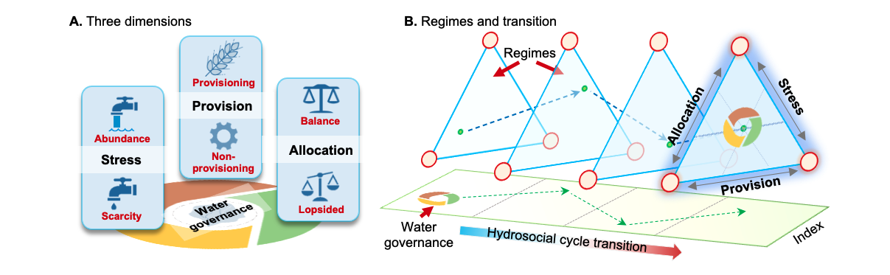

**Figure 1**: Identifying the water governance regimes in transitions of a hydrosocial cycle. **A.** Water governance has three key dimensions (stress, purpose and allocation), each of which has two potential directions (denoted in red) when changing. (1) ``stress'' of water shifts between scarcity and abundance; (2) weighting ``purpose'' of water between consumptive services or non-consumptive uses; (3) ``allocation'' changes between balanced or lopsided. **B.** Along with a transition in hydrosocial water cycle, water governance shifts in line with the three dimensions. Combining corresponding indicators, an abrupt change of the IWGI thus indicates a regime shift in water governance.

# 2 Results

## 2.1 Water governance regimes

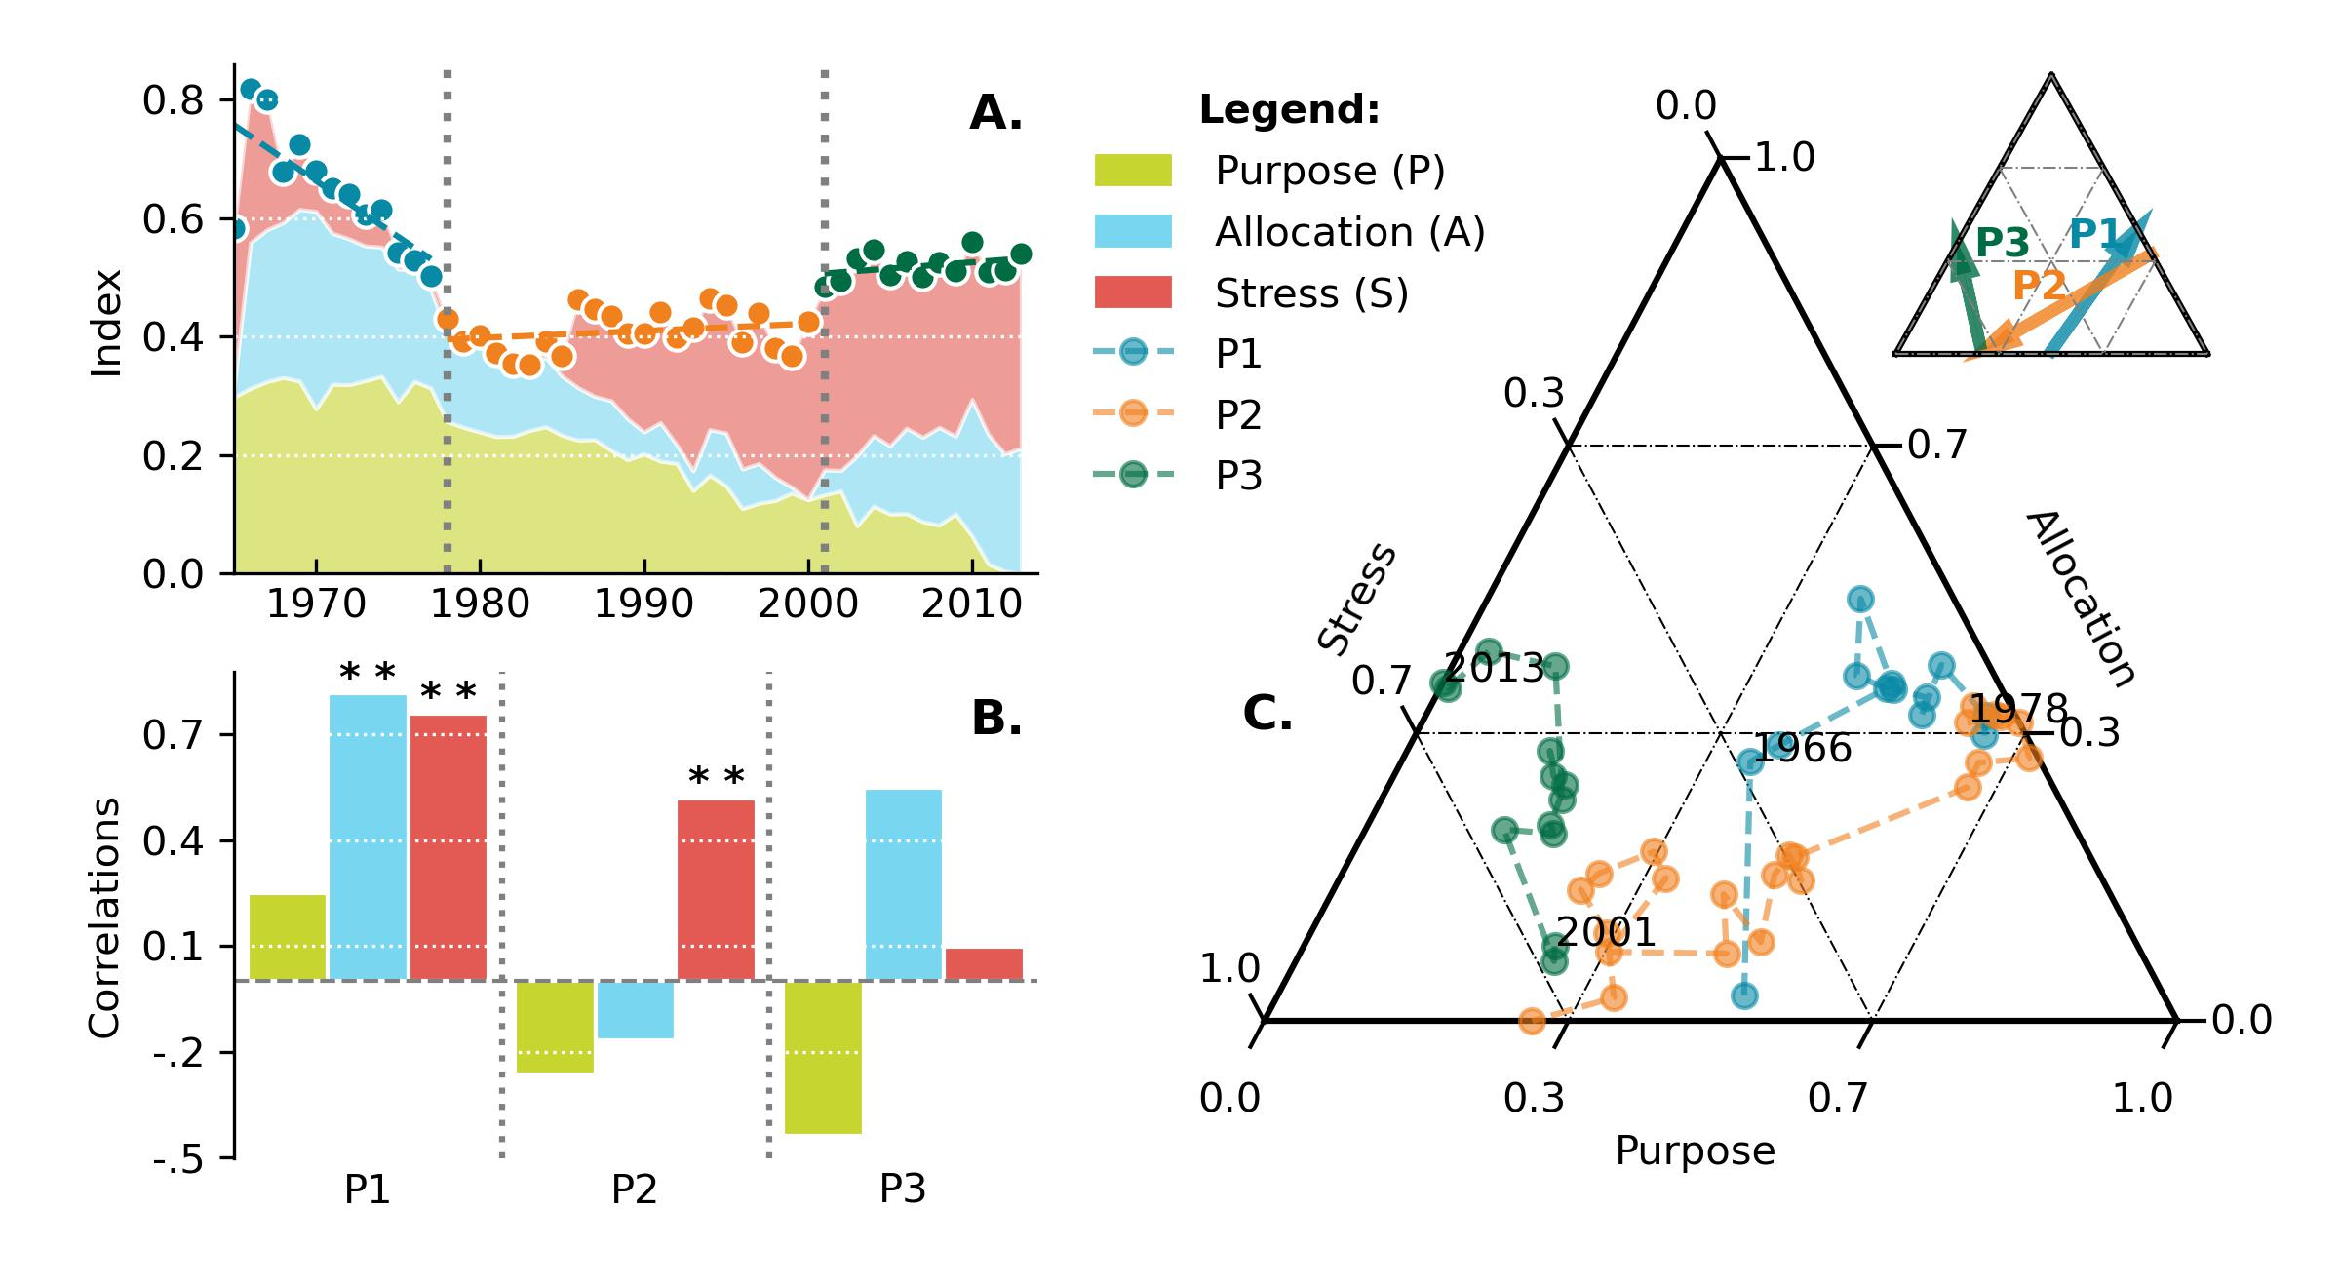

**Figure 2:** Changes in the IWGI index and corresponding water governance regimes: P1: 1965-1978, P2: 1979-2001, and P3: 2002-2013. **A,** detecting change points of IWGI and contributions from each indicator. Two significant change points ($p<0.01$) occurred in 1978 and 2001. **B,** correlation of trends between the IWGI and the indicators. **C,** across three indicators, changing components of the IWGI, whose directions shifts between different regimes.

Two significant breakpoints divide the changes in the IWGI into three periods, with different contributions from three dimensions (Figure [fig:IWGI]A). In the first period (P1, 1965-1978), the IWGI decreased rapidly. While the indicator of purpose and allocation contributed more to the IWGI ( and on average, respectively), the remarkable downward trend correlates significantly () to the decreasing allocation and stress indicators (Figure [fig:IWGI]B). In the second period (P2, 1979-2001), the increasing stress indicator significantly () contributed to the upward IWGI, while the allocation and purpose indicators played negative roles in changing the IWGI. During the third period (P3, 1995-2013), while the stress indicator kept its most prominent share in contributions ( on average), the increased allocation indicator and decreased purpose indicator changed the regime of IWGI. Taken together, the overall features of the three dimensions in different periods are relative to a directional change in the combination of three dimensions (Figure [fig:IWGI]C). The results suggest three distinct water governance regimes: a massive supply regime (P1: 1965-1978), a governance transforming regime (P2: 1979-2001), and an adaptation oriented regime (P3: 2002-2013).

## 2.2 Causes of the regime shifts

image

**Figure 3:** Causes of water governance regime shifts in the YRB. **A.** Changes in the total irrigated area (orange line) and water use intensity ($WU/A$, water use divided by the irrigated area, the green dot line). **B.** Changes in gross values added (GVA) of industry and services (blue line) and their water use intensities ($WU/GVA$ WU divided by the GVA, the red dot line). **C.** Completed time of each new reservoir and their located region's water use (LWU) percentages as a proportion of the total basinal water use (BWU) at that time. Red circles denote the reservoirs mainly for managing and regulating the whole basin.The size of each circle indicates the magnitude of its water storage capacity. **D.** Social transformations (red triangles) and national-level governance policies (the circles, different colours denote signed by different state institutions, see \textit{Appendix} Table~\ref{tab:policies}). The light grey bars count official documents related to the YRB on a basinal scale (the Yellow River Events).

The underlying causes of changes in the IWGI are associated with various factors but are different in the two regime shifts. Changing water demands and supply were critical to the shift between P1 and P2. As the dominant water demand during the massive supply regime (P1), the area of irrigated agriculture in the YRB expanded rapidly at a rate of (Figure[fig:Causes] A), simultaneously supported by increasing supply through the construction of reservoirs (*Appendix* Figure 1). Entering the transformation governance regime (P2), however, the expansion of irrigated areas slowed down, and industry and services gradually took off (Figure[fig:Causes] A and B). Then, the efficiency of water use changed obviously from P2 to P3. Not only irrigated areas keep their slow expansion in the adaptation oriented regime (P3) (Figure[fig:Causes]A), but industry and urban services also assumed a more vital economic role (represented by Gross Added Values, GVA) (Figure [fig:Causes]B). Because of increased efficiency, however, they both experienced significant declines in water use for a unit irrigated area or unit production (Figure [fig:Causes]A and Figure [fig:Causes]B). As a result, the differences between sectors and regions in water use reduced while the total water stress steadily remained high during the adaptation oriented regime (Figure [fig:IWGI]A).

Environmental context, social transformation and policies played roles in all three regimes. We calculated the ratios of regional and basinal water use for each reservoir (R/B ratio) (Figure [fig:Causes]C), with a higher ratio representing a potential role in water supply rather than basinal regulations. Under the guiding ethos of “conquering nature”, most of the reservoirs were built in regions with high water demands during the massive supply regime (R/B ratios were significantly higher, , see Figure [fig:Causes]C)). Since the transformation governance regime (P2), the number of new reservoirs decreased significantly and significantly increased basinal policies rigorously controlled the allocation of water (Figure [fig:Causes]D, and *SI Appendix* Figure 1). In the adaptation oriented regime, authorities proposed more national-level water governance policies under the guidance of the national strategy “environmental regulation” (Figure [fig:Causes]D). The regime shift from P1 to P2 is in line with the increasing water supply and demands; while driven by regulatory policies and efficiency enhancement under stable water stress from P2 to P3.

# 3 Discussion

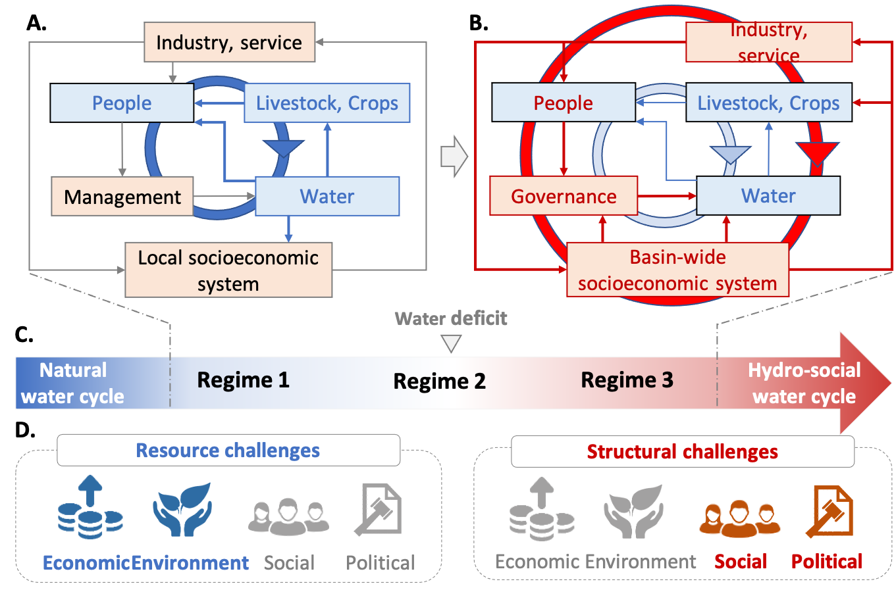

**Figure 4:** Transition schema in hydrosocial cycle and water governance regimes. The natural water cycle dominates blue pathways, while socio-economic feedback dominates red pathways. **A.** As socio-economic systems develop, non-provisioning water demand increases; simultaneously, increased adaptive capacity by engineering allows people to manage water resources to alleviate the water stress. **B.** With further human interventions, trade-offs between provisioning-purpose and non-provisioning water use become prominent; a basin-wide socio-economic system requires more organized water governance. Thus, **C.** **the hydrosocial water cycle transition** correlates with the water governance regime shifts (in the YRB, they are massive supply regime, transformation governance regime, and adaptation oriented regime). The transformation governance regime shift occurs following the water deficit, with the rapid growth of adaptive capacity. **D. Water governance challenges** Through the transitional regimes, water governance faces primarily economic and environmental challenges but social and policy challenges later.

Water governance gradually becomes a national or international concern from a primarily local concern because large river basins are critical sources of ecosystem services, economic development, and human well-being9,34. As the ubiquitous tele-coupling is rising additional water governance challenges in the tighter connected world, the transition of hydrosocial cycle and regime shifts align with different human-water relationships35. The process echoes how societies can change governance practices by enhancing their adaptive capacity in the hydrosocial cycle, and the IWGI quantitatively identifies this transition17,36. It is vital for scientists and decision-makers to recognize the changing governance challenges because models, institutions, engineering, and approaches developed under one regime are not necessarily applicable under a different regime37.

In the case of the YRB, our results show that there have been three distinct but sequential governance regimes: a massive supply regime (P1: 1965-1978), a governance transforming regime (P2: 1979-2001) and an adaptation oriented regime (P3: 2002-2013) (Figure [fig:IWGI]). During the massive supply regime with lower water stress (1965-1978 in the YRB), water governance thus tended to boost water supply for services (mainly provisioning purposes then -livestock and crops) by constructing reservoirs and channels. As the popular slogan “man will conquer nature” suggested, however, the enhancement of water supply aligned with little consideration of the irreversible changes in the human-water relationship, thus drastically increasing water demand with little consideration in basinal conservation38. The rapid expansion of irrigated farmland and water diversion facilities in that decade brought the overburdened YRB close to the critical point, where keeping increasing supply to meet the unlimited demand is unpractical17. As a result, the over 80% surface water use then led to river depletions frequently since 1972, with ecological issues, such as wetlands shrinkage and declines in biodiversity31. In addition, as the water stress also limited the industrial economy in the ascendant, the existing modes of water governance led to a social-ecological crisis and challenged sustainability rigorously32.

The start of the governance transforming regime (P2: 1979-2001) coincided with the rising competition for water use after the “reform and opening-up”. The results in the YRB keep in line with the suggestions from the theoretical analysis: continuous increases in water demand when the basinal total supply is stable can follow substantial changes in governance regime and the rapid enhancement in overall social adaptive capacity17. Being a pioneer in shifting governing institutions, the YRB triggered a series of changes in “who gets water, when and how” during this regime: slowing growth of irrigated acreage; leading water-saving infrastructure; China’s first water quota scheme; The preliminary cross-boundaries water transfer plan and so on33,39,40. Consequently, though water stress remained and increased (mainly led by reducing streamflow and flexibility), the last depletion of the Yellow River in 1999 added a footnote to the climax of this transformation in water governance39.

When it came to an adaptation-oriented regime (P3: 2002-2013), drastically shifting in societies adapted to the stable high water stress. Socio-economic trade-offs between water-dependent regions and sectors played a more important role in this regime, so water governance had to achieve efficient water allocation while balancing different purposes in the face of limited water supply41,42. Reconstruction of resources widespread in different industries and regions was calling for adaptation in water governance, where the urgent requirements of adjusting the rigid quota shares from the previous regime can be an example39. Like this, many national-level governing practices were proposed under the regime because the absence of such policies with the social dilemma of high-quality development became new structural challenges for water governance43.

In general, water governance of the YRB is among the most prominent example in the general transition of hydrosocial cycle -“improving supply, transforming governance, and enhancing adaptation”. With each dimension changing gradually, the emergence of regime shifts drives the water governance challenges at a basin-scale: primarily economic and environmental before the transformation but social and policy-related towards the end (Figure [fig:summary])44,45. In the analogy at a global scale, the resource challenges, represented as water shortage and water supplying difficulties, are mainly faced by undeveloped and developing basins27,46,47. Alternatively, highly-controlled and developed basins (especially for transboundary rivers) must mainly resolve structural challenges, such as water disputes or lack of equity, and maybe in urgent need of novel flexible, efficient sociopolitical governance structures48,49. Linking regime shifts to the governance challenges, the implementation of IWGI thus offers a comprehensive and straightforward way to interpret the intertwines between water governance and the hydrosocial transition.

One of the main limitations in the approach is the few data worldwide with a long-term period, which means still a gap between the comprehensively identifying and widespread application of IWGI. However, we assumed that all water governance issues are relative to “who gets water, when and how”, so water stress, purposes of water services, and water allocation patterns matter. Therefore, we suggest that choices of the indicators for the dimensions can be adapted according to available datasets as the intertwines between the underlying components are much more crucial in holistically understanding the transition of governance regimes. In today’s world, the regime shifts from biophysical to hydrosocial control of dynamics may become increasingly widespread, so the comprehensive strategies to address governance challenges have become the core of complex human-water systems25,50,51. Although river basins have shown improvements in water management technologies and water use efficiency, many of them are still approaching planetary boundaries where human-water systems may collapse52,53. A deeper understanding of governance that incorporates ideas of non-linear regime shifts and transformations should help shift the focus of governance towards maintaining the resilience of the basin’s social-ecological system and improving its sustainability54.

# 4 Conclusion

Three dimensions of water governance change along with the hydrosocial cycle transition: water stress, services purpose, and water allocation, affecting “who gets water, when and how”. We developed an Integrated Water Governance Index (IWGI) to detect regime shifts in water governance by integrating them. Applying the index to a rapidly-changing large river basin (the Yellow River Basin, China) describes how water governance shifts between three regimes over half a century (massive supply regime; governance transformation regime; and adaptation oriented regime, respectively). Our approach quantitatively identifies the general schema for water governance regimes in the YRB, in line with previous theoretical analysis with a representative transition process. Linking regime shifts to the underlying causes, the implementation of IWGI offers a comprehensive and straightforward way to interpret changes in intertwines of water governance, hydrosocial transition, and human-water relationships.

# 5 Methods

To develop a comprehensive and straightforward approach to identifying water governance regimes. First, we constructed the Integrated Water Governance Index (IWGI) based on three dimensions (Stress, Purpose, and Allocation, see Figure [fig:framework]). Then, we analyzed the changes in the IWGI from 1965 to 2013 using change point detection methods. The normalized Indicator for each dimension affects the IWGI by changing trends and contributions.

## 5.1 Integrated Water Governance Index (IWGI)

As shown in the framework Figure [fig:framework], the IWGI combines the three core dimensions (Stress, Purpose, and Allocation) of water governance. Each dimension keeps two directions, and we assumed the hydrosocial cycle aligns with one of them, respectively:

|  |  |
| --- | --- |
|  |  |

We selected an indicator (, , or , corresponding to stress, purpose, and allocation, respectively) to quantify the dimensions effectively. Then, the above equation was transformed into a natural logarithm to facilitate calculation:

|  |  |
| --- | --- |
|  |  |

Then, the Integrated Water Governance Index (IWGI) is an average of the normalized indicators :

|  |  |
| --- | --- |
|  |  |

where:

|  |  |
| --- | --- |
|  |  |

### Indicator of stress

We used the scarcity-flexibility-variability (SFV) water stress index proposed in Qin et al., 2019 to evaluate water stress20. This metric considers management measures (such as the construction of reservoirs) and the impact of changes in the structure of water use on the evaluation of water scarcity. Based on the hydrological and economic context of YRB, four second-level regions are divided (Source Region, Upper Region, Middle Region, and Lower Region, see *Appendix*6). For the whole YRB, the indicator of water stress is the average of all regions’ SFV-index:

|  |  |
| --- | --- |
|  |  |

Where is the SFV-index for region , and the detailed calculation of can be found in the *Appendix*7.

### Indicator of purpose

To quantify purpose , we used Non-Provisioning purpose Shares (NPS) of water use as an indicator. While provisioning purpose water use () includes domestic, irrigated, and livestock water uses, non-provisioning purpose water use () includes industrial and urban services water uses. We calculated the NPS as:

|  |  |
| --- | --- |
|  |  |

In this study, we consider water for livestock, rural or urban domestic and water for agriculture as provisioning water. Others are non-provisioning water uses, such as energy water use.

### Indicator of allocations

To describe allocations , we designed an indicator based on entropy, called Allocation Entropy Metric (AEM), which measures the degree of evenness in water allocation:

|  |  |
| --- | --- |
|  |  |

where is the water proportion of region to the whole basin (here, considering divided regions in the YRB, see *Appendix*6).

## 5.2 Change points detection

With no assumptions about the distribution of the data, we applied the Pettitt (1979) approach of change-point detection to detect a single change-point in hydrological time series with continuous data55. It tests : The variables follow one or more distributions with the exact location parameter (no change) against the alternative: a change point exists. Mathematically, when a sequence of random variables is divided into two segments represented by and , if each segment has a common distribution function, i.e., , and , then the change point is identified at . To achieve the identification of change point, a statistical index is defined as follows:

|  |  |
| --- | --- |
|  |  |

where:

|  |  |
| --- | --- |
|  |  |

The most probable change point is found where its value satisfies and the significance probability associated with value is approximately evaluated as:

|  |  |
| --- | --- |
|  |  |

Given a certain significance level , if , we reject the null hypothesis and conclude that is a significant change point at level .

We used as the threshold level of the p-value, meaning that the probability of a statistically significant change-point judgment being valid was more than . We divided the series into two at that point and analyzed each series separately until all significant change points were detected. Though two break points in the main text with , the threshold from to does not affect our results, and the breakpoints we identified are robust (see *Appendix* Figure 2).

## 5.3 Datasets

In order to calculate IWGI in the YRB, all the datasets we need are listed in the *SI Appendix* Table [tab:datasets] with a detailed description in 8.

When calculating the indicators (especially the SFV water stress index and the allocation entropy metric), we should use data at a lower (regional scale in this study) spatial scale. Therefore, we divide the YRB into four regions: source region (SR), upper region (UR), middle region (MR), and lower region (LR), according to characteristics and customary practices in the 6. The formulation in detail for applying the SFV-index is available in the 7. We used multiple sources of datasets in this study, *Appendix* 8 introduces where they came from and how we harmonise them for analysis.

Funding was provided by the National Natural Science Foundation of China (CN) (Grant Nos. NSFC 42041007).

# Declarations

* Funding
* Conflict of interest/Competing interests (check journal-specific guidelines for which heading to use)
* Ethics approval
* Consent to participate
* Consent for publication
* Availability of data and materials
* Code availability
* Authors’ contributions

If any of the sections are not relevant to your manuscript, please include the heading and write ‘Not applicable’ for that section.

Editorial Policies for:

Springer journals and proceedings: <https://www.springer.com/gp/editorial-policies>

Nature Portfolio journals: <https://www.nature.com/nature-research/editorial-policies>

*Scientific Reports*: <https://www.nature.com/srep/journal-policies/editorial-policies>

BMC journals: <https://www.biomedcentral.com/getpublished/editorial-policies>

# 6 YRB Regions

We divide the YRB into four regions to calculate the indicators considering both socio-economic and natural conditions. The division aligns with the customary schema from publications and the YRCC29,31,56, so four important hydrological stations can distinguish the regions (see Figure [fig:YRB]).

* **Source Region (SR):** Over 50% of natural runoff originates from this region. The most ecological function here is water yield, as sparsely populated and less economically developed.
* **Upper Region (UR):** With the highest per capita irrigated land area, there are numbers of large irrigation lands in this region. However, irrigation efficiency is relatively much lower than its lower reaches.
* **Middle Region (MR):** Crossing Loess Plateau, a famous rich-sand area, Yellow River loads most of its sediments here with the highest soil erosion risk. The “grain for the green” project changed the water utilization here strikingly to reverse this situation57.
* **Lower Region (LR):** With a dense population and the traditional agricultural trajectory, the lower region used to be the largest water use region. However, as the industrial transformation going, the proportion of agriculture keeps decreasing, but LR is still the largest water use region in each aspect.

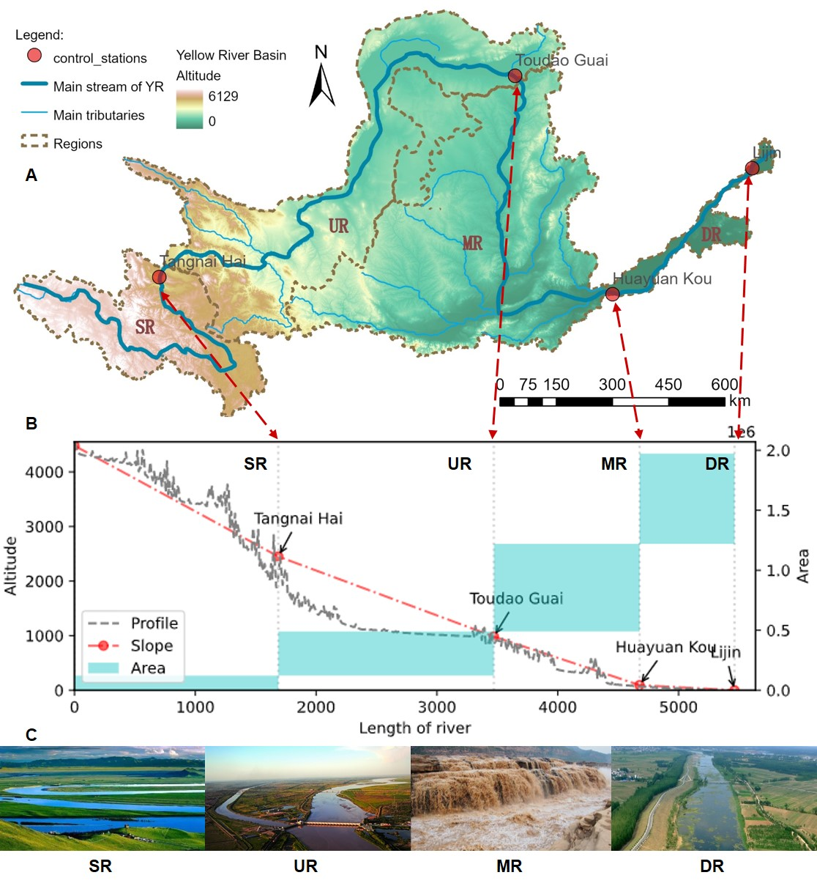

# 7 SFV-index

By taking water flexibility and variability into account, the scarcity-flexibility-variability (SFV) index focus more on dynamic responses to water resources in a developing perspective, which is a valid metric of temporal changes in water stresses20. To apply this method, we need to combine three metrics following:

First, for scarcity, is the total water consumption as a proportion of regional multi-year average runoff volume in year and region (in this study, four regions in the YRB, *Appendix* 6):

|  |  |
| --- | --- |
|  |  |

Second, for flexibility, is the inflexible water use (i.e. for thermal power plants or humans and livestock) as a proportion of average multi-year runoff, in year and region :

|  |  |
| --- | --- |
|  |  |

Finally for variability, the capacity of the reservoir and the positive effects of storage on natural runoff fluctuations are also considered.

|  |  |
| --- | --- |
|  |  |

In all the equations above, is the average runoff in region , is the total storage capacities of reservoirs in the region , is the standard deviation of runoff in the region .

Finally, assuming three metrics (scarcity, flexibility and variability) have the same weights, we can calculate the index after normalizing them:

|  |  |
| --- | --- |
|  |  |

Figure 1: Numbers of new reservoirs in each year. 

Figure 1: Figure 1: Numbers of new reservoirs in each year.

Figure 2: Sensitivity analysis of the threshold of p-values. A. number of breakpoints in different p-values, the scheme with two-breakpoints are the dominant situation. B. Threshold of p-values \alpha=0.0005. C. Threshold of p-values \alpha=0.05. 

Figure 2: Figure 2: Sensitivity analysis of the threshold of p-values. **A.** number of breakpoints in different p-values, the scheme with two-breakpoints are the dominant situation. **B.** Threshold of p-values . **C.** Threshold of p-values .

# 8 Datasets

## Descriptions

This study used multiple types of data (see Table [tab:datasets]): statistical datasets, hydrological datasets, and political datasets.

### Statistical datasets

The water resources use dataset was published by Zhou et al.38, which records water utilization in different sectors along with social-economic situations at the Prefectures level. 2nd National Water Resources Assessment Program mainly extracted this dataset launched in 2002, led by the National Development and Reform Commission and the Ministry of Water Resources (see ref (1) and <http://www.mwr.gov.cn/english/publs/> for more details). Since then, the statistics from the survey using the same criteria have been supplemented and harmonized with the 2013 administrative divisions.

The data covers a total of subcategories of water use under four broad categories: agriculture (IRR), industry (IND), urban (URB) and rural (RUR) water use (see Zhou et al., for details38).

### Hydrological datasets

The reservoir dataset was collected by Wang et al.31, which introduced includes the significant new reservoirs built in the YRB since 1949 (Figure 1). YRCC labelled the regulation-oriented reservoirs among them, see <http://www.yrcc.gov.cn/hhyl/sngc/>). In addition, annual runoff data derived from hydrological station measurements are the same as the datasets used in31 and29.

### Political datasets

The policy dataset collects laws and policies listed in the book56, which are related to the Yellow River basin promulgated and implemented by departments at (such as YRCC) and above (such as national institutions) at the Basin’s level (Table [tab:policies]). In addition, some are difficult to categorize; not a landmark, but numerous water governance practices in the YRB had been recorded in “Yellow River Events” by the YRCC; we collected them from <http://www.yrcc.gov.cn/hhyl/hhjs/>.

## Methods S3. Harmonization

Due to the wide sources of our data set and the different spatial scales, we need to harmonize them into a practical scale.

* 1. Datasets at watersheds scales: We directly divided the annual hydrological data and measured runoff data according to their watersheds’ corresponding hydrological stations (see Figure [fig:YRB] A and B).
* 2. Prefecture: We calculate the area of each prefecture to determine whether they belong to a region, with the threshold of :

|  |  |
| --- | --- |
|  |  |

* Where refers to a specific prefecture and refers to a region within YRB, i.e. SR, UR, MR, or DR. refers to the area of perfect , and refers intersecting area between perfect and region . We define perfecture belongs to region if their intersecting area over 95% of , i.e.:

|  |  |
| --- | --- |
|  |  |

* 3. Province: According to the major provinces contained in different regions, we determine which region the data of that province is merged into by referring to the traditional division practice:
  + SR: Qinghai Gansu and Sichuan,
  + UR: Ningxia and Inner Mongolia,
  + MR: Shanxi and Shaanxi,
  + DR: Shandong, Hebei and Henan.

Finally, when we process the location data (i.e., the location data of the reservoirs), we judge the province it belongs to according to its location and then fit it to the regional scale.

[1]If a policy was proposed by multiple legacies, we only show the highest one.

# Reference

1. Gleeson, T. *et al.* [Illuminating water cycle modifications and Earth system resilience in the Anthropocene](https://doi.org/10.1029/2019WR024957). *Water Resour. Res.* **56**, (2020).

2. Gleeson, T., Cuthbert, M., Ferguson, G. & Perrone, D. Global Groundwater Sustainability, Resources, and Systems in the Anthropocene. *Annu. Rev. Earth Planet. Sci.* 33 (2020).

3. Ahlström, H. *et al.* [An Earth system law perspective on governing social-hydrological systems in the Anthropocene](https://doi.org/10.1016/j.esg.2021.100120). *Earth System Governance* **10**, 100120 (2021).

4. Biermann, F. *et al.* [Navigating the Anthropocene: Improving Earth System Governance](https://doi.org/10.1126/science.1217255). *Science* **335**, 1306–1307 (2012).

5. Steffen, W. *et al.* [The emergence and evolution of Earth System Science](https://doi.org/10.1038/s43017-019-0005-6). *Nat. Rev. Earth Environ.* **1**, 54–63 (2020).

6. Sivapalan, M., Savenije, H. H. G. & Blöschl, G. [Socio-hydrology: A new science of people and water: INVITED COMMENTARY](https://doi.org/10.1002/hyp.8426). *Hydrol. Process.* **26**, 1270–1276 (2012).

7. Qin, D. *et al.* [Theoretical framework of dualistic nature–social water cycle](https://doi.org/10.1007/s11434-013-0096-2). *Chin. Sci. Bull.* **59**, 810–820 (2014).

8. Abbott, B. W. *et al.* [A water cycle for the Anthropocene](https://doi.org/10.1002/hyp.13544). *Hydrological Processes* **33**, 3046–3052 (2019).

9. Best, J. [Anthropogenic stresses on the world’s big rivers](https://doi.org/10.1038/s41561-018-0262-x). *Nature Geosci* **12**, 7–21 (2019).

10. Di Baldassarre, G. *et al.* [Sociohydrology: Scientific Challenges in Addressing the Sustainable Development Goals](https://doi.org/10.1029/2018WR023901). *Water Resour. Res.* **55**, 6327–6355 (2019).

11. OECD. OECD Water Governance Indicator Framework. in *Implementing the OECD Principles on Water Governance* 49–105 (OECD, 2018). doi:[10.1787/9789264292659-5-en](https://doi.org/10.1787/9789264292659-5-en).

12. Wang, J. *et al.* [Understanding the Human-Water Relationship in China during 722 B.C.-1911 A.D. From a Contradiction and Co-Evolutionary Perspective](https://doi.org/10.1007/s11269-016-1555-8). *Water Resour Manage* **31**, 929–943 (2017).

13. Kjellén, D. M., Tropp, D. H. & Jiménez, D. A. *Water governance in perspective: Water Governance Facility 10 years 2005-2015*. 8 (2015).

14. Grafton, R. Q. *et al.* [Global insights into water resources, climate change and governance](https://doi.org/10.1038/nclimate1746). *Nature Clim Change* **3**, 315–321 (2013).

15. Falkenmark, M. & Wang-Erlandsson, L. [A water-function-based framework for understanding and governing water resilience in the Anthropocene](https://doi.org/10.1016/j.oneear.2021.01.009). *One Earth* **4**, 213–225 (2021).

16. Bressers, H. & Kuks, S. [Water governance regimes: Dimensions and dynamics](https://doi.org/10.7564/12-IJWG1). *International Journal of Water Governance* **1**, 133–156 (2013).

17. Loch, A., Adamson, D. & Dumbrell, N. P. [The Fifth Stage in Water Management: Policy Lessons for Water Governance](https://doi.org/10.1029/2019WR026714). *Water Resour. Res.* **56**, e2019WR026714 (2020).

18. Lasswell, H. D. [*Politics: Who Gets What, When, How*](https://books.google.com?id=UlekDwAAQBAJ). (Pickle Partners Publishing, 2018).

19. UNDP Water Governance Facility. *Issue sheet: Water governance*. <https://www.watergovernance.org/wp-content/uploads/2016/08/Issue-sheet-Water-Governance-WEB-1.pdf> (2016).

20. Qin, Y. *et al.* [Flexibility and intensity of global water use](https://doi.org/10.1038/s41893-019-0294-2). *Nat. Sustain.* **2**, 515–523 (2019).

21. Wada, Y., Gleeson, T. & Esnault, L. [Wedge approach to water stress](https://doi.org/10.1038/ngeo2241). *Nat. Geosci.* **7**, 615–617 (2014).

22. Huang, Z., Yuan, X. & Liu, X. [The key drivers for the changes in global water scarcity: Water withdrawal versus water availability](https://doi.org/10.1016/j.jhydrol.2021.126658). *Journal of Hydrology* **601**, 126658 (2021).

23. Liu, J. *et al.* [Water scarcity assessments in the past, present, and future](https://doi.org/10.1002/2016EF000518). *Earths Future* **5**, 545–559 (2017).

24. Flörke, M., Schneider, C. & McDonald, R. I. [Water competition between cities and agriculture driven by climate change and urban growth](https://doi.org/10.1038/s41893-017-0006-8). *Nat. Sustain.* **1**, 51–58 (2018).

25. Jaeger, W. K. *et al.* [Scope and limitations of drought management within complex human-natural systems](https://doi.org/10.1038/s41893-019-0326-y). *Nat. Sustain.* **2**, 710–717 (2019).

26. Schmandt, J. & Kibaroglu, A. Better Basin Management with Stakeholder Participation. in *Sustainability of Engineered Rivers In Arid Lands: Challenge and Response* (eds. Kibaroglu, A. & Schmandt, J.) 260–270 (Cambridge University Press, 2021). doi:[10.1017/9781108261142.018](https://doi.org/10.1017/9781108261142.018).

27. Speed, R. & Asian Development Bank. [*Basin water allocation planning: Principles, procedures, and approaches for basin allocation planning*](http://www.adb.org/sites/default/files/pub/2013/basic-water-allocation-planning.pdf). (Asian Development Bank, GIWP, UNESCO, and WWF-UK, 2013).

28. Mostern, R. & Horne, R. M. *The Yellow River: A natural and unnatural history*. (Yale University Press, 2021).

29. Wang, S. *et al.* [Reduced sediment transport in the Yellow River due to anthropogenic changes](https://doi.org/10.1038/ngeo2602). *Nat. Geosci.* **9**, 38–41 (2016).

30. Song, S. *et al.* [Sediment transport under increasing anthropogenic stress: Regime shifts within the Yellow River, China](https://doi.org/10.1007/s13280-020-01350-8). *Ambio* **49**, 2015–2025 (2020).

31. Wang, Y., Zhao, W., Wang, S., Feng, X. & Liu, Y. [Yellow River water rebalanced by human regulation](https://doi.org/10.1038/s41598-019-46063-5). *Sci. Rep.* **9**, 9707 (2019).

32. Wohlfart, C., Kuenzer, C., Chen, C. & Liu, G. [Social-ecological challenges in the Yellow River basin (China): A review](https://doi.org/10.1007/s12665-016-5864-2). *Environ. Earth Sci.* **75**, 1066 (2016).

33. Nickum, J. E. & Shaofeng, J. The Yellow River Basin. in *Sustainability of Engineered Rivers In Arid Lands: Challenge and Response* (eds. Kibaroglu, A. & Schmandt, J.) 107–120 (Cambridge University Press, 2021). doi:[10.1017/9781108261142.009](https://doi.org/10.1017/9781108261142.009).

34. Best, J. & Darby, S. E. [The Pace of Human-Induced Change in Large Rivers: Stresses, Resilience, and Vulnerability to Extreme Events](https://doi.org/10.1016/j.oneear.2020.05.021). *One Earth* **2**, 510–514 (2020).

35. Díaz, S. *et al.* [Pervasive human-driven decline of life on Earth points to the need for transformative change](https://doi.org/10.1126/science.aax3100). *Science* **366**, (2019).

36. Turton, A. [*Water Scarcity and Social Adaptive Capacity: Towards an Understanding of the Social Dynamics of Water Demand Management in Developing Countries*](https://books.google.com?id=WSuRjwEACAAJ). (SOAS, 1999).

37. Reyers, B., Folke, C., Moore, M.-L., Biggs, R. & Galaz, V. [Social-Ecological Systems Insights for Navigating the Dynamics of the Anthropocene](https://doi.org/10.1146/annurev-environ-110615-085349). *Annu. Rev. Environ. Resour.* **43**, 267–289 (2018).

38. Zhou, F. *et al.* [Deceleration of China’s human water use and its key drivers](https://doi.org/10.1073/pnas.1909902117). *Proc Natl Acad Sci USA* **117**, 7702–7711 (2020).

39. Wang, Y. *et al.* [Review of the Implementation of the Yellow River Water Allocation Scheme for Thirty Years](https://doi.org/10.3969/j.issn.1000-1379.2019.09.002). *Yellow River* **41**, 6–19 (2019).

40. Long, D. *et al.* [South-to-North Water Diversion stabilizing Beijing’s groundwater levels](https://doi.org/10.1038/s41467-020-17428-6). *Nat Commun* **11**, 3665 (2020).

41. Dalin, C., Qiu, H., Hanasaki, N., Mauzerall, D. L. & Rodriguez-Iturbe, I. [Balancing water resource conservation and food security in China](https://doi.org/10.1073/pnas.1504345112). *Proc Natl Acad Sci USA* **112**, 4588–4593 (2015).

42. Song, S., Wang, S., Wu, X., Huang, Y. & Fu, B. [Decreased virtual water outflows from the Yellow River basin are increasingly critical to China](https://doi.org/10.5194/hess-26-2035-2022). *Hydrol. Earth Syst. Sci.* **26**, 2035–2044 (2022).

43. Konar, M., Garcia, M., Sanderson, M. R., Yu, D. J. & Sivapalan, M. [Expanding the Scope and Foundation of Sociohydrology as the Science of Coupled Human‐Water Systems](https://doi.org/10.1029/2018WR024088). *Water Resour. Res.* **55**, 874–887 (2019).

44. [*Water Governance: Challenges and Prospects*](https://www.springer.com/gp/book/9789811326998). (Springer Singapore, 2019).

45. [*Facing the Challenges of Water Governance*](https://www.palgrave.com/gp/book/9783319985145). (Palgrave Macmillan, 2019).

46. Allan, J. R. *et al.* [Navigating the complexities of coordinated conservation along the river Nile](https://doi.org/10.1126/sciadv.aau7668). *Sci. Adv.* **5**, eaau7668 (2019).

47. Liu, J. & Yang, W. [Water Sustainability for China and Beyond](https://doi.org/10.1126/science.1219471). *Science* **337**, 649–650 (2012).

48. UNEP-DHI, UNEP & UNEP. [*Transboundary River Basins: Status and Trends*](http://geftwap.org/publications/river-basins-technical-report). (2016).

49. Mirumachi, N. *Transboundary water politics in the developing world*. (Routledge,Taylor & Francis Group, 2015).

50. Cumming, G. S. & von Cramon-Taubadel, S. [Linking economic growth pathways and environmental sustainability by understanding development as alternate social–ecological regimes](https://doi.org/10.1073/pnas.1807026115). *Proc Natl Acad Sci USA* **115**, 9533–9538 (2018).

51. Cumming, G. S. *et al.* [Implications of agricultural transitions and urbanization for ecosystem services](https://doi.org/10.1038/nature13945). *Nature* **515**, 50–57 (2014).

52. Gleeson, T. *et al.* [The Water Planetary Boundary: Interrogation and Revision](https://doi.org/10.1016/j.oneear.2020.02.009). *One Earth* **2**, 223–234 (2020).

53. Wang-Erlandsson, L. *et al.* A planetary boundary for green water. *Nat Rev Earth Environ* 1–13 (2022) doi:[10.1038/s43017-022-00287-8](https://doi.org/10.1038/s43017-022-00287-8).

54. Falkenmark, M., Wang-Erlandsson, L. & Rockström, J. [Understanding of water resilience in the Anthropocene](https://doi.org/10.1016/j.hydroa.2018.100009). *Journal of Hydrology X* **2**, 100009 (2019).

55. Pettitt, A. N. [A Non-Parametric Approach to the Change-Point Problem](https://doi.org/10.2307/2346729). *J. R. Stat. Soc. Ser. C Appl. Stat.* **28**, 126–135 (1979).

56. Commission, Y. R. C. [*Yellow River Basin Comprehensive Plan (2012-2030)*](http://www.yrcp.com/wssd/bkjc/sll_bkjc/201811/t20181113_44020.html). (Yellow River Water Conservancy Press, 2013).

57. Wu, X. *et al.* [Evolution and effects of the social-ecological system over a millennium in China’s Loess Plateau](https://doi.org/10.1126/sciadv.abc0276). *Sci. Adv.* **6**, eabc0276 (2020).