**PNAS Template for Main Manuscript**

This PNAS template for the Main Manuscript may be used to organize your main text source file. The template is intended to provide a clearly organized PDF to facilitate the review process. Further information is available in our [Author Center](https://www.pnas.org/authors/submitting-your-manuscript#article-types).

**Using the template**

Paste the appropriate text from your manuscript into the relevant section of the template. You may maintain the template formatting, or reapply styles after pasting your text into the template.

Figures should be placed on separate pages with legends set immediately below each figure. Table titles should be set immediately above each table.

References cited in the main text should be included in a separate reference list at the end of this file. Examples of the PNAS citation style are included below.

**Notes about submission**

The following items are required on the title page: **Title, Author Line, Author Affiliations, Corresponding Author information**. Each of these items **must** be provided on the title page for us to proceed with processing your paper.

You are not required to adhere to the section order outlined below. For example, you may combine your Results and Discussion or use alternate section headings. Materials and Methods should be included after the Results and Discussion in most cases. If your paper does not include the standard section headings, please provide a brief explanation in the **Comments to Editorial Staff** field of the submission form.

You may include subheadings within the standard headings listed below. You may also include line numbers.

**Submitting your main manuscript**

Delete this first page, and then save your completed main text file as a PDF for submission, following instructions available [here](http://www.pnas.org/site/authors/procedures.xhtml#preparation).

*Updated September 2020*



**Main Manuscript for**

Regime transition identification for water utilization of river basin

Shuang Songa, b, Shuai Wanga, b, Xutong Wuc, d, Bojie Fua, b.

a. State Key Laboratory of Earth Surface Processes and Resource Ecology, Faculty of Geographical Science, Beijing Normal University, Beijing 100875, P.R. China.

b. Institute of Land Surface System and Sustainability, Faculty of Geographical Science, Beijing Normal University, Beijing 100875, P.R. China.

c. College of Urban and Environmental Sciences, Peking University, Beijing 100871, P.R. China.

d. State Key Laboratory of Urban and Regional Ecology, Research Center for Eco-Environmental Sciences, Chinese Academy of Sciences, Beijing 100085, P.R. China

*Shuai Wang

**Email:**  shuaiwang@bnu.edu.cn

PNAS strongly encourages authors to supply an [ORCID identifier](https://orcid.org/) for each author. Do not include ORCIDs in the manuscript file; individual authors must link their ORCID account to their PNAS account at [www.pnascentral.org](http://www.pnascentral.org). For proper authentication, authors must provide their ORCID at submission and are not permitted to add ORCIDs on proofs.

**Author Contributions:**

Shuang Song, Shuai Wang and Bojie Fu designed this research,

Shuang Song performed the research and analysed data,

Shuang Song, Xutong Wu wrote the paper.

**Competing Interest Statement:** The authors declare no competing interests.

**Classification:** Paste the major and minor classification here. Dual classifications are permitted, but cannot be within the same major classification.

**Keywords:** Regime shifts, Human-water relationship, Water resource management, Water utilization, Sustainable development

**This PDF file includes:**

Main Text

Figures 1 to 5

**Abstract**

For sustaining socio-economic development, human have harnessed large rivers and triggered a range of regime shifts at a basin scale all around the world. Detecting these abrupt reorganizations of structure and function is critical to successful future river basin management. Here, considering three main dimensions of water utilization (stress, priority and configuration), we develop an Integrated Water Resources Utilization (IWRU) Index at a basin scale to indicate regime shifts. By applying this index to the Yellow River Basin, China, it suggests that there were two regime shifts over half a century, whose drivers were economic growths, managements and efficiency improvement. Differ from previous onefold descriptions, IWRU captures various considerations intertwined in water utilization, based on which we proposed a transition framework in interpreting associated changes. By identifying and predicting widespread dilemmas in transition of water utilization, this framework can be a useful guideline for big river basins to develop in a coordinated way.

**Significance Statement**

Water, a key resource to support the sustainable development of human societies, whose natural cycle has been modified by growing socio-economic processes. We propose a new method with an integrated index to detect water utilization regimes and applying it to the Yellow River Basin, a typical overexploited basin in China. After sketching changes of relationships between social development and water utilization within the Yellow River Basin, we summarized a general transition framework. By identifying and predicting widespread development dilemmas, it can be a useful guideline for basins all around the world in their sustainable developing trajectories.

**Main Text**

**Introduction**

Water, at “the centre of the planetary drama of the Anthropocene”, is not only essential for myriad Earth system processes, but also supporting development of human societies in various aspects. However, human's modification has profoundly influenced the water cycle, which may lead adverse changes to functions of human-water systems, resulting in development dilemmas (1, 2). Facing major challenges in the Anthropocene, many of the world's big river basins, also hot spots of economy and civilization, urgently need integrated water resources management toward sustainability (3, 4). Since it requires deep understanding of the complex relationships between human societies and water resources utilization, sketching their transitions provides underlying supports for developing in a coordinated and sustainable way at a basin scales.

Regime is a stable state of system’s structure and function, whose large and persistent changes may lead to substantive impacts on the outcomes of system with widespread cascading effects, defined as regime shifts (5–7). Water have several key functions within a human-water system, the most important of which is sustaining the development of human societies through water utilization. However, interplayed human interference, such as water withdrawal, dam constructions and water managements have significantly changed water functions and induced changes in water use (8). These gradual or abrupt changes triggered regime shifts as societies' development strengthen their interlinks to water utilization with increased dependences. As a result, most large river basins had gone through phases of accelerated exploitation, over-exploitation, and integrated management, for which it is a reasonable assumption that there is a general transition pattern in water utilization (3). Identifying the regime shifts in water utilization and sketching a general pattern, therefore, can help to understand and predict developing trajectories of basins, which are crucial for integrated management and coordinated development towards sustainability.

Features of water utilization has been depicted and studied from various intertwined perspectives. Firstly, water stresses are of increasing importance and concerns. Greater water utilization stresses had become a major constraint to development, because of significant increment in water withdrawals and larger shares of inflexible water use, while store of water resource in reservoirs are helpful to relief of (9–11). Secondly, as the priority of water utilization changed with the need of development. There are noticeable growths in economy profits of industry or services and their priority in water use, leading potential conflicts between different sectors (12, 13). Thirdly, since development are inherently regional concerns, where heterogeneous regions attempt to develop themselves by economically competitive sectors, configuration of water resources also plays as an important aspect. Taken together, existing researches have evaluated the three dimensions of water resource utilization regarding a series of crucial questions: “How much water resources?”, “How to use them?” and “Used for whom or in where?”. However, these dimensions haven't been well integrated by quantitative methods, and a coherent interpret of regime shifts regard to social development and water utilization is needed.

Here, by integrating three above mentioned dimensions of water utilization, we develop an Integrated Water Resources Utilization (IWRU) Index at a basin scale to give a sketch of relationships between human societies and their water utilization **(Figure 1)**. Then, by applying this index to the Yellow River Basin, China, we analyzed water utilization regimes shifts and their drivers in this typical basin of anthropogenic impacts. Finally, we proposed a transition phases framework of development echoing to the regime shifts, which can be a useful guideline for basins to predict dilemmas in water utilization and to develop in a coordinated way.

**Results**

***Water utilization regimes.***

With two significant points, the changing trend of IWRU index are detected into three periods (**Figure 2A**). Not only the slope of changes is various within each period, changes are also mainly contributed by different dimensions (**Figure 2B** and **Figure 2C**). In the first period (P1, 1965-1978), the IWRU index had a rapidly increasing and the lightening of water stresses made the most striking positive contribution (131%), while priority and configuration of the water utilization had slight negative contribution (-11% and -20%). In the second period (P2, 1979-1994), though contributions of priority and configuration turned into positive, the IWRU index experienced a drop because of stresses on water resource playing a larger negative role (-188% dropped than P1). However, as the further increasing of positive contributions of priority (75%) and configuration (84%), and decreases of water stresses in negative contribution (-59%) in the third period (P3, 1995-2013), a positive growth of the IWRU returned.

Taken together, each period has the unique most striking positive contributor to IWRU, and overall features of three dimensions in different periods are shown in **Figure 3**. At the very beginning (1965) and throughout the whole P1, water utilization regime dominated by high stresses. After then, it experienced a shift to low stresses since 1978, with a change in the proportion of contributions between priority and configuration, too. Finally, the contribution of three dimensions were much similar in P3 (32.91%, 31.87% and 35.21% for priority, configuration and stress respectively), making the points highly concentrated at the centre of the ternary diagram in that period.

***Drivers of water utilization regime shifts***

Firstly, the expansion of irrigated area and the economic growth of industry and services are keys to the changes in the priority of water utilization between P1 and P2 **(Figure 4A**). During the P1, irrigated agricultural area in the Yellow River basin expanded rapidly at a rate of 0.25*10^6 ha/yr, and irrigation water was the dominant utilization way (81.56% of the total water use in 1965, and 83.17% in 1978, (see ***SI Appendix*** **Fig. S7**). Entering P2, however, while the expansion of irrigated area stalled, industry and services gradually took off and took up more water resources (**Figure 4B**), leading to 8% reduction of proportion of irrigation water (***SI Appendix* S7**).

Secondly, efficiency of water utilization changed from the P2 to the P3. While irrigated area resumed expansion again in the P3 whose water consumptions were still dominant (**Figure 4A**), both industry, urban services were boosting their gross added values (GVA) (**Figure 4B**). However, the water use density (WUI) of them experienced significant declines and reached the lowest points (**Figure 4A** and **Figure 4B**). It means, water utilization ways have changed, along with technological solutions and a range of water conservation practices (***SI Appendix* Fig. S8**). As a result, the differences between the sectors of water use reduced while the total water consumption remains stable, during the P3 (***SI Appendix* Fig. S7**).

Finally, changing water management practice contributed throughout all three periods. According to the location, we calculate the ratios of regional and basinal water use for each reservoir. In the P1, most of the reservoirs are built in regions with high water demands, as ratios are significantly higher (**Figure 4C**, p<0.01). In the P2, the number of new reservoirs decreases significantly with little increment of total storage capacities (***SI Appendix* Fig. S6**). Entering the P3, however, the number of new reservoirs are even much higher than that in the P1, and most of them were built in regions with lower ratio of regional water use (**Figure 4C** and ***SI Appendix* Fig. S6**).

**Discussion**

***Shifted water utilization regimes with the development of society***

The IWRU index captures the complex human-water feedbacks that links social development and water resources utilization from three dimensions (stress, priority and configuration). Our results show that three distinct regimes of water utilization within YRB, which have been driven by different causes regarding the three above dimensions. At the beginning of P1, the contribution of agriculture in the YRB to GDP was nearly a half (46% in 1965), much higher than that of industry or services (33% and 26% in 1965, respectively see (***SI Appendix* Fig. S9**). Given that downstream industrial water had not depended on Yellow River yet, and the provincial estimates are exaggerated in industrial or services GDP (***SI Appendix* Methods S3**), this figure still greatly understates the dependence on agriculture for social development. At that time, one of the main tasks of the Yellow River Conservancy Commission (YRCC), therefore, was to set up agencies for water infrastructure (14), and the new reservoirs were mostly distributed in regions with high water demands (**Figure 4C**). As a result, this regime is characterized by a rapid expansion of irrigation water to support development of agriculture.

The regime nearly came to an end with the water resource crisis, as the water consumption of the Yellow River had accounted for about 80% of the natural runoff. As the most obvious performance, the Yellow River was dried up for several times since 1972 (***SI Appendix* Fig. S10**). During the regime since 1978, the YRCC undergone a reorganization and received instructions from the Ministry of Water Resources (called Ministry of Water Resources and Electric Power then) to resume and strengthen work related to hydrology and basin management in YRB. Since then, the expansion trend of agriculture has been constrained (**Figure 4A**), while the importance of industry began to increase with the Reform and Opening-up policy. In addition, most laws and regulations have been successively implemented (***SI Appendix* Table 2**). For an example, the far-reaching “87 Water Diversion Scheme”, which was put forward in 1987, limited the amount of water withdraw for each province as a constant in the YRB.

The next regime shift was not occurred until a significant increase in water use efficiency since about 1993. After more than a decade of development, the focus of economy had shifted to industry and services whose contribution of GDP in YRB are 45% and 31%, while agriculture accounting for only 23% (***SI Appendix* Fig.** **S9**). A rapid increase in industrial demand for water has been accompanied by economic growth, which had led to water-saving reforms in inefficient agriculture. As a result, water use efficiency improved significantly in both agriculture and industry during the third regime (**Figure 4A** and **Figure 4B**), with engineered water-efficient irrigation reaching nearly half (48.6%) of the total irrigated area (***SI Appendix* Fig. S7**), allowing the average water consumption per unit of irrigated area to drop about tenfold (**Figure 4A**).

In short, agricultural expansion, industries and services expansion, water resources management, as well as scientific and technological progress and water use efficiency improvement are intertwined in human-water system. They have driven the YRB to change regimes twice between 1965 and 2013, which can be interpreted as a transition process along with social development.

***Transition framework in water utilization***

The links between the above transition process and the regime shifts of water utilization may be pervasive as socio-economic processes are gradually dominating human-water systems in most river basins. As such, we summarized a transition framework, which conceptualizes a general trajectory towards regional socio-economic dominating water utilization stage by stage. In the framework, provisioning water utilization (agriculture, domestic or livestock) are dominated at the primal phase and social processes take over dominating with growths of industry and services in the followed phases, with coordinated considerations of water utilization over the whole basin (**Figure 1**).

Three dimensions of water utilization are various throughout the transition. Firstly, while stresses on water resources increases when economic expansion boosting water demands, socio-economic progress can respond to resource scarcity by better management or efficiency. Water resources were becoming more scarce in the YRB from P1 to P3 (***SI Appendix* Fig. S3**). However, water utilization stresses changes a lot rather than always increasing, because constructions of reservoir and the increased water use efficiency were all played roles (**Figure 4**). Since the scarcity of water resources is directly perceptible and sensitive for utilization, its stresses on societies is one of the most striking drivers to regime shifts within human-water systems (11).

Secondly, the non-provisioning part of water demands growths with secondary and tertiary industries developing, leading priority of water utilization continually tilted to the socio-economic part. As original region of Ancient Chinese Civilization, the Yellow River Basin used to be dominated by agricultural but converted to an energy industry zone now (15). As a result, saving water consumption in agriculture and making concessions for industry and energy is widely recognized as solutions for the competing (16, 17). Anyhow, this changes of priority reflect a truth that growing socio-economic parts are responding to scarcity of water resources and contributing to regime shifts.

Last, with tighter socio-economic links and comparative advantages between regions and sectors, the geographic scope of water resource supply and demand allocation is expanding, leading to changing configurations of water utilization. In the Yellow River Basin, the gap of water consumptions between regions and sectors are narrowing, as the result of a carefully designed configuration.

By combining the above three dimensions, these changes gradually transformed water utilization regimes in a “natural phase” (**Figure 5A**) to one in local or regional phase (**Figure 5B** and **Figure 5C**), with socio-economic processes dominated step by step. In addition to the YRB, human-water relations in major river basins around the world can be explained by the framework. For examples, Indus River, Mississippi River, and Danube River, whose water utilizations have all gone through a relatively natural regime, rapid developments and integrated management regimes (3, 18). In summary, some similar pattern of water utilization can be revealed by the transition framework with basins development.

***Dilemmas and future directions***

Not only the index helps to identify regime shifts of water utilization, our transition framework also helps in predicting possible dilemmas with the development of society. According to cases all around the world, big river basins often face resource dilemmas after resources-dependent developments, while highly developed ones need to resolve structural problems more often (***SI Appendix* Fig. S11**). After the successive exploitation of agriculture, industry and services (refers from natural phase to a local phase in the framework (**Figure 5**), it is easy for basins to get into a resource dilemma. As an example, the YRB proposed a clear transformation towards integrated basin management to get rid of the severe resource dilemma, with several management practices. The most important of these is the “87 Water Allocation Scheme”, which adopts a top-down approach in allocating water resources to all regions and sectors (19). Since then, the scheme has been revised and refined, and a comprehensive water resources utilization system has gradually formed (19). These integrated management practices made the utilization of water resources into a regime of unified scheduling since the P3 in the Yellow River Basin, to escape from the resource dilemma. Accelerated development has been followed by severe water scarcity and a series of ecological problems, similar dilemmas are pervasive in basins highly dependent on water resources, where in need of moving towards integrated governance as well (3, 18, 20).

In addition, further dilemmas occurred as basins developments tighter interlinked to the ecosystems after integrated management and move to a regional phase (refers from a local phase to a regional phase in the framework, (**Figure 5**). Firstly, significant improvement in agricultural irrigation efficiency has been accompanied by re-expansion in irrigated area, resulting in a usually unabated trend of water resources stress which is known as paradox of efficiency (21). Secondly, the changing priority between non-provisioning (i.e. industry or services) and provisioning (i.e. domestic and irrigation water use) may lead the water utilization more inflexible and damage to resilience of the basin (11). Take the YRB as an example again, after getting rid of the resource dilemma, the stresses on water resources were still growing, while inflexible water use (domestic and thermal uses) growth most strikingly (supplementary Fig. S4). It can be a warning to river basins around the world in comprehensive developments, since these may lead to a reduction in resilience of basins and leave highly coupled human-water systems facing greater vulnerability to collapse --as a structural dilemma (18).

Taken together, based on the identification of current phases and development dilemmas by the transition framework, further transformative governance is still needed to achieve a high-quality sustainable development of the basin, because development is not a panacea for every dilemma (22).

**Materials and Methods**

Here, we constructed the Integrated Water Resources Utilization (IWRU) Index which consists of three dimensions and identified the changes periods of the index over time by change points detection. Each dimension is reflected by an independent indicator after normalization, and water utilization regime were characterized by combination of impacts of each dimension in periods. In addition, the contribution to changes of IWRU index along with each main indicator was decomposed and calculated separately for each regime (i.e. period).

***Integrated Water Resources Utilization (IWRU) Index***

Water resources utilization system is closely related to the social developments (*Dev.*) in three dimensions below (see ***SI Appendix* Methods S4** for details):

- Social development is usually accompanied by a change of priority in water use towards social and economic systems because of higher returns:

- Social development usually lead to more complex structure in configuration of water resources, which is a result of division and cooperation between regions and sectors for developing:

- Further social development can only be achieved by effectively alleviating the water resource stresses generated in the process of development through technological means:

We combine the above three dimensions for an integrated index, remaining their positive or negative relationship with social development:

To effectively represent the three dimensions, we select an appropriate indicator (, , or corresponding to Priority, Configuration and Stress respectively) for each dimension. Then, the above equation is transformed into a natural logarithm to facilitate calculation:

Assuming they have equal weights, the Integrated Water Resources Utilization (IWRU) Index:

where is a normalization of log-transformed indicator for a certain dimension:

In fact, we have tested different normalization methods and it makes no difference in change points detection (see Methods S5. Sensitivity analysis). In this study, finally, we performed min-max normalization as the formulation below:

***Indicator of Stress***

We refer to the scarcity-flexibility-variability (SFV) water stress index proposed in Qin et al., 2019 to evaluate water stress () as the indicator in a certain region . This metric takes into account management measures (such as the construction of reservoirs) and the impact of changes in the industrial structure of water use on the evaluation of water scarcity (see Methods S4 for details). For the whole YRB, indicator of stress is the average stress of all regions’ SFV-index:

Where is the SFV-index for region , and to refers SR, UR, MR, and DR (see Methods S1 Definition of study area).

***Indicator of priority***

To priority , we use Non-Provisioning Shares (NPS) of water use as an indicator. While provisional water use () includes domestic, irrigated and livestock water uses, the non-provisioning water use () includes industrial and urban services water uses. Then, we can calculate the non-provisioning shares by:

Where refers a certain region, or the whole basin, i.e:

Indicator of configurations

To description of configurations , we designed an indicator by imitation of information entropy, called Configuration Entropy Metric (CEM), a metric to measure the degree of evenness of water configuration (see Methods S4). While our indicator should reflect that with the development of society, water resources configuration is more balanced among regions and generally meets the needs of different sectors (means smaller gaps, too), but different regions have a trend of division of labour among various sectors (with larger gaps):

where and are Configuration Entropy Metric in different regions and different sectors. is differences between sectors in a certain region to the whole basin (see Methods S4).

***Change points detection***

With no assumptions about the distribution of the data, the Pettitt (1979) approach of changing points detection is commonly applied to detect a single change-point in hydrological series with continuous data. It tests the : The variables follow one or more distributions that have the same location parameter (no change), against the alternative: a change point exists. The non-parametric statistic is defined as:

Where:

The change-point of the series is located at , provided that the statistic is significant. We use 0.001 as the threshold of p-value (see Methods S5 for Sensitivity analysis), which means the probability of a statistically significant change-point judgment being valid is more than . Since this method only can return one significant change point, we repeat it Until all significant change points were detected.

***Contribution decomposition***

We have decomposed the amount of variation in each index at different stages in order to observe the contribution of each influencing factor to them. Use Integrated Water Resources Utilization (IWRU) Index as an example, which influenced by three dimensions’ normalized indicator: stress (), priority () and configuration (). We can calculate their differences between two certain years ( and , ) by:

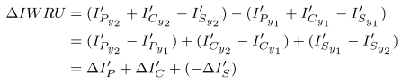

Then, the contribution of dimension to IWRU’s changes can be referred as:

***Datasets***

In order to calculate IWRU, we need to calculate multiple indicators and sub-indicators. All the datasets used are listed in the table S1. A detailed description of the data can be seen in the supplementary materials Methods S2.

**Acknowledgments**

Paste your acknowledgments here.

**References**

1. T. Gleeson, *et al.*, Illuminating water cycle modifications and Earth system resilience in the Anthropocene. *Water Resour. Res.* **56** (2020).

2. G. S. Cumming, S. von Cramon-Taubadel, Linking economic growth pathways and environmental sustainability by understanding development as alternate social–ecological regimes. *Proc Natl Acad Sci USA* **115**, 9533–9538 (2018).

3. J. Best, Anthropogenic stresses on the world’s big rivers. *Nature Geosci* **12**, 7–21 (2019).

4. J. Best, S. E. Darby, The Pace of Human-Induced Change in Large Rivers: Stresses, Resilience, and Vulnerability to Extreme Events. *One Earth* **2**, 510–514 (2020).

5. J. C. Rocha, G. Peterson, Ö. Bodin, S. Levin, Cascading regime shifts within and across scales. *Science* **362**, 1379–1383 (2018).

6. M. Scheffer, S. R. Carpenter, Catastrophic regime shifts in ecosystems: linking theory to observation. *Trends in Ecology & Evolution* **18**, 648–656 (2003).

7. M. Scheffer, S. Carpenter, J. A. Foley, C. Folke, B. Walker, Catastrophic shifts in ecosystems. *Nature* **413**, 591–596 (2001).

8. M. Falkenmark, L. Wang-Erlandsson, J. Rockström, Understanding of water resilience in the Anthropocene. *Journal of Hydrology X* **2**, 100009 (2019).

9. S. L. Postel, G. C. Daily, P. R. Ehrlich, Human Appropriation of Renewable Fresh Water. *Science* **271**, 785–788 (1996).

10. P. Greve, *et al.*, Global assessment of water challenges under uncertainty in water scarcity projections. *Nature Sustainability* **1**, 486–494 (2018).

11. Y. Qin, *et al.*, Flexibility and intensity of global water use. *Nature Sustainability* **2**, 515–523 (2019).

12. J. Liu, *et al.*, Water scarcity assessments in the past, present, and future. *Earth’s Future* **5**, 545–559 (2017).

13. M. Flörke, C. Schneider, R. I. McDonald, Water competition between cities and agriculture driven by climate change and urban growth. *Nature Sustainability* **1**, 51–58 (2018).

14. Yellow River Archives, *Organizational History of the Yellow River Conservancy Commission* (Yellow River Water Conservancy Press, 2004).

15. , Will Energy Bases Drain the Yellow River? *China Water Risk* (August 22, 2020).

16. X. Xiang, J. Svensson, S. Jia, Will the energy industry drain the water used for agricultural irrigation in the Yellow River basin? *International Journal of Water Resources Development* (2016) (August 22, 2020).

17. C. Bebb, Water Rights Transfers and High-Tech Power Plants Hold off Energy-Water Clash in Northern China. *Circle of Blue* (2011) (August 22, 2020).

18. G. S. Cumming, The resilience of big river basins. *Water International* **36**, 63–95 (2011).

19. Y. Wang, S. Peng, G. Jiang, H. Fang, Thirty Years of the Yellow River Water Allocation Scheme and future Prospect. *MATEC Web Conf.* **246**, 01083 (2018).

20. UNEP-DHI, UNEP, UNEP, *Transboundary River Basins: Status and Trends* (2016).

21. R. Q. Grafton, *et al.*, The paradox of irrigation efficiency. *Science* **361**, 748–750 (2018).

22. I. Scoones, *et al.*, Transformations to sustainability: combining structural, systemic and enabling approaches. *Current Opinion in Environmental Sustainability* **42**, 65–75 (2020).

**Figures and Tables**

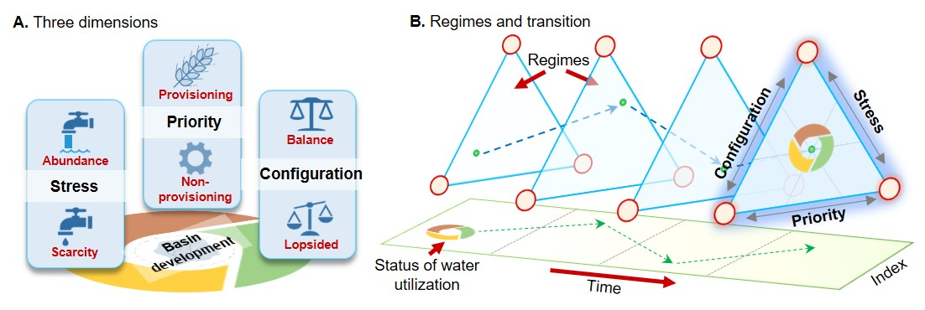

**Figure 1.** A schematic diagram for understanding the changing relationship between social development and water utilization. **A.** **Three dimensions (stress, priority and configuration) of water resources utilization.** Each dimension has two poles (denoted in red) which indicates the two potential directions of water resources utilization changes along that axis. (1) Stress of water utilization shifts between scarcity of water resources and abundance of water resources, which means there is shortage of water supply or not. (2) Priority of water utilization can move between a provisioning part or a non-provisioning one, indicating how much water were used in food supporting to human societies. (3) configuration can move between balanced or lopsided, when allocation of water resources between different sectors or regions changed. We presume that water utilization regimes equally weighted by these basic dimensions, whose combination can highly relate to basin development. **B.** **The changes after combining the three dimensions.** Because the above three dimensions are changing with the development of society, their combined water resource utilization status is also different. When abrupt transitions occur during this process, they may indicate a regime shift in water utilization, so we need an indicator to monitor this change.

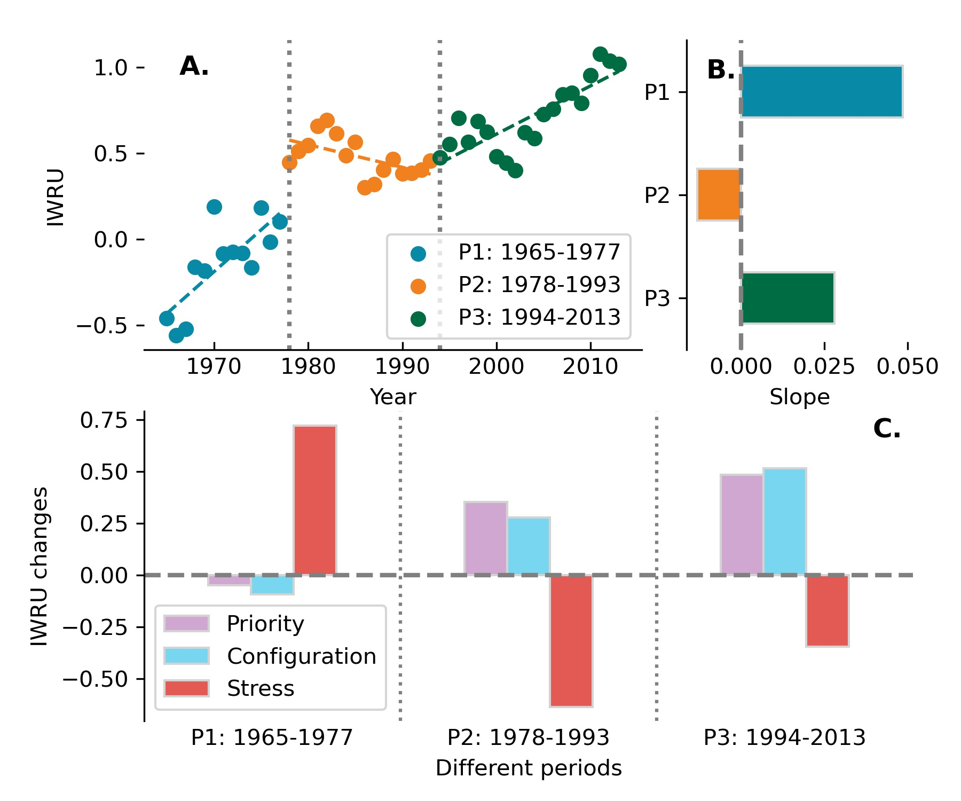

**Figure 2.** Changes of the IWRU index. **A.** Change points detection. With change points in 1978 and 1994, the IWRU have three periods in changing trend. **B.** Changing slopes of each period. **C.** Contributions of each dimension to the changes of IWRU within three periods. Stress, priority and configuration are the main positive contributor of P1, P2 and P3, respectively.

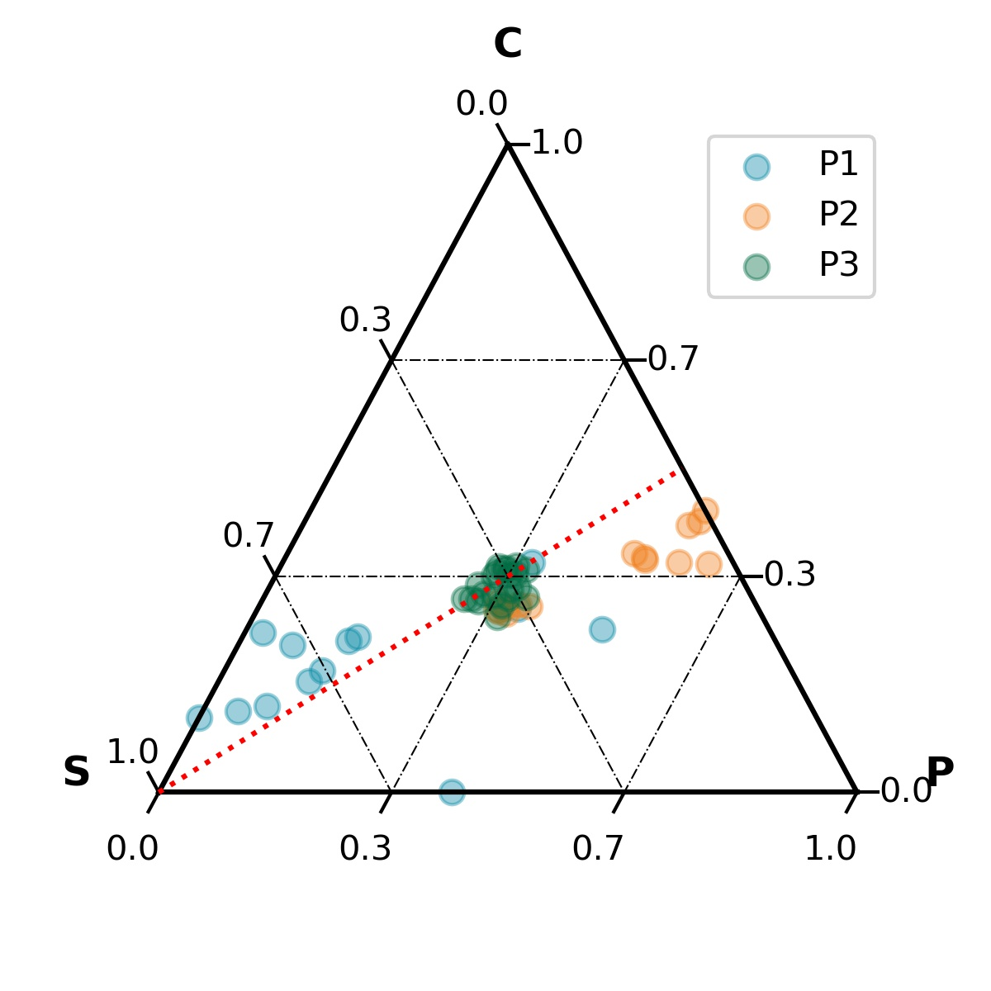

**Figure 3.** Combination of contributions regards three dimensions in different periods (S: stresses; P: priority; C: configuration). The closer a point to an angle of the triangle, greater the proportion of the contribution of this dimension. The red indicator line in this ternary plot denotes 1:1 contribution between priority (P) and configuration (C). When the points are bellow this line, the contribution ratio of configuration is lower than that of priority, and vice versa.

**Figure 4.** Drivers of water utilization regime shifts: economy growths, efficiency changes, and management practices. **A.** Changes of total irrigated area, and water consumptions in per unit of area (***SI Appendix* Method S2**). **B.** Changes of gross values added (GVA) of industry and services, and their water use density (WUI) respectively (***SI******Appendix* Method S2**). **C.** Completed time of each new reservoir and their located regions' water use percentages in basin's total water use (WU), at that time. Red ones denote hub reservoirs in the basin, which plays a role in basinal integrated water management. Size of the points indicates their magnitude of water storage capacities. Some important or special reservoirs' name denoted: (1) Xiaolangdi reservoir and Sanmen Reservoir were constructed mainly responsible for managing sediments of the Yellow River. (2) Liujia Gorge, Longyang Gorge, were constructed mainly responsible for managing water flood discharge and storage. These marked reservoirs, therefore are significant for the entire basin, far crucial than regional development.

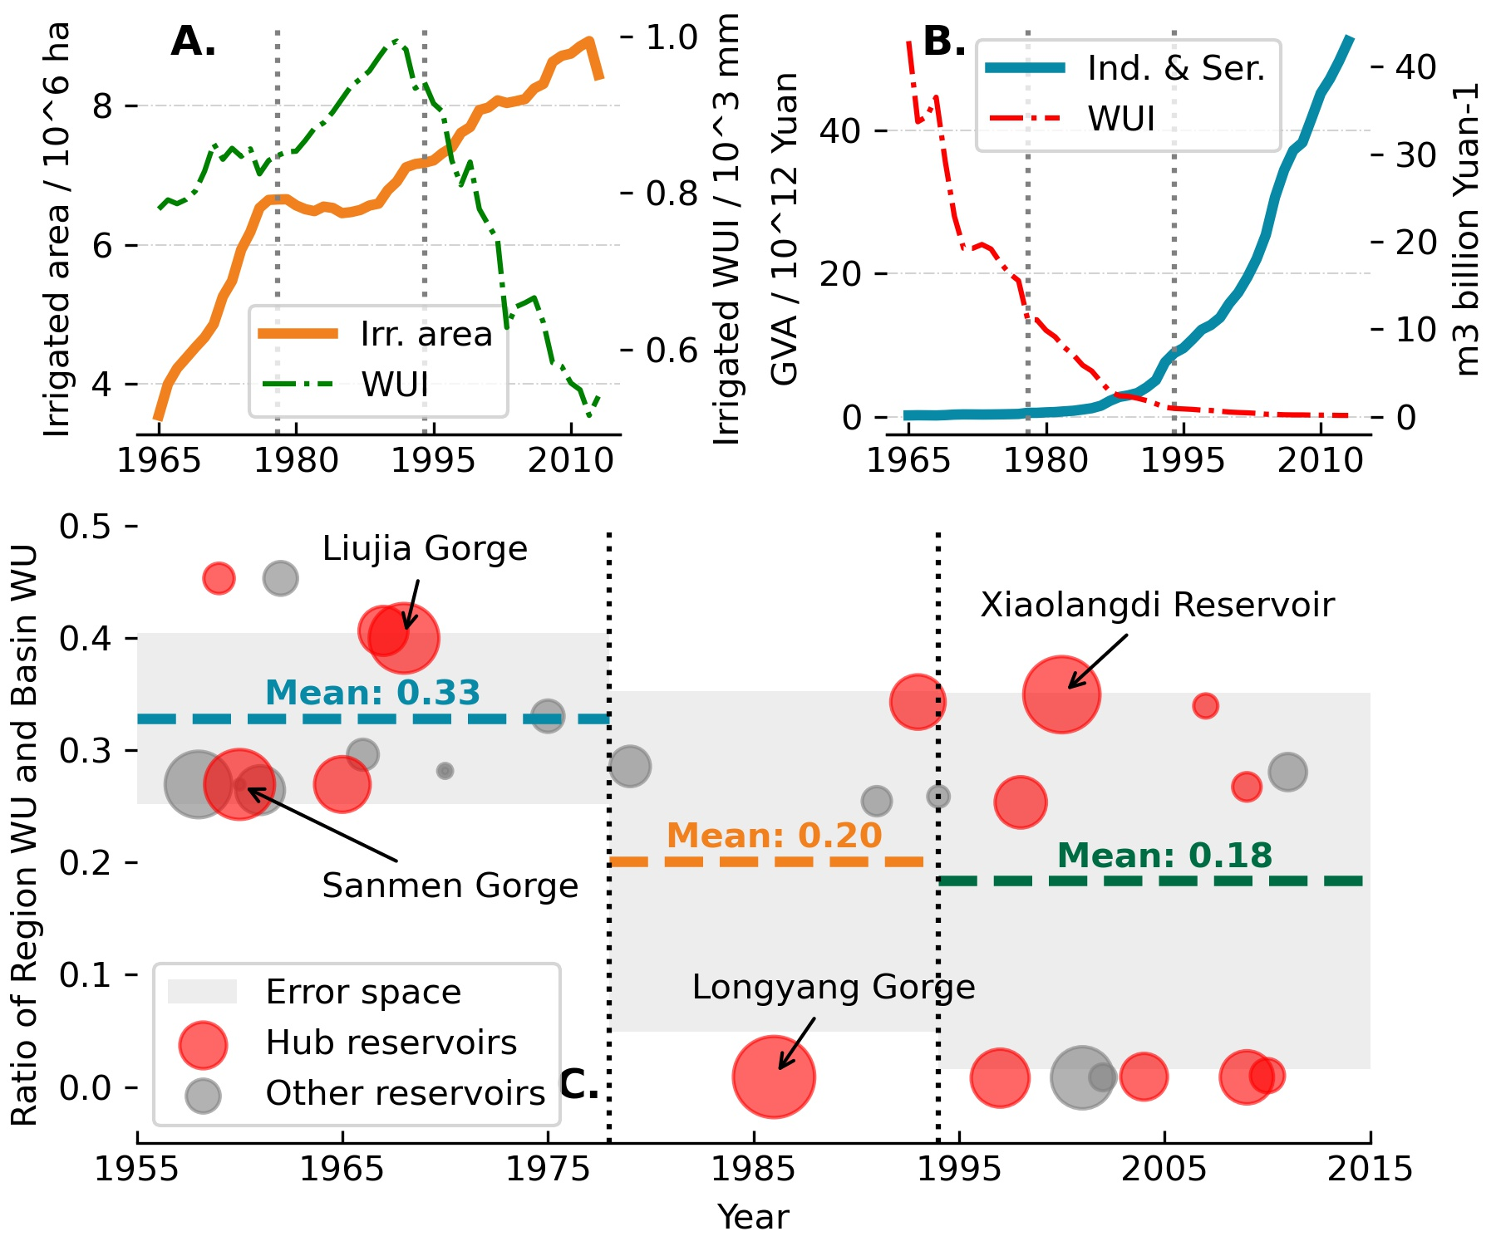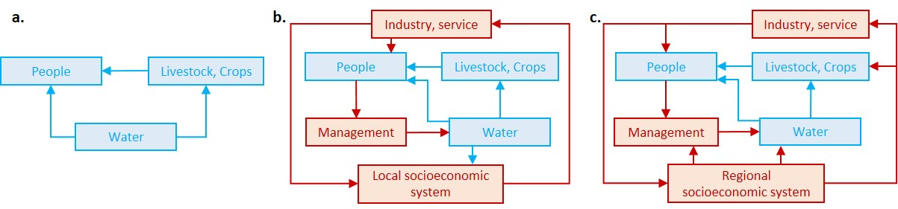

**Figure 5. Transition framework of water utilization.** Blue pathways dominated by natural water loop while red ones dominated by socio-economic loops. **A. Natural phase:** As an indispensable provisioning resource, the main functions of water resource is to support crop, livestocks and human-beings, which are the basic ecological services. **B. Local phase:** With local socio-economic systems developing, industry and services (also known as the secondary and the tertiary industry) calling for further water consumptions. What's more, better organized socio-economic system and developed technology gives humans abilities in better managing water resources, with intensive intervention in the natural water cycle. **C. Regional phase:** With further developed and economically efficient industries and services, trade-off between whose water demands with provisional water demands becomes prominent. Rather than determined by local socio-economic systems, water withdrawals and management act as considerations within the entire basin more, therefore.