**Summary of video tutorials 28 for Blender 2.80.**

Tutorial series: <https://www.blender.org/support/tutorials/>

Tutorial 28: <https://www.youtube.com/watch?v=-gIL6VZ-bkE&list=PLa1F2ddGya_-UvuAqHAksYnB0qL9yWDO6&index=28>

Also

Blender Open Movies <https://www.blender.org/about/projects/>

Blender can be used to create very complex animation sequences. Most releases of Blender are associated with a movie made using it. You can watch these movies at the at Open Movies website above.

To make modes move we need to add bones to the model. These are invisible when rendered but can deform the mesh (or move the model). A group of bones can be brought together to form a skeleton (or armature). The process of adding a skeleton to a model and working out how it should deform the model is know as rigging. You can control the armature by moving it manually to set locations and allowing blender to fill in the gaps between key-frames, this approach is known as animation. The alternative is to control the skeleton using data recorded using a motion capture system, this is known as mocap. In this lab we will learn the fundamentals of rigging and motion capture. This a huge topic so the assignment will only get you started in the area.

**Part 1:** Rigging a cylinder with bones and a controller.

To get started we will rig a very simple object consisting of a cylinder with a few bones and a single controller. Watch the video and follow the instruction below as well.

Launch blender – delete the cube and add a cylinder.

Switch to object mode

Add - mesh - cylinder

Rotate the cylinder through 90 around X –> RX90

Scale in Y direction 6 -> SY6

Switch to edit mode

Loop cut the cylinder with 8 ring along its length, centred on 0 -> <ctrl>R8

In Object mode – wireframe

Select the bone rotate it through 90 degrees –> RX-90

Select bone – context menu  - Viewport display - tick Infront

Translate bone in Y direction -> Gy-6

Scale bone 12 in Y direction -> SY12

Edit mode - Select bone – right click down – subdivide (repeat subdivision to create 4 bone).

Select last bone (just the circle attachment on right not the whole bone) and extrude it -> Ey1

In object mode, <shift> and right click on cylinder, and then also select the armature <shift> right click again on the armature so that they are both selected.

Then press <ctrl>p and select with Automatic Weights. This links the armature with the mesh. The weighting for influence of the bone on the mesh is set by how close each vertex (in the mesh) is to each bone. Bones close to a vertex will influence its movement more than those far away.

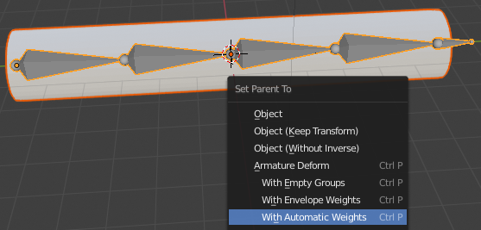

Select the pivot point to move around individual origins.

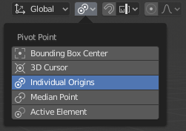

In pose mode select the last (smaller bone on the right hand side) and add an inverse kinemtic constraint press <shift> I -> without targets (in video it is with targets and then we needed to delete the empty).

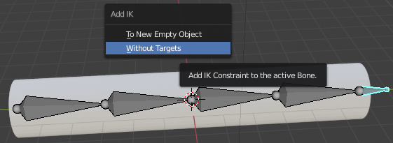

Select the last bone in pose mode and then select bone context option, , set chain to 5 (representing the 5 bones linked to the controller bone).

Grab the last bone in pose mode and move it to see how the cylinder deforms - G

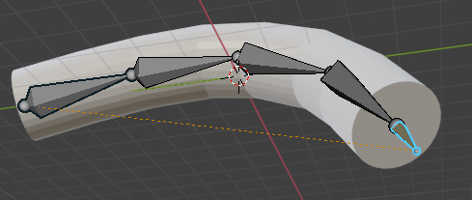

To change the appearance of the last bone (to represent a controller), in object mode add a cone to the scene.

Object mode Add – mesh – cone

Select bone context menu, , in pose mode select the last bone select viewport display and select custom object and change it to cone.

In same menu adjust scale (x=0.2,y=0.2)

Delete the original cone from the Scene collection.

Record your finished setup and comment on the approach you took.

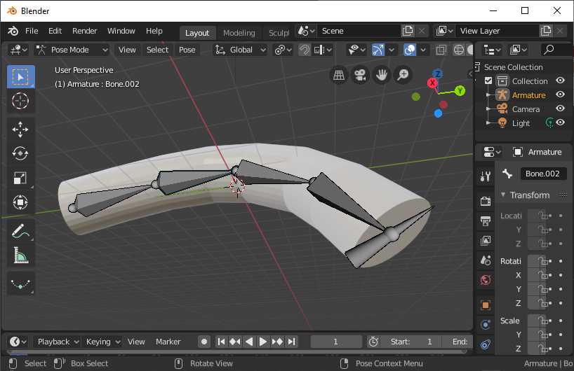

**Part 2:** Rigging a model of a fish

Open the blender model of the cartoon fish supplied.

Use what you have learned in part 1 (and the supporting video) to rig the fish.

Add keyframes to the video and create an animation of the fish swimming.

Remember use press I to insert a key frame and then select “whole character”.

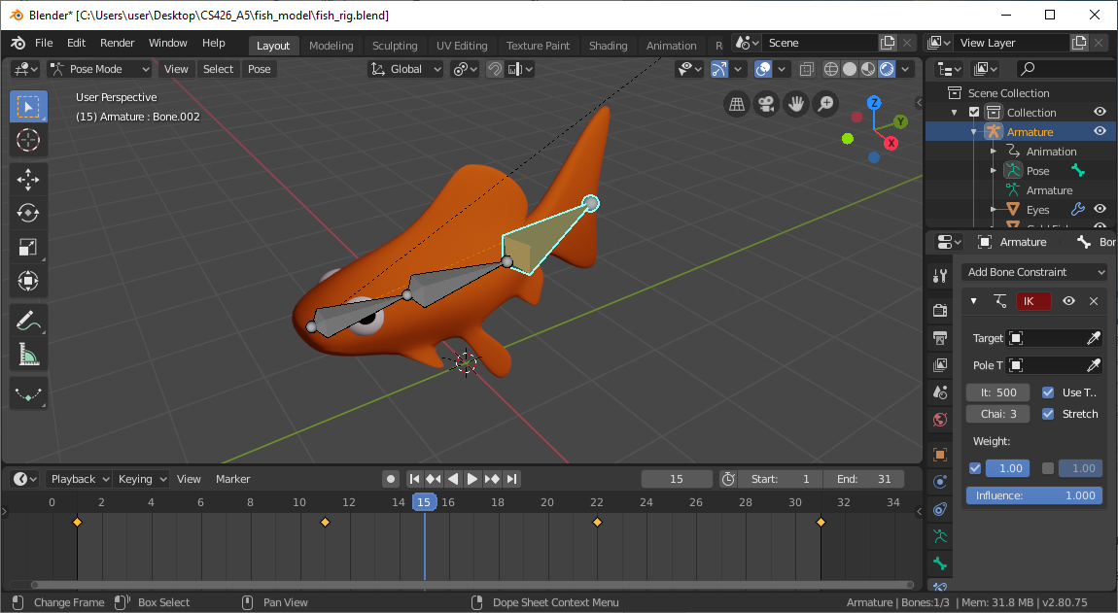

Your report should include a screen shot similar to that above and at least two freeze frame (rendered images) from the time line showing the fish tail in different positions.

View – Align view – Align camera to active view (or numpad 0)

Set render mode, , to 320x160 pixels.

Render – Render image.

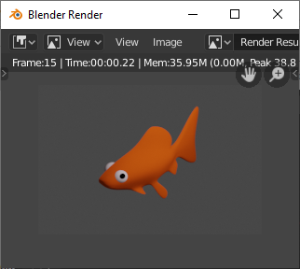 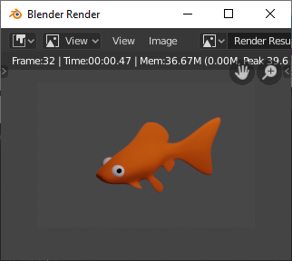

**Part 3:** Create an animation for Vincent.

Load the blender file containing the fully rigged model of Vincent. Create an animation for him with at least two key frames. Render images for the first and last frame of your animation sequence. Refer to the video for further support with this.

You will need to reduce the render setting resolution, , to reduce the image size (e.g. 200x300) and once rendered save the images created for the current frames (first and last). Set start and stop frame to 1 and output to bmp rather than jpeg (or it can all run a bit slow). Render and bottom of render window select – save – save copy.

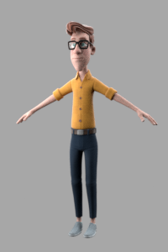 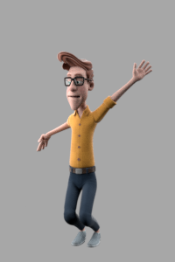

**Part 4:** Rigging a model using an armature associated with a mocap sequence.

Open the existing blender file for the boy.

Select the boy and click on the modifiers button, , and select apply modifier.

Keep this blender file open.

Open a new default blender project, delete the cube and import the mocap file.

File – import – fbx - mocap_original.fbx

Copy the “cube” which represents the boy from the scene collection in the first blender window and paste it into the scene collection of the blender window with the imported fbx file.

In object mode move the model to align with the armature (in pose frame 1, for real T-pose around frame 60). Use G for grab – move in Y direction ->Gy and then rotate about x -> Rx.

In object mode<shift> click on the model, then <shift> click on the armature to select the two of them. The press <ctrl>p and select with automatic weights.

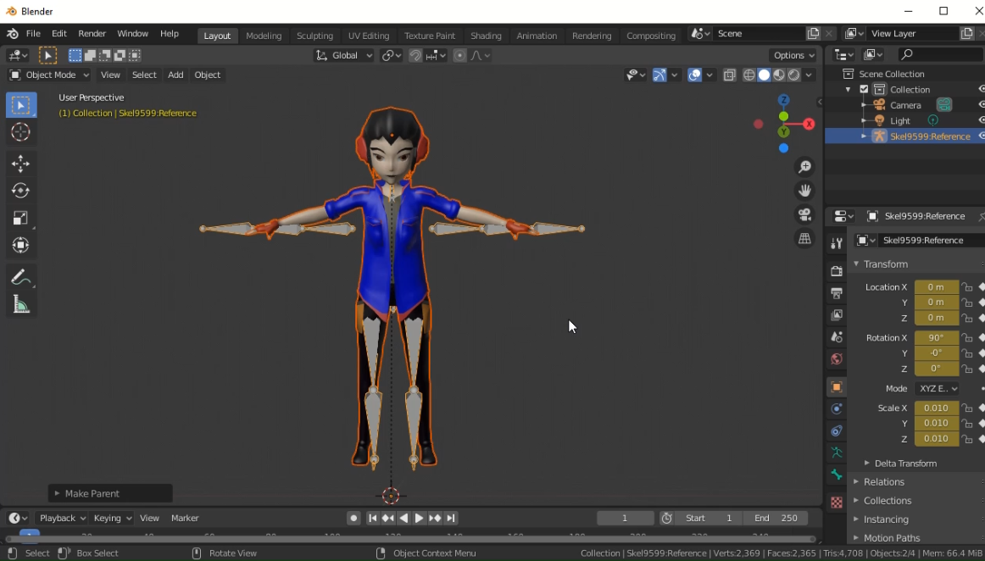

Turn off the visibility of the armature and set the timeline sequence to run to about 600 frames (instead of 250).

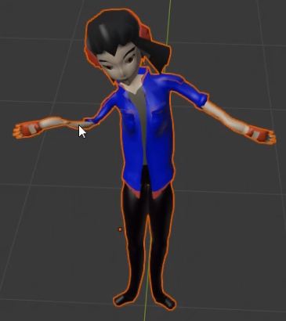 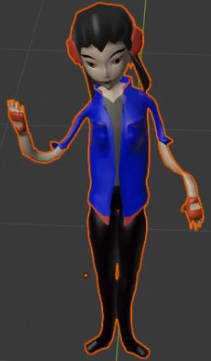 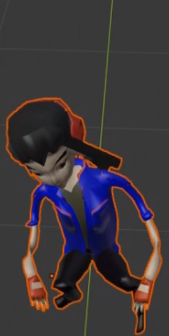

The above images show, T-pose, right hand up and crouching. Clearly there is a much more to rigging but we have made a start. Do not try and go for perfection with this part of the assignment (unless you already know how to do a full rig and would like to demonstrate this knowledge), just align the model and armature and <ctrl>-p and see what you get. The mocap data is controlling the armature, and the armature is deforming the mesh. The next step would be to create vertex groups for each part of the mesh and associate them with the appropriate bones in the armature. Then add constraints to limit bone motion and finally add controllers. For this section record your observations and include two or more screen shots of the rigged model in positions controlled by the mocap.