**Step 1. Setting the Pipette**

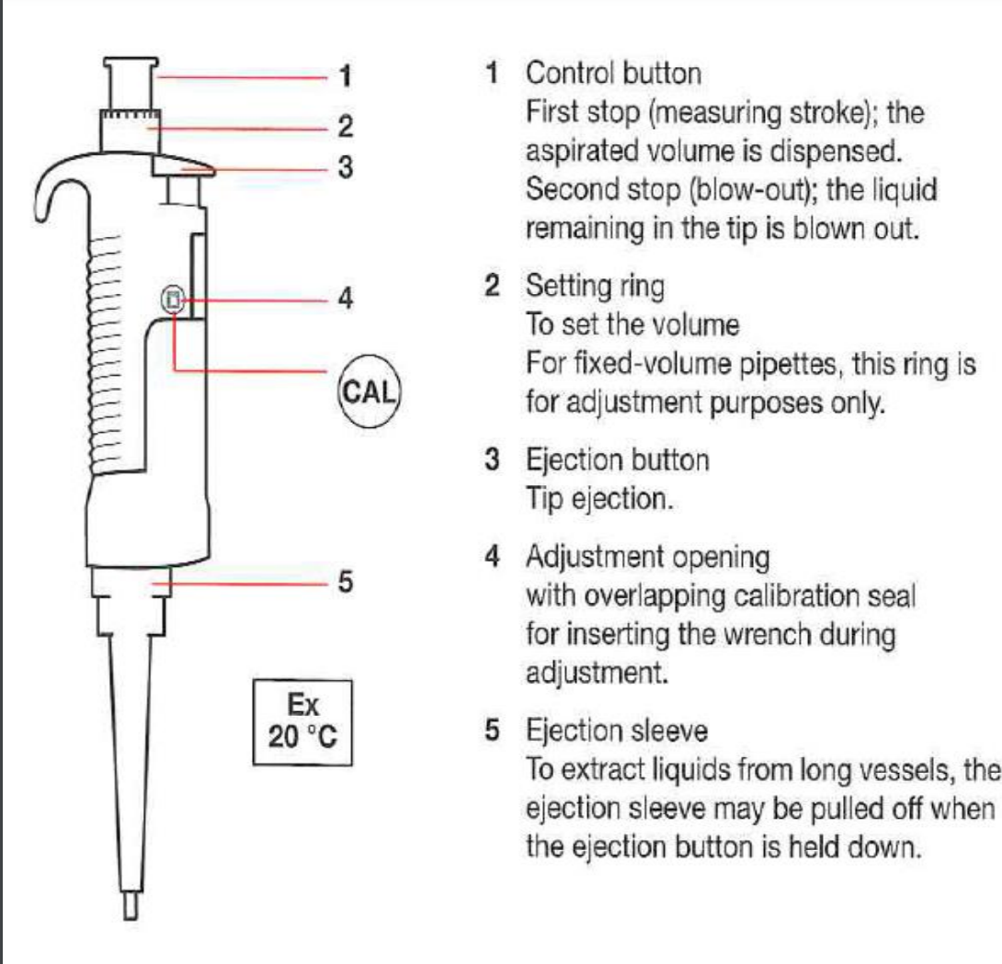

1. **Check your pipette plunger button to ensure you have the right one**.

Pipettes fall into the following ranges: P2.5 (0.1 to 2.5 μl), P10 (0.5 to 10 μl), P100 (10 to 100 μl), P200 (20 to 200 μl), P1000 (200 to 1000 μl), P5000 (500 to 5000 μl).

1. **Put a tip on your pipette Clear tips (P2.5 and P10), yellow tips (P100 and P200), and blue tips (P1000)**

Press down gently, but firmly, to ensure that the tip is firmly on the pipette. Generally, tips fit onto the shaft of the pipette and lock firmly into place.

1. **Adjust the pipette until you reach the desired volume.**

Prevent damage to your pipette with proper handling. Rotating the volume adjustment knob beyond the upper or lower range of the pipette could damage it.

**Step 2. Drawing (Aspirating)**

1. **Press the push-button until it reaches the First Stop.**

When you feel resistance in the push-button, you’ve positioned it to draw the amount set by the volume adjustment knob.

1. **Immerse the disposable tip of the pipette into liquid.**

Hold the pipette almost vertically so it forms an Lshape with the surface of the liquid (< 20 ° from vertical). Dip tip 2-4 mm into the fluid. Do not push down to the bottom of the vial, otherwise the tip is blocked and you draw less liquid than intended. If the tip is not immersed deeply enough into the liquid, an incorrect volume will be also aspirated.

1. **Draw fluid into the pipette**.

When the tip is immersed, gently release the thumb to allow the pushbutton to return to its starting position (fully extended). Do this slowly so the push-button doesn’t snap out and prevent the formation of aerosols.

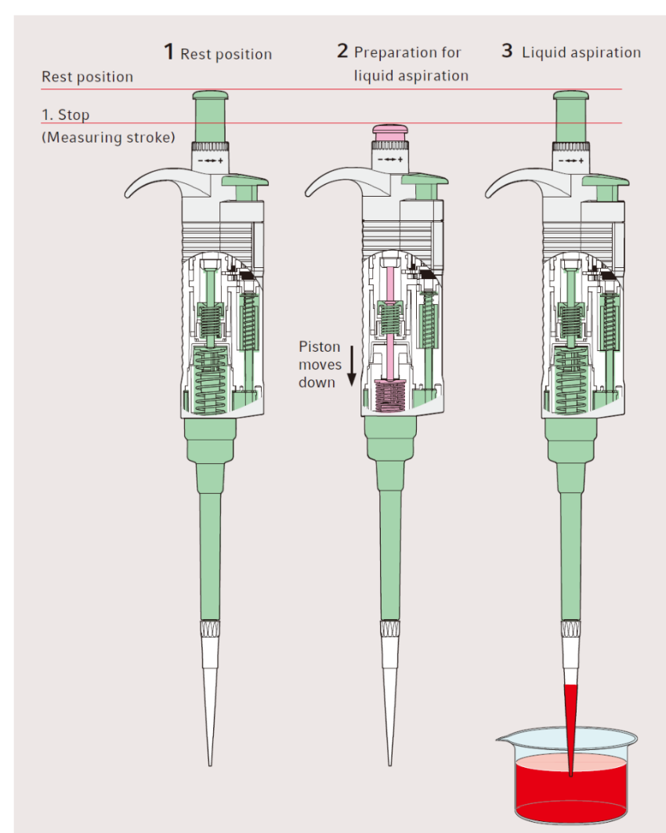  
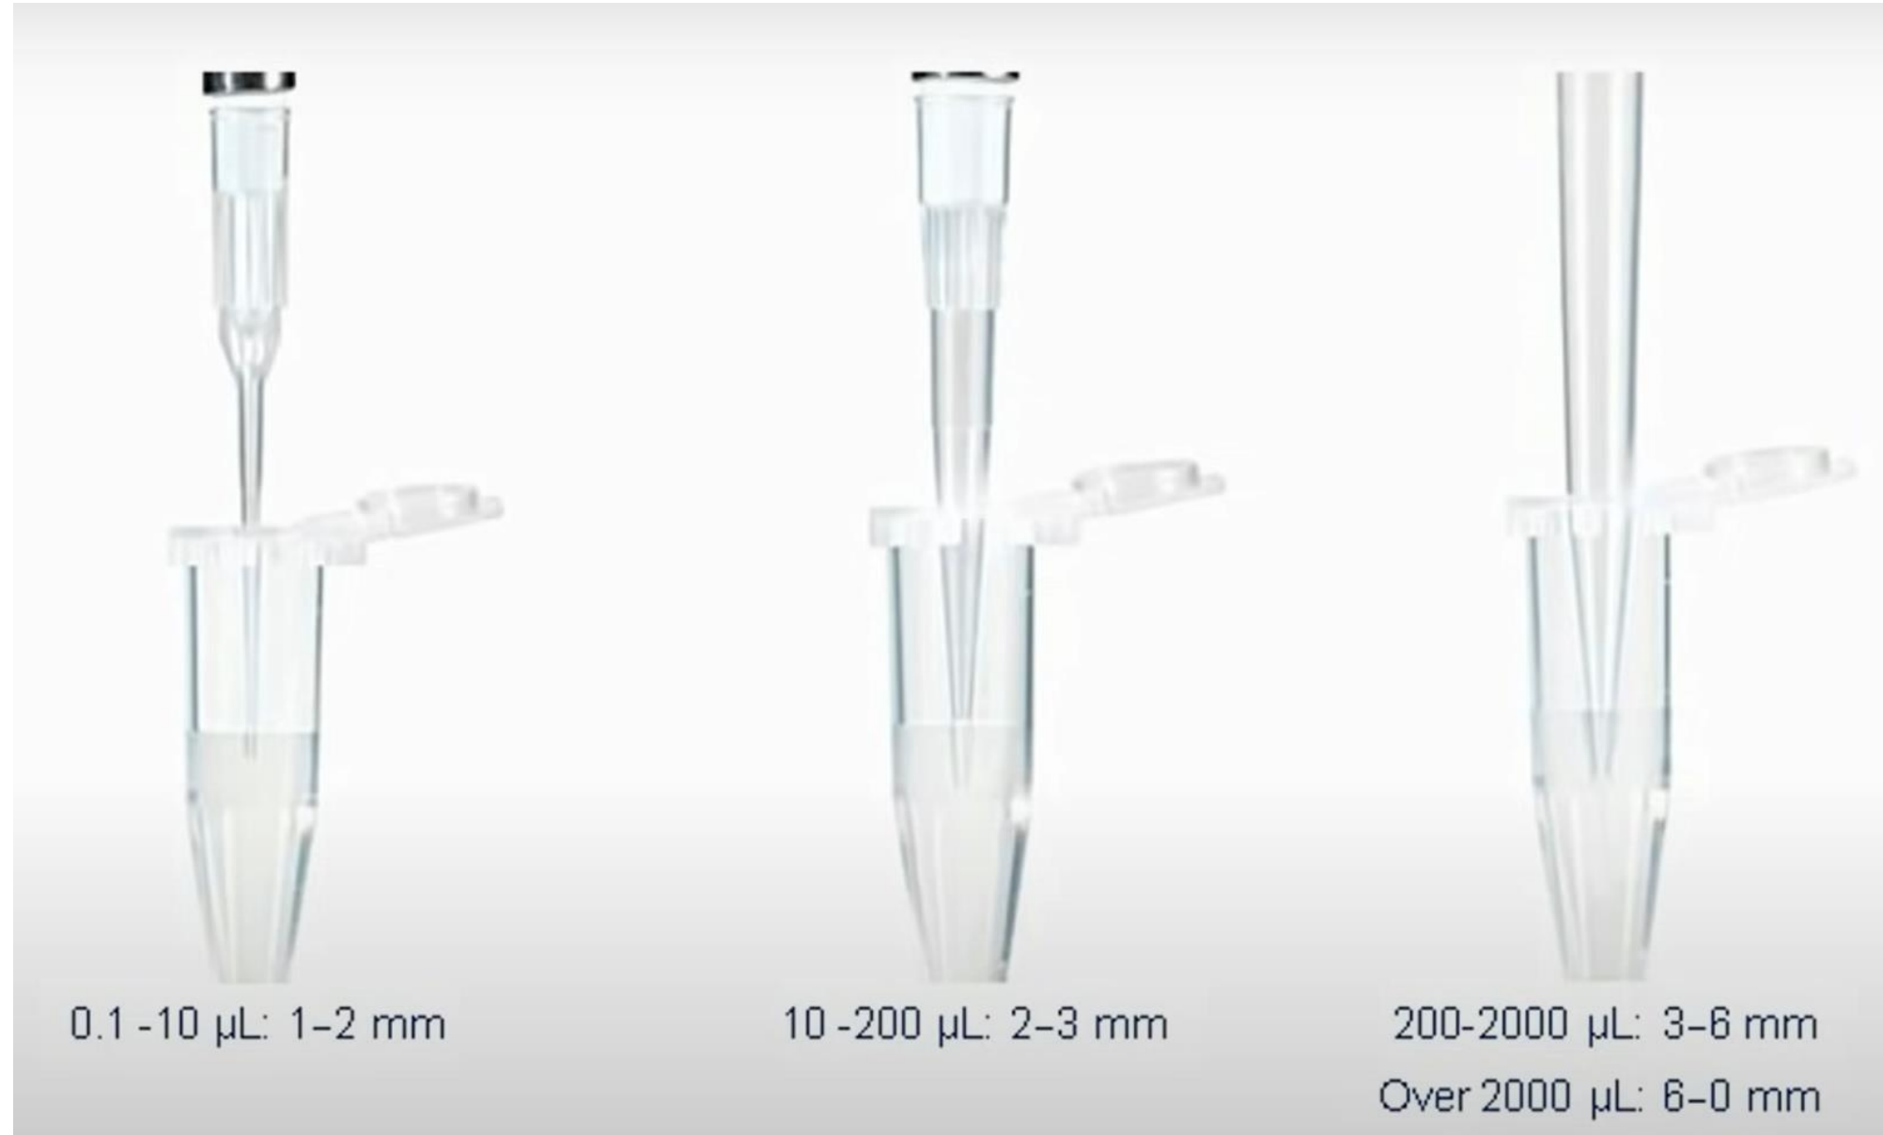

**Step 3. Dispensing**

1. **Touch tip to wall of vessel**

2. **Dispensing angle of 20-45 with contact to vessel wall**

3. **Slowly depress push-button to first, and then to the second stop to expel fluid.** (When dispensing viscous liquids, pause before blowout to ensure that everything has been expelled.)

4. **While keeping the push-button at the second stop**,

slide the tip out of the fluid, along the tube wall and out of the tube.

5. **Dispose the tip and return your pipette to the pipette holder.** The tip can be removed easily with the tip ejector button.

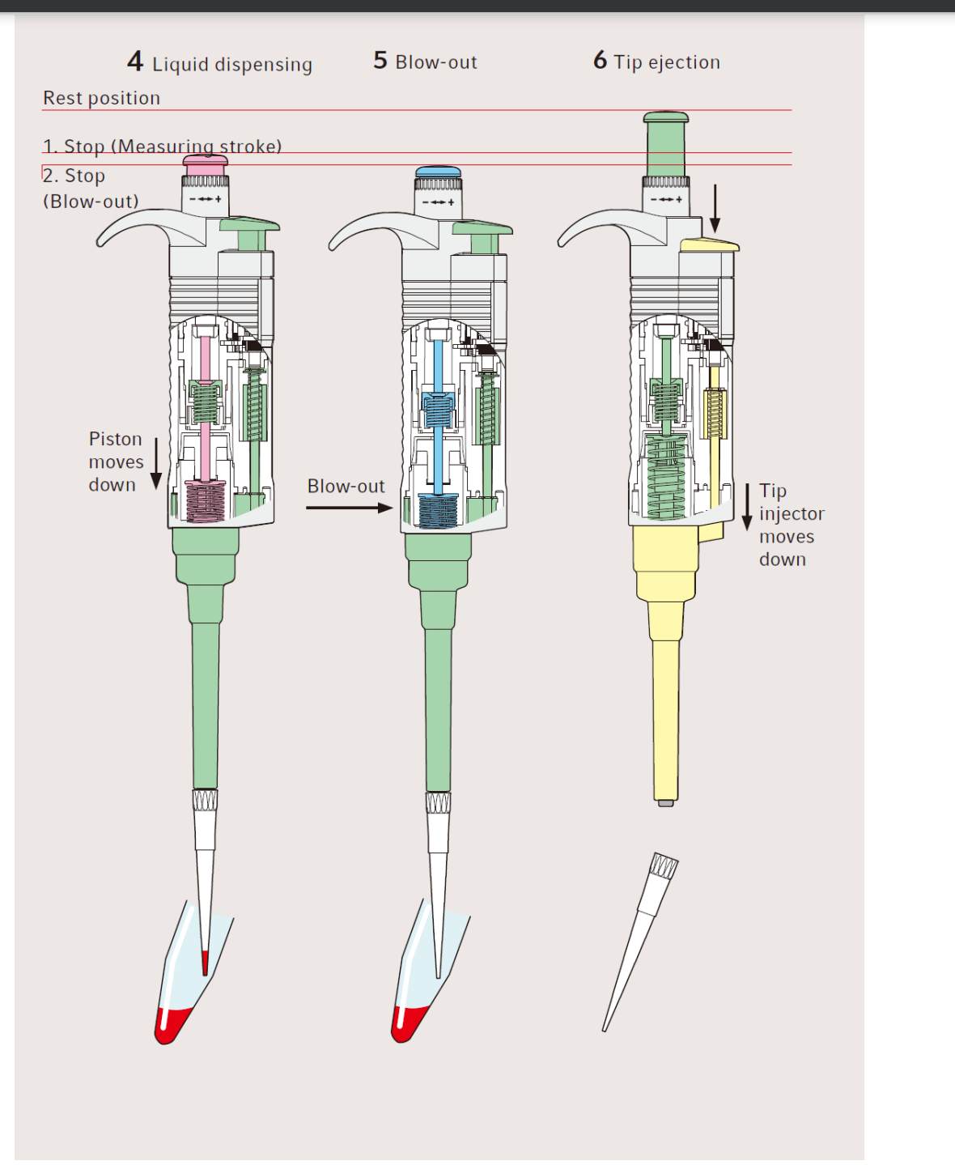

* Prevention of cross contamination
* Use a fresh tip each time ¬ Do not touch the tube with the pipette, only with the tip
* If you suspect pipette contamination, wipe with ethanol on the outside. If the inside is contaminated, talk to our TAs or technician.
* Draw up liquid slowly to prevent the formation of aerosols
* For specific applications, use pipette tips with filters
* Firmly seat the proper-sized tip on end of the pipette. If the fit is loose, you will draw up less volume than intended and the liquid will drip from the tip during use.
* the pipettes have a two-stop position plunger. Depressing to the first stop measures the desired volume. Depressing to the second stop introduces an additional volume of air to blow out any remaining fluid from the tip.
* Always dial DOWN to the desired volume to avoid mechanical backlash affecting accuracy.