ASSIGNMENT – 10

Write a java program to creates three push buttons showing three different colors as their label. When a button is clicked, that particular color is set as background color in the frame.
importjava.awt.*; import java.awt.event.*;
public class AWT1 {
public static void main(String args[]) { Frame frame = new Frame("AWT1");

Button b1 = new Button("Red"); Button b2 = new Button("Green"); Button b3 = new Button("Blue");
b1.setBounds(50, 80, 80, 40);
b2.setBounds(150, 80, 80, 40);
b3.setBounds(260, 80, 80, 40);
b1.addActionListener(new ActionListener() { public void actionPerformed(ActionEvent e) {
frame.setBackground(Color.RED);
}
});
b2.addActionListener(new ActionListener() { public void actionPerformed(ActionEvent e) {
frame.setBackground(Color.GREEN);
}
});
b3.addActionListener(new ActionListener() { public void actionPerformed(ActionEvent e) {
frame.setBackground(Color.BLUE);
}
});

frame.addWindowListener(new WindowAdapter() { public void windowClosing(WindowEvent e) {
System.exit(0);
}
});

frame.add(b1); frame.add(b2); frame.add(b3);

frame.setBackground(Color.LIGHT_GRAY); frame.setSize(400, 300); frame.setLayout(null); frame.setVisible(true);
}
}
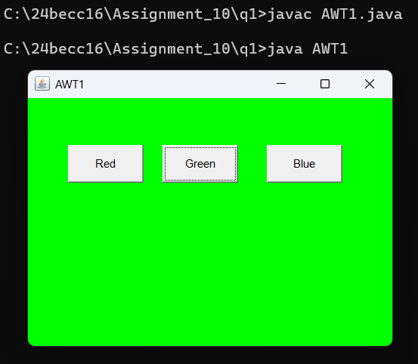

Write a java program, which will create 3 text field and one button labelled as
Subtract. The program will take the input from the two-text filed and upon pressing the Subtract button it will display the result in the third text field.
import java.awt.*; import java.awt.event.*;
public class AWT2 extends Frame {
private TextField textField1, textField2, resultField; private Button subtractButton;
public AWT2() {
setTitle("AWT2"); setSize(300, 250);
this.addWindowListener(new WindowAdapter() { public void windowClosing(WindowEvent e) {
System.exit(0);
}
});

setLayout(null);
textField1 = new TextField(); textField2 = new TextField();

resultField = new TextField();
resultField.setEditable(false); subtractButton = new Button("Subtract");
textField1.setBounds(30, 50, 130, 30);
textField2.setBounds(30, 100, 130, 30);
resultField.setBounds(30, 150, 130, 30);
subtractButton.setBounds(30, 200, 130, 30);
add(textField1); add(textField2); add(resultField); add(subtractButton);
subtractButton.addActionListener(new ActionListener() { public void actionPerformed(ActionEvent e) {
try {
int num1 = Integer.parseInt(textField1.getText()); int num2 = Integer.parseInt(textField2.getText()); int result = num1 - num2; resultField.setText(Integer.toString(result));
}
catch(NumberFormatException ex) { resultField.setText("Invalid Input");
}
}
});
}

public static void main(String[] args) { AWT2 frame = new AWT2(); frame.setVisible(true);
}
}
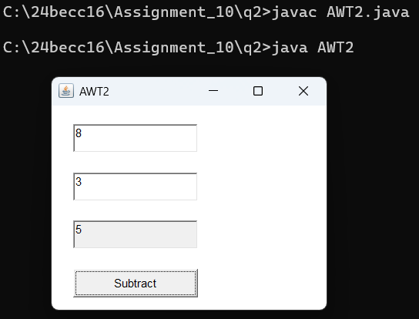

Write a java program, which will create 3 text field, one button labelled as Subtract and one button as Add. The program will take the input from the two-text filed and upon pressing the Subtract or Add button it will display the result in the third text field. import java.awt.*;
import java.awt.event.*;
public class AWT3 extends Frame {
private TextField textField1, textField2, resultField; private Button subtractButton, addButton;
public AWT3() {
setTitle("AWT3"); setSize(300, 250);
this.addWindowListener(new WindowAdapter() { public void windowClosing(WindowEvent e) {
System.exit(0);
}
});
setLayout(null);
textField1 = new TextField(); textField2 = new TextField(); resultField = new TextField();
resultField.setEditable(false); subtractButton = new Button("-"); addButton = new Button("+");
textField1.setBounds(30, 50, 130, 30);
textField2.setBounds(30, 100, 130, 30);
resultField.setBounds(30, 150, 130, 30);
subtractButton.setBounds(150, 200, 80, 40);
addButton.setBounds(50, 200, 80, 40);
add(textField1); add(textField2); add(resultField); add(subtractButton); add(addButton);

subtractButton.addActionListener(new ActionListener() { public void actionPerformed(ActionEvent e) {
try {
int num1 = Integer.parseInt(textField1.getText()); int num2 = Integer.parseInt(textField2.getText()); int result = num1 - num2; resultField.setText(Integer.toString(result));
}
catch (NumberFormatException ex) {

}
});
resultField.setText("Invalid Input!");
}

addButton.addActionListener(new ActionListener() { public void actionPerformed(ActionEvent e) {
try {
int num1 = Integer.parseInt(textField1.getText()); int num2 = Integer.parseInt(textField2.getText()); int result = num1 + num2; resultField.setText(Integer.toString(result));
}
catch (NumberFormatException ex) { resultField.setText("Invalid Input!");
}
}
});
}
public static void main(String args[]) { AWT3 frame = new AWT3(); frame.setVisible(true);
}
}
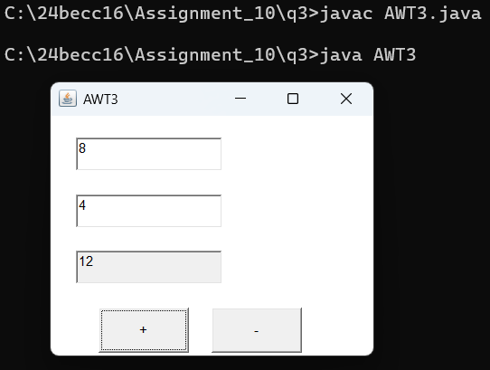

Write a java program, which will create 2 text field and one button labelled as
Factorial. The user will enter a number in the 1st text field and upon pressing the button it will display the Factorial of the number in the 2nd text field.
import java.awt.*; import java.awt.event.*;
public class AWT4 extends Frame{

private TextField textField, resultField; private Button button;

public AWT4() {
setTitle("AWT4"); setSize(300, 250);
this.addWindowListener(new WindowAdapter() { public void windowClosing(WindowEvent e) {
System.exit(0);
}
});

setLayout(null);
textField = new TextField(); resultField = new TextField(); resultField.setEditable(false); button = new Button("Factorial(!)");
textField.setBounds(30, 50, 130, 30);
resultField.setBounds(30, 150, 130, 30);
button.setBounds(30, 200, 130, 30);

add(textField); add(resultField); add(button);
button.addActionListener(new ActionListener() { public void actionPerformed(ActionEvent e) {
try {
int n = Integer.parseInt(textField.getText()); int fact = 1;
for(int i=1; i<=n; i++) { fact *= i;
}
resultField.setText(Integer.toString(fact));
}

catch(NumberFormatException ex) { resultField.setText("Invalid Input!");
}
}
});
}
public static void main(String args[]) { AWT4 frame = new AWT4();

frame.setVisible(true);
}
}
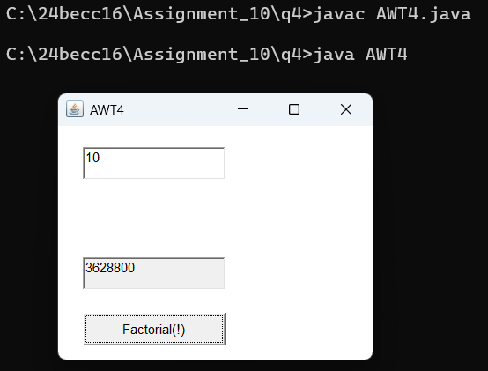

Write a java awt program, which will create 2 text field and one button labelled as Reverse. The user will enter a number in the 1st text field and upon pressing the button it will display the reverse of the number in the 2nd text field.
import java.awt.*; import java.awt.event.*;
public class AWT5 extends Frame {
private TextField textField1,resultField; private Button factorialButton;
public AWT5() {
setTitle("AWT5"); setSize(300, 250);

this.addWindowListener(new WindowAdapter() { public void windowClosing(WindowEvent e) {
System.exit(0);
}
});

setLayout(null);
textField1 = new TextField(); resultField = new TextField(); resultField.setEditable(false);
factorialButton = new Button("Reverse");
textField1.setBounds(30, 50, 130, 30);
resultField.setBounds(30, 150, 130, 30);
factorialButton.setBounds(30, 200, 130, 30);

add(textField1); add(resultField); add(factorialButton);

factorialButton.addActionListener(new ActionListener() { public void actionPerformed(ActionEvent e) {
try {
int n = Integer.parseInt(textField1.getText()); int sum = 0;
while(n != 0) {
int r = n % 10;
sum = sum * 10 + r; n = n / 10;
}
resultField.setText(Long.toString(sum));
}
catch (NumberFormatException ex) { resultField.setText("Invalid Input");
}
}
});
}
public static void main(String[] args) { AWT5 frame = new AWT5(); frame.setVisible(true);
}
}
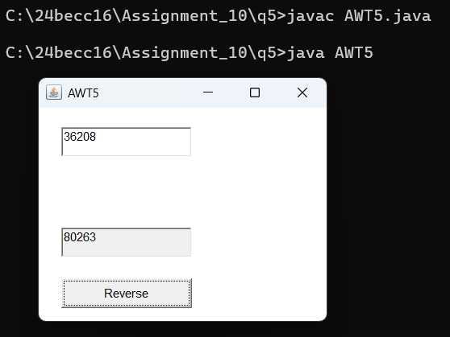

Design an AWT GUI application (called AWT Counter). Each time the "Count" button is clicked, the counter value should increase by 1 and each time the Reset button is clicked the counter value should be reset to zero.
import java.awt.*;

import java.awt.event.*;
public class AWT6 extends Frame { private TextField textField1;
private Button countButton, resetButton; static int count = 0;
public AWT6() { setTitle("AWT6"); setSize(300, 250);

this.addWindowListener(new WindowAdapter() { public void windowClosing(WindowEvent e) {
System.exit(0);
}
});
setLayout(null);

textField1 = new TextField(); textField1.setEditable(false);
countButton = new Button("Count"); resetButton = new Button("Reset");

textField1.setBounds(30, 50, 130, 30);
countButton.setBounds(180, 50, 80, 30);
resetButton.setBounds(50, 100, 80, 30);

add(textField1); add(countButton); add(resetButton);
textField1.setText(Integer.toString(count)); countButton.addActionListener(new ActionListener() {
public void actionPerformed(ActionEvent e) {
textField1.setText(Integer.toString(++count));
}
});
resetButton.addActionListener(new ActionListener() { public void actionPerformed(ActionEvent e) {
count = 0; textField1.setText(Integer.toString(count));
}
});
}

public static void main(String[] args) { AWT6 frame = new AWT6(); frame.setVisible(true);
}
}
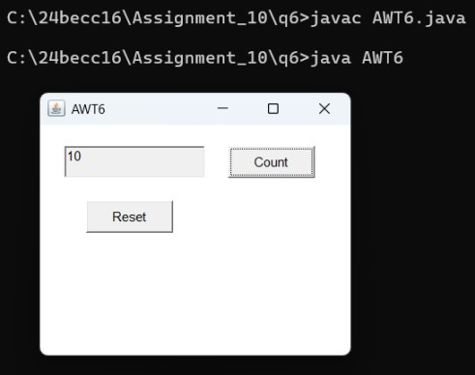

Create three color buttons (with caption “Red”, “Blue” and “Green”) and a text label. Initially the text should be displayed in black color. When the user clicks on a particular color button the text should be changed to that particular color as shown in the figure.
import java.awt.*; import java.awt.event.*;
public class AWT7 {
public static void main(String[] args) {

Frame frame = new Frame("AWT7");
Label label = new Label("Welcome"); label.setAlignment(Label.CENTER);
label.setFont(new Font("Roboto Condensed Light", Font.BOLD, 20));

Button b1 = new Button("Red"); Button b2 = new Button("Green"); Button b3 = new Button("Blue");
b1.setBounds(50, 80, 80, 40);
b2.setBounds(150, 80, 80, 40);
b3.setBounds(260, 80, 80, 40);
label.setBounds(140, 120, 100, 80);

b1.addActionListener(new ActionListener() { public void actionPerformed(ActionEvent e) {
label.setForeground(Color.red);

}
});

b2.addActionListener(new ActionListener() { public void actionPerformed(ActionEvent e) {
label.setForeground(Color.green);
}
});

b3.addActionListener(new ActionListener() { public void actionPerformed(ActionEvent e) {
label.setForeground(Color.blue);
}
});
frame.addWindowListener(new WindowAdapter() { public void windowClosing(WindowEvent e) {
System.exit(0);
}
});
frame.add(b1); frame.add(b2); frame.add(b3); frame.add(label);
frame.setSize(400, 300); frame.setLayout(null); frame.setVisible(true);
}
}
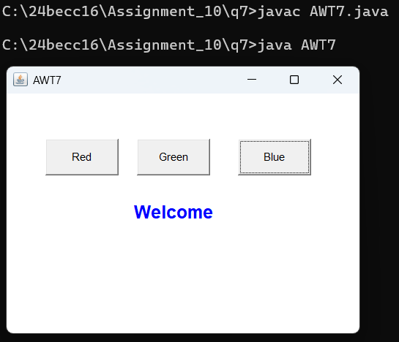

Write a AWT program, which creates 2 text field with two labels and one button labelled as Count. The program will take the input from one text filed. When we click the button it will count the number of digits of the given number and display the result in the second field. Label one will be written as "Input number" and second label will show "Number of digits: ".
import java.awt.*; import java.awt.event.*;

public class AWT8 extends Frame { private TextField textField1, resultField; private Button factorialButton;
private Label lb1, lb2;

public AWT8() {
setTitle("Calculate Number of Digits"); setSize(300, 250);
this.addWindowListener(new WindowAdapter() { public void windowClosing(WindowEvent e) {
System.exit(0);
}
});
setLayout(null);

textField1 = new TextField(); resultField = new TextField(); resultField.setEditable(false);

factorialButton = new Button("No. of Digits"); lb1 = new Label("Input number");
lb2 = new Label("Number of digits");
lb1.setBounds(30, 50, 130, 30);
textField1.setBounds(150, 50, 130, 30);
lb2.setBounds(30, 100, 130, 30);
resultField.setBounds(150, 100, 130, 30);
factorialButton.setBounds(80, 150, 130, 30);

add(textField1); add(resultField); add(factorialButton); add(lb1);
add(lb2);

factorialButton.addActionListener(new ActionListener() { public void actionPerformed(ActionEvent e) {
try {

int n = Integer.parseInt(textField1.getText()); int count = 0;
while (n != 0) { count++;
n = n / 10;
}
resultField.setText(Integer.toString(count));
}

}
}
});
}
catch (NumberFormatException ex) { resultField.setText("Invalid Input");

public static void main(String[] args) { AWT8 frame = new AWT8();
frame.setBackground(Color.LIGHT_GRAY); frame.setVisible(true);
}
}
