Assignment – 4

Q1. Write a program to print the average of three numbers entered by user by creating a class named 'Average' having a method to calculate and print the average. Define another Main class to demonstrate the basic operation.
import java.util.Scanner;
class Average {
public static double calculateAverage(double a, double b, double c) {
return (a + b + c) / 3.0;
}
}
class Main {
public static void main(String[] args) {
Scanner sc = new Scanner(System.in);
System.out.print("Enter 3 numbers: ");
double a = sc.nextDouble();
double b = sc.nextDouble();
double c = sc.nextDouble();
double avg = Average.calculateAverage(a, b, c);
System.out.println("The average of 3 numbers is " + avg);
}
}
Output:
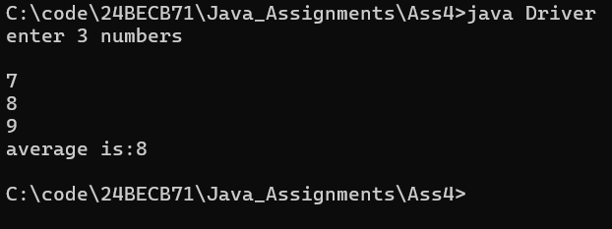
Q2. Write a program to create a class named 'Student' with members 'name', 'roll', ‘branch’. Declare two methods to input the student details and display the details of the student. Create a Main class to test the functionalities of the above class.
import java.util.Scanner;
class Student {
private String name, branch;
private int roll;
public void initialize(String name, int roll, String branch) {
if (roll <= 0) {
System.out.println("Roll No. can only be positive");
System.exit(0);
}
this.name = name;
this.roll = roll;
this.branch = branch;
}
public void display() {
System.out.println("Name: " + name);
System.out.println("Roll: " + roll);
System.out.println("Branch: " + branch);
}
}
class Main {
public static void main(String[] args) {
Scanner sc = new Scanner(System.in);
Student student = new Student();
System.out.print("Enter name, roll and branch of the Student: ");
String name = sc.next();
int roll = sc.nextInt();
String branch = sc.next();
student.initialize(name, roll, branch);
System.out.println("The Student details are: ");
student.display();
}
}
Output:
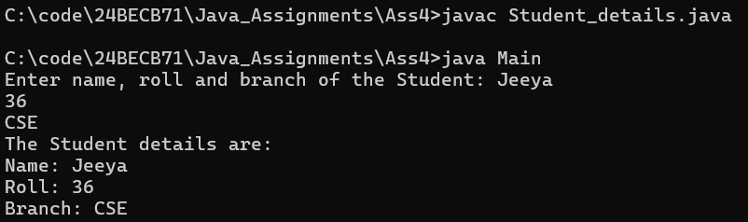
Q3. Declare a class Complex with member real and imaginary part. Define a method initialise() to input the two complex numbers, display() to display the complex number and add() to add the two complex numbers. Declare another class to illustrate the operations of the Complex class.
import java.util.Scanner;
class Complex {
private double real, imag;
public void initialize(double real, double imag) {
this.real = real;
this.imag = imag;
}
public void display() {
System.out.println(real + "+" + imag + "i");
}
public static Complex add(Complex complex1, Complex complex2) {
Complex res = new Complex();
res.initialize(complex1.real + complex2.real, complex1.imag + complex2.imag);
return res;
}
}
class Main {
public static void main(String[] args) {
Complex complex1 = createComplex("first");
Complex complex2 = createComplex("second");
System.out.println("The two complex numbers are: ");
complex1.display();
complex2.display();
Complex sum = Complex.add(complex1, complex2);
System.out.print("Sum of two complex numbers is: ");
sum.display();
}
private static Complex createComplex(String name) {
Scanner sc = new Scanner(System.in);
System.out.print("Enter real and imag for " + name + " complex number: ");
double real = sc.nextDouble();
double imag = sc.nextDouble();
Complex complex = new Complex();
complex.initialize(real, imag);
return complex;
}
}
Output:
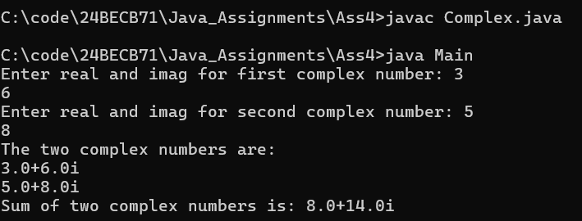
Q4. Write a program to print the area of a rectangle by creating a class named 'Area' having two methods. First method named as 'setDim ()' takes length and breadth of rectangle as parameters and the second method named as 'getArea ()' returns the area of the rectangle. Length and breadth of rectangle are entered through keyboard. [use ‘this’ keyword]
import java.util.Scanner;
class Area {
private double length, breath;
public void setDim(double length, double breath) {
validate(length, "Length");
validate(breath, "Breath");
this.length = length;
this.breath = breath;
}
public double getArea() {
return length * breath;
}
private static void validate(double value, String name) {
if (value <= 0) {
System.out.println(name + " can only be positive");
System.exit(0);
}
}
}
class Main {
public static void main(String[] args) {
Scanner sc = new Scanner(System.in);
Area area = new Area();
System.out.print("Enter the length and breath of the rectangle: ");
double length = sc.nextDouble();
double breath = sc.nextDouble();
area.setDim(length, breath);
System.out.println("The area of the rectangle is " + area.getArea());
}
}
Output:
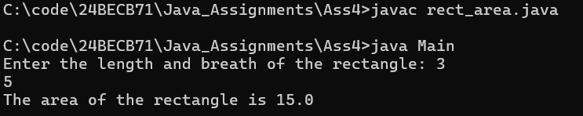
Q5. Write a program to declare a class employee with data members id, name, department, salary. Add a method getData(), putData() to accept and display the details of n employees. Define a Main class to create the objects of employee class and perform basic operations.
import java.util.Scanner;
class Employee {
private int id;
private String name, department;
private double salary;
public void putData(int id, String name, String department, double salary) {
if (id <= 0) {
System.out.println("Employee ID can only be positive");
System.exit(0);
}
if (salary < 0.0) {
System.out.println("Salary cannot be negative");
System.exit(0);
}
this.id = id;
this.name = name;
this.department = department;
this.salary = salary;
}
public void getData() {
System.out.println("ID: " + id);
System.out.println("Name: " + name);
System.out.println("Department: " + department);
System.out.println("Salary: " + salary);
System.out.println();
}
}
class Main {
public static void main(String[] args) {
Scanner sc = new Scanner(System.in);
System.out.print("Enter the number of Employee details you want to add: ");
int size = sc.nextInt();
Employee[] employees = new Employee[size];
System.out.println("\nEnter the details of " + size + " Employees:");
for (int i = 0; i < size; i++) {
employees[i] = new Employee();
System.out.print("Enter the Employee ID, Name, Department and Salary of Employee" + (i + 1) + ": ");
int id = sc.nextInt();
String name = sc.next();
String department = sc.next();
double salary = sc.nextDouble();
employees[i].putData(id, name, department, salary);
}
System.out.println("\nThe employee data are: ");
for (Employee employee : employees) {
employee.getData();
} } }
Output:
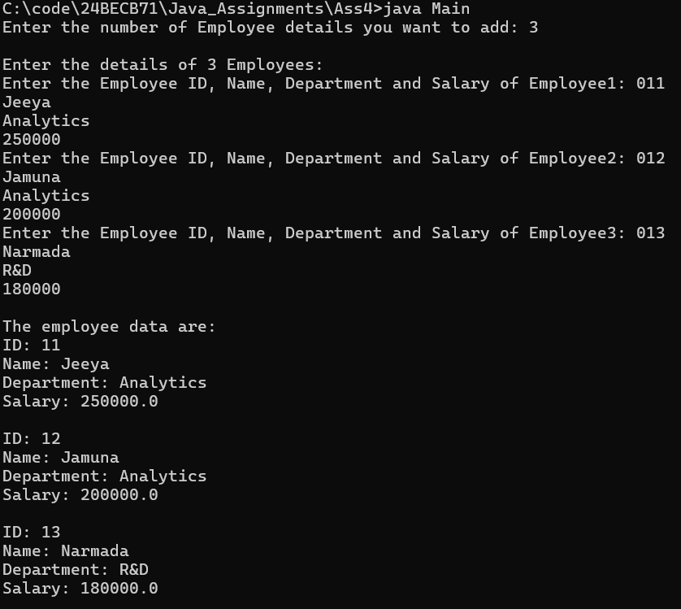

Q6. Define a class Student having the attribute sic, name, branch and cgpa. Write 2 methods to accept and display the student details. Read the details of 5 students using an array of Student class object. Display the student details who have secured the highest CGPA.
import java.util.Scanner;
class Student {
private String sic, name, branch;
private double cgpa;
public void initialize(String sic, String name, String branch, double cgpa) {
if (cgpa < 0.0) {
System.out.println("CGPA cannot be negative");
System.exit(0);
}
this.sic = sic;
this.name = name;
this.branch = branch;
this.cgpa = cgpa;
}
public void display() {
System.out.println("SIC: " + sic);
System.out.println("Name: " + name);
System.out.println("Branch: " + branch);
System.out.println("CGPA: " + cgpa);
System.out.println();
}
public double getCgpa() {
return cgpa;
}
}
class Main {
public static void main(String[] args) {
Scanner sc = new Scanner(System.in);
Student[] students = new Student[5];
System.out.println("Enter details of 5 Students: ");
for (int i = 0; i < 5; i++) {
students[i] = new Student();
System.out.print("Enter SIC, Name, Branch and CGPA of the Student" + (i + 1) + ": ");
String sic = sc.next();
String name = sc.next();
String branch = sc.next();
double cgpa = sc.nextDouble();
students[i].initialize(sic, name, branch, cgpa);
}
System.out.println("\nThe student details are: ");
Student highestCgpa = students[0];
for (Student student : students) {
if (student.getCgpa() > highestCgpa.getCgpa()) {
highestCgpa = student;
}
student.display();
}
System.out.println("Student with highest CGPA is:");
highestCgpa.display();
}
}
Output:
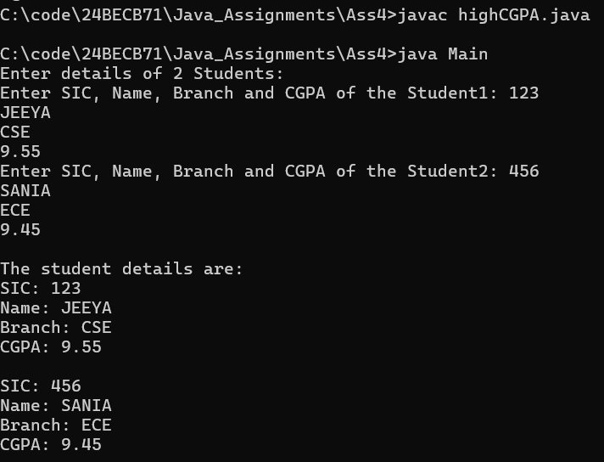
Q7. Define a class ‘Box’ that uses a parameterized constructor to initialize the dimensions of a box. The dimensions of the Box are length, breath, height. The class should have a method that can return the volume of the box. Create an object of the Box class and test the functionalities [use this keyword].
import java.util.Scanner;
class Box {
private double length, breath, height;
public Box(double length, double breath, double height) {
validate(length, "Length");
validate(breath, "Breath");
validate(height, "Height");
this.length = length;
this.breath = breath;
this.height = height;
}
public double computeVolume() {
return length * breath * height;
}
private static void validate(double value, String name) {
if (value <= 0) {
System.out.println(name + " can only be positive");
System.exit(0);
}
}
}
class Main {
public static void main(String[] args) {
Scanner sc = new Scanner(System.in);
System.out.print("Enter length, breath and height for a Box: ");
double length = sc.nextDouble();
double breath = sc.nextDouble();
double height = sc.nextDouble();
Box box = new Box(length, breath, height);
System.out.println("The volume of the Box is " + box.computeVolume());
}
}
Output:
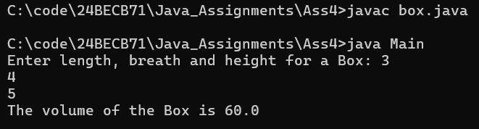
Q8. Design a class ‘Complex’ to manipulate Complex numbers having data members as real and imag. The class should have a parameterizedconstructor to initialize its data members. It should also have methods display() to display the complex number (in the format 5+3i for example), add() to add two Complex numbers. Test these methods by creating main method in another class.
import java.util.Scanner;
class Complex {
private double real, imag;
public Complex(double real, double imag) {
this.real = real;
this.imag = imag;
}
public void display() {
System.out.println(real + "+" + imag + "i");
}
public static Complex add(Complex complex1, Complex complex2) {
return new Complex(complex1.real + complex2.real, complex1.imag + complex2.imag);
}
}
class Main {
public static void main(String[] args) {
Complex complex1 = createComplex("first");
Complex complex2 = createComplex("second");
System.out.println("The two complex numbers are: ");
complex1.display();
complex2.display();
Complex sum = Complex.add(complex1, complex2);
System.out.print("Sum of two complex numbers is: ");
sum.display();
}
private static Complex createComplex(String name) {
Scanner sc = new Scanner(System.in);
System.out.print("Enter real and imag for " + name + " complex number: ");
double real = sc.nextDouble();
double imag = sc.nextDouble();
return new Complex(real, imag);
}
}
Output:
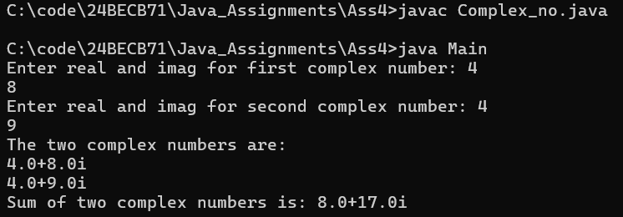
Q9. Design a class ‘Point’ with data members as x and y. The class should have a parameterized constructor to initialize its data members. Define a method distance() which returns the distance between two points.
import java.util.Scanner;
class Point {
private double x, y;
public Point(double x, double y) {
this.x = x;
this.y = y;
}
public static double distance(Point point1, Point point2) {
return Math.sqrt(Math.pow(point2.x - point1.x, 2) + Math.pow(point2.y - point1.y, 2));
}
}
class Main {
public static void main(String[] args) {
Point point1 = createPoint("first");
Point point2 = createPoint("second");
double distance = Point.distance(point1, point2);
System.out.println("Distance between the two Points is: " + distance);
}
private static Point createPoint(String name) {
Scanner sc = new Scanner(System.in);
System.out.print("Enter x and y co-ordinates for " + name + " Point: ");
double x = sc.nextDouble();
double y = sc.nextDouble();
return new Point(x, y);
}
}
Output:
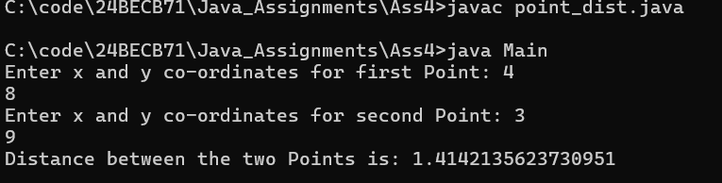
Q10. Design a class ‘Time’ having data members as hour, minute and second. The class should have a parameterized constructor to initialize its data members. It should also have methods display() to display the time in HH:MM:SS format and add() to add two times. Test these methods by creating a main method in another class.
import java.util.Scanner;
class Time {
private int hour, minute, second;
public Time(int hour, int minute, int second) {
validate(hour, "Hour");
validate(minute, "Minute");
validate(second, "Second");
this.hour = hour;
this.minute = minute;
this.second = second;
this.resolve();
}
public void display() {
System.out.println(hour + ":" + minute + ":" + second);
}
public static Time add(Time time1, Time time2) {
return new Time(time1.hour + time2.hour, time1.minute + time2.minute, time1.second + time2.second);
}
private void resolve() {
minute += second / 60;
second %= 60;
hour += minute / 60;
minute %= 60;
}
private static void validate(int value, String name) {
if (value < 0) {
System.out.println(name + " cannot be negative");
System.exit(0);
}
}
}
class Main {
public static void main(String[] args) {
Time time1 = createTime("first");
Time time2 = createTime("second");
System.out.println("The two Time objects are: ");
time1.display();
time2.display();
Time sum = Time.add(time1, time2);
System.out.print("Sum of two Time objects is: ");
sum.display();
}
private static Time createTime(String name) {
Scanner sc = new Scanner(System.in);
System.out.print("Enter hour, minute and second values for " + name + " Time object: ");
int hour = sc.nextInt();
int minute = sc.nextInt();
int second = sc.nextInt();
return new Time(hour, minute, second);
}
}
Output:
