ASSIGNMENT – 9

Q1. Write a JAVA program to read a string from the key board and print its reverse. Also check whether the string is palindrome or not.

import java.util.Scanner; class ReverseString {
public static void main(String args[]) { Scanner sc = new Scanner(System.in); System.out.print("Enter the string: "); String str = sc.nextLine();
StringBuilder rev = new StringBuilder(str).reverse(); System.out.println("The reversed string is: "+rev);
if(str.contentEquals(rev)) {
System.out.println(str+" is a palindrome");

}
else {
}
}
}

System.out.println(str+" is not a palindrome");

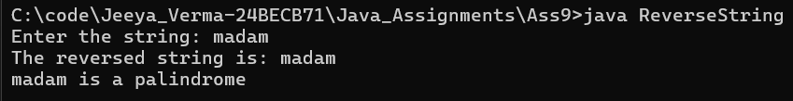
Q2. Write a JAVA program to capitalize first letter of each word in an inputted sentence from keyboard.
Sample Output:
Enter a sentence: india is great India Is Great

import java.util.Scanner; class StrUpperCase {
public static void main(String[] args) { Scanner sc = new Scanner(System.in); System.out.print("Enter a sentence: "); String string = sc.nextLine();
StringBuilder stringBuilder = new StringBuilder(); for (String word : string.split(" ")) {
if (!word.isEmpty()) { stringBuilder.append(Character.toUpperCase(word.charAt(0)))
.append(word.substring(1)).append(' ');

}
}
System.out.println("Transformed String is: " + stringBuilder.toString().trim());
}
}
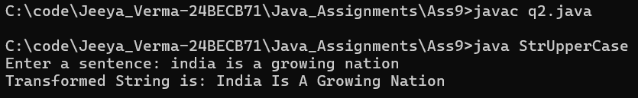

Q3. Write a JAVA program to convert a string into uppercase.

import java.util.Scanner; class UpperCaseString {
public static void main(String[] args) { Scanner sc = new Scanner(System.in); System.out.print("Enter a String: "); String str = sc.nextLine();
System.out.println("Upper-Case String is: "+str.toUpperCase());
}
}
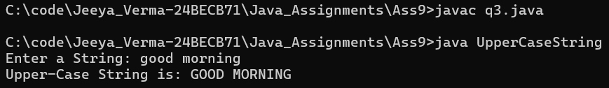

Q4. Write a Java program to input a string and print the total number of characters present in the string.

import java.util.Scanner; class TotalChars {
public static void main(String[] args) { Scanner sc = new Scanner(System.in); System.out.print("Enter a String: "); String str = sc.nextLine();
System.out.println("Upper-Case String is: "+str.length());
}
}
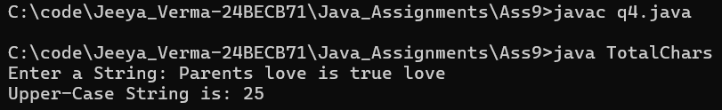

Q5. Write a java program to replace a substring with another string.

import java.util.Scanner; class SubStrReplace {
public static void main(String[] args) { Scanner sc = new Scanner(System.in); System.out.print("Enter a String: "); String string = sc.nextLine(); System.out.print("Enter the Sub-String: "); String subString = sc.nextLine();
System.out.print("Enter the String to replace with: "); String replaceWith = sc.nextLine();
System.out.println("String after sub-string replacement: " + string.replace(subString, replaceWith));
}
}
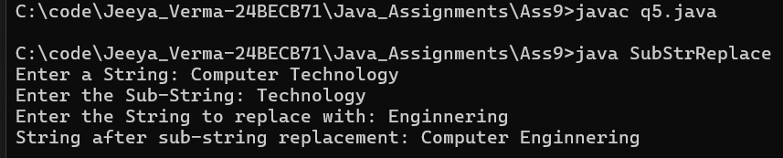

Q6. Write a program that computes your initials from your full name and displays them.

import java.util.Scanner; class Abbreviation {
public static void main(String[] args) { Scanner sc = new Scanner(System.in); System.out.print("Enter your full name: "); String string = sc.nextLine();
String[] words = string.split(" ");
StringBuilder stringBuilder = new StringBuilder(words.length); for (String word : words) {
stringBuilder.append(Character.toUpperCase(word.charAt(0)));
}
System.out.println("Initials String is: " + stringBuilder);
}
}

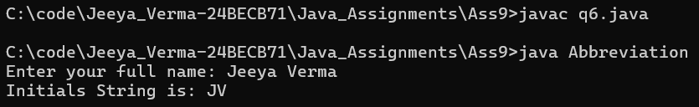

Q7. Write a program that receives two strings and check whether they are equal or not.

import java.util.Scanner; class CmpString {
public static void main(String[] args) { Scanner sc = new Scanner(System.in); System.out.print("Enter a String: "); String string1 = sc.next(); System.out.print("Enter a String: "); String string2 = sc.next();
if (string1.equals(string2)) {
System.out.println(string1 + " and " + string2 + " are equal");
} else {
System.out.println(string1 + " and " + string2 + " are not equal");
}
}
}
