**ROLE OF COMMON SERVICES CENTRES**

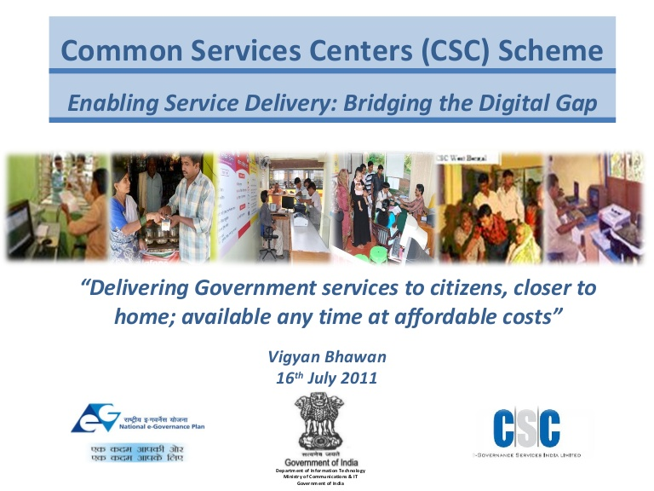

**[](https://twitter.com/timesnow/status/615757555197849600)**



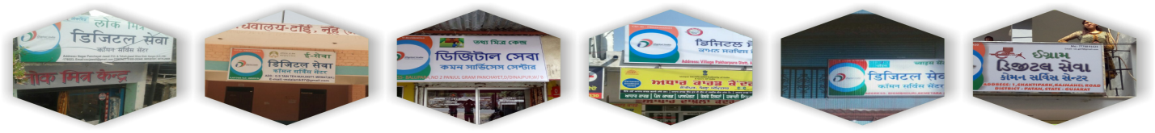

**1. THE SCHEME**

# 1.1 Introduction

The Common Services Centres (CSCs) are internet enabled access points for delivery of various Digital Services (eServices) to the citizens. The CSCs enable citizens to avail the Government and other services closer to their locality in a transparent and timely manner. The ability of CSC to avoid direct interaction of citizens with Government offices brings transparency, accountability and efficiency in the delivery of services through a reduced turnaround time.

# 1.2 Vision and Objectives

“**The primary objective of the CSC is to provide e-governance services within the reach of the citizen, by creating the physical service delivery ICT infrastructure.”** It helps in making a transparent service delivery mechanism and eliminating citizens’ effort in visiting government offices.

The CSCs also aim to provide individual access to internet and access devices to citizens in rural India where the ICT intervention is very low, thereby, reducing /eliminating the digital divide. CSCs being well equipped ICT enabled centres, necessarily play a significant role in enabling universal access to plethora of eServices for citizens and acting as cornerstone for the citizens’ digital empowerment, hence creating a transparent governance ecosystem. Altogether, these CSCs are becoming a game changer by providing a common Information Technology (IT) platform for rural citizens.

Today, CSCs are more than service delivery points in rural India. They are positioned as change agents, promoting rural entrepreneurship and building rural capacities and livelihoods. They are enablers of community participation and collective action for engendering social change through a bottom-up approach with key focus on the rural citizen.

# 1.3 Initial CSC Scheme

The CSC Scheme was initially launched in September, 2006 under National e-Governance Plan (NeGP), with an aim to cover all 6 lakh census villages by one lakh CSCs, as per 1:6 ratio equitably spread across rural India.

# 1.4 CSC 2.0: A Way Forward - Overview

Based on the assessment of the CSC Scheme, the Government of India has launched CSC 2.0 Project in August, 2015, under the pillar-3 of Digital India Programme, to expand the outreach of the CSCs to all Gram Panchayats (GPs) across the country. It has aimed to set up at least one CSC in every GP across the Country within duration of 4 years (by August 2019), thereby envisaging establishment of at least 2.5 lakh CSCs covering all Gram Panchayats of the country over a period of four years. This would also include strengthening and integrating the existing one lakh CSCs already operational under the existing CSC Scheme and making operational an additional 1.5 lakh CSCs at Gram Panchayat (preferably at GP premises). The project is being implemented by CSC e-Governance Services India Limited (CSC –Special Purpose Vehicle, CSC -SPV) under the guidance of respective State Governments and Union Territories (UTs) Administrations.

# 1.4.1 CSC 2.0- Implementation Principle : Business Model

The current implementation principle of CSC 2.0 at GP level is based on a service delivery / transaction oriented self sustainable model with effort towards optimum utilization of infrastructure created in the form of BharatNet/NOFN and other communication infrastructures available in the States/UTs. Presently, CSC is completely an entrepreneurship model with no viability gap funding for hardware and infrastructure support to the Village Level Entrepreneurs (VLEs) from Government of India. For day-to-day operation of CSCs and knowledge up-gradation on new services, the VLEs are being provided with handholding supports through training on Entrepreneurship Development Programme.

# 1.4.2 CSC 2.0 – Other Implementation Principles

**To ensure standardization across all States/UTs, “Digital Seva Kendras” national brand along with co-branding of States/UTs has been introduced.** With a unique identification number of CSC and GIS mapping of each centre, this would create a transparent and accountable monitoring framework for the eServices being delivered through CSCs and help the government to fill the gap in establishing a self-sustaining CSC network across the States/UTs.

Presently, under the project, efforts have been made at State/UT levels for integration of various service portals with the on-line CSC Universal portal- **“Digital Seva Portal”** for delivery of all (G2C & B2C) services through CSCs.

**Participation of women in CSC ecosystem** - The Government is encouraging women entrepreneurs to set up Common Services Centres. This motivates other women to come forward and setup Common Services Centres (CSCs). In addition to this, the Government is also encouraging women members of Self Help Groups to become VLEs.

As a result, till 31 July, 2017, in total **32,361** women entrepreneurs have set up CSCs and are delivering services in rural areas. The Government is determined to include the women and marginalized sections of the society in the CSC movement significantly.

# 1.4.3 CSC e-Governance Service India Ltd. – CSC -SPV

CSC -SPV is the implementing agency for the CSC 2.0 project to provide suitable program management support to DeitY and State/UT Administration for successful implementation of the project. The CSC SPV is an institution in perpetuity even after completion of the project for sustainability of CSCs across the nation. The main activities to be undertaken by CSC -SPV, but not limited to, are as follows:

* Design and develop a national level universal CSC technological platform for implementation of CSC 2.0. This would comprise of some key performance indicators (KPIs) like: financial management, human resource management, MIS and reporting, service delivery, help desk, capacity building and integration of all other portal across all the States/UTs etc.
* Act as coordinating agency for enabling on-boarding and delivery of services (G2C, B2C & B2B) centrally through the universal CSC technological platform. This will ensure a standard list of services that would be available at all CSCs, irrespective of the location.
* To Enable and manage the local language Help Desk for handholding of VLEs.

* To undertake capacity building and entrepreneurship training programme to cover all the existing CSCs and the new CSCs in a periodical manner.
* To undertake monitoring and assessment of scheme across all the CSCs periodically.

* To support State/UT for creation of national and state branding.

# 2. Functions of CSCs

**Presently, CSCs are acting as the following :**

* Service Delivery Centres for – Government to Citizen (G2C), Business to Consumer (B2C), Utility Services, etc.
* Permanent Enrolment Centres (PEC) for Aadhaar, and Aadhaar Printing Centres
* Business Correspondent Agents (BCAs) under Financial Inclusion for Banking services and banking services under Prime Minister’s Jan-Dhan Yojana
* Insurance service Centres
* Educational and Skill Development Centres
* Electoral Registration centres
* Information Centre for various schemes of the Government for creating awareness leading to digital empowerment among the citizens
* Wi-Fi distribution centres (Wi-Fi e-Choupal).

# 3. Outcomes and Advantages of CSCs

###### **Some of outcomes and advantages provided by the CSC scheme are as follows :**

* Transparent and timely delivery of government and other eServices at affordable cost.
* Reducing citizens’ efforts and resources in availing services within their localities by eliminating their visit to Government offices for the same.
* Integrated framework for delivery and dissemination of various government initiatives and benefits through ICT enablement.
* Introducing change agents for skill development, education and trainings, financial inclusion and indirect employment generation.
* Acting as last mile distribution units for various governments’ direct benefits to marginalised/backward communities.
* Encouraging more and more participation of women to become VLEs and increasing their contribution in the social and economic development.
* The CSCs are acting a medium for rural citizens to get digitally empowered and interact with the government and its schemes.

# 4. Key Services through CSC Network

**Key services being delivered to the citizens through CSC network -**

**4.1 G2C Services**

**Central Government Services** : PAN card Application, Passport Applications, Income Tax Return, Employment Service, Swachh Bharat Abhiyan, Pradhan Mantri Awas Yojana (PMAY), Agriculture Service, Soil Health Card, etc.

**State Government Services** : e-District/State Service Delivery Gateway (SSDG) services, Land Record, Ration Card, Birth/Death Certificate, Income, Caste, Domicile certificate, etc.

**UIDAI Aadhaar Service :** Aadhaar Print, Mobile Updates, Demographic Updates, Enrolments, e-KYC (Electronic Know Your Customer), Authentication, Seeding, printing of Aadhaar Card.

**Election Commission Services** : Electoral Registration, deletion of elector’s details, Modification of elector’s details, transposition, etc, Electoral Photo Identity Card (EPIC) Printing.

**4.2 B2C Services**

Indian Railway Catering & Tourism Corporation (IRCTC) Services, e- Recharge, Tour & Travels, Sale & purchase of seeds & farmer equipments, e-Commerce, etc.

**4.3 Financial Services**

**Banking Services :** Setting up of Business Correspondent Agents of various banks at CSCs. And providing the services like **:** New Account opening, Deposit, Withdrawal, and Remittance.

**Insurance Services** : Life Insurance (New Policy), Life Insurance (Renewal of Policies), General Insurance.

**Aadhaar Enabled Payment System (AEPS) Services** : Withdrawal of money only.

**Pension**  : Providing the PFRDA services

**4. 4 Educational Services**

National Digital Literacy Mission, (NDML) – Digital Saksharata Abhiyan (DISHA) / Pradhan Mantri Gramin (PMG) DISHA, CyberGram project, various courses through National Institute of Open Schooling (NIOS), National Institute of Electronics & Information Technology (NEILIT) Courses (Courses on Computer Concepts - CCC & Basic Computer Course -BCC), Tally, various coaching course (IIT, Civil Services), Financial and Legal Literacy

**4.5 Skill Development**

Courses on electronics, motor mechanic, mobile repair, health adviser etc are being offered

**4.6 Utility Services**

Electricity Bill Payment, electricity new connection

**4.7 Health Services**

Telemedicine, JAN Aushadhi, Diagnostic Services

**4.8 Services on CSC National Portal – Digital Seva Portal**

**Fig: Services available on Digital Seva (Apna CSC) Portal**