|  |
| --- |
| *s Games* |
| Get the Apple Game |
| Comp305-Assignment3  3-d Game |
| All work Copyright © 2016 by S Games.  All rights reserved. |
| **Sonia (300819375)** |
|  |



|  |
| --- |
| March 11,2016 |

**Table of Contents**

1) Version History........................................................................3

2) Game Description....................................................................4

3) Game Controls.........................................................................4

4) Interface Sketch……………………………………………………………………5

5) Characters/Objects.……………………………………………………………..6

6) Enemies………….……………………………………………………………………6

7) Scoring.....................................................................................6

8) ScreenShot...............................................................................6

9) Sound Index…………………………………………………………………………7

10) Art/ Multimedia Index............................................................7-8

1. **Version History**

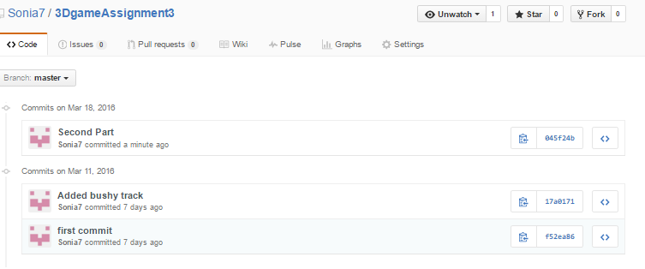

1. **Description**

*This application is a 3d game made by using unity, blender and visual studio. In this game, main object is first person running and jumping to collect the apples. Back, up and forward keys are used to control the player. 10 points are rewarded for each apple. Also, player has to be aware of enemy (scarecrow) and fall. Player has 7 lives to play. If an enemy hits the Player or if it fall one life is lost. Game gets over if player loses all his 7 lives. Player can play again by clicking restart button and in the end high scores are shown on screen with best scores.*

1. **Controls**

*Up Key: Jump movement of player*

*Back Key: Back Movement of player*

*Forward Key: Forward Movement of player*

*Restart Button: Re-play the game after game over*

1. **Interface Sketch**

*Interface looks bushy environment. A player is moving to collect apples and to protect himself from enemy.*

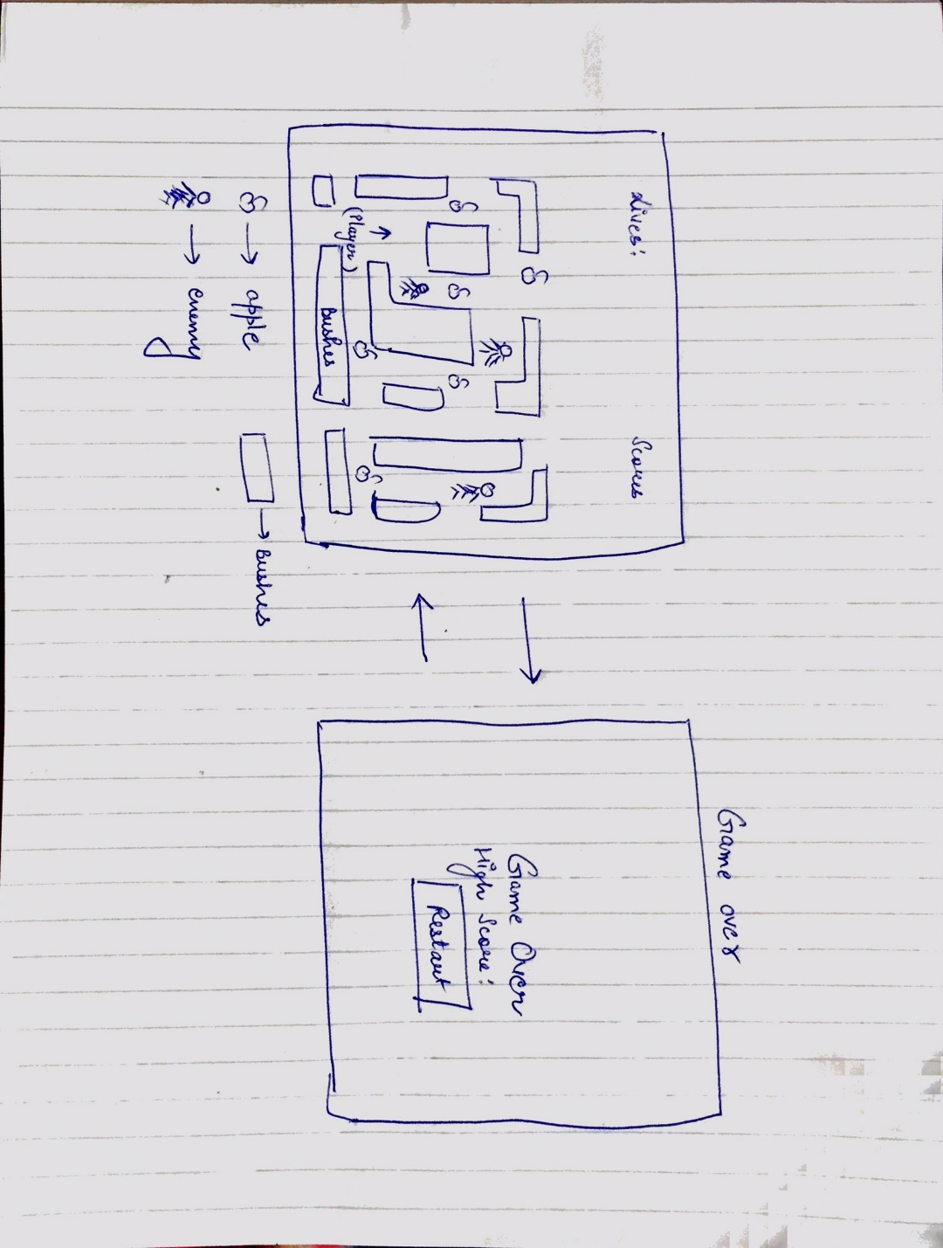

1. **Characters/objects**

***Apples:*** *Apples are the objects collected to increase the scores.*

1. **Enemies**

***Scarecrows:*** *Scarecrows are the only enemies of the Player. Game is over after colliding with enemy 7 times.*

1. **Scoring**

***Lives:***  *One life gets reduced each time player is hit by enemy or fall. Player has 7 lives in starting.*

***Scores:***  *10 scores are awarded for each apple.*

1. **Screenshot:**

**Interface:**

*Interface will look like below snapshot:*

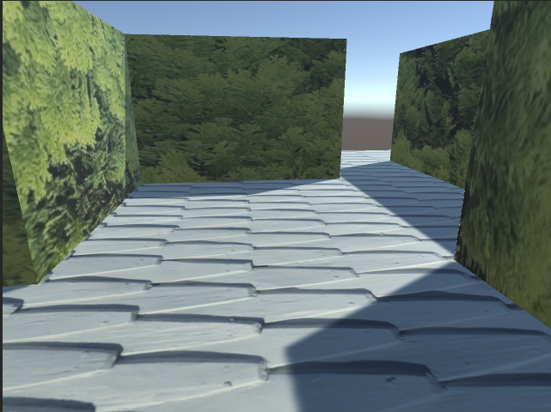

1. **Sound Index:**



1. **Art / Multimedia Index**

*Images used in game are included in assets folder of the game.*

*Bushy environment:*

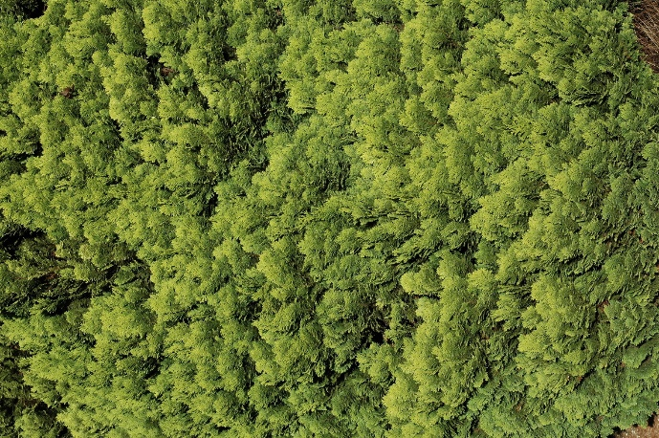

*Floor:*

**