TRAVLENDAR+

**RASD**

*Requirements Analysis and Specification Document*

Version 1.0

*Greco Sonia*

*Guzzo Francesco*

Release Date: xx.10.2017

***TABLE OF CONTENTS***

**1. INTRODUCTION** 4

*1.1 PURPOSE* 4

*1.2 SCOPE* 4

*1.3 DEFINITIONS* 5

*1.4 REVISION HISTORY* 5

*1.5 REFERENCE DOCUMENT* 5

*1.6 DOCUMENT STRUCTURE* 5

**2. OVERALL DESCRIPTION** 5

*2.1 PRODUCT PERSPECTIVE* 6

*2.2 PRODUCT FUNCTIONS* 6

*2.3 USER CHARACTERISTICS* 7

*2.4 ASSUMPTIONS, DEPENDENCIES AND CONSTRAINTS* 7

2.4.1 Domains 7

2.4.2 Assumptions 8

**3. SPECIFIC REQUIREMENTS** 9

*3.1 EXTERNAL INTERFACE REQUIREMENTS* 9

*3.1.1 User interfaces* 9

*3.2 FUNCTIONAL REQUIREMENTS* 12

*3.2.1 [G1] Registration.* 12

*3.2.2 [G2] Login.* 12

*3.2.3 [G3] Allow an User to create/delete meetings.* 12

*3.2.4 [G4] Allow an User to notify a public transport strike.* 13

*3.2.5 [G5] Allow an User to insert personal preferences to modify the calculation of the best path.* 13

*3.2.6 [G6] Allow an User to acknowledge the best path to follow to reach the daily meetings.* 13

*3.2.7 [G7] Allow the application to notify an User if there are changes on the pre-defined route.* 13

*3.2.8 Sequence diagrams* 14

*3.3 PERFORMANCE REQUIREMENTS* 18

*3.4 DESIGN CONSTRAINTS* 18

*3.4.1 Standards compliance* 18

*3.4.2 Hardware limitations* 18

*3.4.3 Other constraints* 18

*3.5 SOFTWARE SYSTEMS ATTRIBUTES* 18

*3.5.1 Reliability* 18

*3.5.2 Availability* 18

*3.5.3 Security* 18

*3.5.4 Maintainability* 18

*3.5.5 Portability* 18

**4. SCENARIOS** 19

*4.1 SCENARIO 1* 19

*4.2 SCENARIO 2* 19

*4.3 SCENARIO 3* 19

*4.4 SCENARIO* 19

*4.5 SCENARIO 5* 19

*4.6 SCENARIO 6* 19

**5. USE CASE** 20

*5.1 USE CASE DESCRIPTIONS* 20

*5.1.1 Visitor registration* 20

5.1.2 User login 20

5.1.3 User creates an event 21

5.1.4 User deletes an appointment 21

5.1.5 User reports a strike 22

5.1.6 User checks daily schedule 22

5.1.7 User refreshes daily schedule 22

5.1.8 User sets a maximum amount of time walking 23

5.1.9 User sets a maximum amount of time biking 23

5.1.10 User sets the option to minimize carbon footprint 24

5.1.11 User defines his own transport means configuration 24

**6. FORMAL ANALYSIS USING ALLOY** 24

**7. EFFORT SPENT** 26

**7. REFERENCES** 26

# **1. INTRODUCTION**

## *1.1 PURPOSE*

Travlendar+ is a project which aims to create a calendar interface that automatically computes and handles the appointments of a person in order to make sure that the user is never late for his/her meetings and everyday activities. Travlendar+ also ensures that the user utilizes the best mobility option available at current time, including walking, taking into account possible disabilities of the user, strikes and weather conditions. The user will be able to give personal constraints (e.g. It won’t be suggested to use the car if the user doesn’t have a driving license; walking distances should be less than a given threshold.. ) by activating or deactivating each travel means. The application will compute times between meetings and prevent them to overlap and keep a spot during the day if the user wants to have lunch in a given slot of time. When the user creates meetings that are unreachable in the allotted time, a warning is created.

## *1.2 SCOPE*

Travlendar+ gives a useful support to users’ life. Achieving the features explained above, the application helps the user making the best decision every day. It doesn’t just keep track of all the appointments and meetings of a person, but it also makes sure that she/he can actually reach the different locations in time, it tells the optimal way to reach them according to various aspects (weather, personal disabilities, owned mobility means, time of the day..).

## *1.3 DEFINITIONS*

## *1.4 REVISION HISTORY*

## *1.5 REFERENCE DOCUMENT*

## *1.6 DOCUMENT STRUCTURE*

# **2. OVERALL DESCRIPTION**

## *2.1 PRODUCT PERSPECTIVE*

*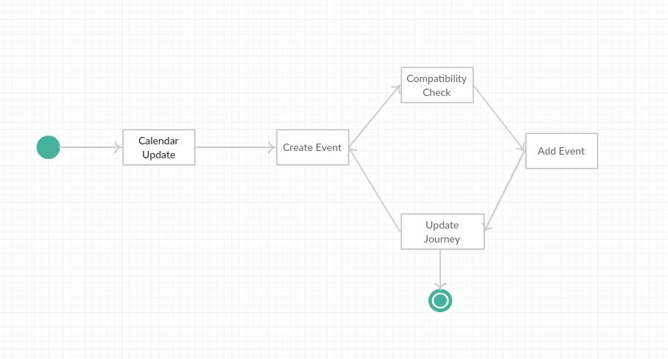Figure 2.1.1. Class Diagram*

*Figure 2.1.2. State Chart*

## *2.2 PRODUCT FUNCTIONS*

The most important requirements of the project are:

- the computed way from the starting point to the goal must be optimal:

• it should be the shortest

• it should choose the best mobility mean, taking into account the weather forecast

• it should consider also other World related phenomena.

- the optimal way suggested, should also consider user’s personal preferences, such as minimizing the carbon footprint, etc.

## *2.3 USER CHARACTERISTICS*

The user of Travlendar+ is a person who needs help to schedule his/her daily appointments and to find the best way to reach them, according to a series of variables.

## *2.4 ASSUMPTIONS, DEPENDENCIES AND CONSTRAINTS*

### 2.4.1 Domains

We suppose that these *domain properties* hold in the considered World:

• [D1] The Username chosen during the registration is unique.

• [D2] The login process needs User’s Username or E-mail, and the corresponding password.

• [D3] The GPS of user’s device is always on and always gives the correct position.

• [D4] Time, Date and Address are necessary to define uniquely a meeting.

• [D5] A public transport strike implies the impossibility to use the related public transport means.

• [D7] If there’s a meeting in a given day, there must be at least an optimal way to reach the goal.

• [D8] The application refers to Google API in order to faithfully represent delays, arrivals and departures of every public transport mean, possible works on the roads or traffic jams at current time.

• [D9] The application should take into account the weather forecast when suggest the optimal way to reach the goal with a given mobility mean.

• [D10] During the working journey, there is always an amount of time kept for breakfast/lunch time.

• [D11] Google’s API considers only car, bike, walk and public transport as transport means that can be chosen to travel through an itinerary.

• [D12] A schedule can be created if and only if there is at least an appointment.

• [D13] Meetings and appointments have to be already defined by the user before the computation of the best path.

• [D14] From the minimum to the maximum carbon footprint, travel means order is: bike/walk, public transports, car.

### 2.4.2 Assumptions

We assume that these *domain assumptions* hold in the considered World:

- There is one and only one calendar corresponding to one user.

- The public transport means are related to Milan’s ATM.

- Initially the app will set available for the user all the transport means considered by google’s API to calculate the best path.

- Maximum time walking for a person is 30 minutes.

- Maximum time biking for a person is 45 minutes.

- The application will calculate the best path for the user at the begin of the day considering information gathered from google’s API, weather news and user’s set preferences.

- If the user wants to make ecological choices, the path will be also calculated considering the carbon footprint level of the different transport means.

- If the day will be rainy, even if the user wants to minimize carbon footprint, he/she will travel by car or public transports.

- The application will recalculate the path of the day only if the route is manually refreshed by the user.

- The application will recalculate during the day the optimal solution only to travel between the appointments already defined.

- The application doesn’t keep track of the position of the user.

- The time for lunch considered by the app is fixed and chosen by the user.

We suppose that these *constraints* hold in the considered world:

- Regulatory policies: the system must require to user the permission to get his position and he has to manage sensible data (position, credentials, e-mail) respecting the privacy law. Furthermore, the system must not use notifications to send SPAM respecting the privacy law.

- It is not possible to create meetings covering the all slot of time reserved for lunch break.

- Hardware limitations:

- USER:

• 3G connection

• GPS

• space for app package

- Interfaces to other applications

- interface with Google API to get information about transport means, traffic jams, mobility schedules, etc.

- interface with Weather Forecast

- the user shouldn’t create overlapping meetings or unreachable ones. A meeting can be unreachable if it not possible to go there in a given slot of time (e.g. it is too far or there are no available transport means).

# **3. SPECIFIC REQUIREMENTS**

## *3.1 EXTERNAL INTERFACE REQUIREMENTS*

### *3.1.1 User interfaces*

The following mockups represent a basic idea of what the mobile app will look like.

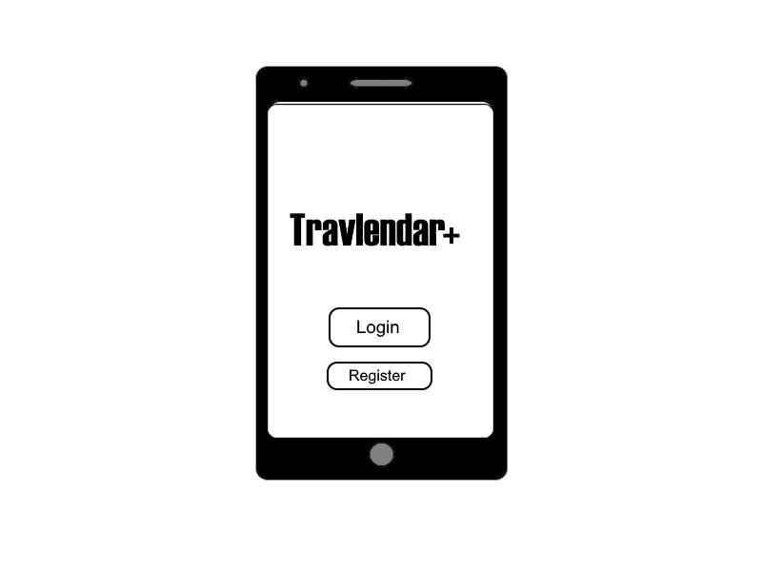

*Figure 3.1.1.1. Initial screen*

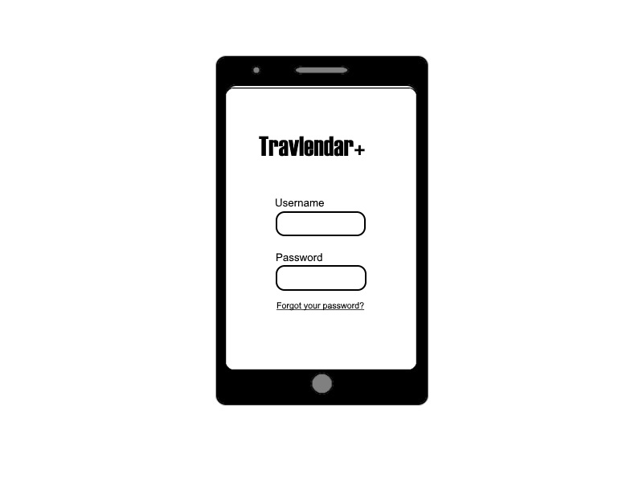

*Figure 3.1.1.2. Login*

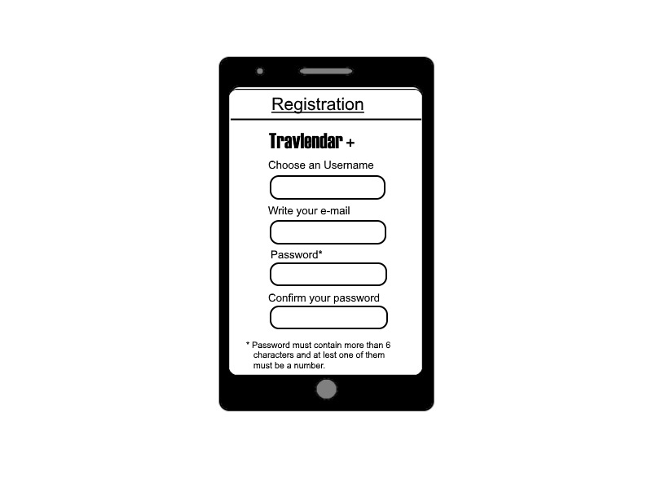

*Figure 3.1.1.3. Registration*

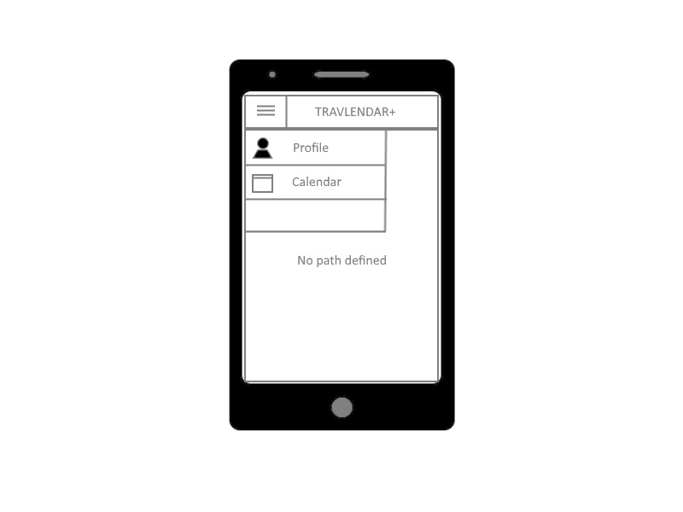

*Figure 3.1.1.4. Menu*

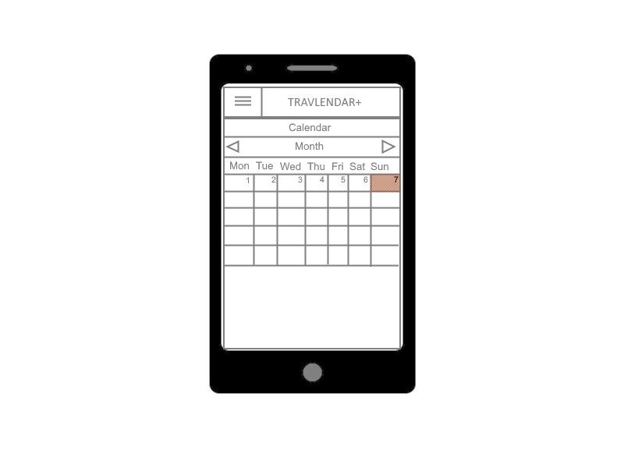

*Figure 3.1.1.5. Calendar*

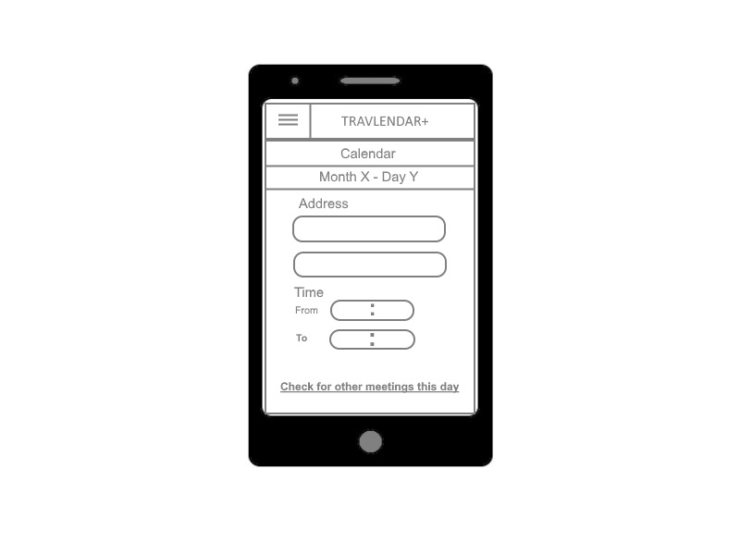

*Figure 3.1.1.6. Event creation*

## *3.2 FUNCTIONAL REQUIREMENTS*

### *3.2.1 [G1] Registration.*

• [R1] A visitor must be able to begin the registration process.

• [R2] The password chosen for the registration must be at least of 7 characters and it must include at least one number and one capital letter.

• [D1] The Username chosen during the registration must be unique.

### *3.2.2 [G2] Login.*

• [R3] The visitor must be already registered to go through the login.

• [R4] A registered User must be able to login to the system using his/her credentials.

• [D2] The logic process needs User’s Username or E-mail, and the corresponding password.

### *3.2.3 [G3] Allow an User to create/delete meetings.*

• [R4] A registered User must be able to login to the system using his/her credentials.

• [R5] The system must ask the User to insert Date, Time and Address of the meeting he/she wants to create.

• [R6] An User must be able to delete a meeting if and only if it is already in the calendar.

• [R7] The system must notify the User with a warning if the meeting he/she wants to create overlaps with another one already in the calendar.

• [D3] The GPS of user’s device is always on and always gives the correct position.

• [D4] Time, Date and Address are necessary to define uniquely a meeting.

• [D10] During the day, there is a fixed slot of time kept for breakfast/lunch time, chosen by the user.

### *3.2.4 [G4] Allow an User to notify a public transport strike.*

• [R4] A registered User must be able to login to the system using his/her credentials.

• [R8] The User must be able to insert a public transport strike in the calendar to influence the calculation of the best path for those days.

• [D5] A public transport strike implies the impossibility to use public transport means.

### *3.2.5 [G5] Allow an User to insert personal preferences to modify the calculation of the best path.*

• [R4] A registered User must be able to login to the system using his/her credentials.

• [R9] The User must be able to insert personal preferences and constraints:

- A maximum amount of time for walking

- Minimize carbon footprint

- Insert owned mobility means

- Choose not to use public transport means after a certain hour of the day.

• [D6] The application should allow the user to register with his/her personal data, preferences and owned mobility means.

### *3.2.6 [G6] Allow an User to acknowledge the best path to follow to reach the daily meetings.*

• [R4] A registered User must be able to login to the system using his/her credentials.

• [R10] There must be at least a meeting during the day.

• [D3] The GPS of user’s device is always on and always gives the correct position.

• [D7] If there’s a meeting in a given day, there must be at least an optimal way to reach the goal.

• [D8] The application refers to Google API in order to faithfully represent delays, arrivals and departures of every public transport mean, possible works on the roads or traffic jams at current time.

• [D9] The application should take into account the weather forecast when suggest the optimal way to reach the goal with a given mobility mean.

### *3.2.7 [G7] Allow the application to notify an User if there are changes on the pre-defined route.*

• [R4] A registered User must be able to login to the system using his/her credentials.

• [R10] There must be at least a meeting during the day.

• [R11] The system must have already computed the best route at least once.

• [D3] The GPS of user’s device is always on and always gives the correct position.

• [D7] If there’s a meeting in a given day, there must be at least an optimal way to reach the goal.

• [D8] The application refers to Google API in order to faithfully represent delays, arrivals and departures of every public transport mean, possible works on the roads or traffic jams at current time.

• [D9] The application should take into account the weather forecast when suggest the optimal way to reach the goal with a given mobility mean.

### *3.2.8 Sequence diagrams*

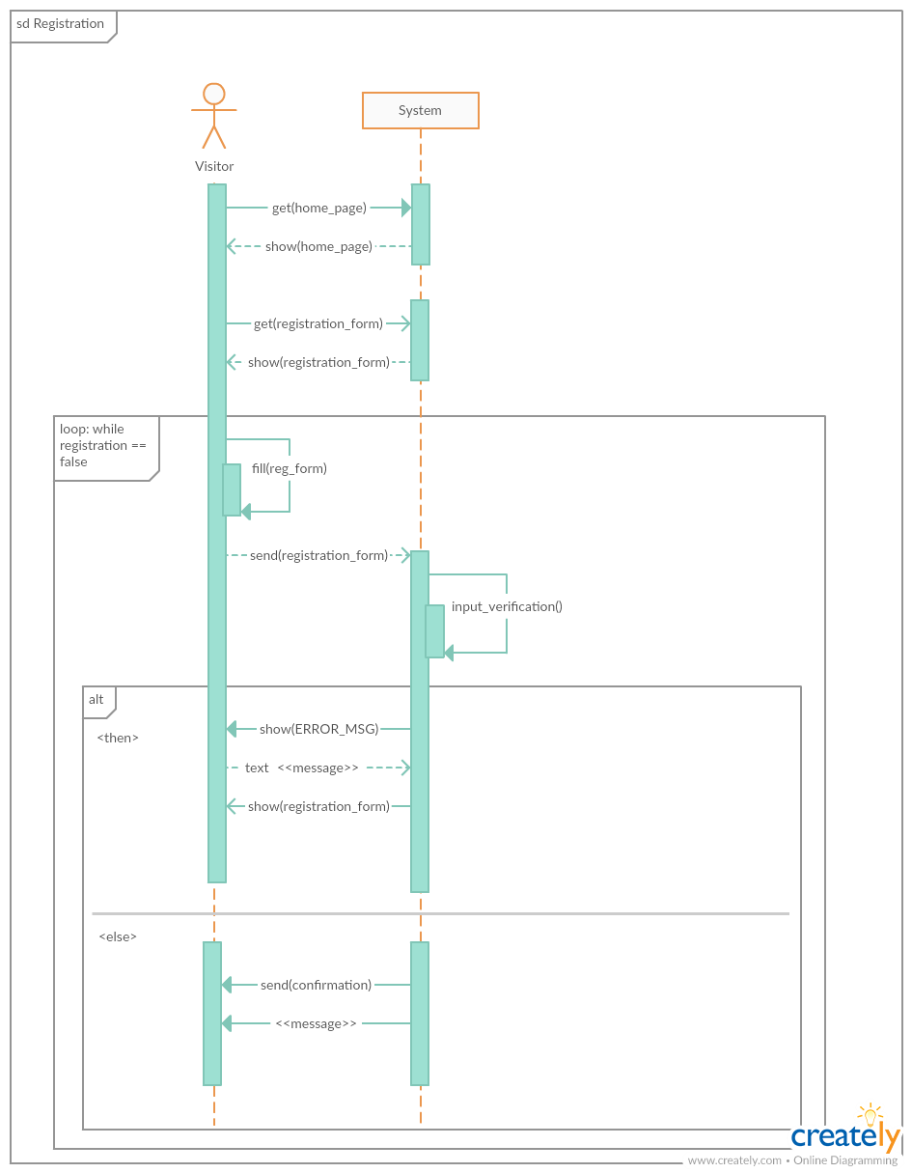

*Figure 3.2.8.1. Registration – sequence diagram*

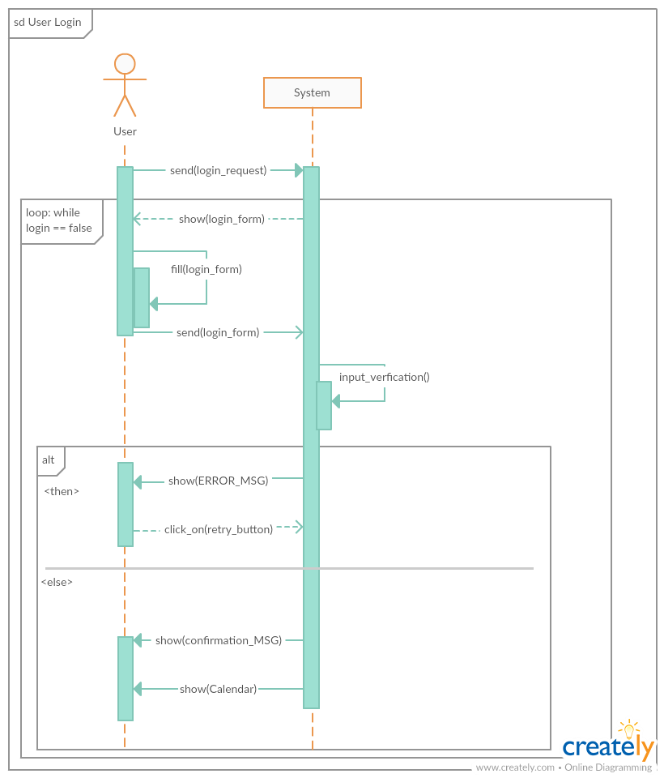

*Figure 3.2.8.2. Login – sequence diagram*

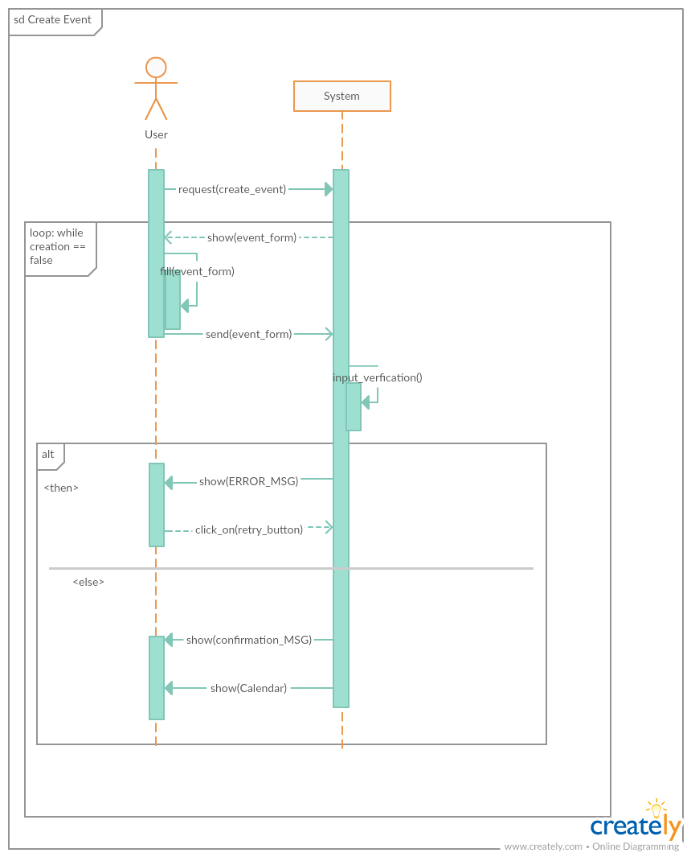

*Figure 3.2.8.3. Event creation – sequence diagram*

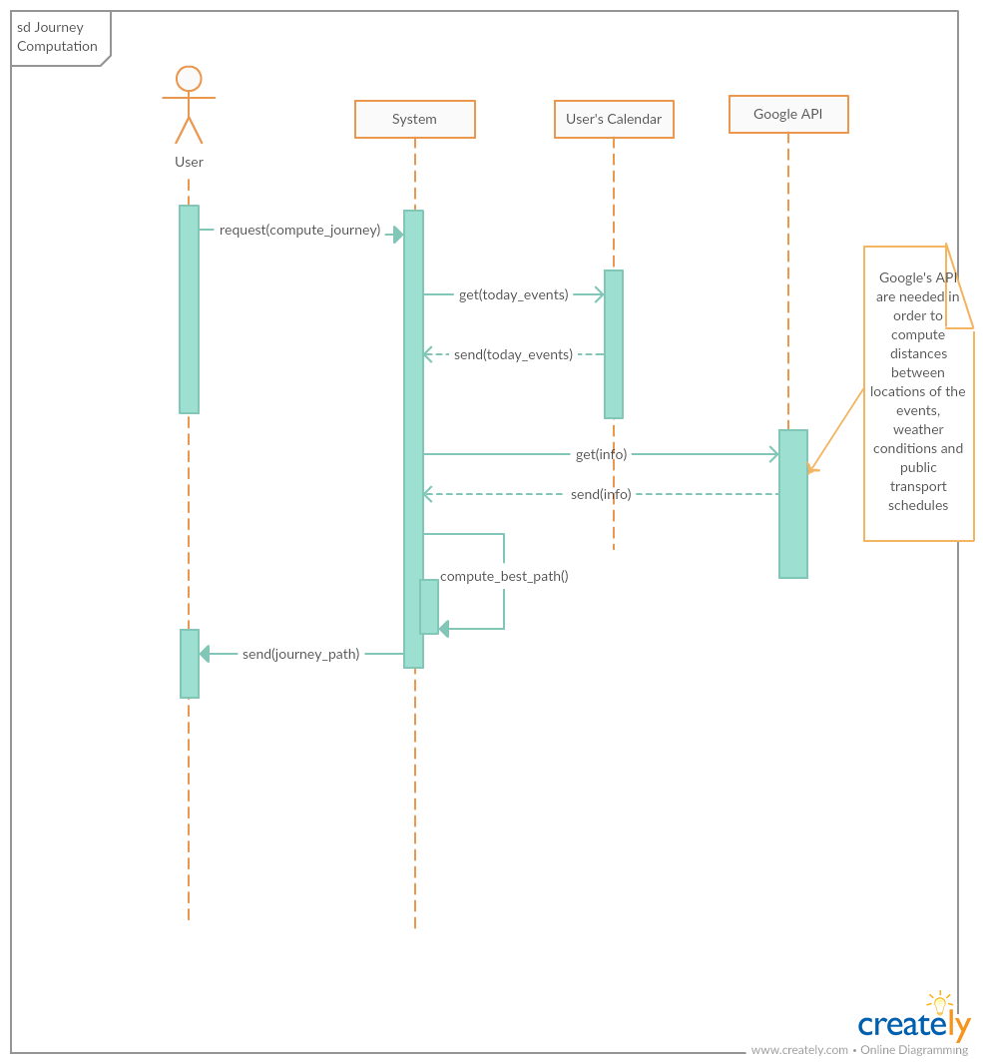

*Figure 3.2.8.4. Computation of the best route – sequence diagram*

## *3.3 PERFORMANCE REQUIREMENTS*

The system has to be able to correctly extract information from Google’s API and compute the best route for the day exploiting them.

## *3.4 DESIGN CONSTRAINTS*

### *3.4.1 Standards compliance*

### *3.4.2 Hardware limitations*

### *3.4.3 Other constraints*

## *3.5 SOFTWARE SYSTEMS ATTRIBUTES*

### *3.5.1 Reliability*

The system must guarantee 24/7 service, especially during the part of the day included in the planned journey. Reliability of the application is strictly related to Google’s API information availability.

### *3.5.2 Availability*

The system must be available 24/7, allowing the user to create or delete, whenever he/she wants, meetings or appointments on the calendar.

### *3.5.3 Security*

User’s credentials and passwords are stored in the system. Their security and user’s privacy is highly taken into account among the primary concerns.

### *3.5.4 Maintainability*

The application will be periodically updated to fix possible bugs and improve user’s experience.

### *3.5.5 Portability*

The application runs in all the devices which have internet access, with at least 3G connection for smartphones (Android/iOS). The application could also be developed in order to become a web application.

# **4. SCENARIOS**

## *4.1 SCENARIO 1*

Walter is a chemistry professor.He has always gone to work using his car, but he now wants to use more environmental friendly mobility means. He doesn't have a bike, so he uses Travlendar+ daily to find out which is the available path with the less carbon footprint.Walter cannot arrive late at school and he doesn't know the schedule of the public transport means. He's happy to use the app, because it tells him when the chosen transport mean is coming and it gives him the possibility to buy the tickets for it.

## *4.2 SCENARIO 2*

Laura is the director of a chain of clothing stores and has a very busy life. Besides her job in her office, she also has to schedule appointments with all the shop managers in the area of Milan. Every appointment must take place in a specific shop because Laura also has to check the conditions of the building and the quality of service of her employees. In order to schedule all her appointments during the day and plan her movements in the city, Laura relies on Travlendar+. She'll always be sure to have a slot of time for a lunch break.

## *4.3 SCENARIO 3*

Marco works in a bank from 8 AM until 4 PM every day. He goes to the gym on Mondays and Thurdays at 7 PM, every week. Lately, the director of the bank asked him to do extra hours at work. He needs assistence on planning the fastest way from work to the gym, because he doesn't want to give up on training, but he also has to be at home at latest at 9PM every day. He goes to work by car, so Travlendar+ is a useful mean for him, because it keeps him updated with the traffic situation and helps him finding the best way to reach the goal in the fastest time.

## *4.4 SCENARIO*

Chiara is a doctor. Her weekly duties are strictly dependent to her work schedule. She uses Travlendar+ to keep track of her daily shifts and appointments with private patients. Given the old age of most of her private patients, she would like to visit them in their houses, in the morning, between 8 and 11 AM, in order to let them rest in the afternoon. Thus, she needs help to plan the fastest route to reach all the location,in order to accomplish the goal of meeting all the patients and not make them wait for more than 10 minutes. As a matter of fact, the application won't let her organize an appointment in a given day and in a given location, if she won't be able to reach it in time.

## *4.5 SCENARIO 5*

Filippo is a retired man of 72 years of age. He finds it difficult to walk for more than 10 minutes, without feeling tired and sore. Daniele, his nephew, helped him organizing his weekly schedule, adding all the meetings to which he has to participate, in the calendar of Travlendar+ and specifying all his personal needs. Wherever he has to go, the app will never tell him to make a journey which includes more than 10 minutes of walking, driving a bike or a car, because he specified so in the preferences section during the registration process. On the contrary, he will get suggestions about the fastest, or more suitable, public transport mean to take, to reach his goals.

## *4.6 SCENARIO 6*

Elena is a convinced ecologist and she always uses her bike, wherever she has to move in the city of Milan. She works for a company which make cruelty-free and vegan cosmetics and her job is to go to customers' house, to give in what they ordered and bought in the online shop. Her priority is to deliver all the packages during her morning shift, between 9 and 12 AM, because she works part time and she won't get extra money for extra hours. Calculating the best route for a bike, for every situation would be hard without Travlendar+. Since she has it, she always manages to carry out all the deliveries in the given time.

# **5. USE CASE**

## *5.1 USE CASE DESCRIPTIONS*

### *5.1.1 Visitor registration*

|  |  |
| --- | --- |
| **ACTORS** | Visitor |
| **GOALS** | [G1] |
| **INPUT CONDITIONS** | The Visitor has to have downloaded *Travlendar+* |
| **EVENTS FLOW** | 1. The Visitor enters the home page ad clicks on the sign in button.  2. The Visitor starts the registration process filling all the mandatory fields with the requested informations (user ID, password, email et similia).  3. The Visitor confirm the registration clicking on the confirm button.  4. The System saves the data and sends an email to the Visitor to verify the previous registration. |
| **OUTPUT CONDITIONS** | The Visitor successfully ended the registration process and now can login in the application and start exploiting all its features. |
| **EXCEPTIONS** | 1. The Visitor is already an User.  2. The Visitor did not insert correctly the information in the mandatory fields.  3. The username chosen by the Visitor already exists. |

### 5.1.2 User login

|  |  |
| --- | --- |
| **ACTORS** | User |
| **GOALS** | [G2] |
| **INPUT CONDITIONS** | The User has to have successfully completed the registration process. |
| **EVENTS FLOW** | 1. The User inserts his/her credentials : username and password.  2. The User clicks on the login button.  3. The System redirects the User on the home page of the application. |
| **OUTPUT CONDITIONS** | The User is successfully redirected to the home page. |
| **EXCEPTIONS** | 1.The User did not insert correctly the information in the mandatory fields(username or password). |

### 5.1.3 User creates an event

|  |  |
| --- | --- |
| **ACTORS** | User |
| **GOALS** | [G3] |
| **INPUT CONDITIONS** | The User has to have successfully completed the login process. |
| **EVENTS FLOW** | 1. The User enters the calendar section of the application from the main menu.  2. The User selects a specifc day on the calendar in which he/she has to insert the appointment.  3. The User inserts all the information needed in the mandatory fields to complete the creation of an event: address, starting and ending time.  4. The User clicks on the button create event to successfully finish the event creation process.  5. The System gets the information and starts the creation of schedule for that specific day. |
| **OUTPUT CONDITIONS** | The User has now successfully created an event and the relative schedule for that day. |
| **EXCEPTIONS** | 1.The User did not insert correctly the information in the mandatory fields.  2.The event can’t fill the already existent schedule because overlapping previous appointments. |

### 5.1.4 User deletes an appointment

|  |  |
| --- | --- |
| **ACTORS** | User |
| **GOALS** | [G3] |
| **INPUT CONDITIONS** | The User has to have successfully completed the login process. |
| **EVENTS FLOW** | 1. The User enters the calendar section of the application from the main menu.  2. The User selects a specifc day on the calendar.  3. The User selects an event/appointment existent in the chosen schedule that he wants to delete.  4. The User clicks on the button delete event to successfully finish the event deletion process.  5. The System gets the information and starts processing a new route for the remaining events in the schedule. |
| **OUTPUT CONDITIONS** | The User has now successfully deleted an event in the relative schedule for that day. |
| **EXCEPTIONS** | There are no possible exceptions. |

### 5.1.5 User reports a strike

|  |  |
| --- | --- |
| **ACTORS** | User |
| **GOALS** | [G4] |
| **INPUT CONDITIONS** | The User has to have successfully completed the login process. |
| **EVENTS FLOW** | 1. The User enters the calendar section of the application from the main menu.  2. The User selects a specifc day on the calendar.  3. The User clicks on the button report strike.  4. The User fills all the mandatory fields reporting the type of the strike and its duration.  5. The System gets the information and starts processing a new route for the events in the schedule. |
| **OUTPUT CONDITIONS** | The User has now successfully reported a strike. |
| **EXCEPTIONS** | There are no possible exceptions. |

### 5.1.6 User checks daily schedule

|  |  |
| --- | --- |
| **ACTORS** | User |
| **GOALS** | [G3][G6][G7] |
| **INPUT CONDITIONS** | The User has to have successfully completed the login process and created a daily schedule. |
| **EVENTS FLOW** | 1. The User enters the main page of the application .  2. The user can select the different sections of the programmed route to extinguish the daily journey.  3. The user can gather informations from the specific itinerary he selected and check on the map the route he will go through.  4. The User can check all the warnings related to previous recalculation of the daily route. |
| **OUTPUT CONDITIONS** | The User has acknowleged the daily path. |
| **EXCEPTIONS** | There are no possible exceptions. |

### 5.1.7 User refreshes daily schedule

|  |  |
| --- | --- |
| **ACTORS** | User |
| **GOALS** | [G3][G6][G7] |
| **INPUT CONDITIONS** | The User has to have successfully completed the login process and created a daily schedule. |
| **EVENTS FLOW** | 1. The User enters the main page of the application .  2. The user can click on the button “Refresh” to recalculate the daily itineraries. |
| **OUTPUT CONDITIONS** | The User has refreshed the daily path. |
| **EXCEPTIONS** | There are no possible exceptions. |

### 5.1.8 User sets a maximum amount of time walking

|  |  |
| --- | --- |
| **ACTORS** | User |
| **GOALS** | [G3][G5] |
| **INPUT CONDITIONS** | The User has to have successfully completed the login process. |
| **EVENTS FLOW** | 1. The User enters the main page of the application .  2. The User enters the main menu of the application.  3. The User go on his profile page e clicks on the button “Preferences”.  4. The User enters the “Maximum time walking” section.  5. The User inserts the maximum time of walking he wants to effort. |
| **OUTPUT CONDITIONS** | The System has got the information that will influence next path calculations. |
| **EXCEPTIONS** | There are no possible exceptions. |

### 5.1.9 User sets a maximum amount of time biking

|  |  |
| --- | --- |
| **ACTORS** | User |
| **GOALS** | [G3][G5] |
| **INPUT CONDITIONS** | The User has to have successfully completed the login process. |
| **EVENTS FLOW** | 1. The User enters the main page of the application .  2. The User enters the main menu of the application.  3. The User go on his profile page e clicks on the button “Preferences”.  4. The User enters the “Maximum time biking” section.  5. The User inserts the maximum time of biking he wants to effort. |
| **OUTPUT CONDITIONS** | The System has got the information that will influence next path calculations. |
| **EXCEPTIONS** | There are no possible exceptions. |

### 5.1.10 User sets the option to minimize carbon footprint

|  |  |
| --- | --- |
| **ACTORS** | User |
| **GOALS** | [G3][G5] |
| **INPUT CONDITIONS** | The User has to have successfully completed the login process. |
| **EVENTS FLOW** | 1. The User enters the main page of the application.  2. The User enters the main menu of the application.  3. The User go on his profile page e clicks on the button “Preferences”.  4. The User ticks the “Ecological choice” field.  . |
| **OUTPUT CONDITIONS** | The System has got the information that will influence next path calculations. |
| **EXCEPTIONS** | There are no possible exceptions. |

### 5.1.11 User defines his own transport means configuration

|  |  |
| --- | --- |
| **ACTORS** | User |
| **GOALS** | [G3][G5] |
| **INPUT CONDITIONS** | The User has to have successfully completed the login process. |
| **EVENTS FLOW** | 1. The User enters the main page of the application.  2. The User enters the main menu of the application.  3. The User go on his profile page e clicks on the button “Preferences”.  4. The User goes in the “Avaiable transport means” section.  5. The User defines his own transport means configuration.  . |
| **OUTPUT CONDITIONS** | The System has got the information that will influence next path calculations. |
| **EXCEPTIONS** | There are no possible exceptions. |

# **6. FORMAL ANALYSIS USING ALLOY**

*in this section you will include your Alloy model. We require*

*you to comment on the model by discussing the purpose of the model, what you can prove*

*with it and why what you prove is important given the problem at hand. You are also*

*required to show one or more worlds obtained by running your model.*

# **7. EFFORT SPENT**

The total amount of hours spent working on the project:

|  |  |  |
| --- | --- | --- |
| Sonia Greco | Date | Time |
|  | 01.10.2017 | 1 h |
|  | 07.10.2017 | 1 h |
|  | 10.10.2017 | 5 h |
|  | 17.10.2017 | 5 h |
|  | 19.10.2017 | 4 h |
|  |  |  |
|  |  |  |
|  |  |  |
|  |  |  |
|  |  |  |
|  |  |  |
| Francesco Guzzo | Date | Time |
|  | 01.10.2017 | 1 h |
|  | 07.10.2017 | 1 h |
|  | 10.10.2017 | 5 h |
|  | 17.10.2017 | 5 h |
|  | 19.10.2017 | 4 h |
|  |  |  |
|  |  |  |
|  |  |  |
|  |  |  |

# **7. REFERENCES**