HOSPITAL MANAGEMENT SYSTEM
Design Document
V1.1


 | Prepared By | Reviewed by | Approved By
Name | Dilip Kumar.R  Sonia.M  Deivanayaki.R  Rizwana Raseena  Mohit Inder  Priyadharshini.M
Role | Team Member
Signature
Date

Table of Contents
1.0 Introduction 3
1.1 Purpose of this document 3
1.2 Scope 3
1.2.1 In Scope 3
1.2.2 Out Scope 3
1.3 Intended Audience 3
1.4 Definition & Acronyms 3
1.5 References 3
2.0 Conventions and Standards Followed 4
3.0 Use Case Realization 4
3.1 Flow of Events – Design 4
3.1.1 Login Sequence 4
3.1.2 Enroll_Patient Sequence 5
3.1.3 Add_Patient Sequence 5
3.1.4 Physician_Search Sequence 6
3.1.5 Patient_Diagnosis_Details Sequence 6
3.1.6 View_Patient_HistorySequence 7
3.2 Class Diagrams-Design 8
3.2.1 Login Module 9
3.2.2 Enroll_Patient Module 10
3.2.3 Add_Patient Module 11
3.2.4 Physician_Search Module 12
3.2.5 Patient_Diagnosis_Details Module 13
3.2.6 View_Patient_History Module 14
3.3 UI CONTROLS 14
3.3.1 Login 14
3.3.2 Enroll_Patient 15
3.3.3 Add_Patient 16
3.3.4 Physician_Search 16
3.3.5 Patient_Diagnosis_Details 17
3.3.6 View_Patient_History 18
4.0 UI DESIGN 18
4.1 Login 18
4.2 Enroll_Patient 19
4.3 Add_Physician 20
4.4 Physician_Search 21
4.5 Patient_Diagnosis_Details 22
4.6 Patient_History 23
5.0 Component Descriptions 23
6.0 Database Design 27
6.1 Identification of DDL, DML and PL/SQL objects 27
6.2 Table Structure 28
6.3 E- R Diagram (Relationship between Tables) 31
7.0 Change Log 32

Introduction

Purpose of this document
The purpose of the detail design document is to define the detailed design for all the components of Hospital Management system that are specified in the Business Requirement document. All the low level components, interfaces and integrations are detailed out in this document.

Scope

In Scope
- Enroll Patient
- Add Physician
- Physician Search
- Patient Diagnosis Details.
- View Patient History

Out Scope
- Migration of current patient and physician list into the application

Intended Audience
The intended audience for this document is
- Developers, testers, other associates in the project
- Client
- Delivery Assurance Group, Process Engineering group

Definition & Acronyms

References
Hospital_Management_Console_BRD_V1.0

Conventions and Standards Followed
Employee Management system will follow Oracle’s java coding standard.


Use Case Realization

Flow of Events – Design

Login Sequence
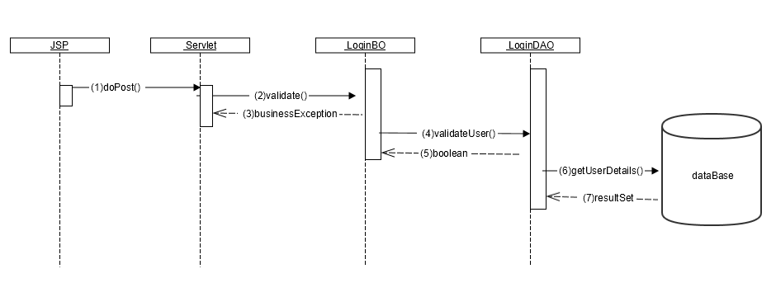

Enroll_Patient Sequence

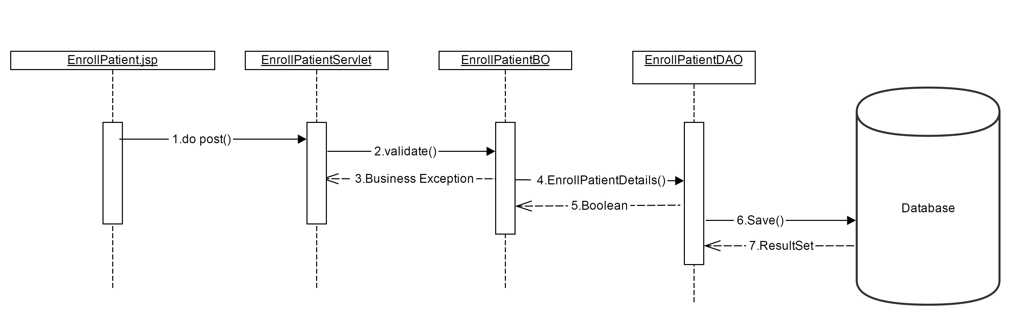

Add_Physician Sequence
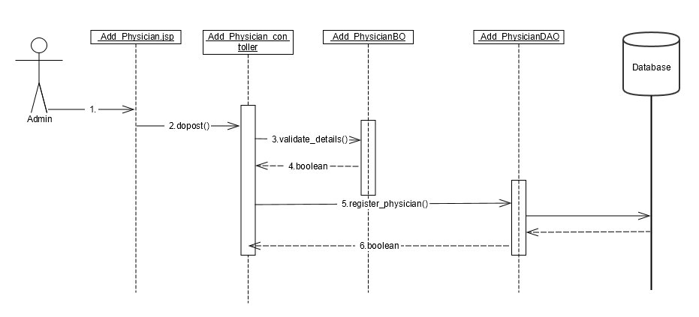

Physician_Search Sequence
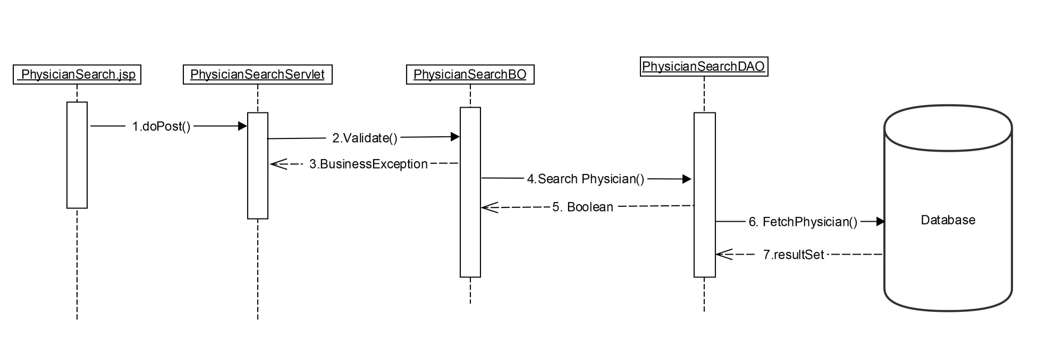

Patient_Diagnosis_Details Sequence
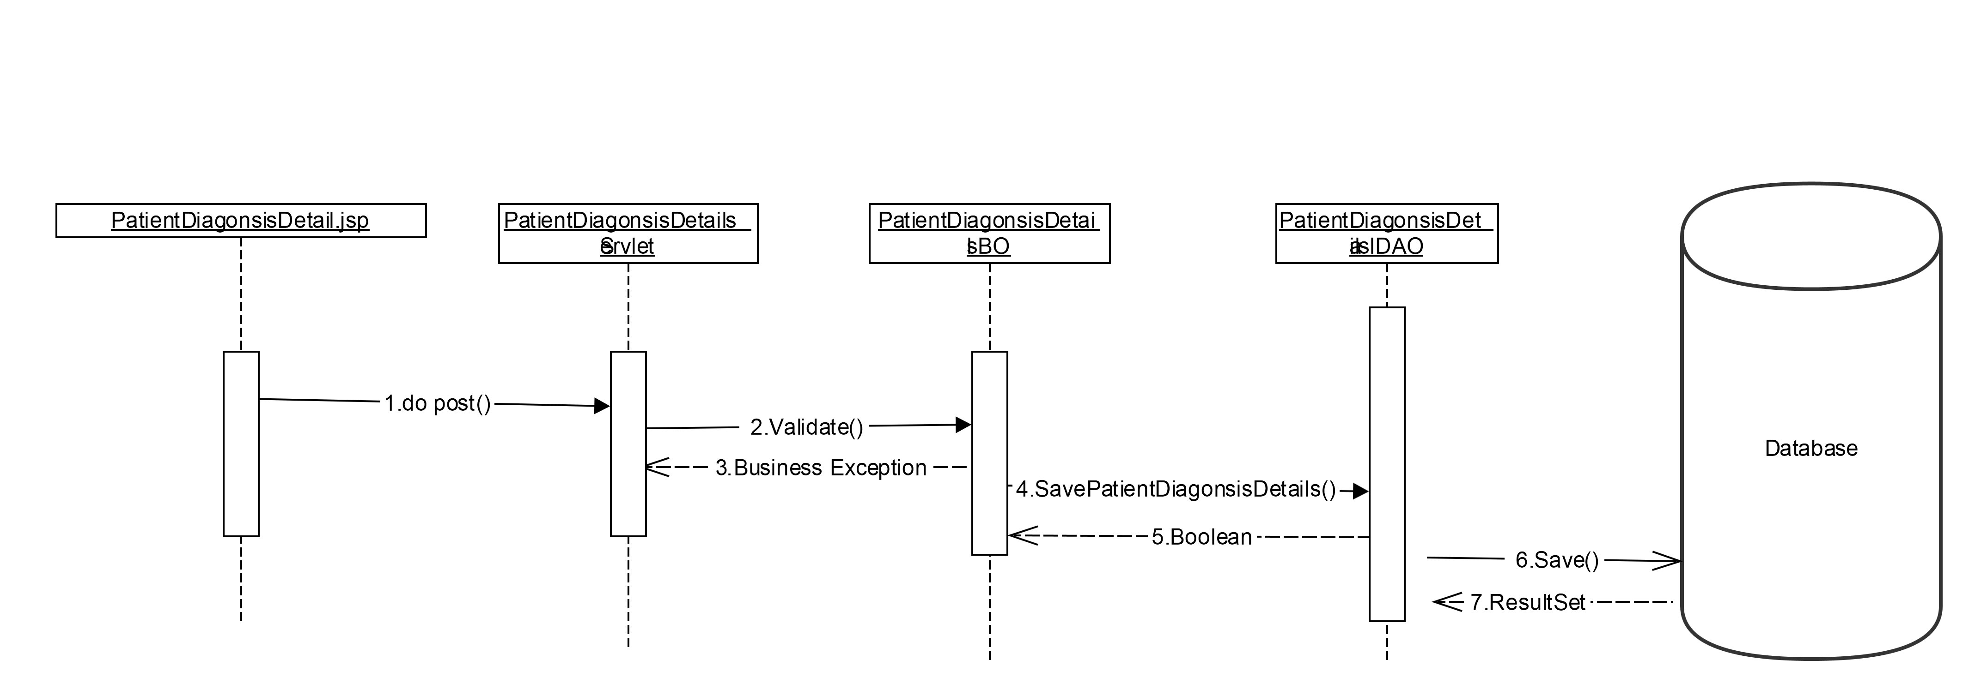

View_Patient_History Sequence
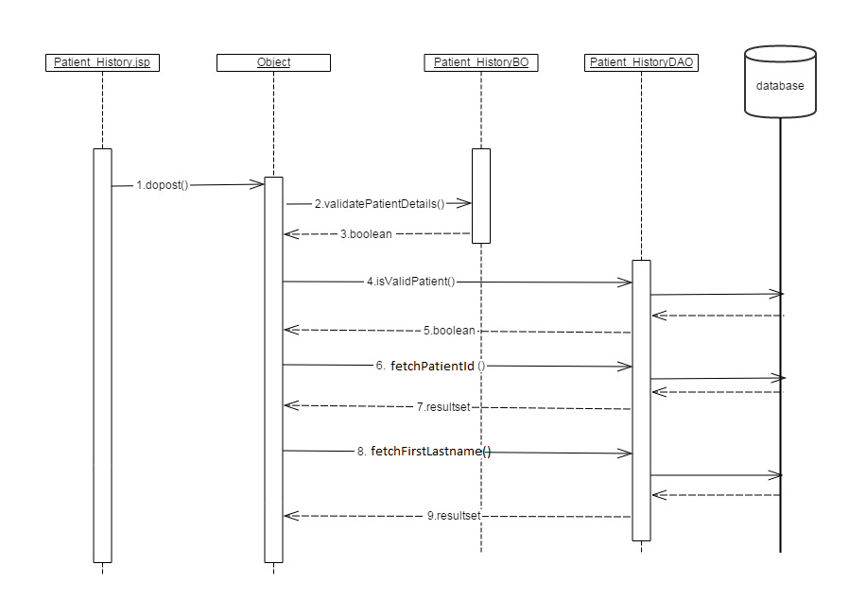

Class Diagrams – Design
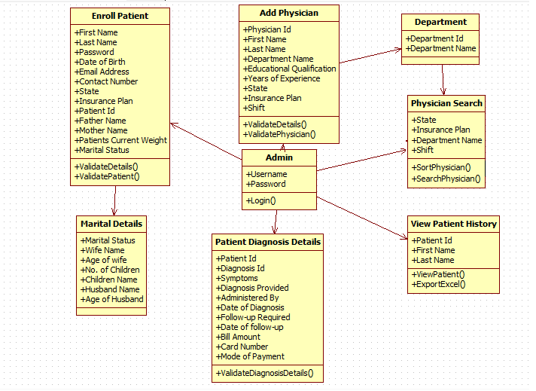

Login Module
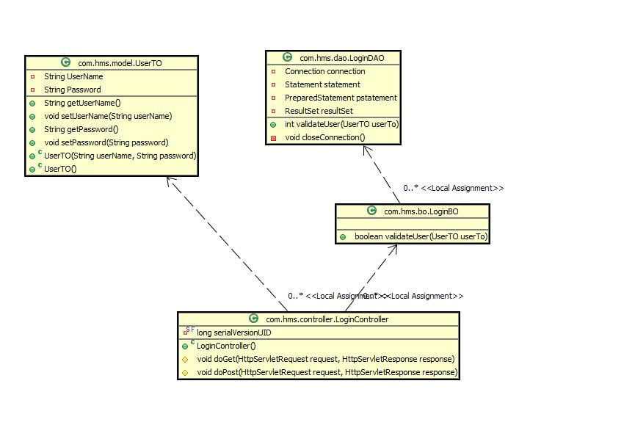

Enroll_Patient Module
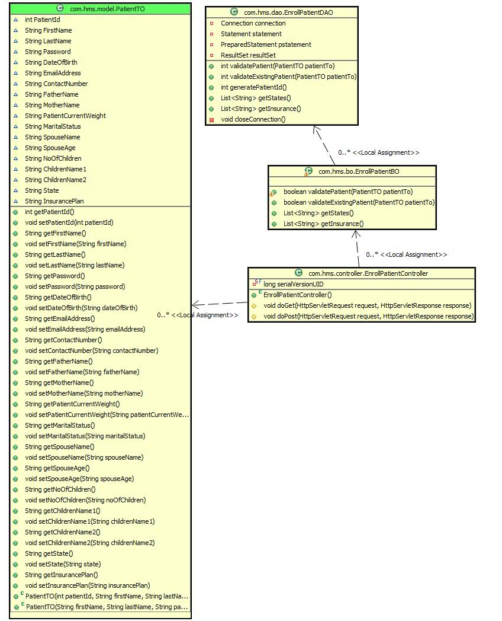

Add_Physician Module
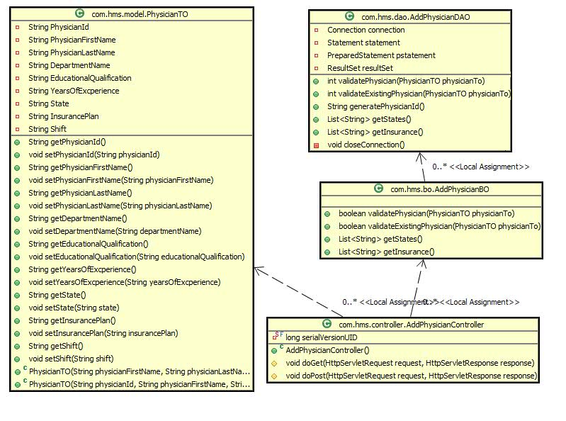

Physician_Search Module

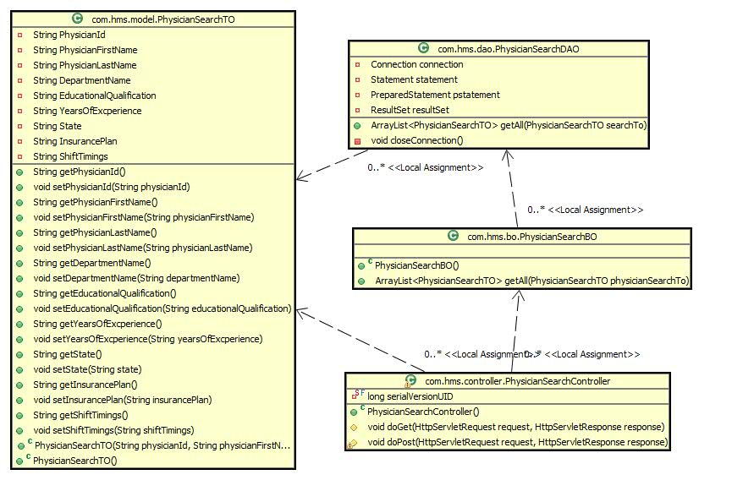

Patient_Diagnosis_Details Module
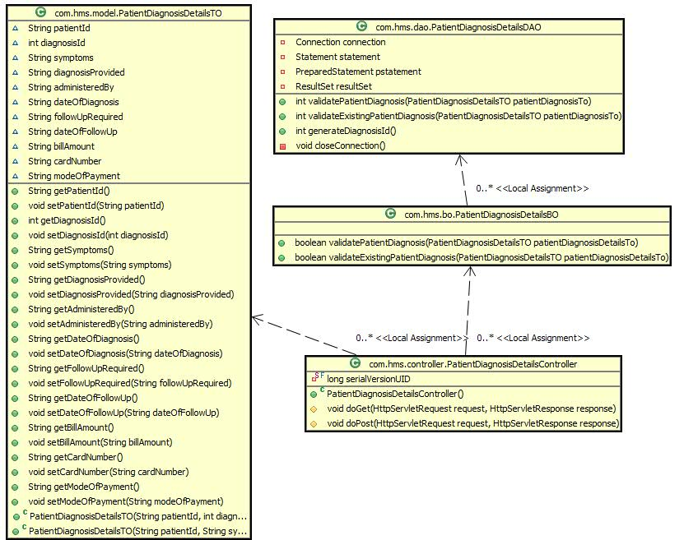

View_Patient_History Module
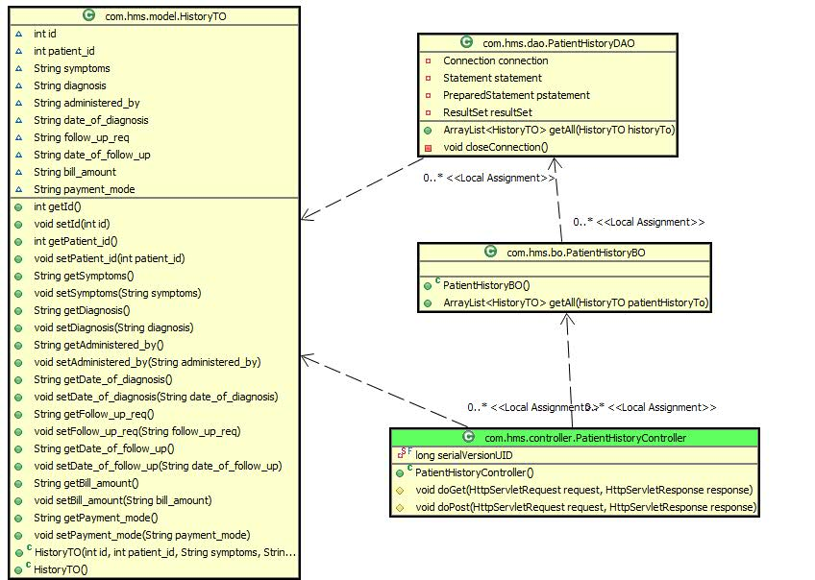

UI CONTROLS

Login
Data Element | Control Type | Default Values | Editable Field | Restrictions | Mandatory Non Mandatory | Data Type | Data Size
Username | Textbox | No | Yes | Alphanumeric | Mandatory | Varchar | 20
Password | Textbox | No | Yes | Alphanumeric | Mandatory | Varchar | 20

Enroll_Patient
Data element | Control type | Default values | Editable Fields | Restrictions | Mandatory/non-mandatory | Data Type | Data Size
First Name | Textbox | No | Yes | Alphabets | Mandatory | Varchar | 30
Last Name | Textbox | No | Yes | Alphabets | Mandatory | Varchar | 30
Password | Textbox | No | Yes | Alpha-numeric | Mandatory | String | 20
Date of Birth | Textbox | No | Yes | Numeric | Mandatory | Date | 11
Email-Address | Textbox | No | Yes | Alphabets | Mandatory | String | 20
Contact Number | Textbox | No | Yes | Numeric | Mandatory | Long | 20
State | Drop down list box | No | Yes | Alphabets | Mandatory | Varchar | 20
Insurance Plan | Drop down list box | No | Yes | Alphabets | Not-Mandatory | Varchar | 30
Father Name | Textbox | No | Yes | Alphabets | Mandatory | Varchar | 30
Mother Name | Textbox | No | Yes | Alphabets | Mandatory | Varchar | 30
Weight | Textbox | No | Yes | Numeric | Mandatory | Long | 11
Marital Status | Radio Button | No | Yes | Alphabets | Mandatory | Varchar | 20
Wife/Husband Name | Textbox | No | Yes | Alphabets | Mandatory | Varchar | 30
Wife/Husband Age | Textbox | No | Yes | Numeric | Mandatory | Long | 11
No of children | Textbox | No | Yes | Numeric | Mandatory | Long | 11
Children Name1 | Textbox | No | Yes | Alphabets | Mandatory | Varchar | 30
Children Name2 | Textbox | No | Yes | Alphabets | Mandatory | Varchar | 30

Add_Physician

Data element | Control type | Default values | Editable Fields | Restrictions | Mandatory/non-mandatory | Data Type | Data Size
First Name | Textbox | No | Yes | Alphabets | Mandatory | Varchar | 20
Last Name | Textbox | No | Yes | Alphabets | Mandatory | Varchar | 20
Department | Drop down list box | No | Yes | Alphabets | Mandatory | Varchar | 20
Educational Qualification | Textbox | No | Yes | Alphabets | Mandatory | Varchar | 20
Years of Experience | Textbox | No | Yes | Alphabets | Mandatory | Int | 10
State | Drop down list box | No | Yes | Alphabets | Mandatory | Varchar | 20
Insurance Plan | Drop down list box | No | Yes | Alphabets | Not-Mandatory | Varchar | 30
Shift | Drop down list box | No | Yes | Alphabets | Mandatory | Varchar | 20

Physician_Search Module
Data element | Control type | Default values | Editable Fields | Restrictions | Mandatory/non-mandatory | Data Type | Data Size
State | Drop down list box | No | Yes | Alphabets | Mandatory | Varchar | 20
Plan | Drop down list box | No | Yes | Alphabets | Mandatory | Varchar | 30
Department | Drop down list box | No | Yes | Alphabets | Mandatory | Varchar | 20
Shift | Drop down list box | No | Yes | Alphabets | Mandatory | Varchar | 20
Sort | Drop down list box | No | Yes | Alphabets | Mandatory | Varchar | 20

Patient_Diagnosis_Details Module
Data element | Control type | Default values | Editable Fields | Restrictions | Mandatory/non-mandatory | Data Type | Data Size
Patient Id | Textbox | No | Yes | Numeric between(5-10) | Mandatory | Varchar | 20
Diagnosis Id | Textbox | No | Yes | Numeric between | Mandatory | Varchar | 20
Symptoms | Textarea | No | Yes | Alpha-numeric | Mandatory | Varchar | 20
Diagnosis Provided | Textarea | No | Yes | Alphabets | Mandatory | Varchar | 30
Administered by | Textbox | No | Yes | Alphabets | Mandatory | Varchar | 30
Date of Diagnosis | Textbox | No | Yes | Date | Mandatory | Date | 20
Follow-up Required | Textbox | No | Yes | Alphabets | Mandatory | Boolean | 3
Date of Follow up | Textbox | No | Yes | Date | Mandatory | Date | 20
Bill Amount | Textbox | No | Yes | Numeric | Mandatory | Int | 20
Card Number | Textbox | No | Yes | Numeric | Mandatory | BigInt | 30
Mode of payment | Textbox | No | Yes | Alphabets | Mandatory | Varchar | 20

View_Patient_History Module
Data element | Control type | Default values | Editable Fields | Restrictions | Mandatory/non-mandatory | Data Type | Data Size
Patient Id | Textbox | No | Yes | Numeric between(5-10) | Mandatory | Int | 10
First Name | Textbox | No | Yes | Alphabets | Mandatory | Varchar | 30
Last Name | Textbox | No | Yes | Alphabets | Mandatory | Varchar | 30

UI DESIGN

Login
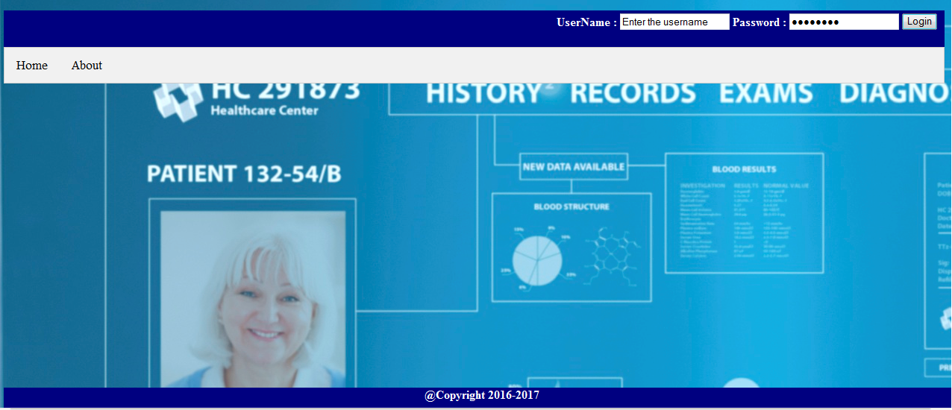

Enroll_Patient

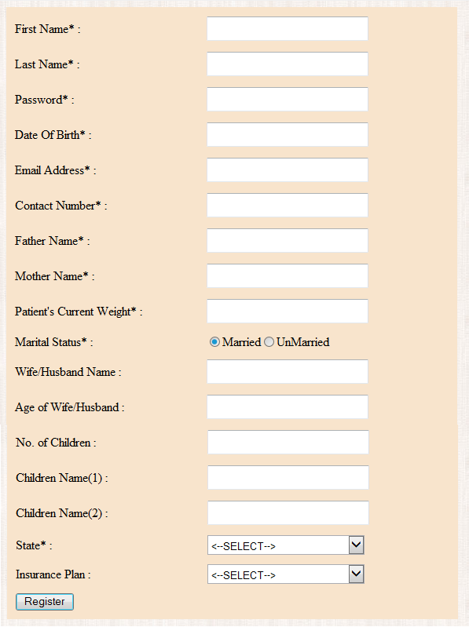

Add_Physician

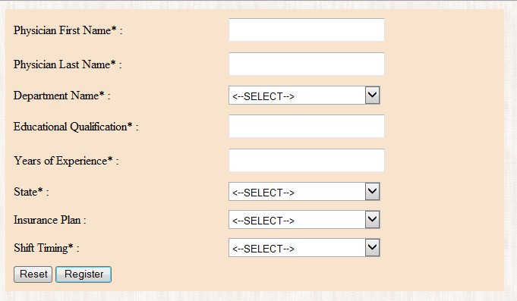

Physician_Search

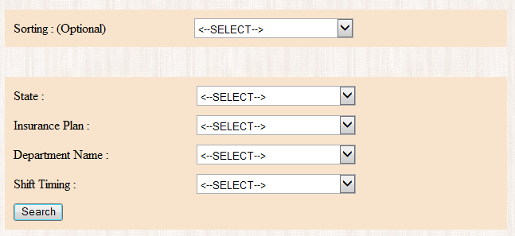

Patient_Diagnosis_Details

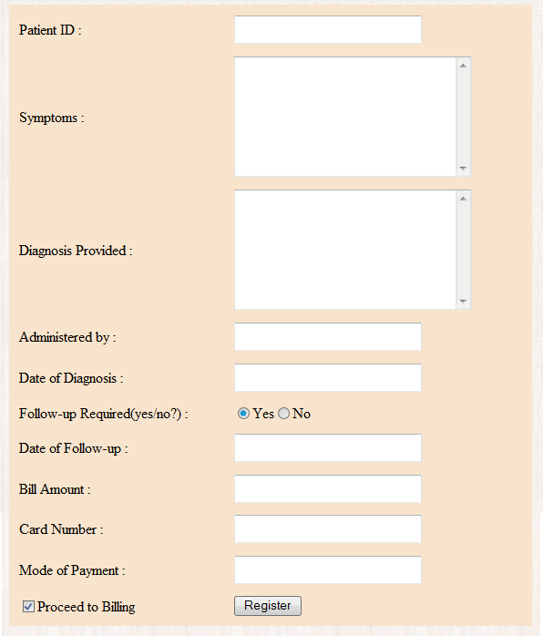

Patient_History

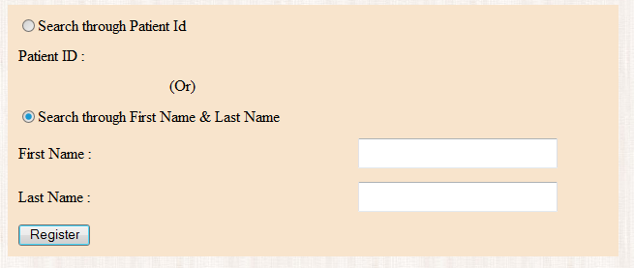

Component Descriptions
Class | Method | Program Logic
LoginController | doPost  Parameters  String Username,  String password  Return Type  void | - Calls doPost() method to get user action. Depending upon the action , calls the other classes.
LoginBO | validateUser  Parameters  UserTO userTo  Return Type  boolean | - Calls validateUser() method once after getting user ID and password  and check for business validations.  - If validation is correct, it returns true or else it throws business error exception message.
LoginDAO | validateUser  Parameters  UserTO userTo  Return Type  int | - Create a Connection object.  - Calls is validateUser() method and check whether the data provided matches the data in database.  - Build the select query.  - Create a prepare statement and pass the input parameter userid to the prepare statement.  - Execute the query.  - Create a prepare statement and pass the input parameter userid to the prepare statement.  - Execute the query  - Iterate through the result set  - Get password from each result set.  - Compare the password given by user and whatever retrived from database.  - If the password matches it returns ‘0’ with successfully logged in message or else throw error message.
EnrollPatientController | doGet  doPost  Parameters  String Username ,  String Firstname,  String Lastname,  String Password,  Date DateOfBirth,  String EmailAddress,  String ContactNumber,  String FatherName,  String MotherName,  String PatientCurrentWeight,  String MaritalStatus,  String SpouseName,  String SpouseAge,  String NoOfChildren,  String ChildreName1,  String ChildrenName2,  String State,  String InsurancePlan  Return Type  void  void | - Calls doGet() method to get user action. Depending upon the action calls other classes.  - Calls doPost() method to get user action. Depending upon the action calls other classes.
EnrollPatientBO | validatePatient  validateExistingPatient  Parameters  PatientTO patientTo  Return Type  Boolean  Boolean | - Calls validateExistingPatient() method and check for business validations.  - If any of the validations doesn’t meet it will throw business error exception message  - If validation is correct it returns true to EnrollPatientController class.  - If validation is failed,it Calls the validatePatient() method and check for business validations.  - If any of the validations doesn’t meet it will throw business error exception message  - If validation is correct it returns true to EnrollPatientController class.
EnrollPatientDAO | validatePatient  validateExistingPatient  generatePatientId  Parameters  PatientTO patientTo  Return Type  Int  Int  Int | - Create a connection object.  - Calls validateExistingPatient() to check the patient is already registered  - Build the query to select the patient details  - If data is found it returns the already registered message  - If data is not found then Calls validatePatient() to register the patient into the database.  - Build the Insert into query.  - If data is successfully inserted, it returns the successfully registered message.  - Calls generatePatientId() to generate an Id for every physician registered scuccessfully.
AddPhysicianController | doGet  doPost  Parameters  String UserName,  String FirstName,  String LastName,  String Department,  String EducationQualification,  String YearsOfExperience,  String State,  String InsurancePlan,  String Shift  Return Type  void  void | - Calls doGet() method to get user action. Depending upon the action calls other classes.  - Calls doPost() method to get user action. Depending upon the action calls other classes.
AddPhysicianBO | validatePatient  validateExistingPhysician  Parameters  PhysicianTO physicianTo  Return Type  Boolean  Boolean | - Calls validateExistingPhysician() method and check for business validations.  - If any of the validations doesn’t meet it will throw business error exception message  - If validation is correct it returns true to AddPhysicianController class.  - If validation is failed,it Calls the validatePhysician() method and check for business validations.  - If any of the validations doesn’t meet it will throw business error exception message  - If validation is correct it returns true to AddPhysicianController class.
AddPhysicianDAO | validatePhysician  validateExistingPhysician  generatePhysicianId  Parameters  PhysicianTO physicianTo  Return Type  Int  Int  Int | - Create a connection object.  - Calls validateExistingPhysician() to check the physician is already registered  - Build the query to select the physician details  - If data is found it returns the already registered message  - If data is not found then Calls validatePhysician() to register the patient into the database.  - Build the Insert into query.  - If data is successfully inserted, it returns the successfully registered message.  - Calls generatePhysicianId() to generate an Id for every physician registered scuccessfully.
PhysicianSearchController | doPost  Parameters  String userName ,  String state,  String plan,  String departmentName,  String shiftTimings  Return Type  void | - Calls doPost() method to get user action. Depending upon the action calls other classes.
PhysicianSearchBO | getAll  Parameters  PhysicianSearchTO physicianSearchTo  Return Type  ArrayList | - Call the getAll() method and check for business validations.  - If any of the validations doesn’t meet it will throw business error exception message  - If validation is correct it returns ArrayList to PhysicianSearchController class.

PhysicianSearchDAO | getAll  Parameters  PhysicianSearchTO physicianSearchTo  Return Type  ArrayList | - Create a connection object.  - Calls getAll () method and check whether the data provided matches the data in database.  - Build the select query.  - Execute the query  - Check if provided fields matches the database. If it matches ruturn ArrayList otherwise return failed message.
PatientDiagnosisDetailsController | doGet  doPost  Parameters  String userName ,  String patientId,  String symptoms,  String diagnosisProvided,  String administeredBy,  String dateOfDiagnosis,  String followUpRequired,  String dateOfFollowUp,  String billAmount,  String cardNumber,  String modeOfPayment  Return Type  void  void | - Calls doGet() method to get user action. Depending upon the action calls other classes.  - Calls doPost() method to get user action. Depending upon the action calls other classes.
PatientDiagnosisDetailsBO | validatePatientDiagnosis  validateExistingPatientDiagnosis  Parameters  PatientDiagnosisDetailsTO patientDiagnosisDetailsTo  Return Type  Boolean  Boolean | - Calls validateExistingPatientDiagnosis() method and check for business validations.  - If any of the validations doesn’t meet it will throw business error exception message  - If validation is correct it returns true to PatientDiagnosisController class.  - If validation is failed,it Calls the validatePatientDiagnosis() method and check for business validations.  - If any of the validations doesn’t meet it will throw business error exception message  - If validation is correct it returns true to PatientDiagnosisController class
PatientDiagnosisDetailsDAO | validatePatientDiagnosis  validateExistingPatientDiagnosis  generateDiagnosisId  Parameters  PatientDiagnosisDetailsTO patientDiagnosisdetailsTo  Return Type  Int  Int  Int | - Create a connection object.  - Calls validateExistingPatientDiagnosis() to check the patientDiagnosis is already registered  - Build the query to select the patientDiagnosis details  - If data is found it returns the already registered message  - If data is not found then Calls validatePatientDiagnosis() to register the patient into the database.  - Build the Insert into query.  - If data is successfully inserted, it returns the successfully registered message.  - Calls generateDiagnosisId() to generate an Id for every patientDiagnosis registered scuccessfully.
PatientHistoryController | doPost  Parameter  int patientId,  Return Type  void | - Calls doPost() method to get user action. Depending upon the action calls other classes.
PatientHistoryBO | getAll  getFNLN  Parameters  HistoryTO patientHistoryTo PatientTO patientTo  Return Type  ArrayList  ArrayList | - Call the getAll() method and check for business validations.  - If any of the validations doesn’t meet it will throw business error exception message  - If validation is correct it returns ArrayList to PatientHistoryController class.  - Call the getFNLN() method and check for business validations.  - If any of the validations doesn’t meet it will throw business error exception message  - If validation is correct it returns ArrayList to PatientHistoryController class in the sorted order.
PatientHistoryDAO | getAll  getFNLN  Parameters  HistoryTO patientHistoryTo PatientTO patientTo  Return Type  ArrayList  ArrayList | - Create a connection object.  - Calls getAll() method and check whether the data provided matches the data in database.  - Build the select query.  - Execute the query  - Check if provided fields matches the database. If it matches ruturn ArrayList otherwise return failed message.  - Calls getFNLN() method and check whether the data provided matches the data in database.  - Build the select query.  - Execute the query  - Check if provided fields matches the database. If it matches ruturn sorted ArrayList otherwise return failed message.

Database Design

Identification of DDL, DML and PL/SQL objects
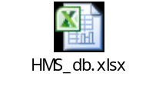

Table Structure
Table Name | Column Name | Column Discription | Data Type | Data Size | Primary Key | Other Constraint
ADMIN_LOGIN | ADMIN_USERNAME | Column is used for storing admin username | VARCHAR | 20 | YES | NOT NULL
ADMIN_LOGIN | ADMIN_PASSWORD | Column is used for storing admin password | VARCHAR | 20 |  | NOT NULL
PATIENT_DETAILS | ID | Column is used for storing patient Id | VARCHAR | 20 | YES | NOT NULL
PATIENT_DETAILS | FIRSTNAME | Column for storing patient first Name | VARCHAR | 225 |  | NOT NULL
PATIENT_DETAILS | LASTNAME | Column for storing patient last Name | VARCHAR | 255 |  | NOT NULL
PATIENT_DETAILS | PATIENT_PASSWORD | Column for storing password | VARCHAR | 30 |  | NOTNULL
PATIENT_DETAILS | DOB | Column for storing date of birth | DATE |  |  | NOT NULL
PATIENT_DETAILS | EMAIL | Column for storing email-id | VARCHAR | 30 |  | NULL
PATIENT_DETAILS | PHONE | Column for storing phone number | INT | 20 |  | NOT NULL
PATIENT_DETAILS | STATE | Column for storing patient state | VARCHAR | 20 |  | NOT NULL
PATIENT_DETAILS | PLAN | Column for storing Insurance Plan | VARCHAR | 30 |  | NULL
PATIENT_DETAILS | FATHER_NAME | Column for storing FatherName | VARCHAR | 30 |  | NOT NULL
PATIENT_DETAILS | MOTHER_NAME | Column for storing MotherName | VARCHAR | 30 |  | NOT NULL
PATIENT_DETAILS | WEIGHT | Column for storing weight | INT | 11 |  | DEFAULT_NULL
PATIENT_DETAILS | MARITAL_STATUS | Column for storing marital status | VARCHAR | 20 |  | NOT_NULL
PATIENT_DETAILS | SPOUSE_NAME | Column for storing spouse name | VARCHAR | 30 |  | DEFAULT_NULL
PATIENT_DETAILS | SPOUSE_AGE | Column for storing spouse age | INT | 11 |  | DEFAULT_NULL
PATIENT_DETAILS | NO_OF_CHILDREN | Column for storing no of children | INT | 11 |  | DEFAULT_NULL
PATIENT_DETAILS | CHILDREN_NAME1 | Column for storing children name1 | VARCHAR | 30 |  | DEFAULT_NULL
PATIENT_DETAILS | CHILDREN_NAME2 | Column for storing children name2 | VARCHAR | 30 |  | DEFAULT_NULL
PHYSICIAN_DETAILS | ID | Column is used for storing physician id. | VARCHAR | 20 | YES | NOT NULL
PHYSICIAN_DETAILS | FIRSTNAME | Column for storing the first name. | VARCHAR | 30 |  | NOT NULL
PHYSICIAN_DETAILS | LASTNAME | Column is used for storing last name | VARCHAR | 30 |  | NOT NULL
PHYSICIAN_DETAILS | DEPARTMENT | Column is used for department of physician | DATE | 30 |  | NOT NULL
PHYSICIAN_DETAILS | EDUCATION | Column is used for storing education qualification | VARCHAR | 20 |  | NOT NULL
PHYSICIAN_DETAILS | YOP | Column is used for storing year of experience | INT | 10 |  | NOT NULL
PHYSICIAN_DETAILS | STATE | Column is used for storing physician state | VARCHAR | 20 |  | NOTNULL
PHYSICIAN_DETAILS | PLAN | Column is used for storing insurance plan | VARCHAR | 30 |  | NULL
PHYSICIAN_DETAILS | SHIFT | Column is used for storing Physician’s working shifts | VARCHAR | 30 |  | NOTNULL
DIAGNOSPATIENT_DETAILS | ID | Column is used for storing diagnosis id | VARCHAR | 20 | YES | NOTNULL
DIAGNOSPATIENT_DETAILS | PATIENT_ID | Column is used for storing Patient_id | VARCHAR | 20 |  | NOTNULL
DIAGNOSPATIENT_DETAILS | SYMPTOMS | Column is used for storing symptoms | VARCHAR | 300 |  | NOTNULL
DIAGNOSPATIENT_DETAILS | DIAGNOSIS | Column is used for storing diagnosis provided | VARCHAR | 300 |  | NOTNULL
DIAGNOSPATIENT_DETAILS | ADMINISTERED_BY | Column is used for storing administered physician name | VARCHAR | 30 |  | NOTNULL
DIAGNOSPATIENT_DETAILS | DATE_OF_DIAGNOSIS | Column is used for storing date of diagnosis | VARCHAR | 20 |  | NOTNULL
DIAGNOSPATIENT_DETAILS | FOLLOW_UP_REQ | Column is used for storing follow up details | VARCHAR | 20 |  | NOTNULL
DIAGNOSPATIENT_DETAILS | DATE_OF_FOLLOW_UP | Column is used for storing date of follow up | VARCHAR | 20 |  | NOTNULL
DIAGNOSPATIENT_DETAILS | BILL_AMOUNT | Column is used for storing bill amount | INTEGER | 10 |  | NOTNULL
DIAGNOSPATIENT_DETAILS | CARD_NUMBER | Column is used for storing card number | INTEGER | 60 |  | NOTNULL
DIAGNOSPATIENT_DETAILS | MODE_PAYMENT | Column is used for storing mode of payment | VARCHAR | 20 |  | NOTNULL

E- R Diagram (Relationship between Tables)

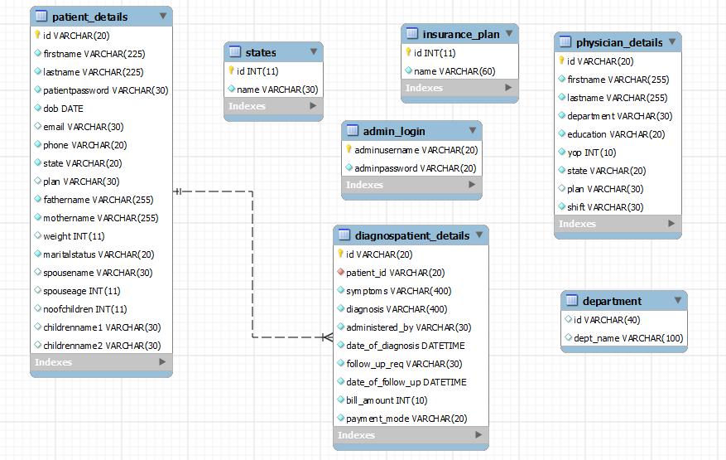

Change Log
Please note that this table needs to be maintained even if a Configuration Management tool is used.
Version Number | Changes made
V1.0 | <First version>
V1.1 | Added Delete Department functionality

