**IMPLEMENTATION**

Steps to follow

1. Download and Install Eclipse Kepler.
2. Run the Admin , Key , Storage and Device Applet.
3. Go to Admin applet and click ‘**Add Soldier**’ button. Now create User profile by adding the Device ID, Batch No and Name.



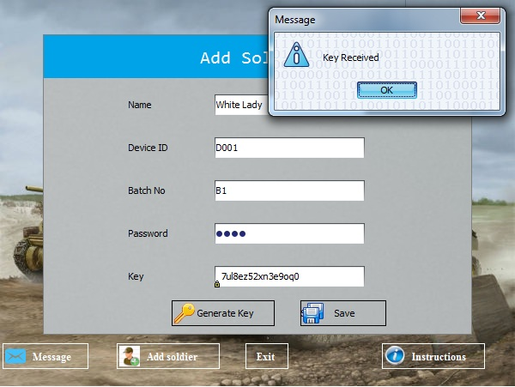

1. Create a User Key for the particular user by clicking ‘**Generate Key**’ button.
2. Save the User attributes along with the generated User Key by clicking ‘**Save**’.
3. The User Key will be sent to the Central authority.

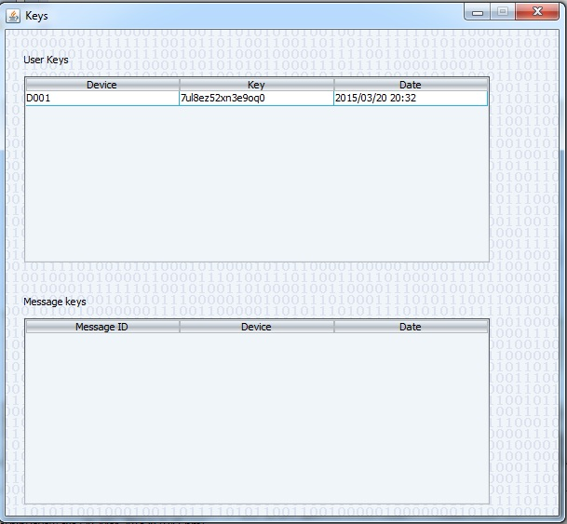

1. Click ‘**Message**’ button in Admin applet to enter the message to be conveyed.
2. Click ‘**Request Key**’ button to generate a Public Key and Private Key pair for encrypting and decrypting the message respectively.
3. Click ‘**Encrypt**’ button to encrypt the message. The message is encrypted with Public key. The corresponding Private Key will be encrypted with the User Key and sent to User Device.
4. Send the encrypted message to the Storage Node by selecting ‘**Send**’ button.

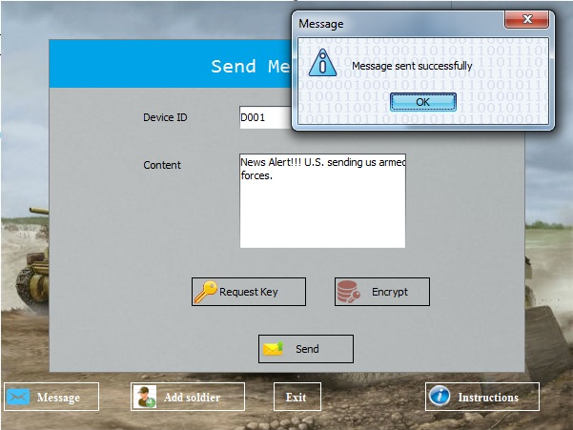

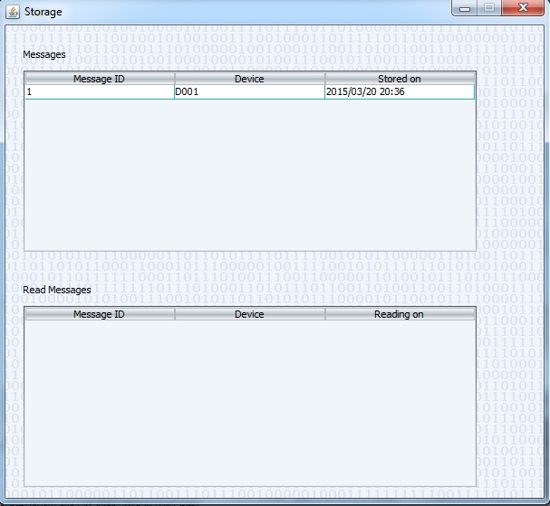

1. Go to the Device Applet. The User enters the Device ID and Password. The User gets access into device if the Device ID and Password matches. Click ‘**Login**’ button.
2. The User requests for the message from Storage Node by clicking ‘**Request Message**’ button.

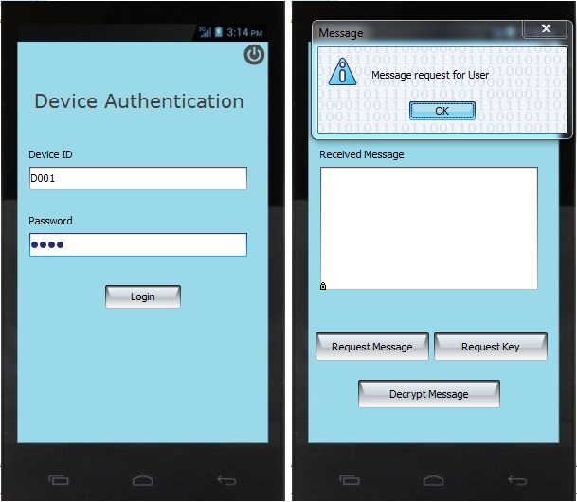

1. The Storage Node sends the message waiting for the respective device. The message is in the form of Cipher Text.
2. The User then requests for the User Key from Central Authority by clicking ‘**Request Key**’ button.The Central Authority grants the User Key for the respective user.
3. Click ‘**Decrypt**’ button. The User enters the User Key received and tries to decrypt the message.

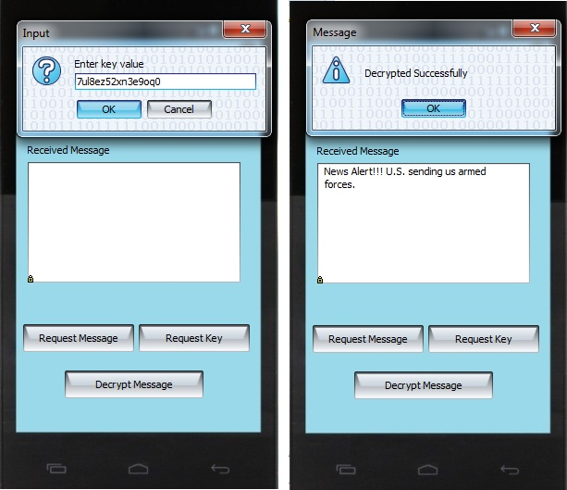

If the entered User Key matches with the Key created by the admin for the corresponding device, then the message is displayed to the user.

The Storage Node will be notified once the message has been retrieved by the user.

1. Each User will be able to view the message only once. The access will be removed for the device once the message has been seen.