**Css validation**

**HTML**

**About page**

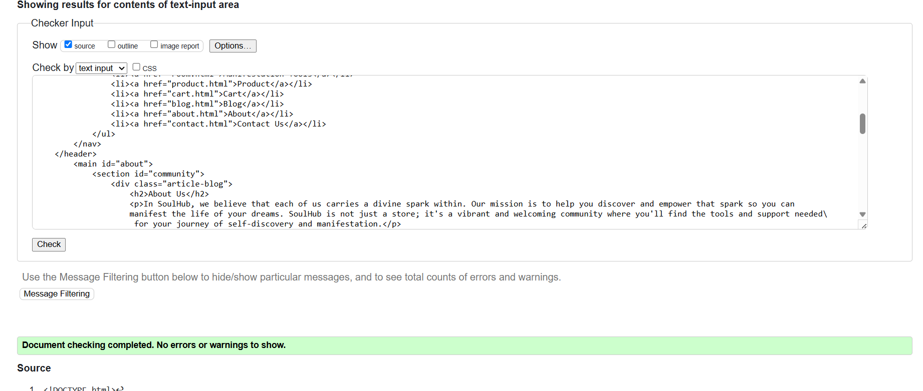

**Blog page**

**Correction**

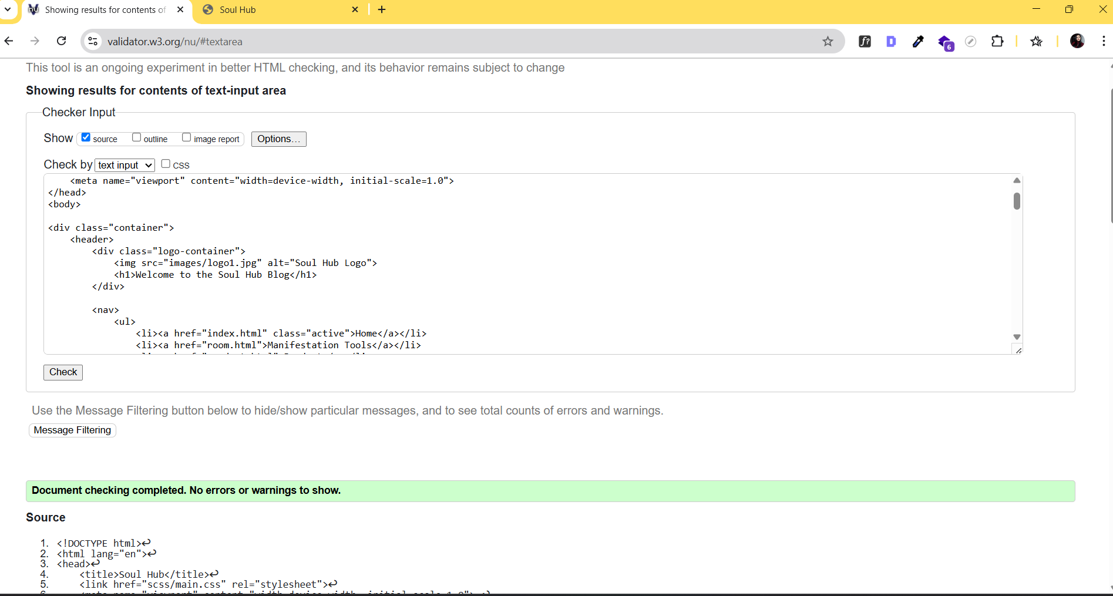

**Cart**

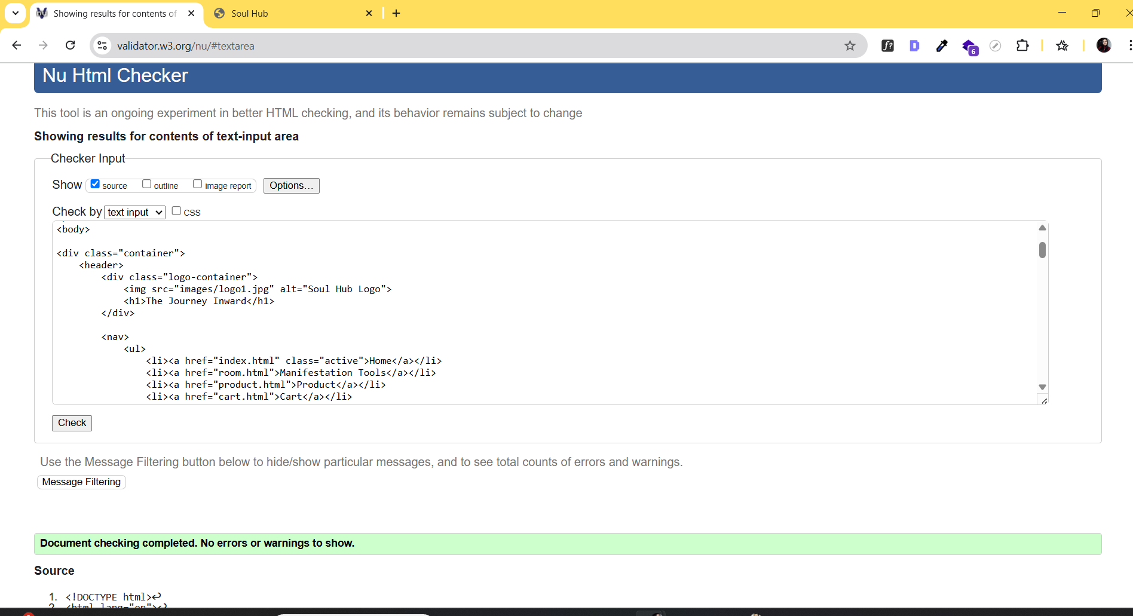

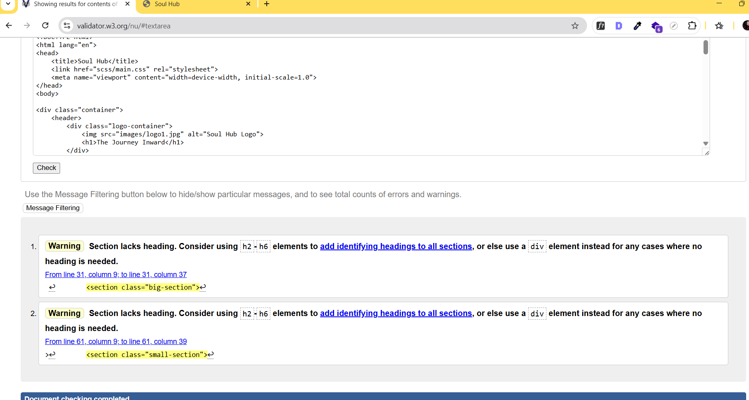

**Correction**

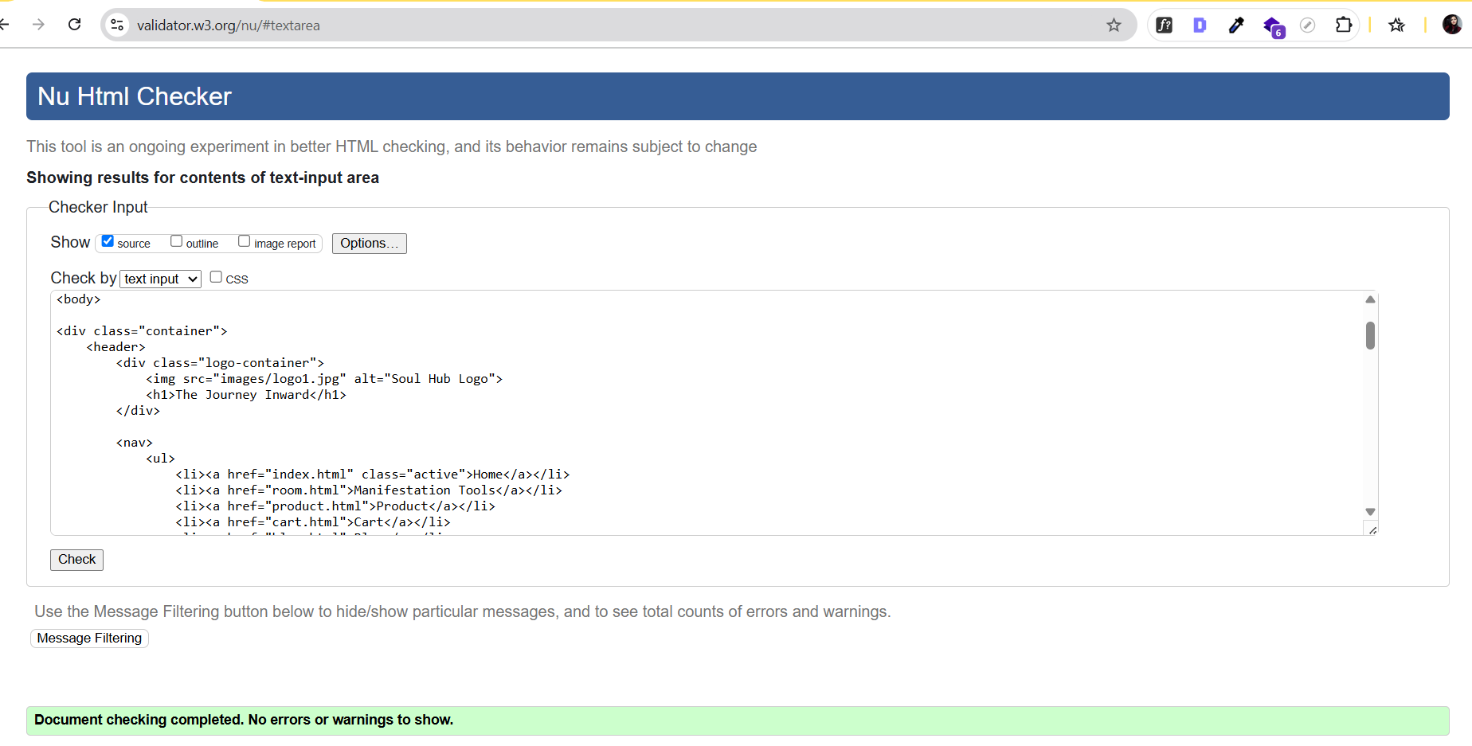

**Index**

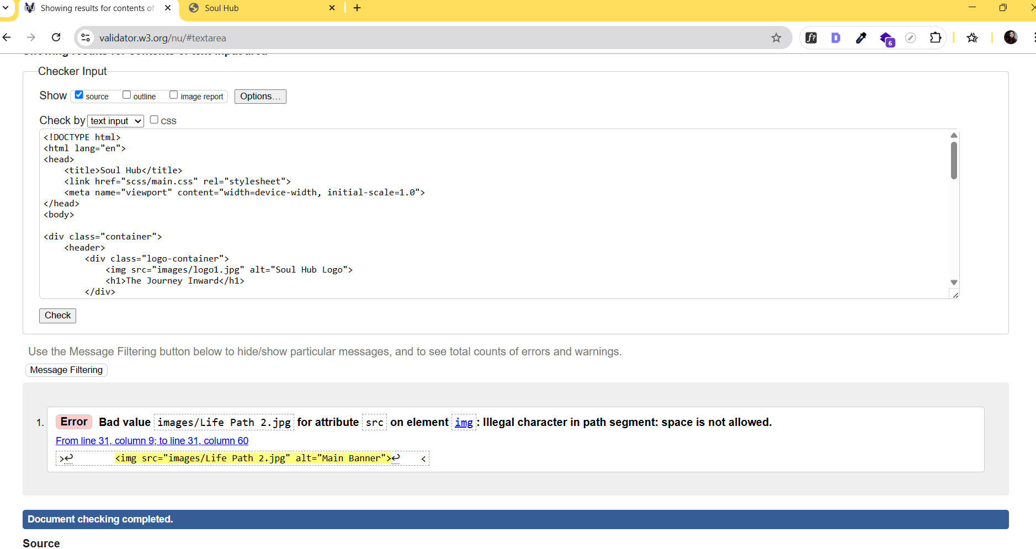

**Correction**

