# **Analysis goals:**

# **Findings**

**1: Find a pattern for one of the measurements over time, and/or across different countries/regions.**

* Nauru is the most obese country in the world as it has highest sum of BMI
* Viet Nam is the healthiest country in the world due to least sum of BMI among all the countries

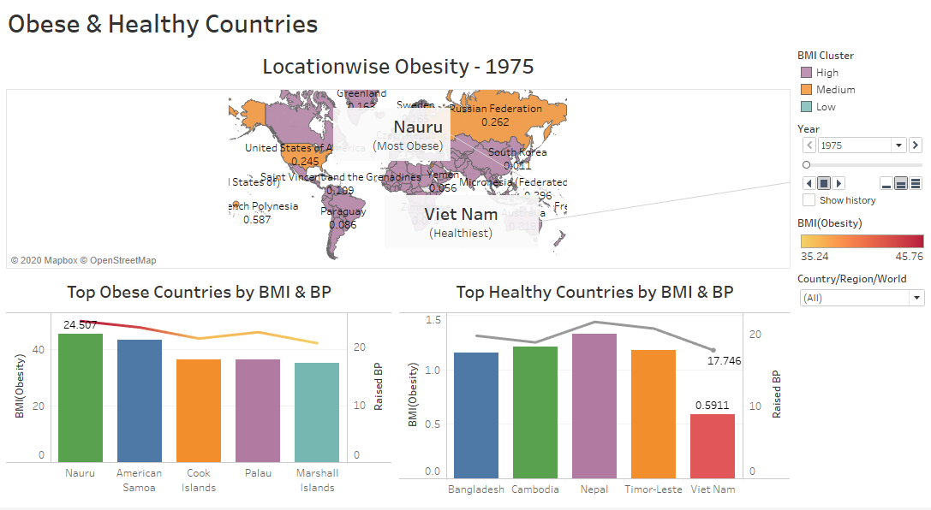

**2: Find a relationship between two or three measurements over time and/or across different area.**

* Obesity is increasing amongst people irrespective of where they belong over the course of time particularly in women

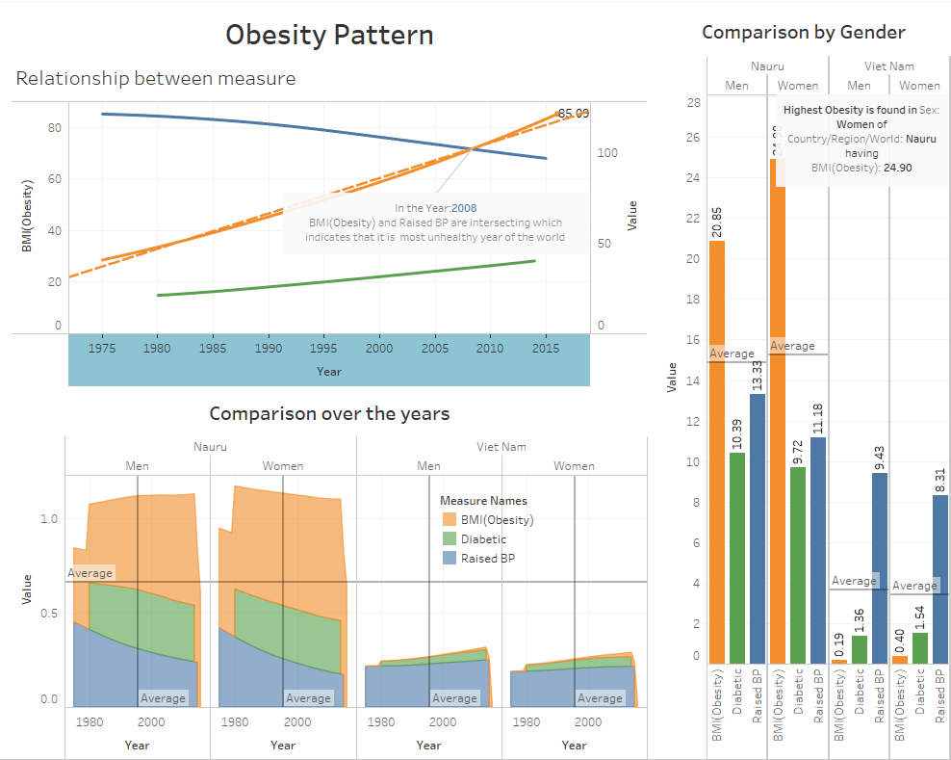

# **The 'what'**

**Dataset type:**

* + Table ( Contains Attributes and Items)
  + Geometry (Contains Position)

**Data type:**

* + Items
  + Attributes
  + Positions

**Attribute type:**

* + Qualitative
    - Categorical (Country/Region/World, Sex, Year)
  + Quantitative
    - Continuous (Prevalence of raised blood pressure, Prevalence of raised blood pressure, Age-standardized diabetes prevalence)

# **The 'why'**

**Visualisation Showcases:**

* Most Obese Country and Healthiest Country
* Be it the most obese or healthiest country, it is observed that Women are more unhealthy than Men.
* BMI is increasing for all the countries over the period of time unlike Diabetes and BP indicating that people are moving towards unhealthy lifestyle all over the world.

**Actions:**

* **Analyze :**
  + Discovered that Nauru – a small island above Australia is the most Obese Country as per given dataset as it has highest sum of BMI. Also people normally have more BP.
* **Search :**
  + Explored that irrespective of Country, Women are unhealthier than men
* **Query :**
  + It is identified that Obesity is increasing amongst people irrespective of where they belong to.

**Targets**

**Data**

* **Trends** 
  + By looking at the linear curve, it can be seen that there is a rapid increase in BMI resulting in obesity over the period of time in the whole world.
* **Attribute** 
  + All the three measure – BMI, BP and Diabetes are co-related with each other in person’s health factor. If all the three or combination of any or even single measure is increasing than also it indicates that people are getting unhealthy over the period of time.

# **The 'how'**

# **Description of various features used in Visuals:**

* **Marks:** 
  + Map is used to show BMI (Obesity) in different Countries of the world.
  + Bar Chart in combination with Line graph is used to show most obese and healthy countries of the world
  + Area chart is used to show correlation amongst both the genders over the period of time along with all three measures.
  + Line chart is used to show correlation between all three measures.
* **Channels:** 
  + Color – Color is applied to various clusters formed for all countries and also to all three measures. Throughout the story Orange depicts “BMI”, Green denotes “Diabetes” and blue represents “Raised BP”
  + Labels – Labels are applied to locations and all three measures
  + Tool tip – When we hover over the locations in Map, it shows customized tool tip for each country as shown below. Also various tooltips required are kept in each chart.

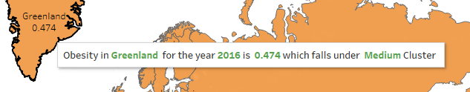

* **Filters :**
  + Dynamic multi valued filter is used for country and BMI cluster
  + Animated filter is used for year in a map which will help to show the historical data too.
  + Clusters: - Countries are clustered into High, Medium and Low categories based on their Obesity i.e. BMI
* **Dashboard :**
  + There are two dashboards for each finding which contains multiple charts , filters and legends to give insights and summary.

* **Story :**
  + One Story is used to say about each finding having the two dashboards with a caption indicating brief on each finding.

# **Reason to choose various types of graphs:**

Visuals play an important role in understanding complex data in an easier manner. This Story majorly contains below types of graphs:

* Line charts is used to show trend of the measures like BMI, Diabetes and Raised BP over the period of time.
* Map is used to show Obesity values across the countries.
* Bar Chart, Line Chart and Area graphs are used to show comparison between BMI, Diabetes and Raised BP
* Annotations are used to high-light main points like Most/Least obese country, Highest BP in specific Gender and in which year the measure like BMI and BP are intersecting depicting that year as one of the most unhealthy year