DAY 1 (TASK): **Overview of Cloud Computing**

***EXAMPLE:- TICKET RAISING SYSTEM***

# **TASK1.1: Research and list at least five benefits of cloud computing over a traditional on-premises infrastructure:**

**Availability:**

=================

Scenario: Imagine you can't log in to your work computer because of a glitch. You quickly submit a ticket for help. Even if the computer center in your city has a problem, Azure's system makes sure your request gets sent to another city's center, so someone can still help you, and you're not stuck waiting for hours.

**Scalability:**

==========================

Scenario: Picture this: It's a big day for your company, and everyone's rushing to submit their IT problems at the same time. Maybe a new software update caused issues for many employees. Instead of crashing or getting slow, the ticket system grows instantly like a superhero, so everyone can get their issues sorted quickly, just like at a checkout counter when lots of people are buying things.

**Elasticity:**

==========================

Scenario: Let's say there's a sudden surge in requests because everyone's setting up their work-from-home setups. The ticket system notices the extra load, kind of like a traffic light sensing more cars, and automatically opens more lanes to help out. Later, when things calm down, it goes back to normal, like the traffic light returning to its usual timing.

**Agility:**

==========================

Scenario: Uh-oh! A new virus threatens our computers! The IT team swiftly creates and applies a protective update to all company devices. Meanwhile, they use Azure tools to quickly send out a message to everyone, explaining the issue and what they need to do to stay safe, like sending out a warning to everyone in the company, but much faster!

**Fault Tolerance:**

==========================

Scenario: Imagine if the main computer room where all our tech lives has a problem. With Azure's backup plan, it's like having a secret stash of tools in another room. Even if one room has a leak, we can quickly grab what we need from the other room and keep working smoothly, so your requests for help never get lost.

**Disaster Recovery:**

==========================

Scenario: A huge storm knocks out power to our main office and the computers there. But our ticket system doesn't give up! It's like having a spare generator hidden away, so it starts running from another place, like a secret hideout. Even if our main place is in chaos, you can still get help without any interruptions.

**TASK1.2 : Describe the CapEx and OpEx models of financing IT infrastructure , providing examples of when each model might be preferred**.

CapEx:

=====================

If the organization plans to build an on-premises ticketing infrastructure with dedicated servers and custom software, CapEx might be preferred.

When long-term ownership and customization are critical. CapEx might be preferred when the company has predictable and stable IT infrastructure needs, and when they have the financial resources to make upfront investments. It can also be preferred when the company requires full control over its infrastructure and wants to customize it to meet specific requirements.

OpEx:

=====================

For a cloud-based ticketing system (SaaS), OpEx is advantageous due to scalability, ease of management, and predictable costs.

When rapid deployment and immediate deductions are essential. OpEx might be preferred when the company has variable or unpredictable IT infrastructure needs, as it allows for more flexibility to scale resources up or down based on demand. It can also be preferred when the company wants to avoid upfront investments and prefers to pay for IT infrastructure as a recurring operational expense.

**TASK2.1: Create a brief report differentiating between public, private, and hybrid clouds. Include a diagram that represents each cloud model**.

Cloud computing offers various deployment models, including public, private, and hybrid clouds. Each model has unique characteristics and is suitable for different organizational needs. This report provides a brief overview and differentiation of these cloud models, along with diagrams representing each one.

**1. Public Cloud:**

Definition: Public clouds are owned and operated by third-party cloud service providers. These providers offer resources such as virtual machines, storage, and applications over the internet to the general public or multiple organizations.

-Characteristics:

- Resources are shared among multiple customers.

- Services are accessible over the internet.

- Customers pay for what they use on a subscription or pay-per-use basis.

# Advantages:

- Cost-effective, as customers only pay for the resources they use.

- Scalable, with the ability to quickly provision additional resources.

- No need for upfront investment in hardware or infrastructure.

# Use Cases:

- Startups and small businesses looking for cost-effective IT solutions.

- Organizations with variable or unpredictable workloads.

**Diagram:**

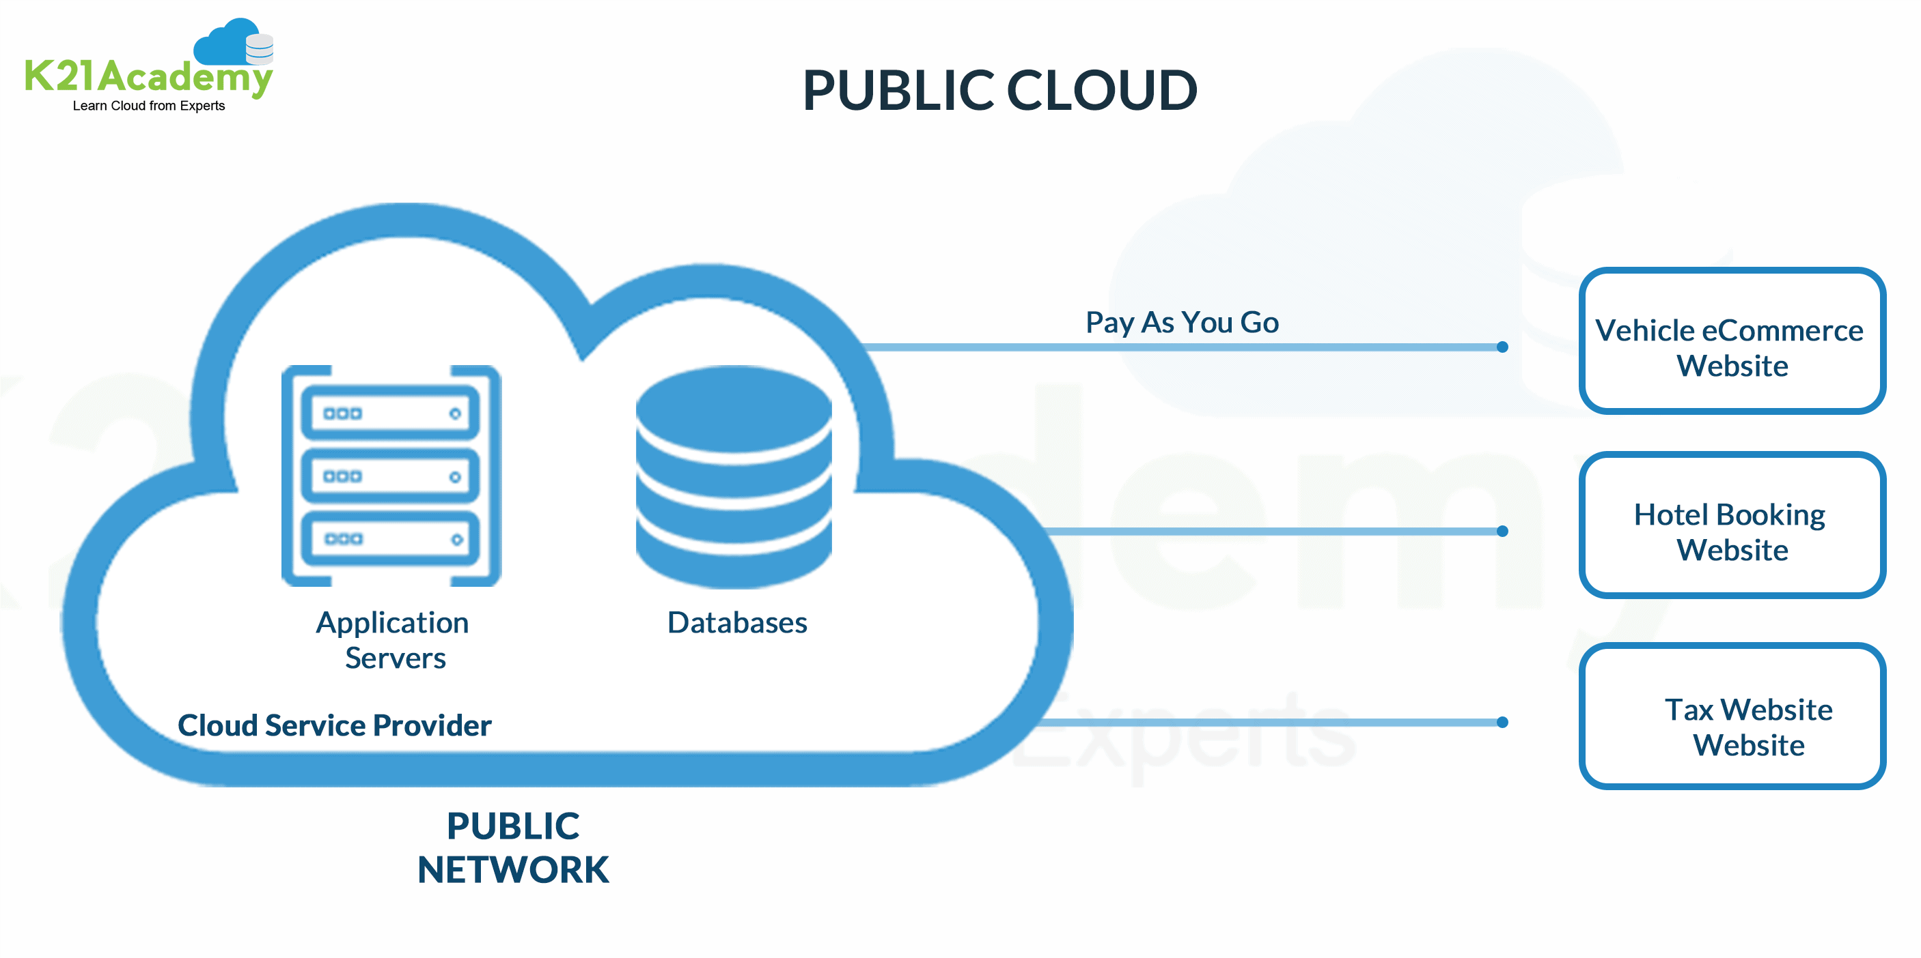

**2. Private Cloud:**

Definition: Private clouds are dedicated cloud environments that are exclusively used by a single organization. These clouds can be hosted on-premises or by a third-party service provider.

# Characteristics:

- Resources are dedicated to a single organization.

- Provides greater control and customization compared to public clouds.

- Offers higher levels of security and compliance.

# Advantages:

- Greater control over data and resources.

- Enhanced security and compliance.

- Ability to customize the cloud environment to meet specific requirements.

# Use Cases:

- Organizations with strict security and compliance requirements.

- Industries such as healthcare and finance that handle sensitive data.

**Diagram:**

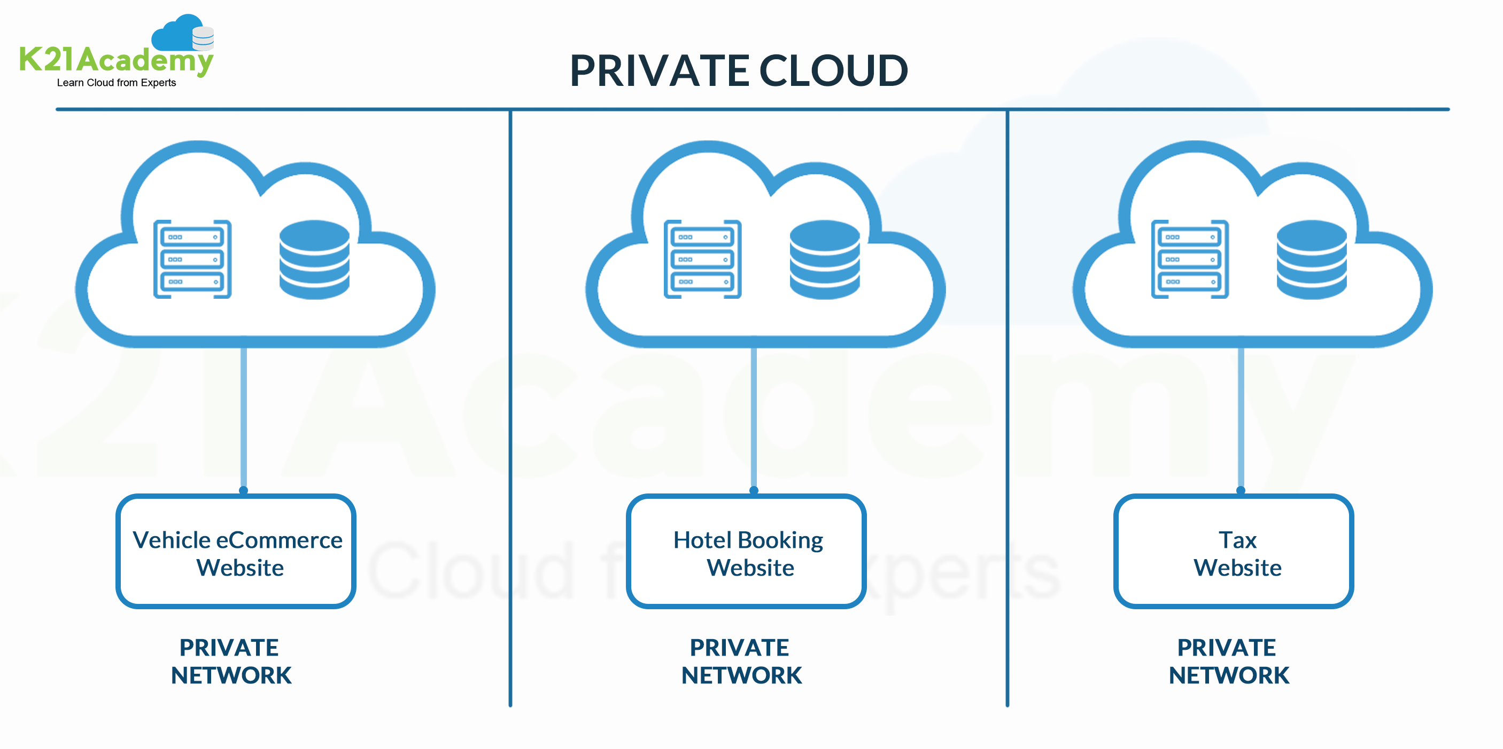

**3.Hybrid Cloud:**

Definition: Hybrid clouds combine public and private cloud environments, allowing data and applications to be shared between them. This model provides greater flexibility and scalability.

# Characteristics:

- Allows organizations to leverage the benefits of both public and private clouds.

- Provides a unified management interface for both environments.

- Enables workload portability between clouds.

# Advantages:

- Flexibility to scale resources based on changing requirements.

- Ability to use public cloud for non-sensitive workloads and private cloud for sensitive workloads.

- Cost-effective, as organizations can use public cloud for bursty workloads.

# Use Cases:

- Organizations with fluctuating workloads.

- Applications that require both public and private cloud environments.

**Diagram:**

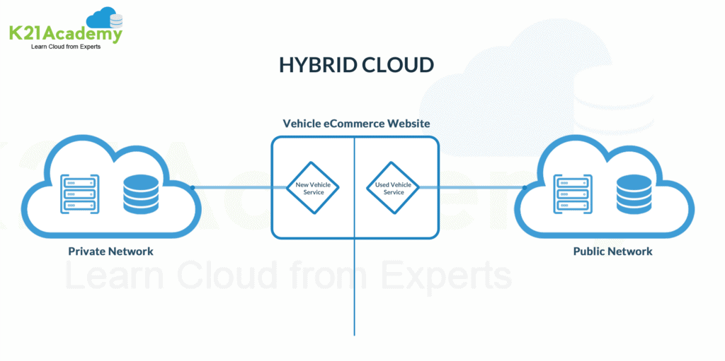

**TASK2.2For each cloud model, list one real-world application or scenario where that model would be the most appropriate choice.**

1.Public Cloud:

Real-World Application: A startup company developing a new mobile app chooses to host their app on a public cloud platform. The company has limited resources and wants to minimize upfront costs. They also anticipate a variable and potentially high volume of users, making the scalability of public cloud resources ideal for their needs.

2.Private Cloud:

Real-World Application: A financial services firm with strict regulatory requirements decides to build a private cloud to host its financial data and applications. The firm needs to ensure data privacy, security, and compliance with regulations such as GDPR and HIPAA. A private cloud allows the firm to have full control over its infrastructure and data, meeting its security and compliance needs.

3.Hybrid Cloud:

Real-World Application: A retail company uses a hybrid cloud model to manage its e-commerce platform. The company uses the public cloud for hosting its website and handling peak shopping seasons when traffic is high. It uses a private cloud for sensitive data such as customer financial information, ensuring security and compliance with industry regulations. The hybrid cloud model allows the company to scale resources up or down based on demand while maintaining control over sensitive data.