## **DAY 15: AZURE INFRASTRUCTURE CONFIGURATION:**

**TASK 3.1 Create Resource groups based on different project environments (eg: Developments, Testing, Production). Explain the organization benefits of using resources group.**

Using resource groups in an organization offers several key benefits:

1. Centralized Management: Resource groups provide a centralized way to organize and manage resources within an organization. Instead of scattering resources across different platforms or services, they can be grouped logically based on projects, departments, or environments. This centralized approach simplifies resource management tasks such as provisioning, monitoring, and access control.

2. Cost Management: Resource groups help in effectively managing costs by providing visibility into resource usage and spending. By grouping resources based on projects or departments, organizations can track and allocate costs more accurately. This enables better budget planning and optimization of resource utilization, ultimately leading to cost savings.

3. Security and Compliance: Organizing resources into groups allows for more granular control over security policies and access controls. Administrators can define permissions and policies at the resource group level, ensuring consistent security measures across all resources within the group. This helps in enforcing compliance with regulatory requirements and mitigating security risks.

4. Scalability and Performance: Resource groups enable organizations to scale resources up or down more efficiently based on demand. By grouping related resources together, it becomes easier to provision additional capacity or optimize performance for specific workloads. This scalability ensures that resources are available when needed, minimizing downtime and improving overall performance.

5. Streamlined Operations: Resource groups facilitate streamlined operations by providing a clear organizational structure for managing resources. Teams can collaborate more effectively within the context of resource groups, making it easier to coordinate tasks, share information, and troubleshoot issues. This streamlining of operations improves productivity and enhances the overall efficiency of the organization.

6. Automation and DevOps Practices: Resource groups support automation and DevOps practices by providing a consistent environment for deploying and managing infrastructure and applications. Automation scripts and deployment pipelines can target specific resource groups, allowing for standardized and repeatable deployment processes. This automation accelerates the delivery of new services and features while reducing the risk of errors and inconsistencies.

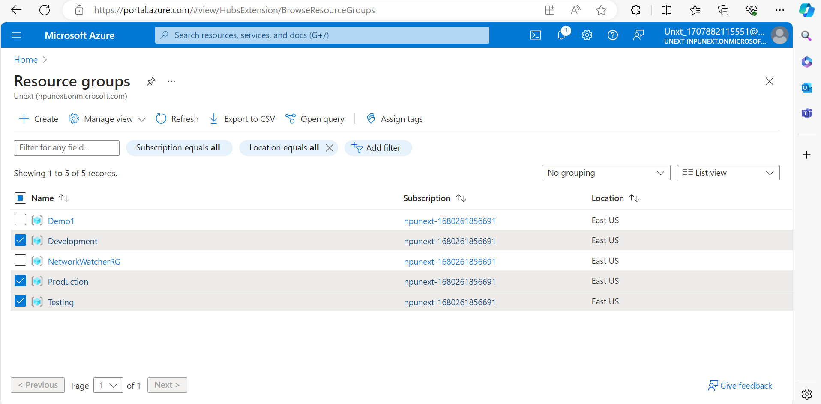

## **TASK 3.2 Explore and document the purpose and usage of Availability Zones and Availability Sets in ensuring application reliability, without creating VMs.**

**Availability Zones:** Availability Zones are physically separate locations within an Azure region. Each zone is made up of one or more datacentres equipped with independent power, cooling, and networking to ensure resilience1. Here are some key points:

1. Fault Isolation: Availability Zones are designed to protect your applications from datacentre failures. They are close enough for low-latency network connections but far enough apart to avoid local outages1.

2. High Availability: If one zone experiences an outage, the regional services, capacity, and high availability are supported by the remaining zones1.

3. Zonal and Zone-Redundant Services: You can use multiple availability zones together to keep separate copies of your application and data within separate physical datacentres in a large metropolitan area1. There are two ways that Azure services use availability zones:

o Zonal resources are pinned to a specific availability zone. You can combine multiple zonal deployments across different zones to meet high reliability requirements1.

o Zone-redundant resources are spread across multiple availability zones. Microsoft manages spreading requests across zones and the replication of data across zones1.

**Availability Sets:** Availability Sets are logical groupings of VMs that reduce the chance of correlated failures bringing down related VMs at the same time2.They place VMs in different fault domains for better reliability2.Here are some points:

1. Fault Isolation: Availability Sets place VMs in different fault domains for better reliability, especially beneficial if a region doesn’t support availability zones2.

2. Update Domains: Each virtual machine in your availability set is assigned an update domain and a fault domain by the underlying Azure platform2.

3. High Availability: Using two or more VMs in an availability set helps highly available applications and meets the 99.95% Azure SLA2.

4. Cost: There’s no extra cost for using availability sets, you only pay for each VM instance you create.

