Explain regression
Regression is a statistical method used to analyze the relationship between variables and predict a continuous outcome. It helps us understand how one variable (the independent variable) affects another variable (the dependent variable).

Explain regression in simple terms for a beginner in data analytics. Include a real-world example, define key terms

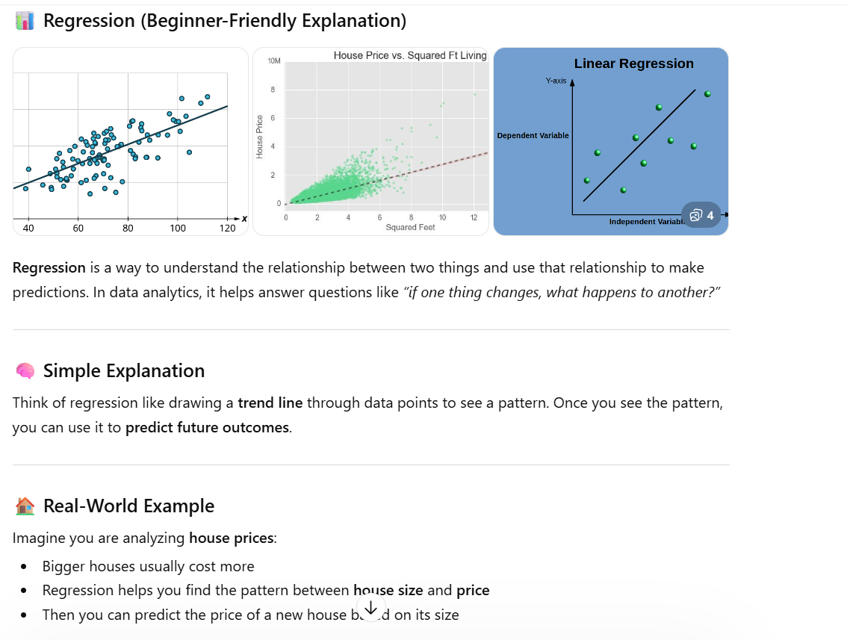
This prompt is more specific and strong because it defines the level (beginner), requests key terms, and asks for a real-world example and practical tools

Help me understand SQL
SQL (Structured Query Language) is a language used to communicate with databases. It allows you to store, retrieve, and manage data in a structured way.

Teach me the basics of SQL as a beginner. Explain what SQL is used for, and show examples

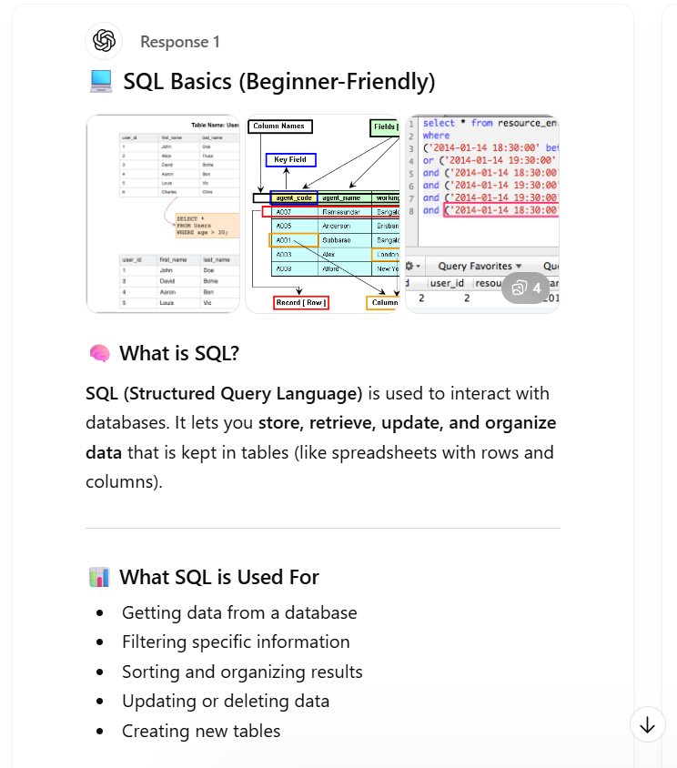
This prompt is strong because it clearly defines the learning level and specifies which SQL concepts to cover. It also asks for examples, which makes the explanation easier to understand and apply.

Create a dataset
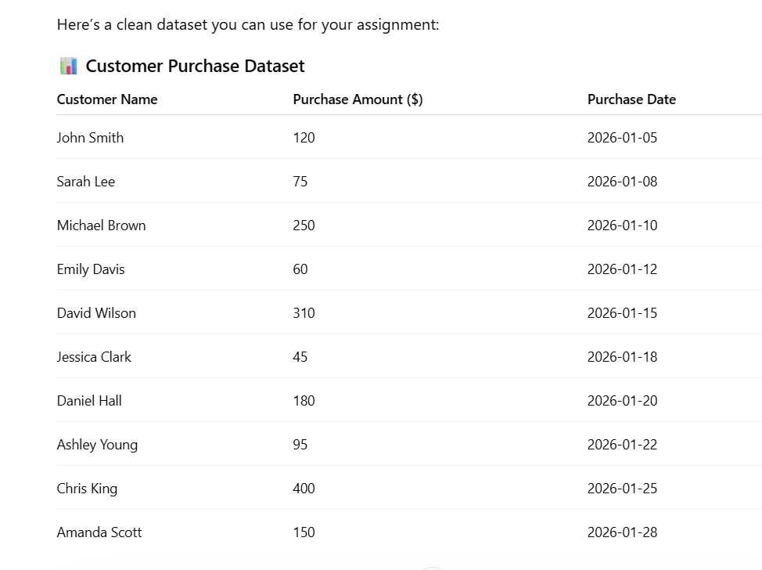

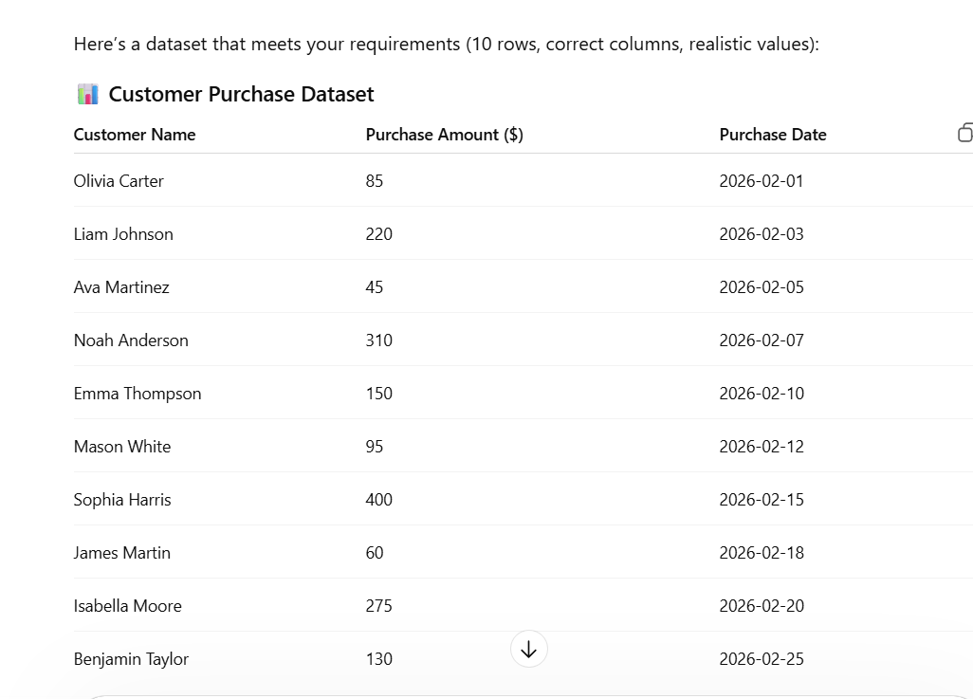Create a dataset with 10 rows showing Customer Name, Purchase Amount, and Purchase Date

